ECE/CTCS/WP.7/GE.11/2020/INF.1
28 September 2020

Economic Commission for Europe
Steering Committee on Trade Capacity and Standards
Working Party on Agricultural Quality Standards
Specialized Section on Standardization of Meat
Twenty-eight session
Geneva, 12—13 October 2020 (online)
Item 4 of the provisional agenda
Revision of the Standard for Porcine meat, carcases and cuts Geneva
Revision of standards
The following comments are submitted by the delegation from Serbia
1. Marbled pork and revision of pork standards
Colour and marbling standards exist, but permission is needed to use them.

Color (with 5 degrees)
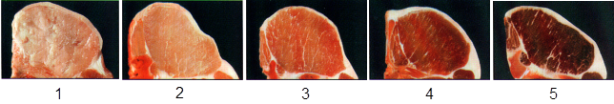
Marbling (with 5 degrees)
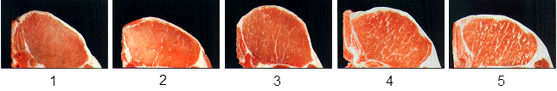
Or
Color (with 6 degrees)
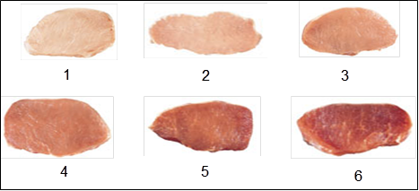
Marbling (with 1-6, 10 degrees)
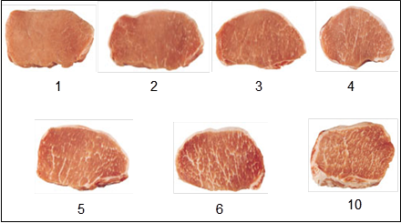

2. Quality of porcine and bovine meat fat
UNECE standards are standards for carcasses and cuts, but not for meat quality or for lean-to-fat ratio in cuts (muscles).
The lean-to-fat ratio in skeletal muscles (not for carcasses and cuts) is defined in e.g. ‘COMMISSION DIRECTIVE 2001/101/EC of 26 November 2001 amending Directive 2000/13/EC of the European Parliament and of the Council on the approximation of the laws of the Member States relating to the labelling, presentation and advertising of foodstuffs. Official Journal of the European Communities L 310/19.’ (see below)
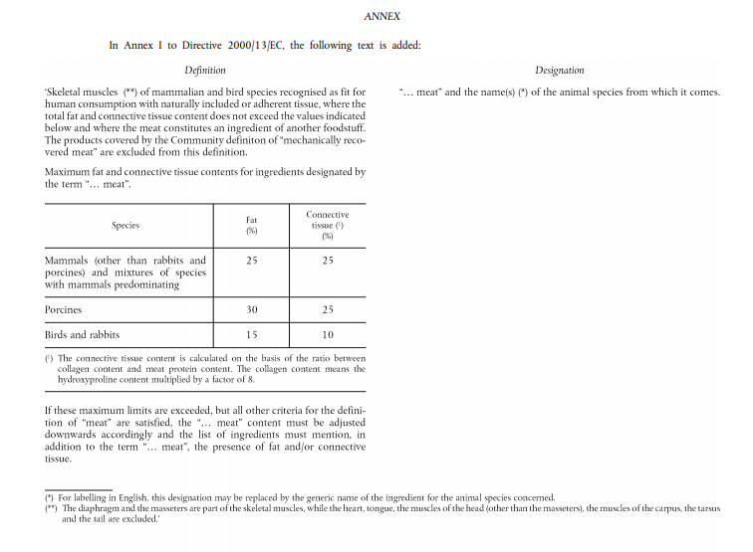
3. Meat and bone meal quality and
4. Animal protein from bones and other slaughter products
The UNECE Specialized Section for Standardization of Meat develops UNECE standards for meat products (for human consumption). The two proposed new standards (‘Meat and bone meal quality’ and ‘Animal protein from bones and other slaughter products’) require fodder experts (and e.g. a new UNECE group), because neither are intended for human consumption.

____________

