UNITED  NATIONS |  | E
 | Economic and Social  Council | Distr.  GENERAL  ECE/TRADE/C/WP.7/GE.11/2008/6  20 February 2008  Original : ENGLISH

ECONOMIC COMMISSION FOR EUROPE

COMMITTEE ON TRADE

Working Party on Agricultural Quality Standards

Specialized Section on Standardization of Meat

Seventeenth session
Geneva, 28 to 30 April 2008
Item 6 of the provisional agenda

DRAFT NEW UNECE STANDARD FOR EDIBLE MEAT CO-PRODUCTS

Submitted by the Working Group(*)

The following draft proposal for a UNECE Standard for Edible Meat Co-Products has been prepared by the Working Group (Australia, France and the United States of America), using as a first input the meeting of rapporteurs held in Paris from 30 to 31 October 2006 and the work that has been carried out further to the recommendations and decisions that were taken at the sixteenth session of the Specialized Section in April 2007. It should serve as a paper to initiate the discussions to define a standard for edible meat co-products.

UNECE STANDARD
FOR EDIBLE MEAT CO-PRODUCTS

1. Introduction

1.1 UNECE standards for meat products

The purpose of UNECE standards for meat products is to facilitate trade by recommending an international language for use between buyer and seller. The language describes meat items commonly traded internationally and defines a coding system for communication and electronic trade. As the texts will be updated regularly, meat industry members who believe that additional items are needed or that existing items are inaccurate or no longer being traded are encouraged to contact the UNECE secretariat.

The text of this publication has been developed under the auspices of the UNECE Specialized Section on Standardization of Meat. It is part of a series of standards which UNECE has developed or is planning to develop.

The following table contains the species for which UNECE standards exist or are being developed and their code for use in the UNECE meat code (see section 4).

For further information please visit the UNECE website at <http://www.unece.org/trade/agr>.

Annex I contains a description of the codification system, which includes a specific application identifier for the implementation of the UNECE code.

Species | Species code  (data field 1)
Bovine (Beef) | 10
Bovine (Veal) | 11
Porcine (Pork) | 30
Ovine (Sheep) | 40
Caprine (Goat) | 50
Llama | 60
Alpaca | 61
Chicken | 70
Turkey | 71
Duck | 72
Edible meat co-products | 90

1.2 Scope

This Standard recommends an international language for edible co-products marketed as fit for human consumption. It provides purchasers with a variety of options for meat handling, packing and conformity assessment that conform to good commercial practice for meat and meat products intended to be sold in international trade.

To market edible co-products across international borders, the appropriate legislative requirements of food standardization and veterinary control must be complied with. The Standard does not attempt to prescribe those aspects, which are covered elsewhere. Throughout the Standard, such provisions are left for national or international legislation, or requirements of the importing country.

The Standard contains references to other international agreements, standards and codes of practice that have the objective of maintaining the quality after dispatch and of providing guidance to Governments on certain aspects of food hygiene, labelling and other matters that fall outside the scope of this Standard. Codex Alimentarius Commission Standards, Guidelines, and Codes of Practice should be consulted as the international reference for health and sanitation requirements.

1.3 Application

Contractors are responsible for delivering products that comply with all contractual and specification requirements and are advised to set up a quality-control system designed to assure compliance.

For assurance that items comply with these detailed requirements, buyers may choose to use the services of an independent, unbiased third party to ensure product compliance with a purchaser’s specified options. The Standard includes illustrative photographs of co-products to make it easier to understand the provisions.

1.4 Adoption and publication history

Following the recommendation of the Specialized Section, the Working Party on Agricultural Quality Standards adopted this text at its XXX session (reference: ECE/TRADE/C/WP.7/XXX).

UNECE standards for meat undergo a complete review three years after publication. Following the review, new editions are published as necessary. Changes requiring immediate attention are published on the UNECE website at: <http://www.unece.org/trade/agr/standards.htm>.

2. Minimum requirements

All edible co-products must originate from healthy animals slaughtered in establishments regularly operated under the applicable regulations pertaining to food safety and inspection.

Edible co-products must be:

- Intact, taking into account the presentation
- Free from visible blood clots, or bone dust
- Free from any visible foreign matter (e.g. dirt, wood, plastic, metal particles)
- Free of offensive odours
- Free of unspecified bones fragments
- Free of contusions having a material impact on the product
- Free from freezer-burn

Removal and preparation of edible co-products shall be accomplished with sufficient care to maintain integrity and identity and avoid unnecessary scores.

3. Purchaser-specified requirements

The following subsections define the requirements that can be specified by the purchaser together with the codes to be used in the UNECE edible meat co-products code (see section 4).

3.1 Additional requirements

Additional purchaser-specified requirements, which are either not accounted for in the code (e.g. if code 9 “other” is used) or that provide additional clarification on the product or packing description shall be agreed between buyer and seller and be documented appropriately.

3.2 Species

The code for edible meat co-products in data field 1 as defined in section 1.1 as: 90.

3.3 Product/cut

The four-digit product code in data field 2 is defined in section 5.

3.4 Refrigeration

Edible meat co-products may be presented chilled, frozen or deep-frozen. Depending on the refrigeration method used, tolerances for product weight to be agreed between buyer and seller. Ambient temperatures throughout the supply chain should be such as to ensure uniform internal product temperatures as follows:

Refrigeration code  (data field 4) | Category | Description
0 | Not specified | No category specified
1 | Chilled | Internal product temperature maintained at not less than –1.5° C or more than +7° C at any time following the post-slaughter chilling process.
2 | Frozen | Internal product temperature maintained at not exceeding –12° C at any time after freezing
3 | Deep-frozen | Internal product temperature maintained at not exceeding –18° C at any time after freezing.
4 - 8 | Codes not used
9 | Other

3.5 Production history

3.5.1 Traceability

The requirements concerning production history specified by the purchaser require traceability systems to be in place. Traceability requires a verifiable method of identification of edible meat co-products, cartons and cuts at all stages of production. Traceability records must be able to substantiate the claims being made and the procedures used to certify conformity must be in accordance with provisions concerning conformity-assessment requirements of section 3.10.

3.5.2 Co-product category

Co-product category code  (data field 3) | Category | Description
00 | Not specified
10 | Beef
11 | Veal
30 | Porcine
40 | Ovine
42 | Lamb
50 | Caprine
52 | Kid
80 | Equine
99 | Others | Any other co-product category agreed between buyer and seller

3.5.3 Production system

The purchaser may specify a production system. In any case the production has to be in conformity with the regulations in force in the importing country. If no such regulation exists, the regulation of the exporting country shall be used.

Production system code  (data field 6) | Category | Description
0 | Not specified | No system specified
1 | Mainly indoors | Production methods that are based on indoors housing
2 | Restricted outdoors | Production methods that are based on limited access to free movement
3 | Pasture | Production methods that are based on access to open land
4 | Organic | Production methods that are in conformity with the legislation of the importing country concerning organic production
5 – 8 | Codes not used
9 | Other | Any other production system agreed between buyer and seller

3.5.4 Feeding system

The purchaser may specify a feeding system. In any case the feeding has to be in conformity with the regulations in force in the importing country. If no such regulation exists, the feeding system shall be agreed between buyer and seller.

Feeding system code  (data field 7) | Category | Description
0 | Not specified
1 | Grain fed | Grain is the predominant component of the diet
2 | Forage fed | Forage is the predominant component of the diet, with some grain supplement
3 | Exclusively forage fed | Forage is the only component of the diet
4 | Milk fed | Feeding system based on milk
5 | Formula fed | Feeding systems that are milk substitute based
6 | Specialized/Functional | Special enriched feeding system aimed to either change some characteristics of the product or its nutritional profile
7 - 8 | Codes not used
9 | Other | Any other feeding system agreed between buyer and seller

3.5.5 Slaughter system

The purchaser may specify a slaughter system. The slaughter always has to be in conformity with the regulations in force in the importing country. If no such regulation exists, the slaughter system shall be agreed between buyer and seller.

Slaughter system code  (data field 8) | Category | Description
0 | Not specified
1 | Conventional | Stunning prior to bleeding
2 | Kosher | Appropriate ritual slaughter procedures used
3 | Halal | Appropriate ritual slaughter procedures used
4 – 8 | Codes not used
9 | Other | Any other authorized method of slaughter must be specified by seller and buyer

3.5.6 Post-slaughter system

The purchaser may specify a post-slaughter system. In any case the post-slaughter has to be in conformity with the regulations in force in the importing country. If no such regulation exists, the post-slaughter system shall be agreed between buyer and seller.

Post-slaughter processing codes  (data field 9) | Category | Description
0 | Not specified
1 | Washed | Raw and washed with fresh water
2 | Scalding | Washing in water at a temperature of 65-75° C
3 | Blanching | Plunged in boiling water at a temperature of 100° C for a few minutes
4 | Cooked and bleached | Plunged in boiling water at a temperature of 100° C for a few minutes with added bleach
5 | Scalded and bleached | This processing may have bleach added
6 | Casing fat removal¹
7 | Casing mucosa removal
8 | Casing fat and mucosa removal¹
9 | Other specified | Post-slaughter system for edible co-products specified as agreed between buyer and seller.

¹ Buyer and seller should agree on the percentage of fat left on the product.

Note: Individual market requirements will have specific regulations governing the removal of specified-risk material.

3.6 Edible co-product colour

Edible co-product colour code  (data field 10) | Category | Description
0 | Not specified
1 | Specified | Range required
2 – 9 | Codes not used

Specific requirements regarding colour if required need to be agreed between buyer and seller and are not provided for in the coding system.

Size/weight ranges of edible co-products

Size/weight range code  (data field 12) | Category | Description
0 | Not specified
1 | Weight | Range required
2 | Diameter | Range required
3 | Length | Range required
4 | Diameter and length | Range required
5 | Weight and diameter | Range required
6 | Weight and length | Range required
7 | Weight, diameter and length | Range required
8 | Other specified | Range required
9 | Code not used

3.8 Packing, storage and transport

3.8.1 Description and provisions

The primary packaging is the primary covering of a product and must be of food grade materials. The secondary packaging contains products packaged in their primary packaging. During storage and transport, edible co-products must be packaged to the following minimum requirements:

- Chilled with or without packaging
- Frozen / deep-frozen packed to protect the products
- Salt or brine
- Individually wrapped (I.W.)
- Bulk packaged (e.g. plastic or wax-lined container, barrels)
- Bulk sorted (e.g. in layers)
- Vacuum-packed (VAC)
- Modified atmosphere packaging (MAP)
- Other

The conditions of storage before dispatch and the equipment used for transportation shall be appropriate to the physical and, in particular, the thermal condition of the edible co-products (chilled, chilled in a modified atmosphere, frozen, or deep-frozen) and shall be in accordance with the requirements of the importing country. Attention is drawn to the provisions of the UNECE Agreement on the International Carriage of Perishable Foodstuffs and on the Special Equipment to be Used for Such Carriage (ATP) (ECE/TRANS/165).

3.8.2 Packing code

Packing code  (data field 13) | Category
0 | Not specified
1 | Individually wrapped (I.W.)
2 | Bulk packaged (e.g. plastic or wax-lined container, barrels)
3 | Bulk sorted (e.g. in layers)
4 | Vacuum-packed (VAC)
5 | Modified atmosphere packaging (MAP)
6 – 8 | Codes not used
9 | Other

3.9 Labelling information to be mentioned on or affixed to the marketing units of edible co-products

3.9.1 Mandatory information

Without prejudice to national requirements of the importing countries, the following information must be listed on product labels:

Labelling information | Packaged or packed meat
Health stamp | X
Slaughter number or batch number | X
Slaughter date (optional) | X
Packaging date | X
Name of the product | X
Durability information as required by each country | X
Use-by date, as required by each country | X
Temperature or storage methods: chilled, frozen, deep-frozen, in salt or brine | X
Storage conditions (see section 3.4 Refrigeration) | X
Appropriate identification of packer, processor or retailer | X
Quantity (number of pieces) | X
Net weight | X

3.9.2 Additional information

Additional information may be listed on product labels as requested by the importing country’s legislation or at the buyer’s request or as chosen by the processor. If listed, such product claims must be verifiable (see also 3.5.1).

Examples of such product claims include the following:

- Characteristics of the livestock, production and feeding systems
- Country of birth
- Country(ies) of raising
- Country of slaughter
- Country(ies) of packing
- Country (ies) of origin. In this standard the term “country of origin” is reserved to indicate that birth, raising, slaughter, processing/cutting and packing have taken place in the same country.
- Slaughter and post-slaughter systems
- Production and processing systems
- Quantity (number of pieces)
- Slaughter date
- Slaughter number
- Storage conditions (other than temperature)

3.10 Provisions concerning conformity-assessment requirements

The purchaser may request third-party conformity-assessment of the product’s quality/grade/ classification, purchaser-specified options of the standard, and/or animal identification. Individual conformity assessments or combinations may be selected as follows:

Quality/grade/classification conformity assessment (quality): a third party examines and certifies that the product meets the quality level requested. The name of the third-party certifying authority and quality grade standard to be used must be designated as noted in section 3.1.

Trade standard conformity assessment (trade standard): a third party examines and certifies that the product meets the purchaser-specified options as specified in this trade standard, except for quality level. The name of the third-party certifying authority must be designated as noted in section 3.1. Optionally, the purchaser may indicate specific purchaser specified options to be certified after the name of the third-party certifying authority.

Animal or batch identification conformity assessment (animal/batch ID): a third party certifies that the product meets specified requirements. The name of the third-party certifying authority and the requirements must be designated as noted in section 3.1.

Conformity assessment code (data field 14) | Category
0 | Not specified
1 | Quality/grade/classification (quality) conformity assessment
2 | Trade standard conformity assessment
3 | Animal/batch identification (animal/batch ID) conformity assessment
4 | Quality and trade standard conformity assessment
5 | Quality and animal/batch ID conformity assessment
6 | Trade standard and animal/batch ID conformity assessment
7 | Quality, trade standard, and animal/batch ID conformity assessment
8 | Code not used
9 | Other

4. UNECE Code for purchaser requirements for Edible Co-Products

4.1 Definition of the code

The UNECE code for purchaser requirements for edible meat co-products has 14 fields and 20 digits (3 digits not used) and is a combination of the codes defined in sections 3 and 5.

No. | Name | Section | Code Range
1 | Species | 3.2 | 00 – 99
2 | Product/cut | 5 | 0000 – 9999
3 | Co-product category | 3.5.2 | 00 – 99
4 | Refrigeration | 3.4 | 0 – 9
5 | Field not used | – | 0 – 9
6 | Production system | 3.5.3 | 0 – 9
7a | Feeding system | 3.5.4 | 0 – 9
7b | Field not used | – | 0 – 9
8 | Slaughter system | 3.5.5 | 0 – 9
9 | Post-slaughter system | 3.5.6 | 0 – 9
10 | Edible co-products colour | 3.6 | 0 – 9
11 | Field not used | – | 0 – 9
12 | Size/weight ranges | 3.7 | 0 – 9
13 | Packing | 3.8.2 | 0 – 9
14 | Conformity-assessment | 3.10 | 0 – 9

4.2 Example

The following example describes a chilled, vacuum packaged, heart that was third party certified, with post-slaughter processing agreed between buyer and seller and size/weight range by weight, from a beef that was pasture raised and forage fed.

This item has the following UNECE Edible Meat co-product code: 90610010103200710152

No. | Name | Requirement | Code value
1 | Species | Edible meat co-Products | 90
2 | Product/cut | Heart | 6100
3 | Co-product category | Beef | 10
4 | Refrigeration | Chilled | 1
5 | Field not used | – | 0
6 | Production system | Pasture | 3
7a | Feeding system | Forage | 2
7b | Field not used | – | 0
8 | Slaughter system | Not specified | 0
9 | Post-slaughter system | Other specified | 7
10 | Edible co-product colour | Specified | 1
11 | Field not used | – | 0
12 | Size/weight ranges | Weight | 1
13 | Packing | Vacuum-packed (VAC) | 5
14 | Conformity assessment | Trade standard conformity assessment | 2

5. Edible meat co-products descriptions

Definition of “Edible meat co-products”:

“Edible meat co-products” is defined as animal product other than red or white meat muscles. Edible co-products are identified in many countries by the following descriptions: (fancy meat items, offal meat items, and variety meat items).

Multilingual index of products

Product | English | Page | French | Russian | Spanish | Chinese
BOVINE – CODE (10)
6000 | Tongue long cut
6010 | Tongue short cut
6030 | Tongue swiss cut
6040 | Tongue root
6045 | Tongue root fillet
6050 | Cheek
6060 | Cheek – papillae off
6061 | Cheek meat
6260 | Papillae
6114 | Head
6240 | Head meat
6120 | Brain
6070 | Tail
6080 | Liver
6090 | Kidney
6211 | Heart and lungs
6210 | Lungs
6183 | Trachea
6100 | Heart
6110 | Thymus gland (sweetbreads)
6112 | Salivary glands
6140 | Rumen (paunch)
6141 | Rumen Pillars (mountain chain tripe)
6152 | Reticulum (honeycomb tripe)
6154 | Omasum (bible tripe)
6155 | Abomasum
 | Thin shirt (meat spec)
 | Thick skirt (meat spec)
6180 | Testes
6181 | Pizzel
6182 | Oesophagus
6280 | Weasand meat
6190 | Spleen
6200 | Tendons
6201 | Flexor tendons
6202 | Achilles tendons
6203 | Skirt sinew
6270 | Diaphragm membrane
6271 | Skirt membrane (tunic tissue)
6272 | Membrane
6273 | Ligamentum nuchae
6493 | Feet
6494 | Mammary glands
6495 | Rectum (Bung)
6496 | Small intestine
6497 | Large intestine
6498 | Intestine
xxxx | Blood stabilised
xxxx | Blood defibrinated
xxxx | Blood plasma
xxxx | Blood serum
VEAL – CODE (11)
6500 | Tongue long cut
6510 | Tongue short cut
6520 | Tongue swiss cut
6620 | Head
6621 | Skull
6570 | Brain
6524 | Cheek
6624 | Pluck
6582 | Lungs
6550 | Heart
6530 | Liver
6540 | Kidney
6559 | Salivary glands
6560 | Thymus gland (sweetbreads)
6561 | Tail
6580 | Spleen
6590 | Tendons
6610 | Thin skirt
6611 | Thick skirt
6622 | Feet
6623 | Testes
6625 | Oesophagus
6613 | Weasand meat
6614 | Papillae (lips)
6626 | Intestines
6628 | Abomasum
6629 | Rumen (stomach/paunch)
6632 | Rumen pillars (mountain chain tripe)
6633 | Reticulum (honeycomb tripe)
6634 | Omasum (bible tripe)
6640 | Blood stabilised
6641 | Blood defibrinated
6642 | Blood plasma
6643 | Blood serum
OVINE – CODE (40)
CAPRINE – CODE (50)
7000 | Tongue long cut
7010 | Tongue short cut
7015 | Tongue swiss cut
7150 | Head
7151 | Skull
7070 | Brain
7028 | Cheek
7110 | Head trimmings (meat)
7140 | Pluck
7141 | Heart and lung
7100 | Lungs
7030 | Liver
7040 | Kidney
7050 | Heart
7060 | Thymus gland (sweetbreads)
7080 | Rumen (stomach)
7090 | Spleen
7091 | Tendons
7130 | Testes
7485 | Intestine
7486 | Small intestine
7487 | Caecum
7495 | Feet
xxxx | Blood stabilised
xxxx | Blood defibrinated
xxxx | Blood plasma
xxxx | Blood serum
PORCINE – CODE (30)
7500 | Tongue short cut
7501 | Tongue Swiss cut
7502 | Tongue long cut
7609 | Tongue root trim
7549 | Head
7550 | Brain
7585 | Mask
7586 | Temples
7692 | Ears
7693 | Snout
7578 | Lips
7525 | Pluck
7524 | Heart and lungs
7540 | Heart
7526 | Lungs
7528 | Trachea
7020 | Liver
7530 | Kidney
7541 | Thick skirt
7542 | Thin skirt
7543 | Diaphragm
7510 | Tail
7515 | Testes
7527 | Oesophagus
7560 | Stomach
7570 | Stomach (butterfly cut)
7571 | Small intestine
7572 | Intestine
7573 | Large intestine (chitterling)
7574 | Caecum
7575 | Frise (chaudin)
7576 | Suivant (robe)
7577 | Rectum (fuseau)
7578 | Anus (rosette)
7579 | Mensentry
7580 | Bladder
7581 | Uterus
7600 | Spleen
7670 | Thymus gland (sweetbreads)
7671 | Salivary gland
7672 | Pancreas gland
7679 | Bones
7681 | Neck bone
7684 | Skirt sinew
7690 | Skin (rind)
7694 | Ear root
7695 | Caul fat
7696 | Abdominal fat
7697 | Flank fat
xxxx | Blood stabilised
xxxx | Blood defibrinated
xxxx | Blood plasma
xxxx | Blood serum
xxxx | Stomach (pepsin) lining
xxxx | Ovaries
xxxx | Clear plate
4175 | Fore feet
4176 | Hind feet

5.1.1 Bovine, species code (10)

Tongue long cut – 6000
Tongue long cut is the entire organ with its root; all of the hyoid bones are left except for the stylohyal. The larynx, the epiglottis and the first three rings of the trachea remain attached. The root is trimmed at the third tracheal ring; the oesophagus and the pharynx are removed entirely.

To be specified:
- Colour (white, black or spotted)
- Epithelium fat removed or incised lengthways further to health inspection
- Approximate fat depth retained
- Lymph/slavery glands removed
- Parts considered as not saleable by some countries must be specified (specified-risk material)

Tongue short cut – 6010
Tongue short cut is prepared from a tongue long cut (item 6000) and is separated from the root and from the throat in front of the epiglottis and directly behind the thyroid process (urohyal) of the hyoid bones. The hyoid bones, except for the stylohyal, are left and the tip of the epiglottis is removed. The base of the tongue is trimmed up to the “false lean”, leaving approximately 10% of the trimming fat; the salivary glands are removed, except for the sublingual glands.

To be specified:
- Lymph glands and salivary glands removed
- Colour (white, black or spotted)
- Epithelium fat removed or incised lengthways further to health inspection

Tongue swiss cut – 6030
Tongue Swiss cut is derived from a tongue short cut (item 6010) by the removal of the fat from the ventral surface of the tongue, the tip of the epiglottis, the hyoid bone, sublingual salivary glands and the M. mylohyoideus of the tongue blade.

To be specified:
- Colour (white, black or spotted).
- Epithelium fat removed or incised lengthways further to health inspection

Tongue root – 6040 (throat trimmings)
Tongue root is prepared from a tongue long cut and is the soft tissue surrounding the throat organs (larynx, three tracheal rings, salivary glands, lymph nodes, fat, connective tissue and associated muscles).

Tongue root fillet – 6045
Tongue root fillets are derived from the tongue root by removing the muscles from each side of the root (sterno- thyroidal or hoyïdial muscles).

Cheek – 6050
Cheek is the muscle which, along with the periphery of the mouth, covers the external part of the upper and lower jawbones. It extends from the lip to behind the mouth up to the parotid salivary glands. The whole cheek does not include the external part of the lip; however, it does include the papillary fringe of the mouth.

To be specified:
- Parotid lymph/salivary glands retained or removed
- External fat removed

Cheek – papillae off - 6060
Cheek (item 6050) is trimmed further with all of the papillae (chops) as well as the parotid gland removed. The lymph glands and salivary glands are not removed.

To be specified:
- Lymph glands and salivary glands removed
- External fat removed

Cheek meat – 6061
Cheek meat is prepared from cheek papillae off by complete removal of the parotid lymph nodes, parotid salivary glands and mandibular salivary glands. The pack can only include the muscles derived from the cheek - M. masseter, M. buccinator and may include the M. pterygoideus (which lies inside the lower jaw). Must not include any portions of lymph nodes, salivary glands or other muscle tissues removed from other parts of the head.

Papillae – 6260
Papillae (chops) are derived from the cheek (item 6050) and are removed along the natural seam between the M. masseter muscle (cheek) and the M. buccinator (papillae).

To be specified:
- Mucous membrane removed

Head – 6114
Whole skinned beef head removed from the carcase by cutting at the occipital joint and the first cervical vertebra (cutting is perpendicular to the major axis of the cervical vertebrae).

To be specified:
- Parts considered as not saleable by some countries must be specified (specified-risk material)
- Tongue removed
- Eyes removed

Head meat – 6240
Head meat is prepared from a head and includes any or all meat removed from the skull or lower jaw but will not include the conical papillae. Head meat must not include lymph nodes, salivary glands, muscles or trim pieces derived from the tongue or neck.

Brain – 6120
The brain consists of (cerebellum, lobes, the thalamus and the annular protuberance), and is separated from the spinal cord directly behind the annular protuberance.

Peeled brain:
The whole brain from which the meninges (skin or membrane) have been removed revealing the brain tissue. The parts considered as not saleable by some countries must be specified (specified-risk material)

Tail – 6070
The tail is separated from the carcass at the junction between the sacral and coccygeal vertebrae.

To be specified:
- Excessive fat cover trimmed
- Number of vertebrae

Liver – 6080
The entire organ including the Spiegel lobe and the capsule.

To be specified:
- Lymph nodes retained or removed
- Vena cava removed
- Ligament removed
- Colour
- Skinned

Kidney – 6090
The entire organ with the blood vessels, the urethra and the capsule removed.

To be specified:
- External fats retained or removed
- Renal hilus and internal fats removed or retained

Heart and lungs – 6211
Consists of the lung and heart attached.

To be specified:
- Additional trim to removed attached organs

Lungs – 6210
Comprising of the whole organ.

To be specified:
- Trachea removed
- Lungs separated
- Diaphragmatic lobe only
- Colour

Trachea – 6183
Trachea is commonly referred to as the windpipe and is part of the animal’s respiratory system. The trachea is removed from the base of the larynx and extends down to the lungs where it subdivides into three parts. The trachea comprises a number of cartilaginous rings, muscular and connective tissue and a mucous membrane.

Heart – 6100
The whole heart with blood vessels trimmed where they enter the organ. The bones (ossa cordis) are removed.

To be specified:
- Auricles, aorta and the pulmonary truncus are removed
- Fat cover retained or removed at the base of the heart
- Untrimmed - blood vessels and fat retained

Thymus gland (sweetbreads) – 6110
Thymus gland (derived from young male or female animals) is covered by its throat attachment along the trachea. The surrounding fat is removed.

Salivary gland – 6112
The salivary gland includes the interior lining of the cheek.

Rumen (Paunch) – 6140
Rumen is raw, washed, unscalded paunch with the dark membrane retained. External surface is trimmed free of fat deposits.

To be specified:
- Reticulum removed or retained
- Dark inner layer removed
- Blanched and stiffened: (stiffened by plunging into boiling water for a few minutes (at 100° C)

Rumen pillars (mountain chain tripe) – 6141
Rumen pillars are derived from the rumen tripe (item 6140) and are removed in one piece. External fat deposits are removed.

Reticulum (honeycomb tripe) – 6152
Reticulum or honeycomb is derived from the rumen (item 6140), the dark inner layer is removed. The honeycomb is prepared raw or scalded and bleached.

To be specified:
- Scalded and/or scalded and bleached
- Retained in natural shape or split

Omasum (bible tripe) – 6154
Omasum is the third stomach of a ruminant and contains thin muscular folds (leaves) and is located between the abomasum and reticulum.

Abomasum – 6155
Abomasum is the fourth stomach of a ruminant which secretes the gastric juice and is located between the omasum and the duodenum. The stomach is separated from the duodenum by the pyloric valve, a strong muscular sphincter.

Thin skirt
See bovine meat cuts – 2190

Thick skirt
See bovine meat cuts – 2180

Testes – 6180
Testes are prepared by the removal of the epididymis (which is attached to the caudal border) and the removal of the cord like tube in close proximity to the conical shaped head of the testes.

To be specified:
- Capsule retained or removed

Pizzel – 6181
The male organ. The outer skin layer is removed.

To be specified:
- Root attachment material retained or removed
- Tip retained or removed

Oesophagus – 6182
.The Oesophagus (Esophagus) or gullet consists of a muscular tube through which food passes from the pharynx to the stomach. The oesophagus is lined with mucous membrane, and is more deeply lined with muscle which moves swallowed food down to the stomach

Weasand meat – 6280
The fleshy part around the oesophagus from the pharynx to the rumen.

Spleen – 6190
Spleen is prepared by the removal of the splenic blood vessels.

Tendons – 6200
Tendons are prepared from a bovine carcase and consist of the superficial and deep flexor tendons and surrounding fibrous tissue of the fore and hind feet. Tendons can be prepared and described as a specific portion of the skeletal structure e.g. Achilles tendon, flexor tendons.

Flexor tendons – 6201
Tendons consist of the superficial and deep flexor tendons and surrounding fibrous tissue of the fore legs.

Achilles tendons – 6202
Achilles tendons consist of the tendonous extension connecting and surrounding fibrous tissue of the hind legs.

Skirt sinew – 6203
Skirt sinew may be the yellow elastic or white fibrous connective tissue when removed from skirt meat. It will have a parchment (sheet) appearance. When specified, it could also be the intact sacrociatic ligament, shoulder tendon, and elbow tendon.

Diaphragm membrane – 6270
Diaphragm membrane is the fascia. Membrane may contain small amounts of muscular pillars or red meat and associated fat.

To be specified:
- Fleshy portions and associated parts removed from the rim of the diaphragm

Skirt membrane (tunic tissue) – 6271
Skirt membrane is the tough fibrous membrane (peritoneum lining or abdominal tunic) and/or the thick skirt (hanging tender). The skirt membrane may contain small amounts of muscular pillars and associated fat.

Membrane – 6272
Membrane is the sheath of connective tissue that forms an envelop for the muscle or organs.
There are different types of membrane located within the muscular system of the carcase. The outer thin serous membrane is the (perimysium) stripped from the muscle surface (e.g. Flank steak, Tenderloin).
Thick fascia membrane is silver fascia lining covering several muscle groups.
Other recoverable membranes are peritoneum and pleura.

To be specified
- Derived from individual muscle or muscle groups
- Linea alba to be included

Ligamentum nuchae – 6273
Ligamentum nuchae is a large portion of the supraspinous ligament which extends along the vertebral column, being particular evident in the neck and thoracic region of the carcase.

To be specified:
- Whole or individual portions
- Acceptable level of meat residue portions retained

Feet – 6493
Skinned or scaled and plucked feet: The anteriors are cut at the joint between carpian and radius and the posteriors are cut at the joint between tarsian and tibia.

To be specified:
- Sawn or disjointed at the joint.

Mammary glands – 6494
Udders.

To be specified:
- Fat retained or removed
- Cooked

Rectum (Bung) – 6495
The rectum (bung) attaches to the colon end of the large intestine and terminates at the anus. It is wide and bulbous in shape and has more membrane covering as compared to the large intestine. Bung is a common term used to identify the rectum.

Small intestine – 6496
Small intestine comprises the duodenum, the jejunum and the ileum.

To be specified:
- Parts considered as not saleable by some countries must be specified (specified-risk material)
- Amounts of fat retained
- Length of intestine
- Mucous membrane removed

Large intestine – 6497
Comprises three portions: the caecum, the colon and the rectum.

To be specified:
- Parts considered as not saleable by some countries must be specified (specified-risk material)
- Amounts of fat retained
- Length of intestine
- Mucous membrane removed

Intestine – 6498
Combination of both large and small intestine packed together.

To be specified:
- Parts considered as not saleable by some countries must be specified (specified-risk material)
- Amounts of fat retained
- Length of intestine
- Mucous membrane removed

Blood stabilised – 6450
Stabilised blood, preserved or not with sodium chloride (NaC1), cooled or frozen.

Blood defibrinated – 6451
Defibrinated blood, preserved or not with sodium chloride (NaC1), cooled or frozen.

Blood plasma – 6452
Product of stabilised blood after removal of blood cells preserved or not with sodium chloride (NaC1), cooled or frozen.

Blood serum – 6453
Product of defibrinated blood after removal of blood cells preserved or not with sodium chloride (NaC1), cooled or frozen.

5.1.2 Veal, species code (11)

Tongue long cut – 6500
The entire organ with its root, all of the hyoid bones are left except for the stylohyal. The larynx, the epiglottis and the first three rings of the trachea remain attached. The root is trimmed at the third tracheal ring; the oesophagus and the pharynx are removed entirely.

To be specified:
- Parts considered as not saleable by some countries must be specified (specified-risk material)
- Colour (white, black or spotted)
- Epithelium fat removed or incised lengthways further to health inspection
- Approximate fat depth
- Lymph/slavery glands removed

Tongue short cut – 6510
Tongue is prepared from a tongue long cut (item 6500) and is separated from the root and from the throat in front of the epiglottis and directly behind the thyroid process (urohyal) of the hyoid bones. The hyoid bones, except for the stylohyal, are left and the tip of the epiglottis is removed. The base of the tongue is trimmed up to the “false lean”, leaving approximately 10% of the trimming fat; the salivary glands are removed, except for the sublingual glands.

To be specified:
- Lymph glands and salivary glands removed
- Colour (white, black or spotted)
- Epithelium fat removed or incised lengthways further to health inspection

Tongue swiss cut – 6520
Tongue Swiss cut is derived from a tongue short cut (item 6510) by the removal of the fat from the ventral surface of the tongue, the tip of the epiglottis, the hyoid bone, sublingual salivary glands and the M. mylohyoideus of the tongue blade.

To be specified:
- Colour (white, black or spotted).
- Epithelium fat removed or incised lengthways further to health inspection

Head – 6620
Whole veal head: removed by cutting at the occipital joint and the first cervical vertebra (cutting is perpendicular to the major axis of the cervical vertebrae).

To be specified:
- Plucked after scalding
- Skinned
- Plucked, scalded and bones removed
- The parts considered as not saleable by some countries must be specified (specified-risk material)

Skull – 6621
Skull (without lower mandible) containing the brain.

To be specified:
The parts considered as not saleable by some countries must be specified (specified-risk material).

Brain – 6570
The brain consists of (cerebellum, lobes, the thalamus and the annular protuberance), and is separated from the spinal cord directly behind the annular protuberance.

Peeled brain:
The whole brain from which the meninges (skin or membrane) have been removed revealing the brain tissue. The parts considered as not saleable by some countries must be specified (specified-risk material)

Cheek – 6524
Cheek is the muscle which, along with the periphery of the mouth, covers the external part of the upper and lower jawbones. It extends from the lip to behind the mouth up to the parotid salivary glands. The whole cheek does not include the external part of the lip; however, it does include the papillary fringe of the mouth.

To be specified:
- Parotid lymph/salivary glands retained or removed
- Without the papillary fringe of the mouth

Papillae (lips) – 6614
Papillae (lips) are derived from the cheek (item 6524) and are removed along the natural seam between the M. masseter muscle (cheek) and the M. buccinator (papillae).

To be specified:
- Mucous membrane removed.

Pluck – 6624
The Pluck consists of liver, heart, lungs, a portion of the diaphragm and sweetbreads as part of trachea as these organs are all attached.

To be specified:
- Thick skirt and the spleen retained or removed
- The parts considered as not saleable by some countries must be specified (specified-risk material)
- With the thymus

Lungs – 6582
Comprising of the whole organ.

To be specified:
- Trachea removed
- Lungs separated
- Diaphragmatic lobe only

Heart– 6550
The whole heart with blood vessels trimmed where they enter the organ. The bones (ossa cordis) are removed.

To be specified:
- The auricles, aorta and the pulmonary truncus are removed
- Fat cover retained or removed at the base of the heart
- Untrimmed - blood vessels and fat retained

Liver – 6530
The entire organ including the Spiegel lobe and the capsule.

To be specified:
- Lymph nodes retained or removed
- Vena cava removed
- Ligament removed
- Colour
- Skinned

Kidney – 6540
The entire organ with the blood vessels, the urethra and the capsule removed.

To be specified:
- External kidney fat retained or removed.
- Renal hilus and internal fats removed or retained.

Salivary gland – 6559
The salivary gland includes the interior lining of the cheek.

Thymus gland (sweetbread) – 6560
Thymus gland (derived from young male or female animals) is covered by its throat attachment along the trachea. The surrounding fat is removed.

Kernel of veal sweetbread:
-Heart sweetbread
-Throat sweetbread

Tail – 6561
The tail is separated from the carcass at the junction between the sacral and coccygeal vertebrae.

To be specified:
- Excessive fat cover trimmed
- Number of vertebrae

Spleen – 6580
The elongated organ is attached to the rumen, from which all connecting tissues have been removed.

Tendons – 6590
Tendons consist of the superficial and deep flexor tendons and surrounding fibrous tissue of the fore/hind legs. Tendons can also be prepared from specific portions of the skeletal structure.

To be specified:
- Tendons from fore or hind legs

Thin skirt – 6610
Thin skirts are derived from the muscular portion of the diaphragm. The white tendinous tissue covering the skirt meat is removed.

To be specified:
- Tissue retained

Thick skirt – 6611
Thick skirts are prepared from the lumbar part of the diaphragm. The white tendinous tissue covering the skirt meat is removed.

To be specified:
- Tissue retained

Feet – 6622
The anteriors are cut at the joint between carpian and radius and the posteriors at the joint between tarsian and tibia. Skinned or scaled and pluck feet after scalding.

To be specified:
- Sawn or disjointed at the joint.
- Whole or sliced
- Boned

Testes – 6623
Testes are prepared by the removal of the epididymis (which is attached to the caudal border) and the removal of the cord like tube in close proximity to the conical shaped head of the testes.

To be specified:
- Capsule retained or removed

Oesophagus – 6625
The Oesophagus (Esophagus) or gullet consists of a muscular tube through which food passes from the pharynx to the stomach. The oesophagus is lined with mucous membrane, and is more deeply lined with muscle which moves swallowed food down to the stomach.

Weasand meat – 6613
The fleshy part around the oesophagus from the pharynx to the rumen.

Intestine – 6626
Opened intestine with the attached mesentery.

To be specified:
- Parts considered as not saleable by some countries must be specified (specified-risk material)
- Scalded scraped and stiffened by plunging in boiling water
- Mesentery removed

Abomasum – 6628
Abomasum is the fourth stomach of a ruminant which secretes the gastric juice and is located between the Omasum and the duodenum. The stomach is separated from the duodenum by the pyloric valve, a strong muscular sphincter.

Rumen (stomach / paunch) – 6629
Whole paunch with the reticulum, scalded, opened and cleaned to remove the epithelium.

Rumen pillars (mountain chain tripe) – 6632
Rumen pillars are derived from the rumen tripe (item 6629) and are removed in one piece. External fat deposits are removed.

Reticulum (honeycomb tripe) – 6633
Reticulum or honeycomb is derived from the rumen (item 6629), the dark inner layer is removed. The honeycomb is prepared raw or scalded and bleached.

To be specified:
- Scalded and/or scalded and bleached
- Retained in natural shape or split

Omasum (bible tripe) – 6634
Omasum is the third stomach of a ruminant and contains thin muscular folds (leaves) and is located between the abomasum and reticulum.

Blood Stabilised – 6640 –
Stabilised blood, preserved or not with sodium chloride (NaC1), cooled or frozen.

Blood defibrinated – 6641
Defibrinated blood, preserved or not with sodium chloride (NaC1), cooled or frozen.

Blood Plasma – 6642
Product of stabilised blood after removal of blood cells preserved or not with sodium chloride (NaC1), cooled or frozen.

Blood serum – 6643
Product of defibrinated blood after removal of blood cells preserved or not with sodium chloride (NaC1), cooled or frozen.

5.1.3 Ovine, species code (40) / Caprine, species code (50)

Tongue long cut – 7000
The entire organ with its root; all of the hyoid bones are left except for the stylohyal. The larynx, the epiglottis and the first three rings of the trachea remain attached. The root is trimmed at the third tracheal ring. The oesophagus and the pharynx are removed entirely.

To be specified:
- Parts considered as not saleable by some countries must be specified (specified-risk material)
- Approximate fat depth
- Lymph/slavery glands removed

Tongue short cut – 7010
The tongue is separated from the root and from the throat in front of the epiglottis and directly behind the thyroid process (urohyal) of the hyoid bones. The tip of the epiglottis is removed.

To be specified:
- Lymph/slavery glands removed

Tongue swiss cut – 7015
Derived from a tongue long cut (item 7000) by the removal of part of the tongue that remains after all of the hyoid bones and most of the attached fat have been removed. The muscular part making up the root and the muscles of the base are removed, resulting in a boned, trimmed tongue consisting solely of the body of the muscle, which is about 95% lean.

Head – 7150
Whole ovine head: removed by cutting at the occipital joint and the first cervical vertebra (cutting should be perpendicular to the ventral axis).

To be specified:
- Skin on/off
- The parts considered as not saleable by some countries must be specified (specified-risk material)

Skull – 7151
Skull (without lower mandible) containing the brain.

To be specified:
- The parts considered as not saleable by some countries must be specified (specified-risk material)

Brain – 7070
The Brain consists of (cerebellum, lobes, the thalamus and the annular protuberance), and is separated from the spinal cord directly behind the annular protuberance.

Peeled Brain:
The whole brain from which the meninges (skin or membrane) have been removed revealing the brain tissue. The parts considered as not saleable by some countries must be specified (specified-risk material).

Cheek – 7028
Cheek is the muscle which, along with the periphery of the mouth, covers the external part of the upper and lower jawbones. It extends from the lip to behind the mouth up to the parotid salivary glands. The whole cheek does not include the external part of the lip; however, it does include the papillary fringe of the mouth.

To be specified:
- Parotid lymph/salivary glands retained or removed
- Without the papillary fringe of the mouth

Head meat – 7110
Head Meat is prepared from a head and includes any or all meat removed from the skull or lower jaw but will not include the conical papillae. Head meat must not include lymph nodes, salivary glands, muscles or trim pieces derived from the tongue or neck.

Pluck – 7140
Pluck consists of the liver, heart, lungs, trachea and portion of the diaphragm together as one item.

To be specified:
- The parts considered as not saleable by some countries must be specified (specified-risk material)
- Thick skirt retained
- Spleen retained
- With the thymus

Heart and lungs – 7141
Consists of the lung and heart attached, part of the oesophagus and may also include the heart sweetbreads.

To be specified:
- Additional trim to removed attached organs

Heart – 7050
The whole heart with blood vessels trimmed where they enter the organ.

To be specified:
- The auricles, aorta and the pulmonary truncus are removed
- Fat cover retained or removed at the base of the heart
- Untrimmed - blood vessels and fat retained

Lungs – 7100
Comprising of the whole organ.

To be specified:
- Trachea removed
- Lungs separated
- Diaphragmatic lobe only

Liver – 7030
The entire organ including the Spiegel lobe and the capsule.

To be specified:
- Lymph nodes retained or removed
- Vena cava removed
- Ligament removed

Kidney – 7040
The entire organ with the blood vessels, the urethra and the capsule removed.

To be specified:
- External fats retained or removed
- Renal hilus and internal fats removed or retained

Thymus gland (sweetbreads) – 7060
Thymus gland derived from young animals and is removed from the cervical and cardiac area. The surrounding fat is removed.

Rumen (stomach) – 7080
Rumen (stomach) is raw, washed and scalded in order to remove the epithelium. External surface is trimmed free of fat deposits.

To be specified:
- Reticulum removed or retained

Spleen – 7090
The elongated organ is attached to the rumen, from which all connecting tissues have been removed.

To be specified:
- Parts considered as not saleable by some countries must be specified (specified-risk material)

Tendons – 7091
Tendons consist of the superficial and deep flexor tendons and surrounding fibrous tissue of the fore/Hind legs. Tendons can also be prepared from specific portions of the skeletal structure.

To be specified:
- Tendons from fore or hind legs

Testes – 7130
Testes are prepared by the removal of the epididymis (which is attached to the caudal border) and the removal of the cord like tube in close proximity to the conical shaped head of the testes.

To be specified:
- Capsule retained or removed

Intestine (Casings) – 7485
Small intestine and large intestine packed together.

Small intestine – 7486
Small intestine.

Caecum – 7487
Part of the large intestine corresponding to the caecum.

To be specified:
- The parts considered as not saleable by some countries must be specified (specified-risk material)
- Amounts of fat retained
- Length of intestine
- Mucous membrane removed

Feet – 7495
Skinned or scaled and plucked feet: the anteriors are cut at the joint between carpian and radius or tarsian and tibia.
.
To be specified:
- Sawn or disjointed at the joint

Blood Stabilised – 7470
Stabilised blood, preserved or not with sodium chloride (NaC1), cooled or frozen.

Blood defibrinated – 7471
Defibrinated blood, preserved or not with sodium chloride (NaC1), cooled or frozen.

Blood Plasma – 7472
Product of stabilised blood after removal of blood cells preserved or not with sodium chloride (NaC1), cooled or frozen.

Blood serum – 7473
Product of defibrinated blood after removal of blood cells preserved or not with sodium chloride (NaC1), cooled or frozen.

5.1.4 Porcine, species code (30)

Tongue short cut – 7500
Tongue short cut is the part of the tongue that remains after removal of the stylohyal, the larynx and the epiglottis. The root is cut in a straight line behind the hyoïd bones. This cut removes the trachea and the root, but the hyoïd bones remain in the tongue. The mucous membrane between the epiglottis and the tongue remains.

To be specified:
- Lymph/slavery glands removed

Tongue swiss cut – 7501
Tongue Swiss cut is the part of the tongue that remains after all of the hyoid bones and most of the attached fat are removed. The base of the muscular root is removed, resulting in a tongue that includes only the body of the muscle, boned, trimmed.

Tongue long cut – 7502
Tongue long cut is the entire organ with its root, all of the hyoid bones are left except for the stylohyal. The larynx, the epiglottis and the first three rings of the trachea remain attached. The root is trimmed at the third tracheal ring; the oesophagus and the pharynx are removed entirely.

To be specified:
- Approximate fat depth retained
- Lymph/slavery glands removed

Tongue root trim – 7609
Tongue Root Trimming is the lean meat obtained when trimming the tongue (special short cut).

Head – 7549
Whole skinned head is removed from the carcase by cutting at the occipital joint and the first cervical vertebra (cutting is perpendicular to the major axis of the cervical vertebrae).

To be specified:
- Jowl removed

Brain – 7550
The brain consists of (cerebellum, lobes, the thalamus and the annular protuberance), and is separated from the spinal cord directly behind the annular protuberance. The meninges are left on.

Mask – 7585
The mask is derived from a head by the removal of all bone (skull) in one piece. The tongue is removed.

Temples – 7586
Temporal muscles with skin removed.

Ears – 7692
Ear flap and gristles (scutiform and auricular) scruff and hair are removed.

To be specified:
- Whole
- Square cut

Snout – 7693
Nasal cartilage.

Lips – 7587
Lips are derived from the cheek papillae on and is the portion exhibiting the conical papillae.

Pluck – 7525
Pluck consists of the liver, heart, lungs, trachea and portion of the diaphragm together as one item.

To be specified:
- Thick skirt retained
- Spleen retained
- With the thymus

Heart-lung – 7524
Consists of the heart and lung and part of the oesophagus.

Heart – 7540
The whole heart with blood vessels trimmed where they enter the organ.

To be specified:
- The auricles, aorta and the pulmonary truncus are removed
- Fat cover retained or removed at the base of the heart
- Untrimmed - blood vessels and fat retained

Lungs – 7526
Comprising of the whole organ.

To be specified:
- Trachea removed
- Lungs separated
- Diaphragmatic lobe only

Trachea – 7528
Trachea is commonly referred to as the windpipe and is part of the animal’s respiratory system. The trachea is removed from the base of the larynx and extends down to the lungs where it subdivides into three (3) parts. The trachea comprises a number of cartilaginous rings, muscular and connective tissue and a mucous membrane.

Liver – 7520
The entire organ including the Spiegel lobe and the capsule.

To be specified:
- Lymph nodes retained or removed
- Vena cava removed
- Ligament removed

Kidney – 7530
The entire organ with the blood vessels, the urethra and the capsule removed.

To be specified:
- External fats retained or removed
- Renal hilus and internal fats removed or retained

Thick skirt – 7541
Pillar of the diaphragm with fat and connective tissue removed.

To be specified:
- Connective retained

Thin skirt – 7542
Fleshy peripheral part of the diaphragm with pleura. Fat and connective tissue is removed.

To be specified:
- Connective tissue retained

Diaphragm – 7543
Consist of the whole diaphragm (thin and thick skirt). Fat and connective tissue retained.

To be specified:
- Fat and connective tissue removed
- Removal of tendinous tissue

Tail – 7510
Pork tail is removed so that 2-4 caudal vertebrae remain on the carcass. It is trimmed of excess fat and skin at the base (attachment to the carcass).

To be specified:
- Trimmed – caudal cartilages removed
- Caudal cartilage and connective tissue retained

Testes – 7515
Testes are prepared by the removal of the epididymis (which is attached to the caudal border) and the removal of the cord like tube in close proximity to the conical shaped head of the testes.

To be specified:
- Capsule retained or removed

Oesophagus – 7527
The Oesophagus (Esophagus) or Gullet consists of a muscular tube through which food passes from the pharynx to the stomach. The oesophagus is lined with mucous membrane, and is more deeply lined with muscle which moves swallowed food down to the stomach.

Stomach – 7560
Stomach (raw) washed and un-scalded.

To be specified:
The entire stomach, turned inside out, cleaned, trimmed and scalded. Specifications about scalding: duration, temperature and additives added to scalding water must be specified. Blanched and stiffened: Stiffened by plunging into boiling water for a few minutes (at 100° C).

Stomach butterfly cut – 7570
The entire stomach, open, cleaned and trimmed but not scalded.

Small intestine – 7571
Located between the pylorus and the caecum. It includes the duodenum, the jejunum and the ileum.

Intestine – 7572
Part of the digestive system including the small intestine, the caecum and the large intestine.

Large intestine – (chitterling) – 7573
Located between the caecum and the rectum and includes two parts. The upper helocoidal colon and the lower colon.

Caecum – 7574
Part of the small and large intestine corresponding to the caecum.

Upper colon – 7575
Upper colon (helicoidal part).

Suivant (or robe) – 7576
Straight part or dorsal lumbar part of the colon.

Rectum – 7577
Part of the intestine corresponding to the rectum.

Anus – 7578
Part of the intestine corresponding to the anus or bung.

Mesentery – 7579
Mesentery.

Bladder – 7580
Whole organ.

Uterus – 7581
Whole organ.

Spleen – 7600
The elongated organ is attached to the rumen, from which all connecting tissues have been removed.

Thymus (sweetbreads) – 7670
Thymus gland (derived from young male animals) is covered by its throat attachment along the trachea. The surrounding fat is removed.

Salivary gland – 7671
The salivary gland includes the interior lining of the cheek.

Pancreas gland – 7672
The pancreas gland is located to the posterior surface of the liver and close to a loop of the duodenum into which the pancreatic duct enters.
The pancreas gland is a lobular organ, pale in colour and closely resembles the salivary gland.

Bones – 7679
Leg bones (femur) - Femur bones are the long bones of the hind leg and will contain ample amounts of bone marrow.
Shoulder bones (humerus) – The humerus bones are the long bones of the shoulder and will contain ample amounts of bone marrow.

To be specified:
- Femur bones only
- Humerus bones only

Neck bones – 7681
A neck bone is prepared from a carcase and consists of the 7 cervical vertebrae and attached meat portions that remain after boning. The neck bone can be prepared with the riblet (4 ribs) and up to 4 thoracic vertebrae retained.

Skirt sinew – 7684
Skirt sinew consists of the connective tissue which attaches the diaphragm muscle to the inside of the abdominal cavity. It is composed of both yellow elastic and white fibrous tissues and has a parchment (sheet) appearance.

Skin – 7690
Rind is skin derived from a porcine carcase or side and consists of the skin, which has been removed from any or all primals.

Ear root – 7694
Scutiform and auricular gristle.

Caul fat – 7695
Epiploon or large omentum.

Abdominal fat – 7696
Abdominal fat.

Flank fat – 7697
Fat covering the flank near the leg.

Blood Stabilised – 7674
Stabilised blood, preserved or not with sodium chloride (NaC1), cooled or frozen.

Blood defibrinated – 7675
Defibrinated blood, preserved or not with sodium chloride (NaC1), cooled or frozen.

Blood Plasma – 7676
Product of stabilised blood after removal of blood cells preserved or not with sodium chloride (NaC1), cooled or frozen.

Blood serum – 7677
Product of defibrinated blood after removal of blood cells preserved or not with sodium chloride (NaC1), cooled or frozen.

Stomach (pepsin) lining –xxxx
The thin lining of a portion of the pork stomach. It is deep red in colour. It displays characteristics similar to the honeycomb tripe from ruminant animals. This item is usually harvested as washed only.

Ovaries – xxxx
Ovaries are the reproductive gland of the female animal, and or attached to the uteri at the furthest ends of it. They are rounded and approximately 2.5 cm in size.

Clear plate – xxxx
Layer of pork fat removed from the loin of a pork carcass with or without skin.

Fore feet – 4175
Fore feet (trotter) are prepared from a forequarter (item 4021) at the carpal joint, severing the fore foot (trotter) from the shoulder. The fore feet shall be practically free of hair and hair roots. Skin shall remain.

To be specified:
- Skin removed

Hind feet (hind trotter) - 4176
Hind feet (hind trotter) are removed from a leg at the tarsal joint severing the hind foot (trotter) from the leg. Skin shall remain.

To be specified:
- Skin removed

Annex I

Codification system

1. Purpose of the GS1 system

The GS1 system is widely used internationally to enhance communication between buyers and sellers and third-party conformity assessment entities. It is an identification and communication system standardized for use across international borders. It is managed by GS1 Global Office, together with national GS1 member organizations around the world.

The system is designed to overcome the limitations of using company, industry or country-specific coding systems and to make trading more efficient and responsive to trading partners. The use of the GS1 standards improves the efficiency and accuracy of international trade and product distribution by unambiguously identifying trade items, services, parties, and locations. GS1 identification numbers can be represented by data carriers (e.g. bar code symbols) to enable electronic reading whenever required in the trading process.

GS1 standards can be used in Electronic Data Interchange (EDI) and the GS1 Global Data Synchronization Network (GDSN). Trading partners use EDI to electronically exchange messages regarding the purchase and shipping status of product lots. Trading partners use GDSN to synchronize trade-item and party information in their back-end information systems. This synchronization supports consistent global product identification and classification, a critical step towards efficient global electronic commerce.

2. Use of the UNECE code in the GS1 system

GS1 uses application identifiers as prefixes to identify the meaning and format of the data that follow it. It is an open standard, which can be used and understood by all companies in the international supply chain, regardless of the company that originally issued the codes.

The UNECE purchase specification code defined in section 4.1 has been assigned the GS1 application identifier (7002) to be used in conjunction with a Global Trade Item Number (GTIN) and represented in the GS1-128 bar code symbology. This allows the UNECE code information to be included in GS1-128 bar code symbols on shipping containers along with other product information (see examples 1 and 2).

UNECE meat-cut definitions are also being proposed for use by suppliers as an attribute of the GDSN global product classification system. In this way, suppliers can use the UNECE meat-cut code to globally specify the cut of each product GTIN in the GDSN. Once defined by the supplier, all interested buyers will know the exact UNECE cut of each product published in the GDSN (see example 3).

Example 1:




(01) Global Trade Item Number (GTIN)
(3102) Net weight, kilograms
(15) Use-by date
(7002) UNECE purchase specification code
(10) Batch number

Example 2:


(01) Global Trade Item Number (GTIN)
(3102) Net weight, kilograms
(13) Slaughter/packing date
(21) Serial number

Other data, such as the UNECE code, refrigeration, grade and fat depth can be linked to the GTIN via Electronic Data Interchange (EDI) messages.

3. Application of the system in the supply chain

(1) Customers order, using the UNECE standard and the coding scheme. | 
(2) On receipt of the order, the suppliers translate the UNECE codes into their own trade item codes (i.e. Global Trade Item Number). | 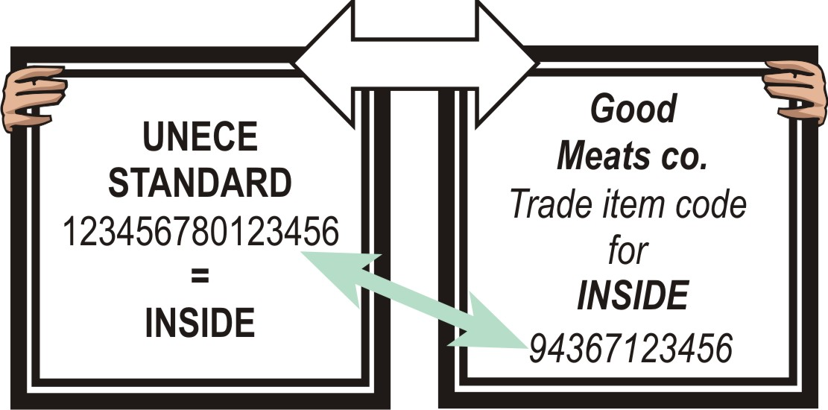
(3) Suppliers deliver the order to the customers. The goods are marked with the GS1-128 bar code symbol. | 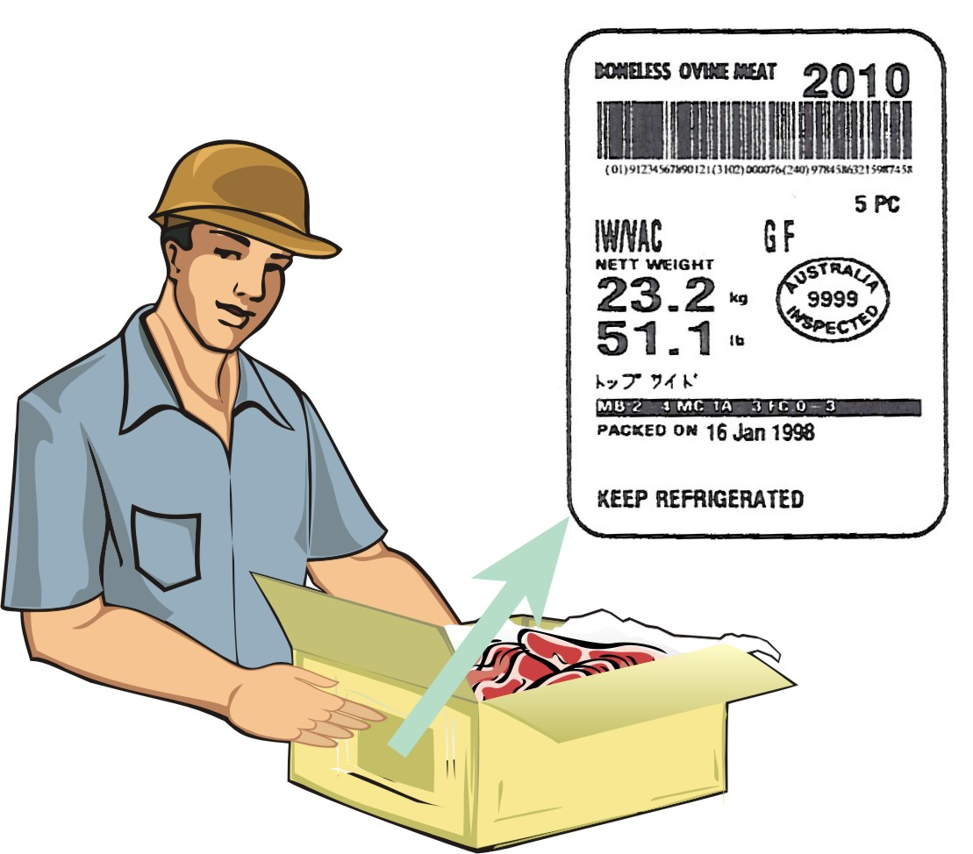
(4) Customers receive the order and the GS1-128 bar code symbol scanned, thus allowing for the automatic update of commercial, logistics and administrative processes. | 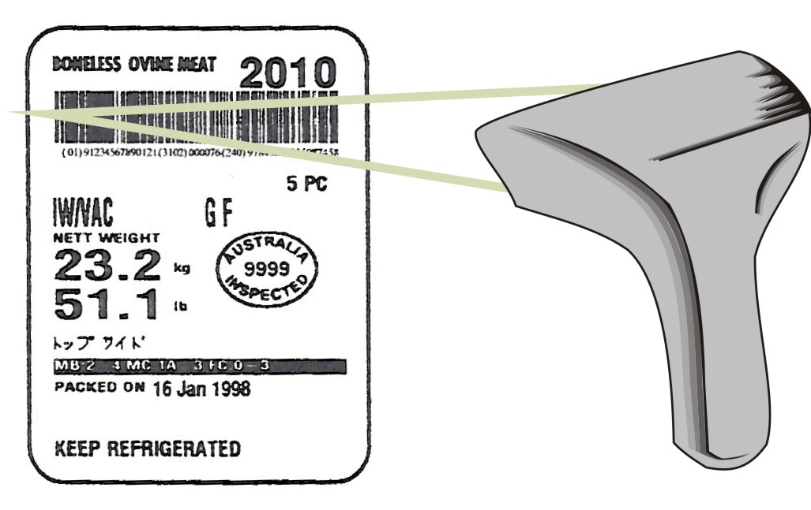
(5) The physical flow of goods, marked with GS1 standards, may be linked to the information flow using Electronic Data Interchange (EDI) messages.
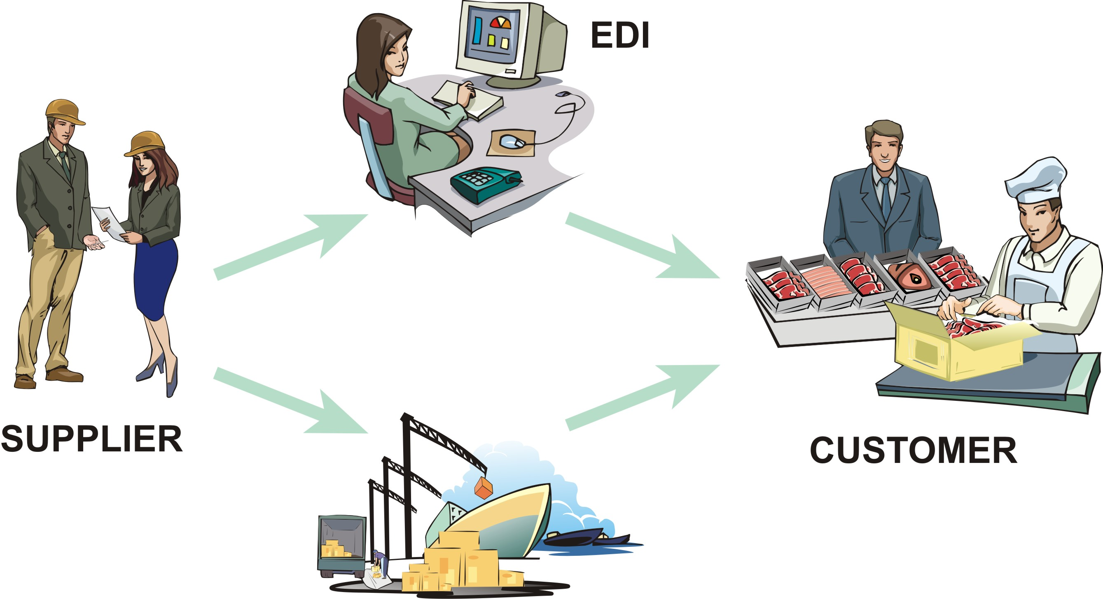

Example 3:

4. Use of UNECE meat-cut definitions in the GDSN

(1) Suppliers publish or update information about a product in the GDSN and use the appropriate UNECE meat-cut definition to define the meat cut of the product using the GDSN meat cut attribute.

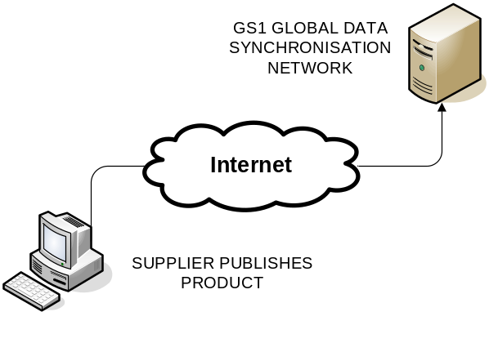

(2) Interested buyers use the UNECE meat cut and other product information published in the GDSN to synchronize product information in their own information systems.

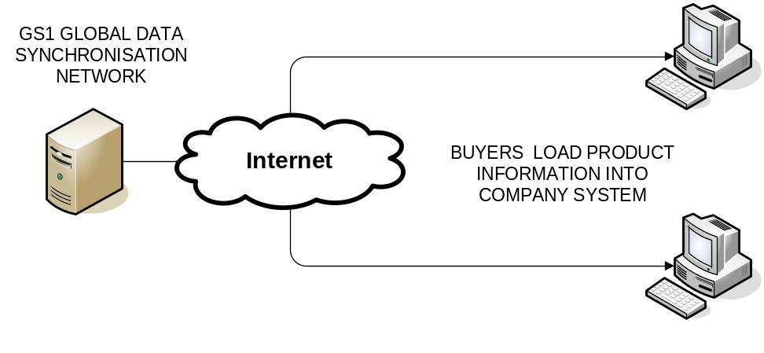
(3) Buyers use UNECE meat-cut information in their information systems to identify by GTIN which products they wish to order.

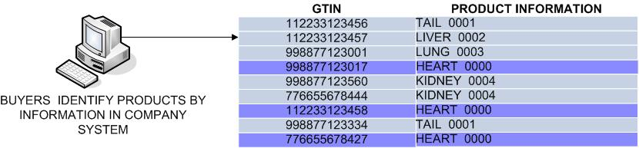

(4) Buyers use product GTIN and related information to order product from supplier using EDI or GDSN-compatible data pool service providers.

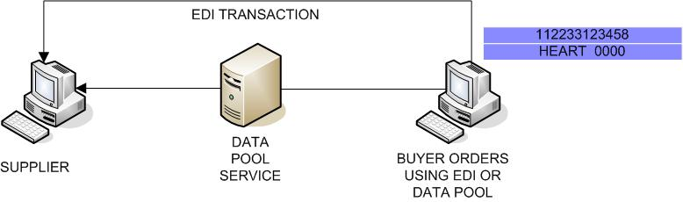

Annex II

Addresses
(English only)

United Nations  Economic Commission for Europe  Agricultural Standards Unit  Palais des Nations  CH – 1211 Geneva 10  SWITZERLAND  Tel: +41 22 917 1366  Fax: +41 22 917 0629  e-mail: agristandards@unece.org  http://www.unece.org/trade/agr/ |  | GS1 International  Blue Tower  Avenue Louise, 326  BE 1050 Brussels  BELGIUM  Tel: +32 2 788 7800  Fax: +32 2 788 7899  http://www.gs1.org/contact/
AUS-MEAT Ltd  Unit 1 / 333 Queensport Road North  Murarrie  Queensland 4172  AUSTRALIA  Tel: +61 7 33 61 92 00  Fax: +61 7 33 61 92 22  e-mail: ausmeat@ausmeat.com.au  http://www.ausmeat.com.au/ |  | Poland  Ministry of Agriculture and Rural Development  30 Wspolna St.  00-930 Warsaw  Poland  Tel: +48 22-623 2061  Fax : +48 22-623 2300  e-mail : integracja@ijhar-s.gov.pl
France  Direction générale de la consommation, de la concurrence et de la répression des fraudes  Cité Administrative,  Bd de la Liberté - CS92104  Rennes Cédex 9  CP 35021  FRANCE  Tel: +33 2 99 29 76 00  Fax: +33 2 99 29 80 05  e-mail: alain.boismartel@dgccrf.finances.gouv.fr |  | United States Department of Agriculture (USDA)  Agricultural Marketing Service  Livestock and Seed Program  1400 Independence Ave., S.W.  Washington D.C. 20250 0249  UNITED STATES  Tel: +1 202 720 5705  Fax: +1 202 720 3499  e-mail: craig.morris@usda.gov  http://www.ams.usda.gov/

(*) The present document has been submitted after the official documentation deadline by the Trade and Timber Division due to resource constraints.
When specified by the purchaser, edible co/products will be subject to metal particle detection.
Freezer-burn is localized or widespread areas of irreversible surface dehydration indicated, in part or all, by changes from original colour (usually paler) and/or tactile properties (dry, spongy).
Durability information is processing date either a use-by date or a best-before date as required by each importing country.

