Economic Commission for Europe
Committee on Trade
Working Party on Agricultural Quality Standards

Specialized Section on Standardization of Seed Potatoes

Meeting of the Extended Bureau

Melbourne, Australia, 1 - 4 April 2014

DRAFT

UNECE Guide on Seed Potato Tuber Inspection Recommended Practices

1. Introduction
These Guidelines refer to the UNECE STANDARD S-1, concerning the marketing and commercial quality control of Seed Potatoes.
All seed potato lots to be certified under the UNECE Standard must be inspected before marketing.
Knowledge of the relevant requirements is essential for the inspector. National standards have precedence over UNECE standards; however, when a UNECE label is affixed the requirements of the UNECE Standard must have been met.
2. Scope of inspection
The inspector is to inspect for conformity with the relevant standards and/or UNECE Standard of seed potato tubers at the export-control stage.
Inspection for conformity with additional import requirements shall be provided for under phytosanitary authority and results shall be noted on a phytosanitary certificate.
All inspections are conducted when seed potatoes are in their final containers and are sealed or will be sealed immediately after inspection in the presence of the inspector. In addition, inspectors should see the seed potatoes being graded in order to obtain an impression of their quality and uniformity.
3. Bio-Security
Inspectors should undertake measures to avoid contamination from one farm to another. They should use clean knives. The client may want to furnish a knife to the inspector that does not leave the farm.
4. Sampling
A randomly collected sample of the seed potato tubers from the lot to be inspected should be gathered and set aside for tuber size, grade and quality inspection. The tubers need to be sufficiently clean to allow for a visual inspection, i.e. no caked dirt.
A tuber has two ends. The “heel-“, or “stolon-“or “stem-end” is where the stolon was attached. The opposite end is called the “apical”, “rose-“, distal- or “bud-end”.
During the inspection process some tubers of the sample may be cut to establish the presence or absence of internal defects. If tuber samples are to be assessed for internal defects and diseases, they should be cut along the longitudinal axis, drawn through the widest part of the tuber (i.e. from end to end), and examined. However, clipping of the stem end may reveal discolourations or oozing of the vascular ring, that otherwise may be missed.
Samples must be representative of the lot to allow for an accurate inspection and certification of the lot. Accessibility to the sample should not weigh on the importance of the sample. When accessibility is an issue the inspector may be forced to restrict the inspection. This may not be acceptable in an importing country.
4.1 Number of Samples
It is the inspector's responsibility to examine enough samples to ensure an accurate picture of the lot: generally 20 kg per 10,000 kg.
In the case of bulk loads, the entire load will be considered the sample unit. Then the sample unit consists of representative sub-samples (20 kg per 10,000 kg), which are randomly taken throughout the lot. The sub-samples are individually recorded, as taken, on the note sheet. The Application of Tolerances (see 16) does not apply to the individual sub-sample and the counts are averaged.
Potatoes in totes are treated the same as potatoes in bags, and are subject to the Application of Tolerances (see 16).
5. Note Sheet and Inspection Certificate
An inspector should note his findings and counts on a note sheet in a legible and accurate manner or store it by electronic means. All information on the inspection certificate should be supported by information on the note sheet. It is the responsibility of the inspector to ensure that all information is properly recorded. Notations will be recorded so that anyone familiar with inspection procedures can interpret them and write a certificate. Note sheets and certificates must withstand legal scrutiny.
5.1 Inspection Certificate
The inspection certificate should note:
- The Regulations with “UNECE Standard”, if appropriate
- Content: "Seed potatoes"
- The Designated Authority (DA) or its recognized initials
- Country and/or region of production
- Reference number of the lot, including where appropriate the producer's identification number
- Month and year of closing
- Variety
- Category and class and, where appropriate, record of field generation
- Sizes
- Declared net weight
5.2 Classifications
Classifications in the UNECE Standard are according to categories which are subdivided in classes. (See Appendix 1) The records of the seed lot are necessary for the inspector to allow affixing classification of the seed lot on the inspection certificate and labeling
6. Type and Number of Containers
Bags must be new; other containers may be reused provided that they are clean.
Containers shall be closed officially or under official control in such a manner that they cannot be opened without damaging the official sealing device or without leaving evidence of tampering on the official label.
Labels shall be sown in when closing the bag or containers shall be sealed.
Re-closing shall be carried out only by the DA or under its control.
The number of containers must be reported. The inspector verifies the container count provided by the client for each lot and report it as the "inspector's count." If the number of containers available for inspection does not match the application, it is the inspector's responsibility to confirm that the amount presented for inspection constitutes the lot. If an accurate count cannot be determined, the inspector may report the count based on someone else's authority. However, the reason for doing so must be reported on the note sheet. The client generally provides a manifest for count and it is acceptable to use this for the number of containers.
Each container shall contain tubers of the same variety, category, class, size and origin.
A lot should be sufficiently homogeneous which means that seed potatoes within different containers are as uniform as is practical and will not vary excessively in composition and appearance.
7. Official label
Each container shall bear on the outside an official label which has not been previously used; the label shall be “WHITE with a DIAGONAL PURPLE LINE” for Pre-basic seed, “WHITE” for Basic seed, and “BLUE” for certified seed. Reference to the UNECE Standard may be included on the label.
The Official Label will have:
- The relevant Standard and, if appropriate: “UNECE Standard”
- Nature of the contents: "Seed potatoes"
- The Designated Authority (DA) or its recognized initials
- Country and/or region of production
- Reference number of the lot, including where appropriate the producer's identification number
- Month and year of closing
- Variety
- Category and class and, where appropriate, record of field generation
- Size
- Declared net weight
The minimum dimensions are 110 x 67 mm.
7.1 Re-labelling
If a second check appears necessary, the authority, which carried out the second check, must be stated on the label, as well as the date of the re-closing. If a new label is necessary, this must show the particulars, which appeared on the old label, the date of the re-closing, and the authority concerned.
7.2 Supplier's label
Each container may be accompanied by a special label of the supplier
8. Official statement
Each container shall have on the inside an official statement of the same colour showing at least: the Designated Authority (DA) or its recognized initials; the reference number of the lot which includes the producer's identification number and the variety. The statement shall be so worded that any confusion with the official label shall be avoided.
This statement is not necessary when an adhesive label or a label of untearable material is used. The particulars given on the label may be indelibly printed on each container in substitution for the official statement provided for above.
9. Chemical treatment
The nature of the active substance of any chemical treatment of the seed potatoes shall be indicated on the outside of each container, on a tear resistant or adhesive label being either the official label or a label provided by the supplier, or printed on each container. This information may also appear inside each container.
10. Origin
It is the inspector's responsibility to verify the origin from the client or certification records.

11. Temperature of Product
Because the pulp temperature of seed potatoes is important the inspector should determine and report the temperature or range in temperatures on each lot.
12. Size.
The size requirements are in Chapter V of the Standard:
12.1.1 Pre-basic TC is exempt from the minimum sizing requirements.
12.1.2 The minimum size of tubers must be such that they do not pass through a square gauge of 25 mm; for varieties having, on average, a length of at least twice the greatest width, the square gauge must not be less than 25 mm. In the case of tubers, which are too large to pass through a square gauge of 35 mm, the difference between the maximum and minimum limits of size should be expressed in multiples of five.
12.1.3 The maximum variation in size between tubers in a lot must be such that the difference between the dimensions of the two square gauges used does not exceed 20 mm unless the buyer and seller agree to deviate from this requirement.
12.1.4 The lot shall conform to the distribution of tuber sizes of the harvested crop within the size specified on the label.
T1: Tolerances for sizing:

Minimum size tolerances in per cent by weight of tubers
10% | With a maximum deviation of 5 mm from the minimum size indicated for lots with tubers having a length of at least twice their maximum width
3% | For all other lots
Maximum size tolerances in per cent by weight of tubers
3% | Larger than the maximum size indicated

A tuber is within the maximum size when the inspector can drop the potato through the sizer when the longitudinal axis is at right angles to the sizer; however a tuber is considered above minimum size when the tuber is held by the sizer regardless of the position of the tuber.
The inspector should examine each sample to ensure the lot meets the size requirements. Sizing of tubers at maximum or minimum size is generally sufficient, unless tubers in the lot deviate from a standard size distribution.
Potatoes under the minimum or over the maximum diameter should be weighed to determine the percentage.
13. Faults as External Defects and Disorders
External defects and disorders can be detected externally.
However, cutting may be required to determine the extent of the injury.

T2. Reference table of tolerances that apply in the UNECE Standard:

Faults found as a percentage of the inspected sample.

 | PBTC | Pre-basic | Basic Class I | Basic Class II | Certified Class I | Certified Class II
Earth and extraneous matter | 1 | 1 | 2 | 2 | 2 | 2
Dry and wet rot | 0 | 0.2 | 1 | 1 | 1 | 1
External defects | 3 | 3 | 3 | 3 | 3 | 3
Shrivelled tubers | 0 | 0.5 | 1 | 1 | 1 | 1
Chilling injury | 0 | 0.2 | 1 | 1 | 1 | 1
Tuber moth damage | 0 | 4 (20)* | 4 (20)* | 4 (20)* | 4 (20)* | 4 (20)*
Scab (common and netted) | 0 | 5 (1/3)* | 5 (1/3)* | 5 (1/3)* | 5 (1/3)* | 5 (1/3)*
Powdery scab | 0 | 1 (10)* | 3 (10)* | 3 (10)* | 3 (10)* | 3 (10)*
Rhizoctonia | 0 | 1  (1)* | 5 (10)* | 5 (10)* | 5 (10)* | 5 (10)*
Total faults | 3 | 5 | 6 | 6 | 6 | 6

Seed potatoes shall be free from Globodera rostochiensis (Woll) and Globodera pallida (Stone), Synchytrium endobioticum (Schilb.) Perc., Clavibacter michiganensis Spp. sepedonicus (Spieck. and Kotth.) Skapt. and Burkh., Ralstonia solanacearum (E.F. Smith) E.F. Smith, Potato spindle tuber viroid, Tomato Stolbur, Meloidogyne chitwoodi and fallax, Ditylenchus destructor and Phthorimaea operculella (Zeller).
13.1 List of Faults as External Defects and Disorders
13.1.1 Air Cracks are longitudinal cracks, often fresh and without apparent connection with mechanical injury. They usually occur during the harvesting and bagging process, although some may occur after bagging if the bags are handled roughly. They are not countable.
13.1.2 Bruises are common in potatoes. Mechanical Damage is counted under bruise or cut, when damage to the yielding capacity is evident. The discolouration varies but is generally brown, gray or black. The skin and flesh of the potato may be broken or torn or may simply show discolouration. The size and shape of a bruise may vary considerably. The tolerance for external defects in this case, “damaged tubers,” is for all categories: 3 per cent by weight. An affected tuber is countable when injury is to be caused to its yielding capacity.
Bruises are quality defects. Fresh or recent bruises may be pink or vary from a bright shiny gray to jet black, but they do not show dry or dry starchy flesh.
Old bruises may vary from dull gray to light brown and show dry or starchy in the tuber flesh. There may be a separation or some corkiness of the flesh.
A deposit of powdery, discoloured starch will frequently be noticed in bruises or cuts. Inspectors should be careful not to confuse this starch deposit with Fusarium Rot.
The difference can be readily noted upon cutting the potato. If the flesh next to the deposit is affected, the condition has been caused by some decay. If the flesh is sound, it should be considered only as a bruise. All categories: 3 per cent by weight.
13.1.3 Cleanness: Fairly clean. The tubers need to be sufficiently clean to allow for a visual inspection, i.e. no caked dirt. Adhering dirt, staining from soft rot or other foreign matter must be considered in determining whether or not the potatoes meet the cleanness requirements of the Standard.
13.1.4 Chilling injury causes the tuber flesh to become reddish brown to black. Symptoms on the tuber surface are a dark brown sometimes sunken patch. Symptoms may be internal. All affected tubers are countable. The tolerance is for Pre-basic TC: 0 per cent by weight and for other categories: 2 per cent by weight
13.1.5 Cuts and Knobs Removed are countable when the damage is considered injurious i.e. the producing quality of the tuber is in question. The tolerance for total external defects (e.g. misshapen or damaged tubers) is in all categories: 3 per cent by weight.
13.1.6 Earth, Clods, Rocks and Extraneous Matter have the following tolerances for Pre-basic TC and Pre-basic: 1 per cent by weight; basic and certified: 2 per cent by weight.
Loose dirt over 400g in a 20kg sample is over tolerance for Basic and Certified.
13.1.7 Elephant Hide may be caused by environmental and physiological factors. The symptoms are roughened scaling of the skin unlike scab infections. The skin often appears darker and thicker than normal with deep checking, cracking or scaling. Affected tubers are not countable, but it may be noted when requested.
13.1.8 Enlarged Lenticels may be due to excessive moisture and are not countable unless accompanied by rot deterioration of underlying tissue
13.1.9 Flattened or Depressed Areas may generally be found after several months of storage. They are most often the result of dehydration at pressure points. They exhibit a rubbery feel and a slight wrinkling or a soft elasticity of the skin over the flattened area. They are not countable unless the underlying tissue is deteriorated to a level that it affects the yielding capacity of the seed potato.
13.1.10 Flea Beetle is a small insect that causes an injury by feeding on or near the surface of the tuber. The results are a brown splinter-like pegs extending 3 to 6 mm into the potato. There are countries with a zero tolerance for this type of injury
13.1.11 Folded End describes an end of the tuber that folds inward on potatoes and are not countable, because they are not expected to have an influence on the yielding capacity of the seed potatoes.
13.1.12 Freezing Injury means that the potato is frozen or shows evidence of having been frozen. A potato is frozen when the presence of ice crystals are seen at the time of inspection. Symptoms vary greatly. Tissue at the stem end of the tuber is more sensitive to freezing than those at the bud end. Cells around the vascular ring are more susceptible to freezing than other cells in the potato. Potatoes injured by freezing may be firm but show internal discolouration near the stem end. Potatoes that were frozen will become soft and watery upon thawing (wet breakdown) or in dry air they become dry, leathery, and granular with chalky white masses of starch. Often there is a clear line of demarcation between affected flesh and healthy flesh. Field freezing will generally manifest first on areas that are sunburned (exposed to the elements) and develop bluish-gray blotches beneath the skin along with soft, flabby, watery areas.
All tubers that are frozen or showing freezing injury are countable and the tolerances are as for “wet breakdown due to extreme temperatures applies” i.e. for Pre-basic TC: 0 per cent by weight, for Pre-basic: 0.2 per cent by weight and for Basic and Certified: 0.5 per cent by weight.
13.1.13 Grass Root Symptoms e.g. quack, nut and wire grass may have roots growing into and even through potatoes. Grass damage is not countable.
13.1.14 Greening caused by exposure of the tube to light is not countable for seed potatoes because there is no injurious effect to the quality of the seed potato.
13.1.15 Growth Cracks usually follow the long axis of the potato and are a result of internal pressure exceeding the tensile strength of surface tissues during tuber enlargement. It is only countable when there is an expectation that there is an effect on the yielding capacity of the seed potato.
13.1.16 Grub Damage is an insect injury affecting potatoes. Grubs eat away at the skin and flesh of the potatoes leaving holes, usually of considerable size. They may be countable as “misshapen and damaged” tubers when there is damage to the yielding capacity.
13.1.17 Root Knot Nematodes may produce galls on the tuber surface, depending on the cultivar. Tuber galls appear as small raised lumps above the developing nematodes giving the skin a rough appearance. Galls may be grouped in a single area or scattered near the eyes. When infested tubers are cut and small brown spots may be seen within the tuber cortex. Each spot represents a mature female surrounded by a mass of brown eggs.
There is a zero tolerance for this symptom in the Standard. Infestation may sometimes show no external symptoms. However, the tolerance is zero for internal symptoms.
13.1.18 Pink Eye symptoms are pinkish blotches near the eyes and mostly around the rose end of the tubers due to the pink underlying tissue. The internal tissue is firm to corky with pink to reddish-brown colour. Black areas and cavities may also occur. The discoloured tissues around the eyes may turn light brown, become wrinkled and cracked. Pink eye may be confused with late blight, but it does not have the brick-red granular tissue that is characteristic of blight. It is a physiological defect that may give access to secondary disease organisms. Tubers with deteriorated tissue underneath the pink eye are countable.
13.1.19 Potato Spindle Tuber Viroid (PSTVd). Tubers may be more elongated than normal or they may be typically spindle shaped and covered with a remarkably large number of eyes. The tissue around the eyes is slightly prominently swollen and looks like heavy ‘eyebrows’. In serious cases the tubers may be deformed showing deep growth cracks. The UNECE Standard has a zero tolerance for PSTVd.
13.1.20 Rhizoctonia (Black Scurf) Tuber-blemish is caused by dark brown or black sclerotia forming on tuber surface; coverage may be difficult to assess accurately on unwashed dirty tubers. Growth cracking accompanied with star like elephant hide netting and trumpet shaped holes can be a symptom of Rhizoctonia. It is countable when >10% of the surface is covered, or with Pre basic, when >1% is covered. (See appendix, 3)
13.1.21 Rodents make cavities that bear teeth marks in the form of corrugations or ridges. Bird damage shows as identified pit-like markings lining the cavity. It is not countable.
13.1.22 Root Rot Nematodes (Potato Rot Nematode) initial symptoms are grey to white mealy spots beneath the tuber surface (visible if cut or peeled). The symptoms progress towards the vascular tissue and the affected spots coalesce and darken and the skin becomes papery and cracked. Affected tubers are susceptible to secondary infection by opportunistic fungal or bacterial pathogens. The UNECE Standard has a zero tolerance for confirmed symptoms.
13.1.23 Scab: See Appendix 2 for countable tubers.
13.1.23.1 Common scab ranges from superficial, corky lesions to extensive raised scabs occurring either singly or in groups. In netted form as a superficial corky russeting of the skin. Tubers affected over a specified per cent of their surface (see appendix 2) are countable. The tolerances are for Pre-basic TC (0% surface cover): 0 per cent by weight and for all other categories (>33.3% surface cover) 5 per cent by weight
13.1.23.2 Rough Raised Netting affects the skin of potatoes; it may be fine, raised and/or rough. However, netting is only countable when it shows the symptoms of netted scab and is rough and raised. The tolerance for netted scab is part of the total tolerance for scab: Tubers affected over a specified per cent of their surface (see annex VIII of the Standard) is for: Pre-basic TC (0% surface cover): 0 per cent by weight and for all other categories (>33.3% surface cover): 5 per cent by weight
13.1.23.3 Russet Scab is a roughening, scurfing, or cracking of the tuber skin, sometimes occurring in localized areas or sometimes over most of the tuber surface. The affected tissues vary from light tan to brown in colour, and may consist of a superficial cork-like layer or have a cushion-like appearance.
13.1.23.4 Powdery scab’s symptoms are round individual raised scabs present on tubers at harvest, lesions erupt exposing brown powdery tissue (sporeballs) leaving tattered fragments of skin along edge of lesion.
Infection at time of eye development can result in outgrowths (cankers: lower picture) of varying sizes developing at rose end of tubers. Root galls can also form on stolons. Tubers affected over a specified per cent of their surface (see annex VIII) are countable. Tolerances are for Pre-basic TC (0% surface cover): 0 per cent by weight, for Pre-basic (> 10% surface cover): 1 per cent by weight and for Basic and Certified (> 10% surface cover): 3 per cent by weight.
Different types of scabs may be difficult to distinguish from one another. When no definite determination can be made as to the type of scab, or a combination of scabs are present, the inspector will identify the defect as "scab" and count it as such. When the type of scab can be identified, please see appendix 2 (Annexe VIII of the UNECE Standard).
13.1.24 Shrivelled tubers are countable when they have become excessively dehydrated and wrinkled, including dehydration caused by silver scurf. The tolerances are for Pre-basic TC: 0 per cent by weight, for Pre-basic: 0.5 per cent by weight and for Basic and Certified: 1 per cent by weight.
13.1.25 Silver Scurf is a tuber skin blemish disease which starts as small, round, silvery patches on the skin. In humid conditions, dark sooty conidiophores can develop around the edge of lesions. Large silvery patches develop as individual lesions expand and merge during storage. Tubers can become dehydrated leading to shrivelling. Symptoms are not countable unless the tubers are shrivelled.
13.1.26 Sprouts. Tubers with sprouts are not countable unless they have led to shriveled tubers.
13.1.27 Tuber moth. At harvest affected tubers may show little visible evidence of infestation but be harbouring eggs or young larvae. As the larvae feed on the tubers damage becomes extensive with galleries just under the skin or deep into the tuber. Affected tubers may lose excessive moisture through the wounds becoming shriveled. Secondary infection by fungal pathogens can also lead to tuber rotting.
Countable tubers are affected by galleries covering more than 20 % of the cut surface, the tolerances are for Pre-basic TC: 0 per cent by weight and for all other categories: 4 per cent by weight. However there is a zero tolerance for live insects and larvae.
13.1.28 Tuber Necrosis (e.g PVYNTN, TRV, or PMTV) is seen in some varieties. It may be caused by some strains of PVY, when symptoms are favoured by high temperatures. The tuber symptoms progress in store from a smooth pink to a reddish-brown necrotic ring or arc on the tuber surface. Then they become raised and finally they become an unsightly sunken crater which may turn a darker brown. The lesions remain superficial and there are no necrotic arcs within the tuber flesh which distinguishes this disease from spraing caused by PMTV or TRV, which is brown, corky arcs and spots in the tuber flesh, sometimes visible on the skin surface.
Variety variation makes differentiation on visual symptoms problematic. Other tuber symptoms include growth cracking and elephant hide.
13.1.29 Wart Disease Symptoms are a cauliflower-like growths on the tuber that were cream and generally have become black when the crop died. The UNECE Standard has a zero tolerance.
13.1.30 Wireworm larvae bore small shallow holes or deeper tunnels into the tuber. Tunnels are always narrow (unlike slug damage) but can be extensive. Wireworm damage provides an entry point for other pathogens which may lead to tuber rots. When the hole is recently made, it may appear as a small dirty hole, however when it has been made early in the growing season the hole may be lined with new skin growth.
14. Faults by Internal Defects and Disorders
Internal Defects are defined by the fact that there is no apparent damage to the surface area of the potato unless the inspector cuts the tuber. Discolouration in the vascular tissue is considered internal.
Sampling to determine the presence of internal defects accurately requires the inspector to use good judgment. The inspector may cut a certain predetermined number of tubers or additional numbers when a problem has been discovered.
All cut samples should be recorded with the number of potatoes cut to determine the percentage of internal defects.
Symptoms of internal defects are not countable unless it is determined that they are caused by a transmittable disease or are injurious to the yielding capacity of the seed.
14.1 Faults by Internal Defects and Disorders
14.1.1 Blackheart generally may occur when the potatoes are exposed to high temperatures with an insufficient air supply. The internal symptoms are a dark gray to purplish discolouration which later becomes jet black. The discoloured areas are usually sharply set off from the healthy tissues. Generally the discolouration is restricted to the heart of the potato, but frequently radiates to the exterior as well. There is no tolerance for black heart.
14.1.2 Chilling injury causes the tuber flesh to become reddish brown to black. Symptoms on the tuber surface appear as a dark brown sometimes sunken patch. Symptoms may be internal. It should be noted by the inspector, as it may have an influence on the yielding capacity of the affected seed potatoes.
14.1.3 Heat or Drought Necrosis causes gray or yellow or brown discolouration in the vascular system and may occur at either the stem end or the bud end. It also is in the tissues between the vascular ring and the tuber surface. Discoloured tissue near the surface makes the skin appear dark, but generally there are no external symptoms.
14.1.4 Hollow Heart or Hollow Heart with Discolouration is a condition brought about by too rapid or irregular growth. The precursor may be a light brown discolouration. Hollow heart exists of cavities of varying size. They may be lined with light brown to brown dead tissues. No tubers are countable, there is no tolerance.
14.1.5 Internal Potato Necrosis (not net necrosis) is caused by alfalfa mosaic virus. The tissue under the skin has a rusty-brown colour in patches starting at the stem-end similar to late blight infections. The discoloured areas may later extend throughout the potato. Potatoes apparently clean at harvest may show discolouration after six weeks storage without a definite pattern of internal discolouration. It may be dry, brown blotches in pockets but also in loops and half circles. In suspected lots of potatoes a true estimate of potato necrosis damage can be obtained only by cutting. It has no tolerance and is not countable.
14.1.6 Net Necrosis is the presence of a network of necrotic strands brown to brownish-black in colour and sometimes extending throughout the flesh of the potato. It may be caused by the Leaf Roll virus, in which case it should be noted.
14.1.7 Stem End Browning exists of dark brown to black streaks or areas that can be detected by cutting off the stem end. It may have a chemical cause but it also may be the beginning of net necrosis.
14.1.8 Vascular Discolouration shows a clearly discoloured vascular ring mostly at the stem end and it is generally caused by wilt. There is no tolerance and the tubers are not countable.
15. Dry Rot, Wet Rot and Wet Breakdown
Rot is the disintegration of tissue as a result of the action of invading organisms, usually bacteria or fungi. Rot can be triggered by environmental factors. A tuber rot may be classified as either “wet” rot (also called “soft” rot) or “dry” rot according to its external and internal appearance.
The diseases causing these types of rots are listed in the “List of Diseases and Disorders Causing Rot Symptoms” (15.3.1)
15.1 Wet rot: tuber softening to maceration, associated with a fluid exudate, which has arisen due to a primary or secondary bacterial and/or fungal infection. All affected tubers are countable. The tolerances for wet rot (not caused by pests listed under section B in appendix 1), including wet breakdown due to extreme temperatures are for Pre-basic TC: 0 per cent by weight, for Pre-basic: 0.2 per cent by weight and for Basic and Certified: 0.5 per cent by weight.
15.2 Dry rot: tuber tissue exhibiting a sunken, necrotic lesion without the loss of fluid exudates, which may remain localized or enlarge by becoming wrinkled and mummified to encompass the whole tuber. The tolerances for dry rot not caused by pests listed under section B (appendix 1), are for Pre-basic TC: 0 per cent by weight, for Pre-basic: 0.2 per cent by weight and for Basic and Certified: 1 per cent by weight. All affected tubers are countable.
15.3 List of Diseases and Disorders Causing Rot Symptoms
15.3.1 Alternaria Tuber Rot (Early Blight) is a dry rot. It shows lesions of irregular size and shape and brown to purplish-brown, slightly sunken with irregular borders. Alternaria tuber rot occurs in potatoes harvested during cool humid weather. The infection opens the way for secondary infections by species of Fusarium and other organisms.
15.3.2 Bacterial Ring Rot may be in potatoes that appear healthy or have dark discolourations under the skin at the stem end or under the eyes. The tubers may show a characteristic cracking not deeper than the vascular ring. The vascular ring and surrounding tissue may be pale yellow or glassy becoming darker. The rot is odourless and cheesy or crumbly. Rotting may later extend into the central pith. Upon cutting the potato near the stem end the vascular ring may show a yellowish-white or light brown discolouration. This may involve the entire ring or only isolated portions of it. The infected tissue is often crumbly in consistency and may ooze from the freshly cut surface if the potato is squeezed. Infected potatoes may be apparently healthy at digging time and develop symptoms in storage.
Bacterial ring rot potatoes are very susceptible to secondary infection, especially by soft rot organisms. Affected tubers show various stages of decay up to complete disintegration. With secondary infection, there is often a distinctive separation between the portions of the potato inside and outside of the vascular region; the outer layer can be broken off like a shell. There is a zero tolerance for bacterial ring rot.
15.3.3 Blackleg Tuber Rot is a wet rot of soft brownish white rot extending from the heel end or lenticels. Affected area has by a dark margin. It produces a distinctive fishy smell. Decayed potatoes may be white or only slightly coloured and cheesy or buttery in consistency but gradually turn black and slimy as the decomposition progresses. In storage it is typical for blackleg to be confined to the center of the potato, which becomes hollowed and black with a layer of slimy lining. The tolerance are as for wet rot: for Pre-basic TC: 0 per cent by weight, for Pre-basic: 0.2 per cent by weight and for Basic and Certified: 0.5 per cent by weight. .
15.3.4 Brown Rot is a wet rot, initially a brown staining of the vascular ring starting at the stolon end. The disease is sometimes indicated by sunken spots at the stem, or by gray coloured spots on the surface. As the disease progresses the vascular tissue rots away completely and pale coloured sticky ooze may appear at the eyes lenticels and/or stolon end of the tuber to which soil may adhere.
Frequently there are no external indications. The presence of the defect may be determined only by cutting the potatoes. In the more advanced stages, this disease is termed brown rot. In this stage, it is frequently followed by slimy soft rot. There is a zero tolerance for brown rot.
15.3.5 Fusarium Tuber Rot is usually dry at low temperatures and wet at high temperatures. It is never slimy even when wet and never has a bad odor unless accompanied by other fungi or bacteria. The applicable tolerances are for dry or wet rot depending on the moisture in the decayed area.
There are several different species of Fusarium with slightly different symptoms: generally dry rots develop around an initial wound dehydrating the tuber
F. solani var. coeruleum: Circular rot with concentric wrinkles and white, orange or blue mycelial growth on surface. Light brown rot with a diffuse edge develops from skin inwards.
F. sulphureum: Small lesions develop at wounds and expand producing symptoms externally similar to gangrene, i.e. slightly depressed and irregular shape. Internally lesions develop cavities filled with grey powdery tissue.
F. avenaceum: Symptoms tend to be similar to F.solani var. coeruleum although rots are often smaller and affected tissue is dark brown.
Do not confuse infections of multi-coloured starchy molds with Fusarium tuber rot. These starchy molds, commonly misidentified as Fusarium, often appear either alone or in conjunction with Fusarium as they also enter the potato through injuries, cuts and bruises. The rot may be dry and brittle, wet and jelly-like or even mushy and leaky.
If the entire decayed area is so dry that no moisture appears when squeezed, or is only slightly moist it should be reported as "dry rot."
15.3.6 Jelly End Rot is identified by its jelly like, watery consistency occurring at the stem end of the potato, second growth knobs or pointed ends. This disorder is caused by conditions that interfere with the deposition of starch in the growing tissues. There is some evidence that fluctuations in moisture supply during the growing season may be responsible.
Jelly end rot often dries leaving a shriveled flaky area. In the mushy, leaky stage the tolerances for wet breakdown apply for Pre-basic TC: 0 per cent by weight, for Pre-basic: 0.2 per cent by weight and for Basic and Certified: 0.5 per cent by weight. Otherwise these potatoes are countable as misshapen with a tolerance for External defects (e.g. misshapen or damaged tubers) in all categories of 3 per cent by weight
15.3.7 Late Blight Tuber Rot. A tuber infection will show as a darker brown sometimes purplish area on the tuber surface. The internal rot is a reddish brown granular rot which can remain close to the surface or progress to the centre of the tuber. Rot development is irregular without a distinct leading edge and can be threadlike.
Affected tubers often have firm flesh with brown areas but secondary infection can lead to wet breakdown of the tubers. Depending on the stage of decay the tolerances for wet or dry rot apply.
15.3.8 Leak tuber rots develop at wounds soon after harvest when growing conditions are hot. Tubers are discoloured with a greasy feel. Rots develop in flesh of tuber with a clear dark line separating healthy outer tissue from spongy, soft brown diseased tissue which turns dark on exposure to air.
Rotten tissue initially smells alcoholic but once advanced smells fishy. The tolerances are as for wet rot.
15.3.9 Pink Rot may develop in the tubers at lenticels and eyes soon after harvest when conditions have been wet and warm just before harvest. Tubers are rubbery, usually affected at the heel end. Affected tissue turns pink on exposure to air within an hour. Tubers can have a distinctive sweet smell and ooze a colourless clear liquid if squeezed hard. Tolerances are as for wet rot.
15.3.10 Sclerotium Rot: Internally the rot is pale brown with fluffy white mycelia and black sclerotia developing in cavities. Sometimes tubers may have a heel end rot. Tolerances are for rot depending on the stage of the decay.
15.3.12 Wet Breakdown. Upon thawing, potatoes exhibit a wet leaking condition known as wet breakdown. All affected tubers are countable and the tolerances are the same as for wet rot i.e. wet breakdown due to extreme temperatures for Pre-basic TC: 0 per cent by weight, for Pre-basic: 0.2 per cent by weight and for Basic and Certified: 0.5 per cent by weight.
16. Application of Tolerances
Individual samples shall not have more than double the tolerances specified. The only exception is that at least one defective and one off-size potato may be permitted in any sample, provided that the averages for the entire lot are within the tolerances specified for the grade.
17. Combination of Internal and External Defects
Potatoes may exhibit a combination of internal and external defects.
18. Calculation of results
During the inspection process a tuber should only be counted once for a defect or damage. Calculate total counts and percentages for each disease, defect, or condition and compare with the tuber standard tolerance to determine if the lot meets the tuber standard.
An inspector may find two defects in one tuber: e.g. cutting (a limited number of tubers or entire sample) shows an internal defect in a potato with an external defect. When either defect would be countable by itself, the countable potato will be counted against the defect with the lowest tolerance; i.e. the most severe defect. E.g. wet rot will always be considered as the more severe defect.
19. Additional measures
If the sample exceeds the tolerance for any of the categories, an inspector may proceed to either increase the sample size and/or re-grade the lot as required to make sure it complies with the specified standard.
20. Second opinion inspections
In the case of a disputed inspection, growers will be entitled to ask for a confirmatory inspection to be conducted by another inspector.

References:
  - UNECE STANDARD S-1, concerning the marketing and commercial quality control of Seed Potatoes. 2013 Edition.
  - Guide for Seed Potato Inspectors under the UNECE STANDARD S-1
  - Shipping Point and Market Inspection Instructions (USDA April 2012)
  - UNECE Survey Tuber Inspection Procedures in Scotland, Germany, Netherlands and USA.

Appendix 1: Tolerances in the UNECE Standard
Annex III (A & B)
Minimum quality conditions for lots of seed potatoes
A. Tolerances for defects and disorders allowed for seed potato tubers
1. Presence of earth and extraneous matter
Pre-basic TC and Pre-basic 1 per cent by weight
Basic and Certified 2 per cent by weight
2. Dry and wet rot not caused by pests listed under section B below, including wet breakdown due to extreme temperatures
Pre-basic TC 0 per cent by weight
Pre-basic 0.2 per cent by weight
Basic and Certified l per cent by weight, of which wet rot cannot exceed 0.5 per cent
3. External defects (e.g. misshapen or damaged tubers)
All categories 3 per cent by weight
4. Scab caused by Streptomyces spp. (common and netted): Tubers affected over a specified per cent of their surface (see annex VIII)
Pre-basic TC (0% surface cover) 0 per cent by weight
All other categories (>33.3% surface cover) 5 per cent by weight
5. Powdery scab: Tubers affected over a specified per cent of their surface (see annex VIII)
Pre-basic TC (0% surface cover) 0 per cent by weight
Pre-basic (> 10% surface cover) 1 per cent by weight
Basic and Certified (> 10% surface cover) 3 per cent by weight
6. Rhizoctonia: Tubers affected over a specified per cent of their surface (see annex VIII)
Pre-basic TC (0% surface cover) 0 per cent by weight
Pre-basic (> 1% surface cover) 1 per cent by weight
Basic and Certified (> 10% surface cover) 5 per cent by weight
7. Shrivelled tubers: Tubers which have become excessively dehydrated and wrinkled, including dehydration caused by silver scurf
Pre-basic TC 0 per cent by weight
pre-basic 0.5 per cent by weight
Basic and Certified 1 per cent by weight
8. Chilling injury
Pre-basic TC 0 per cent by weight
Other categories 2 per cent by weight
9. Tuber moth: Tubers affected by galleries covering more than 20 % of the cut surface
Pre-basic TC 0 per cent by weight
Other categories 4 per cent by weight
10. Total tolerance for items 2 to 7:
Pre-basic TC 3 per cent by weight
Pre-basic 5 per cent by weight
Basic and Certified 6 per cent by weight
B. Zero tolerances
The seed potatoes shall be free from Globodera rostochiensis (Woll) and Globodera pallida (Stone), Synchytrium endobioticum (Schilb.) Perc., Clavibacter michiganensis Spp. sepedonicus (Spieck. and Kotth.) Skapt. and Burkh., Ralstonia solanacearum (E.F. Smith) E.F. Smith, Potato spindle tuber viroid, Tomato Stolbur, Meloidogyne chitwoodi and fallax, Ditylenchus destructor and Phthorimaea operculella (Zeller).

Appendix 2: UNECE Standard Annex VIII
Assessment key for percentage tuber surface area coverage of blemish diseases
Common Scab (estimated 33.3%) |  | Netted Scab (estimated 33.3%)
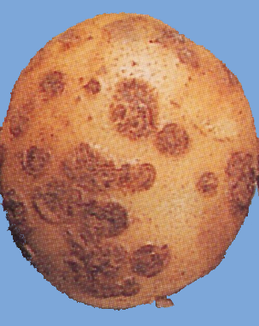 |  | 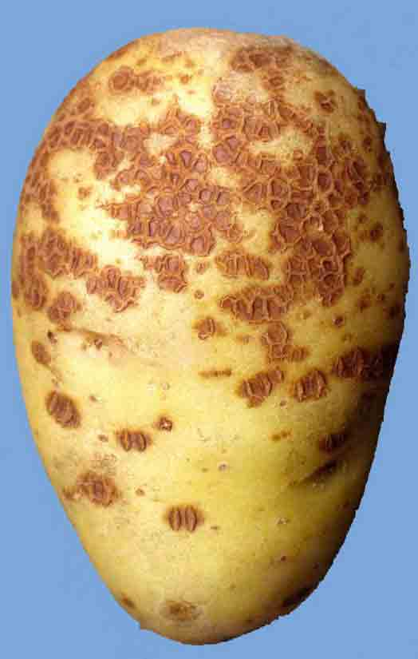

Powdery scab (estimated 10%)

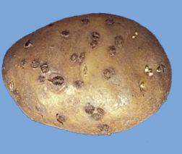

Appendix 3: Countable tubers for Rhizoctonia

1% surface area coverage
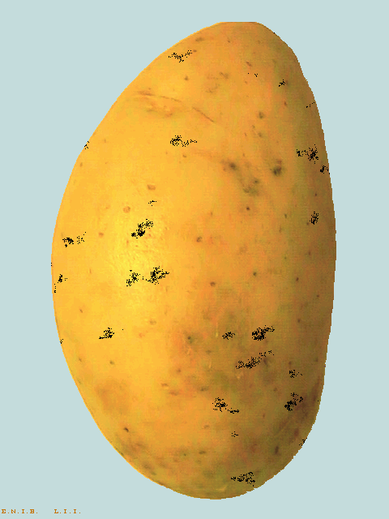 | 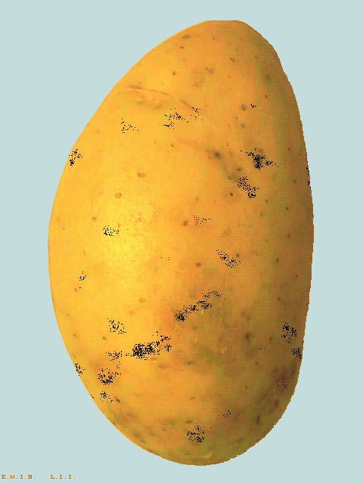
Homogeneous | Concentrated

10% surface area coverage
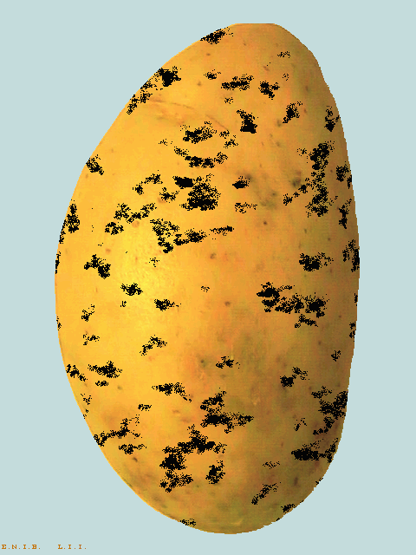 | 