GE.6/BUR/2013/6

This document contains proposals by the delegation of New Zealand on how to improve the IPPC-related text in the Standard, as well as the results of their discussion at the Extended Bureau meeting in Fargo in October 2013.

UNECE STANDARD S-1
concerning the marketing and
commercial quality control of

SEED POTATOES

2013 EDITION



UNITED NATIONS
New York and Geneva, 2013
NOTE

Working Party on Agricultural Quality Standards

The commercial quality standards developed by the Working Party on Agricultural Quality Standards of the United Nations Economic Commission for Europe (UNECE) help facilitate international trade, encourage high-quality production, improve profitability and protect consumer interests. UNECE standards are used by governments, producers, traders, importers and exporters, and other international organizations. They cover a wide range of agricultural products, including fresh fruit and vegetables, dry and dried produce, seed potatoes, meat, cut flowers, eggs and egg products.

Any member of the United Nations can participate, on an equal footing, in the activities of the Working Party. For more information on agricultural standards, please visit our website <www.unece.org/trade/agr>.

The present revised Standard for Seed Potatoes is based on document ECE/TRADE/C/WP.7/2013/9, reviewed and adopted by the Working Party at its sixty-ninth session.

The designations employed and the presentation of the material in this publication do not imply the expression of any opinion whatsoever on the part of the United Nations Secretariat concerning the legal status of any country, territory, city or area or of its authorities, or concerning the delimitation of its frontiers or boundaries. Mention of company names or commercial products does not imply endorsement by the United Nations.

All material may be freely quoted or reprinted, but acknowledgement is requested.

Please contact the following address with any comments or enquiries:

Agricultural Standards Unit
Trade and Timber Division
United Nations Economic Commission for Europe
Palais des Nations
CH-1211 Geneva 10, Switzerland
E-mail: agristandards@unece.org

Contents
Page
Introduction 5-9
I. About ECE 5
II. History and goals of the Working Party on Agricultural Quality Standards 5
A. History 5
B. Goals 5
III. History, goals and scope of the UNECE standard for seed potatoes 6
A. History 6
B. Goals and scope 6
IV. Application of the Standard 6
V. Development of the Standard 7
VI. Cooperation with other international organizations 7
A. European Union 7
B. International Plant Protection Convention 8
1. European and Mediterranean Plant Protection Organization 8
2. North American Plant Protection Organization 8

UNECE Standard S-1 concerning the certification and commercial quality control of seed potatoes 9-13
I. Definition of produce 9
II. Provisions concerning the variety 9
III. Provisions concerning quality 9
A. Minimum requirements 10
B. Classification 10
1. Pre-basic category seed 10
2. Basic category seed 10
3. Certified category seed 10
4. Field generation 10
C. Derogation from classification 11
D. Sampling for lot inspection 11
E. Comparative trials 11
IV. Provisions concerning sizing 11
V. Provisions concerning tolerances for sizing 11
VI. Provisions concerning presentation 12
A. Conditions of containers 12
B. Closing of containers 12
C. Nature of contents of containers 12
VII. Provisions concerning marking 12
A. Official label 12
B. Official statement 12
C. Re-labelling 13
D. Supplier’s label 13
E. Chemical treatment 13
Annexes
I. Minimum conditions to be satisfied in the production of Pre-basic TC seed potatoes 14
II. Minimum conditions to be satisfied by the crop; field inspection procedures 15
III. Minimum quality conditions for lots of seed potatoes 17
IV. Minimum conditions to be satisfied by direct progeny of seed potatoes;
post-harvest evaluation procedures 19
V. Label 21
VI. Guidelines for organizing comparative trials of plots grown from samples collected from lots of
seed potatoes (certified according to the Standard) 22
VII. Definitions of terms applicable to the Standard 23
VIII. Assessment key for percentage tuber surface area coverage of blemish diseases 28
IX. Sampling tubers for virus testing 30
X. International dispute settlement 37
XI. UNECE Standard for Seed Potatoes (Summary table of tolerances) 39
Introduction
I. About UNECE
The United Nations Economic Commission for Europe (UNECE) was set up in 1947 by the Economic and Social Council. It is one of five regional commissions of the United Nations.
Its primary goal is to encourage greater economic cooperation among its 56 member States. However, all interested United Nations Member States may participate in its work. Over 70 international professional organizations and other non-governmental organizations take part in UNECE activities.
It focuses on economic cooperation and integration, environment, housing and land management, statistics, sustainable energy, trade, timber and transport.
UNECE activities include policy analysis, development of conventions, regulations and standards, and technical assistance.
II. History and goals of the Working Party on Agricultural Quality Standards
A History
In October 1949, the UNECE Committee on Agricultural Problems established the Working Party on Standardization of Perishable Foodstuffs to determine common standards for perishable foodstuffs "and to study steps to be taken on the international level in order to secure the general adoption of standards and control systems". Later, the responsibility of the Working Party was extended to cover non-edible horticultural produce and quality development, which is reflected in its present name.
The activities have led to the elaboration of a wide range of UNECE standards for fresh fruit and vegetables, dry and dried produce, seed potatoes, eggs and egg products, meat and cut flowers. Standards for fruit juices and quick frozen foods have been elaborated in Joint ECE/Codex Alimentarius Groups of Experts and are now further developed in the relevant Codex bodies.
B. Goals
UNECE standards harmonize existing national commercial quality standards for perishable produce to:
- Facilitate fair international trade and prevent technical barriers to trade
- Improve producers' profitability and encourage production of high-quality produce
- Protect consumer interests.
The UNECE Working Party and its four Specialized Sections provide a forum where countries can discuss all issues relating to commercial quality that may arise in their domestic markets and have implications for international trade. The Working Party offers assistance to countries by organizing workshops on the harmonization of national with international commercial standards.
III. History, goals and scope of the UNECE standard for seed potatoes
A. History
Work on the UNECE Standard for Seed Potatoes (hereinafter “the Standard”) began in 1958.
At the 9th session of the Working Party some disagreements were raised concerning the nomenclature of the different categories of seed potatoes. The Group of Experts (from the Federal Republic of Germany, the Netherlands and the United Kingdom of Great Britain and Northern Ireland) was charged of preparing an analysis of existing national regulations and drafting recommendations for international standardization.
Provisional recommendations were adopted in 1960 at the 10th session of the Working Party for trial and revision according to the resulting experience.
The first version of the text was adopted by the Working Party in 1963 at its 16th session. The Standard has been regularly updated since then.
B. Goals and scope
The goal of the Standard is to act as a world reference intended to facilitate fair international trade by:
- Creating a harmonized commercial quality certification system
- Promoting its use
- Defining harmonized quality requirements for seed potatoes.
To reach this goal the Standard covers the following requirements controlled by certification:
- Varietal identity and purity
- Genealogy and traceability
- Diseases and pests affecting commercial quality
- External quality and physiology
- Sizing and labelling.
As a consequence, the Standard considers issues falling under the WTO-TBT agreement.

IV. Application of the Standard
The Standard adopted by the Working Party is recommended to countries for application as defined below.
Countries applying this Standard should notify the UNECE secretariat of their Designated Authority (DA) responsible for its implementation.
Application means the use of the UNECE Standard for export and import. This means for
Export: All seed potatoes certified and labelled for export by the DA meet at least the requirements of the Standard.
Import: Seed potatoes certified and labelled according to the UNECE Standard are accepted as meeting national standards or technical regulations for seed potato quality. Where a country establishes more stringent quality requirements these should be technically justified and the same requirements applied to domestic production. The DA shall notify the UNECE secretariat of each additional or more stringent quality requirement, together with technical or scientific justification for it.

The responsibility of the DA is to ensure the application of the provisions and conditions as specified in the Standard. The responsibility for the quality of the lot remains with the owner.

The application of the Standard is without prejudice of any other legislation concerning industrial or commercial property, protection of crops, and the health of persons and animals.
V. Development of the Standard
For the development of the Standard and the work of the Specialized Section on Seed Potatoes, the Terms of Reference and Working Procedures of the Working Party on Agricultural Quality Standards and its Specialized Sections apply and can be downloaded from the UNECE website. According to these procedures, “any member of the United Nations or of one of its specialized agencies can participate, on an equal footing, in the activities of WP.7 and its specialized sections”.
VI. Standards and regulations adopted by other international and regional organizations
A. European Union
In July 1966, the Council of the European Union adopted a Council Directive on the marketing of seed potatoes, applicable to the production with a view to marketing, and to the marketing of seed potatoes within the Community (Directive 2002/56/EC-OJ L 193, 20.07.2002 former 66/403/EEC).
It was stated in the proceedings that "It is desirable to establish a uniform certification scheme for the Community based on the experience gained in the application of schemes in the Member States and that of the Economic Commission for Europe".
The above Directive envisaged that provisions should be made for authorizing the marketing within the Community of seed potatoes harvested in a third country where they afford the same assurances as seed potatoes officially certified within the Community and complying with the Community rules. The last Council Decision (Council Decision 95/513/EC, 0J L 296, 9.12.1995, p. 31) on the equivalence of seed potatoes produced in third countries established that seed potatoes harvested in those countries, as specified and officially controlled by the relevant Authorities, and which belong to the categories specified therein, are equivalent to seed potatoes harvested within the Community. Seed potatoes shall be certified and their containers officially marked and sealed in accordance with the UNECE Standard for Seed Potatoes recommended by the Working Party on Standardization of Perishable Produce and Quality Development of the UNECE. The Decision does not affect the requirements which Member States establish under Council Directive 2000/29/EC (former 77/93/EEC) on protective measures against the introduction into the Member States of organisms harmful to plants or plant products (0J L 169, 10.7.2000, p.1).
B. International Plant Protection Convention
The purpose of the International Plant Protection Convention (IPPC) is to secure a common and effective action to prevent the spread and introduction of pests of plants and plant products, and to promote appropriate measures for their control. It is managed by the IPPC Secretariat in the FAO Plant Protection Service and is recognized by the WTO-SPS agreement as the standard-setting body on phytosanitary issues.
The International Standards for Phytosanitary Measures (ISPMs) established under the Convention provide, inter alia, guidelines for the establishment of phytosanitary import regulations and the provision of phytosanitary certification. Phytosanitary certificates, in the case of seed potatoes, facilitate international trade by confirming compliance with the phytosanitary requirements of the importing country.

ISPM No. 33 provides guidance for the production, maintenance and phytosanitary certification of pest free potato (Solanum spp.) micropropagative material and minitubers for international trade.

National Plant Protection Organizations (NPPOs) and Regional Plant Protection Organizations (RPPOs) such as the European and Mediterranean Plant Protection Organization (EPPO) (see B.1) and the North American Plant Protection Organization (NAPPO) (see B.2) work together to help contracting parties meet their IPPC obligations.

1. European and Mediterranean Plant Protection Organization
In 1999, EPPO published a recommended certification scheme for seed potatoes. This scheme focused on micropropagation as the recommended method of initial seed production (nuclear stock) and detailed the organisms, which should be tested for and the appropriate test procedures. Conditions and tolerances for the production of Pre-basic TC (mini-tubers) were also defined. The requirements for the certification of Pre-basic, Basic and Certified category seed potatoes were aligned, as far as possible, with those of the UNECE Standard for Seed Potatoes.
2. North American Plant Protection Organization
In 1995, NAPPO approved a potato standard: NAPPO Regional Standard for Phytosanitary Measures (RSPM#3), "Requirements for the importation of potatoes into a NAPPO member country”. It is regularly reviewed and is available at: http://www.nappo.org.
The standard identifies a number of pest risk management measures, including federal or state/ seed potato certification systems. Also, it established common criteria for limited generation certification systems and diagnostics. It includes lists of quarantine and regulated non-quarantine pests for the three NAPPO countries. The pest lists in the standard are reviewed on an annual basis to verify the technical justifications for these pests to remain on quarantine lists and to incorporate new terminology from the IPPC, e.g. regulated non-quarantine pests..

UNECE Standard S-1 concerning the certification and commercial quality control of seed potatoes
I. Definition of produce
Produce is seed potatoes. Seed potatoes are tubers (including minitubers) and potato micropropagative material of cultivated tuber-forming Solanum spp. for planting and which are certified by the DA as meeting the specific requirements of this Standard.
This Standard does not apply to potatoes intended for planting for:
- Trials or scientific purposes
- Selection work.
These, however, shall always be covered by documentary confirmation of quality by the DA.
II. Provisions concerning the variety
Varieties shall be accepted for certification under the Standard if an official description and a reference sample can be made available to the DA.
The variety should be distinct, uniform and stable according to the guidelines of the International Union for the Protection of New Varieties of Plants (UPOV) and have a denomination allowing its identification.
III. Provisions concerning quality
The purpose of the Standard is to define the quality requirements of seed potatoes at the export control point, after preparation and packaging.
A. Minimum requirements
Seed potatoes shall be substantially free from injurious diseases and pests and from any defects likely to impair their quality as seed. They shall be substantially dry outside and, in general, of normal shape for the variety.
These requirements shall be observed in conjunction with the standards and tolerances set out under B on Classification.
Neither growing crops of seed potatoes nor seed potatoes shall be treated with sprout inhibitors.
B. Classification
Seed potatoes shall be classified according to variety and the standards given below. Their classification shall be subject to official control in the producing country. The DA is responsible for the maintenance of all classification data to provide traceability. Seed potatoes shall be placed in two classes within each of three categories as defined below:
1. Pre-basic category seed
These are seed potatoes of generations prior to basic seed:
(a) Pre-basic TC (tissue culture) class seed shall be directly derived by micropropagation and may be tissue culture plantlets or tubers of the first generation meeting the requirements specified in annexes I, II, III and IV;
(b) Pre-basic class seed shall be generations of seed multiplied in the field prior to Basic seed, meeting the requirements specified in annexes II, III and IV.
2. Basic category seed
These are seed potatoes descended directly from Pre-basic or Basic category seed or produced under the special provisions of a national certification scheme and are mainly intended for the production of certified seed potatoes.
Seed shall be classified as either Basic I or Basic II, according to the minimum requirements given in annexes II, III and IV.
3. Certified category seed
These are seed potatoes descended directly from Pre-basic, Basic or Certified category seed and are mainly intended for the production of potatoes other than seed potatoes.
Seed shall be classified as either Certified I or Certified II, according to the minimum requirements given in annexes II, III and IV.
4. Field generation
Each class may be additionally classified according to the number of generations (FG1, FG2 etc.). The final designation of a class will therefore contain a class name and may contain a field generation record (e.g. Basic I FG3, Certified I FG3).
C. Derogation from classification
Producing countries are, however, free to create within the categories and classes provided for in subsection B, classes which are subject to specific requirements.
D. Sampling for lot inspection
Sampling of seed potatoes for inspection and certification purposes shall be carried out officially or under official supervision. To assess compliance with Annex III, tuber samples, representative of the lot, shall be taken at a minimum rate of 20 kg for each 10 000 kg and may be collected either during grading or from at least two containers. More samples may be taken if one of the initial samples is close to tolerance. Cutting of tubers may be part of the inspection process.
E. Comparative trials
It is recommended that comparative trials be established by the DA to ascertain the condition of seed potatoes certified according to the Standard, taking into account statistical variability outlined in annex IX. The guidelines for organizing such trials, set out in annex VI, should be followed.
The results of such trials shall be treated in confidence, but on request the results relating to individual consignments may be exchanged between the DA of the importing and exporting countries concerned.
IV. Provisions concerning sizing
Pre-basic TC are exempt from the minimum sizing requirements.
The minimum size of tubers must be such that they do not pass through a square gauge of 25 mm; for varieties having, on average, a length of at least twice the greatest width, the square gauge must not be less than 25 mm. In the case of tubers, which are too large to pass through a square gauge of 35 mm, the difference between the maximum and minimum limits of size should be expressed in multiples of five.
The maximum variation in size between tubers in a lot must be such that the difference between the dimensions of the two square gauges used does not exceed 20 mm unless the buyer and seller agree to deviate from this requirement.
The lot shall conform to the distribution of tuber sizes of the harvested crop within the size specified on the label.
V. Provisions concerning tolerances for sizing
Minimum size tolerances in per cent by weight of tubers
10% | With a maximum deviation of 5 mm from the minimum size indicated for lots with tubers having a length of at least twice their maximum width
3% | For all other lots
Maximum size tolerances in per cent by weight of tubers
3% | Larger than the maximum size indicated
VI. Provisions concerning presentation
A. Condition of containers
Bags must be new; other containers may be reused provided that they are clean.
B. Closing of containers
Containers shall be closed officially or under official control in such a manner that they cannot be opened without damaging the official sealing device or without leaving evidence of tampering on the official label provided for in section VII (A).
The official system of closing shall comprise either the incorporation into the system of the label mentioned above if it is without a string-hole, or, in all other cases, by the application of an official seal.
Re-closing shall be carried out only by the DA or under its control.
C. Nature of contents of containers
Each container shall contain tubers of the same variety, category, class, size and origin.
A lot should be sufficiently homogeneous which means that seed potatoes within different containers are as uniform as is practical and will not vary excessively in composition and appearance.
VII. Provisions concerning marking
A. Official label
Each container shall bear on the outside an official label in accordance with annex V and which has not been previously used; the label shall be white with a diagonal purple line for pre-basic seed, white for basic seed, and blue for certified seed. Reference to the UNECE Standard may be included on the label.
B. Official statement
Each container shall have on the inside an official statement of the same colour and showing at least the particulars indicated under 3, 5 and 7 in annex V. The statement shall be so worded that any confusion with the official label referred to in paragraph A shall be avoided.
This statement is not necessary when an adhesive label or a label of untearable material is used. The particulars given on the label may be indelibly printed on each container in substitution for the official statement provided for above.
C. Re-labelling
If a second check appears necessary, the authority, which carried out the second check, must be stated on the label, as well as the date of the re-closing. If a new label is necessary, this must show the particulars, which appeared on the old label, the date of the re-closing, and the authority concerned.
D. Supplier's label
Each container may be accompanied by a special label of the supplier.
E. Chemical treatment
The nature of the active substance of any chemical treatment of the seed potatoes shall be indicated on the outside of each container, on a tear-resistant or adhesive label being either the official label or a label provided by the supplier, or printed on each container. This information may also appear inside each container.

Adopted in 1963, also as European Standard No. 19
Last revised 2013
Annex I
Minimum conditions to be satisfied in the production of Pre-basic TC seed potatoes
1. The parent material must be true to type for the variety.
2. These seed potatoes must be produced from officially certified initial stock, which shall be free from, at least, the following pests:
- Potato Spindle Tuber Viroid
- Clavibacter michiganensis spp. sepedonicus (ring rot)
- Ralstonia solanacearum (brown rot)
- Pectobacterium spp. and Dickeya spp. (syn. Erwinia spp.)
- Potato viruses X, Y, S, M and A
- Potato Leaf Roll Virus
3. The facilities and procedures used for this production must be subject to official approval by the DA. Measures must be applied to avoid contamination, e.g. protected environment, double door entry, protective clothing, dedicated footwear or disinfection. The record-keeping system should document the source of the material and the volume of production.
4. The growing medium should be pest-free.
5. All reasonable husbandry practices for the prevention or spread of pests and diseases must have been effectively carried out.
6. The growing crop must have been kept free from Synchytrum endobioticum (Schilb) Prc., potato viruses, bacterial diseases and from deviations of variety and type.
7. The satisfaction of these conditions and the tolerances prescribed for this class in annexes II, III and IV shall be established by official inspection and/or testing.
8. The satisfaction of the conditions under item 2 shall be established by appropriate tests for those pathogens known to occur in the country.
9. Confirmation of variety purity or trueness-to-type may be dependent on inspection of the crop derived from the seed potatoes.
Annex II
Minimum conditions to be satisfied by the crop; field inspection procedures
A. Minimum conditions to be satisfied by the crop
1. The field shall not be contaminated by Globodera rostochiensis (Woll) nor Globodera pallida (Stone).
2. The proportion of growing plants affected by blackleg shall not exceed:
(a) In crop for the production of Pre-basic category seed, 0 per cent
(b) In crop for the production of Basic I class seed, 0.5 per cent and of Basic II
ass seed, 1 per cent
(c) In crop for the production of Certified I class seed, 1.5 per cent and of
certified II class seed, 2 per cent.
3. The proportion of growing plants showing symptoms of virus diseases shall not exceed:
(a) In crop for production of Pre-basic TC class seed, 0 per cent
(b) In crop for production of Pre-basic class seed, 0.1 per cent
(c) In crop for production of Basic I class seed, 0.4 per cent, with no more than
0.2 per cent of plants showing severe virus disease
(d) In crop for production of Basic II class seed, 0.8 per cent, with no more than
0.4 per cent of plants showing severe virus disease
(e) In crop for production of Certified I class seed, 2 per cent, with no more than
1 per cent of plants showing severe virus disease
(f) In crop for production of Certified II class seed, 10 per cent virus disease,
with no more than 2 per cent of plants showing severe virus disease.
4. The proportion of growing plants not true to the variety and plants of another variety should not exceed:
(a) In crop for production of Pre-basic TC class seed, 0 per cent
(b) In crop for production of Pre-basic class seed, 0.01 per cent
(c) In crop for production of Basic category seed, 0.25 per cent
(d) In crop for production of Certified category seed, 0.5 per cent.
5. The crop shall be free from:
(a) Synchytrium endobioticum (Schilb) Perc.
(b) Clavibacter michiganensis spp. sepedonicus (Spieck. and Kotth.) Skapt.
and Burkh.
(c) Ralstonia solanacearum
(d) Potato spindle tuber viroid
(e) Tomato Stolbur.
6. Depending on the circumstances and character of potato production in the country, requirements for isolation and rotation of the crop may be considered.
7. The satisfaction of the above-mentioned standards or other conditions shall be established by official inspection and/or testing.
B. Field inspection procedures
1. Scope of inspections
All seed potato crops to be certified under the Standard must be inspected during growth. Field inspections should be carried out in accordance with the following procedures.
The DA should adopt a risk-based approach to the inspection of ware potato crops growing in the vicinity of seed potato crops.
Other measures, e.g. specifying provenance of seed potatoes which may be planted, may also be deployed to control the health of non-seed potato crops on seed-producing farms.
2. Level and timing of inspection
A minimum of two inspections is recommended for growing plants. Where possible, inspections should start at or shortly before the flowering stage.
The DA shall specify the inspection procedures. In general, the procedures should allow the inspector to inspect at random a representative sample of plants from a crop. The number of plants affected by the diseases listed in annex II, section A, points 2 and 3 and those not true to variety or of another variety (annex II, section A, point 4) should be recorded separately in the field inspection report and each expressed as a percentage of the total number of plants inspected in the crop.
During each crop inspection the inspector should verify the purity and identity of the variety. The first generation derived from Pre-basic TC class seed potatoes should be inspected at a more intensive rate to identify off-types.
3. Additional measures to support crop inspections
Field inspection results will normally be determined by visual assessment of the crop. Inspectors may be supported by appropriate tests when confirmation of the cause of a particular symptom is required.
4. Removal of plants with faults mentioned in annex II, section A, points 2-4
The DA may permit roguing within specified limits, provided the tolerances specified in annex II, section A are met at the time of inspection. Roguing must include removal of all tubers, as well as the foliage of the plant, to ensure that no affected material will be harvested.
5. Second opinion inspections
In the case of a disputed inspection, growers will be entitled to ask for a confirmatory inspection to be conducted by another inspector.

Annex III
Minimum quality conditions for lots of seed potatoes
A. Tolerances for defects and disorders allowed for seed potato tubers
1. Presence of earth and extraneous matter
- Pre-basic TC and Pre-basic 1 per cent by weight
- Basic and Certified 2 per cent by weight
2. Dry and wet rot not caused by pests listed under section B below, including wet breakdown due to extreme temperatures
- Pre-basic TC 0 per cent by weight
- Pre-basic 0.2 per cent by weight
- Basic and Certified l per cent by weight, of which wet rot cannot exceed 0.5 per cent
3. External defects
Tubers with the following external defects are countable:
- Pressure bruises: spots of more than 10% of the tuber surface and discolouration of more than 10 mm in depth
- Mechanical damage: more than 10% of the total tuber weight (when removed by a straight cut) is affected or any damage which is not healed

- All categories 3 per cent by weight
4. Scab caused by Streptomyces spp. (common and netted): Tubers affected over a specified per cent of their surface (see annex VIII)
- Pre-basic TC (0% surface cover) 0 per cent by weight
- All other categories (>33.3% surface cover) 5 per cent by weight
5. Powdery scab: Tubers affected over a specified per cent of their surface (see annex VIII)
- Pre-basic TC (0% surface cover) 0 per cent by weight
- Pre-basic (> 10% surface cover) 1 per cent by weight
- Basic and Certified (> 10% surface cover) 3 per cent by weight
6. Rhizoctonia: Tubers affected over a specified per cent of their surface (see annex VIII)
- Pre-basic TC (0% surface cover) 0 per cent by weight
- Pre-basic (> 1% surface cover) 1 per cent by weight
- Basic and Certified (> 10% surface cover) 5 per cent by weight
7. Shrivelled tubers: Tubers which have become excessively dehydrated and wrinkled, including dehydration caused by silver scurf
- Pre-basic TC 0 per cent by weight
- pre-basic 0.5 per cent by weight
- Basic and Certified 1 per cent by weight
8. Chilling injury
- Pre-basic TC 0 per cent by weight
- Other categories 2 per cent by weight
9. Pest damage (e.g. slugs, wireworms, tuber moth, flea beetles): tubers with more than 10 holes or with more than 3 holes of 5 mm or more in depth are countable
- Pre-basic TC 0 per cent by weight
- Other categories 4 per cent by weight
10. Total tolerance for items 2 to 7:
- Pre-basic TC 3 per cent by weight
- Pre-basic 5 per cent by weight
- Basic and Certified 6 per cent by weight
B. Zero tolerances
The seed potatoes shall be free from Globodera rostochiensis (Woll) and Globodera pallida (Stone), Synchytrium endobioticum (Schilb.) Perc., Clavibacter michiganensis Spp. sepedonicus (Spieck. and Kotth.) Skapt. and Burkh., Ralstonia solanacearum (E.F. Smith) E.F. Smith, Potato spindle tuber viroid, Tomato Stolbur, Meloidogyne chitwoodi and fallax, Ditylenchus destructor and Phthorimaea operculella (Zeller).
C. Tuber inspection procedures
1. Scope of inspection
All seed potato lots to be certified under the Standard must be inspected before marketing.
2. Inspection method
A randomly collected sample representative of the seed potato tubers from the lot to be inspected should be gathered and set aside for tuber size, grade and quality inspection. The tubers need to be sufficiently clean to allow for a visual inspection, i.e. no caked dirt.
During the inspection process some tubers of the sample may be cut to establish the presence or absence of internal defects. If tuber samples are to be assessed for internal defects and diseases, they should be cut along the longitudinal axis, drawn through the widest part of the tuber (i.e. from the stem end to the bud end), and examined.
3. Calculation of results
During the inspection process a tuber should only be counted once for a defect or damage. Calculate total counts and percentages for each disease, defect, or condition and compare with the tuber standard tolerance to determine if the lot meets the tuber standard.
4. Additional measures
If the sample exceeds the tolerance for any of the categories, an inspector may proceed to either increase the sample size and/or re-grade the lot as required to make sure it complies with the specified standard.
5. Second opinion inspections
In the case of a disputed inspection, growers will be entitled to ask for a confirmatory inspection to be conducted by another inspector.
Annex IV
Minimum conditions to be satisfied by direct progeny of seed potatoes; post-harvest evaluation procedures
A. Minimum conditions to be satisfied by direct progeny of seed potatoes
1. Pre-basic seed
(a) The proportion, in direct progeny, of plants of other varieties should be
0 per cent for Pre-basic TC class.
The proportion, in direct progeny, of plants not true to the variety and of other varieties should not exceed 0.01 per cent for Pre-basic class.
(b) The proportion, in direct progeny, of plants showing symptoms of mild or
severe virus diseases should not exceed:
- 0 per cent for Pre-Basic TC class
- 0.5 per cent for Pre-Basic class.
2. Basic seed
(a) The proportion, in direct progeny, of plants not true to the variety and of
other varieties should not exceed 0.25 per cent.
(b) The proportion, in direct progeny, of plants showing symptoms of virus
disease should not exceed 2 per cent, with not more than 1 per cent showing
severe virus disease, for Basic I class seed, and 4 per cent, with not more
than 2 per cent showing severe virus disease, for Basic II class seed.
3. Certified seed
(a) The proportion, in direct progeny, of plants not true to the variety and of other varieties should not exceed 0.5 per cent.
(b) The proportion, in direct progeny, of plants showing symptoms of virus disease should not exceed 10 per cent, with not more than 5 per cent showing severe virus, for Certified I class seed and 10 per cent showing severe virus for Certified II class seed. Mild mosaic symptoms of discoloration and no leaf deformation should be ignored in categorizing virus for Certified II class seed.
The tolerances allowed under points 1(b), 2(b) and 3 are applicable only where the virus diseases are caused by viruses already prevalent in countries applying the UNECE Standard for Seed Potatoes.
The incidence of the virus and/or other pathogens in the direct progeny may be determined by inspection and/or testing of tubers or plants derived from a sample of tubers from the crop, i.e. post-harvest evaluation.
B. Post-harvest evaluation procedures
The tolerances in the Standard for the post-harvest evaluation are the “Minimum conditions to be satisfied by direct progeny of seed potatoes” (Section A).
Sampling may be done just after haulm destruction is complete, during the harvest or from storage.
The DA shall specify the sample size depending on field size, category, tolerance and the desired confidence level (see Annex IX. Sampling tubers for virus testing).
Tuber dormancy may be broken chemically and/or by temperature treatment.
The requirement for a post-harvest evaluation may depend on “regulated haulm destruction dates” or for specific reasons defined by the DA depending on local circumstances.
There are two options for post-harvest evaluation:
(a) visual examination of growing plants (grow-out)
The grow-out, usually aimed at virus indexing, may be done in field or greenhouse. The evaluation may be visual with confirmation by laboratory testing as required.
Should a variety mixture and/or chemical damage be observed during a grow-out post-harvest evaluation, the DA shall take appropriate action.
Trueness-to-type can only be assessed in a field grow-out.
(b) laboratory test
A laboratory test for viruses may be done on leaves of a grow-out sample by ELISA (Enzyme linked immunosorbent assay), PCR (Polymerase chain reaction) or other appropriate technique, on sprouts or sprouted tubers by ELISA or PCR and/or on tubers by PCR.
A laboratory test for the bacterial diseases referred to in annex III.B may be done by tuber testing using ELISA, PCR and/or IF (Immunofluorescence test) and additional confirmation techniques (plating, bio-assay).
Annex V
Label
A. Particulars
1. “UNECE Standard”, if appropriate
2. Nature of the contents: "Seed potatoes"
3. The Designated Authority (DA) or its recognized initials
4. Country and/or region of production
5. Reference number of the lot, including where appropriate the producer's identification number
6. Month and year of closing
7. Variety
8. Category and class and, where appropriate, record of field generation
9. Size
10. Declared net weight
B. Minimum dimensions
110 x 67 mm.
Annex VI
Guidelines for organizing comparative trials of plots grown from samples collected from lots of seed potatoes (certified according to the Standard)
I. Purpose of the comparative trials
The examination of seed potatoes in plots enables the assessment of the conditions specified in annex IV for randomly selected seed lots put on the market.
II. Organization
1. Responsibility for the sampling
The sampling shall be done under the authority of the DA.
2. Sampling
- The lot as defined in annex VII is the unit represented by at least one sample.
- A sample consists of 110 tubers, taken at random from the lot.
- The sample shall be placed in a sealed sack; its label shall bear the information mentioned in annex V.
3. Trial fields
- Planting should be done in plots of 100 plants. The plots should be grouped by variety so as to facilitate comparison.
- Fertilization must be moderate, especially N, to facilitate virus expression.
4. Visual examination
To be accurate, the visual examination shall in general be carried out in two stages, with an interval of 10-15 days between them. Laboratory testing may support visual examination. Primary viral infections shall not be taken into consideration.
Annex VII
Definitions of terms applicable to the standards
The definitions provided herein apply specifically to certified seed potatoes moving into international trade under provisions of this Standard and their meaning may therefore differ from their classical meaning.
Incorporation of the terms in this glossary signifies their unique use by countries, which have adopted the Standard.
Blackleg:
Commonly used name of a bacterial disease of potatoes, generally caused by Pectobacterium atrosepticum (syn. Erwinia carotovora subsp. atroseptica). Similar symptoms may, however, be caused by Pectobacterium carotovorum (formerly E. carotovora subsp. carotovora) and Dickeya spp. (syn. E. chrysanthemi).
Certification:
An official control procedure, which aims at ensuring the production and supply of seed potatoes which satisfy the requirements of this Standard.
Chilling injury:
Consists of internal damage to the tuber caused by exposure to temperatures slightly below or slightly above freezing, even for a relatively short period of time. A greyish discoloration predominantly of the vascular tissue can occur within hours after exposure. Chilling injury results in a tuber with no, or very poor, germination.
Clonal selection:
A system of potato propagation that starts from selected plants that fulfil the requirements of the pre-basic seed.
Clonal stock:
Propagation stock of a particular variety descended from a clonally selected mother plant. Clonal stocks are subject to visual inspection (diseases and trueness-to-type) and additional testing for diseases.
Consignment:
A quantity of seed potatoes consisting of one or more lots which have been consigned to one commercial party and is covered by one set of documents.
Contaminated field:
A field made subject to regulatory action because of the presence of a designated pathogenic organism in the soil.
Designated Authority (DA):
Organization(s), agency or agencies designated and empowered by legislation to administer the certification of seed potatoes under the Standard.
Disease:
Any disturbance of a plant caused by pathogenic organisms which interferes with its normal structure, function or economic value.
External defects:
Any tuber defect that can be detected externally. Countable tubers are those which may have a negative impact on yielding capacity or storability, or which are likely to lead to secondary infection.
Field:
A defined area of land used for cultivation of seed potatoes.
Free from:
Not present in numbers or quantities that can be detected by the application of appropriate sampling, inspection and testing procedures.
Field generation number:
The number of growing cycles since the first introduction in the field after micropropagation or clonal selection.
Homogeneous:
Uniform in composition and appearance.
Initial stock:
The initial pathogen-tested microplants produced and maintained under an official control programme.
Inspection:
Visual examination of plants, tubers, container, equipment or facilities by an authorized person, to determine compliance with regulations.
Lot:
A quantity of seed potatoes bearing the same reference number which has been prepared for marketing, and being of the same variety, category, class, size and origin.
Micropropagative multiplication:
The process of propagating microplants of initial stock by taking nodal cuttings under aseptic conditions to produce large numbers of microplants. The resulting microplants are retained for further multiplication cycles or grown to maturity to provide harvestable tubers usually of the class PBTC.
Mild virus diseases:
Diseases which manifest themselves only by leaf discolorations or mottle (mild mosaic) and may not be easily discernible by visual inspection. The following viruses are usually the causes of mild virus diseases: PVX or PVS.
Origin:
Officially defined area where a lot of seed potatoes was grown.
Parent material:
Initial stock or selected plants or tubers in the clonal selection used to increase a clone of seed potatoes.
Phytosanitary provisions:
Provisions in accordance with the International Plant Protection Convention.
Potato leaf roll disease:
A severe virus disease caused by potato leaf roll virus (PLRV). Plants are usually smaller than healthy plants and sometimes stunted. The top of the plant is paler and the leaves are more erect than usual. Older lower leaves roll upward and become brittle, such that they can be easily broken (metallic rustling) when squeezed gently. Primary infection may cause a slight rolling of the upper leaves, sometimes accompanied by discoloration.
Primary virus infection:
Infection occurring during the current growing season and not arising from the seed tuber.
Quality:
The sum of all characteristics that determine the acceptance of seed potatoes in relation to the specifications of this Standard.
Quality Control:
The control by the DA of all activities encountered in the process of producing and marketing seed potatoes in conformance with the Standard.
Quality pest:
A pest carried by planting material, subject to official regulatory control, but not a quarantine pest.
Quarantine pest:
A pest of potential national economic importance to the country thereby endangered and not yet present there, or present but not widely distributed and being actively controlled.
Regulated non-quarantine pest:
A non-quarantine pest whose presence in plants for planting affects the intended use of those plants with an economically unacceptable impact and which is therefore regulated within the territory of the importing contracting party.
Rot:
Rot is the disintegration of tissue as a result of the action of invading organisms, usually bacteria or fungi Rot can be triggered by environmental factors. A tuber rot may be classified as either a wet (also called soft) or dry rot according to its external and internal appearance, and the diseases causing these types of rots are specified in the List of Diseases and Pests.
Wet rot: tuber softening to maceration, associated with a fluid exudate, which has arisen due to a primary or secondary bacterial and/or fungal infection.
Dry rot: tuber tissue exhibiting a sunken, necrotic lesion without the loss of fluid exudates, which may remain localized or enlarge by becoming wrinkled and mummified to encompass the whole tuber.
Sampling:
The procedure of drawing at random a number of tubers, plants or parts of plants, which may be taken as representative of the lot or the field.
Severe Mosaic:
Disease symptom caused by a virus, characterized by discolouration and distortion of foliage, and easily discernible by visual inspection.
Severe virus diseases:
Manifest themselves by deformations of the foliage with or without discolouration. Symptoms can be rugosity, crinkle, rolling and brittleness of the leaves or dwarfing of the plant, as with the severe mosaic or/and the potato leaf roll disease.
The following viruses or virus combinations are usually the origin of severe virus diseases:
- PLRV, PVY, PVA or PVM,
- PVY + PVX, PVA + PVX or PVX + PVS.
Sprout inhibitor:
A chemical substance, applied either to the plants during the growing season or to the tubers after harvest, which suppresses or prevents the normal development of sprouts.
Substantially free:
Not present in numbers or quantities in excess of those that can be expected to result from and be consistent with normal handling and good cultural practices employed in the production and marketing of the commodity.
Testing:
The use of one or more procedures, other than inspection for determining the presence of a pathogenic agent or for varietal identification.
Traceability:
A system of documentation that enables the source and performance of a lot to be tracked during the classification process.
Annex VIII
Assessment key for percentage tuber surface area coverage of blemish diseases
Common Scab (estimated 33.3%) |  | Netted Scab (estimated 33.3%)
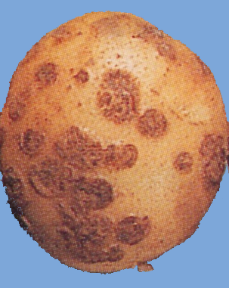 |  | 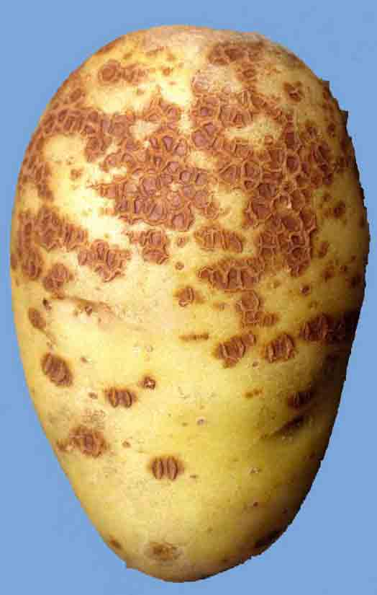

Powdery scab (estimated 10%)
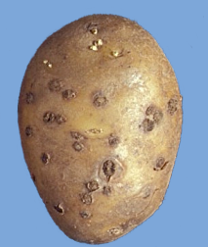
Rhizoctonia
1% surface area coverage
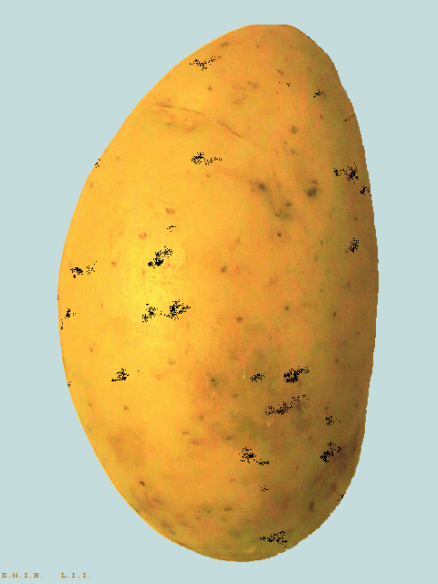 | 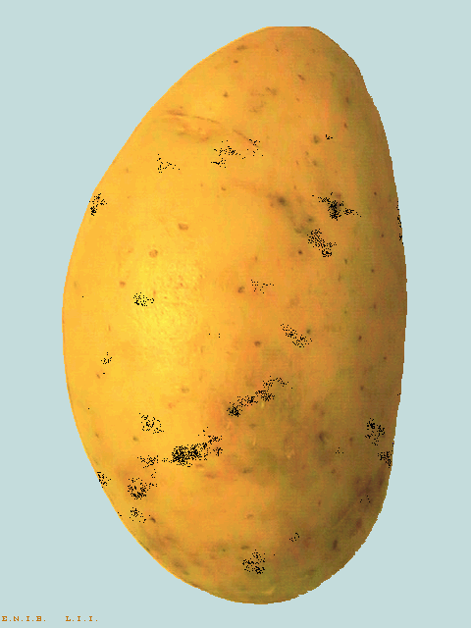
Homogeneous | Concentrated

10% surface area coverage
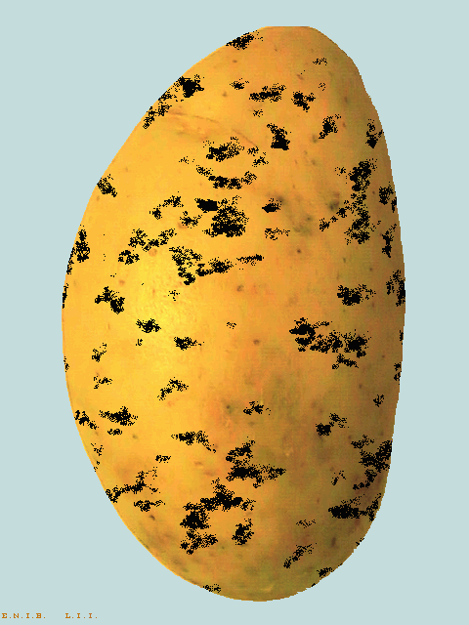
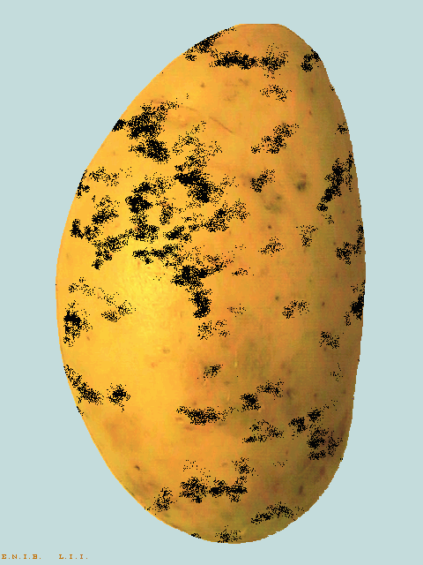

Homogeneous | Concentrated

Annex IX
Sampling tubers for virus testing
1. Introduction
In testing seed stocks for the incidence of virus, it is seldom feasible to test the entire stock, so a test is done on a sample from the stock. Ideally, only seed stocks with infection levels below the tolerance would be accepted and those above the tolerance rejected. However, taking a sample from a stock means that only an estimation of the actual incidence of virus can be made.
The reliability of this estimation will vary with the size of the sample relative to the size of the lot and the population standard which is set for the test. Defining an acceptable population standard for any sample entails two types of risk.
The first is that of rejecting a stock containing less virus than the tolerance and is often described as the “grower’s” risk. The risk of accepting a stock containing more virus than the tolerance is known as the “buyer’s” risk. From the point of view of classification authorities, this could also be described as the risk of passing a stock which fails to meet the official tolerances.
The choice of analytical technique may also have a bearing on the precision of the result, in particular the use of bulking of individual samples into one laboratory analysis. Bulking will have an impact on the confidence interval of the test.
Such testing makes a number of important assumptions, which are, primarily, that the infected tubers are distributed homogeneously in the stock and that tubers are sampled randomly. In addition, the choice of the size of sample to be tested will need to be balanced by other practical factors, such as cost, available facilities, labour, logistics of handling samples, seed stock size, etc.
The following tables and graphs illustrate some of the principles involved in sampling tubers for testing for virus.
2. Confidence limits
Testing different samples from the same seed stock will give a range of results which, statistically, will lie within a specific interval with a certain percentage confidence. This interval is known as the confidence interval.
The acceptable level of confidence or probability should be decided before the testing is conducted but 95 per cent confidence/probability is normally used. The accuracy of the estimation can be improved by increasing the sample size and by adjusting the allowable number of infected tubers in the sample, i.e. the sample tolerance (Table 1).
For example, the size of the confidence interval for a sample tolerance of 4 per cent (4 allowable tubers) is 8.8 per cent based on a sample of 100 tubers but, on a sample of 200 tubers, the interval decreases to 6 per cent i.e. 7.7-1.7. The effect on the confidence interval of increasing the sample size does, however, become smaller at the larger sample sizes. Increasing the sample size from 100 to 200 tubers improves the accuracy of the estimation by 32 per cent, i.e. confidence interval reduced from 8.8 to 6.0 per cent, whereas increasing the sample size from 300 to 400 tubers only gives an improvement of 15 per cent.
In practice, therefore, the benefits of increasing the sample size have to be weighed up against the additional cost of the testing. The accuracy of the estimation can also be affected by changing the allowable number of infected tubers in the sample (Table 1). For example, by decreasing the number of allowable tubers from 4 to 3, i.e. changing sample tolerance from 4 to 3 per cent, the confidence interval is decreased from 8.8 to 7.9 per cent and the confidence limits themselves become lower. Decreasing the allowable number of infected tubers in the sample also has a significant effect on the probability of classifying at higher tolerances than those allowed in the sample as illustrated in the next paragraph.
Table 1
Confidence limits, at a probability of 95 per cent, for various sample tolerances of virus in relation to the size of the sample
Tolerance for virus in a seed stock (per cent) | Size of sample | Allowable number of infected tubers | Confidence limits
Tolerance for virus in a seed stock (per cent) | Size of sample | Allowable number of infected tubers | Lower | Upper
0.5 | 100 | 0 | 0.00 | 2.95
 | 200 | 0 | 0.00 | 1.49
 | 300 | 1 | 0.01 | 1.84
 | 400 | 2 | 0.06 | 1.79
2 | 100 | 1 | 0.03 | 5.45
 | 200 | 3 | 0.31 | 4.32
 | 300 | 5 | 0.54 | 3.85
 | 400 | 7 | 0.71 | 3.57
4 | 100 | 4(3) | 1.1(0.6) | 9.9(8.5)
 | 200 | 8(7) | 1.7(1.4) | 7.7(7.1)
 | 300 | 12(11) | 2.1(1.8) | 6.9(6.5)
 | 400 | 16(15) | 2.3(2.1) | 6.4(6.1)
10 | 100 | 10(8) | 4.9(3.5) | 17.6(15.2)
 | 200 | 20(18) | 6.2(5.4) | 15.0(14.0)
 | 300 | 30 | 6.9 | 13.8
 | 400 | 40 | 7.2 | 13.4
3. Probability of classifying stocks to meet specified tolerances
From the confidence intervals, it can be seen that classifying stocks based on a sample will contain a risk that some stocks, which fail a test, do in fact meet the tolerance, and others, which pass, should fail. Table 2 and Figure 1 show the effect of varying sample size and the number of virus infected tubers allowed in the sample on the probability of classifying seed stocks with different incidences of virus infection. For example, in a test on a sample of 100 tubers where 3 virus infected tubers were allowed, there would be a 14 per cent chance of classifying a stock containing 6 per cent virus as meeting a tolerance of 4 per cent.

Table 2
Probability of classifying seed stocks at two tolerances for virus based on a laboratory test in relation to the size of sample and the allowable number of virus-infected tubers in the sample
Tolerance for virus in a seed stock (per cent) | Size of sample | Allowable number of infected tubers | Probability of acceptance or classification
Tolerance for virus in a seed stock (per cent) | Size of sample | Allowable number of infected tubers | Infected tubers in stock (per cent)
Tolerance for virus in a seed stock (per cent) | Size of sample | Allowable number of infected tubers | 0.5 | 1 | 2 | 4 | 6 | 8 | 10
0.5 | 100 | 0 | 61 | 37 | 13 | 2 | 0 | 0 | 0
 | 200 | 0 | 37 | 13 | 2 | 0 | 0 | 0 | 0
 | 300 | 1 | 56 | 20 | 2 | 0 | 0 | 0 | 0
 | 400 | 2 | 68 | 24 | 1 | 0 | 0 | 0 | 0
2 | 100 | 1 | 91 | 74 | 40 | 9 | 2 | 0 | 0
 | 200 | 3 | 98 | 86 | 43 | 4 | 0 | 0 | 0
 | 300 | 5 | 100 | 92 | 44 | 2 | 0 | 0 | 0
 | 400 | 7 | 100 | 95 | 45 | 1 | 0 | 0 | 0
4 | 100 | 3 | 100 | 98 | 86 | 43 | 14 | 4 | 1
 | 200 | 7 | 100 | 100 | 95 | 45 | 8 | 1 | 0
 | 300 | 11 | 100 | 100 | 98 | 46 | 5 | 0 | 0
 | 400 | 15 | 100 | 100 | 99 | 46 | 3 | 0 | 0
10 | 100 | 8 | 100 | 100 | 100 | 98 | 85 | 59 | 32
 | 200 | 18 | 100 | 100 | 100 | 100 | 97 | 75 | 37
 | 300 | 30 | 100 | 100 | 100 | 100 | 100 | 91 | 55
 | 400 | 40 | 100 | 100 | 100 | 100 | 100 | 94 | 54

Note: The allowable number of tubers is, often, set at a lower level than the overall seed stock tolerance of 4 per cent and 10 per cent respectively, particularly in the case of a relatively small sample size. By lowering the tolerance in a sample, the buyer’s risk is reduced.

Figure 1
Probability of classifying seed stocks with different incidences of virus as meeting a tolerance of 0.5, 2, 4 or 10 per cent for virus in a laboratory test in relation to the size of sample and the allowable number of virus-infected tubers in the sample

Figure 1.a
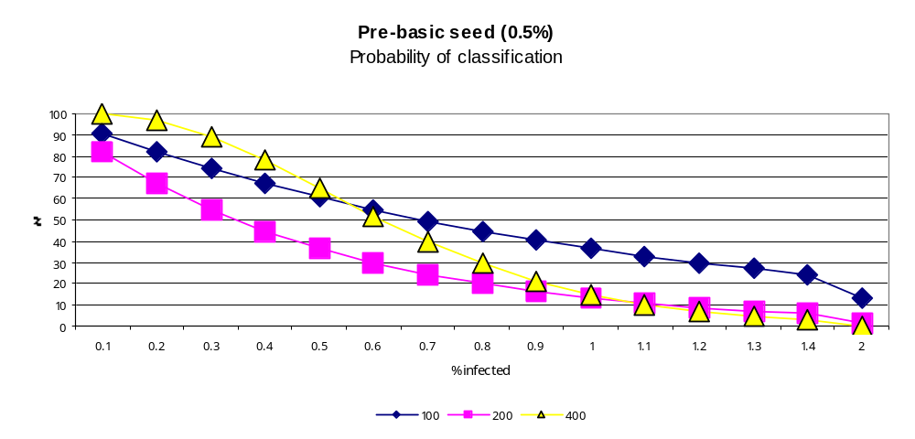Pre-basic seed (0.5%)
Probability of classification

Figure 1.b
Basic seed I class (2%)
Probability of classification
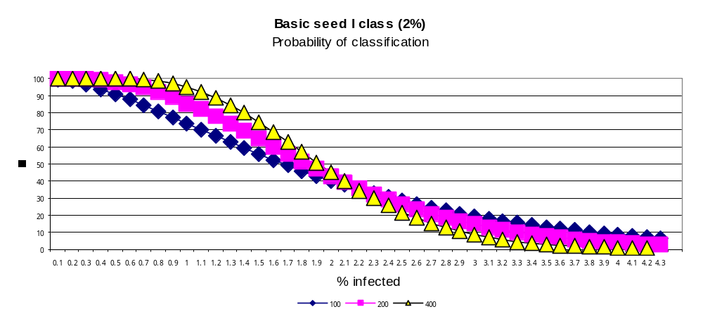

Figure 1.c
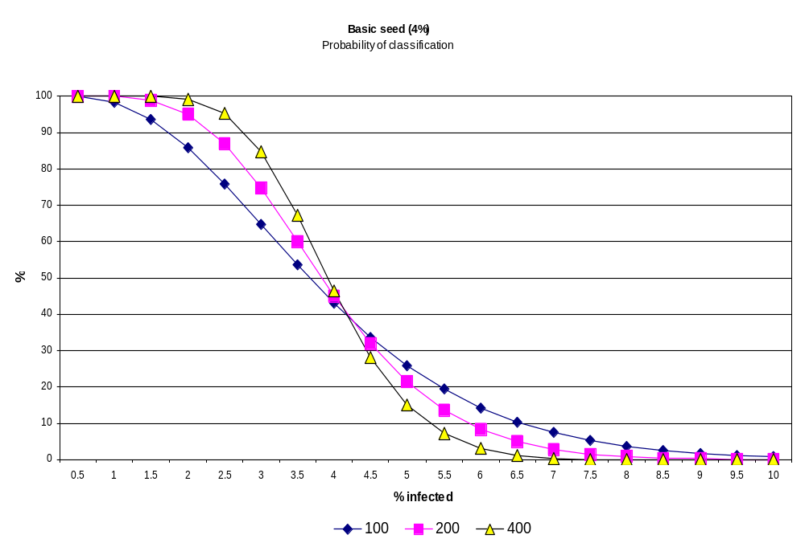Basic seed (4%)
Probability of classification

Figure 1.d
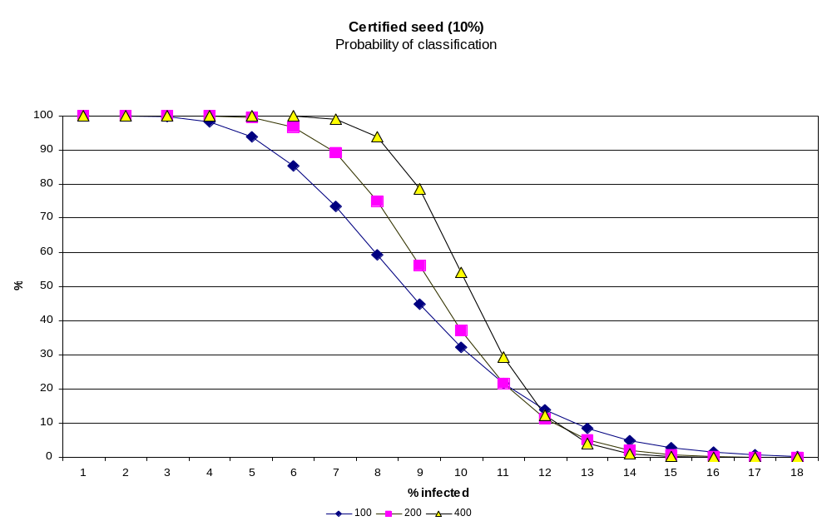Basic seed (10%)
Probability of classification

4. Bulking of samples for analysis
When testing a sample of tubers or leaves submitted to a diagnostic lab for analysis bulking of individual tubers or leafs together is an effective way of reducing the costs and time associated with the test. Users of such tests should be aware that bulking more individuals leads to a less precise test result at higher numbers of positives found particularly at levels above the UNECE progeny tolerance limits. This effect is shown in the following tables. The DA should take account of the precision of the results associated with bulking.
ISTA has an online statistical tool for measuring the confidence in testing when bulking samples which can be found at:
http://www.seedtest.org/en/statistical_tool_for_seed_testing_content1--1143--279.htm
The examples below set out the 95% confidence limits associated with a sample of 96 tubers/leaves divided into 24 bulks of 4 individuals and for 100 tubers/leaves divided in to 10 bulks of 10 individuals.
Table 3
Example 24 x 4 tubers/leaves (96 tuber sample) 95% confidence limits shown
Number of positive reactions (1 reaction = 4 plants) | Calculated most  probable value | 95% confidence limit that the result is between
Number of positive reactions (1 reaction = 4 plants) | Calculated most  probable value | Lower | Upper
1 | 1.06 | 0.03 | 5.76
2 | 2.15 | 0.26 | 7.57
3 | 3.28 | 0.67 | 9.31
4 | 4.46 | 1.21 | 11.04
5 | 5.67 | 1.83 | 12.79
6 | 6.94 | 2.54 | 14.56
7 | 8.26 | 3.32 | 16.37
8 | 9.64 | 4.16 | 18.24
9 | 11.09 | 5.07 | 20.18
10 | 12.61 | 6.06 | 22.20
11 | 14.21 | 7.11 | 24.31
12 | 15.91 | 8.25 | 26.54
13 | 17.72 | 9.47 | 28.90
14 | 19.66 | 10.78 | 31.43

Table 4
Example 10 x 10 tubers/leaves (100 tuber sample) 95% confidence limits shown
Number of positive reactions (1 reaction = 10 plants) |  | Calculated most probable value | 95% confidence limit that the result is between
 |  | Calculated most probable value | Lower |  | Upper
0 | 0 |  |  | 0 | 3.62
1 | 1.05 |  |  | 0.03 | 5.72
2 | 2.21 |  |  | 0.26 | 7.80
3 | 3.50 |  |  | 0.69 | 10.03
4 | 4.98 |  |  | 1.29 | 12.52
5 | 6.70 |  |  | 2.05 | 15.43
6 | 8.76 |  |  | 3.00 | 19.00
7 | 11.34 |  |  | 4.18 | 23.72
8 | 14.87 |  |  | 5.70 | 30.79
9 | 20.57 |  |  | 7.78 | 45.01
Annex X
Dispute settlement
1. Context
Disputes may arise between exporters and importers of seed potatoes.
These disputes may concern:
- non-compliance at official inspection, or
- non-compliance at commercial inspection
The non-compliance could be as a result of finding faults above the agreed tolerance(s), or failure to meet requirements such as sizing, packaging or administrative requirements. .
In the case of commercial disputes, the non-compliance could also result from failure to meet contractual requirements which may include presence of faults within official limits but over contractually stated limits or could relate to the presence of faults not mentioned in the official standards.
To settle a dispute it is important to be clear about whether the non-compliance is in relation to the Standard, or to other official regulations or commercial/contractual requirements.
2. Settlement of official disputes
Where a designated importing authority identifies a non-compliance it should inform the exporting designated authority, giving details of the reason for the non-compliance. It may be possible to resolve the dispute quickly by negotiation, particularly when a problem is administrative or minor. Wherever possible this should be expedited by both parties.
Resolution of the problem may require that a joint inspection of the lot/part lot be carried out. The joint investigation may include re-sampling and/or re-testing of the potatoes to confirm (or refute) the initial findings. The investigation can be done with or without the agreement of the buyer and seller.

3. Settlement of commercial disputes
In the case of commercial disputes resolution between buyer and seller, these may agree to ask for direct intervention of private experts within a framework e.g. RUCIP rules.
4. Establishment of framework for resolution
In the case of official disputes, the importing authority should inform the exporting authority of the problem as soon as possible after the arrival of the consignment to allow prompt commencement of the resolution process.
In any case where a lot or part-lot is rejected as a result of an official import inspection, the authority should inform the exporting authority as soon as possible after rejecting the lot/part-lot giving details of the lot and the reason for rejection.
It is recommended that notification to the exporting authority, seller and buyer should be made within three working days of identifying the problem.
Where a joint investigation is carried out, experts from both countries should participate in the joint re-inspection of the lot/part-lot. The methodology used in the investigation should be in accordance with internationally recognized sampling procedures and analysis methodologies, such as those adopted by UNECE, IPPC, EPPO and NAPPO.
5. Reporting the results of the resolution process
The report of the resolution process and, if applicable, the joint investigation should be made available to the parties concerned with a recommendation for resolving the dispute.
Annex XI
UNECE standard for seed potatoes
(Summary table of tolerances)
 | Pre-basic TC |  | Pre-basic | Basic Class I | Basic class II | Certified class I | Certified class II
1. Crop tolerances
Globodera rostochiensis (soil tolerance) | 0 |  | 0 | 0 | 0 | 0 | 0
Globodera pallida (soil tolerance) | 0 |  | 0 | 0 | 0 | 0 | 0
Black leg (%) | 0 |  | 0 | 0.5 | 1 | 1.5 | 2
Synchytrium endobioticum | 0 |  | 0 | 0 | 0 | 0 | 0
Clavibacter michiganensis | 0 |  | 0 | 0 | 0 | 0 | 0
Ralstonia solanacearum | 0 |  | 0 | 0 | 0 | 0 | 0
Potato spindle tuber viroid | 0 |  | 0 | 0 | 0 | 0 | 0
Tomato stolbur | 0 |  | 0 | 0 | 0 | 0 | 0
Virus tolerance | 0 |  | 0.1 | 0.4  (0.2 severe) | 0.8  (0.4 severe) | 2  (1 severe) | 10  (2 severe)
Other varieties and off-types | 0 |  | 0.01 | 0.25 | 0.25 | 0.5 | 0.5
2. Lot tolerances
Earth and extraneous matter (%) | 1 |  | 1 | 2 | 2 | 2 | 2
Dry and wet rot (not caused by Synchytrium e. Clavibacter m. Ralstonia s.) (%) | 0 |  | 0.2 | 1 | 1 | 1 | 1
External defects | 3 |  | 3 | 3 | 3 | 3 | 3
Shrivelled tubers | 0 |  | 0.5 | 1 | 1 | 1 | 1
Chilling injury | 0 |  | 0.2 | 1 | 1 | 1 | 1
Tuber moth damage | 0 |  | 4 (20) | 4 (20) | 4 (20) | 4 (20) | 4 (20)
Scab (common and netted) | 0 |  | 5 (33.3)* | 5 (33.3)* | 5 (33.3)* | 5 (33.3)* | 5 (33.3)*
Powdery scab | 0 |  | 1 (10)* | 3 (10)* | 3 (10)* | 3 (10)* | 3 (10)*
Rhizoctonia | 0 |  | 1 (1)* | 5 (10)* | 5 (10)* | 5 (10)* | 5 (10)*
Total tolerances (%) | 3 |  | 5 | 6 | 6 | 6 | 6
Globodera rostochiensis | 0 |  | 0 | 0 | 0 | 0 | 0
Globodera pallida | 0 |  | 0 | 0 | 0 | 0 | 0
Synchytrium endobioticum | 0 |  | 0 | 0 | 0 | 0 | 0
Clavibacter michiganensis | 0 |  | 0 | 0 | 0 | 0 | 0
Ralstonia solanacearum | 0 |  | 0 | 0 | 0 | 0 | 0
Potato spindle tuber viroid | 0 |  | 0 | 0 | 0 | 0 | 0
Tomato stolbur | 0 |  | 0 | 0 | 0 | 0 | 0
Meloidogyne chitwoodi and fallax | 0 |  | 0 | 0 | 0 | 0 | 0
Ditylenchus destructor | 0 |  | 0 | 0 | 0 | 0 | 0
Phthorimaea operculella | 0 |  | 0 | 0 | 0 | 0 | 0
3. Direct progeny tolerances
Other varieties and off-types | 0 |  | 0.01 | 0.25 | 0.25 | 0.5 | 0.5
Virus (%) | 0 |  | 0.5 | 2  (1 severe) | 4  (2 severe) | 10  (5 severe) | 10
* The figure in brackets is the allowable % surface/cut area covered: a tuber is deemed to be affected by the disease only if surface/cut area affected exceeds the specified allowable surface tolerance.
_______________

? As defined in International Standard for Phytosanitary Measures 33 (ISPM 33, 2010).
? Reservation from the United States to allow for further consultation.
? The Representatives of the European Commission and France reserved their position on this issue.
International Standard for Phytosanitary Measures 5 (ISPM 5, 2012).
? From “Holliday P (1989). A Dictionary of Plant Pathology. Cambridge University Press.

