**REVISED VERSION**

**Inshell Walnuts - Draft Explanatory Brochure**

**Proposal by the delegation of United States of America**

The following draft explanatory brochure for Inshell Walnuts was submitted by the delegation of USA.



**REVISED VERSION – 7 APRIL 2014**

Inshell Walnuts

Peppers

*Explanatory Brochure*

Note

Commercial quality standards for agricultural produce are developed and approved by the United Nations Economic Commission for Europe through its Working Party on Agricultural Quality Standards. These international standards facilitate trade, encourage high-quality production, improve profitability and protect consumer interests. They are used by governments, producers, traders, importers and exporters, as well as international organizations. They cover a wide range of agricultural products, including fresh fruit and vegetables, dry and dried produce, seed potatoes, meat, cut flowers, eggs and egg products.

The Explanatory Brochure on the Standard for Inshell Walnuts from varieties (cultivars) grown from *Juglans regia* L. has been developed to harmonize the interpretation of the Standard, thereby facilitating international as well as national trade. It addresses producers and traders, as well as inspection authorities. It corresponds to the latest edition of the DDP-01 Standard for Inshell Walnuts, based on document ECE/TRADE/C/WP.7/2013/29, reviewed and adopted by the Working Party at its sixty-ninth session, which was officially adopted in November 2013. Subsequent revisions to the Standard will be placed on the website at: http://www.unece.org/trade/agr/standard/dry/ddp-standards.html

Any member of the United Nations can participate, on an equal footing, in the activities of the Working Party. For more information, please visit our website <http://www.unece.org/trade/agr/welcome.html>.

The designations employed and the presentation of the material in this publication do not imply

the expression of any opinion whatsoever on the part of the United Nations Secretariat concerning

the legal status of any country, territory, city or area or of its authorities, or concerning the

delimitation of its frontiers or boundaries. Mention of company names or commercial products

does not imply endorsement by the United Nations.

All material may be freely quoted or reprinted, but acknowledgement is requested.

Please contact the following address with any comments or enquiries:

Agricultural Standards Unit,

Economic Cooperation, Trade, and Land Management Division

United Nations Economic Commission for Europe

Palais des Nations

CH-1211, Geneva 10, Switzerland

e-mail: agristandards@unece.org

Contents

|  |  |
| --- | --- |
| I. Definition of Produce |  |
| II. Provisions concerning Quality |  |
| III. Provisions concerning Sizing |  |
| IV. Provisions concerning Tolerances |  |
| V. Provisions concerning Presentation |  |
| VI. Provisions concerning Marking |  |

|  |
| --- |
| *The official text of the standard is indicated in blue background and white bold type; the interpretative text of the standard is indicated in black. References to photos representing the visual interpretation are printed in black bold. The entire text of the standard without the interpretative text appears in the annex.* |

Definition

of

Produce

I. Definition of Produce

This Standard applies to inshell walnuts free from outer husks, of varieties (cultivars) grown from *Juglans regia* L., intended for direct consumption or for food when intended to be mixed with other products for direct consumption without further processing.

This standard does not apply to inshell walnuts that are processed by salting, sugaring, flavouring or roasting, or for industrial processing.

**Interpretation:** *Inshell walnuts come in a range of colours, sizes and shapes.*

*The following are excluded from this standard: inshell walnuts for industrial processing.*

Provisions concerning Quality

II. Provisions concerning Quality

The purpose of the standard is to define the quality requirements of inshell walnuts at the export-control stage, after preparation and packaging.

However, if applied at stages following export, the holder/seller shall be responsible for observing the requirements of the standard. The holder/seller of products not in conformity with this standard may not display such products or offer them for sale, or deliver or market them in any other manner.

**A. Minimum requirements**[1]

In all classes, subject to the special provisions for each class and the tolerances allowed, the inshell walnuts must display the following characteristics:

(a) The shell must be:

* intact; however, slight superficial damage and partially open walnuts are not considered as a defect, provided the kernel is physically protected (photos 1.1 and 1.2)

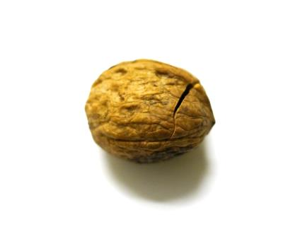

Surface crack

* 1. Slight superficial damage (Allowed)

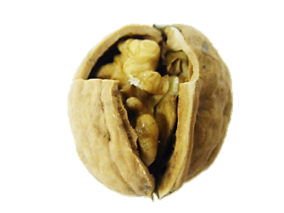

Exposed kernel

**¼”**

* 1. Superficial damage (Not Allowed)

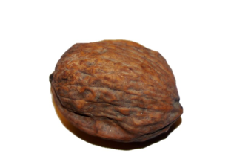

* 1. Misshapen (Allowed)

**Interpretation:** *The whole inshell walnuts must have no damage or injury. Inshell walnuts that have holes that expose the interior of the produce are not allowed.*

* clean; practically free of any visible foreign matter, including residues of adhering husk and dirt affecting in aggregate more than 10 per cent of the total surface area (photos 1.4, 1.5, 1.6, 1.7 and 1.8).

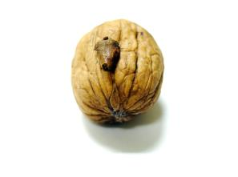

Adhering hull

* 1. Adhering Hull/husk < 10% (Allowed)

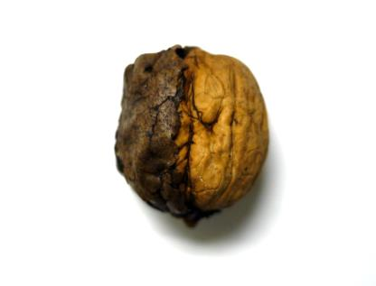

Adhering

hull

* 1. Adhering Hull/husk > 10% (Not Allowed)

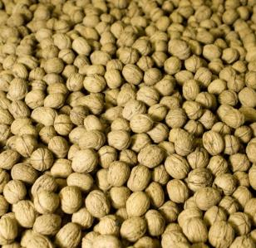

* 1. Clean shell (Allowed)

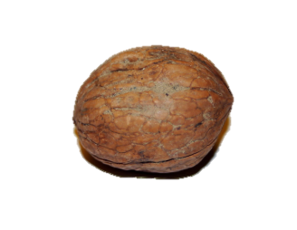

Adhering

dirt

1.7 Adhering dirt < 10% (Allowed)

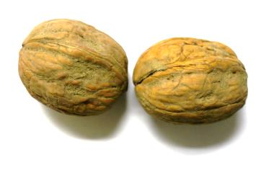

Adhering dirt

1.8 Adhering dirt > 10% (Not Allowed)

* free from blemishes, areas of discolouration or spread stains in pronounced contrast with the rest of the shell affecting in aggregate not more than 25 per cent of the surface of the shell (photos 1.9, 1.10, 1.11)

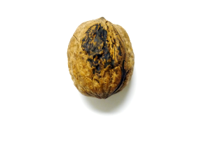

Spread stain

* 1. Discoloured or spread stain < 25% (Allowed). NOTE: Each quadrant approximates 25%

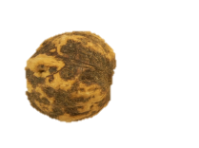

* 1. Discoloured or spread stain > 25% (Not Allowed). NOTE: Each quadrant approximates 25%

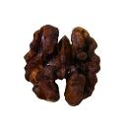

* 1. Sunburnt kernels
* Well formed

(b) The kernel must be:

* free from rancidity
* sufficiently developed (1.12)
* free of dried tough portions affecting more than 25 per cent (photo 1.13).

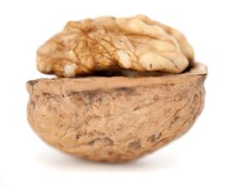

* 1. Well-developed kernel

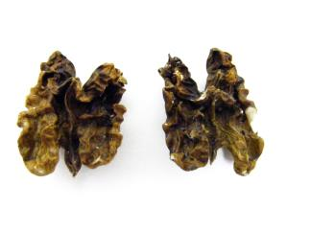

* 1. Tough or shrivelled kernels > 25% (Not Allowed). NOTE: Each quadrant approximates 25%

**Interpretation**: *Walnut kernels must be clean (free of dirt, dust, debris, foreign materials); sufficiently developed (must have the typical size); with characteristic shape and colour of the variety type.*

* sufficiently mature for fresh walnuts; i.e. it must be possible to peel off the skin of the kernel easily and the internal central partition must be turning brown.
* free from blemishes, areas of discolouration or spread stains in pronounced contrast with the rest of the kernel affecting in aggregate more than 25 per cent of the surface of the kernel (photo 1.14)

**(NOTE:** The *United States of America does not participate in fresh walnut standard.)*

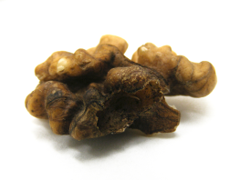

1.14 Stained or discoloured kernel > 25% (Not Allowed)

(c) The whole produce (shell and kernel) must be:

* sound; produce affected by rotting or deterioration such as to make the produce unfit for human consumption is excluded
* free from mould filaments visible to the naked eye (photo 1.15)

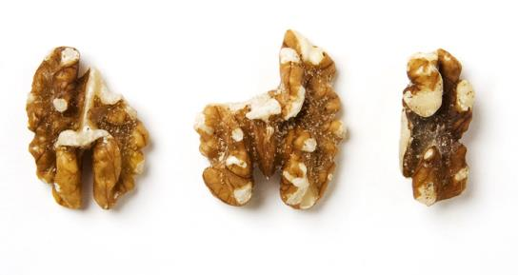 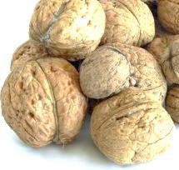

Mould

1.15 Mould filaments on shell and kernel (Not Allowed)

* free from living pests, whatever their stage of development (photo 1.16)
* free from damage caused by pests, including the presence of dead insects and/or mites, their debris or excreta
* free of abnormal external moisture
* free of foreign smell and/or taste.

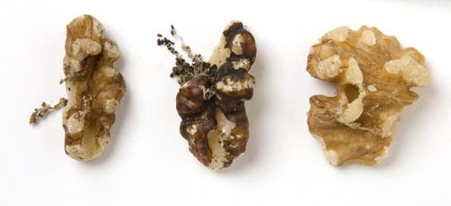

1.16 Insect damage (Not Allowed)

**Interpretation**: *Inshell walnuts and kernels must be free of visible mould filaments or mycelia. Mould filaments grow and develop when walnuts are packaged and stored with excess moisture. Mould filaments and mycelia come from microorganisms (usually fungus) growing and developing on internal and external parts of fruits. Excess moisture of walnuts and/or warm conditions during storage promote and increase the presence and contamination with fungus resulting in high levels of visible filaments and mycelia spores, causing deterioration of colour, texture, moisture content, flavour, smell and taste of produce.*

The shells may be washed and bleached provided that the treatment applied does not affect the quality of the kernels.

The condition of the inshell walnuts must be such as to enable them:

* to withstand transportation and handling
* to arrive in satisfactory condition at the place of destination.

**Interpretation:** *The inshell walnuts must be free of any disease or serious deterioration which appreciably affects their appearance, edibility or keeping quality.*

**B. Moisture content[2]**

The fresh inshell walnuts shall have a natural moisture content of at least 20.0 per cent

The dry inshell walnuts shall have a moisture content not exceeding 12.0 per cent for the whole nut or 8.0 per cent for the kernel.[3]

**Interpretation:** *Maximum moisture content refers to the limits of moisture allowed for the produce in order to be commercialized. It is important to understand that excess moisture of the produce increases microorganism and insect development, contamination and deterioration of produce. Excess drying, on the other hand makes product easy to break. Broken inshell walnuts are unacceptable for commercialization, therefore, excess moisture and excess drying are not allowed. The method to determine the moisture content is based on the method prescribed by AOAC: AOAC Official Method 934.06 - Moisture in Dried Fruits.* (**Note:** The United States of America does not participate in fresh walnut standard)

**C. Classification**

In accordance with the defects allowed in section “IV. Provisions concerning tolerances” the inshell walnuts are classified into the following classes:

“Extra” Class, Class I and Class II.

**Interpretation:** *The defects allowed must not affect the general appearance of the produce as regards quality, keeping quality and presentation in the package.*

Provisions concerning sizing

III. Provisions concerning sizing

The minimum size is 26 mm for Classes Extra and I and 24 mm for Class II.

Sizing is mandatory for Extra Class and Class I but optional for Class II.

Size is determined by

* Screening, i.e. minimum diameter in mm measured by a round sieve, or
* Size range, i.e. minimum and maximum diameter in mm which must not exceed 2 mm of difference. However, for oblong varieties having a height of at least 1.25 times of the equatorial section, the maximum size range shall not exceed 3 mm.

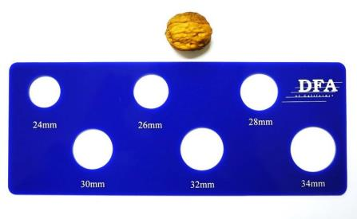

1.17 Sizing scale

**Interpretation:** *Each class type would need to meet the indicated size in order to be accepted for commercialization and to improve the uniformity within the package (photo 1.17)*

Provisions concerningtolerances

IV. Provisions concerning tolerances

At all marketing stages, tolerances in respect of quality and size shall be allowed in each lot for produce not satisfying the minimum requirements of the class indicated.

**Interpretation:** *Tolerances are provided to allow for deviation in handling and for natural deterioration of fresh produce over time. To determine conformity with the tolerances, samples are taken according to Annex II of the OECD Council Decision [C(2006)95]*. Decision on conformity of the lot is taken depending on the percentage of non-conforming produce in the total sample.* *A sample is deﬁned as that unit of walnuts taken to represent a designated portion of a lot and is added to other samples from that lot to form a composite from which a 100-nut test is drawn.*

*\* Downloadable from:* [*www.oecd.org/dataoecd/33/0/19517729.pdf*](http://www.oecd.org/dataoecd/33/0/19517729.pdf)

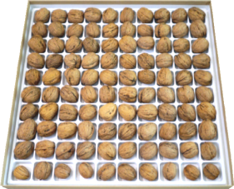

1.18 Sampling tray (100 count)

**A. Quality tolerances**

|  | *Tolerances allowed  per cent of defective inshell walnuts by count or weight (with regard to the total inshell weight basis)* | | |
| --- | --- | --- | --- |
| *Defects allowed* | *Extra* | *Class I* | *Class II* |
| (a) Tolerances for defects affecting the external appearances of the shell such as shells with adhering husk/hull, dirt and blemishes, open, broken or damaged shells | 7 | 10 | 15 |
| Mouldy affecting fresh walnuts (external) only | 5 | 5 | 5 |
| (b) Tolerances for the edible part not satisfying the minimum requirements (by count, based on a 100 nut sample) *: | 8 | 10 | 15 |
| of which no more than: |  |  |  |
| Mouldy | 3 | 4 | 6 |
| Not sufficiently developed, shrunken or shrivelled kernels ** | 8 | 10 | 15 |
| Rancid or damaged by pests, rotting or deterioration | 3 | 6 | 8 |
| Living Pests | 0 | 0 | 0 |
| (c) Size tolerances (if sized) |  |  |  |
| For inshell walnuts not conforming to the provisions concerning sizing and the size indicated in total | 10 | 10 | 10 |
| (d) Tolerances for other defects: |  |  |  |
| Foreign material including fragments of shell, hull, dust, etc. (by weight) | 2 | 3 | 4 |
| of which no more than: |  |  |  |
| Foreign matter of mineral origin | 0.25 | 1 | 2 |
| Inshell walnuts belonging to other varieties or commercial types than that indicated | 10 | 10 | 10 |

* In Turkey, tolerances for the edible part not satisfying the minimum requirements are determined by weight.

** In the calculation of tolerances, whatever the class, two half-empty walnuts or four quarter-empty walnuts are counted as one empty walnut.

Provisions concerning presentation

V. Provisions concerning presentation

**A. Uniformity**

The contents of each package must be uniform and contain only inshell walnuts of the same origin, quality, crop year, size (if sized) and variety or commercial type (if indicated).

The visible part of the contents of the package must be representative of its entire contents (photo 1.19)

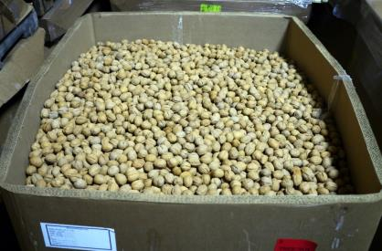

1.19 Inshell walnuts, uniform appearance.

**Interpretation:** *For inshell walnuts, the uniformity in size, colour, and general quality may change during transportation. Lots and packages having inshell walnuts of Class II may be less uniform in quality, colour and size compared to lots of Class I and Extra Class.*

**B. Packaging**

Inshell walnuts must be packed in such a way as to protect the produce properly.

The materials used inside the package must be clean and of a quality so as to avoid causing any external or internal damage to the produce. The use of materials, particularly of paper and stamps bearing trade specifications, is allowed, provided the printing or labelling has been done with non-toxic ink or glue.

Packages must be free of all foreign matter in accordance with the table of tolerances in section “IV. Provisions concerning tolerances”.

**Interpretation:** *Packaging must be of such quality and strength as to protect the inshell walnuts during transportation and handling (photos 1.20, 1.21, 1.22 and 1.23).*

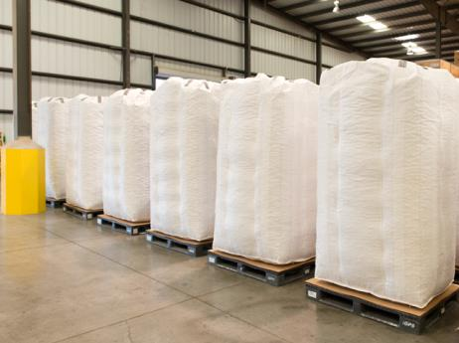

1.20 Inshell walnut super sacs

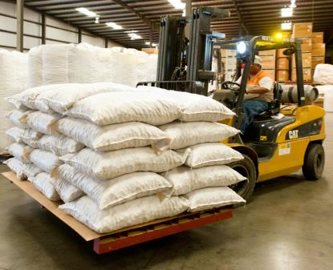

1.21 Inshell walnut bags

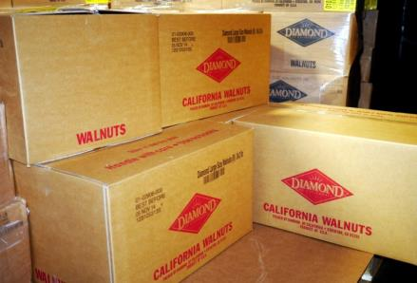

1.22 Inshell walnut cartons



1.23 Walnut retail pack

Provisions

Concerning

marking

VI. Provisions concerning marking

Each package[4]must bear the following particulars in letters grouped on the same side, legibly and indelibly marked and visible from the outside:

**Interpretation:** *On each package, all particulars must be grouped on the same side of the package, either on a label attached to or printed on the package with water insoluble ink. In case of re-used packages, all labels must be carefully removed and/or previous indications deleted.*

**A. Identification**

Packer and/or Dispatcher: Name and physical address (e.g. street/city/region/postal code and, if different from the country of origin, the country) or a code mark officially recognized by the national authority[5].

**Interpretation:** *For inspection purposes, the “packer” is the person or firm responsible for the packaging of the produce (this does not mean the staff that actually carry out the work, who are responsible only to their employer). The code mark is not a trademark but an official control system enabling the person or firm responsible for packaging to be readily identified. The dispatcher (shipper or exporter) may, however, assume sole responsibility, in which case identification of the “packer” as defined above is optional (photo 1.24).*

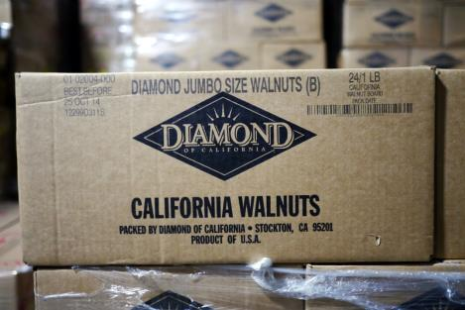

1.24 Marking: Identification of packer/dispatcher, address, size, produce origin

**B. Nature of produce**

* “Walnuts” or “Dry walnuts”; or
* “Fresh walnuts” or equivalent denomination
* Name of the variety or commercial types (optional).

**C. Origin of produce**

* Country of origin[6] and, optionally, district where grown or national, regional or local place name.

**D. Commercial specifications**

* Class
* Size (if sized); expressed by:
* The minimum diameter followed by the words “and above” or equivalent denomination; or
* The minimum and maximum diameters
* Crop year (mandatory for “Extra” Class and Class I, optional for Class II)”
* “Best before” followed by the date (optional)
* "Store in a cool place", or “preservation very limited, store in a cool place”, for fresh walnuts.

**E. Official control mark (optional)**

Adopted 1970 (as UNECE Standard for Unshelled Walnuts)

Revised 2013

1. Definitions of terms and defects are listed in annex III of the Standard Layout – Recommended terms and definition of defects for standards of dry (Inshell Nuts and Nut Kernels) and dried produce [<http://www.unece.org/trade/agr/standard/dry/StandardLayout/StandardLayoutDDP_e.pdf>](http://www.unece.org/trade/agr/standard/dry/StandardLayout/StandardLayoutDDP_e.pdf)
2. The moisture content is determined by the method given in **Annex I** of the Standard Layout – Determination of the moisture content for dried produce <<http://www.unece.org/trade/agr/standard/dry/StandardLayout/StandardLayoutDDP_e.pdf>>. The laboratory reference method shall be used in cases of dispute.
3. Reservation from Romania, requesting 10.0 and 6.0 per cent respectively.
4. These marking provisions do not apply to sales packages presented in packages.
5. The national legislation of a number of countries requires the explicit declaration of the name and address. However, in cases where a code mark is used, the reference “packer and/or dispatcher” (or equivalent abbreviations) must be indicated in close connection with the code mark, and the code mark should be preceded with the ISO 3166 alpha country code of the recognizing country, if not the country of origin.
6. The full or a commonly used name should be indicated.