Specialized Section on Standardization of Fresh Fruit and Vegetables
Sixtieth session
Geneva, 29 May – 1 June 2012
Item 5 (a) of the provisional agenda
UNECE explanatory brochure and Standard for Pineapples

COLEACP contribution to the UNECE Explanatory
brochure on the Standard for Pineapples

COLEACP Note explaining coloration, maturity and de-greening

The explanations mentioned hereafter have been extracted from the Technical Itinerary for the “Cayenne” Pineapple « Ananas Comosus » developed by the PIP, a programme implemented by COLEACP upon the request of the ACP Group of States and the European Commission. The aim of PIP is to support exporting companies from ACP countries in the compliance process with the regulatory and commercial requirements of the European markets.

A few years ago, Smooth Cayenne was the main variety exported to the European Union. New hybrid « sweet » varieties are now developing strongly. The advantages of this new generation of hybrids are:
- The fruits naturally display better colour ;
- Low acidity in contrast with Smooth Cayenne ;
- Hardiness in transport and storage.

In addition to these two varieties suitable for shipment by sea, “Queen” fruits are also good for top of the market outlets (for example those shipped by air). They colour naturally and are very fragrant. They are also fragile during the transport and storage.

In this note, extracts from the two Technical Itineraries are presented :
- Technical Itinerary for the Smooth Cayenne type;
- Technical Itinerary for MD2 hybrid (originating from the crossing of two other hybrids: PRI 58-1184 and 59-443).
Technical Itinerary for the “Smooth Cayenne” Pineapple
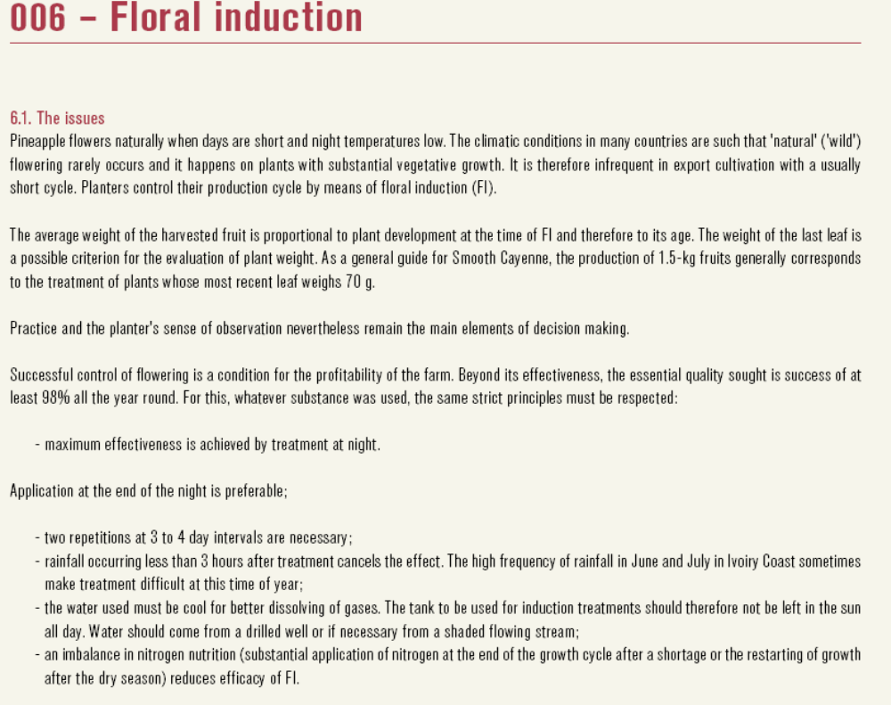

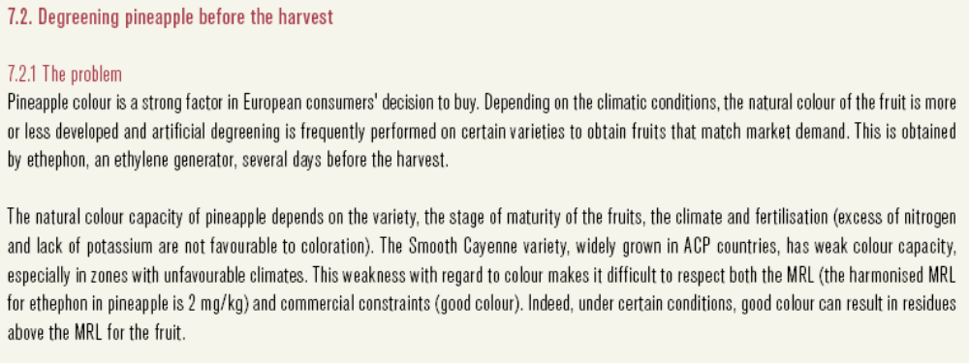
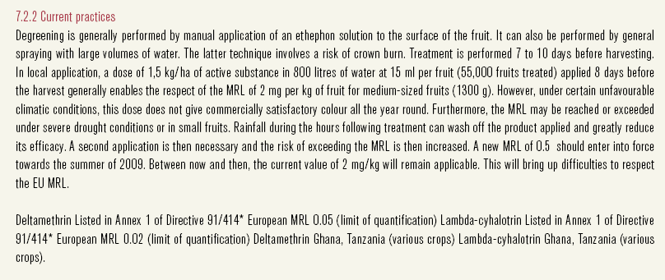

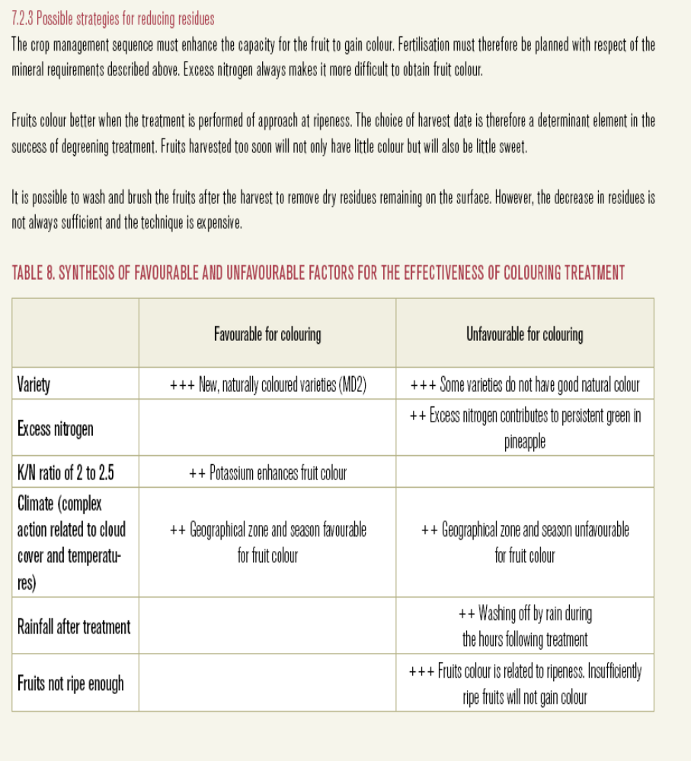

2. Technical Itinerary for the MD2 hybrid pineapple

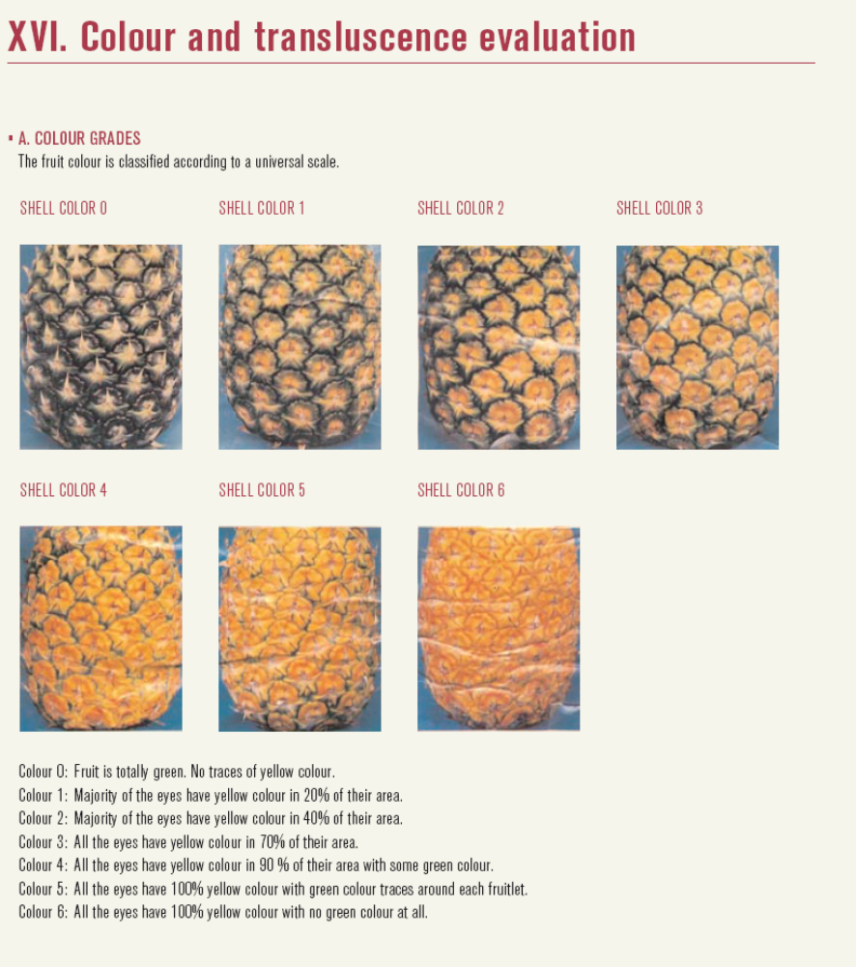

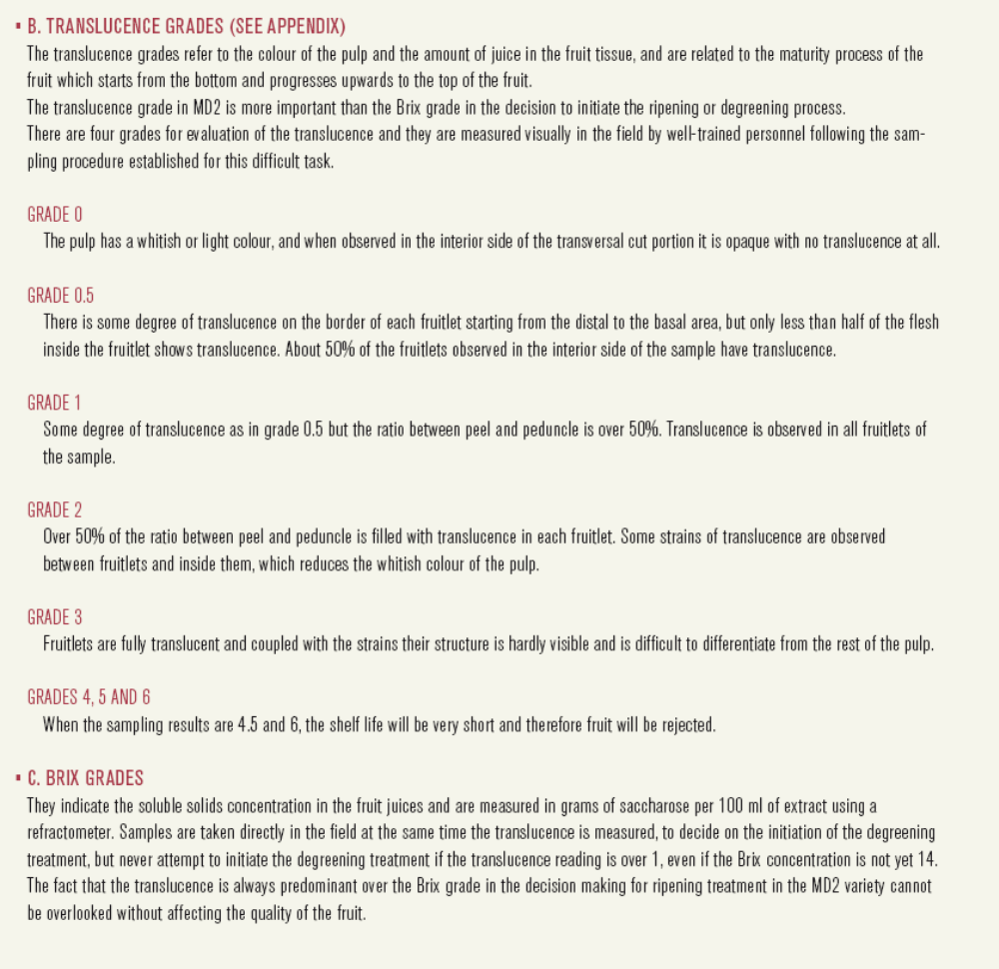

(*) The aim of PIP is to support exporting companies from ACP countries with a view to helping them comply with the regulatory and commercial requirements of the European market.



