TRADE/WP.7/GE.1/2002/INF.1 (Italy)

Multi-regional Operating Programme
Services For Trade Valorisation Of Southern Italian Agricultural Products

Measure 4 – Common Actions

GUIDELINES FOR
REDESIGNING THE
SUPPLY CHAIN

Classification
Electronic Identification
Traceability

by Lauro Panella

Ismea

Rome, Italy
December 2001

INDEX

Introduction 3

1. Classification, product catalogues and E-commerce______________________________4
1.1 Theoretical framework 4
1.2 Hypothetical methods for the product catalogues 4
1.3 Informations' exchanges in French fruit and vegetable productions 16
1.3.1 Prodat construction_____________ _______________________________________________________ 17
1.4 E-commerce 17
1.5 Further developments 18
Appendix A1 - Strawberry catalogue____________________________________________________________19
Appendix A2 - Cataloguing method byECR Italy __________________________________________________20

2. electronic identification of the products and optimum management model for the supply chain__________________________________________________________________ 28
2.1 Optimum management model 28
2.2 Relationships between Retailer-Packhouse/cooperative: Order-Delivery-Invoice cycle 29
2.3 New structure of the EAN/UCC code of consumer units for variable weight products 30
2.3.1 The new code's structure ________________________________________ _____________________31
Appendix B 33

3. traceabiity_____________________________________________________________________________36
3.1 Introduction 36
3.2 The logic behind the traceability models 37
3.3 Methodical scheme of traceability models 37
3.4 Identification instruments and data transmission in the trade phase: standard bar codes 40
3.4.1 Identification of locations_________ _______ ____________________________________________ 43
3.4.2 Identification of trade units ___ ____________________________________________________ 43
3.4.3 Identification of logistics units___ _____________________________________________________ 43
3.4.4 Bar coding and logistics units ________________________________________________________ 45
3.5 alphanumerical codes__________________________________________________________________ 46
3.6 Identification instruments and data transmission in the production and packaging phase 46
3.6.1 Bar codes__________________________________________________________________________46
3.6.2 Alphanumerical codes_________ ______________________________________________________ 47
3.6.3 Radio frequency systems______________________________________________________________47
3.7 Some examples of traceability 48
3.7.1 Apofruit (Moc Mediterraneo - Italy)____________________________________________________ 48
3.7.2 Osas- Sibarit (Moc Campoverde- Italy)__________________________________________________ 50
3.7.3 Vers Direct Nederland (The Netherlands)_________________________________________________52
3.7.4 Bloemen Veiling Holland (The Netherlands )______________________________________________53
3.7.5 Albert Heijn (The Netherlands )________________________________________________________ 54
3.7.6 Martinavarro (Spain)_________________________________________________________________55
3.7.7 Anecoop (Spain)_____________________________________________________________________55

glossary_________________ _________________________________________________________________56

Introduction

Over the last few years, the agricultural production system has undergone major management re-organisation due to the new operational possibilities generated by the rapid development of information technology. Ismea has been following this process since 1999, in the framework of the work carried out for Macro Organizzazioni Commerciali (Moc – Macro Trade Organisation).
Mocs are companies, mainly agricultural, whose partners operate throughout the entire supply chain. These were created from the Programma Operativo Multiregionale (POM) “Services for the trade evaluation of Southern Italian agricultural products”, approved by Decision C(96) 2796 dated 10-10-1996, and finalised to pursue the objectives of evaluation, re-qualification and re-structuring of widely-consumed agricultural products. There are fourteen Mocs, of which seven operate in the fruit sector, four in the olive oil sector and three in horticulture.
POM Measure 4, called “Common Actions”, has specific objectives regarding protection of the consumer and evaluation of the instruments for integrating the physical and management supply chains and for ensuring a common reference point for promotion and trade orientation. Ismea is the responsible subject towards POM for putting this measure into action.
Here, we will highlight what emerged regarding the benefits and the difficulties surrounding the possible use of IT (information technology) instruments, at all levels, within the companies belonging to each of the Mocs’ operating sectors. However, special reference will be made to the fruit and vegetable sector, in particular fresh products, because solutions applicable to it may easily be applied to the other sectors, as this is the most difficult sector to manage. In any case, we have tried to widen the field of discussion to the entire agricultural sector by noting the results and operating methods from other sectors.
As Professor Galizzi said: "information technology is very complicated". It covers a wide range of uses which, however, can be reduced to two simple concepts: improving the information and physical flows within the company (management of the production lines and storage) and in relation to the supplier and the customer.
The basic element of information technology is the electronical identification of the product. We will see here how this capacity has many implications within the companies: in the Order-Confirmation-Invoice cycle and in the material management of the product, in its traceability, and in the development of e-commerce (mainly B2B, business to business), etc. Furthermore, we will focus our attention on the different positions taken up about this, both theoretically and from a practical point of view, especially regarding the technical instruments to be used.
However, it must be remembered that all these arguments in question are largely connected and are still under discussion.

Chapter 1

Classification, product catalogues and e-commerce

1.1 Theoretical framework

The classification of products, the logical consequence of which is the production of Product Catalogues, allowing unique codes to be assigned, give the possibility to operators to exchange information electronically. But, they risk falling into a trap developed, as we will see in the chapter on traceability, by cobweb links. This situation develops when single operators adopt different systems for electronic recognition which are not compatible with each other. In this way, the operator is tangled in its own net (with its suppliers at the top and customers at the bottom), from which it cannot extricate itself (for example selling to others) without footing the costs of re-converting. It would be logical for all the operators on the market to use the same systems.
Currently, as there is no low regulation regarding this, everything depend on the market forces. The following is a typical problem of using non-compatible systems: each retailer has its own product catalogues which are produced, as we will see, to assign identification codes for the characteristics of each product; a supplier of more than one retailer often has to use different identification numbers for the same product, thus having to foot significant internal costs. In this way the inefficiencies of the system are burdened by the operators at the top of the chain.
The risk of a cobweb can be widened to the technology used. The adoption of telematic systems Electronic Data Interchange (EDI), that is the technology of the electronic interchange of the data, to speed up the process of order transmission between all the agents of the chain but, like the EDIFACT version, uses a connecting structure between Intranet terminals, which is not as open as Internet, but can only be accessed if one is connected to a specific network, using a certain type of software. This problem, linked also to the installation and complex management, has ensured that it is not widely used. Currently, operators are experimenting other electronic instruments like SGML, XML or EANCOM which use Internet as their connection network.
For these reasons, Ismea has elaborated a general minimum standard for product catalogues.

1.2 Hypothetical methods for Product Catalogues

The catalogue should be produced registering the following characteristics, generally thought by the operators to be the most important:
- Product information: type, variety, origin, calibre, quality, type of cultivation, label, packaging, etc..
- Logistic information: n° of packages, type of packaging, packaging material, pallets, return or not empties, etc..

Framework of the Fresh Fruit and Vegetables Catalogue.

Tab.1 – List of TYPES of fruit and vegetables

APPLES

PEARS

KIWIS

ORANGES

LEMONS

OTHER CITRUS FRUITS

STRAWBERRIES

CHERRIES

SUMMER FRUITS

PEACHES

AUTUMN FRUITS

GRAPES

BERRY FRUITS

TROPICAL FRUITS
BANANAS
DEHYDRATED FRUITS

DRIED FRUITS

SALAD GREENS
GREENS (TO BE COOKED)
LEAFY SALAD VEGETABLES
VEGETABLES (SALAD AND OTHER)
GREEN, LEAFY VEGETABLES FOR COOKING
AROMATICS

MUSHROOMS
DRIED MUSHROOMS
ROOT VEGETABLES
TUBEROUS VEGETABLES
BULBOUS VEGETABLES
FRESH PULSES
DRIED PULSES

Tab.2 – List of different VARIETIES

APPLES PEARS
GOLDEN |  | EARLY MORETTINI
STAYMAN WINESAP |  | COSCIA
OZARK GOLDEN |  | DR GUYOT
STARK RED |  | WILLIAM
MORGENDUFT |  | MAX RED BARTLETT
GRANNY SMITH |  | SANTA MARIA
RENNET |  | ABATE FETEL
RUBRA |  | KAISER .
ROYAL GALA |  | DECANA DEL COMIZIO
PINK LADY |  | CONFERENCE
FUJI |  | PASSACRASSANA
SUMMERED |  | ROSADA
ELSTAR |  | BUTIRRA D'A.
JONATHAN |  | PACKAM'S
GLOSTER |  | NASHI
RED DELICIOUS |  | OTHER PEARS
JONAGOLD
IDARED
BRAEBURN
OTHER APPLES

STRAWBERRIES CHERRIES
STRAWBERRIES |  | CHERRIES
OTHER STRAWBERRIES |  | DURONI
 |  | OTHER CHERRIES

KIWI ORANGES
KIWI |  | NAVEL
YELLOW KIWI |  | TAROCCO
OTHER KIWI |  | MORO
 |  | BLOOD
 |  | VALENCIA
 |  | OVAL
 |  | W. NAVEL
 |  | OTHER ORANGES

LEMONS OTHER CITRUS FRUITS
PRIMO FIORE |  | CLEMENTINE
VERDELLO |  | MONREALE
LIMONE |  | MANDARIN
OTHER LEMONS |  | LATE MANDARIN
 |  | MAPO
 |  | KUMQUAT
 |  | CITRON
 |  | GRAPEFRUIT
 |  | PINK GRAPEFRUIT
 |  | OTHER CITRUS FRUITS

SUMMER FRUITS PEACHES
WATERMELON |  | YELLOW
SEEDLESS WATERMELON |  | WHITE
MELONS |  | YELLOW NECTARINES
APRICOTS |  | WHITE NECTARINES
PLUMS |  | CLING PEACHES
FRESH FIGS |  | OTHER PEACHES
PRICKLY PEARS
MEDLARS
OTHER SUMMER FRUIT

AUTUMN FRUITS BERRY FRUITS
POMEGRANATE |  | WILD STRAWBERRIES
APPLE QUINCE |  | BLACKBERRIES
PEAR QUINCE |  | BLUEBERRIES
JUJUBE |  | RASPBERRIES
PERSIMMON |  | RED CURRANTS
WINTER MELONS |  | TREE STRAWBERRY
CHESTNUTS |  | GOOSEBERRIES
MARRON CHESTNUTS |  | OTHER BERRY FRUITS
OTHER AUTUMN FRUITS

GRAPES TROPICAL FRUITS
PANSE |  | YELLOW PINEAPPLE
PRIMUS |  | WHITE PINEAPPLE
PERGOLONE |  | AVOCADO
REGINA BIANCA |  | MANGO
ITALIA |  | PAPAYA
PIZZUTELLA BIANCA |  | PASSION FRUIT
PIZZUTELLA NERA |  | GRANADINES
CARDINAL |  | LYCHEES
MOSCATO D'AMBURGO |  | COCONUTS
PALIERI |  | BABACO
ALPHONSE LA VALLEE |  | KIWANO
REGINA NERA |  | DATES
SEEDLESS WHITE |  | DATES ON THE BRANCH
SEEDLESS BLACK |  | OTHER TROPICAL FRUITS
OTHER GRAPES

BANANAS DEHYDRATED FRUITS
BANANAS |  | PINEAPPLE
OTHER BANANAS |  | COCONUTS
 |  | FIGS
 |  | PEARS
 |  | PEACHES
 |  | PRUNES
 |  | SULTANAS
 |  | MIXED TROPICAL
 |  | OTHER DEHYDRATED FRUITS

DRIED FRUITS SALAD VEGETABLES
CASHEWS |  | CARDOON
PEANUTS |  | CUCUMBER
CAROBS |  | TRIMMED CHICORY
CHESTNUTS |  | SPRING ONIONS
ALMONDS |  | SMOOTH, ROUND, SALAD TOMATOES
HAZELS |  | RIBBED, ROUND, SALAD TOMATOES
SORRENTO WALNUTS |  | ROUND, CAMONE SALAD TOMATOES
CALIFORNIAN WALNUTS |  | CHERRY TOMATOES
BLEGGIANE WALNUTS |  | S. MARZANO TOMATOES
BRAZILS |  | S. MARZANO R TOMATOES.
PECANS |  | RED VINE TOMATOES
PINENUTS |  | VARIEGATED VINE TOMATOES
PISTACCHIO |  | CELERY
PUMPKIN SEEDS |  | CELERIAC
SUNFLOWER SEEDS |  | FRESH GARLIC
TOASTED MAIZE |  | OTHER SALAD VEGETABLES
TOASTED CHICKPEAS
MIXED SELECTION
OTHER DRIED FRUITS

GREEN LEAFY VEGETABLES VEGETABLES FOR SALAD
FOR COOKING FOR COOKING
CHARD |  | WHITE CAPUCCIO CABBAGE
BEET TOPS |  | PURPLE CAPUCCIO CABBAGE
ENDIVE |  | GREEN PEPPERS
SPINACH |  | YELLOW PEPPERS
TURNIP TOPS |  | SWEET RED PEPPERS
OTHER GREEN LEAFY VEG. FOR COOKING |  | RED ‘BULL’S HORN’ PEPPERS
 |  | GREEN ‘BULL’S HORN’ PEPPERS
 |  | SMALL SWEET PEPPERS
 |  | HOT PEPPERS
 |  | SMALL GREEN PEPPERS FOR FRYING
 |  | OTHER VEG. FOR SALAD OR COOKING

LEAFY SALAD VEGETABLES VEGETABLES FOR COOKING
ROMANA LETTUCE |  | GREEN ASPARAGUS
TROCADERO LETTUCE |  | WHITE ASPARAGUS
RED ROMANA LETTUCE |  | WILD ASPARAGUS
RED TROCADERO LETTUCE |  | PUGLIA ARTICHOKES
ICEBERG LETTUCE |  | ROMAN ARTICHOKES
WHITE FRASTAGLIATA LETTUCE |  | TUSCAN ARTICHOKES
RED FRASTAGLIATA LETTUCE |  | ARTICHOKES FOR BOTTLING
BELGIAN ENDIVE |  | CARDOON
CURLY ENDIVE |  | WHITE CAULIFLOWER
SCAROLE ENDIVE |  | GREEN CAULIFLOWER
MILAN RADICCHIO |  | PURPLE CAULIFLOWER
TREVISO RADICCHIO |  | BROCCOLI
VERONA RADICCHIO |  | WHITE KOHLRABI
RED CHIOGGIA RADICCHIO |  | PURPLE KOHLRABI
VARIEGATED CHIOGGIA RADICCHIO |  | GREEN SAVOY CABBAGE
CUT RADICCHIO |  | WHITE SAVOY CABBAGE
ROOT RADICCHIO |  | BRUSSEL’S SPROUTS
SMALL CHICORY RADICCHIO |  | WILD FENNEL
ROCKET |  | MIXED (ROSCANI, FRIAR’S BEARD, ETC.)
LAMB’S LETTUCE |  | WHITE AUBERGINE
OTHER LEAFY SALAD VEGETABLES |  | LONG AUBERGINE
 |  | ROUND AUBERGINE
 |  | PURPLE AUBERGINE
 |  | SUN-DRIED TOMATOES
 |  | PENTOLINO TOMATOES
 |  | CELERY
 |  | PUMPKIN
 |  | SQUASH
 |  | WHITE COURGETTES
 |  | LOCAL COURGETTES (SMALL)
 |  | OTHER VEGETABLES FOR COOKING

AROMATICS SALAD VEGETABLES
BASIL |  | WHITE BUTTON MUSHROOMS
WATERCRESS |  | CREAM BUTTON MUSHROOMS
CHIVES |  | CAPELLA MUSHROOMS
MARJORUM |  | HONEY FUNGUS
MINT |  | OYSTER MUSHROOMS
LAVENDER |  | CEPS
ROSMARY |  | OTHER MUSHROOMS
SAGE
THYME
FLAT-LEAFED PARSLEY
CURLY PARSLEY
OTHER AROMATICS

DRIED MUSHROOMS SALAD VEGETABLES
DRIED CEPS |  | CARROTS
OTHER DRIED MUSHROOMS |  | NEW CARROTS
 |  | CARROTS WITH TOPS
 |  | LONG WHITE RADISH
 |  | LONG RED RADISH
 |  | WHITE RADISH
 |  | RED RADISH
 |  | GINGER
 |  | BITTER ROOTS (SONCINO, ETC.)
 |  | OTHER ROOT VEGETABLES

TUBEROUS VEGETABLES BULBOUS VEGETABLES
NEW POTATOES |  | WHITE ONIONS
LDONG, YELLOW-FLESHED POTATOES |  | ROUND, WHITE ONIONS
ROUND, WHITE-FLESHED POTATOES |  | RED ONIONS
RED POTATOES (WHITE-FLESHED) |  | GOLDEN ONIONS
FOREIGN POTATOES |  | SMALL, FLAT, BORETTANE ONIONS
SWEET POTATOES |  | SMALL PICKLED ONIONS (GOLD, RED, WHITE)
OTHER TUBEROUS VEGETABLES |  | GARLIC
 |  | LEEKS
 |  | OTHER BULBOUS VEGETABLES

FRESH PULSES DRIED PULSES
GREEN HARICOTS |  | CHICKPEAS
YELLOW HARICOTS |  | BROAD BEANS
PODDING BEANS |  | SPELT
BROAD BEANS |  | MIXED PULSES
PEAS |  | LENTILS
MANGETOUT |  | MAIZE POP CORN
OTHER FRESH PULSES |  | PEARL BARLEY
 |  | DRIED PEANS
 |  | SOYA BEANS
 |  | BROWN BORLOTTI BEANS
 |  | WHITE HARICOTS
 |  | SPANISH BEANS
 |  | BLACK-EYED BEANS
 |  | YELLOW, DUTCH BEANS
 |  | BLACK BEANS
 |  | RAVIOTTI BEANS
 |  | OTHER DRIED PULSES

OTHER

GRATED CARROTS
BAGS OF MIXED SALAD
BAGS OF SPINACH
BAGS OF ROCKET

BAGS OF LAMB’S LETTUCE
CONTAINERS OF MIXED MAIZE

LUPINI
BEETROOTS
CARROT RINGS
LUNOR-TYPE POTATOES
LUNOR-TYPE CARROTS
BLACK, OVEN-BAKED OLIVES
SPRING OLIVES
OTHER

Tab.3 –Table of ORIGINS

Regions | for istance Sicily
Countries | for istance Austria

Tab.4 –Table of CALIBRES

ORANGES
ICE Calibre | Diameter (mm)
13 | 53-60
12 | 56-60
11 | 56-63
10 | 60-68
9 | 62-70
8 | 64-73
7 | 67-76
6 | 70-80
5 | 73-84
4 | 77-88
3 | 81-92
2 | 84-96
1 | 87-100
0 | 100 +

APRICOTS
Category | Diameter (min) (mm) | Maximum difference between fruit in the same package
EXTRA | 35 | 5
I and II CALIBRATED | 30 | 10
II NOT CALIBRATED | 30 | -

LEMONS
ICE Calibre | Diameter (mm)
8 | 42-49
7 | 45-52
6 | 48-57
5 | 53-62
4 | 58-67
3 | 63-72
2 | 68-78
1 | 72-83
0 | 83 +

MANDARINS and CLEMENTINES
ICE Calibre | Diameter (mm)
10 | 35-42
9 | 37-44
8 | 39-46
7 | 41-48
6 | 43-52
5 | 46-56
4 | 50-60
3 | 54-64
2 | 58-69
1 | 69-73
CHERRIES
Category | Diameter ( min) (mm)
EXTRA | 20
I and II | 17
III | 15
STRAWBERRIES
Category | Diameter (min) (mm)
EXTRA | 25
I and II | 18
III | 15

PLUMS
Diameter (min) (mm)
Category | Large fruit varieties | Other varieties
I and EXTRA | 34 | 28
II | 30 | 25

GRAPES
 | Greenhouse varieties | Outdoor varieties
Category | Greenhouse varieties | large | small
EXTRA | 300 g | 200 g | 150 g
I | 250 g | 150 g | 100 g
II | 150 g | 100 g | 75 g
III | 75 g | 75 g | 75 g

KIWI
Category | Min. weight
EXTRA | 90 g
I | 70 g
II | 65 g
The difference in weight between the largest and smallest fruit in each package must not be greater than:
- 15 g for fruit weighing less than 85g.
- 20 g for fruit weighing between 85 and 120 g.
- 30 g for fruit weighing 120 g or more.

GRAPEFRUIT
N° per box | ICE Calibre | Diameter (mm) | Circumference (cm)
75 | 12-13 | 53-63 | 16-20
64 | 10-11 | 58-68 | 18-21
56 | 8-9 | 62-73 | 19-23
48 | 5-6-7 | 67-84 | 21-26
40 | 3-4 | 77-92 | 26+

PEACHES and NECTARINES
Origin | Diameter (mm) | Circumference (cm)
Domodossola | 51-56 | 16-17
Como | 56-61 | 17,5-19
Bologna | 61-67 | 19-21
Ancona | 67-73 | 21-23
Aancona | 73-80 | 23-25
AAAancona | 80-90 | 25-28
AAAAncona | 90+ | 28+

KHAKI
n° per box | ICE Calibre | Diameter (mm) | Circumference (cm)
 |  | 54-64 | 18-20
 |  | 64-68 | 20-22
 |  | 68-75 | 22-24
 |  |  | 24-26
 |  |  | 26+

APPLES
N° per box | ICE Calibre | Diameter (mm) | Circumference (cm)
 |  | 65-70 | 20,5-22
 |  | 70-75 | 22-23,5
 |  | 75-80 | 23,5-25
 |  | 80-85 | 25-28,5
 |  | 90+ | 28,5

PEARS
n° per box | ICE Calibre | Diameter (mm) | Circumference (cm)
 |  | 55-60 | 17,5-19
 |  | 60-65 | 19-20,5
 |  | 65-70 | 20,5-22
 |  | 70-75 | 22-23,5
 |  | 75+ | 23,5+

CHESTNUTS
Size | Category | n°per Kg.
 | AAA | < 48
 | AA | 48-65
 | A | 65-85
 | B | > 85

WHITE and PURPLE ASPARAGUS
Category | Diameter (min) (mm) | Calibre
EXTRA | 12 mm | Max. diff. of 8 mm between the largest and smallest stalk in the same package or bunch
I | 10 mm | Max. diff. of 10 mm between the largest and smallest stalk in the same package or bunch
II | 8 mm | No homogeneity required

PURPLE and GREEN ASPARAGUS
Category | Diameter (min) (mm) | Calibre
EXTRA and I | 3 mm | Max. diff. of 8 mm between the largest and smallest stalk in the same package or bunch
II | 3 mm | No homogeneity required

BABY CARROTS
Calibre | Diameter (min) (mm) | Weight
MINIMUM | 10 mm | 8 g
MAXIMUM | 40 mm | 150 g

CARROTS from the MAIN HARVEST
Calibre | Diameter (min) (mm) | Weight
MINIMUM | 20 mm | 50 g
MAXIMUM | EXTRA: 45 mm | EXTRA: 200 g

CAT. EXTRA: the difference between the largest and smallest root in the same package must not be greater than 20 mm or 150 g.
CAT: I: the difference between the largest and smallest root in the same package must not be greater than 30 mm or 200 gr.

SWEET PEPPERS
The calibre of sweet peppers is given by the maximum normal diameter (width) of the axis. “Width” of flat sweet peppers is given as the maximum diameter of the central section. Furthermore, the difference in diameter between the largest and smallest sweet pepper in the same package must not be greater than 20 mm. The width of the vegetables must not be less than:
30 mm for long sweet peppers;
40 mm for square sweet peppers (pointed and not);
55 mm for flat sweet peppers (topepo).
Calibration is not obligatory for category II as long as the minimum calibres are respected.

PEAS
Calibration is not obligatory.

ARTICHOKES
The calibre corresponds to the diameter of the widest part of the axis. The following calibration is obligatory for artichokes in the "Extra" and "I" categories.
Diameter (cm)
13 +
11 – 13
9 – 11
7.5 - 9
6 – 7.5

Artichokes in category "II" which do not fall into the above calibration scale must be calibrated as follows:
Diameter (cm)
13 +
9 – 13
6 – 9

A diameter of 3.5 - 6 is permissible for artichokes of the "Poivrade" or "Bouquet" variety.

CAULIFLOWERS
The calibre is given by the maximum diameter of the normal section on the axis of growth, or on the basis of measurements of the arc of same. The minimum diameter is 11 cm and the minimum arc is 13 cm. The difference between the maximum and minimum calibre of cauliflowers in the same package must not be greater than 4 in the case of calibration by diameter or 5 cm in the case of calibration by arc.
CABBAGE
Calibration is determined by the net weight. The net weight of each item must not be less than 350 g. Calibration is compulsory for packaged cabbages. In this case, the weight of the heaviest item in a package must not exceed the double of the lightest. When the weight of the heaviest item is 2 kg or less, the difference between the heaviest and lightest may be up to and including 1 kg.

CUCUMBERS
Calibration is determined by unit weight. The minimum weight of field-cultivated cucumbers is 180 g. The minimum weight of greenhouse produced cucumbers is 250 g.
Calibration is compulsory for cucumbers in the Extra and I categories. Furthermore, those produced in greenhouses must have:
- a minimum length of 30 cm for those weighing at least 500 g;
- a minimum length of 25 cm for those weighing between 250 and 500 g.
The weight difference between the heaviest and lightest cucumber in the same package cannot be greater than:
- 100 g if the lightest cucumber weighs between 180 and 400 g;
- 150 g if the lightest cucumber weighs at least 400 g.

ONIONS
CATEGORY I
Onions in this category must be good quality. They must have the shape and colouring typical of the particular variety. The bulbs must be:
- resistent and compact;
- not gone to seed;
- without empty and resistant skin;
- without swellings caused by abnormal growth;
- practically without the root top (the root top may, however, be present in onions gathered before reaching maturity).
Slight discolouring is permissible if it does not affect in any way the last protective layer of the edible portion.
CATEGORY II
Those onions that cannot be classified in category I, but have the minimum characteristics described above. The onions must be sufficiently resistant and may have the following defects, as long as they preserve their essential characteristics of quality and presentation:
- shape and colour not typical of the variety;
- traces of going to seed (up to a maximum of 10% in number or weight of a specific amount);
- traces of rotting;
- slight signs of parasite infection or disease;
- minor scarring;
- minor bruising which does not affect optimum preservation of the product.
They may have the root top attached. Discolouring is permissible as long as it does not in any way touch the last protective layer of the edible portion.
CATEGORY III
This category includes those onions which cannot be classified in the superior categories, but have the characteristics of category II onions. Furthermore, they may also have:
- slight traces of earth;
- signs of going to seed (up to a maximum of 20% in number or weight of a specific amount);
- bruising which does not affect optimum preservation of the product.

GREEN BEANS

Calibration is only compulsory for filiform green beans. The calibre is determined by the maximum width of the bean, according to the following scale:
Type | Width (mm)
VERY FINE | Not more than 6 mm
FINE | Not more than 9 mm
MEDIUM | May be more than 9 mm

Fine and medium beans cannot be classed in the “Extra” category. Filiform medium beans cannot be classified in category “I”.

LETTUCE, CHICORY and ENDIVE

Type is determined by unit weight.
CATEGORIES I and II
Type of lettuce | Field | Greenhouse
Lettuce, not Iceberg | 150 g | 100 g
Iceberg lettuce | 300 g | 200 g
Chicory and endive | 200 g | 150 g

CATEGORY III
Type of lettuce | Field | Greenhouse
Lettuce | 80 g | 80 g
Chicory and endive | 100 g | 100 g

AUBERGINES
Calibration is determined:
- by the maximum diameter of the centre section of the longitudinal axis;
The minimum diameter must be 40 mm for oval aubergines and 70 mm round aubergines.
The difference between the smallest and largest aubergine in the same package must not be greater than 20 mm for oval aubergines and 25 mm for round aubergines.
- by the weight.
The minimum weight is100 gr.
The following scale, compulsory for category I, must be followed:
- from 100 to 300 g with a maximum difference of 75 g between the smallest and largest aubergine in the same package.
- from 300 to 500 g with a maximum difference of 100 g between the smallest and largest aubergine in the same package.
- over 500 g with a maximum difference of 250 g between the smallest and largest aubergine in the same package.
Oval aubergines must have a minimum length of 80 mm.

TOMATOES

Type | n° per box | ICE Calibre | Diameter (mm) | Circumference (cm)
 |  |  | 30-35
 |  |  | 35-40
 |  |  | 40-47
 |  |  | 47-57
 |  |  | 57-67
 |  |  | 67-82
 |  |  | 82-102
 |  |  | 102+

Tab.5 –Table of PACKAGES.

BAG | 2 KG
BAG | 2.5 KG
BAG | 3 KG
BAG | 5 KG
PLASTIC BAG
AERATED PLASTIC BAG
CARDBOARD BOX
BOX | 0.5 KG
BOX | 1 KG
BOX | 1.5 KG
BOX | 2 KG
CLINGWRAP
BUNCH
NETTING | 0.750 KG
NETTING | 1 KG
NETTING | 2 KG
NETTING | 3 KG
NETTING | 5 KG
SMALL SACK | 1 KG
SMALL SACK | 1.5 KG
SMALL SACK | 2 KG
SACK
TRANSPARENT TRAY
TRAY | F 3
TRAY | F 4
TRAY | F 6
TRAY | F 8
TRAY | 1 KG
PUNNET | 0.5 KG

1.3 Information’s exchange of in French fruit and vegetable productions

The French GENCOD-EAN association, together with national producers, suppliers, distributors and professional bodies, has elaborated a project on the exchange of information in the fruit and fresh vegetables sector. In this document, for reasons of brevity, we will only mention the main points. For details, refer to the original work.
The project is based on the consideration and assertion that in the exchange of EDI messages, from the moment of ordering to delivery and invoicing, the identification codes of the product in electronic communications are usually the EAN 13 type. They are defined by the suppliers according to the standard EAN/UCC regulation regarding the identification of products (the standard structure of the code will be shown in detail in the next chapter).
However, the use of this structure requires that, before ordering, the supplier declares the codes that will be used in daily exchanges to the customer. The ideal solution for declaring these codes and giving than an exact meaning is for the distributor to be sent a list in the form of an EANCOM message, known as a PRODAT message.
The key point in this project is the defining of the main rules for constructing a PRODAT message for the implementation of the EAN codes in the fresh fruit and vegetable sector.
The scenario envisaged regards the classic relationship between the supplier, buyer and the sales point. Operationally, after receiving references to a certain amount of their products from the buyer, the supplier then gives to it the corresponding product lists (PRODAT message with EAN code), allowing the distributors to update their electronic database. At the moment of transmitting their offers, the suppliers therefore use the EAN codes declared previously. On the basis of their organisational methods, the purchase order is sent by the buyer immediately after selecting the offers sent by their suppliers or after analysing the needs sent by the their sales points, based on the expiry dates expressed by the purchasing center of the buyer.

1.3.1 PRODAT construction

EAN rules for coding products state that two different EAN 13 codes must correspond to two different articles. In the specific case of fruit and vegetable products it is not always easy to determine whether two articles are different or if they should be considered as identical. Thus, for example, the notion of origin could be evaluated differently by different operators, as they could refer to continent, country, region, province, department, etc.
The working groups involved in the project decided to use, at EDI control system, codes defined by the suppliers. Therefore, it was necessary to lay down the criteria to be used for coding products. These criteria, which are not necessarily valid for all products, are the following:

- variety;
- calibre;
- category;
- origin;
- quality brand;
- colouring;
- treatment after gathering;
- maturity;
- organic product;
- packaging.

Detailed specification of such criteria, which is not given here, is given in the project in a very similar way as in the previous paragraph. From the moment that a supplier uses the EAN 13 code, defined by them for the identification of a product that could be sold to their customer, they may describe the product in a PRODAT message. The criteria for composing these messages are listed in the appropriate technical tables attached to the final document, which may be referred to.

1.4 E-Commerce

An important field for the implementation of product catalogues is the e-commerce. The product catalogues are an necessary ticket for entry into B2B (business to business) as they offer the great advantage of data synchronisation.
E-commerce is mainly divided into two sections: business between company and consumer (B2C, business to consumer) and business between companies (B2B, business to business).
In general, for both sections, e-commerce requires a telematic site where supply and demand meet. This can be managed directly by the supplier or by an outside company. The system is the same: the customer accesses the site and purchases the product. There are two elements required for e-commerce to work: the telematic connection system and the methods for recognising products.
In business to consumer, the system is usually managed directly by the supplier with an Internet site in which they display their products, as they would in a shop window. The customer browses in this site and completes the purchase order for the chosen product. In general, this system does not require a specific language for the identification of products.
Business to business is more complex and more technically advanced.
B2B usually uses connecting networks, open or closed, between operators, suppliers and buyers. Closed networks, such as EDI and Internet with specific access codes, put the operators in contact with each other following specific procedures agreed to by network users. Usually, an entrance-fee has to be paid to join the system. The system can be managed by the supplying company (as is the case when a supplier auctions its products to its customers), by the purchasing company (as is the case when the purchaser wants competition among its suppliers) or by an outside company who manages the system according to the operators’ supply and demand.
The language used for transactions is coded among the system users. This allows the products to be recognised and the possibility to initiate the ordering, confirmation and invoicing process. We have seen in the previous paragraphs how the catalogues allow the coding of products. The ordering cycle is described in the following chapter. As these are systems of their own, it is normal to suppose that wider standardisation would allow more participation and a wider use of B2B systems.
The open business to business systems are like a cross between the closed B2B systems and B2C. Thus, we will not go into too much detail in describing them.
The general problems of e-commerce can be summarised as follows:
- following technical developments (applications, language and connections);
- developing official standards or in any case those allowing the widest possible use;
- developing safety systems (access, payment).

It is obvious how this system tries to extricate itself from the complexities of using the traditional EDI system (a translator is proposed). The system uses the instruments for transferring EANCOM information which, as we will see later, is much simpler than EDI. The system as a whole functions with HTML files, in other words on Internet.

1.5 Further developments

Many companies are currently working on “putting the house in order” in the sense that in order to obtain maximum benefit in economic terms they must first make their internal systems uniform and then do the same to those outside the company. This is not easy considering the existing barriers regarding different company policies and operational difficulties. It is certain that the problem also affects the retailers, as they have ties with hundreds of suppliers. Uniforming and standardisation of data for a specific geographical area could be considered, as has happened with EAN in Australia since 1989. This has allowed 300,000 products to be catalogued, so that from 2002 all the main and frequent trade deals will be rendered paperless.
The main problems in developing catalogues, which are, as we will see, common to the whole new technology sector, are of two sorts:
- high costs, particularly in training personnel;
- the need to overcome the local framework of implementation and use.

APPENDIX A1

STRAWBERRY CATALOGUE

Description of data

On the basis of the scheme outlined previously, we have constructed a model catalogue, choosing the strawberry as our product. Therefore, it was necessary to elaborate all the catalogue references and calculus software use for developing the various possible combinations.

References

- Variety: from periodical investigations on variety carried out by Ismea, it has been possible to identify 13 varieties of strawberry, representing the major part of production and the quantity commercialised. We then inserted “others” to cover the missing categories. This characteristic became a significant variable, so much so that it is a discriminating character in choosing the reference.

- Zone of production or origin: the main Italian and foreign strawberry producing areas were considered for this variable.

- Quality: the trade variables as defined by the current quality regulations were considered.

- Calibre: in the specific case of strawberries, this variable is not considered.

- The type of farming: the main farming variables which are connected to the commercialised product were considered.

- The type of label on the package: three macro groups were identified relating to the producers’ label: private label, wide distribution or none.

- The type of packaging: the most common packagings were considered, along with “others”.

The unique code is born from the combination of every single information with all the others. The overall number of codes obtainable is in the following table.

STRAWBERRIES – the number of codes according to the different uses of the variables
Variety | Origin | Quality | Calibre | Type of Cultivation | Label | Package | Total combinations
14 | 13 | 3 | - | 3 | 3 | 8 | 39.312
5 | 13 | 3 | - | 3 | 3 | 8 | 14.040
5 | 3 | 3 | - | 3 | 3 | 8 | 3.240
5 | 3 | 3 | - | 2 | 1 | 3 | 270

The software generates a code composed of 26 digit. For example, the code 00210001001001000003001001 contains the following information:

0021 0001 0010 0100 0003 001 001

Product name Variety Origin Quality Type of Cultivation Label Package
Strawberry Payaro Abruzzo Extra Conventional GDO 125 g punnet

APPENDIX A2

In the following we report the Catalogue of Products model laid down by ECR Italia presented at the ECR Europe Millennium Conference, Turin, March 2000.

Level 2 | Level 3 | Level 4 | Level 5
CHEESE
 | MOZZARELLA CHEESE
 |  | BUFFALO
 |  |  | BALL
 |  |  | BRAID
 |  |  | PAT
 |  |  | SMALL FORMAT
 |  | COW'S MILK
 |  |  | BALL
 |  |  | BRAID
 |  |  | PAT
 |  |  | SMALL FORMAT
 |  | MIXED MILK
 |  |  | BALL
 |  |  | BRAID
 |  |  | PAT
 |  |  | SMALL FORMAT
 |  | LIGHT
 |  |  | BALL
 |  |  | BRAID
 |  |  | PAT
 |  |  | SMALL FORMAT
 | OTHER FRESH MILKY PRODUCTS
 |  | BURRATA
 |  | PROVOLA
 |  | STUFFED CHEESE
 |  | OTHER
 | PARMESAN AND SIMILAR CHEESE
 |  | GRATED
 |  |  | PARMESAN
 |  |  | PADANO
 |  |  | OTHER
 |  |  | MIXED
 |  | SMALL PIECES
 |  |  | PARMESAN
 |  |  | PADANO
 |  |  | OTHER
 |  | BIG PIECES
 |  |  | PARMESAN
 |  |  | PADANO
 |  |  | OTHER
 |  | CHIPS
 |  |  | PARMESAN
 |  |  | PADANO
 |  |  | OTHER
 | RICOTTA (COTTAGE CHEESE)
 |  | COW'S MILK
 |  |  | FRESH
 |  |  | RIPE
 |  |  | OVEN-COOKED
 |  | MUTTON'S MILK
 |  |  | FRESH
 |  |  | RIPE
 |  | MIXED MILK
 |  |  | FRESH
 |  |  | RIPE
 | TABLE CHEESE
 |  | GORGONZOLA
 |  |  | NATURAL
 |  |  | MILD
 |  |  | MIXED
 |  | "CROSTA FIORITA" CHEESE
 |  |  | BRIE
 |  |  | CAMEMBERT
 |  |  | OTHER "CROSTE FIORITE" CHEESE
 |  | ASIAGO
 |  | EWE'S MILK CHEESE
 |  |  | SARDINIAN
 |  |  | ROMAN
 |  |  | TUSCAN
 |  |  | OTHER
 |  | MONTASIO, LATTERIA &C
 |  | SWISS CHEESE
 |  |  | BIG PIECES
 |  |  | CHIPS
 |  | MAASDAM
 |  | QUARTIROLO
 |  | FONTINA/FONTAL
 |  | TALEGGIO
 |  | CACIOTTA AND ITALIAN CHEESE
 |  | RIPE MOZZARELLA CHEESE
 |  |  | PROVOLONE AND SCAMORZA
 |  |  | CACIOCAVALLO
 |  |  | SILANO
 |  |  | OTHER
 |  | RIPE GOAT'S CHEESE
 |  | OTHER FOREIGN CHEESE
 |  |  | ROQUEFORT
 |  |  | GOUDA
 |  |  | EDAM
 |  |  | CEDDAR
 |  |  | FETA (GREEK CHEESE)
 |  | OTHER TABLE CHEESE
 | CRESCENZA
 |  | NORMAL
 |  |  | UP TO 100 GR
 |  |  | FROM 101 TO 250 GR
 |  |  | OVER 250 GR
 |  | LIGHT
 |  |  | UP TO 100 GR
 |  |  | FROM 101 TO 250 GR
 |  |  | OVER 250 GR
 | COOKING MOZZARELLA
 | OTHER FRESH TRADITIONAL CHEESE
 |  | GOAT'S CHEESE
 |  | ROBIOLA
 |  | FRESH PRIMO SALE
 |  | TOMINI
 |  | OTHER
 | SOPHISTICATED CHEESE
 |  | IN OIL
 |  | ENRICHED
 |  | SPICED
 | MASCARPONE
 |  | UP TO 250 GR
 |  | OVER 250 GR
 | INDUSTRIAL FRESH CHEESE
 |  | SPREADING
 |  |  | NORMAL
 |  |  | LIGHT
 |  |  | SPICED
 |  | FLAKES
 |  | OTHER
 | SLICED MELTED CHEESE
 |  | NORMAL
 |  |  | UP TO 200 GR
 |  |  | FROM 201 TO 400 GR
 |  |  | OVER 400 GR
 |  | LIGHT
 |  |  | UP TO 200 GR
 |  |  | FROM 201 TO 400 GR
 |  |  | OVER 400 GR
YOGURT
 | DIETETIC YOGURT
 |  | WHITE
 |  |  | 0 - 125 GR
 |  |  | 126 - 250 GR
 |  |  | 251 - 500 GR
 |  |  | >500 GR
 |  | FRUIT FLAVOR
 |  |  | 0 - 125 GR
 |  |  | 126 - 250 GR
 |  |  | 251 - 500 GR
 |  |  | >500 GR
 |  | OTHER FLAVORS
 |  |  | 0 - 125 GR
 |  |  | 126 - 250 GR
 |  |  | 251 - 500 GR
 |  |  | >500 GR
 |  | TO DRINK
 |  |  | 0 - 125 GR
 |  |  | 126 - 250 GR
 |  |  | 251 - 500 GR
 |  |  | >500 GR
 | TWO-CONTAINER YOGURT
 |  | FRUIT FLAVOR
 |  | CEREALS
 |  | OTHER FLAVORS
 | YOGURT TO DRINK
 |  | WHITE
 |  |  | 0 - 125 GR
 |  |  | 126 - 250 GR
 |  |  | 251 - 500 GR
 |  |  | >500 GR
 |  | FRUIT FLAVOR
 |  |  | 0 - 125 GR
 |  |  | 126 - 250 GR
 |  |  | 251 - 500 GR
 |  |  | >500 GR
 |  | OTHER FLAVORS
 |  |  | 0 - 125 GR
 |  |  | 126 - 250 GR
 |  |  | 251 - 500 GR
 |  |  | >500 GR
 | WHITE YOGURT
 |  | WHOLE MILK
 |  |  | 0 - 125 GR
 |  |  | 126 - 250 GR
 |  |  | 251 - 500 GR
 |  |  | >500 GR
 |  | SKIM MILK
 |  |  | 0 - 125 GR
 |  |  | 126 - 250 GR
 |  |  | 251 - 500 GR
 |  |  | >500 GR
 | FLAVORED YOGURT
 |  | WHOLE MILK WITH FRUIT
 |  |  | FRUIT PULP
 |  |  | FRUIT PIECES
 |  | SKIM MILK WITH FRUIT
 |  |  | FRUIT PULP
 |  |  | FRUIT PIECES
 |  | FLAVORED WHOLE MILK
 |  |  | THICK
 |  |  | OTHER
 |  | FLAVORED SKIM MILK
 |  |  | THICK
 |  |  | OTHER
SWEET FRESH PRODUCTS
 | FRESH
 | SNACKS | COATED
 |  |  | SINGLE SNACK
 |  |  | 2 - 5 PIECES
 |  |  | > 5 PIECES
 |  | STUFFED
 |  |  | SINGLE SNACK
 |  |  | 2 - 5 PIECES
 |  |  | > 5 PIECES
 | SWEET FRESH SNACKS
 | FRESH DESSERTS
 |  | PUDDING
 |  |  | CRÈME CARAMEL
 |  |  | OTHER FLAVORS
 |  | GLASS WITH CREAM
 |  |  | CHOCOLATE
 |  |  | VANILLA
 |  |  | COFFEE
 |  |  | OTHER FLAVORS
 |  | CUSTARD
 |  |  | CHOCOLATE
 |  |  | VANILLA
 |  |  | OTHER FLAVORS
 |  | PROFITEROLES
 |  | COOKED CREAM
 |  |  | STRAWBERRY
 |  |  | CARAMEL
 |  |  | CHOCOLATE
 |  |  | COFFEE
 |  |  | OTHER FLAVORS
 |  | TIRAMISU
 |  | MOUSSE
 |  |  | FRUIT BASE
 |  |  | CHOCOLATE BASE
 |  |  | OTHER
 |  | FRESH CAKES
 |  | OTHER KIND OF CAKES
 | MILD CHEESE
 |  | NATURAL
 |  |  | 1-2 PIECES
 |  |  | 4 PIECES
 |  |  | 6 PIECES
 |  |  | OVER 6 PIECES
 |  | FRUIT
 |  |  | 1-2 PIECES
 |  |  | 4 PIECES
 |  |  | 6 PIECES
 |  |  | OVER 6 PIECES
 |  | MOUSSE
 |  |  | 1-2 PIECES
 |  |  | 4 PIECES
 |  |  | 6 PIECES
 |  |  | OVER 6 PIECES
 |  | OTHER
 |  |  | 1-2 PIECES
 |  |  | 4 PIECES
 |  |  | 6 PIECES
 |  |  | OVER 6 PIECES
FRESH MILK AND CREAM
 | FRESH MILK
 |  | WHOLE
 |  | PARTIALLY SKIM
 |  | SKIM
 |  | ENRICHED
 |  | FLAVORED
 |  | UHT
 | FRESH CREAM
 |  | WHIPPED CREAM
 |  | LIQUID CREAM
 |  |  | FOR CAKES
 |  |  | FOR COOKING
 |  |  | FOR COFFEE
FRESH CONDIMENTS
 | BUTTER
 |  | NORMAL
 |  |  | PORTIONED
 |  |  | 30 - 125 GR
 |  |  | 126 - 250 GR
 |  |  | 251 - 500 GR
 |  |  | 501 GR AND OVER
 |  | SALTED
 |  |  | PORTIONED
 |  |  | 30 - 125 GR
 |  |  | 126 - 250 GR
 |  |  | 251 - 500 GR
 |  |  | 501 GR AND OVER
 |  | OTHER KIND OF BUTTER
 |  |  | PORTIONED
 |  |  | 30 - 125 GR
 |  |  | 126 - 250 GR
 |  |  | 251 - 500 GR
 |  |  | 501 GR AND OVER
 | MARGARINE
 |  | MAIZE
 |  |  | PAT
 |  |  | TRAY
 |  | OTHER BASES
 |  |  | PAT
 |  |  | TRAY
 | LARD
CHARCUTERIE
 | SLICED CHARCUTERIE
 |  | RAW HAM
 |  |  | 0 - 100 GR
 |  |  | 101 - 200 GR
 |  |  | 201 GR AND OVER
 |  | COOKED HAM
 |  |  | 0 - 100 GR
 |  |  | 101 - 200 GR
 |  |  | 201 GR AND OVER
 |  | COPPA
 |  |  | 0 - 100 GR
 |  |  | 101 - 200 GR
 |  |  | 201 GR AND OVER
 |  | SALAMI
 |  |  | 0 - 100 GR
 |  |  | 101 - 200 GR
 |  |  | 201 GR AND OVER
 |  | BALONEY
 |  |  | 0 - 100 GR
 |  |  | 101 - 200 GR
 |  |  | 201 GR AND OVER
 |  | BRESAOLA
 |  |  | 0 - 100 GR
 |  |  | 101 - 200 GR
 |  |  | 201 GR AND OVER
 |  | BACON
 |  |  | 0 - 100 GR
 |  |  | 101 - 200 GR
 |  |  | 201 GR AND OVER
 |  | SPECK
 |  |  | 0 - 100 GR
 |  |  | 101 - 200 GR
 |  |  | 201 GR AND OVER
 |  | MIXED
 |  |  | 0 - 100 GR
 |  |  | 101 - 200 GR
 |  |  | 201 GR AND OVER
 |  | GRILLED CHARCUTERIE
 |  |  | 0 - 100 GR
 |  |  | 101 - 200 GR
 |  |  | 201 GR AND OVER
 |  | OTHER
 |  |  | 0 - 100 GR
 |  |  | 101 - 200 GR
 |  |  | 201 GR AND OVER
 | SQUARED CHARCUTERIE
 |  | BACON
 |  | SMOKED BACON
 |  | COOKED HAM
 |  | OTHER PRODUCTS
 | NOT SLICED CHARCUTERIE
 |  | RAW HAM
 |  | COOKED HAM
 |  | COPPA
 |  | SALAMI
 |  | BALONEY
 |  | BRESAOLA
 |  | BACON
 |  | SPECK
 |  | GRILLED CHARCUTERIE
 |  | OTHER
 | SLICES
 |  | RAW HAM
 |  | COOKED HAM
 |  | COPPA
 |  | SALAMI
 |  | BALONEY
 |  | BRESAOLA
 |  | BACON
 |  | SPECK
 |  | GRILLED CHARCUTERIE
 |  | OTHER
PRECOOKED PRODUCTS
 | WURSTEL
 |  | PORK
 |  |  | 0 - 100 GR
 |  |  | 101 - 200 GR
 |  |  | 201 GR AND OVER
 |  | TURKEY
 |  |  | 0 - 100 GR
 |  |  | 101 - 200 GR
 |  |  | 201 GR AND OVER
 |  | CHICKEN
 |  |  | 0 - 100 GR
 |  |  | 101 - 200 GR
 |  |  | 201 GR AND OVER
 |  | OTHER
 |  |  | 0 - 100 GR
 |  |  | 101 - 200 GR
 |  |  | 201 GR AND OVER
 | OTHER PRECOOKED PRODUCTS
 |  | COTECHINO (SPICED PORK SAUSAGE FOR BOILING)
 |  |  | UNBROKEN
 |  |  | SLICES
 |  | ZAMPONE (STUFFED PIG'S TROTTER)
 |  |  | UNBROKEN
 |  |  | SLICES
 |  | STINCO
 |  | OTHER
OTHER FRESH PRODUCTS
 | FRESH READY SAUCES
 |  | TOMATO BASE
 |  | CHEESE BASE
 |  | PESTO
 |  | WALNUT SAUCE
 |  | OTHER VEGETAL SAUCES
 |  |  | AUBERGINES
 |  |  | ARTICHOKES
 |  |  | PEPPERS
 |  |  | OTHER VEGETABLES
 | BASES
 |  | PIZZA BASES
 |  |  | PAT
 |  |  | ROLL
 |  |  | READY BASE
 |  | SHORT PASTRY
 |  |  | PAT
 |  |  | ROLL
 |  | PUFF PASTRY
 |  |  | PAT
 |  |  | ROLL
 |  | OTHER KIND OF PASTA
 |  |  | PAT
 |  |  | ROLL
 | SAUCES
 |  | MAYONNAISE
 |  | TUNA-FISH
 |  | COCKTAIL
 |  | OTHER SAUCES
 | YEAST
 | FRESH JUICES 100%
 |  | ORANGE
 |  | GRAPEFRUIT
 |  | OTHER JUICES
READY DISHES/SPECIALTIES
 | READY FIRST DISHES
 | MEAT READY DISHES
 | FISH READY DISHES
 | VEGETABLE READY DISHES
 | FISH SPECIALTIES
 |  | SMOKED SALMON
 |  |  | UNBROKEN
 |  |  | ALREADY SLICED (WHOLE)
 |  |  | SLICES
 |  |  | SCRAPS
 |  | OTHER SMOKED PRODUCTS
 |  |  | SWORDFISH
 |  |  | TUNA
 |  |  | OTHER FISH
 |  | SHRIMPS
 |  | CAVIAR AND SUBSTITUTES
 |  | OTHER SPECIALTIES
 | PATE' AND FRESH SPREADING CHEESE
 | PIZZA
 |  | WHOLE
 |  |  | MARGHERITA
 |  |  | OTHER
 |  | SLICES
 |  |  | MARGHERITA
 |  |  | OTHER
 | SALTED SNACKS
 |  | SANDWICHES
 |  | SMALL PIZZA
FRESH PASTA
 | STUFFED FRESH PASTA
 |  | MEAT BASE
 |  |  | 0 - 125 GR
 |  |  | 126 - 250 GR
 |  |  | 251 - 500 GR
 |  |  | 501 GR AND OVER
 |  | RICOTTA & SPINACHES
 |  |  | 0 - 125 GR
 |  |  | 126 - 250 GR
 |  |  | 251 - 500 GR
 |  |  | 501 GR AND OVER
 |  | ONLY VEGETABLES
 |  |  | 0 - 125 GR
 |  |  | 126 - 250 GR
 |  |  | 251 - 500 GR
 |  |  | 501 GR AND OVER
 |  | CHEESE BASE
 |  |  | 0 - 125 GR
 |  |  | 126 - 250 GR
 |  |  | 251 - 500 GR
 |  |  | 501 GR AND OVER
 |  | MIXED
 |  |  | 0 - 125 GR
 |  |  | 126 - 250 GR
 |  |  | 251 - 500 GR
 |  |  | 501 GR AND OVER
 | NOT STUFFED FRESH PASTA
 |  | BRAN PASTA
 |  | GNOCCHI
 |  | NOODLES
 |  | OTHER FRESH PASTA
FRESH EGGS
 | HEN'S EGGS
 |  | SMALL
 |  |  | UP TO 6 PIECES
 |  |  | OVER 6 PIECES
 |  | MEDIUM
 |  |  | UP TO 6 PIECES
 |  |  | OVER 6 PIECES
 |  | LARGE
 |  |  | UP TO 6 PIECES
 |  |  | OVER 6 PIECES
 |  | SPECIAL
 |  |  | UP TO 6 PIECES
 |  |  | OVER 6 PIECES
 |  | EXTRA FRESH
 |  |  | UP TO 6 PIECES
 |  |  | OVER 6 PIECES
 |  | READY FRESH EGGS
 | OTHER FRESH EGGS

Chapter 2

Electronic identification of products and optimum management model for the supply chain

2.1 Optimum management model

The starting point for the implementation project of new management and operational systems is the outlining of an optimum management model. The outlining and the organization of instruments to be used, necessarily, implies a simultaneous analysis of companies’ internal management methods. This means to make them consistent with the new communication instruments, in order to distinguish if any subsequent problems refer to the instruments themselves or, rather, to the weaknesses of the internal structure of the company. In other words, we must be aware that the most significant difficulties within companies are not those connected to activating new technology, but are organisational problems related to the change of mentality and operating methods.
The basic model for implementing the relations among the operators in the production chain (exchange of information and goods) has been elaborated by starting from the bottom of the chain (Retail) and refers to the classic relationship among the agents in the fruit and vegetable chain. Thus, the main actors are: Retailer, Cooperative – Packhouse – Distribution Center – MOC, and the Producer. Thus, the model outlined is the following:

Moc/Cooperative/
Packhouse/
Distribution Center
Producer
Retail

Trade phase Production and packaging phase
Identification Identification
Classification

In the previous chapter, we discussed classification as an element which allows a common and agreed electronic language to be adopted. The next step is that of electronic identification of the product. Below, we will distinguish the difference between identification and classification regarding, mainly, the consumer unit. For the time being, we will leave the analysis of identification of trade and logistic units, which will be dwelt in detail in the next chapter.
To identify a consumer unit means to give it a unique recognition code. In order to do this, it is necessary to establish which fundamental characteristics bring it to the consumer’s perception. Identification by unique codes is the defining and necessary element for the producers and distributors in order to exchange information relating to the goods on sale, by adopting a code (e.g. EAN standard) which plays the role of “common recognising language”.
Classifying means grouping the consumer units, that is in types of similar varieties, useful for common analysis of the market. Classification is therefore an important element, especially between Moc/Cooperative and its shareholders, but it is not necessary to agree to a common classification between the former and the Retailer.
Indeed, identification covers a wider range than classification. It is especially important in the trade phase of the product to allow the seller to use the advantages of new computer technology, in allocating the final product. Naturally, the greater the number of operators using same identification language, the less the number of interface problems among operators in different sectors and different geographical areas.
Further on, we will outline the guidelines for the standardisation process for electronic identification which has been conducted by the Osservatorio Pesi Variabili at Indicod, to facilitate the use of standard EAN codes in the trade phase.
Then, some Italian producers and most of the national Retailers identified and agreed to the main characteristics of the consumer unit for variable weight goods. This was in order to have new common rules to assign the unique EAN codes. A summary is in Appendix B to this document.
In the production phase, on the other hand, it is not strictly necessary to adopt the same procedure of identification as in the trade phase. If the organisation of this phase permits it, homogeneity is certainly possible. Furthermore, while the dealings in the trade phase are very similar for all operators, this is not always true for the previous phase. In fact, at this level, operating relationships among the economic dealers are usually more specific and significantly different among companies in different geographical areas, both with respect to the products and to the internal organization. In all these cases, classification can be useful. Similar problems will be tackled in the next chapter when we will deal with traceability.

2.2 Retailer - Moc/Cooperative/Packhouse relationship: Order – Deliver – Invoice Cycle

This model was built assuming of adopting the EAN standards since they are, currently, the most widely used throughout the world. This is due to their structure, which allows identification of the product relative to the consumer (the new EAN 13 code structure) and to the packaging (the new EAN 128 code structure) during the transmission of information about the fiscal/administrative cycle of the goods. We will analyse the structure of these codes later on. Obviously, these standards could be modified if they are considered inadequate or not widely used.
From a practical point of view, the main information messages should contain the following characteristics, assuming that they will be transmitted on the EDI network.
As regards the Ordering message, the main information – the price - (sent by the customer on ordering and immediately checked by the supplier), is not known on filling out the order for most products. Indeed, the price can only be checked for those categories of goods whose value is relatively stable with time. For all other goods, the content of the order would be limited to the transmission of quantities.

The message will contain:
the Heading
- Order number;
- Date;
- Supplier’s identification code (EAN or VAT number);
- Customer’s identification code (EAN):
- Date of delivery of the goods;
- Time period/exact time of delivery
Details
- Consumer unit EAN code;
- EAN or not packaging code;
- Description of the Consumer;
- Ordered Quantity;
- Average weight of each container (for loose goods);
- Number of items in each package (for packaged goods);
- Invoice price.

Summary
- Total of the ordered quantities (in packages).

Regarding the Order Confirmation, it should be taken into account that the time period between ordering and delivery is particularly short. As the “price” element could only be sent in the order for a small number of categories, the aim of the confirmation, for most of the goods, would be solely to check the codes and quantities. Furthermore, it should be elaborated and sent almost immediately after receiving the order, to allow time for finding and allocating the quantities required by one supplier from other suppliers. Regarding the contents, the Confirmation contains, both in the heading and detail sections, the same as that highlighted for the Order.

The invoice document is aimed at:
- automating the checking of the bill/invoice and the registration of the accounting details;
- eliminating paperwork.

Further improvement could be hypothesised by activating the transmission of the Delivery Note electronically. This message should be transmitted by the Packhouse to the Retailer before the arrival of the goods, with the advantage of:
- allowing the Retailer to search for any goods missing with respect to that ordered/confirmed;
- preparing the internal stock.

2.3 New Structure of the EAN/UCC code of the consumer units for variable weight products.

For coding variable weight products, like “fresh” products, e.g. dairy products, salami, bread, meat, fruit and vegetables, etc. (see Appendix B), the solutions adopted are generally not internationally recognised. The producers-exporters are consequently bound to observe only the national governing regulations in the different countries they export goods to.
Currently, variable weight products are identified and coded using an EAN/UCC-13 code with the following structure (see also figure 1):
- The first digit, which is always ‘2’.
- The next 5 digits, which represent the identification code of the product. This code is supplied by Indicod to the producers, who must request it. This is assigned without taking into account, as a discriminatory factor, features as the type of packaging or average weight. For example, if a producer requests two codes for “Parmigiano Reggiano” in 150g and 300g packets, Indicod will assign one code for use for both products.
- The next digit is for controlling the price of the unit specified by the previous 5 digits, and is calculated by an appropriate algorithm.
- The next 5 digits represent the price of the unit in Italian Lire.
- The last digit is the control digit for the whole code and is calculated on the basis of the previous 12 digits by an algorithm used for all types of products with EAN/UCC-13 codes.

Fig. 2.1: The current structure of the code (Indicod)
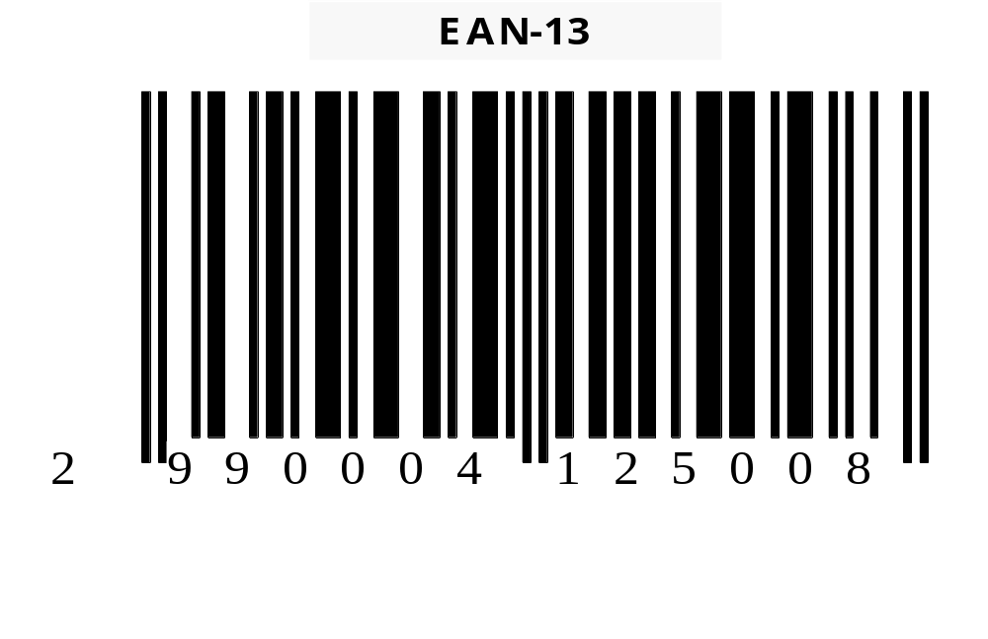

This structure makes 100,000 numbers available for coding products. However, of these 100,000 numbers, Indicod only has 80,000 available for assigning as codes to the producers, as the codes in which the first digit 2 is followed by 0 or 1 are reserved for use within the distributing companies.

2.3.1 The new structure of the code

The definition of the new structure aims to significantly increase the number of codes available for variable weight products, as the combination of the references identified (see Appendix B) multiplies their request significantly. Furthermore, the following properties have been preserved:
- The code remains of the EAN/UCC-13 type.
- The first digit remains the same, ‘2’.

The consequent result is represented by the following structure (see also fig. 3):
- An initial digit, which is always ‘2’.
- The following 6 digits, which represent the identification code for the product. This is obtained by using as the sixth digit the number for controlling the price in the current structure, as this is not required in the new structure.
- The next 5 digits represent the price in Euros, always with two decimal points. This means that the figures 03512 must be used in the code to represent the price 35.12 Euros, while 35.00 Euros would be represented by the figures 03500.
- The last digit is the control number for the whole code and is calculated on the basis of the previous 12 digits through the algorithm used for all types of EAN/UCC-13 coded products.
A significant increase in the number of codes available is gained by this structure. This is equal to 10 times those available currently.

Fig. 2.2: The new structure of the code (Indicod)
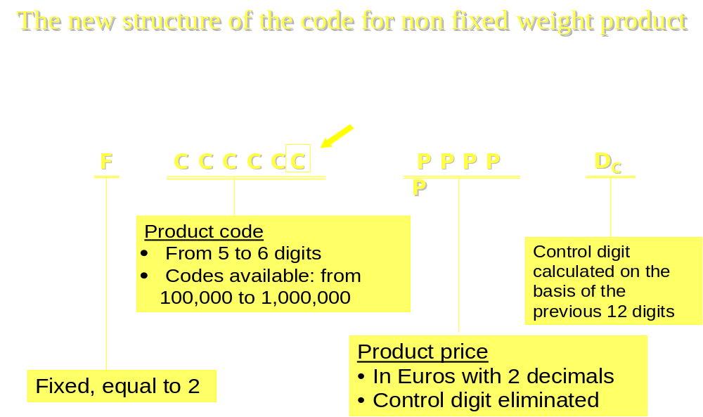

As regards packaging, the same structure is used as that currently in use. We will discuss labelling of the products in detail in the next chapter.

Fig. 2.3: The structure of the packaging code (Indicod)
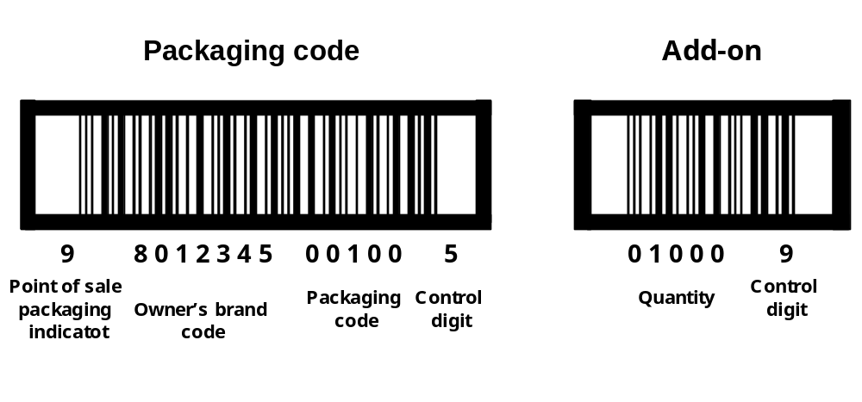

APPENDIX B

We show an outline of the main points discussed in the Osservatorio Pesi Variabili 2002 at Indicod. The work concentrated on the identification of the reference for the electronic identification for some variable weight products. The operational course for implementation and sample documents for fruit and vegetables, meat, fish, salami, cheese, bread and dairy products are in the following.

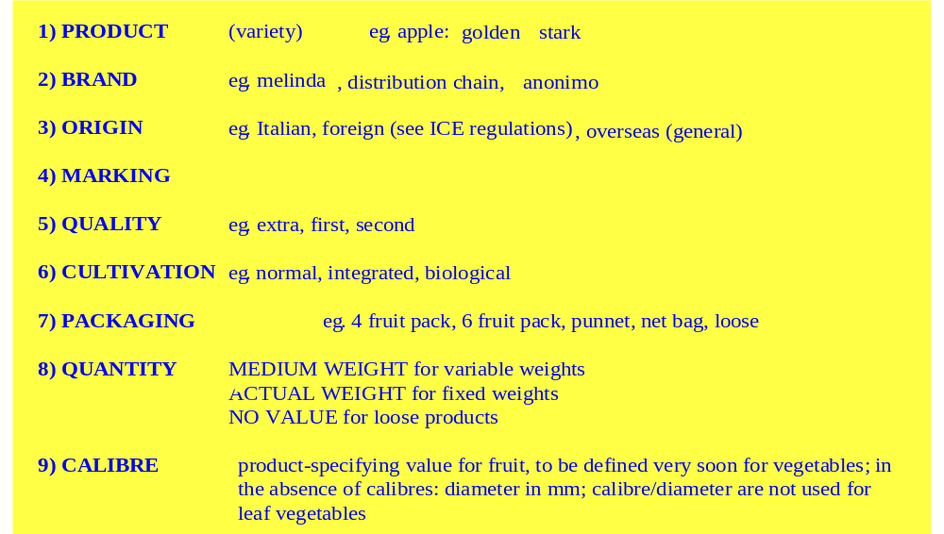
Sample document for fruit and vegetables (Indicod)

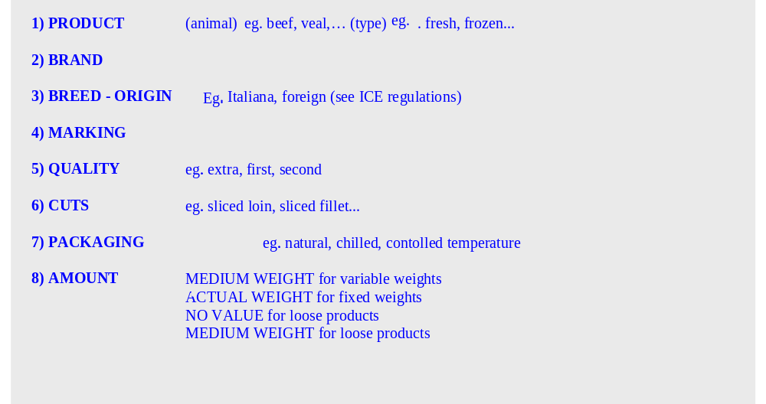
Meat document (Indicod)
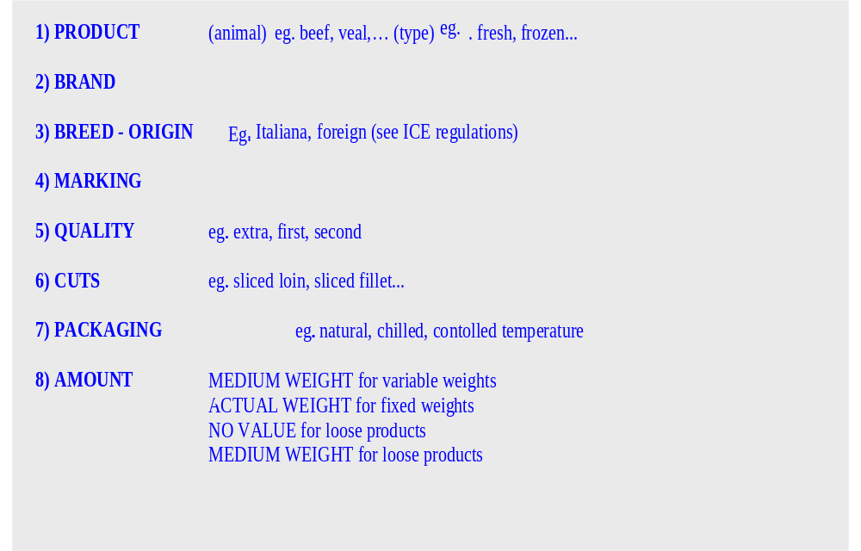
Fish document (Indicod)

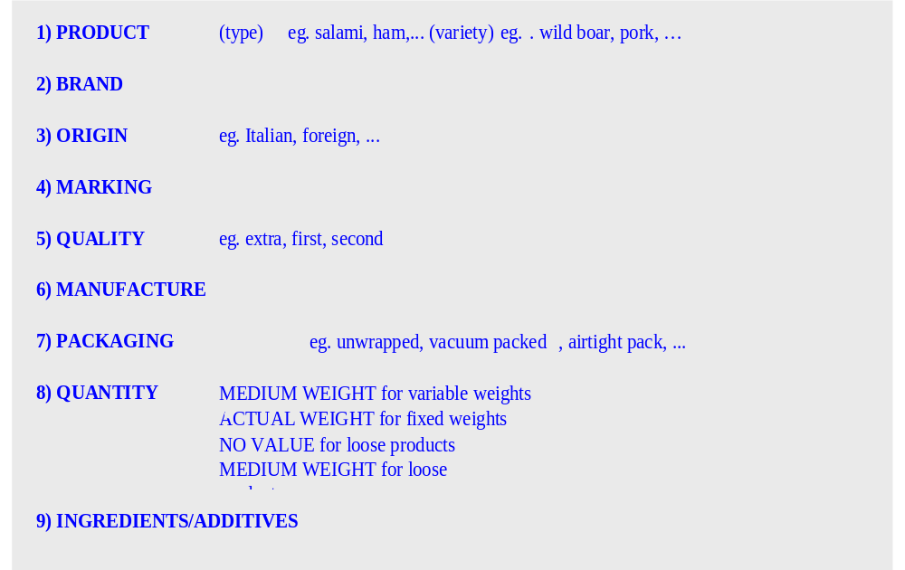
Salami document (Indicod)
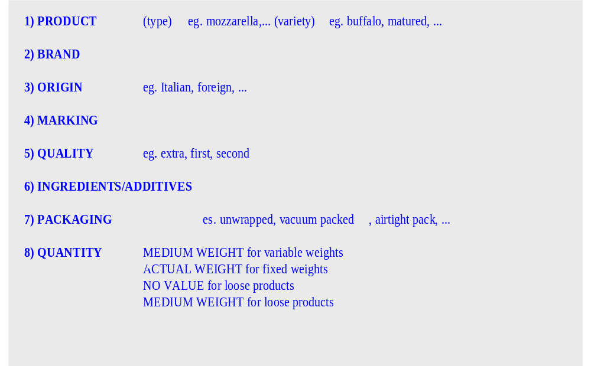
Cheese document (Indicod)

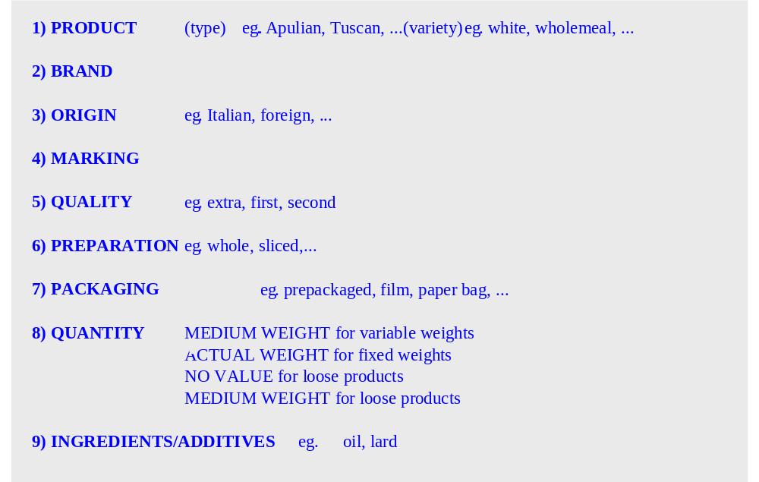
Bread and cakes document (Indicod)

Chapter 3

Traceability

3.1 Introduction

The traceability of products is becoming a subject of primary importance within the various food production chains. In an economic system with the companies challenging each other in a competition mainly founded on customer satisfaction, traceability has been for some time an indispensable instrument for gaining the consensus of the market. The cases of the pharmaceutical and car industries, who are able to withdraw defective products from the market very quickly and precisely, are only the end of the iceberg in the use of these new competitive strategies thanks to the advent of new information technology. The food sector markets are coming to know this new competitive model. Companies in this sector have for some years started to make use of information technology in a structural way, and to put traceability systems into place. The alarm triggered by the BSE crisis has only accelerated the process which was already underway.
As the history of economics shows, the moment a new procedure is introduced, it generates competition, advantages and an increase in the added value, which with the time tends to reduce until it changes from a novelty to an indispensable prerequisite for the presence itself on the market. Traceability, which currently in the food production system is in a transition phase of competitive advantages, will be no exception to this rule.
In this chapter we will analyse the subject of traceability from a technical and economic point of view, paying particular attention to the fresh products sector. We will discuss the different technology that is being studied and we will outline some concrete examples of implementation in Italian and foreign companies. The overall aim of the work is to provide some methodological suggestions concerning the general guidelines for the traceability of fresh products within the Italian agricultural system.
While dealing with the subject of traceability, we must always bear in mind that we are talking about a technical aspect. In fact, we must not confuse traceability with food safety, which is a much wider subject, or with marketing elements. However, it is without doubt that traceability contains many elements of food safety and marketing that single companies can use to their advantage.
The aim of traceability, as it has been specified in the White Paper on Food Safety and also in the European Parliament Regulations Proposal, is to know the course followed by the product and who are the actors who contributed to its generation.
Not by chance, current national legislation, where it exists, as for example in the case of traceability of meat products (subject discussed in appendix), does not oblige companies to declare if their product is healthy (safety) or what species of cow it comes from (marketing), but only to identify the agents who at each stage in production have contributed to the realisation of the product (compulsory information). This regulation recognises, however, the possibility for the companies to supply additional information (which may provide specific details regarding both safety and marketing); but a facultative feature is not a compulsory one. Traceability, finally, is a tool of knowledge for the customer, since it makes the production actors more responsible, as it allows them to be recognised.

3.2 The logic behind the traceability models

The implementation of a traceability process must respect the requirements of the different sectors involved, especially regarding:
- Structure of the chain and companies size;
- Types of products;
- Specific management characteristics;
- Logistics;
- Markets;
- Requests and expectation by the consumers.

It is normal for each food production chain to have its own characteristics, and it is important to consider the economic field in which determined instruments are allocated.
Traceability is a useful but expensive tool. This does not only require specific technological attributes, but also important managerial changes. Certainly, the benefits that this can generate are enormous. These are connected to the opportunity to generate synergies in the computerised management of the ordering cycle of the product, warehouses, information and physical flows, both incoming and outgoing. However, the benefits must be higher than the costs for each agent involved. Otherwise, no one will adopt the system, if not through regulations or market requirements.
The cost of traceability depends mainly on the amount of information that needs to be tracked, that is the information that should travel along the supply chain until the consumer. The more complex and difficult to track the information is, the higher the costs are. In any case, the consumer determines which information needs traceability.
Another characteristic, that the traceability system adopted should have, is that it must be largely agreed to by the companies as regards both the information to be tracked and the technology to be used. Indeed, it is important that such a process does not penalise any agent in the various chains, but assigns jobs, costs and gains equally. Also, as there are no regulations, (as in the beef sector) that impose a model that nobody can avoid, it is necessary implementing self-binding systems, accepted by all the actors.
The necessity for agreement leads to the search for standardisation of the process which is as generic as possible. Later on, we will enter into the details of this standardisation. Here, we must touch on it to analyse the defects that could occur if this was not.
The biggest risk is that of a proliferation of systems that are not necessarily compatible with each other, which would generate much confusion in the management of the process. Incompatibility would also mean a “cobweb” of the companies, in the sense that those adopting the same system would be obliged to work together even if other problems arose among them.

3.3 Methodical scheme of traceability models

We have seen how a voluntary traceability procedure must be constructed by identifying the:
- information that must travel down the supply chain;
- technical tools to be implemented for gathering this information and transporting it towards both the supplier and the customer.

The first point is the most important one. To establish what and how much is the minimum amount of information is the most delicate issue of the entire operation. As already said, the main source for determining this choice is the behaviour (and requests) of the consumer/customer. The information must necessarily differ according to the type of considered product. For example, in the fruit and vegetable sector, this could refer to:
  - type/variety;
  - origin/producer/packager;
  - quality;
  - cultivation (organic, integrated, etc.);
  - day of production/delivery date;
  - other.

Obviously, the larger the amount of information, the more complex the system becomes. This information is given to the consumer on an appropriate label placed on the package. The system for transmitting consumer unit information most widely used is the EAN 13 bar code (described in the previous chapter).
Now, we must face the problem of which instrument should be used for finding and transporting the information. At this regard, we can refer to the diagram of flux of information in a traceability circuit for the fruit and vegetable sector that is outlined here.
If the producers are too small (as in the Italian case), the packhouse/cooperative finds difficult to work the supplied product separately. This is because the supplies are limited and do not allow a single batch to be completed (not only in the case of fruit and vegetables, but also in mixing milk and dairy products and in the olive oil sector). Then, considering this difficulty, it is useful to separate the production/gathering phase from the trade phase.
The latter must necessarily, to avoid the problem of webbing, be standardised, so that to develop a unique traceability language capable of interfacing with all operators. In this phase, the product is a so-called non-retail item (logistical unit), mainly composed of batches.
The instrument used to transmit the information on the batch, which is now very widespread, is the EAN 128 bar code. This instrument, which we will introduce later in the structure of a logistical code, could also be used (together with the Serial Shipping Container Code) for standardising the trade phase of the traceability procedure for fresh products.
We will now analyse the phase regarding the relationship between the producers and the Cooperative/Packhouse.
This phase, which often represents a closed circuit, does not necessarily need to be standardised. In truth, every company could, in the relationship with their suppliers, install a technical gathering system for the information based on their own specifications. The type and quality of the information must, however, be functional to the standardised traceability process that comes after the Packhouse phase.
Some companies have already started their own systems for gathering information, which is then de-coded on entering the gathering/working/distribution centre and recorded in their own database. The tools usually developed are bar codes, alphanumerical codes and microchips, etc.
The main problem lies in the formation of the batch. Companies are not currently able to identify the different products which make up a batch because of the differences/mixing that this undergoes at the Packhouse. If it was not possible to trace a single producer, we could consider making the batch up according to other parameters which would allow the restriction of the range of suppliers. In this way another problem could be tackled by means of traceability. That is, the random destruction of the product. Indeed, in the case of one of the products being contaminated, the companies, not being able to identify the exact supplier, would be obliged to destroy all of the product.
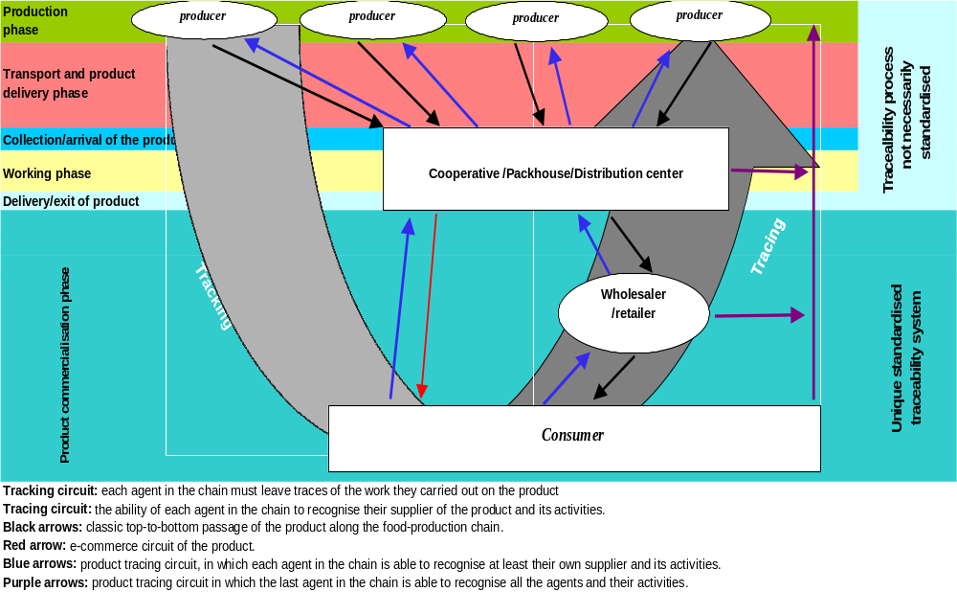
Figure 3.1 – Flow of information in a fresh-produce traceability circuit

The parameters for restricting the composition of the single batch could be identified as:
- originating in a specific geographical area;
- time/date of delivery;
- calibres;
- quality;
- cultivation;
- other.

Furthermore, it should also be pointed out that the entire traceability system must take into account the other systems for gathering information that companies already use, in order to create synergy and not to generate excessive bureaucracy. We refer to the HACCP, ISO 9000, ISO 9002, ISO 14000, Emas, EU rules and other regulations.
Finally, two further considerations. The first concerns the serious risk, which must be dealt with, that the type of information chosen does not oblige the companies to come across other procedures that are, for instance, industrial secrets. The second concerns the role, competences and responsibilities to be assigned to the transport companies.

3.4 Identification instruments and data transmission in the trade phase: standard bar codes

The most widely used instrument for transporting information in the trading phase is the EAN/UCC bar code. EAN International has laid down the Fresh Produce Traceability Guidelines, in which numbering systems and EAN/UCC bar codes for the non-retail item (e.g. cardboard boxes, boxes, bins) and logistical unit (e.g. pallets) have been developed. This paragraph outlines the main points of that laid down in this document (refer to the original document for further details).
According to EAN International, traceability requires a verifiable method for identifying farmers, fields and products on all containers and packaging in every stage of the supply chain. The identification numbers must be properly applied and registered to guarantee that all operations that occur throughout the chain are linked. Each company must be responsible for the links between their own suppliers and their own customers.
The focal point of the traceability process is the composition of the batch. The more homogeneous the batch is, the more accurate the traceability system is. Traceability data may be transmitted by electronic means, such as EDI messages or XML, and related to the logistic units identification number - the Serial Shipping Container Code (SSCC).

The traceability model represents:

- The physical flows are shown by the continuous arrows. Only those steps where a transformation occurs are taken into account.
- The flows of information are shown by broken arrows. These accompany the physical flows to assure traceability.

Figure 3.2 - Traceability model in the fresh product chain (EAN International)
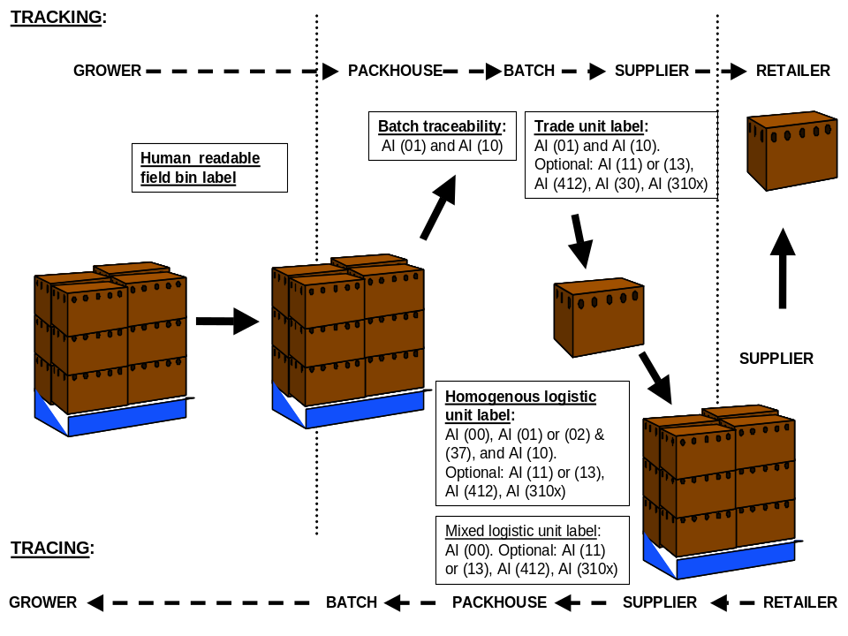

The introduction of the EAN/UCC standard allows transmission of data for traceability. The application of these standards requires the growers, packers, importers and exporters, carriers and wholesalers and retailers to register the serial numbers of the SSCC, identification numbers (Global Trade Item Numbers – GTIM), information on the non-retail item and the Global Location Numbers (GLN).
EAN/UCC Global Trade Item Numbers is an identification system based on assigning a unique identification number for each good in each stage of production and distribution. The visible aspect of this number is the bar code. The EAN/UCC numbering system ensures that each number is unique. The EAN/UCC Global Location Number is a number code that identifies each legal, functional and physical entity within a company. Each location is assigned a single identification number. The EAN/UCC-13 code is used for identifying the location.
Before going into the technical details, the document defines the consumer, trade and logistical unit.


Figure 3.3 – Differences between the consumer, trade and logistical unit (EAN International)
The procedure on which the guidelines are based may be illustrated thus:

Figure 3.4 - Trace and recall - Indicod

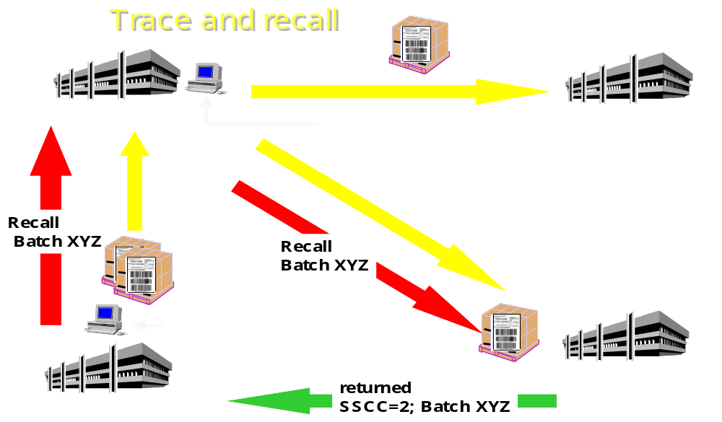

    - – Identification of locations.

Traceability requires the identification of all the physical entities (locations) where the product originates, is packaged, stored and stocked. This includes every agent in the chain.
Identification of location is necessary for sending EDI messages. The EAN/UCC Global Location Numbers (GLN) are a key concept in the management of the chain. The EAN/UCC-13 numerical structure is used for identifying locations. Below is the structure of this code.

Numerical structure of the GLN
EAN/UCC company prefix and location references | Control number
N₁ N₂ N₃ N₄ N₅ N₆ N₇ N₈ N₉ N₁₀ N₁₁ N₁₂ | N₁₃

Traded and logistics units should carry the GLN of the packhouse where the product was packaged. Each physical location of a packhouse must be assigned a GLN. Alternatively, the physical location of the packhouse can be determined by a combination of a Global Trade Item Number (GTIN) and associated batch number on a traded unit or the Serial Shipping Container Code (SSCC) on a logistic unit.

3.4.2 Identification of trade units
The normal rule for EAN/UCC numbering is that the supplier of the product assigns the Global Trade Item Number (GTIN). However, when a product is packed specifically for a customer and orderable only by this customer, it is then permissible for a GTIN to be assigned by the customer. EAN International has developed the GTIN to uniquely identify trade item. It contains 14 digits expressed in four different ways: EAN/UCC-14, EAN/UCC-13, UCC-12 and EAN/UCC-8. The table below shows the GTIN structures.

Numerical structure of the Global Trade Item Number
Numerical structures | 14-Figure Global Trade Item Number (GTIN)
EAN/UCC-14 | N₁ | N₂ | N₃ | N₄ | N₅ | N₆ | N₇ | N₈ | N₉ | N₁₀ | N₁₁ | N₁₂ | N₁₃ | N₁₄
EAN/UCC-13 | 0 | N₁ | N₂ | N₃ | N₄ | N₅ | N₆ | N₇ | N₈ | N₉ | N₁₀ | N₁₁ | N₁₂ | N₁₃
UCC-12 | 0 | 0 | N₁ | N₂ | N₃ | N₄ | N₅ | N₆ | N₇ | N₈ | N₉ | N₁₀ | N₁₁ | N₁₂
EAN/UCC-8 | 0 | 0 | 0 | 0 | 0 | 0 | N₁ | N₂ | N₃ | N₄ | N₅ | N₆ | N₇ | N₈

Generally, the numbers in red indicate the identification code of the company, assigned by EAN/UCC, while those in black indicate the identification references of the product (references agreed to by all participants in the national EAN/UCC systems).

3.4.3 Identification of the logistics unit

The Serial Shipping Container Code (SSCC) uniquely identifies the logistics unit. The SSCC is an 18-figure number, which is not significant, of fixed length and does not contain classifying elements.
The numerical structure of the Serial Shipping Container Code
Extension digit | EAN/UCC company prefix and product references | Check digit
N₁ | N₂ N₃ N₄ N₅ N₆ N₇ N₈ N₉ N₁₀ N₁₁ N₁₂ N₁₃ N₁₄ N₁₅ N₁₆ N₁₇ | N₁₈

In detail:
Figure 3.5 – Graphic structure of the Serial Shipping Container Code - Indicod

8012345
EAN Prefix
and Producer’s label code
(00)
Identifier
3
Non-defined indicator

000000001
Sequential number of the pallet
3
Check
Digit

The extension digit is assigned by the user according to internal requirements. We will not go into the assigning of the reference numbers, for which reference can be made to the original text. The EAN/UCC-128 system and the similar EAN/UCC Application Identifiers are used to represent the SSCC and other information requested. The Application Identifier 00 precedes the SSCC. The EAN/UCC-128 system is used to identify pallets or other logisitcs units carrying trade items. It uniquely identifies the logistic unit for administrative and logistics purposes and provides identifying elements for the item or its contents, together with additional information on any other operators involved. The EAN/UCC Logistics Label is fully compatible with ISO 15394 and EN 1573 standards. Furthermore, it provides a link between the physical flow of the goods (using EAN/UCC bar codes) and the flow of information (using EANCOM® messages). Below is an example of the structure of a logistics label which contains extra and variable information regarding the logistical unit, both in bar code (EAN 128) and legible form.

Figure 3.6 - The structure of the EAN/UCC logistical label - Indicod
EAN/UCC LOGISTICS LABEL
EAN International
rue Royale 145
B-1000 Brussels
UNIFORM CODE COUNCIL
To
8136 Old Yankee Road
Dayton, Ohio 45459
U.S.A.
SSCC
3 5412345 123456789 2
CONSIGNMENT
SHIP TO POST
541234550127501
(4
0
1
)5
4
1
2
3
4
5
5
0
1
2
7
5
0
1
(4
2
1
)8
4
0
4
5
4
5
9
(0
0
)3
5
4
1
2
3
4
5
1
2
3
4
5
6
7
8
9
2
From
840
45459

The upper part of this section contains general information

The middle part contains the contents of the bar code in legible form

The bottom part includes the bar codes and their interpretation

Figure 3.7– Information on the EAN/UCC logistical label - Indicod
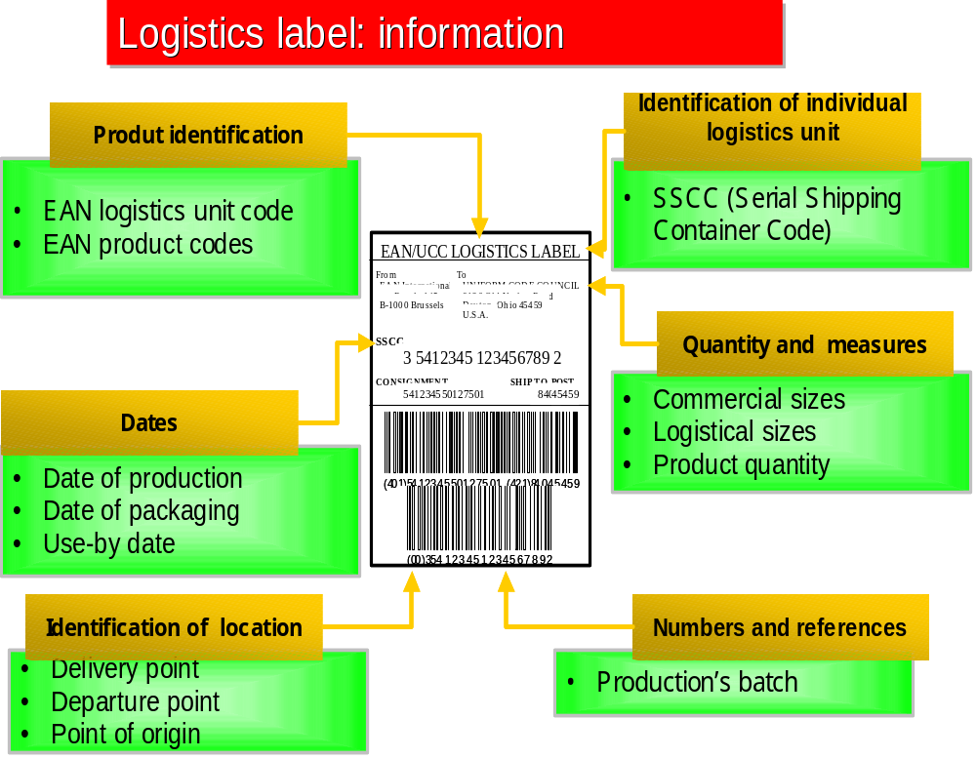

3.4.4 Bar coding and the logistics unit

EAN/UCC numbers which identify the trade item and logistics unit of fresh products are represented by the EAN/UCC-128 bar codes. These enable the identification numbers and related information to be automatically legible, storable and ready for elaboration. The use of the EAN/UCC-128 symbology is not intended for data scanned in points of sale. This system uses a special character, which is not numerical, known as Function 1 (FNC1), following the initial digit in the bar code. According to international ISO/IEC Standard 15417, the use of the FNC1 immediately following the start character of the 128 code is exclusively reserved for EAN/UCC.

Figure 3.8 – Example of a EAN/UCC-128 bar code (Indicod)


In conclusion, EAN International has developed a “global business language”. The system is based on the standard EAN 128 bar code which, as we have seen, enables a wide range of analysis methods of the supply chain, offering information on the origin and identity of the product. However, attaining complete traceability requires checks at every stage of the chain, especially for the production and the packhouse companies. A fast and accurate path requires collaboration by everyone throughout the chain. Backtraceability from the batch represents the weak link, unfortunately, because this should contain identical or only slightly different products. A tracing system capable of identifying a precise location and element should be based on a continuous flow of information and adequate logistic solutions. To obtain a similar scope, the companies must accept the following challenges:
- incorporate regulatory standards, such as HACCP;
- establish private programmes such as EUREGAP to cater for consumer demand;
- make sure that traceability becomes effectively operational together with logistic management, finance and administration.

3.5 Alphanumerical codes

The use of alphanumerical codes in the trading phase has not reached the level of use and standardisation of the bar codes, examined in the previous paragraph. In general, they are “owners” codes, which are adopted by the companies not only for the trading phase but for the entire process.
The structure of these codes will be discussed in the following paragraph.

3.6 Identification instruments and data transmission in the production and package phase

Here, we will deal with the communication of information between the packhouses and the supply companies. This type of relationship is, generally, specific and not compatible, as it is related to territory, the product and single characteristics of the companies, and not to experience and personal relationships among the operators. However, no form of standardisation is required in this phase, even though it would be desirable. The critical point in traceability is the difficulty in making up a homogeneous batch. From a technical/instrumental viewpoint, we can say that every packhouse should have its own data-gathering point, in which all the information sent by the suppliers or gathered on receipt of the product, is recorded. From the examples of traceability procedures already in use in some companies, we will be able to see how this gathering centre for information is indispensable. The information received by the packhouse is based on bar codes, alphanumerical codes or radio frequency systems.

3.6.1 Bar codes

The bar codes used are usually of standard or “owner” type. The standard ones are identical to those seen until now, and used in the trading phase. The “owner” type codes are created within the production circuit in each company and are suitable for the specific relationships between the company and its suppliers. The technical structure of these codes is, generally, not dissimilar from the EAN standard. We will subsequently have the chance to see some of these codes when we examine the traceability projects of some companies.

    - Alphanumerical codes

Alphanumerical codes are technically a sequence of numbers and letters of various sizes placed on labels. They are of “owner” and not standard type. They are used both at the packhouse and in the trading phase. The recognition phase is generally performed by an Internet connection, but is also done via Intranet. When the customer requests information on the product purchased, s/he goes to the supplying company’s website, and can access the required information by inserting the code in the appropriate place. This description immediately indicates that the system is not of standard type but creates a unique tie between the customer and the supplier. Very often, a third company performs the role of telematic centre for receiving the codes and provides information on the net. They offer services for a number of companies, both customers and suppliers (and final consumers).

3.6.3 Radio frequency systems

This technology is based on the use of radio frequency signals in the gathering of information, the so-called wireless system. Technically speaking, the data is gathered through a main computer which then transfers them onto a microchip installed on bins or pallets. When the data enters the packhouse access system, the chip is scanned by special scanners which then send the information to the internal data gathering centre. This, other than recording the data, is usually supplied with software that, depending on the working programme used, provides indications in real time on the internal distributing of the product. The strength of these systems is that the microchip is capable of sending a wide range of information from the field to the gathering centre, therefore allowing optimum management of the production systems with many suppliers and products. There are two weak points: the complexity of management, especially within the gathering centre, and the cost of implementing the system. Given the wide range of information gathering, the system allows the optimal information flow to the subsequent phase of trading. Many actors14 are in fact convinced that the future development of information transfer systems will use a combination of radio frequency systems and standard EAN 128 codes. The following is a description of a radio frequency system elaborated by Symbol Technologies15. The system originates from a tag (small data-carrying tokens, like microchips) connected to a database computer by a scanner (tag reader, a mobile or fixed scanner).
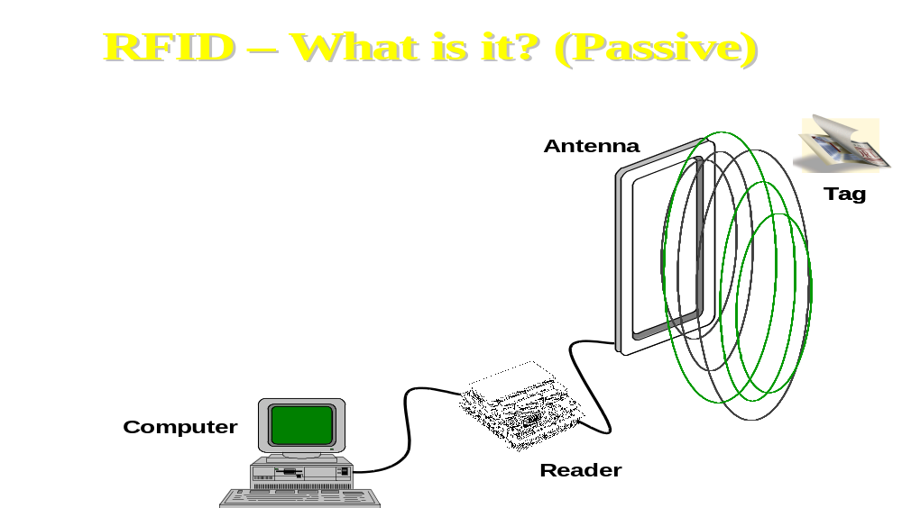
Figure 3.9 – Radio frequency system (Symbol Technologies)
The data can also be transmitted in the opposite direction to update the product information contained in the tag. RFID (Radio Frequency Identification) is not intended as a system for getting rid of bar codes, but as a system to reinforce them, as the two systems have different applications. Bar codes are low-cost systems for basic product information, while RFID is a more costly system for dealing with variables. Although RFID is not yet widely used, there are a number of examples of its success, such as “Speedpass”, a system which allows motorists to pay for buying petrol in petrol stations.
Some of the main operational problems may be summarised thus:
- Field of scanning: varies from a few inches to a few yards (metres) depending on the type of antenna array, which has a lesser field than fixed portals.
- Standards: some standards are fixed, such as ISO 13 MHz and EAN/UCC GTAG for UHF. The main question for the companies is choosing the correct type of RFID.
- Cost: tags cost between US$0.35 and US$1.00, and it is difficult to predict when these will become low-cost like bar codes.
- Multi-item scanners: RFID does not guarantee the accurate scanning of individual items on the pallets due to interference, but quantities in the batches are identified.

In the future, the success of RFID depends on its integration with the existing ADC (Automatic Data Capture) systems and hardware, as there cannot be “RFID islands”.
Some companies are in an advanced stage of experimenting with these systems. The Dutch brewers Heineken16 is developing the use of microchips in the bottling stage. The English supermarket chain
Sainsbury’s17 initiated pilot schemes in 1998 on the use of microchips in pallets for recyclable products, regarding the relationship between their distribution centres and supermarkets.
Such projects have led to the conclusion that this system:
- improves the flow of information in the supply chain;
- reduces labour costs;
- reduces stock losses;
- allows a more cost-effective management of the supply chain.
The Swedish distribution chain ICA18, together with the Ericsson computer company, is implementing the use of Bluetooth technology, which allows a wireless method of transmission for data using a long-wave radio frequency system (with a field of application from 10 to 100 metres). The system is based on the use of a specific chip which allows the use of portable phones for scanning and sending data.

3.7 Some examples of traceability

In the following subsections we illustrate some traceability projects, which are currently implemented in Europe.

3.7.1 Apofruit (Moc Mediterraneo – Italy)

The aims of the pilot project can be summarised in two phases.
PHASE 1: Traceability between the producer and the customer. The plan is to introduce an automated system for fruit arriving and sending it to the customer. The system will be based on the application of bar codes.
PHASE 2: Management of the traceability system to the final consumer. The plan is to integrate the system in order to manage traceability per consumer unit, and therefore transfer all producer information on to the label of this unit.
The functions being developed within the pilot project concern the following company procedures:
Tracing the product along the production process
A.1 actions to be taken in accepting incoming products;
A.2 actions taken in the product selection phase;
A.3 actions taken in the packaging phase;
A

Final delivery
B.1 actions taken in the delivery phase and interfacing with the Internal Management System for emission of the covering bill
B

A.1 Actions to be taken in accepting incoming products.
This phase requires a label containing the bar code relevant to the incoming batch from the partner/supplier to be produced automatically. The label will enable the product to be traced in all phases of the procedure. Upon delivery, the current system gives the partner/supplier a bill with the necessary information, including among other things: bill number, deliverer, product, date. This information constitutes the “body” of the label which will accompany the product in its journey to the customer. These will then be used directly from the current programme of delivery, which will be modified as necessary to allow for the printing of the labels, the number of which will be preventively given by the operator on the deliverer’s advice. This is because they must be prepared before the complete delivery of the consignment, as the subsequent phase of distribution is extremely fast and dispersive. The delivery note number will also become the bar code on the labels in the delivery. For printing the labels, a printer connected to the personal computers at all the entry points will have to be adopted. Frequently, different deliveries arrive together, and they must be put together in order to attain the necessary standard. Therefore, a “coupling” function managed by a portable batch terminal will be used. This function will enable the company employee to scan the bar code on the label of one item to be coupled and then another.

A.2 Actions during the product selection phase
Selection of the product enables division of batches by calibre. In this phase, two actions must be taken:
- the printing of n labels for the containers containing the calibrated product;
- placing of the product in the appropriate batch created by selection/calibration.
The connection will be made by an appropriate procedure from a computer, into which the bar code information on the batch and on the criteria used for selection will be inserted. This information registered on the computer will then be sent to the central computer, where they will be registered appropriately, creating of database. The labels will be produced by a printer guided by the same terminal used for loading data.

A.3 Actions in the packaging phase
An innovative method which will produce a card with a bar code for each order/pallet in order to automate all the working and product sending phases is planned. The cards will then be given to the packaging departments for preparing the goods. The new procedure will enable the printing of the cards for each order on request, subsequently indicating those that have already been printed. The stationing will be made up of a personal computer connected to the web and a laser printer.

B.1 Actions during the delivery phase and interfacing with the Internal System for producing the covering bill
The delivery phase concludes the tracing of the product throughout its course. In this phase, the body of the product in transit, with all the necessary information, is assigned to a confirmed order line. To do this, it has been thought to produce a user-friendly function, using advanced graphics. The pallet will be identified by the label previously printed and placed on the pallet during packaging.
The weighting phase will be carried out along two or three lines. They will all use the same software, and each one will have a personal computer, a laser gun connected using radio frequencies and a serial connection to the weighting machine.
The procedure will include the following phases:
- identification of the order line to be weighted, through reading the bar code on the pallet;
- interface with the weighting system for the automatic recouping of the weight;
- interface with the sending management system;
- the possibility to view a list of the “weighting being carried out” for several access keys (customer, order, article, etc.);
- automatic signalling on completion of the weighting of a complete order.
At the end, it will be possible to produce an automated working register, in which the product batches are connected to those sent to the customer.

3.7.1.2. Phase 2: Management of tracing to the final consumer

This last phase plans the upgrading of the pricing/labelling machines to allow for the trace code on the label of each package or trade item to be transferred.
Each labelling machine must be implemented with a bar code scanner which will allow access to the trace code on the labels applied to the products during the delivery and selection phases. Therefore, it will be possible to reproduce the trace code on the label for the consumer, which is no more than the number of the delivery bill or the batch code, with every change made to the printing programme.

3.7.2 Osas-Sibarit (Moc Campoverde – Italy)

The experimental prototype identifies the Production Block. However, this has been designed in the most extreme and complex conditions in which the food production sector could operate.
In fact, the characteristics of the experimental food production chain developed by Campoverde Moc are the following:
- a large number of associates (about 400);
- a large number of Production Blocks (about 1,600);
- high daily requirements (up to 8,000 cwt/day);
- large circulation of Bins (50,000);
- very quick turnaround of the incoming storeroom (average time between assignment and selling of about 3-4 days);
- high perish ability of products;
- restricted storage space.

The system is based on reader/writer microchip technology. Each component of the chain is identified by a chip, usually a reader, although some of them require a RW (reader/writer) type chip.
The following are identified by a chip:
- The companies.
- The production blocks.
- Transport vehicles.
- Drivers of the transport vehicles.
- The bins for transporting goods.
- The fork-lifts for internal movement of the goods .
- The storage cells.
- Cells units (traceability of the cell).
- The working/production lines.
- The labelling machines.

The process starts at the entrance to the building on arrival of a delivery coming from one or more blocks. At the entrance to the building, at the gate, there is a reader antenna, which the vehicle transporting the goods passes under.
The system automatically identifies:
- the vehicle;
- the driver;
- the company;
- the production blocks involved;
- the chips of all the bins.

After the weighting, in which multiple weighting is also effected, the system combines the Bins’ codes to the blocks. The system then emits the delivery bill by production block.
On the basis of the storage situation, the load arriving and the dynamic prevision model, the system then assigns the positioning of the bins within the warehouse, designating the cell and sector for each production block .
The cell and sector numbers then appear, together with the block, on the large display positioned in the main yard. The fork-lifts each have two reader chips and a system for registering operations. The first reader reads the chip for the first bin in the load transported (the only hitch in the system is that the bins in the vehicle must be stacked (4 bins per pile) so that the block is always the same in each pile). The second reader reads the chip that identifies positioning in the cell.
The system for registering the operations consists of 6 keys, two for each of the possible operating methods of the fork-lift:
- consignment to the warehouse from the main yard;
- loading of the working/production line from the warehouse;
- moving within the warehouse.

3.7.3 Vers Direct Nederland (The Netherlands)

Vers Direct Nederland (VDN) carries out intermediary activities in the fresh fruit and vegetable sector between its suppliers and customers. It has 140 Dutch suppliers, 64 Israeli and 1 Turkish. The main products dealt with are: tomatoes, pepper, aubergines, courgettes and almost the entire range of fruit products. Its income during 2000 was over 140 billion lire. Its customers are the main Dutch retailers and grocers. VDN does not have warehouses or storage platforms. It carries out virtual intermediary activities, in which supply and demand are connected. When an order arrives from a customer, VDN orders the quantity of product from one of its suppliers, who will then send it to customer through a transporter also chosen by VDN. The company buys and sells the product, but does not manage it.
This activity requires efficient organisation. All the supply companies, and the customers, are connected on the web by internal software using Microsoft Internet Explorer. This software, called ASC II, is of their own design. The circuit created is closed, in the sense that it is not possible to connect to it simply by surfing on Internet. A CD-Rom is supplied to all the companies who wish to join the network to download the programme.
The programme allows a wide range of information that is sent to VDN by both the buyer and the seller in the network to be managed. VDN creates the contact and buys/sells on the web instantly. They act like a stockbroker. This experience has been gained through managing auctions in Holland, which were very widespread in the fruit and vegetable sector. They do not use the EDI system because it is thought to be too expensive and incapable of uniforming the different software languages used, for example Microsoft, Apple and Mac.
An imaginary scenario: a trader asks VDN for a consignment of a product with determined characteristics and delivery time through the programme which operates on the web. VDN buys the product from one of its suppliers, from which it knows about availability, because this information has been given in the internal programme. VDN orders the consignment through a courier, also on the web (including air transporters). The seller company prepares the so-called batch-lines, that is they send VDN all the information regarding the batch. The internal VDN programme gives further information to the supplier and transporter regarding numbers and identification to be added to the label with the EAN code. In this way, the material batch travels from the supplier to the customer (bypassing VDN) with information in the standard EAN code and further information, which can be placed on a label stuck to the boxes. The buyer, opening the programme through a simple Internet connection, will enter the VDN database and will find all the necessary information on the batch ordered simply by inserting the EAN code and the additional codes. The system functions following the standard EDIFACT typology, which creates networks thanks to simple Internet connections, to which the additional information given by ASC II is added.
The system allows the complete traceability of the product, also thanks to the fact that the batches are always homogeneous because the suppliers are large companies.
All this information is catalogued in a standard way, in the sense that agreed numbers are used to indicate product references (variety, quality, etc.). There is a standard cataloguing procedure in The Netherlands. Four years ago, the large Dutch retailers, specifically Royal Ahold, together with EAN Holland and the government, put into place the so-called Unit Identifier Commodity Commission, which was the working nucleus for the classification and cataloguing of products. This activity was made easier by the fact that the trade channels are very concentrated. In fact, 80% of products sold in The Netherlands pass through the Retailer, which is dominated by the Royal Ahold Group. Sometimes, however, standard identification is not used in The Netherlands. Furthermore, this is not true for any other country.
All this information also allows the managing of the order, order confirmation, invoicing and warehouses to be improved. The critical point is in the fact that the personnel of the companies in the network, especially the supply companies, are not always capable of making the computer systems work. They still frequently use faxes.

3.7.4 Bloemen Veiling Holland (The Netherlands)

The Bloemen Veiling Holland company (BVH – better known as the Flower Auction Holland company) is a large cooperative managing flower auctions in Naaldwijk (The Hague), which together with the Alsmere (Amsterdam) one, is the biggest in The Netherlands. They both have the same monetary income.
BVH associates are Dutch flower producers, of which there are about 6,000. The amount of money generated by the Auction was over 2,658 billion lire in 2000. The number of people involved, both BVH employees and associate suppliers and buyers, is about 1,800. 80% of products are exported, and work is carried out in a number of other companies. Overall, the company grounds cover 550,000 m², of which 35,000 m² is refrigerating cells (the largest in the world). All the flowers produced are treated. The main sorts are: roses (922 million per year), chrysanthemums (770 million per year) and gerbera (350 million per year). The most widely produced pot plants are: kalanchoe (25 million per year) and chrysanthemums (18 million per year).
The Dutch producers have decided to combine and produce the Auction, which is managed by the BVH cooperative. Buyers participate in the auction, generally mass producers and exporters, who sell the products all over the world, particularly in Germany, the UK and France. Israeli, Colombian, Kenyan, Spanish and French producers are also associated with the cooperative.

The auction functions as follows:
During the night, the producers bring their produce to the Auction headquarters, which has enormous refrigerated rooms of different temperatures (for example, -8°C for roses). The producers, who are associates of the cooperative, are telematically connected (they each have their own identifying code) to the BVH server, which acts as a data bank which all the information regarding supply is fed into (producer’s name, product name, etc.). The Intranet network functions using the EDI and EDIFACT systems. The auction opens at 6 every morning. A trolley with a sample product runs through a hall with electronic tables full of buyers. The product is described and then the clock is started. The clock is a mechanism which starts off showing the offer price and then starts to go down. The buyers stop the clock at their preferred price, and order the quantity required (not less than a certain amount) on the electronic system in the hall. This system automatically prints the contract (the buyer must subscribe to the auction register and is assigned a personal code).
All information regarding the supplier’s, buyer’s and product codes and the quantity and price is included in the contract. All this information is printed on an internal 128 figure bar code (not EAN standard), which is then placed on the cases of product in question. Products are also identified using a numerical bar code. They will have been catalogued years previously with the Alsmere auction; this system is currently in force for the whole of The Netherlands. In the meantime, the product has already undergone two checks regarding what the supplier has declared. One takes place on entering the warehouse and one when the product goes up for auction. The auctioning phase closes at 11:00. Subsequently, we have in sequence:
- the distribution phase within the auction warehouse (duration: 60 minutes);
- withdrawal from the warehouse;
- loading (these last two phases last about 30 minutes).

The internally produced bar code is scanned at each phase. The transporters are part of the EDI network, as are the buyers. In this way, all passages through the Intranet network can be checked. Up to 10,000 contracts are produced on peak days. The system is complex. The main problems derive from relationships with the supplying companies’ personnel, who are not always capable of providing the correct information electronically. Obviously, this system also allows automatic management of the order, order confirmation, invoicing and stocks.
A system using microchips and EAN 128 bar codes to be placed on the pallets that make up the batch is now being experimented. Currently, the system only provides for the use of internal bar codes to be placed on each batch. This means that the pallet may contain products destined to more than one customer. Conversely, BVH is aiming, with the new system, at the construction of an integrated process which enables single pallets to be destined to single buyers. From a technical viewpoint, EAN 128 bar codes and microchips that identify, through integration, both the product and the supplier and buyer are placed on the pallets.

The EAN 128 code studied should be composed of the following:

8003 | = returnable container
087 | = country number
13022 | = organisation number
00762 | = type/objective
12345678 | = serial number code

The microchip structure functions through antennas installed within the auction halls. The microchip used is the Texas Instrument Glass Transponder Multipage R/W (read/write) 32 mm type. Everything is set up to improve the phases following auction. Regarding traceability, it must be said that an electronic system capable of gathering a similar amount of information must be capable of traceability everything, even fertilizers. However, the current system is closed, as it is effectively based on the EDI Intranet. In any case, anyone can adhere to the system by paying for admission to the auction. In this case, BVH sends all the instructions for the above-decribed procedures to the new company, including their identification number and the numerical catalogue for recognising products. However, subscriptions are expensive.

3.7.5 Albert Heijn (The Netherlands)

Albert Heijn (AH) is the biggest Dutch supermarket chain. It is part of the Royal Ahold group. The chain had deals totalling about 12,000 billion lire in 2000. It employs 20,000 people and has fruit and vegetable suppliers throughout the world. This number is fixed because companies must have certain determined characteristics in order to become an AH supplier. Working with fixed operators, AH does not have the problem of constructing a database. Management philosophy provides that suppliers respect their demands, especially regarding homgeneity of batchs. Those who cannot apply these, at least to some extent, cannot be suppliers. The system in place for traceability enables the consumer to be given all the information requested regarding the type of product, supplier’s name, calibre, type of production (organic or standard) and the country of origin. The system is constructed in two phases, both applying the EUREGAP and EAN standards.
The supplier must respect EUREGAP good quality regulations in order to label the package or box. These rules consist of applying identification numbers, which are: category (e.g. CAT 1 A-40 for Spanish oranges) and the calibre (e.g. CAL ½). This label also includes a standard EAN 14 bar code. This standard also enables identification of the producer and other information regarding the product and delivery times. The suppliers must always be able to prove that they are capable of following these regulations, or otherwise they leave the circuit of suppliers.
Regarding packaging (pallets, and then distribution), the supplier must label this, in a homogeneous way, according to AH internal regulations. These must be finalised to the use of the EUREGAP regulations described above. (Regarding this, AH recognises the great difficulty that large cooperatives may find in this phase.) Obviously, to do this, AH requires catalogues produced for numerically recognising products, especially in relationships with the producers. The catalogues have been created and are internally managed by AH. The transport system is centralised by AH, which uses their own transport companies (there are 4), therefore allowing better tracing along the entire chain. The whole process must refer to a global good quality system.

3.7.6 Martinavarro (Spain)

This is a Spanish cooperative with over 9,000 producers. They have implemented electronic identification systems which allow to manage the entire field – packhouse phase. This data gathering system allows for efficient traceability. The data originates from the field and is then placed into groups which are managed by the central server at the packhouse.
The composition of the batch follows criteria of homogeneity according to 4 categories of quality.

3.7.7 Anecoop (Spain)

This is a large Spanish cooperative of producers. The traceability system adopted is based on internal bar codes, which are capable of transporting all the information requested by the producers. These codes are managed in a way that respects EAN rules (outlined in the section on Fresh Produce Traceability Guidelines) in the trading phase. The composition of the batch is managed by a database inside the packhouse. The incoming product is selected on the basis of variety and delivery times. The batch is homogenised according to these variables.

Glossary

ADC: Automatic Data Capture – Automatic data receiving systems.
ASC x 12: Accredited Standards Committee x 12 – formed by ANSI (American National Standards Institute) in 1979, this commission is responsible for defining EDI standards in the USA.
CAO: Computer assisted Ordering – A retail system that automatically generates replacement orders when the level of these is less tha a pre-determined level.
EAN: European Article Number - European Association for bar coding products.
EANCOM®: a combination of the UN/EDIFACT standards produced by EAN International for standardising the messages for commerce and distribution.
EDI: Eletronic Data Interchange.
Extranet: applications which use the World Wide Web for a limited number of users, generally exchanging private information, and which is not accessible to everyone. They use the public Internet domain as a transmission system, but limit access with passwords or channelling systems.
INDICOD: Italian association for EAN numbering.
ISDN: Integrated Service Digital Network.
ISO: The International Organisation for Standardisation.
UN/EDIFACT: EDI for Finance, Administration, Commerce and Transport – a combination of standards, directives and guidelines, agreed internationally for the electronic exchange of structured data, managed by the United Nations.
GENCOD: Groupement d'études de normalisation et de codification – French organisation for EAN numbering.
GNL: Global Location Number – Number which identifies the location.
GTIN: Global Trade Item Number – Number which identifies the product commercialised.
ER: Efficient Replenishment.
POS: Point of Sale.
RFID: Radio Frequency Identification.
SGML: Standard Generalised Markup Language – An ISO standard (ISO 8879: 1986) produced by IBM. It is widely used in editing for coding information for independent sellers.
SSCC: Serial Shipping Container Code – a code of 18 numbers used to identify the transport units (usually pallets) containing standard or non-standard product combinations managed by UCC/EAN (it can be within the UCC/EAN 128 code).
SKU: Stock Keeping Unit.
UCC: Uniform Code Council – Association for uniforming bar codes in the USA and Canada.
XML: eXtensible Markup Language – Developed by the World Wide Web Consortium to place the SGML system on the web in a simplified form to overcome the limitations imposed by HTML (the normal Internet pages) and make Internet capable of new applications for the exchange of messages and documents.

Work on the catalogue product was developed by the EDI Works Meeting held at CSO (Centro Servizi Ortofrutticoli) in Ferrara, Italy, which Ismea took part in, in 2000.
Ismea-CSO: Proposta metodologica per la costruzione di Cataloghi Prodotti, Rome, Italy 7th february 2001.
GENCOD - EAN France: Le ÉCHANGES de DONNÉES INFORMATISÉS dans le secteur des FRUITS et LÉGUMES FRAIS, Issy Les Moulineaux, septembre 2000
This chapter is taken from the Coordination centre for the electronic identification of Moc products set up in 2001 at Ismea, and contributed to by Coop Italia, Indicod, CSO and the Mocs.
This paragraph is taken from Linee Guida per la Migrazione del Codice EAN/UCC per i prodotti a Peso Variabile. Indicod, Milan, June 2001.
This is based on the works carried out by: the working group Fresh Produce Treceability Guidelines, EAN International - UCC, Brussels; the working group on traceability in Mocs(in collaboration with Indicod, Coop Italia, Centro Servizi Ortofrutticolo di Ferrara); the working group on traceability in food companies in the Reggio Emilia region (coordinat by Centro Italiano Servizi TeTa); Osservatorio Pesi Variabili, at Indicod, Milan.
European Union Commission: White Paper on Food Safety, Brussels, January 2000.
European Union Commission: Proposta di Regolamento del Parlamento Europeo e del Consiglio che stabilisce i principi ed i requisiti generali della legislazione alimentare, istituisce l'Autorità europea per gli alimenti e fissa procedure nel campo della sicurezza alimentare, Brussels, November 2000
EAN International: Fresh Produce Traceability Guidelines, Brussels, March 2001.
Mitic, Miotrag: Food Safety - Using Technology to Improve Traceability – in the Cies Convention: The Intelligent Supply Chain, Amsterdam, October 2001
14 See the summary of the Cies convention: The Intelligent Supply Chain, Amsterdam, October 2001
15 Riso, Frank: Intelligent Chip Technology in the Cies convention: The Intelligent Supply chain, Amsterdam, October 2001
16 Teeuwen, Jan: Chip in Crate, in the Cies convention: The Intelligent Supply Chain, Amsterdam, October 2001
17 Banks, Andy: Supply Chain Development in the Cies convention: The Intalligent Supply Chain, Amsterdam, October 2001
18 Scheepsma, Leonard and Iarnesjo, Jan-Olof: A World Without Wireless – Bluetooth Technology and its Application in Retail – Cies convention: The Intelligent Supply Chain, Amsterdam, October 2001
Interview conducted by Ismea on Monday 1 October 2001 with the Director of VERS DIRECT NEDERLAND, Mr. Leo de Jong - Barendrecht, Rotterdam, (Holland) .
Interview conducted by Ismea on 2 October 2001 with Mr. Bert van den Bosch, Logistical director, and Mr. Multem, his colleague at BLOEMEN VEILING HOLLAND - Naaldwijk, The Hague, Holland.
Interview conducted by Ismea on Wednesday 3 October 2001 with Mr. Willem F. Hofmans, quality manager of ALBERT HEIJN - Zaandam , Amsterdam , Holland.
Martinavarro, Joaquin, MARTINAVARRO: intervention at the forum Traceability as Benefit, NOT Burden , 3rd Official EUREPGAP Conference, Bologna, Italy 11 / 12 October 2001
Mar Vilanova, ANECOOP: intervention at the forum Traceability as Benefit, NOT Burden , 3rd Official EUREPGAP Conference, Bologna, Italy 11 / 12 October 2001

