UNITED KINGDOM
The following information was provided and approved by the authorities of the countries listed. The United Nations Economic Commission for Europe (UNECE) is not responsible or liable for the content provided and declines all legal implications related thereto.
Date: January 2018
COMPETENT AUTHORITY | EXPLANATIONS | PHOTO EXAMPLE (IF AVAILABLE)
Rural Payments Agency  Address: PO Box 69 Reading RG1 3YD  Web: https://www.gov.uk/guidance/comply-with-marketing-standards-for-fresh-fruit-and-vegetables  Email: hmi-tdc@rpa.gsi.gov.uk  Phone: 0044 345 607 3224 | - UK codes are issued by the Rural Payments Agency.  The code format is as follows: P/12345. The lead letter could be either A, B, C, D, E, F, G, K or P followed by 5 numbers. | 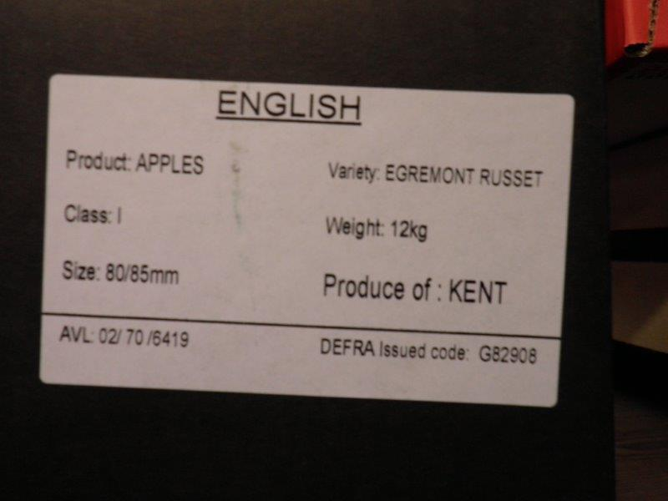

The designations employed do not imply the expression of any opinion whatsoever on the part of the United Nations Secretariat concerning the legal status of any country, territory, city or area or of its authorities, or concerning the delimitation of its frontiers or boundaries. Mention of company names or commercial products does not imply endorsement by the United Nations.

