SPAIN
The following information was provided and approved by the authorities of the countries listed. The United Nations Economic Commission for Europe (UNECE) is not responsible or liable for the content provided and declines all legal implications related thereto.
Date: January 2018
COMPETENT AUTHORITY | EXPLANATIONS | PHOTO EXAMPLE (IF AVAILABLE)
Agencia Espanola deConsumo Seguridad Alimentaria y Nutricion (for RGSEAA, RSGA, NRS, RSA code marks)  Ministerio de Economia, Industria y Competitividad (for SOIVRE code marks)  Address: Po. De la Castellana, 162. 28046-Madrid  Website: www.mineco.gob.es  Phone: +34912582852  Ministerio de Agricultura, Pesca, Alimentacion y Medio Ambiente (MAPAMA) | - RGSA is the General Sanitary Registry Code. RGSA is the same as NRS or RSA (RGSA xx.xxxxxx/xx; NRS xx.xxxxxx/xx; and RSA xx.xxxxxx/xx). The following website is available In order to check any particular company: http://rgsa-web-aesan.msssi.es/rgsa/formulario_principal_js.jsp  - The code starting with SOIVRE (XX/NIF or DNI) is the registration number of the database for national traders in fruit and vegetables according to EU Regulation 543/2011. However the SOIVRE code is not available on the internet, therefore the following address should be contacted to ask for any particular company: Sgsoivre.sscc@comercio.mineco.es  - Information on the registration code of the agri-food industry by Autonomous communities and MAPAMA can be found at: http://www.mapama.gob.es/es/ministerio/servicios/informacion/informacion-y-atencion-al-ciudadano/default.aspx | 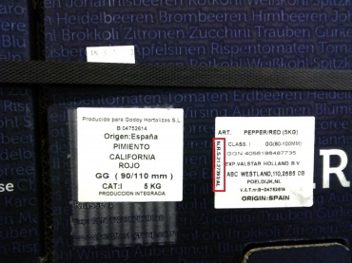  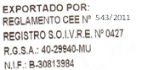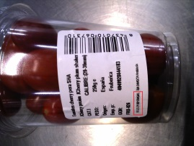  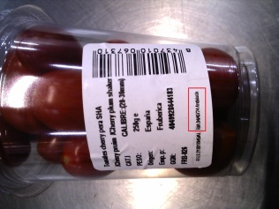  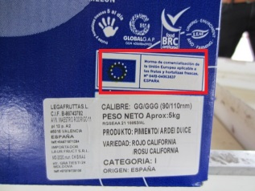
The designations employed do not imply the expression of any opinion whatsoever on the part of the United Nations Secretariat concerning the legal status of any country, territory, city or area or of its authorities, or concerning the delimitation of its frontiers or boundaries. Mention of company names or commercial products does not imply endorsement by the United Nations.

