SOUTH AFRICA
The following information was provided and approved by the authorities of the countries listed. The United Nations Economic Commission for Europe (UNECE) is not responsible or liable for the content provided and declines all legal implications related thereto.
Date: January 2018
COMPETENT AUTHORITY | EXPLANATIONS | PHOTO EXAMPLE (IF AVAILABLE)
Department of Agriculture, Forestry and Fisheries  Address: Private Bag x250, Pretoria 0001  Web: www.daff.gov.za  Email: billym@daff.gov.za  Phone: +27 (0) 12 319 73 09  Fax: +27 (0) 12 319 6791 | A Food Business Operator (FBO) Code is an alpha-numeric code which is registered with the Competent Authority by food business operators under the Agricultural Product Standards Act No. 119 of 1990.  The purpose of the registration of FBO codes is to facilitate traceability by means of tracing and tracking of products one step up and one step down in the supply chain. Each FBO is allocated a unique code by the Competent Authority. Examples include farms, packhouses, transporters, exporters, etc who are responsible for the production, handling, packing, processing and distribution of agricultural products of plant origin destined for export.  The food production unit (farm) is identified by PUC – Production Unit Code and packing facility is identified by PHC - Pack House Code. The standards and requirements regarding the control of export of agricultural products stipulate that all containers containing agricultural products shall be marked with the PUC or PHC which is registered with the Competent Authority.  The Competent Authority is able to track and trace a food product using the PUC code indicated on the container as shown on the photo which includes the indication of PUC: H0196 | 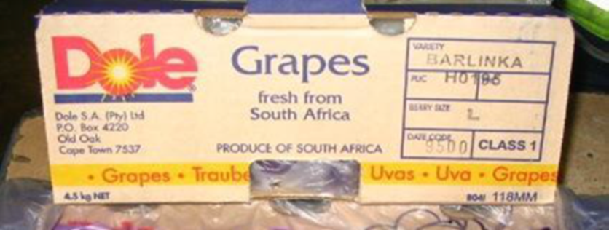

The designations employed do not imply the expression of any opinion whatsoever on the part of the United Nations Secretariat concerning the legal status of any country, territory, city or area or of its authorities, or concerning the delimitation of its frontiers or boundaries. Mention of company names or commercial products does not imply endorsement by the United Nations.

