BRAZIL
The following information was provided and approved by the authorities of the countries listed. The United Nations Economic Commission for Europe (UNECE) is not responsible or liable for the content provided and declines all legal implications related thereto.
Date: May 2020
COMPETENT AUTHORITY | EXPLANATIONS | PHOTO EXAMPLE (IF AVAILABLE)
Ministry of Agriculture, Livestock and Food Supply - MAPA  Address : CGQV/DIPOV/SDA/MAPA  Esplanada dos Ministérios, Bloco “D”, Sala 236-A  70063-900 Brasília, DF  Brazil  Web: https://www.gov.br/agricultura/pt-br/assuntos/inspecao/produtos-vegetal  Email: cgqv@agricultura.gov.br; dipov@agricultura.gov.br  Phone: 55-61-3218-34-28 | - CGC/MAPA  Federative Unit (alpha) State code (AC, AL, AM, AP, BA, CE, DF, ES, GO, MA, MT, MS, MG, PA, PB, PE, PI, PR, RJ, RN, RO, RR, RS, SC, SE, SP or TO), followed by a numerical code with 6 digits (including zero) and a verification numerical number.  - This code is issued after a company sends its full registry details as set out on national regulation (Instrução Normativa SDA nº 09, de 21 de maio de 2019).  - The code is accessible in a public database for verification:  List of registered establishments (click on the tab CGC)  or  http://indicadores.agricultura.gov.br/qualidadevegetal/index.htm (click on the tab CGC). | CGC/MAPA code:  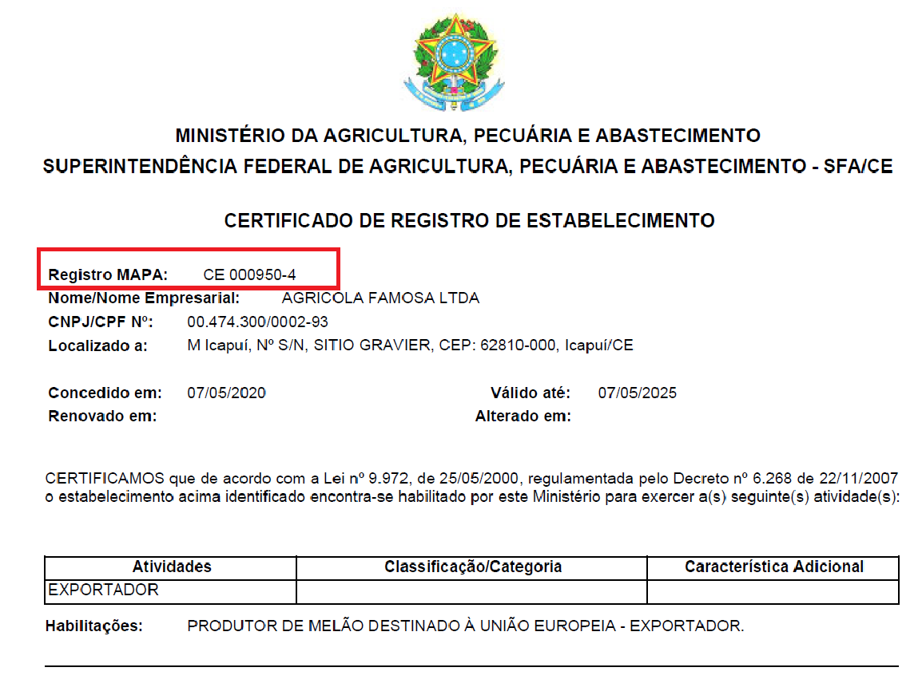
The designations employed do not imply the expression of any opinion whatsoever on the part of the United Nations Secretariat concerning the legal status of any country, territory, city or area or of its authorities, or concerning the delimitation of its frontiers or boundaries. Mention of company names or commercial products does not imply endorsement by the United Nations.

