The Storm in the Czech Republic (18.01.07 ).

During the night of January 18th, forest land in the Czech Republic was ravaged by the wind storm “Kyrill”, and caused extensive damage to the forest areas, especially in the South-West part of the country. In the whole of Central Europe, the total damage is estimated around 55 million m³. In the Czech Republic the estimated damage is around 10 million m³.

The Czech Ministry of Agriculture declared the state of emergency for the particular affected localities from 25th January to 5th February 2007. This decision was required because of security measures. Therefore, quick action was undertaken to select companies for timber removal and for forest regeneration, especially for the main part of state forests, given the extreme situation.

The wind damage has affected many forest owners, mostly state forests, which are generally under the administration and management of the Ministry of Agriculture (more than 5.1 million m³).

One of the most damaged areas is the Šumava National Park, with about ca. 700 thousand m³ lost in this important natural green border between the Czech Republic, Germany, and Austria. Wood in the most highly protected (first zone of protection) area will not be processed (zones without control measures). This area is under the administration and management of the Ministry of Environment. Also significant damage is registered in other state forests; for example in forest under care of the Ministry of defence (ca. 980 thousand m³).

The quantity of wood damaged is in many of these areas considerably bigger than the total allowable cut. (Map No.1)

Map No.1 – Storm damage (% of total allowable cut).
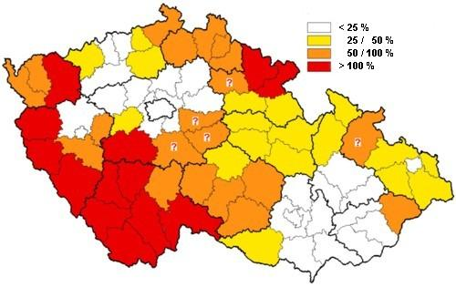

Source: FPS of the MGMRI (Knizek, Liska: Lesnicka prace, February 2007).

The Kyrill windstorm hit mainly sites at higher altitude with the “Norway spruce” as a predominant kind of tree for these locations. Consequences to be expected are a higher appearance of insects this summer, especially the bark beetles, mostly Ips typhographus L.. (Map No.2) All responsible institutions and officials are monitoring carefully the development around this matter and will carry out special measures as needed.

Map No.2 – Bark beetle risk.
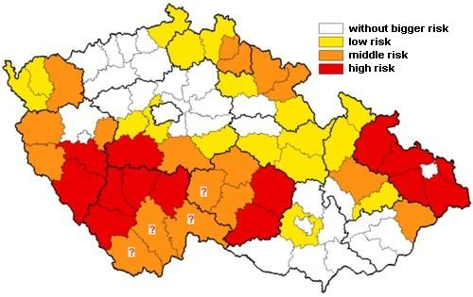
Source: FPS of the MGMRI (Knizek, Liska: Lesnicka prace, February 2007).

Overview of estimate of wind damage).

Ownership | Volume of damage (million m3) | Storm-damaged wood processed (million m3) | Share of damaged wood that has been processed (%)
Forests of the Czech Republic, S.E. | 5.1 | 2.6 | 51.0
Military Forests and farms of the Czech Republic, S.E. | 1.0 | 0.48 | 48.0
Private and municipal | 3.2 | 2.30 | 71.0
National parks | 0.8 | 0.48 | 48.0
Total | 10.1 | 5.86 | 58.7

Source: Ministry of Agriculture of the Czech Republic (15.5.2007).

This report has been done on the basis of articles from the Czech forest magazine “Lesnicka prace” (Forestry labour), the information from the editors, Forest protection service of The Forestry and Game Management Research Institute (FPS of the MGMRI) and Ministry of Agriculture of the Czech Republic.

