


Timber Committee European Forestry Commission

United Nations Economic Commission for Europe Food and Agricultural Organization

Review of the elaboration process, contents, dissemination and use of

the MCPFE/UNECE/FAO report on State of Europe’s Forests 2007

Roman Michalak, Eve Charles
UNECE/FAO Timber Section

Geneva, 31 December 2009

Acknowledgments

Special acknowledgments should be addressed to numerous experts from countries, national and international organisations that contributed to this Enquiry. We are particularly grateful to all UNECE colleagues who were involved in forming the presented results. Special thanks are directed to Mr. Alex Korotkov and Mr. Kit Prins who assisted in the review and in the final formulation of the review results.

Contents

- Introduction.....................................................................................................................4
- Report evaluation by the UNECE/FAO Timber Section’s parent bodies and partner organisations....................................................................................................................7
2.1 5th Ministerial Conference on Protection of Forests in Europe, Warsaw 2007.8
2.2 The thirtieth session of the Joint FAO/UNECE Working Party on Forest Economics and Statistics, Geneva, 2-3 April 2008.........................................................8
2.3 External review of the MCPFE process within the period 2008-2009...............9
- Questionnaire on the elaboration process, contents and dissemination of the report – feedback by participants in the reporting process.........................................................11
3.1 Part I – Report elaboration process.................................................................11
3.2 Part II – Report contents and dissemination....................................................13
- Questionnaire on the report’s content, appropriateness and use – feedback by report’s users………………………………………………………………………………..….15
- Evaluation of the dissemination of the report...............................................................22
5.1. Dissemination of the MCPFE 2007 report......................................................22
5.2. Analysis of visibility of the SoEF 2007 on internet...........................................22
5.3 Analysis of the use of the SoEF 2007 database................................................24
- Final conclusions and recommendations for future activities.......................................26
- Annexes ........................................................................................................................31
Annex I. Terms of Reference for the Review of the elaboration process, contents,
dissemination and use of the MCPFE/UNECE/FAO report on State of Europe’s Forests 2007............................................................................................................................................32
Annex II. Conclusions from the 1st Meeting of the UNECE/FAO/MCPFE Advisory Group, Geneva, Switzerland, 24 February 2009........................................................................35
Annex III. Extraction from the report of Joint FAO/UNECE Working Party on Forest Economics and Statistics, thirtieth session, Geneva, 2-3 April 2008............................................................................................................................................37
Annex IV. The MCPFE External Review report at the MCPFE Expert Level Meeting on 24-25 November in Oslo (extraction) .......................................................................................39
Annex V. Enquiry for review of the MCPFE/UNECE/FAO report State of Europe’s Forests 2007 - report’s producers..............................................................................................41
Annex VI. Review of the use of the MCPFE/UNECE/FAO State of Europe Forests' report Results from a survey conducted by the UNECE/FAO secretariat – report’s users...........................................................................................................................................46
Annex VII. Results of the Internet search for State of Europe’s Forests 2007..................55
Annex VIII. List of the MCPFE quantitative indicators for SFM……...............................60

- Introduction

The United Nations system-wide assessment includes self-evaluations, which are conducted in each biennium to ensure that the activities carried out under the sub-programme correspond adequately to the UN objectives and to the needs of member States, stakeholders and clients. For the biennium 2008-2009, it has been decided to review the production, contents, dissemination and use of the report on the State of Europe’s Forests 2007 (SoEF 2007).

The report on the State of Europe’s Forests 2007 is the most recent publication in the series of European forest resources assessments which has been prepared under the auspices of United Nations Economic Commission for Europe (UNECE), Food and Agriculture Organization of the United Nations (FAO) and the Ministerial Conference on the Protection of Forests in Europe (MCPFE). The report is considered to be the most comprehensive and up-to-date assessment of European forests and forest management produced so far. The process lasted approximately four years and involved hundreds of experts. For the first time, all data collected for the needs of the report preparation have been made available for public access through a web-based database. The preparatory process for the elaboration of the new edition of the report which should be presented at the 6th Ministerial Conference on the Protection of Forests in Europe in Oslo in 2011 has already begun. Analysis of the most recent preparatory process and learning about the report’s users, their opinions, as well as the use of collected data, is thus of critical importance for the preparation of the next report.

The self-evaluation entails collecting opinions with regard to the report’s quality and appropriateness by national correspondents, authors of the report, researchers and other end users. The methodologies applied for this self-evaluation range from discussions at meetings and with individual users to enquiries (Annex I). The UNECE/FAO Team of Specialists on Monitoring Sustainable Forest Management and the FAO/UNECE Working Party on Forest Economics and Statistics provided comments on the preparatory process, as well as on the report itself, during their meetings in 2008 and 2009. Information on the dissemination of the publication and statistics on downloads of the source data from the website of the European Forestry Commission complement the review process.

The final report of this self-evaluation, completed in December 2009, is expected to serve as basic source of information for the organization of the reporting process for the next Ministerial Conference, including the production of the report, its contents, dissemination and database. The report will be shared with the Team of Specialists on Monitoring Sustainable Forest Management, the Advisory Group on the Elaboration of the State of Europe’s Forests report, and the Bureaux of the UNECE Timber Committee and FAO European Forestry Commission. Despite the focus of the review on pan-European reporting, the outcome of the exercise will be of a broader usefulness. The information collected will contribute to an improvement of the quality and the outreach of other outputs prepared by the UNECE Timber Section as well as to other, national and international, reports on criteria and indicators for sustainable forest management.

Background

The MCPFE/UNECE/FAO report on the State of Europe’s Forests 2007 follows the structure of improved MCPFE Pan-European Criteria and Indicators for Sustainable Forests Management, which includes 35 quantitative and 12 qualitative indicators. The report is based on forest resources assessment and other forest sector-related data collected from MCPFE and FAO national correspondents and international data providers. Information on some indicators was presented in a form of case studies.

The SoEF 2007 report continues the series of European forest resources assessments that had been prepared by UNECE/FAO and/or MCPFE, and which is expected to be maintained. In the framework of preparations for the next assessment cycle it is of utmost importance to collect experiences and views from both the report’s users and producers.

Objectives

The main objective of this evaluation process was to improve knowledge on usage of the report State of Europe’s Forests 2007 and through this to evaluate the appropriateness of the format and contents of the recent report. The second goal was to use the results in planning and producing State of Europe’s Forests 2011 (SoEF 2011).

The review assessed the effectiveness and usage of the report, mainly by answering the following questions:
- Does the report achieve its stated purpose?
- Which impact did the report achieve?
- Who are the primary users of the report? How many users were reached? Where are they located? Which potential users were not reached?
- In which manner could the production process of the report be improved?
- In which manner could content and the presentation and of outputs be improved?
- How could the report’s life be extended?
- Could the promotion of associated outputs (database, national country reports) be improved?

Methodology

The review process covered a number of SoEF 2007 related activities, undertaken at different levels and addressing different groups, during the biennium 2008 - 2009 that included different aspects of the whole process of production of the report, from the source data collection, to the dissemination of the final products. The subject of evaluation was the production process and applied methods for cooperation with various partners, which included national correspondents, advisors, authors, reviewers, editors. This included also effectiveness of the applied means for cooperation like the Team of Specialists on Monitoring Sustainable Forest Management, the Advisory Group on the Elaboration of the State of Europe’s Forests report.

The key element of the evaluation was the assessment of the SoEF 2007 report that encompassed both quantity and quality of the contents and appropriateness of its graphic form. Evaluation of the report’s dissemination and extension processes was carried out as well for the needs of assessing the report’s impact, including general users, science and policy makers.

The review has been conducted via the differentiated set of tools, tailored to the particular tasks. The range of applied methods vary from the Section’s internal assessment of the process effectiveness, through evaluation, conclusions and recommendations received from parent bodies (Joint FAO/UNECE Working Party, UNECE Timber Committee, and FAO European Forest Commission), and ending at various questionnaire techniques.

Applied method has also entailed questionnaires addressed directly to national contributors and users as well as researchers on end-users’ opinions on the report’s quality and appropriateness. In addition to the questionnaires, an analysis of the dissemination process has also been carried out, of both paper copies distributed and downloads of electronic documents. Finally, the frequency of the report in the Internet was analysed, in order to collect additional information for report’s usage and impact assessment.

2. Report evaluation by the UNECE/FAO Timber Section’s parent bodies and partner organisations

The report on State of Europe’s Forests 2007 presents one of the most important sources of information about forests and forest management in Europe, serves as the main reference for evaluation and development of forest related policies. Its elaboration involved significant amount of human and financial resources. The report and its production process were a subject of discussion and review of the MCPFE and UNECE/FAO parent bodies. The report’s contents was presented to and discussed by the 5th MCPFE Conference (November 2007, Warsaw), production process was reviewed by the FAO/UNECE Working Party on Forest Economics and Statistics (April 2008, Geneva), aspects relevant to the report were also covered by the external review of the MCPFE process.

5th Ministerial Conference on Protection of Forests in Europe, Warsaw 2007

The report State of Europe’s Forests 2007 was presented to the 5th MCPFE Conference by Prof. Dr. Michael Koehl and Dr. Ewald Rametsteiner (the main editors of the report). The report set the background for the introductory session of the Conference “Europe’s Forests - state of art and challenges ahead”, where the contents and conclusions of the report were addressed by the sessions’ key speakers Ms. Mariann Fischer Boel, European Commissioner for Agriculture and Rural Development, Mr. Marek Belka, Under-Secretary General and Executive Secretary of UNECE and Mr. Jan Heino, Assistant Director-General, Forestry Department, FAO.

All the key-note speakers acknowledged the report as a most important source for evaluation of the state of forests and sustainable forest management in Europe. Ms. Mariann Fischer Boel, welcoming the report State of Europe’s Forests 2007, underlined that policies were only as good as the information on which they are based, so the SoEF 2007 report would shine valuable light on what should be done in the future. Mr. Marek Belka said that the SoEF 2007 report, jointly prepared by UNECE with the Liaison Unit Warsaw and FAO, showed, with a few exceptions, that Europe was moving towards sustainable forest management. Mr. Jan Heino stated that the contents of the report on the State of Europe’s Forests 2007 gave basis for conclusion that Europe has achieved sustainable forest management. The above statements proved the relevance of the report as a main source of general information on status and trends of forests in Europe. The session confirmed also that the major role of the report which was to provide this information to high-level policy makers was fulfilled.

The thirtieth session of the FAO/UNECE Working Party on Forest Economics and Statistics, Geneva, 2-3 April 2008

The FAO/UNECE Working Party on Forest Economics and Statistics (WPFES) reviewed the preparatory process of the report on State of Europe’s Forests 2007, which was issued in November 2007 under the responsibility of UNECE/FAO and the Liaison Unit Warsaw for the Ministerial Conference on the Protection of Forests in Europe and co-funded by the European Commission (Annex II). The Working Party considered the report as being useful and as being a tremendous improvement on its predecessors.

The WPFES delegations made many detailed and constructive comments and suggestions, including the following:
- A heavy burden had been laid on national correspondents by the close proximity of SoEF 2007 and the Global Forest Resource Assessment (FRA) 2005, with possibly different status for the same reference year 2005.
- Data supplied by international data providers had been submitted to national correspondents for review rather late, giving insufficient time to consult other sources and improve the data analysis.
- The validation process for the quantitative indicators, although long and resource intensive had been very beneficial, resulting in improved data quality and better understanding of the issues. Some of the consistency checks incorporated in the enquiry had been unnecessarily burdensome (rounding issues).
- A few countries had not supplied data, even though some data existed, partly because of misunderstandings and failure of communication.
- The “traffic lights” analysis of sustainable forest management (different colours for positive, negative or stable developments) was an easily understandable tool for presenting the overview.
- The delay in provision of an online database was a hindrance to researchers and prevented the dissemination of the explanatory matter behind each observation. Ideally the database should make it possible to extract all the data for a single country, including the information provided by international data providers.
- The data on socio-economic indicators, including value-added, workforce, and occupational safety had been hard to gather and still had many gaps.
- The enquiry on qualitative indicators had been a good start in new area, and provided satisfactory results, although some of the data requests had been repetitive.

The Working Party made the following recommendations for future work on the state of Europe’s forests:
- An on-line database with the SoEF 2007 data (including metadata) should be set up as soon as possible.
- Efforts should be undertaken to communicate on the SoEF 2007 results, to the technical and general media. Working Party delegates would be put in contact with the member for their country of the Forest Communicators Network. Any citations, comments, translations etc. about the SoEF 2007 should be sent to the UNECE/FAO secretariat.
- Planning should start this year for the report to the Oslo ministerial conference. International data providers and expert authors should be involved from the early stages.
- Maximum use should be made of the FRA 2010 data to avoid unnecessary adjustments, in view of the fact that forest inventories rarely provide annual data.
- Data provided by international data providers should be sent to national correspondents for validation at the same time as they are passed to the study organizers, to avoid delays and last minute revisions.
- The “traffic lights” method of showing progress towards sustainable forest management should be continued and refined.
- There should be a formal request to each country to nominate officially a national correspondent for the next MCPFE report. Often, these correspondents would be the same as those for FRA 2010.
- International data providers should be contacted at an early stage, to establish a shared understanding of the indicator requirements and available data, and to reach firm agreement on what will be provided and when.

The Working Party was informed of the activities under this work area in 2007-08 and plans for 2008-09. This included the draft version of the study on private forest ownership in Europe, which the WPFES welcomed, as a major step forward in an area, which had been little known at the European level before. It asked the secretariat to issue the study after revision in the light of comments received before 10 May 2008. It considered the study should be repeated but at intervals of 5-10 years. The timing should be synchronized with other data collection activities.

The Working Party invited the Team to review the options for collecting information on indicators of sustainable forest management “by forest type” (eight MCPFE indicators with fourteen proposed forest types) in view of the considerable difficulties expected by national correspondents in supplying this information. This should also be included in proposals addressed to the Working Party, whose role as interface between policy and technical levels, should agree on a course of action. Given the complexity of collecting this information, it would be necessary to make firm arrangements well before the enquiry for the report to the Oslo Ministerial Conference is circulated, so that countries could prepare the appropriate data sets. The Working Party welcomed the progress in preparing FRA 2010 and encouraged the secretariat to continue to play a leading role in the FRA process.

The production process of the SoEF 2007 was also discussed by the Advisory Group on the elaboration of the report “State of Forests and Sustainable Forest Management in Europe” for the 6th Ministerial Conference on the Protection of Forests in Europe at its 1st Meeting in Geneva, 24 February 2009 (Annex III). Based on the overall evaluation of the past reporting process, the Advisory Group found that there was too much focus on the production of the final report neglecting other means of communication. The Advisory Group recommended the use of communication tools such as a web-based database, additional publications, and downloadable versions of maps, graphs, tables and press releases to promote the report further and reach a wider audience during the next reporting cycle.

External review of the MCPFE process within the period 2008-2009

The MCPFE Expert Level Meeting (ELM), which is the MCPFE decision-making body between the conferences, decided to carry out an external review of the MCPFE process within the period 2008-2009. The overall aim of the MCPFE External Review was to provide basis for decisions on the strategic direction of future work of the MCPFE. The comprehensive review, which involved different groups (signatory countries, stakeholders and peers), covered all aspects of the MCPFE. Beside the organisational arrangements and political commitments, the subjects of evaluation were also operational tools and information materials for SFM produced by the process. The later included Criteria and Indicators for SFM (C&I) which shaped the structure of the SoEF 2007 report.

The MCPFE External Review report was presented at the MCPFE Expert Level Meeting on 24-25 November in Oslo. The results on added value show that added value was the highest for a conceptual, but also practically applicable, tool clarifying the core concept of forestry. It also showed that a high value across all participants is given to some tools supporting SFM implementation, notably C&I for SFM. All participants also see topical conferences and topical reports (e.g. the State of Europe’s Forests) as of high value.

The MCPFE review’s participants were requested to evaluate how much added value did the following MCPFE “outputs” have for forest-related policies at national level: conferences, declarations, resolutions, C&I, guidelines for national forest programmes; classification of protected and protective forests and other wooded land; guidelines for SFM; guidelines for afforestation and reforestation; joint conferences; MCPFE publications; or some others (Figure 1).

Figure 1. The added value of the MCPFE outputs at national level (all respondents),
Source: MCPFE, 2009

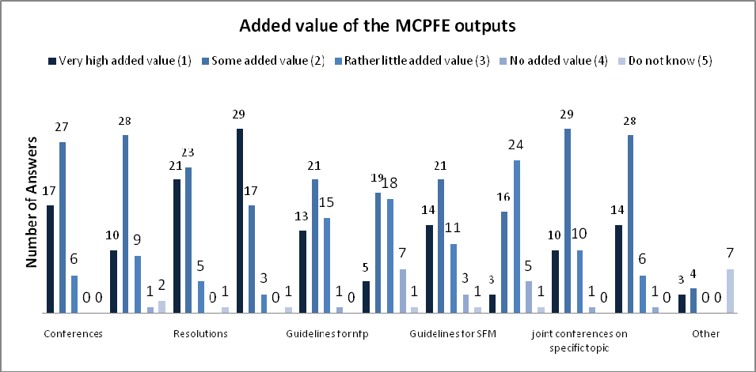

C&I

All reference groups reported that from the reviewed MCPFE outputs, C&I have generated the highest added value at national level. An important role in developing, implementing and promoting this tool has been played by the UNECE/FAO. The second highest output the respondents mention was the MCPFE Resolutions, and the third were the MCPFE Conferences. In addition, all groups mentioned collaboration work with relevant stakeholders and peers to provide very high added value. MCPFE workshops, declarations, joint conferences and publications were reported to generate some added value. More detailed results received from the groups are available in Annex IV.

3. Questionnaire on the elaboration process, contents and dissemination of the report – feedback by participants in the reporting process

The UNECE/FAO Team of Specialists on Monitoring Forest Resources for SFM in the UNECE Region conducted a review in early 2008, based on the initial written feedback from Team members (see the questionnaire in the Annex V). The results of this review were intended to serve as input to the preparation of the process of reporting for the next Ministerial Conference. The review was divided into two parts (Part I: Report elaboration process, Part II: Report contents and dissemination). The results presented below are from of the written feedback (based on 8 responses from Team members) and the related further discussion at the Team meeting. It is based on the meeting minutes of the 4th Team meeting, held in Vienna, Austria, in May 2008.

3.1 Part I – Report elaboration process

- General approach for the SoEF 2007 preparation. The general approach for the SoEF 2007 preparation was seen as appropriate. However, several issues were raised that would need improvement during future reporting cycles. First of all the need for further, more effective, harmonization of reporting cycles between the FRA and MCPFE reporting. In some specific areas, reporting formats (data quality) and specifications (e.g. for reporting on biodiversity indicators) need further work. In addition, relevant existing data from previous reports should be taken into consideration (i.e. consider pre-filling data cells). Additional resources might need to be made available to ensure required organizational procedures.

- General organization of work. The organization of work was generally considered as appropriate. The importance and need for a body or group e.g. an advisory group on MCPFE report elaboration to co-ordinate work was underlined. It was suggested that this new body or advisory group should be established shortly after commencing preparations of the next “State of Europe’s Forest” report. Evaluation of the MCPFE 2007 report preparation, use and implication, and follow-up of recommendations of the Working Party as well as the recommendations of this Team should be one of its first tasks.

- Furthermore, the Team recommended dedicating special attention to establish early and intensive collaboration with international data providers, and to start work early to improve reporting on indicators which have been found to be difficult to report data on (e.g. non-wood goods and services, marketed services, expenditure for services, some socio-economic indicators). Early studies on these indicators should be undertaken to allow timely decision making and the establishment of a suitable format for these indicators to be included in the report, i.e. should these indicators be part of regular reporting or should they require a special thematic study.

- The Team members commented on the recruitment process for authors to the report. Team members suggested better representation of different regions in the authors’ team composition in the different chapters. The main objective for the next reporting is to select adequate candidates (authors) early, who would be involved early in the data collection, analysis and report production process.

- Time schedule. While the time schedule was generally seen as appropriate and realistic, the Team members raised concerns about time limitation during the report’s elaboration, particularly the lack of time during the final stages (e.g. report writing, key findings revision) of report elaboration. This should be avoided in the next period of work. Another concern was raised about the time frame for the next reporting. The short period of time between FRA and MCPFE reporting might entail additional complications.

- The Team members commented on the unavailability (so far) of the SoEF 2007 national reports for external uses, and expressed the need to have these reports (qualitative and quantitative indicators) available as soon as possible. Thus, dissemination was seen as an important area of improvement, to be properly planned, organized and considered in the time schedule.

- Data collection/validation from national correspondents – quantitative indicators, including structure of questionnaire, secretariat support. While a large majority of participants found this issue to have been well organized and carried out, the Team members also signalled possible improvements in reporting tables for selected indicators (forest regeneration, forest damage). The need for further facilitation of applied definitions (reformulation, explanation) was addressed (more user friendly comments boxes) as well. Better harmonization with the FRA formats and incorporation of the results of EU COST Action E43 (Harmonisation of National Forest Inventories in Europe: Techniques for Common Reporting) were also suggested. Revision of specifications for definitions should be addressed by the new Team next meeting.

- Meeting participants expressed their views on the character of the new network of National Correspondents. Team members were in favour of designating one national correspondent from each country who would be responsible for organization and providing national data on both qualitative and quantitative indicators. The MCPFE national correspondent should preferably also be the person who provides data for the Global Forest Resources Assessment.

- Validation of data provided by international data providers. Various aspects related to data collection through international data providers were addressed by Team members. Experts underlined that international data provider’s data validation is time consuming, and often, the final result slightly differs from the original data. Time available for data validation was insufficient especially in terms of the report’s official release date. For the MCPFE SoEF 2011 (provisional name) report, the collaboration with international data providers and reporting process should be undertaken earlier. Meeting participants recommended earlier, identification of experts specialized in “international data providers” indicators’ areas, would facilitate data collection and validation process.

- Data collection/validation on qualitative indicators. In general Team members stipulated further improvement (including simplification) of the reporting format for qualitative indicators.

- Opportunities for participation in report elaboration. Generally, the opportunities provided responded to needs and expectations of Team members. However, experts reiterated the need for better communication and cooperation, especially in regards to the final phases of report elaboration. National experts should be given the opportunity to review the first draft of the report in order to be able to identify and thus avoid misinterpretation of data provided.

- Since time limitations during the report’s elaboration created many difficulties, it was suggested that a better time frame should be assigned for data collection and report writing. Team members should be in better contact with the report’s authors, keeping in mind however, that an increase in the amount of collaborators often delays the preparatory phase for publications.

- Overall improvements in future SoEF report preparation process. In addition to the proposals already included in the answers to the review enquiry and recommendations provided so far, the Team members stressed the importance of early communication, including secretariat’s intentions and plans regarding the next reporting cycle. Better monitoring of data collection provided by other organizations would also be useful for pan-European reporting.

- Finally the possibility and relevance for pre-filing SoEF 2011 report’s enquiry was examined as well. While the Team did not reach a common opinion, pre-filling was seen as a concrete option for the next reporting cycle, particularly also because the next round of the MCPFE reporting will most likely be based on the same set of C&I as those applied for the 2007 report. This means that almost all the data reported for the last MCPFE conference (for 1990, 2000 and 2005 years), if not otherwise decided by the national correspondent, will be valid for the 2011 reporting.

3.2 Part II – Report contents and dissemination

- Are needs and expectations met by the report? In general, the Team shared questionnaire respondents’ opinion that the SoEF 2007 report was satisfactory and clearly met expectations. The report was described as well-balanced with consistent style and contents. The concluding parts of the report were also found appropriate. It was found however that the coherence between data from the report and its respective annexes could be further improved. In addition, information provided at national level should be more clearly distinguished from independent data interpretation.

- Team meeting participants suggested extending work on reporting and data collection, through carrying out additional analysis, e.g. on quality and completeness of collected data and deepened analysis of particular topics.

- Appropriateness of overall structure. The general perception of the Team was that the report structure was appropriate. With regard to the country grouping applied in the MCPFE 2007 report, the Team members discussed ways to improve the eastern European countries grouping. Due to the enormous forest resources of the Russian Federation, considering this country as a separate entity would increase clarity and ensure visibility of other countries of that sub-region.

- Evaluation of individual chapters. Team members were acquainted with the results of evaluation of particular chapters, in which most of the sections were evaluated as “very good” (i.e. 4 in 1-5 scale) in terms of structure and contents, with good evaluations for completeness and accuracy of chapters. Meeting participants raised several areas of possible improvements, e.g. the possibility to verify texts directly related to particular countries by national correspondents.

- Team members also discussed problems related to the possibilities of application of the SoEF 2007 report for national purposes. It was strongly suggested that the main report should be accompanied by the countries’ original information in the form of national reports. This information could be accessible online or given in the form of a CD. This would allow the dissemination of data that has not been included in the output tables.

- Graphic design. The review showed that graphs were seen as appropriate, with some possibilities for improvement, including e.g. graphic readability and maps through better communication between the graphic designers and the authors. The inclusion of photographs could be considered to improve the attractiveness of the report, and highlight the report’s conclusions.

- A separate comment was made on evaluation of trends on SFM implementation through application of “traffic lights” concept, which was generally seen as a useful way for evaluating and communicating trends in individual indicators over time. It was suggested to work further to improve this approach.

- Dissemination. The team then discussed the report’s dissemination process which to their opinion was inadequate. The Team suggested wider distribution of hard copies to all national correspondents, including a set the national reports.

- All data collected during the report elaboration process should be made available to the public through website based data browser. Experts addressed the need for more user friendly online services that would enable easy access to the report and other relevant data. Some of the Team members suggested the use of Wikipedia as another way to disseminate the report.

- Experts have found that differences in the FRA and MCPFE reporting format (i.e. 2005 data in FRA report are extrapolations while SoEF reports field data for this year, at least partly) could lead to data misinterpretation for the same years. This data inconsistency can have serious implications in terms of reporting to national statistical yearbooks.

4. Questionnaire on the report’s content, appropriateness and use – feedback by report’s users

The UNECE/FAO Timber Section conducted a review of the use of the MCPFE/UNECE/FAO State of Europe’s Forests 2007 report. The review was carried out in autumn 2009 and aimed at evaluating various aspects related to the use of the report, e.g. profile of the report’s users, their expectations, opinions and recommendations regarding the report. The enquiry, which was prepared by using SurveyMonkey software, was disseminated through UNECE/FAO and International Institute on Sustainable Development (IISD) mailing lists. All answers received from 57 respondents are presented in Annex VI.

Review results

- Affiliation of the report’s users. Respondents were requested to describe their affiliation according to the proposed classification (Figure 2). The majority of the users (43.9%) chose the “Government/public body” as their affiliation; the subsequent categories were “University/Research” (19.3%) and “International Governmental Organization” (14.0%). The above results reflected dominance of the main target group for the report, being the forest policy specialists. Percentages of the remaining categories are relatively even, with the exception of the category “Forest owners/managers” – which none of respondents chose. It is difficult to explain the absence of responses from this group. One possible reason could be that this group of users was omitted during dissemination of the enquiry. Forest owners/managers could have self-identified themselves under the category - “Non-Governmental Organization”.

Figure 2. Which affiliation best describes your work?
Source: UNECE/FAO, 2009
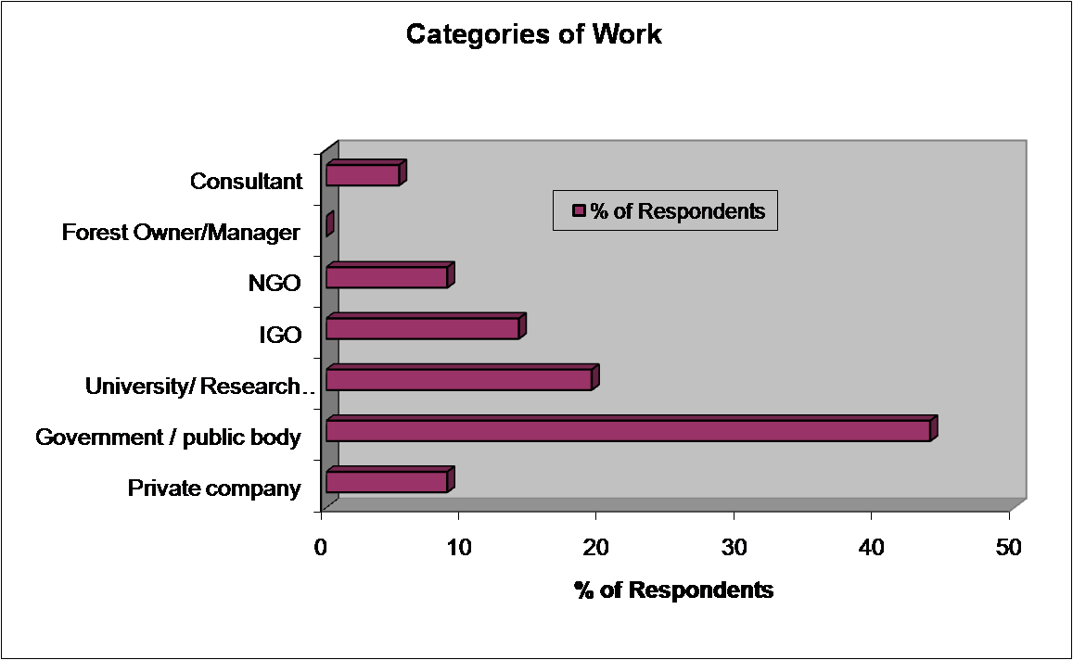

- Means of learning about the report. Enquiry recipients were also asked how they had learnt of this publication; when responding to this question they could select more than one of the suggested answers. The most frequent means of communication was the “Official announcement/press release”; 55.1% of respondents (Figure 3) indicated this category. The remaining categories (i.e. newsletter or publication, internet search, conference or workshop, recommendation by colleague) were selected by a relatively even number of respondents (22.4 – 32.7%). The above result is consistent with the profile of users that responded to the enquiry, as the report was widely publicised and disseminated among national (governmental) contact points to the UNECE/FAO and MCPFE.

Figure 3. How did you learn of this publication?
Source: UNECE/FAO, 2009

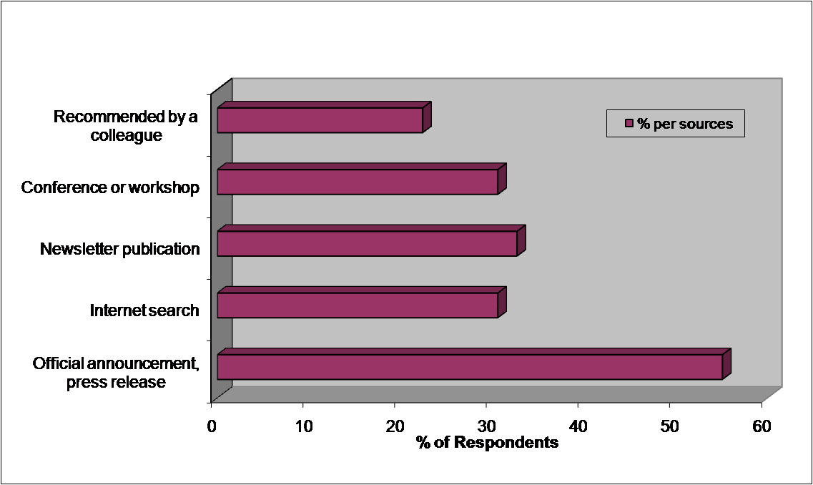

- Needs and expectations arising from the report. The responses clearly indicated the prevailing need related to the report (Table 1); almost 86% of respondents expected general information on the status and trends of forests in Europe. The second most selected category was detailed information on quantitative indicators; 64.3% respondents selected this category (more than one response was allowed under this question), while 41.1% respondents were looking for detailed information on qualitative indicators. Although most of the users were looking for information characterising the entire European region, 44.6% of respondents perceived the report as an important source of information on SFM in a specific country or sub-region.

Table 1. What were your needs and expectations from the report?
Source: UNECE/FAO, 2009
Category | % of resp.
General information on status and trends of forests in Europe | 85.70%
Detailed information on quantitative indicators | 64.30%
Information on sustainable forest management in a specific country or sub-region | 44.60%
Detailed information on qualitative indicators | 41.10%
Information on European forests for use in a wider context | 41.10%
Source data for your own research | 39.30%
Information for decision-making and planning | 30.40%
Other | 5.40%

- The overall result of responses to this question reconfirms the main purpose of the report – to provide a comprehensive and holistic description of the state forests in Europe. At the same time the report serves as a source of information meeting various needs declared by users. Parts of the report are used for specific areas and regions. Information collected for its preparation is useful for policy making, analytical and statistical works, and scientific research as examples.

- Level of satisfaction of users’ expectations. More than 97% of respondents answered that the report met their needs and satisfied their expectations, of which 35.2% said “partly” (Figure 4). Respondents not only highly appreciated the report, but added some recommendations for improvement and further development. Users called for more frequent information for decision-making; the report’s contents should be more "authoritative" to help promote desirable activities and policies. Finally, some respondents pointed out the need for estimating the area under SFM and improving the report’s synthesis.

Figure 4. Did the SoEF 2007 report meet your needs and satisfy your expectations, as reported in response to the previous question?

Source: UNECE/FAO, 2009

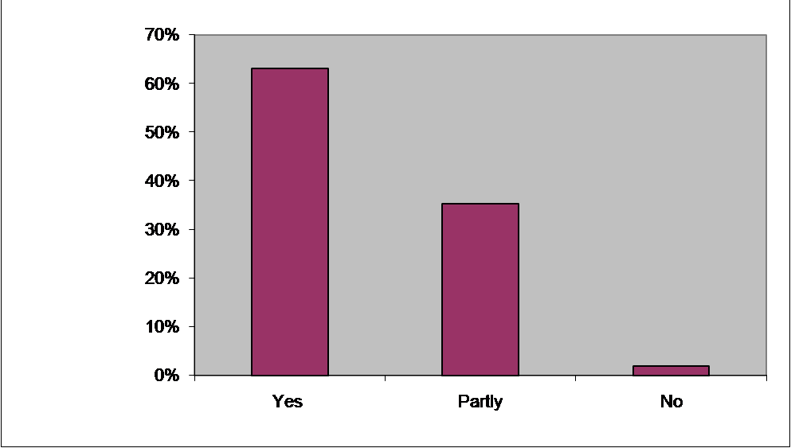

- In addition to demand for higher frequency of information provision, the report’s users required more detailed analysis in particular chapters. Several comments raised concerns about the geographical coverage of the report. According to some comments, the report should include only the European part of the Russian Federation, in order to provide information on only “European forests”. Other comments, however, postulated the need for more detailed data on all Russian forests. Presentation of aggregated data at the EU level was requested as well.

- Overall structure/layout of the report. According to 98.2% of respondents (Figure 5), the report’s overall structure/layout matched users’ needs (for 21.8% - partly). Users suggested a clearer formulation of recommendations for decision-making in future reports. Some users commented on the lack of connection between the chapters (indicators) and discussion about how different C&I are linked.

Figure 5. As a reader, did the overall structure/layout of the SoEF 2007 match your needs?
Source: UNECE/FAO, 2009

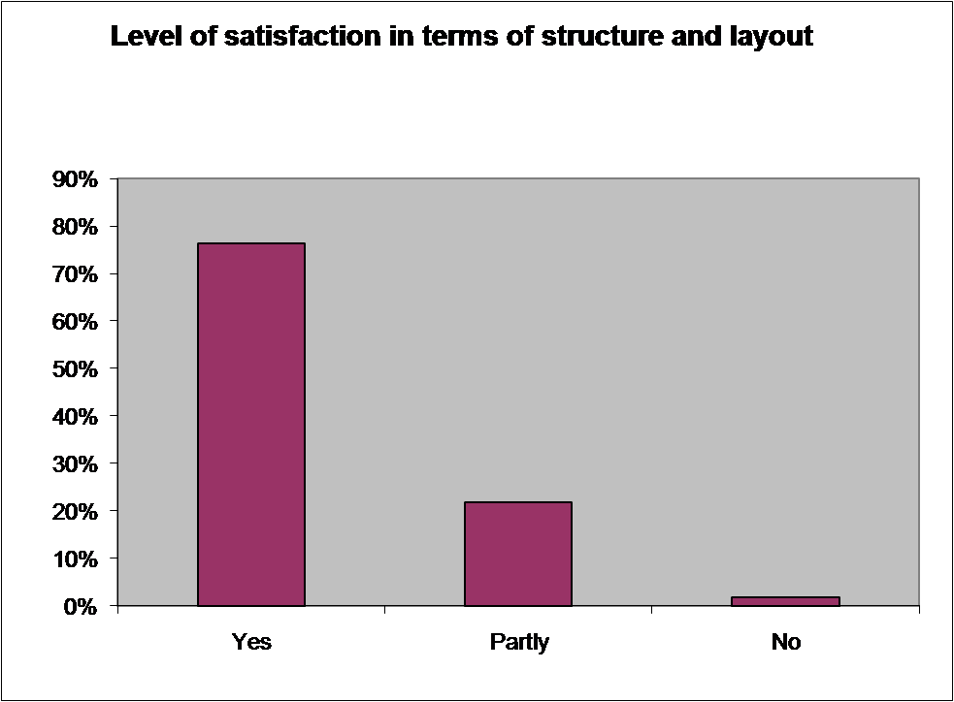

- Users observed that they found it logical and reasonable that the facts are presented with little detail, due to huge differences among described regions. However, in other comments the “lack of controversy” in the report was said to make the whole report “less attractive”, while including more debate would increase the report’s objectivity. Developing the report’s structure by including subheadings or bullet points or boxes would make the report easier to read. Including discussions of cross-linkages or controversial points would have increased the attractiveness of the report, according to some users.

- Relevance of the report’s parts. Respondents were asked to evaluate the relevance of the main parts of the report for their work or activities, by using a scale from 1 to 5 (1 being the most relevant, 5 being the least relevant). For the needs of this analysis, the percentages of respondents that indicated the most relevant (1) or relevant (2) categories were added together; the results of this calculation are presented in Figure 6.

Figure 6. Which parts of the report were relevant to your work or activity?
Source: UNECE/FAO, 2009

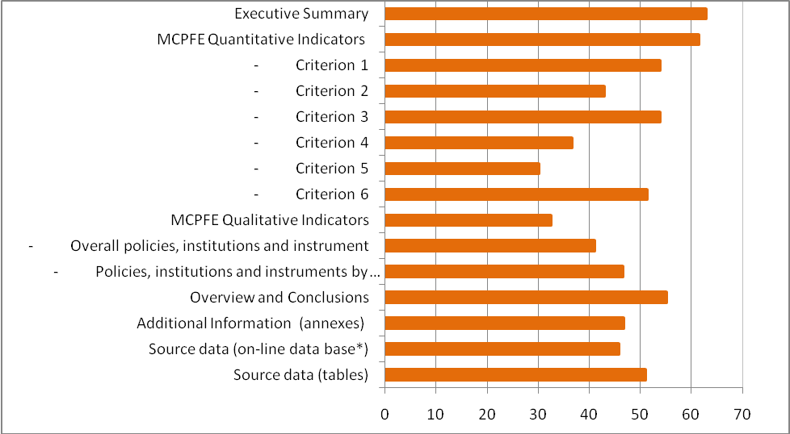

- The highest number of respondents (62.8% of responses) chose the “Executive Summary” as the part of the report that was most relevant or relevant for their activities. The next category – “MCPFE Quantitative indicators” (in general) was indicated as relevant by 61.3% users (Table 2). The “Overview” and “Conclusions” were assessed at a slightly lower level (55.1%). The part related to “Qualitative indicators” (in general) was rated as less relevant (32.4%); however, its components – “Overall policies, institutions and instruments” and “Policies, institutions and instruments by policy area” were evaluated at a much higher level; 46.5% and 40.9% respectively.

Table 2. Which parts of the report were relevant to your work or activity?
Source: UNECE/FAO, 2009
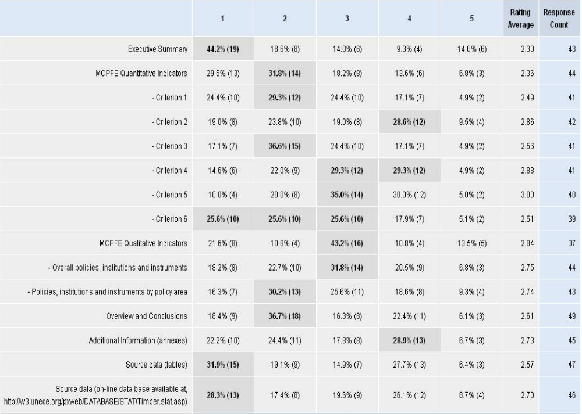

- Respondents evaluated the relevance of particular criteria (quantitative indicators) for their activities. The results indicated that criteria of general and economic character (general indicators – 53.7%, productive functions – 53.7% and socio-economic indicators – 52.2%) were evaluated as more relevant. Criteria 4 and 5 (protected and protective functions) were as of less interest (36.6% and 35.0% respectively).

- Overall design of the report. The report’s design was assessed by the great majority of respondents (85.5%) as matching their needs (Figure 7). While the overall layout was good the different shades of the same colour hampered readability of some graphs and made them unsuitable for copying. Another problem was the unavailability of the report’s graphics (graphs, maps) for use in other publications prepared later by countries.

Figure 7. As reader, did the overall design of the report match your needs?
Source: UNECE/FAO, 2009

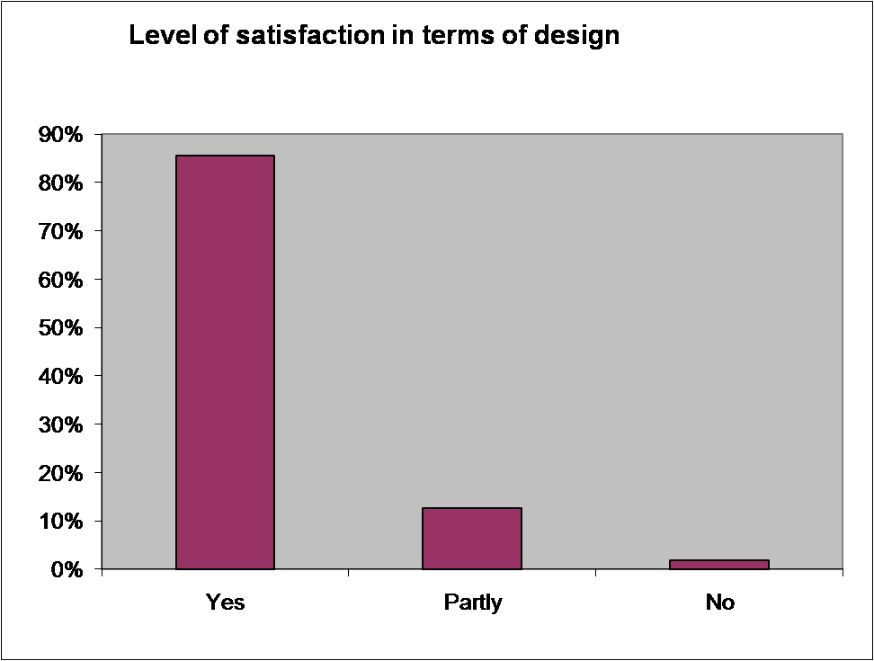

- Added value. The vast majority of users (91.1%) responded that the report added value to their work and activities (Figure 8). The respondents pointed out that the report is “the most relevant document on forest data in Europe” and “provides the most recent data of forest resources and the trends on the progress towards SFM in the pan-European region”. Users appreciated in particular the variety of products available (electronic version, printed book, interactive database).

Figure 8. Has the report added value to your work programme and/or activities?
Source: UNECE/FAO, 2009

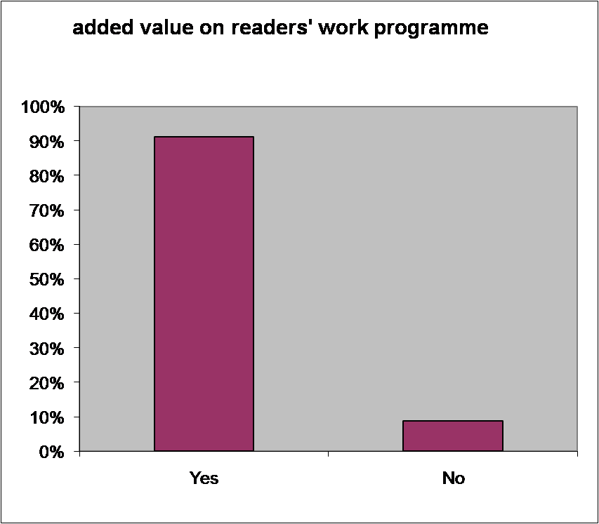

- Although some of the respondents evaluated the report as providing “milestone for determination of a contemporary sustainable forest policy and strategy on European, regional and national levels”, it was also observed that the report had not provided “enough real solutions of existing problems yet”.

- Other suggestions to improve the content and/or presentation of the information. As expressed in the quantitative enquiry most respondents noted the present form of the report was suitable and responded to current needs. Respondents acknowledged the value of the Executive Summary with its key statements which were then further elaborated in the report. Suggestions to follow and maintaining the same format in future reports for easy comparison were made.

- Several suggestions of a different nature for the next editions were given by the report’s users. One of them, however not directly related to the report, referred to the periodicity of reports and suggested establishing this monitoring and reporting on the state of forests in Europe on a more permanent basis and with fixed intervals (i.e. every 5 years), instead of the current, irregular reporting for the MCPFE ministerial conferences.

- In their comments users called for better interpretation of trends and more clear methodology description in the final report. Future editions of the report should be enriched by information related to e.g. adaptive capacity of the forests, forest technical infrastructure and down the chain socio-economic data and analysis. Report users claimed more attention should be paid in future reports to non-wood forest products and forest management experiences and innovations in the countries. The need for additional work on "difficult-to-measure" (in particular social) indicators should be carried out in order to provide more accurate data.

- Report users stressed the need for including more information related to methodological and technical aspects of reporting on state of forests and SFM in Europe. Stating the difficulties, problems and deficiencies when establishing forest basic concepts and indicators, gathering, comparing and processing data would provide, according to the respondents, added value. Data compliance, conformity and uniformity quality checks (in appropriate cases) could improve information quality and reliability.

- Respondents suggested including in the report comparisons with other regions. Some information at EU aggregated level would be useful. It was also suggested to exclude the Asian part of Russian Federation from the statistics, or the study should describe state of forests in the pan-European area.

- Other suggestions included improvement of report’s graphics, including more graphs and maps, and presentation of figures a better graphical form, e.g. using the example of the recent publication by FAO, Vital Forest Graphics.

- Respondents complained of insufficient dissemination of the report, in particular at national, regional and local levels. Suggestions for more language versions of the whole report as well as more leaflets, and other dissemination materials were made.

- A further increase of the compatibility of the MCPFE C&I reporting with the global FRA was recommended. The compatibility should refer to both selection of indicators and variables and access to results (see next section).

5. Evaluation of the dissemination of the report

The issue of dissemination of the SoEF 2007 report was reported and addressed specifically at sessions of the UNECE/ FAO parent bodies. This item provides information on dissemination of the report, results of the enquiry of the report’s visibility on the Internet and information on downloads of source data collected for the report’s elaboration via interactive database.

5.1. Dissemination of the MCPFE 2007 report

The UNECE/FAO/MCPFE report State of Europe’s Forests 2007 and the report on Implementation of the MCPFE Commitments was officially announced and presented at the 5th Ministerial Conference on Protection of Forests in Europe on 3 November 2007 in Warsaw. The conference was attended by over 400 participants representing the highest forest sector authorities from the MCPFE member and observer countries as well as international organisations. All Conference participants were provided with copies of the report, and the report’s main findings (available in four languages: English, French, Russian, and Polish). Copies of the report were also distributed amongst MCPFE focal points (countries and organizations). A press conference and a press release were carried out, which highlighted the report’s main topics. Both were widely disseminated through general press agencies networks.

Hard copies of the report (1500 printed copies) and the report’s main findings (500 printed copies in each of 4 languages) have been disseminated by the MCPFE Liaison Units (Warsaw and Oslo), electronic version of the report could be found at the MCPFE LU website (www.mcpfe.org). Electronic versions of the report and other relevant documents, including original versions of all national reports (both on qualitative and quantitative indicators) could be downloaded from the UNECE/FAO Timber Section website (http://www.unece.org/trade/timber/fra/outputs.htm).

Following the request from the UNECE/FAO parent bodies, the Timber Section produced a special CD containing background materials, source data collected for the needs of the report elaboration and electronic versions of the report and its key findings. The CD together with paper copies was disseminated among the UNECE/FAO contact points (heads of delegations). This information package was also distributed during the meetings that were organised or participated by UNECE/FAO or MCPFE, notably during the European Forest Week (Rome, October 2008).

According to the information from the Liaison Unit Oslo, all copies of the report and its key findings have been distributed during meetings or by request. Based on the dissemination results it could be assumed that report should have reached all key institutions and organisations dealing with forestry in Europe. It is difficult to evaluate further dissemination of the report within countries.

5.2. Analysis of visibility of the SoEF 2007 on the Internet

The main goal for the analysis of the SoEF 2007 visibility in internet was to learn more about the profile of the report’s users. The analysis was carried out with the use of data viewer in Google through the advanced search for web pages that have the exact wording or phrase: State of Europe’s Forests 2007. As a result of this query, 8,820 web pages responding the search criterion were found.

In further analysis the first 20 websites and 28 subsequent websites (every tenth) were selected and classified according to the website owner’s affiliation (with the use of the same categories as in chapter 4) and website profile (by sector). Detailed results of the query are available in Annex VII, however a summary appears below.

Website affiliation. The results of the analysis (Table 3) revealed dominance of the two groups of website owners - Intergovernmental Organizations and University/Research Centre (35.4% of websites each). Compared with the results of the report’s user survey a higher share of University/ Research Centre could be noticed, on other hand Government/Public bodies are represented in this sample in much smaller extent. This could be explained by the assumed function of science, which is dissemination of (processed) information, while governments are rather end users of the report.

Table 3. Attributed website owner’s affiliation
Source: UNECE/FAO, 2009
Website affiliation | Share of identified websites (%)
Government / public body | 8.3
University/ Research Centre | 35.4
Intergovernmental Organization | 35.4
Non Governmental Organization | 0
Private Company | 2.1
Consultant | 0
Forest Owner/Manager | 4.2
Not classified | 14.6

Website profile. The analysis results show that selected websites could be assigned to two thematic groups i.e. Ecology/Climate and Forest Sector, the third group (cross-sectoral) encompassed those websites where definitive assessment of the sector was impossible or difficult. The prevailing majority of the websites (72.9%) were classified as belonging to the forest sector, while the rest of them mostly represented websites of more general character (Table 4).

Table 4. Attributed website profile (by sector).
Source: UNECE/FAO, 2009
Website profile category | Share of identified websites (%)
Forest sector | 72.9
Ecology/Climate | 4.2
Cross-sectoral | 18.8

Because of the type of the query and the small number of websites included, the results of the enquiry should be considered as of indicative character only. Nevertheless, even this sample indicated that the use/dissemination of the report is quite concentrated. The report is predominantly visible within the limits of the forest at national and international levels, and for purpose of science. This reaffirms that the report seems to reach its primary target group and meets its main goals. Also the report’s role as a source of information for scientific purposed was reflected in this analysis, while the impact of the SoEF2007 on and visibility in other sectors and levels is more limited. While the above analysis includes direct impact, it is likely that information from the report was used for other needs through indirect ways, which was impossible to detect in this analysis.
5.3 Analysis of the use of the SoEF 2007 database

Due to the move of the MCPFE Liaison Unit from Poland to Norway, which included also transfer of the website, technical characteristics of the UNECE webpage receiving detailed information about retrievals of the electronic copies of the report was unfortunately not possible. However analysis of the intensity of use of the interactive database, was doable. The database, which was jointly prepared by the UNECE and FAO experts, was made operational in January 2009. The database, containing majority of data collected for the needs of the report elaboration, is available at the UNECE portal, together with other statistics collected by the UNECE.

The intensity of the use of the forestry database was evaluated with use of number of downloads from January to December 2009. This means that the statistics do not include the number of visits without data download. Because of database construction (each indicator stands a separate table), a retrieval means downloading data from one database table (i.e. indicator).

The registered number of retrievals amounted to 5108 in the analysed period, one fourth of which was noticed in January (Figure 9). The number of monthly retrievals gradually decreased during the first months of use, and stabilised at the level 200-400 retrievals per month. The observed trend could be explained by a specific character of the database, that its contents are renewed in long period, approximately every 4 years. Thus, further decline of retrievals could be expected before new dataset collected for the SoEF 2011 is uploaded and made available. The strength of this decrease could be weakened by gaining new users. In the light of the results of the |Internet quest, there are still many potential users within and outside the forest sector.

Figure 9. Number of retrievals by month from January to November 2009.
Source: UNECE/FAO, 2009

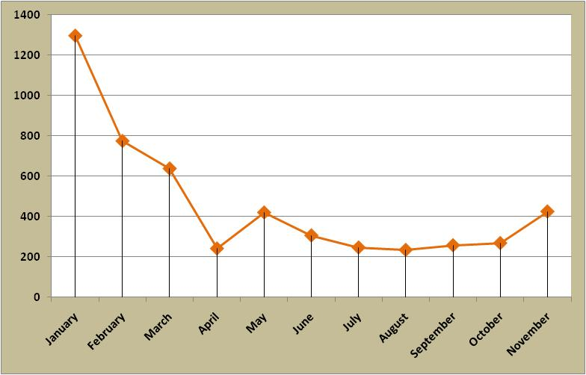
In addition to monitoring the intensity of database use over time, it is also possible to register a number of downloads of individual tables, which in most cases correspond to MCPFE indicators (Figure 10). This information allows for monitoring of the number of retrievals of information by indicators included in the database (list of indicators is available in Annex VIII). This provides an indication of the relative importance of different indicators.

Collected information indicates that information characterising general forest resources (forest area – 1.1, growing stock - 1.2, carbon – 1.4) are the most popular among data users. Information on forest damage (2.4) and increment/harvesting (3.1) complete the group of the highest intensity of use. The numbers of retrievals of the remaining indicators are at lower levels and vary among criteria and indicators. The overall structure of the downloads is similar to some extent to the structure of the parts of the SoEF 2007 indicated by the reports users as the most relevant (Figure 6). This suggests that the primary users of the collected information are coming from the forest sector (including forest research).

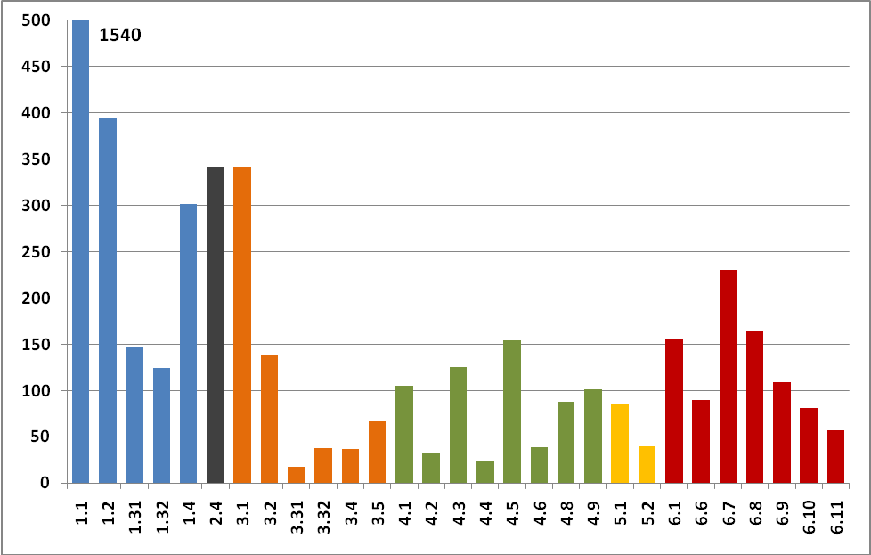

Figure 10. Number of retrievals by table/indicator from January to November 2009.
Source: UNECE/FAO, 2009

Information on the retrievals’ structure is interesting and useful, but it should serve only as introductory material for further analysis. Each table and indicator should be analysed on an individual basis, because reasons for the number of downloads registered could vary depending on the needs, completeness of information, applied definitions and other reasons. The analysis of the results of intensity of use of this database should be helpful during the revision of the current set of the MCPFE indicators.

6. Final conclusions and recommendations for the future activities.

As presumed in the self-evaluation terms of reference, this review was expected to give answers to a set of questions pertinent to the last as well as future editions of the report. The answers provided below, are elaborated on the basis of the material collected, and intended to address the most important issues; however, the complete information that explores the questions in depth are available in the above thematic chapters of this evaluation.

- Does the report achieve its stated purpose?

The primary goal of the report State of Europe’s Forests 2007 was to provide the 5th Ministerial Conference on the Protection of Forests in Europe with the latest available, objective, reliable, and comprehensive information on the status and developments of forests and sustainable forest management in the member countries, and in the region as a whole. The report successfully accomplished this role through its use as an informative background document for discussions at the MCPFE Conference held in Warsaw in November 2007.

After the Warsaw Conference, the forest policies of the MCPFE countries could be based, further elaborated and developed on the very good (best currently available) information on the status and trends in the forestry sector of the region. The deep expert analysis of the success (or their lack, in some cases) of the SFM developments helped to better understand processes in individual countries and sub-regions.

The factual information presented in the report, and easily available via the Internet, or in the printed format, has helped member countries to improve their internal evaluation and assessment of national forest resources, thus contributing also to their reporting within the global Forest Resources Assessments.

The SoEF 2007 report reaffirmed the role of the criteria and indicators for sustainable forest management as an efficient tool for monitoring, assessing and reporting progress on SFM. The report provided highly valued data and its analysis for further elaboration and presentation of many pan-European level and country-level reports.

The process of the collection of data for the SoEF 2007, processing of data, analysis and preparation for their publication contributed to maintaining and further development of strong professional links with the partner organizations, various other related international data providers and, first of all, with the network of country experts and national correspondents. For example, it strengthened the network of national correspondents in the period between the global FRA reporting cycles.

  - Which impact did the report achieve?

The MCPFE process has formulated and retrieved the concept of sustainable forest management. To monitor the implementation of the SFM at the regional and country level, accurate and up-to-date information and quantitative data are needed. This information was provided in the State of Europe’s Forests 2007 report and accompanying database. The participants of the latest MCPFE Conference considered the SoEF 2007 report as “of high value”.

The information reported in the SoEF 2007 serves as a basis for submitting proposals and projects to Governments and Governmental institutions, thus influencing the SFM in Europe context. This refers to all the report coverage, including forest resources and carbon cycle, forest ecosystems health, productive functions (wood and non-wood), biodiversity, protective functions (soil and water), socio-economic aspects and developments.

The report presents considerable information, which was not reported previously, also on the reason of the limits of National Forest Inventories, Accounts and Assessments, or even national reporting capacities, could be collected and presented, thus enriching the informative basis of SFM policies. The national and pan-European data/ information published in the report have enabled comparisons with national indicators, and SFM developments at the national level in individual countries.

The report contributed to the input of the European component of the FAO Global Forest Resources Assessment. The high-level scientific standards of the SoEF 2007 data analysis and presentation showed the direction for possible up-grading such multi-layer studies in the future.

- Who are the primary users of the report? How many users were reached? Where are they located? Which potential users were not reached?

The forest sector policy-makers, intergovernmental organizations, non-governmental organizations, the private sector, including the sectoral and sub-sectoral associations, the civil society and public in large, also outside the forest sector, are the main users of the report. However, the self-evaluation process indicated lack of balance between the groups of users.

The FAO/UNECE Working Party on Forest Economics and Statistics urged its delegates to establish contacts with members of the Forest Communicators Network in their countries, with the purpose that the SoEF report would reach more users in individual countries and the region. The report is easily available and can be obtained from the MCPFE Liaison Unit Oslo (www.mcpfe.org). The electronic versions of the report, the interactive, user-friendly database, and other relevant documents are available on the UNECE portal (http://www.unece.org/trade/timber/fra/outputs.htm).

Based on the analysis on the dissemination process it could be assumed that the report reached all key institutions and organisations dealing with forestry in Europe. It is difficult to evaluate dissemination of the report within countries, but based on some comments from users, the situation could vary among states.

The report is predominantly visible within the limits of the forest at national and international levels, and for purpose of science. This reaffirms that the report seems to reach its primary target group and meets its main goals. Also the report’s role as a source of information for scientific purposes was reflected in this analysis, while the impact of the SoEF2007 on and visibility in other sectors and levels is more limited. While the above analysis includes direct impact, it is likely that information from the report was used for other needs through indirect ways, which was impossible to detect in this analysis.

The online database with the SoEF 2007 data was made available. Still, more targeted and “persistent” information on this important product should flow, also on such occasions as MCPFE meetings, FRA-related events, in correspondence linked to the SFM developments, etc. The translation of the future reports into the UNECE working languages would facilitate reaching a wider circle of potential users. The dissemination of SoEF outputs in CD format has helped to widen the circle of potential users.

- In which manner could the production process of the report be improved?

Although some respondents to the “internal report-usage enquiries” stated that the “report is excellent in its present form”, still there is a room for further improvements and up-grading of this publication, including the process of its production, and substantive contents.

The data supplied by international data providers, those which are the subject for the verification by countries, should be submitted to national correspondents for review, giving sufficient time to consult other sources and improve the data and its analysis.

In the forthcoming report (SoEF 2011), maximum use should be made of the FRA 2010 data, thus helping to avoid unnecessary adjustments, taking into account that forest inventories rarely provide annual data.

The analysis of the data and information collected in the process of the SoEF report production could be deeper and more detailed, especially on a sub-region level. However more time and resources would need to be allocated for this work. The more straight-forward and clear formulation of conclusions, proposals and recommendations for decision-making and their highlighting in the relevant chapters (for each indicator) would make the production of the report more “demanding” and more “demanded”.

- In which manner could content and the presentation and of outputs be improved?

More detailed information on the state of forests in all European countries, allowing a comparison of trends and the state of the forest management at the pan-European level could contribute to the improvement of the SoEF outputs. For example, the data on economic function of forests could be further elaborated, including the role of industries. A neutral interpretation of trends in corresponding chapters and sections of the report could be helpful for users.

The emerging and/ or “hot policy” developments (e.g. renewable energy in Europe) should be addressed in more detail. At the same time, widening the range of parameters to be reported under the individual C&I for SFM should be balanced with the potential burden to country correspondents to report these data/ information.

A summary of the SoEF report and publication of accompanying individual leaflets on the basis of the main report in the UNECE working languages would be helpful and would find its own niche of users.

Improving the quality of graphic material in the published report, as well as its layout as a whole, could make the report more user-friendly and attractive for potential users. Employing professional editors and publishers would contribute to that, but necessitates the availability of resources.

  - How could the report’s life be extended?

Additional analysis of the data/ information collected, as well as the material published in SoEF report (its outputs), could be published in scientific and mass-media sources and would prolong the life of the report and the added value to it. The inclusion of photographs could improve the attractiveness of the report.

The publication of the SoEF 2007 results in the national reports based on C&I, e.g. “State of Finland’s Forests 2007”, gives an opportunity to provide a balanced set of information at the national level on the status and trends of sustainable forest management, and extending the life of the regional reports on SFM. Encouragement of development of other national and international reports based on SoEF 2007 would extend its usefulness and recognition.

Although the report was evaluated as the milestone for determination of a contemporary forest policy and strategy on European, regional and national levels, some of the reviewers observed that the report had not provided enough real solutions of existing problems yet. More "authoritative" and clearly formulated conclusions and recommendations on specific aspects of SFM in the SoEF reports would promote desirable activities and policies at the national level, affecting forest sector.

- Could the promotion of associated outputs (database, national country reports) be improved?

The provision of online database(s) of the reported data/ information should be completed in parallel to publication of the report. This would allow an immediate involvement of researchers/ analysts in their deeper processing and value-adding, and would prevent the dissemination of the explanatory notes behind each observation. Ideally the database should make it possible to extract all the data for a single country, including the information provided by international data providers

More active involvement of the UNECE/FAO Forest Communicators Network, as well as a more frequent publication of press-releases linked with each important action done in this area were recommended. It was also observed that press-conferences devoted to the most important events, associated with the elaboration and publication of the SoEF reports (and related outputs) would be helpful.

Summary

The results of this evaluation confirmed the high value of the State of Europe’s Forest 2007. Responses showed that 78 % of users were satisfied with the overall content of the report, more than 85% of users were satisfied with the overall design, and nearly 91% of users agreed that the report added value to their work programme or activities.

The report was in general perceived as responding to the demand. Practically all elements, as well as the overall concept of the report, were evaluated to be of high quality and relevance. The same positive evaluation applies to the report’s production process. The means of production and cooperation were seen as effective and efficient. Finally the report was assessed as being useful and adding value to the user’s work programme and/or activities.

While positive in general, the evaluation provided more detailed comments and suggestions for future improvements. The report’s producers called for better communication among process participants, especially during data verification stage. Reviewers underlined the need of better coordination between forest reporting processes (SoEF and FRA) and enhanced use of synergies from this cooperation. Several proposals referred to form and contents of the final report, highlighting the problem of better interrelating of the report’s parts. Recommendations also concerned the extension of the report’s promotion, and included new, further elaborated products, better suited to the needs and more attractive for new users.

Comments and suggestions received through the review are valid and in particular important as they were often formulated by experts, who were deeply involved in the report’s production process. Although, when those comments are further analysed, other circumstances of the report’s production must be taken into account. It should be noted that the total resources necessary for the 2007 report production extended well beyond their internal budgets dedicated for this activity. Thus production of the report demanded proper coordination between the responsible units and mobilisation of additional resources (financial and in-kind).

While the issue of coordination was resolved efficiently, mobilisation of resources was eventually below the needs. The above situation resulted in some delays, noticed by reviewers, and in the need of completion of many tasks within extremely short deadlines, often with the use of smaller number of staff than originally planned. When mentioning the good overall result of the 2007 process, it must be underlined that this result was achieved mainly thanks to additional voluntary contributions from national and international experts, as well as extraordinary involvement of secretariats, authors and other persons participating in the process.

Experience collected through this exercise is of utmost importance, and should be used in production of the SoEF 2011. The detailed results of the review have been incorporated, to the possible extent, in the reporting for the next Ministerial Conference. The conclusions from this review can be found in the Annex 1 of this document. It should be mentioned, however, that the overall financial conditions regarding the report’s production has not improved since the previous reporting cycle. In addition, despite the length of the reporting cycle for the next Ministerial Conference is as short as the previous one, increased quality and quantity of reported information are expected.

Due to the higher expectations and increased costs of the report production process, the understaffing and deficit of the current report’s budget is higher than those for 2007 report. Obviously elaboration of the SoEF 2011 will benefit from the experience gathered during the previous reporting cycles and increased efficiency. Unfortunately this would be insufficient to effectively implement all advice received during the self-evaluation process, especially the recommendations on supplementary publications.
7. Annexes

Annex I. Terms of reference for the review of the elaboration process, contents, dissemination and use of the MCPFE/UNECE/FAO report on State of Europe’s Forests 2007

Annex II. Extraction from the report of FAO/UNECE Working Party on Forest Economics and Statistics, thirtieth session, Geneva, 2-3 April 2008

Annex III. Conclusions from the 1st Meeting of the UNECE/ MCPFE Advisory Group, Geneva, Switzerland, 24 February 2009

Annex IV. The MCPFE External Review report at the MCPFE Expert Level Meeting on 24-25 November in Oslo (extraction)

Annex V. Enquiry for review of the MCPFE/UNECE/FAO report State of Europe’s Forests 2007 - report’s producers

Annex VI. Review of the use of the MCPFE/UNECE/FAO State of Europe Forests' report Results from a survey conducted by the UNECE/FAO secretariat – report’s users

Annex VII. Results of the Internet search for State of Europe’s Forests 2007

Annex VIII. List of the MCPFE quantitative indicators for SFM, as adopted by the MCPFE Expert Level Meeting 7-8 October 2002, Vienna, Austria.

Annex I

Terms of reference for the review of the elaboration process, contents, dissemination and use of the MCPFE/UNECE/FAO report on State of Europe’s Forests 2007

(Multidimensional evaluation, planned for period 2008-2009)

Purpose/Goals

- To improve knowledge on usage of the report State of Europe’s Forests 2007;
- To evaluate the appropriateness of the format and contents of the recent report;
- To improve the content and outreach of the next report, “State of Europe’s forests 2011”.

Scope

It is proposed that the review process includes a number of selected activities, undertaken at different levels and addressing different groups, during the biennium 2008 - 2009:

- Evaluation of different aspects of the whole process of production of the report, from the source data collection, to the production of the final products;
- Evaluation of the effectiveness of the internal review process of the publication (advisors, reviewers, editors);
- Assessment of the report’s content and quality;
- Evaluation of the report dissemination and extension processes;
- Research on the report’s impact, including general users, science and policy makers;
- Elaboration of conclusions and recommendations for the next reporting cycle.

Background

The MCPFE/UNECE/FAO report on the State of Europe’s Forests 2007 follows the structure of improved Pan-European Criteria and Indicators for Sustainable Forests Management, which includes 35 quantitative and 12 qualitative indicators. The report is based on forest resources assessment data collected from MCPFE and FAO national correspondents and international data providers. Information on some indicators was presented in a form of case studies.

The SoEF 2007 report continues the series of European forest resources assessments that had been prepared under auspices of UNECE/FAO and/or MCPFE, which is expected to be maintained. In the framework of preparations for the next assessment cycle it is of an utmost importance to collect experiences and views from both the report’s users and producers.

Issues

The review shall assess the effectiveness and usage of the report, mainly by answering the following questions:

- Does the report achieve its stated purpose?
- Which impact did the report achieve?
- Who are the primary users of the report? How many users were reached? Where are they located? Which potential users were not reached?
- In which manner could the production process of the report be improved?
- In which manner could content and the presentation and of outputs be improved?
- How could the report’s life be extended?
- Could the promotion of associated outputs (database, national country reports) be improved?

Methodology

The review shall be conducted via a differentiated set of tools, tailored to the particular tasks. The range of applied methods will vary from the Section’s internal assessment on process effectiveness, through evaluation, conclusions and recommendations received from parent bodies (Joint FAO/UNECE Working Party, UNECE Timber Committee and FAO European Forest Commission), ending at various questionnaire techniques.

Applied method will also entail questionnaires addressed directly to national contributors and users as well as research on end-users opinions on the report’s quality and appropriateness. In addition to the questionnaires, an analysis of the dissemination process will also be carried out, of both paper copies distributed and downloads of electronic documents. Finally, through citations, the reference of the report in general and scientific publications will be reviewed, in an attempt to assess its usage, and impact.

Evaluation Schedule

The following is a suggested timetable for the following segments of the review. The first part of the review will consist of internal review activities, undertaken in 2008:

A. Report evaluation by the Timber Section’s parent bodies
(April - May 2008)

- UNECE/FAO Working Party on Forest Economics & Statistics, March 2008;
- Special Session of the UNECE Timber Committee and the FAO European Forestry Commission, April 2008;
- UNECE/FAO Team of Specialists on “Monitoring forest resources for Sustainable Forest Management in the UNECE Region”, May 2008.

B. Questionnaire on the report elaboration process, contents and dissemination – process participants (April - December 2008)

Development of questionnaire, determination of addresses (April-May 2008);
Conduct of the Survey (May - September 2008);
Collection and Analysis of Main Findings (September - December 2008).

The second part of the review would address the report’s target group and entail the following:

A. Questionnaire on the report content, appropriateness and use – report’s users
(April – September 2009)

Development of questionnaire;
Determination of addresses (actual and potential users);
Conduct of the Survey;
Collection and Analysis of Main Findings.

B. Evaluation of the dissemination of the report (July – October 2009)

Evaluation of dissemination of the report (paper and electronic versions);

Evaluation of report citations in the general media and scientific publications.

C. Final Elaboration of the review results, formulation of final conclusions and recommendation for the future activities (December 2009)

Resources

The resources will primarily be in the form of staffing, the secretariat supporting and coordinating the review.

Intended Use

Through the review, it can be expected that the Timber Section will better get to know the actual as well as potential users of the report and their needs. Furthermore, the Section would improve its monitoring and continuous evaluation systems, processes and procedures. The results of the review will be incorporated and evaluated, in the preparation of the process of reporting for the next Ministerial Conference. They could also be contribution to the development of the European component to the FAO Global Forest Resources Assessment.

_________________________________
Annex II

The Advisory Group
on the elaboration of the report “State of Forests and Sustainable Forest Management in Europe” for the 6th Ministerial Conference on the Protection of Forests in Europe

1st Meeting of the UNECE/FAO/MCPFE Advisory Group
Geneva, Switzerland, 24 February 2009

Meeting’s conclusions

General arrangements for the next SoEF:
- Following the decisions made at the MCPFE Expert Level Meeting in May 2008 and in accordance with the MCPFE Working Programme, the report on State of Europe’s Forests will be prepared for the next MCPFE conference. The report will cover the set MCPFE Criteria and Indicators (C&I), endorsed in 2002. According to the reporting process and planned activities, it was mentioned that the earliest and provisional release date for the report would be around mid-2011.

- The report will be jointly released by and under the responsibility of the UNECE/FAO Timber Section (TS) and the MCPFE Liaison Unit Oslo (LUO), both represented by their heads, who are advised by the Advisory Group (Annex 1). The managerial part of the report’s preparation will be delegated to the UNECE/FAO TS. The MCPFE LUO will contribute to the preparation of the report, including the allocation of resources.

Specific issues discussed by the Advisory Group :

- Based on the overall evaluation of the past reporting process, the Advisory Group found that there was too much focus on the production of the final report neglecting other means of communication. The Advisory Group recommended the use of communication tools such as a web-based database, additional publications, and downloadable versions of maps, graphs, tables and press releases to promote the report further and reach a wider audience during the next reporting cycle.

- Based on experiences from the 2007 report, the Advisory Group further discussed the possibilities/ways of analyzing the level of SFM in Europe’s forests. They advised pursuing the overall approach applied for the 2007 report (Annex 2), using the “traffic lights” concept, as a starting point. The discussion on the report’s format will be continued at the subsequent meetings.

- The Advisory Group suggested a structure containing “three and half” level of data presentation and evaluation (pan-European, EU27, sub-regional and national). Further discussions are needed to decide how sub-regions will be divided/composed. The way in which the Russian Federation data will be presented needs more consideration.

- The Advisory Group discussed potential authors for the next SoEF edition (Annex 3). The Group proposed Michael Koehl, Ewald Rametsteiner and Christopher Prins as the coordinate lead authors, who would be responsible for writing the main parts of the report. As regards the lead and thematic authors, the Advisory Group suggested Team members should inform the UNECE/FAO and MCPFE of their recommendations on potential authors for the next report.

- The Advisory Group discussed the organization and planning of the reporting process (Annex 4) as well as the provisional budget (Annex 5) for externally funded activities. The proposed planning and funding were found realistic. Additional comments and suggestions for modifications proposed by the Advisory Group members were included in most recent documents. The Advisory Group stressed the importance of initiating fundraising activities early.

Next steps and deadlines:
- The date of the next MCPFE conference has not yet been decided. In order to be consistent with the provisional date of the MCPFE conference scheduled for early 2011, the report would need to be completed by the end of 2010. The Advisory Group recommended the following deadlines:
- first draft of questionnaire commented by the Team members - September 2009;
- 2nd draft revised by the Advisory Group – November 2009;
- the questionnaire should be distributed by the end of 2009;
- deadlines for country replies – end of March 2010;
The above mentioned dates (Annex 6) might need adjusting once the date of the next MCPFE conference is set.

- The Advisory Group members will assist the UNECE/FAO with the preparatory works for the next report; particular attention will be drawn on the elaboration of the national enquiries on quantitative and qualitative indicators on SFM.

- The next meeting of the Advisory Group will examine the pre-final draft at its next meeting, which will be held at the United Nations in Geneva on 18 November 2009.
Annex III

The report of FAO/UNECE Working Party on Forest Economics and Statistics, thirtieth session, Geneva, 2-3 April 2008 (extraction)

REPORT OF FAO/UNECE WORKING PARTY ON
FOREST ECONOMICS AND STATISTICS ON ITS THIRTIETH SESSION

V. STATE OF EUROPE’S FORESTS 2007: LESSONS LEARNED (Item 4 of the agenda) Documentation: ECE/TIM/EFC/WP.2/2008/6

11. The Working Party reviewed the process of preparing the report the State of Europe’s Forests 2007 (SoEF 2007), issued under the responsibility of UNECE/FAO and the Liaison Unit Warsaw for the Ministerial Conference on the Protection of Forests in Europe (MCPFE) in November 2007. The process, which had been overseen by the Working Party, had lasted about four years and involved hundreds of experts. The Working Party considered the report was very useful and an advance on its predecessors. Organized according to the indicators of sustainable forest management, it provided the best available picture of the state of Europe’s forests.

12. Delegations made many detailed and constructive comments and suggestions, including the following:
- A heavy burden had been laid on national correspondents by the close proximity of SOEF 2007 and Forest Resource Assessment (FRA) 2005, with possibly different status for the same reference year 2005.
- Data supplied by international data providers had been submitted to national correspondents for review rather late, giving insufficient time to consult other sources and improve the data analysis.
- The validation process for the quantitative indicators, although long and resource intensive, had been very beneficial, resulting in improved data quality and better understanding of the issues. Some of the consistency checks incorporated in the enquiry had been unnecessarily burdensome (rounding issues).
- Some Working Party members had not yet received copies of the finished study.
- A few countries had not supplied data, even though some data existed, partly because of misunderstandings and failure of communication.
- The “traffic lights” analysis of sustainable forest management (different colours for positive, negative or stable developments, by region, see table 40) was an easily understandable tool for presenting the overview.
- The delay in provision of an online database was a hindrance to researchers and prevented the dissemination of the explanatory matter behind each observation. Ideally the database should make it possible to extract all the data for a single country, including the information provided by international data providers.
- The data on socio-economic indicators, including value added, workforce, and occupational safety had been hard to gather and still had many gaps.
- The enquiry on qualitative indicators had been a good start in new area, and provided satisfactory results, although some of the data requests had been repetitive.

13. The Working Party made the following recommendations for future work on the state of Europe’s forests:
- An on-line data base with the SOEF 2007 data (including metadata) should be set up as soon as possible.
- Efforts should be undertaken to communicate on the SOEF 2007 results, to the technical and general media. Working Party delegates would be put in contact with the member for their country of the Forest Communicators Network. Any citations, comments, translations etc. about the SOEF 2007 should be sent to the UNECE/FAO secretariat.
- Planning should start this year for the report to the Oslo ministerial conference. International data providers and expert authors should be involved from the early stages.
- Maximum use should be made of the FRA 2010 data to avoid unnecessary adjustments, in view of the fact that forest inventories rarely provide annual data.
- Data provided by international data providers should be sent to national correspondents for validation at the same time as they are passed to the study organizers, to avoid delays and last minute revisions.
- The “traffic lights” method of showing progress towards sustainable forest management should be continued and refined.
- There should be a formal request to each country to nominate officially a national correspondent for the next MCPFE report. Often, these correspondents would be the same as those for FRA 2010.
- International data providers should be contacted at an early stage, to establish a shared understanding of the indicator requirements and available data, and to reach firm agreement on what will be provided and when.
Annex IV

The MCPFE External Review report at the MCPFE Expert Level Meeting on 24-25 November in Oslo (extraction)

...
The results on added value show that added value was highest for a conceptual but also practically applicable tool clarifying the core concept of forestry (SFM). But it also showed that a quite high value across all participants is given to explicit and written common policy commitments (Resolutions), and a high level event. All participants also see topical conferences and topical reports (e.g. the State of Europe’s Forests report) as of high value. The value of a range of other guidelines developed by the MCPFE was of high value to some, but not to all participants (e.g. guidance on nfp implementation). Given that quite high added value was seen by a range of work and “products” of the MCPFE there is little reason to conclude that the different general formats used are seen as inappropriate per se.

Annex to the Review of the MCPFE - Task 2 Written survey (extraction)

The question asked the respondents to evaluate how much added value did the following MCPFE “outputs” have for forest-related policies at national level: Conferences, Declarations, Resolutions, C&I, guidelines for nfps; Classification of Protected and Protective Forests and Other Wooded Land (FPA); guidelines for SFM; guidelines for afforestation and reforestation; joint conferences; MCPFE publications; or some others (the respondents were asked to provide an example for the category “other”).

a) All respondents
All reference groups report that from the MCPFE outputs, C&I has generated the highest added value at national level (Figure 10). The second highest the respondents mention the MCPFE Resolutions, and the third are the MCPFE Conferences. In addition, all groups mention collaboration work with relevant stakeholders and peers to provide very high added value. MCPFE workshops, Declarations, joint conferences and publications are reported to generate some added value.

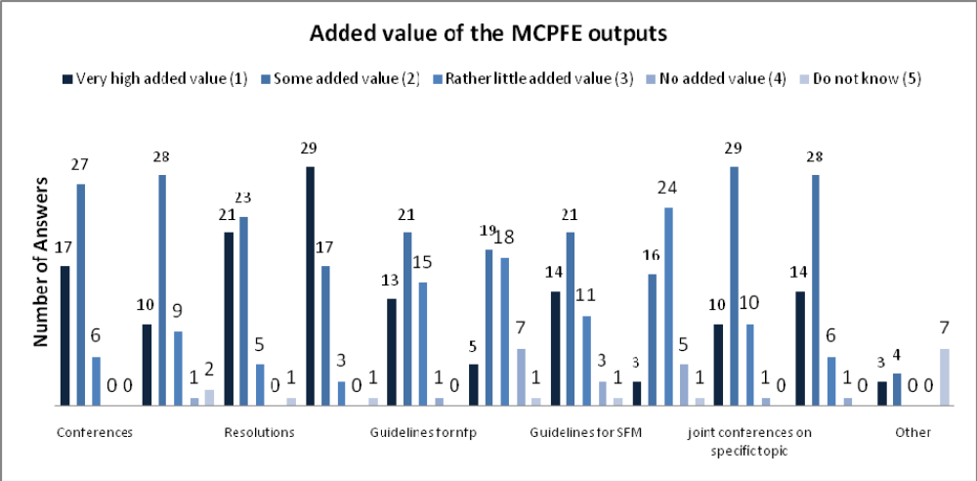
Figure 10 The added value of the MCPFE outputs at national level (all respondents)

b) Signatory Countries
The Signatory Countries report as the most important outputs C&I, MCPFE Resolutions, guidelines for nfps, and MCPFE Conferences. Also MCPFE publications and joint conferences on specific themes with relevant stakeholders and peers are rated to generate some added value. According to Signatory Countries, classification of protected and protective forests and other wooded land (FPA), and pan-European guidelines for afforestation and reforestation have produced the lowest added value at national level
(Figure 10).

Signatory Countries emphasise the significance of the guidelines for nfps. They provide in additional comments information about the importance of the PEBLDS. South West and South East European countries rate Conferences, Declarations and Resolution higher. North West European countries consider C&I the most influential and report guidelines for SFM and nfp to generate some added value. One Signatory Country comment that the MCPFE generates added value by providing expertise and background information in developing national forest policies more efficiently. Southern East and South West European countries evaluate the impact of the MCPFE outputs to be the lowest (Annex 22).

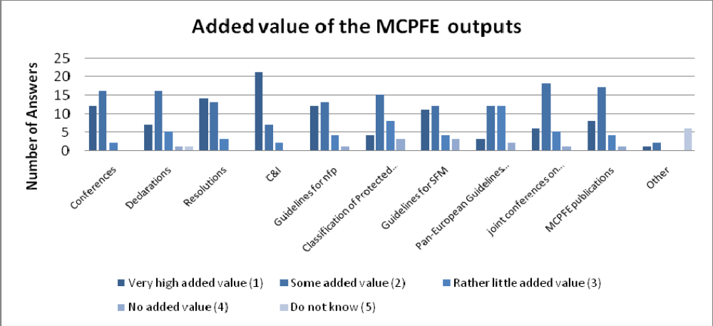
Figure 11 The added value of the MCPFE outputs at national level (Signatory Countries)

c) Stakeholders and peers
According to stakeholders and peers, the C&I, Resolutions and Conferences have generated the highest added value at national level. Results are very similar with Signatory Countries in that sense. However, stakeholders and peers seldom mention nfps.

Compared to results of the Signatory Countries, both stakeholders and peers more frequently evaluate the MCPFE Conferences and Publications to generate very high added value. Both stakeholders and peers also rate Declarations, joint conferences on specific topics and MCPFE publications quite highly. Classification of protected and protective forests and other wooded land, and pan-European Guidelines for afforestation and reforestation are mentioned by some stakeholders and peers to produce no added value. Stakeholder organisations consider developing of C&I and guidelines for SFM the most significant outputs (Annex 23).
Annex V
Review of the MCPFE/UNECE/FAO report
State of Europe’s Forests 2007
The MCPFE report on sustainable forest management in Europe –
- report’s producers

Introduction

The Ministerial Conference on the Protection of Forests in Europe (MCPFE) in Vienna in 2003 reaffirmed the role of the criteria and indicators for SFM as a tool for monitoring, assessing and reporting progress on sustainable forest management. In consequence of this and previous Ministerial commitments, the relevant report for the pan-European level for the 5th MCPFE Conference in Warsaw was elaborated.

The report’s arrangement follows the structure of improved Pan-European Criteria and Indicators for Sustainable Forests Management, which include 35 quantitative and 12 qualitative indicators. The report is based on forest resources assessment data collected from MCPFE and FAO national correspondents and international data providers (IDPs), such as ICP Forests, Joint Research Center (JRC), Eurostat and others. Information on indicators 4.7 (Landscape pattern) and 6.4 (Expenditures for services) was presented in a form of case studies.

The MCPFE report on State of Europe’s Forests 2007 (SoEF 2007) continues the series of European forest resources assessments that had been prepared under auspices of UNECE and/or MCPFE, which is expected to be maintained. In the frame of preparations for the next assessment cycle it is of utmost importance to collect experiences and views from both report’s users and producers.

The objective of this review is to provide preliminary input to the discussion under agenda item 4 “Team review of the MCPFE report “State of Forests and Sustainable Forest Management in Europe 2007””at the upcoming UNECE Team of Specialists meeting 26-27 May 2008 in Vienna, Austria.

Moreover, the review results will furthermore provide invaluable input to the preparation of the process of reporting for the next Ministerial Conference, it could also be a contribution to the improvement of the European component to the FAO Global Forest Resources Assessment.

The questionnaire is divided into two parts:
Part I: report elaboration
Part II: MCPFE SoEF 2007 report, dissemination
Please send the completed questionnaire to the UNECE/FAO secretariat (christopher.prins@unece.org) and the Team Leader (ewald.rametsteiner@boku.ac.at) if possible, before 23 May 2008, in order to allow its consideration at the Team meeting.

- QUESTIONNAIRE -

Part I - report elaboration process
(review of overall planning and time plan, questionnaire design, data collection, data validation, report writing and draft report review)

  - Do you consider general approach for the SoEF 2007 preparations as appropriate? Please mark

Yes [ ] Partly [ ] No [ ]
In the case of “partly” or “no”, please explain why and provide suggestions for improvement, if possible

  - Do you find the general organization of work (Advisory Group for the MCPFE SoEF 2007, degree and form of Team involvement in preparation, National Correspondent networks, and involvement of the international data providers) as sufficient and effective? Please mark

Yes [ ] Partly [ ] No [ ]
In the case of “partly” or “no”, please explain why and provide suggestions for improvement, if possible

3. Do you consider the time schedule for the SoEF 2007 preparations as appropriate and realistic?

Yes [ ] Partly [ ] No [ ]
In the case of “partly” or “no”, please explain why and provide suggestions for improvement, if possible

4. Do you evaluate process of national data collection/validation on quantitative indicators collected through national correspondents, including structure of the questionnaire, secretariat (LUW and UNECE/FAO) assistance and support, as well organized and well carried out?

Yes [ ] Partly [ ] No [ ]
In the case of “partly” or “no”, please explain why and provide suggestions for improvement, if possible

5. Do you evaluate process of data validation on quantitative indicators collected through international data providers, as well organized and well carried out?

Yes [ ] Partly [ ] No [ ]
In the case of “partly” or “no”, please explain why and provide suggestions for improvement, if possible

6. Do you evaluate process of national data collection/validation on qualitative indicators (structure of the questionnaire, data collection through MCPFE Focal Points) as well organized and well carried out?

Yes [ ] Partly [ ] No [ ]
In the case of “partly” or “no”, please explain why and provide suggestions for improvement, if possible

7. Did the provided opportunities for your participation in report elaboration (incl. data checking, draft report review) respond your expectations and needs?

Yes [ ] Partly [ ] No [ ]
In the case of “partly” or “no”, please explain why and provide suggestions for improvement, if possible

  - What can / should be improved or considered in any future SoEF report preparation process, according to your opinion?

Part II - Report contents and dissemination

- Did the MCPFE SoEF 2007 report meet your perceived general needs and satisfy your expectations?

Yes [ ] Partly [ ] No [ ]
In the case of “partly” or “no”, please explain why and provide suggestions for improvement, if possible

- Is the overall structure of the MCPFE SoEF 2007 report (six MCPFE criteria, quantitative and qualitative indicators, regional grouping) appropriate?

Yes [ ] Partly [ ] No [ ]
In the case of “partly” or “no”, please explain why and provide suggestions for improvement, if possible

- How do you evaluate particular parts of the SoEF 2007 report?

Please rate the following chapters from 5 (excellent) to 1 (poor) Please mark: 5 4 3 2 1 N/A

 | Arrangement/  Structure | Contents | Completeness/  data accuracy
Executive Summary
Introductory Part
MCPFE Quantitative Indicators
MCPFE Qualitative Indicators
Overview and Conclusions
Annexes – data tables
Annexes - other

Please explain any issue related to the report’s content that needs improvement.

- Is the graphic design (layout, graphs, maps and tables) of the MCPFE SoEF 2007 report appropriate?

Yes [ ] Partly [ ] No [ ]
In the case of “partly” or “no”, please explain why and provide suggestions for improvement, if possible

- In your opinion, was report and data dissemination (report, leaflet, pdf) and promotion (e.g. special session at the 5th MCPFE, etc. ) well designed and appropriate?

Yes [ ] Partly [ ] No [ ]
In the case of “partly” or “no”, please explain why and provide suggestions for improvement, if possible

- What can / should be improved or considered in any future SoEF report (structure, contents, format, etc.) or dissemination, according to your opinion?

Annex VI

Review of the use of the MCPFE/UNECE/FAO State of Europe Forests' Report
Results from a survey conducted by the UNECE/FAO secretariat

- Which affiliation best describes your work?

Government / public body | 43.9%
University/ Research Centre | 19.3%
International Governmental Organization | 14.0%
Non Governmental Organization | 8.8%
Private Company | 8.8%
Consultant | 5.3%
Forest Owner/Manager | 0.0%

- How did you learn of this publication?

Official announcement, press release | 55.1%
Newsletter or publication | 32.7%
Internet search | 30.6%
Conference or workshop | 30.6%
Recommended by a colleague | 22.4%

- What were your needs and expectations from the report?

General information on status and trends of forests in Europe | 85.7%
Detailed information on quantitative indicators of sustainable forest management in Europe (if a specific thematic area/criterion, please state which in the box below) | 64.3%
Information on sustainable forest management in a specific country or sub-region | 44.6%
Information on European forests for use in a wider context | 41.1%
Detailed information on qualitative indicators of sustainable forest management in Europe | 41.1%
Source data for your own research | 39.3%
Information for decision-making and planning | 30.4%
Other | 5.4%

Comments from users:
1. | Especially the SoEF could provide information about the state of the forests in all European countries, more in detail, so that one could compare the trends and the state of the forest management in Europe - regarding e.g.  - current and historical forest cover (hectares, %)  - ownership structure (forest area according to forest ownership types – state/municipal/Church/…..etc)  - current tree species composition (%)  - growing stock volume (stock of timber according to the tree species)  - natural tree species composition (%)  - natural forest cover (%)  - current share of silvicultural systems (low forest=coppice forest, high forest=forest of seed origin, coppice-with-standards, grazing forest, plantations)  - main forest risk factors (forest fires, air pollutions, grazing, illegal logging etc)  - and % of forests threatened by these factors
2. | Extent of area under SFM.
3. | .. info about Russia where I have a consultancy job.
4. | When submitting proposals and comments to eligible government bodies relevant data on European context are needed.
5. | … forest resources and Carbon Cycle, forest ecosystems health, productive functions (wood and non-wood), biodiversity, protective functions (soil and water), socio-economic conditions.
6. | Increment of forests (area and stock), and in particular carbon stored in forests.
7. | As a donor assistance agency, we are interested in data related to the Balkans especially on forest management, private forest management, illegal logging, and biodiversity. This includes Kosovo, which we hope you add to your lists to begin establishing some country profile and information as soon as possible. USAID is supporting the forest product industry in Kosovo and new government needs to move forward.
8. | I did not have any needs for this publication.
9. | NON WOOD FOREST PRODUCTS

- Did the SoEF 2007 report meet your needs and satisfy your expectations, as
defined in question 3?

Yes | 63.0%
Partly | 35.2%
No | 1.9%

1. | Comments from users:  Information for decision-making should be more frequent in the document and more "authoritative" to help promote desirable activities and policies, to help persuade national governments to act in accordance with the requirements of sustainable forestry.
2. | 1) I think including Russia in the region "eastern Europe" was a mistake because it distorts all the figures. Russia should be kept as a separate entity.  2) The two protective functions on pp. 74 and 76 are not well defined because the second includes 'cultivated soils' without making it clear how this differs from 'soil erosion' in the first indicator. 'Managed natural resources' is a very obscure phrase that no user can readily understand. Is 'the landscape' what is meant?  3) Forest fires: does this cover forests or forests and other wooded land?  4) The numbers of threatened forest species of fauna seems to be way too high in CZ and Serbia, so they must have diverging criteria as compared to the rest (total bird species in all habitats of CZ will not amount to many more than the number indicated in Table 15). It would have been interesting to get experts in to look at precisely what species are threatened and why. This would have made it possible to understand what kinds of forests are disappearing or how fragmentation affects species, thus giving recommendations for new policies. General sentences e.g. "... birds seem to be less dependent than mammals on forests" (p. 67) are not useful.  5) Wood consumption, p. 94, it should be made clear that this is only apparent consumption. The data on trade covered p. 96 should not use different products than those discussed for apparent consumption.
3. | Forests of Europe and whole Russian Federation are included in the statistics. Referring to this statistics as data on "European forests" could be quite confusing and misleading (although this fact is mentioned in the beginning of the study).
4. | The output tables are the most valuable for us - but lot of figures in the tables is missing, and several more could be added.
5. | …estimates of area under SFM in each country would be useful
6. | Harvests by ownership category and by assortments would be nice
7. | I needed more detailed info about diverse states within the Russian federation
8. | a more detailed level of data would be useful.  more dynamic access.  price data, socio economic data
9. | Unfortunately there is always some data that is not available - it is not a weakness of the report it is a weakness of national statistics e.g. data on harvests by ownership types would be very valuable but more or less not available in a comprehensive way.
10. | It could be useful to have aggregated data at EU level
11. | Lack of synthesis
12. | … haven’t thought much about it.
13. | Economic function of forests might be more elaborated. The role of industries as well. Some disconnection with emerging or hot policy developments (e.g. renewable energy in Europe)
14. | Need more micro data.
15. | I have not used it.
16. | … information on sub-regions not detailed enough
17. | WE WOULD LIKE MORE INFORMATION ABOUT NON WOOD FOREST PRODUCTS

- As reader, did the overall structure/layout of the SoEF 2007 match your needs?
(e.g. chapter layout: MCPFE criteria, quantitative and qualitative indicators, regional grouping etc.)

Yes | 76.4%
Partly | 21.8%
No | 1.8%

1. | Comments from users:  I would suggest clearer formulation of recommendations for decision-making and their highlighting in the relevant chapters (for each indicator)
2. | 1) Same remark as above for Russia.  2) The way the report is structured exactly along the lines of the C&I makes it quite rigid. There often seems to be no connection between the chapters because there is no discussion of how different C&I are linked. At the same time, there is too much text to read, with no structuring in the form of subheadings or bullet points or boxes. Discussions of cross-linkages or controversial points could be done in boxes. There is no controversy at all and that makes the whole thing boring, if I may say so. Example of a controversy could have been the results on defoliation which don't match what the normal observer can see in our forests.
3. | Way in which the facts are presented (not very detailed), seems to be logical and reasonable due to huge differences among described regions.
4. | …nice design, the report is comprehensible
5. | Well, I do not really read through it - I always search through. Hence I can not really say.
6. | … overview tables and country tables in the annex did not always fit (totals)
7. | Haven't thought much about it.
8. | Need more quantitative information, maybe in an annex?
9. | I have not red it.

- Which parts of the report were relevant to your work or activity? Please rate
relevance using a scale from 1 to 5, 1 being the most relevant, 5 being least relevant:

7. As reader, did the overall design of the SoEF 2007 match your needs?(e.g. layout, graphs, maps and tables)

Yes | 85.5%
Partly | 12.7%
No | 1.8%

Comment from users:
1. | Too much of one color (in different shades), making some graphs quite unreadable (e.g. p.98) and totally unsuitable for copying.  Layout should be made more interesting along the lines described above.  It would be a good thing to employ a professional lay-outer.
2. | …see above
3. | More graphs
4. | …can’t say

8. Has the report added value to your work programme and/or activities?

Yes | 91.1%
No | 8.9%

1. | Comments from users:  It helps me to accommodate my understanding of forest functions, criteria & indicators of sustainable forest management, etc. to the "official opinion". It is also helpful to learn something about general trends in forests, though there are not enough real solutions of existing problems yet.
2. | It provides the most recent data on forest resources and the trends on the progress towards SFM in the pan-European region. Work on forestry issues in the regional (EU) context requires availability of data. Also the annexes with the most recent forest definitions (by FAO) are useful.
3. | Invaluable as a source of final FRA data.
4. | SoEF is THE most relevant document on forest data in Europe.
5. | Not until now, but it could be a possible source of some information
6. | … to be informed
7. | I appreciate the "summary" and "trend" character of the report and its accessibility. I very welcome that the basic/overview quantitative and qualitative information on forestry and its development in Europe were gathered in one report.
8. | As a source of valuable information
9. | Direct use as information source for applied research
10. | … latest source data were useful
11. | Well accepted reference source for different purposes. Easy accessible per internet, data base and printed book. Excellent technical support by MCPFE Liaison unit Oslo.
12. | In my work as a policy maker it helps to inform trends to help me do my job more effectively.
13. | More information on SFM in Europe; learning from the experiences; policy& regulations.
14. | information on European forests (information on specific countries that otherwise would be difficult to get)
15. | This is a good source of information on the region, including on Central Eastern Europe. I appreciate the information on private forests as well.
16. | Some data can me mixed with our own statistics and help build the case of the sector
17. | Not necessary we used the Europe data for comparison with Canada, we are not published them but we used it sometime to compare.
18. | … compléter les autres données disponibles dans le monde
19. | Enabling comparisons with national indicators and providing briefing on international developments. However more use is made of Global FRA results.
20. | Giving the milestones for determination of a contemporary sustainable forest policy and strategy on European, regional and national levels.
21. | … citation resource

9. Do you have suggestions to improve the content and/or presentation of the information to make the next report more user-friendly and more widely accessible? If so, please summarize them below

1. | Comments from users:  Maybe some brief version of the document would be worthy. Several leaflets, for example.
2. | This report is not enough known, even in the forest Administration in Paris. It has not been transmitted to colleagues on the field.  Executive summary in French is excellent: it was distributed (1 000 copies) during EFW, 2008.  For the future, ensure a wide diffusion by DVD.
3. | Asian part of Russian Federation should be excluded from the statistics, or the study should describe "State of forests in MCPFE area", not "State of Europe forests"
4. | … not many.... I especially appreciate the Executive summary with the key statements which are then further elaborated in the book.
5. | No
6. | I think the report is excellent in its present form.
7. | Stick to data tables, facts, description (estimation) of data accuracy, methods of data handling.
8. | … see comments to question 4
9. | … more detailed data would be useful
10. | Follow the same format for easy comparative purpose.
11. | -More focus on Forest management experiences and innovations in the countries.  -Diversify ways of dissemination
12. | Some information at EU aggregated level would be useful for our concrete work at EU level.
13. | 1. More graphs and maps  2. Lack of interpretation of trends  3. More clear methodology description
14. | … not really
15. | More down the chain socio-economic data and analysis. Because forests depend on the economic viability of their resource using industries.
16. | Micro data added in the annex, table is great but we cannot manipulate or do our own calculation.
17. | The presentation of figures could be in a better graphical form. The recent publication by FAO Vital Forest Graphics is a good example of presenting similar forms of data as SoEF.
18. | traduction en français
19. | Label data tables by indicator number. Increase compatibility with Global FRA, both in selection of indicators and in access to results.
20. | I don't have
21. | MORE ATTENTION TO NON WOOD FOREST PRODUCTS

10. Any additional comments

1. | Comments from users:  As for the future reporting periods, it may be considered to establishing of this monitoring and reporting on the state of forests in Europe on a more permanent basis and fixed intervals (i.e. every 5 years), comparing to the current reporting for the MCPFE ministerial conferences. Further work on "difficult-to-measure" (in particular social) indicators should be carried out in order to provide more accurate data.
2. | Additional topics could be:  - What is being done to plant tree species/varieties that are less susceptible to being felled by storms? Ditto for species better adapted to drought.  - Information on the length of forest roads per 1000 hectares may show that some countries have too many. Who finances such roads is also relevant.
3. | No
4. | Compare with other regions and promote private sector and communities.
5. | Stating the difficulties, problems and deficiencies when establishing forest basic concepts and indicators, gathering, comparing and processing data will also have an added value for our work.  Data compliance, conformity and uniformity quality checks (in appropriate cases) could improve information quality and reliability.
6. | … nice publication - good work
7. | Please move fast on Kosovo
8. | No.
9. | No additional comments

Annex VII
Results of the Internet search for State of Europe’s Forests 2007

Date of the search: 15.12.2009
Viewer: Google

Method: advanced search; command “Find web pages that have this exact wording or phrase: “State of Europe’s Forests 2007”.

Results: 8,820 web pages responding search criterion were found

For further analysis the first 20 websites and 30 subsequent websites (every tenth) were selected.

Applied classification of website owners:

Category | Code
Government / public body | 1
University/ Research Centre | 2
International Governmental Organization | 3
Non Governmental Organization | 4
Private Company | 5
Consultant | 6
Forest Owner/Manager | 7
Not classified | 8

Applied classification for website profile:

Category | Code
Forestry sector (forest and wood) | F
Ecology/Climate | E
Cross-sectoral | G

Summary Results

Website owner category | Share of identified websites (%)
Government / public body | 8.3
University/ Research Centre | 35.4
International Governmental Organization | 35.4
Non Governmental Organization | 0
Private Company | 2.1
Consultant | 0
Forest Owner/Manager | 4.2
Not classified | 14.6

Website profile category | Share of identified websites (%)
Forestry sector (forest and wood) | 72.9
Ecology/Climate | 4.2
Cross-sectoral | 18.8
Detailed results of the query

Pos. | text | Owner | Profile
1 | State of Europe's Forests 2007: the MCPFE report on sustainable ...  13 Nov 2007 ... Title, State of Europe's Forests 2007: the MCPFE report on sustainable forest management in Europe. Creator, Ministerial Conference on the ...  forestportal.efi.int/view.php?id=1895&c=E1 - Cached - Similar | 2 | F
2 | State of Europe's Forests 2007  The MCPFE report on Sustainable Forest Management in Europe, jointly prepared by the MCPFE Liaison Unit Warsaw, the UNECE and the FAO.  www.eomf.org/article.php?id=49&langue=en... - Cached - Similar | 2 | F
3 | The State of Europe's Forests: 2007 – Report of the Fifth ... by M Köhl The MCPFE report “State of Europe's Forests 2007”1 was presented at the fifth. Ministerial Conference on the Protection of Forests in Europe (MCPFE), ...  www.springerlink.com/index/p4vp640577254220.pdf | 2 | F
4 | EUROPE'S FORESTS 2007 File Format: PDF/Adobe Acrobat - View as HTML  State of Europe's Forests 2007. It is evident that the MCPFE has played a major role in promoting sustainable for- est management and in coordinating and ...  timber.unece.org/fileadmin/DAM/other/reports_key_findings_EN.pdf | 3 | F
5 | Europe - Wikipedia, the free encyclopedia "State of Europe's Forests 2007: The MCPFE report on sustainable forest management in Europe" (PDF). EFI Euroforest Portal. pp. ...  en.wikipedia.org/wiki/Europe - Cached | 8 | G
6 | Ministerial Conference on the Protection of Forests in Europe ... by JL Innes - 2009  Ministerial Conference on the Protection of Forests in Europe, State of Europe's forests 2007 , The MCPFE Report on Sustainable Forest Management in Europe, ...  ideas.repec.org/a/eee/forpol/v11y2009i2p163-164.html - Cached - Similar | 8 | G
7 | Happy News - Ministerial Conference on Protection of European ... 5 Sep 2007 ... The Report on State of Europe's Forests 2007 prepared by the Economic Commission for Europe and the MCPFE Liaison Unit will be presented ...  www.happynews.com/.../952007/ministerial-conference-protection-european-forests-agrees-documents.htm - Cached | 8 | G
8 | Sustainable Forest Management in Europe File Format: Microsoft Powerpoint - View as HTML 24 Oct 2008 ... Threats to forests in Europe: Storms; Fire; Air pollution; Other damaging factors. Source: State of Europe's Forests 2007. The Challenges ...  www.fao.org/forestry/foris/data/efw/Plenary4Sletnes.ppt | 3 | F
9 | Facts & figures - European Forest Week 2007. State of Europe's forests 2007 - The MCPFE report on sustainable forest management in Europe. Warsaw, Poland, Ministerial Conference on the Protection ...  www.europeanforestweek.org/48475/en/ - Cached - Similar | 3 | F
10 | MCPFE Summary of the MCPFE Report on State of Europe's Forests 2007 prepared on the occasion of the 5th MCPFE. The English version is out of stock. ...  www.mcpfe.org › Publications - Cached - Similar | 3 | F
11 | Ministerial Conference on the Protection of Forests in Europe  File Format: Microsoft Powerpoint - View as HTML 7 Nov 2007 ... State of Europe's Forests 2007. - reflects status and trends in accordance with 6 Criteria (characterized by quantitative indicators) ...  www.european-foresters.org/DanishGCM/.../APPENDIX%209.ppt - Similar | 7 | F
12 | Getting the best out of Europe's forests File Format: PDF/Adobe Acrobat - Quick View I welcome the report State of Europe's Forests 2007. Policies are only as good as the information on which they are based, so this report will shine ...  ec.europa.eu/commission_barroso/fischer-boel/speeches/forests_en.pdf - | 8 | G
13 | Microsoft PowerPoint - MCPFE Koli workshop sept 08 File Format: PDF/Adobe Acrobat - Quick View 53 gigatones of carbon stored in forest biomass, which is increase of 2 billion tonnes since 1990. Source: State of Europe's Forests 2007 ...  www.mmm.fi/attachments/metsat/.../MCPFE_Koli_workshop_sept_08_.pdf - | 1 | G
14 | Forests, Deserts, Land - Media Reports - Linkages - Thursday, 3 ... The database is a comprehensive research tool based on the report “State of Europe's Forests 2007,” and includes information collected by hundreds of ...  www.iisd.ca/media/forests_deserts_land.htm - Cached - Similar - | 8 | G
15 | 5th MCPFE Conference: Warsaw - Centre for Dialogue on European ...  According to the Report on State of Europe's Forests 2007 presented at the Conference, both the area of forests and their productive potential are ... findarticles.com/p/articles/mi_m0EIN/is_2007.../ai_n21081934/ - Cached - | 8 | G
16 | 5th Ministerial Conference on the Protection of Forests in Europe ... 23 Oct 2007 ... The documents consider the roles of forests in mitigating climate ... (SFM) at national and regional levels: State of Europe's Forests 2007; ...  forestportal.efi.int/view.php?id=1852&r=4 - Cached - | 2 | F
17 | Hardwood markets  File Format: Microsoft Powerpoint - View as HTML  12 Nov 2009 ... Print; Website: State of Europe's Forests 2007. Next SoEF 2011. Future Forest Monitoring in the European Union. 11-12 November 2009, ...  www-conference.slu.se/futforestmon/presentations/4%20Pepke.ppt - | 3 | F
18 | Forest Europe  File Format: PDF/Adobe Acrobat - Quick View  Next issue in March/April 2007. REPORTING FOR THE 5th MCPFE. STATE OF EUROPE'S FORESTS 2007. - reflects status and trends of 6 Criteria characterized by ...  www.mcpfe.org/?module=Files;action=File.getFile;ID=349 - Similar - | 3 | F
19 | EconPapers: Ministerial Conference on the Protection of Forests in ...  Ministerial Conference on the Protection of Forests in Europe, State of Europe's forests 2007, The MCPFE Report on Sustainable Forest Management in Europe, ...  econpapers.repec.org/.../v_3a11_3ay_3a2009_3ai_3a2_3ap_3a163-164.htm - Cached - | 2 | G
20 | Press release 05/11/2007  The Minister pointed out the optimistic data as included in the "Report on State of Europe's Forests 2007", according to which both the area of forests and ...  www2.mos.gov.pl/mos/news/press_releases/2007.11.05.html - Cached - | 3 | F
30 | Means of combating forest dieback - EU support for maintaining ... by C Volume - Related articles 21 Jan 2009 ... MCPFE (2007). State of Europe's forests 2007. The MCPFE report on Sustainable Forest Management in Europe, Jointly prepared by the MCPFE ...  www.sisef.it/iforest/show.php?id=480 - Cached - Similar | 2 | F
40 | European Observatory Of Mountain Forests  State of Europe's Forests 2007. The MCPFE report on Sustainable Forest Management in Europe, jointly prepared by the MCPFE Liaison Unit Warsaw, ...  www.eomf.org/?langue=en&PHPSESSID... - Cached | 2 | F
50 | Forest genetic resources and adaptation of forest management to ... File Format: PDF/Adobe Acrobat - View as HTML State of Europe's Forests 2007. • Trends in implementation of sustainable forest management in Europe (1990, 2000 and 2005) ...  www.nordgen.org/ngdoc/forest/Konferanser/2008_Koskela.pdf | 2 | G
60 | Dias nummer 1 File Format: Microsoft Powerpoint - View as HTML  IPCC 2007: Harvested wood products be used for climate mitigation! ... Source: MCPFE/UNECE/FAO “State of Europe's Forests 2007”, based on data collected by ...  diggy.ruc.dk:8080/retrieve/12211 | 2 | E
70 | EU-wide maps of growing stock and above-ground biomass in forests ... by H Gallaun – 2009 MCPFE, 2007 MCPFE, State of Europe's forests 2007. The MCPFE report on sustainable forest management in Europe, Ministerial Conference on the Protection of ...  linkinghub.elsevier.com/retrieve/pii/S0378112709007403 | 2 | F
80 | PowerPoint Presentation File Format: PDF/Adobe Acrobat - View as HTML Data for Germany, Estonia and Luxembourg included in Natura 2000 areas. Sources: State of Europe's Forests 2007. State of Finland's Forests 2007 ...  wwwb.mmm.fi/.../METSO-new_ways_to_conserve_nature_May2008.pdf | 1 | F
90 | EUFORGEN During the conference in Warsaw, reports on the State of Europe's Forests 2007 and on the Implementation of MCPFE Commitments were also released. ...  www2.bioversityinternational.org/networks/.../viewreport.asp?...SB03 - Cached | 2 | F
100 | Legújabb publikációink - Erdészeti Tudományos Intézet (ERTI ... - Köhl, M., Rametsteiner, E., Somogyi, Z., Marchetti, M., Parviainen, J., Zingari, P.C., Lebedys, A. (2007): State of Europe's forests 2007. ...  www.erti.hu/ujpub.php?id=1 - Cached - Similar | 2 | F
110 | Publications ... and Rametsteiner, E. (Eds.) MCPFE/UNECE/FAO State of Europe's Forests 2007 - The MCPFE report on sustainable forest management in Europe, Criterion 4. ...  forest.jrc.ec.europa.eu/publications - Cached | 2 | F
120 | Ryby płaczą w polskich rzekach Wpoprzednich częściach omówi- - File Format: PDF/Adobe Acrobat - Quick Viewby R ŻuRek - Related articles MCPFE 2007 State of europe's forests 2007. The MCPFE Report on Sustainable Forest Ma- nagement in Europe Jointly prepared by the. MCPFE Liaison Unit Warsaw, ...  www.iop.krakow.pl/files%5CPROFILE%5CRoman%20Zurek%5Cpdfy%20Zurek%5CRy... - | 2 | E
130 | Entwaldung – Wikipedia - [ Translate this page ] State of Europe's Forests 2007. The MCPFE Report on Sustainable Forest Management in Europe. MCPFE Liaison Unit Warsaw. Warschau, 2007. ...  de.wikipedia.org/wiki/Entwaldung - Cached - Similar | 8 | G
140 | 1 cop I e IV.qxp File Format: PDF/Adobe Acrobat - View as HTML Mcpfe/Unece/Fao, State of Europe's forests 2007. The Mcpfe report on sustainable forest management in Europe, Mcpfe Liaison Unit Warsaw, United Nations ...  www.gruppo2013.it/.../Le%20nuove%20sfide%20per%20il%20settore%20forestale.pdf | 2 | F
150 | Bæredygtig skovdrift - Træ Er Miljø Databasen er baseret på rapporten ”State of Europe's Forests 2007”. ”International Tropical Timber Organization's (ITTO)” har på deres hjemmeside en ...  www.trae.dk/Dokumenter/Dokument.asp?DokumentID... - Cached - Similar | 4 | F
160 | Foreste e cambiamento climatico File Format: PDF/Adobe Acrobat - View as HTML MCPFE, UNECE e FAO, State of Europe's Forests 2007. The MCPFE report on sustainable forest management in Europe (“Lo stato delle foreste europee 2007 - ...  www.copa-cogeca.be/img/user/file/FT_EN/DOC/5657IT.pdf | 7 | F
170 | Inizio Taormina Primo:Inizio Taormina by AI di Scienze Forestali - Related articles MCPFE, 2007 – State of Europe's forests 2007. The. MCPFE report on sustainable forest management in. Europe. Ministerial Conference on the Protection of ...  paduaresearch.cab.unipd.it/2179/1/sitzia_viola_selvi_08.pdf | 2 | F
180 | UNECE: Reporting on sustainable forest management 2007 These result tables are extracted from State of Europe's Forests 2007 and correspond to Annex 9 of the Report. They provide a set of data collected through ...  timber.unece.org/index.php?id=77 - Cached - Similar | 3 | F
190 | Opinion of the European Economic and Social Committee on the role ... File Format: PDF/Adobe Acrobat - Quick View Temporal evolution of the European Forest sector carbon sink 1950-1999. Global Change Biology 9. (2) State of Europe's Forests 2007. ...  eur-lex.europa.eu/LexUriServ/LexUriServ.do?uri=OJ:C:2009:228...EN... | 3 | F
200 | Kutatói Nap 07 ok6 - File Format: PDF/Adobe Acrobat - View as HTML by AE Egyesület - Related articles 2007. nov. 30. ... Protection of Forests in Europe, Liaison Unit Vienna, pp. 114. MCPFE, 2007. State of Europe's Forests 2007. The MCPFE Report on ...  www.aee.hu/kutatoi_nap_2007.pdf - Similar | 2 | F
210 | MMM - MCPFE - Euroopan metsäministerikonferenssit State of Europe's forests 2007 -raportti tuo esille muun muassa sen, että Euroopan metsävarat ovat kasvussa, ja että metsien hakkuumahdollisuuksia olisi ...  www.mmm.fi/fi/.../mcpfe_euroopan_metsaministerikonferenssit.html - Cached | 1 | F
220 | Zelená správa - ForestPortal.sk - portál o lesoch Slovenska File Format: PDF/Adobe Acrobat rečná správa za riešenie úlohy v roku 2006. NLC – LVÚ Zvolen, 116 s. State of Europe's Forests 2007. The MCPFE Report on Sustainable Forest Manage- ...  www.forestportal.sk/ForestPortal/lesne_hospodarstvo/doc/zs2008web.pdf - | 1 | F
230 | Timer Section Newsletter, no. 16, Oct-Dec 2007 File Format: PDF/Adobe Acrobat - View as HTML finished reporting for The State of Europe's Forests 2007 and that, in turn, came soon after the FRA 2005 reporting requirement. ...  timber.unece.org/fileadmin/DAM/other/Newsletter_18_2008_final.pdf - | 3 | F
240 | GE.09-20285 Distr. GENERAL ECE/TIM/EFC/WP.2/2009/6 20 January 2009 ... File Format: PDF/Adobe Acrobat - Quick View Resources Assessment 2005 and the State of Europe's Forests 2007. The Team of Specialists actions for 2007-2008 are elaborated in the Report of the meeting ...  timber.unece.org/fileadmin/DAM/meetings/ece-tim-efc-wp2-2009-06e.pdf - | 3 | F
250 | NWFP Digest-L 28 Aug 2009 ... The database is a comprehensive research tool based on the report State of Europe's Forests 2007, and includes data which have so far not ...  www.fao.org/forestry/55322/en/ - Cached - Similar - | 3 | F
260 | Item 3_Proposal for climate change activities, based on a gap ... File Format: PDF/Adobe Acrobat - Quick View 3 Apr 2009 ... State of Europe's Forests 2007, based on quantitative indicators for Sustainable Forest. Management (collected for MCPFE 2007 State of ...  timber.unece.org/.../Item_4a_Proposal_for_climate_change_activities__based_on_a_gap_analysisx.pdf | 3 | F
270 | Global Trade File Format: Microsoft Word - View as HTML State of Europe's Forests 2007. Available at: www.mcpfe.org/files/u1/publications/pdf/FE_EN.pdf. Tan, X., Shi, K. & Lin, F. 2007. The Production and Trade ...  www.unece.org/timber/mis/.../GlobalTradePepke250908.doc | 3 | F
280 | Les forêts et l'eau Le rapport State of Europe's Forests 2007, préparé conjointement par l'Unité de liaison Varsovie de la CMPFE, la FAO et la Commission économique des Nations ...  www.fao.org/docrep/010/a1598f/a1598f16.htm | 3 | F
290 | Contribution of the forestry sector to national economies, 1990-2006 File Format: PDF/Adobe Acrobat State of Europe's forests 2007 - The MCPFE report on sustainable forest management in Europe. Warsaw, Poland, Ministerial Conference on the ...  ftp://ftp.fao.org/docrep/fao/011/k4588e/k4588e00.pdf - Similar - | 3 | F
300 | Potential Sustainable Wood Supply in Europe File Format: PDF/Adobe Acrobat - Quick View MCPFE/UNECE/FAO (2007): State of Europe's forests 2007. The SOEF 2007 on sustainable forest management in Europe. Warsaw, Poland. ...  www.unece.org/.../tc.../Paper_PotentialWoodSupply_v18Oct.pdf | 3 | F

Annex VIII.

List of the MCPFE quantitative indicators for SFM, as adopted by the MCPFE Expert Level Meeting 7-8 October 2002, Vienna, Austria.

Criterion 1: Maintenance and Appropriate Enhancement of Forest Resources and their Contribution to Global Carbon Cycles

1.1 Forest area - Area of forest and other wooded land, classified by forest type and by availability for wood supply, and share of forest and other wooded land in total land area
1.2 Growing stock - Growing stock on forest and other wooded land, classified by forest type and by availability for wood supply
1.3 Age structure and/or diameter distribution - Age structure and/or diameter distribution of forest and other wooded land, classified by forest type and by availability for wood supply
1.4 Carbon stock - Carbon stock of woody biomass and of soils on forest and other wooded land

Criterion 2: Maintenance of Forest Ecosystem Health and Vitality
2.1 Deposition of air pollutants - Deposition of air pollutants on forest and other wooded land, classified by N, S and base cations
2.2 Soil condition - Chemical soil properties (pH, CEC, C/N, organic C, base saturation) on forest and other wooded land related to soil acidity and eutrophication, classified by main soil types
2.3 Defoliation - Defoliation of one or more main tree species on forest and other wooded land in each of the defoliation classes “moderate”, “severe” and “dead”
2.4 Forest damage - Forest and other wooded land with damage, classified by primary damaging agent (abiotic, biotic and human induced) and by forest type

Criterion 3: Maintenance and Encouragement of Productive Functions of Forests (Wood and Non-Wood)
3.1 Increment and fellings - Balance between net annual increment and annual fellings of wood on forest available for wood supply
3.2 Roundwood - Value and quantity of marketed roundwood
3.3 Non-wood goods - Value and quantity of marketed non-wood goods from forest and other wooded land
3.4 Services - Value of marketed services on forest and other wooded land
3.5 Forests under management plans - Proportion of forest and other wooded land under a management plan or equivalent

Criterion 4: Maintenance, Conservation and Appropriate Enhancement of Biological Diversity in Forest Ecosystems
4.1 Tree species composition - Area of forest and other wooded land, classified by number of tree species occurring and by forest type
4.2 Regeneration - Area of regeneration within even-aged stands and unevenaged stands, classified by regeneration type
4.3 Naturalness - Area of forest and other wooded land, classified by “undisturbed by man”, by “semi-natural” or by “plantations”, each by forest type
4.4 Introduced tree species - Area of forest and other wooded land dominated by introduced tree species
4.5 Deadwood - Volume of standing deadwood and of lying dead-wood on forest and other wooded land classified by forest type
4.6 Genetic resources - Area managed for conservation and utilisation of forest tree genetic resources (in situ and ex situ gene conservation) and area managed for seed production
4.7 Landscape pattern - Landscape-level spatial pattern of forest cover
4.8 Threatened forest species - Number of threatened forest species, classified according to IUCN Red List categories in relation to total number of forest species
4.9 Protected forests - Area of forest and other wooded land protected to conserve biodiversity, landscapes and specific natural elements, according to MCPFE Assessment Guidelines

Criterion 5: Maintenance and Appropriate Enhancement of Protective Functions in Forest Management (notably Soil and Water)
5.1 Protective forests – soil, water and other ecosystem functions - Area of forest and other wooded land designated to prevent soil erosion, to preserve water resources, or to maintain other forest ecosystem functions, part of MCPFE Class “Protective Functions”
5.2 Protective forests – infrastructure and managed natural resources - Area of forest and other wooded land designated to protect infrastructure and managed natural resources against natural hazards, part of MCPFE Class “Protective Functions”

Criterion 6: Maintenance of Other Socio-Economic Functions and Conditions
6.1 Forest holdings - Number of forest holdings, classified by ownership categories and size classes
6.2 Contribution of forest sector to GDP - Contribution of forestry and manufacturing of wood and paper products to gross domestic product
6.3 Net revenue - Net revenue of forest enterprises
6.4 Expenditures for services - Total expenditures for long-term sustainable services from forests
6.5 Forest sector workforce - Number of persons employed and labour input in the forest sector, classified by gender and age group, education and job characteristics
6.6 Occupational safety and health - Frequency of occupational accidents and occupational diseases in forestry
6.7 Wood consumption - Consumption per head of wood and products derived from wood
6.8 Trade in wood - Imports and exports of wood and products derived from wood
6.9 Energy from wood resources - Share of wood energy in total energy consumption, classified by origin of wood
6.10 Accessibility for recreation - Area of forest and other wooded land where public has a right of access for recreational purposes and indication of intensity of use
6.11 Cultural and spiritual values - Number of sites within forest and other wooded land designated as having cultural or spiritual values

