REPUBLIC OF LATVIA

MARKET STATEMENT

1. GENERAL ECONOMIC TRENDS AFFECTING THE FOREST AND FOREST INDUSTRIES SECTOR
Like in the previous years also in 2002 there was a remarkable economic growth in Latvia (Table 1).
In 2002 GDP increased by 6.1%, i.e., twice as rapid compared to the global GDP growth and in actual prices it was 5194.7 mln LVL (Table 2). According to the growth of the GDP in 2002 Latvia takes 3rd place in Central and Eastern European Countries after Lithuania and Turkey.
The bulk in the GDP growth in 2002 was given by trade sector, manufacturing, commercial services, and construction.
Growth in the manufacturing sector basically depends on the outer demand. During the first months, because of the little demand from the EU, manufacturing volumes slightly decreased. In the following months the export volumes to EU showed a rapid increase again. In wood processing industry the situation is similar to the manufacturing industry - its index of actual production amount to the respective period of the previous year was 97.5%. In the following quarters the situation improved, the demand for wood processing industry production from other countries increased, prices for timber and timber products also increased, as well as there was growth in the volumes of manufacturing industry as a result exceeding the production volumes in the respective period in 2001.
The increase of the Euro rate had a favourable effect on the competitiveness of the forest sector products. Export to EU countries constituted 27% of the total forest sector export value.
Increase of the consumer prices in Latvia is close to that of the inflation rate of the developed countries, and it is one of the lowest among Central and Eastern European Countries. In 2002 the increase of the consumption prices was 1.9%.
Improvement of the economical environment, low inflation and increasing competition in bank sector promoted gradual decreasing of the loan interest rates in 2002. The average interest rate of the given out short term loans to the local enterprises and physical entities decreased for 4.5% (from 9.9% in 2001 to 5.4% in December 2002), and long term - for 2.4% (from 9.8% to 7.4%).
The business development was favourably influenced by the decrease of the enterprise income tax rate - from 25% to 22%. The legal acts also provide tax discounts for the big investment projects and to those entrepreneurs that produce high tech products or are operating in the special economic zones.
The direct foreign investment volume in Latvia in 2002 had doubled if compared to 2001 - 4.7% of GDP. The total investment value invested in forest sector enterprises in the end of 2002 constituted 36.5 mln LVL, i.e., 3.1% of the total investment volume. Dominating share of the incoming investments was related to wood processing development.

2. POLICY MEASURES TAKEN IN OUR COUNTRY OVER THE PAST 18 MONTHS, WHICH MIGHT HAVE A BEARING ON TRADE AND MARKETS OF FOREST PRODUCTS
The Conception of the Latvia's Forest and the Related Sectors National Programme was developed and accepted by the Government last year (09.07.2002). The conception provides to develop a programme that would ensure sustainable management of Latvia's forests and the development of forest and the related sectors in the context of common development of national economy. As it was concluded in the final report by the experts of the EU PHARE project "Optimization of the Latvia's Industry Cluster", up to now Latvia's forest sector, mainly forest industries, is fragmented and it is insufficiently integrated with such related sectors as energy sector, construction, transport, IT, information, science, finances, tourism, and others. Work on programme development was started with direct involvement of forest and related sector’s associations, environmental NGO’s and state authorities. To support the programme development Latvia's and FAO technical co-operation programme was launched "Formulation of Strategic Targets for the Forest Sector and Human Resources Development in Strategic Planning".

3. DEVELOPMENTS IN FOREST PRODUCTS MARKETS SECTORS (MAJOR EMPHASIS)
3.A. Wood energy, with a focus on government policies promoting wood energy
Local (wood, peat, hydro resources, wind power) and imported (oil products, natural gas, coal) energy resources are being used in Latvia. In 2002 the total energy consumption constituted 1.97x10¹⁷J, out of which 60% were imported.
From the local energy resources mostly wood fuel is used, and it comprises about 22% of the total primary energy resource consumption. Latvia's National Energy Programme provides support for use of the local renewable energy resources and to increase the share of the wood fuel up to 30% in the year 2020.
Out of the total harvested volumes in Latvia according to the experts there are about 12.5% used as fuel, and besides that quite a remarkable volume of the sawmill residues are used for energy production. There are about 200 000 m³ residues (mainly sawdust) used for producing briquettes and pellets.
Increasing prices of the fossil fuel resources promotes replacement of the heat energy production equipment and technologies for using wood and wood residues.
In Latvia wood fuels are used in various ways: (1) in heating private dwellings with fuel wood or chip briquettes; (2) wood chips are burnt in relatively big furnaces (enterprises and municipal heat supply objects). The utilisation of other wood residues - (sanding dust, moulding waste, plywood waste) is on the agenda in near future. Additional contribution will provide harvesting residues - small dimension logs from thinnings, stumps and others.
Thus there are quite a lot of wood energy resources that can be utilised in Latvia. Rational utilisation of these resources is one of the preconditions for increasing energy efficiency. At the moment there is no programme approach stimulating the use of a wider range of fuel wood in heat energy production. As an obstructive factor for optimising the renewable energy resources market is tax policy on fossil fuels, inefficient fuel utilisation technologies and consumers' low paying capacity.
The disadvantageous tax policy promotes export of fuel wood to Scandinavian countries where tax policy on fossil fuels is facilitating fuel wood consumption.
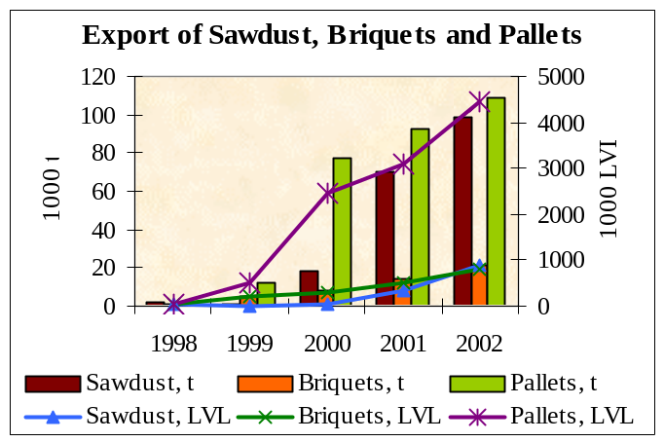In 2002 compared to 2001 exported roundwood fuel wood volumes increased by 3.7%, chips, sawdust, and other wood residues - by 40.2%.
This trend is also observed in the first 6 months of 2003 (compared to the respective period in 2002), increase of the fuel wood export reached 55%. Also the prices have increased because of the growth of the value of the export fuel wood production by 81.7%.
Rational processing and use of the raw material in energy production enterprises would increase wood industry efficiency and increase forest sector’s contribution in GDP.

3.B. Wood raw materials (e.g. roundwood: sawlogs, pulpwood and fuelwood)
As a result of land reform and increase economic activity in private forests the annual harvesting volumes during the last five years have increased from 10 to 12.2 mln m³, while in the state forests harvesting volumes remained stable - 4 mln m³ per year on average.
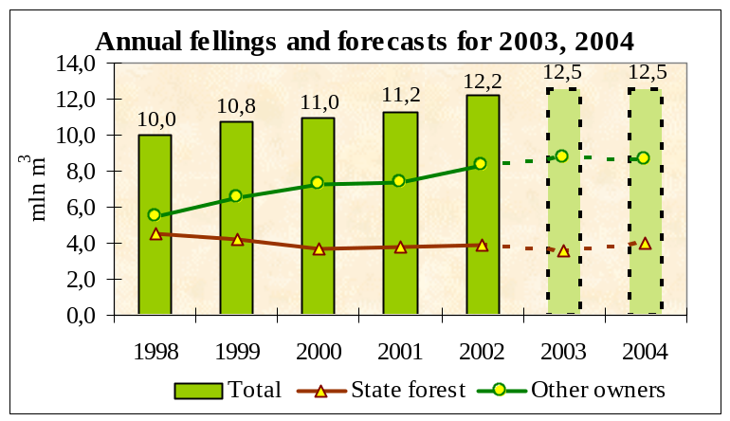It is envisaged that harvesting volumes will slightly increase in 2003 and might remain in that level in 2004
In utilisation of roundwood still a considerable share is constituted by the roundwood export (31%) (out of which 87% was pulpwood) and production of sawn-wood (52%), fire wood (9%), plywood, matches, log houses, piles, poles and others.
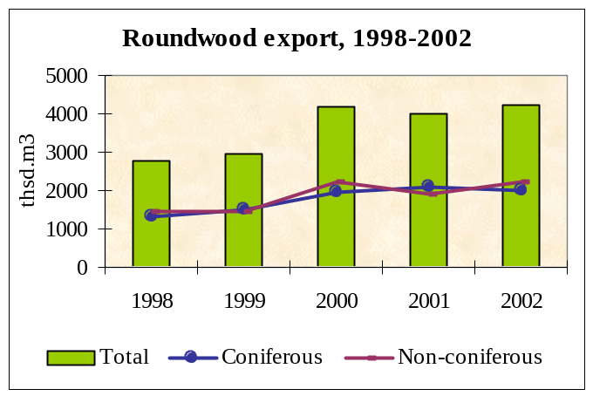Roundwood export in 2002 compared to 2001 increased by 5.9% (11.5% by value) and reached 4224.7 thsd m³ (out of those softwood - 47%, hardwood - 53%). The export of sawlogs (diameter above 14 cm) has increased. Roundwood (pulpwood) is mainly exported to Sweden and Finland, sawlogs to Germany.
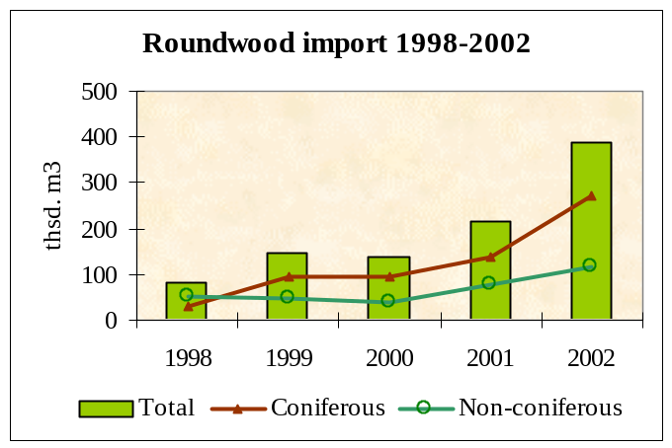Roundwood import compared to 2001 increased by 80.8% in 2002 (by 66% by value), they are mainly imported from Russia, Lithuania, and Belarus. It can be explained by the fact that the wood processing capacities and efficiency in Latvia exceed the available harvesting volumes and by the increasing log prices. Increase of the log prices was also affected by the drought in summer 2002, when in many regions harvesting was prohibited for fire-security reasons.
In the first half of 2003 (compared to the same period in 2002) the roundwood export volumes decreased by 4.5% and increased by 5% by value. Import growth in the first half of 2003 (compared to the same period in 2002) comprises 23.8% (45.2% by value).

3.C. Implications of forest law enforcement, governance and trade (FLEGT) on markets
The Forest Law complemented with the respective Regulations determine the access of people to forests, felling of trees, regeneration, marketing of reproductive material, conservation of biological diversity, soil and water protection, socio-cultural heritage values. Regulations determine the required information forest owners have to submit to the State Register of Forests.
Nevertheless, when analyzing the information on timber harvesting (12.2 mln m³) and utilization (13.46 mln m³) volumes in 2002, about 1.2 mln m³ of unknown origin timber were identified in the Latvian market. This causes social and economical consequences and unfair competition.
As a consequence to that drafting of legal acts and other measures avoiding appearance of unknown (illegal) timber flow whether local or imported has been initiated.

3.D. Certified forest products

In Latvia the certification of forest management and timber product chain-of-custody certification is performed under two certification schemes: Forest Stewardship Council (FSC) and Pan-European Forest Certification (PEFC).
FSC certification in Latvia is developing remarkably. Until February 2003 a total of 1,63 mill. ha have been certified according to the FSC requirements.
The 100% of the state forest area managed by State Stock Company "Latvijas Valsts Mezi" (Latvia's State Forests) have received FSC certificate.
FSC forest management certificate has been granted to 57 thousand ha area of Riga City forests.
Private forest owners have received FSC forest management certificate for 2.7 thousand ha forest area.
PEFC Latvian scheme has been evaluated as complying with PEFC provisions and requirements, accepted by the PEFC Board of Directors, has received a positive vote from PEFC Member Countries' National Boards, and has been internationally recognized as PEFC Latvian National Scheme on July 20, 2001.
Up to September 2003 under PEFC certification scheme 210 private forests have been certified with the total forest area of 20 thousand ha, also eight forest enterprises have certified their chains-of-custody.

3.E. Value-added wood products
Value-added wood production (furniture, furniture parts, joinery and carpentry products) and trade in Latvia is developing rapidly. It is related to the new technologies entering Latvia's wood processing industry.
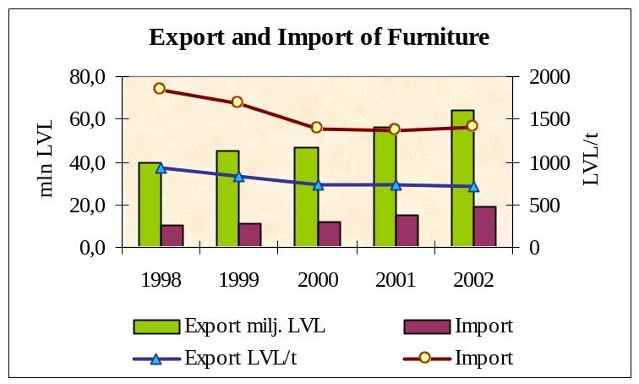In 2002 the kitchen and bedroom furniture production has increased, and office furniture production has decreased slightly. There has been a very rapid increase in the production of garden furniture (mainly from solid wood). This furniture group is also the dominating one in the furniture export. Compared to 2001 furniture export in 2002 has grown in monetary value by 14.2%, and import by 25.5%. Furniture is mainly exported to Germany, Denmark and other EU countries. The main furniture importers in Latvia are Poland, Italy, and Lithuania.
During the last 5 years there has been a remarkable growth in the joinery and carpentry production: wooden frames, doors, doorsteps, parquet plates, concreting moulds, and other necessary for construction articles (stairs, stairs parts), as well as glued timber parts (solid wood components and scantlings for wood and door frame production, glued solid wood boards, glued timber frames for construction). Window frame production has increased by 28%, and door frame production - by 128%. There is a remarkable growth in both export and in local consumption.
Wooden wrapping and packing equipment production in 2002 increased by 36%, and export volumes by 34%. The bulk of the wooden wrapping and packing equipment is formed by europallets.
In 2002 further processed sawn-wood production volumes increased by 11%. Also production and export of prefabricated buildings of wood has increased by 27% in 2002.

3.F. Sawn softwood
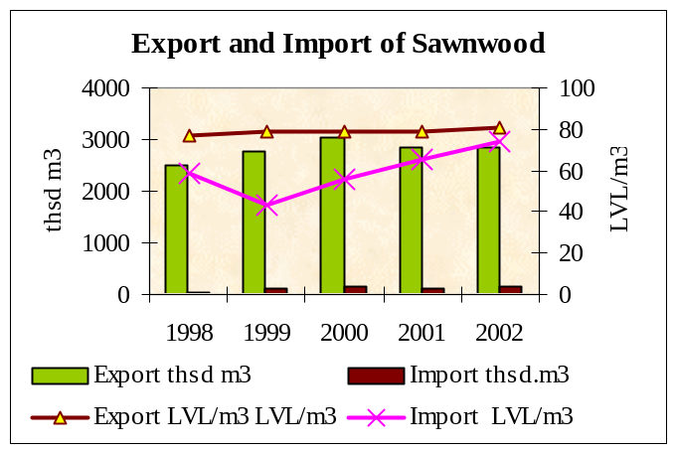Production of sawn-wood in 2002 compared to 2001 has increased by 11.3%.
The mayor groups of sawn-wood consumption are:
- solid wood boards and furniture (32%);
- construction items (window and door frames, parquet, squareboards, a. o.) and dwellings (46%);
- carpentry and household items (wooden packing, further processed sawn-wood, a. o.) (22%).
In 2002 compared to 2001 total volume of sawn-wood export has grown by just 0.1% while in the monetary value increased by 3.5%. Sawn hardwood, the volumes increased by 15% in the monetary value - by 21.1%; soft sawnwood export volume decreased by 3% while income increased by 0.5%. Stagnation of sawnwood export value is determined by local processing into other value-added products - furniture, joinery and carpentry products. Export volumes of non-dried and non-planed sawn-wood is decreasing.
The main Latvian export partners are Great Britain, Germany, and Netherlands. In 2002 sawn softwood export volumes to Denmark went down by 37%, to USA - by 33%, to Netherlands - by 28%, to France - y 21%. These figures are much smaller in terms of value. However there has been quite a remarkable increase of sawn-wood export to Sweden in 2002 compared to 2001 - by 87.7%, to Japan - by 53.5%, and to Iceland - by 34.5%.
Increase of sawn-wood export was possible due to saw-milling of the imported in Latvia timber, as well as further processing of the imported sawn-wood - drying, planing, and impregnating. The biggest importers of sawn-wood in Latvia are Russia, Estonia, Belarus, and Ukraine. Sawn softwood import is likely to increase while sawn hardwood is likely to increase in both import and export volumes.
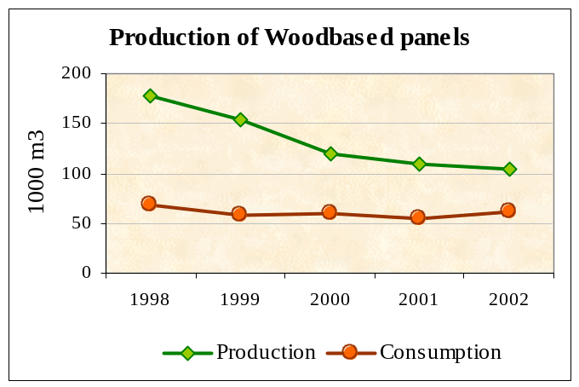
3.H. Wood-based panels (particle board, fibreboard and MDF, OSB, plywood)
In the board production and export the bulk of the volume is taken by plywood. Although the plywood production volumes in Latvia in 2002 increased by 11% compared to 2001, plywood export grew only by 0.9% and in the monetary value decreased by 0.3%. In 2002 the biggest plywood producer SC "Latvijas finieris" (LF) based its turnover growth 8.1% on the further processed plywood items production
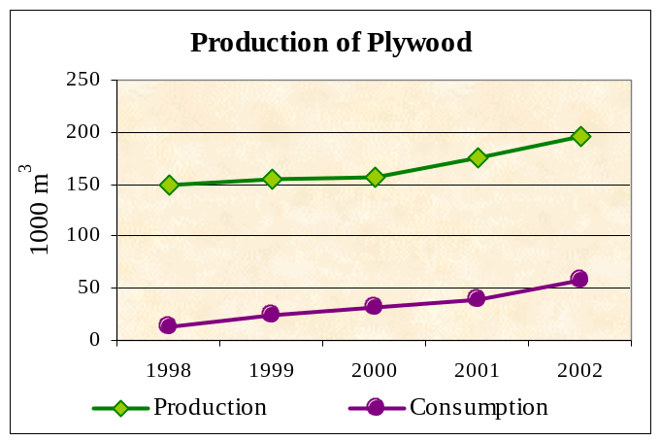Production of particle board and fibreboard during the last years has been decreasing. SC "Bolderāja" is producing about 100 thsd m³ boards per year, a big part of which are laminated thus increasing their value. It is likely that in future the production of laminated boards and items made of laminated boards will increase.
The biggest buyers of Latvian fibreboard are Germany, Great Britain, and France. Latvia imports fibreboard from Russia, Belarus and Lithuania.

3.I. Pulp and paper
Paper production in Latvia has increased 3 times during the past three years (from 16 thsd t in 2000 to 33 thsd t in 2002). Paper and paper board consumption in Latvia constituted 54 kg per capita in 2002. Compared to the previous year it has increased by 26%.
Paper and paper articles' import in Latvia is increasing by every year; in 2002 it reached 139.4 thsd t (in 2001 it was 123.3 thsd t). There has also been a slight increase in paper and paper board articles export volumes in 2002 compared to 2001 by 26.6%, and pulp and recovered paper export - by 20.5%.

4. TABLES
4A. ECONOMIC INDICATORS

Table 1. Key Indicators of Economic Development
 | 1998 | 1999 | 2000 | 2001 | 2002 | 2003 p
GDP | 3,9 | 2,8 | 6,8 | 7,9 | 6,1 | 7,0
Private consumption | 6,2 | 3,7 | 7,4 | 7,8 | 7,2 | 7,5
Public consumption | 6,1 | 0 | -1,9 | 0,3 | 1,5 | 3,0
Consumer prices | 4,7 | 2,4 | 2,6 | 2,5 | 1,9 | 2,5
Foreign trade balance (% of GDP) | -10,6 | -9,8 | -6,9 | -9,6 | -7,8 | -8,0
Direct foreign investments received during the year (% of GDP) | 5,8 | 5,2 | 5,7 | 2,1 | 4,7 | 5,0
Registered unemployment rate (%, end of period) | 14,2 | 14,3 | 14,4 | 13,1 | 12,0 | 11,8
Exchange rate of LVL against SDR (end of period) | 0,7997 | 0,7997 | 0,7997 | 0,7997 | 0,7997 | 0,7997
p – projection

Table 2. Gross Domestic Product
Year | 1998 | 1999 | 2000 | 2001 | 2002
I-XII | 3592.2 | 3889.7 | 4348.3 | 4812.6 | 5194.7
I-III | 838.3 | 901.1 | 1000.8 | 1109.7 | 1167.1
IV-VI | 907.9 | 961.4 | 1060.8 | 1193.7 | 1276.5
VII-IX | 916.8 | 976.8 | 1095.1 | 1203.5 | 1318.0
X-XII | 929.2 | 1050.4 | 1191.6 | 1305.7 | 1433.1

4B. FOREST PRODUCTS PRODUCTION AND TRADE

Table 3. Forest sector production export from Latvia in 2002 compared to 2001
HS code | Production | 2001 |  |  | 2002 |  |  | 2002./2001.
HS code | Production | 1000 (units) |  | 1000 (LVL) | 1000 (units) |  | 1000 (LVL) | 1000 (units) | 1000 (LVL)
3605 | Matches | - |  | 1 575,5 | - |  | 1 805,9 | - | 14,6
44 | Wood and articles of wood | - |  | 427 256,8 | 1 409,4 | (t) | 472 811,0 | - | 10,7
4401 | Fuelwood: | 964,6 | (t) | 16 494,3 | 183,5 | (t) | 26 613,3 | 46,1 | 61,3
440110 | Fuelwood (round) | 90,1 | (t) | 1 678,2 | 1 226,0 | (t) | 3 212,5 | 103,7 | 91,4
440120-440130 | Chips, particles; other wood residues | 874,5 | (t) | 14 816,1 | 8,4 | (t) | 23 400,8 | 40,2 | 57,9
4402 | Charcoal | 7,1 | (t) | 1 622,4 | 4 224,7 | (m³) | 1 865,8 | 18,3 | 15,0
4403 | Roundwood: | 3 990,1 | (m³) | 65 197,5 | 1 994,8 | (m³) | 72 721,8 | 5,9 | 11,5
440320 | Coniferous | 2 071,9 | (m³) | 37 270,2 | 863,1 | (m³) | 35 792,9 | -3,7 | -4,0
 | - diameter to 14 cm | 1 697,9 | (m³) | 28 354,0 | 1 131,7 | (m³) | 14 639,1 | -49,2 | -48,4
 | - diameter more 14 cm | 374,1 | (m³) | 8 916,2 | 2 229,9 | (m³) | 21 153,8 | 202,5 | 137,3
440330-440399 | Non-coniferous | 1 918,2 | (m³) | 27 927,3 | 998,3 | (m³) | 36 928,9 | 16,3 | 32,2
 | - diameter to 16 cm | 1 758,6 | (m³) | 25 423,9 | 1 231,6 | (m³) | 15 701,6 | -43,2 | -38,2
 | - diameter more 16 cm | 159,6 | (m³) | 2 503,4 | 49,7 | (m³) | 21 227,3 | 671,7 | 747,9
4406 | Sleepers | 28,0 | (m³) | 2 309,5 | 2 857,2 | (m³) | 5 011,5 | 77,7 | 117,0
4407 | Sawnwood: | 2 854,9 | (m³) | 223 901,9 | 2 289,6 | (m³) | 231 697,4 | 0,1 | 3,5
440710 | Coniferous | 2 361,4 | (m³) | 191 298,7 | 567,6 | (m³) | 192 198,9 | -3,0 | 0,5
440720-440799 | Non-coniferous | 493,6 | (m³) | 32 603,2 | 12,2 | (m³) | 39 498,5 | 15,0 | 21,1
4408 | Veneer sheets | 10,8 | (m³) | 6 966,4 | 15,2 | (m³) | 7 882,5 | 13,1 | 13,1
4409 | Further processed sawnwood | 6,8 | (m³) | 1 621,0 | 12,8 | (m³) | 2 978,2 | 125,0 | 83,7
440910 | Coniferous | 4,6 | (m³) | 995,4 | 2,4 | (m³) | 2 210,2 | 180,0 | 122,0
440920 | Non-coniferous | 2,2 | (m³) | 625,6 | 80,0 | (m³) | 768,0 | 9,1 | 22,8
4410 | Particle board | 80,8 | (m³) | 5 761,3 | 67,6 | (m²) | 5 302,3 | -1,0 | -8,0
4411 | Fibreboard | 394,1 | (m²) | 305,4 | 144,3 | (m³) | 130,5 | -82,8 | -57,3
4412 | Plywood | 143,0 | (m³) | 42 880,1 | 135,5 | (t) | 42 771,9 | 0,9 | -0,3
4415, 4416 | Wooden packaging | 121,3 | (t) | 15 227,0 | 80,2 | (t) | 20 411,6 | 11,7 | 34,0
4418 | Joinery and carpentry | 4 | (t) | 31 201,6 | 31,4 | (t) | 37 730,5 | 21,5 | 20,9
47 | Pulp of wood, recovered paper | 26,1 | (t) | 1 098,6 | 35,1 | (t) | 1 290,3 | 20,5 | 17,5
48 | Paper and paperboard, articles of paper | 27,7 | (t) | 14 834,3 | - |  | 19 392,6 | 26,6 | 30,7
9401- 9404 | Furniture | - |  | 55 863,7 | 8,9 | (t) | 63 808,8 | - | 14,2
9406001 | Prefabricated building constructions | 7,0 | (t) | 2 451,7 |  |  | 3 194,8 | 26,9 | 30,3
 | Total |  |  | 503 080,7 |  |  | 562 319,8 |  | 11,8

Table 4. Forest sector production import to Latvia in 2002 compared to 2001
HS code | Production | 2001 |  |  | 2002 |  |  | 2002./2001.
HS code | Production | 1000 (units) |  | 1000 (LVL) | 1000 (units) |  | 1000 (LVL) | % (units) | %  (LVL)
3605 | Matches | - |  | 47,0 | - |  | 44,0 | - | -6,4
44 | Wood and articles of wood | - |  | 28 672,6 | - |  | 41 027,1 | - | 43,1
4401 | Fuelwood: | 0,3 | (t) | 30,9 | 4,7 | (t) | 70,1 | 1 264,2 | 126,6
440110 | Fuelwood (round) | 0,0 | (t) | 0,1 | 4,2 | (t) | 13,0 | - | -
440120-440130 | Chips, particles; other wood residues | 0,3 | (t) | 30,9 | 0,5 | (t) | 57,1 | 57,1 | 85,0
4402 | Charcoal | 0,1 | (t) | 10,6 | 0,3 | (t) | 27,1 | 123,5 | 156,9
4403 | Roundwood: | 213,9 | (m³) | 6 201,0 | 386,8 | (m³) | 10 291,9 | 80,8 | 66,0
440320 | Coniferous | 138,3 | (m³) | 2 695,7 | 269,7 | (m³) | 5 959,5 | 94,9 | 121,1
 | - diameter to 14 cm | 118,1 | (m³) | 2 247,4 | 23,7 | (m³) | 303,2 | -80,0 | -86,5
 | - diameter more 14 cm | 20,2 | (m³) | 448,4 | 246,0 | (m³) | 5 656,3 | 1 116,7 | 1 161,5
440330-440399 | Non-coniferous | 75,5 | (m³) | 3 505,3 | 117,1 | (m³) | 4 332,4 | 55,0 | 23,6
 | - diameter to 16 cm | 8,6 | (m³) | 123,0 | 10,2 | (m³) | 117,7 | 17,6 | -4,4
 | - diameter more 16 cm | 66,9 | (m³) | 3 382,3 | 106,9 | (m³) | 4 214,7 | 59,8 | 24,6
4406 | Sleepers | 1,1 | (m³) | 257,1 | 13,0 | (m³) | 754,5 | 1 068,8 | 193,5
4407 | Sawnwood: | 104,5 | (m³) | 6 837,6 | 157,9 | (m³) | 11 645,1 | 51,1 | 70,3
440710 | Coniferous | 99,2 | (m³) | 6 336,9 | 150,0 | (m³) | 11 005,4 | 51,3 | 73,7
440720-440799 | Non-coniferous | 5,4 | (m³) | 500,7 | 7,9 | (m³) | 639,6 | 46,7 | 27,8
4408 | Veneer sheets | 0,9 | (m³) | 825,1 | 1,1 | (m³) | 1 134,8 | 18,5 | 37,5
4409 | Further processed sawnwood | 1,1 | (m³) | 487,3 | 1,2 | (m³) | 600,8 | 6,6 | 23,3
440910 | Coniferous | 0,7 | (m³) | 239,5 | 0,9 | (m³) | 334,1 | 27,5 | 39,5
440920 | Non-coniferous | 0,4 | (m³) | 247,8 | 0,3 | (m³) | 266,7 | -25,4 | 7,6
4410 | Particle board | 25,9 | (m³) | 4 005,0 | 36,8 | (m³) | 5 192,1 | 42,2 | 29,6
4411 | Fibreboard | 2 899,5 | (m²) | 3 485,5 | 3 034,0 | (m²) | 4 153,0 | 4,6 | 19,2
4412 | Plywood | 6,3 | (m³) | 887,0 | 6,3 | (m³) | 923,6 | -0,6 | 4,1
4415, 4416 | Wooden packaging | 4,3 | (t) | 911,3 | 6,3 | (t) | 1 303,5 | 45,4 | 43,0
4418 | Joinery and carpentry | 2,6 | (t) | 2 982,4 | 2,9 | (t) | 3 345,9 | 11,2 | 12,2
47 | Pulp of wood, recovered paper | 0,6 | (t) | 142,3 | 2,2 | (t) | 313,1 | 252,4 | 120,1
48 | Paper and paperboard, articles of paper | 123,3 | (t) | 77 091,4 | 139,4 | (t) | 89 995,4 | 13,0 | 16,7
9401- 9404 | Furniture | - |  | 14 802,6 | - |  | 18 626,5 | - | 25,8
9406001 | Prefabricated building constructions | 0,9 | (t) | 440,0 | 1,2 | (t) | 541,7 | 32,3 | 23,1
 | Total |  |  | 121 196,0 |  |  | 150 555,2 |  | 24,2

