** **

**UNECE/FAO**

**Joint Wood Energy Enquiry**

**2013**

**User Manual**

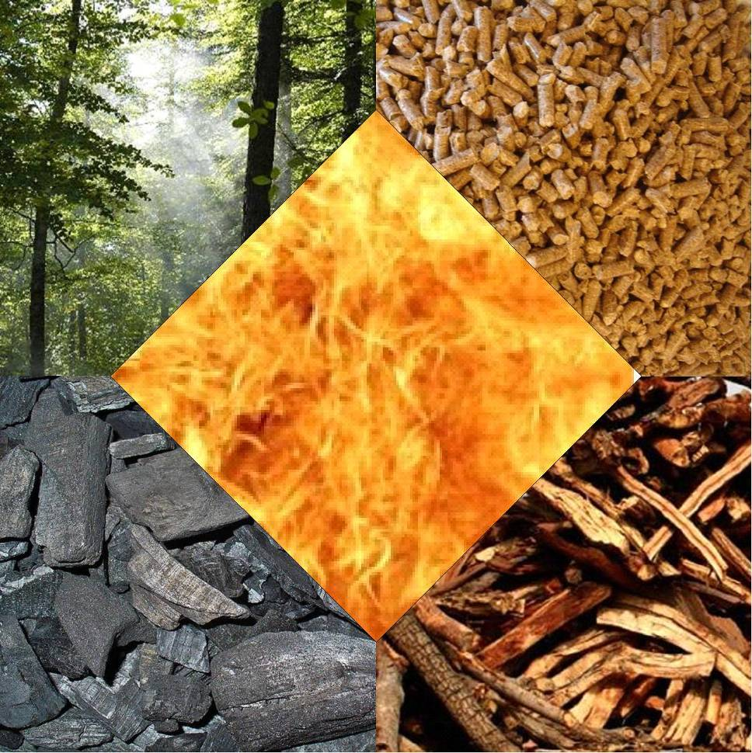

# About this User Manual

This manual describes the revised structure of the UNECE/FAO Joint Wood Energy Enquiry. It builds on improvements and experiences made and valuable feedback from national correspondents during the previous rounds in 2005, 2007, 2009 and 2011. This paper seeks to support and guide national correspondents in providing latest data on wood energy for the reference year 2013. The objective is to gain better information on the changes and developments in the field of wood energy. Every effort has been made to make this manual and the spreadsheets as comprehensive as possible. Nonetheless they remain work in progress. Correspondents and experts are invited to send questions and/or suggestions to [woodenergy.timber@unece.org](mailto:woodenergy.timber@unece.org)

December 2014

# Table of contents

About this User Manual 1

Table of contents 2

List of tables 2

List of figures 2

Acronyms and Abbreviations 3

Foreword 4

1. About 5

2. Objective 5

3. Structure of the Enquiry 5

3.1. Background tables 6

3.1.1. “Introduction” table 6

3.1.2. “Definitions” table 6

3.1.3. “Quality indicators” table 6

3.1.4. “Conversion factors energy” table 7

3.1.5. “Conversion factors volume” table 7

3.2. Results tables 8

3.2.1. “Aggregated data S -> U” table 8

3.2.2. “EU NREAP Progress Report-T4” table 10

3.3. Data collection tables 10

3.3.1. Table “T I fibre sources” 11

3.3.2. Table “TII processed wood based fuels” 12

3.3.3. Table “T III pwbf origins” 12

3.3.4. Table T IV “T IV energy use” 13

3.3.5. EU National Renewable Energy Action Plan (NREAP) Progress Report 15

4. Prefilling 17

5. Data collection procedure 17

5.1. National Correspondent 17

5.2. Suggestions on collecting data 18

5.3. Communication 18

# List of tables

Table 1: Conversion factor volumes solid m³ to other 8

Table 2: Conversion factor volumes other to solid m³ 8

Table 3: Aggregated data S -> U” table 8

Table 4: National Renewable Energy Action Plan progress report table 4 15

# List of figures

Figure 1: Scope of the JWEE 2013 10

Figure 2: Data collection procedure 19

# Acronyms and Abbreviations

bv m³ bulk volume

CN Combined Nomenclature

FAO Food and Agriculture Organization of the United Nations

HS Harmonized Commodity Description and Coding System

IEA International Energy Agency

ISIC International Standard Industrial Classification

JFSQ Joint Forest Sector Questionnaire

JWEE Joint Wood Energy Enquiry

JWPFSEM Joint FAO/UNECE Working Party on Forest Statistics, Economics and Management

l Litre

m³ solid cubic metre, underbark

NAI Net Annual Increment

NREAP National Renewable Energy Action Plan

PWBF Processed wood based fuels

RENQUES IEA/Eurostat/UNECE country annual questionnaire renewables and wastes

Rwe Roundwood equivalent in m³

S1 Direct source of wood

S2 Indirect source of wood

S3 Post-consumer recovered wood/wood waste

S4 Unspecific source of wood

SFM Sustainable Forest Management

t metric tonnes [megagram]

t d.m. Metric tonnes dry matter

t f.m. Metric tonnes fresh matter

TJ terajoules

toe tonnes of oil equivalent

U1 Use of wood for energy by commercial heat and power/main activity producer

U2 Use of wood for energy by wood processing industries

U3 Use of wood for energy by private households

U4 Use of wood for energy by undefined user

UNECE United Nations Economic Commission for Europe

# Foreword

A major objective in energy policy in Europe and beyond is to increase the share of renewable energy: ambitious targets have been agreed and incentives have been put in place in several countries. National renewable energy action plans specifying how these targets will be achieved have been drawn up in all European Union member states: similar plans exist for most other European countries or are being drawn up.

Wood is currently the principal source of renewable energy in the UNECE region, accounting for about half of all renewable energy consumption. In addition to addressing climate and energy commitments, wood energy has the potential to create new job opportunities in rural areas by stimulating wood harvesting and processing and the development of wood fuel markets and trade opportunities. Strong political support has seen wood energy markets grow, notwithstanding the economic downturn and the consequent sharp decline in demand for forest products. Increasing energy prices have also contributed to this growth – the impact of the decline in 2014 remains to be seen.

Recent studies have shown that more wood is used for energy than previously estimated, and that a substantial part of this comes from non-forest resources such as industrial co-products, landscape care wood and recovered wood.

For wood and paper products production, most countries have reliable information available for the current and expected wood fibre supply and demand. On the other hand, wood energy statistics are often scattered among different entities and integrated within statistics on energy from renewables and waste. Energy statistics typically focus on the consumption and transformation side rather than the underlying supply patterns and origin of fuels. Developing reliable statistics on the sources and uses of wood energy is thus a highly cross-sectoral and complex exercise.

The UNECE/FAO Joint Wood Energy Enquiry addresses this information gap by providing a framework for dialogue and cooperation between all relevant wood energy stakeholders. The Joint Wood Energy Enquiry provides specific information on the origin and amount of wood energy consumed by different users. This knowledge allows decision makers to enhance socio-economic welfare by reducing conflicts between energy and material use while guaranteeing the fulfillment of renewable energy targets and sustainable forest management commitments. Reliable statistics remain fundamental for policy formulation at both national and international level.

# About

The UNECE/FAO Joint Wood Energy Enquiry collects information on wood energy for the reference year 2013 and is referred to as “JWEE 2013”hereafter.

The JWEE has been developed and constantly further refined since 2006. It is a joint exercise involving the Forestry and Timber Section of the United Nations Economic Commission for Europe (UNECE/FAO Forestry and Timber Section), the Food and Agriculture Organization of the United Nations (FAO) as well as national statisticians and experts from the forestry, energy and waste sectors. The main forum to exchange views on the JWEE is the Joint FAO/UNECE Working Party on Forest Statistics, Economics and Management. In 2012 a workshop was held in Paris[1] to further improve information exchange.

Member states’ participation is on a voluntary basis. UNECE and FAO are able to provide some technical support and transfer of knowledge to member states, however, no financial support can be granted.

The JWEE 2013 is available online in English. A Russian language version is being prepared. Users are strongly encouraged to download the latest spreadsheet from [www.unece.org/forests/jwee.html](http://www.unece.org/forests/jwee.html).

# Objective

Wood energy data is often scattered among different entities or concealed within statistics on renewables and waste. The JWEE aims to act as a bridge-builder between the energy, waste and forestry sectors, catalyzing cross-sectoral collaboration among national experts and relevant stakeholders.

The JWEE asks for detailed and disaggregated data on the supply and use of wood energy. Such level of detail allows for an effective analysis of trends and developments in the sector and a reliable assessment of the data quality. The JWEE does not necessarily require official data on wood energy, but rather looks for data that reflects realities in the wood energy sector in a timely manner. Correspondents and experts are encouraged to critically assess available official data on wood energy and where appropriate complement it by using empirical data from studies, science and industry. Expert estimates are also welcome in cases where no hard data is available. Past experience has shown that through the JWEE, member states can enter into a process of gradual improvement of their wood energy data. Correspondents may also be in a position to supply data for previous JWEE rounds, thus enabling the establishment of a time series.

# Structure of the Enquiry

The enquiry consists of a number of different tables/workbooks having different functions. Only four tables are designed for raw data collection. Two additional tables compile the data provided for verification and reporting purposes. The remaining sets of tables provide background information on the JWEE structure, definitions and conversion factors.

## Background tables

The JWEE has been developed to be self-explanatory even without this Manual at hand. It provides an extensive set of additional information to facilitate the task of correspondents and experts.

### “Introduction” table

The introduction worksheet is a “table of contents” with hyperlinks to the different workbooks. Besides the links, every worksheet is briefly described to highlight its key content and function.

The only action required from correspondents is to select their country in cell “B6”. After selecting the country, the enquiry will i) show the country on all the subsequent tables and ii) prefill some cells in Tables TI and TII with the most recent information on production and trade of forest products for that country.

### “Definitions” table

The JWEE 2013 does not introduce any new definition. Any of the 80+ different definitions refers to established definitions from the energy, forestry and waste sectors. These terms and definitions are listed according to the JWEE section in which they appear:

* Fibre sources and types (Table I)
* Processed wood based fuels (Tables II and III)
* Energy use (Table IV)
* Conversion factors (Conversion factors)
* Miscellaneous (other)

Each of the definitions is supplemented with its source and a hyperlink in a separate column. Correspondents can thus look up and understand the context of each definition. Some of the hyperlinks refer to valuable information beyond the scope of the JWEE 2013.

### “Quality indicators” table

One of the features of the JWEE is the intention of going beyond official data. Correspondents and experts are encouraged to use any source of information for providing as detailed information as possible.

Data accuracy can vary greatly and correspondents are asked to rate the quality of data points. The data quality indicator (DQ) allows correspondents to submit the most complete dataset possible even though data may originate from a range of sources of differing quality.

The following data quality flags are proposed:

A Excellent data quality (e.g. empirical data from a recent study)

B Good data quality (e.g. older studies with widely recognized precision or a good expert estimate - based on more than one source)

C Rough estimate (about right order of magnitude),

D No information on data quality available

O Official national statistics

### “Conversion factors energy” table

The table “Conversion factors energy” plays a crucial role in the JWEE 2013. The values are applied to link the different data collecting tables and above all the links to table T IV. The table contains a set of default conversion factors. **These factors are generic and correspondents are encouraged to adjust the values to national circumstances as appropriate, and indicate such changes by inserting comments.**[2] In case of disagreement with the conversion factors, correspondents are kindly invited to revise the default set presented in the table “conversion factors energy”.

This table facilitates cross-sectoral communication and collaboration. Wood energy data in the energy sector is often provided in units such as terajoules (TJ) and tonnes of oil equivalent (toe). In the forestry and waste sectors units based on weight and volume are used for reporting. Therefore the conversion factors provided will help bring together different sectors to provide a single dataset in the standard unit of metric tonnes dry matter (t d.m.) in table T IV and solid cubic metres (m³) in the “aggregate s->u” table.

For each of the different fibre sources, the JWEE 2013 provides default/generic conversion factors from the original unit to:

* Density (ρ)
* Wood density (ρ) dry matter
* Moisture Content wet basis (%)
* Higher heating value of dry matter (GJ/t d.m.)
* Lower heating value (GJ/t f.m.)
* Wood fibres input (m³)/product output

### “Conversion factors volume” table

Data in the table “Conversion factors volume” is for information only and not directly applied and linked to the data collection tables. They represent default values and may vary according to local conditions and definitions. It presents conversion factors from and to solid m³ under bark (i.e., excluding bark).

Table : Conversion factor volumes solid m³ to other



Table : Conversion factor volumes other to solid m³



## Results tables

### “Aggregated data S -> U” table

This table is meant to provide an instant overview of the results provided when filling in the JWEE Table T IV. It presents wood energy flows from the different sources (S1-S4) to the different users (U1-U4) in a highly aggregated format. This table reflects the main information presented in country profiles and also provides the basic information for calculating indicators on wood energy use.

Table : Aggregated data S -> U” table



All values of this table are presented in 1000 m³ as a unique, single unit, using the conversion factors of the “conversion factors energy” table. It enables correspondents and experts to immediately check their values and verify the consistency of the data before submission. **This table should not be modified** by correspondents. Only in the case of insufficient resources to complete Tables I-IV, countries may enter aggregated data directly into this table.

**S1 Direct**

Any wood fibre entering energy production without any further treatment or conversion. It comprises removals from forests and outside. This comprises also any wood defined by the FAO as coming from “Other Wooded Land” (OWL) and “Trees Outside Forests”, but is wider than these two definitions. It comprises any woody biomass from any land use and covers amongst others infrastructure maintenance (roads, railway, power transmission lines, pipelines, etc.), hedgerows, agricultural residues from fruit tree orchards, wood from gardens and parks, etc. It comprises any form of woody biomass, such as green chips, roundwood or split, stacked or loose from any part of the trees such as roots, stemwood and branches, fruits and shells.

**S2 Indirect**

Processed and unprocessed co-products (residues) from the wood processing industries are considered as indirect supply. These co-products can be solid (sawdust, chips, slabs, etc.) or liquid from the pulp industry (black liquor or tall oil). Processed wood fuels with improved energy content per bulk volume (compressed), such as wood pellets, briquettes but also wood charcoal are also included under indirect supply.

**S3 Recovered**

The so-called post-consumer recovered wood comprises any waste wood fibre after at least one life cycle. It comprises wood from construction, renovation and demolition, but also packaging as well as old furniture. Countries often apply different classifications to distinguish between different wood waste categories (contaminated with paint, glue, etc.). Please note that the wood component in mixed-waste streams should also be included where possible.

**S4 Unspecified**

Many countries know something about the amount of wood used but not its source. Surveys conducted when compiling energy statistics may not necessarily be interested in identifying the different sources and origin of the wood fibres. This category represents a further step in making the JWEE more compatible with energy statistics.

**U1 Power & Heat**

The definition of U1 refers to “Main Activity Plants” (International Energy Agency definition), which refers to plants which are designed to produce electricity/combined heat and power (CHP) or Heat only. If one or more units of the plant is a CHP unit (and the inputs and outputs cannot be distinguished on a unit basis) then the whole plant is designated as a CHP plant. However a sawmill, for example, which produces heat for itself as well as selling heat outside, would fall under the next (U2) category. **Main activity supply undertakings generate electricity and/or heat for sale to third parties, as their primary activity.** They may be privately or publicly owned. Note that the sale need not take place through the main activity grid.

**U2 Industrial**

This refers to “auto producer” (IEA definition) undertakings that generate electricity and/or heat, **wholly or partly for their own use as an activity which supports their primary activity**. They may be privately or publicly owned. It includes mainly the forest based industries, such as the (chemical) pulp producers who sell some of their energy to third parties (real or virtual sales are considered). Ideally the data should also include the process heat that is used for the production of the good at the specific plant.

**U3 Residential**

This user group is referred to by the IEA as all consumption by households, excluding fuels used for transport. It includes households with employed persons (ISIC Division 95) which is a small part of total residential consumption.

**U4 Other**

This definition comprises any other economic sector not covered by the above (e.g. agriculture, forestry and fishing, commercial and public services and transport).

### “EU NREAP Progress Report-T4” table

*Only in English version.* See Section 3.3.5

## Data collection tables

The core of the JWEE 2013 consists of four interlinked data workbooks. These tables request detailed information on wood energy sources, the transformation of woody biomass into processed wood based fuels, trade as well as final use by the different user groups. The structure of the tables prevents double counting or overestimation of wood fibres’ availability – in particular for processed wood based fuels and their raw material sources.

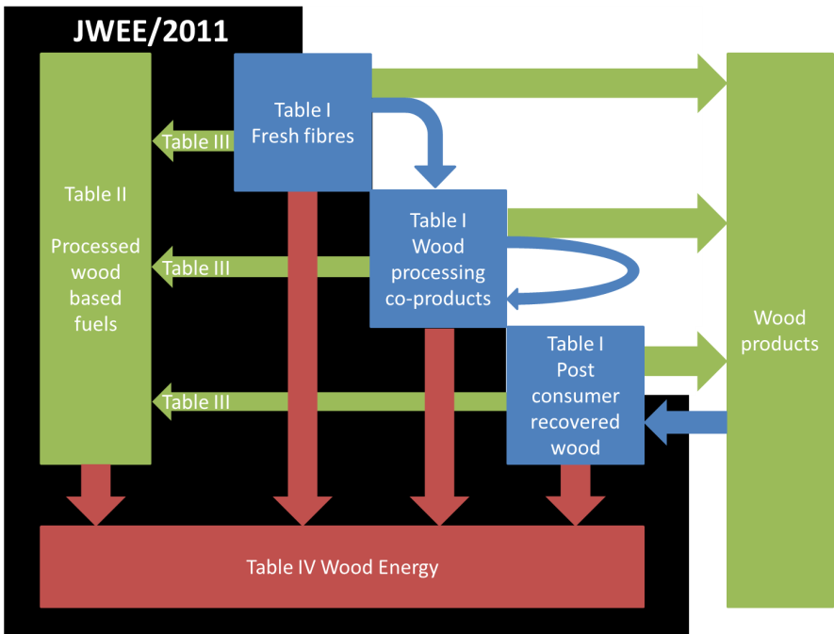

Figure : Scope of the JWEE 2013

The entire enquiry consists of over 300 empty cells – of which a few are pre-filled with data on forest products, as soon as the reference country is chosen in the “Introduction” table. However, not every single cell has to be filled. Most responses typically contain a modest average of data entries in addition to the prefilled set of data. Correspondents and experts are nonetheless encouraged to provide disaggregated data wherever possible. **Correspondents are also invited to substantiate and/or clarify any data entry by inserting comments as appropriate.**

### Table “T I fibre sources”

|  |  |
| --- | --- |
| **T I fibre sources** | Assessment of wood available for energy *and* material use at national level. Partially pre-filled table with 2013 data from the Joint Forest Sector Questionnaire as of November 2014. |

Table “T I fibre sources” is an inventory of the domestically available wood sources and fibre types for the reference year. It also includes information on the trade balances. The volumes reported should include any fibres available, without considering their potential use at that stage – **This table is not limited to energy use of wood fibres.** This approach will enable some conclusions on the role of wood energy for the forest based sector and also helps to assess potential gaps, availabilities and conflicts.

Table I goes beyond the set of data collected in the Joint Forest Sector Questionnaire (JFSQ). However, the linkage and overlapping with the JFSQ is taken into consideration and any data already available at international level is used to pre-fill a number of cells.

The cell on “Black liquor (without crude tall oil)” is prefilled, based on JFSQ information on chemical pulp production using the conversion factors from the “Conversion factors energy” table Since the conversion factors for prefilling the black liquor data are generic, country correspondents are strongly encouraged to verify the amount and to adjust it accordingly. The unit has been changed to metric tonnes upon request during the Paris workshop.

Since the 2009 questionnaire, the category tall oil has been modified to “Crude tall oil” to include the entire amount of resin acids, fatty acids and other derivates that are obtained when acidifying black liquor soap with sulphuric acid. Tall oil generation is not being prefilled, since it is a highly specific by-product of kraft pulping of pine wood. The amount of tall oil pitch should also be reported under this category – despite the fact that a very limited number of countries may have different tax schemes for each tall oil distillate.

Bark data is also prefilled based on the rather conservative estimate that bark represents 3% of harvested industrial roundwood. This estimate is unlikely to reflect real volumes. In fact, in the UNECE region, the bark of conifers and non-coniferous species ranges from as little as 4% of the total over bark volume (and weight) to as much as 30%[3]. The objective of prefilling a low estimate is increase awareness on this concealed source of energy. Unlike fuelwood bark, industrial roundwood bark has a different application right from the beginning. Sawmills and pulp and paper plants are equipped with very efficient bark separation units. Any international statistic and most of the national statistics report industrial roundwood under bark. However, bark may play a significant role in the fuel supply to pulp and paper and sawmill industries for heat and steam production.

A few cells may require cross-sectoral communication and collaboration. It is suggested that national/ international waste statistics and experts may provide useful information on wood waste. The table also provides some information, where NCs and experts may find relevant information on wood waste.

The column on “Gross Domestic Supply” should remain unchanged since it is calculated based on production and net trade figures.

*Please note that the column on EU imports is only for countries wishing to complete the NREAP progress report table.*

### Table “TII processed wood based fuels”

|  |  |
| --- | --- |
| **T II processed wood based fuels** | Assessment of national production of processed wood based fuels (charcoal, pellets, briquettes, biodiesel, ethanol and pyrolysis oils). |

Even though the JWEE 2013 does not cover most of the forest based products, it makes an exception for the production of processed woodbased fuels (pwbf). This is necessary since pwbf are subject to intensive trade. In case of exports, these volumes are first deviated from the domestically available volumes and then need to be subtracted from the available biomass. Table TII compiles the information about national production and trade.

Wood charcoal (and now wood pellets) are already reported in the JFSQ, so these cells are prefilled with existing data. Briquettes can also be included under pellets if it is not possible to distinguish them from pellets (please indicate in comments when this is done).

The column on “Gross Domestic Supply” should remain unchanged since it is calculated based on production and net trade figures.

*Please note that the column on EU imports is only for countries wishing to complete the NREAP progress report table.*

### Table “T III pwbf origins”

|  |  |
| --- | --- |
| **T III pwbf origins** | Supplementary table to TII. Assessment of wood fibres origin and quality used for the production of processed wood-based fuels (pwbf). *Providing information in this table is optional.* |

Table “T III pwbf origins” is optional. This table has been developed to avoid double counting. It subtracts the wood fibres used for the production of processed wood-based fuels from the domestic supply and therefore provides an exact balance of wood available for energy and material use (see column J in Table IV). The table enables correspondents and experts to provide information on the sources of wood fibre used for the production of solid (wood charcoal, wood pellets, wood briquettes) and liquid processed wood-based fuels (pyrolysis oils, cellulose based ethanol, wood based biodiesel). The liquid biofuels have been inserted for completeness so priority should be given to providing information on solid wood-based fuels.

This table may be of particular interest to countries with an extensive production of processed wood-based fuels and a high share of net exports. The transformation of wood co-products and wood fibres to pellets and their export can significantly reduce the wood availability at national level. Despite the fact that filling this table is optional, the secretariat very strongly encourages correspondents to at least provide information on the production of wood pellets. The reason for that is that the pellets sector traditionally uses co-products as raw material. Due to the downturn of the sawmill sector and a constant increase in wood pellets production capacity and demand, the wood demand pattern of the sector is changing dramatically. The share of co-products in the raw material portfolio is on the decline and increasingly fresh fibres are directly used to produce wood pellets. Careful assessment of this sector is likely to provide valuable information for decision makers.

In case correspondents and experts are unable to provide total volumes, they may provide information on the specific shares for each single fibre source in percentage points. In case no detailed information is available, aggregated shares for the direct, indirect and recovered fibres may be entered. In case of partial information on the fibres used, the remaining amount will be automatically highlighted and included in table IV. In case no data are provided in this table, the volumes required will be generated based on default values and will be subtracted from fibres from unknown sources.

### Table T IV “T IV energy use”

|  |  |
| --- | --- |
| **T IV energy use** | Core table of the enquiry - assessment of fibre origin and amounts used for energy production by the different sectors |

Table “T IV energy use” is the core of the JWEE 2013 where correspondents and experts from the energy, forestry and waste sectors need to collaborate closely. It provides in one single table the information on wood resources as inserted in tables T I – T III and asks for energy use of wood fibres by sectors. The users are differentiated according to the International Standard Industrial Classification of all economic activities (ISIC). Any value in this table is given in the standard unit of 1000 metric tonnes dry matter (t.d.m.), except for certain liquid co-products.

“T IV energy use” of JWEE 2013 derives its horizontal structure (users of wood energy) from the vertical part of the IEA/Eurostat/UNECE country annual questionnaire on renewables and wastes (called RENQUES hereafter). It has been designed to be compatible with the structure of RENQUES[4]. The total volumes of the JWEE 2013 may provide information for cell F1 of RENQUES *“Table 2. SUPPLY, TRANSFORMATION, ENERGY SECTORS & END USE”.* The structure of the JWEE 2013 is compatible with IEA “Table 4. PRODUCTION OF WOOD/WOOD WASTES/OTHER SOLID WASTES”.

In this table, up to 190 single data points can be filled. However, it is not expected that all cells will be filled by correspondents or experts. Totals are calculated based on the information provided in the relevant data cells. Correspondents may enter data directly into the total columns, in case no disaggregated data is available. Providing 24 key data points (18 of which being Totals) in lines 12, 17, 20, 22, 23, 31 and columns S, AB, AE, and AO is satisfactory. These are key data points that provide highly useful information for analysis and filling in of the “aggregated data S -> U” table.

In case no other information is available, correspondents and experts are invited to provide information or expert estimates for details in line 35. Energy experts should be able to provide information for line 35. In case these are available in energy units, information from Table “Conversion Factors Energy” can be applied.

Values in columns I to K, black background and white figures are calculated and cannot be changed in this table.

Column “I” presents the data entered in the previous tables T I – T III as “Gross Domestic Supply”. Conversion factors are used to harmonize the different units from tables T I – T II. In case correspondents would like to use specific conversion factors, they are invited to modify the default set in table “Conversion Factors Energy”.

Column “J” compiles the data entered in table T III as “transformation (table TIII)”. It prevents double counting of wood fibres and is thus a crucial step in providing accurate information on wood fibres availability at national level. The values are calculated based on the information on the production of pwbf (T II) and the share of the different wood sources and types of fibres. Conversion factors are used to harmonize the different units from tables T II and T III. In case correspondents would like to use specific conversion factors, they are invited to modify the default set in table “Conversion Factors Energy”.

Column “K” calculates the “Net Domestic supply” of wood fibres at national level. The values are generated by subtracting values in column “J” from column “I”. The Net Domestic supply represents all wood fibres available at national level for material and energy use.

The other columns

The JWEE columns V and X are compatible with the related IEA flows under "Total final consumption", i.e. "Paper, pulp and print" and "Wood and wood products". All other categories under Total final consumption-Industry (textile, construction, food etc.) would fall under JWEE column Z (other). In addition V and and X should ideally include the autoproducer figure by flow, that is, find out how much of e.g. autoproducer heat/CHP/elec is coming from the wood or pulp sectors. The rest of the autoproduced Electricity, Heat and CHP would go under column Z (if it comes from other industries) or the other columns if it comes from residential, commercial and so on. Of course, it might be hard for correspondents to have a detailed breakdown of autoproducer energy. IEA stats do not seem to have this breakdown.

### EU National Renewable Energy Action Plan (NREAP) Progress Report

|  |  |
| --- | --- |
| **EU NREAP progress report – Table 4** | A guidance table, designed to facilitate the reporting of EU Member States to the European Commission on progress with regards to their respective NREAP. |

European Union (EU) member states are requested to submit progress reports on their National Renewable Energy Action Plans (NREAP) every second year until 2021. During its 34th session, the Working Party on Forest Statistics, Economics and Management highlighted a potential convergence between the UNECE/FAO and Eurostat reporting process and proposed to explore means for the Joint Wood Energy Enquiry (JWEE) data for EU countries to feed into the template for NREAP progress reports. Following this proposal, “EU NREAP progress report – Table 4” has been developed and included in the JWEE 2011. The table is compatible with Table 4 of the EU “Template for Member States progress reports under Directive 2009/28/EC” [5] and aims at easing the task of JWEE correspondents from the EU reporting countries. The JWEE 2013 therefore offers a table that automatically compiles submitted data to pre-fill table 4 of the NREAP progress report template.

|  |
| --- |
| **Disclaimer:**  Using JWEE 2013 data to pre-fill table 4 requested by the European Commission is meant to be an informal service for JWEE 2013 correspondents but does not carry implications on European Commission reporting processes. The JWEE 2013 and the EU NREAP are two entirely separate data collection processes. The UNECE/FAO denies any responsibility for the correctness, the reliability and the completeness of the information thereby provided, since reporting structures, correspondents, methodologies and (default) conversion factors may differ between the two processes. |

However, it is hoped that the “EU NREAP table 4” will i) raise the visibility of NCs and experts, ii) promote the use of the JWEE structure, iii) enable countries to further streamline their data reporting processes, iv) and improve cross-sectoral cooperation and communication at all levels.

Table : National Renewable Energy Action Plan progress report table 4



Data is taken from Table I, Table III and Table IV of the JWEE and is provided for all the categories in the NREAP progress report except for “Agricultural by-products / processed residues and fishery by-products” and “Common arable crops for biofuels”:

1. “Direct supply”: relates to Table IV “Primary solid biomass” for each sector, to which we add the feedstock for the production of Wood Charcoal, pellets and briquettes multiplied by the percentage of fibres from direct supply (from Table III).
2. “Indirect supply” relates to Table IV “Forest based Industry- solid co-products” and black liquor for each consumption sector, to which we add the feedstock for the production of wood charcoal, pellets and briquettes multiplied by the percentage of fibres from indirect supply (from Table III).
3. “Energy crops (grasses etc.) and short rotation trees”: is brought in from the Table I category “Fuelwood- from short rotation coppice”.
4. “Biomass from waste”: is brought in from Table IV, “Post-consumer recovered wood” for each consumption sector, to which we add feedstock data on charcoal, pellets and briquettes from Table III, if available.
5. “Others”: is brought in from Table IV category “Wood from unknown sources” across all consumption sectors.
6. “Energy crops (grasses, etc.) and short rotations trees for biofuels”: includes data from Table IV on cellulose based ethanol and wood based biodiesel.

A number of assumptions have been made to permit the data to be calculated.

* Short-rotation coppice (table I) is assumed to be 100% for energy. It is counted on the line for energy crops and deducted from the TIV data.
* Columns T-X present assumptions about the share of imports in the total consumption, the EU share of those imports and the split between direct and indirect sources of wood for processed wood fuels such as pellets. These assumptions can be directly replaced by empirical study results or estimates and are only meant to assist correspondents.
  + The import share for wood energy is based on the total imports of wood for all purposes.
  + The source of wood (direct vs indirect) for pellets is assumed to be 50/50

# Prefilling

The UNECE/FAO secretariat pre-fills tables as far as possible to avoid duplication of correspondents’ efforts. The secretariat is providing pre-filled data for shaded fields in the enquiry (based on JFSQ data). However, correspondents may modify these figures should they meanwhile have obtained access to more recent or reliable data.

# Data collection procedure

## National Correspondent

Appointing a National Correspondent (NC) is essential to maintain a clear line of communication between the Secretariat in Geneva and the Member states. It is not necessary or expected that the NC personally provides all the data but that the correspondent brings all the data together. The NC is therefore encouraged to reach out to national specialists for specific data (e.g. solid/liquid processed wood fuels, energy or waste statistics, pellets associations, etc.) in order to collect the latest information on each commodity and use.

The main functions of the JWEE National Correspondent are:

* To oversee the collection and verification of data provided for the JWEE.
  + coordinate with different governmental and non-governmental groups (National Statistical Institute, Forestry Ministry, Energy Ministry, industry associations, and other interested groups).
  + understand the data and ensure the data is coherent and in balance with known figures (e.g. electricity consumption or wood removals).
* To function as the key contact between the international secretariat and the various bodies bringing data together, replying to questions, providing feedback on questionnaire and process, and meeting deadlines. The correspondent is also expected to raise issues or difficulties, both directly with the secretariat and at international meetings to review the JWEE process (e.g. ECE/FAO Working Party).
* To use estimations where official data is unavailable or unreliable and share these with the international secretariat. Deviations from data standards should be explained (either directly in the questionnaire or in a side note), particularly where data do not cover the entire geographic area or trade sector.

## Suggestions on collecting data

A common issue is the difficulty on finding data that are not generally available. Correspondents at the 2012 Paris workshop[6] discussed a number of different approaches facilitating the collection of data. These include the use of household survey data to estimate fuelwood use, contacting pellet producers or associations and working with energy information networks. Special studies could also be carried out with support from other actors. Frequently persistence and repeated contacts result in improved information.

The 2012 wood energy workshop in Paris invited:

* Member states to establish a national network or working group of wood energy experts. To this end, they should:
  + Identify the right person to be appointed as national correspondent;
  + Use informal methods for initiating contact with stakeholders;
  + Conduct a “mapping exercise” to identify relevant institutions and actors; this includes but is not limited to national statistical institutions, energy agencies, forestry agencies, wood and biomass energy associations, trade federations, the academic community and energy users.
* First-time respondents to provide minimal data to JWEE rather than seeking to complete all parts;
* EU member states to get in touch with the authorities providing data for NREAP progress reports.

## Communication

As mentioned above, the NC is invited to consult with any expert at the national level to find required information. Should it be difficult to reach out to national contacts, we would be pleased to provide our support to identify and facilitate the necessary contacts.

The secretariat may directly inform national experts or specialists about the enquiry based on the networks and contacts made in all relevant sectors. The secretariat will inform any specialist who has been contacted directly that information should be provided via the NC. Where possible, the secretariat will inform NCs about each directly contacted expert. This may not always be possible due to confidentiality reasons of some networks (e.g. national correspondents of the International Energy Agency). The secretariat will ask the NC for approval for any data not being sent through them.

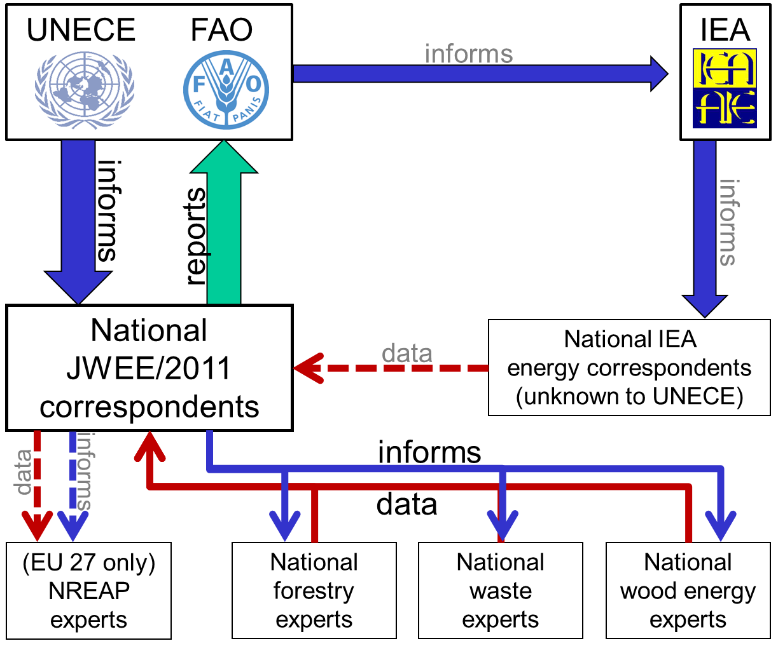

Figure : Data collection procedure

1. See http://www.unece.org/forests/jwee-workshop-2012.html
2. The UNECE/FAO publication “Forest Products Conversion Factors for the UNECE Region” (UNECE/FAO 2010) - <http://www.unece.org/fileadmin/DAM/timber/publications/DP-49.pdf> may be useful to determine country specific conversion factors.
3. “Forest Products Conversion Factors for the UNECE Region” (UNECE/FAO 2010) <http://www.unece.org/fileadmin/DAM/timber/publications/DP-49.pdf>
4. primarily RENQUES tables “WOODVEG” (Wood/Wood Wastes/Other Solid Wastes), “CHARCOAL” (Charcoal (kt)), “MUNWASTER” (Municipal Waste (renewable)), “BIOGASOL” (Biogasoline (tonnes)), “BIODIESEL” (Biodiesel (tonnes)) and “OBIOLIQ” (Other Liquid Biofuels (tonnes)).
5. <http://ec.europa.eu/energy/renewables/transparency_platform/doc/article_22_progress_reports/template_progress_reports__article_22.zip>
6. See “presentations” at http://www.unece.org/forests/jwee-workshop-2012.html