Planning, implementation, follow-up and review of the Sustainable Development Goals

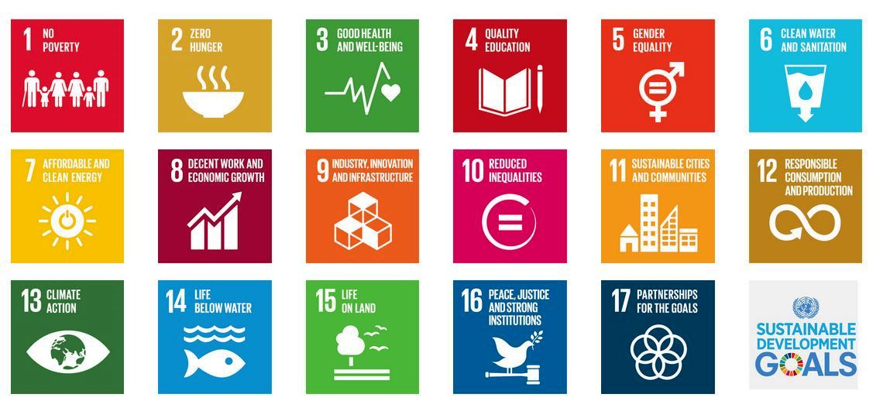

Regional survey by UNECE and the Regional UN Development Group for Europe and Central Asia

Geneva and New York, 2 December 2015

Purpose

At the UN Sustainable Development Summit in New York (25-27 September 2015), the Heads of State and Government adopted the 2030 Agenda, including the ambitious and far-reaching 17 Sustainable Development Goals (SDGs). Entering into force on 1 January 2016, they will guide sustainable development efforts in all countries in the 15-year period until 2030.

In this context, this survey is sent to the Governments of 56 UNECE member States to collect inputs on three crucial topics:

- The plans and approaches of governments to integrate the SDGs and targets in their national strategies and to implement them in their countries.
- The plans of governments to build and conduct monitoring and review at the national level for the SDGs and targets.
- The expectations of governments towards the regional UN system in view of SDG implementation and follow-up.

The survey is jointly conducted by UNECE and the Regional UN Development Group for Europe and Central Asia. The information received will be summarized and shared by their secretariats. It will serve to share experiences and to provide a practical overview of the first steps on the path to achieving the SDGs. Once the results are available, it is further envisaged to organize dialogues with and among member States in Geneva and New York in early 2016 to discuss and take forward the results.

Questionnaire

Please complete
COUNTRY:

AUTHORITY:

NAME OF FOCAL POINT:

FUNCTION:

TELEPHONE:

E-MAIL:

REMARKS:*

Please return the completed questionnaire by MONDAY, 15 FEBRUARY 2016 to:

UNECE, Sustainable Development and Gender Unit (SDGU)
E-Mail: sdgu@unece.org

The electronic version of the questionnaire is available at:
www.unece.org/fileadmin/DAM/sustainable-development/Regional_SDG_survey_final.docx

*The completed questionnaires will be posted on the websites of UNECE and the Regional UN Development Group for Europe and Central Asia (ECA R-UNDG).
Please indicate under “Remarks” above if you prefer your reply not to be posted.

For questions or assistance, please contact:
Mr. Michael KUNZ, UNECE secretariat, Geneva
(michael.kunz@unece.org; +41-22 917 24 45)

Ms. Liudmila BARCARI, R-UNDG secretariat, New York
(liudmila.barcari@undp.org; +1-212 906 5440)

Note: At the current stage and shortly after the adoption of the SDGs, there may be no consolidated government position yet on many issues raised in the questionnaire. You are therefore kindly encouraged to share any preliminary thinking or tentative considerations you may have that will help provide an informal insight into the state of planning and debate in your Government.
Overall planning

Planning is a key step to embark on the path of SDG implementation. This includes the formulation of national (sustainable) development strategies and the integration of the SDGs in policy measures.

Question 1:
What are the overall plans of your Government to translate the SDGs and targets into action and measures at the national and subnational level and integrate them in national strategies and other policy interventions? In addition, will new planning tools or processes be developed in support of the SDGs or will existing structures be used?

Prioritization

One distinctive feature of the SDGs is their universality, i.e. the entire SDG agenda should be implemented by all countries of the world. Nevertheless, particular topics and targets will be of higher priority than others given a country’s specific circumstances.

Question 2:
What is your Government’s approach to identify SDGs and targets that have priority for your particular country context?

Adaptation

When devising national and local policies, experience suggests that global goals and targets may be adapted to national circumstances and that objectives, targets and indicators are developed and chosen that are in addition or complementary to the global agenda.

Question 3:
How does your Government foresee to transform global SDGs and targets into local objectives, targets and indicators (“localization” or “nationalization”)?

Governance and budgeting

The SDGs are widely seen as an integrated agenda that encourages holistic policy-making and cross-sectoral cooperation. As such, they may have an impact on institutional and governance structures as well as on processes for resource allocation.

Question 4:
Does your Government envisage any changes in the budgeting processes and governance structures due to the SDGs, and which institution in your Government will oversee SDG implementation in your country?

Stakeholder involvement

SDG implementation will require forging partnerships and collaboration between a range of actors. This will also have a bearing on the work of governments with other stakeholders, including civil society, the private sector and academia.

Question 5:
How does your Government envisage to strengthen existing and build new partnerships with other stakeholders for the purpose of SDG implementation?

UN role in planning and implementation

As recognized in inter-governmental fora, the UN will play a critical role in support of SDG planning and implementation. Some key UN functions and services include providing fora for policy dialogue and exchange; international legal instruments, norms, regulations and standards; policy advice and expertise; capacity-building and technical cooperation. Based on the feedback from its member States, the UN system at the regional level will work towards strengthening and improving regional UN structures and processes and inter-agency cooperation to provide the most ‘fit for purpose’ SDG-related services.

Question 6:
What are the expectations and needs of your Government regarding the role of the UN system in the region in assisting with SDG planning and implementation? Please highlight possible areas of improvement as well as any suggestions you may have.

Data and Monitoring

While the development of statistical indicators for the SDGs is ongoing, there are many calls for a “data revolution” to ensure that high-quality data will be available to monitor progress under the SDGs. This may involve more and better data, disaggregated data, new data sources, and building and strengthening statistical capacities on the ground.

Question 7:
How does your Government envisage to address the need for data, to strengthen statistical capacities and to monitor SDG progress?

Assessment of progress

Based on a solid data foundation, it will be crucial to identify the reasons for SDG progress and shortcomings as well as to derive appropriate policy interventions and corrections.

Question 8:
How does your Government envisage to identify the drivers of satisfactory or unsatisfactory SDG progress and to draw the related policy conclusions?

Reporting

National reports are recognized as important cornerstones in the future SDG follow-up process. Typically, they will be government-led and involve a range of other stakeholders. The format and content of national reports is expected to depend on data availability and other constraints. Sharing national reports for discussion and mutual learning could be beneficial for all stakeholders, including at the subregional and regional levels.

Question 9:
What is the current (even preliminary) thinking of your Government regarding possible modalities for reporting on SDG progress at the national level in your country, what are the constraints, and what should be the channels used to share these national reports internationally?

UN role in follow-up and review

In addition to providing a possible regional platform (see question 11), the role of the UN in SDG follow-up and review could include statistical support, synthesis of national reports, preparation of thematic reports and other services.

Question 10:
What are the expectations and needs of your Government regarding the role and services of the UN system in the region² in SDG follow-up and review?

Regional platform

The 2030 Agenda highlights the opportunities of follow-up and review at the regional level for peer learning, including through voluntary reviews, sharing of best practices and discussion on shared targets. Regional reviews should draw on national-level reviews and build on existing review mechanisms. Member States are encouraged to identify the most suitable regional forum in which to engage, supported by the Regional Commissions. Earlier, the General Assembly had invited the Regional Commissions to hold annual meetings in preparation of the High-level Political Forum (HLPF).

Question 11:
How could a regional platform for follow-up and review be designed that integrates national experiences and existing review mechanisms and channels the findings to the global level in a coherent manner?

***

The 56 UNECE member States are listed as follows. They include 17 countries in which the Regional UNDG (R-UNDG) works (marked with *). In addition, the R-UNDG is active in Kosovo (under UN Security Council resolution 1244). Albania*, Andorra, Armenia*, Austria, Azerbaijan*, Belarus*, Belgium, Bosnia and Herzegovina*, Bulgaria, Canada, Croatia, Cyprus, Czech Republic, Denmark, Estonia, Finland, France, Georgia*, Germany, Greece, Hungary, Iceland, Ireland, Israel, Italy, Kazakhstan*, Kyrgyzstan*, Latvia, Liechtenstein, Lithuania, Luxembourg, Malta, Republic of Moldova*, Monaco, Montenegro*, Netherlands, Norway, Poland, Portugal, Romania, Russian Federation, San Marino, Serbia*, Slovakia, Slovenia, Spain, Sweden, Switzerland, Tajikistan*, the former Yugoslav Republic of Macedonia*, Turkey*, Turkmenistan*, Ukraine*, United Kingdom, United States and Uzbekistan*.
UNECE, R-UNDG, regional or subregional offices or units of UN entities, specialized agencies, funds and programmes, UN Country Teams active in the region.
See outcome document of UN Sustainable Development Summit “Transforming our world: the 2030 Agenda for Sustainable Development”, paras 80 and 81.
A/RES/67/290, para 13.

