User guide for the layout of the papers for the Work session on confidentiality

First Author* and Second Author**

* Department of Computer Science, State University, Anyville, AB 12345, USA, e-mail
** Center for Applied Research in Computer Science, Applied Research Laboratory, Anyville, AB 12345, USA, e-mail

Abstract: We have limited ourselves to a few simple requirements for the layout. However, you should ensure that the layout of your paper fulfils these requirements. You may start writing the text of your paper in this file, and then save a copy with another name to keep this as an example. The template, i.e., the “template.dot”, defines the page set-up, the body-text and the styles of the headings. The main text is defined as 12pt Times New Roman.
If an abstract is included, please use 10pt Times New Roman. The addresses should also be written in 10pt. Put one extra line before the first heading of your paper.

The font of the Title and the headings
The title of the paper should be in 16pt Times New Roman. Just mark the title with ‘Title’ (instead of e.g. body text).
The first-level heading should be in 14pt Times New Roman. Just mark your first-level heading as ‘Heading 1’. The space before the heading will automatically be set to the required 24pt and the space after the first-level heading and before the body text will be set to 6pt.
When you click on ‘styles and formatting’ under the ‘format’ drop-down menu, the predefined styles will be displayed in a window.

The second-level heading
The second-level heading should be in 12pt bf Times New Roman. Similar to the first-level heading, just mark your second-level heading as ‘Heading 2’. The space before the heading will then automatically be set to the required 12pt and to 4pt after the heading.

The third-level heading
The third-level heading should have the same style as the second level heading. Just mark it as ‘Heading 3’. Your paper should have a maximum of three levels of headings.

Tables, figures and references
The text, which explains the figures and the tables, should be as illustrated below, i.e., below the figure or the table:
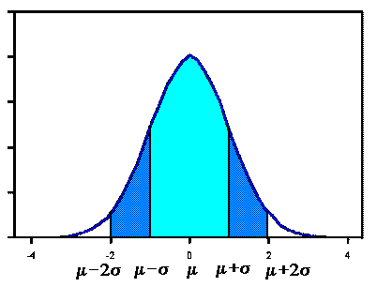
Fig 1.1 Normal distribution with expectation μ and standard deviation σ.

The font for the ‘References’ should be in 14bf Times New Roman. See the example below for which fonts to use for the references. Please put in two blank lines before the ‘References’.

References
Barnett, J.A., Payne, R.W. & Yarrow, D. (1990). Yeasts: Characteristics and identification: Second Edition. Cambridge.

