COUNTRY:
Name of the respondent:
Title of the respondent:
Name of the institution:
Email:
QUESTIONNAIRE ON DATA DISAGGREGATION FOR POVERTY MEASUREMENT
UNECE Workshop on Harmonization of Poverty Statistics, 28 November 2018, Vienna

The objective of the questionnaire is to collect countries practices in identifying and monitoring policy-relevant target groups for disaggregation of poverty measures. The Resolution 70/1 on the 2030 Agenda for Sustainable Development states “quality, accessible, timely and reliable disaggregated data will be needed to help with the measurement of progress and to ensure that no one is left behind. Such data is key to decision-making.” The issue of disaggregation is therefore particularly important in view of the SDGs indicators requirements.
PART I. VARIABLES DESCRIBING TARGET GROUPS
1. Does your office collect data and produce poverty statistics on the following selected variables describing target groups?
Sex (target group of women): YES NO
Age (target groups of children, youth and older people): YES NO
Disability status (target group of persons with disabilities): YES NO
Migratory status (target group of migrant population): YES NO
Ethnicity (target groups defined by ethnicity or race): YES NO
Others— please specify:
2. Please provide comments, if any:

PART II. VARIABLES DESCRIBING SOCIO-ECONOMIC AND GEOGRAPHIC LEVELS
3. Does your office collect data and produce poverty statistics on the following selected variables describing socio-economic and geographic levels?
Household type (characteristics of household composition): YES NO
Employment status (characteristics of labour force participation): YES NO
Tenure status of the household (characteristics of the level of YES NO
occupancy of housing unit by a private household):
Receipt of current transfers (characteristics of income): YES NO
Degree of urbanisation (characteristics related YES NO
to urban/rural areas):
Others— please specify:
4. Please provide comments, if any:

PART III. CLASSIFICATION OF MONETARY RECEIPTS OF CURRENT TRANSFERS
5. Please indicate whether the national statistical office (NSO) collects data, for example through household surveys, on households receiving the following componentsof current transfers.

 |  | If “NO” is marked, please indicate the reason:
 |  | Type of transfers does not exist | Type of transfers exists but data not collected by the NSO through household surveys | Data collected according to a different definition, if marked, please explain:
Current transfers received related to healthcare and treatment of diseases | YES NO
Current transfers received related to education | YES NO
Current transfers received associated with supporting disabled people | YES NO
Current transfers received related to support for persons of retirement age | YES NO
Current transfers received associated with the loss of the breadwinner | YES NO
Current transfers received related to support of family and children | YES NO
Current transfers received associated with supporting the unemployed | YES NO
Current transfers received related to subsidising housing expenses | YES NO
Current transfers received related to poverty | YES NO
Monetary transfers and remittances (money received from relatives, friends, etc. inside and outside the country) | YES NO
Merit benefits | YES NO
Support for groups not classified by other functions | YES NO
6. Please provide comments on the applicability of the above classification of social transfers to your country (e.g important component is missing from the classification):

7. Please indicate the three types of current transfers received in your country that represent the most important source of income for households in receipt of current transfers:
Current transfers received related to healthcare and treatment of diseases
Current transfers received related to education
Current transfers received associated with supporting disabled people
Current transfers received related to support for persons of retirement age
Current transfers received associated with the loss of the breadwinner
Current transfers received related to support of family and children
Current transfers received associated with supporting the unemployed
Current transfers received related to subsidising housing expenses
Current transfers received related to poverty
Monetary transfers and remittances (money received from relatives, friends, etc. inside and outside the country)
Merit benefits
Support for groups not classified by other functions
8. Please provide comments, if any:

9. Please indicate the ratio of current transfers received to household income:
For all households
total value of current transfers received for all households (A) divided by total household income for all households excluding current transfers received (B)

$\frac{A}{B}=$

For three lowest deciles of households
total value of social transfers received for three lowest deciles of households (C) divided by household income for the three lowest deciles of households excluding current transfers received (D)

$\frac{C}{D}=$

PART IV. SOCIAL TRANSFERS IN KIND
10. The Canberra Group Handbook on Household Income Statistics defines social transfers in kind as goods and services provided by government and non-profit institutions that benefit individuals but are provided free or at subsidised prices. Do you calculate the imputed value of the social transfers in kind? YES NO
11. Please provide comments, if any:

12. If yes, please indicate the ratio of social transfers in kind to household income:
For all households
total value of social transfers in kind received for all households (A_{in kind}) divided by total household income for all household, excluding current transfers received (B)

$\frac{Ain kind}{B}=$

For three lowest deciles of households
total value of social transfers in kind received for three lowest deciles of households (C_{in kind}) divided by the household income for the three lowest deciles of households excluding current transfers received (D)

$\frac{Cin kind}{D}=$

13. Do you include in the calculation of household income the imputed value of the social transfers in kind? YES NO
PART V. EXAMPLES ON COMMUNICATION/DISSEMINATION OF POVERTY STATISTICS TO THE USERS
14. Please attach example(s) showing how your country communicates/disseminates poverty statistics to users (e.g. from (online) publications).
15. Please attach example(s) country showing a visual presentation (graph, infographic) of poverty statistics by any of the disaggregation variables listed in questions 1 and 3 above (e.g. by household type).
NB: Below is an example from the Netherlands on poverty by age, for your easy reference.
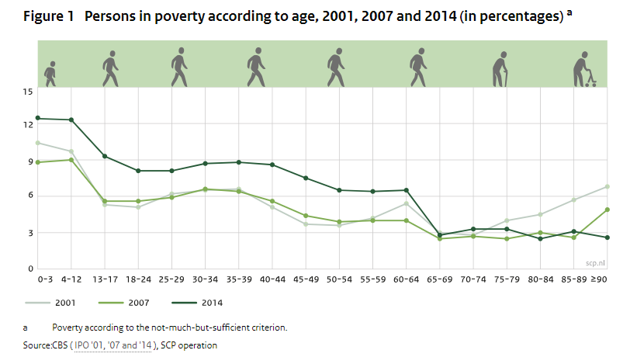
PART V. DISAGGREGATION OF POVERTY STATISTICS IN THE CONTEXT OF SDGs
16. What actions does your country plan to improve disaggregation of poverty statistics in view of the SDG indicators requirements?

This part refers to current transfers that are received by the household or by individual members of the household at annual or more frequent intervals, in monetary terms. For receipts of social transfers in kind (goods and services), please see Part IV.
Based on the European System of integrated Social PROtection Statistics (ESSPROS) with modifications. ESSPROS Manual and user guidelines, Eurostat, 2012

