

Housing and Health Survey Osh, Kyrgyz Republic

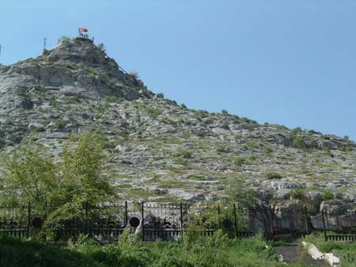

Holy Sulayman mountain in the centre of Osh city

February 2004
- THE SURVEY

Southern capital in southwestern Kyrgyz province of Osh the city of Osh lie on the eastern edge of the Fergana Valley. Osh is about 1290 km southwest of Bishkek, the capital of Kyrgyzstan. It is separated from Bishkek by high mountain ranges. Osh sits on a major commercial road from Bishkek to Afghanistan through Dushanbe and Khorugh in Tajikistan, to Afghanistan. Osh is the second largest city in Kyrgyzstan after Bishkek. Coal, lead, and zinc mines surround the city, together with sheep grazing and wool production they are the major economic activities. At 2500 years of age, Osh is one of the oldest settlements in Central Asia. It was known as early as the 8th century as a center for silk production along the Silk Road. Since the 10th century, Muslim pilgrims have been visiting a hill in the center of the city, called Sulayman-Tahta (Solomon's Throne), where it is said the Prophet Muhammad once prayed. Many visitors are childless women who come to pray so that they may be able to have children.

The survey procedure

After the visit of the Deputy Minister of Health, Chief Sanitary Doctor and the WHO representative to the municipality of Osh city in January 2004, the official decision was made to launch a survey about housing and health in the city.
Local coordinators of the survey and the place for the survey headquarter were identified in the provincial Center of Sanitary and Epidemiological Surveillance.

A sample of the 800 households with addresses was obtained from the National Statistic Committee. Names and addresses were retrieved from the special clustered database of addresses the committee is using for different survey purposes. It has to be mentioned that the sample was taken from the Osh city municipality address database, which includes Osh city, Almalyk village and Djapalak rural municipality consisting of several villages around the city.

Taking into consideration some of local conditions it was decided to use advertisement on local mass media to promote and inform about the survey. Information letters were not sent to the relevant households. As only because only 25% (some not-functioning) of the addresses from the total sample of 800 addresses had telephone and mainly in central part of the city, it was decided to contact people “door to door”. This approach as well as readiness of the people to participate in the survey mainly explains the high response rate for Osh survey.

Language issue

The questionnaires used in this survey were in Russian language. Taking into consideration the ethnical proportion of the Kyrgyz and Uzbek population in Osh population the questionnaires were translated into Kyrgyz and Uzbek. These translated questionnaires were used then during the training of the interviewers to allow them proper formulating of the questions in Kyrgyz or Uzbek when it is needed. All the interviewers were tri-lingual people mainly the students of the medical faculty of the University.

From the 9th of February 2004, 12 teams of 24 surveyors each contacted or tried to contact the representative of 800 households. Fifteen days later 482 households were interviewed.

From the total of 800 households of the sample there were 19 (2.4%) that were excluded from the survey because of wrong addresses. This included few office and a few international residents. One interview was excluded from the final number of interviews because the only one health questionnaire from this household was not the one corresponding to the interviewed person.
- Interviews made – 481 (60 %) from the total sample of 800;
- Wrong addresses – 19 (2,4 %);
- Not done interviews 34 (4,3 %):
  - could not be reached 4,3 %;
  - incomplete interview 1 (0,1 %);
  - refusals 27 (3,4 %)

From the remaining 781 addresses 266 were not contacted at all.
From the remaining 515 addresses:
- 481 interviews were done (93,4%);
- 34 was not done (6,6%)because of following:
  - 6 (1.2%) could not be reached during the survey because people were out of the city or no one live in the house for the moment;
  - 27 (5,2%) refused to participate and didn’t allow the interviewers to enter the houses;
  - 1 (0,2%) interview was not complete.
24 health questionnaires, which were collected by the questionnaire pick-up person, were not filled out. In many cases mothers and fathers refused filling of the health questionnaires for their children.

Conclusions

- 481 households were interviewed. It is 60% response rate on the total of the households of the sample;
- 481 interviews constitutes 93 % response rate from the contacted households (filtered sample);
- Only 34 interviews were not done from the contacted households which is 4,3 % from the total sample and 6,6% from the filtered sample (contacted households);
- 27 households refused to participate in total. Refusal rate is 6.1% of the filtered sample;

- Main reasons of the refusals were:
-general fear about letting unknown people into the house/flat;
-no interest in the survey.

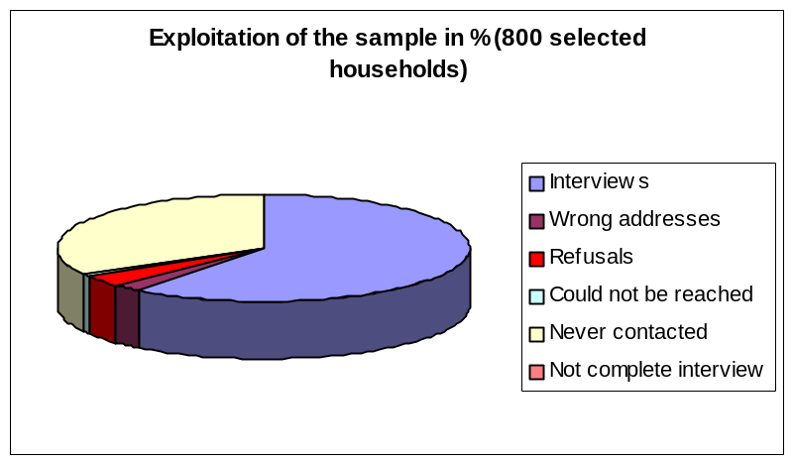

- THE SURVEYED POPULATION: a sample of 1710* persons living in 481 households. A sample of 1132 persons has been analysed

The analysis of 1132 health questionnaires show a sample of population that ranges from 0 to 90 years of age, the average age being 29 years.
36 % of the surveyed households is less than 20 years old and 6 % is 65 years and older.

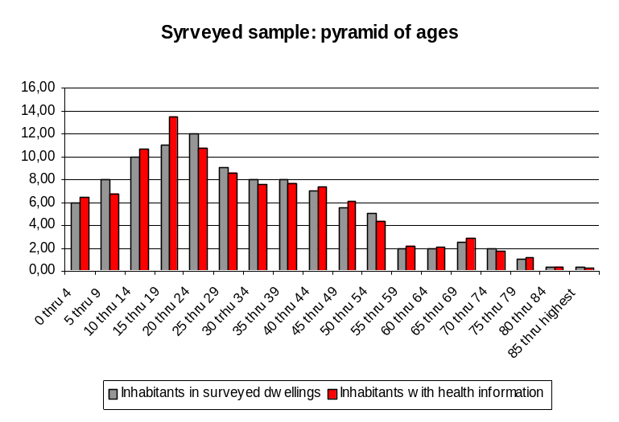

The surveyed sample in general is perfectly representative for the population of the Osh municipality according to the data provided by the last national census.

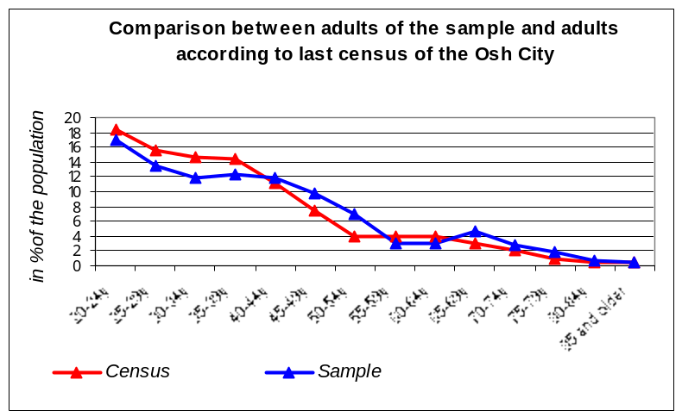

The interviewed persons are 38 years-of-age on average. More than 6 out of 10 are women.

Women are more numerous than men (sex ratio=0.67).

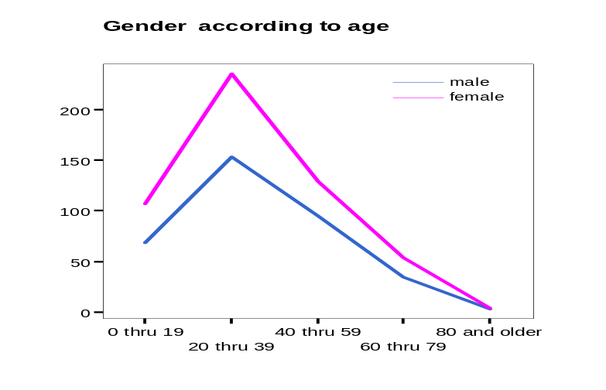

The size of households is 3,6 on average and ranges from 1 to 7 persons. Almost 1 surveyed household in 2 consists of more than 3 persons in whom 1 in 3 consists of 6 persons and more.

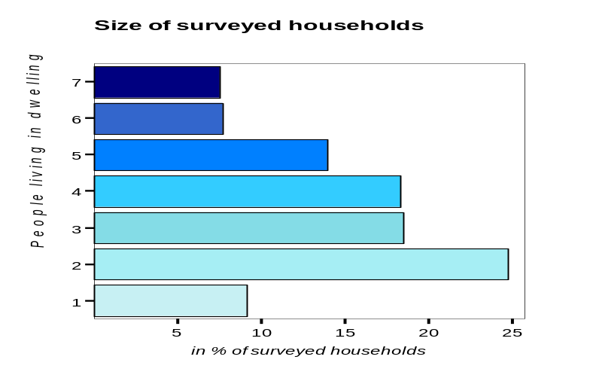

Presence of member(s) with a handicap is indicated in 8 % of the households (38 households), corresponding to 8,6 % of the surveyed population (76 persons).
30 % of the surveyed population is covered by a health public insurance. Others are not covered.

60 % of the adults of 18 years of age and above are married and live with their spouse. Nevertheless 4 adult persons out of 10 are living single and 1 out of 10 is widowed.
Divorced, separated and widowed are quite more numerous among women than men.

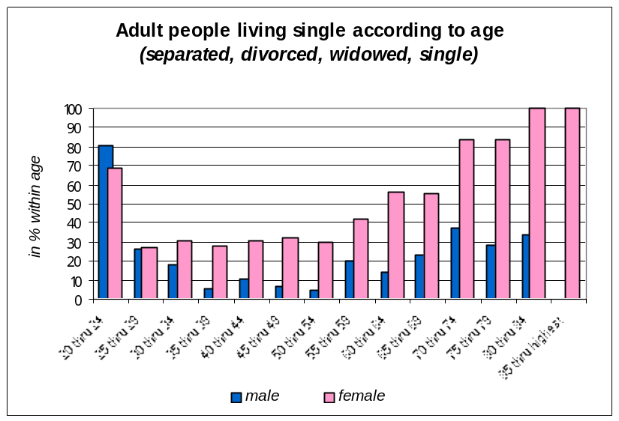

7 % of the surveyed population was not born in Kyrgyzstan. People from foreign origin are living in the country for 35 years on average and for a longer time for women: 37 years versus 30 years for men.

Only less than 2,5 % of the adult surveyed population has no school education. The majority (85%) is secondary and post-secondary graduate.

Adults of 18 and older in Osh are active: 34 % of them are working full time and 8 % part time. 22 % are unemployed and almost 13 % are retired. Nevertheless the rate of unemployment is high: 22 % of the adults affirm they are unemployed and Respectively 25 % and 9 % of the surveyed households have 1 or 2 unemployed member(s), especially among women who represent 63 % of the unemployed people.

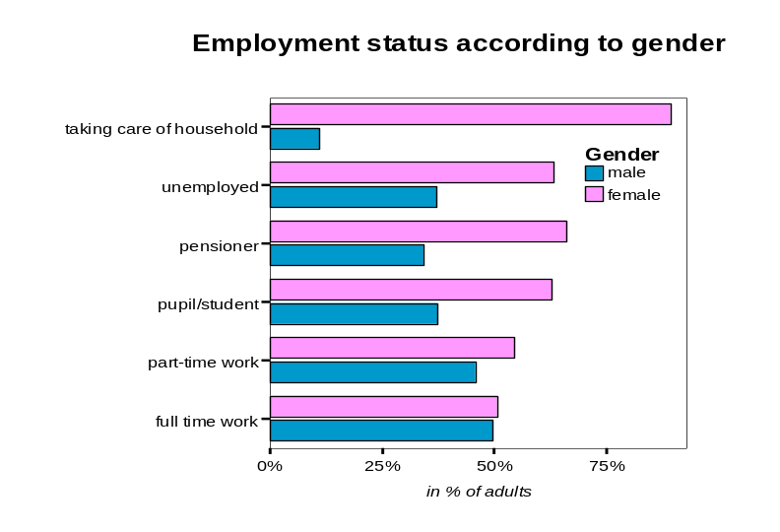

85 % of the surveyed households are owners of their dwelling. The interviewed persons have indicated the following disposable monthly net income that the household has after deduction of taxes.

Disposable income of household - in Soms

 | Cases | % | Valid Percent
Under 500 soms | 102 | 21.21 | 35.66
501-1.000 | 67 | 13.93 | 23.43
1.001-1.500 | 45 | 9.38 | 15.73
1.501-2.000 | 23 | 4.77 | 8.04
2.001-2.500 | 20 | 4.15 | 6.99
above 2.500 | 29 | 6.02 | 10.14
Don't know and no answer | 195 | 40.54 | 100.00
Total | 481 | 100.00

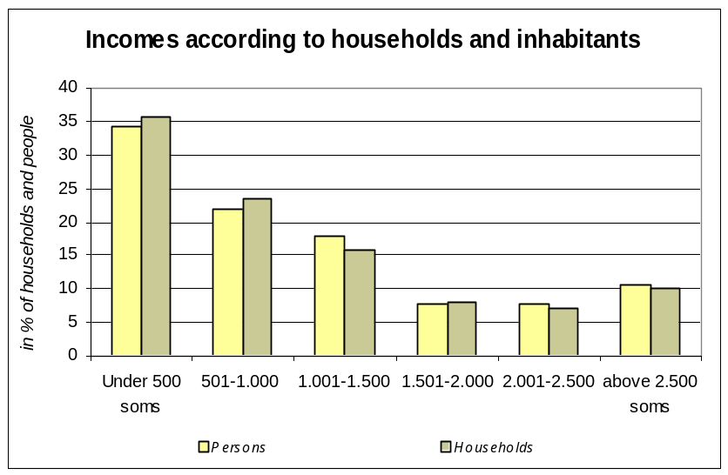

Housing charges represent 32% of the disposable incomes of households on average. 2 % of the households declare to receive housing allowance.

For almost 60 % of the households, the percentage they allocate to the housing needs represent less than 30 % of their net income.

Nevertheless, 70 % of them complain that they meet difficulties to pay the total housing expenditures.

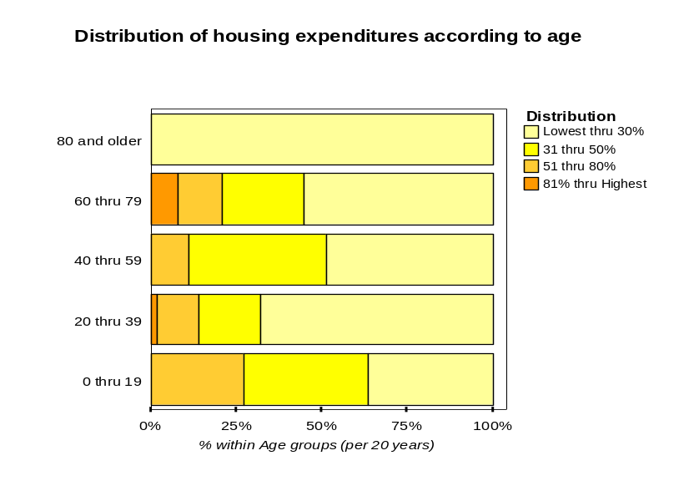

3. WHERE DO PEOPLE LIVE?

Surveyed housing and inhabitants are distributed between the center, the suburbs and rural areas. Larger size of families live more frequently in suburbs and rural sectors.

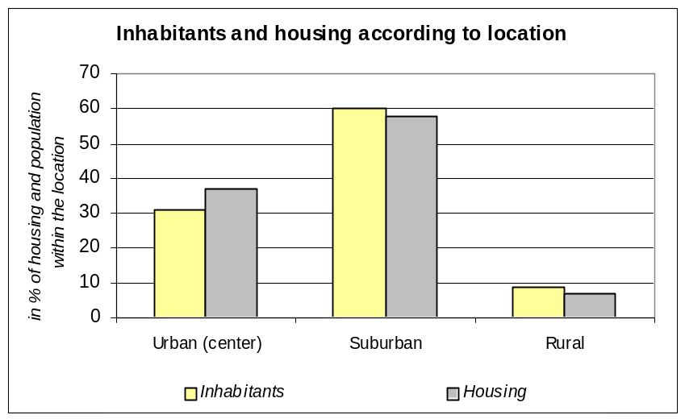

The majority (60 %) of the surveyed inhabitants are located in the suburbs of Osh (58 % of the total surveyed dwellings). Only 33 dwellings with 152 inhabitants each are located in rural areas around Osh. 1 surveyed dwelling out of (53 % of the surveyed population) is located close a noisy street according to the surveyors.

Occupiers per dwelling on average in….
Centre | 3.2
Suburbs | 3.7
Rural area * | 4.6
The city | 3.6
In the city close to busy street | 3.3
In the city close to less busy street | 3.9

43 % of the surveyed population lives in a mainly detached houses neighbourhood then by a panel blocks (28 %) and apartments block (24 %) environment.

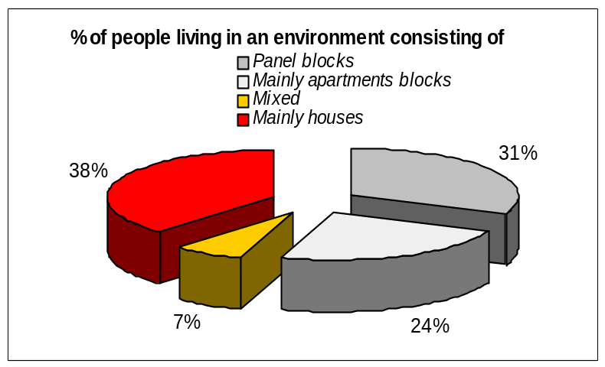

1 surveyed housing on 2 is living in a brick or detached one family house: the distribution of type of housing and inhabitants within the surveyed sample is quite equivalent. But some details show larger families in detached one family houses than in flats in panel blocks.

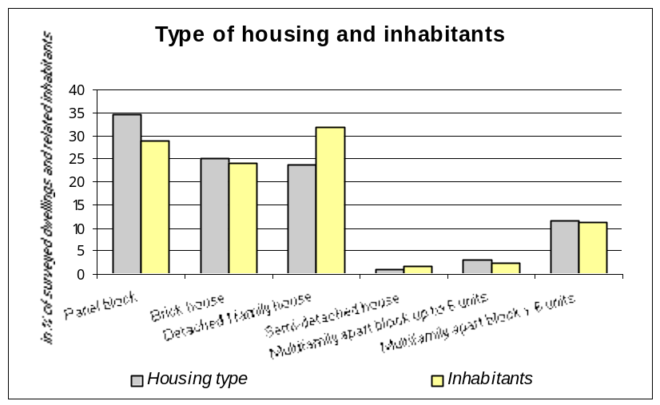

Detailed data show differences of housing types between the lowest and the highest incomes of households: more than 50 % of the households belonging to the lowest income group (60 % of the surveyed households) live in flats (55 %) rather than houses (45 %), - versus 30% and 70% for the highest income group respectively (17 % of the surveyed households).

But there are no significant differences in noisy locations and in the quality of the view according to the income of the households.

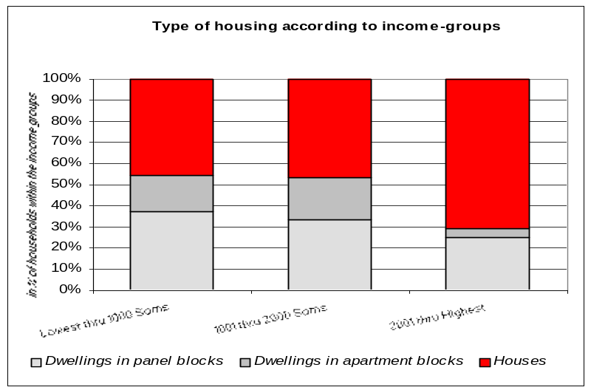

According to the interviewed persons, their home is well connected to the city center: 93% declare that they reach easily the center with public transport and the majority of them knows at what time in the evening the last ride back is. But only 1 in 4 declare to reach the center by car or walking, cycling is the last frequent option with only 11 % of the answers. Almost 30 % of the surveyed households have parking closely. Globally, people are satisfied with parking arrangements while 50 % has no opinion.

68 % of the surveyed households have a green space belonging to the building: 55 % are private. There is visible vegetation from the dwellings in more than 80 % of the surveyed cases. Less than 10 % if the dwellings are located close to a public park or a green space accessible within less than 100 meters.

Only less than 20 % of the green spaces are considered as well maintained by the surveyors.
But graffiti, litters and dog droppings are more numerous to ruin the immediate environment of the surveyed dwellings: in less than 50 % of surveyed case, the surveyors consider the living area they have visited as clean, without graffiti on the surveyed building and around, or without dog droppings. Results are worst mostly because litters: 80 % of surveyed residential environment are considered as littered or very littered, confirming the opinion of interviewed inhabitants who are more than 6 in 10 to declare that they feel annoyed or very annoyed by litters and trash in their immediate environment.
This is a critical point. The city is considered as quite poorly maintained. It is well known that the feeling of safety and the acceptance to socialize are strongly associated with maintenance of the immediate environment. This is an area of concern for the municipality and the population.

Only 14 % of the interviewed residents affirm there are enough recreational areas for children, teenagers and elderly. On top of this, 50 % of the interviewed residents quote the lack of places in the immediate environment where to sit, relax and talk peacefully with neighbours and friends.
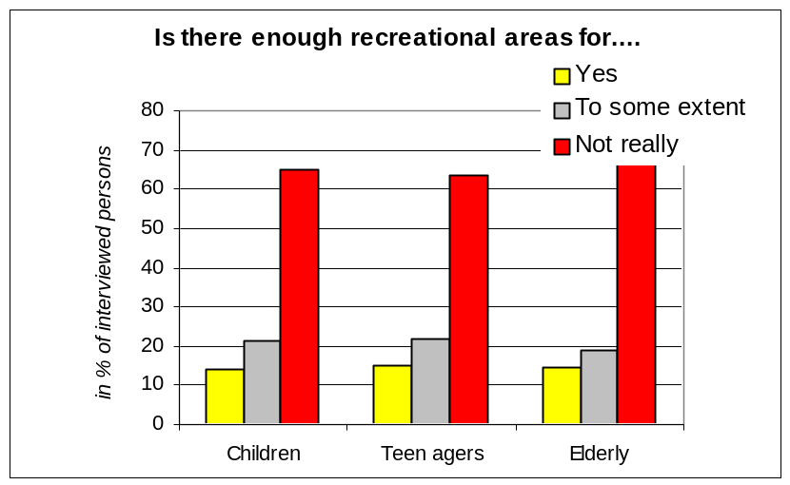

40 % of the parents would encourage children to play on local playgrounds but 33 % affirm there is no playground in their living immediate environment.

The majority: 70 % of the residents declare to feel safe when returning at home when dark. Those who feel insecure are women in 7 cases in 10. 2 main reasons are specified: the first one is related to the general fear of other people: bad persons (!), bad neighbours, hooligans in 31 % of the answers while 27 % quote dunked people and drug addicts as the first cause of their feeling of insecurity. The second cause is linked with the lacks of lighting in the streets and / or in staircases.

Nevertheless 70% of the residents consider the location of their housing as a good or very good place to live but think it is not so well evaluated by the others who do not live there.

The main reasons of satisfaction quoted by the people who consider they live in a good or very good area are the quietness of the place and the quality of the new buildings. The second indicated reason is the proximity of the city center, of the relatives and families, then of facilities and services: market, school, hospital etc...The third reason is linked with neighbors and the quality of social environment.

It is interesting to note that the same feature of priority reasons for satisfaction or dissatisfaction is found in all cities surveyed during the LARES exercise. Cleanliness of the immediate environment, noise and accessibility to shopping and social services are constantly among the key issues!

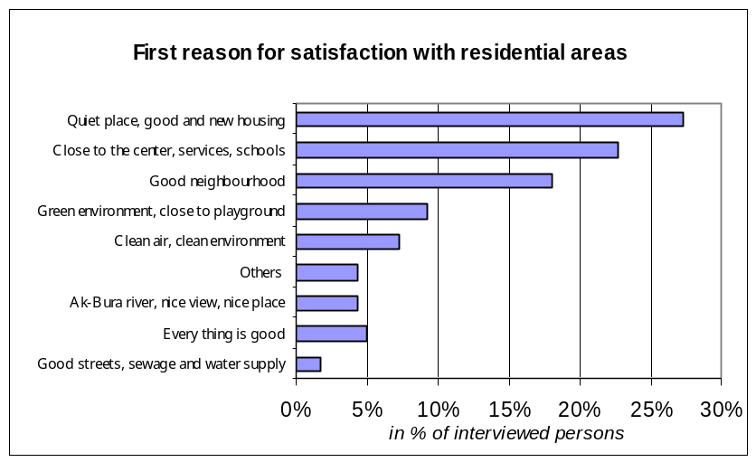

1 interviewed person out of 4 considers her or his location as a bad or very bad area to live. They are dissatisfied with the living environment because the area is dirty, with a lot of solid waste and wastewaters problems. The second alleged cause is linked to problems of temperature: lack of heating in winter or too hot temperature in summer. The third is concerning abilities for people to reach the centre: they complain their location is to far from the city centre, the public transport connections bad and/or public services limited.

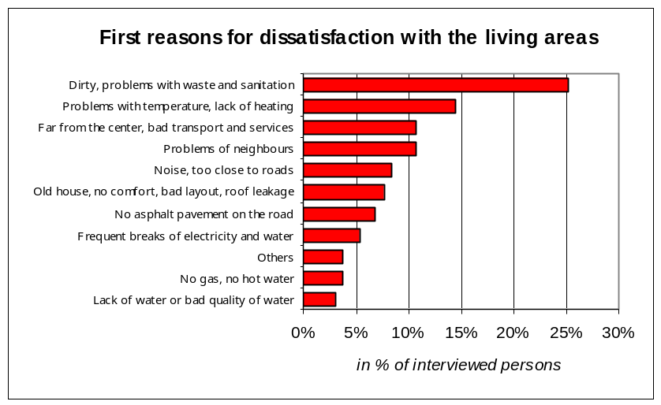

1 interviewed resident in 4 declares that he or she knows what things to change to improve her or his immediate environment: the first answers are linked with the socialization facilities strengthening the social life including increasing of playgrounds, benches, green spaces and trees; then the second cause reported is related to the cleanliness of the environment, the streets and residential spaces through better waste collection and the third to the improvement of the quality of the streets with asphalt.

More than 65 % of the residents never envisaged moving in another dwelling because they are unhappy with their current living conditions. Nevertheless, if they should move, 62 % of the interviewed households of Osh declare to prefer to move in another neighbourhood or another housing area. Only 11 % declare they would like to leave for another city.

4. HEALTH

1. Determinants of health

- Size and weight
The size and the weight of adults is 165 cm and 66 kg on average. Detailed data shows that men are taller than women: 170 compared to 162 cm and heavier: 72 compared to 62 kg.
The tallest are the people from 20 to 39 years of age with 172 cm for men and 162 cm for women.
64 % of the adults of 20 years old and more have a normal weight. So the majority does not have problems with the Body Mass Index.
Nevertheless 5% are underweight, 23 % overweight and 8 % are obese. This is an excellent score compared to many other urban areas in Europe !

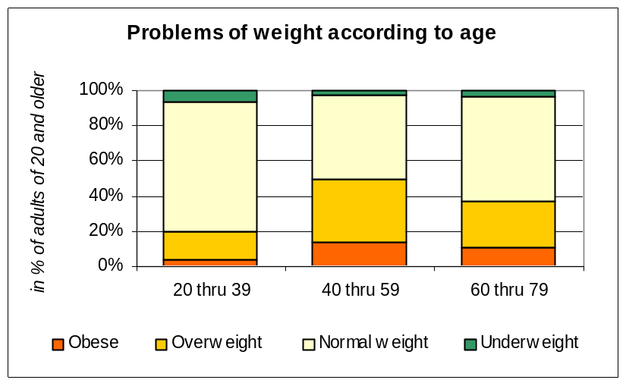

Globally, adult women are less affected by overweight and obesity than men (27 % versus 38%): the 40-59 age group is the most affected by excess of weight problems: 1 adult in 2 is affected by overweight plus obesity while 15,5 % of the women are affected by obesity.

-Behaviours

Almost 72 % of the sample population above 18 declares they have never smoked or have stopped smoking.
Nevertheless, detailed data shows that those who are more affected by smoking are the people of 20 through to 39 years of age, women being more moderate than men’s. Almost 95 % of the women declare they have never smoked versus 37 % of the men.

Only 1 adult in 2 declares to have never drunk or used to drink alcoholic beverages: when adults drink, it is occasionally in 96 % of the cases! Maybe there is a strong likelihood of underreporting alcohol consumption! ...Like all over the cities surveyed.
Nevertheless, detailed results show that 50% of the adults are inclined or have been inclined to drink alcohol. Only 1 % affirms that he or she drinks daily one glass or more of an alcoholic beverage. Women drink slightly less than men: 60 % of them compared to 32 % of the men declare that they never drink.

Young people of 18 years of age begin to drink and smoke from the age of 14 and 12 respectively. 5 % of the young people within the age group 14-18 declare that they drink occasionally or are used to drink.

The surveyed population of Osh doesn’t practice a lot of sport and report limited physical exercises: 89 % of the population older than 5 years never practice sport or does only sport occasionally or has stopped practicing.
This is a very important question. Physical exercise is needed for maintaining good health. It seems that both cultural aspects and lack of availability and facilities to practice sport are the main causes of this poor result. This is one area where significant health results could be achieved.
Only 11 % do sport frequently: among them 1 in 4 practices sport intensively. Youngest are the most involved in sport and physical exercises: 23 % do sport frequently.

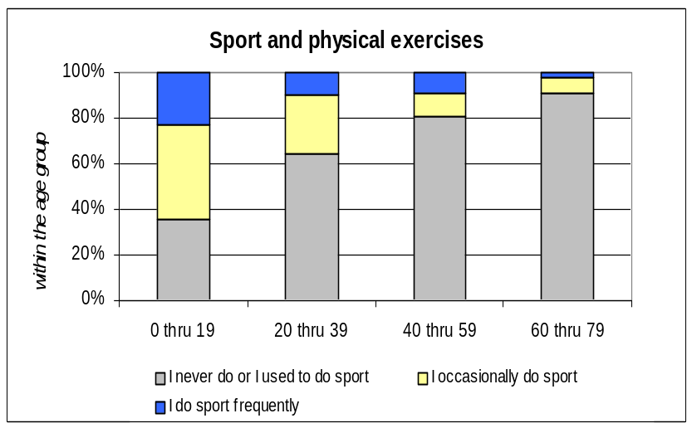

Globally, older they are after 20 years, more people declare to decrease sportive activities. Globally, women are less involved in sport and other physical activities than men: 72 % never do sport versus 56 % for men.

-Time spent out of the dwellings

Adults spent 7,3 hours per day out of the dwelling on average during the working days and 5,3hrs during the weekends. Results show more than 1hr of difference within gender and age groups.
Men spent more time out of the dwellings than women during the working days: 8 hrs on average versus 6,8hrs for women; this difference is less significant during the weekends: 5,8hrs for men against 5hrs for women).
27 % of people spend less than 4 hours outside. Detailed results indicate that more than 85 % of the elderly above 80 years of age stay more in their dwellings spending less than 4 hrs per day outside.

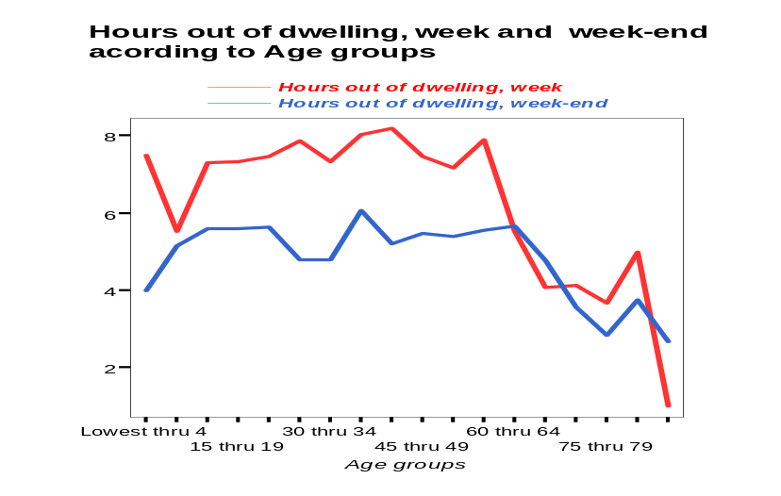

Time spent out of the dwellings during the working days and weekends, practice of sport or physical exercises are clearly related to the BMI.
Those who spent less than 7hrs per day outside their dwelling are 2,6 times more at risk to be obese than the others.

The trend of spending more and more time inside the dwellings has cultural causes, but it abolished to changes in behaviors. Children spend more and more time in front of the TV, have less exercise; and the adults too.

This is the main way to major public health problems such as obesity, coronary diseases, muscle skeletal disorders and diabetes type 2. Encouraging social links outside the dwelling and physical exercises lead to better health.

This may be a long and different process but people working in town planning and design of dwellings of the cities have to take this into account to save the health of the future generations.

-Handicap and physical constraints

9 % of the surveyed population declares that it has one handicap or some physical constraint. But 17 % give details about handicaps or physical constraints that affect them. This shows that a lot of people suffering from physical limitations do not consider themselves as ‘handicapped’.

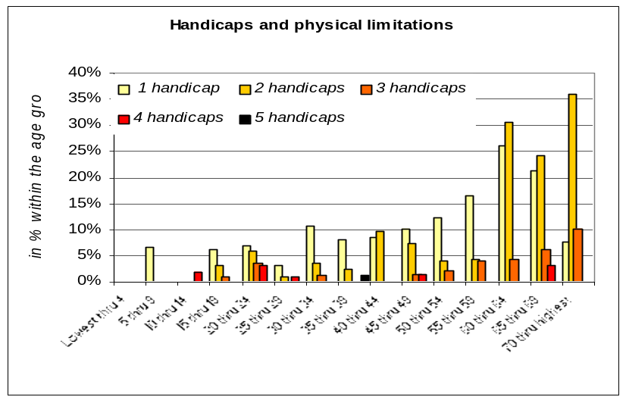

Elderly are the most affected: almost 7 surveyed people out of 10 of 80 years of age and above have 1 handicap at least.

The first handicaps in the elderly older than 80 is linked with difficulties to use stairs, to bend down and grasp some small objects in 71 %, 57 and 29 % of the cases respectively.
4 persons in 10 with handicap or physical limitations declare to have some problems to make a normal use of their dwelling and a few less (33 %) indicate that their dwellings need some adaptations in order to make the best possible use of them.

When people are not handicapped or suffering from physical limitations, they are 15 % and 9 % only to have some difficulties to make a normal use of their dwellings and to need some adaptations. The first adaptations quoted are linked with accessibility to the dwellings and equipment: lift installation, flat at the first floor, handrails in the staircase, toilets indoor, wheelchair...The second series of adaptations needed are associated with size of kitchen, staircases, need of shower, dwelling repairs...Less than 1 % of these adaptations have been realized while almost 8 % of them are assessed as possible according to the handicapped people who are less than 1 in 5 to consider the impossibility to make required adaptations as a reason of moving into another dwelling.

2. Diseases

During the survey the population of the sample had to indicate if they suffered from a chronic disease and distinguish whether these diseases had been diagnosed by a physician or not. Differences between indicated and diagnosed diseases are very small. Unless specified differently, this report will only deal with diagnosed diseases.

a) Chronic diseases

- Allergies (4, 5 %)
- Chronic bronchitis (4 %)
- Migraine and frequent headache (3,1 %)
- Asthma (1 %)
- Chronic anxiety and depression (1 %)

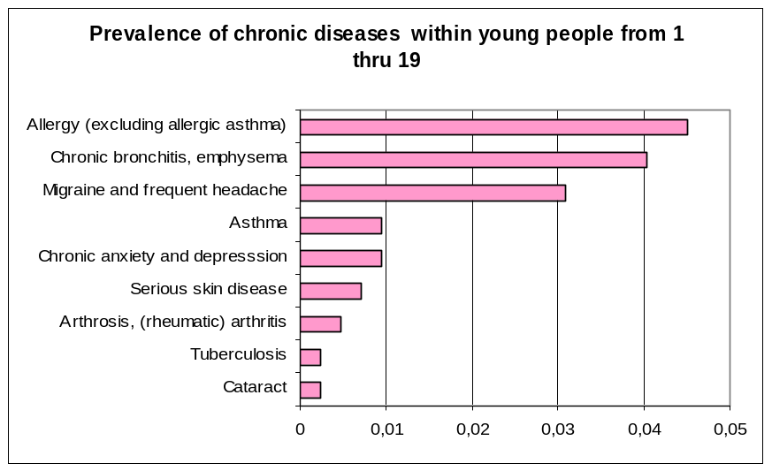

- Top five of the diagnosed chronic diseases within the adult population (from 20 through 65):
- Migraines or frequent headache (10,7 %)
- Chronic bronchitis (7,8 %)
- Arterial hypertension (7,5 %)
- Gastric or duodenal ulcer (5,1 %)
- Allergies (4,8%)

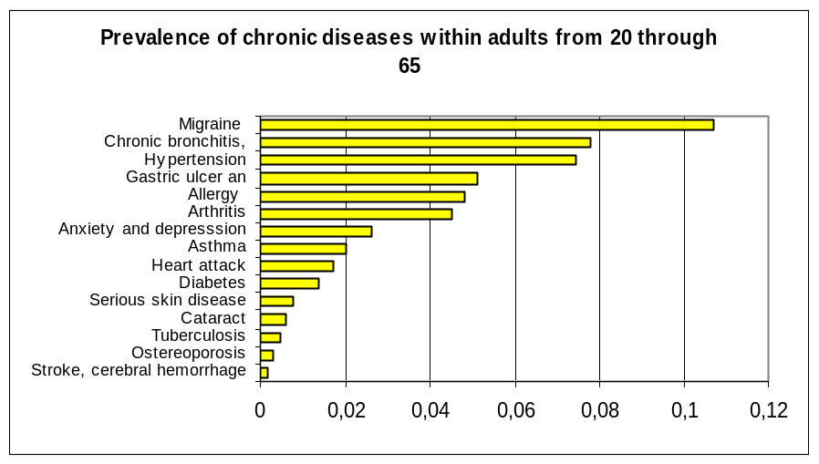

- Top five of the diagnosed chronic diseases within the elderly (above 65 years of age):
- Hypertension (32,8 %)
- Migraine and frequent headache (28,3 %)
- Arthritis (22,4 %)
- Cataract and Chronic bronchitis (both 13,4 %)
- Gastric or duodenal ulcer (10,4 %)

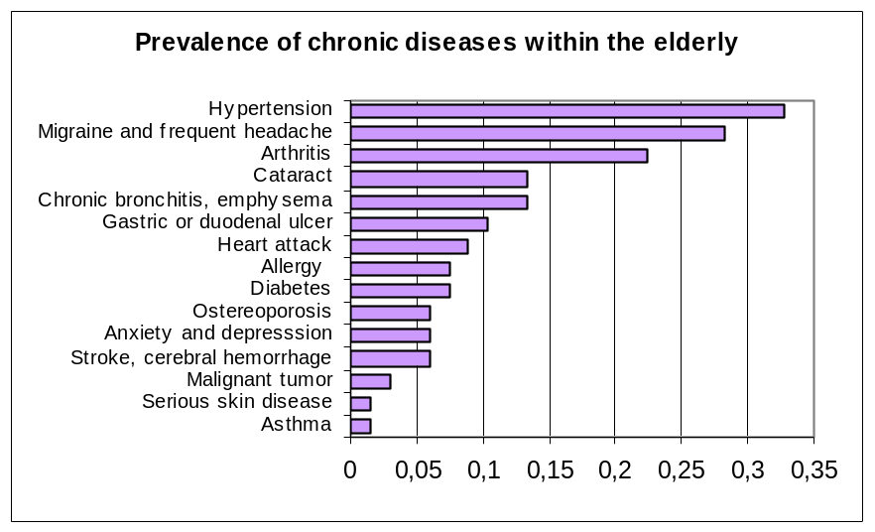

b) Acute diseases and other diseases

During the previous winter, different acute diseases occurred among the population especially colds and throat illnesses, which have been indicated by 602 people i.e. 1 person in 2 within the surveyed sample. It was diagnosed in 324 cases (Prevalence for diagnosed people: 28,6 %).

Prevalence of acute diseases and symptoms from 1 through
19
0
5
10
15
20
25
30
35
40
Attack of asthma
Watery eyes or eye inflammations
Fatigue
Eczema
Headache
Any nasal allergies, including hay fever
Acute bronchitis or pneumonia
Wheezing or whistling in chest
Diarrhoeal diseases
Cold or a throat illness
Problem with sneezing, or runny or a blocked
nose

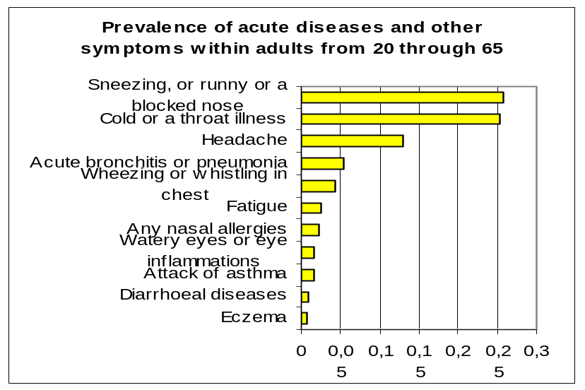

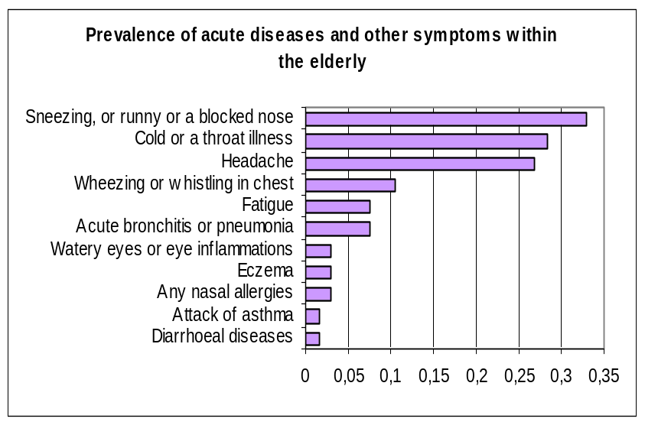

c) Other symptoms of diseases

Other symptoms of diseases occur among the surveyed population such as headache that is indicated in more than 310 cases and diagnosed by a doctor in 39,3 % of the cases. More than 1 person in 2 has indicated sneezing that has been diagnosed in 50 % persons.

Sneezing or runny or blocked nose is the biggest indicated and diagnosed symptom among the surveyed sample. Added to wheezing or whistling in chest, nasal allergies, eczema, eye inflammations the prevalence of diseases linked with allergy affects all age groups: 40,51 % of the surveyed people suffer from 1 allergic symptom at least.

Older people are more affected than youngest by allergies: 38 % of the people aged from 60 through 79 versus 29 % to 31 % for the younger.

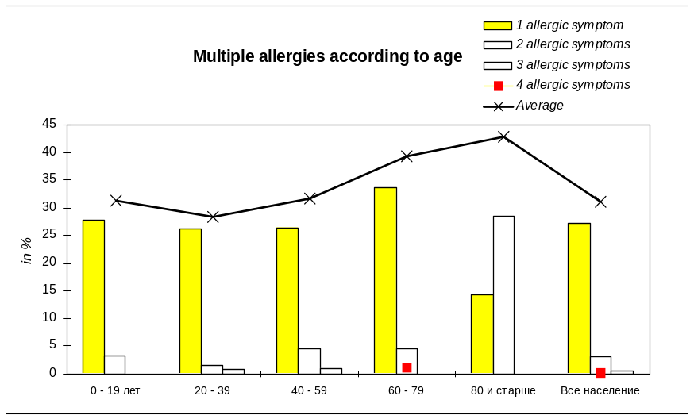

7,5 % of the adults report that they have chronic anxiety and depression: 2,5 % are diagnosed by a physician take prescribed medicine and think it is related to their housing conditions.

Nevertheless, other detailed results show a high prevalence of trends of depression within the adults: 166 (prevalence in adults: 22 %) are affected: older they are, more depressed they are, especially women who are more affected than men in all the age groups.

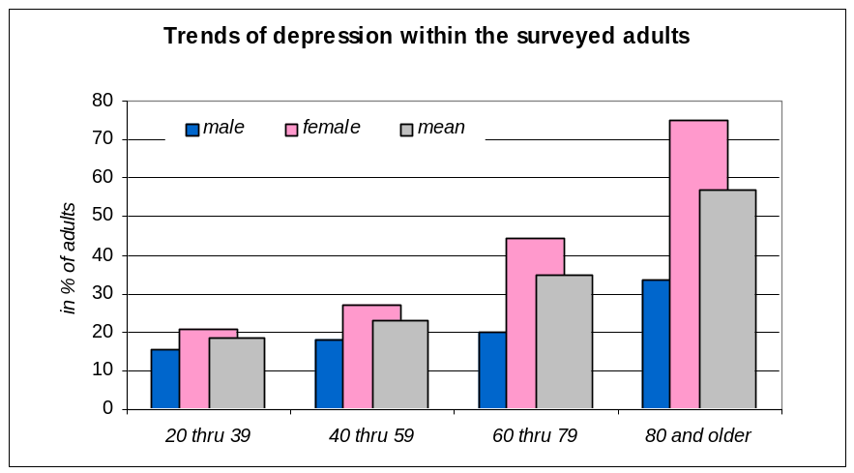

3. Accidents

During the past 12 months, 369 accidents occurred among the surveyed population. The global prevalence of accidents is 32,6 %.

Striking and collision, cuts are the most frequently occurring accidents with 107 and 94 cases respectively. Followed by falls in 74 cases, burns in 31 cases then 27 electrical accidents, 12 poisoning and 5 gas intoxications that have been reported during the past year.

Older age groups of people are the most affected by all accidents except suffocations and choking and poisoning.

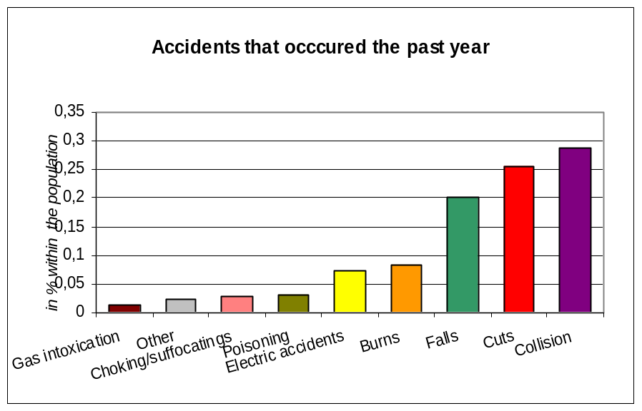

With young people, the elderly are the most affected by falls, striking and collisions: 7 % of the young below 20 years of age and 28 % of the 80 years and above has fallen or got a collision or striking during the past year.

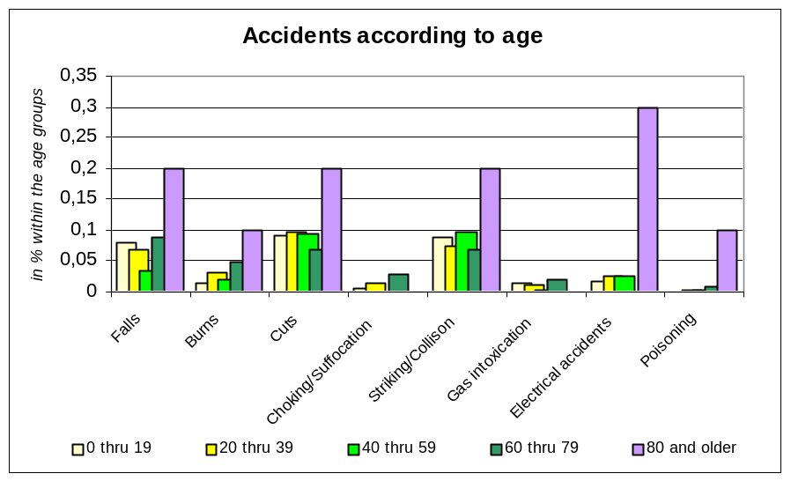

The most often injured part of the body is upper limbs (39,1 %), lower limbs (24,1 %), head (19,3%) and surface area (5,5%) according to the answers.

6 accidents (3,1 %) have led to a hospitalization, 55 (24 %) to a visit to the doctor; among these, 31 have led to a prescribed treatment. But people themselves have treated the majority of the accidents.

Women are particularly affected with all types of accidents also, except for falls.

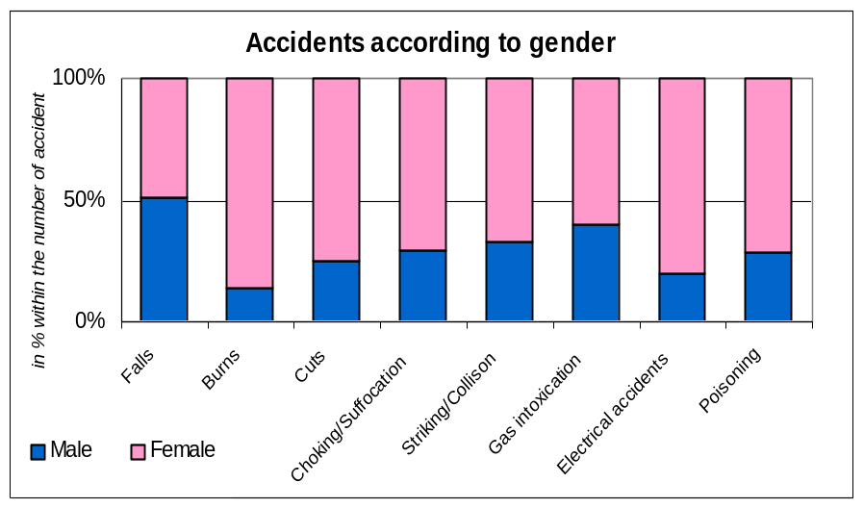

Detailed results show a higher risk to cut, to fall and to get collision or striking for handicapped persons who are exposed 2,3 times more than not handicapped persons.

Data for accidents follow a similar pattern as for other European cities surveyed with a quite higher rate of electrical accidents and poisoning.

This could be linked to the intensive use of additional heating systems for electrical accidents.

For poisoning it needs more research for starting a good prevention campaign.

Falls and cuts can be prevented partially through adequate measures.

5. HOUSING and HEALTH

Surveyed housing stock consists of flats and houses in equal parts. 35 % of the surveyed dwellings are located in panel blocks while around 15 % are located in multi apartments blocks of more than 6 units for the major part. Except 4 units, the whole surveyed sample has been built after 1945: almost 7 dwellings in 10 are less than 30 years old.
Only 10 % of the surveyed dwellings are located at the 5th floor and above.

57 % of the surveyed dwellings are smaller than 50m² the average size of the dwelling and the average number of inhabitable rooms per dwelling being 37m² and 3,3 respectively.

The number of rooms and the disposable size is 0,9 and 10,3 m² per inhabitant on average.
20 % of the interviewed residents are dissatisfied or highly dissatisfied with the size and the layout of their dwelling. 42 % declare that they need more rooms against 55 % who consider the number of rooms as sufficient and 1,5% who need less. More than 1 in 4 surveyed adult people say they cannot find a place in their dwelling to be alone when they want (cf privacy).

68 % of the surveyed households have a green space belonging to the building: 55 % are private gardens. So, more than 7 persons in 10 live close greenery and can dispose of a green space or a garden.

Typical features of the surveyed housing

- Heating / temperature indoor and energy
Almost 48 % of the surveyed households say that they are dissatisfied or highly dissatisfied with the heating system of their dwelling against 32 % who are satisfied or very satisfied.
More than 6 interviewed persons in 10 declare that their dwelling has problems sometimes, often or permanently with temperature in winter due to low temperatures while 20 % have problems in summer. 9 % of the surveyed dwellings cumulate problems with temperature all year long.

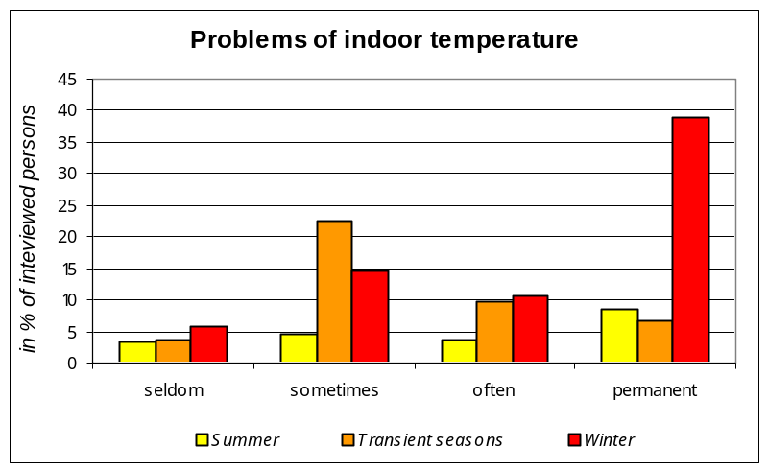

The low efficiency and the no functional heating systems are the two major reasons alleged by the households to explain the problems of temperature they meet in winter. The lack of control of the heating devices and not tight or single glazed windows are the second major reasons, with the lack of heating in some rooms and the bad insulation of the building: 80% of the dwellings with problems of temperature in winter have problems with temperature in transient seasons, confirming the bad quality of insulation of the building and windows.

Furthermore, more than 1 dwelling in 2 does not have heating system in all inhabitable rooms.
Flats in panel blocks or multi apartments blocks are 63 % and 80 % time more affected than houses with low temperature in winter and transient seasons respectively. The income of the household is not associated with indoor thermal comfort, even in summer when 12 % of the dwellings meet problems with too hot temperature.

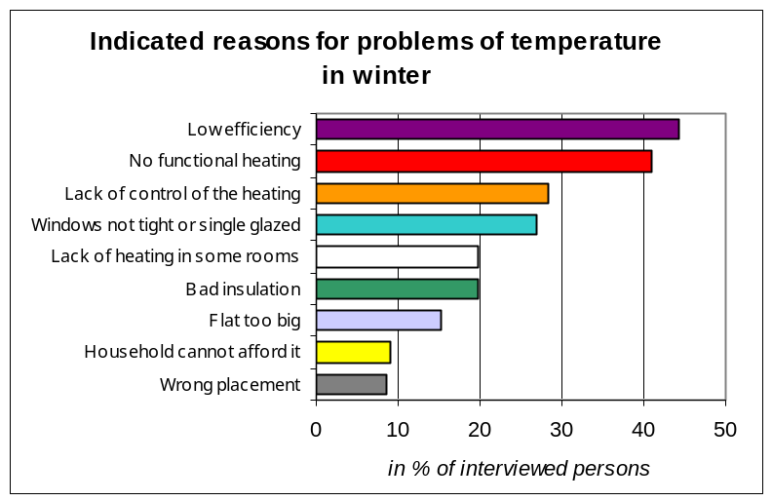

36 % of the dwellings are connected to a central heating source supplying the neighborhood.
Those who are not connected to a central system have a heating source for their own dwelling or for the building in 24 and 7 % of the surveyed cases respectively that uses electricity in more than 1 case in 2 to provide warmth. Solid fuel is the second source used in 28 % of the cases, followed by gas (16 %).

An additional heating device is use in more than 7 dwellings out of 10: more than 60 % of those using an additional heating device use it daily during the cold and transient season. Electricity is the major source of energy used in additional heating (78 % of the cases) followed by gas and solid fuel (10 % each).

Dwellings where additional heating are used are 6,3 times more often those that meet problems of temperature in winter (from 3.9 to 10.1) than those without problems.
In transient seasons, they are 4,7 times more often affected with problems of temperature (from 2,3 to 9,6) than those others also.

37 % of the interviewed persons are dissatisfied or very dissatisfied with the thermal insulation of their dwellings and think it could be one of the 4 main improvements to do to contribute to reduce their energy consumption. The other interventions and housing improvements that could contribute to reduce energy are quoted as following: better equipment efficiency, better regulation of heating and tight or double glazed windows.

Almost 50 % of the interviewed households declare that they spend more than 20 % of their income for heating, and 62 % rate the expenditures as expensive. No one consider that the expenditures spent for heating are rather cheap.

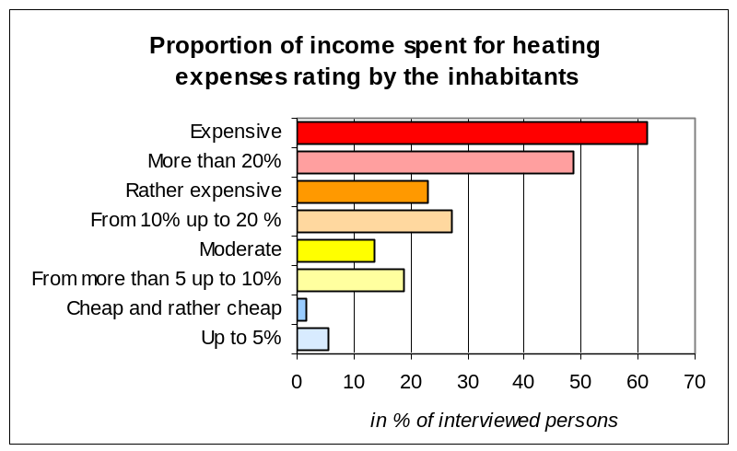

Strong associations have been proved between bronchitis or pneumonia and sneezing and permanent or frequent problems of temperatures in winter.
Bronchitis or pneumonia – OR = 4,596 (1,332-15,863)
Wheezing or whistling in chest – OR = 1,812 (1,170 – 2,806).

- Lighting
17 % of the interviewed persons declare to miss natural daylight and need to turn the lights for compensate the natural light.
Young people are more affected than the older by the lack of natural daylight, but there is no association either with the type of housing where they live either with the floor.
Almost 9 bathrooms in 10 do not have windows compared to 5 % of the kitchen.

Globally, 51 % of the people are satisfied or very satisfied with the view they have from their building.
People are 8 times more (8.481- 4.640/15.505) satisfied or very satisfied with the amount of natural light when they are satisfied with the view they have from their windows.

Strong associations have been shown between the lack of natural daylight and the trends of depression (1.779- 1.196/2.647) and the health status (2.060 -1.167/3.636) within adult people: they declare to feel better when they don’t miss natural daylight.
Links also exist between the dissatisfaction with the view from the building and trends of depression (1.684 -1.087/2.607).

- Air quality
More than 7 interviewed people in 10 are satisfied or very satisfied with the indoor air quality. When dissatisfied, the major causes for dissatisfaction is dampness, followed by smells, dust, lack of air exchange then draught and smoke.
The surveyed residents consider that the problem they meet with indoor air quality occurs due to the lack of or poor heating (17 % of the answers), to the roof leakage (13 %) or to the lack or to the free ventilation (11 %).
30 % surveyed persons consider that dust is a particularly large problem in their dwellings.

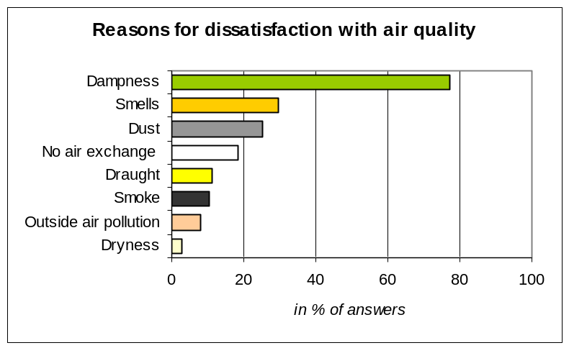

45 % of the surveyed households indicate there is neither free nor forced ventilation system in the dwelling. The majority (55 %) of the ventilation systems consists of free ventilation.

Furthermore, 37 % claim they have problems with dampness or condensation (mainly in kitchen, then in bathrooms and toilets, at last in living rooms and sleeping rooms), and 27 % claim there are some moulds growths in their dwellings (mainly on the ceiling and walls of the kitchen, then bathrooms, at last living rooms and bedrooms).
38 % claim they have problems with draughts and moving air in winter, often or permanently and
32 % note dust as a particularly important problem in their dwelling: this confirms the expressed wish to have asphalted roads.

The analysis of the inspection questionnaire shows that mould contaminations are observed in one room at least of 55 % of the dwellings. 10 % have mould-contaminated areas larger than 1sqm.

In 53 % or the surveyed dwellings, smells of dampness in at least one room is quoted also. Furthermore condensation signs and wallpaper coming off the walls have been quoted as affecting at least one room in 37 % and 49 % of the surveyed dwellings respectively. The inspection questionnaires show a lack of exhaust system in 98 % of the kitchen and a lack of free or forced ventilation system in 32 % and 20 % of the kitchen and the bathrooms respectively.
Dwellings are 2 (1.9 –1.114/3.241) to 4 (3.84 – 1.791/8.234) times more contaminated by mould growths and dampness respectively than the others when the occupiers meet permanent problems with temperature in winter and in summer and when they are dissatisfied with the amount of natural light (2.333 –1.278/4.259) and use additional heating (1.850 – 1.074/3.185).

According to the interviewed people nobody smokes in 72 % of the dwellings: adults and children may sleep in bedrooms where people have smoked in 38 % and 17 % of the dwellings respectively.

It has been demonstrated that indication of mould growths are linked with diseases related to allergies (1.623 - 1.176/2.239) in general population. Moulds growths are significantly linked with acute bronchitis (2.015 - 1.029/3.948), sneezing and whistling in chest (1.714 -1.226/2.395) also.
Dissatisfaction with indoor air quality is strongly associated with acute bronchitis or pneumonia (6.549 - 3.253/13.185), migraine and frequent headache (1.944-1.083/3.489), while the lack of ventilation is associated with the lowest health status perceived (1.808 -1.102/2.968).
But the most significant links have been found between the evaluations of indoor air quality, the health status perception, chronic anxiety and depression related to the flat and trends of depression in the adults.
-Depression related to flat is associated with mould growths (4.274 -1.321/13.827), smells of dampness (3.591-1.204/10.714:) reported by the surveyors, dissatisfaction with indoor air quality
(2.950-1.011/8.604) reported by the surveyed persons,
-Trends of depression are associated with mould growths (2.449 -1.580/3.796), with smells of dampness (2.089 -1.444/3.020) reported by the surveyors, dissatisfaction with indoor air quality (3.348 - 2.037/5.504) reported by the surveyed persons.
Furthermore, smokers are 43% more inclined to allergies than no smokers (1.426 -1.051/1.935) and 50 % more affected by sneezing, running or blocked nose (1.506 -1.098/2.065). The analysis could not find some associations between children and smoking due to the weakness of the sample.

- Noise
45 % of the interviewed people are often or permanently disturbed by noise in their dwellings. The most loud and frequent disturbance it is essentially due to traffic (58 % of the answers), to neighbors (32 %) and to staircases (14 %), then by surrounding areas (12 %) and animals (9 %). More than 4 out of 10 assumes that in general noise annoyance may be due to an insufficient phonic insulation, and 5 in 10 precise it is linked to insufficient phonic insulation in windows that are not tight or double glazed then by staircases and doors in 17 % of the cases and at last by walls inside the dwellings or to other dwellings in 12 and 16 % respectively.

Detailed results show the distribution of levels of annoyance in dwellings is associated to the location within the city: those that are close to a busy street are 3,2 (3.218 -1.574/6.578) times more disturbed often or permanently by noise in than the others.

25 % of the interviewed people affirm that noise has been evoked as a reason of sleep disturbance and 30 % as a reason of frustration within the household members: 29 % of the adults confirm they have sleep disturbance every night for a period of 2 weeks at least before the survey.

22 % of the adult quotes they have had sleep disturbed by noise in the same period. In most of the cases, this disturbance of sleep is attributed to excessive noise of traffic (41%) followed by neighbor flats (40 %) then by noisy surrounding areas and playing children in building (10 %).

In 10 % of the surveyed dwellings vibrations associated or not with noise are felt. 70 % of the adults who live in Osh fall asleep in less than 30 min and sleep 7,3hrs per night on average.

Adults diagnosed by a doctor for chronic depression sleep 5,8 hrs on average (1,7hr less than those who are not depressed), the same time than those who take medicine against their diagnosed depression but, less than those who affirm their depression is related to their flat.

The most disturbed by noise in their sleep are older elderly and those of the 20-39 age group (23,5 % of this age group).

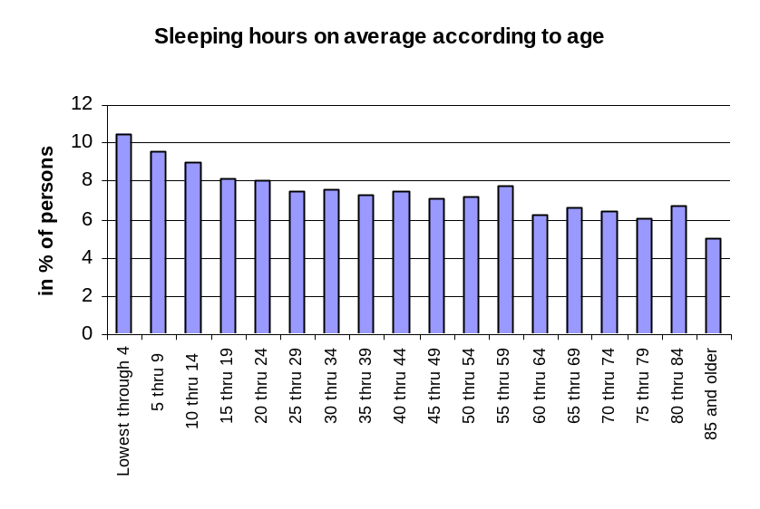

The analysis shows strong links between disturbance by noise in the dwelling and sleep disturbance by noise. The most interesting are the following:
-Disturbance by noise in the dwelling and trends of depression (1.990–1.124/3.523), collision and striking (2.589 –1.141/5.874), and falls (2.521 – 1.065/5.968)
-Sleep disturbed by noise and migraine and frequent headache (2.024 – 1.249/3.278), allergic symptoms (2.087 – 1.031/4.223), trends of depression (5.068 –3.426/7.497), chronic anxiety and depression diagnosed by a doctor (3.362 –1.401/8.071), accidents: electrical accidents (3.451 –1.407/8.464), gas intoxication (6.184 –1.025/37.299), collision and striking (1.972 – 1.143/3.402), suffocation and choking (9.836 –2.517/38.439), and falls (2.285 –1.216/4.295).

Accessibility and dangerous spots
88 % and 94 % of handicapped people consider their building and dwelling as not accessible for handicapped persons with wheelchairs, or walking with aids, or with any other physical constraints, and 93 % of the interviewed residents declare that their buildings and dwellings are not equipped well enough to satisfy the needs of a member of the family having a handicap.
The surveyors quote that 70 % of the dwellings have doorsteps, the first item strengthening accessibility of the buildings and dwellings and risks of accidents.

Furthermore, dwellings are also affected with the electrical facilities: more than 1 dwelling in 2 does not have electrical installations earthed. All the electrical accidents occurred in dwellings without earthed installations. Except 2, all the surveyed buildings do not have fire detection equipment. 55 % of the interviewed persons think it would be difficult to escape in case of fire.

2 interviewed persons out of 10 quote the existence of dangerous spots for children in the dwelling: the major items specified in 1 case out of 2 are electrical installations.

- Hygiene and sanitation
The surveyors reported 403 kitchen 309 bathrooms and 309 toilets (flush) within 481 surveyed dwellings: that means 16 % and 36 % of the dwellings are not equipped with indoor kitchen and bathrooms and toilets respectively.
Among the existing kitchen and bathrooms there are important lacks of facilities: 26 % of the kitchen do not have access to cold water, versus 4,5 % for the bathrooms; 94 % of the kitchen do not have hot water versus 87 % for the existing bathrooms. Consequently, few gas water heaters exist but when existing the majority could be considered as dangerous: among 27 gas water heaters existing in kitchen, 15 are not connected to outside while in 20 existing in the bathrooms, 9 are not connected to outside.
The interviewed people quote often or permanent problems with the quantity of the water supplied in 24 % of the cases, but they are more numerous to have experienced often or permanently troubles with quantity of hot water: 61 %.

In 12 % of the cases the residents evoke problems with water drainage systems. They are few to evoke problems with water quality: 7 % even if 53 % of the interviewed residents think it is necessary to treat the water that is provided to their dwelling before to drink it. In spite of these affirmations, except 7 persons, the whole surveyed population drink public water supplied to the dwellings.

When indoor kitchen and bathrooms exist the residents are satisfied or very satisfied with the equipment of the kitchen and the bathroom in 61 % and 54 % of the cases respectively.

Those who are not satisfied or very dissatisfied evoke the lack of bathroom, the lack of hot water, the lack of gas or the bad gas equipment conditions as the first reasons of their dissatisfaction in 16 % of the answers.
Then the old equipment and lack of furniture is the second reason quoted in 13 % of the answers.

At last 12 % of the interviewed people complain about the lack of kitchen, or about separate kitchen and 11 % about the small size of the rooms. At last 10 % evoke the high levels of dampness and condensation...

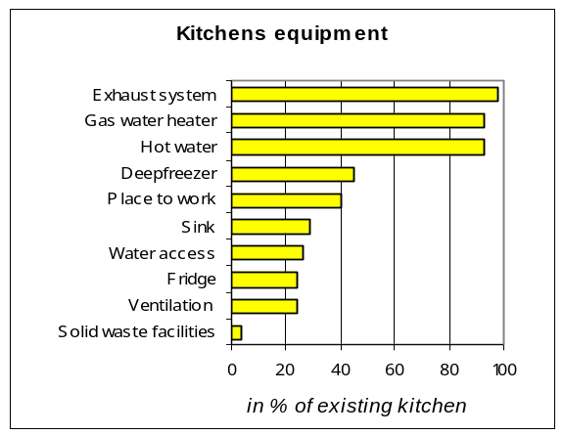
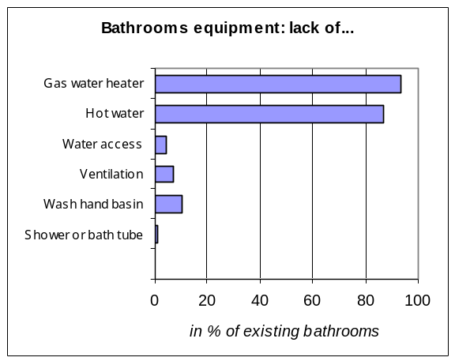

Strong relations have been proven between people who complain with equipment of the bathrooms and kitchen and trends of depression (2.479 -1.367/4.494 and 3.039-1.753/5.267 respectively).

- Pests
61 % of the surveyed people indicate they have had infestation in their dwelling in the past, during the last 12 months, and now, during the survey.

The main infestation that occurred during the survey was rats (11 % of the dwellings were infested), then mice (10 %) and cockroaches (9 %). Before, in the recent past dwellings were more numerous to be infested by cockroaches (20 %), ants (24 %) and flies (42 %). While infestations by mice do not change; rats infested only 5 % of the dwellings in the past.
Treatments to control pests are used in almost 8 dwellings in 10 : all means are used to fight against infestations but the main one is insecticidal spray that is used in 43% of the dwellings.

Even if infestations of pests are not linked to allergy and asthma, indirect effects on health may be observed with control treatments carried out in the dwellings: relations have been seen in general population and young people between the use of insecticidal spray and allergic symptoms (2.009 -1.504/2.684) such as sneezing, runny or blocked nose (1.659 -1.157/2.378) and headache (1.533 -1.149/2.046).

…and pets

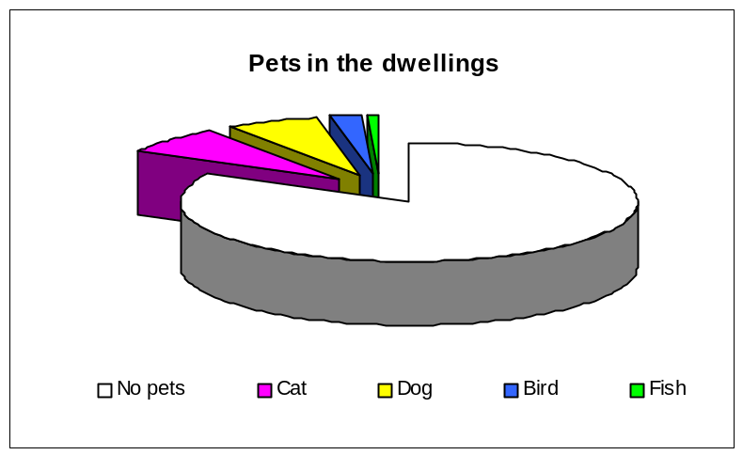

83 households (17 %) declare that they have 83 pets.

Cats are the most present in the dwellings: 7,5 % have one cat, 6,5% have one dog, 2 % have one bird and less than 1 % have one fish at least. Nobody indicates other kinds of pets.

Presence of cats in the dwellings is clearly linked with diseases related to headache (2.367- 1.276/4.389).

- Maintenance
78 % of the buildings have 100% of their dwellings inhabited, 12 % are under 10% empty and 10 % is more than 10 % empty.

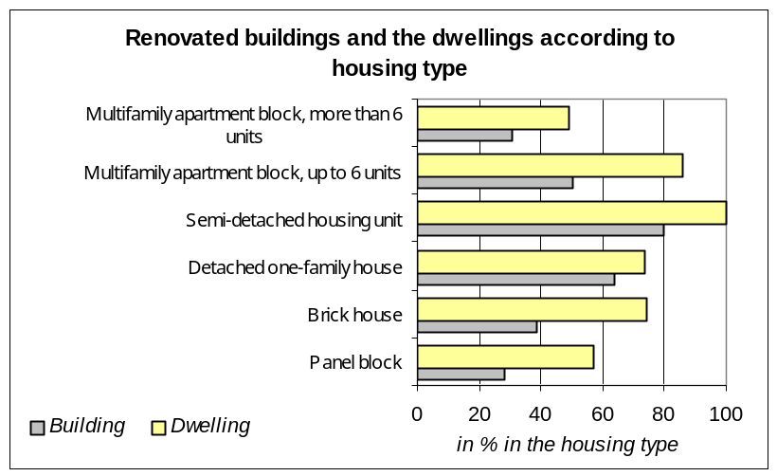

Surveyed households quote leaking roofs in 32 % of the buildings. According to the surveyors, only 177 surveyed dwellings have one room at least with faulty elements at several places.
Private owners and cooperatives perform the cleaning of the building and the staircases in the majority of the cases. They are usually those responsible for maintenance in case of need of repairs.

Furthermore in 67 % of the dwellings there is a housekeeper who takes care of the daily maintenance.

Interviewed households have been living in their dwelling for 13 years on average: but there are some differences according to the type of dwellings. People have been living in flats for less than 10 years (9,8 years on average) versus 17 years in houses.
Globally 41 % of the buildings and 66 % of the dwellings have been renovated since the interviewed persons have been living there. The renovation of the dwellings is more frequent than for the buildings, and more for houses than for flats, especially in panel blocks.

6. CONCLUSION & RECOMMENDATIONS

60 % of the surveyed people consider their health as good or very good, 32 % are without a clear opinion and only 8 % consider their health as bad or very bad.

The older persons are the ones who have the worst opinion about their health. Nobody above 80 years of age considers her or his health as “very good” and more than 4 in 10 consider her or his health as bad or very bad.

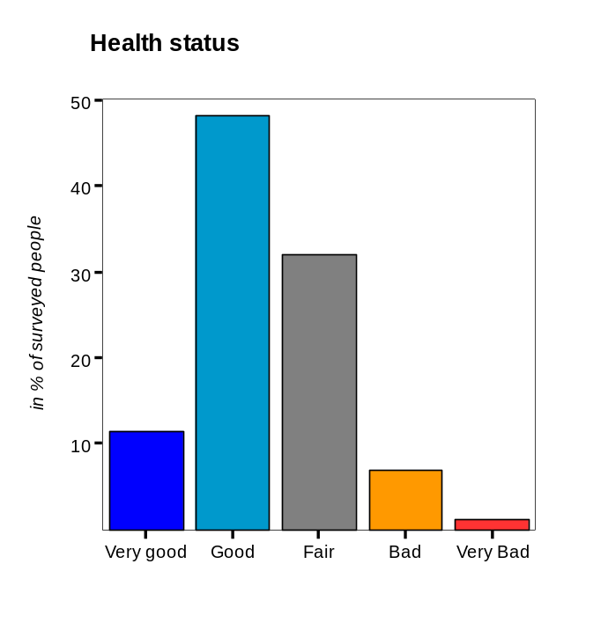

Osh seems to be a place where people like to live. 47 % of the interviewed persons affirm to be satisfied or very satisfied with their dwelling: a majority of adult people feel they have privacy at home, affirm they feel in control in their home and claim they do what they want when they want in their home..

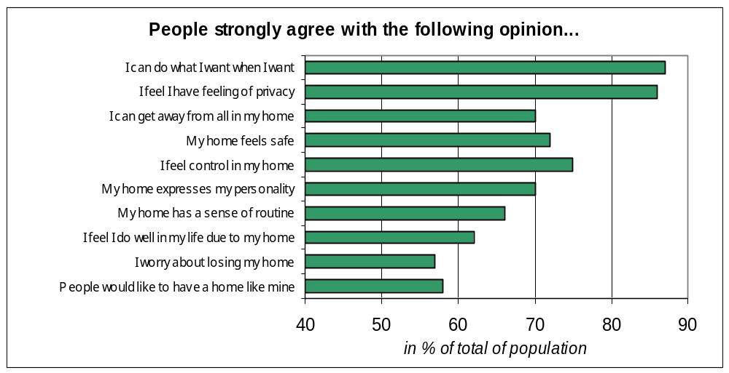

Nevertheless 40 % do not have any clear opinion and 13 % affirm they have a bad or very bad opinion of their dwelling.

The bad conditions of dwellings: old, decayed, needing repairs are the first reasons alleged for dissatisfaction with the dwellings. Then residents complain about the lack or water access, the lack of hot water and the bad conditions of pipes and sewage. They complain about the small size of the dwellings, with an insufficient number of inhabitable rooms. They allege their bad heating system, the cold indoor temperature in winter, the problems they meet with badly equipped, not fit or not existing bathrooms, kitchen and toilets.

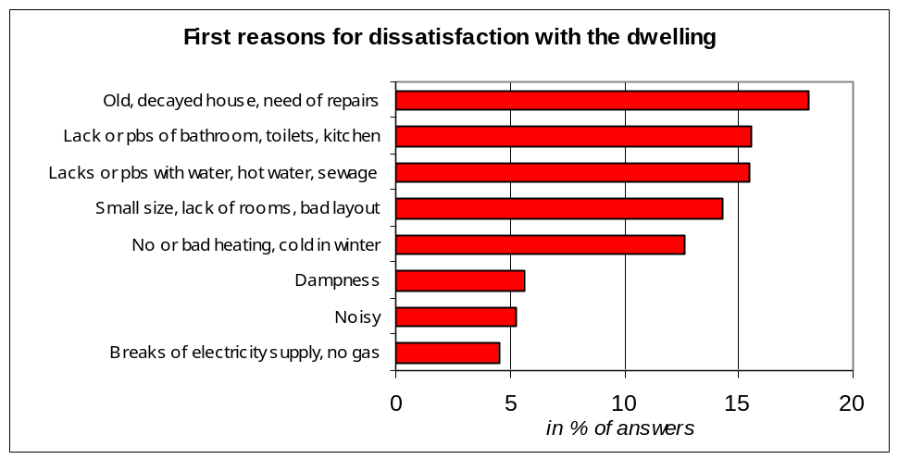

Globally, even if there is a large satisfaction with their dwelling and with their housing condition, it remains that some recommendations may be made by WHO at this stage of the analysis, that should likely improve health of the population through the improvement of housing conditions.

These recommendations require the participation of all the housing stakeholders such as occupiers, renters, owners, town planners and architects, social workers, construction workers, municipal and national decision makers.

There is unfortunately a very first recommendation focused on equity that should be considered as a top priority by all stakeholders:

Very substandard housing should be eradicated: everything should be done to allow each dwelling to have basic equipment at least:
- 1 indoor kitchen
- 1 indoor cold and hot water access, with sewage
- 1 shower and a private toilet
- 1 gas water heater connected to outside
Even if there is a very few number of dwelling equipped with gas water heater, all those which are not connected heaters must be immediately fixed.

The other recommendations are made for achieving the following objectives:
- Reduce the prevalence of diseases related to problems of temperature in winter,
- Reduce the prevalence of diseases related to air quality, such as allergic symptoms,
- Prevent depression and loneliness by strengthening the social life among the most vulnerable groups.

The following measures could be either implemented or strongly supported in the short term at local level; most of them aim at making easier the healthy choice through housing and urban planning measures:

-Assess actively the housing stock to identify the substandard housing, encourage occupiers and owners for rehabilitation, otherwise prohibit them for housing,

-Prevent low temperature in winter and related risk for health: improvement of the insulation of the dwellings and the heating devices or central systems efficiency.

-Prevent disorders in the energy and water supplies.

-Improve the maintenance of the urban environment with efficient waste collection,

-Improve the quality of the streets with asphalt,

-Strengthen the social life in the city-quarters encouraging and promoting the use of convivial places, open spaces and gardens, municipal rooms for children, teenagers and elderly, support the work of local associations, social workers initiative in order to prevent and reduce the loneliness of the most vulnerable groups.

In particular all measures linked to energy (provision of hot water, heating, provision of water) should be given priority. These measures should cover energy saving (reduce leakage of water, of heat...), improve efficiency of heating systems (electrical heating is not efficient), ensure a safe level of ventilation of dwellings as well as accessibility price for those more in need.

These two measures will avoid the risk of seeing an increased rate of mortality and morbidity during winter due to cold homes and should be seen after eradication of substandard housing as the very first priority.

Contents

......................................................................................................................... Pages

1 -Presentation of the survey --------------------------------------------------------- 2-3

2 - The surveyed population
-The sample of population--- --------------------------------------------------------4
-Socio economical status -------- -------------------------------------------------7-8

3 - Who do people live? ?------------------------------------------ --------- 9-13

4 – Health

1-Determinants of health
-Size and weight----- ---------------------------------- -------------------------------- -- 14
-Behaviours (smoke/alcohol/sport/time spent out of the dwelling) 14-15
-Handicap and physical limitations 16

2-Diseases
a) Chronic diseases 17-19
b) Acute diseases and other diseases 19
c) Other symptoms of diseases 20

3-Accidents 21-22

5- Housing and Health

Introduction 23

Typical features of surveyed housing
- Heating / temperature and energy 23-24
- Lighting 25
- Air quality 25-27
- Noise 27-28
- Accessibility and dangerous spots 28
- Hygiene and sanitation 28-29
- Pests and pets 29-30
- Maintenance 30-31

6-Conclusion and recommendations 32-34

