 | 
UNITED NATIONS  ECONOMIC COMMISSION FOR EUROPE | WORLD HEALTH ORGANIZATION  REGIONAL OFFICE FOR EUROPE

MEETING OF THE PARTIES TO
THE PROTOCOL ON WATER AND HEALTH
TO THE CONVENTION ON THE PROTECTION
AND USE OF TRANSBOUNDARY
WATERCOURSES AND INTERNATIONAL LAKES

Second Meeting of the Task Force
on Extreme Weather Events
Geneva, 27 – 28 October 2009

Item 3 of the provisional agenda

Guidance on Water Supply and Sanitation in Extreme Weather Events

DRAFT
VERSION JUNE 2009

Preface

“Anybody who can solve the problems of water will be worthy of two Nobel Prizes, one for peace and one for science” (President J. F. Kennedy)

Many Countries in the European Region experienced a growing number of episodes of extreme weather events, often displaying distinctive features of disasters ,associated with a significant burden of premature deaths, diseases and forced displacement of communities. Because of this the linkage between extreme weather events and population health, survival and well being has been increasingly recognized by the scientific and decision-making communities. To avoid or to limit these undesirable effects adaptation policies are called to include also risk management of natural hydro meteorological disasters through structural and non-structural measures including environmental and water management, land-use and urban planning, application of science and technology, partnership and networking, financial instruments and, last but not least, protection of crucial facilities like health services and water supply and sanitation utilities . Indeed water supply and sanitation utilities are key health determinants in critical conditions of extreme weather events requiring special attention in local and transboundary context implementation of adaptation measures to climate change and variability.
Facing these new environmental scenarios of climate variability and change, recalling the main objective of the Protocol on Water and Health and in accordance with article 16 a Task Force on Extreme Weather Events (TFEWE) was established by the first Meeting of the Parties to the Protocol on Water and Health (Geneva, 17–19 January 2007) in order to assist Parties in the implementation of the provisions of the Protocol through the achievement of its approved 2007-2009 Work Programme.
The Ministry of Environment of Italy took the leadership of the Task Force on Extreme Weather Events (TF EWE).
The First meeting of the Task Force Extreme Weather Events took place in Rome
(April 21-22, 2008), hosted by the Ministry of Environment of Italy, endorsed the joint workplan including:
(a) contribution to the development of the policy guidance for water and adaptation in close cooperation with the TF water and climate
(b) contribution to the Amsterdam international workshop on water and climate change adaptation
(c) review/sharing of good practices and adaptation measures at Country level in the area of extreme events and climate change
(d) development of Guidance on water supply and sanitation in extreme weather events (WSS GL) to support and assist Countries in developing adaptation and mitigation programmes .
Countries partners volunteer to participate to the drafting group for development of these guidance, among them Azerbaijan, Czech Republic, Hungary, Italy, Netherland, Slovakia, United Kingdom of Great Britain and Northern Ireland as well as international Organizations as Armenian Women for Health and Healthy Environment, World Meteorological Organization and WHO Regional Office for Europe were crucial for guidance development.

1. INTRODUCTION: WHERE WE ARE IN THE REGION

EXTREME EVENTS AND DISASTERS

- Extreme weather events as floods or wind storms are the more frequent natural disasters observed in the last hundred years, however their frequency showed a striking worldwide increasing trend in the last two decades at the global level as well as at the UNECE Region (Figure1).

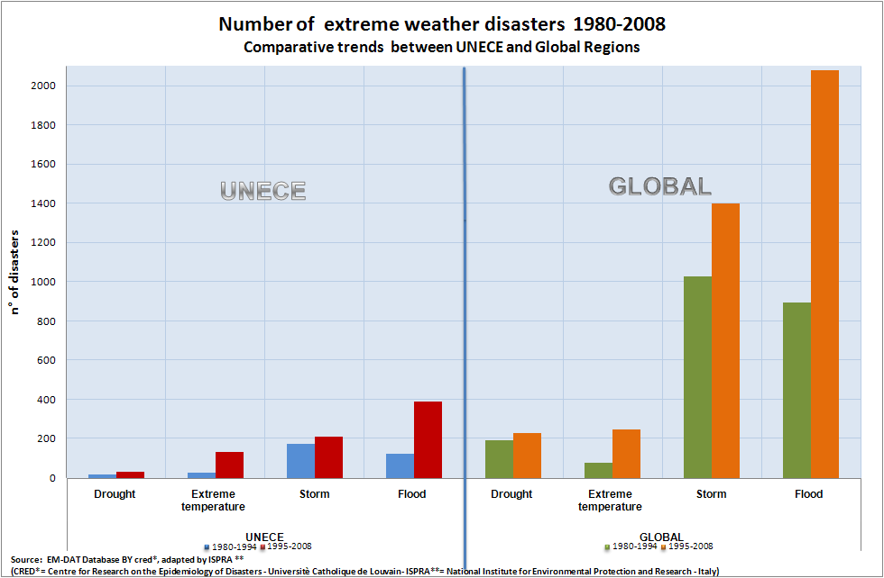
Figure 1 – Global and UNECE data on recurrence of extreme events disasters

- Although it was observed a slight decline in the figures of fatalities in the past ten years- that can be partially explained by an improved response system in emergency - the number of affected people in disasters, defined as: people requiring immediate assistance during a period of emergency, i.e. requiring basic survival needs such as food, water, shelter, sanitation and immediate medical assistance, accounts for several millions in the Region showing an increase of about 400% of affected people of last two decades compared to 1970-1989 period, namely more then 38 millions vs about 8 millions (Fig. 2). However these numbers are describing the tip of the iceberg, since are related ONLY to disaster conditions, being indeed missing in the Region the total significant number of adverse weather events which won’t respond to disaster criteria of EMDAT database, but will carry many environment and health impacts and socio economic damages including recovery cost of service and transport infrastructures, houses, economic activities and health system expenditure.

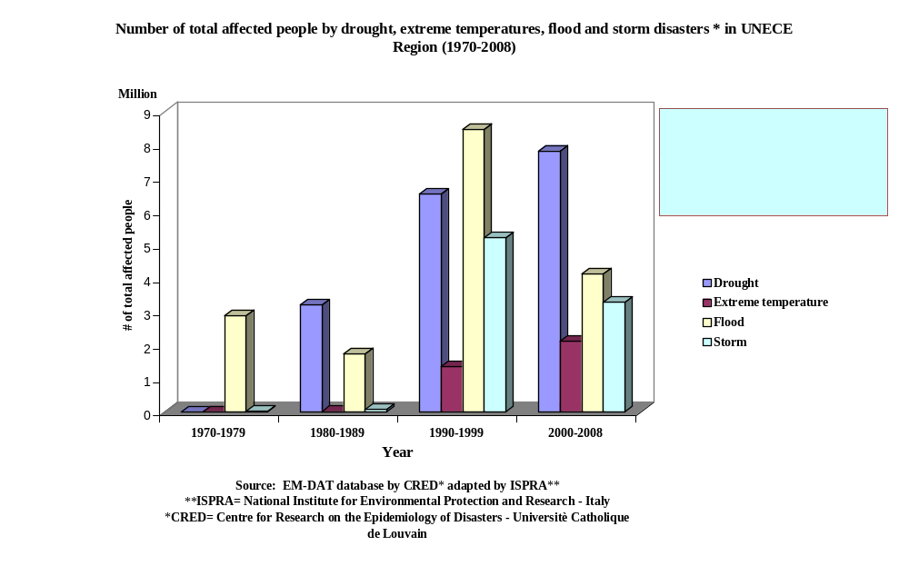

Figure 2 – Affected population in UNECE Region by extremes disasters

- There is a need to strengthen preventive actions to limit effects from direct damages and ensure safe basic survival needs such as water, sanitation and medical assistance in emergency and to counteract health hazards of extreme temperatures, increase of water temperature, water scarcity, chemical and biological contamination of waters and food, infectious diseases. Adaptation policies to cope with changing meteoclimatic scenarios then should include disaster hazard reduction strategies , but also the overall risk management of extreme weather events such as river, coastal and flash floods, heat wave and cold spells, prolonged water stress conditions and drought that,even when they don’t show disaster profile ,may pose significant risk to population’s health and well being. According to observed data Such extremes are getting so frequent that we shall start thinking of them as frequent adverse weather events.

- Evidence show that water supply and sanitation utilities are key health determinants in these critical conditions and climate change is acting as an amplifier of all vulnerabilities of theses services in terms of existing networks, quality of performance in critical conditions, implementation of technology development and safe delivery of the service. Besides flooding events, increasing water scarcity in many parts of the world may further limit access to water for sanitation, and consequently exacerbate health impacts and limit the ability of natural ecosystems to assimilate wastes. In large cities water scarcity is reducing the self-cleaning capacity of sewers and flooding is exacerbating stormwater overflows and resulting pollution. Water supply and treatment is likely to become increasingly energy intensive and expensive with climate change that may cause conflicts between mitigation and adaptation policies.

RECALL OF CLIMATE CHANGE SCENARIOS AND WATER SERVICES

- Main international and European scientific organizations pointed out the future impacts of climate changes on water services to population, identifying vulnerable groups and vulnerable sub regions. People living in water-stressed basins of the Mediterranean region, especially those living in megacities, rural areas strongly dependent on groundwater, small islands, and in glaciers- or snowmelt-fed basins, will have more problems to cope with changes in availability and quality of water. Sub regional environmental vulnerability to extreme events relevant for water services efficiency include Southern and South-Eastern Europe and Central Asia.
Many changes induced by climate change and variability will impact on water quality, availability and efficiency of water supply and sanitation system:

- Increase of lake and river surface water temperatures: causing changes like movement of freshwater species northwards and to higher altitudes, alterations in life-cycle events (earlier blooms up of phytoplankton and zooplankton), increase of harmful cyanobacteria in phytoplankton communities with consequent raising of threats for lakes ecological status and of risks for human health;
- Reduced water flows from shrinking glaciers and longer and more frequent dry seasons; decreased summer precipitation leading to a reduction of stored water in reservoirs fed with seasonal rivers; interannual precipitation variability and seasonal shifts in stream flow; reduction in inland groundwater levels; increase in evapotranspiration as a result of higher air temperatures, lengthening of the growing season and increased irrigation water usage;
- Increase of household water demand: drinking water supply systems and raw water sources reliability may be altered by changes in quantity and quality of river flow and groundwater recharge;
- Heavy effects on drinking-water quality as a consequence of decrease of pollutants dilution, (increasing water temperatures, water scarcity/ flow). At the same time, increased water flows will displace and transport different components from the soil to water resources through fluvial erosion;
- Unsuitability of water for drinking and agriculture purpose as a consequence of saline intrusion;
- Sanitation system efficiency. Higher precipitation in cities may affect performance of the sewerage systems; uncontrolled surcharges may introduce microbial and chemical pollutants to water resources that are difficult to handle through the use of conventional drinking-water treatment processes.

- The World Business Council on Sustainable Development (WBCSD) states that:

Adaptation will not reduce the frequency or magnitude with which climate change events occur, but will protect business and society against events such as drought, hurricanes and flooding.

- Amongst the new challenges for water services, the WBCSD identified:
- greater demand as a result of increased temperatures and changes in supply;
- need to cope with greater variability in river flow due to changes in temperatures and precipitation, with possible damage to water supply infrastructure during heavy rains or droughts;
- salinisation of coastal groundwater reservoirs;
- vulnerability of water services designed for steady conditions to under conditions of higher variability such as floods and droughts.

- Clearly identified risks include: potential conflict between industrial water users situated in water-scarce areas for access to diminishing resources of decreasing quality; flooding of water supply works in riparian countries, leading to supply disruption; considerable costs of infrastructure upgrading; and damage and/or contamination associated with sewer flooding during flash floods.

- The European Union of National Associations of Water Suppliers and Waste Water Services (EUREAU), which regroups both public and private suppliers, and collectively supplies water to around 405 million European citizens, recognizes

Water, as one of the most important enablers of economic and social development and public health […] needs to be resilient to climate change and shifting weather patterns. There will be increasing pressure on water resources in the coming decades. Climate change represents a key challenge for the water sector in terms of availability of water, flooding in urban areas, and impacts on water and wastewater treatment systems and assets”

- Some Countries in the Region already develop ad hoc legislation/plans to overcome impacts on water supply and sanitation systems in extreme weather events condition (see next Box as example).

Case study “Plans for Development of Water Supply and Sanitation” for regions and on national level in the Czech Republic.

In the Czech Republic each from the 13 regions, and separately the capital Prague, should prepare “Plans for Development of Water Supply and Sanitation”. The content of the Plans is embedded in the Czech legislation. Parts of them are also plans for crisis situations.
The Plans should contain:
- Assessment of the present state of the water supply and sanitation system in municipalities or parts of them on the territory of the region, for which the Plan has been developed.
- Balance of water demand and sanitation separately developed for all municipalities or their parts in the region.
- Specification of surface and ground water resources planned for take off for water supply treatment.
- Plan for technically and economically optimal expansion and reconstruction of water supply and sanitation systems in municipalities or their parts in the region.
- Plan for drinking water supply during the crisis situation (flood, draught or others).
- Economic part containing costs calculation for implementation of measures under the d) and e) and their influence on the future prices of water supply and sanitation.
- The time plan for implementation of measures under the d) and e) according to their urgency.

Part of each Plan is also an information database serving to decision making and elaboration of the water supply and sanitation development strategy for the whole territory of the State. On the basis of them one national Plan should be developed.

The proposed measures and their implementation must not exceed prescriptions and limits for noise, vibrations and must prevent infection distribution. During the selection among more variants such solution must be preferred which combines optimum investment and operational costs in relation to the quality of supplied drinking water and disposed waste water.

2. CHALLENGES FOR WATER UTILITIES MANAGERS

- Observed and expected impacts on water and sanitation system infrastructure (catchments, reservoirs, treatment plants, pipeline and distribution systems) caused by drastic hydraulic flow changes, mechanical stress, physical breaking, increasing of corrosion incidence will challenge directly utilities managers/companies amplifying existing vulnerabilities, specially for sanitation.
- At the EU level more than 20 millions of citizen are lacking safe sanitation, the Urban Waste Water Directive is from 1991 and there are no plans to revise it . although is probably the most expensive Directive ever adopted with investment costs of about € 30 billion for the new 12 Member States. Still not all Member States (EEA, 2006) have complied yet.

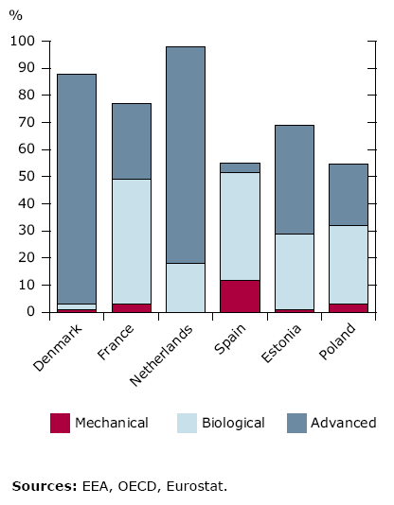

- In the Conference “Financing water supply and sanitation in Eastern Europe, Caucasus and Central Asia” November 2005, Yerevan, Armenia( OECD, 2005) of EECCA Ministers of economy/finance and environment and their partners one of the main conclusion was:

“ In the countries of Eastern Europe, Caucasus and Central Asia (EECCA countries), problems of access to water services are rooted in the history of that region. Ambitious investment programmes led to the development of extensive networks of water infrastructure in urban and rural areas. However, these networks were often poorly designed and constructed, and they have not been adequately maintained. As a result, water supply and sanitation infrastructure has seriously deteriorated in most countries in the region and even collapsed in some places, with potentially calamitous consequences for human health, economic activity and the environment.”

- Other (challenging) factors indirectly impacting on water utilities include :
- increasing costs for ordinary and extraordinary maintenance of systems;
- increasing costs for technology development and tools (eg rain harvesting etc) to cope with recurrent adverse weather events;
- increasing cost for personnel training and early warning/modeling/forecasting;
- decision-making to solve conflicts about water users, large vs small sized companies;
- new regulations on water supply and sanitation
- communication issues;
- conflicts between energy crisis/demand and use of water (es low energy desalination techniques) (Fig. XX )
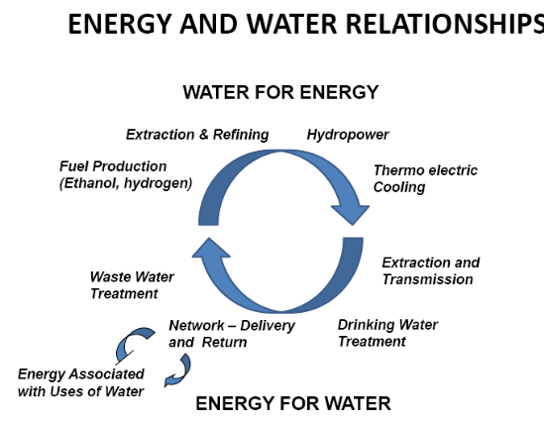

- These issues should be thought in a global scenario and should be prevented and managed within a general framework involving transboundary cooperation, public authorities and agencies in climate change adaptation strategies. They also requires a significant modification of strategies, infrastructure, systems and practices which are currently adopted by a large part of water and wastewater utilities.

- Appropriate adaptation/countermeasure in adverse weather events should be carefully assessed on emerging environmental health risks knowledge and water utilities companies should be directly involved in adaptation strategies.

3. BASIC DISASTER PREPAREDNESS and EARLY WARNING

INTRODUCTION
- The effectiveness of risk reduction in extremes conditions rely upon commitment to apply integrated risk management principles in development planning, the existence of well-defined institutional responsibilities, a democratic process of consultation and information and awareness campaign. It moves beyond disaster response and reaction, towards risk anticipation and mitigation. In this view utilities managers should be considered responsible stakeholder on responding on how to cope with water and sanitation hazard/ risks along with increasing demographic pressure, land use, overexploitation of resources and climate change.

- Risk in extreme weather conditions is the result of three factors: the magnitude of the hazard, the degree of exposure to the hazard and the overall socio-economic and environmental vulnerability (see Figure xx below).
Indeed vulnerability is a combination of factors that can be physical, economic, social, political, environmental, technical, ideological, cultural, educational, ecological and institutional. These factors are often complex, dynamic and interrelated, mutually reinforcing/amplifying each other. Several Agencies and institutions have developed sets of indicators (e.g. CEH Wallingford Climate Vulnerability Index) that can be used to approach vulnerability issues..

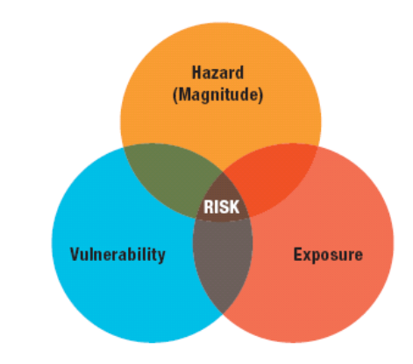
Figure xx. Source, ISDR

- Over the past decades, there has been a trend on developing ad hoc information to localize socio-economic activities, high density populated areas, sensitive sites ( hospitals, nuclear power plants, industrial sites, etc), infrastructures in hazard-prone areas. This has increased the knowledge demand of risk assessment, to promote a “risk culture” towards assessing, evaluating and reducing the escalation of risk linked to changes in land use and climate variability. Furthermore international agreements have set to include disaster risk reduction strategy into the development process of adaptation strategies to climate change.
- In its Terminology (2004) ISDR defines Disaster Risk Management as:
"The systematic process, administrative decisions, organization, operational skills and abilities to implement policies, strategies, and coping capacities of the society and communities to lessen the impacts of natural hazards and related environmental and technological disasters”.This definition includes structural and non-structural measures to avoid (prevention) or to limit (mitigation and preparedness) the adverse effects of hazards.Disaster management provides the means to prevent hazards becoming disasters. The process of disaster management involves a cycle of three phases: preparedness, response, and recovery (see Figure XX - Source: Swiss civil Protection).

Figure XX. Source: Swiss civil protection

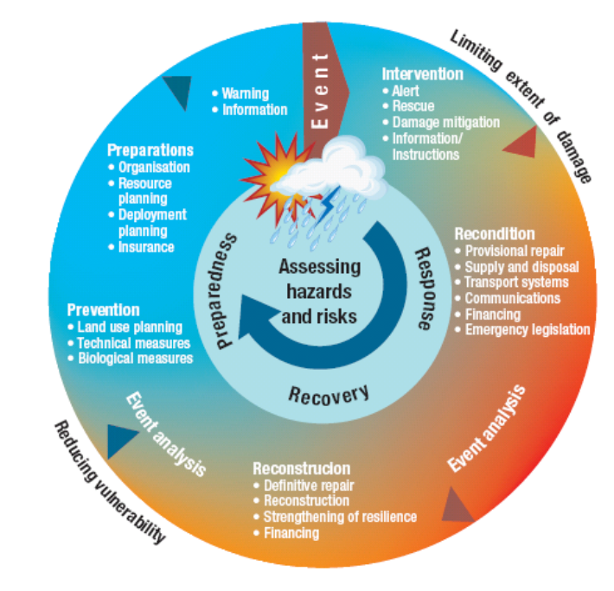

(a) Preparedness: preventive and precautionary measures to minimize the magnitude of hazards caused or increased by development activities (in the long term); to reduce the population exposure to natural hazards and to minimize the socio-economic vulnerability of people and material assets exposed to these hazards, reducing the vulnerability at local level and limiting the extent of adverse impact of the inevitable event (in the short-term).Prevention should be incorporated into the medium -long-term planning development process.

(b) Response : measures aiming at limiting the negative effects of population exposure to hazards, and the duration of the exposure, such as alert systems, rescue and assistance of victims. It also includes, based on the latest disaster experience, immediate measures to prevent further adverse impacts, provisional reconditioning of important infrastructure and documentation of the latest disaster and its direct consequences.

(c) Recovery : aims at minimizing the delay to the return to normality of the economic and social activities. From a long term planning point of view, recovery should also include the analysis of the disaster in order to learn lessons and integrate corrective measures into prevention and preparedness plans.

- Preparedness plays an essential role in the whole process, focusing on technology and trained staff needs procedures and tools to cope when a disaster occurs.
The role of water supply and sanitation utilities is crucial both in preparedness plan, preparation and the implementation of adaptation strategies since it holds real information and technical capability concerning the management of the water catchments, adduction, storage, treatment, distribution and quality in extreme weather conditions.

3.1 INFORMATION NEEDS: FROM RISK ASSESSMENT TO RISK REDUCTION

- Focusing on the three different and complex components of risk - hazard, exposure and vulnerability- is the key principle for any development of preparedness and response plans as of effective warning systems.

- There are many tools already available at international and national level. Some of them can be sectorial as approach, in terms of type of the extreme (e.g. floods plans, heat wave ) or the impact (e.g. environmental, shelter safety, public health), others can provide a more comprehensive assessment approach.

3.1.1 Integration of information needs
- Basic data supporting risk management includes both hydrometeorological data (systematic streamflow measurements, information on the dam operating policy, reservoir flood-control policy, historical flood data, annual peaks from rivers in the same region as the river for which hazard assessment is desired, rainfall frequency data, envelope curves showing the largest observed floods as a function of drainage area, data on temperature, evapotranspiration, soil moisture, ground water, reservoir and lake levels, seasonal weather forecasts, etc.), but - even more important - topographical data (including specialized geologic, geomorphic or soils studies, etc.). These data are usually obtainable from local municipalities or military source, depending on the required spatial resolution. However without adequate topographic data, it is difficult or impossible to predict the area that is to be affected by an extreme event (especially for floods).

- Other information “mixing” the two categories above are also useful, such as maps showing the aerial extent of a flood based on aerial photographs, or data on drainage alterations and degree of urbanization, affecting the runoff. As an example, a list of useful data for flood-hazard assessment can be obtained from Comprehensive Risk Assessment of Natural Hazards – WMO 955; But other information should be gathered for population and socio-economic vulnerability. To estimate the “elements at risk”, updated census data on the geographic distribution of the population (or specific categories, such as older people or known cardiopathic/ill people for heat waves) are essential for an accurate estimation of the exposure. Old information can be updated with recent census and surveys, or aerial photographs and satellite images. This type of image collection is also useful in determining the density of housing or factories. To transform the building count into an economic value (Chapter 7 of the Comprehensive Risk Assessment of Natural Hazards – WMO 955) it is necessary to have appropriate economic data, relevant to the region in exam. Attempting to estimate also the cost of indirect damages such as unemployment and disruption of economic markets is not uncommon to risk analyses, but remains still difficult.

- The experience gained from previous disasters can be used to construct curves of percentage losses versus disaster magnitude. Such information is however not readily transferable from one region to another, due to differences in construction practices, lifestyles and economic factors.

- Finally, combining the information above (geographical definition of exposed areas, population census and survey of the economic and sensitive values and assets located in these areas like hospitals, industries, major infrastructure, nuclear power station etc ), it is possible to obtain the estimation of vulnerability of the elements at risk. In combination with data about frequency and magnitude of the hazard, different horizons of economic losses can be calculated and expressed, e.g. in terms of damage per square meter per year ($/m²/yr) or in damage curves (APFM, 2007: Economic aspects of Integrated Flood Management).

- Integrated risk maps help the final users to clearly identify the most endangered areas, infrastructures and utilities. Risk mapping summarizes and presents graphically the outcome of the risk assessment. Other than identifying the risk areas allows the users to have an overall and general view on all the components of risk in quantitative terms, identifying those risk components that needs to be addressed as a priority, that is contributing to planning risk management measures and preparedness.

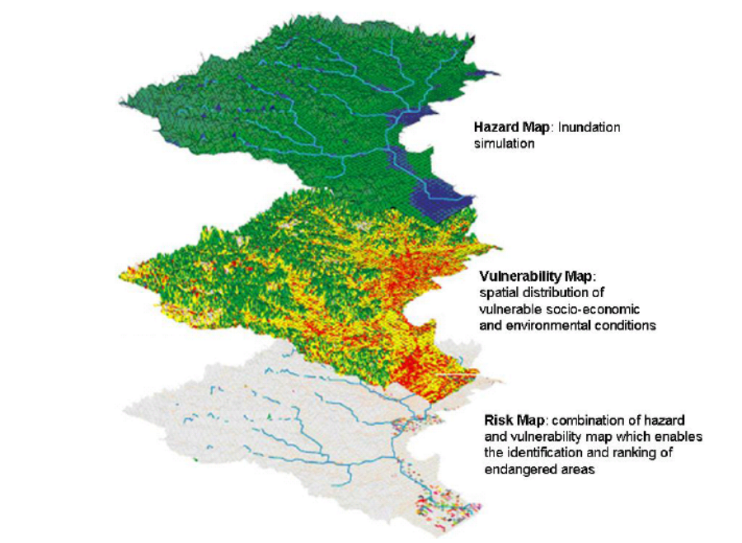
Figure XX. Risk map with a geographical information system (GIS) (adapted from ADRC http://www.adrc.or.jp/publications/Venten/HP/herath4.jpg ).

- Many countries have already developed risk maps for selected geographical areas and for various hazards, at different magnitude levels. Some European countries are in the process of harmonizing risk maps of national coverage, but this level of coverage is still rare.

- Communities and operators of water supply and sanitation utilities should take part in the participatory assessment of risks, vulnerabilities and capacities of supply, distribution and treatment system linked to action planning by communities, linking them to local development plans.

- Be ready to gather information right after the disaster is another key factor to improve prevention and preparedness . Damage analysis should start before clearing-up operations, when the traces of impacts are still visible. This will be useful for improving next risk assessment including effectiveness of rescue operations, and reconstruction phase.

- Utilities managers are often pushed by urgent repair works needs and may miss such analysis. Cooperation with other experts/institutions working on the matter may further improve their performance for emergency response and relief coordination.

- An assessment during this phase it’s also necessary to understand administrative levels of responsibility for the response, ( i.e. local or regional emergency response forces?) or if assistance from the national or international level is required.
Keeping in mind this, essential information for the emergency response at this stage would include:
(a) Number of people affected by the malfunctioning of the utility due to the disaster;
(b) Assets that have been damaged (e.g. flooded map), restoration requirements;
(c) Water quality data;
(d) assets at risk of being further damaged (hazard or risk map), based on the status of existing defences and, consequently, number of people at risk of being affected by the further malfunctioning;
(e) Status of lifelines (evacuation/access roads, electricity grid, fuel and disinfection product supply), hospitals and shelters;
(f) Current and expected water levels at various locations as well as weather conditions.

- Further guidance on this issue is available from various sources, especially national and international bodies working on emergency response and relief coordination. A short list of readily available guidance material is provided in the following:

• UNDAC Field Handbook published by OCHA, providing a rapid assessment methodology on a sectorial basis;
• UNHCR Handbook for Emergencies providing checklists for initial assessments as well as guidance on the provision of safe drinking water;
• Community Damage Assessment and Demand Analysis, by the All India Disaster Mitigation Institute, provides guidance on a staged assessment process for the local level;
• Post-Disaster Damage Assessment and Need Analysis, of the Asian Disaster Preparedness Centre, provides ready-made templates for early reporting of damages and needs;

3.1.2 Monitoring and forecasting
- Both in dry and wet periods, a reliable assessment of water availability and quality and its outlook for the near and long term depends from data on precipitation, temperature, evapotranspiration, soil moisture, streamflow, ground water, reservoir and lake levels, and snowpack, as well as seasonal weather forecasts. During a drought, the value of this information increases.

- Monitoring tools to measure the previously indicated variables include rain-gauges (measurements of rainfall depth and intensity), level meters or hydrometers (measurement of piezometric level of groundwater), anemometers (measurement of wind speed), low-cost weather radar (monitoring the motion of rain fronts) and cameras for real-time display of critical areas usually connected to remote control units, sending information to a centralized data collector.

- To manage water quality properly also in extreme weather events, it is important to rely on an on-line monitoring system capable of detecting sudden quality variations in different parts of the supply system (wells, springs, water intakes). A typical case is the monitoring of turbidity allowing the water manager to avoid the exploitation of water characterised by high amounts of suspended solids.

- Monitoring should not restrict itself to the hydrometeorological factors, but also include potential impacts e.g. areas subject to landslides or mudflows, glacier and snow melt and the resulting impact on reservoirs.

- All information collected by monitoring network should be made available to all responsible organizations including public health systems, reservoirs, dams, water utilities operators.and transboundary Countries that could involved in impacts.

- Besides hazard assessment, monitoring networks are also the basis to forecasting and early warning systems. Agencies/Bodies with responsibilities for monitoring climate and water supply and sanitation, , are usually performing the monitoring but the agencies responsible for collecting, analyzing, and disseminating data and information may vary according to each country’s infrastructure. An analysis of the existing network and their task should be undertaken.

- Tables and maps should be available providing details on monitoring locations, parameters, sensors, recorders, telemetry equipment and other related data. In addition, monitoring sites in adjacent basins should be inventoried. In low relief basins, data from those sites could be very useful. Analysis should be performed to identify sub-basins that are hydrologically or meteorologically similar. It could be as well that information from national monitoring networks is inadequate (architecture, technologies, etc.) for assessment at local or transboundary level .

- To improve local networks the adoption of WMO recommended or NMHS standards may facilitate integration of network and data delivery.

- Rather than duplicate networks, it is preferable to develop cooperative arrangements. serving many purposes. In this respect, big water companies have their own monitoring systems usually linked to the company Remote Control System and are technologically equipped to counteract power supply failure in extreme weather conditions. Smaller companies are usually not structured with these devices/facilities and connection among suppliers at local and transboundary level should be properly arranged.
For specific information on how to establish an appropriate hydrometeorological network: WMO Guide to Hydrological Practices (WMO 168 or the CIMO Guide).

Vulnerability assessment of coastal areas

- Another important step for the assessment of potential risks of climate changes and extremes on coastal aquifers is the evaluation of the groundwater sensitivity to sea water intrusion. According to Chachadi and Lobo-Ferreira (2005) groundwater vulnerability to sea water intrusion can defined as “the sensitivity of groundwater quality to an imposed groundwater pumpage or sea level rise or both in the coastal belt, which is determined by the intrinsic characteristics of the aquifer”. Similarly, groundwater vulnerability to sea water intrusion caused by extreme weather events can be defined as the sensitivity of groundwater quality to the potential consequences of extreme weather events, which is determined by the intrinsic characteristics of the aquifer. Groundwater vulnerability assessment requires a detailed knowledge of hydrogeological processes as well as of the interactions of groundwater with surface waters and aquatic ecosystems. In fact, understanding processes inside coastal aquifers, particularly how water moves within and between these aquifers and adjacent saline groundwater, is essential for the management of salinisation. Information required for such an assessment would include geology and hydrogeology maps, hydrology and catchment topography data, monitoring data, intake screen depth and stratigraphy, groundwater level variation and groundwater quality (http://www.connectedwaters.unsw.edu.au/resources/articles/coastal_aquifers. html); all these data should have spatial references. GIS and geodatabase management procedures are effective tools for the collection, evaluation and integration of the spatially resolved available information and should be extensively used in order to support the spatial definition of homogeneous groundwater vulnerability areas to salt water intrusion. In more detail two similar approaches for sea water intrusion vulnerability assessment are presented in this chapter, the GALDIT index (Sundaram et al, 2008; Chachadi et al. 2003; Chachadi and Lobo-Ferreira , 2005) and the Decision Support System (DSS) for salt water intrusion proposed by Sophocleous and Ma (1998), both described in the BOX XX below.

Approaches for the sea water intrusion vulnerability assessment
According to Chachadi et al. (2003), the most important factors that influence the aquifer vulnerability to sea water intrusion are: Groundwater occurrence (aquifer type: unconfined, confined and semi-confined), Aquifer hydraulic conductivity, Level of groundwater above sea, Distance from the shore (distance inland perpendicular from the shoreline), Impact of existing status of sea water intrusion in the area and Thickness of the aquifer. A numerical ranking system was devised using GALDIT factors (from the underlined letters of the parameters) and is composed of three significant parts: weights, ranges and importance ratings. The steps for the vulnerability assessment are four: the indicators identifications, the indicators weighs estimation, the assignment of importance rates to indicators variables and the definition of the decision criterion through the integration of indicators scores (Chachadi AG, 2005). The development of the GALDIT model was performed in the framework of the EU-India INCO-DEV COASTIN project aiming at the assessment of aquifer vulnerability to sea-water intrusion in coastal aquifers (Chachadi and Lobo-Ferreira , 2005).
Within the work of Sophocleous and Ma (1998) a relatively simple decision support system (DSS) was developed to assist the regional authorities in identifying vulnerable areas to salt water intrusion and in developing management policies to prevent salt water intrusion. In this work, the important variables were associated with salt water intrusion vulnerability by performing a multi-regression analysis. Classification techniques were then employed to identify homogeneous hydrogeological unit-areas within the heterogeneous structure of the aquifer and to regionalise site values of salt water vulnerability. On the bases of the numerical simulations performed for the DSS development, the most important factors which influence salt water intrusion were identified to be: the existence of clay layers, vertical and horizontal aquifer hydraulic conductivities, pumping rates and locations of well screens relative to salt water/fresh water interface.
Finally, in the two approaches, GIS tools were used to map the spatial distribution of the variables affecting the vulnerability to salt water intrusion in order to support the definition of vulnerability homogeneous areas.
- A comprehensive knowledge of the nature of climatic variations in space and time is vital to characterize exposure and therefore climatic stressors that impact on a system. The combination of hydrological and hydrogeological models with climate models give the opportunity to adjust global climate model (GCM) bias and include improved representations of hydrological processes. Moreover, a combination of statistical techniques and regional modelling can be used to downscale climate models and to simulate weather extremes and variability in future climates. Accordingly, regional hydrological and groundwater models integrated with climate and statistical models allow to consider the groundwater balance in the aquifer and to simulate saltwater intrusion under the present and future scenarios of climate change. Finally, together with integrated modelling, empirical approaches, such as the ‘analogue approach’ give information that is more specific than that given by the GCMs. By reconstructing past climates (i.e. temperature and precipitation) in a given area these approaches can be used to construct future scenarios by analogy. (Dragoni and Sukhija, 2008).
Moreover, a case study application of vulnerability and risk assessment tools for the analysis of the impact of seawater intrusion into coastal aquifers is presented in Box XX below.
Case study: assessment of saltwater intrusion in the alluvial aquifers of the Province of Savona (Italy).

Climate change and extreme weather events may exacerbate the problem of saltwater intrusion into coastal aquifers.
In the province of Savona (North-Western Italy) a hydrogeological characterization was performed in order to identify the main alluvial aquifers significant for groundwater storage and make a preliminary assessment of the potential effects of saltwater intrusion on water resource management.
The hydrogeological study for the delimitation of aquifers allowed to identify five coastal aquifers, stretching over coarse alluvial soil in a total length of ~35km². The largest one is Centa with 27 km². The average depth of water table in the area is 8m while the height of groundwater table reaches approximately 5m above sea level. The aquifer is unconfined and its thickness is approximately 30m. The outcomes of the analyses showed that the main problems affecting the coastal aquifers in the province of Savona were the following:
- excessive water withdrawals from aquifers: 2-5,000,000 m³/year (10-20% of total volume);
- high population density in coastal areas, equal to 260,000 inhabitants;
- land use mostly for urban and agricultural purposes (greenhouses);
- reduced river runoff due to low precipitation and subsequently reduced groundwater recharge;
- saline intrusion into near-shore aquifers.
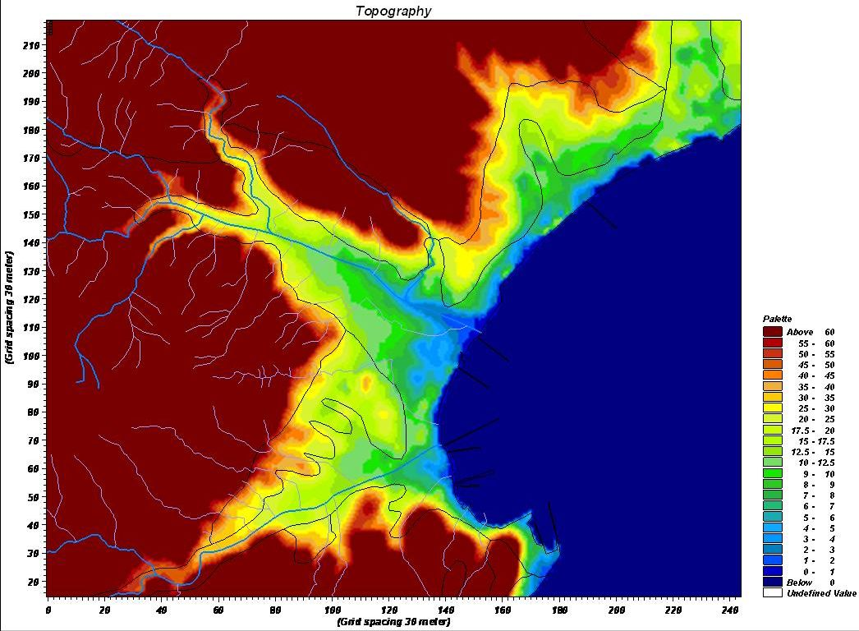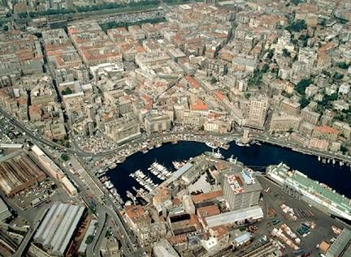

In particular, the problem of saline intrusion into the coastal aquifers is extremely important in the analysed area given that the water is used for water supply and for agricultural purposes (by water wells). In fact, the salt water intrusion in potable groundwater causes reduction of water volume for about 30-50%. Moreover, 50-60% of the surrounding area is subject to the same risk.

In order to assess the availability of groundwater for water supply and evaluate the long-term sustainability of groundwater the resource, the evaluation of the hydrogeological balance of each aquifer was carried out. The main activities included geological and hydrogeological studies on regional scale; identification of water sources for utilization (in particular for drinking purpose); development of hydro-geological model for the coastal aquifers; hydrogeological accounting and assessment of over utilization risk.

The results of the analysis showed that the integration of monitoring systems with water balance models may support the management of the groundwater resource and the saline intrusion risk assessment guiding the definition of adaptation measures (e.g. water extraction, physical and biological barriers).

TOOLS FOR DISASTER PREPAREDNESS PLANNING FOR UTILITY MANAGERS

- This section provides a brief summary of the available tools that the company can implement in order to cope with disasters due to extreme weather events including relevant parameters, their use among water utilities, quality management aspects in urban and rural contexts, and action for risk reduction purposes.

3.2.1 Hydrological forecasting tools

- Various hydrological tools are available for flood or drought hazard analysis. Hydrological analysis should be compulsory during the planning phase of water supply and sanitation utilities in changing climate conditions. The use of these hydrological tools depends mostly on the availability of adequate data. It is however not the purpose of this publication to give a detailed explanation about these techniques, tools and data needs, but to offer general overview and references.

Frequency analysis

- If stream flow data is available abundantly, flood or drought frequency analysis is used to estimate the relation between flood magnitude peak or minimal flow and frequency (WMO, 1989). As the flow record is almost always shorter than the return interval of interest, empirical extrapolation is used to predict the magnitude of the target flood or of the low-flow. A frequency distribution is most commonly used as the basis for extrapolation, and various distributions may be fitted to observed data. In the case of floods, recognition that floods may be caused by several mechanisms (snowmelt or rain on snow; convective or frontal storms) has led to the concept of mixed distributions.
The mixed distribution permits a better statistical representation of the frequency of occurrence of processes, but is, at times, difficult to apply to the problem of hazard assessment due to a lack of supporting evidence allowing the categorization of causes of each flood event. Once the target peak flow has been determined, the corresponding areas of inundation can be calculated.

Regionalization techniques

- When observed data are available only for short periods or few stations , regionalization techniques can be used. These regionalization techniques are based on the assumption that, within a homogenous region, frequency curves at various sites are similar except for a scale factor depending from hydrological and meteorological characteristics of individual sites (Stedinger et al., 1993). In this case, data from various homogeneous sites are combined together to produce a larger sample than the one available at a single site, although the advantage may be offset by correlation between sites. As a rule, however, regional frequency analysis produces results that are more reliable than frequency analysis at a single site (Potter, 1987).

Rainfall/runoff models
- If stream flow data is limited , but on the other hand rainfall data is available, another tool that can be used for flood hazard analysis are rainfall/runoff models.
A rainfall/runoff model is a mathematical model that predicts the discharge of a certain river as a function of rainfall. To gain confidence in predictions obtained from a particular model, it should be calibrated using observed sequences of rainfall and runoff data. If no data are available, use of regional, historic or pale flood data, along with evidence of the extent of past flooding or droughts, is especially important when assessing flood peaks or minimal flows in watersheds that have a limited number of systematic stream gauge measurements.

- In order to produce a flood forecast for the communities and locations at risk, there must be a hydrological modelling capability that uses meteorological and hydrological data. Hydrological models use real-time precipitation and streamflow data. The models translate observed conditions into future stream conditions.
Hydrological models or procedures vary in complexity, accuracy and ease of use.
Simple hydrological models consist of tables, graphs or empirically derived relationships. More sophisticated hydrological modelling systems use in-situ data, remotely sensed data, and multiple hydrological models that are integrated to produce very accurate hydrological forecasts. Due to advances in Geographic Information Systems and the availability of geo-referenced data, parameters of some hydrological models can now be estimated without having to rely exclusively on historical hydrological data for model calibration. The evolution of personal computer technology has paved the way for quite complex modelling systems to be run on them. These systems are easier to use, are easier to maintain, and are more affordable.

- Current hydrological forecast systems are quite affordable and powerful, but effectiveness rely on trained staff. These systems are capable of producing a broad range of forecasts of stream conditions that will occur in a few hours to seasonal probabilistic outlooks targeted to months in advance for larger rivers. Model system selection depends on the amount of data available, complexity of hydrological processes to be modelled, accuracy and reliability required, lead-time required, type and frequency of floods that occur, and user requirements.

- With reference to forecasting tools for heat waves, they consist of calibrated models for the definition of meteorological maps; these models are usually fed by a series of parameters measured at ground level such as atmospheric pressure, humidity, wind speed, temperature. Through these maps pressure fields are simulated and/or forecast for definition, through mathematical algorithms, of rain, wind and temperature fields.

3.2.2 Early Warning Systems and utilities services

- A warning means that the hazard is now a reality and that action has to be taken. Early warning is vital for many response activities. The effectiveness of the warning depends on its reliability, skilled interpretation of warning signal, exchange and interactive cooperation between different early warning system (public health, meterological, environmental , water managers and suppliers) and following emergency/rescue operations . The longer the lead-time, the more useful the warning, since the number of options for reaction is larger.
(Fig. : XX) Four Elements of people-centred
Early Warning Systems
Source:
UN/ISDR Platform for the Promotion of Early Warning

- To improve cooperation and avoid conflicts, an open and transparent communication mechanism among warning manager, the disseminator, the receiver and down to the operators that should take action is a pre-requisite. Relevant data and information on hydro-meteorological variability and trends, water quality availability and health risks should be made available to water supply and sanitation utilities operators.

- The main elements of the early warning chain are:
- Detecting and forecasting impending extreme events to formulate warnings on the basis of scientific knowledge and monitoring, consideration of factors that affect disaster severity and frequency;
- Disseminating warning information, augmented by information of the possible impacts on people and infrastructure (i.e. vulnerability assessment), to the political authorities for further communication to the threatened population, including appropriate recommendations for urgent actions;
- Responding to warnings, by the operators of the utilities, the population at risk and the local authorities, based on a proper understanding of the information, and subsequent implementation of protective measures.

- Communication throughout the early warning chain must be two-way and interactive. Originators, disseminators and end-users must be in continuing contact with one another in order to make the system responsive to people’s needs, priorities and decisions. The system has to adjust to users; not the other way around.

Involvement of utility managers in land-use plans
- Knowledge about the hazard is a prerequisite for a successful impacts mitigation. Hazard and risk maps must be established, even if only a residual risk exists. Avoiding exposure to the hazard by keeping hazard zones free of intensive economic use is a frequently recommended concept. However, water sources, and fertile soils encourage intensive human activities (agriculture, industries, touristic areas) and settlements development, and skilled planning is required in hazard zones. Appropriate building codes and zoning restrictions should be established with the objective, if not to avoid, to minimize the risk in these areas. With a multi-hazard approach in mind, it is also interesting to take into account the positive side effects of some land uses (e.g. the conservation of pervious surface areas as farmland will also be effective as evacuation areas for other hazards). The prescription of what constitutes a good practice is highly dependent on the type of hazard. Safe delivery of water supply and sanitation services in critical conditions should be included in land-use plans and revised regularly ( e.g. changes in land-use plans due to socio-economic development together with utilities managers) taking into account the improved knowledge and technologies to cope with hazard.

3.2.3 Structural measures
- There are several available structural measures and must be adapted case-to-case to the type of hazard. Since total protection is not feasible, a predefined protection target or design standard has to be set . This target varies according to the economic and social values to be protected and according to the economic capacity of the society to protect them. These protection targets often are or become insufficient, either because knowledge of the hazard has improved (e.g. climate change) or due to an increase of the values to be protected (i.e. population development). In all cases prevention measures have to be accompanied by worst-case scenario emergency planning, which forms a key element of preparedness, including regular inspection and maintenance.

- Safe buildings are a key element in reducing vulnerability. Adequate building codes can improve resilience for several risks including earthquakes, floods, landslides and tornados.

- Stepping up investments in structural measures is necessary to reach “water security”, i.e. coping with too much, too dirt or too little water. Maintaining water supply and sanitation utilities operational during extreme events will contribute in making the community more resilient to hazards. To this purpose, building-in planned redundancies (e.g. building two access/evacuation routes rather than one, having back up power generation capacity, groundwater reservoir etc.) should be promoted.

- The involvement of managers of water supply and sanitation utilities is essential, since they should be able to operate continuously while responding to hazards. Therefore, they need to be empowered; their management capabilities need to be strengthened; and their participation should be incorporated into disaster mitigation strategies.
In case of emergency, vital facilities, equipment and communications have to be replaced/ repaired as soon as possible, even provisionally . In the first instance this includes the «lifelines» such as water supply, electricity supply, roads and telecommunications, hospitals and sewage systems. In absence of temporary unavailability of safe water sources and sanitation facilities utilities should be ready for alternatives sources and facilities.

- Furthermore it is also important to recover the water supply system in case of pollution deriving from flooding events: a chlorine dispenser for disinfecting polluted water at an adequate level is expected to be installed in the critical sections of the system.
Other recovery actions may consist in mobile disinfecting plants or spare pumping stations installed in the same aquifer exploiting waters from a confined (unpolluted) artesian stratum.
More details can be found in the adaptation measures chapters of this guidance.

3.3 ROLE OF THE HEALTH SYSTEM IN DISASTER PREPAREDNESS AND EARLY WARNING
- As already stated in the previous sections, development infrastructure that forms the economic and social lifeline of a society, such as communication links, hospitals, etc. should be designed to cope with the most severe of natural hazards and be functional even under a disaster situation. Furthermore, such infrastructure should not increase the magnitude of the hazards.

- Health systems need therefore to quickly recover their capacity to meet demand for health infrastructures and health service delivery in extreme weather conditions.
Extreme weather events affect health systems’ operations and efficiency in different ways. Health facilities built in hazard prone areas can be damaged, as can be damaged the access to them. The increase demand of health care could exceed the local public health capacity (including drugs, stockpile vaccines, trained personnel).

- Moreover, the spontaneous or organized migrations away from the area affected by the extreme events towards other non-affected areas could shift the problem of exceeding the capacity of the health system to other areas.
This increases also the potential risk of a critical outbreak of communicable diseases, as well as an increase in the risk for psychological diseases among the affected population.
Extended periods of drought or heat waves could lead weakened resistance to various diseases.

- The interruption of a health facility’s operations after a disaster may be short-term (hours or days), or long-term (months and years). It all depends on the magnitude of the event and its effects on the health sector. The magnitude of an event cannot be controlled; its consequences, however, can be.

- When planning a future health facility, the effects of these phenomena can be controlled if site selection is guided by sound information and criteria, and the design, construction, and maintenance can withstand local hazards.

- During the 126th session of PAHO’s Executive Committee, it was decided to reduce the impact of emergencies and disasters on health through the following actions :
• Planning and executing public health policies and activities on prevention, mitigation, preparedness, response, and early rehabilitation;
• Providing an integrated focus addressing the causes and consequences of all possible emergencies or disasters that can affect a country;
• Encouraging the participation of the entire health system, as well as the broadest possible
intersectoral and inter-institutional cooperation, in reducing the impact of emergencies and disasters;
• Promoting intersectorial and international cooperation in finding solutions to the health problems caused by emergencies and disasters.

- As example a comprehensive reference for challenges that has to be met by public health sector in floods is summarized in table XX below.

Table XX: Health system planning for flood preparedness
(Source: adapted from Meusel et al., 2004 and WHO, 2005)

Type of activities | Health outcome and preventive measures
Pre-flood activities | Long-term risk management: flood health prevention as part of multipurpose planning  Inter-institutional coordination  Infrastructure flood-proofing  Service planning risk zoning, risk mapping of health care and social care facilities, availability of communication and transport possibilities; emergency medical service preparedness, water and food supply planning for emergencies, evacuation organization, etc.)  Awareness-raising campaigns targeting different groups in areas at risk  Capacity building and personnel training for emergency
Health protection during floods | Prevention and treatment of infectious diseases respiratory problems, , injuries, mental health problems and skin and eye diseases review and prioritize  Possible extra vaccinations for the general population  Communication campaign such as Distribution of “boil water” notices, general hygiene advice and information on preventing mould, rodents, snake bites, and electrocution  Outbreak investigation where appropriate  Enhanced epidemiological surveillance of infectious diseases  Risk assessment major environmental sources of contamination of health relevance  Intensify Monitoring of drinking water quality (tap)  Water and food provision
Long-term health protection | Treatment for mould and other pathogenic exposures  Post-flood counselling (for anxiety and depression, for example)  Medical assistance  Enhanced cause-related surveillance  Research for future preparedness and response

- Communication and information to the public is also a key role of health sector to prevent exposure to hazards in extremes ( heat wave, cold spell, floods). For more details please refer to next chapter.

4. COMMUNICATION IN EXTREME WEATHER EVENTS

INTRODUCTION: IMPORTANCE OF A COMMUNICATION STRATEGY

- People not aware of risks can slow down the emergency operations. Persuading people to evacuate in advance of a predicted threat is very difficult because people tend to discount warnings and it can exacerbate the problem. Appropriate information distribution and sound decision making before and during weather emergencies are critical to saving lives, reducing injuries and protecting property.

- A communication strategy can improve the effectiveness of the interventions and so the authorities (water managers) should consider to include this strategy into the risk disaster management and adaptation plans to the extreme weather events. Different types of risk communication strategies should be developed, depending on the type of extreme weather events (heat waves, cold waves, storms, flooding etc.).

- The communication strategy should include a plan of specific activities which should start before the crisis (pre-events activities) such as capacity building projects, training of personnel (media staff included) and awareness raising campaigns targeting different group at risk. During the event the communication campaign should provide the public with an early and accurate announcement to foster trust in the institutions, public flexibility and guide appropriate public participation to support the rapid control of the crisis.

4.1 COMMUNICATION ACTIVITIES
- Extreme weather events and the impact they have on health, emphasize the need to keep the community and the general population informed on the associated risks for individuals and protection measures before, during, and after event. Information has to be provided to the general public on how best to protect themselves from extreme weather and climate events in general.

- Awareness on water and sanitation management and health outcomes should be addressed even before the occurrence of the crisis. Risk communications team should be formed to facilitate the communication activities with active involvement of water and sewerage utilities, key state and local public health spokespersons and media. Team leader should be designated and each member should have assigned responsibilities.

- Trainings should be organized for the team to ensure timely and effective communication skills to inform the public, partners, and stakeholders about recommendations. During public health emergencies the spokesperson’s image and voice should be familiar to audience to deserve trust, he should be trained on how to deliver information and he should be informed about water and sanitation utilities and public health threats.

- Along with the increasing of the awareness and training, the attitude change of the general public should be promoted. The communication is a dialogue and requires close interaction between information providers and those who need the information. Belief and attitude can be changed through openly pointing and explaining the issue. After improvement of people’s understanding, receptiveness of climate change messages and creating ownership of the problem, behavioural changes can be promoted. Individuals and groups would be persuaded that they can make a difference in terms of their own lifestyle choices and in mobilizing their communities to reduce their risk of climate – sensitive diseases.

- Appropriate risk communication procedures foster the trust and confidence that are vital in a crisis situation. The information should be provided early in a crisis and it should be transparent about what is known and unknown, that helps build trust and credibility. The first official announcement will establish the trust and this will guarantee the public acceptance of official guidance and trust in institutions.

- The announcement should be accurate, timely, frank and comprehensive. There is a constant complexity between the provision of accurate information and provision of information quickly. To wait for completed and verified information before releasing it to the public can generate an information vacuum which can bring to speculations. On the contrary, to release not doubly-checked or inaccurate information runs the risk of misleading the public and undermining credibility of a spokesperson. Furthermore, uunderstanding the public is critical for conducting an effective communication. For changing people’s belief and their perception it is necessary to understand what they think and why they act in that way. Communicator should develop proper messages to targeting public including information how public can make themselves safer in crisis situation.

4.2 PARTNERSHIP IN COMMUNICATION
- Effective risk communication includes planning, preparation, messaging and working with the media and the ability to manage the flow of information at each stage.
The media play a major role and it is the most common channel of communication to the public. The best way to address the challenge is to establish regular briefings with the media and a trained key staff to deliver, explain and update all information.

- Necessary information should be identified and appropriate leaflets, fact sheets and information materials should be developed. Dissemination of information can be achieved by means of mass media (radio, television, and newspapers), web sites and short message systems via mobile telephones. The general public mostly accepts television advices.

- The media communication strategy should be planned in advance with participation of all stakeholders and then it can be adapted to the current emergency. Cooperation with partners as an ongoing process is important to make effective the media communication to inform, persuade, or motivate the public to take action.
- In order to deliver targeted and effective messages it is necessary to find out the reporter’s needs. Knowledge and media warnings alone were often not enough to persuade people of the seriousness of the situation. Interpersonal communication is very powerful. Media information was generally interpreted in discussion with other individuals. So, communicator should take into account social networks and send targeted messages to media. In some countries certain groups of the population are more difficult to reach than others, e.g. the elderly, immigrants, rural communities and other groups. They need a specific attention and a specific approach.

- Communication to the public and the news media should be planned taking into consideration what information is crucial to pass on in initial messages; what kind of messages should be delivered before, during, and after event; what are the obstacles to effective communications and their minimization, to whom and when. Isolated communities should be identified and special tools developed to reach them.

- The best available and affordable communication tools and strategies for different events and different locations should be identified.

4.3 MONITORING AND EVALUATION OF THE OUTCOMES

- Before and during the events the communication strategies and their tools should be tested practically and monitored while an evaluation of the outcomes should be carried out after the event. The ex post evaluation is crucial to measure the value and the effectiveness of the activities, also in terms of budget allocated for their implementation. It is important to know changes as a result of communications: the level of awareness of the target audience; actions before/after extreme weather events and gaps in communications that can be improved. Also, evaluation results are information source for risk managers, decision makers and the public. It is imperative that after events lessons are learned, what went not well and should be improved, and considered to be planned for the next event.

- When the crisis is over, communication plan performance should be evaluated and lessons learned documented. The objective for measuring is to gain information so that improvements can be made to contribute to the control of the crisis, which means that the right messages should be delivered on right time.

5. VULNERABILITY OF COASTAL AREAS AND BATHING WATERS IN EXTREME WEATHER EVENTS

INTRODUCTION
- Coastal zones are unique valuable systems with irreplaceable ecological, cultural and economic resources. They concentrate population, economic activities, and natural resources in a complex and fragile environment including interdependent sets of subsystems in a limited physical space. In the last decades, the combination of increasing human and natural pressures have threatened the ecological integrity and the socio-economic welfare of coastal areas (Ledoux and Turner 2002; Sarda 2005; Jickells 2005; Nicholls 2004). Moreover, the envisaged effects of global climate change, including variations in the frequency and intensity of extreme weather events, will pose further challenges to medium- long-term coastal management.

- Vulnerable coastal environmental and socio-economic systems include fishery, tourism and agriculture, marine and freshwater resources, and finally key transport and health infrastructures - such as bridges, roads, hospitals - and energy facilities along with municipal water supply and sanitation systems.

- Global warming and intense extreme weather events could affect not only marine fisheries biodiversity but also fishery management (e.g. transportation, marketing, occupational safety), sea food and bathing water safety. More intense dry periods may limit surface and groundwater resources availability as well as quality (contaminants concentration) with consequences for water supply for agriculture and energy production also.
- Finally, extreme rainfall and storm events may result in increased runoff, river discharge, more intense erosion and flooding, mobilization of chemical and biological contaminants. The combination of rising sea level and more intense coastal storms would increase salinisation of water supplies including aquifers used for drinking-water. Finally, sanitation utilities (e.g. wastewater treatment plants), which are key facilities for human and environmental health under ordinary conditions, require additional protection and capability to cope with conditions under extreme weather events such as river flash floods and coastal storm surge.

SALINE WATER INTRUSION IN AQUIFERS USED FOR THE PRODUCTION OF DRINKING – WATER

- Global climate change and extreme weather events (e.g. severe storms, droughts and floods) are expected to have negative effects on the quantity and quality of water resources (EEA, 2007) amplifying the anthropic pressures on surface water and groundwater resources (Hiscock and Tanaka, 2006) resulting from the growth in the global population and the demand for potable water .
Among water resources, groundwater is a key source of water supply, especially of drinking water. In fact, worldwide more than 2 billion people depend on groundwater for their daily water consumption (Kemper, 2004).
- From a water quality perspective, extreme dry periods may result in a lower dilution capacity and in increased concentration of contaminants in groundwater acquifers, especially in the unconfined ones. In quantitative terms, reduced groundwater recharge during dry periods and increased water abstraction due to warmer temperature may cause further water stress reducing groundwater table levels.

- Particularly in coastal areas where the pressure on water demand is very high due to population, agriculture and tourism, the potential consequences of extreme weather events on freshwater aquifers are exacerbated by the intrusion of seawater into freshwater aquifers.

- Larger storm surges produced by extreme storms combined with a rising sea level could result in much higher rates of coastal erosion which would in turn impact the levels of saline intrusion into coastal freshwater resources (http://www.ozcoasts.org.au/ indicators/saline_intrusion.jsp).

- Coastal freshwater aquifers are strategic resources that provide water for many important uses including town water supply, domestic water supply, irrigation of crops and industrial processes. Therefore, in addition to extreme events and rising sea levels, saltwater intrusion into groundwater could be exacerbated by human abstraction and over exploitation.

- In general it is enough a freshwater contamination by seawater of only 5% to prevent many important uses including drinking water supply, irrigation of crops, parks and gardens and to threaten groundwater dependent ecosystems (http://www.connectedwaters.unsw.edu.au/resources/articles/coastal_aquifers.html). Accordingly, the prevention of saltwater intrusion into coastal aquifers is a key challenge not only to maintain an adequate water quality for human consumption, but also to grant other possible human uses of groundwater resources, particularly under predicted climate changes and extremes.

- At international and European level, water quality standards are used to protect human health from the adverse effects of saltwater contamination into drinking water. Limit values of sulphate/ chloride/ conductivity are useful to estimate seawater intrusion and intrusions of non seawater salts in groundwater (EU Groundwater Directive, 2006/118/EC). The Drinking Water Directive (DWD, 98/83/EC) fixed a salinity limit measured as conductivity, equal to 2500 μS/cm.

- According to the World Health Organization (WHO, 2006) no health-based guideline value for chloride in drinking-water was proposed, (excess of 250 mg/litre can give rise to detectable taste in water). As far as sulphate is concerned, WHO (2006) stated that the average daily intake of sulfate from drinking-water, air and food is approximately 500 mg, food being the major source. The existing data do not identify a level of sulfate in drinking-water that is likely to cause adverse human health effects. However, because of the gastrointestinal effects resulting from ingestion of drinking-water containing high sulfate levels, it is recommended that health authorities be notified of sources of drinking water that contain sulfate concentrations in excess of 500 mg/litre.

- Important quality standards are also available to set the suitability of groundwater quality for irrigation and protection of plants from saltwater contamination. According with Camberato (2001) irrigation water is classified into four categories based on the salinity hazard which considers the potential for damaging plants and the management accompanying measures needed for utilization as an irrigation source (Table XX).

Table XX. Classification of saline irrigation water according to USDA (United States Department of Agriculture) Salinity Laboratory, based on salinity level, potential injury to plants, and management accompanying measures.

Salinity class | Electrical conductivity | Total dissolved salts | Potential injury and management accompanying measures
 | µS/cm | (ppm)
Low | < 250 | < 150 | Low salinity hazard; generally not a problem; additional management is not needed.
Medium | 250 - 750 | 150 - 500 | Damage to salt sensitive plants may occur. Occasional flushing with low salinity water may be necessary.
High | 750 - 2500 | 500 - 1500 | Damage to plants with low tolerance to salinity will likely occur. Plant growth and quality will be improved with excess irrigation for leaching, and/or periodic use of low salinity water and good drainage provided.
Very high | > 2500 | > 1500 | Damage to plants with high tolerance to salinity may occur. Successful use as an irrigation source requires salt tolerant plants, good soil drainage, excess irrigation for leaching, and/or periodic utilization of low salinity water.

- In addition to water quality standards, groundwater monitoring systems are necessary particularly in coastal areas where it is important to check saltwater contamination, the implementation of monitoring programs to protect drinking water quality is an important task. The use of adequately design monitoring networks can help in optimizing the number of sampling points, choosing adequately times and sampling position and construct an efficient and optimized sampling network (Marangani, 2008). Another tool to help managers in detect seawater intrusion and monitor future contamination of the coastal aquifers is the application of integrated indexes.
- According to Edet and Okerekean (2001), monitoring should be based on the Assessment Index (AI) considering the following indicators of saltwater intrusion: Total Dissolved Solids (TDS), Density (D) Sodium (Na), Chloride (Cl) and Br/Cl ratio. Moreover, in order to characterize the complexity of salinization and groundwater evolution processes, and to determine the spatial extension of the saltwater contamination, Di Sipio et al. (2006) proposed the use of geochemical and isotopic analyses associated with electrical conductivity data.

- Generally, hydrogeological exploration programs for the assessment of salt intrusion processes require the use of dedicated monitoring wells and piezometers, the collection of water samples and aquifer performance/water quality tests. The use of multiple-depth monitoring wells including several piezometers installed at different depths can help in monitoring ground-water levels and water quality and determine if the hydraulic gradient is established from the coast to the pumping wells, indicating possible seawater intrusion (Wesley and Crawford, 2008).

- In order to evaluate the potential impacts and risks of seawater intrusion into coastal aquifer systems and to employ appropriate monitoring systems and adaptive measures, especially during the extreme weather events, it is essential to characterize both the exposure to climatic factors and the sensitivity of groundwater resources to climate variations and extremes (See also chapters 3).

- A comprehensive knowledge of the nature of climatic variations in space and time is vital to characterize exposure and therefore climatic stressors that impact on a system. The combination of hydrological and hydrogeological models with climate models give the opportunity to adjust global climate model (GCM) bias and include improved representations of hydrological processes. Moreover, a combination of statistical techniques and regional modelling can be used to downscale climate models and to simulate weather extremes and variability in future climates. Accordingly, regional hydrological and groundwater models integrated with climate and statistical models allow to consider the groundwater balance in the aquifer and to simulate saltwater intrusion under the present and future scenarios of climate change. Finally, together with integrated modelling, empirical approaches, such as the ‘analogue approach’ give information that is more specific than that given by the GCMs. By reconstructing past climates (i.e. temperature and precipitation) in a given area these approaches can be used to construct future scenarios by analogy. (Dragoni and Sukhija, 2008).

5.2 CONSEQUENCES OF EXTREME WEATHER EVENTS IN BATHING WATER QUALITY

5.2.1 Vulnerability
- Vulnerability - has to be taken into account from two perspectives, i.e. the susceptibility of i) the people and ii) the water source. Vulnerability due to the susceptibility of people, is given e.g. for elderly or immune-compromised people. Also, with respect to diarrhoeal diseases, young children can be considered as a highly susceptible group.

- On the other hand the vulnerability of water sources plays massive role in changing of bathing water quality. E.g. the shallow lakes are more vulnerable against droughts than deep lakes. The water level of them can decrease seriously causing concentration of nutrients and the water temperature become warmer in a shorter period giving better conditions to proliferate the emergent tropic, subtropic pathogens. Some examples serves as proofs to overlook the severity of the consequences of climate change.

- In several European countries, especially the Nordic countries, enteric virus infections especially Norovirus remain a major waterborne risk (Risebro et al. 2007). It is certainly plausible that the burden of disease due to these infections elsewhere in Europe is much greater than currently realised. The large majority of enteric viral infections are strictly anthropogenic, but climate change impacts on the (re)-emergence of viral infections could come as a result of a move to poorer quality water supplies as a result of seasonal aridification or the impact of extreme weather events. For example Norovirus infections may pose an increased risk associated with especially in areas where wastewater treatment is inadequate such as rural areas reliant on septic tank. In addition changing demographics as a result of migration into Europe as a result of climate change elsewhere damaging livelihoods secondary to rising sea levels of aridification could bring in new viruses and reintroduce viruses that have declined in importance in Europe. For example, Hepatitis A infection (HAV) has decreased substantially in most European populations in recent decades as a result of improved sanitation and hygiene. Immigration into Europe from Africa will lead to increased incidence of HAV in immigrant populations and this could lead to increased risk to water sources from this virus with subsequent re-emergence. Also climate change will impact on avian and mammal populations which could lead to new viruses posing a risk to health. For example, although primarily a respiratory disease SARS, a zoonotic infection, was shown to be spread through wastewater in one outbreak. Avian influenza is also a virus that is enteric, at least in birds. Recent outbreaks in domestic poultry have suggested faecal spread of the infection. Contamination of water is unlikely to be a direct source of disease in humans but could well help its spread in wildlife including water fowl that would then pose a risk to others, including bathers.

Box XX. Case study for consequences of drought in shallow lake namely Lake Balaton in Central Europe, Hungary in 2003.

The Lake Balaton is situated in the western part of Hungary, in Trans Danubia. The average depth of the lake is 3 m-s; at the deepest point is 11 m-s. In 2003 the water level decreased more than 70 cm-s. The average precipitation was ……and the average temperature was ……..during the summer time. All together the depth of the water at the southern flat beaches of the lake became 10-20 cm for hundred of meters into the lake. As you can see on the pictures below green algal bloom occurred along the whole beaches. This algal material collected the diatoms inside the mass and they were like lances made injuries on peoples’ skin causing skin irritations. A lot of complaints were detected during this period. Additionally the view and smell of the beach was disgusting because of algal scum.

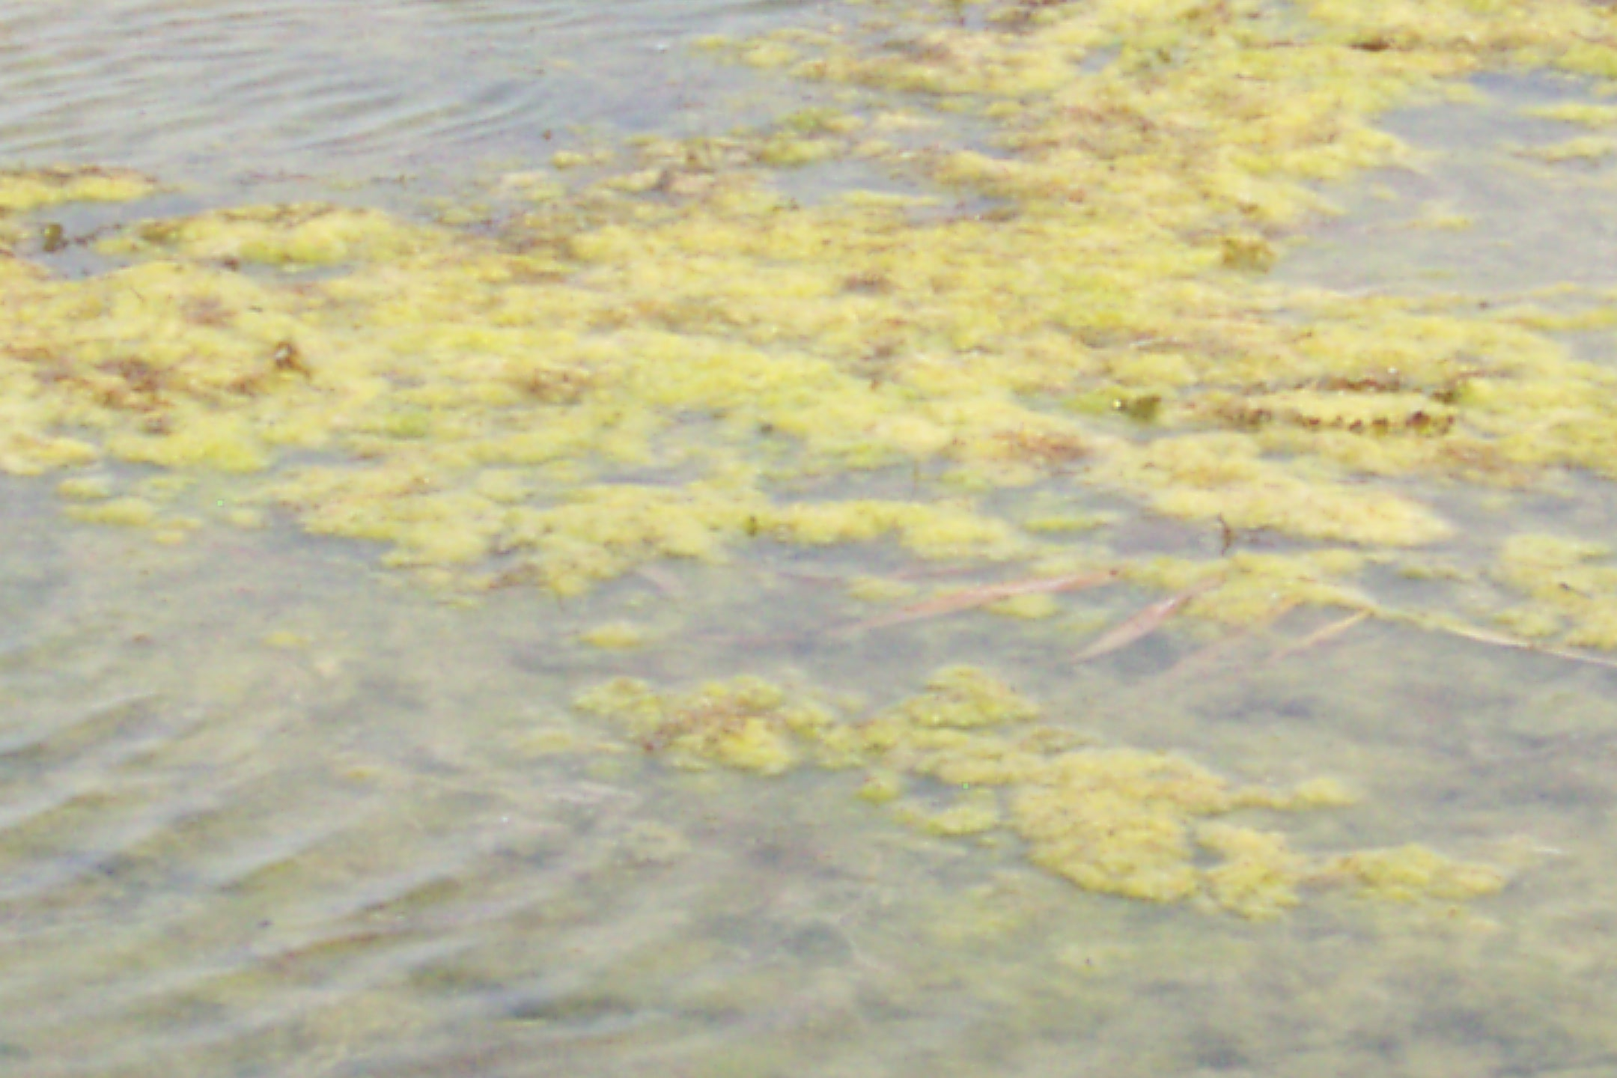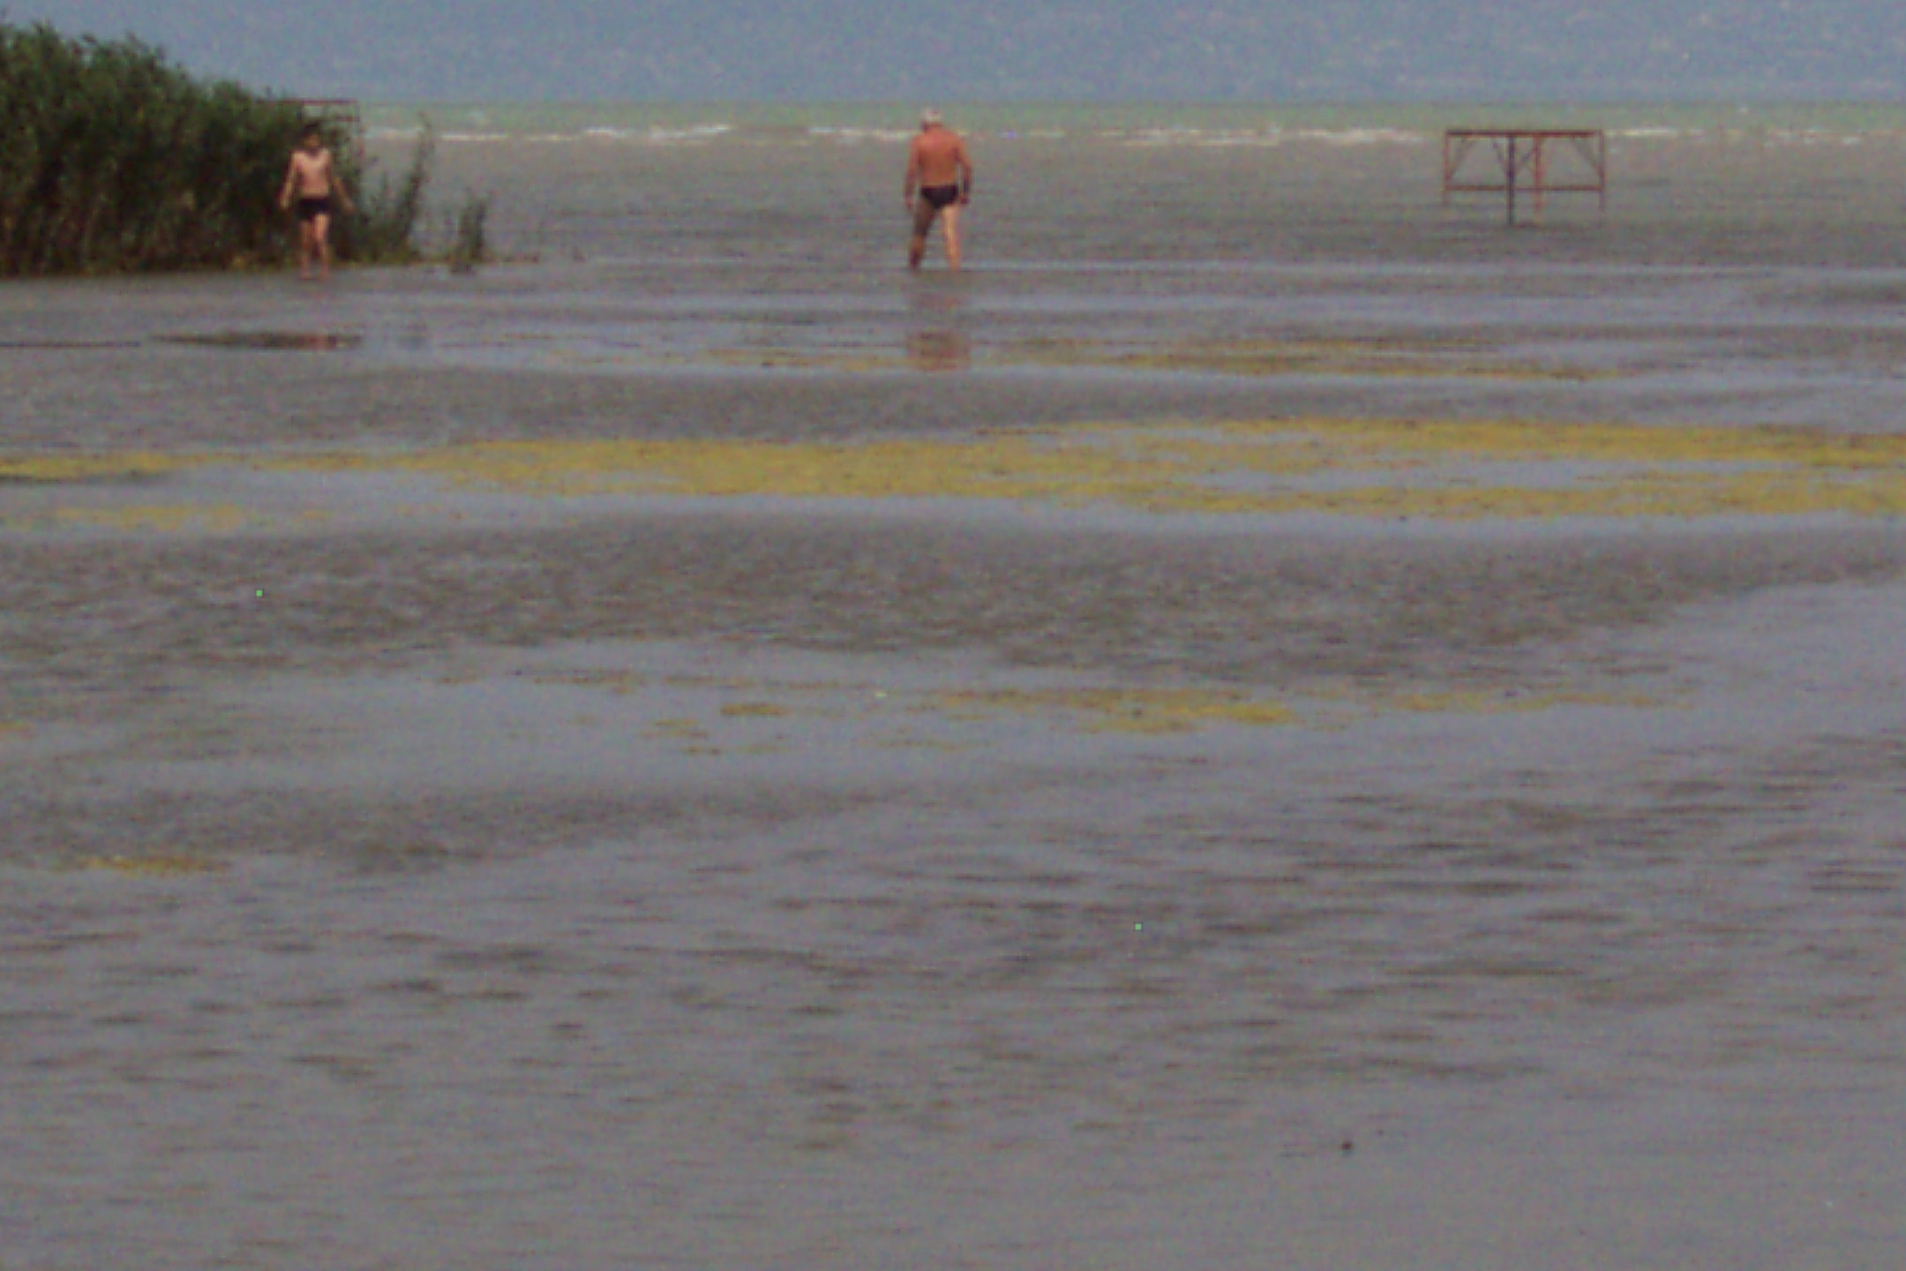

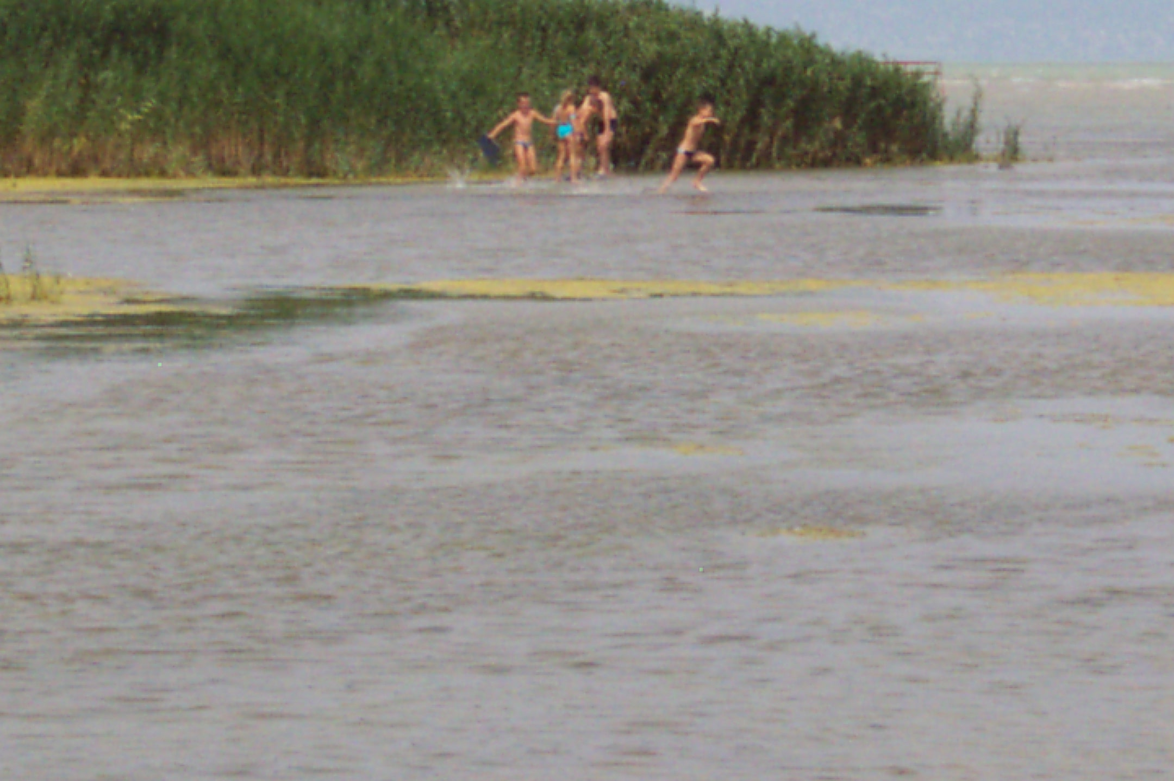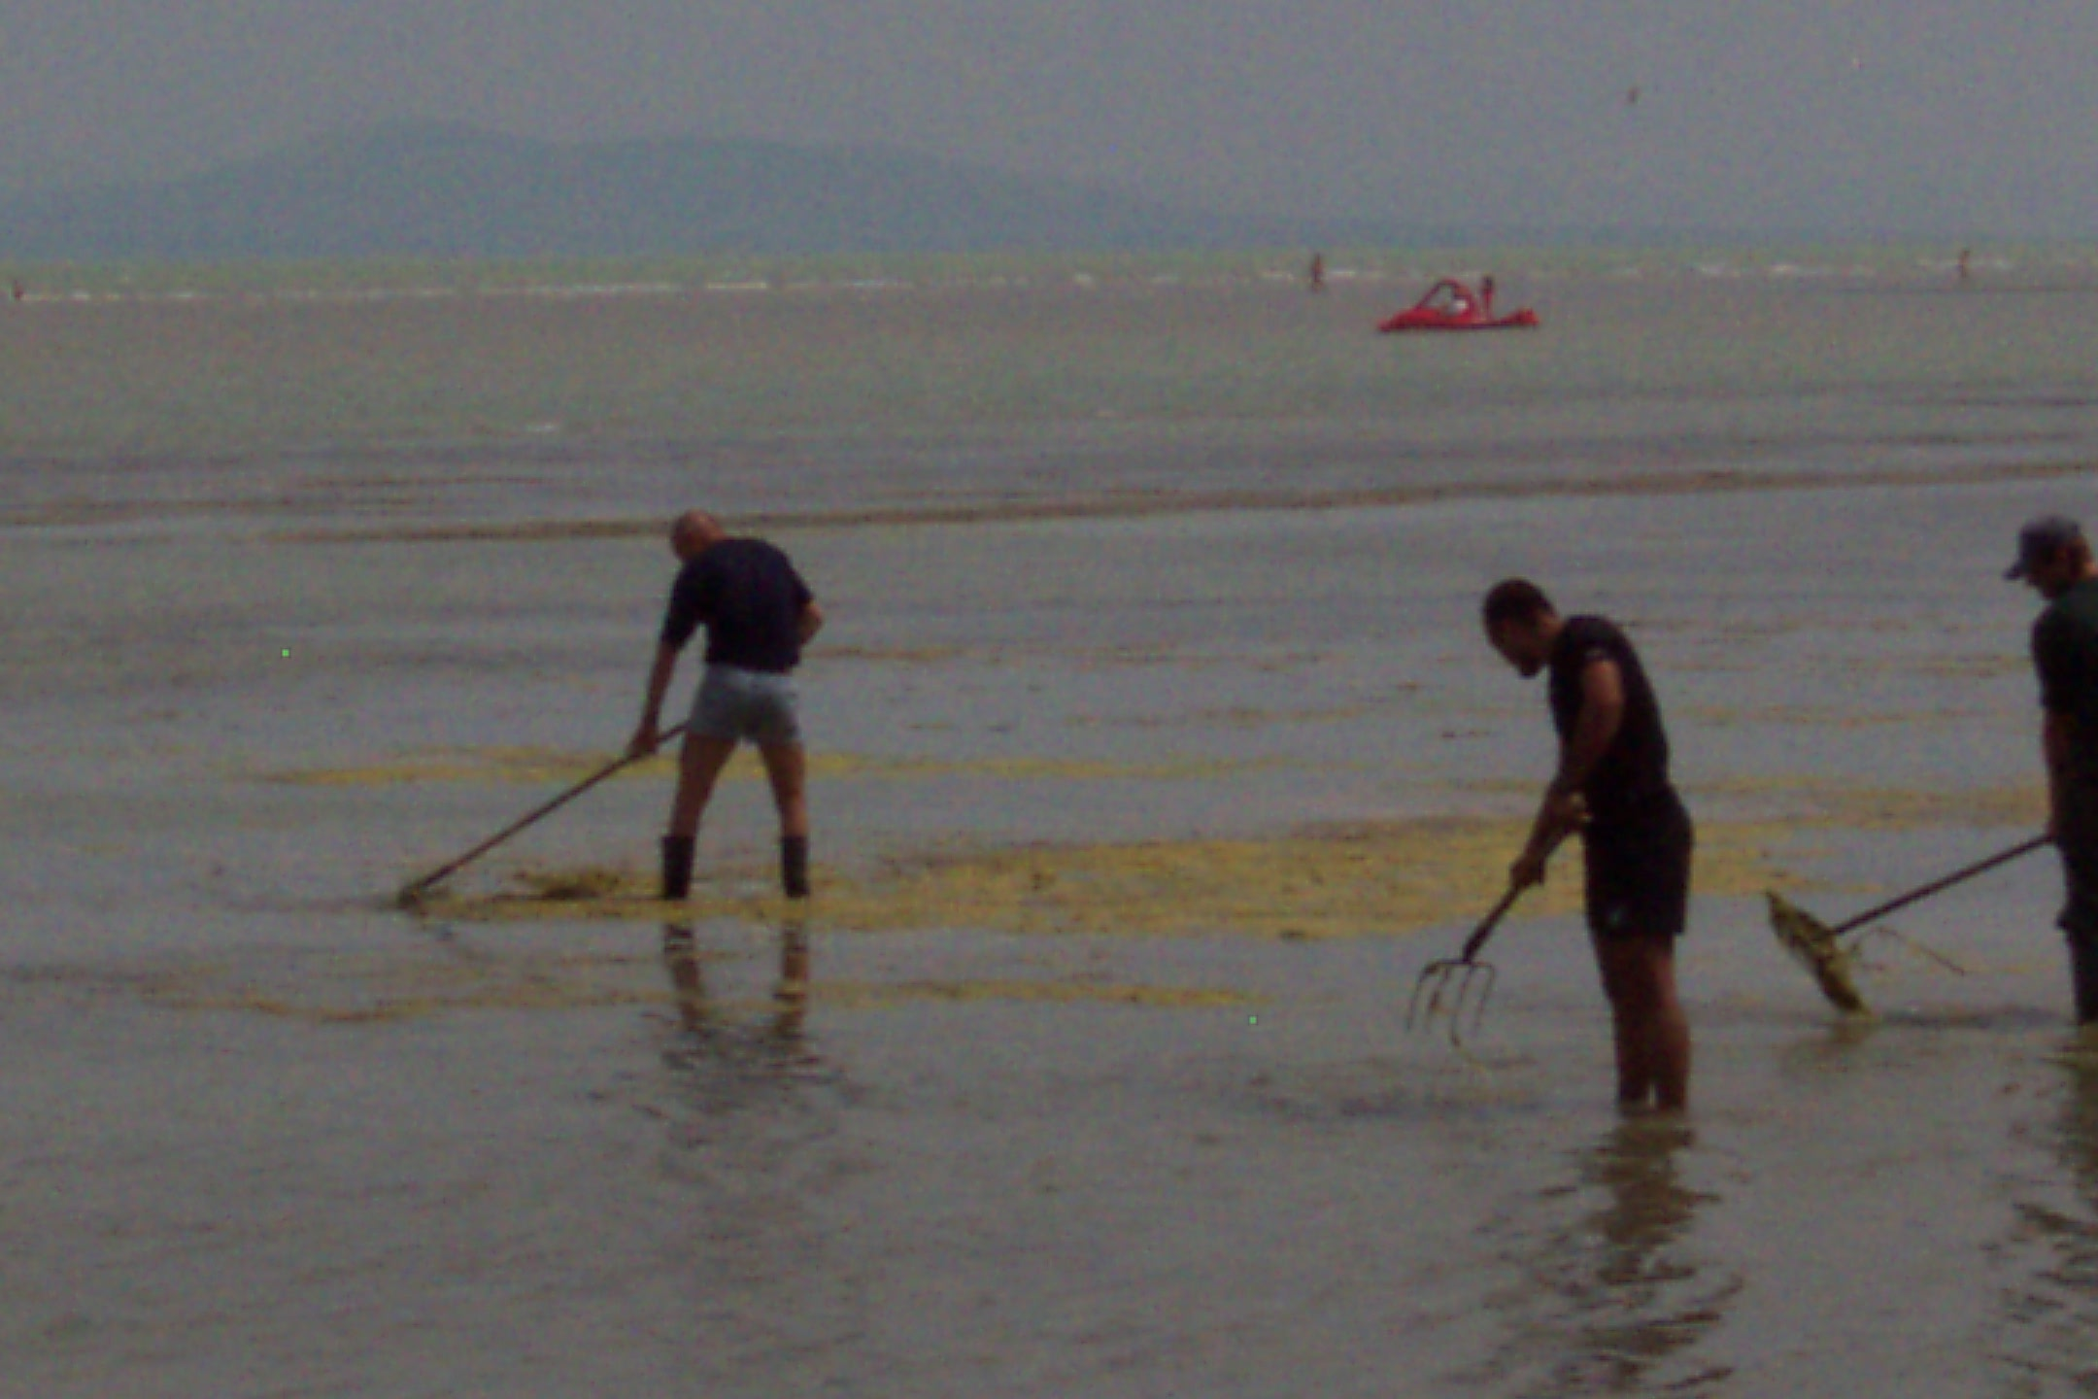

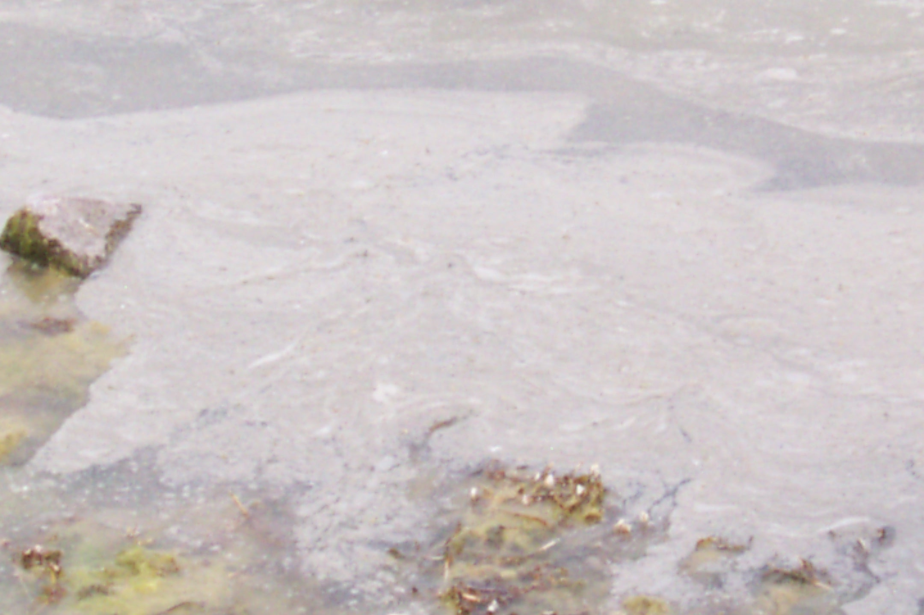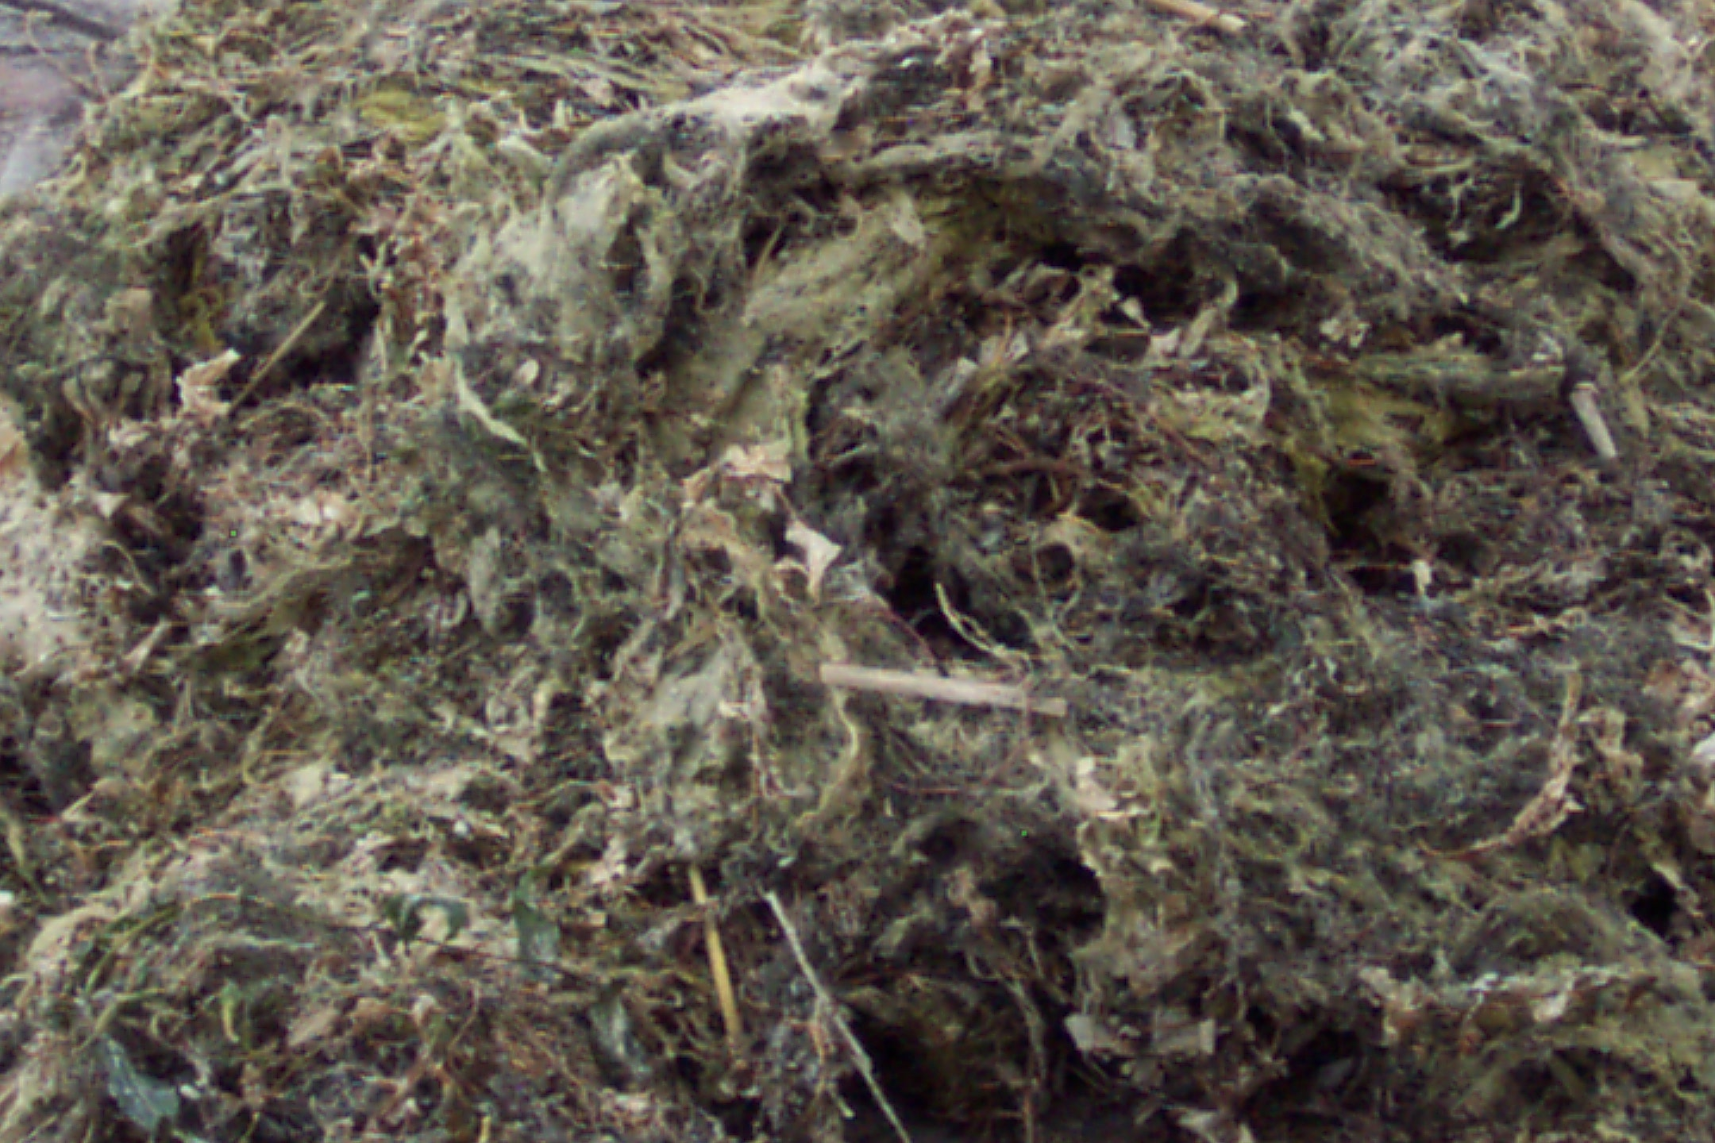

5.2.2 Water quality changes caused by extreme weather

Stormy rainfalls

- Stormy rainfalls causing increased flooding run off, erosion and river discharges will have a major impact on the abundance of waterborne pathogens in bathing waters due to increased erosion of agricultural soils and the overflow of rural and urban sewage treatment systems. A lot of faecal pathogens will be washed into the bathing waters.

- Zoonotic infections can increase because of the faeces produced by wild birds and mammals (rodents) on the beaches can influence the water quality by washing them into the water. The increased erosion from agricultural areas may increase the nutrient load in the bathing water providing better conditions for proliferation of toxic cyanobacteria. Bathing in fresh water containing toxic cyanobacterial bloom or scum can cause nausea, vomiting, hay fever like symptoms especially at children because they play in the shallow water at beaches and the blooms can accumulate in the shallow water at the beaches collected by the wind there. The amount of cyanotoxins can reach the DTI (daily tolerable intake) especially at children.

Global warming
- As mentioned previously the warmer air temperature may warm the water and new pathogen or harmful species can occur in the European region as well not characteristic previously. For example Vibrio species, Naegleria species, Acanthamoeba species can proliferate in the warmer waters. New subtropical/tropic cyanobacterial species can invade the European bathing waters. At the same time the survival time can decrease at some bacteria due to higher UV irradiation.

Droughts and water scarcity
- Droughts or shortage of water can effect the bathing water quality by not diluting satisfying enough the sewage treatment outflow and with the increase of the concentration of pathogens can cause infections in a greater number.

- The previously mentioned case study at Lake Balaton is one of the consequences of shortage of water. The concentration of nutrients by shortage of water has consequences like frequent cyanobacterial blooms as well.

5.3. ELEMENTS OF MITIGATION MEASURES FOR BATHING WATERS
Joint information systems and exchange of information
- In most of the member states in Europe the database of water quality in the ecological point of view belongs to environmental ministries or agencies however the bathing water quality including the pathogens’ occurrence belongs to health ministries or networks. By this way in an extreme weather situation the data sharing is absolute necessary to make prompt and satisfying measurements.

Paying attention on prevention at sewage treatment plants
- In planning and constructing sewage water treatment plants the overflow of untreated sewage must prevent in case of stormy rainfall as well.

Prevention of erosion by modification of landscape
- The run off from agricultural nutrient rich areas and diffuse pollution from urban areas must keep from reaching the bathing waters by planting of buffer strips, reforestation, perpendicular agricultural activity at hilly areas etc.

Monitoring during the extreme weather events and risk assessment
- Monitoring system should build up during extreme weather events to have enough data to make relevant measurements.

Information the public on the situation
- On of the main issues during the extreme weather events is to inform the public on the harm of the situation. It can be covered by internet or media.

6. IMPACTS OF EXTREME WEATHER EVENTS ON HEALTH

6.1. HEALTH IMPACTS OF EXTREME TEMPERATURES

6.1.1 Heat-waves
- The knowledge of health impacts from extreme temperature and linkages to water supply during periods of very hot and dry weather and possible health effects may imply restrictions and prioritization of water use, control of drinking water quality, efficiency of sanitation system and requires collaboration between the health sector and the water suppliers. Heat-wave-related deaths are an emerging problem in summer in the European Region, and an increase in the frequency and intensity of heat-waves could further aggravate this problem. Heat is a natural hazard, and much is known about the effects of high temperatures on the human body, so that adverse health effects of hot weather and heat-waves are largely preventable. Prevention requires a portfolio of actions that can be integrated in a defined heat–health action plan (WHO).

- Major heat-wave events are also associated with other health hazards – such as air pollution, wildfires and failures in water, food or electricity supply. All have implications for the public health response.

- Episodes of extreme temperature can affect health significantly, and they present a challenge for health systems. For instance, in the summer of 2003, a severe heat-wave struck much of Western Europe. Twelve European countries reported more than 44,000 excess deaths for August 2003 compared to averages for five years before (Robine et al., 2008). There is little information from eastern European countries on the effects of heat-waves on health.

- During heat-waves, water as well as electricity consumption/demand is increasing, sometimes together with a decrease of hydropower potential water stress related. Hot and dry weather over an extended period of time may also influence quality of water. Reduced river flows due to less rainfall may also lead to increased pathogen or chemical loading (Bates et al., 2008). As a consequence, humans may be more exposed to these pathogens and, in places with piped water supplies, water treatment plants are more challenged to provide safe drinking water.
Examples/”Cases studies”
- During the hot and dry summer of 2003, low river flows in the Netherlands, for example, resulted in apparent changes in water quality (Senhorst and Zwolsman, 2005).
- Higher temperatures being associated with increased episodes of diarrhoeal disease are reported for example from Peru and the Pacific Islands, (Checkley et al., 2000; Singh et al., 2001; Lama et al., 2004).

- Other health impacts due to exposure to very hot temperatures are: sun stroke, cramps, heat exhaustion or heatstroke. Heat-wave-related mortality results from a wide range of causes. Heatstroke is fatal in 10–50% of all cases and may lead to neurological morbidity in 20–30% of patients (Bouchama & Knochel, 2002).

- For populations in the EU, mortality has been estimated to increase 1–4% for each degree increase of temperature above a cut-off point (Baccini et al., 2008). During heat-waves, deaths increase from a range of causes. The PESETA (Projection of Economic impacts of climate change in Sectors of the European Union based on bottom-up Analysis) project (PESETA, 2008) estimates 86,000 extra deaths per year in EU countries with a global mean temperature increase of 3°C in 2071–2100 relative to 1961–1990. Increasing numbers of older adults in the population will increase the proportion of the population at risk. Heat-waves may have larger effects on mortality during high-ozone days, highlighting the interaction between climate change and air pollution.

6.1.2 Cold waves
- Cold weather still threatens the health of many European populations. In temperate countries, there is a seasonal variation of mortality. Most European countries have between 5–30% higher deaths rates in winter than in summer. Persons with cardiovascular diseases are more at risk, in winter, because of the cold-induced tendency for blood to clot. However, overall winter mortality rates are falling in some European countries. Several studies have attributed this decrease to improved home heating, better general health and improved prevention and treatment of winter infections (Christensen, 2007). In temperate countries, cold waves continue to be a problem. Low temperatures can be reached in a few hours and extend over long periods.
Cold-wave may affect water, electricity or heating systems availability with potential impacts on population health and health services delivery.

CASE STUDY Cold wave in Tajikistan, 2008
The recent cold wave in central Asia gives an example of possible health consequences. In 2008, Tajikistan had the coldest winter for 30 years, with electric-power generation impaired through frozen inlet streams. Consequently, health services and households did not have energy for prolonged periods. A rapid health assessment showed a sharp increase in the number of cases of severe burns and frostbite, a 50% increase in hospital admissions from acute respiratory infections, and a doubling of maternal and infant mortality compared to the same period in 2007.

6.1.3 Health risks from changes in water temperature
- Climate changes are expected to determine a growing temperature of Earth’s surface, an effect that will not be homogeneous on all surface waters. Indeed, surface waters temperature is depending not only on external temperature but also on residence times, depth, flow and wind, and it is expected that higher water temperatures might occur in stagnant waters (heat waves). Climate change can also increase the resident times of surface waters in the summer season also as a consequence of less precipitations and higher evaporation rates (summer droughts) (Scijven and de Rosa Husman, 2005).

- It is worth to note that with few exceptions, enteric bacterial pathogens are not able in replicating in the aqueous environment: enteric viruses and protozoa replicate only in humans or other specific hosts, while in aquatic environment are inactivated with a rate that increases with temperature. Enteric pathogens are differently sensitive to temperature: cysts of Giardia and enteroviruses are less inactivated with respect to oocysts of Cryptosporidium (Scijvenand de Rosa Husman, 2005). It is also known that a large variation in temperature susceptibility exists among viruses (Schijven and Hassanizadeh, 2000): for instance, viruses like hepatitis A viruses are rather temperature insensitive. In conclusion, increasing temperature should generally enhance enteric pathogens inactivation but also exert selection towards less temperature sensitive species, directly promoting the growth of some indigenous bacteria, including pathogenic species (Lipp et al 2002; Kirshner et al 2008).

- V. cholerae, responsible for outbreaks of cholera around the world, is recognized to be a component of coastal and estuarine ecosystems (Colwell 1996). Some evidence suggests that both O139 and clinical strain O1, associated to major outbreaks, may have arisen by genetic exchange with non-O1 strains (Lipp, 2002). Evidence indicates that toxigenic strains may arise from environmental, nontoxigenic progenitors in coastal areas (Chakraborty et al., 2000), and it appears that seasonal environmental factors may affect the acquisition of virulence genes to a significant degree (Lipp et al., 2002).

- It is known that pathogenic Vibrios, such as Vibrio parahemolyticus and Vibrio vulnificus, occur in estuarine waters throughout the world, are present in a variety of seafood (Croci et al., 2001; de Sousa et al., 2004; DePaola et al., 1990, 2003) and are part of the natural flora of zooplankton and coastal fish and shellfish. Their number is dependent on the salinity and temperature of the water, and cannot be detected in water with a temperature below 15°C. With the possibility of acquisition of virulence genes by environmental strains and with a changing climate, the geographic range of these pathogens may also change, potentially resulting in increased exposure and risk of infection for humans. Indeed V. parahaemolyticus and V. vulnificus are responsible for a majority of the non-viral infections related to shellfish consumption in the United States, Japan and South-East Asia (Wittman & Flick, 1995), and they also occur occasionally in other parts of the world. To date the number of cases which have occurred in Europe is extremely low, but recently a large outbreak (64 cases), caused by consumption of V. parahaemolyticus contaminated shellfish harvested in Galicia, was registered in Spain (Lozano-Leon et al., 2003).

- Furthermore, changes in plankton populations and other hosts for which Vibrios are commensals or symbionts would similarly alter their ecology. Indeed, increasing productions of exudates from algal and cyanobacterial proliferations are expected to further promote the growth of autochtonous pathogens (Lipp et al 2002; Eiler et al 2007), and an increased presence of Vibrio spp. (including the serotypes of V. cholerae O1 and O139, and V. vulnificus) has been frequently associated with blooms of cyanobacteria and eukaryotic phytoplankton species (Epstein 1993, Eiler et al. 2007).

- Another important group of autochthonous pathogens is Legionella spp. which can cause a number of infections of different severity, generically called legionellosis, spanning from mild febrile illness (Pontiac fever) to a potentially fatal form of pneumonia. Legionella spread over a wide range of natural environmental conditions, with better performances at temperature higher than 35°C and at high phytoplankton concentration (Fliermans et al., 1981), and the identification of Legionella spp. in hot-water tanks or in thermally polluted rivers emphasizes that water temperature is a crucial factor in its colonization of water distribution systems, its proliferation in the environment, and therefore in risk of Legionella infection. Thermally altered aquatic environments can results in rapid multiplication of legionellae, which can translate into human disease (Fields et al 2002). Another important aspect in Legionella ecology is its nutrient requirement. Legionella can proliferate in biofilm, in association with amoebae or protozoa or cyanobacteria (Fields et al 2002; WHO, 2007). It is commonly found in association with other microorganisms and it has been isolated in cyanobacteria mat, at 45°C over a pH range of 6.9 to 7.6. where it was apparently using algal extracellular products as its carbon and energy sources (Tison et al., 1980).

- Naegleria fowleri and Acanthamoeba spp., as possible emergent waterborne pathogens, can proliferate in warmer water columns. Most commonly, the amoeba may be found in bodies of warm freshwater, such as lakes, rivers, geothermal (naturally hot) water such as hot springs, geothermal (naturally hot) drinking water sources, warm water discharge from industrial plants, poorly maintained and minimally-chlorinated or unchlorinated swimming pools, soil (Beheds et al., 2007, Vivesvara et al., 2007, Blair et al., 2008, Jamerson et all, 2008). Infections with Naegleria are very rare, and occur mainly during the summer months of July, August, and September, usually when it is hot for prolonged periods causing higher water temperatures and lower water levels, but it is worth to note that infections can increase during heat wave years. Acanthamoeba spp. are a microscopic, free-living amoeba that are relatively common in the environment. This amoeba has been isolated from water (including natural and treated water in pools or hot tubs), soil, air (in association with cooling towers, heating, ventilation and air conditioner [HVAC] systems), sewage systems, and drinking water systems (shower heads, taps) (Mubareka et al., 2006, Boost et al., 2008).

- Additionally, Acanthamoeba spp. contain several bacterial endosymbionts which can be human pathogens (e.g. Legionella spp.), so they are considered to be potential emerging human pathogens (Schmitz-Esser et al., 2008).

- Cyanobacteria are ubiquitous autotrophic bacteria. Several species produce different toxins that act with different mechanisms and have been associated with acute human intoxications after exposures through drinking and bathing waters (Funari and Testai, 2008). The most investigated group are the hepatotoxins, that include about 80 different congeners of microcystins (MCs), and nodularins (NOD), all inducing acute effects in the liver. Environmental factors can also influence cyanotoxin production, but their role is not fully understood: some studies on MCs showed that the variations of parameters such as light, culture age, temperature, pH, and nutrients give rise to differences in cellular cyanotoxin content (Sivonen and Jones, 1999).

- Among these parameters, increasing temperature represents an important factor for increased cyanobacterial proliferation (often associated to increase of nutrients and decreased salinity), and a main factor for their poleward movements and possibly their toxicity. The proliferation of cyanobacterial blooms has been described in the majority of European lakes, used for drinking water supply and recreational purposes, so that this situation has given rise to concern for human health that can be affected by consumption of contaminated drinking water or food or by ingesting water during recreational activities.

- Indeed, some experimental evidences on Aphanizomenon spp. isolated cultured strain have indicated that increasing temperatures up to 28 ºC caused an approximate 2-fold increase in paralytic shellfish (PSP) toxin production (Dias et al. 2002). Cylindrospermopsis raciborskii, known as a species of tropical origin, has been found to occur starting from the mid 90ies with increasing frequency in Germany, France, Italy, temperate North America areas, and more recently it has been described as the predominant component of the phytoplankton community of different Portuguese rivers and reservoirs (Saker et al. 2004).

- On this basis it can be reasonable to hypothesize that the warming trend linked to climate change is likely to accelerate the spread and abundance of this (and possibly others) subtropical and potential toxic species.

6.2 Health impacts of drought
- Globally, the area affected by drought has likely increased since the 1970s. Projections show decreasing water availability and increasing frequency of drought in mid-latitudes and semi-arid low latitudes, with increases in drought frequencies for southern and south-eastern Europe, as well as central and south East Asia (IPCC, 2007).

- Droughts and severe water stress have major effects on various sectors such as agriculture, forestry or industry. Droughts can damage ecosystems and increase the risk of wildfires. In southern Europe, climate change is projected to worsen conditions (high temperatures and drought) in a region already vulnerable to climate variability, and to reduce water availability, hydropower potential, summer tourism and, in general, crop productivity (IPCC, 2007).

- The effects of drought on health include also deaths, malnutrition (undernutrition, protein-energy malnutrition and/or micronutrient deficiencies), infectious and respiratory diseases (Menne and Bertollini, 2000). Drought and the consequent loss of livelihoods is also a major trigger for population movements, particularly rural to urban migration. Population displacement can lead to increases in communicable diseases and poor nutritional status resulting from overcrowding, and a lack of safe water and food (Menne and Bertollini, 2000; del Ninno and Lundberg, 2005). Women seem to be more severely affected by malnutrition and children by nutritional deficiencies. Sedentary communities seem to be more vulnerable than nomadic populations even though the degree of malnutrition was higher in children of nomadic population groups. Household conditions increase the severity of certain health problems like trachoma (Laloo, 2008).

- Other drought related factors that may result in a short-term increase in the risk for infectious disease outbreaks include stagnation and contamination of drainage canals and small rivers. Droughts are also associated with water scarcity, which can also represent an increased risk to human health, especially due to worsening hygienic conditions and higher probability of microbial contamination of drinking water, associated with intrusion of organic material along the distribution net when following pressure drops.

- The spatial distribution, intensity and seasonality of meningococcal (epidemic) meningitis appear to be strongly linked to climatic and environmental factors and particularly to drought, although the causal mechanism is not clearly understood (Molesworth et al., 2001, 2002a, b, 2003).
- Drought events can also affect the transmission of some mosquito-borne diseases (Bouma and Dye, 1997; Woodruff et al., 2002; Chase and Knight, 2003).

- Drought may exert its influence on cyanobacterial proliferation by increasing nutrient availability (higher concentrations due to surface water evaporation in summer) and reducing water bodies flow (thus increasing the areas of still waters which promote their growth).

- Finally, droughts can be responsible for lowering groundwater table in coastal areas (lower recharge and excessive withdraw) so promoting the phenomenon of their salinization due to seawater intrusion.

- Both, extreme rainfall and droughts can increase the total microbial load in freshwater and have implications for disease outbreaks and water-quality monitoring (Howe et al., 2002; Kistemann et al., 2002; Opopol et al. 2003; Knight et al., 2004; Schijven and de Roda Husman, 2005).

6.3 ENVIRONMENTAL HEALT RISK FROM FLOODS
- Flooding is the most common natural disaster in the European Region (EM-DAT).With climate change, winter floods are likely to increase throughout the European Region. Coastal flooding related to increasing storminess and sea-level rise is likely to threaten up to 1.6 million additional people annually in the EU alone.

- The potential health effects of flooding include (Vasconcelos, 2006):
- direct health effects: drowning, injuries (cuts, sprains, laceration, punctures, electric injuries, etc.), diarrhoeal diseases, vector-borne diseases (including those borne by rodents), respiratory infections, skin and eye infections, and mental health problems; and
- other effects with health consequences: damage to infrastructure for health care and water and sanitation, crops (and/or disruption of food supply) and property (lack of shelter), disruption of livelihood and population displacement.

- The limited data available on flood events from a few event-based epidemiological studies show that the greatest burden of mortality is from drowning, heart attacks, hypothermia, trauma and vehicle-related accidents in the immediate term (Meusel et al., 2004). Studies of the long-term health effects of floods are lacking (WHO Regional Office for Europe, 2005).

- Flooding may lead to contamination of waters with dangerous chemicals, heavy metals, or other hazardous substances, from storage or from chemicals already in the environment (e.g. pesticides) (Pardue et al., 2005). Furthermore, there is little published evidence demonstrating a causal effect of chemical contamination on the pattern of morbidity and mortality following flooding events (Euripidou and Murray, 2004; Ahern et al., 2005).
- Indeed, heavy rainfalls/floods can cause over-flooding of sewage treatment plants, run off of animal dejections and manures with a consequent increase of contamination of surface waters and soils. Several studies have shown that contamination of freshwater by enteric pathogens is higher during the rainy season (Nchito et al., 1998; Kang et al., 2001). In a study in the Netherlands (Schjven et al., 2005), one of the main conclusion was that increased precipitation in winter and more frequent heavy rain events in summer lead to peak concentrations of waterborne pathogens in surface waters that are several orders of magnitude above average levels.

- These higher pathogens concentrations can affect the quality of drinking and bathing waters, and some foods like vegetables, soft fruits and shellfish. Moreover, the increased load of suspended particles can jeopardize the efficiency of the water filtration and treatment systems, worsening the risk of drinking water supplies contamination.

- Flood related increases in diarrhoeal disease have also been reported in India (Mondal et al., 2001), Brazil (Heller et al., 2003) and Bangladesh (Kunii et al., 2002; Schwartz et al., 2006). The floods in Mozambique in 2001 were estimated to have caused over 8,000 additional cases and 447 deaths from diarrhoeal disease in the following months (Cairncross and Alvarinho, 2006).

- Risks to human health from contaminated water may depend upon socio-economic variables (Bates et al. 2008). In high-income countries, rainfall and runoff events may increase the total microbial load in watercourses and drinking water reservoirs, although the linkage to cases of human disease is less certain. The contamination of surface water in early spring in North America and Europe may explain some of the seasonality in sporadic cases of water-borne diseases such as cryptosporidiosis and campylobacteriosis. Many water-borne disease outbreaks are related to heavy precipitation events, often linked to water treatment failures (Bates et al., 2008). the risk of infectious disease following flooding is generally low, although increases in diarrhoeal diseases after floods have been reported (Miettinen et al., 2001; Reacher et al., 2004;Wade et al., 2004; Wolf and Menne, 2007) . In the USA an association between extreme rainfall events and monthly reports of outbreaks of water-borne disease has been reported (Curriero et al., 2001).

- In low income urban communities improved drainage and storm water management is particularly important, as blocked drains can cause flooding with contaminated water. Cities with combined sewer overflows can experience increased sewage contamination during flood events

- It is worth to note that heavy rains and floods can increase nutrient availability of lakes so inducing cyanobacterial proliferation. Furthermore, increased freshwaters inputs into rivers from increased run off dilute the estuarine environment and can promote blooms of toxic cyanobacteria. For example, a large bloom of M. aeruginosa in the upper San Francisco Bay Estuary was widespread throughout 180 km of waterways; microcystins were detected in all stations sampled, also in zooplankton and clam tissues (Fristachi and Sinclair, 2008).

Box XX Changes in quality - Case study: Environmental health aspects of the drinking-water outbreak in consequence of karst water flood (Hungary contribution)

The climate change may lead due to an extreme rainfall event to increase of water-borne disease, and cause thereby a microbiological contamination of the water source and supply. In consequence of the complexity of the pathways from the surface to the consumer, it is difficult to detect an association between rainfall and human disease. The case study describes a large scale drinking water outbreak. The water supply of a Hungarian city is mainly based on the sensitive karst water springs. Enormous quantity of precipitation fell on the catchment area of the karst water source, causing an unusually strong karst water flow and flood. Microbiological contamination from several potential sources on the protecting zone of the karst water was washed into the wells and watermains and caused an outbreak. 3673 people got ill out of the 60000 inhabitants living in the water supply zone and 161 patients were taken to hospital. Public health intervention and hygienic measures were made in line with epidemiological actions, and focused on i.) the protection of the healthy people through providing safe drinking-water supply, ii.) the identification of the contamination, and iii.) taking measures on risk reduction and preventive actions.

6.4 VECTOR BORNE DISEASES AND EXTREME EVENTS
- Climate change is likely to cause changes in ecological systems that will affect the risk of infectious diseases in the European Region, including the seasonal activity of local vectors and the establishment of tropical and subtropical species.
Hot-dry period followed by intense rainfall, water marsh after floods, open water reservoir options in water resource management they all create suitable environments for water feed vectors.

- Besides, the movement of people and goods, changes in hosts and land use will continue to affect patterns of infectious disease in the Region. Chikungunya virus has been introduced into the Region by travelers returning from endemic countries (ECDC/WHO, 2007). The presence of a suitable vector would allow for local outbreaks. An example is the tiger mosquito, Aedes albopictus, which has substantially extended its range in Europe over the last 15 years and presents reasons for concern about the transmission of other viral diseases (Scholte & Schaffner, 2007).

- Several climate change related models estimate an increase of malaria risk: For example, in the United Kingdom it was estimated that, with temperature increases, the risk of local malaria transmission could increase by 8–15% by 2050. In Portugal, the number of days suitable for survival of malaria vectors is projected to increase. Nevertheless, there is agreement that the risk of transmission of malaria related to localized climate change is very small. Risks are greater in the countries where importation of malaria coincides with socioeconomic degradation, the disintegration of health and social services, uncontrolled cross-border migration and lack of environmental management for mosquito control (Confalonieri et al., 2007; WHO Regional Office for Europe, 2004).

- The limit of tick distribution in the European Region is shifting northwards and to higher altitudes. A shift towards milder winters may enable expansion of the range of Lyme disease, but only if all of the vertebrate host species required by the tick vector are equally able to expand their population distribution. Another important vector-borne disease in southern Europe is cutaneous leishmaniasis, transmitted by sandflies. The disease has been reported in dogs (reservoir hosts) further north, although the possibility of previous underreporting cannot be excluded. Changes in the geographical distribution of the sandfly vector have been reported in several European countries (Lindgren et al., 2006).

- The role of climate change in the future epidemiology of other vector borne diseases is uncertain. The impact of climate change on bird migration patterns may play a role in the distribution of West Nile fever (Hubalek et al., 2006) and prolong the active season (and thus the incidence) of Toscana virus, while milder weather conditions that favors tick reproduction may influence the distribution of Crimean-Congo hemorrhagic fever (Ergonul, 2006).

6.5 Summary of climate sensitive emergent/re-emergent pathogens

 | Pathogen | Health significance* | Relative infective dose* | Infection caused
Viruses: | Norovirus GGI and GGII  Sapovirus  Hepatitis A virus  Rotavirus  Enterovirus  Adenovirus  Avian influenza virus# | High  High  High  High  High  High  Low | Low  Low  Low  Low  Low  Low  unknown | Gastroenteritis  Gastroenteritis  Hepatititis  Gastroenteritis  Gastroenteritis  Respiratory&intestinal  influenza
Bacteria: | pathogenic Escherichia coli  Campylobacter jejuni, C. coli  Helicobacter pylori  Legionella pneumophila  Vibrio cholerae  Vibrio parahaemolyticus#  Vibrio vulnificus#  Vibrio alginolyticus  Toxic cyanobacteria | High  High  High  High  High  Medium  Low  Low  Medium | Low  Moderate  unknown  High  high  high  low  unknown  Moderate | Gastroenteritis  Gastroenteritis  Stomach&duodenal ulcer  Pneumonia  Cholera  wound infections, otitis and lethal septicaemia  gastroenteritis, respiratory dysfunctions, allergic reactions
Protozoa: | Cryptosporidium spp.  Giardia spp  Naegleria fowleri#  Acanthamoeba spp.# | High  High  Low  Low | Low  Low  High  unknown | Gastroenteritis  Gastroenteritis  Meningoencephalitis  Keratitis, blindness
Taxa labelled with # are considered potentially emerging. * according to WHO-report “Emerging Issues in Water and Infectious Disease”, 2003.

7. THE WATER SAFETY PLAN APPROACH IN RISK ASSESSMENT AND MANAGEMENT EXTREME WEATHER EVENTS FOR WATER UTILITIES

7.1 WATER SAFETY PLANS
- Water Safety Plans (WSPs) were introduced by WHO as “the use of a comprehensive risk assessment and risk management approach that encompasses all steps in water supply from catchments to consumer”. Its aim is clear: “to consistently ensure the safety and acceptability of a drinking-water supply”. The great advantage of the WSP strategy is that it is applicable to ensuring the safety of water in all types and sizes of water supply systems, no matter how simple or complex. A further important specificity of the WSP approach is that it is dynamic and practical, and not a standardized, fixed operating procedure. It is therefore suited to deal with the changes in quantity and quality expected to result from extreme weather events. In the following paragraphs, the key steps of a water safety plan are reviewed on the basis of the official WHO manual

WSP Team creation
- The WSP team is typically constituted by utility staff having experience in the water supply system and direct understanding of the hazards to continuity of supply and quality of the final product. The adequate integration of extreme weather events in a WSP approach requires that the team also, at the least, include experts from the geohydrological and meteorological services covering the service area of the water services. This will allow access to historic information on past flooding and drought events, as well as detailed projection for future changes in hydrological patterns. Communication should also be established at an early stage with the national health system to (a) understand better the vulnerability of key components of the health system (hospitals, dispensaries, first aid stations, hospices etc.); (b) under the role the health system can play in case of flooding and drought, and how it mutual support can be organized; (c) gather information on people with special needs with restricted self-help capacity (elderly, immune-compromised people, those needed extended home nursing care).

Description of the water supply system
- European water services draw on a wide variety of sources (rivers, lakes, wells, mines etc.); these resources need to be fully identified and registered, including their geohydrological characteristics. This registration must be done with a sufficient level of detail to allow vulnerability assessment. For example, it is not sufficient to merely register an aquifer, links with the overlaying surface water and vulnerability to pollution originating therein needs to be registered and assessed. In coastal areas, not only the feedwater of the aquifer needs to be registered but also the potential intrusion of seawater.

- Although by no means exhaustive, the following list illustrates some of the concerns that the WSP team will face at this point of the process:

- Linked water services. Interconnections between water services are important to provide aid in case a water service is compromised by an extreme weather event. The hazards of such emergency inter-connections need to be assessed. Links are not limited to piped distribution network. Experience has shown that water services of major conurbations may be called upon, at very short notice, to take over water supply in rural areas where shallow wells became unproductive during periods of extreme drought. In such case, connections are done by lorry.
- Water treatment beyond the control of the water service. Where service is of inconsistent quality, as is often the case in eastern Europe, information needs to be gathered on current practices of in-house water storage and treatment so that the current unsatisfactory nature of the distribution lines can be taken into account when assessing further hazards.
- Land use. Detailed information on land use needs to be gathered, identifying potential hazards such as cattle grazing but bearing in mind that extreme weather may change the nature of the hazard. For example, a historic contaminated site may present no hazard during routine conditions, but might become an important hazard during intensive rain events.
- Staff capacity. The development of an integrated description of the system may require advanced computer modelling of piped distribution networks, treatment systems, distribution networks etc. Staff training may be necessary to master GIS and propriety software to effectively perform this type of work, especially in major water services.

Identification of hazards and assessment of risks
- The role of the WSP is to ask “what can go wrong at what point for which hazardous event, how likely is it, and how severe would be the consequences”.

- Correct implementation of this step of the WSP requires considerable out-of-the-box thinking capacity. For example, information gathering may have been done on the composition of distribution pipes in recognition of plumbosolvency problems, but pressure fluctuations may have remained unrecognised as a specific hazard. This would be an issue in water distribution, but perhaps even more so in sanitation and drainage networks. Hazard identification and risk assessment inside consumer premises also remains a challenge for many water utilities.

- The Table XX below lists some of the hazards typically associated with extreme weather events.

Table XX Typical hazards associated with extreme weather events
Catchment |  | Treatment |  | Distribution
Hazardous event | Associated hazard | Hazardous event | Associated hazard | Hazardous event | Associated hazard
Meteorology | Flooding  Water quality change  Drought | Power supply | Interruption, loss of treatment, distribution compromised. | Pipe burst | Ingress of contamination
Seasonal variations | Colonization of resource waters by opportunistic invader species | Capacity of treatment works | Hydraulic overload of both drinking water and wastewater treatment plans | Pressure fluctuations | Ingress of contamination
Unconfined aquifer | Water quality subject to unexpected change esp. after long dry spells. | By-pass facilities | Inadequate treatment | Intermittent supply | Ingress of contamination
Well/boreholes not watertight | Surface water intrusion | Treatment failure | Untreated water
Borehole casting corroded or incomplete | Surface water intrusion | Screen / Filter blockage | Inadequate removal of particulate matter
Flooding | Quality and quantitative sufficiency of raw water | Flooding | Loss or restriction of treatment works
 |  | Failure of continuous supply of treatment chemicals | Compromised treatment / disinfection

Determination and validation of control measures
- “Control measures” are activities and processes applied to reduce or mitigate risks. They are determined for each of the identified hazards or hazardous events; missing controls to deal with identified hazardous events need to be documented and addressed. An update or improvement plan should be developed to address all newly identified hazards.

- Control measures must be considered not only for their longer-term average performance, but also in light of their potential to fail or be ineffective over a short space of time. This is especially important in extreme weather: certain pathogenic organisms and their toxins may, for example, only pose real risk under condition of extreme drought.

- “Validation” is the process of obtaining evidence of the performance of control measures. Validation is different from operational monitoring of processes. It can for example include visual inspection of the catchments area to ensure absence of cattle, assessment of the underground travel time in river bank filtration, certification of alternative suppliers, testing of alarms for the sudden discontinuation of UV disinfections etc.

- “Risks”, the likelihood that a hazard will occur time the severity of its consequences, needs to be recalculated taking into account the effectiveness of each control.

Development, implementation and maintenance of an improvement plan
- Improvement plans are not necessarily limited to work within the water service’s own installations. The WSP approach is now giving more attention to catchments initiatives, with joint action between water services and other stakeholders in the catchments. Such joint initiatives are usually welcomed by Regulators as they are likely to yield, over time, more sustainable results with lower carbon footprint than would be possible through installing more advanced unit operations.

- The development of upgrade plans offers a clear opportunity to explore in-depth the links between water and sanitation systems in one area. Well-known risks exist for the contamination of the resource waters from untreated wastewater or wastewater treatment plant effluents from under performing installations. These risks can become much more important in case of flooding of the wastewater treatment, their partial collapse under increased load factors, or the flooding of sludge dying beds. Detailed review of the risks during the development of improvement plans may lead to their re-assessment.

Monitoring control measures
- “Operational monitoring” includes defining and validating the monitoring of control measures and establishing procedures to demonstrate that the controls continue to work. For example, in many countries of eastern Europe leaky pipes and unauthorized connections lead to ingress of contaminated water. Maintenance of system pressure could be a control measure, and installation of pressure gauges throughout the system an appropriate monitoring measure to ensure that the controls work at all times.

- Back-up systems are necessary to ensure continuity of supply in case monitoring indicates failure of a control. For example, if chlorination were to fail and flooding of access roads were to prevent new supplies reaching the production unit, pre-identified alternative water sources could be allowed access to the distribution network. Of course, risk associated with the use of such alternative source should be identified and addressed during the overall establishment of the WSP.

Verification of the effectiveness of the WSP
- Verification involves three activities which, when undertaken together, provide evidence that the WSP is working effectively. These are:

(a) Compliance monitoring: validating effectiveness and monitoring performance against set limits.
(b) Internal and external auditing of operational activities, ensuring that water quality is within targeted limits and that risks are controlled.
(c) Consumer satisfaction: monitoring of consumer satisfaction is important to ensure that the water distributed by the utility will indeed be used. Communication programmes need to be set up to instruct people on safety issues. This may involve reassuring the consumers on the continued safety of the water when, for example, temporary discoloration or other organoleptic changes occur due to the sudden changes of raw water quality, but also the management of incidents which compromise the microbial quality of the water. Care should be given to preventing consumers from turning to unsafe water sources if problems do not compromise safety of the distributed water or are of such nature that they can easily be controlled by simple in-house treatment.

Preparation of management procedures
- Standard Operation Procedures (SOPs) need to be prepared for the management of the system under routine conditions. Equally important is the preparation of Incident Situation Operational Procedures (ISOPs) as an integral part of a WSP. ISOPs need to describe in detail the steps to be followed n specific “incident” situations where a loss of control in the system may occur. An efficient, regular review and updating cycle is also important especially as new information and more refined models on expected impacts of climate change are released almost daily.

- Notwithstanding all reasonable efforts to make contingency planning as detailed and comprehensive as possible, it is humanly impossible to foresee all events. Unforeseen events/incidents may, indeed in all likelihood will, occur for which there are no corrective actions in place. In this case, a generic emergency plan should be followed. This would have a protocol for situation assessment and identification of situations that require activation of the emergency response plan.

- It is important that impacts of past extreme events, or near misses of service disruption by extreme events, be analysed as they could be an indicator of a likely future emergency. It is also important that such lessons be shared as widely as possible within the water utility community through specialised networks, journals etc.

- Supporting programmes include: research and development; training and capacity building, equipment calibration, laboratory intercalibration, preventive maintenance, development and installation of customer complaint protocols and their processing, as well as legal training.

Periodic review
- The WSP team should meet periodically to review the overall plan and learn from experiences and new procedures. The review process is critical to the overall implementation of the WSP and provides the basis from which future assessments can be made.

- Following an emergency or incident or near miss, risk should be reassessed and may need to be fed into the improvement / upgrade plan.

- Also after substantial capital investments to adapt to climate change, such as the installation of storm water reservoirs, or the installation of PAC columns, a review of the WSP is indicated to see if SOPs and ISOPs are still adequate or need to be refined and reviewed.

Handling incidents
- A WSP should be reviewed following every emergency, incident or unforeseen event irrespective of whether new hazards were identified to ensure that, if possible, the situation does not recur and whether the response was sufficient or could have been handled better.

- A post-incident review is always likely to identify areas for improvement; in many cases, the greatest benefit will result when also other stakeholders are included in the review.

Integrated water resource management
- The advantages of placing water services in the framework of integrated water resources management have been lauded by many authors. Examples of such advantages are: the reduction of negative externalities that arise from the uncoordinated use of interdependent water and land resources; opportunity costs which arise when production factors are used of low value/benefit costing; and cost savings achieved by widening the range of management options.

- A number of countries outside the European Union are making progress towards IWRM through activities in the area of watershed management, clarifying institutional roles and responsibilities, increasing stakeholder participation, and anchoring financing mechanisms on in integrated management concept.

- Inside the European Union, the legislative framework has been created for climate adaptation strategies of water services to fit into an IWRM approach. The main elements of this legal strategy are:

- The Directive 2000/60/EC of the European Parliament and the Council of 23 October 2000 establishing a framework for Community action in the field of water policy – the Water Framework Directive.
- Directive 2007/60/EC of the European Parliament and of the Council of 23 October 2007 on the assessment and management of flood risks
- Communication from the Commission to the European Parliament and the Council COM (2007) Final.

- Important progress is being made in the provision of guidance on water resource management and climate change by the Parties to the 1992 Convention on the Protection and Use of Transboundary Watercourses and International Lakes; the guidance documents resulting from these efforts could be usefully consulted in conjunction with the present volume.

- Finally, it needs to be recalled that health issues are frequently neglected or under-estimated in water resource strategies. Health considerations should, however, be incorporated in regional and national stakeholder dialogues on sustainable water resource management, including the use of these resources for water supply and sanitation. Proper screening and scoping exercises will need to be developed to determine the key health issues, and to define the framework in which they are to be considered.

8. ADAPTATION MEASURES FOR WATER SUPPLY UTILITIES in EXTREME WEATHER EVENTS.

- This chapter describes some of the key adaptations that can be made and actions taken by water supply operators in order to continue the supply of safe clean drinking water during extreme weather events. The focus of the chapter is on drought and flood conditions, but the principles highlighted may be equally applicable to other extreme weather events. Many water suppliers already have in place, or are implementing adaptation measures for a number of reasons. Often, and especially where the original driver was not initially thought of in this context (e.g. population growth), it may not be recognised that these measures are also appropriate in mitigating the impacts climate change or extreme weather events, regardless of their original intention.

- Climate change is likely to affect the availability and quality of raw water, which in turn could affect the efficiency of drinking water treatment processes and the stability of drinking water in distribution. In general terms water suppliers will need to consider adaptations to deal with greater variation in water quantity (both availability of raw sources and demand for suppliers); and greater variability in raw water quality and therefore requirements to ensure the supply of safe drinking water. Therefore in order to ensure safe and continuous water supply during extreme weather events measures must be taken across all aspects of the water supply system – with regard to water sources (catchments and aquifers); water collection, treatment and distribution, and also in the management of demand and water use on premises.

8.1. ADAPTATION MEASURES FOR DROUGHT EVENTS

8.1.1. Measures to ensure continued operation of water supply utilities
- Drought is a function of water scarcity. Water scarcity may prevail over long time periods and the distinction between operational water management during times of water scarcity and emergency activity in a drought situation is much less clear than say in the event of a major flooding event. Thus the continued supply of safe drinking water during drought conditions must normally be considered as part of a continuum of operational management during times of water scarcity. Thus many of the adaptation measures adopted in water scarce regions are equally relevant during periods of drought (in either water scarce or other regions).

- As with the management of water supplies during any extreme weather event it is vitally important to consider the potential impacts (and thus adaptation options) across the whole water supply system from source to tap. The interrelation of measures across the supply system must also be assessed when considering adaptation measures.

Source and reservoir management
- The careful management of water resources is fundamental to the supply of adequate safe drinking water during drought conditions. Water suppliers must work with a variety of stakeholders to understand the climatic and meteorological conditions in which they are operating and also with those responsible for environmental protection, the management of water and land-use within catchment areas.

- Water suppliers need to have in place standing arrangements for communicating with meteorological forecasting units to ensure that long and short term forecasts of dry periods can be highlighted and pre-prepared drought management plans activated.

- As part of their comprehensive risk assessment and management activities (incorporated in a Water Safety Plan framework [ref to WHO 3rd Edition]), water suppliers need to identify risks to the availability and quality of resources posed by drought scenarios.

- Suppliers should work with meteorological and environmental agencies to agree statistical estimates or models of a variety of scenarios. These should typically be based on drought “return periods” or frequencies. Thus scenario details can be created for situations that might be experienced annually, once in every 5 years or once every 20 years for example. Where appropriate, these scenarios can be coordinated with other water resource management activities such as river basin management plans prepared under the European Water Framework Directive. Suppliers should then use these scenarios as planning assumptions to assess the risks to water supply quality and quantity (see chapter 6).

Proactive adaptation measures: water sources / resources
- The primary impact of drought or water scarcity on drinking-water supplies is one of resources or availability. Where possible adaptation measures to assist in the management of drinking water supplies during such periods should be put in place in anticipation of future drought conditions. These measures are also likely to form part of long term water resources planning and may also contribute to several complementary objectives of the water supplier (e.g. planning for population growth). Table XX below describes some example proactive measures:

 | Adaptation activity | Example adaptation measures
Water quantity / resources | strategic water resource planning (25 years +) | - interconnection of the reservoirs between wet/ dry areas (inter-regional transfers)  - variety of sources – might need WTW process capable of dealing with river source at one time of year and stored (reservoir) source at another  - Silting of ponds, reservoirs, collection chambers and intake works (due to land degradation and increased erosion)  - Improving infrastructure resilience  - Resource optimization by supervision systems (telemetry monitoring systems coupled with SCADA & automated control)
Water quantity / resources | Alternative sources | - Standby sources that are operated regularly to ensure they work when required, and sampled so know quality  - Small suppliers with no local alternatives  - New water sources – risk assessment: reclaimed water, desalination etc

Proactive adaptation measures: water quality & safety
- Water quality and safety may also be adversely impacted by drought/water scarcity. The primary impacts are likely to be:
- A general decrease in raw water quality due to less dilution in source waters;
- Surface water sources may vary greatly due to reduced flow patterns, drawn down of storage reservoirs and changes in reservoir limnology.
- Groundwater may be more susceptible to contamination that previously due to changes in hydrogeological flow patterns caused by a changing water table level and associated impact on the saturated soil layers.
- An increase in raw and treated water temperatures;
- Increased temperature and nutrient concentrations in surface waters that may also increase the likelihood and extent of algal blooms (and associated cyanobacteria);

- Adaptation measures in themselves may also impact on the safety of water supplies, for example through the need to mix waters with different chemical matrices, or the potential to introduce novel species if large scale raw water resource transfers are made.

- As with adaptations for water resources, where possible measures to assist in ensuring the continued safety of drinking water supplies should be put in place in anticipation of future drought conditions. Table XX below describes some example proactive measures:

Table xx | Adaptation activity | Example adaptation measures
Source water quality | Enhanced monitoring to detect deterioration in drought (or when drought conditions are predicted) | Enhanced monitoring of:  - Turbidity / physical quality  - Indicator organisms (pathogen loading)  - Algal species and counts  - Broad chemical screens (e.g. GC/MS scan) for emerging contaminants  - Limnology – risks of low draw-down, storage reservoir inversion (use of bubblers, forced currents etc)  - Vector-borne diseases (open reservoir management)  - Emerging risks – suggest chemicals/pathogens, viruses etc [link to chapter on emerging health risks]
New sources | Use of alternative/ standby sources | - Knowledge of quality of sources  - Pre-event trials / experimentation into impact of mixing water matrices

Case Study – impact of climate change on water resources in Azerbaijan

Vulnerability assessment in Azerbaijan suggest a 15 – 20% decrease in available water resources. Adaptation measures put in place include:
- Reservoirs - construction of new & increasing the of efficiency of existing (US$305million)
- Improvement of water management systems (US$12m)
- Reconstruction of existing water and irrigation systems (costs TBC)
- Reducing demand through the use of water saving technologies (US$418m)
- Afforestation (US$10m)

These adaptation measures are expected to save 10 billion cubic metres of water to help deal with water scarcity and extreme weather events.

8.1.2. Operation of water supply utilities

Water treatment works
- In order to consider the impact of drought or water scarcity conditions on the operation of water treatment works, suppliers need to consider the original purpose of the works and any treatment processes and the operating performance (both as originally designed and current). Only then can they determine whether adaptation measures are required. For example suppliers need to review plant & equipment (e.g. chemical dosing equipment) to ensure it remains appropriate for any reduction in flow or change in source water quality – issues to consider include:

Table XX. WTW adaptation – issues to consider/questions to ask
Monitoring arrangements | Can monitors detect quality changes which may be more severe or happen quicker than “normal operation”?
 | Can monitors detect new risks that might occur due to changes in raw water flows and quality?
Flow controls (weirs, pipes, pumps etc) | Will these still operate at (significantly) reduced flows?
 | Will these operate under variable flow conditions?
Water losses during treatment | Minimise losses on site through:  - audit of all water losses: running sample taps, monitor sample waste, etc; minimise where possible without compromising quality  - optimisation of treatment processes – e.g. optimise filter washing regime to ensure minimal water use but maintain adequate backwash / bed expansion (without compromising water quality).
Delivery of treatment chemicals | What impact does the extreme event have on delivery timescales, quantity, etc
Storage of treatment chemicals | Is this affected by the extreme event?  Are the chemicals themselves affected by the event (air temperature, humidity etc) – what alternative storage options are there?
Chemical dosing equipment | What are the critical control parameters for chemical treatment processes in use (pH, temperature, etc)?  Are variations of these within tolerance levels?  What are the alternatives (e.g. change in chemical change in process, reduction in throughput)?
Disinfection process | Impact of increased water temperature / changed pH on effectiveness of disinfection  How will flow changes affect the effective Ct of disinfection stages?
Power supplies | Is an alternative power supply available in the case of supply restrictions?  Has it been (robustly) tested?  Does using it affect any treatment stages / pumping options?
Staff / Personnel | How might workers (or their access to work) be affected by the extreme event? What are the contingencies?

Distribution systems
- Variations in the quality and quantity of treated water entering into a drinking-water supply distribution system (of whatever size and scale) and introduce new challenges to the operation of that system.

Table 7. Adaptation of distribution systems – issues to consider/questions to ask

Quantity / volume related | - Interconnection of distribution networks / resilience; knowledge of key cross-connections, how to operate in emergency situation, water quality implications of operation (is advice to consumers needed?)
Quantity / volume related | - Manage diurnal flows and levels in service reservoirs – may be necessary to retain water in the reservoirs to meet demand in peak hours (night vs day)
Quantity / volume related | - Storage tank / service reservoir flow rate monitoring in order to promptly make interventions to reduce water lost through leakages
Quality related | - Assess need for enhanced monitoring of distribution systems and consumer supplies for physical parameters, chemical parameters (if risk identified) indicator organisms, etc
Quality related | - If flows are restricted then need to consider risks of stagnation in tanks & pipes, minimise “dead ends” in the distribution system in advance to reduce risk of stagnant water
Quality related | - Change in operating regime may cause re-suspension of solids (iron etc) in pipework. Not health issue, but may cause mains water to be rejected leading to consumers seeking an alternative (unsafe) source of drinking water;
Quality related | - Survey of high risk premises to assess the risk of backflow contamination from premises – localised risk but need to cover high risk sites such as industrial buildings, chemical works, sewage works, ports etc.

8.1.3. Demand management
- The role of the water supply utilities should be central in taking decisions to reduce water consumption at a local level. This can be either due to voluntary measures or restrictions placed on supplies.

- Demand may increase during conditions of water scarcity as those consumers with steady consumption trends (eg some industrial uses) continue to use water, and other users (eg irrigation or domestic households) increase their water consumption in an attempt to continue a similar way of life to non-drought conditions. In particular given the associated weather conditions, consumers may increase the amount outdoor activities and the associated water uses (e.g. artificial swimming pools) and use more treated drinking water to irrigate crops or plants in domestic garden areas in attempts to avoid drought stress to crops and plants.

There is a continuum of options, all of which may be voluntary or mandatory/regulatory:

Voluntary reduction in use / demand
Mandatory restrictions on use
Temporary reduction in flow/
pressure
Physical flow restrictions
Temporary (rota) cuts in piped supply
Cessation of piped supply

Examples of demand management measures that can be taken are shown below (Table XX):

Demand management mechanism | Example actions | Issues / risks
Voluntary reductions in use and/or demand | Encouraging increased water efficiency in premises - either through information, short-term incentives, or long-term planning in community building standards.  Voluntary reduction in use by large industrial users | Consumers to not participate voluntary/insufficient reduction in demand, localised storage of water may actually increase demand.  Impact on economic viability of industry
Mandatory restrictions on use  (e.g. through local or national legislation) | Not permitting certain uses of treated (mains) drinking-water supply e.g. car washing, garden watering, ornamental pools & fountains etc. | Confusion over restrictions leading to non-compliance; possible reluctance to participate in future voluntary initiatives.
Temporary reduction in flow/pressure | Reducing pressure and/or flows in supply system on temporary basis at supplier’s sites, e.g. by reducing volumes in storage reservoirs or limited pumping. | Increased risk of ingress/ contamination of supply system
Physical restrictions to flow / pressure | Localised flow restricted to certain premises, locations, supply systems (eg “trickle flow” device that provides minimum flow for domestic & sanitary uses). | Increased risk of ingresS/ contamination of supply system Potential impact on public health due to restrictions in drinking-water / sanitation where consumers do not prioritise these needs.
Temporary (rota) cuts in piped supply | Temporary cessation of supply to specific part of a supply system to enable adequate supplies to other areas. This may be achieve by closing of valves in the distribution system, with the affected areas “rotated” to provide supplies to all areas at some point during any given period. | Increased risk of ingress/ contamination of supply system Potential impact on public health due to restrictions in drinking-water / sanitation where consumers do not prioritise these uses.  Encourages consumers to seek alternative (potentially unsafe) supply of drinking-water.
Cessation of piped supply | Piped drinking water supply is stopped at source or to a specific area. | Increased risk of ingress/ contamination of supply system Impact on public health due to lack of safe drinking-water/sanitation.  Encourages consumers to seek alternative (potentially unsafe) supply of drinking-water.

- Where pressure or flow reductions are put in place suppliers need to consider the location and needs of vulnerable sectors of the population. For example all premises will need a minimum amount over a certain time period for drinking water and sanitation [see section xx], medical facilities and care homes will need continual supplies of water, schools and community buildings may need to be prioritised over other premises and certain sectors of the population may have specific needs (e.g. for home medical care such as renal dialysis).

- If the water supply is not continuous then suppliers will need to carry out a risk assessment pf the potential impact on the quality and safety of the supply. This will need to consider the potential contamination risks from ingress (where a pressurised system becomes depressurised) or backflow from contaminated premises in the supply area. Supplies must ensure that enhanced monitoring of water quality is put in place, in particular for faecal indicators and (where is potential risk is identified) possible chemical contamination.

- Increased health monitoring of the population should also be considered to detect any resulting health/disease burden following change in drinking-water and/or sanitation arrangements. Water suppliers will need to liaise closely with health professionals to determine the possible risks to consumers and mitigation measures that should be put in place.

- Any restrictions on water use will need to be carefully and clearly communicated to consumers so that they are adequately informed of both the resource situation and actions they can take to assist in resource management. Many examples have shown that where communities are supplied by common or central supplies then increasing awareness of water scarcity will result in a marked decrease in consumption as individuals take small scale actions for he collective good of the community. Often suppliers may see demand initially increase in the early stages of any public campaign to raise awareness of water scarcity as people will become aware of possible restrictions and may store stocks of water, however this will generally be more than compensated for by subsequent reductions in use.

8.1.4 Transboundary water resource management and bulk transportation of water
- Where highly drought-stressed areas exist it may be necessary to transfer water in from other regions where resources are more plentiful. Transboundary water transfers can take many forms, varying from small scale intra- or inter-regional transfers (for example between neighbouring water suppliers) to larger scale transfers or bulk transportation.

CASE STUDY TRANSBOUNDARY TRANSFER OF RAW WATER RESOURCES IN AZERBAIJAN

The Kura-Araks river system is a principal source of water for industry, agriculture, residential uses and energy in Armenia, Azerbaijan and Georgia, Islamic Republic of Iran and Turkey. The rivers are important to regional cooperation as they cross and form many of the borders. Both rivers are seriously degraded in places. Water quality is impaired by the disposal of untreated municipal, industrial, medical and agricultural wastes, and by high sedimentation loads resulting from upstream deforestation. Water quantity is constrained by use of water for agricultural and hydropower purposes, which also impacts upon the river ecosystem in places.

Integrated, inter-country efforts are underway to evaluate the degree of ongoing degradation of these river ecosystems and to take action to halt and reverse damaging trends where necessary. The proposed project aims to ensure that the quality and quantity of the water throughout the Kura-Aras river system meets the short and long-term needs of the ecosystem and the communities relying upon the river system. Transboundary co-operation is focussing on:
• fostering regional cooperation;
• increasing capacity to address water quality and quantity problems;
• demonstrating water quality/quantity improvements;
• initiating required policy and legal reforms;
• identifying and preparing priority investments and;
• developing sustainable management and financial arrangements.

Activities in progress include:
• Develop a water sharing agreement between Georgia and Azerbaijan;
• Establish sub-basin management councils
• In each country, implement at least one on-the-ground investment to address an urgent cross-border water scarcity or pollution conflict.
• Carry out awareness raising, training, seminars and conferences;
• Undertake data collection, data base preparation, information management systems;

8.2 ADAPTATION AND MITIGATION FOR FLOODING

8.2.1. Ensuring continuity in the provision of safe drinking-water

Planning & Preparation
- By their nature water supply assets are in many cases located close to water bodies or in floodplain areas. Water suppliers need to plan in advance the actions that they would take if a critical site (e.g. treatment plant) or infrastructure were to be unavailable due to an extreme event. In the case of flooding, suppliers should work with environmental protection or federal agencies to identify flood risk areas and estimate the extent and depth of flooding that could be expected in a variety of scenarios.

- Suppliers should have in place a site-specific plan that identifies not only safe actions and escape routes of staff, but also actions that can be taken to minimise the impact of floodwater on operational equipment. The actions taken will depend on how critical the water supply asset it, if there is no option of alternative supplies and continued operation is required then physical flood protection will be necessary, for example the installation of physical flood barriers to prevent / reduce the impact of rising flood waters. If alternatives are available then actions will be required to minimise damage to ensure that if possible the asset can be restarted after a flood with minimal remedial actions and impact on supplies.

Figure 7. Flood protection - order of intervention (flowchart)

Water supply site liable to flooding

Is the site critical to continued supply (i.e. no alternative)?
Prepare shutdown plan to minimise damage & facilitate restart

Yes

Can entire site be protected (eg by flood barrier)?
Yes
Install flood barrier / protection to site

No

Identify critical assets on site
Install flood protection around critical assets
Critical

Non-critical

Prepare shutdown plan to minimise damage & facilitate restart

- Pre-event adaptations might involve in the installation of whole-site flood protection, the fitting of flood protection measures to individual buildings, assets (e.g. intake structures/well heads, power supply buildings) or drainage systems (to prevent surcharging). The scale of flood protection measures will be a balance between the expected severity and likelihood of flooding , and the costs associated with physical protection measures. Typical measures may include:
- Where possible making buildings water-tight (e.g. temporary flood gates on doors / openings; enabling closure of external drains (to prevent backflow into the building), etc
- Increasing flood-resistence of buildings/assets by raising critical equipment and points of potential ingress above the maximum expected flood level
- Installation of physical flood barriers (around site or specific asset)
- Raising of boundary walls at intake sites
- Raising the level of borehole headworks (and ensuring headworks are sealed against surface water ingress)

- Suppliers should also note for alluvial flooding, flood protection measures can often be some distance from the water supply site itself – for example to identify sacrificial floodplain areas to flood in preference to the location of the water supply asset – hence the need for drinking water suppliers to work closely with agencies responsible for planing and flood protection on a basin-wide approach.

- Flood preparation measures can also involve actions that staff are required to take to minimise damage in the event of a flood such as checking seals on borehole headworks to prevent ingress, isolating process streams or electrical equipment. Companies should approach this is a systematic manner to identify risks and how these might be mitigated. Examples of some of the actions that may be taken in advance of a flood are given below:
- Relocation of critical stores
- Relocation of treatment chemical stores above
- Closure of unused (non-critical) drainage & overflow valves to reduce risk of backflow
- Isolation of all electrical equipment once flood water reach a certain trigger level (so as to minimise recover necessary and aid reinstatement of supplies

- Extreme events, likely to be more common under climate change scenarios require a rethink on the assumptions made in the preparation of flood adapation measures. In particular recent extreme events have shown the need for water suppliers should rethink and review their vulnerability assessments, to rely less on historical forecasts and plan for more extreme circumstances outside of previous assumptions.

Emergency planning
- Suppliers should also ensure that they have a clear understanding of local and regional resilience and emergency response arrangements. These will vary widely and may even change within a suppliers operational area. Suppliers should ensure that they are aware of the key agencies involved, who is responsible for the co-ordination of response and recovery actions (eg area police chief, the local mayor’s office etc) and what is expected of their own organisation. Taking into account appropriate security and confidentiality issues, emergency planners should share information about each others equipment and capabilities to enable a co-ordinated response to be planned. This may allow a much large event to be successfully managed without the need for large stockpiles of equipment of materials.

- Critical issues to consider are:
Catchments
- rethink vunerability assessments
- don’t rely on history, forecasts are short-term
- Plan for more extreme events – rethink assumptions
- Rainfall levels, flood levels, deterioration in raw water quality

Treatment works
- assess local risks & have a plan in place

Distribution
- assess risks & mitigation measures, e.g. Access to service reservoirs
- controls to prevent contamination by “backflow”

Consumers
- assess risks in & from buildings in advance,
- understand human behaviour in extreme events,
- prepare clear information & advice

- Suppliers should ensure that formal emergency plans and arrangements are put in place with all agencies and that these are exercised in a variety of conditions. Emergency plans should include key actions to be taken by each organisation and contact details for health authorities/ professionals, state, regional and local agencies, key operational control centres (e.g. of ministries/bureaus of environment protection departments etc.) and emergency services. These contact details and associated protocols should be tested on a periodic basis in conjunction with the partner agency.

- Emergencies exercises should cover both the crisis phase and the recovery phase, as the recovery and reintroduction of assets is critical. Recovery plans should include planning of measures to ensure that the drinking water supply is safe for consumption (or appropriate advice is given to consumers) – see later section.

- Resources to help in dealing with an extreme event can be shared across a particular sector or group of affected sectors. Water suppliers may put in place “mutual aid” arrangements where collective agreements are made to share a proportion of each others equipment or resource. For example a water supplier may arrange to share road tankers, static water tanks, pumps, laboratory services or other operational assets from a water supplier who is no affected by an event in their area. It is important that such arrangements are planned for and agreed in advance (based on predictions of what may happen) so that they can be put in place without delay in an major incident. It is good practice to have in place an agreed list of equipment and capabilities that suppliers are willing to share in advance of any event occurring, together with an agreement in principle of the minimum and maximum levels of aid that may be available on a voluntary or commercial basis.

- In additional to mutual aid from other water suppliers, aid can be sought and obtained from existing partners and contractors, civil emergency organisations (who may hold strategic euipqment stores), national agencies and in many cases the military. Again it is important to document in advance what aid is available (what and how much), where it is located (or delivery lead times), and the processes that need to be followed in order to initiate the provision of this aid (including tried and tested communication arrangements/contact numbers).

- Water supplier emergency plans should have in them clear definitions of roles in an incident including a description of the role of each organisation and of individuals / teams who contribute to the incident response. If emergency plans rely on bringing in additional resources it needs to be clear before they arrive what they are there to achieve.

Interdependancies – electricity suppliers
- In the event of an extreme event (particularly flooding or adverse weather) services from other utility providers may be affected. Electrical power supplies are critical to the continued operation of the water supply system. Water suppliers should put in place arrangements with local electricity companies to restore power supplies to key water supply assets as an essential service. It is helpful for suppliers to identify key strategic assets that are critical to the continued supply of treated drinking water. Service Level Agreements should be put in place with electricity companies which specify agreed standards of service. Such agreements may include resolutions on the provision of multiple electricity feeds to a site, or a minimum “down time” period, within which mains electricity supplies are restored. Where multiple feeds are in place, a full failure analysis should be conducted to see if there are common points in the electricity distribution system that may cause all independent feeds to fail simultaneously. It may also be appropriate for co-funded projects to be put in place to improve the resilience of power supplies to a particular location or asset. An assessment of the reliability of a power supply should be combined with an assessment of need for alternative power sources.

- Water suppliers should consider the need for either fixed or potable equipment to provide an alternative power supply. Where generators are used, care should be taken to ensure that these are appropriately sized for the site at which they are (or may be) used. This should take into account the continued operation of all key processes, pumps, monitoring and alarms, and also the additional loads placed on the supply by operating changes (for example the starting of pumps). Generators should be regularly maintained and tested to ensure they operate when required. This regular testing should ideally be conducted “on-load” – that is with a typical electrical power demand on the system – to simulate real conditions in the event of a power failure. Consideration should also be given the mode of changeover between mains power supplies and the alternative source. This may necessitate manual intervention by operators, although various automated change over options are possible to minimise the impact on the water supply processes.

- Where flooding of plant or equipment does occur then the risks of operating this equipment should be assessed before use. If electrical systems can be powered down before inundation occurs then damage can be significantly limited. In situations such as this the key action is the electrical components to be dried (either in-situ or off site), and once flooding has subsided, or equipment relocated, reinstalled and restarted.

- Sites where flooding of electrical components is posible should have simple, easy to understand signs / labels warning operators of the risks of operating flooded equipment. This is especially important for community water supplies, for example “WARNING – DO NOT TURN THE PUMP ON. There is a danger of electrical shock and damage to your well or pump if they have been flooded”.

CASE STUDY (Hungary) Water supply problems in the case of power cuts caused by extreme weather conditions.

In the west Transdanubia region of Hungary a Mediterranean cyclone resulted in a considerable amount of precipitation in the form of snow on 27th January, 2009. A great quantity of snow froze on (mainly medium voltage) network cables, which were damaged by its weight and by the accompanying strong wind, thereby causing an extensive power cut. The power cut affected 34 settlements and 89,000 consumers. Due to the interruption of the power supply, the electrically driven pumps and equipment of both the water utilities and the waste water treatment plants ceased working as there was a shortage of emergency power generators with the required capacity. The pressure in the water supply systems fell and varied significantly. The greatest cause for concern in regard to public health considerations was not so much the stagnant water in the piped distribution systems as the possibility of ground water and waste water feeding back into the water pipes. In compliance with the provisions of Government Decree 201/2001 (X. 25.) on the quality requirements of drinking water and the associated control procedures, the municipality and the water supply company notified the population that, on the recommendation of National Public Health Service (NPHMOS) any water intended to be used for drinking or cooking should be boiled until the time when the water pressure had been fully stabilised. In several settlements water tankers had to be used to ensure sufficient water supply, which also proved difficult under the transport conditions affected by the snow. The measure remained effective until the achievement of a negative bacteriology result in the water samples taken after the stabilisation of the water pressure confirmed the restoration of water supply.
Under the difficult ground conditions the restoration operation took more than 72 hours.
Both water supply and waste water treatment are of key importance for public health, as the lack of them may constitute a considerable health risk, and therefore the provision of an adequate back-up power supply based on a satisfactory number and capacity of emergency generators, to cover for the eventuality of power cuts caused by extreme weather conditions, is an important factor in the vulnerability assessment.

Emergency distribution / water supplies
- Where the normal water supply arrangements are disrupted due an extreme event, then suppliers and/or agencies need to provide an alternative supply to at least meet the drinking and sanitary requirements of the population.

- The amount of water required by consumers will be dependant on priority of need that you are addressing. This is easily summarised in the diagram below, which gives a an estimated volume required per person for different uses. It should be remembered water of different quality.

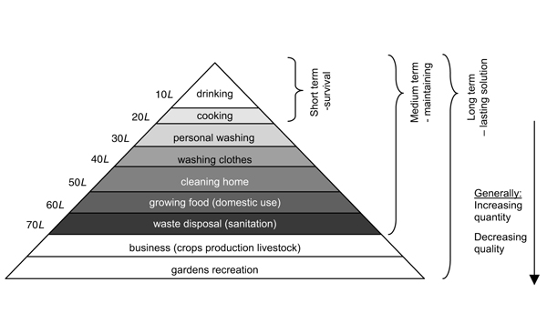
Figure 8. [From: WHO – Technical Notes for Emergencies Technical Note No. 9 Draft revised: 7.1.05]

- Note – where supply is via a existing piped system of safe water supply, it is NOT recommended that this supply system be used to provide untreated water. The recovery of such a system to a standard where safe drinking water can once again be delivered will take a substantial period of time, during which public health may be compromised. Equally consumers who are expected to do something different to normal – e.g. boil water before drinking where they do not normally do this, or use only for non-consumption purposes should be informed clearly by the supplier what they must do [link to communication chapter]. Very careful consideration should be given to the method of providing these volumes of water, and the quality requirements of the different uses.

- Where consumers are normally supplied their drinking water via a piped system (be it centralised or a community water supply and this is no longer available (or its use restricted, by an extreme event, then drinking water must be supplied to the community. An effective way to distribute water in the absence of the “normal” piped water supplies is via the use of mobile water tanks or storage units. These can be in various forms:
- Road Tankers / trailer tanks
- Pillow tanks / bags – large plastic water holders placed on the ground of back of a vehicle
- Bowsers / portable tanks (usually towed behind a vehicle to a static location)
- Bottled water

- Where possible use tanks and tankers dedicated to the carriage of drinking water and should be constructed of a material that would not be detrimental to the quality of drinking water held within it. Even where dedicated tankers are used then these should be disinfected prior to use (see below). Where suitable quality control measures are in place they these may be disinfected prior to an event and stored in a “ready” state for easy dispersal in an event. This must include suitable storage conditions (the tank must not be contaminated and satisfactory test samples should be obtained from stored tanks on a regular basis).

- Where containers are not dedicated to drinking then they should be cleaned, flushed and disinfected prior to use. The internal surface of the tank, together with internal surfaces of any fixtures or fittings (taps, pipework etc.) should be cleaned with clean water and detergent, then flushed with potable water (if possible via a pressurised supply/pipe) ensuring safe disposal of the flushing water. The tank should then be disinfected internally by the addition of a chlorine solution for 24hrs (for example 14% sodium hypochlorite solution for 24hours), and then rinsed (with safe, potable water), and refilled with a safe water supply. After at approximately 30 minutes standing time a sample of the tank contents should be taken to ensure it is safe to supply to consumers. The water should meet all local drinking water quality requirements, applicable to the manner in which it is supplied (and advice given to consumers).

- Suppliers should ensure that consumers are adequately informed about the purpose of the water supplied and what are appropriate uses and precautions to take. Suppliers should take into account that where consumers have to transport drinking water from a distribution point or temporary tank/bowser/tanker then the receptacle used do do this will introduce a risk to the safety of the drinking water. Even where the drinking-water stored in the temporary tank is safe, consumers should therefore be advised to boil (and cool) the water before consuming to mitigate the risks of contamination during carriage to their premises.

8.3 RECOVERING DRINKING SUPPLY

8.3.1 Drought

Replenishment of reservoirs
- We replenishing raw water storage reservoirs, reservoir managers should ensure that this is done in a controlled manner, so as not to impact adversely on the quality of water being abtracted for treatment. For example this may involve only allowing the reservoir to replish at a certain rate to avoid the disturbance of excessive debris, or ensure adequate dilution of a poor quality source.

- Suppliers should also take into consideration the impact on the aquatic system downstream of reservoir, and balance the needs of the drinking water supply with those of other downstream abstractors and possible environmental / ecological impacts.

- Suppliers should also be aware that some deterioration in raw water quality is seen several months or years later as a result of changes during a drought period. For example colouration of water from upland catchments containing peat soils (due to naturally occurring humic acids) has been seen to increase markedly in summers following a previous drought period. Thus ongoing assessment of risks from catchment areas, informed by local knowledge of catchment hazards remains important in the post-recovery period.

8.3.2. Flooding
- When recovering drinking water supplies after a flooding event it is critical that water suppliers work closely with community leaders and local health professionals/health departments, especially with regard to any precautionary measures that must be taken prior to consumption of water that is supplied (e.g. boiling).

- As a general principle, where possible water suppliers should prioritise the use of groundwater / well water where these are well protected (from a confined or well protected aquifer) in preference to using water taken from rivers or lakes (surface water). This is because the likely contamination impact on surface waters will probably be very much greater. However this will vary due to local circumstances, and a risk assessment, based on local knowledge of source waters should be used to prioritise their use for treatment and supply as drinking water.
Before restarting flooded treatment works and distribution metwork disinfection will require a number of planned actions that need to be taken and tailored for centralized, decentralized and community-based production utilities.
Key principles of recovery are summarized in the following table XX:

Table XX. Key Principles in recovering a water supply system
(summary table)
Recovering wells & boreholes | Start with most used /critical supply first  Assess damage: check pump, check borehole casings/void (using clean steel rod or dip tube)  Rehabilitate: clear borehole with compressed air, ensure headworks are above ground level and re-sealed, repair pump & ancilliary equipment.  Test pump output: pump out at least 2x borehole volumes, check clarity and basic quality. If not acceptable then re-assess and rehabilitate again (or if repeated then consider abandoning). Check pump output with required demand / pre-event output.  Disinfect: ENSURE NOBODY CAN USE DURING DISINFECTION. Check pH is between 6 & 8, and turbidity <5NTU. Add at least 1 litre of 0.2% chlorine solution for every 100litres water volume in the borehole & allow to stand for as long as possible. Flush until residual chlorine is <0.5mg/l.  Sample: Sample for indicator bacteria (evidence of pathogens). If possible ensure satisfactory samples from two seperate sampling exercises are obtained prior to supply to consumers.

Recovering water treatment works | Use skilled, experienced personnel (where possible who have a working knowledge of the particular WTW).  Reinstatement priorities should be as follows (complete all prior to supply to consumers):  - Ensure source protection as far as possible  - Reinstate physical treatment  - Reinstate disinfection  - Reinstate chemical treatment stages  - Reinstate non-critical treatment (in short term) stages  Follow same model as above:  Assess/rehabilitate/test/disinfect/sample.
Recovering small-scale piped water distribution systems | Follow principles from WHO technical note:  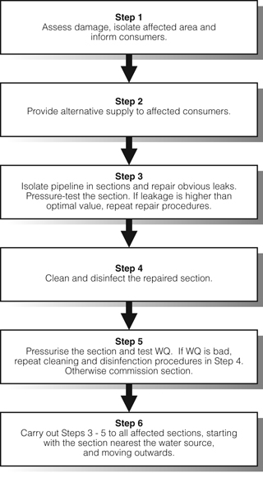

8.3.3 Disinfecting and restarting domestic networks (house connections and public buildings)
- Supplies should prioritise premises where vulnerable consumers may use the water supply (e.g. hospitals, health care centres etc.), and public buildings to ensure that risks to the general population are reduced. Remediation of domestic premises will be more complex and require

- It may require the utilisation of a dedicated workforce with knowledge of domestic plumbing arrangements to work alongside the population of an affected area in assessing risks and putting into place actions to remediate the domestic pipework.

- Remediation and recovery strategies for pipework within premises should be based on an assessment of risk of what contamination may have occurred during the extreme event. Where a risk of chemical contamination is present, depending on the nature of the chemical concerned, then domestic water systems may be remediated through simple flushing and sampling (to confirm safety of the water), through to a requirement to replace internal pipework (especially where this is plastic). Water suppliers should work with both building owners, and health professionals who understand the human toxicological profile of the substance concerned to determine an appropriate remediation strategy.

- Where the potential for contamination by pathogens is identified by the risk assessment then the domestic system should also be disinfected. The most effective way to do this is one premises at a time, ensure the supply is not consumed for a set period, introduce a high strength chlorine based solution into the distribution pipework (eg at the entrance meter or tank), allow to stand for severak hours (typically 2.0mg/l chlorine for at least 8 hours) and then flush the system until a low chlorine residual is obtained (typically 0.2 – 0.5 mg/l).

- If chemical contamination is suspected then remediation will be dependant on the nature of the contaminant but may vary from flushing or pipework, treatment with specific removal chemicals (and then flushing) through to complete removal and replacement of domestic pipework.

Case study UK summer 2007 flooding

WEATHER EVENT:
Wettest May – July period since records began (250yrs)
4 times the average rainfall
1 months rainfall in a 24hr period

IMPACTS
13 people died
Major disruption to essential services
>50,000 premises flooded
Several £billions in damage
Sewerage systems overwhelmed in many areas
300 sewage treatment works flooded
6 water treatments works shutdown
Mythe WTW (Gloucestershire) shutdown due to site flooding
No piped water supply to 340,000 consumers

EMERGENCY SUPPLY and RECOVERY
Alternative supplies provided by tankers, temporary tanks (bowsers) & bottled water
Full recovery of the supply system took 16 days
A combination of extreme rainfall following a prolonged wet period led to unprecedented flooding in parts of England and Wales in June and July 2007. This caused significant disruption to essential services – transport, electricity supplies and the provision of water and sanitation services. Floodwater levels were considerably higher than had previously been experienced and in many cases exceeded the levels that had been planned for.

Over 300 sewage treatment works were flooded and 6 water treatment works were shutdown due to flooding, including Mythe WTW which is the only source of piped drinking water to 340,000 consumers in Gloucestershire. Alternative water supplies were provided via mobile tankers, temporary tanks (bowsers) in the streets and bottled water. Full recovery of the piped water supply took 16 days.

Although there were no direct health effects reported as a result of the water supply interruption, the importance of a holistic (water safety plan) approach to managing risks throughout the water supply system was demonstrated. Existing plans to shutdown the WTW during flood events assisted in the recovery of WTW operations; and regulations to prevent major contamination of depressurised water mains was effective in reducing risks to consumers when water supplies were re-instated

However the recovery of the piped water supply was delayed by a lack of understanding of role and responsibilities of water suppliers by other agencies responding to the incident. In addition, inappropriate advice about water consumption was initially provided to consumers due to a lack of understanding of risk management in water supply operations.

Knowledge and understanding of the roles and responsibilities of responding organisations is therefore highlighted as a key learning point from this incident. Although a flood plan was in place at the site, the events of summer 2007 were more severe than the water supplier had been planned for. The need to re-think vulnerability assessments to take account of more extreme events is also highlighted as a key learning point.

Summary
- Climate change is likely to affect the availability and quality of raw water, which in turn could affect the efficiency of drinking water treatment processes and the stability of drinking water in distribution. More frequent extreme rainfall events could lead to increased surface water turbidity and higher numbers pathogens (and their indicators). This will result in a greater challenge for water treatment works, particularly surface water sites. Changes in rainfall may cause more frequent or intense period of water scarcity and/or drought. This will result in a decrease in available resource but may also increase the chances of resource contamination.

- Water suppliers can adapt to prepare for extreme events to minimise the impact of these events on consumers such as improving the resilience and interconnectivity of supplies, assessing risks to supply systems and treatment processes in advance and where possible put in place controls to minimise these risks. Besides recovery actions already summarized in the previous table XX, action to minimise the impact during an extreme event, will focus on:
  - Catchment:
    - rethink vunerability assessments
    - don’t rely on history, forecasts are short-term
    - Plan for more extreme events – rethink assumptions
    - Rainfall levels, flood levels, deterioration in raw water quality
  - Treatment works:
    - assess local risks & have a plan in place
  - Distribution:
    - assess risks & mitigation measures
    - Access to service reservoirs
    - controls to prevent contamination by “backflow”
  - Consumers:
    - assess risks in & from buildings in advance,
    - understand human behaviour in extreme events,
    - prepare clear information & advice

9 ADAPTATION MEASURES FOR DRAINAGE, SEWERAGE AND WASTEWATER TREATMENT

9.1 Climate change impacts on drainage systems, sewer systems and waste water treatment plants
- The climate change inevitably leads to changes in weather conditions in affected regions. Increase of average temperature and from this arising decrease of precipitation amount and its different spread out during the year, e.g. long periods without precipitations followed by the extraordinary strong flash rains can be expected.

- When speaking about the impact of climate change on the drainage/sewer systems and waste water treatment plants (WWTPs) it is important to consider changes in quantity and timing of precipitations (rainfall intensification, flash floods, long dry periods), air temperature rise, sea level rise and higher frequency of extreme weather events (decrease in return period of extreme events).

- Storms, heavy rainfall events and higher frequency of flood events require:
- quality protection of drainage systems, sewer systems and WWTPs against high peaks of hydraulic load;
- additional storm water storage in retention reservoirs and storm water tanks;
- treatment of the first flash storm water with high concentration of pollutants.

- Prolonged periods without any rainfall lead to:
- lower waste water discharge and consequent accumulation of solid waste sediments and incrustation in sewage conduits that can cause conduit clogging;
- decrease in wastewater flow and unpleasant odour from water rotting in the system;
- increasing population of rodents associated with increased quantities of sediments and solid waste in pipelines;
- growing risk of diseases dissemination;
- salt water intrusion especially in coastal agricultural areas causing degradation of sewer conduits and affecting the quality of waste water.

- Increasing in air temperature affects processes of wastewater treatment, either in the positive or the negative sense, especially due to:
- lower oxygen solubility in water can cause possible lower efficiency of active sludge compartment, which leads to higher consumption of compressed air in biological treatment process for the same treatment effect;
- higher dust concentration causes higher costs of air filtration;
- faster biological processes (activated sludge process, digestion) due to the higher air temperature
- more efficient sludge dewatering processes thanks to higher air temperature
- decreasing costs for heating up of anaerobic digesting facilities.

- One of the first steps leading to knowledge on impacts of weather events on drainage/sewer systems and WWTPs is the assessment of the risk levels related to the different weather events. In particular, such events as extremely intense rainfall and river flooding are characterized by a primary risk for public safety, while heat waves or extended droughts generally imply a delayed secondary effect on drainage and waste water systems.
- Decreasing dilution capacity of the receiving water bodies is an important aspect of the climate change because expected longer periods of droughts would lead to significant decrease in river flow. On the contrary, the pollution load of wastewater will be higher because of application of saving strategies in water supply and water use during dry periods, or due to the high pollution concentration in the first flash storm water after the dry period. Higher concentration of pollutants in the wastewater together with the decreased dilution capacity of the recipient would require increased WWTP`s purification effect and may even evoke stricter limits for discharge to recipient in order to keep current quality level of surface waters.

- When designing the measures for adaptation of sanitation systems on extreme weather events it is also necessary to know, that every extreme hydrological situation causes fluctuation of pollutant concentration in wastewater inflow to the WWTPs and thus affects the efficiency of the treatment process. The differences in biochemical load cause problems in different technological sections and related treatment processes.

9.2 ADAPTATION MEASURES ON URBAN WASTEWATER TREATMENT PLANTS BEFORE AND DURING DROUGHTS
- At first, it should be emphasised that from the point of view of drainage of urbanised areas, in contrast with extreme rains and river floods, which represent primarily a risk for safety of the inhabitants, also as a consequence of possible lower capacity of treatment by WWTPs, extreme droughts endanger in particular the environment and have lower immediate impact than other extreme weather events.

- However, the necessary management, maintenance and operational measures for mitigation of adverse effects of extreme drought on sewer systems and urban wastewater treatment plants (UWWTPs) should be mentioned. The following may be regarded as the main consequences of an extremely dry period:
- reduction of passability of sewage system pipeline through incrusts and sediments, and lengthening of the time of stay of wastewater in the sewage systems caused by partial of full blocking of pipeline;
- deterioration of water organoleptic properties - bad smell from the sewage system, as well as from the first UWWTP`s section;
- increased occurrence of rodents and other undesirable animals in the sewage system, and, as a consequence also in its vicinity;
- possibility of infection spread must be indicated as the most dangerous effect.

- Preventive measures must be organised in time, and planned as a part of standard UWWTP`s operation and maintenance linked to the average rain-free periods in the region. Cooperation with other organisations participating in city cleaning is advisable.

9.2.1 Maintenance of sewer systems in the time of an extremely long dry period
- During the period of long-term drought, periodical control and cleaning of electromechanical equipment and of sewage system pipelines and accumulation tanks should be carried out, in order to ensure their full hydraulic capacity, and to prevent accumulation of solids there. In the case of big combined sewer systems, regular and frequent cleaning of road and pavements (urban areas), and sewer system inlets and manholes is also important. During the long-term dry periods, it is recommended to rinse the sewer system pipelines by service water (water treated in the biological stage of UWWTP, to avoid wasting of water treated in water supply stations). For rinsing of urban surfaces, completely non-harmful disinfected water has to be used, according to public health regulations.
- Availability of simultaneous models used for identification of the most critical points from the point of view of sedimentation and hydraulic capacity is increasing in the present time. Extensive monitoring and measurements are necessary for calibrating these systems. It is also necessary to realize that mathematical models illustrating the rate of flow through sewage systems are less accurate in the area of minimum rate of flow. In some cases, sufficient information on possible sediment formation during extremely low rates of flow may be obtained only through monitoring of current status of pipelines.

- All usual, as well as exceptional maintenance procedures should be defined in the maintenance, crisis and emergency plans. The appropriate training of the staff and employees is also necessary so that they are able to identify risk, and to respond to it. In the case of extensive city sewage systems, maintenance of roads and sewer and drainage networks is usually carried out by several companies, and so the joint maintenance plan valid for all participating companies must be drawn up.

- It should be mentioned, that in coastal areas it is necessary to prevent infiltration of sea water to the sanitation system, whose function could be endangered by the salt in water (see chapter XX). As a consequence the pipelines should be waterproof and regularly checked.

9.2.2 Opration of UWWTPs in the time of extremely long dry periods - changes in hydraulic and pollution load
- UWWTPs appointed for wastewater treatment from combined sewer systems are usually constructed to be able to maintain high efficiency even during high fluctuations of rate of flow and pollution. In the period of longer droughts, and in the subsequent period of torrential rains, these fluctuations are even higher. Differences between the level of UWWTP`s pollution load in peaks of workdays, or during washing out of sediments from the sewage system, and the level of their pollution load during nights in the rain-free period are extreme. UWWTP`s technological equipment should be designed taking into account this fluctuation of pollution as well as hydraulic load.

- Important UWWTP`s technological adaptation measure for the periods of extreme droughts should be the possibility to regulate the amount of dissolved oxygen in activation tanks (the amount of air pumped into it), in order that conditions of operation of the UWWTP`s biological section in the time of extreme pollution load are similar as during the normal operation. On-line oxygen-measuring sensors would consequently help the regulation of the process.

9.3 ADAPTATION MEASURES BEFORE AND DURING FLOODS
- The knowledge of weather change indicators and provision of information on current weather conditions in the respective area are fundamental aspects of strategies for protection of sanitation systems against flash rains and floods. This enables appropriate response of the UWWTP`s management to the local climate changes, showing increased rains or decreased periods between flash rains, and prevents overloading and engorgement of sanitary systems.

- Potential vulnerability of the system during heavy rains and floods is related to the spatial variability of changes in hydrological conditions, type of drainage and sewer system (combined or separate sewerage system), type of technological process applied in waste water treatment (biological, physico-chemical), and also to the structure of drained area (centralised systems, decentralised local systems). Adaptation measures should be defined and implemented specifically according to the weak spots of the respective network.

9.3.1 Centralized drainage/sewerage systems and urban waste water treatment plants – preventive measures
- Centralized systems are often characterized by a large drained area with high share of built up area, served by one central main UWWTP with a dominant role and possibly several smaller facilities in the city outskirts. Vulnerability of centralized systems can be seen in the function of the central UWWTP. When an emergency situation occurs and the central UWWTP is out of order, all the wastewater from attached area is discharged into the receiving water body in one spot without any treatment. This unfavourable situation could have significant impact on surface water quality.

- Centralized urban sewer networks were often built stepwise during the history of the city and thus the combined sewer systems have been formed. Rainwater from built up areas (roads, pavements etc.) is drained together with the wastewater from households and industries. This type of combined system worked satisfactorily until a heavy rainfall event occurred, then the hydraulic capacity of the system was insufficient. Because of high concentration of pollution in the first flush water combined sewer overflows can be potential sources of pollution for the receiving surface waters. This problem can be overcome by installing retention tanks for storage of superfluous flush water, which can be treated on the UWWTP subsequently when the storm is over.

- In modern housing developments or in rural areas where no sewerage system existed before, separate drainage systems use to be installed. Separate drainage systems have two pipelines (branches), one for sanitary wastewater, which carries its content to the UWWTP and one for surface water (rain water) ending directly in the receiving water body. This type of sewer system is effective in controlling the flows to the UWWTP. Problems could arise with misleading connections and also with high pollution of surface water from the first flush.

- In adapting on climate change, proving as increased rains or flash flood, the preparedness and immediate feedback of sewer and UWWTP`s management play the key role in prevention of flooding of the systems. Old age of urban facilities can be a significant limitation. Structural parameters of the network can be insufficient for adaptation to changed hydraulic and chemical loads without problems. The adjustment of the whole hydraulic capacity of the system can be economically unfeasible. In these cases the risk of flooding of the system can be mitigated but not fully eliminated.

- The highest possible hydraulic capacity of the existing sanitation systems can be achieved predominantly by the periodical preventive maintenance of the system and its important nodes, including precise cleaning of drainage/sewer pipelines and fittings and its other parts to avoid overfilling or congestion of the system. Moreover, the pipelines must be kept waterproof and impermeable to prevent infiltration of wastewater to groundwater as well as not to allow penetration of water from outside to the sewers during flood. Machine and electric parts of pumping stations should be regularly controlled and maintained. Except for the ordinary electro-mechanical equipment, also spare flood pumps should be available for the emergency situation. Alternative electricity sources should be also prepared because power failure can often occur during floods.

- It is advisable that UWWTP`s managements develop and regularly update maintenance, crisis and emergency plans for sanitation systems for both extreme situations (floods and droughts), which provide operators with management rules and levels of critical indicators, which enable them to recognize the potential threat and to be able to respond on time and correctly to the potential emergency situation. Especially in the case of large systems, draining the extensive urban areas, including drainage of roads and other urban areas, where different parts of the system are being operated by different operators, the common maintenance and emergency plans are desirable aiming to secure permanent clearness of the whole system.
- Fundamental assumption of a well-prepared crisis and emergency plan is intimate knowledge and detailed mapping of the system. The best way would be use of easily available detailed plan in GIS form. Modelling of emergency situations for current weather conditions and also for expected conditions in the future enables to define weak spots in the system and to propose effective measures in planning procedure. The use of simulation models of storm water runoff in complex networks has recently increased due to their better accessibility and reliability. It should be mentioned that the accuracy of simulated scenarios primarily depends on a deep knowledge of the network, precise model calibrations based on measured data and skilled technical staff able to interpret the results (see chapter XX info needs).

- The precondition of a well-handled emergency situation is skilled staff capable to recognise the danger, analyse the risk and respond properly. The staff of the facility should be duly educated and the system regularly tested for emergency situations. Another important aspects are a good communication among all actors, system operators, owners, state administration, river basin authorities, management of official rescue system and all other stakeholders.

9.3.2 Decentralized and community-based sanitation systems – preventive measures
- Some issues concerning centralized sanitation systems mentioned above can be taken into account also when considering the decentralized and community-based systems. Nevertheless, the situation in this case is still different:
- decentralized systems are characterized by small-sized networks and facilities with limited budget;
- equipment of small-sized networks and facilities is usually not on the highest technological level thus during emergency situation it is less operative and effective;
- use of simulation models and telemetry systems may not be affordable, so the experience and knowledge of the network as well as of the whole equipment and of its reaction to the past critical events becomes more important (periodical surveys, register of critical situations during extreme events, etc.);
- extreme weather events usually do not culminate so often on a smaller area, although when it happens, it can hit a major part of the system. Response to the impact is therefore less flexible in terms of operational, hydraulic and treatment capacity.

- Impact of storm-water on decentralised systems can significantly increase the water flow fluctuation during rainfall events, so the construction of measures mitigating the water inflow to the UWWTP is highly recommended, e.g. separation between sewer and rain water drainage networks, which is possible if suitable natural receiving bodies for storm-water discharges are available.

- Operators of decentralized systems should closely cooperate with the state environmental authorities and with operators of the main centralised sanitation systems to use the experience and equipment of these organisations (it is advisable to sign agreements on cooperation in emergency situation).

- Many rural settlements are not equipped by the sewer and UWWTP. Wastewater disposal from households is secured by the small home WWTPs, septics or simply cesspools are used for biological waste. When small home WWTPs are being designed for wastewater disposal it is necessary to take into account the location of rural remote houses in flood prone areas.

9.3.3 Centralized drainage/sewerage systems and UWWTPs - protective measures during floods
- Even if weather forecasts are nowadays detailed and precise the assessment of extent of flash storm and its impact on the sanitation system is unpredictable. This is valid especially for extensive combined sewer systems. Flood does not only mean a temporary increased level of river or other surface waters during which the area in the proximity of the riverbed is flooded. The damage can be caused also by the water not being able to flow naturally away from any area or by the volume of rainwater exceeding the capacity of drainage system for a longer time.

- In long highly fluctuating rivers, flood waves generated by intense rainfall can propagate quite rapidly, with potentially dangerous effects on sanitation systems along the river as well as downstream on areas not directly affected by storm events. During flood surface water from the river can enter the sewer system through hydraulic connections between river body and sewer, e.g. through combined sewer overflows, weirs, outlets, leaky sewage conduits. UWWTP can be flooded also directly from the river or from the backwater in the surrounding area.

- Reasons leading to flooding of UWWTP can be insufficient flood protection, failure in the system or because of magnitude of the flood wave. Damages could be caused also by human factor when some duties given in emergency plan were neglected. Good management of sanitation system therefore requires deep knowledge of hydrological regime of adjacent surface water bodies. The operators should have good communication with river authorities, dam and sluices operators, flood protection bodies along the river and should be prepared to immediately install components of the flood mitigation and protection system (mobile flood protection walls, pumping devices etc.).

- Flood always covers all the hydraulic capacity of the drainage system. Natural gravitational discharge from drainage system or from UWWTP is gradually disabled and it is necessary to start operating of reserve pumping stations. That is why full operability of ordinary as well as emergency electromechanical equipment (flood pumps) of the sanitary system should be secured. Moreover electric generators should be on stand by as breakouts are frequent and the skilled staff should be ready to fulfil all duties embedded in the crisis and emergency plan. Vulnerability of the system is then strongly influenced by the number of pumping stations available to pump the excessive water back to the receiving water body. UWWTPs located on flat land are more vulnerable than those connected to the gravitation sewer. Special attention and equipment require UWWTPs located on the coast of the sea being endangered by the flooding during the sea storm.

- Full service of UWWTPs and pumping stations should be ensured as long as possible by continual control/maintenance of the electro-mechanical facilities as well as of the structural compartment of the system. Fundamental maintenance activities within the system are solid waste disposal and cleaning of sewer conduits, storm water tanks and other objects to keep maximum hydraulic capacity of the system.

- For large systems, a central operational unit should be in charge of supervising the response of the whole network, steering special maintenance teams and potentially alerting public and other stakeholders involved in the case of risk for public safety (sewer back- flooding of urban areas, possible contamination of sensitive areas with waste water, pollution of water bodies and groundwater sources, etc.).

- Simulating models can be applied for defining appropriate operative measures within the specific network during the extreme event in real time. The epicentre of extreme rainfall events is usually confined to a small area, so it could be possible to use the residual hydraulic capacity of drainage/sewer networks by regulating the flow or redistributing storm water towards the less loaded branches. This kind of measure requires interconnections between different parts of the sewerage network, installation and proper maintenance of automatic control system elements within the system, and a well-calibrated centralized system of real time control (RTC).
- The protection of the UWWTP must be based on the assessment of the real level of risk so that the operation of the UWWTP will be preserved and flooding of vital equipment and pollution of the surface water by washing out of different chemicals prevented. There are several practical advices how to protect the UWWTP against flood:
- structure of flood protection embankment around the UWWTP`s and sewerage facilities, possibly construction of mobile flood protection walls;
- close anti-backflow devices (valves, gates, sluices etc.) and use of pumping stations to protect the systems against the back wave from the recipient;
- location of essential UWWTP compartments above the level of flood with long return period (operation of this solution is more costly, because whole inlet has to be pumped up even during dry periods);
- use of principle of “containment” – crucial technology and electro-technical equipment are placed in one protective steel container or concrete structure assuring the safe operation of the facilities inside during the flood;
- remove and save store dismountable equipment of the UWWTP and of the sewer facilities to prevent its damage;
- remove all the chemical stuffs and other potentially dangerous contaminants from the area of UWWTP and sewer facilities to prevent additional pollution of surface and groundwater.

- During the flood the UWWTP should be kept in operation as long as possible even if the most of the wastewater is treated only partially. High dilution capacity of the receiving water body during flood enables to keep an acceptable quality of water, even if only part of the incoming wastewater, to which the UWWTP is designed, is treated completely.
In the case that flood protection is overcome and the situation does not allow operation of the UWWTP anymore, firstly electrical devices (pumps, compressors, in general electric devices that are needed for recovery of wastewater treatment plant should be removed to avoid any damage caused by rising water.

Case study :Scenarios of water entering UWWTPs` area during the 2002 flood in the Czech Republic.
During the big 2002 flood in the Czech Republic several tens of large UWWTPs were flooded. The scenarios were different and they can be divided into four categories:
- overflowing of flood protection embankments because of rising water level in the river (e.g. central UWWTP in Prague);
- flooding of waste water treatment plant area from the flooded surrounding because of insufficient flood protection upstream (e.g. UWWTP in České Budějovice);
- flooding of WWTP because of too large inlet of water from the river that entered drainage and sewer systems through insufficient anti-back flow devices (e.g. UWWTP in Teplice, UWWTP in Ústí nad Labem);
- flooding from back-flow water coming from downstream.

9.3.4 Decentralized and community-based sanitation systems - protective measures during floods
- Very often the operators of decentralized sanitation systems are not prepared enough to handle emergency situation without help of professionals, mostly because of lack of reserve technology (reserve pumps, tank trucks etc.) and sometimes also because of insufficient expertise of the staff. Good cooperation with the state administration and with operators of central UWWTPs or with other organisations owing the necessary equipment during emergency situation can help to overcome this problem.
- Activities that have to be done during and after the flood (until total recovery of the system) are:
- to avoid release of contaminated water and especially contaminated sludge from cesspools and septics into the surface and groundwater;
- to protect drinking water resources, wells and bore wells from contamination by polluted flood water;
- to keep the sanitation system working as long as possible;
- if necessary to remove all electric devices from pumping stations and small house WWTPs endangered by flooding so that it can be used for smooth start of the system after the flood;
- after the flood remove all sludge from cesspools and sceptics’, to have it treated in the nearest UWWTP and start to operate them as soon as possible;
- to rinse flooded sewer with pressure water if needed and reset the operation of the local sewer system and UWWTP as soon as possible.

- In rural areas it is very important to observe basic hygienic requirements: to prevent massive escape of dangerous bacteria to surface water and groundwater and to keep the sanitary system in operational status as long as feasible, or in the status that can be as quickly as possible recovered to the operational one.

9.4 RECOVERY OF SEWAGE SYSTEM AND UWWTP`S FUNCTION
- Once the extreme weather event is over, damage assessment is the fundamental part of the recovering procedure. It must be carried out as quickly and thorough as possible, it is necessary to identify the most affected areas, and to define priorities and the necessary aid, in order that management of recovery is rational, and not chaotic. Further, it is necessary to carry out first analyses of what actually happened during the flood, and to roughly assess impacts and direct causes of the event (i.e., especially identify insufficient flood protection measures in order to improve them in the future). Later, it is necessary to draw up a deeper estimate of risks and analysis of the individual aspects of the extreme event and its effects. For this secondary process, it is important, in particular:
- specify all critical elements in the system, in relation to the extreme flood event;
- develop an expert analysis on the basis of newly collected data;
- design new measures;
- improve infrastructure for any possible future extreme event.

9.4.1 Recovery and restart of drainage/sewer network operation
- In particular the following activities should be mentioned as basic operations ensuring restoration of functions of the drainage/sewer system after the extreme event:
- restart normal operation - through a special service team, working uninterruptedly 24 hours a day, function (passability) of conduits and of the main pumping stations collectors in the sewer network should be verified and restored;
- perform uninterrupted centralised monitoring of functions of the drainage and sewer system main junctions, accumulation tanks, pumping stations etc.;

- Long-term impacts of possible service failures on the local inhabitants should be mitigated. In this critical period, it is necessary not to neglect relations with the public and stakeholders, which can be encouraged through timely provision of information and promptly dealing with all complaints.

9.4.2 Recovery and restart of the UWWTP operation
- Similarly as in the case of restoration of sewer network function, restoration of UWWTP operation after flood has to be started immediately after the danger passed off. Procedure for start of UWWTP operation is as follows:
(a) General primary measures:
- making all area of the UWWTP accessible and documenting damage;
- gradual removal of dirt, disinfection and cleaning of buildings and technological equipment (if necessary);
- drawing up of a plan for restart procedure of the UWWTP operation;
- assessment of structural stability of buildings and structural compartmetns.
(b) Technological measures:
- ensuring electrical energy supply;
- making wastewater distribution systems and the bypass systems of the UWWTP passable.
(c) Technological start of the UWWTP operation (putting into operation):
- start of pre-treatment (grating, grit chamber, grease trap) operation, for the present time with bypass of sedimentation and biological stage;
- start of sludge management operation (at least storage reservoirs) - this is the necessary precondition for start of primary sedimentation operation;
- start of operation of mechanical treatment stage, and chemical precipitation in sedimentation tanks (its preconditions are functional pre-treatment and sufficient capacity for sludge storage);
- start of operation of the aeration system, and subsequently gradual putting of the biological stage into operation (its precondition is functional primary sedimentation);
- gradual putting of automated management systems into operation, preceded by the manual dispatcher control.

- The most difficult part of the procedure is gradual putting the biological treatment stage into operation. During the flood, activated sludge is usually washed away from the tanks, or its decay takes place (similar situation occurs by the process anaerobic sludge stabilisation in sludge digestion tanks). It can be done by:
- inoculation with sludge from another UWWTP;
- "cultivating" of new active sludge without inoculation;
- using the original sludge, although decayed, which has not been washed away, thanks to the sedimentation in the biological stage tanks after aeration switch off and before inflow of flood water (the best functioning method).
(According to the experience from the Czech Republic in 2002, reaching of the biological stage performance comparable with the original one takes several months, regardless of the way used for putting of the activation tanks into operation).

- To speed up the process of putting of the UWWTP into operation after flood, it should be modified according to the level to which the UWWTP was affected by the flood, and according to the respective method used for putting operation of the UWWTP out of order before flood. For example, if the electrical equipment was protected against the flood by means of dismantling, part of the procedure is not its cleaning, but its re-assembly. If some of the UWWTP stages was/were not affected by the flood thanks to partial success of flood protection measures, the procedure of putting of the UWWTP back into operation is shorter and less complicated. However, the sequence of putting of the individual UWWTP stages into operation always has to be kept.

9.5 SPECIFIC ISSUES OF INDUSTRIAL WASTEWATER TREATMENT PLANTS
- The functioning of industrial wastewater treatment plants (IWWTPs) can be threatened especially during floods. Flooded and washed out IWWTP can represent enormous danger for people and for environment due to the possible presence of hazardous substances.

- With regard to the fact that the industrial facilities use different technologies for wastewater treatment according to the quality of treated wastewater and the chosen techniques, the flood protection strategies and damage recovery in IWWTP would require specific approach. Besides the basic principles applied by UWWTP, protection of IWWTP against flood would require specific crisis and emergency plans, including accident emergency warning systems connected to the national one, and individual detailed analyses of technology/technique, equipment and used and discharged chemicals. Industrial wastewater, sludge and chemicals stored and used in the process have often to be treated as hazardous and thus regulations valid for hazardous substances have to be highly respected. Special training of the staff is inevitable.

- Flood protection measures in IWWTPs and recovery activities should take into account special technologies used as a part of industrial treatment process, which require special approach, not usual by UWWTP. Beside protection of special electrical equipment (e.g. for electro-flotation), safe intermediate storage of contaminated wastewater, sludge and other chemicals should be designed (for example safe tanks, flood protected industrial lagoons for liquid hazardous wastes etc.).

- During flood an emergency situation can develop not only as a threat to surface or ground water, but also to another parts of environment (contamination of soil, toxic gases emissions etc.), therefore the operators should be educated and prepared to respond also to these situations.

- During the flood it is recommended:
- to ensure good functionality of pumping stations, in order to ensure their continual operation to avoid releases of untreated industrial wastewater into surface or groundwater;
- to protect each compartment of IWWTP against flood, including temporary toxic sludge storage;
- to install (temporarily or permanently) equipment for wastewater treatment as mobile ones with possibility to operate these transportable devices above the level of flood water to avoid untreated water to release into surface or groundwater;
- to keep the internal warning system signalising the defects in the IWWTP in operation even during the flood;
- to be prepared to clean all the contaminated equipment and to dispose hazardous toxic waste water and sludge. For this purpose a recovery plan using all preceding experience can be developed. In no way wastewater or sludge with hazardous substance can be released into surface or groundwater.

- The guidelines for IWWTPs to recover after flood are basically the same as for large UWWTPs – accessibility of area, damage assessment, re-establishment of source of electrical power, sewer conduits cleaning and stepwise recovery of all treatment processes (from preliminary treatment to automatic control systems). It is obvious that if some of the processes were under operation also during flood, recovery process would then be much faster.

Damage caused by the 2002 flood to IWWTP in Roztoky in the Czech Republic, where the wastewater from pharmaceutical industry is treated
The IWWTP has anaerobic mechanical-biological treatment process. The purification is further completed in UWWTP. Load of the wastewater treatment plant is 72 000 P.E. and inlet is 840 m³/day. During the extreme flood it was totally flooded. Water level in the receiving river overcome 6 m high flood protection embankment with 1.4 m thick overflowing jet. Floodwater pressure elevated the gas tank even with the basement, building of engine room was damaged, tank for chemical injection floated 100 m far and other tanks were fixed to their places just by the pipeline fittings. All electro-motors and control systems were destroyed. Total costs of recovery reached 29 % of budget for preceding reconstruction in year 2000. The wastewater treatment plant was put into operation after three months.

After the experience gained from the 1997 and 2002 floods in the Czech Republic, flood protection measures on IWWTPs should be an important part of crisis and emergency plan, which is dealt with when the administrative permission for IWWTP is being issued according to the Czech regulations.

Summary
- Climate proofing of centralized middle to large-sized drainage and sewerage networks consists of a wide range of preventive measures with both direct and indirect effects on the impact of extreme weather events. For both centralized or decentralized system managements, the editing and the diffusion of a fully comprehensive emergency plan is fundamental in order to prepare operative staff to recognize and react to defined risk levels. In particular, a warning system may be useful in case of inefficiency that can cause safety risks.

- Furthermore, weather sensitive design criteria are the primary means for climate proofing in new drainage networks. Their dynamic adaptation to local climate changes, such as rainfall intensification or reduction of extreme events’ return time, is fundamental to avoid frequent saturation of the drainage network. However, metropolitan drainage and sewerage systems can be very old and an adjustment of the whole hydraulic capacity to fast climate modifications is often economically unsustainable. The risk of floods in urban areas can therefore be reduced, not eliminated.

- In existing networks, the highest hydraulic capacity should be assured by undertaking periodical maintenance and cleaning of the most significant nodes of the network. In the case of large systems where road drains, drainage and combined sewerage might be managed by different companies, coordinated maintenance plans would be recommended.

- The full service of treatment plants and pumping stations should be ensured by periodical maintenance of the structures and the electro-mechanical components and by providing the stations with emergency electrical generators, as one of the effects of extreme rain events are often local electricity breakdowns. Prior to this is the detailed and widespread knowledge of the whole network which, especially in large and old draining systems, often requires long and expensive surveying campaigns finalized with the construction of a geographical information system (GIS) in order to make the information easily accessible by different users.

- In recent years, the use of hydrodynamic models to simulate the effects of rain events on large combined sewer networks has become more and more accessible. Collecting the simulated data from an adequate series of possible hypothetical weather scenarios can allow a centralized supervisory to predict the most critical nodes of the network depending on the localization and the intensity of a storm, and thus direct emergency operations in advance. Moreover, RTC methods based on a centralized telemetry structure are nowadays fundamental means for the management of complex drainage and sewerage systems.

- Prolonged floods can also be considered extreme events for all the drainage and sewerage systems characterized by hydraulic connections with water bodies such as combined sewer overflows (CSOs), discharge channels or non impermeable sewers within flooding areas. In long highly variable rivers, in particular, flood waves generated by intense rainfall can propagate quite rapidly, with potentially dangerous effects on downstream drainage systems not directly affected by storm events. A good management of a drainage system highly interconnected with main water bodies could therefore require: a deep knowledge of their hydrological regime; a close relationship with river authorities and entities managing dams or locks potentially existing upstream or downstream of the interested area; the installation of flow regulating organs wherever water bodies can interfere with the drainage network capacity (anti-backflow valves, movable CSO weirs, RTC regulated pumps, etc.).

- Extended drought periods normally have a much less critical effect on drainage and sewerage systems. Incrustations, unpleasant odours and, in the worst case scenario, disease diffusion could be the effect of an extremely long dry period on combined sewers in a densely populated area; although it is not a major issue for well designed covered sewers.

- Persistent droughts can also have an environmental impact once intense rainfall events occur directly after them and exceed combined sewer capacity. First storm water spilled by CSOs has been proved to have a significant polluting impact on receiving bodies, with immediate local effects on their quality, for which reason the main treatment plants should have first storm treatment compartments (although a potential reduction in the biological treatment efficiency due to storm water should be taken into account). In fact, as concerns wastewater treatment, extreme weather events impacts affect the purge capacity of the plants since the wastewater input pollution load changes giving problems to the following compartments and processes of the entire treatment system.

- Being generally characterized by small-sized networks and limited budgets, decentralized systems are subject to different constraints to climate proofing management, such as:

- intensity of the events: extreme weather events reach their acme more rarely on a smaller area of interest, although when it happens they can involve a major portion of the system, whose response to the impact is therefore less flexible in terms of operational, hydraulic and treatment capacity;
- the use of simulating models and telemetry systems may not be economically sustainable, while the knowledge of the network and of its reaction to past critical events becomes more important (periodical surveys, register of extreme events’ criticalities, etc.);
- the impact of stormwater on country or rural based systems can significantly increase the flow variability during rainfall events, so that the separation between sewerage and drainage networks is highly recommended (especially in case of high availability of natural receiving bodies for stormwater discharges);
- in the possibility of rural houses in flooded areas, it is necessary to make a careful planning and management of domestic treatment plants.

- In general, decentralized systems should have tight interactions with the main environmental authorities and even agreements with centralized systems’ managements for emergency interventions.

CASE STUDY: Flemish Environment Agency. Sewerage network and sanitation planning, management and recovery in case of extreme events

Planning of waste water infrastructure for extreme events
In the Flemish Region, since many years, the use of hydrodynamic models to simulate the effects of rain events on the sewer networks is widely integrated and applied in the processes of planning, designing and construction of new sewer networks, as well as in the optimisation of the existing sewer networks.
Extensive drought periods do not occur in our region in such conditions and/or extremity that they have a critical effect on the drainage and sewerage systems. However they can have an environmental impact when followed by intense rainfall events, since in the Flemish Region the majority of the sewer networks consist of combined sewerage systems.
Therefore the collecting systems are constructed following standards:
- allowing extensive volumes (minimal 6 times the volume of the dry weather flow) of a mixture of waste water and rainwater to be transported towards the centralised treatment facilities;
- limiting the pollution of receiving waters due to storm water overflows to a maximum of 7 days of overflow / year.
In addition, the construction of sewer networks has since more than 10 years evolved into separated systems. This decoupled system aims at preventing the rainwater to flow into the sewer networks and at keeping the rainwater where it falls in order for it to infiltrate back into the ground. This evolution enlarges relatively the existing hydraulic capacity of the sewer systems for events of extreme rainfall.

Management of waste water infrastructure for extreme events
As for management, sewer systems need to have a sufficient dimension to prevent untreated waste water from overflowing into the rivers and treatment plants need to treat sufficiently high volumes of a mixture of waste water and rainwater in case of intense rainfalls. Since several decades, it has always been the standard in the Flemish Region to secure a biological treatment of a volume equal to 3 times the dry weather flow (3Q14, in else more than 5Q24) and to provide a primary treatment on a equal supplementary volume. About ten years ago, a study of Aquafin, the public limited company responsible for the construction and the management of the treatment plants and the large collecting systems of the Flemish Region, showed that the entire volume collected towards the treatment plants (thus 6Q14, in else more than 10Q24) can be treated biologically (secondary and in most cases tertiary treatment, to remove nitrogen and phosphorus) without substantial costs. All renovated and new treatment plants and/or treatment plants where this could be implemented without excessive costs now have these treatment facilities. Moreover, Aquafin continuously monitors the system’s functionality of all treatment plants and crucial pumping stations of the sewerage network to prevent ecological damage at most in case of a dysfunction. This continuous monitoring, with linked alarm system, enables a quick response in case of extreme events. Since 2008, the Flemish Region is implementing a supplementary control system on the good management of the treatment facilities via a quotation on different indicators, such as the continuous functionality of the treatment plants and the pumping stations and the adequate reactions in case of dysfunction.

Restarting wastewater treatment plants after flooding (recovery)
In the Flemish Region, the functionality of wastewater treatment plants is rarely affected by flooding events. The recovery activities were limited to the restarting of the installations due to power cut-offs.

Monitoring of waste water infrastructure: storm overflows
The Flemish Environment Agency (VMM) is responsible for the ecological supervision of the waste water treatment infrastructure. Since 2002, VMM has elaborated a network of measuring stations to monitor the effects of storm overflows on the surface water quality. This storm overflow network consists of 250 measuring stations running on solar energy which monitor overflow infrastructures 24/7 with level sensors and quality sensors (turbidity, conductivity, temperature,...).

After a few years of measuring expertise, following conclusions can be made:
- the expected maximum duration of overflows working, namely 2% on a yearly base, was an underestimation. An average of 3.4% has been measured;
- the data of the measuring stations have revealed several bottlenecks, resulting in local adaptations on the infrastructure and further optimisation of investments in the sewer system;
- the monitoring network is used as an instrument to support grants or refusals for companies to connect to the public sewer system.
Since 2008, VMM has redirected the measuring stations to critical points in the sewer system like certain treatment plants and pump stations. These critical points will also be monitored by the wastewater treatment plants and local/municipal authorities by means of additional flow measurements in order to improve the waste water collection, transportation and final treatment.
As a result, a better interaction of the (critical) pump stations should minimize the overflows with positive effects on the surface water quality.
- 10. SUMMARY AND CONCLUSIONS

According to EM DAT criteria
EM−DAT: The OFDA/CRED International Disaster Database − www.emdat.be − Université Catholique de Louvain, Brussels − Belgium
EM DAT data base glossary
IPCC Technical Paper VI – Climate Change and Water (June 2008). http://www.ipcc.ch/ipccreports/tp-climate-change-water.htm ? WHO/JRC – EC/EEA (2008) “Impacts of Europe’s changing climate – 2008 indicator-based assessment” EEA Report No 4/2008 JRC Reference Report No JRC 47756 EEA (p 178) Copenhagen available from URL http://reports.eea.europa.eu/eea_report_2008_4/en/ accessed November 2008.
In this paper, the term “water services” is consistent with the definition given in Art 2 § 38 the European Water Framework Directive: “ all services which provide, for households, public institutions or any economic activity: (a) abstraction, impoundment, storage, treatment and distribution of surface water or groundwater, (b) waste-water collection and treatment facilities which subsequently discharge into surface water”
Anon. “Adaptation – an issue brief for business” WBCSD Geneva
EUREAU Position Paper “Climate change and Water and Waste Water Services” Note URL: http://www.eureau.org/page.php?id=6 accessed 5 November 2008
Report of the World Water Week Seminar "Europe’s Sanitation Problem”, 2008
1) Effectiveness of urban wastewater treatment policies in selected countries: an EEA pilot study “, EEA, 2005; 2) Analysis of Drinking Water and Wastewater Services in Eight European Capitals : the Sustainable Development Perspective, BIPE, 2006;
EU coastal pop
(http://www.clemson.edu/turfornamental/tmi/Irrigation/Irrigation%20Water%20Quality.pdf)
This evidence is still underreported, as causes of death have been attributed instead to cardiovascular and respiratory diseases. An increased risk of dying was found among individuals with pre-existing illnesses, for example, heart disease, cerebrovascular disease, respiratory diseases, blood and metabolic/endocrine gland disorders, cardiopulmonary and genitourinary disorders. Elderly people are most at risk because ageing impairs the body’s physiological capacity to regulate its own temperature (thermoregulation). Children, people with chronic diseases, and those confined to bed, need particular care during extremely hot weather (Matthies et al., 2008).
Legionella pneumophila is the well known agent of this pneumonia, especially fatal in elderly people. Outbreaks of legionellosis have been reported from all countries in Europe, many of them linked to hotels and other types of holiday accommodation, or to those systems where water temperature is higher than ambient temperature. Legionellosis is indeed caused by aerosols from contaminated potable water distribution systems, cooling towers, building water systems, respiratory therapy equipment and hot tubs, but the presence of Legionella spp. in these artificial water systems depends ultimately from the reproductive success of the bacterium in natural environment (WHO 2007).
In humans, Naegleria fowleri can invade the central nervous system via the nose, more specifically the olfactory mucosa and nasal tissues, resulting in significant necrosis of and haemorrhaging in the olfactory bulbs. From there, amoebae climb along nerve fibers through the floor of the cranium via the cribriform plate and into the brain, becoming pathogenic and causing primary amoebic meningoencephalitis (PAM or PAME) (Vivesvara et al., 2007).
Acanthamoeba is capable of causing several infections in humans like Acanthamoeba keratitis, a local infection of the eye that can result in permanent visual impairment or blindness (Anger et al., 2008).
Long term effects are known for one congener (MC-LR) and for NOD, and due to MC tumour promoting activity, IARC has recently classified them as possible human carcinogens (class 2B) (IARC, 2006). Other important groups of toxins are the neurotoxins (e.g. anatoxin-a and the Paralytic Shellfish Poisoning (PSP) toxins) and the cytotoxin cylindrospermopsin, for which genotoxic and possibly carcinogenic effects have been hypothesised. The toxicity of a given cyanobacterial bloom is determined by its strain composition, i.e., the relative share of toxic versus nontoxic genotypes (Kurmayer et al., 2002).
World Health Organization (2004) “Guidelines for Drinking-water Quality” WHO Geneva p48 available from URL http://www.who.int/water_sanitation_health/dwq/gdwq3rev/en/index.html accessed 4 November 2008
World Health Organization (2008) “Water Safety Plan Manual: Step-by-step risk management for Drinking-water Suppliers” WHO Geneva / IWA
See for example Reece J (2002) “Urban water and sanitation services: an IWRM approach” TEC Background Papers 11. Global Water Partnership.
Timmermans J Eds Guidance on Water and Climate Change UNECE Geneva to be verified
The term “water suppliers” is used to collectively describe the organisations primarily responsible for the supply of drinking water. This may include private or public water utilities, (local or regional) public authorities or councils, or national / federal organisations

