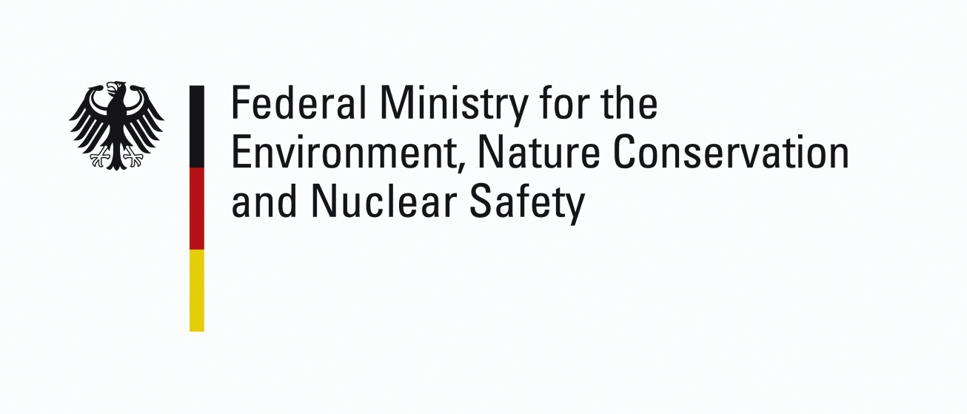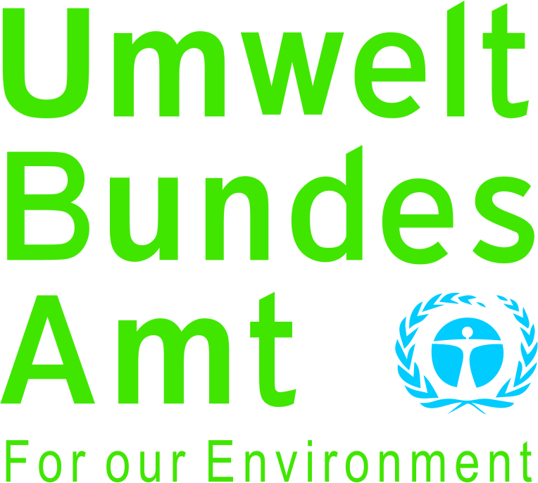

INTERNATIONAL WORKSHOP
on the project
ASSISTANCE TO RAISING KNOWLEDGE ON INDUSTRIAL SAFETY AT UNIVERSITIES

REGISTRATION FORM
Armenia (Yerevan), 26 March, 2013

Please complete and return this form before 28 February 2013 to:
 |  | and a copy to:
“Eco Peace” scientific, ecological NGO  Sheram str. 111, apt. 24, 0034 Yerevan, Armenia  Kristine Sahakyan  Tel: (+374 91) 52 93 27  E-mail: eco-peace@rambler.ru |  | Federal Ministry for the Environment, Nature Conservation and Nuclear Safety  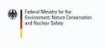  UBA, Z6, Wörlitzer Platz 1, 06844 Dessau  Gerhard Winkelmann-Oei  Tel: +49.340.2103.3298  E-mail: gerhard.winkelmann-oei@uba.de
 | Participant of Country, institution/organization
 | Division, your position

Participant |  |  |  | Family Name |  |  |  | First Name
Mr.
Mrs.
Ms. |  |  |  | Date of Birth |  |  | (DD/MM/YYYY)
Address of the institution/organization (in full):
 | Home address (in full):
 | Phone number:
 | E-Mail address:
Describe the motivation for your participation

Language Preference | English |  |  |  | Russian
Date |  |  | Signature

