Indico registration for participants

The website for registering into a United Nations official meeting is : https://indico.un.org

Please use firefox or google chrome browser only

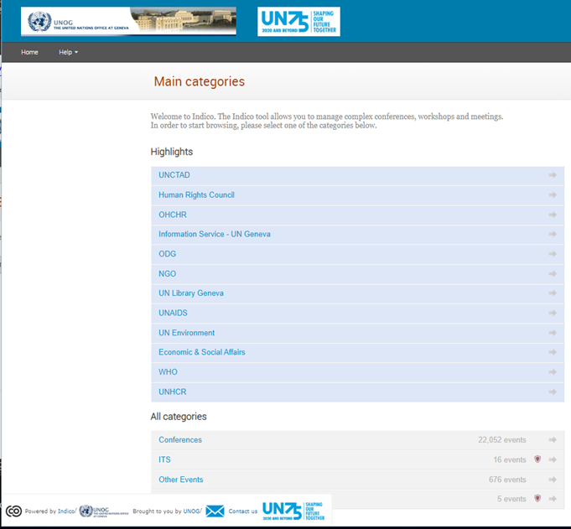

All meetings organized by the Environment Division will be under:
All categories » Conferences » ECOSOC » UNECE » ECE/PP

Registration
A registration link will be provided on the meeting webpage and the Invitation email sent by the Secretariat.
The registration link will take you to the meetings registration page similar to the attached image below.
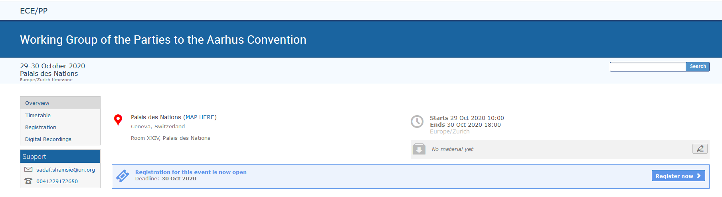

Click the Register now button and the login window below will appear:
Login in if you already have an Indico account or create a new account for new users.
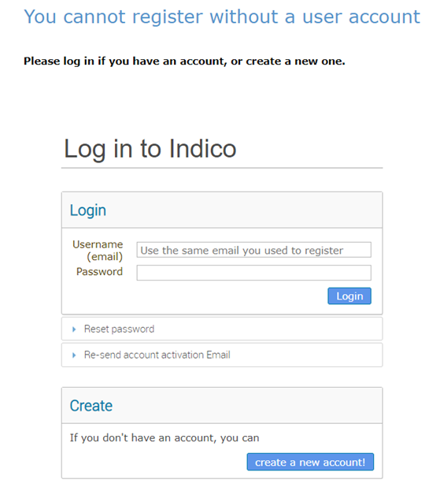

New Indico user account creation:
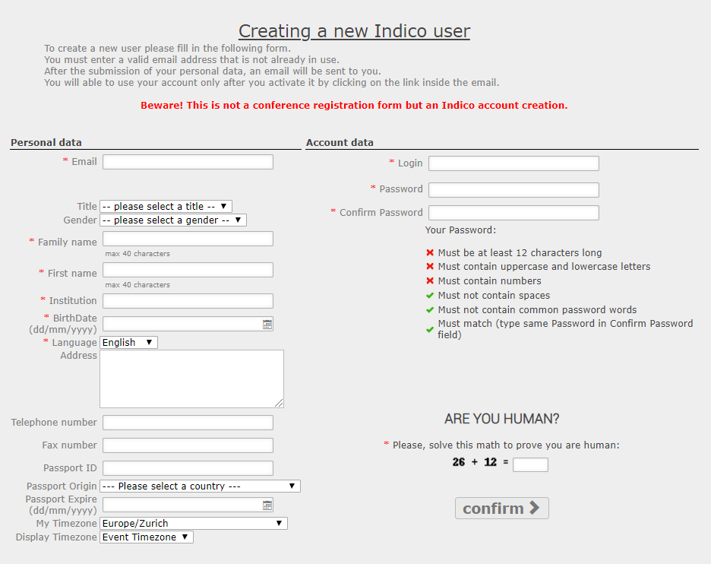
You will receive a confirmation email once your request is accepted.
You can now go back to the meeting registration page and login using your Indico account.
Once your registration is approved a UN EVENT PASS will be available for you to download from your account.

