Second Spanish Implementation Report of the Protocol on Pollutant Release and Transfer Registers.
(Kiev or PRTR Protocol).
(2014-2016)
In accordance with the Decision I/5 (ECE/MP.PRTR/2010/2/Add.1) and the Decision II/1(ECE/MP.PRTR/2014/4/Add.1)
January 2017

www.prtr-es.es

Summary

0.-CERTIFICATION SHEET 5
1.-Information related on the process for the preparation of this report. 7
2.-Information related on the Protocol requirements. 8

ANNEXES:

ANNEX 1.Decision I/5: http://www.unece.org/fileadmin/DAM/env/pp/prtr/docs/ece_mp.prtr_2010_2_Add.1_e.pdf.
Decision II/1:
http://www.unece.org/fileadmin/DAM/env/pp/prtr/MOPP2/Post-session_documents/ECE.MP.PRTR.2014.4.Add.1_e.pdf

ANNEX 2. List of industrial activity categories which have to report to national Spanish PRTR system.

ANNEX 3. List of the public authorities involved in PRTR-España Regsiter both the national and regional level.

ANNEX 4. Additional information on PRTR-España system: www.prtr-es.es. How to use the web page: examples of queries and specific searches on the public information, Downloads and available ways to enhance the public participation.

ANNEX 5. Main capacity-building, training and promoting activities developed by PRTR-España.(Updated information including the activities undertaken in 2014-2016)

0.-CERTIFICATION SHEET
Protocol on Pollutant Release and Transfer Registers Implementation Report in accordance with Decision I/5 (ECE/MP.PRTR/2010/2/Add.1) and Decisión II/1 (ECE/MP.PRTR/2014/4/Add.1)
CERTIFICATION SHEET
The following report is submitted on behalf of

____SPAIN (ESPAÑA)____________________________
[name of the Party or the Signatory] in accordance with decision I/5
Name of officer responsible for submitting the national report: | Ms Carmen Canales Canales
Signature:
Date: | January 15th, 2017
IMPLEMENTATION REPORT
Please provide the following details on the origin of this report.
Party/Signatory | SPAIN
NATIONAL FOCAL POINT
Full name of the institution: | MINISTRY OF AGRICULTURE AND FISHERY, FOOD AND ENVIRONMENT.
Name and title of officer: | Dña. Carmen Canales Canales,  Head of Unit of Industrial Environment.  Deputy Directorate of Air Quality and Industrial Environment.  D.G. of Enviromental Quality and Assessment and Natural Affairs.
Postal address: | Plaza de San Juan de la Cruz, s/n. 28071. Madrid.
Telephone: | + 34 915975418
Fax: | +34 915975955
E-mail: | info@prtr-es.es/ ccanales@magrama.es.

Contact officer for national report (if different):
Full name of the institution: | PRTR-ESPAÑA, Spanish Register of Emissions and Pollutant Sources. (Administrator of the Spanish PRTR system).
Name and title of officer: | Dr. Iñigo de Vicente-Mingarro
Postal address:
Telephone: | +34 902545350/+34 917499121
Fax: | +34917499140
E-mail: | info@prtr-es.es
Designated competent authority responsible for managing the national or regional register (if different): | idem
Full name of the institution:
Name and title of officer:
Postal address:
Telephone:
Fax:
E-mail:

1.-Information related on the process for the preparation of this report.
Provide a brief description of the process by which this report has been prepared, including information on which types of public authorities were consulted or contributed to its preparation, how the public was consulted and how the outcome of the public consultation was taken into account and on the material which was used as a basis for preparing the report.
This 2nd PRTR Protocol implementation report has been prepared by the Industrial Environment Area, which is the Departament responsible for managing the Spanish PRTR Register: PRTR-España, (www.prtr-es.es).
This second National Implementation Report (NIR) has been drawn up on the basis of the 1st NIR (2010-2013) submitted to the UNECE Protocol secretariat in December 2013.
The 1st Draft was made available to the public for comments and remarks from September, 9th, to October, 7th 2016 inclusive. (http://www.mapama.gob.es/es/calidad-y-evaluacion-ambiental/participacion-publica/segundo_informe_implementacion_protocolo_prtr.aspx).
Also, it was distributed to different departments and relevant authorities, at national and regional levels (Regional Government and responsible areas of air, water, soil and waste), as well as other public bodies..Finally, it was also made available on the Spanish PRTR webpage from September, 1th to December 30th 2016 to be consulted and downloaded and submiiting coments/remarks through suggestion box and/or e-mail (info@prtr-es.es).

No comments or remarks were received to this first draft from any entity, organizations, departments, NGOs, public /private institutions nor from the public in general. Only those related to update the name of the PRTR regional/national competent authority departments/institutions,where appropriate.
Once finalished the timing for submitting the pertinent observations, the final version of the report was eventually drawn up.
The final version of this 2nd NIR is submitted to the Protocol Secretariat (UN/ECE) according to the format and procedure stablished in the Decision I/5 (ECE/MP.PRTR/2010/2/Add.1) and the Decision II/1(ECE/MP.PRTR/2014/4/Add.1).
Shipping in Spanish and in two of the oficial languages of the Protocol, English and French. The report, in its three versions is completed with additional information (Annexes 2, 3 4 and 5, in hard copy and .pdf formats. Annexes are only included in English in all cases).
PRTR-España, permanently provides with open channels to receive feedback, comments and suggestions (both in Sapnish and English): info@prtr-es.es; mailbox for suggestions on the webpage (http://www.prtr-es.es/Sugerencias; http://www.en.prtr-es.es/Sugerencias), information Services of the Ministry: http://www.magrama.gob.es/es/ministerio/servicios/informacion/default.aspx ..

2.-Information related on the Protocol requirements.
Artícles 3, 4 y 5.
List legislative, regulatory and other measures that implement the general provisions in articles 3 (general provisions), 4 (core elements of a pollutant release and transfer register system (PRTR)) and 5 (design and structure).
In particular, describe:
- With respect to article 3, paragraph 1, measures taken to ensure the implementation of the provisions of the Protocol, including enforcement measures;
Real Decreto Legislativo 1/2016, of 16th December, on integrated prevention and pollution control (Recast) (BOE 316, 31/12/2016) (http://prtr-es.es/Data/images/BOE_A_2016_12601.pdf). This legal act constitutes the recast text of the former Law 16/2002 (IPPC) and all its subsequent amendements.
Real Decreto 508/2007 of 20th of April, which regulates the provision of information on releases to the E-PRTR and on IPPC permits (“autorización ambiental integrada”, AAI), (BOE 96, 21/04/2007). (http://www.prtr-es.es/Data/images//Real-Decreto-508-2007-de-suministro-de-información-sobre-emisiones-del-Reglamento-E-PRTR-y-sobre-AAI.pdf), which describes the requirements and the information that the owners/operators have to provide to the National Register of Emissions and Pollutant Sources, PRTR-España. Annexes I, II, and III, specify the industrial activities, substances and media, and in Annex III are specified those data which must be provided.
Real Decreto 102/2011, of 28th of January, related to the air quality. (BOE 25 de 29/01/11). The Final Disposition 1st of this Royal Decree amends the Real Decreto 508/2007, giving rise to the clarification of certain information requirements and publications thereof in the National Register of Emissions and Pollutant Sources (PRTR-España), as well as the disciplinary regime applied for noncompliance (http://www.prtr-es.es/Data/images//RD-102-2011-mejora-de-la-calidad-del-aire.pdf, see page 9.593).
Real Decreto 815/2013, of 18th of October, amending Regulation of Industrial Emissions and development of the Ley 16/2012, of 1st of July, of integrated prevention and pollution control. This Royal Decree includes theFinal Disposition 4th which modifies the Annex 1 of the Real Decreto 508/2007 which modifies the annex 1 of the Royal Decree 508/2007, updating the list of industrial activities which must notify the National Register of Emissions and Source Pollution (PRTR-España). (BOE 251, 9/10/2013). (http://www.prtr-es.es/Data/images/BOE_A_2013_10949.pdf).(See also Annex 2 of this report)
- With respect to article 3, paragraph 2, measures taken to introduce a more extensive or more publicly accessible PRTR than required by the Protocol;
The requirements for owners/operators of facilities to inform to PRTR-España are described in Annex I (as amended by Real Decreto 815/2013, of 18th of October), II and III of the Real Decreto 508/2007 and subsequent amendments in the Real Decreto 102/2011.
In PRTR-España, there are the following requirements going beyond the obligations of the Protocol:
- More industrial activity categories: in Annex 2 of this 2nd NIR is included the list of industrial activities which have to report to PRTR España, in accordance with the last amendement of the Real Decreto 508/2007 (Real Decreto 815/2013, Annex 5). (See also answer given for Art. 7 c)).
- The List of substances which must be reported includes115, while in the Protocol are 86.(See also answer given for Art. 7 d))
- Not only those releases above the Protocol thresholds should be reported but also the whole amount of emissions.These thresholds are applied in Spain in terms of publication and to meet international obligations.
- To collect the information on wastes all type of wastes transferred off-site, and the corresponding amount must be reported. The European List of Waste is used to identify the type os wastes. iWhen the total amount of reported off-site transfers exceeds the threshold 2 t/y for hazardous or 2000 t/y for those non-hazardous, then both data total amount and the specific type of wastes which contribute to them are published.
- Publication of data in PRTR-España is, by law, 11th months after the reporting year. It means that 15th of November, every year, data from the previous reporting year are published. (Real Decreto 102/2011. http://www.prtr-es.es/Data/images//RD-102-2011-mejora-de-la-calidad-del-aire.pdf)
- With respect to article 3, paragraph 3, measures taken to require that employees of a facility and members of the public who report a violation by a facility of national laws implementing this Protocol to public authorities are not penalized, persecuted or harassed for their actions in reporting the violation;
Ley 27/2006, of 18th of July, which regulates rights of access to information of public participation and access to justice in Environmental issues (it transposes the Directives 2003/4/CE and 2003/35/CE), which develops the Aarhus Convention principles on justice. (Title IV of Law 27/2006).
- With respect to article 3, paragraph 5, whether the PRTR system has been integrated into other reporting mechanisms and, if such integration has been undertaken, into which systems. Did such integration lead to elimination of duplicative reporting? Were any special challenges encountered or overcome in undertaking the integration, and how?.
For the purpose of environmental information, PRTR and IED/IPPC legislation have been integrated (See answers Art. 3.a) and b)). IED/IPPC permits tipically include the provisions about the reporting duties to the PRTR.
PRTR_España is simultaneously the official inventory for both PRTR and IED facilities/installations.
PRTR-España includes per each facility, where possible, the identification codes used in other European legal frameworks, i.e. ETS or UWWTP. Streamlining works are ongoing s in order to simplify the procedures and to improve the consistency with other instruments, such as National Inventories. With regard the information on off-site transfer of wastes coordinated works where possible extend, are being carried out jointly the the National Institute of Statistics, based on both the European List of Waste and the EUROSTAT waste codes..
In relation to the PRTR core elements (Art. 4 a-j of the Protocol), in PRTR-España, (see also answer in subparagraph e)):
- The information is provided at facility level: PRTR-España currently makes available information on 7.323 industrial facilities (updated December 2016).
- Diffuse sources: links to the available information is included (Minsiterio de Agricultura y Pesca, Alimentación y Medio Ambiente (http://www.en.prtr-es.es/informacion-publica) and to the E-PRTR))..
- The public information can be searched by industrial activity codes, NACE codes, pollutant and Group of pullutants, geographical location. (http://www.en.prtr-es.es/informacion-publica).
- Includes all environmental media (releases to air, water and land);
- Also includes information on off-site transfers. Relating to the waste information the European List of Waste is used.
- The reporting is on yearly basis and mandatory (see answer Art 8.a).
- The information is yearly updated on the webpage. Also when new/amendments/corrections are submitted/provided. The thresholds are used interms of public information. With regard the confidentiality, the information included in the Spanish PRTR system is considered as “environmental information” and, thenfore, it is not subject to confidentiality. Only both contact and personal data are confidential (such as e-mail, telephone number, etc.).
- Is a user friendly design, with many options for searching and queries, various format download possibilities, on-line helps and supplementary information.
- Different tools are provided on line to facilitate the public participation in design, develop and update process. (See answer qustion Art. 13).
- PRTR-España, www.prtr-es.es, is an electronic tool that incorporates the collection, management and dissemination of data throught the Internet, taking into account the Spanish legal competence framework..
- With respect to article 5, paragraph 1, how releases and transfers can be searched and identified according to the parameters listed in subparagraphs (a) to (f);

In relation to how it can be sought information on PRTR-España, the possibilities of search by users are multiple per each of the options: .
- Data by industrial facilities: http://www.prtr-es.es/informes/facilitylevel.aspx (ESP); http://www.en.prtr-es.es/informes/facilitylevel.aspx, (ENG).
- Emission data by pollutants: http://www.prtr-es.es/informes/pollutant.aspx, (ESP); http://www.en.prtr-es.es/informes/pollutant.aspx, (ENG)
- Emission data by Industrial activities: http://www.prtr-es.es/informes/industrialactivitypollutant.aspx, (ESP); http://www.en.prtr-es.es/informes/industrialactivitypollutant.aspx, (ENG).
- Data by waste transfer: http://www.prtr-es.es/informes/waste.aspx, (ESP); http://www.en.prtr-es.es/informes/waste.aspx, (ENG).
- Data of waste transfer by industrial activities: http://www.prtr-es.es/informes/industrialactivitywaste.aspx, (ESP); http://www.en.prtr-es.es/informes/industrialactivitywaste.aspx, (ENG).
In addition, time series are available on:
- Data by facilities (http://www.prtr-es.es/informes/industrialactivitywaste.aspx, ESP); (http://www.en.prtr-es.es/informes/seriescomplex.aspx, ENG).
- Data by Emissions (http://www.prtr-es.es/informes/seriespollutant.aspx, ESP; http://www.en.prtr-es.es/informes/seriespollutant.aspx, ENG) and
- Data by Waste Transfer (http://www.prtr-es.es/informes/serieswaste.aspx, ESP; http://www.en.prtr-es.es/informes/serieswaste.aspx, ENG).
Per each of these options, searches and queries by the following can be made:
- Reporting year
- Geographical location (regions and provinces; river basis districts)
- detailed information at industrial facility level or
- settle by groups of activities
- Subtances and/or groups of substances (POPs, GHGs, HM, etc...)
- Downloads in different formats (.pdf, Word, Excel, .XML) are available.
.
There are also on-line help boxes, (i.e: http://www.en.prtr-es.es/informes/facilitylevel.aspx, http://www.en.prtr-es.es/informes/pollutant.aspx, etc...) and a downloadable user manuals and help documents (documentary fund of the page http://www.prtr-es.es/documentos/manuales-usuario-prtr). Entire public information is available in Spanish and in English, and partly in the other Spanish languages.(see examples in Annex 4 of this report)
- With respect to article 5, paragraph 4, provide the Universal Resource Locator (url) or Internet address where the register can be continuously and immediately accessed, or other electronic means with equivalent effect;
PRTR-España website: www.prtr-es.es.
Link (directly) to the Spanish version: http://www.prtr-es.es/.
Link (directly) to the English version: http://www.en.prtr-es.es/
- With respect to article 5, paragraphs 5 and 6, provide information on links from the Party’s register to relevant existing, publicly accessible databases on subject matters related to environmental protection, if any, and a link to PRTRs of other Parties:
- Information on “other sources”: http://www.prtr-es.es/informacion-publica (ESP) and http://www.en.prtr-es.es/informacion-publica (ENG):
- Emissions from other sources to air http://www.prtr-es.es/Emisiones-difusas-atmosfera-1073102012.html (ESP). http://www.prtr-es.es/Releases-atmosphere-1111112012.html (ENG)
- Emissions from other sources to water: http://www.prtr-es.es/Emisiones-difusas-agua-1074102012.html (ESP); http://www.prtr-es.es/Releases-water-1112112012.html (ENG)
2.- International and National links in:
http://www.prtr-es.es/conozca/Enlaces-interes-1027062012.html (ESP);
http://www.en.prtr-es.es/conozca/Enlaces-interes-1027062012.html (ENG).

Article 7.
List legislative, regulatory and other measures that implement article 7 (reporting requirements).
Describe or identify as appropriate:
- With respect to paragraph 1, whether the reporting requirements of
paragraph 1 (a) are required by the national system, or whether those of paragraph 1 (b) are required by the national system;
In Spain applies paragraph 1 (a). All reporting requirements are described in:
Real Decreto 508/2007 of 20th of April, which regulates the provision of information on releases to the E-PRTR and on IPPC permits (“autorización ambiental integrada”, AAI) (BOE 96 de 21/04/2007). Annex I(*), II and III (http://www.prtr-es.es/Data/images//Real-Decreto-508-2007-de-suministro-de-información-sobre-emisiones-del-Reglamento-E-PRTR-y-sobre-AAI.pdf).
Real Decreto 102/2011, of 28th of January, related to air quality (BOE 25 of 29/01/11). Final Disposition 1st, (http://www.prtr-es.es/Data/images//RD-102-2011-mejora-de-la-calidad-del-aire.pdf).
(*) See also answer to subparagraph c)
- With respect to paragraphs 1, 2 and 5, whether it is the owner of each individual facility that is required to fulfil the reporting requirements or whether it is the operator;
In Spain, owners are who have the duty to notify to the PRTR-España Register. This means that most commonly the owners are who do this work, but it is also prevalent in some activities delegate this task to the operators. TOwners are who have the legal responsibility of reporting.
- With respect to paragraph 1 and annex I, any difference between the list of activities for which reporting is required under the Protocol, or their associated thresholds, and the list of activities and associated thresholds for which reporting is required under the national PRTR system;
The list of Industrial activities covered by the Register PRTR-España and its capacity thresholds are included in Annex I(*) of the Real Decreto 508/2007 (as amended by the Real Decreto 815/2013, 18th of October,in which the list of industrial activitiesunder the PRTR requirements (http://www.prtr-es.es/Data/images/BOE_A_2013_10949.pdf)is updated, incorporating more activities than those covered by the PRTR Protocol and the European Regulation 166/2006 E-PRTR.
In Annex 2 of this 2nd NIR is the whole list of industrial categories (in English and Spanish) which have to report to PRTR-España.
- With respect to paragraph 1 and annex II, any difference between the list of pollutants for which reporting is required under the Protocol, or their associated thresholds, and the list of pollutants and associated thresholds for which reporting is required under the national PRTR system;
The List of Pollutants and associated thresholds for which reporting is required in PRTR-España are described in Annex II of the Real Decreto 508/2007, (http://www.prtr-es.es/Data/images//Real-Decreto-508-2007-de-suministro-de-información-sobre-emisiones-del-Reglamento-E-PRTR-y-sobre-AAI.pdf).There are two important differences in comparison with Annex II of the Protocol:
- In Spain, information has to be reported on a total of 115 substances out of 86 of the Protocol:
  - 91 substances included in the Regulation (CE) No 166/2006 of the European Parliament and of the Council fo 18th of January of 2006 related to the establishment of theE-PRTR register.
  - Over 6 pollutants into the air:
    - Total sSuspended particles (PST),
    - Thallium (TI),
    - Antimony (Sb),
    - Cobalt (Co),
    - Manganese (Mn) and
    - Vanadium (V).
  - Pollutants into water:
    - COD,
    - o,p'-DDT, p,p'-DDD, p,p'-DDE, p,p'-DDE,
    - Benzo(a)pyrene, Benzo(b)fluoranthene, Benzo(k)fluoranthene,
    - indeno(1,2,3-cd)pyrene, 1,2,3-trichlorobenzene, 1,2,4-trichlorobenzene, 1,3 5-Trichlorobenzene,
    - p-xylene, o-xylene, m-xylene,
    - Penta-BDE, Octa-BDE, Deca-BDE.
- The total value of emission per each released pollutant must be reported, independently the emission thresholds laid down in the Protocol /Regulation (CE) 166/2006). (See answer to Art. 7 e)).
- With respect to paragraph 3 and annex II, whether for any particular pollutant or pollutants listed in annex II of the Protocol, the Party applies a type of threshold other than the one referred to in the responses to paragraph (a) above and, if so, why;
In Spain, Protocol thresholds do not apply as reporting thresholds. The thresholds specified in both Protocolo and E-PRTR regulation are only used in term of public information (“public information thresholds”).
Owners/operators have to report the total amount of all emissions/transfers of each pollutant released to air, water and land. When the reported value is above the corresponding threshold then is published on the PRTR-España web site and submiited to the European Commission in compliance with the E-PRTR.
All detail specifications are ddescribed in the Spanish PRTR regulations (Annex II Real Decreto 508/2007 (http://www.prtr-es.es/Data/images//Real-Decreto-508-2007-de-suministro-de-información-sobre-emisiones-del-Reglamento-E-PRTR-y-sobre-AAI.pdf) and subsequent amendments (Real Decreto 102/2011, http://www.prtr-es.es/Data/images//RD-102-2011-mejora-de-la-calidad-del-aire.pdf)
- With respect to paragraph 4, the competent authority designated to collect the information on releases of pollutants from diffuse sources specified in paragraphs 7 and 8;
Competent Authorities at regional and national levels responsible for the collection and management of information on releases from diffuse sources, (usually related to inventories and geo-referenced information of air emissions and waters pollution)
State Authorities:
- General Deputy of Air Quality and Industrial Environment.Ministry of Agriculture and Fishery, Food and Envionment.
- River Basin District Departments. (See Annex 3 of this report, in hard copy and .pdf versions, the entire list of them). Ministry of Agriculture and Fishery, Food and Environment.
Regional Authorities:
- See the entire list of Regional Authorities, Annex 3 of this report
- With respect to paragraphs 5 and 6, any differences between the scope of information to be provided by owners or operators under the Protocol and the information required under the national PRTR system, and whether the national system is based on pollutant-specific (paragraph 5 (d) (i)) or waste-specific (paragraph 5 (d) (ii)) reporting of transfers;
The Spanish system is based on the Art. 7 para 5 (d) (ii) of the Protocol. lbut it is much more stricter than the prosivions estipulated both in the protocol and in the E-PRTR regualtio
The owners/operators according to the Real Decreto 508/2007 and the Final Disposition 1st, of the Real Decreto 102/2011, must report about their off-site transfers of wastes, identifying each of them through the European List of Wastes (ELW, according to current legislation).Whenf the total amounts of hazardous (HW) and non-hazardous wastes (NHW) exceed the corresponding thresholds 2 t/year or 2000 t/year, then data are published in PRTR-España at facility level both the total amount and the specific type of wastes which contribute to this a mount. The total amount is also submitted to E-PRTR following the European regulation..

Examples can be consulted on :
(ESP): http://www.prtr-es.es/informes/waste.aspx, and
http://www.prtr-es.es/informes/industrialactivitywaste.aspx.
(ENG): http://www.en.prtr-es.es/informes/waste.aspx and
http://www.en.prtr-es.es/informes/industrialactivitywaste.aspx
- With respect to paragraphs 4 and 7, where diffuse sources have been included in the register, which diffuse sources have been included and how these can be searched and identified by users, in an adequate spatial disaggregation; or where they have not been included, provide information on measures to initiate reporting on diffuse sources;
The information on releases from diffuse sources in PRTR-España is based on the available information on national inventories and other information requirements (to air) and in the available information for certains pollutants in water.
Current links in PRTR-España from which it can access to the available information are:
Information on “other sources”: http://www.prtr-es.es/informacion-publica (ESP) and http://www.en.prtr-es.es/informacion-publica (ENG):
- Emissions from other sources to air: http://www.prtr-es.es/Emisiones-difusas-atmosfera-1073102012.html (ESP). http://www.prtr-es.es/Releases-atmosphere-1111112012.html (ENG)
- Emissions from other sources to the water: http://www.prtr-es.es/Emisiones-difusas-agua-1074102012.html (ESP); http://www.prtr-es.es/Releases-water-1112112012.html (ENG)
- With respect to paragraph 8, the types of methodology used to derive the information on diffuse sources.
Information in PRTR-España is based on the available information in national inventories and other information requirements (to air) and on the available information for certains pollutants in water.
Current links in PRTR-Españawhereo the available information is accessible are:
Informations from “other sources”: http://www.prtr-es.es/informacion-publica (ESP) and http://www.en.prtr-es.es/informacion-publica (ENG):
- Emissions from other sources to the atmosphere: http://www.prtr-es.es/Emisiones-difusas-atmosfera-1073102012.html (ESP). http://www.prtr-es.es/Releases-atmosphere-1111112012.html (ENG)
- Emissions from other sources to the water: http://www.prtr-es.es/Emisiones-difusas-agua-1074102012.html (ESP); http://www.prtr-es.es/Releases-water-1112112012.html (ENG)

Article 8.
For each reporting cycle since the last national implementation report (or date of entry into force of the Protocol), please indicate:
- The reporting year (the calendar year to which the reported information relates);
The annual calendar of the full reporting cycle to the national register, PRTR-España,is as follows:

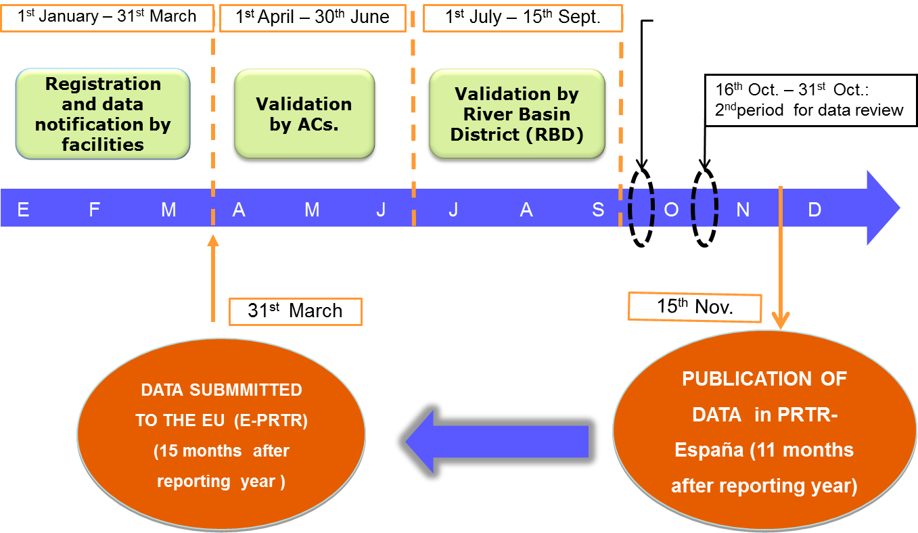

This Calendar:
  - Takes into account the legal framework of environmental competences (Shared by Regional and National Goverments)
  - Provides additional periods of data reviews;
  - Allows publication of data, at national level, within the following year after the reporting one (11 months later) and in advance in comparison with the E-PRTR (15 months later), and,
  - Finally, allows the Ministry to meet the requirements of the European legislation and international agreements.
The first year of data with PRTR criteria was 2007. Data from previous years (2001 to 2006) come from the former EPER reporting criteria.
To introduce the new web (www.prtr-es.es), replacing the former EPER, and the publication of 2007 data (first year under PRTR criteria), the Ministry organized the 1st International Conference on PRTR, with the participation of the EU, OECD, WG on PRTR of UNECE. (1st conference documents are available in: http://www.prtr-es.es/documentos/otros (jornada_presentacion_informacion_publica_2007_16042009).
- The deadline(s) by which the owners or operators of facilities were required to report to the competent authority;
According to the Calendar specified in previous subparagraph (a), the mandatory deadline at national level, in whichhe Ministry must have all the information at the National register is:
    - June 30th (Real Decreto 508/2007).mandatory date at national level
Regional Governments whose facilities (owner/operators) have to report directly using the Ministry website (identified of the attached map in green), having the run from January 1st to March 31st each year.
Regional Governments with its own systems of information (identified in the attached map in grey), may set different deadlines for registration, reporting and data validation, in the scope of their competences,. In these cases, they should submit the information to PRTR-España before June, 30th each year. Data submission process is telematically done, using the appropriate functionalities, through the PRTR-España platform...

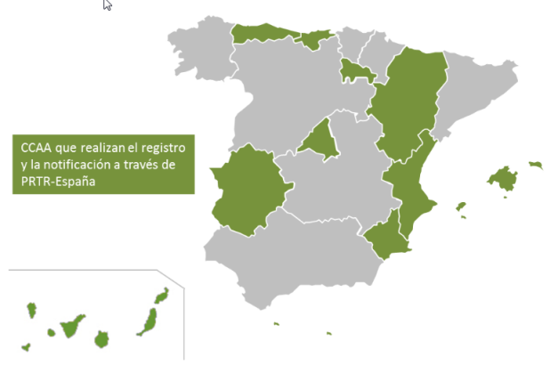

(More information on the web, sections “Know more”: http://www.en.prtr-es.es/conozca/Autoridades-competentes-1024062012.html, (ENG version))
- The date by which the information was required to be publicly accessible on the register, having regard to the requirements of article 8 (reporting cycle);
,The date of publication of data on the PRTR-España website (www.prtr-es.es), is always November 15th, according to the Final Disposition 1st of Real Decreto 102/2011. This implies that data are published, 11 months after the reporting year, within the immediately following year.
- Whether the various deadlines for reporting by facilities and for having the information publicly accessible on the register were met in practice; and if they were delayed, the reasons for this;
Although deadlines are tight, there are no relevant difficulties during the reporting process of facilities to the Competent Authority, and from them to the Ministry of Agriculture and Fishery, Food and Environment, through the PRTR-España platform.
However, it should be notede that the most common difficulties are related to the interaction with other legislation tools and requirements arising from the information thereof. Especially in two aspect:
- dates and deadlines and
- Scopes.
Both are bound, mostly, by the European regulation itself, for example, requirements for inventories of GHG, the emissions trading scheme (ETS) and E-PRTR. These “small” differences may represent imbalance in the national and regional schedules of collection and data management that, at the end, interfere with compliance of the reporting requirements.
On the other hand, and considering that such difficulties can affect the public information, PRTR-España system allows on a permanent basis the revision and updating of data, besides the additional data review periods described in subparagraph (a), , so that errors can be immediately remedied, by notice of the Competent Authority to the Ministry. This system also allows almost automatically.the correction of the public information.
- Whether methods of electronic reporting were used to facilitate the incorporation of the information required in the national register, and if such methods were used, the proportion of electronic reporting by facilities and any software applications used to support such reporting.
the whole process of notification, validation, data upload and the management of the information is electronically (on-line) through PRTR-España (www.prtr-es.es). (See also Annex 4 of this report,).
In some Regions, for example, the authorities send to the owners a draft declaration to facilitate them the process.
The main difficulties on the grounds of data reporting are related tos:
  - Identifying all substances that are, or may be issued by a given industrial activity to one or more environmental media: usefulness of the sectorial sublists included in the "Guide for the Implementation of E-PRTR register" ((ESP), (ENG)), and the "Guide to the implementation of the Records of Pollutant Release and Transfer ((ENG); (ESP)).
  - Right interpretation of the codes used to categorise methods and methodologies by facilities and authorities: How a specific datum should be reported as M, C or E, meanly when it is based on discontinuous measurements over time.
  - Interpretation/validation of emission data when they are “Estimated” (E).
  - Identification and quantification of emission data of those substances in very small quantities and which are detected below limits of detection (LOD) or quantification (LOQ), using the current techniques.
  - Diversity of measurement methods (national, European, international, or own ones).
  - Diversity of methods based on emission factors calculations.
  - Application of different criteria for notification, review and validation of the data.
  - Data reported in different units to kg/year (releases) or t/year (waste) than requested,
  - Comparability of reported data.
  - Contextualization of the information available to the public. It is difficult to understand, for example, the differences between PRTR thresholds and emission limit values (ELVs).

Article 9.
Describe the legislative, regulatory and other measures ensuring the collection of data and the keeping of records, and establishing the types of methodologies used in gathering the information on releases and transfers, in accordance with article 9 (data collection and record-keeping);
Owners/operators have to report to environmental authorities at least once a year, about all releases and off-site transfer of wastes they generate, in accordance with the provisions described in the Real Decreto 508/2007 (Annex III) and the Real Decreto102/2011 (Final Disposition 1st)
Methods used in determining the reported data must be given accordingly to the regulation mentioned aboved. Per each datum it should be indicated if it is measured (M), calculated (C) or estimated (E). In every case, methods, methodologies, standards, emission factors, mass balances, etc. must be indicated, as appropriate. When data are indicated as measured (M), the type of chemical analysis used must be also specified.
The information is completed including what it is named "origin of the method used", just to indicate when the method used is mandatory by any environmental permit, GBR, sectoral legislation and whether or not it is internationally accepted standard (ISO, EN, UNE, EPA, etc.). More information on how this matter is reported, is available on the website (user manuals):
http://www.prtr-es.es/conozca/Manuales-usuario-PRTREspana-1116112012.html,
http://www.en.prtr-es.es/Data/images/Manual_usuario_1_2.pdf,
http://www.en.prtr-es.es/Data/images/Manual_usuario_2.pdf.
As regards as the time of keeping the information, it is applied the Spanish Laws and in any case the PRTR Protocol provisions, since Spain is Party to the Protocol.
(http://www.en.prtr-es.es/Data/images//Ratificación-Protocolo-PRTR-8FD560E11D2441C2.pdf).

Article 10.
Describe the rules, procedures and mechanisms ensuring the quality of the data contained in the national PRTR and what these revealed about the quality of data reported, having regard to the requirements of article 10 (quality assessment).
In PRTR-España, several functionalities to monitor the quality of data reported by facilities and validated/revised by the authorities have been developed taking into account the provisions of Real Decreto 508/2007 and its subsequent amendements
Whenever possible, tables with fixed options are provided in reporting formats, without open text fields.Some examples are:
  - TAX identification number,
  - Geographical location,
  - Postal address data: types of roads, postal code, building number cities, states and countries
  - River basic districs,
  - National Economic Classification codes,
  - Industrial activities codes
  - Pollutant substances,
  - Environmental media,
  - Types of waste (European List of Wastes and manage operations (R and D),
  - Methods/Methodologies used to obtained data,
  - etc.
All these variables are considered as critical ones when validating the information reported by facilities and/or authorities.
It is also required additional information which is helpful to check the reported data with the information required under other legal instruments (ETS, etc), national inventories (INE, GHG, etc.).
Moreover, specific functionalities have been developed for authorities and System Administrator (Ministry) to detect potential errors, inconsistencies or outliers, such as:
  - % above the pollutant PRTR threshold.
  - % variation respect to emission/release values reported the previous year.
  - Statistics at national level, top 5, 10 and 20 per each pollutant and environmental media. Annual, geographical and sectorial distributions.
A working group, coordinated by the Ministry, was established at national level, in which participate all the authorities involved in PRTR (Regional Goverments, CC.AA., and River Basic Districs, CC.HH.). This WG deals with every PRTR issues and analyzes the reporting exercise per each cycle (reporting review and publication). Its main aim is to find consensus, to the extend possible, on setting harmonized validation criteria.
At regional level similar criteria for checking data reported by owners/operators are used.
  - Additional criteria on how to report emission data ,
  - Requesting reports from accredited laboratories (OCA) on the measurements carried out.
  - Methods of calculation used in point measurements
  - Additional information on the methods used to estimate releases
  - Results of environmental inspections and compliance conditions established in its environmental permits ,
  - Pollutant subtances authorized in its environmental permits (IED/IPPC permits, or other environmental permits such as air pollution, discharges to water)
  - Checking with other sources and information requirements: verified CO₂ emissions in ETS, production and waste management data.

Article 11.
Describe the way(s) in which public access to the information contained in the register is facilitated, having regard to the requirements of article 11 (public access to information).
All the public information contained in PRTR-España is accessible on the Internet, www.prtr-es.es:
- in Spanish (http://www.prtr-es.es/) and
- English (http://www.en.prtr-es.es/).
- It is also available in the other Spanish languages (Catalá, Galego, Euskera).
Besides data of releases and off-site transfer of wastesabove the PRTR thresholds, both at facility and aggregated level (by industrial activity, pollutant/waste,.. http://www.prtr-es.es/informacion-publica), the following information is also available in PRTR-España
- the complete Inventory of facilities which have to report to the register, (http://www.prtr-es.es/Informes/InventarioInstalacionesIPPC.aspx).
- Ireference/document section with the relevant legislative acts,
- technical documents,
- general information about the PRTR pollutant substances
- links to other PRTR registers worldwide, etc.
More details on public information, are described in the Annex 4of this report:
- How the public information is organised,
- What type of information can be consulted and,
- Help/support systems/options available for search/queries friendly about the information given.
(See also the answers in questions on Articles 3, 4 and 5, mainly as regard as Article 5 e))
At regional level, some Autonomous Communitties have also its own PRTR websites, (regional PRTRs http://www.prtr-es.es/conozca/Enlaces-interes-html#comunidadautonoma), In some of these cases the regional data are published previously to the National Register, PRTR-España, in the same way that nationally data are published before being sent to the European register (E-PRTR)
It should also be noted that the PRTR data are used by other public authorities and departments to prepare its own reports about the state of play on areas/matters of their competence.
Moreover, several types of awareness activities are frenquently carried by the Ministry such us:
- Dissemination workshops, meetings,
- Conferences in national/international congresses addressed not only to public in general but also to other stakeholders like Academia, technological Institutions, industrial and environmental organizations, etc.
- Organization of specific events to announce the puiblication of new data or to present new design/functionalities in the website. (All the information/documents of these events/activities are available for the public in http://www.prtr-es.es/documentos/otros).
As regards the measurement taken when the public cannot be able to access the information using electronic tools, it should be noted that, (Article 11.5):
- The resquests/queries (2014-2016) have been received by electronic media (practically 100%),
- At the same time, it is always possible to use any of the common administrative procedures established by law (Ley 30/1992, of 26th of November, relating to Legal Regime of Public Administrations and the Common Administrative Procedure and its amendements; (Ley 4/1999, of 13th of January), and Ley 27/2006, of 18th of July, relating to the access to information, public participation in decision-making and access to justice in environmental matters, (this law incoporates the EU Directives 2003/4/CE and 2003/35/CE)).
What it is established as general procedure is that all requests for information to the Government (both national and regional levels), may be issued and processed by any of the existing communication procedures: paper, fax, phone, etc., and presented at any public institution. If this occurs, then it will be the Administration which conveys the request for information to the appropriate agency to give it the right course.

(See also answer Art. 13).

Article 12.
Where any information on the register is kept confidential, give an indication of the types of information that may be withheld and the frequency with which it is withheld, having regard to the requirements of article 12 (confidentiality). Please provide comments on practical experience and challenges encountered with respect to dealing with confidentiality claims, in particular with respect to the requirements set out in paragraph 2.
In Spain, the mandatory data included in the PRTR-España Register, are considered as environmental information and, therefore, they are not subject to claim confidentiality.

The additional information that it is resquested to the owners/operators, and which is optional according to both the PRTR Protocolo and the EU Regulation 166/2006, can be published when the owners/operators give their express consent to make it publicly accessible.
Only personal contact data (names/telephone number, e-mails) are not published in any case.
However,any claimfor confidentialitythat could be requested in relation to PRTR data must follow the provisions established in the Ley 27/2006, of 18th of July, relating to the access to information, public participation in decision-making and access to justice in environmental matters, (this law incoporates the EU Directives 2003/4/CE and 2003/35/CE), (http://www.en.prtr-es.es/Data/images//Ley27-2006deAccesoalaInformaciónAmbiental.pdf).

Article 13.
Describe the opportunities for public participation in the development of the national PRTR system, in accordance with article 13 (public participation in the development of national pollutant release and transfer registers), and any relevant experience with public participation in the development of the system.
Additionally the usual ways available for public participation established by the Spanish Ministry of Agriculture and Fishery, Food and Environment (http://www.magrama.gob.es/es/ministerio/servicios/participacion-publica/default.aspx, http://www.magrama.gob.es/es/ministerio/servicios/informacion/default.aspx), there are three permanent channels opened by which the stakeholders and the public in general can directly participate/request information in PRTR-España:
- by telephone: +34902545350
- e-mail: info@prtr-es.es
- suggestion box:
  - http://www.prtr-es.es/Sugerencias (ESP),
  - http://www.en.prtr-es.es/Sugerencias (ENG)

Using these channels the public can participate, comment, suggest improvements and/or request for information about the Register when they deem, throughout the year.

Article 14.
Describe the review procedure established by law to which all individuals have access if they consider that their request for information has been ignored, wrongfully refused or otherwise not dealt with in accordance with the provisions of article 14 (access to justice), and any use made of it.
The procedure applied is described in the Title IV of the Ley 27/2006, of 18th of July, relating to the access to information, public participation in decision-making and access to justice in environmental matters, (this law incoporates the EU Directives 2003/4/CE and 2003/35/CE), ((http://www.en.prtr-es.es/Data/images//Ley27-2006deAccesoalaInformaciónAmbiental.pdf)).

Article 15.
Describe how the Party has promoted public awareness of its PRTR and provide detail, in accordance with article 15 (capacity-building), on:
- Efforts to provide adequate capacity-building for and guidance to public authorities and bodies to assist them in carrying out their duties under the Protocol.
From the beginning of the register in 2001, when it was EPER-España, up to now the Ministry has worked jointly the Competent Authorities throughout the process of design and development. In Spain the authorities in charge for collecting the data supplied to the Spanish PRTR are mainly the Regional Governments (Autonomous Communities, CC.AA). In the validation/review process of data is also involvedthe Central Government on issues related to direct releases to the river. (See also tanswer for Article 8).
User manuals for public authorities were also developed when appropiate. All these documents are available to them in the "Members Area" of the PRTR platform. When it is required/requested, specific training sessions for authorities are carried out.
Finally, the Working Group on PRTR coordinated by the Ministry discusses any decision on modification, updating or improvement which affect the operation, scope, requirements of information, model strucutre for transfer of information before further implementations/development. (See also the answer forArticle 10).
(b) Assistance and guidance to the public in accessing the national register and in understanding the use of the information contained in it.
The main way used to promote the PRTR-España Register is the webiste: www.prtr-e.es. The public website is provided with support systems, "help windows", explanations, manuals and documents that help the public in general to handle the page in a friendly maner, explaining the several search options and making the available information understandable . The following are the main actions usually carried out on the page:
- PRTR data annually published: every year in November, the 15th
- Updating the documents/references section and the legal regulations related to PRTRs,
- Dissemination of the whole historical data (the last 10 years directly on the web page (2006-2015). Information regarding previous reporting years (2001 to 2005) ara available under request through the channels arranged for that purpose. See answer for Article 13)).
- What’s new, News, other/additional information sections, etc.
PRTR-España can also be followed by the social networks (twiter, facebook):
- Twiter (https://twitter.com/prtr_es),
- Facebook (https://www.facebook.com/pages/PRTR-España/125756327492909?fref=ts).

Any new action / modification / new views / publishing annual data/search options, etc., is disseminated through several diffusion channels both institutional and others relating to environmental information, such as:
- Ministry public information services (e-mail box):
  - http://www.magrama.gob.es/es/ministerio/servicios/informacion/default.aspx
  - Environmental Quality and Assessment Departament e-mail box: http://www.magrama.gob.es/es/calidad-y-evaluacion-ambiental/temas/default.aspx?
- Industrial organizations, mainly CEOE (the Spanish Confederation of Enterprise Organizations) and others
- NGOs
- Institutional/private Technological Centers,
- Academia, Universities
- City Councils, Municipalities,
- Regional Governments (Autonomous Communitties),
- Working Groups both at national and international level,
- Users and stakeholders via info@prtr-es.es
Specific diffusion/awareness actions are also scheduled through national/international congress/conferences, specially when the National Congress on Environment takes place (CONAMA) (every two year): CONAMA VI (2002), CONAMA VII (2004), CONAMA VIII(2006), CONAMA IX(2008), CONAMA X(2010), CONAMA XI (2012), CONAMA XII (2014) and CONAMA XIII (November, 2016).
The website of PRTR-España (public information),) has been visited by more than 8,200,000 since 2008 first year in which data are published following PRTR criteria and visit/use statictis are implemented. The month average is over 100,000 (monthly updated information is given on the PRTR-España web page):
. :

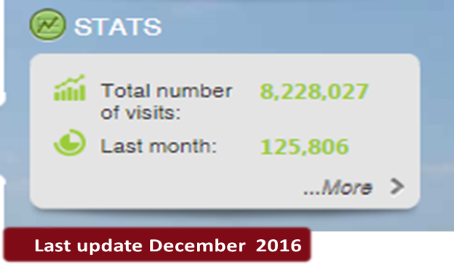
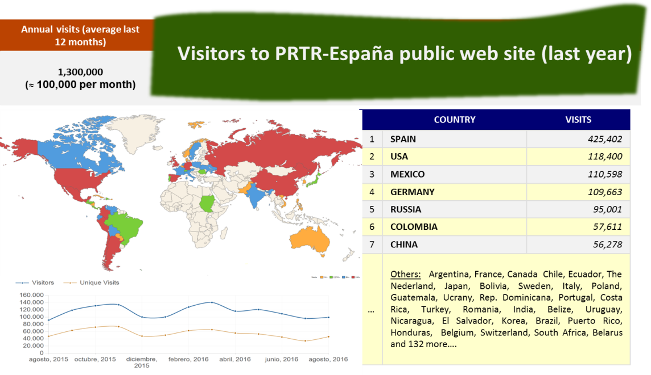

Moreover, the main awareness conferences organised by the Ministry and held in Madrid since 2007 which must be highlighted t:
- Public Participation Conference to the New PRTR España register implementation process. Held in Madrid, April 26th, 2007.(Information available: http://www.prtr-es.es/documentos/otros)
- I International Conference to present the public information of the PRTR-España Register on the Internet: Publication of the 2007 Data. Held in Madrid, April, the 16th, 2009. (Information available in: http://www.prtr-es.es/documentos/otros).
- II International Conference PRTR-España: 2001-2011. Ten Years of Public Information. Challenges for the Future. Held in Madrid, July, 3-4, 2013 (information available in http://www.prtr-es.es/documentos/otros).
- II Public Information and Participation Conference PRTR-España, 2014: NEW SCOPES, NEW CHALLENGES AND MUCH MORE INFORMATION. 2013 data publication. Held in Madrid November, 18th, 2014.. (Information available: http://www.prtr-es.es/documentos/otros).
- III Public Information and Participation Conference PRTR-España, 2016: COMUNICATION ON THE BASIS OF A GOOD INFORMTION. 2014 data PUBLICATION” Held in Madrid, December, 15th, 2016. (Information available: http://www.prtr-es.es/documentos/otros)
(See more information in Annex 5 of this report)

Article 16.
Describe how the Party has cooperated and assisted other Parties and encouraged cooperation among relevant international organizations, as appropriate, in particular:
(a) In international actions in support of the objectives of this Protocol, in accordance with paragraph 1 (a);
(b) On the basis of mutual agreements between the Parties concerned, in implementing national systems in pursuance of this Protocol, in accordance with paragraph 1 (b);
(c) In sharing information under this Protocol on releases and transfers within border areas, in accordance with paragraph 1 (c);
(d) In sharing information under this Protocol concerning transfers among Parties, in accordance with paragraph 1 (d);
(e) Through the provision of technical assistance to Parties that are developing countries and Parties with economies in transition in matters relating to this Protocol, in accordance with paragraph 2 (c).
Spain is member of the following international groups and committies related to PRTR:
- Bureau of the Parties to the PRTR Protocol. (UN/ECE)
- Working Group of the Partes to the Protocolo (UN/ECE)
- International Co-ordinating Group on PRTR (Chair).
- Committee Art. 19 E-PRTR, according to the Regulation 166/2006 on European PRTR.
- Task Force on PRTR (OECD) (Vice-chair).
New capacity-building activities/proyects with technical support by Spain (during the corresponding period of this 2nd NIR, 2014-2016) :

  - Technical assistance (UNEP-UNITAR GEF initiative): “POPs reporting, monitoring and information dissemination using PRTRs” (PHASE I and PHASE II). (Technical workshops, study tours, steering committe, etc. (Peru, Ecuador, Panama, Dominican Republic, El Salvador and Moldova, Kazakhstan, Belarus and Cambodia): Inception Workshop PHASE II..Madrid, Spain 26-28 November 2015.
Other initiatives and international projects in which PRTR-España has participated in awareness, promotion activities (period 2014-2016):
- "Get your right to a healthy community“. 2nd Subregional Workshop on the Protocol on Pollutant Release and Transfer Registers for countries in Eastern Europe, Caucasus and Central Asia. 19-21 September 2016. Minsk, Belarus.
- “International PRTR Week”: 2ndGlobal Round Table on Pollutant Release and Transfer Registers (2nd GRT on PRTRs), 18th OECD Task Force on PRTRs y su Bureau (18thTF on PRTRs) y el 4thWorking Group of the Parties to the Protocol on PRTRs y su Bureau (4th WGPP on PRTRs). November 2015. Hosted by the Goverment of Spain under the auspices of UNECE, OECD and with the colaboration of UNITAR and UNEP..
- “Registro de Emisiones y Convenios Ambientales en América Latina”. (Panel discussion). XXXIV Congreso Interamericano de Ingeniería Sanitaria y Ambiental. Monterrey, Nuevo León (México), November 2014
- «Application, utilisation et présentation des données PRTR
(quelques expériences espagnoles)». Résultats de l’étude relative à la réalisation d’un Registre des Rejets et Transferts des Polluants (RRTP) au niveau des provinces de Tanger-Tétouan et Nador. Tanger. Marruecos (Maroc/Morocco). September 2014.
- Application, use and presentation of PRTR data (the Spanish case). Regional meeting on PRTR and Pollution indicators. UNEP-Mediterranean Action Plan (MAP). Ankara (Turkey), 16-17 June 2014.
  - Application, use and presentation of PRTR data
(some Spanish experiencies). Strengthening the Ministry of Nature Protection of the Republic of Armenia in Introduction of the System of IPPC. Ministerio de Agricultura, Alimentación y Medio Ambiente. Madrid. Spain. March 2014.

Additional information is given in Annex 5 of this report.

Provide any further comments relevant to the Party’s implementation, or in the case of Signatories, preparation for implementation, of the Protocol. Parties and Signatories are invited to identify any challenges or obstacles encountered in setting up, gathering data for and filling in the register.
The main difficulties encountered during the implementation process of PRTR- España are summarized in answer to question on Article 8. Issues relating to the identification of activities/facilities, significant pollutants and, especially, everything related to how emissions data are determined and the techniques or methodologies used.
Another important topic is the practical application /uses of the information by the public in general and its participation in the process. Actions/activities are needed not only to ensure the knowledge of the register itself by the public, but also to promote applications and uses, in context, that the information in PRTRs can offer. And not only for the public in general but also to other stakeholders and public administrations. (See conclusions of the 2nd Global Round Table on PRTR, “Chairs’ statement: Madrid statement on pollutant release and transfer register perspectives for a sustainable future Madrid Declaration on.)
The most important challenges for the future, are:
• Further works on improving the quality of information gathered/offered
• Comparability / harmonization /equivalences of existing registers. Assessment of the strengths and weeknesses found so far in the implementation of the Protocol.
• Move forward in the promotion of the Protocol, as the first international legal instrument with the aim of increasing the ratifications not only by the UNECE countries but also by countries beyond the region.

ANNEXES

To the second Spanish Report on
The Implementation of the Protocol on Pollutant and Transfer Releases. (PRTR/KIEV Protocol)
In accordance with the Decision I/5 (ECE/MP.PRTR/2010/2/Add.1) an the Decision II/1 (ECE/MP.PRTR/2014/4/Add.1)
Annex 1.
Decision I/5: http://www.unece.org/fileadmin/DAM/env/pp/prtr/docs/ece_mp.prtr_2010_2_Add.1_e.pdf
Decision II/1:
http://www.unece.org/fileadmin/DAM/env/pp/prtr/MOPP2/Post-session_documents/ECE.MP.PRTR.2014.4.Add.1_e.pdf

Annex 2.
List of industrial activity categories which have to report to national Spanish PRTR system.

Annex 3
List of the public authorities involved in PRTR-España Regsiter both the national and regional level.(updated)

Annex 4.-
Additional information on PRTR-España system: www.prtr-es.es. How to use the web page: examples of queries and specific searches on the public information, Downloads and available ways to enhance the public participation.

Annex 5.-
Main capacity-building, training and promoting activities developed by PRTR-España.(Updated information including the activities undertaken in 2014-2016)

ANNEX 1.

Decision II/1
http://www.unece.org/fileadmin/DAM/env/pp/prtr/MOPP2/Post-session_documents/ECE.MP.PRTR.2014.4.Add.1_e.pdf

Decision I/5

http://www.unece.org/fileadmin/DAM/env/pp/prtr/docs/ece_mp.prtr_2010_2_Add.1_e.pdf

ANNEX 2.

List of industrial activity categories which have to report to national Spanish PRTR system..

Activity Spanish code list | Description (ES) | Description (EN)
1 | Instalaciones de combustión / energéticas | Energy/Combustion industry
1.a | Refinerías de petróleo y gas | Mineral oil and gas refineries
1.a.i | Refino de petróleo o de crudo de petróleo | Refining crude oil or petroleum
1.a.ii | Producción de gas combustible distinto del gas natural y de gases licuados del petróleo | Production of fuel gas different than natural gas and liquid petroleum gas
1.b | Gasificación y licuefacción | Installations for gasification and liquefaction
1.b.i | De carbón | Coal
1.b.ii | De otros combustibles, cuando la potencia térmica nominal => 20 MW | Other fuels when total rated thermal input ≥20 MW
1.c | Centrales térmicas y otras instalaciones de combustión | Thermal power and other combustion plants
1.c.i (a) | Combustión de combustibles fósiles, residuos o biomasa, potencia térmica nominal total = 50MW | Combustion of fossil fuel, wastes or biomass with total rated thermal input = 50 MW
1.c.i (b) | Combustión de combustibles fósiles, residuos o biomasa, potencia térmica nominal total > 50MW | Combustion of fossil fuel, wastes or biomass with total rated thermal input > 50 MW
1.c.ii (a) | Cogeneración, calderas, generadores de vapor o cualquier otro equipamiento o instalación de combustión, potencia térmica nominal total = 50MW | Cogeneration, heating, steam generator or other equipment or combustion installation, with a total rated thermal input = 50MW
1.c.ii (b) | Cogeneración, calderas, generadores de vapor o cualquier otro equipamiento o instalación de combustión, potencia térmica nominal total > 50MW | Cogeneration, heating, steam generator or other equipment or combustion installation, with a total rated thermal input > 50MW
1.d | Coquerías | Coke ovens
1.e | Laminadores de carbón, con una capacidad de 1 t/h | Coal rolling mills, capacity = 1 t/h
1.f | Fabricación de productos del carbón y combustibles sólidos no fumígenos | Manufacture of coal products and solid smokeless fuel
2 | Producción y transformación de metales | Production and processing of metals
2.a | Calcinación o sintetización de minerales metálicos incluido el mineral sulfuroso | Metal ore (including sulphide ore) roasting or sintering installations
2.b | Producción de fundición o aceros brutos (capacidad > 2,5 t/h) | Production of pig iron or steel (capactiy > 2.5 t/h)
2.c | Procesamientos de metales ferrosos | Processing of ferrous metals
2.c.i | Laminado en caliente (capacidad > 20 t acero bruto/h) | Hot-rolling (capacity > 20 t crude steel/h)
2.c.ii | Forjado con martillos (energía de impacto > 50 kJ por martillo y potencia térmica > 20 MW) | Smitheries with hammers (impact energy > 50 kJ for hammer and thermal potential > 20 MW)
2.c.iii | Galvanización (capacidad > 2 t acero bruto/h) | Application of protective fused metal coats (capacity >2 crude steel /h)
2.d | Fundiciones de metales ferrosos (capacidad producción > 20 t/día) | Ferrous metal foundries (production capacity > 20 t/d)
2.e | Producción de metales en bruto no ferrosos | Processing of non-ferrous metals
2.e.i | Minerales, concentrados o materias primas secundarias por procesos metalúrgicos, químicos o electroquímicos | Ores, concentrates or secondary raw materials by metallurgical, chemical or electrolytic processes
2.e.ii | Fusión de metales no ferrosos ( > 4 t/día plomo y cadmio o > 20 t/día resto de metales) | Melting of non-ferrous metals (> 4t/d lead and cadmium or >20 t/d other metals)
2.f | Tratamiento de superficie por procedimiento electrolítico o químico (vol. de cubetas o líneas completas > 30 m³) | Surface treatment using electrolytic or chemical process volume treatment vats or complete process lines > 30m³)
3 | Industrias minerales | Mineral industry
3.a | Explotaciones mineras subterráneas y operaciones conexas. | Underground mine and related operations
3.b | Explotaciones a cielo abierto y canteras (cuando la superficie de la zona en la que efectivamente se practiquen operaciones extractivas equivalga a 25 ha) | Opencast mine and quarry (when the surface of the area effectively under extractive operation equals 25 ha)
3.c. | Producción de cemento, cal y óxido de magnesio | Production of cement, lime and magnesium oxide
3.c.i. (a) | Fabricación de cemento por molienda (capacidad > 500 t/d) | Production of cement by mill (capacity > 500 t/d)
3.c.i. (b).1 | Fabricación de clínker hornos rotatorios con una capacidad de producción > 500 t/d, | Production of cement clinker in rotary furnace with production capactiy > 500 t/d
3.c.i. (b).2 | Fabricación de clínker hornos de otro tipo con una capacidad de producción > 50 t/d | Production of cement clinker in other furnaces (production capacity > 50 t/d)
3.c.ii. (a) | Producción de cal hornos rotatorios (capacidad > 50 t/d) | lime production in rotary kilns (capacity > 50 t/d)
3.c.ii. (b) | Producción de cal hornos de otro tipo (capacidad > 50 t/d) | lime production in other kilns (capacity >50 t/d)
3.c.iii | Producción de óxido de magnesio en hornos con una capacidad > 50 t/d | Magnesium oxide production in kilns with capacity >50 t/d
3.e | Fabricación de vidrio, incluida la fibra de vidrio (cap. fusión > 20 t/d) | Production of glass, including fiberglass (fusion capacity > 20 t/d)
3.f | Fundición de materiales minerales, incluida fabricación de fibras minerales (cap. fundición > 20 t/d) | Melting mineral substances, including the production of mineral fibres (fusion capacity > 20 t/d)
3.g | Fabricación de pdtos. cerámicos mediante horneado con cap. produc >75 t/día, o cap. horneado > 4 m³ y > 300 kg/m³ densidad carga por horno | Production of ceramic products by firing, production capacity > 75 t/d or with a kiln capacity > 4 m3 and with a setting density per kiln > 300 kg/m3
4 | Industria química | Chemical industry
4.a | Fabricación de productos químicos orgánicos | Production of organic chemicals
4.a.i | Fabricación hidrocarburos simples | Production of simple hydrocarbons
4.a.ii | Fabricación hidrocarburos oxigenados | Production of oxygen-containing hydrocarbons
4.a.iii | Fabricación hidrocarburos sulfurados | Production of sulphurous hydrocarbons
4.a.iv | Fabricación hidrocarburos nitrogenados | Production of nitrogenous hydrocarbons
4.a.v | Fabricación hidrocarburos fosforados | Production of phosphorus-containing hydrocarbons
4.a.vi | Fabricación hidrocarburos halogenados | Production of halogenic hydrocarbons
4.a.vii | Fabricación compuestos orgánicos metálicos | Production of organometallic compounds
4.a.viii | Fabricación materias plásticas | Production of plastics materials
4.a.ix | Fabricación cauchos sintéticos | Production of synthetic rubbers
4.a.x | Fabricación colorantes y pigmentos | Production of dyes and pigments
4.a.xi | Fabricación tensioactivos y agentes de superficie | Production of surface-active agents and surfactants
4.b | Fabricación de productos químicos inorgánicos | Production of inorganic chemicals
4.b.i | Fabricación de gases | Production of gases
4.b.ii | Fabricación de ácidos | Production of acids
4.b.iii | Fabricación de bases | Production of bases
4.b.iv | Fabricación de sales | Production of salts
4.b.v | Fabricación de no metales, óxidos metálicos u otros comp. inorgánicos | Production of non-metals, metal oxides or other inorganic compounds
4.c | Fabricación de fertilizantes a base de fósforo, de nitrógeno o de potasio | Production of phosphorous-, nitrogen- or potassium-based fertilisers
4.d | Fabricación de productos fitofarmacéuticos o biocidas | Production of plant protection products or of biocides
4.e | Procedimiento químico o biológico para fabricación de medicamentos | Production of pharmaceutical products
4.f | Fabricación de explosivos y productos pirotécnicos | Manufacture of explosives and pyrotechnic products
4.f.i | Fabricación de explosivos | Production of explosives
4.f.ii | Fabricación de productos pirotécnicos | Production of pyrotechnic products
5 | Gestión de residuos y aguas residuales | Waste and waste water management
5.a | Valorización o eliminación de residuos peligrosos (capacidad > 10 t/d) que realicen una o más de las siguientes actividades | Disposal or recovery of hazardous waste with (capacity> 10 t/d) involving one or more of following activities
5.a.i | Tratamiento biológico | Biological treatment
5.a.ii | Tratamiento físico-químico | Physico-chemical tratment
5.a.iii | Combinación o mezcla previas a las operaciones mencionadas en 5.a y 5.b | Blending or mixing prior to submission to any of the other activities listed in points 5.a and 5.b
5.a.iv | Reenvasado previo a cualquiera de las operaciones mencionadas en 5.a y 5.b | Repackaging prior to submission to any of the other activities listed in points 5.a and 5.b
5.a.v | Recuperación o regeneración de disolventes | Solvent reclamation/regeneration
5.a.vi | Reciclado o recuperación de materiales inorgánicos que no sean metales o compuestos metálicos | Recycling/reclamation of inorganic materials other than metals or metal compounds
5.a.vii | Regeneración de ácidos o de bases | Regeneration of acids or bases
5.a.viii | Valorización de componentes utilizados para reducir la contaminación | Recovery of components used for pollution abatement
5.a.ix | Valorización de componentes procedentes de catalizadores | Recovery of components from catalysts
5.a.x | Regeneración o recuperación de aceites | Oil re-refining or other reuses of oil
5.a.xi | Embalse superficial (por ejemplo, vertido de residuos líquidos o lodos en pozos, estanques o lagunas, etc.) | Surface impoundment
5.b | Valorización o eliminación de residuos en plantas de incineración o coincineración de residuos | Disposal or recovery of waste in waste incineration plants or in waste co-incineration plants
5.b.i | Para residuos no peligrosos, (capacidad > 3 t/h) | For non-hazardous waste with a capacity > 3 t/h
5.b.ii | Para residuos peligrosos, (capacidad > 10 t/d) | For hazardous waste with a capacity > 10 t/d
5.c | Eliminación de residuos no peligrosos (capacidad > 50 t/d), que incluyan una o más de las siguientes actividades | Disposal of non-hazardous waste (capacity > 50 t/d) involving one or more of the following activities
5.c.i | Tratamiento biológico | Biological treatment
5.c.ii | Tratamiento físico-químico | Physico-chemical tratment
5.c.iii | Tratamiento previo a la incineración o coincineración | Pre-treatment of wate for incineration or co-incineration
5.c.iv | Tratamiento de escorias y cenizas | Treatment of slags and ashes
5.c.v | Tratamiento en trituradoras de residuos metálicos, incluyendo los residuos eléctricos y electrónicos y los vehículos al final de su vida útil y sus componentes | Treatment in shredders of metal waste, including waste electrical and electronic equipment and end-of-life vehicles and thir components
5.d | Vertederos (recepción > 10 t/d o cap. > 25.000 t), excluidos los vertederos de inertes | Landfills (receiving > 10 t/d or capacity > 25,000 t) excluding landfills of inert waste
5.e | Eliminación o aprovechamiento de canales o desechos animales (capacidad > 10 t/d) | Disposal or recycling of animal carcases or animal waste (capacity > 10 t/d)
5.f | Instalaciones de tratamiento de aguas residuales urbanas (capacidad de 100.000 equivalentes-habitante) | Urban waste-water treatment plants (capacity equal 100,000 resident)
5.g. | Tratamiento de aguas residuales independientes, no incluidas en la legislación de aguas residuales urbanas, y vertidas por instalaciones anejo 5 RD 815/2013 | Independently operated industrial waste-water traetment, not included in the legislation of urban waste water, discharged by installations annex 5 RD 815/2013
5.g.i | Con una capacidad < 10.000 m³/d | With capacity < 10,000 m3/d
5.g.ii | Con una capacidad ≥ 10.000 m³/d | With capacity ≥ 10,000 m3/d
5.h | Valorización, o una mezcla de valorización y eliminación, de residuos no peligrosos (cap. > 75 t/d) que incluyan una o más de las siguientes actividades. (Si sólo es digestión anaeróbica, los umbrales = cap. 100 t/d) | Recovery, or a mix of recovery and disposal, of non-hazardous waste with (capacity >75 t/d) involving one or more of the following activities
5.h.i | Tratamiento biológico | Biological treatment
5.h.ii | Tratamiento previo a la incineración o coincineración | Pre-treatment for incineration or co-incineration
5.h.iii | Tratamiento de escorias y cenizas | Treatment of slags and ashes
5.h.iv | Tratamiento en trituradoras de residuos metálicos, incluyendo residuos eléctricos y electrónicos, y vehículos al final de su vida útil y sus componentes | Treatment in shredders of metal waste, including waste electrical and electronic equipment and end-of-life vehicles and their components
5.i | Almacenamiento temporal de los residuos peligrosos no incluidos en el apartado 5.d en espera de tratamientos según 5.a, 5.b, 5.d o 5.j, (cap. > 50 t), excluido el almacenamiento temporal, pendiente de recogida, en el sitio donde el residuo es generado | Tempory storage of hazardous waste not covered under point 5.d pending any of the activities listed in points 5.a, 5.b, 5.d o 5.j, (capacity > 50t) excluding temporary storage, pending collection, on the site where the waste is generated
5.j | Almacenamiento subterráneo de residuos peligrosos (cap. > 50 t) | Underground storage for hazardous waste (capacity > 50 t)
6 | Industria derivada de la madera (papel y cartón) | Derivated wood industry (paper and cardboard)
6.a | Fabricación de pasta de papel | Production of pulp
6.b | Producción de papel, tableros y otras materias derivadas del papel | Production of paper, boards and other wood-based materials
6.b.i | Fabricación de papel y cartón (cap >20 t/d) | Production of paper and board (capacity of 20 t/d)
6.b.ii | Fabricación de tableros derivados de la madera (cap > 600 m³/d) | Production of wood-based panels (capacity > 600 m3/d)
6.c | Conservación de la madera y de productos derivados con sustancias químicas, distintas de tratamientos para combatir la albura exclusivamente. | Preservation of wood and wood products with chemicals, differences of treatment to combat exclusivily the sapwood
6.c.i | Con una capacidad de producción = 50 m³/d | With a production capacity of 50 m3/d
6.c.ii | Con una capacidad de producción > 75 m³/d | With a production capacity > 75 m3/d
6.d | Producción y tratamiento de celulosa (cap >20 t/d) | Installations for the production and treatment of cellulose ( capacity > 20 t/d)
7 | Ganadería y acuicultura intensiva | Intensive livestock production and aquaculture
7.a | Instalaciones destinadas a la cría intensiva de aves de corral o de cerdos que dispongan de más de: | Installations for the instensive rearing of poultry or pigs that it has more of:
7.a.i | 40.000 plazas para gallinas ponedoras, o del número equivalente en excreta de nitrógeno para otras aves de corral | 40 000 places for poultry, or the equivalent number in nitrogen excrete for other poultries
7.a.ii | 2.000 plazas para cerdos de cebo de más de 30 kg | 2 000 places for rearing of pigs >30kg
7.a.iii | 750 plazas para cerdas reproductoras | 750 places for sows
7.b | Acuicultura intensiva (cap 1.000 t/a de peces y crustáceos) | Intensive aquaculture (capacity 1000 t/y of fish and crustaceans)
8 | Productos de origen animal y vegetal de la industria alimentaria y de las bebidas | Animal and vegetable products from the food and beverage industries
8.a | Mataderos (cap. producción de canales > 50 t/d) | Slaughterhouses (production capacity of carcases > 50 t/d)
8.b. | Tratamiento y transformación destinados a la fabricación de productos alimenticios o piensos a partir de: | Treatment and processing for production of food or feed products from:
8.b.i | Mat. prima animal (no leche), (cap. producción de pdtos. acabados > 75 t/d) | Animal raw material (no milk), (finished products production capacity > 75 t/d)
8.b.ii.(a) | Mat. prima vegetal (cap. producción de pdtos. acabados > 300 t/d) | Vegetal raw material (finished products production capacity > 300 t/d)
8.b.ii.(b) | Mat. prima vegetal (cap. producción de pdtos. acabados > 600 t/d si la instalación funciona durante un periodo < 90 días consecutivos un año cualquiera) | Vegetal raw material (finished product production capacity > 600 t/d when the installation operates < 90 consecutive days in any years)
8.b.iii.(a) | Sólo materias primas animales y vegetales, productos combinados o por separado, cap. producción de pdtos. acabado > 75t/d si A ≥ 10. (A = materia animal (% del peso) de la cap. de producción de pdtos. acabados) | Animal and vegetal raw material, combined or separate products, finished products production capacity >75 t/d if A ≥ 10. (A= animal materia (% of weight) of the finished prodct production capacity)
8.b.iii.(b) | Sólo materias primas animales y vegetales, productos combinados o por separado, con cap. de producción de pdtos. acabado > [300-(22,5xA)]t/d en cualquier otro caso. (A = materia animal (% del peso) de la cap. de producción de pdtos. acabados) | Animal and vegetal raw material, combined or separate products, finished products production capacity > [300- (22,5xA)] t/d in any other case. (A= animal materia (% of weight) of the finished prodct production capacity)
8.c | Tratamiento y transformación de leche (leche recibida >200 t/d) | Treatment and processing of milk (milk received > 200 t/d)
9 | Otras actividades | Other activities
9.a. | Tratamiento previo o tinte de fibras o pdtos. textiles (cap. tratamiento > 10 t/d) | Pre-treatment or dyeing of textil fibers or textiles of fibers or textil products (treatment capacity > 10 t/d)
9.b. | Curtido de cueros (cap. pdto. acabado > 12 t /d) | Plants for the tanning of hides and skins (finished products production capacity > 12 t/d)
9.c | Tratamiento de superficies con disolventes orgánicos (cap. de consumo > 150 kg/a o 200 t/a) | Surface treatment using organic solvents (consumption capacity > 150 kg/y or 200 t/y)
9.d | Fabricación de carbono o grafito | Production of carbon or graphite
9.e | Instalaciones para la construcción, pintura o decapado de buques (capacidad para buques de 100 m de eslora) | Installations for the building of, and painting or removal of paint from ships (capacity for ships of 100 m length)
9.f | Captura de flujos de CO₂ procedentes de instalaciones con fines de almacenamiento geológico | Capture of CO2 coming from installations for geological storage

ANNEX 3.

List of the public authorities involved in PRTR-España Regsiter both the national and regional level.(Updated)
.

A2.1.-River Basic Districs involved in the PRTR data management and validation process:

ADMINISTRACIÓN GENERAL DEL ESTADO | Instituciones (organismos)
Organismos de cuenca de las confederaciones hidrográficas dependientes del Ministerio de Agricultura y Pesca, Alimentación y Medio Ambiente. | Organismo de cuenca de la Demarcación Hidrográfica del Miño-Sil
 | Organismo de cuenca de la Demarcación Hidrográfica del Cantábrico
 | Organismo de cuenca de la Demarcación Hidrográfica del Duero
 | Organismo de cuenca de la Demarcación Hidrográfica del Tajo
 | Organismo de cuenca de la Demarcación Hidrográfica del Guadiana
 | Organismo de cuenca de la Demarcación Hidrográfica del Guadalquivir
 | Organismo de cuenca de la Demarcación Hidrográfica del Segura
 | Organismo de cuenca de la Demarcación Hidrográfica del Júcar
 | Organismo de cuenca de la Demarcación Hidrográfica del Ebro

A2.2.-Departments of Regional Goverments involved in the PRTR data management and validation process:

GOBIERNO AUTONÓMICO | Instituciones (organismos)
DIPUTACIÓN GENERAL DE ARAGÓN | - Dirección General de Sostenibilidad
GENERALITAT DE CATALUÑA | - Dirección General de Calidad Ambiental y Cambio Climático  - Agencia Catalana del Agua
GENERALITAT VALENCIANA | - Conselleria de Agricultura, Medio Ambiente, Cambio Climático y Desarollo Rural, Dirección General del Cambio Climático y Calidad Ambiental, Servicio de Prevención y Control Integrado de la Contaminación
GOBIERNO DE CANARIAS | - Consejería de Política Territorial, Sostenibilidad y Seguridad  - Consejos Insulares de Aguas de Gran Canaria, Fuerteventura, Lanzarote, Tenerife, La Palma, La Gomera, El Hierro
GOBIERNO DE CANTABRIA | - Consejería de Universidades e Investigación, Medio Ambiente y Política Social, Dirección General de Medio Ambiente
GOBIERNO DE LA COMUNIDAD DE MADRID | - Consejería de Medio Ambiente, Administración Local y Ordenación del Territorio, Dirección General del Medio Ambiente
GOBIERNO DE LA CIUDAD DE CEUTA | - Consejería de Medio Ambiente y Sostenibilidad
GOBIERNO DE LA CIUDAD DE MELILLA | - Consejería de Coordinación y Medio Ambiente, Oficina Técnica de Control de Contaminación Ambiental
GOBIERNO DE LA RIOJA | - Dirección General de Calidad Ambiental y Agua
GOVER DE LAS ISLAS BALEARES | - Consejería de Medio Ambiente, Agricultura y Pesca  - Dirección General de Recursos Hídricos  - Dirección General de Energía y Cambio Climático
GOBIERNO DE NAVARRA | - Gobierno de Navarra, Dirección General de Ordenación del Territorio y Medio Ambiente, Servicio de Economía Circular y Agua
GOBIERNO DEL PRINCIPADO DE ASTURIAS | - Dirección General de Prevención y Control Ambiental
GOBIERNO VASCO | - Departamento de Medio Ambiente y Política Territorial  - Agencia Vasca del Agua
JUNTA DE ANDALUCÍA | - Dirección General de Prevención y Calidad Ambiental.  - Dirección General de Planificación y Gestión del Dominio Público Hidráulico. Secretaria General de Medio Ambiente y Cambio Climático
JUNTA DE CASTILLA Y LEÓN | - D.G. de Calidad y Sostenibilidad Ambiental
JUNTA DE CASTILLA-LA MANCHA | - Viceconsejería de Medio Ambiente
GOBIERNO DE EXTREMADURA | - Dirección General de Medio Ambiente de la Junta de Extremadura
GOBIERNO DE LA C.A. REGIÓN DE MURCIA | - Dirección General de Calidad y Evaluación Ambiental
XUNTA DE GALICIA | - Aguas de Galicia  - Dirección gEneral de Calidad y Cambio Climático.

ANNEX 4.

Additional information on PRTR-España system: www.prtr-es.es.
How to use the web page: examples of queries and specific searches on the public information, Downloads and available ways to enhance the public participation

- FACILITY INVENTORY
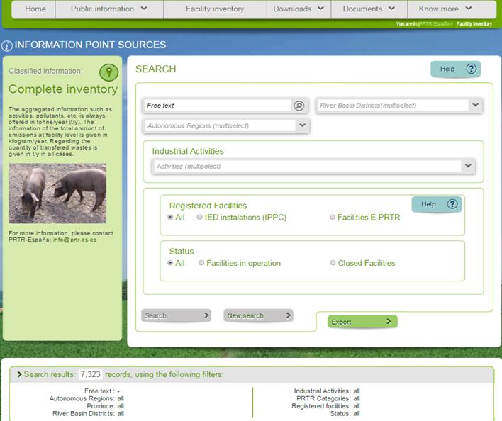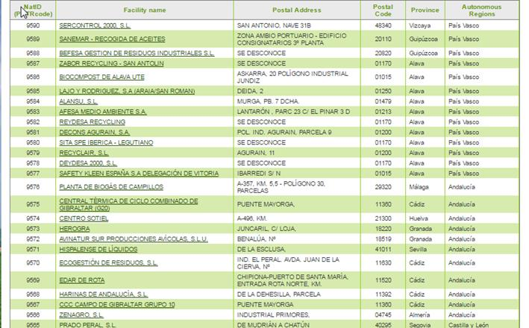

- DATA AT FACILITY LEVEL
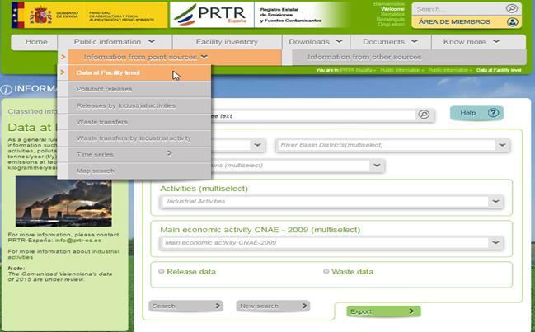
(example of summary information consulted)
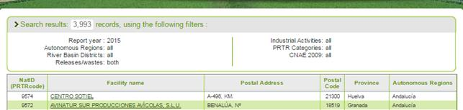
Data given per each FACILITY
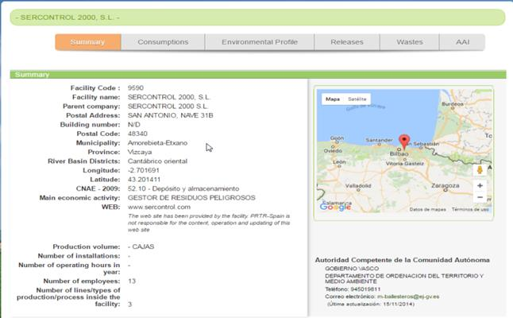
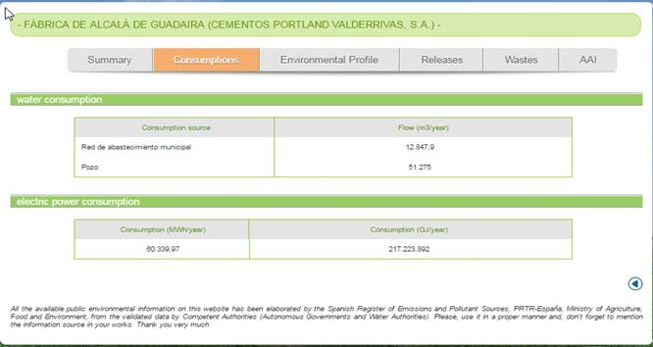
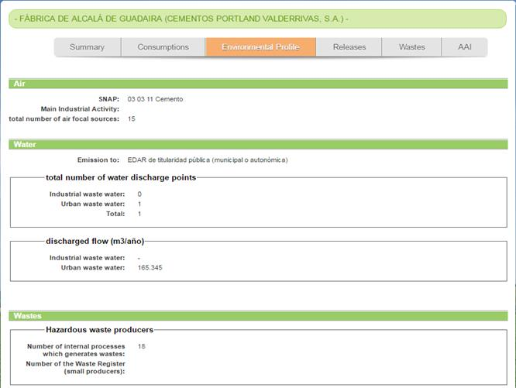
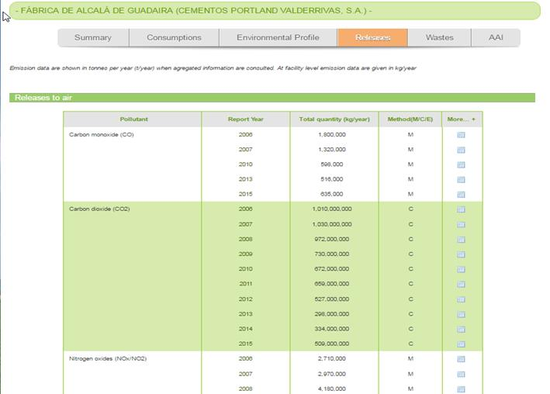
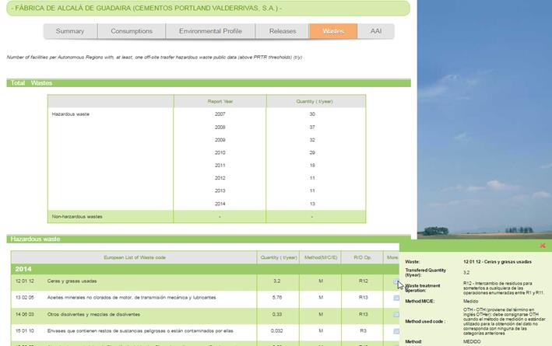
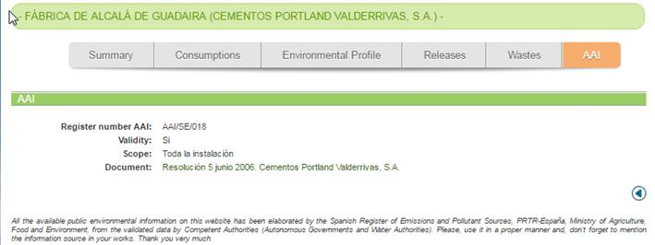

- POLLUTANT RELEASES
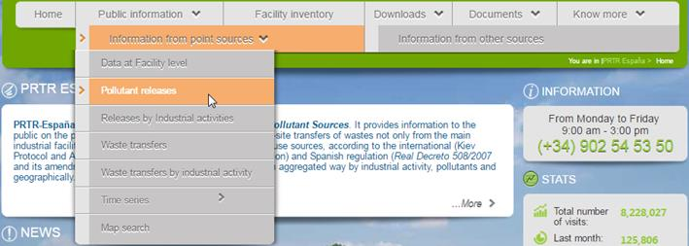

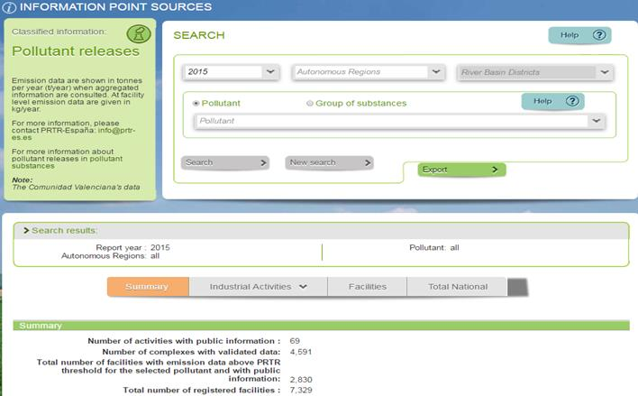
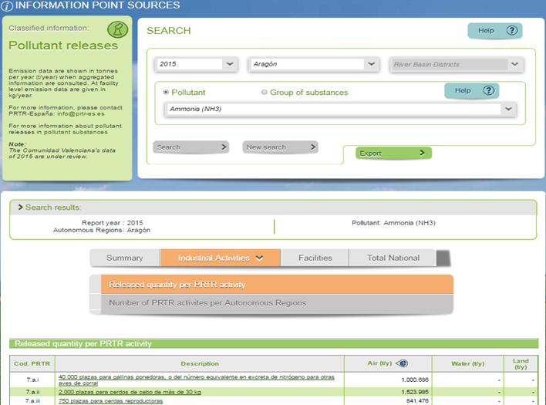

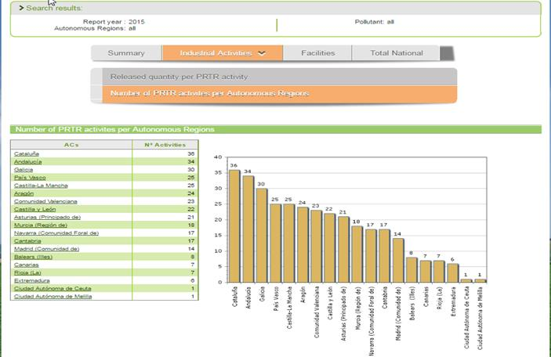
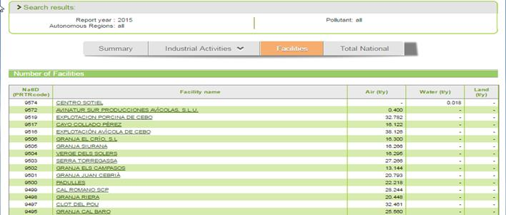
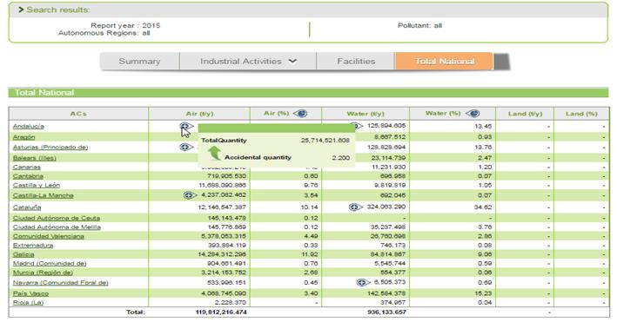
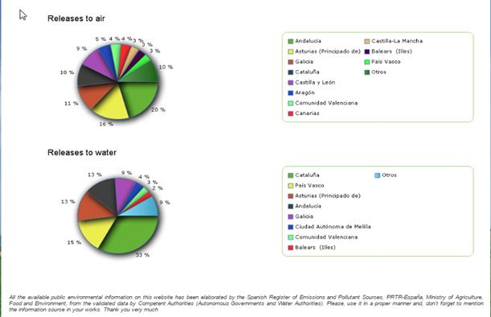
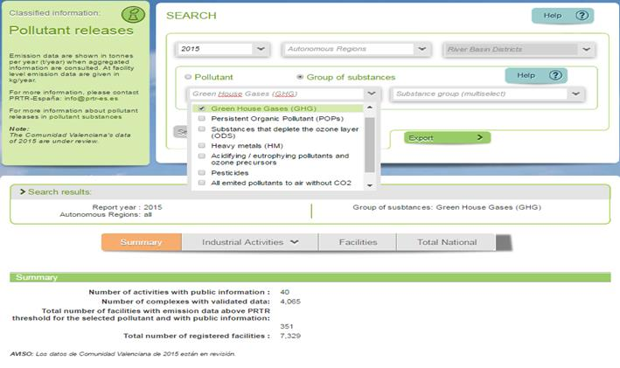
- RELEASES BY INDUSTRIAL ACTIVITIES
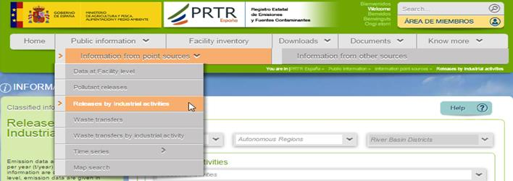
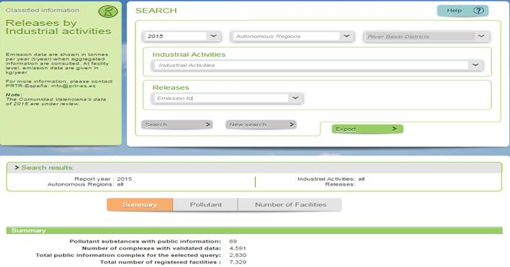
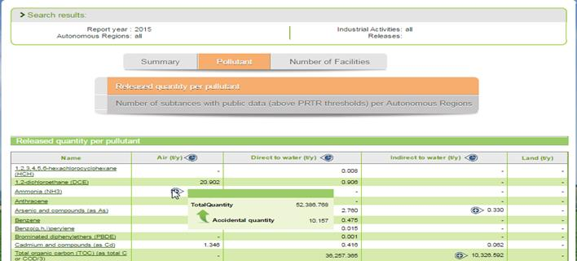
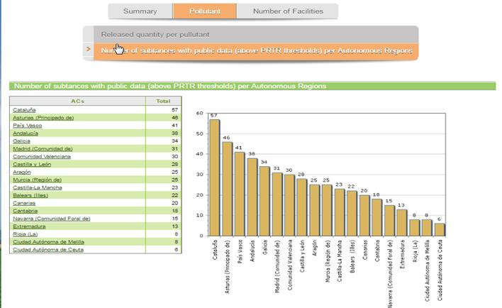
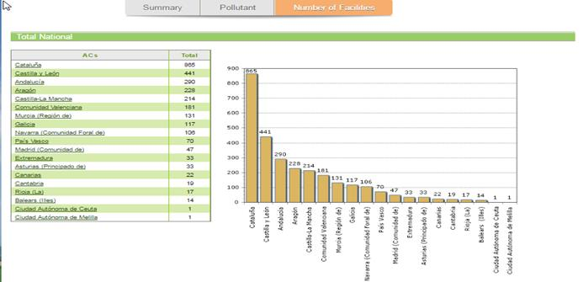
- WASTE TRANSFERS
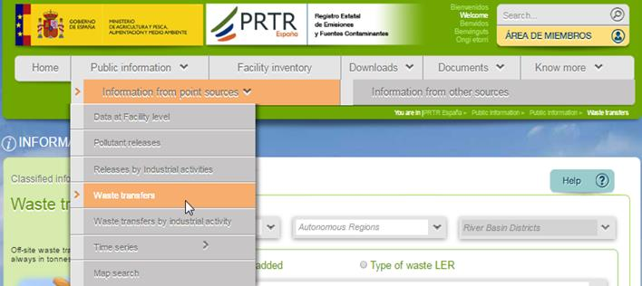
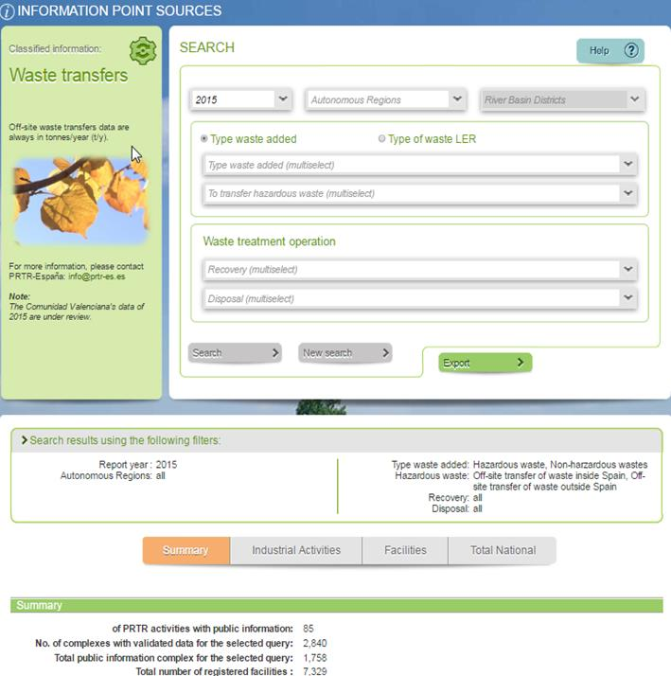
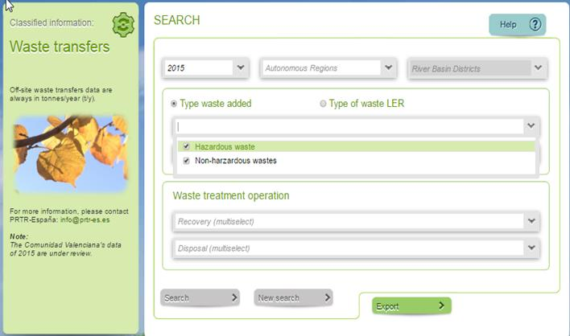
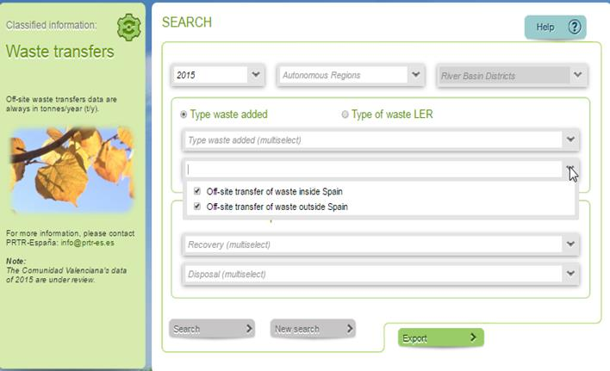
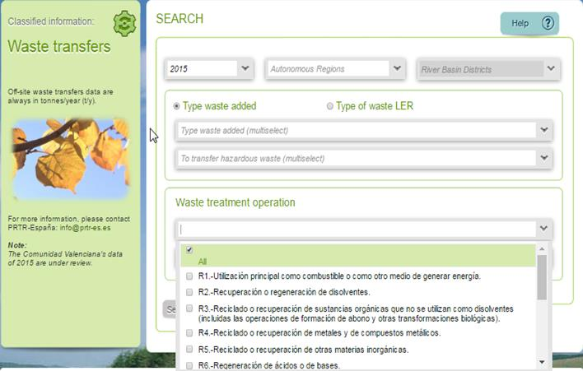
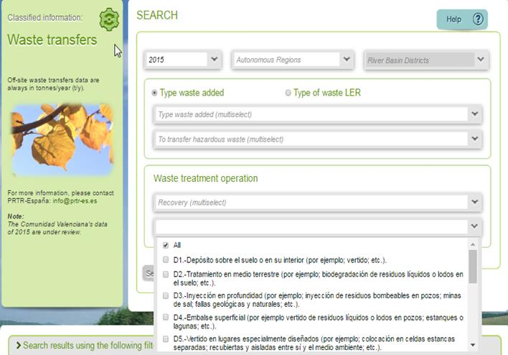
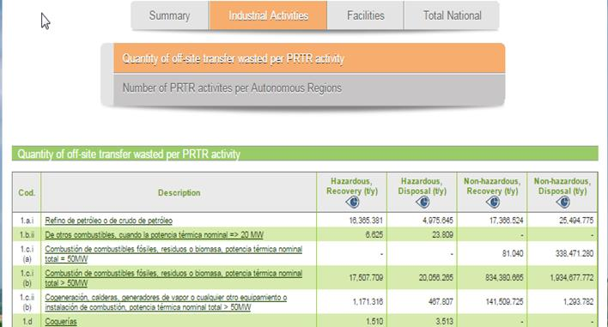

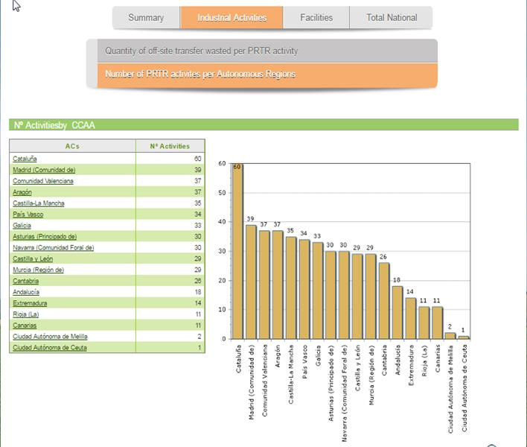
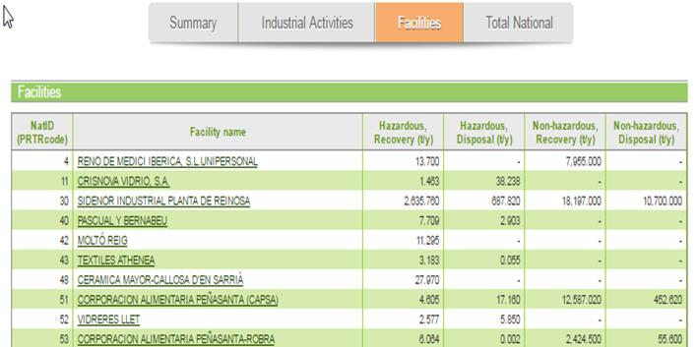
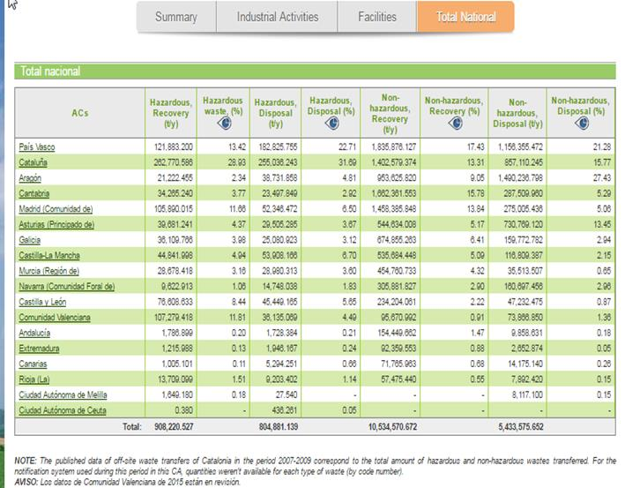
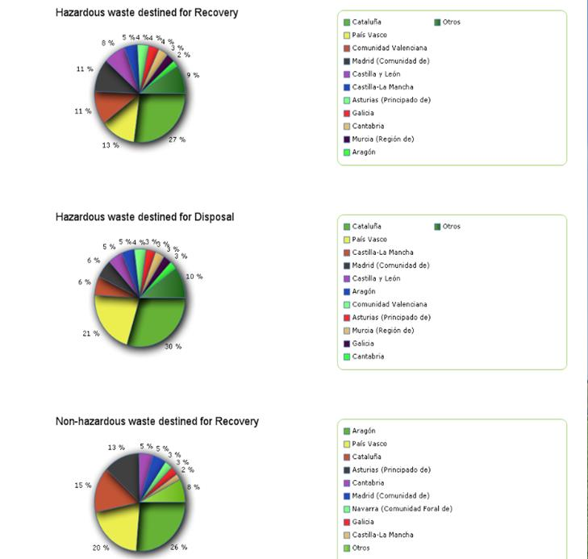

- WASTE TRANSFERS BY INDUSTRIAL ACTIVIVY
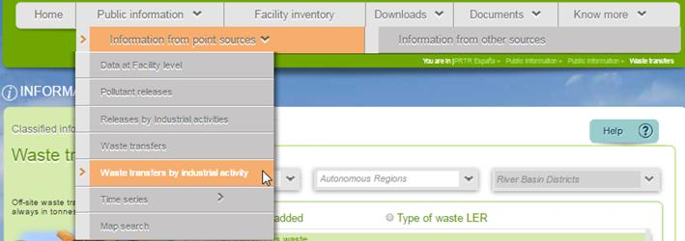

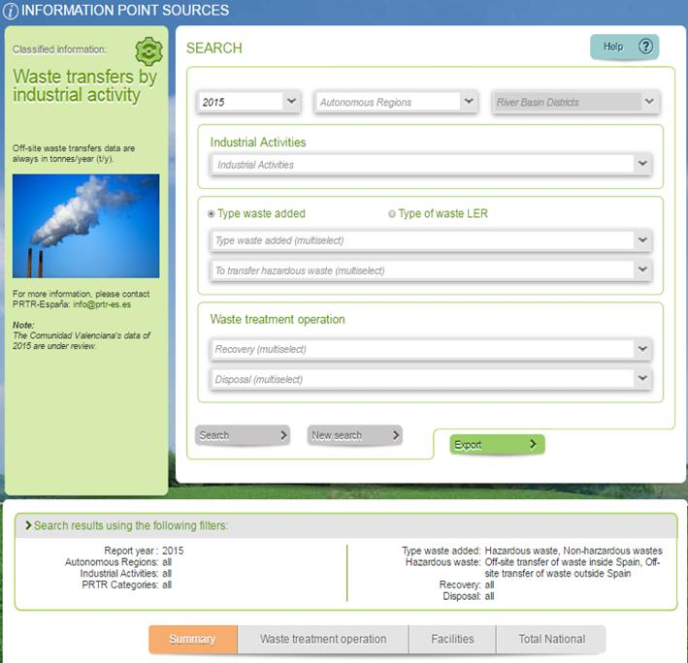
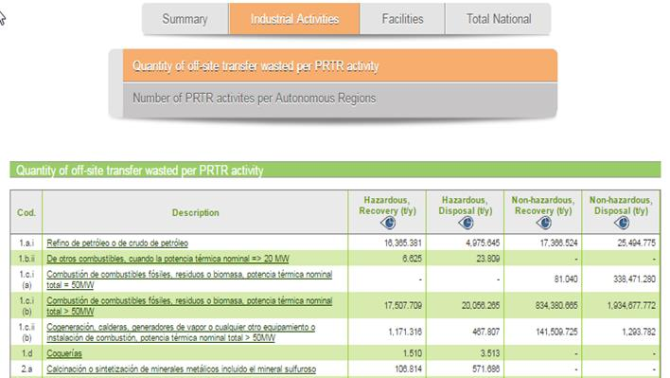
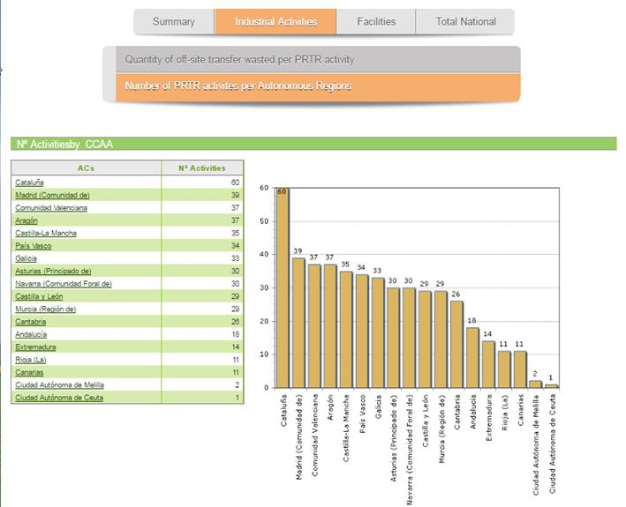
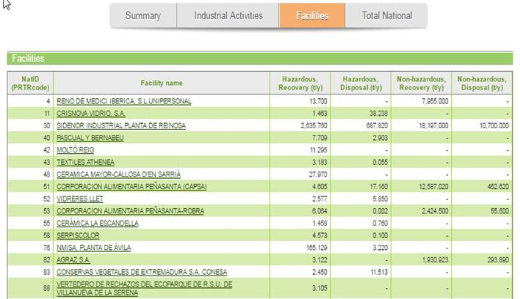
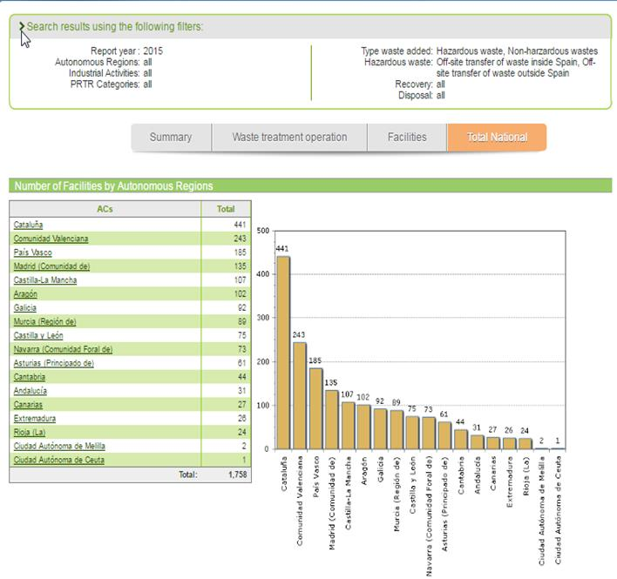

- TIME SERIES: INDUSTRIAL FACILITES
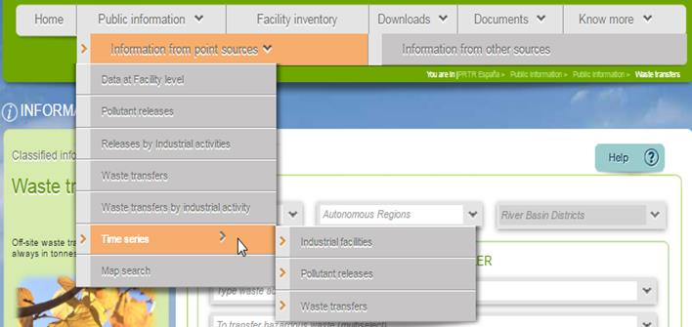

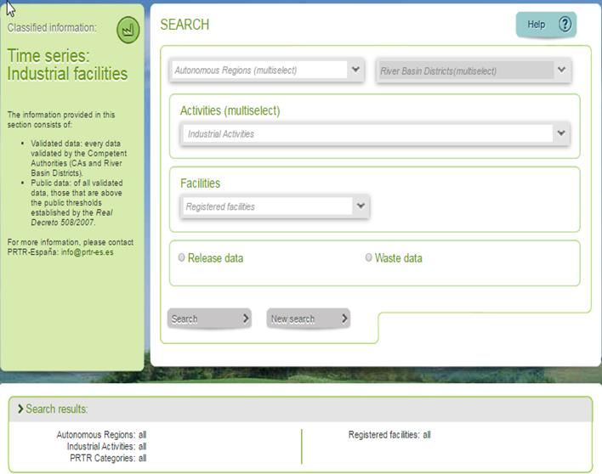
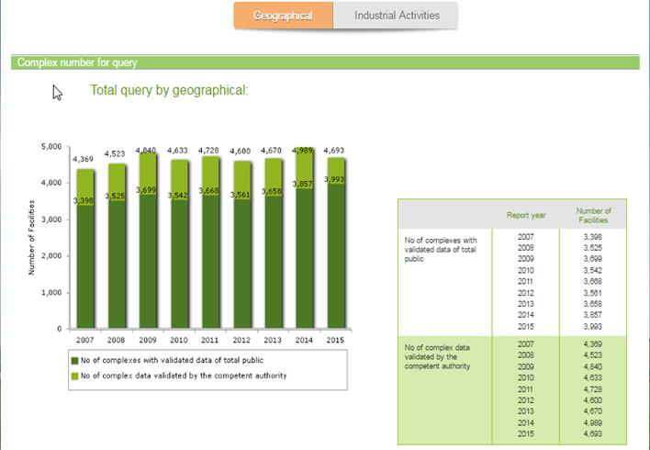

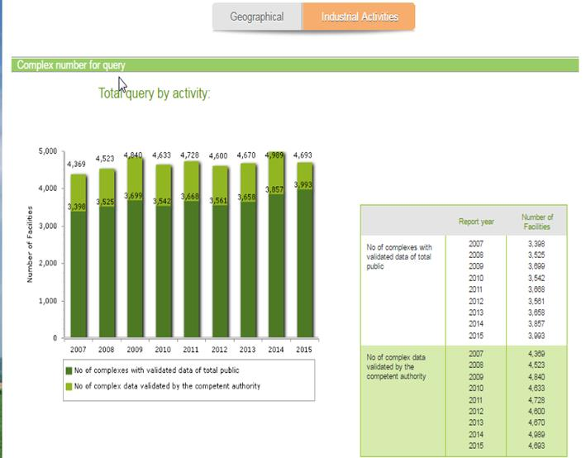

- TIME SERIES: POLLUTANT RELEASES

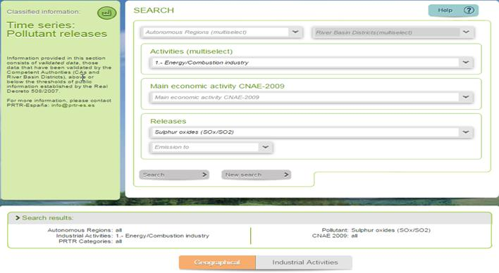
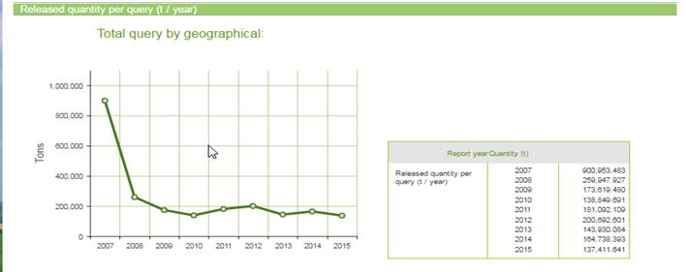
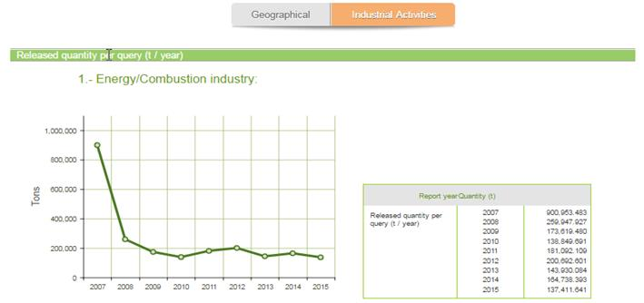

- TIME SERIES: WASTE TRANSFERS
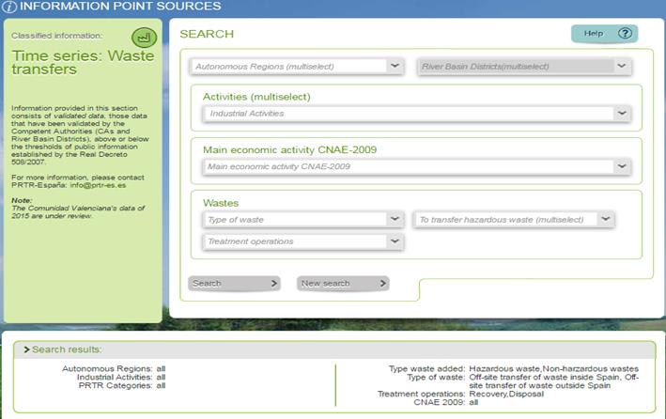
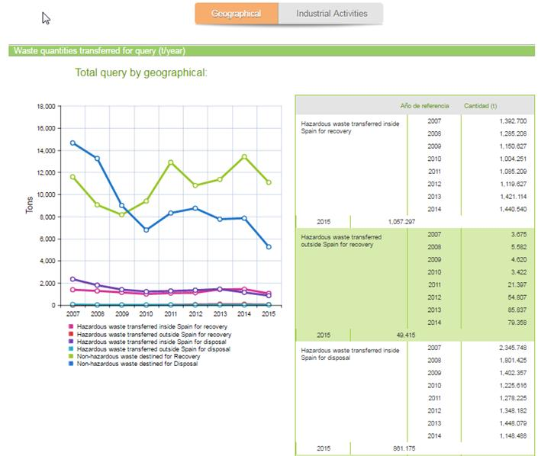
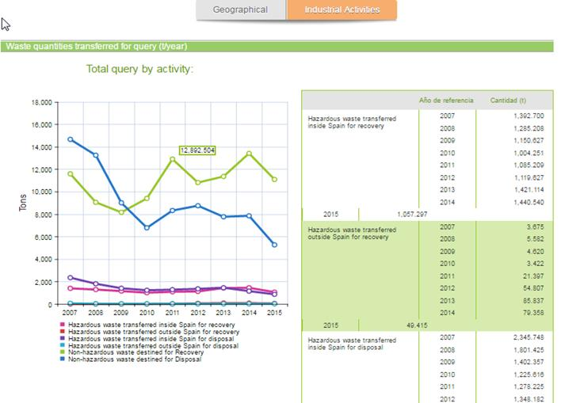
- MAP SEARCH
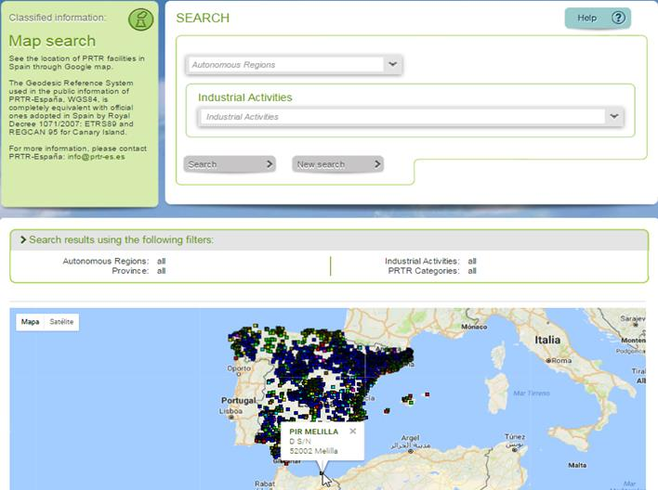
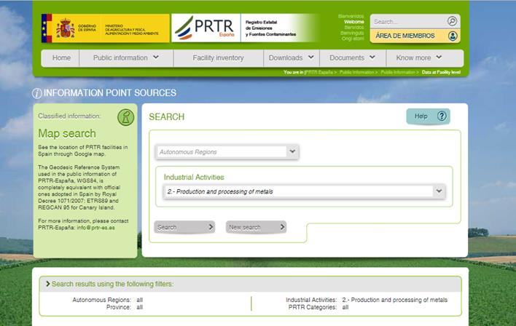
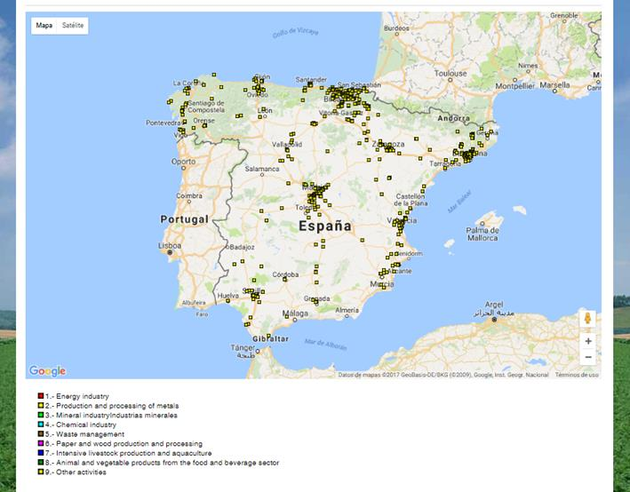

- SEARCH BY: in each option/menu several possibilities of queries:
- Year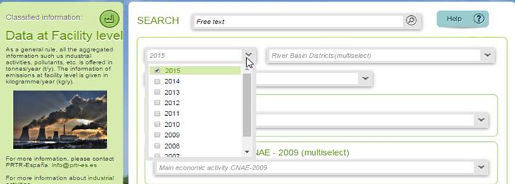
- Autonomous regions
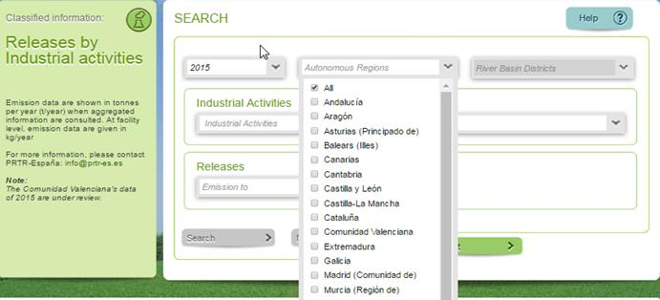
- Rive Basin Districts
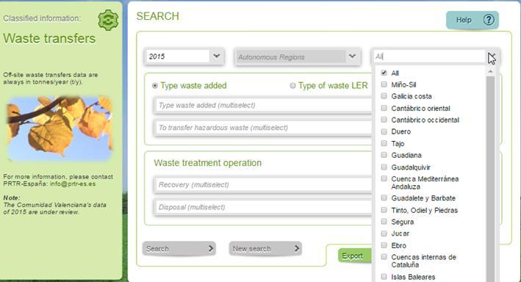
- Industrial activity
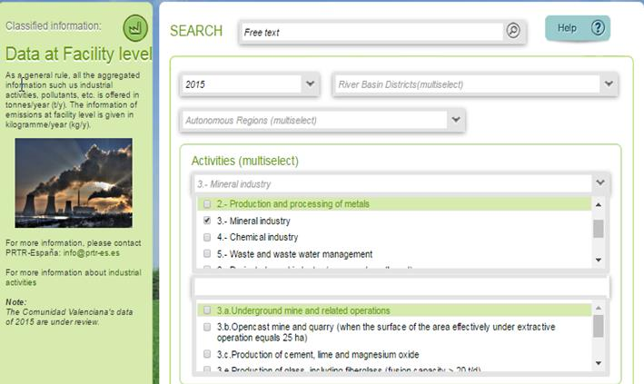
- Main economy activity
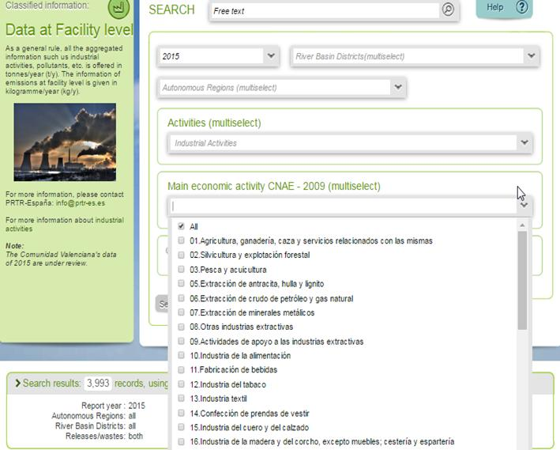
- Group of pollutants:
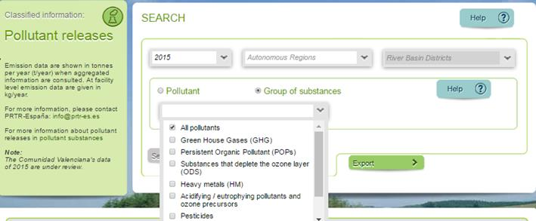
- HELPs
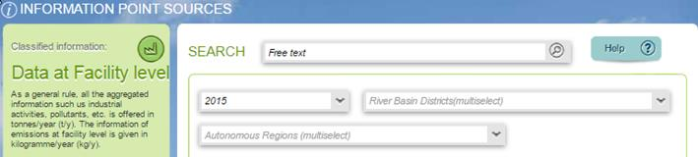

- PRTR-ESPAÑA USER MANUALS in “DOCUMENTS”
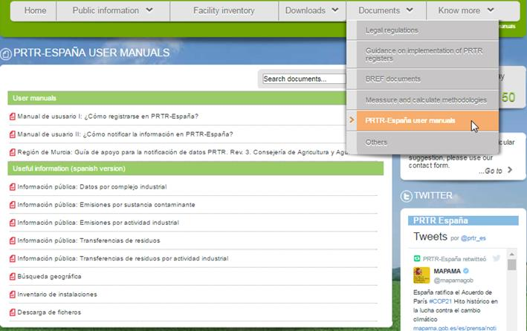
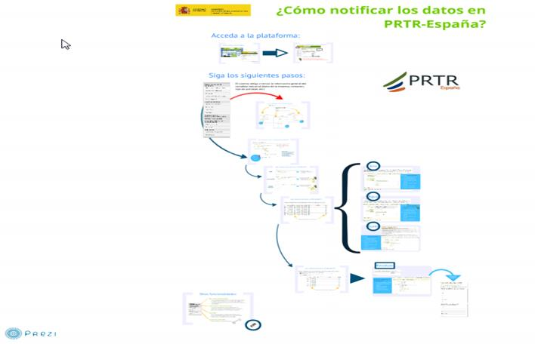
- INFORMATION FROM OTHER SOURCES
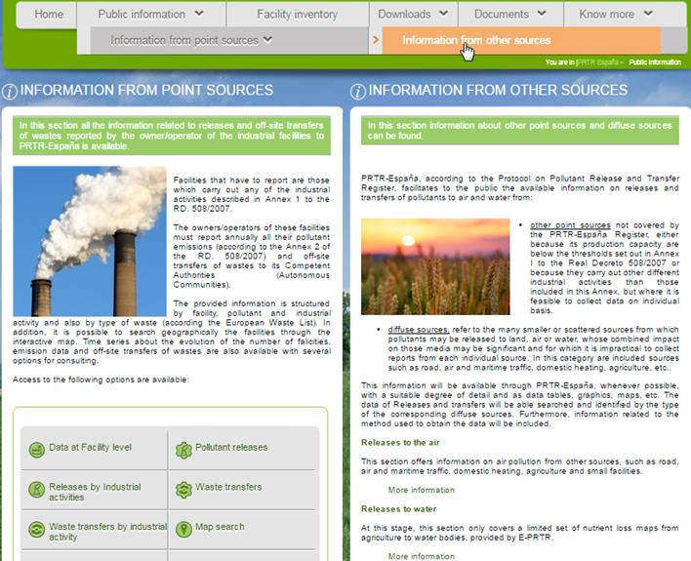
- MAIL, TELEPHONE, TWITER, FACEBOOK, SLIDESHARE, SUGGESTIONS CONTACT FORM
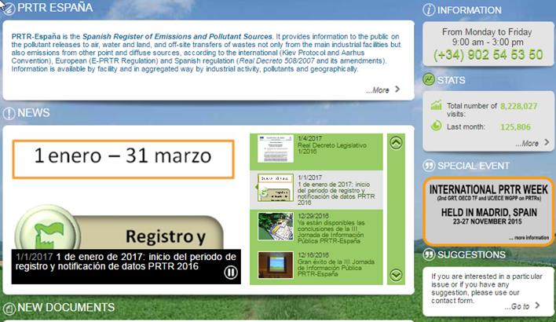
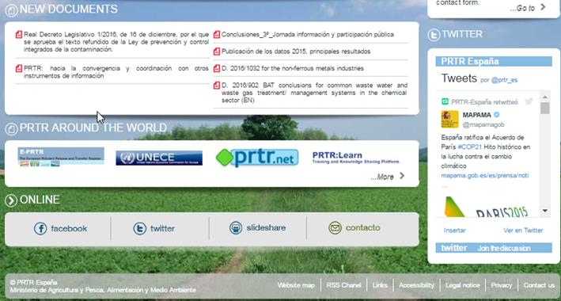

- INTERESTING LINKS
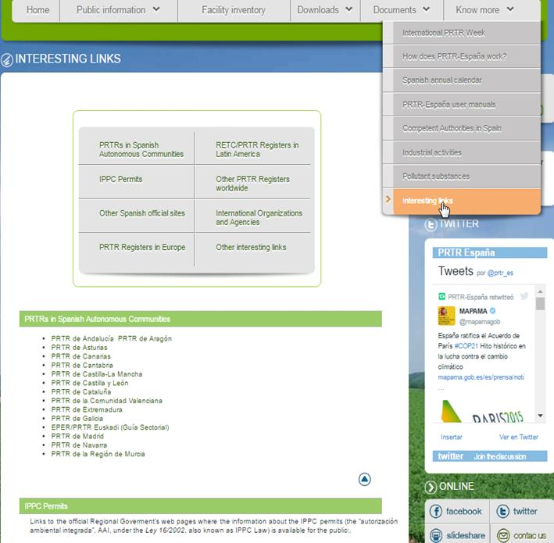

ANNEX 5.

Main capacity-building, trainning and promoting activities developed by PRTR-España (period 2014-2016).

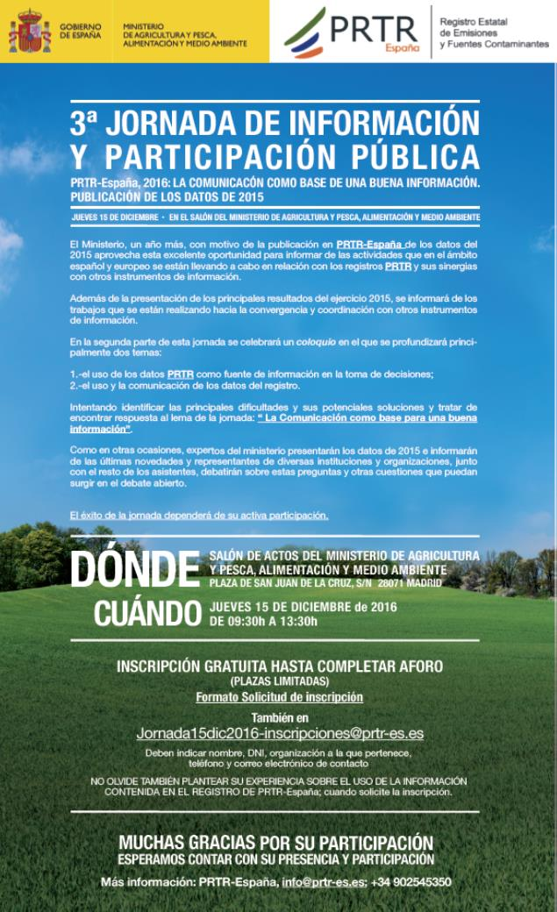
- “International PRTR Week”: 2nd Global Round Table on Pollutant Release and Transfer Registers (2nd GRT on PRTRs), 18th OECD Task Force on PRTRs y su Bureau (18thTF on PRTRs) y el 4thWorking Group of the Parties to the Protocol on PRTRs y su Bureau (4th WGPP on PRTRs). Noviembre 2015. Hosted by the Goverment of Spain under the auspices of UNECE, OECD and with the colaboration of UNITAR and UNEP..November 2015.
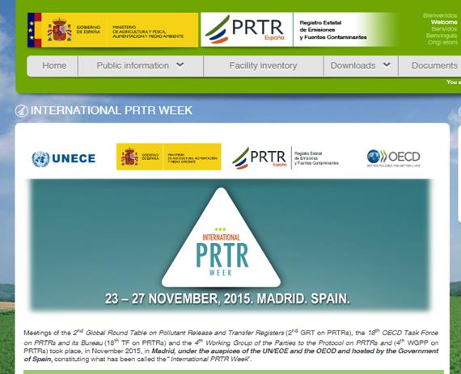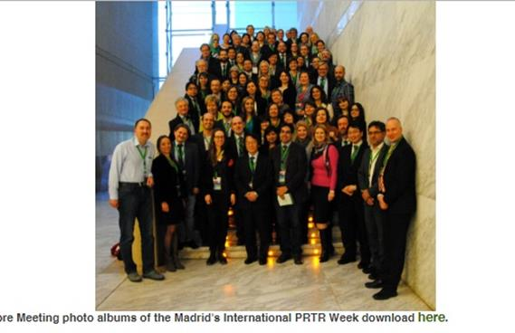

- “Get your right to a healthy community“.2nd Subregional Workshop on the Protocol on Pollutant Release and Transfer Registers for countries in Eastern Europe, Caucasus and Central Asia. 19-21 September 2016. Minsk, Belarus.
- “Global Project on the Implementation of Pollutant Release and Transfer Registers (PRTR) as a tool for Persistent Organic Pollutants (POP) reporting, dissemination and awareness raising”. Inception Workshop Report..Madrid, Spain 26-28 de noviembre de 2015
- Mesa Redonda: Registro de Emisiones y Convenios Ambientales en América Latina. XXXIV Congreso Interamericano de Ingeniería Sanitaria y Ambiental. Monterrey, Nuevo León (México), noviembre de 2014
- «Application, utilisation et présentation des données PRTR
(quelques expériences espagnoles)». Résultats de l’étude relative à la réalisation d’un Registre des Rejets et Transferts des Polluants (RRTP) au niveau des provinces de Tanger-Tétouan et Nador. Tanger. Marruecos (Maroc/Morocco). Septiembre de 2014.
- Application, use and presentation of PRTR data (the Spanish case). Regional meeting on PRTR and Pollution indicators. UNEP-Mediterranean Action Plan (MAP). Ankara (Turkey), 16-17 junio de 2014.
- Application, use and presentation of PRTR data
(some Spanish experiencies). Strengthening the Ministry of Nature Protection of the Republic of Armenia in Introduction of the System of IPPC. Ministerio de Agricultura, Alimentación y Medio Ambiente. Madrid. España. Marzo de 2014.

- “Application, use and presentation of PRTR data; The Spanish experience”. “Capacity-building and awareness activities with cooperation from Spain”.Get your right to a healthy community Subregional Workshop on the PRTR Protocol in SEE 28-29 May 2013. Sarajevo, Bosnia and Herzegovina. organised by the secretariat of the UNECE Protocol on Pollutant Release and Transfer Registers to the Convention on Access to Information, Public Participation in Decision-making and Access to Justice in Environmental Matters and by the Organization for Security and Co-operation in Europe.
- “IPPC-Integrated Prevention and Pollution Control en Turquía: To achieve a high level of protection of the environment by introducing integrated prevention and control of pollution Project purpose: The establishment of the framework conditions to achieve reform of the administrative, legal and technical structures to implement integrated environmental permitting of IPPC installations in Turkey by the end of the project, according to the demands of the Industrial Emissions Directive”. Twinning Project TR 08 IB EN 03. Proyecto conjunto del Ministerio de Agricultura, Alimentación y Medio Ambiente (España) (líder del proyecto) y el “Chief Inspectorate for Environmental Protection of the Ministry of Environment of Poland”. Financiado por la UE. Entidad beneficiada: Ministerio de Medio Ambiente de Turquía. 2011-2013.
- “Fortalecimiento de capacidades para facilitar el diseño de los registros de emisiones y transferencia de contaminantes (registros RETC) nacionales y el contexto internacional”. Registro Estatal de Emisiones y Fuentes Contaminantes de España (PRTR-España). Taller de trabajo en el marco del proyecto GEF/UNITAR. España-Ecuador. Celebrado en Madrid, España. 13-17 de febrero de 2012.
- Final Meeting of the Steering Committee of the project “POPs reporting, monitoring and information dissemination using PRTRs”, and back-to-back working sessions.”Experience in Spain on reporting POPs using PRTR Spain (Ministry of Agriculture, Food and Environment of Spain)”. Ginebra, Suiza, 28-31 agosto 2012.
- Reunión Comité Técnico Regional para la Implementación de un RETC en Centroamérica y la República Dominicana. Evaluación de la implementación de los RETC a nivel nacional y regional, discusión de acciones para la preparación de una fase II. Reuniones técnicas proyecto MARM-CCAD, en coordinación con otras iniciativas de USAID-CCAD, USEPA-UNITAR y UNITAR para el diseño e implantación de un Registro Regional de Emisiones y Transferencia de Contaminantes en Centroamérica. Sede SICA CCAD, Tegucigalpa. Honduras. 14-16 de noviembre de 2012.
- Reunión Comité Técnico Regional para la Implementación de un RETC en Centroamérica y la República Dominicana. Definición y acuerdos para el alcance y características del RETC regional: actividades, sustancias, umbrales, medios y mecanismos de reporte. Reuniones técnicas proyecto MARM-CCAD, en coordinación con otras iniciativas de USAID-CCAD, USEPA-UNITAR y UNITAR para el diseño e implantación de un Registro Regional de Emisiones y Transferencia de Contaminantes en Centroamérica. Sede SICA CCAD, San Salvador. El Salvador. 5-9 de diciembre de 2011.
- Taller “Lineamientos Estratégicos Nacionales de Investigación Ambiental: Experiencias internacionales en investigación ambiental en Europa y en España”. Ministerio del Ambiente del Ecuador. Quito, 17-21 de octubre de 2011.
- Implementación de un RETC en la región de Centroamérica y la República Dominicana: “Aspectos Jurídicos de RETC: Caso Español y Europeo”; “Ejemplos del alcance de RETC en diferentes contextos: Caso Español y Europeo”, Experiencias en el reporte en RETC: Caso Español y Europeo”, “Información Pública en un RETC, casos Español y Europeo”. Reuniones técnicas proyecto MARM-CCAD, en coordinación con otras iniciativas de USAID-CCAD, USEPA-UNITAR y UNITAR para el diseño e implantación de un Registro Regional de Emisiones y Transferencia de Contaminantes en Centroamérica. Reuniones técnicas en Costa Rica, Honduras, Guatemala y El Salvador. 13-22 de junio de 2011.
- Diseño de las Características Clave del Sistema RETC: “Aspectos Jurídicos de RETC: Caso Español y Europeo”; “Ejemplos del alcance de RETC en diferentes contextos: Caso Español y Europeo”, Experiencias en el reporte en RETC: Caso Español y Europeo”. Reunión técnica Proyecto GEF/UNITAR “Programa de UNITAR de Fortalecimiento de Capacidades para Facilitar el Diseño de los RETC Nacionales y el Contexto Internacional”: 17-19 de mayo de 2011, Quito (Ecuador).
- “Aspectos Jurídicos de RETC: Caso Español y Europeo”. Diseño de las Características Clave del Sistema RETC. Reunión técnica Proyecto GEF/UNITAR “Programa de UNITAR de Fortalecimiento de Capacidades para Facilitar el Diseño de los RETC Nacionales y el Contexto Internacional”: 22-23 de julio de 2010, Lima (Perú).
- “Ejemplos del alcance de RETC en diferentes contextos: Caso Español y Europeo”. Diseño de las Características Clave del Sistema RETC. Reunión técnica Proyecto GEF/UNITAR “Programa de UNITAR de Fortalecimiento de Capacidades para Facilitar el Diseño de los RETC Nacionales y el Contexto Internacional”: 22-23 de julio de 2010, Lima (Perú).
- “Experiencias en el reporte en RETC: Caso Español y Europeo”. Diseño de las Características Clave del Sistema RETC. Reunión técnica Proyecto GEF/UNITAR “Programa de UNITAR de Fortalecimiento de Capacidades para Facilitar el Diseño de los RETC Nacionales y el Contexto Internacional”: 22-23 de julio de 2010, Lima (Perú).
- “EL REGISTRO PRTR-España”. Jornada Técnica: Introducción al RETC. Proyecto GEF/UNITAR “Programa de UNITAR de Fortalecimiento de Capacidades para Facilitar el Diseño de los RETC Nacionales y el Contexto Internacional”, 19-20 de julio de 2010, Quito (Ecuador).
- “METHODS_IN_ PRTR_España”. 2nd PRTR Expert group meeting. Bruselas 27 de octubre de 2009.
- “PRTR-España: Spanish Register of Emissions and Pollutant Sources” 1st PRTR Expert group meeting. Bruselas 29 de mayo de 2009.
- “Implementation of PRTR in Spain: PRTR-España. Reporting electronic tool for competent authorities and facilities”. WORKSHOP on E-PRTR data flows in a Shared Environmental Information System. DG Environment, Bruselas December 2008, 2nd.
- “Integrated Prevention and Pollution Control in Spain, IPPC permits (AAI) and EPER/PRTR Registers”. Twinning Project PHARE RO/06/IB/EN/06. Romania – North Eastern Region; Bacau, julio 2008.
- “Implementation of PRTR in Spain: “PRTR-España”. A Reporting electronic tool for competent authorities and facilities”. INFRA 30122 organised by TAIEX in co-operation with The Ministry of Environment and Sustainable Development of Romania: Obligations and methods to reporting to EC- Regulation 166 /2006 EPRTR and Decision 2006/194/EC., Bucarest, Rumania. Julio 2008.
- “Legal implementation, identification of facilities, reporting facilities and competent authotrities“. Workshop on the European Pollutant Release and Transfer Register (PRTR)INFRA 26043 organised by TAIEX in co-operation with The Ministry of Environment and Physical Planning State Environmental Inspectorate, FYROM, Skopje. Abril 2008
- “The industry point of view, challenges to implement EPER and PRTR”. Workshop on the European Pollutant Release and Transfer Register (PRTR) INFRA 26043 organised by TAIEX in co-operation with in co-operation with The Ministry of Environment and Physical Planning State Environmental Inspectorate, FYROM, Skopje. Abril 2008.
- “EPER-España” REGISTER 2002 –2006 4 years of experience” Workshop on the European Pollutant Release and Transfer Register (PRTR) INFRA 24566 organised by TAIEX in co-operation with the Croatian Environment Agency. Zagreb, julio 2007.
- “Industry experience in implementing EPER/E-PRTR” .Workshop on the European Pollutant Release and Transfer Register (PRTR) INFRA 24566 organised by TAIEX in co-operation with the Croatian Environment Agency. Zagreb, julio 2007.
- “El nuevo Registro PRTR de emisiones y Fuentes contaminantes” Jornada Técnico-Informativa, XLIII Asamblea general de miembros ATEG. Madrid, febrero 2008.
- “Nuevo Registro PRTR-España: Presentación y Aplicación en Cantabria” Jornada Informativa. Santander Cantabria, enero 2008. Gobierno de Cantabria.
- “PRTR-ESPAÑA: LA NUEVA HERRAMIENTA DE REGISTRO Y NOTIFICACIÓN” JORNADA INFORMATIVA SOBRE EL REGISTRO DE EMISIONES Y TRANSFERENCIA DE CONTAMINANTES. Palma de Mallorca, enero 2008. Gobierno de Baleares
- “De EPER hacia el nuevo concepto PRTR”. Jornada informativa Cámara de Comercio de Madrid y Consejería de Medio Ambiente y Ordenación del Territorio de la Comunidad de Madrid. Enero 2008. Comunidad de Madrid
- “La nueva herramienta de Registro y Notificación. PRTR-España”. Jornada Informativa. Comité de Medio Ambiente CEOE. Madrid. Diciembre 2007.
- “Las AAI y las obligaciones de Información en el Registro EPER/PRTR España”. Encuentro anual sobre “Legislación Medioambiental”. IFAES 20 y 21 de noviembre 2007 Madrid
- “Cómo Funciona y qué servicios ofrece el nuevo Registro Estatal de Emisiones y Fuentes Contaminantes, PRTR-España”. Encuentro anual sobre “Control de Emisiones Atmosféricas”. IFAES 20 y 21 de noviembre 2007 Madrid
- “Jornada de Participación pública en el proceso de implantación del nuevo registro PRTR-España”. Ministerio de Medio Ambiente. Madrid, abril 2007.
- “Presentación de los nuevos requisitos de información a PRTR-España”. Jornada informativa. Comité de Medio Ambiente CEOE. Madrid. Marzo 2007
- “El Inventario EPER en España y en Europa. El futuro que viene: el registro E-PRTR (European Pollutant Release and Tranfers Registers)”. Encuentro anual sobre “Legislación Medioambiental”. IFAES 1,2, y 3 de marzo de 2005 Madrid
- “Prevención y Control Integrados de la Contaminación, (IPPC, MTD e Inventario EPER”. Master en Ingeniería y Gestión del Medio Ambiente en la Empresa. Cámara Navarra de Comercio e Industria. Enero 2004
- “EPER-España, Registro Estatal de Emisiones y Fuentes Contaminantes”. Curso “Control Integrado de la Contaminación. Inventario. Junta de Castilla y León. Sedano, Burgos. Junio de 2003.
- “Inventario EPER”. Master en Gestión y Control Ambiental de la Empresa. Escuela Técnica Superior de Ingenieros de Montes, Universidad Politécnica de Madrid. Marzo 2003.
- “Inventario EPER”. Curso de Prevención y Control Integrados de la Contaminación. Aplicación en España de la Ley 16/2002 de 1 de julio. EOI, Escuela de Organización Industrial, Madrid, noviembre de 2002.
- “Registro Estatal de Emisiones y Fuentes Contaminantes EPER”. CREA, Confederación de Empresarios de Aragón. Zaragoza octubre de 2002,
- “Aspectos legales y Funcionamiento del Registro Estatal de Emisiones y Fuentes Contaminantes EPER”. 7º Encuentro Internacional sobre Cubilotes Modernos. Industria Química del Nalón, Oviedo 17-18 de octubre de 2002.
- “Sesión Informativa sobre el Funcionamiento del Registro Estatal de Emisiones y Fuentes Contaminantes EPER”. Ministerio de Medio Ambiente, Madrid 10 de octubre de 2002.
- “El Registro Estatal de Emisiones y Fuentes Contaminantes EPER”. Jornada Informativa Organizada por el Ministerio de Medio Ambiente y CEPCO en el marco de CONSTRUCTEC 2002 en IFEMA Madrid, 27 de septiembre de 2002.
- “Funcionamiento del Registro Estatal de Emisiones y Fuentes Contaminantes EPER”. ECOFIRA FORUM, Encuentro de Directores de Medio Ambiente Valencia, Abril 2002.

