EECCA CSI 29- Passenger transport demand

Key message

Since 1999 public passenger transport volume has grown slowly due to economic growth in the EECCA region and improved public transport accessibility. Private car ownership rates also increased. Along with economic developments of the region passenger transport activities are expected to increase in the future. Public transport is more environmentally friendly as compared to private cars. Urban settlements have to develop more sustainable public transport strategies to prevent growing environmental impact.

Rail and electric urban transport play significant role in public transport in many EECCA countries. However, their share decreased during the last five years. It is important to safeguard the competitive position of this more environmental benign transport.

Some measures, including modernization of transportation facilities and use of less energy intensive and more environmentally friendly transport outlined in EECCA Environmental Strategy can be taken to ensure that transport development in the countries are sustainable.

Key policy question: What are the developments in passenger transport demand in EECCA countries?
Key assessment
The methodology presented in the UNECE guidelines allows to asses only developments of the public passenger transport in EECCA countries, due to absence of statistics regarding the passenger transport demand by private cars in EECCA countries. It is, however important to look at the developments of private cars use, as their contributions to environmental pollutions from passenger transport accounts for more than 50%. To overcome this limitation of data availability, the assessment was enhanced by information on car ownership rates.
From the beginning of the 90^{ies} public transport demand in the EECCA countries was falling due to general economic decline in the region. At the end of 90th passenger demand by public transport started to increased. In 2004 it exceeded the level of 1995 by 2 % and amounted to 770 mln passenger-km (Fig 1). Growth of economical activities and household disposable income, improvements in public transport accessibility, developments of private business for public transportation and openness of new international destinations after 1990 are among the main reasons of the increase of public transport.
Over the 2004-2005 period a slight decline of the volume of pubic transport demand took place in Russia and Belarus. Among some of the most important reasons of such trends are price increase for rail in Belarus; reduction of transport subsidies for various citizens’ groups in Russia as well as increase of private car ownership.

Fig. 1. Trends of passenger public transport demand

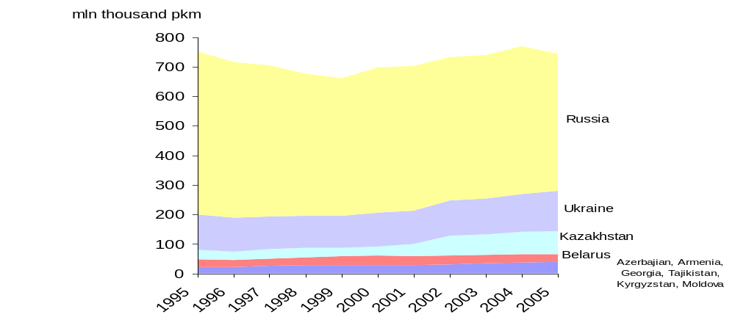

As mentioned above, it is hard to assess developments in the passenger transport activity by private car owners based on the proposed UNECE methodology due to the lack of statistical data. However it is possible to assess the general trends in development of this area by looking at the car ownership rates (Fig. 2). All EECCA countries have a stable growth of private car ownership rates. There are a number of important “drivers” leading to such increase. Growth in household disposable income* is the most important one. Another factor is automobile import policies which allowed low taxes for import of old used cars from the main car production regions (EU, Japan, US) in the middle of 90th.
Russia and Belarus have the highest car ownership rates (amount of private car per 1000 people) - 160 and 170 cars per 1000 people relatively in 2004, whereas Kyrgyzstan stands well behind (37 cars per 1000 people).
Fig.2 Private car ownership in some EECCA
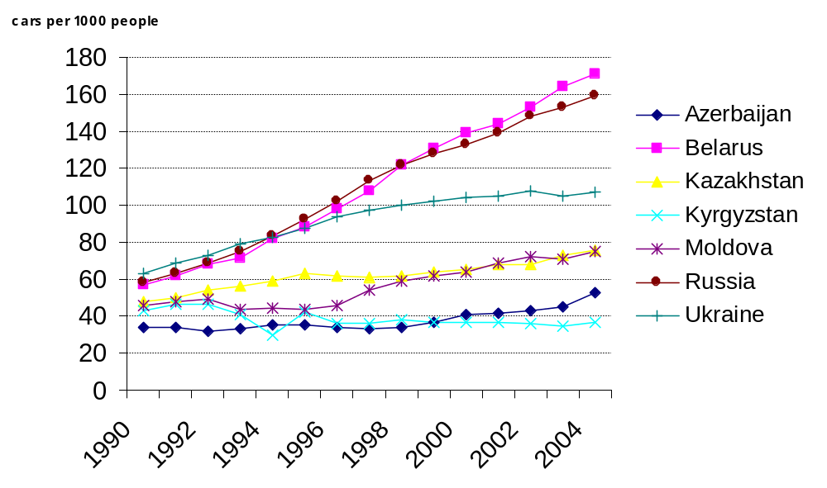
If the present policy and technological trends continue car ownership rates for all EECCA countries are expected to rise by about 350% from 2000 to 2050. The total passenger transport activity by public transport and private cars is expected to rise by about 170% during the same period and the CO2 emissions related to passenger transport are expected to increase by 160%. Other adverse effects of passenger transport such as air pollution, traffic congestion and noise are also likely to increasingly affect environment and quality of life (WBCSD 2004).

Specific policy question

Is the share of more environmentally benign transport in total inland transport being reduced relative to other transport modes?
Due to the data availability reasons described above this part of the indicator is focused only on the public transport.
A shift in modal split of the passenger demand by public transport in EECCA was registered from 1995 to 2005. More environmentally benign transport, rail and electric transport, lose their share to busses and air. Rail transport share amounted for 39% in 1995 and only 33 % in 2005, Electric transport’s share (metro, trams and trolley busses) fall from 16% in 1995 to 14% in 2005. There are several reasons for such a modal shift. Maintenance costs for rail and electric transport infrastructure are high. Much bigger investments are needed to open new metro lines or trolleybus and tram routes as compared to buss routes. From the middle 90^{ies} private business was encouraged to support improvements of public transport in all EECCA countries. Private business mostly operates with buses and minibuses as more flexible and less costly transport mode. They run new routes and compliment the existing metro, tram and trolleybus routes in order to increase frequency and total capacity of public traffic. Such involvement of private business allowed EECCA countries to substantially improve accessibility of public transport and its quality of service. At the same time, it stimulated modal shift towards less environmental benign transport. The share of busses in EECCA countries increased from 34% in 1995 to 39% in 2005.
As in many other countries, air transport has been growing in EECCA during last 10 years as a result of development of new domestic and international routes and increase in household disposable income. The average annual growth of air transport in the EECCA region was 1% 2000-2005.

Fig. 3. Modal split trends of passenger public transport demand in EECCA (%)
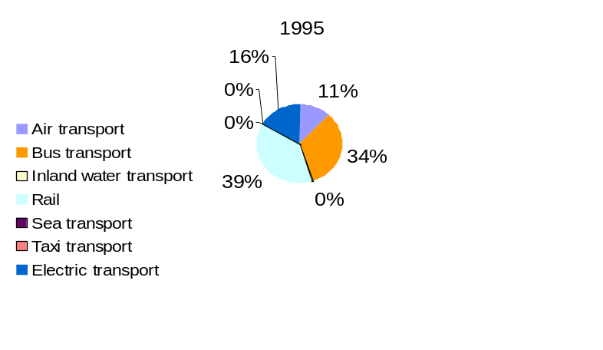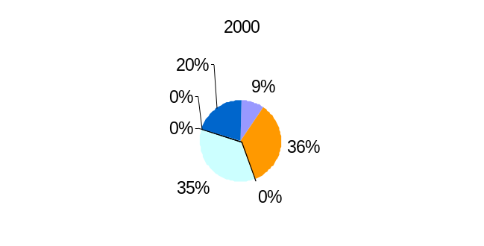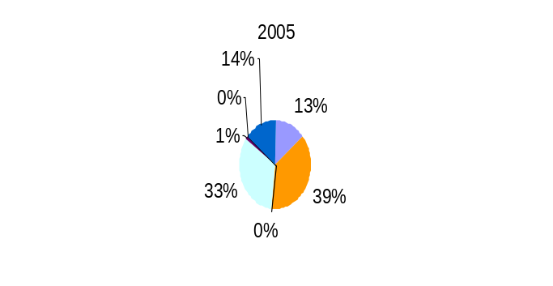
Country based data shows existing differences between the countries of the EECCA region. (Fig.4). Belarus, Ukraine and Russia still maintain the highest level of rail and electrical transport in total passenger transport demand (59%, 57% and 52% relatively in 2005), although their share was slightly decreasing since 1995. In these countries there are better possibilities to renew transport infrastructure and a well developed urban public transport networks. The share of electric transport in Moldova however, decreased substantially over the years - from 59% in 1995 to 29 % in 2005. This is due to high maintenance costs of trolleybuses, which is the only electric transport in Moldova and also due to general political instability in the region. In other EECCA countries rail and electric transport did not have any significant shares due to a lack of infrastructure availability and natural landscapes. This small share at the same time continues to drop for reasons described above.

Fig. 4 Modal split of passenger public transport demand in some EECCA countries (%)

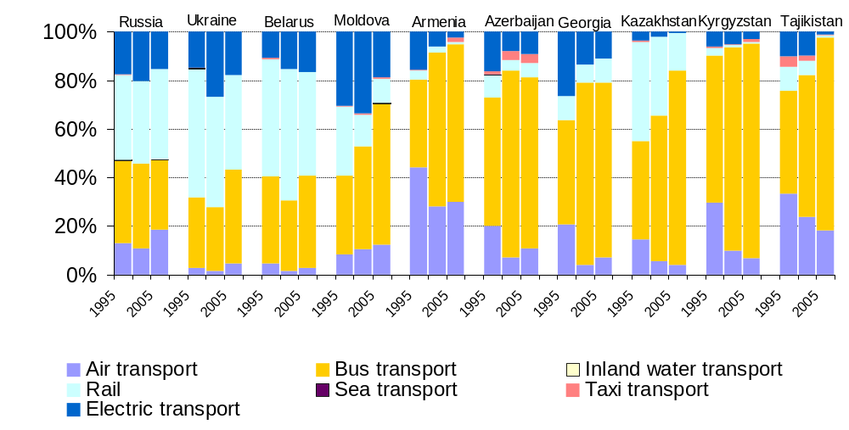
Recommendation:
From an environmental point of view it is important to keep a competitive position of rail and electric urban transport as an alternative that contributes less to climate change air pollutions compared to road transport. However, such a position can be maintained only if modernization of transport infrastructure will focus on sustainable development. Some measures, including modernization of transportation facilities and use of less energy intensive and more environmentally friendly transport outlined in EECCA Environmental Strategy can be taken to ensure that transport development in the countries is sustainable.

Methodology for indicator calculation
How did we create this indicator?

The indicator is calculated according to the UNECE Guidelines for the Application of Environmental Indicators in Eastern Europe, Caucasus and Central Asia for EECCA countries (http://www.unece.org/env/europe/monitoring/Belgrade/CRP1.Indicators.En%20edited.MK..pdf). However some modifications were made due to regional analysis needs and data availability. These are presented below.

To measure volume of passenger transport demand separate trends of the volume of passenger transport are calculated. It includes buses, trolleybuses, taxi, trams, underground, trains, inland water transport, maritime transport and airplanes. CIS stat data is used as a main data set for calculation of the indicators. This data is computed as the total number of passengers carried by all transport means both within the country and in international transportation irrespective of types of tariffs applied and including passengers enjoyed the right of free transportation
According to UNECE Guidelines for the Application of Environmental Indicators in Eastern Europe, Caucasus and Central Asia, private cars should be included as well. However, due to absence of that indicator private car ownership was used to enhance the assessment.
The indicator of modal split is presented as a share of particular mode of passenger transport in total passenger transport demand (i.e. the modal split share for passenger transport).

Time period: 1995-2005 for passenger demand, 1990 – 2005 for car ownership rate
Units: passenger-kilometer- for passenger demand, number of cars per 1000 people for car ownership rates
Data source:

Interstate Statistical Committee of the Commonwealth of Independent States. ’15 years of the Commonwealth Independent States’. CD published 2006-11.

When the data was not available the gaps were filled from other sources as presented in the table below:
Country | Gap for filling | Proposed gap filling
Central Asia
Kazakhstan | 2002-2005, numbers of taxi transport demand | Data for 2002 year was applied for 2003, 2004 and 2005
Caucasus
Azerbaijan | Volume of tram transport, 2004 – 2005 | Data for 2003 year was applied for 2004 and 2005
Armenia | - Volume of rail transport in 1995;  - Volume of tram transport, 2005 | - CISSTAT, 1996  - CISSTAT, 2003

Until now data for passenger demand by private car in passenger kilometers was not collected in EECCA countries. There are well developed methods used in EU countries, which can be applied to the EECCA region. Currently, these methods are rather complicated, time consuming and expensive.
According to the methodology CIS STAT, passenger turnover, which is used as a main date set for calculation of this indicator, is collected within the country and in international transportation.
* household income after tax
Projections are based on the reference case scenario. The reference case projects one possible set of future conditions, based on recent trends. Adjustments are made for expected deviations from recent trends due to factors such as existing policies, population projections (UNSTAT), income projections (IEA) and expected availability of new technologies. Expectations for other future changes in trends, such as saturations in vehicle ownership, are also incorporated. In general, no major new policies are assumed to be implemented beyond those already implemented in 2003 and major technological breakthroughs. World Business Council for Sustainable Development (WBCSD) ‘The Sustainable Mobility Project’. http://www.wbcsd.org/web/publications/mobility/smp-model-document.pdf.
Electric transport include: metro, trams and trolley busses.
It also can be due to the lack of data from part of the territory. Part of territory of Moldova declared itself as an independent state Transtnistrian Republic in 1992. In general self proclaimed its statistics is not included in this figure.

