United Nations Economic  Commission for Europe | 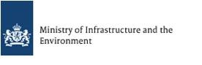 | 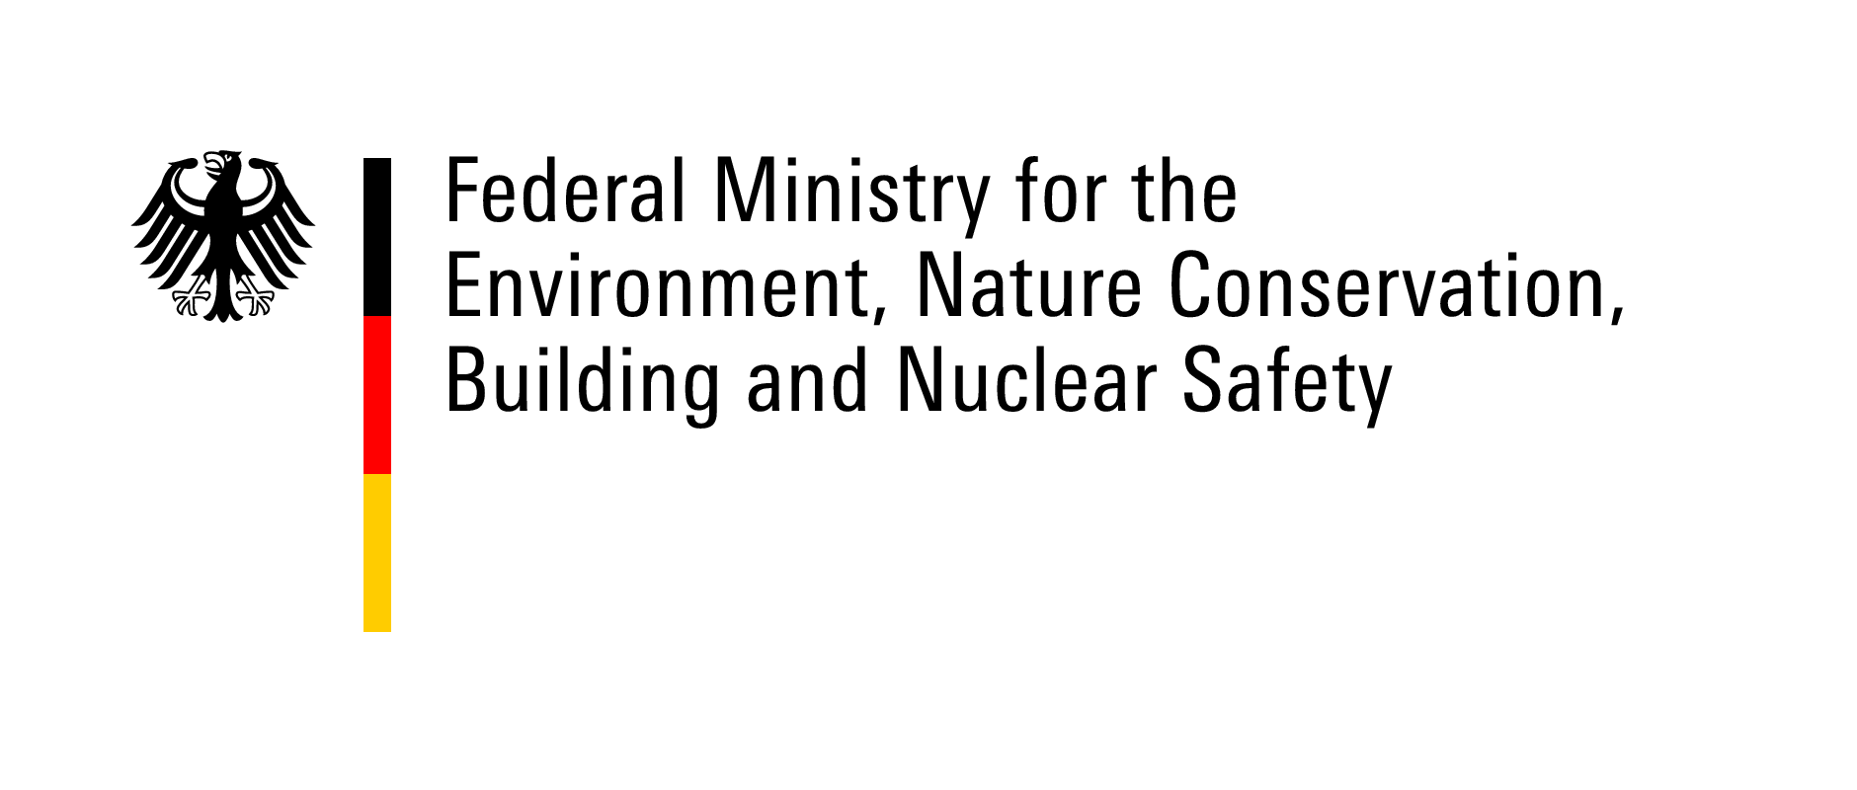 | 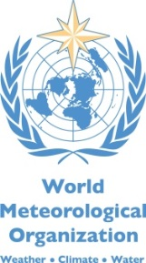
TEMPLATE FOR SUBMITTING CASE STUDIES ON TRANSBOUNDARY FLOOD ISSUES

Second workshop on Transboundary Flood Risk Management
Geneva, 19-20 March 2015

We invite submission of case studies highlighting good practices and challenges in transboundary flood risk management. The case studies will serve as a basis for the workshop background paper and will define final workshop programme.
They should illustrate examples of transboundary cooperation, which is essential for improving flood management, focussing on solutions and also any barriers to technical, legal, institutional or management issues. Please use this template to provide as much information on the case studies as possible.

1) Name of the river basin(s) you are proposing:

2) Please shortly describe the river basin/sub-basin, basin States, climatic conditions (e.g. climate zone, precipitation amount, flood season, role of snow and ice melt in flood generation)

3) What types of floods affect the river basin (riverine/fluvial floods, flash floods/pluvial floods, coastal floods, groundwater floods, flooding related to reservoir operation, etc.)? Please provide a short account of the major flood events that have affected the basin in the past decade(s) as well as their impacts (e.g., in terms of losses of live, damages to property and overall economic losses). If possible, please indicate how many of the basin States were affected by each event.

4) Please provide information on arrangements that provide a basis for cooperation in terms of flood management in the basin, such as bi- or multilateral agreements and institutions (e.g. river basin organizations).

5) Please indicate the scope and mandate of these arrangements in terms of flood management (e.g. flood forecasting and warning, emergency assistance, exchange of basin hydrological data and information, joint studies, coordination of flood defence projects, coordinated flood emergency management, joint basin planning (land and water), joint Integrated Water Resources Management plans).

6) Please provide indication on what are the main factors contributing to success of those arrangements for cooperation on transboundary flood management. What are the major shortcomings in flood management cooperation and the underlying technical systems and institutional arrangements that provide support?

7) Please propose one technical area (such as provided under 4 above) or institutional area (e.g. flood management policy, law, organizational setup, finances, capacity building for specific technical areas) that you see as the key area where the flood management system could be improved in the shared basin. Please be as specific as possible.

8) Please provide your name and contact details or name and contact details of appropriate contact person. Please also provide references or websites where more detailed information can be found, if available.

We kindly ask you to send your replies by 15 January 2015, to the following e-mail addresses: maria.berglund@fresh.thoughts.eu and anna.kaplina@unece.org

THANK YOU VERY MUCH!

