Water-Food-Energy-Ecosystems Nexus:

Reconciling Different Uses in Transboundary River Basins

UNECE Water Convention

Draft Methodology for the Nexus Assessment for discussion, version 1 September 2014

An informal paper prepared by the Royal Institute of Technology (KTH) jointly with the secretariat[1]

# Summary

An assessment of the water-food-energy-ecosystems nexus is being carried out as part of the programme of work for 2013–2015 under the Water Convention.

The Task Force on the Water-Food-Energy-Ecosystem Nexus, established by the Meeting of the Parties to overview and guide the preparation of the nexus assessment chaired by Finland, agreed on the main features of the assessment at its first meeting of the Task Force (Geneva, 8–9 April 2013).

Notably it was decided that a scoping-level assessment of the nexus, covering all confirmed basins, would be mostly qualitative, involving the identification of linkages and major issues, substantiated by appropriate indicators. The methodology was to be generic, applicable to diverse river basins and also to aquifers.

With the guidance from the Task Force, a draft methodology was developed, circulated for review and tested in practice. The draft methodology version presented in this document has been shaped by the piloting on the Alazani/Ganikh Basin, the subsequent assessment of the Sava Basin as well as comments from the Task Force in response to the circulation of an earlier draft version in December 2013.

While it is clear that a generally consistent methodology is needed for application to the set of basins, some learning and iterative improvement of the approach is expected in the course of the process, upon further application. Furthermore, some aspects of the methodology are still being developed: the governance assessment component is being refined and is only briefly described in this document.

The Task Force is invited to review and express views on the methodology at its second meeting which is to be held in Geneva from 8 to 9 September 2014. Should need for adjustments emerge, such changes can be made for the forthcoming basin assessments. However, it should be acknowledged that substantive changes may require revisiting the on-going assessments.

The planned basin assessments derive from expressions of interest in response to the invitation from the Parties to countries and joint bodies sharing transboundary basins.

# Introduction

## Need for an intersectoral approach to policymaking

Land, energy, water and the ecosystems that they support are our most precious resources. Those resources provide food, energy services, clean water and other essential services. Food, energy and water demands are growing. They are traded in local and global markets. Their scarcity has been at the heart of conflict. They are affected by climate change. The use and production of one affects the use of and production of others.

At the same time, billions of people are without secure, clean and modern access to food, energy and water .[2] Population growth, economic development, increased energy and food needs all exert increasing pressures on the natural resources. Common development needs have to be met in a sustainable manner, without compromising the functioning of ecosystems.

Further, these resources are commonly managed in national institutional silos[3] (), meaning that energy, land management and water resources planning takes place in isolation, without adequate consideration of what the planned developments require or assume about other sectors, and of what implications – positive or negative – they have. The negative impact from the isolated management of one resource can propagate very fast from one sector to another, as well as a low level of coherence between two sectorial policies involving the use of a common resource can negatively impact both sectors.[4]

Shortcomings in inter-sectoral coordination are a major challenge both on the national and transboundary levels, in developing countries, economies in transition as well as in developed countries.

In a transboundary setting, the intersectoral implications propagating across borders reach another level of complexity as the trade-offs and externalities may cause

friction between the riparian countries and different interests.

Identifying interrelationships associated with the provision of these services, the resources that supply and the institutions that govern them, is of great importance. If this is achieved in the correct setting, it will help identify synergies, avoid potential tensions and inform good governance. Thus the need to understand these integrated issues at various scales - including at a transboundary basin level - is crucial.

Integrated management approaches[5] have been developed to study plan and develop policy for resource management. However, examples of these approaches have been shown to be inadequate, where resources are tightly interwoven[6].Each approach examines future development scenarios of one sector, yet no account of consistent and concurrent scenarios of other sectors are normally made. Integrated management processes make inter-sector linkages explicit. However, they do not necessarily look beyond those. In an example discussed later a non-water using activity in one country is shown to impact water use in another. This might not normally be seen by IWRM.

Also, these integrated approaches typically assume that the related sectors are static, or that their development is not fundamentally changed by the scenario drivers. This can result in important feedbacks being ignored or overlooked. For example, climate change may change the intersectoral relations and the level of use of some resources.[7]

So significant are the simulated impacts (Howells et al 2013), that governments and the global community (GSDR 2014) have called for a move to improve nexus (or concurrent multi-sector) planning.

Further, in many cases the capacity (e.g. human, funding, and infrastructure) may not be in place to facilitate efficient coordination and cooperation. With a shortage of human capacity, the priority will often be to focus on core responsibilities. Cross-cutting efforts may suffer as a consequence. Data gaps and asymmetric access to information may also be an obstacle to more cohesive governance. If information is missing or not available to all relevant departments or levels of government this can hamper productive dialogue and cohesive action. Better governance would require better coordination, facilitated by improved relationships between different branches and levels of government (GTF, tba).

By advancing knowledge, toolkits, capacity building and inter-sector transboundary dialogue, this nexus approach aims to help demonstrate the need and identify areas where coordinated planning, dialogue and governance holds new and effective paths to secure development that is sustainable. It is not the goal of this methodology to develop a detailed integrated master strategy, but rather offer insights into where integrated management might offer additional benefits, and lay a foundation for future joint actions.

## Water as an entry point

In order to promote the prevention, mitigation and control of adverse transboundary impacts as well as equitable and reasonable use of shared water resources — key obligations under the Water Convention — effective interventions commonly need to be made outside “the water box”[8]. For example where decisions regarding agricultural policy are made in order to reduce excessive water use or pollution. So the water management authorities need to work much more closely and in better coordination with the different sectors of the economy.

In the context of transboundary basins, water provides a useful point of entry to a nexus analysis. Water resources are used by almost all economic sectors and the society for different purposes and by different users. The physical link it creates between countries calls for transboundary coordination. As such, the nexus approach can be seen as a subsequent (or even parallel) step to IWRM. It is made for the purpose of strengthening transboundary cooperation by actively involving all sectors whose action can improve synergies.

The table in annex 1 provides a comparison of IWRM and a Nexus assessment.

## Mandate for this work under the Water Convention

Tensions between sectoral objectives, unintended consequences of resource

management and trade-offs between sectors may result in friction and possibly conflict.

By assessing the situation in transboundary basins jointly, and by improving the

knowledge base, synergies can be achieved and potential solutions identified.

Recognizing this challenge, the Parties to the Water Convention at the sixth session of the

Meeting of the Parties (Rome, 28–30 November 2013) included an assessment of the

water-food-energy-ecosystems nexus[9] in the programme of work for 2013–2015[10] under

the Water Convention.

The Meeting of the Parties also established a Task Force on the Water-Food-

Energy-Ecosystem Nexus, chaired by Finland, to overview and guide the preparation of the nexus assessment. The Parties invited countries and joint bodies sharing transboundary basins to indicate their interest in participating in the assessment by the end of January 2013. The first meeting of the Task Force (Geneva, 8–9 April 2013) was attended mainly by representatives of the countries and organizations linked to proposals for basins to be assessed. At the meeting, a possible approach was presented in the form of a discussion paper[11].

The first meeting involved presentations on intersectoral studies or specific nexus assessments in different basins, discussions on the different aspects of the process and stages of the assessment, and group work to survey the preferences of the participants for the scope of the assessment and the depth of the analysis.

Based on the discussions and aware of the resource constraints, the nexus Task Force agreed that a scoping-level assessment of the nexus, covering all confirmed basins, would be mostly qualitative, involving the identification of linkages and major issues, substantiated by appropriate indicators.

As follow-up, the Royal Institute of Technology (KTH) was contracted to develop a draft methodology for review and comments by the Task Force and to be tested in practice

The draft methodology was circulated to the Task Force in December 2013 and the current revised version has benefited from the comments provided as well as from application to the Sava River Basin in the spring of 2014.

As governance being recognized as a crucial aspect in improving policy coherence, coordination and transboundary cooperation, a governance/institutional assessment component has been separately developed by the University of Geneva.

While it is clear that a consistent methodology is needed for application, some learning and iterative improvement of the approach is expected in the course of applying the approach to different basins.

# Nexus assessment methodology

The nexus assessment, and this methodology in particular, provides tools to enable the application of the “Nexus approach” by identifying linkages, benefits and trade-offs among sectors at the national and transboundary levels, quantifying them and assessing the trends under different developmental scenarios as means towards optimal use of natural resources for sustained growth. The outcomes of the assessment facilitate coordination of policies and actions across sectors, institutions and countries.

## Principles

In connection to the aims of the transboundary nexus assessment and in order to ensure achievement of the objectives, there is a core set of features that should characterize the approach adopted. These features are:

1. **Participatory process** - Participation of representatives of the countries sharing the basin and the active sectors for ownership and takes into account the views of all the relevant stakeholders.

2. **Knowledge mobilization** - using to the maximum possible degree the expertise available in the basins assessed.

3. **Sound scientific analysis** – it complements the process and draws from past experiences to ensure high quality in the assessment outcome.

4. **Capacity building** - the process will help all parties gaining experience in efficient management of natural resources by sharing examples, promoting constructive discussion across states and sectors, and providing the tools required to address nexus issues at the basin level.

5. **Collective effort** - the outcome of the nexus assessment will reflect the broad range of views and expertise involved throughout the procedure, including both Parties to the Water Convention and non-Parties.

As such, the countries participating in this assessment would benefit from:

• An improved knowledge base about linkages between sectors, to support decision-making at national, basin and transboundary levels;

• The analysis and quantification of selected interesting aspects of the nexus, the identification of possible knowledge gaps and their improvement;

• Joint identification of opportunities for benefits and of solutions for capitalizing on the synergies, addressing trade-offs and reconciling different resource uses;

• Promotion of dialogue between the different sectors from the riparian countries at the basin level; bring together authorities, private sector, civil society

• Exchange of good practices across countries and between basins;

• Capacity building through workshops, exchanges, self-assessments and knowledge mobilization during the assessment process;

• Creation or increase of awareness and stimulation for further action on cross-sectoral issues.

## Emphasis on participation in this collaborative assessment

A key element of the nexus approach is joint issue identification, mapping and capacity building together with officials and experts from the countries sharing the basins assessment. The process helps develop dialogue from one sector to another, across borders, and between scales (local and national.) Focusing the assessment on issues

In particular, according to Matthews (2014)[12] consulting various stakeholders and incorporating their views in a nexus assessment from the very beginning is instrumental for its success and ensuring its responsiveness to specific needs and circumstances. Effective stakeholder engagement in a nexus approach should include consultations with

* Local, national and regional decision makers to present early on in the process the relevant policy questions;
* Rural and urban planning authorities and resource managers that can provide information on future development plans and any conflicting development viewpoints;
* Practitioners that can quantify and prioritise various nexus issues, resource analysts and modelers who can discuss and align modeling scenarios, assumptions, and input data; and
* Additionally, identify the perceptions of stakeholders regarding inter-sectoral linkages/benefits/trade-offs and their expected future development as well resource security concerns.

These consultations ensure that local, national and regional strategies and goals are adequately considered in the policy planning process, and that the assessments are targeted towards the constraints in each particular context. This ultimately enables the key-stakeholders to both affirm and refine promising strategies and actions, and help identify areas in which the respective sectors may come into competition.

It is recognized that applying an insectoral assessment in a framework where an assessment’s objectives are specifically defined with local, national and regional decision makers can make it a valuable tool to answer specific questions and to ensure its findings are useful to inform future policies. However, the nexus assessment in the framework of the Convention is of scoping nature, meant as an overview of the intersectoral links, allowing to point at the related opportunities for benefits in terms of e.g. reduced negative externalities, improved resource efficiency and related economic benefits as well as higher sustainability.

## Iterative process

To develop the process, the UNECE, guided by the Task Force on the Water-Food-Energy-Ecosystems Nexus has adopted an evolutionary 'learning-by-doing' process. After application to further basin assessment, need to revise and update this Methodology document to incorporate the lessons learned may emerge. The findings, as well as a final Methodology report will be the products of this exercise.

## Phases of development

The work itself is divided into three phases. **Phase A** is the development of a ‘*broad methodology*’. **Phase B** focuses on applying the methodology to analyse a specified set of trans-boundary river basins analysis. That application is composed of three parts: first a diagnosis of the basin, then a workshop where key issues are jointly identified, synergetic solutions and finally a final report that synthesizes the information, backs it up with descriptions and analysis as well as provides illustrative quantifications to justify the conclusions (including possible coordinated actions). Finally **Phase C** will result in a consolidated summary of the findings of the work.

The sequence of the phases is presented graphically below.

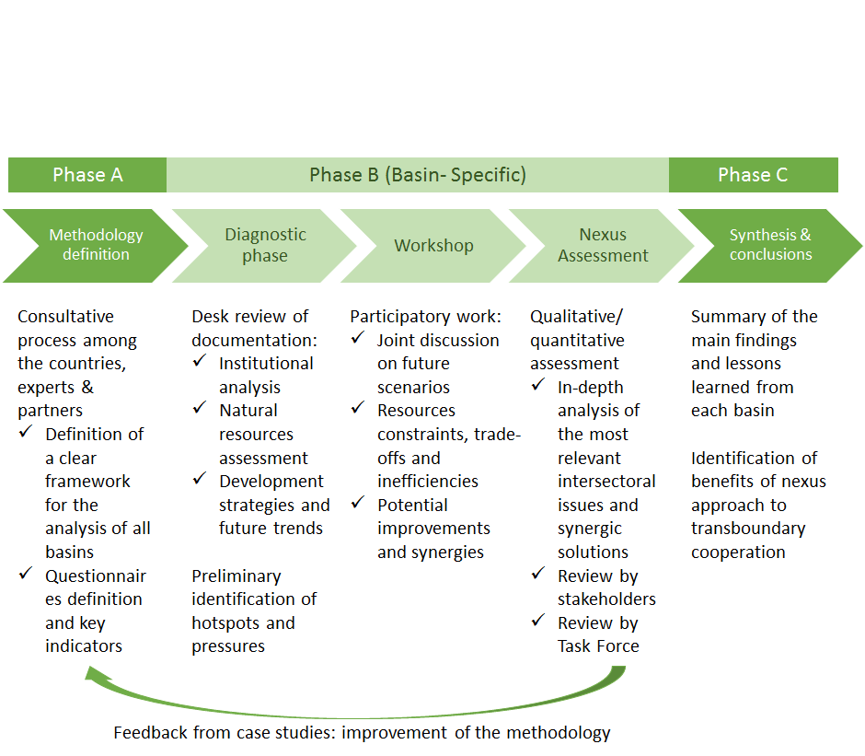

### Phase A

Phase A, the ‘*broad methodology*’ a basic structure which includes the development of a consistent terminology, organisational framework, indicators and preliminary areas of investigation. These are then applied in Phase B to different transboundary basins and results synthesised in Phase C.  Phase A is evolutionary, aswhere . T the experiences and lessons learned from analysis of pilot basin (Phase B) will be used to adjust and serve as a test for the appropriateness of the methodology. This will help increase its value and its usefulness to future basin assessments to the riparian countries. The piloting resulted in a review of the methodology and its improvement. Phase C includes conclusions and important remarks based on experience collected at the end of the assessment project is completed in the selected basins.

### Phase B

Phase B has several objectives. These include:

* To identify potential issues that would benefit from transboundary cross sector coordination. Selected examples that illustrate the need for cooperation would be quantified.
* Build capacity in the process and  support a dialogue between representatives of key sectors from all the riparian countries.
* And, to point to key data, indicators, processes and aspects of management and coordination that may support identification of actions that provide additional benefits from joint or coordinated actions.

It should be noted that this process draws from several information sources and key sets of indicators. The indicators are discussed later, however a key source of information is an institutional analysis (see annex 2). That informs step B of the methodology. It identifies relevant parts of the legal basis, regulations, institutions, processes and (selected) incentives relevant to associated with the use of resources and production of food, energy, water, ecosystem and other services in the basin.

### Phase C

Phase involves synthesising conclusions and lessons from each of the basin assessments and developing recommendations regarding intersectoral coordination in transboundary basins. The conclusions are expected to highlight the value of an integrated, cross-sectoral approach in resource management to improve water, food, energy and environmental security and to support additional benefits to be realized through transboundary cooperation.

# Nexus assessment of a transboundary basin

## Assessment process

The six steps of each basin assessment (Phase B)are summarised below. In each step participation by key stakeholders is critical. This includes joint information gathering,   identification of issues and potential solutions, and engagement of officials and stakeholders both between sectors and across boundaries.

Steps 1 to 3 support the *desk study*, which helps initiating the stakeholders consultations and participation processes with an awareness and a preliminary understanding of the main issues and challenges in the basins as well as an initial idea of potential opportunities of cross-sectoral cooperation.

Building on Step 3, Steps 4 to 6 constitute the core activities of the *participatory workshop* and the analysis of its outcomes.

|  |  |  |  |
| --- | --- | --- | --- |
|  | Step | Actors | Location |
| 1 | Identification of basin conditions and its socio economic context | Analysts. | Desk study |
| 2 | Identifying the economic sectors to be included | Analysts. Authorities | Desk study |
| 3 | Sector analysis | Analysts. Authorities | Desk study/Workshop |
| 4 | Intersectoral mapping | Stakeholders | Workshop |
| 5 | Nexus dialogue | Stakeholders | Workshop |
| 6 | Identification of synergies | Stakeholders and analysts | Workshop/Desk study |

In the next paragraphs the steps are explained in detail. For illustration we include in italics insights from the first transboundary nexus analysis, undertaken in the Alazani/Ganikh basin (in italics). The Alazani/Ganikh is shared between Georgia (upstream) and Azerbaijan (downstream). In Georgia, households consume fuelwood to meet energy needs. Hydro electricity and crops are produced with significant scope for expansion. In the region forests play an important role, providing ecosystem services for tourism as well as flood control. The nexus assessment indicated clear and new trans-sector and trans-country cooperation opportunities, -  that might not have otherwise been identified. Further, in identifying these trans-sector and trans-boundary a new ‘type’ of dialogue was initiated. It should be noted that exchange about the findings and possible follow-up actions can continue beyond the current assessment in the framework of the Water Convention, possible adding significantly to the value of the exercise., The modalities and arrangement of future dialogue to be adopted and adapted by key institutions in a manner that is dynamic and suited to local conditions.[13]

### Step 1 Identification of basin conditions and its socio economic relevance

The first step is to characterize: the needs of the population living in the basin area, as well as national needs that rely on the basin for their fulfilment. These needs might include - amongst others -  meeting basic human needs (such as water, food, energy and environmental security), poverty reduction/improvement of socio-economic conditions, economic development and, a healthy environment amongst others, or needs to address factors that compromise human wellbeing in these terms. These frame the underlying motive for the analysis.

In order to describe these needs and the conditions in the basin, notably the natural resource base that allows responding (or not) to the needs, readily available and tested indicator sets are used including those from UNECE and World Resources Institute (basin scale) and World Bank_WDI (country scale). It is acknowledged that for an accurate assessment, basin or local level information would be ideal, but in the case of many basins, national level information will need to be used as a proxy in the absence of more detailed data.

Another important input for this step will be the outcomes of a questionnaire screening the Energy, Water, Land-Use and Ecosystem resources. This first screening of the basin and information gathered directly from local stakeholders through a questionnaire inform a desk study compiling relevant existing information and earlier studies. Particular attention is paid to documentation referred to by the participating authorities .

*Alazani examples of “conditions and socio-economic relevance” included  i. lack of access to safe water in rural areas, ii. polluting household biomass fuel burning, iii. expensive modern fuels, iv. aging water treatment and agricultural infrastructure, v. hydropower growth potential, vi. agricultural growth potential, vii. deforestation, viii. land degradation, ix. flood protection etc.*

### Step 2 Identifying the economic sectors to be included

In step 2, the needs identified are associated to the sectors and institutions in those sectors. A sector loosely means chain of activities from resource to service. Those resources include: land, energy, water and ecosystems. The services include food, clean water and useful energy supplies (needed by households and the economy). Economic activities using the resources include in some cases also, for example, industries, navigation and tourism. The main purpose of this step is to identify which sectors and related institutions/actors need to be considered in the assessment process. Due to the limited resources available for the assessment and practical organizational constraints, as priority the main ministries involved in the management of natural resources are engaged in the participatory process through their nominated representatives. The consideration of the various actors is expanded in the institutional assessment. Institutions from the riparian countries would include national and local government institutions of the main relevant sectors (most commonly energy and agriculture sectors), environmental protection authorities, and, where feasible, local communities[14]. As appropriate, involvement of the private sector and the civil society is also sought.

*For example in the Alazani, a loose sector mapping to needs (i to ix; please see Step 1 for a key) was made as follows: needs iv, vi and viii were mapped to the included agricultura e sector with a specific sub-sector focus on wine production; (for needs iv, vi and viii), needs ii, iii and v were mapped to the energy sector (for needs ii, iii and v), needs i, iv, v, viii and ix were mapped to the water sector management for needs (needs i, iv, v, viii and ix), need vii;  to forestry and environment (for sector vii) and need ix to disaster management sector (for need ix).*

### Step 3 Sector analysis

In step three, each of the sectors identified in step two is analysed, following roughly the logic of the Driving forces-Pressures-State-Impacts-Responses framework[15]. In order to glean information necessary for the nexus approach the following six dimensions of each sector qualitatively stepped through:

(a) Drivers, Incentives, Policies and Programs (drivers):

Here we wish to unpack how incentives influence activity in the area (across countries). Many of these are national but in some cases there are also clear drivers Drawing from an 'institutional assessment' a full set of sector policies, regulation and programs are mapped to incentives for each service (a) and link in the chain of activities (b) to the resource on which they rely. For example farmers have a need (driver) for irrigation water (a service). Water might normally be charged at a particular rate (an incentive). Yet a government policy seeks to encourage farming. It does so by subsidizing irrigation water (a program). Each of these affects the manner in which resources will be used. In this step we wish to understand the incentives for the use of resource, steps in the sector chain and service use. Ultimately we seek programs that encourage coherence across all sectors.

Regional-national-local implications: Because of the regional developments and national sector priorities, important pulls between these and local basin needs and constraints might be observed. This is undertaken for the same sector, but in different territories of the basin. Thus, common or contradictory transnational trends might also be uncovered.

(b) Socio economic relevance and impacts (pressures):

The sectors contribute to the economy in ensuring local needs and achieving national objectives. Here we consider which services they provide and which impacts they have. For example safe drinking water is a 'service' supplied by the water sector. An impact of the sector might include depletion of water resources upon heavy abstraction. Poor health of the population may be an outcome impact of inadequate water sector management.

(c) Setting (status):

1. Flows & Physical setting

Here we consider the chain of activities for each resource (For example for water this could include: rain, run-off, flow regimes, diversions, withdrawals, return flows, etc. to the service of supplying)

(ii)Institutions and Governance setting (status):

Drawing from an 'institutional assessment', institutions with mandates that cover part or all of the sector's development or regulation are identified. At the same time, inter-sector, local-national as well as trans-national agreements and mechanisms are identified and described. The regional-national-local implications (part of a) shed light on where and how sectors are linked and could be better coordinated.

(d) Solutions and related constraints (management response):

In this step, the goals in the short, medium and long terms are spelled out for each sector. As per step 1, the analysis of the sectors active in the basins will pull on board subsets of relevant indicators.

*Example (Alazani): Agriculture. (a) Incentives to farmers; Investments in the agricultural sector; (b) Impacts: agricultural discharges affect water quality for other uses; poor drainage affects soil salinization and worsen land degradation; (c)(i) Physical configuration: order of magnitude of rainfed and irrigated land. Agricultural inputs and outputs. Effects of climate change; (c)(ii) Roles and responsibilities: institutional analysis; etc.*

The following Steps are carried out in the framework of a participatory multisector workshop. The general structure of these workshops is provided in annex 3.

### Step 4 Intersectoral mapping

At the start of the workshop actors and institutions are asked to summarise key aspects of their sectors, and sector outlooks. Sectors that have been focused on include: water, energy, agriculture, environment, human settlements and economy.

This forms a basis of the dialogue to follow.

Following the sectoral presentations, anonymous opinions on intersectoral issues are collected (in particular, on water uses and environmental concerns) and reported in the opinion based questionnaire (annex 4). Participants at the workshop are then divided into 'sector groups' to focus and analyse each sector. They are asked to consider the sector's present and future development scenarios. The results of the desk study on the sectors is used as reference to make sure no important issues are neglected in the discussion.

The key activity in this step is to consider linkages of their sector with other sectors and the implications there of. Relevant inter-sectoral relations and impacts from its point of view as it grows are captured. For inspiration, they are asked to consider perspectives (a)-(e). The output, however is an integrated-sector diagram that links the sector in focus with other sectors, and each link identified.

The participatory aspect of this step is important to ensure that the local knowledge in the countries and in the basins points to the most relevant and pressing intersectoral issues. It then underpins a move to an intersector nexus dialogue. Each participant is empowered to present the 'integrated nature' of their sector in the next step, where all sectors are represented.

The next step goes beyond conventional sector management considerations.

Example (Alazani): From the workshop, discussion in groups part 1

### Step 5 Nexus Dialogue

In step 5, the participants are grouped into 'sectorally mixed' nexus groups. In the nexus group, a member from each sector group is required. In this a nexus diagram is drawn. This includes links between sectors, and pictures all sectors as equally important. Links identified in step 4 from a sector perspective are considered in this step and consolidated. The links might be unidirectional (from one sector to another) or bidirectional,(affecting each sector).

Figure: A nexus diagram reflecting the conceptual interlinking employed in this intersectoral assessment.

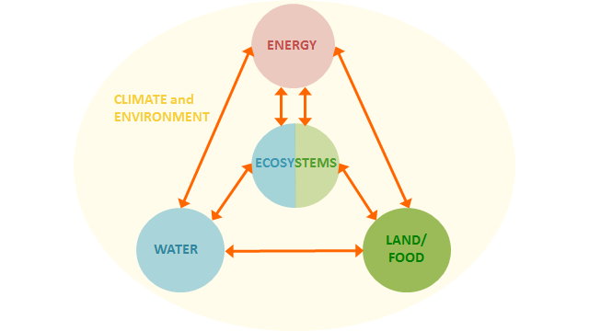

Next, the relevant future tendencies are identified jointly with the participants: scenarios are developed, and the effects between sectors are qualitatively described. This is done in general terms, considering socio-economic trends (population growth, economic development etc.), strategic directions and priorities of the countries and external constraints, such as climate change. The scenarios themselves are stimulated by the needs analysis (step 1) as well as the perspectives of step 3 (a)-(f). When we reach perspective (f) we finally consider the transboundary level,  challenges and solutions in particular. These emerge from the dialogue on common challenges merging different backgrounds, proposals and perspectives.

*One such scenario, for example, in the Alazani, is the implication of continued fuelwood use at the household level in Georgia is considered. Fuelwood provides the heat needed (Step 1) for cooking and heating (perspective a), yet its use increases pollution in the home. To collect the fuelwood, it is physically harvested from a forest (perspective b). As it is free, and the opportunity cost of people's time spent collecting it is low (perspective c), the trend is continued. (In Azerbaijan, alternative fuels are accessible at low cost). However, woodfuel harvesting causes deforestation (an inter-sector link identified in Step 4). Deforestation causes the loss of ecosystem services (another intersector link). Amongst others these include loss of flood control service (due to rainfall runoff implications), a reduction in terrestrial carbon stock (as carbon is captured in the forest trees), and loss of natural beauty. The limited flood control and the difficulty of effectively limiting flash flooding increases the severity of effects from flooding (an inter-sector link). Flooding is propagates downstream, and as the river forms for a substantial part of its length the border, both countries are affected by the flooding and its effects on the erosion (a transboundary link). The net effect is both inter-sector and transboundary.*

### Step 6 Identification of synergies (across the sectors and countries)

In step 6, after brainstorming and identifying needs and issues (step 1), uncovering key intersectoral issues in meeting those needs (step 5) then possible solutions are identified. Solutions could be of various kinds – changes to policies, new policies, management and measures practices, institutional arrangements, infrastructure operation and so on — . Particularly promising may be solutions that require cross sector, transboundary

Ideally the thinking and dialogue should be prolonged to explore who (which sector, organization etc.) is in a position to address the identified potential solutions and what concrete actions could be undertaken by local actors, . This could benefit from being incorporated into ongoing or planned initiatives. For instance, in some basins the riparian countries are part of the EU Water Initiative’s National Policy Dialogues or there are regional organisations like basin organisations or other joint bodies, possible with a multiple sector representation, which could provide a framework for identification of beneficial future activities. The potential benefits of such options of cooperation across sectors and countries are substantiated, wherever the available data is enough to support it, with explicit calculations (for example, on emissions reduction or savings obtainable etc).

*In the Alazani, for example, we identify a transboundary nexus action. It is transboundary as it is required in Georgia and has impacts in Azerbaijan. It relies on nexus relationships. It identifies an action in the energy sector that proporgates through the environment to the water sector. It is a local action with national implications. The action is fuelwood substitution in the Georian side of the Alezani.*

In summary there are clear indications of how the 'nexus approach' adds value. It can help uncover the co-benefits (or external costs) associated with actions in one sector, provides insight at local and national level as well as across boundaries.

Transboundary water cooperation has the potential to generate diverse and significant benefits for cooperating countries. Those benefits can be realised by accelerating economic growth, increasing human well-being, enhancing environmental sustainability and contributing to political stability. Commonly the understanding of possible benefits is narrowly focused on sharing (volumes of) water. The intersectoral or nexus approach invites to consider the intersectoral implications of policies and management measures, and the related opportunities for benefits in a broad sense. Aid in recognizing wide-ranging benefits is sought from the “Policy Guidance Note on identifying, assessing and communicating the benefits of transboundary water cooperation” (UNECE).[16]



*In the Alazani, indoor air pollution is reduced as people switch away from using fuel wood, in Georgia. This improves household health (a benefit). Yet, reduced woodfuel harvesting increases forest stock. Increased forest stock captures carbon dioxide as woody biomass (an inter sector co-benefit) . This is entered in national GHG accounts (a local action with national implications). Further, increased forest cover improves the natural beauty of the region. Supporting a key economic growth sector, namely tourism (an inter sector co-benefit).  The increased forest stock, dampens and retains run-off, providing key flood control services. As Georgia is upstream, the effect is felt downstream in Azerbaijan.*

## Information flow and indicators

The Nexus assessment of each basin is data dependent and indicator-based. Figure 1 shows how indicators and data relate to the 6 steps of the basin assessment.

The information provided by the national administrations in the riparian countries are the preferred source of data[17].  Where information is already available, especially when it has been approved by national authorities or such as country statistics it is gathered directly.

The analysis evolves from a diagnostic analysis of the basin and the riparian countries - zooming on the analysis of the critical sectors - to a participatory phase where intersectoral issues are discussed together, to an in depth analysis of the identified main issues and potential synergic solutions.

Thus, a first set of indicators help the diagnosis of the basin. These might be available at national or basin level depending on the topic. The historical or spatial variation of indicators and information is considered whenever relevant (e.g. water quality can be different from point to point; access to safe water can be increasing, decreasing or stable) and whenever available (often, data at basin level are simply not available or they partially overlap with regional/district level data). This group includes also the Nexus indicators of FAO that specifically look at the interlinkages across Water - Energy, Food - Energy, Water - Food and their trends.

A second set of indicators consists of the evaluation of entity and importance of issues occurring in the basin. The questions are divided into four general groups: Water, Energy, Land Use and Ecosystems. The answers are kept anonymous given the nature of the questionnaire but each person answering has to specify if he is an expert in W, E, L or Eco and which country he represents in order to allow for comparisons.

The third set of indicators and data is the most variable in terms of type and use. Indicators might be needed to validate statements, substantiate qualitative analysis or even calculate inter-sectoral benefits. These are difficult to meaningfully predict a-priori. That is because an exhaustive list would simply be extensive, and different regions would have different focus areas. And, therefore different data requirements.

A set of indicators — as applied in the case of the Alazani/Ganikh Basin — is presented in Annex 4.

Figure 1. Information flow: The indicators (in green) and how they are used in the steps (in blue)

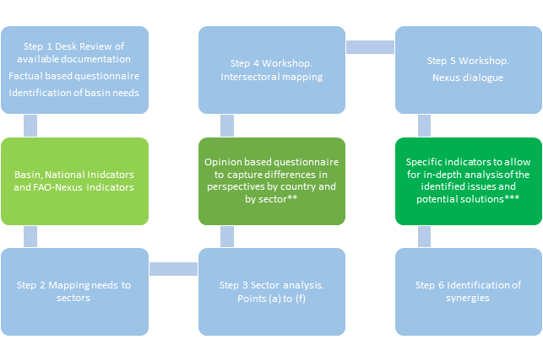

Figure 2. Indicators characteristics

|  |  |  |  |  |  |
| --- | --- | --- | --- | --- | --- |
| **Group** | **\*National Indicators** | **\*Basin Indicators**  **(including GIS)** | **\*Nexus-FAO Indicators** | **\*\*Opinions of countries and sectors** | **\*\*\*Specific indicators** |
| **Type** | Socio-economy and use of resources at country level.  World Development Indicators: Progress towards MDGs, demography and society, environment, economy, states and markets | Indicators on resource availability, quality and uses at basin level.  Water risk indicators: baseline water stress, interannual variability, seasonal variability, flood occurence, and drought severity | Indicators on the inter-linkages across WEF sectors (WE; WF, EF) | Entity of issues related to energy, water, land use and environment according to local authorities (who have good knowledge of the basin) | Indicators to substantiate the in-depth analysis of the identified issues and solutions (including ´secondary feedbacks´) |
| **Use** | Such indicators are used in the initial phases of the assessment.  If needed, they can be validated or adjusted via country/  stakeholder consultations.  In a final stage of the assessment, if better data is missing, they can be used as proxies for potential calculations.  Data on energy and water consumption by sector (A) are also used to determine their energy efficiency and water efficiency  (A) available data only allows for considering the big sectors of industry, agriculture and services | Such indicators are used in the initial phases of the assessment.  If needed, they can be validated or adjusted via country/  stakeholder consultations.  At basin level, data available can differ very much in levels of aggregation, accuracy, reliability, etc.  Qualitative and semi-quantitative indicators can be very useful information to complement the indicators (for example, types of groundwater use in the basin or water quality(B))  (B) water quality ranking (EU WFD or the local/regional equivalent?). | These indicators specifically quantify interlinkages across sectors.  They are used for consultation or compiled in parallel to the nexus assessment, according to the specificity of the case. | Such indicators are used to appreciate the differences in perspective by country and by sectoral affiliation  The opinions are ranked in the questionnaire itself in terms of intensity or importance. | Such indicators are used to substantiate the in-depth analysis of the identified issues and solutions (including ´secondary feedbacks´ (C)  Wherever possible, their quantification can help determining the entity of major issues across sectors and the costs and benefits of synergic solutions  Given the specificity of the focus of the in-depth analysis, the type of evaluation and/or quantification highly depends on the data available.  (C explain here) |
| **Source** | World Bank database - World Development Indicators | UNECE Second Assessment  WRI Aqueduct database  GIS Sources (to be added) | FAO database | Opinion based questionnaire | (Upon request to) the national authorities |

Annex 1

A comparison of Integrated Water Resources Management (IWRM) and a Nexus (intersectoral) assessment.

|  |  |  |
| --- | --- | --- |
|  | IWRM | Nexus (Water-Energy-Food) |
| Origin of the concept | Agenda 21 - Rio de Janerio, 1992 | First Nexus Conference - Bonn, 2011 |
| Trigger | Sectoral strategies and plans need more integration, to meet key water supply goals. | Sectoral strategies and plans need more integration, and dynamic and dependent development scenarios are considered. |
| Objective | Improve efficiency in the use of water. (GWP, 2000) | Address externalities across sectors and achieve overall resource use efficiency. (SEI, 2011) |
| Entry point | Water sector(s); water resources management. | Externalities between sectors; management of natural resources.  The entry point can be different (e.g. water, energy etc) depending on the perspective of the policy maker and the priorities (Bazilian et al, 2011) |
| Main challenges | Securing appropriate water for people, food-production, aquatic and terrestrial ecosystems. Dealing with variability of water in time and space, with risks related to water flows, groundwater recharge and water quality. Create awareness and forge political will to act, promoting collaboration across sectors and boundaries. (GWP, 2000) | Define actions, trade-offs and synergies in the provision of water, food and energy from resource to use. Harmonize often diverging policy directions, targets and goals of different sectors. Develop a flexible, robust and appropriate analytical and policy toolkit. |
| Boundaries of a typical IWRM or Nexus analysis | Basin or sub-basin region. | Depending on the focus, could be local, national, regional or global, with a particular emphasis on basins. |
| Mechanism | Water resource is at the center and outlooks for different users and different needs are considered. | There is no universal methodology or toolkit for a nexus analysis but efforts are made to conceptualize a common framework. Depending on the focus of the analysis, water can be at the center, or energy, land use, etc (Bazilian et al., 2011). However, outlooks for other sectors are dynamic responding to the same drivers as well as to feedbacks between sectors. |
| International dimension | Explicitly reflected where water bodies are shared, calling for transboundary cooperation. | Explicitly reflected where resources or linkages between sectors are shared. (This would include for example, transboundary water bodies, but also regional power pools etc.) |
| Variations on the Nexus | Nexus to complement IWRM (Kura Araks Project, upcoming) | Nexus WEF Climate (World Economic Forum, 2011), (Howells et al, 2013)  Nexus WEF Health & Gender (GTF, upcoming)  Nexus WEF Ecosystems (UNECE Task Force, upcoming) |

(table adjusted and integrated from UNSGAB, *The Nexus Approach vs IWRM - Gaining Conceptual Clarity* available at http://www.water-energy-food.org/en/news/view__1612/the-nexus-approach-vs-iwrm-gaining-conceptual-clarity.html)

[references in the table to be added here]

Annex 2

**Institutional/governance assessment**

**A brief description**

The institutional analysis aims at assessing how conducive institutional arrangements

are to intersectoral coordination.

This draft methodology for the institutional assessment, developed by Dr. Christian Bréthaut from the University of Geneva is based on an analysis of the institutional and governance structures associated with the selected river basin. The different sectors of activity within the nexus include a great number of actors, complex regulatory frameworks and many different types of legal provisions. Conducting an analysis of institutions helps to gain a better understanding of the context in which the different sectors of activity operate.

The methodology for the institutional analysis is divided into four main steps allowing a progressive and cumulative analysis. Every step allows to acquire an increasingly clear understanding of the system, to finally better understand the governance structure as a whole and to identify some areas that instigate further evaluation regarding how effectively inter-sectoral issues can be addressed.

Step 1: To gain a broad understanding of the institutions and governance systems, the first step reflects on the identification of the main sectors of activity involved in the management of the resources concerned with the assessment’s definition of the nexus.

Step 2: After identifying the main resource uses within the nexus, the methodology aims to analyse the main regulations at the sectoral and intersectoral levels.

Step 3: This step focuses on the configuration of the actors involved. The aim is to analyse, what kind of actors are involved (private actors, public actors, national actors, international actors, users associations, NGOs, etc.) in the management of resources. It also aims to determine the nature of links between these identified actors.

Step 4: Finally, the methodology helps to identify specific hot spots (to be understood as the main rivalries identified in step 2) at different institutional levels (local, regional, national, transboundary). This fourth step goes into depth and analyses the governance structure through selected case studies. The analysis focuses on the main use rivalries between actors and tries to understand how these tensions are regulated.

Annex 3

The basin assessment workshops are generally structured as follows to apply the described methodology:

1. Introduction of the nexus and relevant explicatory examples (by the analysts);
2. Presentation of national sectoral policies by relevant authorities, as well as relevant national economic strategies and targets that may affect the basin;
3. Focus on the specific basin. Discussion on future possible developments of the basin (river basin or aquifer management plan, infrastructure plans, sectoral targets, policy priorities etc.);
4. Presentation of official data on climate change and, if available, the predicted impact on the basin. Discussion;
5. Illustration of possible interlinkages and nexus conditions. Explanation of the working groups sessions;
6. First working group session: the sectorial authorities representatives and local experts are divided according to their area of expertise (land, water, energy, ecosystems). Each group identifies anticipated demands and the assumptions about the conditions and availability of other resources ;
7. Second working groups session: mixed groups discuss and prioritise of the interlinkages previously identified across the four areas of the nexus. If possible, the discussion will include possible solutions (synergic actions and chains of sectoral interventions)
8. Preparation of an agreeable inter-sectoral picture of the nexus conditions identified in the basin and of the most important interconnections/impacts/trade-offs and the most appropriate key indicators;
9. Discussion on synergic actions for the identified nexus conditions, by means of measures, policies, coordination arrangements as well as techno-economic solutions, reflect on the transboundary dimension discussion on the benefits and limitations; identification of who/which actors could advance the actions;
10. Presentation (by analysts) of some key findings/results from the workshop and the preparatory work, in the form of nexus graphs and storylines that will be analysed further and included in the basin assessment;
11. The necessary steps for the completion of the assessment, potential aspects to be looked at in more detail. The responsibilities and provision of the key indicators and any other necessary information to fill the remaining gaps are agreed upon

Annex 4

**Indicators**

Indicators are used in the nexus assessment under the Water Convention:

1. National level indicators (for riparian countries)
2. Basin level indicators
3. Specific indicators around the identified issues

Nexus indicators is an area where exchange of experience with FAO is active; FAO having done more extensive and generic review and identification of nexus indicators.

# Basin Indicators

These indicators come mainly from the Second Assessment of Transboundary Rivers, Lakes and Groundwaters, UNECE[18] and the Aqueduct database of the World Water Institute[19].

Information can be available by riparian country or for the basin as a whole. Moreover, in global databases such as Aqueduct, indicators might only be available at basin level and not at sub-basin level. Such indicators can provide important information and can be used, provided that this difference in scale is clearly stated every time they are used. For example, in the analysis of the Alazani/Ganikh indicators for the Kura basin (which includes the Alazani/Ganikh) were also used.

Other documentation - considered reliable and officially accepted by riparian countries - can be used to integrate this group of indicators. Examples of reliable sources can be documentation of projects funded by international aid agencies such as World Bank, Global Environment Facility etc.

## River

|  |  |  |  |  |  |
| --- | --- | --- | --- | --- | --- |
| **indicator** | **Country 1** | **Country 2** | **unit** | **year** | **notes** |
| **Length** |  |  |  | km |  |

## Basin

|  |  |  |  |  |  |
| --- | --- | --- | --- | --- | --- |
| **indicator** | **Country 1** | **Country 2** | **unit** | **year** | **notes** |
| **Sub-basin area** |  |  |  | km2 |  |
| **Country´s share** |  |  |  | % |  |

## Withdrawals in the basin

|  |  |  |  |  |  |
| --- | --- | --- | --- | --- | --- |
| **indicator** | **Country 1** | **Country 2** | **unit** | **year** | **notes** |
| **Total withdrawal** |  |  |  | ×106 m3/year |  |
| **Agricultural** |  |  |  | % |  |
| **Domestic** |  |  |  | % |  |
| **Industry** |  |  |  | % |  |
| **Energy** |  |  |  | % |  |
| **Other** |  |  |  | % |  |

## Underground aquifer

|  |  |  |  |  |  |
| --- | --- | --- | --- | --- | --- |
| **indicator** | **Country 1** | **Country 2** | **unit** | **year** | **notes** |
| **Border length** |  |  |  | km |  |
| **Area** |  |  |  | km2 |  |
| **Thickness mean, max** |  |  |  | m |  |
| **Main groundwater uses** |  |  |  | qualitative |  |
| **Groundwater management measures** |  |  |  | qualitative |  |

## Groundwater balance

|  |  |  |  |  |  |
| --- | --- | --- | --- | --- | --- |
| **indicator** | **Country 1** | **Country 2** | **unit** | **year** | **notes** |
| **Precipitation** |  |  |  | mm |  |
| **Area** |  |  |  | km2 |  |
| **Total flow** |  |  |  | m3/sec |  |
| **Inflow** |  |  |  | m3/sec |  |
| **Infiltration river** |  |  |  | m3/sec |  |
| **Infiltration precipitation** |  |  |  | m3/sec |  |
| **Discharge evaporation** |  |  |  | m3/sec |  |
| **Discharge river** |  |  |  | m3/sec |  |

## Renewable water resources in the sub basin (surface and underground)

|  |  |  |  |  |  |
| --- | --- | --- | --- | --- | --- |
| **indicator** | **Country 1** | **Country 2** | **unit** | **year** | **notes** |
| **Renewable surface water resources** |  |  |  | km3/year |  |
| **Renewable groundwater resources** |  |  |  | km3/year |  |
| **Total renewable water resources** |  |  |  | km3/year |  |
| **Renewable water per capita** |  |  |  | m3/capita/year |  |

## Wastewater information

|  |  |  |  |  |  |
| --- | --- | --- | --- | --- | --- |
| **indicator** | **Country 1** | **Country 2** | **unit** | **year** | **notes** |
| **Wastewater generated (municipal)** |  |  |  |  |  |
| **Wastewater treated** |  |  |  |  |  |
| **Primary** |  |  |  |  |  |
| **Secondary** |  |  |  |  |  |
| **Tertiary** |  |  |  |  |  |

## Stress

|  |  |  |  |  |  |  |
| --- | --- | --- | --- | --- | --- | --- |
| **indicator** | **Country 1** | **Country 2** | **Basin** | **unit** | **year** | **notes** |
| **Baseline Water Stress** |  |  |  | Low to Extremely high |  |  |
| **Inter-annual variability** |  |  |  | Low to Extremely high |  |  |
| **Seasonal variability** |  |  |  | Low to Extremely high |  |  |
| **Flood occurrence** |  |  |  | Low to Extremely high |  |  |
| **Drought severity** |  |  |  | Low to Extremely high |  |  |

# National Indicators

This group of indicators allow for a comparative review of the riparian countries sharing the basin. Their main source is the World Bank database of the World Development Indicators[20]. These indicators can be complemented with data from the Aqua Stat database of the UN Food and Agriculture Organization (FAO)[21] as well as statistics agencies from the riparian countries.

## Socio-economic indicators

|  |  |  |  |  |  |
| --- | --- | --- | --- | --- | --- |
| **indicator** | **Country 1** | **Country 2** | **unit** | **year** | **notes** |
| **GDP** |  |  | Billion USD |  | Specify historical values |
| **GDP growth** |  |  | % |  |  |
| **GDP growth per capita** |  |  | % |  |  |
| **Population** |  |  | Million people |  |  |
| **Population growth** |  |  | % |  |  |
| **Rural population** |  |  | % of total |  |  |
| **Rural population growth** |  |  | % |  |  |
| **Population density** |  |  | People per sq. km |  |  |

## Contribution of natural resources to GDP

|  |  |  |  |  |  |
| --- | --- | --- | --- | --- | --- |
| **indicator** | **Country 1** | **Country 2** | **unit** | **year** | **notes** |
| **Total natural resources rent** |  |  | % of GDP |  |  |
| **Oil rents** |  |  | % of GDP |  |  |
| **Natural gas rents** |  |  | % of GDP |  |  |
| **Coal rents** |  |  | % of GDP |  |  |
| **Mineral rents** |  |  | % of GDP |  |  |
| **Forest rents** |  |  | % of GDP |  |  |
| **Population below national poverty line** |  |  | % of total population |  |  |

## Employment by sector

|  |  |  |  |  |  |
| --- | --- | --- | --- | --- | --- |
| **indicator** | **Country 1** | **Country 2** | **unit** | **year** | **notes** |
| **In Agriculture** |  |  | % of total |  |  |
| **In Industry** |  |  | % of total |  |  |
| **In Services** |  |  | % of total |  |  |

## GDP contribution by sector

|  |  |  |  |  |  |
| --- | --- | --- | --- | --- | --- |
| **indicator** | **Country 1** | **Country 2** | **unit** | **year** | **notes** |
| **In Agriculture** |  |  | % of total |  |  |
| **In Industry** |  |  | % of total |  |  |
| **In Services** |  |  | % of total |  |  |

## Water and energy productivity by sector

|  |  |  |  |  |  |
| --- | --- | --- | --- | --- | --- |
| **indicator** | **Country 1** | **Country 2** | **unit** | **year** | **notes** |
| **Total water productivity** |  |  | USD / m3 |  |  |
| **In Agriculture** |  |  | USD / m3 |  |  |
| **In Industry** |  |  | USD / m3 |  |  |
| **In Services/Domestic Use** |  |  | USD / m3 |  |  |

|  |  |  |  |  |  |
| --- | --- | --- | --- | --- | --- |
| **indicator** | **Country 1** | **Country 2** | **unit** | **year** | **notes** |
| **Total energy productivity** |  |  | Billion USD / Mtoe |  |  |
| **In Agriculture** |  |  | Billion USD / Mtoe |  |  |
| **In Industry** |  |  | Billion USD / Mtoe |  |  |
| **In Services/Domestic Use** |  |  | Billion USD / Mtoe |  |  |

## Water indicators

|  |  |  |  |  |  |
| --- | --- | --- | --- | --- | --- |
| **indicator** | **Country 1** | **Country 2** | **unit** | **year** | **notes** |
| **Internal renewable freshwater resources[22]** |  |  | m3 per capita |  |  |
| **Annual freshwater withdrawal** |  |  | Billion m3 |  |  |
| **--** |  |  | % of internal resources |  |  |
| **Withdrawals for Agriculture** |  |  | % of total withdrawal |  |  |
| **Withdrawals for Industry** |  |  | % of total withdrawal |  |  |
| **Withdrawals for Domestic Use** |  |  | % of total withdrawal |  |  |

|  |  |  |  |  |  |
| --- | --- | --- | --- | --- | --- |
| **indicator** | **Country 1** | **Country 2** | **unit** | **year** | **notes** |
| **Access to improved water source[23]** |  |  | % of population |  |  |
| **--** |  |  | % of rural |  |  |
| **--** |  |  | % of urban |  |  |
| **Access to improved sanitation facilities** |  |  | % of population |  |  |

## Land and agriculture indicators

|  |  |  |  |  |  |
| --- | --- | --- | --- | --- | --- |
| **indicator** | **Country 1** | **Country 2** | **unit** | **year** | **notes** |
| **Land area** |  |  | thousands km2 |  |  |
| **Forest Area** |  |  | % of total |  |  |
| **Permanent Cropland** |  |  | % of total |  |  |
| **Arable Land** |  |  | % of total |  |  |
| **Arable land per person** |  |  | ha per person |  |  |
| **Total wood resources** |  |  | Million m3 |  |  |
| **Logging harvest (official)** |  |  | m3/year |  |  |
| **Logging harvest (illegal)** |  |  | m3/year |  |  |
| **Agricultural irrigated land** |  |  | % of total agricultural land |  |  |
| **Average annual precipitation** |  |  | mm |  |  |
| **Land under cereal production** |  |  | thousands ha |  |  |
| **Fertilizer consumption** |  |  | kg per hectare of arable land |  |  |
| **Agricultural machinery** |  |  | Tractors per 100 km2 of arable land |  |  |

## Energy indicators

|  |  |  |  |  |  |
| --- | --- | --- | --- | --- | --- |
| **indicator** | **Country 1** | **Country 2** | **unit** | **year** | **notes** |
| **Energy production total[24]** |  |  | thousands metric TOE[3] |  |  |
| **Energy use[25]** |  |  | thousands metric TOE |  |  |
| **Energy use per capita** |  |  | kg of oil equivalent |  |  |
| **Use of fossil fuels[26]** |  |  | % of total energy use |  |  |
| **Combustible renewable and waste[27]** |  |  | % of total energy use |  |  |
| **Alternative and Nuclear (= Hydropower)[28]** |  |  | % of total energy use |  |  |
| **Energy use growth** |  |  | % |  |  |

|  |  |  |  |  |  |
| --- | --- | --- | --- | --- | --- |
| **indicator** | **Country 1** | **Country 2** | **unit** | **year** | **notes** |
| **Electricity production** |  |  | Billion kWh |  |  |
| **from Coal** |  |  | % of total electricity production |  |  |
| **from Natural Gas** |  |  | % of total electricity production |  |  |
| **from Oil** |  |  | % of total electricity production |  |  |
| **from Hydropower** |  |  | % of total electricity production |  |  |
| **from Renewables** |  |  | % of total electricity production |  |  |
| **from Nuclear** |  |  | % of total electricity production |  |  |
| **Electricity access** | NA | NA | % of population |  |  |

## Ecosystems indicators

|  |  |  |  |  |  |
| --- | --- | --- | --- | --- | --- |
| **indicator** | **Country 1** | **Country 2** | **unit** | **year** | **notes** |
| **Threatened species (mammals)** |  |  | - |  |  |
| **Threatened species (birds)** |  |  | - |  |  |
| **Threatened species (fishes)** |  |  | - |  |  |
| **Threatened species (higher plants)** |  |  | - |  |  |
| **Terrestrial protected areas** |  |  | % of total land area |  |  |
| **Marine protected areas** |  |  | % of territorial waters |  |  |
|  |  |  |  |  |  |

## Emissions indicators

|  |  |  |  |  |  |
| --- | --- | --- | --- | --- | --- |
| **indicator** | **Country 1** | **Country 2** | **unit** | **year** | **notes** |
| **CO2 emissions per unit of GDP[29]** |  |  | kg/2005 USD of GDP |  |  |
| **CO2 emission per capita** |  |  | Metric tons |  |  |
| **Total CO2 emissions** |  |  | Million Metric tons |  |  |

## Exposure to climate change indicators

|  |  |  |  |  |  |
| --- | --- | --- | --- | --- | --- |
| **indicator** | **Country 1** | **Country 2** | **unit** | **year** | **notes** |
| **Land area where elevation is below 5 m** |  |  | % of land area |  |  |
| **Population living in areas where elevation is below 5 m** |  |  | % of total population |  |  |
| **Population affected by droughts, floods and extreme temperatures** |  |  | % of total population (average annual) |  |  |

# Opinions of Countries and Sectors

These indicators serve for a comparison of the opinions of representatives from different riparian countries and from different areas of expertise. The answers to this questionnaire provide a first-hand information on which issues are considered the most pressing by local stakeholders and to what degrees this perception is different from country to country and from sector to sector.

*Please note*:

* *All responses will be kept strictly confidential.*
* *Please provide your own insight and opinion.*
* *This questionnaire is divided into 5 sections. Please answer each question.*
* *The sections are: WATER; FOOD and LAND USE; ENERGY; ENVIRONMENT and ECOSYSTEMS; and OVERVIEW. Each of the sections is no longer than 1 page.*
* *Please provide answers regarding your own country’s part of the basin.*
* *Please also add any pertinent information and (where possible) indicate the question that it relates too.*

*Please mark each answer box with a ‘tick mark’ unless otherwise indicated. If you cannot answer please tick ‘NA’ for ‘not applicable’ or ‘no answer’.*

**Information on the stakeholder answering the questionnaire**

G.1 Type of organization: Private/administration (local, national)/civil society/NGOs, academia)?

|  |  |  |  |  |  |  |
| --- | --- | --- | --- | --- | --- | --- |
| **a. Private** | **b. Administration (national)** | **c. Administrator (local)** | **d. Civil society** | **e. NGO** | **f. Academia** | **g. Other (please specify)** |
|  |  |  |  |  |  |  |

G.2 Geographical perspective that you represent

|  |  |  |  |
| --- | --- | --- | --- |
| **a. Country (please specify)** | **c. Trans-boundary** | **d. International** | **e. Other (please specify)** |
|  |  |  |  |

**G.3 My area of expertise is:**

|  |  |  |  |  |
| --- | --- | --- | --- | --- |
| **a. Water** | **b. Food and land-use** | **c. Environment and ecosystems** | **d. Energy** | **e. Other (please specify)** |
|  |  |  |  |  |

**G.4 Personal:**

|  |  |  |
| --- | --- | --- |
| **a. Male** | **b. Female** | **c. Age (Please specify)** |
|  |  |  |

## Overview of the Basin

|  |  |  |  |  |  |
| --- | --- | --- | --- | --- | --- |
|  | **Highly agree** | **Agree** | **Neutral** | **Disagree** | **Highly disagree** |
| **I1. There is adequate coordination across sectors?** |  |  |  |  |  |
| **I2. Benefits from natural resources are equitably shared?** |  |  |  |  |  |
| **I3. One sector’s objectives usually have a priority in political decision?** |  |  |  |  |  |
| **I4. Currently, there are no major socioeconomic challenges faced by the local population?** |  |  |  |  |  |
| **I5. The basin seems to be heading towards a secure socioeconomic future?** |  |  |  |  |  |
| **I6. Climate change is an important part of national policy agenda?** |  |  |  |  |  |
| **I7. Local population is aware of environmental issues?** |  |  |  |  |  |
| **I8. The economy in the basin is heavily dependant on one single sector?** |  |  |  |  |  |

## Water Quantity and Quality

|  |  |  |  |  |  |
| --- | --- | --- | --- | --- | --- |
|  | **a. Highly agree** | **b. Agree** | **c. Neutral** | **d. Disagree** | **e. Highly disagree** |
| **W1. There have been municipal water shortages?** |  |  |  |  |  |
| **W2. There have been industrial water shortages?** |  |  |  |  |  |
| **W3. There have been agricultural water shortages?** |  |  |  |  |  |
| **W4. Water shortages are expected in the future?** |  |  |  |  |  |
| **W5. Operation of reservoirs, hydro-power and water diversions have limited the availability for downstream water uses?** |  |  |  |  |  |
| **W6. Better reservoir management is needed?** |  |  |  |  |  |
| **W7. Better water-use management is needed?** |  |  |  |  |  |
| **W8. Water quality has impacted local health?** |  |  |  |  |  |
| **W9. Water quality will worsen in the future?** |  |  |  |  |  |
| **W10. Wastewater treatment needs to be improved?** |  |  |  |  |  |
| **W11. Has water quality deteriorated?** |  |  |  |  |  |
| **W12. Has the ecology of the basin’s water bodies deteriorated over time?** |  |  |  |  |  |
| **W13. There have been serious water quality incidents in the past (such as chemical, microbial or pathogen pollution of drinking water)?** |  |  |  |  |  |
| **W14. Water availability has been impacted strongly with changing weather patterns?** |  |  |  |  |  |

## Food and Land Use

|  |  |  |  |  |  |
| --- | --- | --- | --- | --- | --- |
|  | 1. **Highly agree** | 1. **Agree** | 1. **Neutral** | 1. **Disagree** | 1. **Highly disagree** |
| **L1. Most food consumed in the basin area is produced locally?** |  |  |  |  |  |
| **L2. Agricultural practices (and animal husbandry) should be intensified?** |  |  |  |  |  |
| **L3. Agricultural production is polluting?** |  |  |  |  |  |
| **L3. Local agricultural production (and animal husbandry) will diminish?** |  |  |  |  |  |
| **L4. Land degradation is occurring in the basin area?** |  |  |  |  |  |
| **L5. Low water availability has affected crop yield?** |  |  |  |  |  |
| **L6. Agricultural land will be extended?** |  |  |  |  |  |
| **L7. Protected areas (e.g. forests, wetlands, coasts) are limiting economic activities.** |  |  |  |  |  |
| **L8. Extreme natural events have damaged crops and livestock?** |  |  |  |  |  |
| **L9. Crop yield is highly vulnerable and volatile in the basin area?** |  |  |  |  |  |
| **L10. There have been unaffordabley high food prices in the basin area?** |  |  |  |  |  |
| **L11. Agricultural production negatively affects water quality?** |  |  |  |  |  |

## Energy

|  |  |  |  |  |  |
| --- | --- | --- | --- | --- | --- |
|  | **Highly agree** | **Agree** | **Neutral** | **Disagree** | **Highly disagree** |
| **E1. There is enough energy to reliably serve all needs in the basin.** |  |  |  |  |  |
| **E2. Energy demand will increase significantly.** |  |  |  |  |  |
| **E3. Current energy efficiency levels are low (production, transmission or use)** |  |  |  |  |  |
| **E4. There are clear procedures for taking environmental and social concerns into account when applying for the approval of an energy project.** |  |  |  |  |  |
| **E5. Policies and strategies exist that will help the basin to have a secure energy future.** |  |  |  |  |  |
| **E6. The authorities are giving too much attention to the energy sector, in the expense of other sectors.** |  |  |  |  |  |
| **E7. Hydropower reservoirs are operated to gain multiple benefits outside of the energy sector, like flood control and navigation.** |  |  |  |  |  |
|  | **Insignificant** | **Local and moderate** | **Local but severe** | **Widespread but moderate** | **Widespread and severe** |
| **E8. How would you best describe past incidents regarding energy shortages in the basin?** |  |  |  |  |  |
| **E9. Are there any energy-related activities affecting the water quality of the basin?** |  |  |  |  |  |
| **E10. What is the extent of the impact of climate change on crucial energy infrastructure in the future?** |  |  |  |  |  |
| **E11. How significant is the impact of energy-related activities on the availability of water (quantity and timing)** |  |  |  |  |  |

## Environment

|  |  |  |  |  |  |
| --- | --- | --- | --- | --- | --- |
|  | **Highly agree** | **Agree** | **Neutral** | **Disagree** | **Highly disagree** |
| **V1. Environmental performance of activities in the basin is satisfactory?** |  |  |  |  |  |
| **V2. The environment should receive more attention from the authorities?** |  |  |  |  |  |
| **V3. Human activities are putting significant pressure on the local ecosystems?** |  |  |  |  |  |
| **V4. Human activities are exacerbating the frequency of natural disasters.** |  |  |  |  |  |
| **V5. Sufficient measures have been taken to address natural disasters?** |  |  |  |  |  |
| **V6. Sufficient measures have been taken to address the issue of ecosystem degradation?** |  |  |  |  |  |
| **V7. There are important habitats in the basin which require protection?** |  |  |  |  |  |
| **V8. Severe natural disasters frequently affect the basin?** |  |  |  |  |  |
| **V9. Biodiversity loss is evident in the basin** |  |  |  |  |  |
| **V10. Landscape changes over the past two decades have been occurring in an environmentally detrimental manner** |  |  |  |  |  |

Additional comments

|  |  |
| --- | --- |
| Question | Comment: |
|  |  |
|  |  |
|  |  |
|  |  |

# Specific data (example from the Alazani/Ganikh)

This last group of indicators are specifically selected for each basin analyzed and therefore can be completely different from case to case. Their use reflects the need to investigate in depth topics that came out during the analysis and the workshop. For example, such indicators can help quantifying specific impacts of one sector on a resource but they can also help quantifying the benefits of a proposed action.

## First storyline

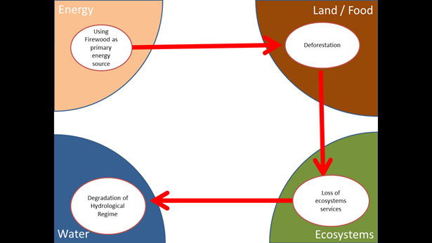

Figure 1 Storyline 1 Interlinked problems

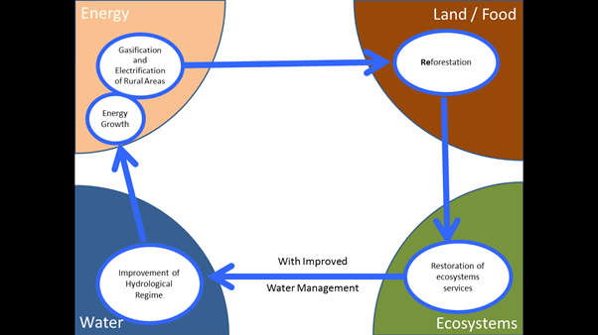

Figure 2 Storyline 1 Interlinked improvements

|  |  |  |  |  |  |  |
| --- | --- | --- | --- | --- | --- | --- |
| **indicator** | **Country 1** | **Country 2** | **Total** | **unit** | **year** |  |
| **Firewood use** | 257513 | 91970 | 348484 | m3 | 2012 | Decreasing due to increased natural gas supply and el. |
| **Deforestation** | 2254 | 24861 |  | 27115 | ha |  |
| **Land Cover** |  |  |  | See below  Figure 1 |  |  |
| **Water flow** |  | See below  Table 1 |  |  |  | Groundwater accounts for 40% of the water flow of the Alazani/Ganikh River, rain water for 31% while snow melting for 29%. |
| **Hydropower (existing, planned and potential)** | -- | -- |  | See below Table 2, Table 3, Table 4, Table 5 |  |  |
|  |  |  |  |  |  |  |
| **Electrification rate** | 100 | 96 |  |  | % |  |
| **Electricity consumption** | NA | 216.6 |  |  | GWh |  |
| **Gasification rate** | 82 | 44 |  |  | % | In AZ side, 100% in 2015 |
| **Natural Gas consumption** | NA | 33627478 |  |  | m3 |  |
| **Fuel use shares** | NA | See below Table 6 |  |  |  |  |
| **Reforestation rate** | 21611 | 10163 |  | 31774 | ha |  |

## Second storyline

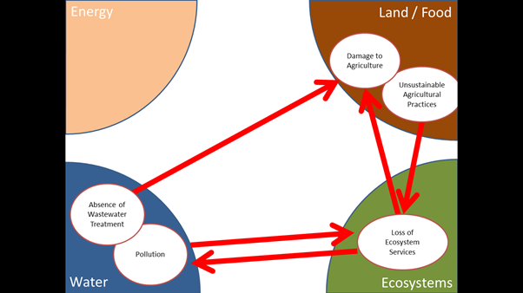

Figure 3 Storyline 2 Interlinked problems

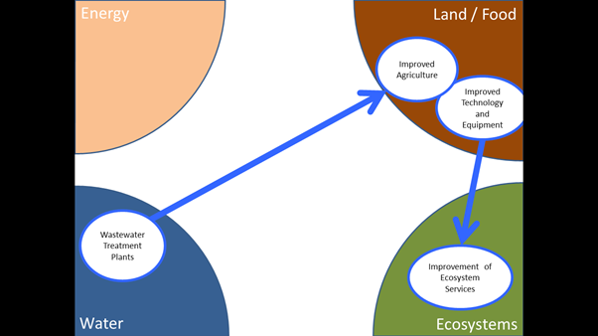

Figure 4Storyline 2 Interlinked improvements

|  |  |  |  |  |  |  |
| --- | --- | --- | --- | --- | --- | --- |
| **indicator** | **Country 1** | **Country 2** | **Total** | **unit** | **year** |  |
| **Water Pollution** | NA | See below  Table 7, Table 8, Table 9, Figure 2 |  |  |  |  |
|  |  |  |  |  |  |  |
|  |  |  |  |  |  |  |
| **Arable land** | NA | 196237 |  | ha | 2013 |  |
| **Irrigated area** | NA | 55871 |  | ha | 2013 | Gravity flow irrigation/ in addition 12500 ha in 2014 due to technical maintenance of pumping stations |
| **Irrigation capacity** | NA | 49000 |  | m3/h | 2013 |  |
| **Area of crops** | NA | 74500 |  | ha | 2012 | Declined since 2008 (114400 ha) |
| **Red listed species** |  |  | See below  Table 11 |  |  |  |
| **Priority Biomes** |  |  | See below  Table 12 |  |  |  |
| **Wastewater produced** | NA | See below  Table 10 |  |  |  |  |
| **Wastewater treatment plants (planned)** | NA | 6500 |  | m3/day | 2014-2015 |  |
| **Wine industry development** | NA | 6 |  | Million bottles | 2012 | Increased from 3,2 million in 2009 |

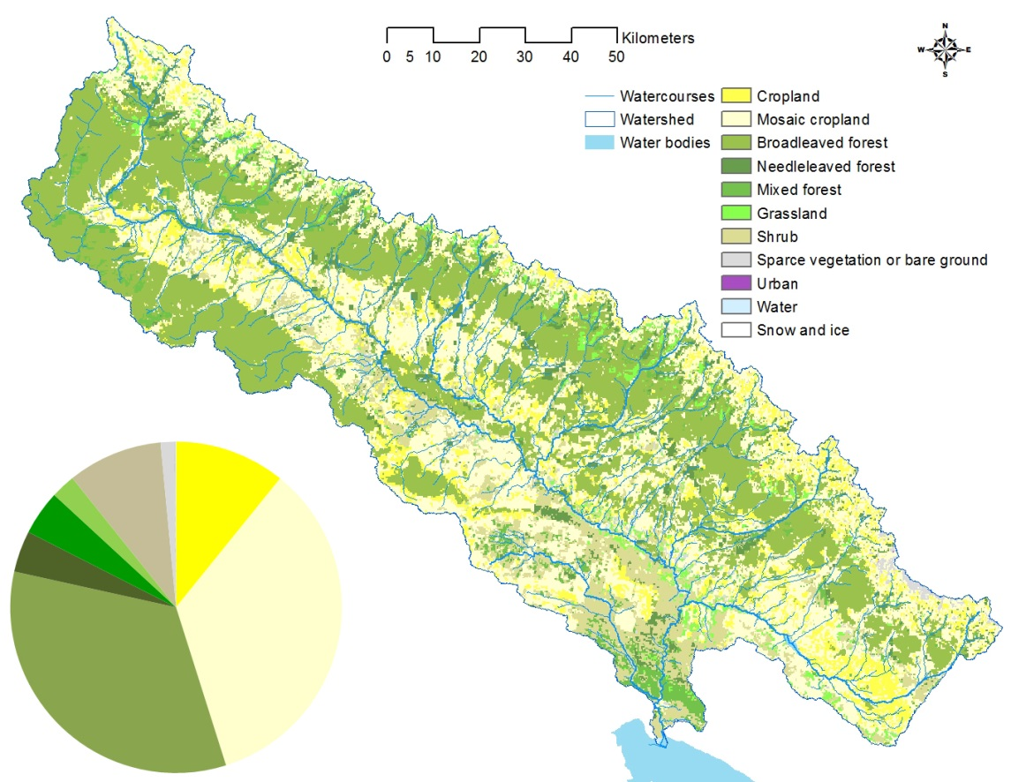

Figure 5: Land cover in the Alazani/Ganikh River Basin according to a global land cover database (Bontemps 2011)

## Others

Table 1: River Alazani/Ganikh – Shaqriani hydrological checkpoint. Average monthly and average annual discharge (m3/sec)

|  |  |  |  |
| --- | --- | --- | --- |
|  | **1932-1960** | **1961-1990** | **1991-2013** |
| **1** | 19,53846154 | 18,42172414 | 25,03652174 |
| **2** | 21,79230769 | 20,02758621 | 25,13565217 |
| **3** | 32,08846154 | 34,61724138 | 36,11304348 |
| **4** | 70,57307692 | 68,31724138 | 78,5 |
| **5** | 98,61923077 | 86,40689655 | 97,55217391 |
| **6** | 85,32307692 | 73,72758621 | 81,44782609 |
| **7** | 53,03846154 | 50,77931034 | 52,60956522 |
| **8** | 36,83846154 | 37,21448276 | 35,88695652 |
| **9** | 40,31153846 | 34,54310345 | 36,84347826 |
| **10** | 42,87307692 | 33,63793103 | 38,15217391 |
| **11** | 36,20769231 | 29,54482759 | 35,36086957 |
| **12** | 24,112 | 23,16896552 | 27,62826087 |
| **YEAR** | 45,2536 | 42,49655172 | 47,53043478 |

Table 2: Existing hydropower plants in Alazani/Ganikh river basin

|  |  |  |  |
| --- | --- | --- | --- |
| **Name** | **Country** | **Capacity (MW)** | **Year of Commissioning** |
| **Chalahesi** | Georgia | 1.5 | 2001 |
| **Intsobahesi** | Georgia | 1.65 | 1993 |
| **Alazanhesi** | Georgia | 4.8 | 1942 |
| **Kabalhesi** | Georgia | 1.5 | 1953 |
| **Napareulhesi** | Georgia | 2.5 | Under re-construction |
| **Khadorhesi** | Georgia | 24 | 2004 |
| **Sheki** | Azerbaijan | 1.6 | 1929 |
| **Balakan** | Azerbaijan | 0.8 | 1954 |
| **TOTAL** |  | **38.35** |  |

Table 3: Recently constructed hydropower plants in Alazani/Ganikh river basin

|  |  |  |  |  |  |
| --- | --- | --- | --- | --- | --- |
| **Name** | **River** | **Region** | **Capacity (MW)** | **Average annual output (GWh)** | **Capacity factor** |
| **Khadori 2** | Alazani | Kakheti | 5.4 | 35.1 | 74% |
| **Shilda** | Chelti | Kakheti | 5.28 | 32.22 | 70% |
| **Alazani II** | Alazani | Kakheti | 6 | 40 | 76% |
| **Ismailly 1** | Geychay | Azerbaijan | 1.6 | 6.3 | 45% |
| **Balkan 1** |  | Azerbaijan | 1.5 | 10 | 76% |
| **TOTAL** |  |  | **19.78** | **123.62** |  |

Table 4: Planned hydropower plants in Alazani/Ganikh river basin

|  |  |  |  |  |  |
| --- | --- | --- | --- | --- | --- |
| **Name of HPP** | **River** | **Region** | **Installed capacity, (MW)** | **Average annual output, GWh** | **Capacity Factor** |
| **Avani** | Avanis khevi | Kakheti | 4.6 | 18.6 | 46% |
| **Chelti 1** | Chelti | Kakheti | 4.8 | 25 | 59% |
| **Chelti 2** | Chelti | Kakheti | 4.8 | 25.09 | 60% |
| **Duruji** | Duruji | Kakheti | 1.74 | 10.7 | 70% |
| **Stori** | Stori | Kakheti | 11.8 | 56.8 | 55% |
| **Stori 1** | Stori | Kakheti | 14 | 69.4 | 57% |
| **Stori 2** | Stori | Kakheti | 11.4 | 50.5 | 51% |
| **Stori 3** | Stori | Kakheti | 13.7 | 60.6 | 50% |
| **Samquristsqali 1** | Samkuristsqali | Kakheti | 4.88 | 25.7 | 60% |
| **Samquristsqali 2** | Samkuristsqali | Kakheti | 22.6 | 117.4 | 59% |
| **Ismailly 2** | Geychay | Azerbaijan | 3.2 | 12.6 | 45% |
| **Mukhas 1** | Dashaghil | Azerbaijan | 1.5 | 10 | 76% |
| **Mukhas 2** | Dashaghil | Azerbaijan | 1.5 | 10 | 76% |
| **Alicanchay** |  | Azerbaijan | 5.85 | 20.3 | 40% |
| **Ayricay** |  | Azerbaijan | 0.62 | 3.1 | 57% |
| **Turyanchay** |  | Azerbaijan | 10 | 40.6 | 46% |
| **TOTAL** |  |  | **116.99** | **556.39** |  |

Table 5: Hydropower potential in the Alazani/Ganikh river basin

|  |  |  |
| --- | --- | --- |
| **River Name** | **River or water reservoir where the river flows into (right, left)** | **Capacity (MW)** |
| **Alazani** | Kura/Mtkvari (left) | 258.8 |
| **Samkuristskali** | Azalani (left) | 71.6 |
| **Ilto** | Azalani (right) | 33.6 |
| **Stori** | Azalani (left) | 66.8 |
| **Usakhelo** | Stori (right) | 28.3 |
| **Lopota** | Azalani (left) | 34.1 |
| **Turdo** | Azalani (right) | 17.7 |
| **Intsoba** | Azalani (left) | 18.5 |
| **Chelti** | Azalani (left) | 35.4 |
| **Kisiskhevi** | Azalani (left) | 7.1 |
| **Duruji** | Azalani (left) | 29.9 |
| **Bursa** | Azalani (left) | 10 |
| **Cheremiskhevi** | Azalani (left) | 5.2 |
| **Sharokhevi** | Azalani (left) | 26.6 |
| **Avaniskhevi** | Sharokhevi (right) | 23.7 |
| **Kabali** | Azalani (left) | 47.7 |
| **Apeni (Areshi)** | Kabali (right) | 5.5 |
| **Chartliskhevi** | Azalani (left) | 18.4 |
| **Shromiskhevi** | Azalani (right) | 14.8 |
| **TOTAL** |  | **754** |

Table 6: Share of fuels in the Alazani/Ganikh river basin (Kakheti region)

|  |  |  |  |  |
| --- | --- | --- | --- | --- |
| **Fuel/Year** | **2009** | **2010** | **2011** | **2012** |
| **Firewood** | 62.7% | 57.2% | 59.7% | 50.4% |
| **Natural Gas** | 18.5% | 21.0% | 21.4% | 28.0% |
| **Electricity** | 18.7% | 21.8% | 18.9% | 21.7% |

Table 7: Water pollution Shaqriani checkpoint

|  |  |  |  |  |
| --- | --- | --- | --- | --- |
| **Sampling Date** | **Nitrite** | **Nitrate** | **Ammonium** | **Phosphate** |
|  | mg/l | mg/l | mg/l | mg/l |
| **2002** | 0,022 | 0,5 | 0,47 | 0,025 |
| **2003** | 0,022 | 0,38 | 1,18 | 0,02 |
| **2004** | 0,0377 | 0,644 | 1,126 | 0,0545 |
| **2005** | 0,04525 | 0,3675 | 0,96625 | 0,021875 |
| **2006** | 0,0212857 | 0,35857 | 0,645714286 | 0,03428571 |
| **2007** | 0,0175333 | 0,84444 | 0,884444444 | 0,0206 |
| **2008** | 0,0127333 | 0,38533 | 0,679416667 | 0,03345455 |
| **2009** | 0,0249167 | 0,60467 | 0,434916667 | 0,0815 |
| **2010** | 0,1634545 | 0,59109 | 0,073790909 | 0,28966667 |
| **2011** | 0,001 | 1,949 | 0,069 | 0,069 |
| **2012** | 0,17525 | 2,21425 | 0,11275 | 0,38775 |
| **2013** | 0,2361667 | 0,51243 | 0,24625 | 0,001 |

Table 8: Toxicity levels in Shaqriani checkpoint

|  |  |
| --- | --- |
| **Sampling Date** | **BOD5** |
|  | mg/l |
| **2003** | 0,83 |
| **2004** | 1,624 |
| **2005** | 1,46875 |
| **2006** | 1,918333 |
| **2007** | 1,143333 |
| **2008** | 1,291667 |
| **2009** | 1,644167 |
| **2010** | 1,072 |
| **2011** | 1,5 |
| **2012** | 2,4125 |
| **2013** | 1,191429 |

Table 9: Temperature of the river in Shaqriani checkpoint as recorded in May of each year

|  |  |  |  |
| --- | --- | --- | --- |
|  |  | **Sampling Date** | **Temperature.** |
|  |  |  | °C |
| **May** | 2004 | 27,05 | 12 |
| **May** | 2005 | 25,05 | 14,7 |
| **May** | 2006 | 22,05 | 19 |
| **May** | 2007 | 10,05 | 12,7 |
| **May** | 2008 | 19,05 | 17 |
| **May** | 2009 | 28,05 | 10 |
| **May** | 2010 | 24,05 | 14,7 |
| **May** | 2012 | 5,05 | 17,2 |
| **May** | 2013 | 8,05 | 13,5 |

Figure 6: Temperature anomaly in the Alazani/Ganikh river basin (Azerbaijan)

Table 10: Wastewater

|  |  |
| --- | --- |
| **Municipality** | **m3/year** |
| **Akhmeta** | 1584375 |
| **Telavi** | 2948063 |
| **Kvareli** | 197456 |
| **Gurjaani** | 1242360 |
| **Lagodekhi** | 1388743 |
| **Dedoplistskaro** | 199812 |
| **Signagi** | 364852 |
| **Sagarejo** | 1398052 |
| **Total Kakheti** | 9323713 |

Table 11: Red listed species within the Alazani/Ganikh River basin according to IUCN (2014)

|  |  |
| --- | --- |
| **Birds** | **Aegypius monachus L.** |
|  | Aquila heliaca Savigny |
|  | Gypaetus barbatus L. |
|  | Marmaronetta angustirostris |
|  | Otis tarda L. |
|  | Tetrao mlokosiewiczi Taczanowski |
|  | Tetrax tetrax L. |
|  | Phalacrocorax pygmeus Pallas |
| **Reptiles** | Emys orbicularis L. |
|  | Eremias arguta Pallas |
|  | Vipera ursini Bonaparte |
|  | Vipera lebetina L. |
|  | Vipera dinniki Nikolsky |
|  | Testudo graeca L. |
| **Amphibians** | Hyla arborea L. |
|  | Triturus vittatus Jenyns |
| **Small mammals** | Miniopterus schreibersii Kuhl |
|  | Myotis emarginatus Geoffry |
|  | Myoxus glis Blasivs |
|  | Nyctalus leisleri Kuhl |
|  | Sciurus anomalus Gmelin |
| **Large mammals** | Capra cylindricornis Blyth |
|  | Capra aegagrus Erxleben |
|  | Cervus elaphus L. |
|  | Hyaena hyaena L. |
|  | Lutra lutra Linnaeus |
|  | Vormela peregusna Guldenstaedt |
|  | Rupicapra rupicapra L. |
|  | Panthera pardus L. |
|  | Ursus arctos L. |

Table 12: Priority biomes

|  |
| --- |
| The Caucasus Ecoregion has four priority biomes, of which three would be relevant for the Alazani/Ganikh River Basin; the forest biome, covering 18,5% of the whole Caucasus Ecoregion but as much as 42% of the Alazani/Ganikh River Basin, the freshwater and wetland biome (8,5% of the Caucasus Ecoregion), and the high mountain biome (17% of Caucasus Ecoregion). |

1. KTH team: Lucia de Strasser, Mark Howells, Tom Alfstad, Holger Rogner and Manuel Welsch; UNECE secretariat supervision by Annukka Lipponen,
2. Howells et al 2013, Bazilian et al (2012)
3. Howells and Rogner (2014)
4. Few examples of these mutual negative impacts can be intensive-agriculture policies that do not account for the impact of nutrients discharged in water bodies, uncoordinated land use, or the sub-optimal use of water management infrastructure.
5. e.g., Integrated Energy Plan (IEP), Integrated Water Resource Management (IWRM), Integrated Land‐use Assessment (ILUA), etc.
6. Welsch et al 2014, Herman et al 2013
7. For example, consider a climate change scenario where rainfall drops and temperatures rise. An Integrated Land‐use Assessment might consider the impacts of lower rainfall on crops and determine water requirements to be met with irrigation, assuming an outlook on water availability. It may go on to calculate the increased energy demand required to pump crop irrigation requirements, assuming an outlook on irrigation and energy costs. However, it will not necessarily call on an Integrated Energy Planning Activity to assess - for the same climate change scenario - whether or not that extra energy can in fact be supplied, - and if so, - at what cost.
8. The “water box” refers to the water sector and its decision-making i.e. water supply and sanitation, hydropower, irrigation and flood control; outside the water box is other decision-making affecting water.
9. The nexus term in the context of water, food (agriculture) and energy refers to these sectors being inextricably linked so that actions in one area commonly have impacts on the others, as well as on the ecosystems which also provide services to these sectors.
10. http://www.unece.org/fileadmin/DAM/env/water/mop_6_Rome/Official_documents/ECE_MP.WAT_37_Add.1_ENG.pdf
11. The discussion paper (in English and in Russian) as well as the presentations and other material

    from the meeting of the Task Force is available at

    http://www.unece.org/env/water/tfnexus_2013.html
12. Report “Pilot Study: Applying the Nexus Approach in the Transboundary Alazani/Ganikh River. UNDP/GEF project "Reducing transboundary degradation n the Kura Ara(k)s river basin.
13. By providing a possible platform for discussing follow-up actions, the EUWI National Policy Dialogues in both countries, and with UNECE and OECD as strategic partners, can provide additional support when some actual national developments such as new Water Law in Georgia and the National Water Strategy can already strengthen outreach efforts to different water-using sectors and intersectoral coordination. Furthermore, is envisioned that in future phase(s) of the United Nations Development Programme (UNDP) Global Environment Facility (GEF)-funded project, “Reducing Transboundary Degradation in the Kura Ara(k)s River Basin”, in line with GEF 6 strategic objectives, will highlight capacity building for development of integrated management systems in support of the nexus to improve water/food/energy/environment security.
14. Due to the highly variable number of riparian countries and size of the basins, the extent of stakeholder involvement inevitably varies.
15. DPSIR framework has been adopted by the European Environment Agency (EEA) and it is broadly

    used under the Water Convention. For details, please Environmental indicators: Typology and overview. Technical report No. 25/1999. EEA. 1999
16. The Guidance is currently under development as part of the Work Programme 2013-2015 under the Water Convention.
17. To facilitate the process, national experts/coordinators engaged for the assessment project support the information collection and liaising with the focal points.
18. available at <http://www.unece.org/?id=26343>
19. available at <http://www.wri.org/our-work/project/aqueduct/aqueduct-atlas>
20. available at <http://wdi.worldbank.org/tables>
21. available at <http://www.fao.org/nr/water/aquastat/dbase/index.stm>
22. Renewable internal freshwater resources flows refer to internal renewable resources (internal river flows and groundwater from rainfall) in the country. Renewable internal freshwater resources per capita are calculated using the World Bank's population estimates (World Bank)
23. Improved water resource means drinking water (World Bank)
24. Energy production refers to forms of primary energy -petroleum, natural gas, solid fuels (coal, lignite, and other derived fuels), and combustible renewables and waste -and primary electricity, all converted into oil equivalents (TOE) (World Bank)
25. “Energy use refers to use of primary energy before transformation to other end-use fuels, which is equal to indigenous production plus imports and stock changes, minus exports and fuels supplied to ships and aircraft engaged in international transport.” (World Bank)
26. Fossil fuels include coal, oil, petroleum, and natural gas products. (World Bank)
27. Combustible renewables and waste comprise solid biomass, liquid biomass, biogas, industrial waste, and municipal waste (World Bank)
28. “Clean energy is non-carbohydrate energy that does not produce carbon dioxide when generated. It includes hydropower and nuclear, geothermal, and solar power, among others”. (World Bank) Note that in the case of Georgia and Azerbaijan, this share can be considered to be equal to hydropower only as the other sources are almost not exploited.
29. “Carbon dioxide emissions are those stemming from the burning of fossil fuels and the manufacture of cement. They include carbon dioxide produced during consumption of solid, liquid, and gas fuels and gas flaring” (World Bank)