Economic Commission for Europe
Committee on Environmental Policy
Special session
Geneva, 23–25 February 2016
Item 3 (f) of the provisional agenda
The Eighth Environment for Europe Ministerial Conference:
draft provisional agenda

Information paper No.7
8 February 2016
Draft mapping of the Environment subprogramme processes and activities that support countries in achieving the Sustainable Development Goals
Note by the secretariat
Summary
The Reform Plan of the Environment for Europe process (ECE/CEP/S/152, annex I, and Corr.1) adopted by the United Nations Economic Commission for Europe (ECE) Committee on Environmental Policy in 2009, and subsequently endorsed by ECE, mandated the Committee to act as the convening body for the preparatory processes for the Environment for Europe ministerial conferences.
At its twenty-first session (Geneva, 27–30 October 2015), the Committee invited its Bureau to continue with its preparations for the Eighth Environment for Europe Ministerial Conference (Batumi, Georgia, 8–10 June 2016). Regarding the Conference agenda item related to the 2030 Agenda for Sustainable Development, the Committee noted the request emanating from the informal joint meeting between Chairs of the governing bodies of the ECE multilateral environmental agreements and the Committee held on 26 October 2015, and asked the secretariat to respond by preparing an information note for the Batumi Ministerial Conference based on the secretariat’s internal mapping of Environment subprogramme processes and activities that might support countries in achieving the Sustainable Development Goals (see ECE/CEP/2015/2, forthcoming).
The present draft document was prepared by the secretariat in accordance with the above mandate. It aims to support the Ministers’ discussion on how to get the pan-European region ready for the implementation of the 2030 Agenda.

Introduction
1. The present information document provides a mapping of processes and activities, being carried out under the Environment subprogramme of the United Nations Economic Commission for Europe (ECE), including the multilateral environmental agreements (MEAs), that will support countries in their achievement of the Sustainable Development Goals (SDGs) as set out in the 2030 Agenda for Sustainable Development. It also describes processes and specific activities that will support the follow-up and review of the 2030 Agenda at different levels, national, regional and potentially global.
2. The work of the Environment subprogramme will be carried out through international policy dialogue, normative work, capacity-building and dissemination of best practices and lessons learned, in the areas of air quality, water, industrial safety, public participation, environmental assessment, monitoring and performance, education for sustainable development, and mainstreaming of environmental concerns into other dimensions of sustainable development.
3. The note looks first at processes and activities that may provide cross-cutting support to countries, including with respect to follow-up and review at the regional level, reflecting on the integrated nature of the 2030 Agenda for Sustainable Development. Second, the processes and activities are examined goal by goal, with reference to relevant targets under each goal. The wording of the targets, which is not included here because of word limits, may be found in the General Assembly resolution 70/1, Transforming our world: the 2030 Agenda for Sustainable Development.
I. Cross-cutting
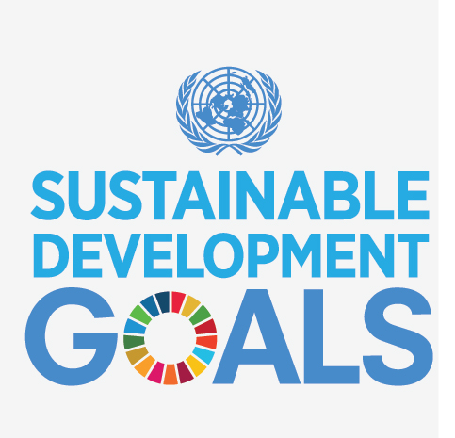
4. The Environment subprogramme includes a series of cross-cutting processes that will support countries in their achievement of all SDGs.
5. In support of the 2030 Agenda and in line with the Environment for Europe (EfE) Reform Plan (ECE/CEP/S/152, annex I, and Corr.1), the EfE ministerial process will continue to serve as a mechanism to:
(a) Improve the environment throughout the region, contributing to sustainable development, poverty eradication, improving quality of life, and a safer world;
(b) Enhance the implementation of strengthened national environmental policies and the prioritisation of environmental objectives;
(c) Support convergence of environmental policies and approaches, while recognizing the benefits from a diversity of approaches to achieve common goals;
(d) Encourage the participation of civil society;
(e) Promote broad horizontal environmental cooperation.
6. The ECE Convention on Environmental Impact Assessment in a Transboundary Context (Espoo Convention) and, in particular, its Protocol on Strategic Environmental Assessment (Protocol on SEA) provide a framework for the comprehensive integration of environmental and health concerns into a wide range of policies and legislation, programmes, plans and development activities, in all economic sectors, thus helping countries to assure alignment of development with the SDGs. The ECE secretariat will assist countries in their efforts to accomplish sustainable development by provision of technical assistance and capacity development, including:
(a) Facilitation of legal reforms;
(b) Pilot projects;
(c) National and local training of trainers aiming at strengthening the institutional and human capacities among Government officials and other experts;
(d) Organization of subregional and national experience sharing and awareness raising events;
(e) Development of recommendations and guidance materials on the basis of best practices identified by State Parties and other stakeholders.
7. The activities of the ECE Convention on Access to Information, Public Participation and Access to Justice in Environmental Matters (Aarhus Convention) and its Protocol on Pollutant Release and Transfer Registers (Protocol on PRTRs) strengthen countries’ capacities and assist Governments in achieving SDGs through implementing their respective commitments on access to information, public participation and access to justice regarding a wide range of issues that affect environment and human health. These activities also facilitate consensus building among Parties and a wide range of stakeholders. These two treaties will continue to provide support to:
(a) Multilateral decision-making processes to take joint commitments;
(b) Regional multi-stakeholder meetings to share challenges and good practices;
(c) Regional and global coordination mechanisms;
(d) Developing recommendations, guidance material and electronic information tools;
(e) Advisory services to Governments and international organizations.
Specific activities will include sessions of the respective meetings of the Parties and subsidiary bodies, round tables and workshops and coordination mechanisms.
8. More generally, the reporting mechanisms under the ECE MEAs will support countries in their reporting of progress on SDGs. Specific examples are cited below in chapter II.
9. Further, the Environmental Performance Review (EPR) Programme assists countries in assessing the efficiency of their efforts to decouple economic growth from environmental degradation through a specific focus on the integration of environmental requirements in sectoral policies and providing recommendations to the countries under review. The EPR Programme will continue to undertake assessments of environmental performance in interested ECE countries that are not members of the Organization for Economic Cooperation and Development. The EPR programme may also provide a model for other mechanisms in support of the follow-up and review of the 2030 Agenda.
10. Finally, the programme on Environmental Monitoring and Assessment provides assistance to countries in developing environmental data and information in preparation for indicator-based national and international state of the environment reports. This includes capacity development and co-managing the establishment of the pan-European Shared Environmental Information System (SEIS) to underpin regular environment assessments in the region and MEAs. The programme will continue to support national and international monitoring programmes and to undertake capacity-development activities that help to improve environmental data collection, strengthen environmental reporting and promote comparability of environmental datasets and indicators.
II. Goal by goal
11. This chapter presents, for each SDG, examples of the Environment subprogramme processes that work towards achievement of SDG and specific, concrete activities that will support countries in achieving SDG. Reference to specific targets is provided in parentheses in the titles.
SDG 1. End poverty in all its forms everywhere (1.4, 1.5)
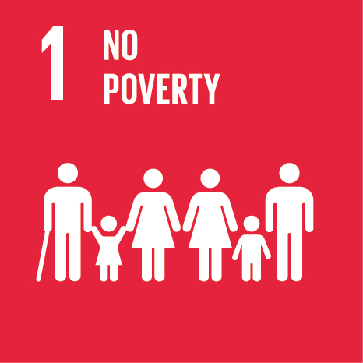
12. The Protocol on Water and Health, jointly serviced by ECE and the World Health Organization (WHO) Regional Office for Europe, specifies that in pursuing the aim of access to drinking water and provision of sanitation for everyone, special consideration should be paid to ensure equitable access to these services for all members of the population. Under the Convention on the Protection and Use of Transboundary Watercourses and International Lakes (Water Convention) and its Protocol on Water and Health, policy guidance and activities on the ground have been developed to strengthen country resilience to water-related disasters, thus reducing exposure and vulnerability to climate-related extreme events as the majority of disasters and their social and economic impacts are water related (floods and droughts).
13. The Equitable Access Score-card: Supporting policy processes to achieve the human right to water and sanitation (ECE/MP.WH/8), developed under the Protocol, will continue to be used at the subregional, national, and local levels to promote awareness on equitable access and a sound basis for policies and measures. Under the Convention, pilot projects on climate change adaptation in transboundary basins will continue to be implemented, thus increasing resilience to climate change, including of the poor and those in vulnerable situations. Activities on climate change are also planned under the Protocol.
14. The activities of the Aarhus Convention and its Protocol on PRTRs facilitate effective public participation and transparent and accountable governance, which are critical for achieving this goal. They help Governments to tackle inequality by ensuring that all persons, including the poorest segments of society and rural communities, have access to reliable information and are able to participate in decisions that impact on their lives. Specific activities on climate change matters will include thematic sessions on promoting the Convention’s principles in international forums, meetings of a task force and advisory services.
SDG 2. End hunger, achieve food security and improved nutrition and promote sustainable agriculture (2.2, 2.4)
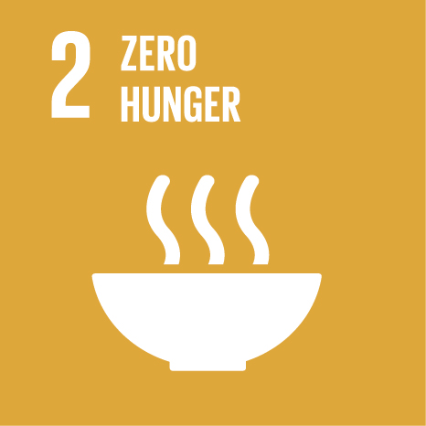
15. The Convention on Long-range Transboundary Air Pollution (Air Convention) sets targets for ammonia and nitrogen oxides and thus assists countries in abating nitrogen emissions and managing nitrogen more sustainably. This has direct impacts on soil quality and will thus help in promoting sustainable agriculture.
16. A task force under the Convention will continue to develop technical and scientific information and encourage coordination of air pollution policies on nitrogen in the context of the nitrogen cycle. The work of the task force will also help countries in fulfilling their obligations to reduce nitrogen oxides and ammonia emissions under the Convention’s Protocol to Abate Acidification, Eutrophication and Ground-level Ozone (Gothenburg Protocol) and Protocol concerning the Control of Emissions of Nitrogen Oxides or their Transboundary Fluxes.
17. Under the Water Convention, the work on the water-food-energy-ecosystems nexus promotes increased efficiency of resource use. Assessments of the water-food-energy-ecosystems nexus carried out under the Convention will allow bringing concrete cooperative solutions to increase water productivity, including in agriculture, and to maintain ecosystems. Lack of access to unsafe water is a primary cause of malnutrition so, by promoting access to safe drinking water for all, the Convention’s Protocol contributes to ending malnutrition. For example, activities under the Protocol to increase surveillance of drinking water and water-related diseases will reduce malnutrition, in particular stunting and wasting.
18. The work under the Aarhus Convention and its Protocol helps Governments to achieve sustainable agriculture through strengthening capacities of authorities to promote effective access to environmental information and to engage effectively non-governmental organizations (NGOs), local communities and other stakeholders in developing and implementing different agriculture-related plans, programmes and projects.
SDG 3. Ensure healthy lives and promote well-being for all at all ages (3.2–3.4, 3.9, 3.d)
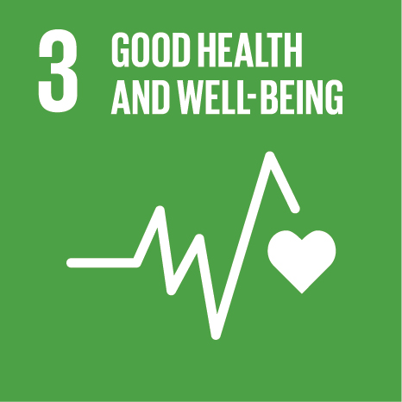
19. ECE is a partner in the European Environment and Health Process, which brings together ministries from the two sectors to shape European policies and actions on environment and health. ECE promotes synergies with the aim to facilitate intersectoral policymaking from the environment perspective. ECE also brings forward the experience from ECE MEAs in the Environment and Health Process. ECE will continue to promote synergies among the different sectors involved and to assist member States to coordinate policies addressing environmental and health issues in the region.
20. Governments of the ECE-WHO European region established the Transport, Health and Environment Pan-European Programme (THE PEP), recognizing the strong connection between transport, health and the environment. The activities organized under THE PEP promote mobility and transport strategies integrating environmental and health concerns. ECE will continue to work on THE PEP and to strengthen the link between the three sectors through assisting member States to implement the goals of THE PEP. This will also help countries to implement the relevant SDGs.
21. By reducing air pollution, the Air Convention tackles the world’s largest environmental health risk for non-communicable diseases and thus helps in preventing morbidity and premature mortality. A joint task force, established by the Executive Body of the Convention and the WHO European Centre for Environment and Health, will continue to assess the health effects of long-range transboundary air pollution and provide supporting documentation. These assessments will allow quantification of the contribution of transboundary air pollution to human health risks and help define priorities for guiding future monitoring and abatement strategies. This will help countries in reducing morbidity and premature mortality related to air pollution.
22. The Protocol on SEA and, at the project level, the Espoo Convention, emphasize the links between environment and health; they contribute to reducing health hazards from chemicals, air, water and soil pollution and contamination by ensuring that environmental and health considerations are taken into account in the planning of all potentially polluting economic activities. By assessing the potential environmental and health impacts of plans and programmes, the Protocol provides early warning of unsustainable options and contributes to the reduction and management of health risks from economic activities.
23. Under the Protocol, capacity-development activities such as training-of-trainers workshops and pilot projects will continue to be undertaken to assist countries to effectively implement strategic environmental assessment (SEA). WHO has provided detailed guidance for the assessment of potential health impacts of government plans and programmes and for the involvement of health authorities. This guidance will be further developed and disseminated to provide guidance for country and sector specific planning.
24. The reduction of water pollution and the protection of water resources are obligations under both the Water Convention and its Protocol. Regular assessments on the status of transboundary water resources carried out under the Convention allow the tracking of progress towards the reduction of pollution of transboundary watercourses. Regular reports under the Protocol similarly allow countries to assess their own progress towards the reduction of pollution and the impacts on human health and well-being.
25. Another objective of the Protocol on Water and Health is to reduce water-borne disease. The establishment of surveillance and early warning systems for water-related disease is a core obligation under the Protocol. Activities under the Protocol to increase surveillance of drinking water and water-related disease will reduce the incidence of water-related disease and, specifically, mortality and morbidity caused by diarrhoea. Activities under the Protocol on the prevention of pollution and the increase of sanitation will support the same objective. Capacity-development activities will be carried out regularly to support the establishment of surveillance and early warning systems.
26. The Convention on the Transboundary Effects of Industrial Accidents (Industrial Accidents Convention) promotes the prevention, preparedness and response to industrial accidents releasing hazardous substances, especially those with transboundary consequences. Activities under the Convention will continue to support countries in the safe management of hazardous chemicals, through their identification and classification in line with the Convention, now aligned with the Globally Harmonized System on the Classification and Labelling of Chemicals. The Convention aims to reduce the risk of technological disasters arising from installations holding chemical substances. Activities related to education, raising awareness of industrial safety and technological disaster risk reduction and management will be organized.
27. The Convention also supports countries in early warning and an Industrial Accidents Notification System is available to countries to alert each other about accidents and to request assistance. The notification system will be regularly maintained and tested and its possible integration with other early warning and notification systems will be examined.
28. Activities under the Aarhus Convention and its Protocol on PRTRs benefit Governments by enabling them to establish a coordinated reporting system on the release of hazardous chemical substances and by promoting easy online access to this reporting system and other environmental information, which in its turn can facilitate early warning, risk reduction and management of national and global health risks. Dialogue is fostered among authorities, technical experts, NGOs and other stakeholders by organizing meetings, workshops and round tables to support the development of capacity to manage hazardous chemical substances.
SDG 4. Ensure inclusive and equitable quality education and promote lifelong learning opportunities for all (4.7, 4.a)
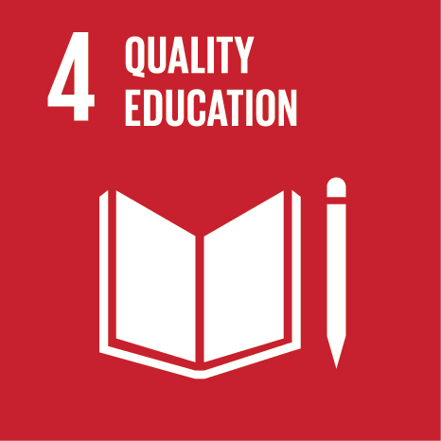
29. The ECE Strategy for Education for Sustainable Development (Strategy for ESD) is a practical instrument to incorporate key themes of sustainable development into the region’s education systems. It represents a cross-cutting process that will allow for a better understanding and enhanced competences related to all aspects of sustainable development. Therefore the implementation of the Strategy will contribute not only to the implementation of this goal, but to the implementation of all SDGs.
30. Implementation of the Strategy for ESD envisages activities focused on: coordination, sharing experience and good practices; capacity development; raising public awareness; strengthening subregional cooperation; and development and application of a set of indicators to measure the effectiveness of the implementation. These activities should be implemented under the guidance of the ECE Steering Committee on Education for Sustainable Development, which is responsible for giving guidance and strategic directions to the implementation of the Strategy, deciding on activities carried out and reviewing the progress of its implementation.
31. A common problem in education facilities is the lack of adequate water and sanitation services and proper hygiene, which particularly affect menstruating girls. The Protocol on Water and Health has a dedicated programme of work to improve water, sanitation and hygiene in schools. A number of activities related to access to water, sanitation and hygiene in schools aim to increase awareness of policymakers through advocacy, strengthen surveillance of public health authorities and increase the capacity of school managers in this area.
SDG 5. Achieve gender equality and empower all women and girls (5.1, 5.5, 5.c)
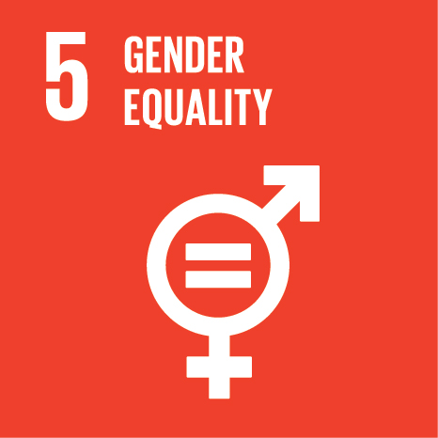
32. ECE continuously strives to promote gender balance in all its environmental governance bodies, not only in the overall representation but also in the identification of speakers, as well as in its environmental capacity-development activities. The Committee on Environmental Policy has gender mainstreaming on its agenda.
33. Gender issues, including gender equality, are addressed in EPRs.
34. The Steering Committee on Education for Sustainable Development is gathering good practices and success stories related to gender equality in the education sector, organizes discussions to share experiences and achievements in the area of mainstreaming gender issues in the education sector in general and specifically in education for sustainable development and disseminates good practices and relevant resources.
35. The application of The Equitable Access Score-card under the Protocol on Water and Health often reveals gender disparities in access to sanitation facilities, especially in schools. Activities under both the Water Convention and its Protocol will aim to ensure women’s full and effective participation and equal opportunities for leadership. For instance, in the framework of the National Policy Dialogues on Integrated Water Resources Management, ECE will strive for equal representation in policy processes.
SDG 6. Ensure availability and sustainable management of water and sanitation for all (all targets)
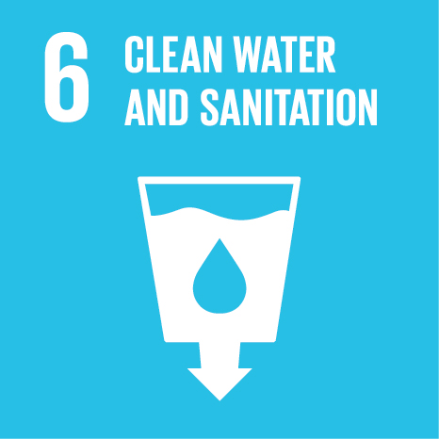
36. The Protocol on Water and Health aims for access to drinking water and the provision of sanitation for everyone through improving water management. The Protocol, as Goal 6, covers the whole water cycle and it therefore addresses comprehensively all of the goal’s targets. Further, by requesting Parties to set national targets, assess progress and report, the Protocol also offers a useful approach for the implementation of the SDG.
37. The Protocol calls for international cooperation and joint action to support implementation, in particular in relation to extreme events, contingency planning, integrated information systems and databases, the exchange of information and the sharing of technical and legal knowledge and experience. The Protocol recognizes the vital role of public participation in the decision-making process for a better management of water resources. The public should, for example, be involved in the process of setting targets and in preparing national summary reports.
38. Countries will be further supported in setting and implementing targets under the Protocol — similar to targets under this Goal — through in-country projects, the exchange of experience and the preparation of a collection of good practices and lessons learned on target-setting. The Equitable Access Score-card under the Protocol will be applied in additional countries and communities. Further, it is planned to revise the reporting template including the common indicators under the Protocol in line with the review of SDG implementation.
39. The Protocol also foresees activities on promoting targeted health interventions for water- and sanitation-related diseases, strengthening water, sanitation and hygiene in schools, small-scale water supplies and sanitation and safe and efficient management of water supply and sanitation systems. In addition, work will promote the exchange of experience and networking on the regional level to address common challenges.
40. The Water Convention requires Parties to take national measures for the protection and ecologically-sound management of transboundary surface waters and groundwaters. It obliges its Parties to prevent, control and reduce transboundary impacts, for example by using best available technologies, monitoring and assessment and the licensing of emissions.
41. That obligation, together with the obligation to use transboundary waters reasonably and equitably, provide a basis for balancing demand between different water uses as well as the ecosystem needs and for improving water-use efficiency. The Convention includes provisions for integrated water resources management and obliges countries to cooperate by concluding agreements for shared waters and setting up joint institutions for their management.
42. A third comprehensive assessment is expected to be prepared under the Convention in 2018–2021, assessing the quality, quantity and other legal and institutional frameworks of transboundary waters in the ECE region and beyond.
43. The activities on water and climate change under the Convention (see SDG 13) will increasingly address water scarcity. The work will support countries in allocating water among different sectors, ensuring sustainability of withdrawals and fighting water scarcity.
44. With the global opening of the Convention, its legal and institutional framework, its soft laws and activities—the exchange of experience, projects on the ground, assessment, capacity development, policy advice, guidelines, etc.—will be available to all countries worldwide. The reporting mechanism will enable countries to review their own progress in transboundary water cooperation and will support monitoring of this goal. In addition, the National Policy Dialogues carried out under the Convention will to support nearly all countries in the Caucasus, Central Asia and Eastern Europe, to better implement integrated water resources management through improved intersectoral cooperation and adoption of policy packages, such as strategies, laws, action plans and basin management plans.
45. The conservation and, where necessary, the restoration of ecosystems is a specific obligation under the Convention. In some of the field projects under the Convention, ecosystems have been restored. Such projects will be replicated elsewhere. In addition, the activities on the water-food-energy-ecosystems nexus under the Convention take into account the ecosystem needs. Additional nexus assessments will be carried out in basins worldwide.
46. The programmes of work under the Water Convention and its Protocol include a broad range of capacity-development activities related to all the targets of this goal.
47. Similarly, the workplans under the Espoo Convention and notably its Protocol on SEA include capacity-development activities to promote the use of SEA, together with cumulative assessment procedures, as a central tool in the sector of sustainable water management.
48. Through ensuring transparency and effective public participation with respect to water management and sanitation, the Aarhus Convention and its Protocol play a similar role to that mentioned under SDG 2. Specific activities in this area include meetings of the Convention’s Task Forces on Access to Information and on Public Participation in Decision-making.
SDG 7. Ensure access to affordable, reliable, sustainable and modern energy for all (7.2, 7.a)
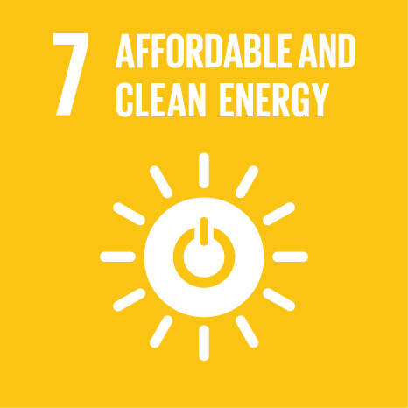
49. The Air Convention sets emission limit values for air pollutants and these have proven to be an effective tool in stimulating investment in clean technologies, including in the energy sector. A task force was established under the Convention to develop a techno-economic database of information on control technologies for air pollution abatement and their costs. The information may be used both in the formulation of draft revisions of technical annexes to existing Protocols to the Convention, as well as for input data to integrated assessment modelling. The information will assist countries in identifying technologies, including in the energy sector, that will help reduce air pollution.
50. An increase in hydropower will be needed to achieve this goal. The work under the Water Convention on the water-food-energy-ecosystems nexus aims to improve efficiency and sustainability of such resource use. Assessments of the nexus will allow the definition of concrete cooperative solutions to increase the ratio of renewable in the energy mix, reducing trade-offs linked to the use of water resources.
51. The application of the SEA procedure, stipulated in the Protocol on SEA, significantly contributes in the development of sectoral energy plans and programmes, as well as policies and legislation, that assist countries to meet their renewable energy targets and enhance international cooperation. The joint workplan under the Espoo Convention and the Protocol on SEA includes assistance to countries to develop their legislative and institutional frameworks, through legal advice and capacity-development programmes. It also coaches countries in the pilot application of SEA in strategic documents in the energy sector.
52. Through ensuring transparency and effective public participation with respect to energy matter, the Aarhus Convention and its Protocol play a similar role to that mentioned under SDG 2.
SDG 8. Promote sustained, inclusive and sustainable economic growth, full and productive employment and decent work for all (8.4)
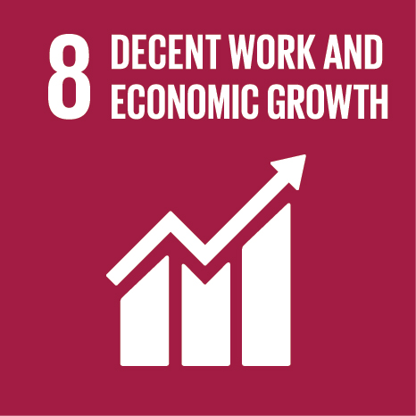
53. By integrating environment and health consideration into all development planning, the Protocol on SEA provides a key tool for greening economies, the integration of green economy considerations into development activities and making production patterns more sustainable. ECE will continue to promote SEA and support the establishment of SEA systems in line with the Protocol. The funding of follow-up activities to current European Union-funded green economy programmes, and the replication or extension of activities to other countries or subregions, is currently under consideration.
54. The work under the Water Convention on the water-food-energy-ecosystems nexus aims to improve resource efficiency. Assessments of the nexus will allow the definition of concrete cooperative solutions to increase resource efficiency and reduce trade-offs.
55. Through ensuring transparency and effective public participation with respect to green economy, the Aarhus Convention and its Protocol play a similar role to that mentioned under SDG 2.
56. The joint work with the United Nations Environment Programme on green economy under the EfE process is leading to the development of a strategic framework for green economy.
SDG 9. Build resilient infrastructure, promote inclusive and sustainable industrialization and foster innovation (9.1, 9.4, 9.a)
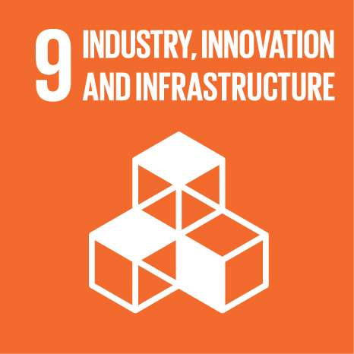
57. The EPR Programme assists countries to assess their actions to improve the efficiency of their efforts to use resource-efficient and environmentally-sound technologies through a specific focus on the application of green economy approaches and green technologies and providing recommendations to the countries under review.
58. As noted under SDG 7, the Air Convention stimulates investment in clean technologies. This will help countries in promoting sustainable industrialization. The information on control technologies for air pollution abatement, as mentioned under SDG 7, will also assist countries in identifying technologies that will help reduce air pollution.
59. By ensuring that a full range of potential environmental and health impacts and opportunities considered in the planning of infrastructure, SEA helps choosing more sustainable alternatives and best available technologies. Pilot projects and training events, for example on transport infrastructure, could be organized under the Espoo Convention and its Protocol.
60. Activities on adaptation to climate change under the Water Convention strengthen countries’ resilience, including the resilience of infrastructure. Several African, least developed and landlocked developing countries are involved in such activities. Regular workshops on increasing resilience, exchanges between transboundary basins active in adaptation to climate change and pilot projects will continue to be organized.
61. The Industrial Accidents Convention promotes actions by governments and operators of hazardous industrial facilities to ensure the safe management of such installations. The Convention will continue to offer capacity-development activities to support national governments and industry in this regard. A guidance document and checklist on safety reports has been prepared; governments will continue to be supported in its application. The Convention will also continue to offer activities and interactive seminars on the exchange of information and technology.
62. The Aarhus Convention and its Protocol can play a similar role to that mentioned under SDG 2, but with respect to inclusive and sustainable industrialization. Furthermore, PRTRs benefit Governments and industry through stimulating improved environmental management. For facilities, monitoring or estimation of pollution levels and their mandatory publication encourages efficiency and the reduction of pollution levels and associated costs. PRTRs can therefore serve as a major driving force for pollution reduction and eco-innovation throughout many sectors of the economy.
63. At workshops and global round tables under the Protocol on PRTRs, industry, industry associations and public authorities will benefit from exchanging experience, enhancing experts’ capacities and promoting synergies on PRTR-related issues. This will also contribute to achieving greater convergence between national PRTRs, so that information on pollution levels in the registers can be compared worldwide.
SDG 10. Reduce inequality within and among countries (10.2–10.4)
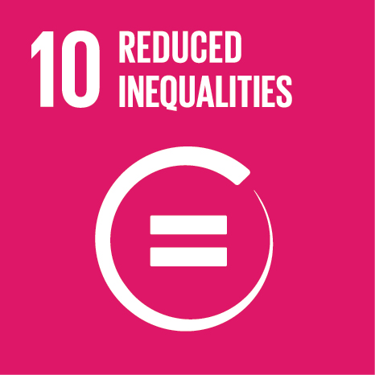
64. The Protocol on Water and Health specifies that, in pursuing the aims of access to drinking water and provision of sanitation for everyone, special consideration should be paid to ensure equitable access to these services for all members of the population. The Equitable Access Score-card will be applied in additional regions, cities and countries.
65. The Aarhus Convention helps Governments to achieve this goal through promoting the rights of every person without any discrimination in relation to access to information, public participation and access to justice regarding a wide range of issues that affect environment and human health.
SDG 11. Make cities and human settlements inclusive, safe, resilient and sustainable (11.1–11.7, 11.a, 11.b)
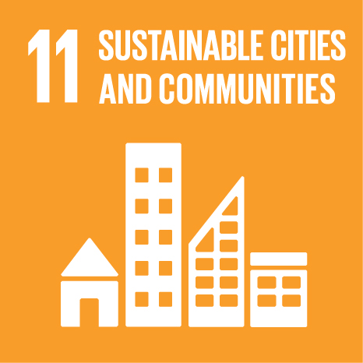
66. THE PEP implements its goals by supporting integrated approaches and solutions to achieve sustainable and healthy transport and mobility. In 2014, high-level representatives, meeting in Paris, introduced a new goal, to integrate transport, health and environmental objectives into urban and spatial planning policies. ECE will continue to assist member States to integrate transport, health and environmental objectives into urban and spatial planning policies and build capacities in these areas.
67. The EPR Programme assists countries to improve national, regional and local development planning by reviewing sustainable development policies at various levels and providing recommendations to the countries under review.
68. Reducing air pollution at the national level, the Air Convention also helps in improving air quality at the city level. The Convention sets emission targets to reduce pollution, which is a key factor in the degradation of surfaces of historical buildings and monuments.
69. An international cooperative programme was established under the Air Convention to perform a quantitative evaluation of the effect of major pollutants on the atmospheric corrosion of important materials and to assess the trends of corrosion and pollution. The information will assist countries in protecting their cultural heritage. The Cooperative Programme for Monitoring and Evaluation of the Long-range Transmission of Air Pollutants in Europe (EMEP) provides sound scientific support to the Convention, in particular in the areas of: (i) atmospheric monitoring and modelling; (ii) emission inventories and emission projections; and (iii) integrated assessment. As the source of information on the emission, transport and deposition of air pollution, EMEP will play a major role in informing policy developments under the Convention. The quantification of effects at the city level under EMEP will assist countries in tracing progress towards improving air quality at that level.
70. By ensuring that environmental and health concerns are thoroughly taken into account in the urban, land-use and regional planning, and that the relevant authorities, stakeholders and the public are effectively consulted, SEA considerably improves development planning and enhances sustainable urbanization and human settlement. SEA is a key tool for integrated plans, programmes and policies, the incorporation of climate change mitigation and adaptation measures and risk prevention and management. Under the Protocol on SEA, pilot projects, training events, guidelines and a seminar for the exchange of experience—possibly in cooperation with the ECE Housing and Land Management unit and with THE PEP and the NGO Local Governments for Sustainability—could be arranged.
71. The Water Convention obliges its Parties to prevent, control and reduce transboundary impacts, including those resulting from floods and from unilaterally decided flood protection measures such as dams. Model provisions on transboundary cooperation in flood management have been developed as well as model provisions that can complement transboundary water agreements. The global network of basins working on climate change adaptation, established by ECE and the International Network of River Basins, promotes experience and knowledge exchange in the fields of disaster risk reduction and climate change adaptation, especially in transboundary basins. The network will be further expanded.
72. Drinking water and sanitation are basic services to which the Protocol on Water and Health aims to ensure universal access. The focus of the Protocol is also on the safety of the drinking water supplies and the equity (including affordability) of access. Activities on setting targets allow cities to develop measurable, time-bound strategies to improve access to water and sanitation.
73. The Industrial Accidents Convention supports governments in reducing the number of deaths and people affected by technological disasters, including accidents triggered by natural disasters. The Convention requires its Parties to take the siting of hazardous facilities into account in their land-use plans or policies, including those of neighbouring countries. It also supports countries in establishing structures for cooperation and coordination, both horizontally—with different ministries involved—and vertically—with local authorities. As such, the Convention is conducive to supporting countries and cities in implementing a holistic management of technological disaster risk.
74. Under the Industrial Accidents Convention, the Espoo Convention and its Protocol on SEA, guidance on land-use planning, the siting of hazardous activities and related safety aspects is being prepared. Countries can be further supported in the implementation of the guidance through dedicated capacity-development efforts. The Industrial Accidents and Water Conventions will, through their joint expert group, continue to support countries in the application of the Checklist on contingency planning for accidents affecting transboundary waters.
75. The Aarhus Convention and its Protocol promotes truly participatory, integrated and sustainable human settlement planning and management through similar measures to that mentioned under SDG 2.
SDG 12. Ensure sustainable consumption and production patterns (12.2, 12.4–12.6, 12.8)
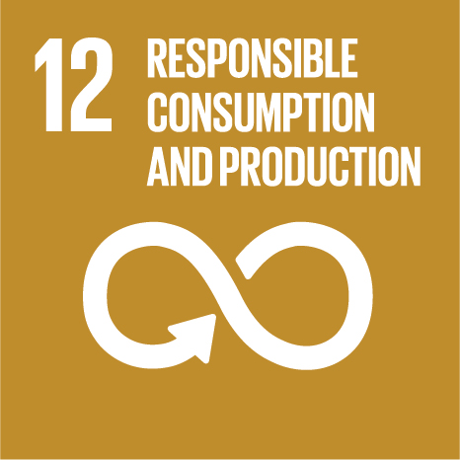
76. The EPR Programme assists countries to reduce waste generation through a specific focus on the assessment of waste management policies during EPRs and providing recommendations to the countries under review.
77. By implementing the ECE Strategy for ESD, countries will ensure people’s awareness for sustainable development and lifestyles in harmony with nature.
78. By setting emission targets for various air pollutants, the Air Convention assists countries in sustainably managing and improving air quality—one of the most important natural resources for life on earth—and in reducing releases of chemicals to air. In doing so, effects of air pollution on other natural resources, such as water, will also be reduced.
79. EMEP will provide sound scientific support to the Air Convention, playing a major role in informing policy developments under the Convention and helping countries in monitoring progress in reducing air pollution. An international cooperative programme under the Air Convention aims to assess, on a regional basis, the degree and geographical extent of acidification of surface waters. The three latest Protocols to the Convention will help countries in ensuring the environmentally-sound management of chemicals throughout their life cycle and to reduce their release to air.
80. SEA contributes to reducing related environmental impacts, by ensuring that environment and health concerns are thoroughly taken into account in, among others, waste management plans and programmes. Pilot SEAs of waste management strategies in the Caucasus are underway under the Protocol on SEA. Similar assessments could be carried out in other countries should funding be available.
81. The Industrial Accidents Convention provides a framework to prevent the accidental release of hazardous substances. It promotes the safe managements of installations producing, handling or storing chemical substances and, as such, the protection of human health and the environment. Activities support countries in the safe management of hazardous chemicals, through their identification and classification in line with the Convention. Subregional seminars, focused on the identification and notification of hazardous chemicals falling under the Convention, foster transboundary cooperation for the sound management of chemicals and reducing accident risk.
82. Through ensuring transparency and effective public participation with respect to management and use of natural resources, the Aarhus Convention and its Protocol play a similar role to that mentioned under SDG 2. Activities under the Protocol on PRTRs benefit Governments and industries by tracking the release of hazardous chemical substances and pollution trends over time; reviewing compliance of local facilities with their permit conditions; examining progress in reducing emissions; monitoring compliance and national progress with international commitments; and helping achieve pollution prevention, lessening the burden of control regulations, which require a large administrative burden to monitor and enforce. PRTRs also reduce costs to Government and industry by providing a coordinated reporting system.
SDG 13. Take urgent action to combat climate change and its impacts (13.1–13.3)
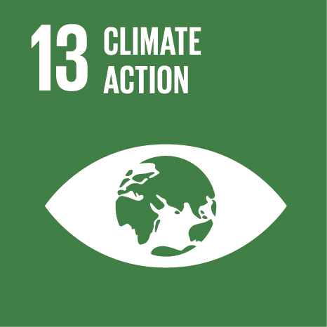
83. The EPR Programme assists countries to integrate climate change measures in their policy framework by reviewing national policies on environment and sectoral management and providing recommendations to the countries under review.
84. By implementing the ECE Strategy for ESD countries will improve education, awareness-raising and human and institutional capacity on climate change mitigation, adaptation, impact reduction and early warning.
85. The Air Convention’s Gothenburg Protocol is the first legally-binding agreement containing obligations to reduce the broader spectrum of short-lived climate pollutants, including ground-level ozone precursors and black carbon. The Protocol will also help in bringing about climate co-benefits.
86. A task force under the Air Convention will develop a better understanding of the intercontinental transport of air pollution across the Northern Hemisphere, including estimates of specific air pollutants. A second task force will work on the interactions between greenhouse gases and air pollution. The Convention will cooperate with the Climate and Clean Air Coalition Cooperation and, on modelling of air pollutants including black carbon, with the Arctic Monitoring and Assessment Programme.
87. The Protocol on SEA provides a concrete procedural tool that can ensure integration of climate change mitigation and adaptation measures into national planning, strategies and policies. Future work under the Protocol is expected to include the development of a database with examples of the use of SEA for the development of adaptation and mitigation strategies, training of trainers workshops, drafting of guidelines on SEA and climate change adaptation and a pilot project to test the application of the guidelines and a thematic seminar on the promotion of SEA as a tool for climate change adaptation.
88. The Water Convention provides a unique—if not the only—intergovernmental framework for supporting transboundary cooperation in climate change adaptation. The Convention will continue supporting countries in developing transboundary adaptation strategies though guidance, projects on the ground and exchange of experience. It will help countries in shared river basins to adapt jointly to climate change, making them more resilient to disasters and water scarcity, by developing common assessments, strategies and implementing joint adaptation measures.
89. The Industrial Accidents Convention provides an unparalleled legal and intergovernmental framework to support governments and operators in the safe performance of hazardous activities, including by running risk assessments and taking all appropriate measures to reduce risks. Such risks include those arising from climate change and natural disasters. The Convention will together with partners continue to address the prevention and mitigation of the transboundary impacts of natural accidents triggering technological disasters. Supporting countries in harmonizing or preparing joint contingency plans and response exercises, ECE could provide further support to strengthen resilience and the adaptive capacity to climate-related hazards and natural disasters.
90. Through ensuring transparency and effective public participation in climate-related decision making, the Aarhus Convention and its Protocol play a similar role to that mentioned under SDG 2.
SDG 14. Conserve and sustainably use the oceans, seas and marine resources for sustainable development (14.1)
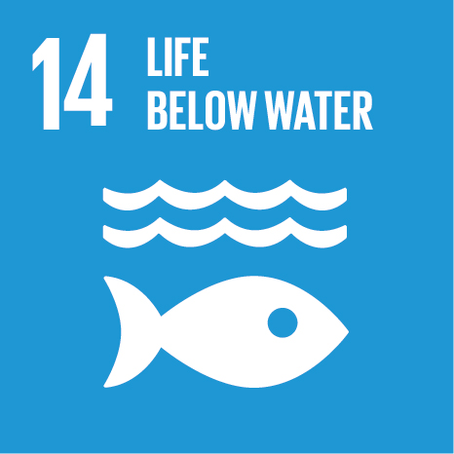
91. The Air Convention sets targets for various air pollutants, including ammonia and nitrogen oxides and thus assists countries in reducing marine pollution from land-based activities, particularly nutrient pollution. The international cooperative programme under the Convention, mentioned under SDG 12, aims to assess, on a regional basis, the degree and geographical extent of acidification of surface waters, which might end up in the oceans.
92. By fostering the protection of freshwater resources, the Water Convention and its Protocol on Water and Health promote the reduction of pollution from land-based activities. Regular assessments under the Convention and reporting under its Protocol will allow countries to track progress in reducing land-based pollution.
SDG 15. Protect, restore and promote sustainable use of terrestrial ecosystems, sustainably manage forests, combat desertification, and halt and reverse land degradation and halt biodiversity loss (15.1, 15.3–15.6)
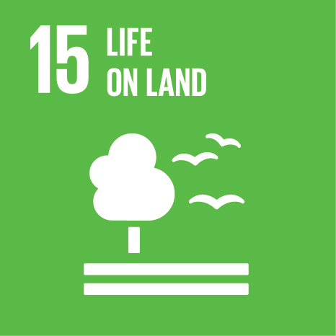
93. The Air Convention sets targets for various air pollutants, and thus assists countries in mitigating effects on ecosystems and biodiversity. An international cooperative programme will provide a periodic overview on the condition of forest ecosystems in terms of health, productivity, diversity and nutrition. The international cooperative programme already mentioned under SDG 12 will assess, on a regional basis, the degree and geographical extent of acidification of surface waters. This too will assist countries in mitigating effects on ecosystems and biodiversity.
94. By ensuring that environmental and health concerns are thoroughly taken into account in the planning of land-use and sectoral activities, SEA contributes to protecting biodiversity and natural habitats. Recommendations could be developed under both the Espoo Convention and its Protocol on SEA on the integration of biodiversity considerations into all SEAs and environmental impact assessments, possibly in cooperation with the Convention on Biological Diversity.
95. The conservation and, where necessary, the restoration of ecosystems is a specific obligation under the Water Convention. Previous assessments under the Convention have focused attention on biodiversity and the integrity of water-related ecosystems. Moreover, Recommendations on the Payments for Ecosystem Services in Integrated Water Resources Management (ECE/MP.WAT/22) have been developed under the Convention and their use is promoted. Pilot projects on adaptation to climate change will promote the implementation of natural measures to increase resilience such as afforestation and ecosystem restoration. The assessment of the water-food-energy-ecosystem nexus will permit the identification of solutions to protect ecosystems with benefits for the other sectors.
96. Through ensuring transparency and effective public participation in the use of ecosystems, the Aarhus Convention and its Protocol play a similar role to that mentioned under SDG 2.
SDG 16. Promote peaceful and inclusive societies for sustainable development, provide access to justice for all and build effective, accountable and inclusive institutions at all levels (16.3, 16.6, 16.7, 16.10)
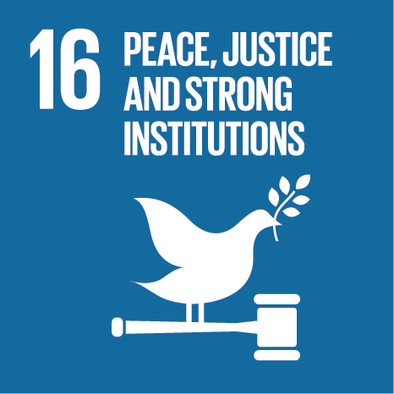
97. By ensuring consultation of the environmental and health authorities, other stakeholders and the public at local, national and international levels, and by ensuring that the outcomes of these consultations are considered, the Espoo Convention and SEA procedures concretely render decision-making regarding the planning of economic activities more inclusive, participatory and representative. The procedures provide for the right of the public to be informed and consulted on envisaged economic activities that are likely to have adverse impacts on the environment and the health of the population.
98. The Water Convention promotes peaceful societies and the rule of law, by fostering the development of agreements based on international water law principles and the establishment of transboundary institutions for the cooperation on shared resources. Work under the Convention will promote the Convention’s implementation and compliance and thereby prevent conflict over the use of shared water resources. Projects on the ground and capacity-development activities will promote the efficiency and accountability of joint bodies for transboundary waters.
99. The Industrial Accidents Convention stipulates the need to inform and involve the public in consultations and activities related to the prevention of, preparedness for and response to industrial accidents, in particular with regard to transboundary issues. It also stipulates inclusive governance arrangements and decision-making structures involving national competent authorities, the public, and industry. An amendment to the Convention’s provision on public information, participation and access to justice is to be considered by the Conference of the Parties at its ninth meeting (Slovenia, 28–30 November 2016). Implementation guidance will offer further support to Parties. The Convention will continue to foster cooperation among authorities, with industry, the public and other relevant stakeholders and respective governance arrangements.
100. Activities under the Aarhus Convention and its Protocol on PRTRs help Governments to achieve this goal through strengthening countries’ capacities to implement their commitments in relation to a wide range of issues related to the environment and human health by promoting: effective, accountable and transparent institutions; effective access to information; effective and inclusive stakeholders’ participation and transparency in national and international decision-making; and effective and equal access to justice for all. Specific support will include the development of guidance material and recommendations as well as online access to good practice case studies and advisory support to Governments and international forums. Meetings of their subsidiary bodies will serve as an effective mechanism to address challenges and good practices in relation to different aspects of the implementation of this goal.
SDG 17. Strengthen the means of implementation and revitalize the global partnership for sustainable development (17.6, 17.9, 17.13, 17.16, 17.17, 17.19)
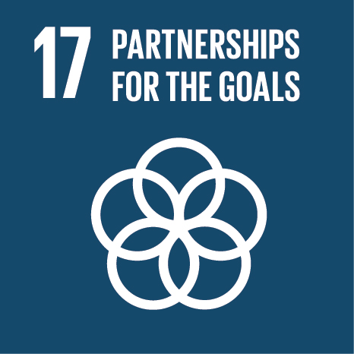
101. The Programme on Environmental Monitoring and Assessment assists countries to improve the quality and flow of environmental data and information across the pan-European region as part of a process to establish a SEIS that promotes good environmental governance and sustainable development. Greater harmonization and prioritization of monitoring activities provides long-term and sustainable prospects for cooperation and partnerships, internationally and across the pan-European region, to support sustainable development.
102. The Joint Task Force on Environmental Statistics and Indicators will continue to assist the countries of the Caucasus, Central Asia and Eastern Europe, and interested South-Eastern European countries, in addressing the challenges related to producing high quality, timely and reliable environmental statistics and indicators, in connection with SEIS activities and the United Nations System of Environmental-Economic Accounting, through capacity-development and other relevant activities.
103. The Air Convention provides a regional platform for sharing knowledge and expertise to support a number of SDGs in countries in the region. The knowledge that is gathered under the Convention is freely available and can be used by countries beyond the ECE region. Exchange of data is also being fostered between the Air Convention, the Convention on Persistent Organic Pollutants, the Convention on Mercury and the Arctic Council.
104. SEA contributes to ensuring that SDGs are taken into account in the policymaking in consultation with all relevant sectors and levels of the government. Pilot projects, training events, guidelines and seminars for the exchange of experience could be organized under the Protocol on SEA.
105. Both the Water Convention and its Protocol are aligning their work to support countries’ efforts in achieving water-related targets. They provide intergovernmental and multi-stakeholder platforms to promote the exchange of experiences to achieve those targets. Activities will provide support to developing countries and countries in transition in their efforts. Policy-related activities in particular, such as National Policy Dialogues and activities on setting targets under the Protocol, will support the development of national plans. Meeting of the Parties and subsidiary bodies of the two instruments, as well as workshops from national to global levels, will promote partnerships and the exchange of experiences.
106. The Industrial Accidents Convention stipulates that Parties facilitate the exchange of technology for prevention, preparedness and response to industrial accidents. The Convention has adopted an Assistance Programme to support countries with economies in transition to enhance industrial safety. Following a decision on the Convention’s opening to countries beyond the ECE region, support might also be provided to other developing countries in the future.
107. The Convention will continue to offer workshops on exchanging information and good practices, which can also address the exchange of technology. Guidance on a specific kind of installation or industry can be envisaged. Activities under the Convention’s Assistance Programme will continue to support countries of the Caucasus, Central Asia and Eastern Europe in efforts towards the accession to and full implementation of the Convention. Awareness-raising of the Convention beyond the region and possible future capacity-development efforts could be conducted in cooperation with the other United Nations regional commissions or other international organizations.
108. The Aarhus Convention and its Protocol provide platforms for sharing knowledge and expertise to support implementation of a number of SDGs in countries. The treaties’ activities facilitate countries’ joint commitments and foster international cooperation between Parties, organizations and other stakeholders. The knowledge that is gathered under the two treaties is widely used by countries beyond the ECE region. Regional and global coordination mechanisms have been established to facilitate promotion of synergy and partnerships. Regular global round tables on PRTRs will be held to foster exchange of knowledge among Governments and stakeholders from different regions.
III. Concluding remarks
109. In line with the United Nations Charter, the EfE ministerial process fosters regional-level policy dialogue and integration, is based on respect for the principle of equal rights of nations, encourages international cooperation in solving international environmental problems and assures national political buy-in to solutions.
110. The EfE process and its ministerial conferences, taking place every five years, as well as the mid-term review in between the two conferences, could integrate issues related to SDGs and the achievement of SDG targets at the regional level, in particular those related to the green economy and the work under the ECE MEAs and policy instruments. For instance, starting with the Batumi Ministerial Conference and until 2030, each ministerial conference could dedicate half a day or more to address pertinent issues related to the implementation of 2030 Agenda in the pan-European region. The name of the process could be adapted accordingly, for example “Environment [for Europe] for Sustainable Development” or “Better Environment for Sustainable Future”. Authorities representing other relevant sectors could be invited to participate or co-organize the relevant sessions (e.g., using the example of organizing segments on education for sustainable development during the Belgrade and Batumi Ministerial Conferences).
111. Given that environment represents one of the dimensions of sustainable development, the ECE Environment subprogramme will contribute to the achievement of all SDGs, including through partnerships with other organizations and institutions and by strengthening synergies with all ECE subprogrammes in the relevant areas of work.
112. Further, the subprogramme could provide practical support to the implementation of the 2030 Agenda by, among others:
(a) Strengthening governance;
(b) Supporting monitoring and review;
(c) Breaking down silos within Governments and within ECE;
(d) Building partnerships outside ECE, with other MEAs, other international organizations, NGOs, academia and the private sector;
(e) Developing capacity and sharing experiences and lesson learned;
(f) Having broad membership across the ECE region and, potentially, beyond;
(g) Translating global goals into national action.
113. The subprogramme thus offers mechanisms and tools to help ECE member States in their achievement of SDGs, including through integration and partnerships.
ECE multilateral environmental agreements and SDGs
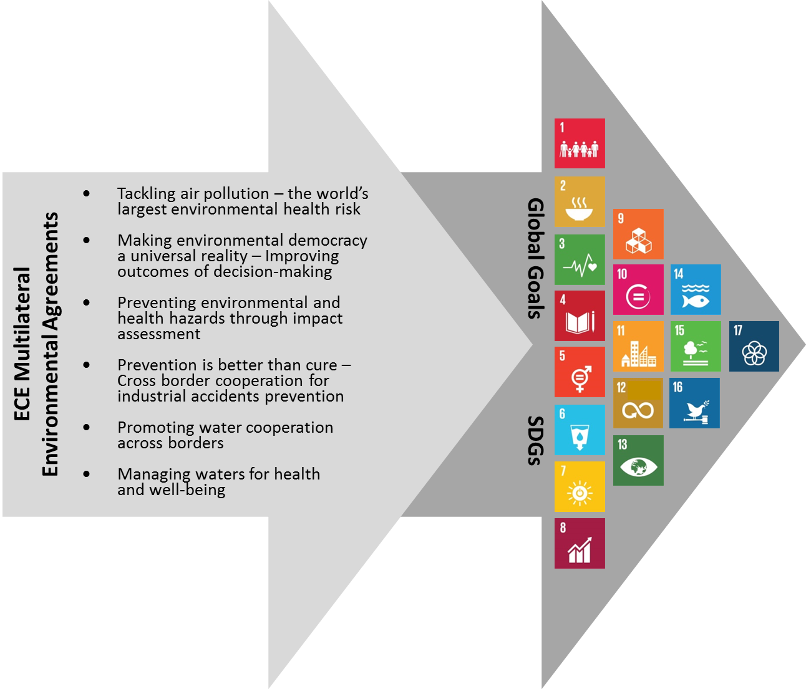

? Please refer to the Resolution adopted by the General Assembly on 25 September 2015 (A/RES/70/1) available at https://sustainabledevelopment.un.org/post2015/summit.
? Subject to decision by the Committee on Environmental Policy.
? The pan-European region under the Environment for Europe process covers the full membership of ECE, i.e., the 56 ECE member States.

