Economic Commission for Europe
Committee on Environmental Policy
Twenty-first session
Geneva, 27–30 October 2015
Item 4 of the provisional agenda
Multilateral environmental agreements

Information paper No. 10
14 October 2015
ECE multilateral environmental agreements for global goals
Note by the secretariat
1. The Sustainable Development Goals (SDGs), or Global Goals, are an inter-governmentally agreed set of goals relating to international development that were adopted as a part of the 2030 Agenda for Sustainable Development at the United Nations Sustainable Development Summit (New York, 25–27 September 2015). They will follow on from the Millennium Development Goals once those expire at the end of 2015. Pursuant to the outcomes of its previous session, the Committee on Environmental Policy (CEP) will consider at its 21st session, among other matters, the role of the United Nations Economic Commission for Europe (ECE) multilateral environmental agreements (MEAs) in the post-2015 development agenda. The MEAs have much to offer to the ECE region and beyond for furthering the Global Goals (see figure below).
2. The MEAs could support the implementation of the Global Goals, for example, in terms of the following topics:
- Strengthening governance (e.g., Aarhus and Espoo Conventions and their protocols, Industrial Accidents Convention, Water Convention and its Protocol);
- Supporting monitoring and review (e.g., Air and Water Conventions);
- Breaking down silos within Governments (e.g. intersectoral cooperation required under most of MEAs) and within ECE (e.g., Industrial Accidents Convention and Protocol on SEA regarding land-use planning and the siting of hazardous activities; the Water Convention regarding water, food (agriculture) and energy nexus; Aarhus Convention and its Protocol, ECE Statistical Division and the Working Group on Environmental Monitoring and Assessment regarding access to information; Aarhus Convention, Protocol on SEA and Industrial Accidents Convention regarding public participation; Protocol on PRTRs and Industrial Accidents Convention regarding management of chemicals; Protocol on SEA and the Water Convention regarding assessment of water sector plans);
- Building partnerships outside ECE, with other MEAs (e.g., Air Convention, Aarhus Convention and its Protocol, Water Convention), other international organizations, NGOs, academia and the private sector (most ECE MEAs);
- Developing capacity and sharing experiences and lesson learned (most ECE MEAs);
- Having broad membership across the ECE region and, potentially, beyond;
- Translating global goals into national action (e.g., all ECE MEAs).

ECE multilateral environmental agreements and SDGs

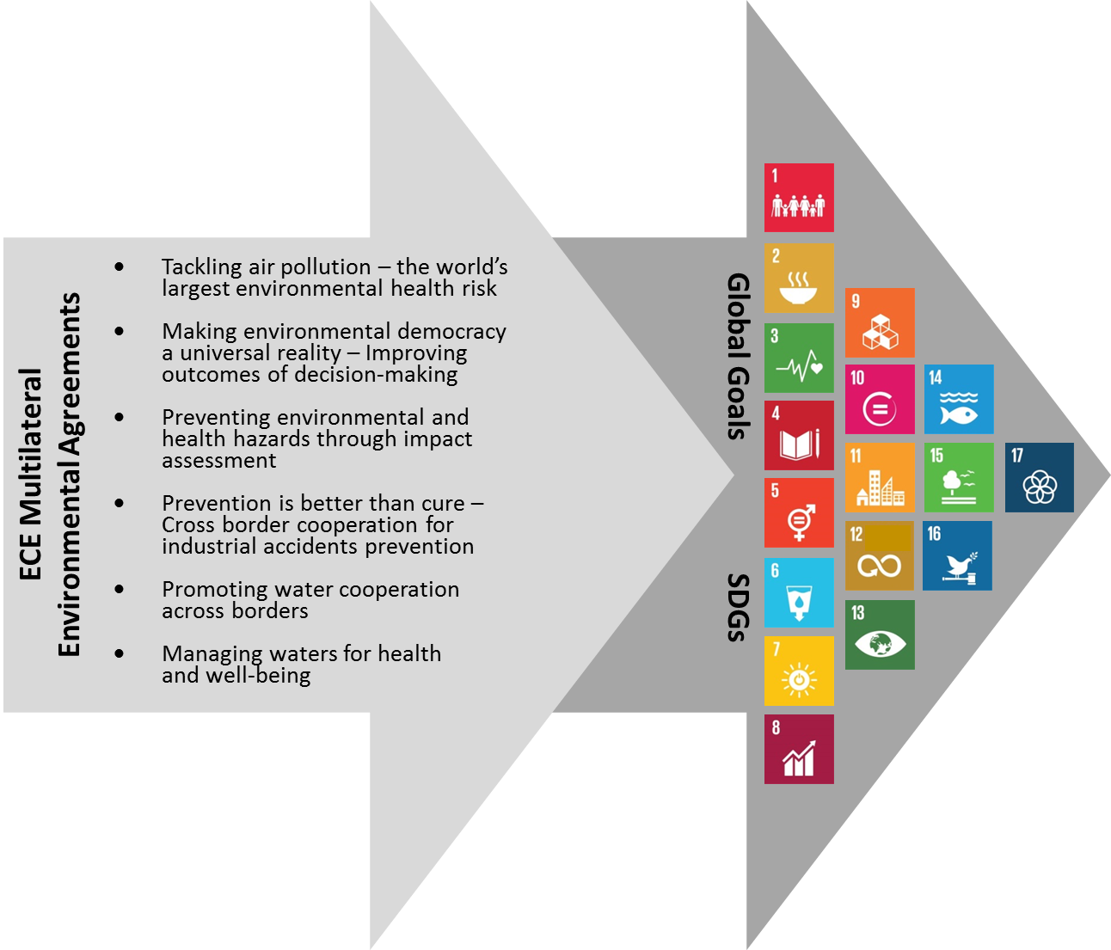
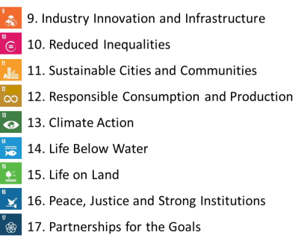
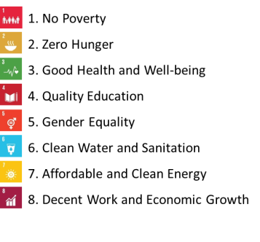

3. The discussion at CEP-21 is expected to focus on how the MEAs can contribute to the achievement of SDGs and support other elements of the post-2015 agenda, such as the Sendai Framework for Disaster Risk Reduction 2015–2030, the Addis Ababa Action Agenda and the outcome of the upcoming twenty-first session of the Conference of the Parties to the United Nations Framework Convention on Climate Conference. In its turn, the 2030 Agenda for Sustainable Development will also influence—to differing degrees—the work under the ECE MEAs.
4. Depending on the outcomes of discussion, CEP might wish to reflect on the usefulness of expanding such discussion at the Eighth Environment for Europe Ministerial Conference (Batumi, Georgia, 8–10 June 2016), for example, under the general segment on the first day of the Conference.
5. During the CEP-21 session, the MEA Chairs and CEP delegates will have the opportunity to discuss the following two questions:
(a) How can the ECE MEAs, through their experience in implementation (e.g., with regard to developing regulatory instruments and programmes, setting standards and establishing partnerships), facilitate achievement of the SDGs by countries?
(b) Can CEP contribute to that facilitation role?
6. The session will begin with a short presentation by the Chair of the informal meeting of representatives of the ECE MEAs and of the CEP. Each of the MEA Chairs will be then invited in turn to speak on up to three of the above-listed topics for two minutes. The discussion will be moderated by the CEP Chair.
7. All delegations—including Governments and stakeholders—will have the opportunity to speak. They will be selected in random order and are invited to speak, alternating with the MEA Chairs, during one minute on one of the topics listed above. At the end, the CEP Chair will summarize the points raised and, as appropriate, present the outcomes.
8. To trigger a reflection beforehand and to allow those, who will not be able to attend the meeting, to share their views, Governments and stakeholders will be invited to respond to an online survey on the related topics prior to the meeting.

This document was not formally edited.
Available from https://sustainabledevelopment.un.org/post2015/transformingourworld.
Convention on Access to Information, Public Participation in Decision-making and Access to Justice in Environmental Matters (Aarhus Convention).
Convention on Environmental Impact Assessment in a Transboundary Context (Espoo Convention).
Protocol on Pollutant Release and Transfer Registers (Protocol on PRTRs) to the Aarhus Convention and the Protocol on Strategic Environmental Assessment (Protocol on SEA) to the Espoo Convention.
Convention on the Transboundary Effects of Industrial Accidents (Industrial Accidents Convention).
Convention on the Protection and Use of Transboundary Watercourses and International Lakes (Water Convention).
Protocol on Water and Health to the Water Convention.
Convention on Long-range Transboundary Air Pollution (Air Convention).
Available from www.wcdrr.org/preparatory/post2015.
Available from www.un.org/esa/ffd/ffd3/.
See http://unfccc.int/meetings/paris_nov_2015/meeting/8926.php.

