DRAFT Discussion Paper version 3 May 2019

PATHWAYS TO SUSTAINABLE ENERGY

- Background: How can UNECE countries attain sustainable energy?

During previous sessions of the Committee on Sustainable Energy (the Committee), member States of the United Nations Economic Commission for Europe (UNECE) endorsed the project “Pathways to Sustainable Energy”. Project implementation is ongoing with a focus on development of policy options drawing on key insights from experts.

This discussion paper seeks to inform the informal open-ended country consultations on 16 May 2019 in Geneva and will be the basis for a decision document at the 28th session of the Committee on Sustainable Energy (25-27 September 2019). The Committee will be asked to endorse policy recommendations, comment on achievements and recommend future activities at that occasion. This document will be further revised after the 16 May session.

The ultimate outcome of the project is the development of strategic orientations, options and actions to ensure the attainment of sustainable energy in the UNECE region. The project’s goal is to strengthen the knowledge and capacities of countries to develop, implement and track national sustainable energy policies aligned with international agreements. On a higher level, it aims to contribute to climate change mitigation and sustainable development. To achieve this goal, the project aims to achieve three milestones:

(a) development of sustainable energy policy and technology options towards 2050 supported by modelling and other tools;
(b) development of an early-warning system on achievement of sustainable energy objectives; and
(c) facilitation of a high-level political dialogue.

Policy dialogues among UNECE member States improve the understanding of countries on how best to achieve energy for sustainable development. The informal consultation on 16 May 2019 will provide the Committee and its subsidiary bodies with an opportunity to provide input to the development of policy pathways to be elaborated until the 28th session of the Committee. The Committee’s inputs will further shape the project’s work plan, including further analysis through sub-regional, policy or technology deep dives.

The forthcoming Committee session is an opportunity to prepare the high-level political dialogue planned in 2020, subject to identification of a host-country. The meeting on 16 May 2019 can define format, participants, content and location of the high-level policy dialogue. Additional funding will be required for the future stages of this project, including additional modelling, deep dives, nexus or pathways work, or work on defining the strategic options.

- Defining sustainable energy in the UNECE region
Figure 1: Energy for Sustainable Development

IEA
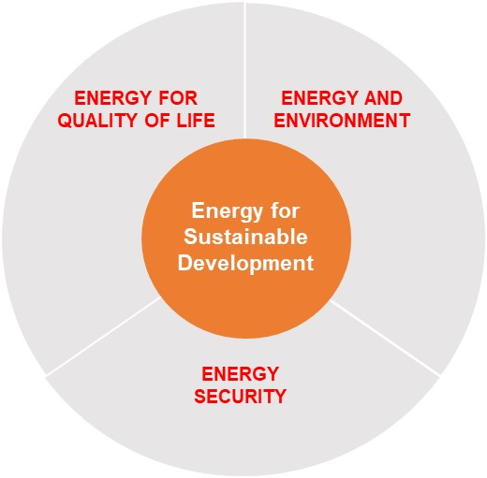
The project defines “Sustainable Energy” through three pillars that embrace the Sustainable Development Goals (SDGs): i) Energy Security, ii) Energy and Quality of Life, and iii) Energy and Environment. Relevant SDG targets align with these pillars (see Figure 1). This visualization highlights the inter-connection among the different facets of sustainable energy the trade-offs countries face.
The following policy objectives were assigned to each of the pillars:

Energy Security
‘Securing the energy needed for economic development’
The Energy Security pillar deals with economic aspects of energy security from a national perspective. It includes accessibility to energy supplies including import, export, and transit considerations. Some countries define energy security as energy independence, whereas others see energy security in a regional context, with a focus on inter-connectivity and trade.
Energy for Quality of Life
‘Provision of affordable energy that is available to all at all times’
The Energy for Quality of Life pillar seeks to improve living conditions by providing access to clean, reliable and affordable energy for all. This includes not only physical access to modern energy and electricity services, but also investigates the quality and affordability of access. Price developments for energy services including electricity, heating, cooling, and transport are important measures. In relation to bio-energy and its nexus-related considerations, such as competition for resources for food production, food prices can give an indicator to the sustainability of energy as well as food systems.
Energy and Environment
‘Minimize impact of energy system on climate, ecosystems and health’
The third pillar of “Energy and Environment” represents the trade-offs between meeting the increasing demand for energy supply, providing a healthy environment with clean air, and protecting the environment from climate change. Energy emissions contribute 60% of total Green House Gas emissions so the energy sector needs to improve its carbon footprint across the energy supply chain and support climate change mitigation efforts. Beyond climate change and air pollution measures, the Energy and Environmental pillar also includes further nexus topics such as the use of water in energy sector transport emissions and air pollution caused by energy generation and consumption.

- Policy Recommendations Overview

- Promote alternative, low-carbon approaches to meeting the energy requirements of providing energy services, for example hydrogen, natural gas, or electric vehicles for mobility, improving industrial process efficiencies and building performance, and encouraging both new entrants and new business models in energy.
- Institute sustainable resource management practices that embrace circular economy principles and that integrate the full spectrum of the 2030 Agenda’s goals and targets (i.e., nexus approaches).
- Recognize that energy security is achieved by ensuring that energy supply, transformation, transport, and demand make optimal contributions to countries’ social and economic development; encourage mutually-beneficial economic interdependence.
- Modernising fossil-based infrastructure is essential if sustainable development equilibrium among the economic, environmental, and social pillars of the 2030 Agenda is to be achieved. The elements of modernisation include deployment of high efficiency, low emissions technology and carbon capture and storage, addressing methane emissions, and using fossil technology to accelerate the uptake of intermittent renewable technology.
- Commonly cited concerns on nuclear energy including environmental and safety risks, waste management, low social acceptability, as well as high upfront costs hinder its wider deployment. The risk of not achieving the climate change mitigation targets should be considered alongside with the risks of nuclear energy deployment.

- The Modelling Approach

Three distinctive scenarios were developed by the two modelling teams. The following scenarios that reflect various levels of emissions constraints based on explicit sustainability policies have been developed:
- cost-driven scenario, which is based on reference technology, no climate policy, and SSP2 Middle of the Road Development assumptions (hereinafter – REF);
- scenario with regional CO₂ constraints, consistent with country-level NDCs and current sustainability policies, based on assumption that the policies are in place through 2030 with “continued ambition” through 2100 (hereinafter – NDC) is a modest step on the road to a 2°C target.
- techno-economic scenario, where regional CO₂ constraints, consistent with NDC through 2030, are assumed to continue reduction (hereinafter – P2C) and thus allows to stay below 2°C.
In addition to these three policy scenarios, a range of technology options were tested within the model. It was decided to explore in more detail technology cost assumptions variations for renewable energy (wind, solar PV, CSP, geothermal), CCS, and nuclear. The intention is to demonstrate how variations in technology costs can impact the deployment of a selected technology under the three policy scenarios.
The three scenarios and variations within the technology costs can be clustered within the two axes for the scenario space. These two axes were identified during stakeholder workshops in 2016 and define the most important and uncertain variables influencing the future of sustainable energy. The two variables are “Degree of Innovation” and “International cooperation”. Innovation was interpreted as all types of innovation including technology and business models. International cooperation focuses on how countries cooperate to achieve shared targets, such as the 2030 Agenda and the Paris Agreement.
More information about the modelling can be found in the Annex (see page 28).

- Key Insights and Policy Recommendations on Pathways to Sustainable Energy in UNECE Region
UNECE’s sustainable energy sub-programme works to assist member States in improving access to affordable and clean energy for all and to help reduce greenhouse gas emissions and the carbon footprint of the energy sector in the region. It is overseen by the Committee on Sustainable Energy, an intergovernmental body in the United Nations development system. The objective is to make concrete, measurable progress towards the 2030 Agenda on Sustainable Development by ensuring that energy makes an enduring contribution, including reducing energy systems’ CO₂ intensity and meeting quality of life aspirations.
The work of the subprogramme falls under three broad and critical areas: (a) reconciling the reality of fossil fuels’ enduring share of the energy mix with the need to address climate change; (b) enhancing integration of energy markets in the region; and (c) facilitating the transition to a sustainable energy system. The subprogramme focusses on issues related to energy security, energy efficiency, cleaner electricity systems, renewable energy, coal mine methane, natural gas and resource management, and the inputs by the expert community into this project have to be seen in this light.
The following chapter proposes a reaction of the modelling results and results from the multistakeholder approach by the six expert groups and tries to make the link with the three pillars of Sustainable Energy above. This work will be further revised after the consultation process on 16 May and add details on trade-offs and nexus areas.

The traditional energy system is centralized and fossil-fuel based
The traditional energy system is defined by large scale generation that generates single- direction, predominantly fossil-fuel based, power and heat to end-users. Today’s energy system paradigm is based on such a unidirectional energy distribution and is the backbone of countries’ industrialization and economic development process as we know it today.
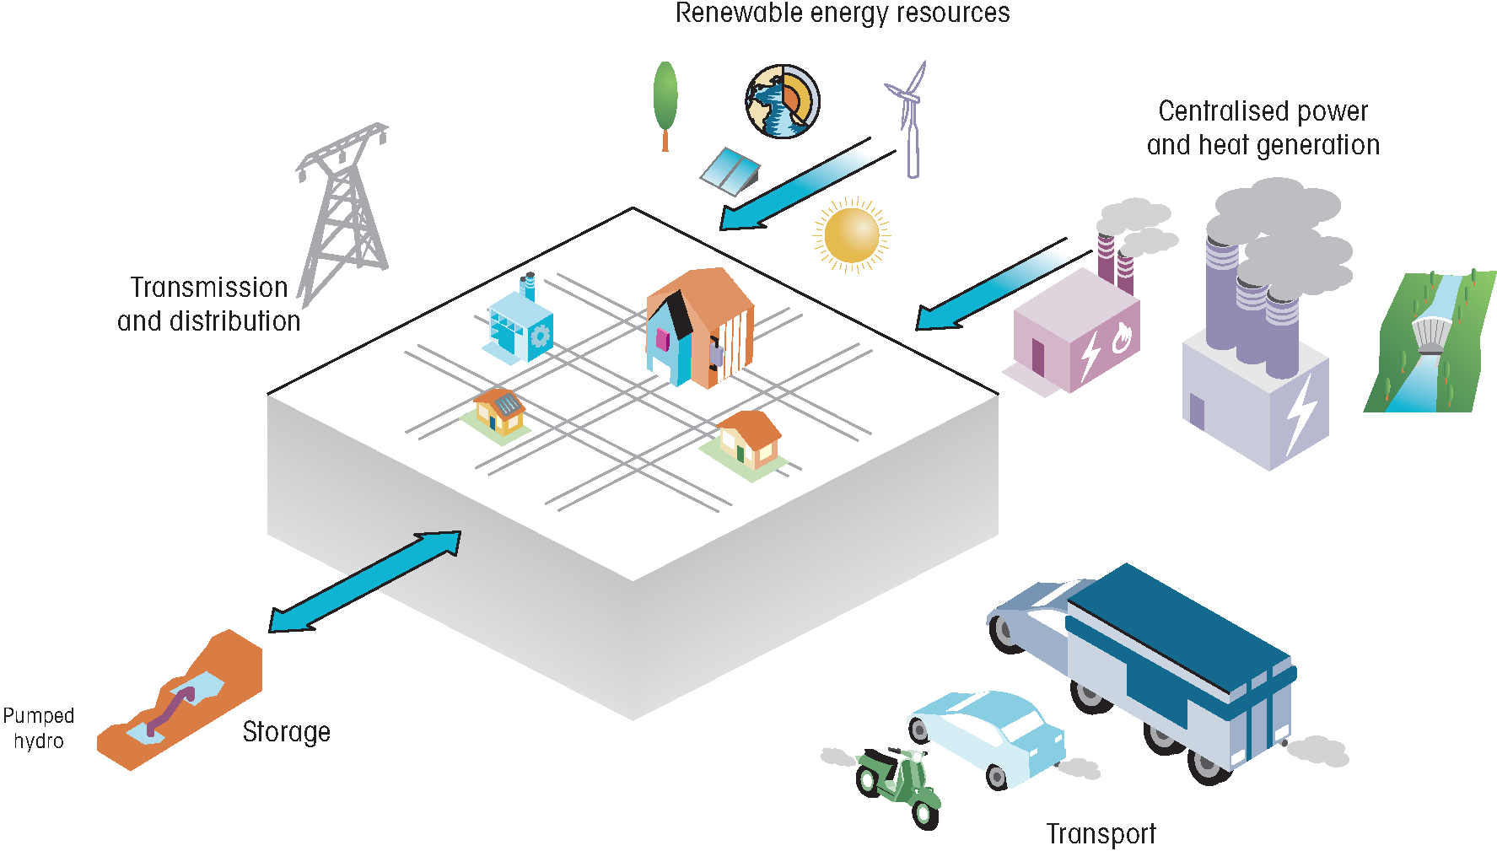
Figure 2: Traditional Energy System, source: IEA 2017

IEA

In UNECE, about 80% of today’s energy mix is fossil-based. Many countries and people depend on fossil energy. Fossil fuel will remain part of the region’s energy mix over the time period of this project, largely due to its important role in providing energy access and economic development. Recent research from the International Panel on Climate Change (IPCC) indicates that the world is on a pathway closer to four than to two degrees Celsius. This reinforces the urgency of the Committee’s programme of work and this project. There are to-date no economically rational scenarios to 2050 in which the share of fossil energy in total primary energy supply falls substantially.
Figure 3: Primary Energy Mix, UNECE

IEA
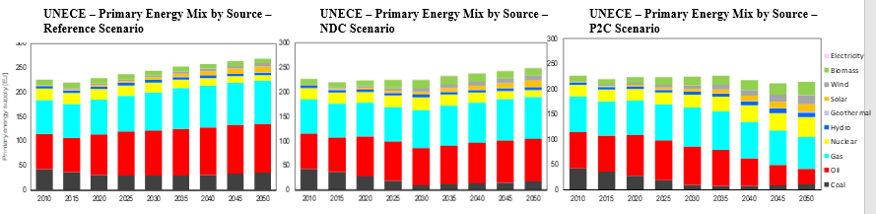
The UNECE region is comprised of high and low income countries, countries that are energy rich and energy poor and countries that are in economic transition. The UNECE region as a whole uses significantly higher primary energy supply per capita than world levels, but within the region there is significant variance. In total, the region’s 56 countries represented 39% of the world’s primary energy consumption (as of 2014) to produce 41% of world GDP. The region produced 38% of the world’s primary energy resources and emitted 36% of global CO₂ from fossil fuel combustion.
Fossil fuels remain dominant in UNECE energy mix: when averaged across the entire region, the share of fossil fuels in total primary energy supply is 80% (equal to the global 81%); when evaluated across the subregions, the least share is in Western Europe at 71%, and the greatest is in Central Asia at 94%. Even under a climate change scenario that meets a 2°C target, fossil fuels will still represent 40% of the regional energy mix in 2050.
That largely reflects historical causation of economic rationale for development national energy resources, and thus far – with certain hedges and modifications – conditions the profile of the UNECE member States in regional and global trade in energy. Figure 3 illustrate trade balance, imports and exports of mineral fuels, mineral oils and products of their distillation, bituminous substances, mineral waxes in 2014 and 2018 (source for Figures 3: ITC calculations based on UN COMTRADE and ITC statistics, http://www.intracen.org/).
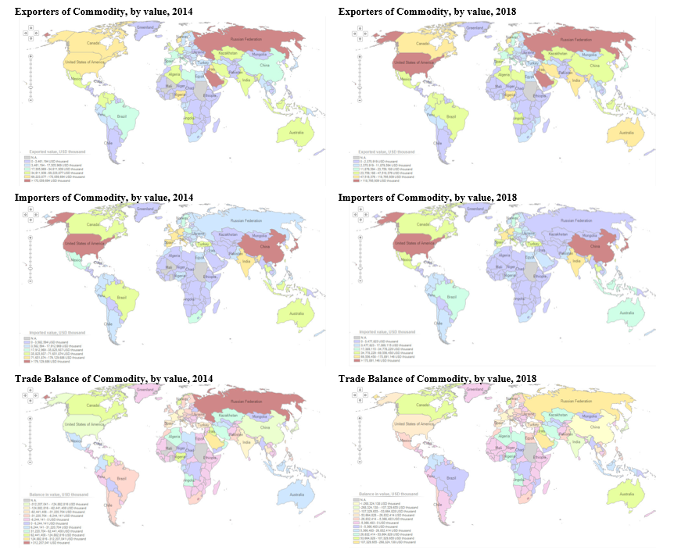
Figure 3: Trade balance, UN COMTRADE

IEA

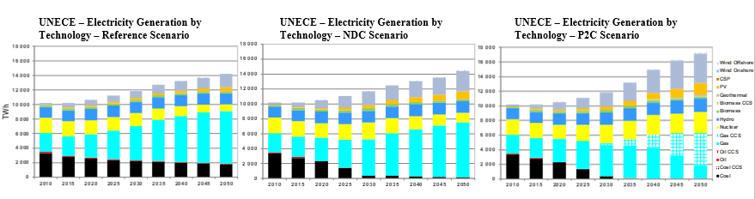
The current state of the UNECE primary energy supply and power generation mix imply that technological change is crucial in order to accelerate energy transition and achieve the sustainable energy. The region is over dependent on fossil fuels and higher CO₂ emission fuels. Electricitry generation portfolio is anticipated to experience significant structural changes based on the UNECE scenarios (we assume 2-degree). Market expansion across all scenarios for all technologies is anticipated except for coal and oil. According to data, P2C scenario implies higher degree of diversification with fast up-take of low carbon emitting technologies.
Figure 5: Electricity Generation by Technology, UNECE

IEA
While the UNECE region as a whole appears is homogenous, at the subregional level there are significant variations in primary energy, electricity generation, electricity generating capacity and final energy supply, with variations in economic development, resource base and state of national energy systems. Figure 6 below shows the proportions in relative values for selected subregions.
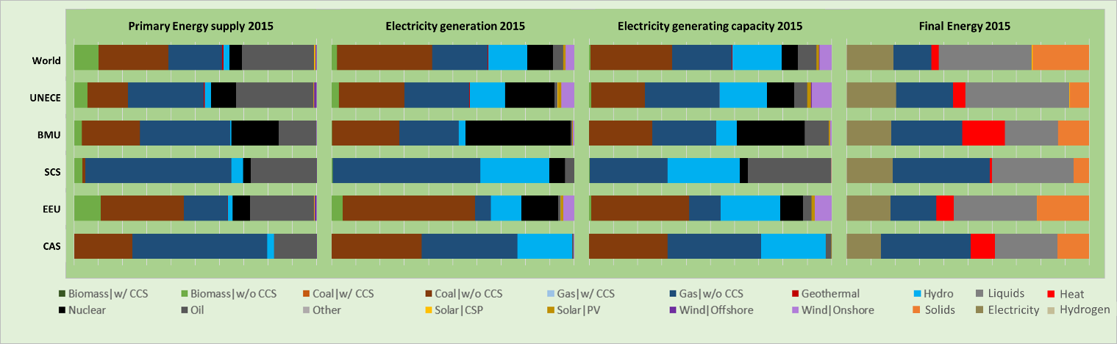
Figure 6: Key technical indicators - energy supply 2015. [Energy supply figures are presented by region – World; UNECE; BMU: Ukraine, Belarus, Moldova; SCS: South Caucasus; EEU: Central and Eastern Europe; CAS: Central Asia]

IEA

Gas, oil, coal and nuclear power are the main sources of primary energy supply across selected subregion in 2015. In the South Caucasus, coal plays a minor role and a large proportion of energy supply comes from gas. In the Central and Eastern Europe, on the contrary, coal has a dominant role in electricity generation. In Belarus, Moldova and Ukraine nuclear power is a very important player in electricity generation, while it is almost absent from the primary energy mix of Central Asia. Traditional renewable resources such as solar, biomass, or wind play rather marginal role across most of the subregions. It is notable that the highest contribution of renewables to the primary energy supply comes from the Central and Eastern Europe subregion. CCS does not play a significant role in any of the subregions.
Similar trends to the primary energy supply emerge for the electricity generation across all regions, with the proportions of oil being significantly lower. A relatively significant amount of biomass is present in the primary energy supply of all regions except Central Asia, nevertheless, is less relevant for electricity generation. The Central Asia region, in particular, relies heavily on these fossil fuels, with about 97% in primary energy supply and about 77% in electricity generation.
Regional energy interdependency
Some countries and sub-regions promote energy independence or self-sufficiency as a means to ensure their energy security, while others strive for efficient integration of energy markets. Countries that consider that energy supply can be assured through energy independence are prepared to pay a premium for it. Other countries consider that energy security can be achieved through diversification of technology choices, suppliers, transit routes, and consumers. Most countries focus on national level actions whereas a priori it would appear that global and regional solutions would be more effective if there were a culture of trust and reliability in energy transactions. The UNECE region is characterized by a wide range of degrees of trust, so regional business models require a foundation of institutionalized investment and transaction frameworks.
For the UNECE region as a whole, promoting mutually beneficial economic-interdependence would accelerate attainment of the 2030 Agenda through integrative, nexus solutions that the notion of sustainable development offers. For energy, it is critical to think in terms of a wholly interconnected, complex system in which supply, demand, conversation, transport and transmission interact freely and flexibly. Ensuring energy security as part of the ongoing deep transformation creates an imperative to mobilize needed investment in the energy system of the future that is rational and pragmatic socially, environmentally, and economically.
Concepts of energy security have evolved over time from security of supply seen by consuming/importing countries to broader views of energy security that embrace supply, demand, and transit. With increasing penetration of digital technology throughout the energy system and with intensification of climatic events, the energy system is exposed to new risks of either human (e.g., hacking or terrorist attacks) or natural origins (events like forest fires, hurricanes, or flooding from rising oceans). These additional security risks create an added imperative to address the challenge of resilience in terms of both planning and recovery.
The role of energy technologies in achieving sustainable energy
All technologies, existing and emerging, as well as energy efficiency will have a role to play in the modernization of the energy system in the UNECE region. Following chapters assess the environmental and socio-economic implications of coal, oil, natural gas, nuclear, renewable energy and energy efficiency in attaining sustainable energy in the region based on energy for sustainable development framework introduced in chapter 3.
The role of coal in a sustainable energy system
Environmental Implications – change in energy mix
Ensuring secure, affordable and sustainable energy requires a diverse energy mix, of which coal is strongly argued to remain a part. Based on data, coal is anticipated to retain its role in the primary energy mix. In absolute terms, on the regional level, coal is expected to plateau through to 2050 (see Figure 3).
As countries implement their climate change pledges, the role of coal in power generation is expected to decline steadily in all scenarios. Traditional coal-fired power generation plants are being shut-down or upgraded. This trend is anticipated to accelerate in P2C scenario under which an absolute phase out of coal in power generation is expected post-2030 (see Figure 4).
Phasing out coal has vast negative socio-economic implications for communities that heavily depend on coal. Current trends demonstrate that coal will remain a leading energy sources in the future, especially in emerging and developing economies. Yet investments in cleaner coal technologies are crucial to maintain the role of coal in energy mix by 2050 and in a longer run.
Environmental implications of coal
GHG emissions associated with coal mining need to be treated carefully. Some coal mines are very gassy and emit a lot of methane (CH₄₎. The emissions do not cease at the time of mine closure. CH₄ escapes abandoned mines through natural and mining related fractures and other conduits. As of 2010, the share of abandoned mine methane (AMM) in total CH₄ emissions from coal was 17%. This share is expected to increase to 24% through to 2050 (Figure 7). Reduction of CH₄ emissions at both active and abandoned mines is possible, yet more has to be done in addition to those several projects already operational. Broadly speaking, managing methane emissions throughout the whole value chain – from well to burner tip – is essential. Methane is a potent GHG with a high global warming potential (GWP) associated with natural gas (see under gas chapter below).
Figure 7: Global Abandoned Mine Methane (AMM) and Coal Mine Methane (CMM) Emissions – Reference scenario, source: PNNL 2018

IEA
The impact of the use of coal, in particular, on air and water pollution is widely argued to be mitigated by using low polluting fuels. Probable shift away from coal arises, as the cost of alternative fuels decreases and their availability increases, and relatively low electricity prices call into question the viability of lignite power plants, as the initially high installation costs of renewable energy systems have come down significantly over the past few years and trends are expected to continue. Moreover, development of storage solutions (leading financial institutions expect that progress in energy storage will pose “very significant – and in cases terminal – challenges” to the conventional energy generation model by 2030 at the latest) and improvements in energy efficiency across the whole energy system progressively put pressure on coal consumption. This is particularly relevant for the aging traditional asset base, an inflexibility of which does not ensure full compatibility with an increasing share of intermittent renewable energy.
Socio-economic implications of coal mine closure and coal phase out
Certain countries increasingly seek to ‘decarbonize’ their power systems and achieve national carbon reduction commitments by the means of phasing out of coal mining and coal-fired generation, yet doing so is often at odds with protecting the livelihoods of people.
The social dimension of coal mining communities and the regional infrastructure based on the growth of basic industries like steel and cement must be at the heart of carefully managed, sustained, long-term governmental policies. Many large industrial complexes were constructed prior to the emergence of carbon-constrained economies and are now, to a greater or lesser extent, relics of economies that no longer exist. Across the UNECE region (e.g. Upper Silesia in Poland, Laustiz in Germany or Karaganda coal basin in Kazakhstan) there are a number of these locales where coal mines, power-generating plants, metallurgical processing plants, manufacturing and shipping facilities are integrated into dense, interrelated businesses. Any restructuring should be implemented in a way that supports coal workers and communities (particularly the mono-industry) and bear the cost of creating new job opportunities.
The process of energy system decarbonisation needs to be supported by proactive processes for developing new visions and perspectives and to facilitate and cushion necessary structural transitions of the coal industry. It thus needs to harmonize often conflicting policy realms, namely:
- Environmental concerns clearly point towards a fast-paced coal phase-out, especially in the case of most carbon intensive uses.
- Economic realities limit the speed that these processes can achieve, as local and national economies need to adjust to new circumstances and must internalise new structures for sustainable economic development under changed economic and industrial conditions. Naturally, such actions may yield substantial business opportunities in many sectors, but even if a transformation of energy system may be economically beneficial, it remains a structural challenge that needs to be carefully planned and managed.
- Social concerns are pivotal in the design of a coal phase-out process. Coal industry reliant regions face massive challenges for their citizens’ continued livelihoods, as the industry is still a very important employer and income generator. As can be observed in most cases, fears of job losses, disruptive structural and cultural changes, economic decline, and other negative implications influence the debate more strongly than the benefits of the low-carbon transition. What can facilitate changing this balance is embracing a concept of “just transition” and pursuing preventive mode of structural policy.

Modernisation of coal-fired plants
Coal-fired power plants have undergone modernisation over the past decade experiencing improvements in operational efficiencies and emission control system performances. Countries with large and aging coal-fired power plants that were designed to handle base load have great potential for modernizing efficiency and flexibility measures. Although traditional power grids were not designed to adapt to rapidly changing supply side schemes, system operators around the world have learned how to use various flexible resources that complement growing shares of variable renewable energy. Several recent studies have explored possibilities for coordinating fossil-fuel power plants with renewable energy: using solar thermal energy to help power generation in pulverized coal power plants; using solar thermal energy to compensate for the energy penalty of carbon capture use and storage (CCUS); using wind power and water electrolytic hydrogenation technology to help integrated gasification combined cycle (IGCC) power plants; using wind power directly to offset energy penalty of CCUS; etc. Modern coal-fired power plants can operate at minimum load levels of 25-40% of the rated load; modern lignite power plants can reach a minimum load of 35-50% of the nominal load. In contrast, power plants built decades years ago in industrialized countries had minimum load levels ranging from 40% (hard coal) to 60% (brown coal).
Modernization can reduce the minimum load even more: minimum load levels of 12% are reported. For example, modernization at Weisweiler power plant in Germany has reduced the minimum load levels of two power units with a capacity of 600 MW by 170 MW (G block) and 110 MW (H block). This upgrade also had a positive effect on the rate of rising, which was increased by 10 MW/min. The fire resistance of boiler and the allowable heat load on components are two main limitations to further increase flexibility.
In systems with a high share of renewable energy, coal-fired power plants with a combined cycle benefit from the implementation of flexibility measures with a maximum potential margin increase of 14%. However, this does not apply to power plants operating on lignite. The integration of variable renewable energy sources into a system with a large number of old power plants operating on different types of coal leads to the fact that flexibility of power plant is of considerable importance, especially because there are no other available flexibility options on a large scale.
The investment costs necessary to modify the flexibility should be considered separately in each case. At the above Weisweiler case, the cost of modernization was about 60 million euros per unit of generation. Generally, costs can be approximately estimated at 100-500 euro/kW, while such upgrading also typically increases the technical life of a power plant by about 10-15 years. For comparison, the cost of building new coal-fired power plants with a service life of more than 40 years at night, ranges from 1,200 euro/kW to more than 3,000 euro/kW if CCUS technology is introduced.
Technological developments for Cleaner Coal
Further steps can be taken to improve emissions from the existing coal-fired generation while increasing efficiency of power plants. Regulators can marry technological developments with more effective regulations in ways that incentivise or compel faster adoption of more efficient boilers and state-of-the-art air quality control systems. Deploying high efficiency, low emission (HELE) coal-fired power plants is a key first step along a pathway to near-zero emissions from coal with carbon capture, use and storage (CCUS). Other negative carbon technologies exist and can be considered.
CCUS, similarly to other innovative low emission energy technology, cost significantly more than conventional technology and require extended development time. However, this is a pathway to near-zero emissions from coal, and the first step is to ensure that coal-fired power generation has the lowest emissions profile in as short timeframe as possible. Once commercialised, CCUS will enable countries to rely on coal – as on secure and affordable energy source – without compromising their CO₂ commitments, and to keep global temperature increase below 2°C.
HELE technologies are commercially available now and, if deployed, can reduce GHG emissions from the entire power sector by around 20%. In addition to significant benefits from reduced emissions, these modern high efficiency plants have emissions of nitrogen oxides (NO_{x}), sulphur dioxide (SO_{x}) and particulate matter significantly reduced. Beyond the climate benefits of reduced CO₂ emissions, reduction in these pollutants is of additional importance at the local and regional level to address air quality, black carbon and related health concerns.
HELE and CCUS are the low-hanging fruit in global GHG mitigation, which should be given more attention, however the cost implications are still too high for wider commercialisation of these technologies. Increasingly, the most advanced coal technologies are the most viable and economic choice, and progress in this direction can have a resounding impact on technological advances in other industries. It is imperative that these technologies are deployed as widely and as quickly as possible in the UNECE region and beyond.
Policy Action:
- Modernising a fossil-based infrastructure is a long-term undertaking and must embrace all pillars of sustainable development seeking to leave nobody behind. Particular attention must be given to a forward looking “just transition“ approach seeking to involve all societal stakeholders to develop new business models that can support regional restructuring and avoid a desertification. Phasing out obsolete fossil-based infrastructure must be the ultimate goal, yet caution is required regarding rapid investments omitting to recognize the crucial role that this infrastructure has for the livelihoods of many.
- Investments in clean fossil fuel infrastructure must be possible and internationally agreed investment guidelines for investing in clean fossil fuels could be a starting point, developed in collaboration with international development banks, the United Nations and environmental organisations.
- The ambitious 2 degree target cannot be achieved without negative carbon technologies to bridge the time until a more rapid renewable energy and other innovative low-carbon energy technologies will be deployed. Deploying renewable energy only will not help achieve the 2 degree target by itself over the time period of this project.
- A price on carbon or carbon tax measures and incentives to reduce emissions from a high carbon value chain (upstream and downstream) must come in effect to drive a low-carbon energy transition.
- Methane is a potent greenhouse gas in its own right. Managing methane emissions along the entire value chain has societal, health, environmental, and economic benefits, as it is also an energy carrier. Methane emissions continue even after mine closure and can be captured for industrial and energy usage. Ownership of such methane flows should be clarified.
The role of oil in a sustainable energy system
Oil will continue to play an important role in both primary (see Figure 3) and final energy mix (Figure 6). In the UNECE Reference scenario, the share of the oil in the primary energy mix is expected to increase form 32% in 2030 to 37% in 2050. In the P2C scenario, on the contrary, during the same period the share of oil in the primary mix is expected to half, from 36% to 16% respectively. Liquids are expected to dominate the final energy mix. Although in the relative terms, in the UNECE Reference scenario the share of liquids is expected to decrease from 48% in 2030 to 45% in 2050, in the absolute terms the value of liquids is anticipated to increase by about 6% from 2030 to 2050.
Figure 8: Final Energy mix, UNECE

IEA
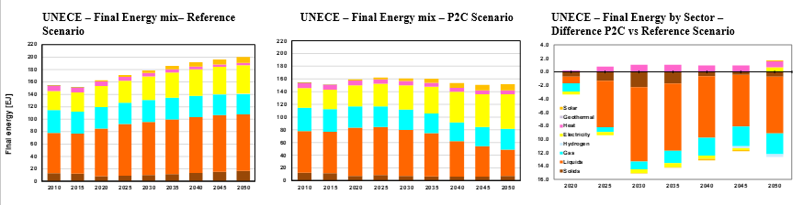
Environmental Implications – change in Energy mix
In Reference scenario (Figure 8), liquids are expected to account for the largest share and are anticipated to grow at the highest rate driven by the demand for transportation services. Introduction of more stringent climate mitigation policies are expected to affect regional final energy mix. In P2C scenario (Figure 8), final energy demand is expected to slow down in mid-term before declining in the long-term. The slowdown from 2030 is expected to be driven by the improvements in energy efficiency and structural changes of the energy system.

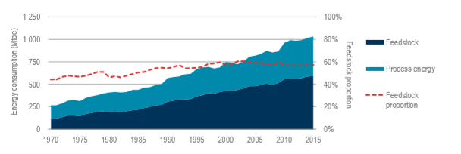
The role of fuel oil and other liquids in the power generation mix is marginal compared to coal and increasing role of natural gas. While the demand for oil in the transportation sector is expected to slow down on the back of further electrification and gasification of the mobility, the demand for oil as a feedstock in industrial sector, particularly in chemical and petrochemical industry, is anticipated to remain significant and to grow driven by increasing global demand for plastics, fertilisers and other petrochemical products. Chemical feedstock consists of molecules of oil, natural gas and other carbon- and hydrogen-containing minerals. In addition, feedstock is also input for the production of synthetic fibre, rubber, detergents and other chemical products which are pivotal in the manufacturing of packaging, carpets, cars, cutlery, electronic goods, toothbrushes, clothes and a plethora of other consumer goods (IEA 2018). International oil companies (IOC) are diversifying their portfolios by devesting upstream assets and investing in downstream assets. Shell and ExxonMobil have been investing in the upgrade of their refineries by investing in ethane crackers in order to be able to produce plastic from shale gas (OilPrice 2019).
Figure 9: Global Feedstock and process energy consumption in the chemical sector, source: IEA 2018

IEA

Policy Action:
- Accelerate the commercialisation of hydrogen to support the transition toward low carbon feedstocks in chemical and petrochemical industry.
- Decarbonise transportation sector by promoting further electrification and gasification of the mobility. Invest in urban infrastructure to support faster uptake of electric vehicles.
- Develop with Experts Policy Recommendation on following topics:
  - Circular economy & plastic waste
  - Resource management for development of batteries
  - Legacy of oil assets and stranded assets

The role of nuclear in a sustainable energy system
Environmental Implications – change in Energy mix
Nuclear reactors do not directly emit CO₂ during their operation, such as fossil fuel based power plants. Mining and refining of uranium ore requires, however, large amounts of energy which, if produced by burning fossil fuels, result in CO₂ emissions. A major environmental implication associated with nuclear energy refers to the creation of radioactive waste, which is dangerous to human health.

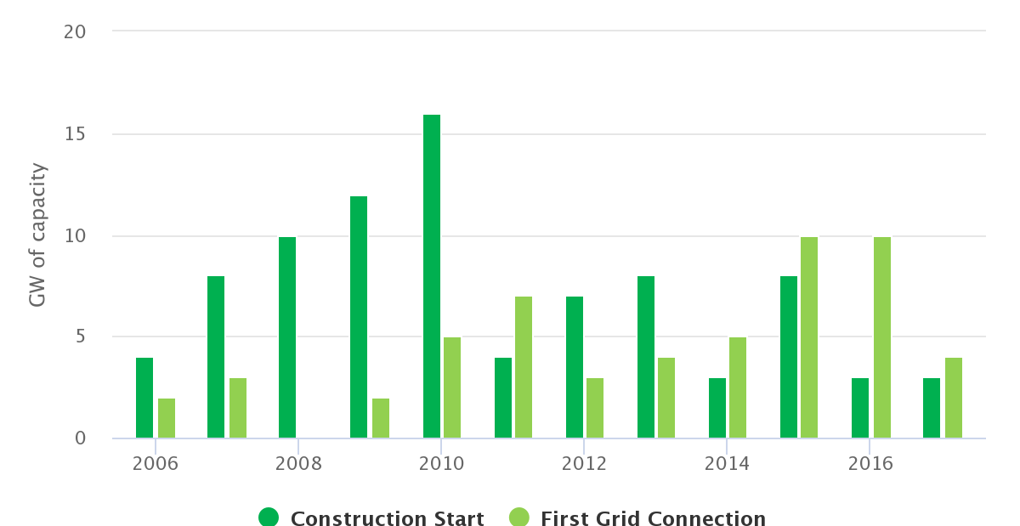
Global nuclear energy capacity amounted to 419 GW in 2017. Nuclear energy additions dropped from 10 GW in 2016 to just 3.6 GW in 2017 globally and increased to more than 10 GW in 2018. . Currently, there are 58 reactors under construction globally. Most constructions have been realised in Asian countries (China, India and Korea accounting for 50% of the new capacity being built) during 2017, with China set to start construction of several new nuclear power plants towards doubling its 2015 capacity to 58 GW by 2020. Korea has also set to increase its installed capacity from 23 GW in 2016 to 38 GW in 2029.
Figure 10: Global construction and connection trends, IEA 2019

IEA
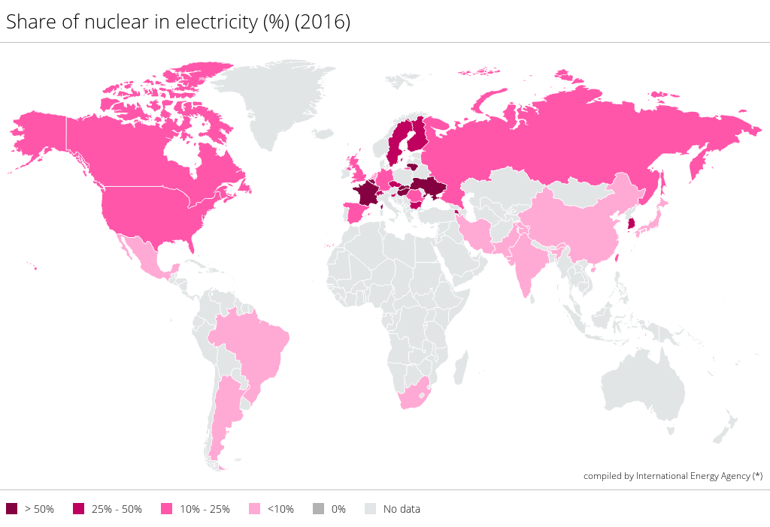
Figure 11: Share of nuclear in electricity mix across the globe (%), source IEA 2016

IEA

There are conflicting views on the role of nuclear energy in the energy mix among UNECE member States. Nuclear energy may be considered as a viable option for filling the gap of reliable, low carbon electricity, especially if uranium and possibly thorium resources are available from the country's own natural resources. As these elements are frequently co-located with rare earth elements, there is a natural affinity between managing critical materials for nuclear and (other) renewable energy sources in an integrated and complementary manner.

In the UNECE region, the share of nuclear energy amounted to 11.2% of the electricity generating capacity (275.3 GW) in 2015, while under the UNECE reference scenario, this figure is expected to gradually decrease towards 2050 (down to 134 GW). Russian Federation had 25.4 GW nuclear energy capacity installed in 2015 and has a plan to expand it in the future. The estimated available uranium resources of the country amount to 1 million metric tonnes. Exports of nuclear goods and services are part of Russia’s energy strategy with over 20 nuclear reactors intended for export construction. Turkey has also began construction of the first of four nuclear reactors and Bangladesh the construction of the second plant of the country’s units.
Meeting the Paris Agreement target is expected to push the uptake of nuclear energy (reaching to 452 GW by 2050) in the whole UNECE region, to provide low carbon baseload power. Nevertheless some countries have chosen to not pursue nuclear energy as their power sector decarbonisation solution due to the underlying risk of accidents, public acceptance, waste management implications as well as the high lifecycle costs. For example, France has set a target to reduce nuclear share of electricity from 75% to 50% by 2030 to 2035. Although some nuclear reactors will continue operating to maintain long-term security of supply, the French energy transformation will require investments in renewable energy and energy efficiency improvements to make up for the change. Finally a referendum taking place in Switzerland banned any new constructions of nuclear power plants.

Socio-economic Implications
A commonly cited concern on nuclear energy involves the limited social acceptability, which was further affected by the Fukushima accident, triggering the consideration of gradual phasing out of nuclear energy in some countries, for example Switzerland, Italy and France. Capital cost of nuclear power plants remain expensive, while their operating costs are relatively low. A holistic estimation on the economic implications of the technology should also account for the decommissioning cost accounting for approximately 9-15% of the initial capital cost and the internalised waste management cost.

Nuclear energy can be an enabler in the transition to sustainable energy offering reliable low carbon baseload power. Small modular reactors (see below under technological implications) could potentially be an option for countries which do not need large capacities and may be a solution to reduce the high upfront costs. They could also be introduced in remote regions which do not have access to grid. On the other hand, small modular reactors can potentially carry the same issues as the big reactors, multiplied by their number, thus resulting in wide-spread risks of waste accompanied by increased domestic security needs to prevent terrorists attacks on these high-risk plants.

Technological implications – role of small modular reactors

Small and medium-sized modular reactors are a type of nuclear fission reactor. Their size is smaller compared to that of a conventional nuclear reactor and they can offer more flexibility as they can be manufactured at a plant and transported for onsite assembling. Global interest in modular reactors has been steadily increasing due their comparatively better cost affordability, enhanced safety performance and production of electricity in remote non-grid connected areas, among other factors.

Nuclear Fusion technology offers the prospect of an almost inexhaustive, radioactive-waste free source of large-scale power production. Although many countries take part in the research around nuclear fusion, it is a technology still in its infancy, and so far presents challenging engineering issues. The nuclear fusion process in essence mimics the process occurring at the core of sun and stars, while the necessary fuels (deuterium and tritium) are almost unlimited.

Develop Policy Recommendations with EGRM Experts. This chapter on nuclear will need to be revisited.

The role of gas in a sustainable energy system
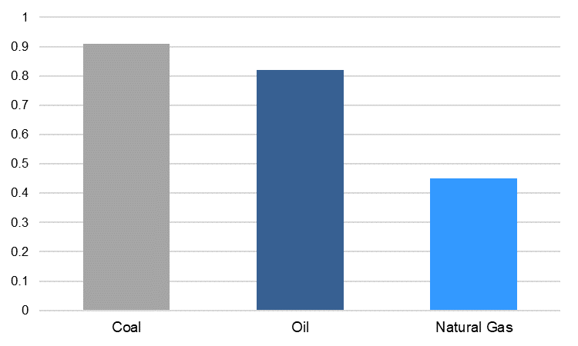
Environmental Implications Natural gas is increasingly gaining traction in the primary energy mix (Figure 3) and is anticipated to play a continuing role through to 2050. Natural gas contributes to reducing carbon intensity and pollution effects resulting from energy related activities. Due to its moderate carbon content compared to other fossil-fuels, fuel switching from coal and oil happens most naturally with natural gas. The lifecycle GHG emissions of gas-fired power generation are 40% lower compared to oil-fired and 50% lower compared to coal-fired. Switching from coal to natural gas in electricity generation can reduce the carbon intensity of fossil energy and improve air quality in many urban areas, in particularly in developing countries, given their rapid rate of urbanisation. Phasing-out oil and coal power plants and switching to gas would reduce global CO₂ emissions by ca. 10Gt p.a. allowing a buffer of only 3-5 years until the exploitation of the 2-degrees carbon budget. (SET-Nav 2019).
Figure 12: Average CO2 Emission factors of oil, gas and coal-based electricity, source: GECF 2019

IEA
In spite of the low CO₂ emissions, abundancy and cost-effectiveness of natural gas, methane emissions associated with natural gas need to be managed carefully across the value chain. Methane has severe impact on environment and climate change that needs to be addressed. (see under chapter “Environmental implications of coal mining”above)
Interplay of Natural Gas and Coal with Renewable Energy

It is uncertain when a combination of technological change, improved energy efficiency and cost reductions for renewable energy sources will lead to renewable energy to account for more than 50% of the primary mix. Based on UNECE P2C scenario (see Figure 3), in 2020 renewables are expected to account for 11% and in 2050 for 49% of the total primary energy mix. The share of natural gas is expected to remain ca. 37% of the total primary energy mix.

Rapid development of the energy transition means that the role of gas - along with other fossil fuels - in electricity generation cannot be taken for granted. There are two contrasting models. On the one hand, the UNECE’s own model shows (see Figure 4) a doubling of gas-fired electricity generation between 2020 and 2050 in the entire UNECE region. On the other hand, Bloomberg New Energy Finance, in its New Energy Outlook (NEO) 2018, anticipates that by 2050 no less than 87% of electricity in Europe (with ‘Europe’ still needing to be defined) will come from renewables, with gas use declining dramatically.

The flexibility and low capital investment and maintenance of gas make gas an attractive source for fossil fuel backup for baseload operations. Since natural gas emits less CO₂ than other fossil fuels, it is the logical choice for such backup. How long such backup will be required is much harder to gauge, since much depends on technological innovation. In addition, gas supply chain is flexible on the back of gas storage, liquified natural gas (LNG) and operational flexibility of gas pipelines. The gas supply chain flexibility allows to adjust the delivery of natural gas in response to increasing variability of gas demand. Potential for hybrid of renewable and natural gas-based technologies (e.g. hybrid solar gas power plants) and leveraging gas infrastructure for the synthetic gas produced from excess renewables imply the potential of the complementarity of natural gas to renewables. (GECF 2019) Decarbonisation projects such as power-to-gas and energy storage or renewable and low carbon gases implementation (e.g. green/blue hydrogen and biomethane) decrease the environmental impact and carbon footprint of the energy sector. Power-to-gas technologies offer value creation for the electricity that cannot be used directly or stored in batteries but can be stored in the form of gas within the gas system at minimum costs.

Increasing the flexibility of coal power plants’ operations could allow for a faster deployment of renewable energy sources, thereby reducing the carbon intensity of electricity generation. However, if coal is anticipated to gradually phase out across the UNECE region (Figure 5), gas could continue as a lead technology thanks to its higher flexibility in coordinating operation with larger variable renewable generation.
Policy Action:
- All energy sources must play a role as countries embrace a low-carbon future. Clean coal and gas can be fuels of choice if fugitive methane is managed. They can provide the base load requirements for introducing renewable energy sources into the grid sustainably. For this, countries must promote holistic, national, sustainable action plans
- The important interplay between traditional energy sources and new ones must be recognized. The interplay of coal and natural gas with renewable energy can provide solutions for the intermittency of renewable resources and further help diversify countries’ energy mix. Big data, smart grids and a systems approach will facilitate this transition.
- Develop with Experts Policy Recommendation on following topics:
  - Role of gas in regional energy strategy: interdependence vs independence.
  - Develop further policy recommendations on the utilisation, repurposing and optimisation of the gas infrastructure. Provide concrete examples.

The role of renewable energy technologies in a sustainable energy system
Evolution of Renewable Energy
Renewable energy is playing a key role in the transformation of the energy system. In recent years, the competitiveness of renewable power generation options has been substantially increasing to the point that renewable energy now accounts for a third of global power capacity. Nearly two-thirds of all new power generation capacity added in 2018 was from renewables, led by emerging and developing economies (Figure 5).
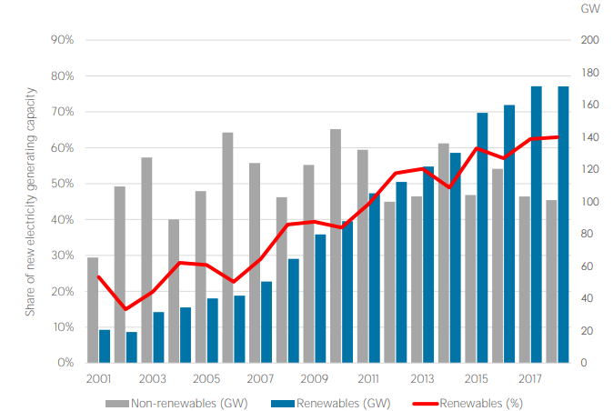
Figure 13: Renewable generation capacity and the energy transition, source: IRENA 2019

IEA

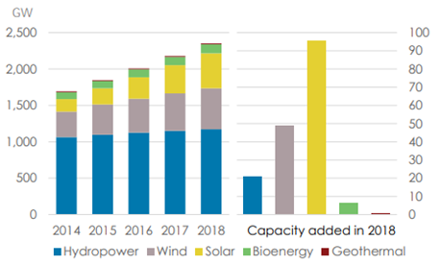
The global renewable generation capacity increased by about 8% compared to 2017. Solar energy continued to dominate, followed by hydropower and bioenergy, while geothermal added capacity was only marginal (Figure 14).
Figure 14: Capacity growth by source of renewable energy, source: IRENA 2019

IEA

IIASA will provide regional comparison. Analysis to follow.

In 2016, the installed electricity capacity of renewable energy sources in the UNECE region amounted to about 869 GW (388 GW coming from large hydro power plants), accounting for almost half of the renewable electricity capacity installed worldwide. Increasing installed capacity of renewable energy technologies in many UNECE countries has driven the reduction in capital costs and increased confidence in lifecycle costs, improving their economic viability. However, it has to be noted that the role of renewable energy in the energy mix across the UNECE region remains imbalanced. Whilst Europe and North America account for 23% and 16% of the total renewable generation capacity, the Russian Federation, South Caucasus and Central Asia collectively account for only 4%. Renewable energy potential (power, heat, transport) remains untapped in many UNECE countries, particularly in the Caucasus, Central Asia, the Russian Federation, and South East and Eastern Europe as pointed out in the REN21 UNECE Renewable Energy Status Report 2017.

Figure 15: Share of Renewable Energy in Total Final Energy Consumption, selected countries of UNECE, 2014, source: REN21 and UNECE 2018

IEA

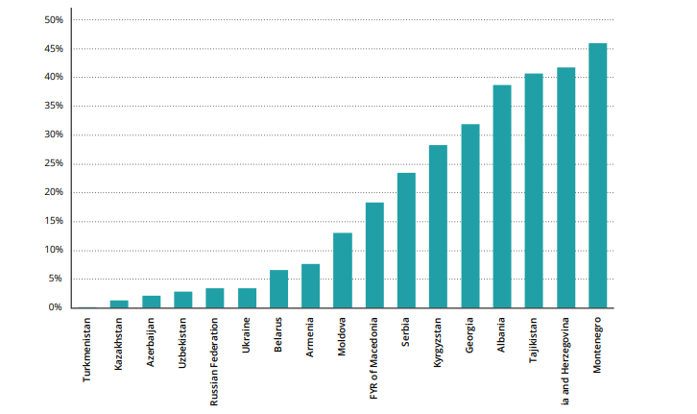
Lack of access to clean energy sources for household heating, lighting and cooking is an issue for more than 17 million inhabitants of the region. Many rural populations still depend on solid fuels for residential heating and cooking, as non-solid fuels are difficult to source. The quality of the electricity supply in terms of affordability, reliability and sustainability is also a major bottleneck impeding the wider deployment of renewable energy in the Russian Federation as well as in countries of South East and Eastern Europe, the Caucasus and Central Asia. Investment in transmission infrastructure is a pre-requisite in these countries for increasing the uptake of renewable energy technologies.
Opportunities to scale up renewable energy

Integration of fluctuating renewable energy into power and heating grids is one of the biggest challenges towards fostering sustainable energy. Flexible power systems such as hydro power plants and storage systems, can play an important role in grid resilience and stability and are of vital importance to balance the fluctuations of the wind and solar PV. Other flexibility options involve demand side management incentivising customers (private, commercial and industrial) to manage or decrease energy consumption. Heat generation from renewable energy at a large scale (solar, geothermal and biomass) requires the development of heating supply systems, while integration of smaller-scale renewable energy into existing heating systems needs to account for many more factors of the system (temperature, content, water quality, etc.) than the excess electricity generated from non-dispatchable renewable power plants.

Renewable energy technologies could address some of the trade-offs between water, energy and food production, bringing substantial benefits in all three sectors. They can moderate competition by providing energy services using less resource-intensive processes and technologies compared to conventional energy, especially in transboundary river basins in South East Europe, the Caucasus and Central Asia. In most of these basins, the riparian countries have active hydropower development but also have the potential to exploit other renewable sources such as solar, wind and geothermal energy. The distributed nature of many renewable energy technologies means that they can offer integrated solutions for expanding sustainable energy while enhancing security of supply across the three sectors. This contributes to addressing the region’s strategic energy challenges. The energy-water-food nexus approach aims to support more sustainable renewable energy deployment by building synergies, increasing efficiency, reducing trade-offs and improving governance among sectors. The emphasis is on transboundary co-operation in both energy sector development and water management. Increasing the renewable energy share can help to reduce water requirements in power generation; boost water security by improving accessibility, affordability and safety; and contribute to food security objectives.

Policy Action:
- Strengthen technological and regional cross-border cooperation by sharing best practices on developing renewable energy infrastructure and scaling up the share of renewable energy in the energy mix and engage in joint investments.
- Recognise the benefits of the water-energy-food nexus and transboundary cooperation and promote the development of renewable energy in South East Europe, the Caucasus and Central Asia basins to support modernisation of the energy system and water management.
- Develop with Experts Policy Recommendation on following topics:
  - Nexus
  - Smart integration of Renewable Energy into the grid
  - Role of digitalisation to support the uptake of renewable energy
  - Role of storage (e.g. batteries)
  - Resource management
    - Access to natural resources to develop batteries. What is specific for our region?
    - Recycling of panels and waste management

Modernising energy systems on the back of widespread electrification
A modernised energy system increasing relies on renewable resources. The ‘3D energy transition’ to a decarbonised, decentralised and democratised energy system is underway. Innovation and technological developments are steering the direction of the transition. Policy makers, who seem to be the followers in the current fast-paced transition, now have the last chance / opportunity to engage and develop policies to speed up the rise of renewable energy, energy storage and widespread system electrification.
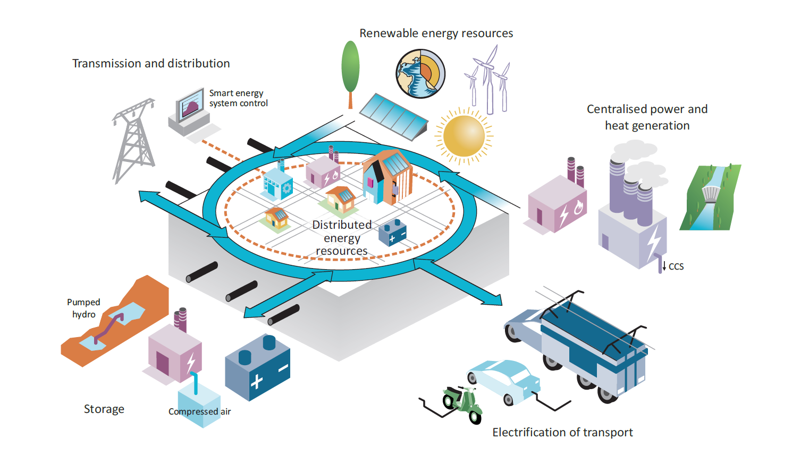
Figure 16: Modernised Integrated Energy System, source: IEA 2017

IEA
Primary drivers of increased share of renewable energy in the electricity sector include: i) growing concerns over negative impacts of emissions from fossil fuel-fired electricity power plants; ii) volatility of fuel prices; iii) quest for energy independence and resilient power grids, iv) shifts in consumer behaviours; and v) innovation and digitalization of energy system.

The energy system as we know it is in flux. As electricity becomes a vehicle for achieving deep transformation of the energy system, the incumbent energy utility companies that rely on the traditional large centralized generation systems and passive consumers need to modernize to protect their market share. Grid operators will need to embrace new business models and increase cooperation with new market entrants and community.
New business models will necessarily be developed on lower carbon applications, increasing energy efficiency and more control by customers under the assumptions in this modeling exercise. Platforms of trusted innovative technologies are expected to create the foundation for the further development of such a system. Technology integration into the energy system, therefore, is a prerequisite for energy transition and modernisation of the energy system.
The democratization of the whole system is underway. Ongoing innovation and digitalization of the energy system is creating a new generation of consumers. Consumers are gradually more interested in installing solar panels and other sources of residential and community scale renewable power generating units are being deployed. People wish to actively manage their energy consumption. Modern customers value to be in control. The so-called prosumers value to produce as well as consume energy. As the cost curve for renewable energy is coming down and more reliable storage solutions (e.g. batteries) are being developed, consumers are being more in control. Therefore, distribution companies need to move the center of gravity to customers.

Innovation is the engine powering the global energy transition. Fostering, therefore, development and deployment of solutions that increase the system flexibility required to integrate higher shares of renewables is the key. Digital technologies are transforming the power sector through better monitoring of the performance of renewable energy assets and enabling the collection and management of large amount of data. Renewable and storage technologies improvements and innovations should be cost effective and made widely available.

Policy Action:
- Promote flexible business models and changes in regulatory framework. Creating necessary regulatory frameworks is highly important for further technological innovation.
- Promote flexible electricity distribution networks based on innovative technologies.
- Develop with Experts this topic further. How the Experts see the energy system modernising. What are the main drivers and what structural changes are already underway. Develop together Policy Recommendations.

Investments on subregional level have to target opportunities to accelerate modernisation of the energy system

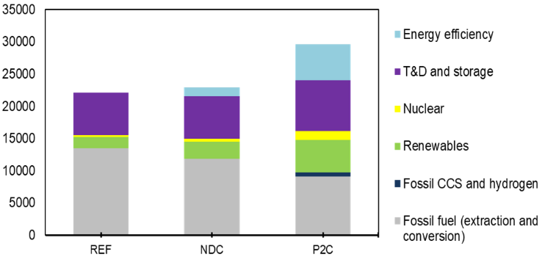
Technological change and digitalisation is underway. Predictable environment with forward looking policies is a precondition for investments in energy innovation which are essential for both economic growth and environment. In spite of the current trend in technological developments the industry is still to large extent locked in due to long legacy in fossil fuel technological developments (Figure 16). For achieving a 2-degree target (P2C Scenario) the investments needs from 2020 – 2050 are expected to increase significantly by 34% compared to Reference Scenario (Figure 16).
Figure 16: Comparing investments needs in UNECE across 3 scenarios ($billions)

IEA

The investment needs in P2C, amounting 27,756 billion US dollars over 2020-2050, are divided more or less equally between 4 sectors: transmission and distribution, energy efficiency, power generation and fossil fuel extraction. Electrification and the need for more power generation increases the investment needs in the sector, yet nuclear plays a major role after renewables, surpassing all fossil fuel power generation combined (Figure 17).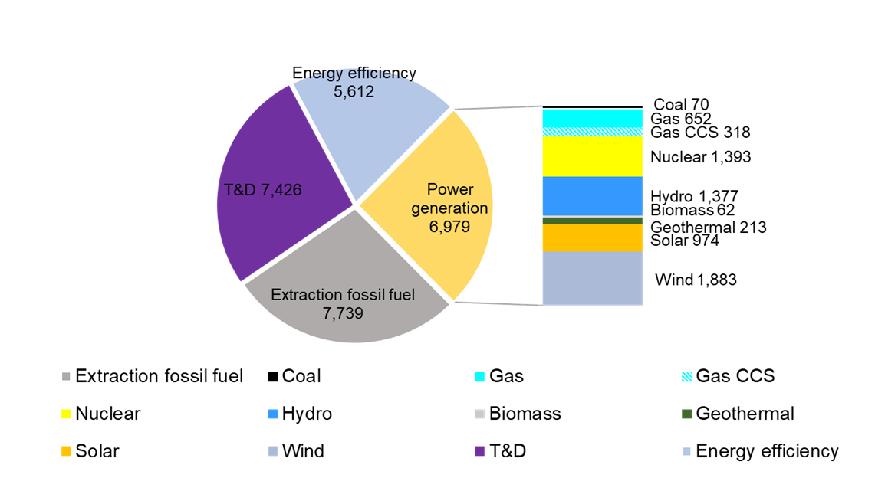
Figure 17: Comparing investments needs in UNECE across 3 scenarios ($billions)

IEA

Public private partnership (PPP) schemes and public based investments are useful to empower consumers and local community to be active participants in the transformation of the energy system. Distributed renewable energy can offer reliable and clean energy to both grid connected and non-grid connected communities.
Policy Action:
- Discuss with Experts where are the gaps and how the gaps vary on the subregional level.
- Develop with Experts Policy Recommendations

Energy Efficiency is a low hanging fruit to support deep energy system transformation

The future energy system has to be designed with efficiency as its core value. Optimizing energy usage, both at generation level as well as consumption level is a natural process that is already slowly occurring lead by technology development and behaviouristic changes. However, the rate of optimization of processes and usage is lower than the rate of increasing of the energy demand (Figure 3).

Reference case show us that: i) the rate of new renewable energy sources cannot follow the demand, ii) fossil-based energy sources will continue to dominate the energy markets for decades and iii) climate change mitigation is not possible with increased rate of energy demand. Therefore, it is necessary to rethink how do we value energy efficiency and start thinking of it as an energy source of its own right–the value of the saved energy to represent equally as a “energy produced”.

The concept of energy efficiency as the first fuel brings additional benefits that are inherently assigned to both energy conservation and energy efficiency, these are:
- Increased energy security of the country/region
- Contributes to climate change mitigation
- Increased flexibility of the energy system for integration of intermediate energy sources
- Energy efficiency measures are locally implemented (raising economic growth and development)
- Lower capital infrastructure investment costs
- Contributes to optimizing industrial processes
- Increases quality of life
Figure 18: UNECE Sub-regions Energy Intensity (MJ/2011 PPP$), source: IEA and UN Statistics, quoted from UNECE 2017

IEA

In 2017 relative to 2000, energy efficiency improvements prevented an increase in global GHG emissions of 12% (ca. 4 Gt CO2-eq) (IEA 2019) (Figure 16). Nevertheless, a lot of energy efficiency potential remains untapped since current policies are not delivering the full potential gains that are available with available technologies.
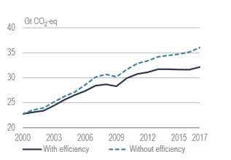
A commonly used measure for energy efficiency is energy intensity. Energy intensity is an indication of how much energy is needed to produce one unit of economic output. Lower ratio indicates that less energy is used to produce one unit of output. It is usually an indicator used on macro-economic level, defined in terms of energy rather than output (UNECE 2017).

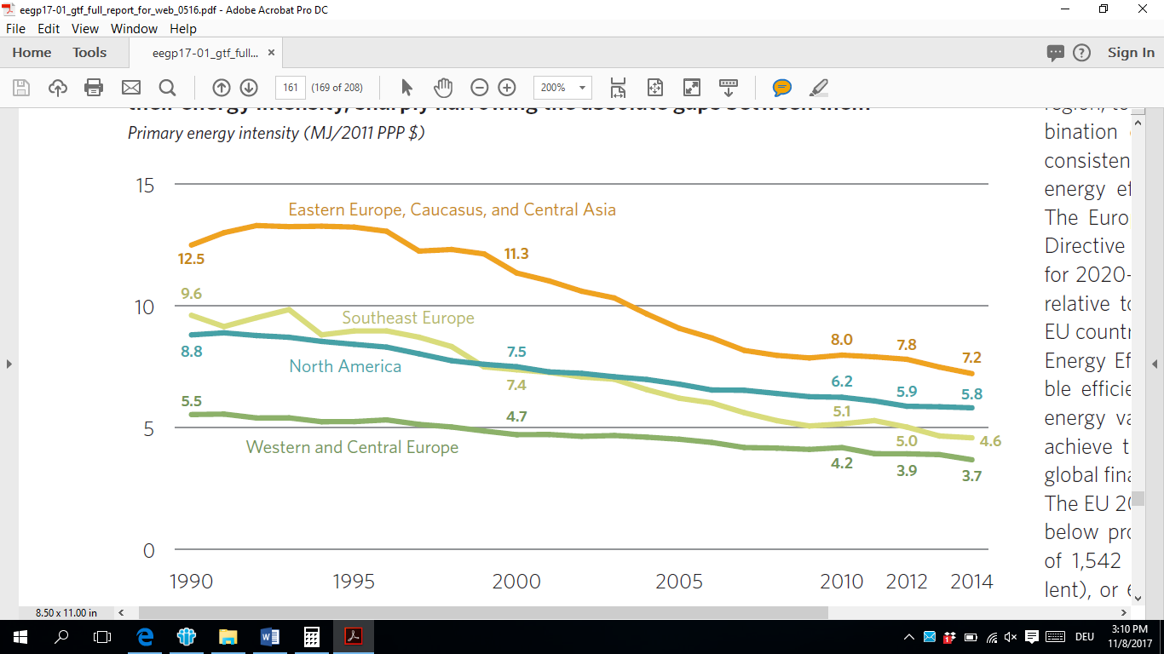
In UNECE, energy intensity has been declining in all subregions. In North America and Western and Central Europe energy intensity declined primarily driven by a combination of cost-reflective energy prices coupled with comprehensive energy efficiency polices and commitments. EU member States were required to develop and implement National Energy Efficiency Action Plans (NEEAP). In Southeast Europe, conflict in 1990s resulted in energy demand decline which dropped faster to economic output. Post-conflict structural shift to lower-intensity services and innovations in productivity contributed to further improvements in energy intensity. However, the sub-region is yet to implement firm and effective energy efficiency policies. Similarly, to Southeast Europe, in Caucasus, Central Asia, Eastern Europe and Russian Federation energy efficiency policies still have to mature to drive further decline in energy intensity (UNECE 2017).
Figure 19: Global Energy-related GHG emissions, comparison with and without efficiency, source: UNECE 2018

IEA

In UNECE region, there is untapped energy efficiency potential for countries, stemming from industry, residential and transportation sector.

Policy Action:
- Before investing in new production and supply infrastructure, countries should improve energy efficiency and productivity when cost-effective in the production, transmission, distribution and consumption of energy.
- Business models that prioritise improvements in energy productivity have to be promoted
- Develop national policies, strategies and action plans to promote energy efficiency as the first fuel.
- Rethink the value of energy efficiency/conservation (nega-watt pricing, energy optimization and increased productivity vs. energy demand incentives, etc.)

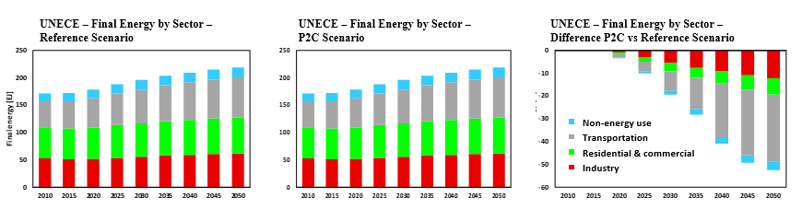
Figure 20: Final Energy by Sector – Reference vs. P2C scenario – UNECE region

IEA
Industrial Energy Efficiency: Energy efficiency in the industry sector already has been proven that brings financial benefits to the companies, not just by the value of the energy saved, but also of increased productivity due to process optimization. According to IEA, cost-effective energy efficiency measures could lead to improvement of 45% to 2040 from current levels (IEA 2019). The main challenge for improvement of industrial energy efficiency is addressing the issue of highly energy intensive processes in some industrial sectors. The production of steel, cement, paper refinement, etc., requires high amount of energy per product, but there is no alternative to the technological processes for such production. This could be addressed with fostering innovation, and targeted R&D that would drive the industry to better efficiency improvements.

Energy and environmental policies could also contribute in steering the industry toward more optimized production. These policies can have effect on the wider scale, because every improvements and enforcement of standards in the industry contributes to better environmental and social conditions and economic opportunities through development of auxiliary services.

Policy Action:
- Limit the energy intensity of industrial sectors.
- Invest in targeted R&D for technologies that are energy intensive.
- Further develop and discuss with Experts Policy Recommendations

Building Energy Efficiency: Buildings are central to meeting the sustainability challenge. In the developed world, buildings consume over 70% of the electric power generated and 40% of primary energy and are responsible for 40% of CO2 emissions from the energy services they require. UNECE’s High Performance Buildings Initiative (HPBI) to disseminate and deploy its Framework Guidelines for Energy Efficiency Standards in Buildings worldwide. The objective is to improve health and quality of life within the built environment while simultaneously decarbonizing building-related energy requirements, thus breaking the historic link between improved health, quality of life and atmospheric carbonization. HPBI comprises three pillars aimed at radical reduction of the global carbon footprint of buildings and dramatic improvement in the health and quality of life provided by buildings.

International Centres of Excellence
- Provide implementation-oriented education and assistance to building developers, contractors, architects, and engineers, as well as regulatory and planning officials.
- Provide community-centric knowledge development and sharing, connecting with resources and accelerating uptake of high-performance buildings.

Global Building Network
- Research and advanced education in building materials, design, and construction for current and next generation architects, engineers, policy makers and other stakeholders.
- Promote sustainable, high performance buildings worldwide in support of both the Guidelines and the UN International Centres of Excellence.

Case Studies Demonstration
- Application of the Framework Guidelines in countries around the world to demonstrate their validity in different climates, stages of development, and regulatory, legislative, and physical infrastructure.
- Preparation of a library of case studies for reference and to support training and education.
Existing technology solutions already allow residential and commercial sector to transform buildings to align with the highest standards of health, comfort, well-being and sustainability, including improving energy productivity and reducing CO₂ emissions. Whilst electrification of home appliances, lighting, refrigeration and air conditioning has been under way, large potential for further electrification still exists in heating and cooking. According to IEA, space heating offers over a quarter of the potential energy savings. In addition, water heating efficiency could also improve by 43% and improvements in space cooling, which is the fastest growing source of building energy demand, could see air conditioner efficiency double (IEA 2019).

Policy Action:
- Enhance efficiency of residential building envelope.
- Introduce NZEB (nearly zero energy buildings) standards for all new public buildings, after 2050 for all commercial buildings
- Develop and integrate flexible business models for residential sector.
- Further develop and discuss with Experts Policy Recommendations

Transport Energy Efficiency: Compulsory fuel economy standards played a pivotal role in boosting the efficiency of road vehicles. According to IEA, the introduction of mandatory standards on fuel has reduced the global use of oil in transport in 2017 by ca. 1.2mbpd. Another 2.2 mbpd would have been saved had the more stringent standards been adopted worldwide (IEA 2019). Carbon taxes have only a limited impact on the cost of mobility. Change in customer preferences coupled with the speed of innovation and commercialisation of new technologies, such as EVs, biofuels and hydrogen, are expected to drive further decarbonisation of transport. Most of the transport in urban areas is consisted of commuter transportation for short distances. This should be addressed with proper planning of city infrastructure and transport efficiency. Large freight transport remains a challenge due to the volume and complexity of the transportation system (national laws vs international, interstate transport, international waters, etc.)

Policy Action:
- Invest in targeted R&D for large freight transport
- Enforce environmental standards for vehicles
- Introduce mandatory planning of cities based on commuter transport efficiency.
- Introduce congestion charge for fossil-fuel vehicles in urban areas.
- Further develop and discuss with Experts Policy Recommendations

Trade-off to be discussed at and developed post-May consultation meeting

- If we want to achieve P2C energy access will not be possible
- If we want to achieve SDG13, then SDG7 will not be possible
- If we want to continue to have coal as a substantial part of our energy mix then we need to invest in CCS
- …

- Annex

Modelling approach

The numeric work has been conducted by the Fraunhofer Gesellschaft (Fraunhofer) (represented by the Institute for Environment, Safety and Energy Technology - UMSICHT and the Institute for Systems and Innovation Research - ISI), the International Institute for Applied System Analysis (IIASA), and the Pacific North West National Laboratory (PNNL).

Modelling of scenarios
All details about the modelling approach and disaggregation and calibration of subregions can be found in document ECE/ENERGY/2018/1. Important to remember are the stages of the scenario analyses:
- Base scenario (SSP2). This will act as the “Reference Scenario”;
- SSP2 + current policies (including NDCs, energy policies, etc.,). A policy scenario based on NDCs under the Paris Agreement for 2030 (NDCs kept beyond 2030 until 2100) with four cases along the two axes “International Cooperation“ and “Innovation: technology, business models”. These will act as the “Current Policies incl. NDCs Scenarios”;
- Base + current policies + adaptive policy pathways to achieve targets (Key Performance Indicators (KPIs) and Long-Term Performance Goals (LPGs) including 2ºC). These will be called “Sustainable Energy Policy Scenarios.

The advantage of using so called Socio-Economic Pathways (SSPs) as reference scenarios is that they have been developed through various iterations by an international research community, including IIASA and PNNL, with the objective to provide five narratives describing alternative socio-economic developments and plausible major global developments. To develop the Pathways project scenarios, basic socio-economic assumptions from SSP2 and respective datasets have to be used. SSP2 functions as the reference scenario for each scenario developed under the Pathways project as it describes a “middle of the road” scenario.

The development of the subsequent policy scenarios is linked to storylines that were developed through a participative approach with energy experts between 2015 and 2016. To explore the multiple pathways that could potentially lead to a sustainable energy future, this reference future needs to be developed first. As the “Reference Scenario”, its socio-economic, market and technology assumptions represent middle-of-the-road developments. SSPs do not include climate mitigations policies or measures (other than those existing in 2010). SSP2 provides an appropriate point of departure for the exploration of multiple (alternative) pathways.

To prepare the scenario development beyond the SSP2 baseline scenario, further information was collected concerning NDCs, energy policies and strategies, energy infrastructure (large-scale power plants, etc.). This scenario will be called “Current Policies Scenario”. After finalisation of the scenarios across the UNECE sub-regions and for different time periods, a detailed analysis will be undertaken. Metrics, signposts and key performance indicators will be used to assess if a path meets the criteria for sustainable energy, to determine which path the world is on at a future point in time, and to explore energy system changes.

Technology roadmap
To increase transparency of input parameters used in the models, Fraunhofer prepared a technology survey. The developed technology portfolio provides a general descriptive guide for the power generation technologies deployed in both models GCAM and MESSAGE. Technologies included are: Solar Photovoltaics, Concentrated Solar Power, Wind Power, Hydro Power, Nuclear Power, Coal-fired Power Plants, Gas Combustion, and Biomass. The technology description highlights the working principle and status-quo as well as the most common variations and a technical outlook.

Both models have a similar cost hierarchy. This means that technologies on the lower or upper end of cost rankings are similar in both models. Technology zoom-ins for Carbon Capture and Storage (CCS), storage, energy efficiency and power to X (such as power-to-ammonia, power-to-chemicals, power-to-fuel, power-to-gas, power-to-heat, power-to-hydrogen, power-to-liquid, power-to-methane, power-to-mobility, power-to-power, and power-to-syngas. power to gas, power to hydrogen) have been prepared.

The following graphic summarizes the modelling approach:

Measuring “Sustainable Energy” in Integrated Assessment Models

One key component of the Pathways Project is the numerical modeling of climate, technology and policy scenarios. A combination of bottom-up and top-down modeling has been applied. The models need numerical input parameters and assumptions for various socio-economic, technological, and climate-related indicators. Also, numerical constraints have been integrated into the models to set specific targets on Sustainable Energy for 2050.
The development of numerical inputs relevant to policy development around Sustainable Energy is not trivial. The models have confusingly large amounts of input and output parameters, which can be selected. It is also not simple to introduce new parameters not already included in the datasets.

The objective of the Pathways Project was to identify a set of the most important indicators that best represent the definition of Sustainable Energy described above. These could be used as Key Performance Indicators (KPIs) within the project. After a broad stakeholder consultation, a list of KPIs was developed for the models given their various modelling constraints.

Summary KPIs for the Project

The table below summarizes the KPIs that can be modelled and that were used for the presentation and analysis of the scenarios.

Energy Security
Name | Title | Measurement in the model | Interpretation and Analysis / Relationship to SDGs
ES-M1 | Energy self-sufficiency: net imports | Net imports in each sub-region and overall UNECE region | Relates to SDGs 8 & 9.  Interpreted in the context of regional cooperation and interconnectivity.
ES-M2 | Energy efficiency | Energy intensity: units of energy per unit of GDP (J/US$ PPP)  Rate of improvement in energy intensity (% CAGR)  Conversion efficiency | Relates to SDG 7.3 target to double the rate of improvement in energy efficiency by 2030. Energy intensity is the SDG7.3 indicator.  Interpreted in the context of both thermodynamic conversion efficiency as well as the energy efficiency of the economy.
ES-M3 | Investment requirements to achieve sustainable energy | Energy investment of GDP (% GDP) | Relates to SDG 7.A, SDG 13.A  Interpreted in the context of impacts and ability to finance the investments.
ES-M4 | Diversity of supply: fuel mix in energy and electricity | Share of different fuels in Total Final Energy Consumption (TFC) and Total Primary Energy Supply (TPES), and in electricity (%) | Relates to SDG 7.2 target ‘substantially increase the share of RE in TFC’.  Interpreted in the context of diversification of supply, share of low-carbon / fossil fuel energy supply, etc.

Energy for Quality of Life
Name | Title | Measurement in the model | Interpretation and Analysis / Relationship to SDGs
QL-M1 | Access to energy services | Energy / electricity services per capita (efficiency adjusted energy consumption) (J/capita/year) | Relates to SDG 7.1 target: Universal access by 2030, and SDG1.
QL-M2 | Energy affordability | Total energy expenditures per GDP per capita | Relates to SDG1 and SDG 7.  Interpreted in the context of energy poverty and household income spent on energy expenditures.
QL-M3 | Food security | Share of calories from non-staple food (%)  (GCAM model only) | Relates to SDG 2.4 (sustainable agriculture), 2.3 (reduce food loss), 13.1 (impact of climate change).  Will be interpreted with a focus on the linkages between sustainable bioenergy (solid biomass) generation of food production.

Energy and Environment
Name | Title | Measurement in the model | Interpretation and Analysis / Relationship to SDGs
EE-M1 | GHG emissions from the energy sector | Total global GHG emissions of the energy sector in MtCO2eq | Relates to SDG13.
EE-M2 | Air polluting energy emissions | Emissions from energy sector: Sulphur Dioxide (SO2), Nitrogen Oxides (NOx), Particulate Matter (PM2.5) (ppm or μg/m3) | Relates to SDG 3.9.1.
EE-M3 | Water use efficiency and water stress caused by the energy sector | Cooling water use in electricity generation (l/kWh)  Water use associated with energy resource extraction (GJ liters absolute and/or L/GJ) | Relates to SDG 6.4.1 ‘substantially increase water use efficiency’ and 6.4.2 ‘substantially reduce water scarcity’.  Interpreted in the context of water use of the energy sector: power generation and water consumption from energy extractive industries.

These KPIs were monitored as output parameters to determine the impact of a policy within a scenario. In addition, some of them can be used as target values (model constraints) in which case the model uses them as a target from which it can be assessed how the other output parameters perform.

Assigning target values can be performed for the following KPIs:

Green House Gas Emissions from the energy sector
Given the COP 21 Paris Agreement, policy scenarios under the Pathways Project should aim to limit global warming to maximum 2ºC. The ‘target’ value or constraint for the model is to limit cumulative total global greenhouse gas emissions of the energy sector over the remainder of the 21st Century to stay below the 2ºC maximum temperature limit. In addition to this “Paris to 2C” scenario, other scenarios include the “Reference Scenario” based on SSP2 and “Current Policies Scenario” will highlight results without the 2ºC constraint in place. These scenarios will help to assess the gap between the current policies in place and the Sustainable Energy objectives agreed within the project.

Air polluting energy emissions
Emissions from energy and transport sector including Sulphur Dioxide (SO2), Nitrogen Oxides (NOx), and Particulate Matter (PM2.5), among others. These can be integrated in the model as constraints. If desired by the project stakeholders, emission targets can be formulated and implemented when developing the policy scenarios to see their impact on the other KPIs.

Energy affordability
In line with SDG 7 target 7.1, universal access to energy is to be achieved by 2030. The UNECE region has, officially, achieved 100% access to electricity and so the indicator to be used measures affordability of energy services. A desired target of maximum 10% of disposable income spent on energy expenditures has been set. This indicator is not a constraint that can be used to converge the model to a solution, so it can only be calculated along with the other modeling outputs.

Energy choice
Finally, the models have no constraints on the form of energy, type of energy or energy technology used. All are included within the models. However, by applying Sustainable Energy objectives in the form of KPIs and constraints, policy options and the evolution of climate knowledge and energy technology, the output from each scenario will evolve. For example, applying a cost optimization approach will result in a mix of energy technologies which changes as the cost information evolves. The model may exclude certain forms of energy generation if they are not supporting the overall cost optimization approach.

List of Abbreviations
AMM abandoned mine methane
CCUS carbon capture use and storage
CMM coal mine methane
CSP concentrated solar power
GDP gross domestic product
GHG greenhouse gas
GWP global warming potential
HELE high efficiency, low emission
IEA International Energy Agency
IGU International Gas Union
IGCC Integrated gasification combined cycle
IOC international oil company
IPCC International Panel on Climate Change
IRENA International Renewable Energy Agency
ITC International Trade Centre
Mbpd million barrels per day
NDC Nationally determined contributions
NOx nitrogen oxides
NZEB nearly zero energy buildings
P2C 2-degree scenario
PNNL Pacific Northwest National Laboratory
PV photovoltaic
R&D research and development
REF Reference scenario
SDG Sustainable Development Goals
SO₂ sulphur dioxide
UNECE United Nations Economic Commission for Europe

For a detailed status report and explanation of previous activities please see ECE/ENERGY/2018/1, CSE-27 2018_INF.11, and CSE-27/2017/INF.8, documents to be found under the 27th session of the Committee on Sustainable Energy here: http://www.unece.org/index.php?id=48583
http://www.unece.org/fileadmin/DAM/energy/se/pdfs/comm_gen/Publications/2017/UNECESustainableEnergyPub.pdf
Commodity 27, as defined by comtrade.un.org (https://comtrade.un.org/db/mr/rfCommoditiesList.aspx?px=H4&cc=27)
Methane is a potent GHG with a high global warming potential (GWP) associated with natural gas (see under gas chapter) but is also very . Global Warming Potential (GWP) is an index, which allows to compare the global warming impact of a greenhouse gas, relative to the most prevalent of the greenhouse gases – CO2. Further it determined the relative contribution of the respective gas to climate change. Based on the 20 year timeframe the GWP of CH4 is 80 times larger to CO2. In the 100-year timeframe the potential of CH4 compared to CO2 falls to 28 times (IGU 2017, GECF 2019).
https://www.e3g.org/docs/Experiences_with_structural_change_EN.pdf
https://poweringpastcoal.org/insights/economy/sunnier-times-ahead-for-coal-workers-in-renewables-tech
https://core.ac.uk/download/pdf/7044067.pdf
https://www.greens-efa.eu/files/doc/docs/ae8afc9a34a8383ca99100a8f2a003b7.pdf
Agora, 2017. Flexibility in thermal power plants – With a focus on existing coal-fired power plants. Agora Energiewende 116.
Kopiske, J., Spieker, S., Tsatsaronis, G., 2017. Value of power plant flexibility in power systems with high shares of variable renewables: A scenario outlook for Germany 2035. Energy 137, 823–833. https://doi.org/10.1016/j.energy.2017.04.138
Agora, 2017. Flexibility in thermal power plants – With a focus on existing coal-fired power plants. Agora Energiewende 116.
The radioactive spent fuel is then stored in special insulated storage containers. Decommission of the nuclear reactor is also a critical issue, involving the dismantling and clean-up of the radioactively contaminated components up to a level that will allow their disposal/reuse .
http://www.world-nuclear.org/getattachment/Our-Association/Publications/Annual-Reports-and-Brochures/At-Work-Annual-Report-2019/at-work-2019-low-res.pdf.aspx
http://www.world-nuclear.org/getattachment/Our-Association/Publications/Annual-Reports-and-Brochures/At-Work-Annual-Report-2019/at-work-2019-low-res.pdf.aspx
https://www.world-nuclear.org/press/briefings/nuclear-power-is-essential-for-energy-environment.aspx
https://cnpp.iaea.org/countryprofiles/Russia/Russia.htm
https://www.iea.org/countries/france/
https://www.iaea.org/topics/small-modular-reactors
https://www.sckcen.be/en/Technology_future/Nuclear_fusion http://www.world-nuclear.org/information-library/current-and-future-generation/nuclear-fusion-power.aspx
https://nangs.org/analytics/irena-renewable-capacity-statistics-eng-pdf
https://www.unece.org/fileadmin/DAM/energy/se/pp/renew/Renewable_energy_report_2017_web.pdf
See detailed description of SSPs: Riahi K. et al (2017): The Shared Socioeconomic Pathways and their energy, land use, and greenhouse gas emissions implications: An overview. In: Global Environmental Change 42 (2017) 153–168.
The summary report „Technology Portfolio: Comparison of Technical Input Parameters from MESSAGE and GCAM” can be downloaded on the project website: https://www.unece.org/fileadmin/DAM/energy/se/pdfs/Pathways_to_SE/Report_Technology_Portfolio_UMSICHT_ISI_FINAL.pdf
See glossary for explanation on terminology.
The baseline input assumptions are based on the Socio-Economic Pathways (SSPs). The advantage of using the SSPs is that they have been developed through various iterations by an international research community, including IIASA and PNNL, with the objective to provide five narratives describing alternative socio-economic developments and plausible major global developments. SSPs are used to analyse the feedbacks between climate change and socio-economic factors and to develop scenarios for use by the research community. The SSPs include qualitative narratives and quantitative elements. To develop the project scenarios, basic socio-economic assumptions from SSP2 and respective datasets will be used. SSP2 will function as the base case scenario (“No Policy Scenario”) in the Pathways project. It describes a “middle of the road” scenario. See detailed description of SSPs: Riahi K. et al (2017): The Shared Socioeconomic Pathways and their energy, land use, and greenhouse gas emissions implications: An overview. In: Global Environmental Change 42 (2017) 153–168.

