CHAPTER 3

THE TRANSITION ECONOMIES

3.1 Introduction

(i) Expectations and outcomes
Aggregate GDP in the ECE transition economies increased by some 2¼ per cent in 1999, the highest average annual rate of growth for the transition economies as a group during the first decade of their economic and political transformation. However, the average figure for 1999 masks an unusual degree of volatility during the year as well as considerable differences between the individual economies. Performance was very weak in the first half of the year, and especially the first quarter when more than half of the transition economies plunged into recession; in contrast, there was a marked recovery of output in most of these countries in the second part of the year.
The uneven pace of output growth in the transition economies was predominantly driven by external factors: the widespread recessionary pressures during the first half of the year – which followed the sharp weakening of output during the second half of 1998 – were largely the aftershocks of the global financial turmoil and the Russian crisis, coupled with the economic fallout from the Kosovo conflict; conversely, the upturn in west European import demand in the second half of 1999 was an important factor behind the recovery in eastern Europe as well while commodity exporters, especially in the CIS, benefited from generally rising demand and better prices for some commodities. The vulnerability of most of the transition economies to external disturbances is yet another sign both of their high dependence on their external markets and of the absence of efficient policy mechanisms to counterbalance negative developments from abroad.
The recent volatility of output as well as the generally high, although varying degree of susceptibility to external shocks led to large discrepancies between ex-ante expectations and actual outcomes in many transition economies in 1999 (table 3.1.1). These differences were greatest in the three Baltic economies where the actual GDP growth rates were several percentage points lower than the official forecasts. GDP growth was generally less than expected in most of eastern Europe but the dismal figure for the increase in their aggregate GDP (1.4 per cent) largely reflects the poor performance in south-eastern Europe which was weakened by the economic consequences of the Kosovo conflict; in contrast, the average rate of growth in the central European transition economies (3.1 per cent) remained almost unchanged from that in 1998 (3.2 per cent).
The growth of GDP in the Russian Federation in 1999 (3.2 per cent) was not only the highest achieved during the past decade but was also much higher than all the forecasts, including the official ones (table 3.1.1). As discussed below, in sections 3.2 and 3.3, it would be premature to draw general conclusions about Russia’s growth prospects on the basis of one year’s outcome, which reflects to a large extent a cyclical upturn after the output collapse of 1998. At the same time the performance in 1999 marks a notable departure from Russia’s past record in several important respects: apart from the notable recovery of output (especially in industry), total employment also increased for the first time in a decade and there were also signs of the steep decline of investment demand coming to an end.
The transition economies are still undergoing – to varying degrees – deep structural changes accompanied by large-scale reallocation of resources. The new corporate sector, now dominated by private actors (combining new private firms and privatized, former state owned enterprises), is already the main engine of growth in many transition economies, especially those which are the more advanced with reforms. Largely operating in accordance with the principles and norms of the market economy, and capable of facing competitive pressures, the new corporate sector serves at the same time as a shield that increases the overall resilience of the economy to external disturbances, provided it is supported by efficient policy mechanisms. But in many transition economies, the prolonged existence of an unrestructured sector of inefficient, large state owned firms continues to be a major handicap for the transition economies, which increases their vulnerability to external shocks. Moreover, the slow process of closing down (or downsizing) unviable firms is itself a persistent (albeit diminishing) source of transformational recession in those economies that are lagging behind in the reform process. In turbulent periods (such as that between mid-1998 and mid-1999) it may be difficult to differentiate between the cyclical and transformational components of recession; however, it seems plausible that the unrestructured part of the enterprise sector – among other factors – has amplified the negative repercussions of external shocks in some of the less advanced transition economies.
In 1999, the economic performance of three central European countries – Hungary, Poland and Slovenia – stands out against that in the rest of the transition economies: the negative impact of the external disturbance was notably weaker compared with other transition economies; on average GDP continued to grow steadily in all the three countries despite the unfavourable external conditions; and final domestic demand (both consumption and investment) remained buoyant (section 3.3). In addition, the situation in the labour markets also improved in Hungary and Slovenia (section 3.5). The growing “maturity” of economic performance in these countries is the most conspicuous indication of their progress in systemic transformation and of their capacity to pursue prudent macroeconomic policies during the course of transition: arguably, a critical mass of successfully implemented reforms is both the source of higher living standards of the population and a safeguard against external shocks.
TABLE 3.1.1
Basic economic indicators for the ECE transition economies, 1997-2000
(Rates of change and shares, per cent)
 | GDP (growth rates) |  |  |  |  |  | Industrial output |  |  |  |  | Inflation (per cent |  |  |  |  |  |  | Unemployment rate
 |  |  | 1999 |  |  |  |  | (growth rates) |  |  |  |  | change, Dec./Dec.) |  |  |  |  |  |  | (end of period, per cent)
 | 1997 | 1998 | Ex-ante forecast | Actual |  | 2000 official forecast |  |  | 1997 | 1998 | 1999 |  |  | 1997 | 1998 | 1999 | 2000 official forecast a |  |  |  | 1997 |  | 1998 |  | 1999
Eastern Europe | 2.1 | 1.8 | 2.9 | 1.4 |  | 4 |  |  | 4.9 | 0.8 | -0.2 |  |  | .. | .. | .. |  | .. |  |  |  | 11.9 |  | 12.6 |  | 14.6*
Albania | -7.0 | 8 | 8 | 8 |  | 8 |  |  | 2.8 | 21.8 | 16.0 |  |  | 42.0 | 7.8 | -1.0 |  | 3 |  |  |  | 14.9 |  | 17.6 |  | ..
Bosnia and Herzegovina b | .. | .. | .. | .. |  | 12 |  |  | 35.7 | 23.8 | 10.6 |  |  | 12.2 | 2.2 | -0.4 |  | .. |  |  |  | 39* |  | 38.5 |  | 39.1
Bulgaria | -7.0 | 3.5 | 3.7 | 2.6 |  | 4 |  |  | -10.0 | -12.7 | -12.5 |  |  | 578.7 | 0.9 | 6.2 |  | 2.8 |  |  |  | 13.7 |  | 12.2 |  | 16.0
Croatia | 6.8 | 2.5 | 1.5-2 | -0.3 |  | 2.6 |  |  | 6.8 | 3.7 | -1.4 |  |  | 4.0 | 5.6 | 4.6 |  | 2-3 |  |  |  | 17.6 |  | 18.6 |  | 20.8
Czech Republic | -1.0 | -2.2 | -0.8 | -0.2 |  | 1.5 |  |  | 4.5 | 1.6 | -3.1 |  |  | 9.9 | 6.7 | 2.5 |  | 3.3-4.4 |  |  |  | 5.2 |  | 7.5 |  | 9.4
Hungary | 4.6 | 4.9 | 5 | 4.5 |  | 5 |  |  | 11.1 | 12.5 | 10.5 |  |  | 18.4 | 10.4 | 11.3 |  | 6-7 |  |  |  | 10.4 |  | 9.1 |  | 9.6
Poland | 6.9 | 4.8 | 4.5 | 4.1 |  | 5.2 |  |  | 11.5 | 3.5 | 4.4 |  |  | 13.2 | 8.5 | 9.9 |  | 5.7 |  |  |  | 10.3 |  | 10.4 |  | 13.0
Romania | -6.1 | -5.4 | -2 | -3.2 |  | 1.3 |  |  | -7.2 | -16.8 | -8.0 |  |  | 151.7 | 40.7 | 54.9 |  | 25-30 |  |  |  | 8.8 |  | 10.3 |  | 11.5
Slovakia | 6.5 | 4.4 | 3 | 1.9 |  | 2 |  |  | 2.7 | 3.8 | -3.4 |  |  | 6.5 | 5.5 | 14.4 |  | 14.1 |  |  |  | 12.5 |  | 15.6 |  | 19.2
Slovenia | 4.6 | 3.9 | 4 | 4.9 |  | 3¾ |  |  | 1.0 | 3.7 | -0.5 |  |  | 8.8 | 6.6 | 8.1 |  | 4-5 |  |  |  | 14.8 |  | 14.6 |  | 13.0
The former Yugoslav  Republic of Macedonia | 1.4 | 2.9 | 6 | 2.7 |  | 6 |  |  | 1.6 | 4.5 | -2.6 |  |  | 4.5 | -1.0 | 2.4 |  | .. |  |  |  | 41.7 |  | 41.4 |  | 47*
Yugoslavia c | 7.4 | 2.5 | 7 | -19.3 |  | 14 |  |  | 9.5 | 3.6 | -23.1 |  |  | 10.3 | 45.7 | 54.0 |  | – |  |  |  | 25.6 |  | 27.2 |  | 27.4
Baltic states | 8.4 | 4.5 | 4.5 | -1.7 |  | 3 |  |  | 8.2 | 5.6 | -8.2 |  |  | .. | .. | .. |  | .. |  |  |  | 6.3 |  | 7.3 |  | 9.1
Estonia | 10.6 | 4.0 | 4 | -1.4 |  | 3.8-4.0 |  |  | 14.6 | 2.3 | -3.9 |  |  | 12.3 | 6.8 | 3.9 |  | 4.0 |  |  |  | 4.6 |  | 5.1 |  | 6.7
Latvia | 8.6 | 3.9 | 4 | 0.1 |  | 3.5 |  |  | 13.8 | 3.1 | -8.8 |  |  | 7.0 | 2.8 | 3.3 |  | 3.0 |  |  |  | 6.7 |  | 9.2 |  | 9.1
Lithuania | 7.3 | 5.1 | 5 | -3.0 |  | 2 |  |  | 3.3 | 8.2 | -9.9 |  |  | 8.5 | 2.4 | 0.3 |  | 4.1 |  |  |  | 6.7 |  | 6.9 |  | 10.0
CIS | 1.1 | -3.0 | -1.1 | 2.9 |  | 2¼ |  |  | 2.5 | -3.0 | 7.2 |  |  | .. | .. | .. |  | .. |  |  |  | 7.6 |  | 9.0 |  | 8.4
Armenia | 3.3 | 7.2 | 4 | 3.0 |  | 5.6 |  |  | 8.2 | -2.7 | 5.2 |  |  | 21.8 | -1.2 | 2.1 |  | 10 |  |  |  | 11.0 |  | 8.9 |  | 11.5
Azerbaijan | 5.8 | 10.0 | 9 | 7.4 |  | 8 |  |  | 0.3 | 2.2 | 3.6 |  |  | 0.3 | -7.6 | -0.5 |  | .. |  |  |  | 1.3 |  | 1.4 |  | 1.2
Belarus | 11.4 | 8.4 | 4-6 | 3.4 |  | 2-3 |  |  | 18.8 | 12.4 | 9.9 |  |  | 63.4 | 181.6 | 251.3 |  | 60 |  |  |  | 2.8 |  | 2.3 |  | 2.0
Georgia | 11.3 | 2.9 | 8 | 3.0 |  | 4.2-4.8 |  |  | 8.2 | -2.7 | 4.8 |  |  | 7.3 | 10.8 | 11.1 |  | .. |  |  |  | 8.0 |  | 4.2 |  | 5.6
Kazakhstan | 1.7 | -1.9 | 1.5 | 1.7 |  | 3 |  |  | 4.1 | -2.4 | 2.2 |  |  | 11.3 | 1.9 | 18.1 |  | 7.1 |  |  |  | 3.9 |  | 3.7 |  | 3.9
Kyrgyzstan | 9.9 | 2.1 | 2.8 | 3.6 |  | 4-5 |  |  | 39.7 | 5.3 | -1.7 |  |  | 14.7 | 18.3 | 39.8 |  | 20 |  |  |  | 3.1 |  | 3.1 |  | 3.0
Republic of Moldova d | 1.6 | -8.6 | -3 | -4.4 |  | 2 |  |  | – | -15.0 | -9.0 |  |  | 11.1 | 18.2 | 43.8 |  | 15 |  |  |  | 1.7 |  | 1.9 |  | 2.1
Russian Federation | 0.9 | -4.9 | -2.5 | 3.2 |  | 1.5-2.5 |  |  | 2.0 | -5.2 | 8.1 |  |  | 11.0 | 84.5 | 36.7 |  | 18e |  |  |  | 11.2 |  | 13.3 |  | 12.3
Tajikistan | 1.7 | 5.3 | .. | 3.7 |  | .. |  |  | -2.0 | 8.2 | 5.0 |  |  | 159.9 | 2.7 | 30.1 |  | .. |  |  |  | 2.8 |  | 2.9 |  | 3.1
Turkmenistan | -11.4 | 5.0 | .. | 16.0 |  | 12 |  |  | -32.3 | 0.2 | 15.0 |  |  | 21.5 | 19.8 | .. |  | .. |  |  |  | .. |  | .. |  | ..
Ukraine | -3.0 | -1.7 | -1 | -0.4 |  | 1 |  |  | -0.3 | -1.0 | 4.3 |  |  | 10.1 | 20.0 | 19.2 |  | 19 |  |  |  | 2.8 |  | 4.3 |  | 4.3
Uzbekistan | 5.2 | 4.4 | 4.4 | 4.4 |  | 5 |  |  | 4.1 | 5.8 | 6.1 |  |  | 27.5 | 25.9 | .. |  | .. |  |  |  | 0.3 |  | 0.4 |  | 0.5
Total above | 1.6 | -1.1 | 0.7 | 2¼ |  | 3 |  |  | 3.7 | -1.2 | 3.6 |  |  | .. | .. | .. |  | ..
Memorandum items: |  |  |  | ..
CETE-5 | 4.5 | 3.2 | 3.6 | 3.1 |  | 4.1 |  |  | 8.4 | 4.5 | 2.8 |  |  | .. | .. | .. |  | .. |  |  |  | 9.8 |  | 10.2 |  | 12.5
SETE-7 | -3.4 | -1.6 | 1.3 | -2.9 |  | 3.6 |  |  | -3.9 | -9.7 | -10.0 |  |  | .. | .. | .. |  | .. |  |  |  | 14.3 |  | 15.4 |  | 16.6*
Former GDR | 1.7 | 2.0 | .. | .. |  | .. |  |  | 7.0 | 7.6 | 4.8 |  |  | 2.3 | 1.1 | 0.2 |  | .. |  |  |  | 19.4 |  | 17.4 |  | 17.7
Source: National statistics; CIS Statistical Committee; direct communications from national statistical offices to UN/ECE secretariat.
Note: Aggregates are UN/ECE secretariat calculations, using PPPs obtained from the 1996 European Comparison Programme. Output measures are in real terms (constant prices). Forecasts are those of national conjunctural institutes or government forecasts associated with the central budget formulation. Industrial output refers to gross output, not the contribution of industry to GDP. Inflation refers to changes in the consumer price index. Unemployment generally refers to registered unemployment at the end of the period (with the exceptions of the Russian Federation, where it is the Goskomstat estimate according to the ILO definition, and Estonia where it refers to job seekers). Aggregates shown are: Eastern Europe (the 12 countries below that line), with sub-aggregates CETE-5 (central European transition economies: Czech Republic, Hungary, Poland, Slovakia, Slovenia) and SETE-7 (south-east European transition economies: Albania, Bosnia and Herzegovina, Bulgaria, Croatia, Romania, The former Yugoslav Republic of Macedonia and Yugoslavia); Baltic states (Estonia, Latvia, Lithuania); and CIS (12 member countries of the Commonwealth of Independent States).
a Annual averages unless otherwise indicated.
b Data reported by the Statistical Office of the Federation; these exclude the area of Republika Srpska.
c The unemployment rate in 1999 excludes Kosovo and Metohia.
d Excluding Transdniestria.
e December/December.

However, progress in systemic transformation differs widely among countries and the majority of the ECE transition economies still have a long way to go before they reach an adequate level of maturity and resilience. Those economies less advanced in the reform process are still prone to severe crises due both to the accumulation of macroeconomic imbalances and their vulnerability to external shocks. Thus, for example, the collapse of the Russian rouble in August 1998 set in motion a domino-like series of currency cries in a number of CIS countries that instigated a wave of instability and a general upsurge of inflation.
In general, the increased turbulence of 1998-1999, which combined an external demand shock with unexpected fluctuations in world commodity prices, was a major challenge and test for economic policy in the transition economies. The sudden and sharp cyclical downturn in some of the transition economies was quite unexpected and policy makers were not always prepared with the right response at the right time. In particular, the failure to recognize – and a reluctance to take into account – the increasing downside risks associated with the abrupt demand shock led to delays in fiscal adjustment; when initiated, the fiscal policy response was not always adequate and was often implemented in an ad hoc manner (section 3.2(iii)). It is also possible to argue that there was some overreaction by monetary policy to externally induced deviations in the long-term trend of domestic prices, caused by the fluctuations in world commodity prices (section 3.2(ii)). However, given the inherent vulnerability and the immature institutional infrastructure of the transition economies, it is not at all clear – even with the benefit of hindsight – whether policy makers in these countries had at their disposal sufficient policy instruments to counter the negative disturbances. In the event, the ongoing process of economic restructuring and reallocation of resources, coupled with the inherent fragility of these economies, imply a high probability of frequent and painful macroeconomic adjustments (and this is still the case even in the more advanced reform countries), in the course of which various economic agents are burdened with unduly high shares of the adjustment costs (section 3.2(ii)).
The susceptibility of the transition economies to external turbulence eventually gave rise to greater price volatility in 1999 (section 3.4). The process of steady disinflation which had been underway for several years was reversed and in the majority of the transition economies price increases in 1999 were larger than those in 1998 (table 3.1.1). This was especially the case in those CIS countries that were victims of the “domino” currency crises triggered by the devaluation of the rouble. However, inflation rates were also higher in many other transition economies, largely because of the sharp increase in the world price of crude oil and the appreciation of the dollar. In turn, persistent wage inertia and increases in some regulated prices created additional cost pressures during the period of weak output.
The weakening of output in the transition economies in 1999 had adverse consequences for their labour markets: thus the modest recovery in the level of employment in the ECE transition economies as a whole in 1997 and 1998 came to a halt (section 3.5), and unemployment increased in most of them (table 3.1.1). In fact, in a number of transition economies unemployment rates reached record levels in the course of 1999; the average rate of unemployment in eastern Europe in December (14.6 per cent) was also at its highest since the start of the transition. The strain on the labour markets persisted throughout the second half of the year in most countries; Russia was the major exception as the 1999 recovery was accompanied by some easing of the situation on the labour market, thus reversing the chronic deterioration during the past decade.
The impact of weak foreign demand was especially manifest in the trade performance of many of the transition economies. The dollar value of total east European trade (both exports and imports) in 1999 was lower than in 1998, the first time it had fallen since 1991 (appendix tables B.10 and B.11); in the Baltic states, the fall in the value of total exports and imports was particularly large (table 3.1.2); the value of exports and imports also fell in most of the CIS countries (table 3.1.2). It should be borne in mind that the change in dollar values also reflects the significant appreciation of the dollar during 1999; but, even so, the general weakening of merchandise trade was significant and had serious repercussions for a number of transition economies, notably in the first half of the year. At the same time it should also be borne in mind that the trade figures for 1999 largely reflect the lagged effects of the 1998 crisis; during the course of the year there was in fact a marked improvement in external conditions as compared with 1998.
Borrowing conditions on the international financial markets, which had deteriorated considerably during 1998, eased somewhat in 1999 but some transition economies continued to face serious difficulties in obtaining access to international finance. Consequently the emerging balance of payment constraints forced a reduction in domestic demand in a number of transition economies, notably among the CIS countries other than Russia. The generally weaker domestic demand in eastern Europe (often the result of tighter policy) also led to smaller current account deficits in some of these countries in 1999. At the same time, it should be pointed out that the leading reformers among the transition economies continued to enjoy normal access to the international capital markets, even during the period of global financial turmoil, and did not face problems in financing their current account deficits. Overall, current account balances improved in most of the transition economies in 1999 (table 3.1.2). Poland was the major exception, booming domestic demand resulting in a record deficit in 1999.
TABLE 3.1.2
International trade and external balances of the ECE transition economies, 1997-1999
(Rates of change and shares, per cent)
 | Merchandise exports in dollars (growth rates) |  |  | Merchandise imports in dollars (growth rates) |  |  | Trade balances  (per cent of GDP) |  |  | Current account  (per cent of GDP)
 | 1997 | 1998 | 1999 a | 1997 | 1998 | 1999 a | 1997 | 1998 | 1999 a | 1997 | 1998 | 1999 a
Eastern Europe b | 6.4 | 9.3 | -0.8 | 6.5 | 9.0 | -2.2 | -10.4 | -10.0 | -9.7 | -4.3 | -4.6 | -5.5
Albania | -35.6 | 50.9 | 28.3 | -32.1 | 28.2 | 11.3 | -21.1 | -19.2 | -17.2 | -11.9 | -1.5 | -4.3
Bosnia and Herzegovina | 232.1 | 82.7 | 47.3 | 29.2 | 36.4 | 14.7 | -40.8 | -42.0 | -42.5 | -31.7 | -26.1 | ..
Bulgaria | 1.0 | -15.1 | -5.6 | -2.8 | 0.5 | 9.9 | 0.1 | -6.2 | -12.3 | 4.2 | -0.5 | -5.5
Croatia | -7.6 | 8.9 | -6.0 | 16.9 | -7.9 | -7.2 | -24.3 | -17.7 | -17.4 | -11.5 | -7.1 | -7.2
Czech Republic | 2.7 | 15.7 | 1.9 | -1.3 | 4.4 | 0.3 | -9.1 | -4.4 | -3.8 | -6.1 | -2.4 | -2.0
Hungary | 21.6 | 20.4 | 8.7 | 17.0 | 21.1 | 9.0 | -4.7 | -5.7 | -6.1 | -2.1 | -4.9 | -4.3
Poland | 5.4 | 2.6 | -3.1 | 13.9 | 10.9 | -2.5 | -11.6 | -12.0 | -12.0 | -3.0 | -4.4 | -7.5
Romania | 4.3 | -1.5 | 2.4 | -1.4 | 4.9 | -12.2 | -8.1 | -8.5 | -5.5 | -6.1 | -7.2 | -3.8
Slovakia | 0.2 | 11.8 | -4.9 | -8.0 | 11.9 | -13.5 | -10.2 | -11.0 | -5.3 | -10.0 | -10.1 | -5.7
Slovenia | 0.7 | 8.1 | -5.6 | -0.6 | 7.8 | -1.4 | -5.5 | -5.4 | -7.2 | 0.2 | – | -3.0
The former Yugoslav  Republic of Macedonia | 2.8 | 11.0 | -11.5 | 7.8 | 9.0 | -8.8 | -15.5 | -17.2 | -17.0 | -7.5 | -8.2 | -4.1
Yugoslavia | 45.0 | 6.8 | -47.2 | 17.3 | 0.5 | -30.5 | -10.9 | -11.9 | -10.4 | -9.3 | -10.2 | ..
Baltic states | 23.1 | 3.5 | -12.6 | 26.7 | 7.5 | -13.9 | -21.9 | -22.4 | -18.7 | -9.5 | -11.1 | -9.6
Estonia | 41.1 | 10.3 | -9.2 | 37.4 | 7.8 | -14.0 | -32.5 | -29.8 | -23.1 | -12.2 | -9.2 | -4.9
Latvia | 15.9 | 8.3 | -4.9 | 17.4 | 17.1 | -7.6 | -18.6 | -21.5 | -18.4 | -6.1 | -11.1 | -12.1
Lithuania | 15.1 | -3.9 | -19.3 | 23.8 | 2.6 | -17.3 | -18.6 | -19.4 | -16.9 | -10.2 | -12.1 | -10.3
CIS c | 0.8 | -15.2 | -9.0 | 8.5 | -14.1 | -32.6 | 5.2 | 6.0 | 13.5 | -0.4 | -1.4 | 6.7
Armenia | -19.9 | -5.2 | -2.2 | 4.3 | 1.1 | -8.4 | -40.4 | -36.0 | -32.8 | -18.8 | -20.6 | -14.7
Azerbaijan | 23.8 | -22.4 | 21.9 | -17.3 | 35.6 | -1.2 | -0.3 | -11.4 | -10.8 | -23.1 | -33.1 | -25.4
Belarus | 29.2 | -3.2 | -19.5 | 25.2 | -1.6 | -28.7 | -10.4 | -12.9 | -5.1 | -5.9 | -7.5 | -0.4
Georgia | 20.5 | -19.7 | 12.4 | 37.3 | -6.3 | -35.4 | -14.2 | -14.1 | -13.7 | -7.6 | -8.5 | -0.5
Kazakhstan | 9.9 | -17.8 | -16.0 | 1.4 | -1.4 | -22.4 | 9.9 | 5.0 | 9.3 | -3.6 | -5.4 | -3.4
Kyrgyzstan | 19.6 | -15.0 | -10.2 | -15.4 | 18.7 | -28.8 | -5.9 | -20.5 | -8.4 | -7.8 | -23.2 | -12.1
Republic of Moldova | 10.1 | -27.8 | -40.3 | 9.3 | -12.6 | -52.9 | -15.4 | -23.1 | -9.8 | -14.8 | -20.4 | -1.2
Russian Federation | -0.3 | -16.3 | -8.2 | 13.1 | -17.9 | -40.7 | 7.7 | 10.3 | 20.7 | 0.9 | 0.7 | 11.2
Tajikistan | -3.1 | -20.0 | 20.3 | 12.3 | -5.2 | -11.5 | -0.4 | -8.7 | 3.2 | -6.1 | -8.1 | -7.5
Turkmenistan | -55.3 | -20.9 | 102.3 | 17.0 | -14.9 | 25.9 | -16.1 | -15.1 | -1.1 | -21.6 | -34.2 | -24.4
Ukraine | -1.2 | -11.2 | -13.7 | -2.7 | -14.3 | -25.1 | -5.8 | -4.9 | -0.8 | -2.7 | -3.1 | 3.3
Uzbekistand | -4.4 | -20.1 | 3.8 | -11.2 | -25.4 | 3.3 | -1.1 | 0.7 | 0.1 | -4.0 | -0.3 | -2.4
Total above b | 3.9 | -3.5 | -5.6 | 8.1 | 0.3 | -14.4 | -1.5 | -2.7 | -0.2 | -2.1 | -3.2 | -0.2
Memorandum items:
CETE-5 | 6.8 | 11.6 | 0.6 | 6.7 | 11.1 | -0.6 | -9.5 | -9.1 | -8.8 | -3.7 | -4.2 | -5.6
SETE-7 b | 4.7 | 0.2 | -7.2 | 6.0 | 2.3 | -8.0 | -13.0 | -12.7 | -12.4 | -6.4 | -6.0 | -5.1
Source: National statistics; CIS Statistical Committee; direct communications from national statistical offices to UN/ECE secretariat; IMF; UN/ECE secretariat calculations.
Note: Foreign trade growth is measured in current dollar values. Trade and current account balances are related to GDP at current prices, converted from national currencies at current dollar exchange rates. Current-price GDP values for 1999 are in some cases estimated from reported real growth rates and consumer price indices. On regional aggregates, see the note to table 3.1.1.
a Full year for eastern Europe and Baltic states; January-September for CIS countries and for the aggregate "Total above". Current account balances for the Baltic states are based on extrapolations of January-September trends (see table 4.1.1).
b Aggregates of current account balances exclude Bosnia and Herzegovina and Yugoslavia.
c Including intra-CIS trade.
d The 1999 trade data are based on Interfax Agency, Statistical Report, 20 January 2000.

Total capital flows to the transition economies were also lower in 1999: the net inflow to eastern Europe and the Baltic states was less than in 1998 while there was a considerable increase in the capital outflow from Russia (chapter 4.3). It is worth underlining, however, that foreign direct investment (FDI) in the transition economies was practically unaffected by the financial crisis of 1998 (with the exception of Russia where it fell slightly in 1999).

(ii) Short-term outlook
The short-term prospects for the transition economies at the beginning of 2000 are now considerably better than they were in the middle of last year. Both domestic conditions (notably the recovery of output and the improvement in domestic demand) and the external environment (dominated by the cyclical upturn in western Europe) are much more favourable than they were in 1999. The available official forecasts suggest that the governments in practically all the transition economies expect positive GDP growth in 2000 and in most cases an acceleration of the economic recovery (table 3.1.1). GDP in the ECE transition economies as a whole should increase on average by some 3 per cent in 2000, which would represent a record rate of growth for the region as a whole. Growth in eastern Europe is expected to average close to 4 per cent; in the Baltic states the expectation is for an average 3 per cent; and in the CIS countries as a whole, GDP could increase by more than 2 per cent.
The official GDP forecasts shown in table 3.1.1 are in many cases (especially in eastern Europe and the Baltic states) those incorporated in the draft budgets for 2000 and in most cases were prepared in late 1999 when the strength of the incipient recovery was still not clear; consequently, some of these forecasts may now be somewhat conservative. Indeed, the acceleration of the recovery of output in some countries during the first months of 2000 (particularly in Hungary and Poland) has already led to upward revisions of some of the forecasts.
In any case, strong and steady economic growth can be expected to continue in Hungary, Poland and Slovenia, and these economies are likely to preserve their leading positions in the ranking of east European growth rates. The expected 2 per cent GDP growth in Slovakia reflects the continuation of a cautious adjustment effort after the authorities abandoned an unsustainable expansionary course in late 1998. The new policy has so far been generally successful as the government has managed to accomplish the change in direction while at the same time avoiding a recession. In recent years, similar adjustments in Croatia and especially in the Czech Republic have led to economic downturns. The authorities in both these countries expect positive rates of GDP growth in 2000, although these are likely to remain relatively low. An economic upturn is expected in the three Baltic states as well, but their rates of growth are unlikely to return to those prevailing before the Russian crisis.
After a generally weak performance in recent years, the governments in a number of south-east European transition economies (Albania, Bosnia and Herzegovina, Bulgaria, The former Yugoslav Republic of Macedonia and Yugoslavia) expect relatively high rates of GDP growth in 2000. But even if these forecasts materialize, in most cases they will only reflect recovery from a very low base; the return of this region to sustained and high rates of economic growth still requires major restructuring and large-scale new investment. In Romania, economic activity is likely to remain weak in 2000 (the government expects only 1.3 per cent GDP growth). The persistent macroeconomic imbalances in this country leave little room for economic policy to manoeuvre, making strong growth unlikely in the short run.
The current recovery in Russia hinges on a fragile equilibrium which is based on the post-crisis gains in competitiveness (thanks to a large depreciation in the real exchange rate and a fall in real wages) coupled with favourable external conditions (in the first place, high oil prices). As discussed in sections 3.2(iii) and 3.3(i), the economy remains highly vulnerable to a reversal in any of these conditions (for example, a fall in oil prices); hence, the short-term economic outlook for Russia still remains rather uncertain. Nevertheless, at present the Russian authorities are quite optimistic as regards the short-term economic outlook. According to the budgetary projections, GDP is expected to grow by some 1.5 to 2 per cent in 2000, although some Russian officials have recently suggested that the rate of growth could be even higher.
Recovery in Ukraine has been underway since the third quarter of 1999 and has continued during the first months of 2000. However, in Ukraine, the uncertainties regarding the short-term outlook are probably even greater than in Russia: if the authorities manage to avert a looming foreign debt crisis, GDP might grow faster than envisaged in the official forecast (1 per cent for 2000); but in the event of a debt crisis, the economy is more likely to sink back into recession. In Belarus, after the setback caused by the Russian crisis, the authorities have set a relatively modest growth target for 2000, which they hope to support with a new, export-oriented policy. The return of the Republic of Moldova’s economy to growth will largely depend on the success of a policy adjustment initiated by the government, the implementation of which will also be a pre-condition for the resumption of IMF financing.
In general, the authorities in most of the other CIS countries have set rather ambitious targets for 2000: GDP growth is envisaged to accelerate in all the Caucasian economies as well as in most of the central Asian CIS countries. The government of Turkmenistan is forecasting double-digit growth rate in 2000 but this will largely depend on success in increasing exports of gas. After a change in policy in 1999, growth resumed in Kazakhstan in the second half of the year and the economy appears poised to continue to grow in 2000 as well. It should, however, be noted that in Kazakhstan (as well as in most of the other central Asian economies) the relatively good GDP outcome for 1999 was largely due to an unexpectedly good harvest; whether this can be repeated in 2000 remains to be seen.
The outlook for inflation in 2000 (table 3.1.1) remains quite favourable in most of the transition economies. In preparation for EU accession, policy makers in Hungary and Poland are targeting further large cuts in the rate of inflation in 2000. Lower inflation is also envisaged in Slovenia, after the minor price shock caused by the introduction of VAT in 1999. In Slovakia the inflation rate is expected to remain in double-digits, mostly reflecting the on-going process of liberalizing regulated prices. The authorities in Romania are aiming at a substantial reduction in the rate of inflation but it is still likely to remain among the highest in eastern Europe. Inflation in the Baltic states in 2000 should remain within the range of 3-4 per cent, while in all the CIS countries for which such forecasts are available inflation in 2000 is expected to be lower than in 1999.

3.2 Macroeconomic policies

(i) Introduction
Policy makers in the transition economies were faced with new and unexpected challenges in 1999. The financial and macroeconomic volatility triggered by the Asian and Russian financial crises of 1997-1998 was followed by a downturn in economic activity in the region in early 1999. During this period west European import demand weakened, the global demand for primary commodities remained subdued and the prices of many commodities were unusually volatile.
The deterioration in the external conditions turned out to be much faster than the speed at which policies responded to the disturbance. Thus the underlying assumptions about economic growth incorporated in the 1999 government budgets turned out to be far too optimistic giving rise in some cases to unexpectedly large shortfalls in revenue. Increased volatility of financial flows and international commodity prices, coupled with the weakening of output, tended to give rise to conflicting objectives for monetary policy in a situation where efficient solutions were difficult to find.
But, probably more important, the external shock brought to the surface a number of inadequacies in the actual policy set-up in a number of transition economies. One important policy lesson of this episode is that, being rather susceptible to disturbances and vulnerable to external shocks, the transition economies need a more carefully designed set of countercyclical policy measures than seem to exist at present. Such measures should in principle incorporate the standard fiscal “automatic stabilizers” but they should also involve rules for much closer coordination between monetary and fiscal policy and steps to ensure policy credibility and raise market confidence. Such a response system needs to be placed on stand-by under normal conditions but should be ready to be activated in the case of external shocks.
Following this line of reasoning, the design of an efficient set of countercyclical policy instruments requires a sufficient degree of policy flexibility in order for adequate responses to be capable of being generated. In this regard, adhering to rigid macroeconomic (in particular, monetary/exchange rate) policy regimes – which may have been efficient at earlier phases of the transition, given the high priority of attaining macroeconomic stability – may become a handicap for the implementation of efficient policies in the later stages of transition.
A properly designed set of shock absorbers may serve as a cushion to dampen the strength of the external shock which may otherwise result in an unnecessarily deep recession with all its negative economic and social consequences. In addition, it will help to minimize the time required to respond to an external shock and in such circumstances timeliness is a very important element that contributes to policy efficiency. A delayed and inefficient response may entail painful and costly macroeconomic adjustments as well as an unfair and socially unacceptable distribution of the adjustment costs among the population at large.
In fact elements of countercyclical policy reactions along these lines are already observable in some of the more advanced reforming countries in central Europe and, as discussed later in this section, some of them were set in motion during the recent period of turbulence. Admittedly, even in these countries, such policy tools are still often rudimentary and their improvement will require persistent policy effort. However, policy makers in the more advanced transition economies are in general switching more and more away from crisis management and ad hoc policy adjustments towards the implementation of long-term policy agenda and short-term, fine-tuning of economic policy. In the countries that have already started accession negotiations with the European Union the latter are now dominating their long-term policy agenda (for discussion of the issue of monetary integration see section 3.2(ii)).
In contrast, policy makers in the less advanced transition economies (notably in the CIS but also in some of the south-east European countries) still face enormous difficulties in implementing a workable macroeconomic policy agenda. Having very little protection, even compared with the more advanced transition economies, in the event of global turbulence such economies quickly become hostages to a hostile external environment that policy makers can do very little to counteract. As indicated by recent experience in some countries, such circumstances may give rise to a resurgence of protectionism and the resurrection of administrative controls over the economy. The way out of this vicious circle lies in the acceleration of the reform process supported by greater attention and assistance from the international community.

(ii) Monetary policy

(a) The monetary conditions in 1999-early 2000
After the turbulence of 1998, caused by global financial turmoil and the Russian crisis, the macroeconomic environment for the transition economies gradually improved in the course of 1999. As fears of a global financial collapse subsided, investor confidence started to recover and capital flows were notably less volatile than in 1998. The Russian monetary authorities managed to avoid a free fall of the rouble in 1999 thus bringing to an end the spread of contagion to neighbouring CIS countries. With the start of the EMU, the exchange rate risk associated with the trade of the transition economies with the European Union (the most important trading partner for central and eastern Europe and the Baltic states) was reduced further. The outbreak of the Kosovo conflict, however, was a further blow for some of the weaker economies in the region, with negative effects on their trade and capital flows.
The long-term monetary policy goals of the authorities in the more advanced reform countries, particularly in those that started accession negotiations with the European Union in 1998, have been largely subordinated to the long-term goal of membership of the Union and participation in the EMU. Notwithstanding the positive disciplinary effect of such an endeavour, the monetary authorities in the transition economies will need to target carefully the timing of monetary integration with the European Union as conflicts may arise between the long-term objectives and the efficiency of monetary policy during the pre-accession phase (this issue is discussed below).
Despite the general improvement in the external environment, exchange rates in some transition economies remained under pressure in 1999, partly because of aftershocks and contagion effects carrying over from the crises of the previous year. These continuing negative effects were especially felt in some of the CIS countries, which had been most strongly affected by the Russian crisis and by the rouble devaluation. Thus the Kazakh monetary authorities, after losing a large proportion of the reserves in support of the tenge, were forced to abandon their intervention in the foreign exchange market in April and the tenge was allowed to float freely. This resulted in a nominal depreciation of the national currency vis-à-vis the dollar by some 50 per cent. The Kyrgyz som followed suit, its nominal exchange rate moving almost in parallel to that of the tenge. The Ukrainian hryvnia also remained under strong and increasing pressure through 1999: by December the exchange rate on the interbank forex market had fallen to 5.4-5.5 hryvnias to the dollar, much below the officially established trading corridor of 3.4-4.6 hryvnias per dollar. The central bank reacted by setting new trading rules in December, effectively restricting the convertibility of the national currency. Nevertheless, its weakness continued into the new year and finally in February the authorities were forced to abandon the defence of the trading band and allowed the hryvnia to float freely.
The rapid depreciation of the Belarussian rouble continued throughout 1999 but this reflected mainly the loose stance of macroeconomic policies; contagion from Russia was only a secondary factor. After failing to control this process with administrative measures (which resulted in the emergence of multiple exchange rates), the National Bank decided in December to partly liberalize the foreign exchange market. This is likely to result in a further nominal depreciation of the national currency, which lost some 70 per cent of its value in 1999. The Moldovan leu also depreciated substantially in 1999, a reflection of the general weakness of the economy.
The exchange rate of the Russian rouble remained very much under control in 1999. Since the August 1998 collapse, the Russian central bank has followed in effect (although not declaring this openly) a policy of zero real appreciation of the rouble vis-à-vis the dollar. To achieve this policy the monetary authorities have reverted to a number of administrative controls over the foreign exchange market, effectively restricting the convertibility of the rouble. On several occasions (notably towards the end of the year and at the beginning of 2000) the central bank also intervened extensively on the foreign exchange market to support the rouble. The dramatic improvement in the Russian current account in 1999 (table 3.1.2) also contributed to the general success of this policy.
In contrast to the CIS countries, the exchange rate regimes in eastern Europe and the Baltic states coped quite successfully with the negative pressures emanating from the global financial turmoil. Among these economies, there was a significant nominal depreciation of the currency in 1999 only in Romania and, apparently, in Yugoslavia (in the latter case, on the black market); however in both cases this was not related to contagion. The persistent weakness of the Romanian leu reflects the difficulties of implementing a reform agenda whereas the dramatic fall of the (black market) value of the Yugoslav dinar in 1999 was a direct consequence of the immense damage inflicted on the economy during the Kosovo conflict coupled with the mushrooming domestic military spending.
Nominal interest rates in most eastern European transition economies, as well as in Estonia, continued to fall in 1999, largely reflecting the progress achieved in macroeconomic stabilization (table 3.2.1). In Hungary the two-week repo rate was lowered from 16.75 per cent at the beginning of 1999 to 14.25 per cent at the end of the year; improving expectations regarding inflation allowed further large reductions at the beginning of 2000 and by the end of February the rate stood at 11.75 per cent. In Poland refinancing rates were reduced substantially in January 1999 and they remained unchanged during the first three quarters; however, an unexpected surge in credit demand prompted a substantial increase in the fourth quarter when the main 28-day repo rate was raised in two steps from 13 per cent to 16.5 per cent and further to 17.5 per cent in February 2000. However, on average, nominal interest rates in Poland in 1999 were substantially lower than in 1998 (table 3.2.1). In the Czech Republic, where economic activity had been weak since 1997 and was further depressed by the external disturbance, the monetary authorities pursued in 1999 deliberate easing of monetary policy and weakening of the exchange rate as countercyclical measures. Thus, the Czech National Bank reduced its two-week repo rate (its principal policy instrument) 11 times in the course of the year, from 9.5 per cent at the end of December 1998 to 5.25 at the end of December 1999.
The three Baltic states faced considerable difficulties in the wake of the Russian crisis (for details see section 3.3). Mounting budget deficits resulted in higher public sector borrowing requirements and these, in turn, pushed up nominal interest rates in Latvia and Lithuania (table 3.2.1). Despite similar pressures, interest rates in Estonia fell rather than rose in 1999 mainly because current legislation restricts borrowing by the public sector on the domestic financial market. Nominal interest rates in Romania as well as in most CIS countries remained relatively high in 1999, a result of persistent (and in some cases rising) inflationary pressures as well as mounting exchange rate volatility.
Even when nominal interest rates fell in 1999, the fall was not very substantial in relative terms. However, the changes in real interest rates were much more dramatic: on average they fell substantially throughout the whole region (chart 3.2.1). The main factor behind this development was the inflationary impact of the sharp upturn in world commodity prices (in the first place oil, but also some other primary commodities), after they had fallen to very low absolute levels in 1997-1998. Where domestic price formation is highly sensitive to imported inflation (as is likely to be the case in the transition economies) it may be difficult to separate the underlying core rate of domestic inflation from imported inflation. Consequently, distortions in the measurement of inflation may give rise to difficulties in tuning interest rate policy (and monetary policy in general) to respond adequately to inflationary pressures. Under such circumstances, a downturn in imported inflation may cause a rise in real interest rates (as in 1998); conversely, a surge in imported inflation may result in falling real interest rates (as happened in 1999).
Real money demand remained relatively stable in 1999 in most eastern European countries; consequently the changes in the level of monetization, with a few exceptions, were not very significant (table 3.2.2). Moderate increase in real money demand continued in Hungary, Poland and Slovenia where such a process has been underway during the past several years. The upturn in the level of monetization in the Czech Republic in 1999 was mostly a recovery from the decline of the previous year; at the same time, the level of credit expansion declined (despite the lower interest rates) due to a substantial tightening of prudential banking regulations. In contrast, the shrinking of the relative proportion of money in circulation in Slovakia (table 3.2.2) reflects a contraction in the demand for liquid money balances due to the upsurge in inflation in 1999. The introduction of the currency board in Bulgaria in 1997 has contributed to the resurgence of public confidence in the national currency; the upturn in money demand has resulted in a notable remonetization of the economy during the last two years. In contrast, the macroeconomic turbulence in a number of CIS countries that followed in the wake of the Russian crisis has been accompanied by a weakening of real money demand and in some cases reversals in the process of monetization which is still at rather low levels anyway.
A relatively new phenomenon for some of the transition economies – although one which has been increasingly noticeable in the more advanced reformers in central Europe – has been the surge in household credit induced by the diversification of the supply of banking products and, in particular by the rapid proliferation of credit cards. Poland has been one of the leaders in this development: the number of credit cards in use has doubled in each of the last three years. In turn, the rapid expansion of household credit in 1999 was one of the factors that prompted the National Bank of Poland to tighten its monetary policy in the fourth quarter of the year.
The extent of dollarization of the money stock (as illustrated by the numbers in the first panel of table 3.2.3) reveals some further features of money demand dynamics in the transition economies. Apart from the preferences of wealth holders (partly influenced by historic factors), the currency composition of the stock of broad money reflects financial investors’ perceptions of the combination of risk and return pertaining to assets denominated in domestic and foreign currency. In this regard, it is noteworthy that the level of dollarization in many of the transition economies remains substantial. In recent years, a marked shift towards holding assets denominated in domestic currency has only occurred in Hungary, Poland and Slovenia.
TABLE 3.2.1
Short-term interest rates in selected transition economies, 1996-1999
(Per cent)
 | Short-term credits |  |  |  | Short-term deposits  (domestic currency) |  |  |  | Average yield on short-term government securities
 | 1996 | 1997 | 1998 | 1999 a | 1996 | 1997 | 1998 | 1999 a | 1996 | 1997 | 1998 | 1999 a
Albania | .. | .. | .. | 22.2 | .. | .. | .. | 13.0 | .. | .. | .. | ..
Bulgaria | 300.3 | 209.8 | 14.1 | 13.6 | 146.4 | 80.8 | 3.0 | 3.3 | 278.7 | 200.8 | 6.2 | 5.6
Croatia | 22.5 | 15.5 | 15.8 | 14.9 | 5.6 | 4.3 | 4.6 | 4.3 | 18.1 | 8.8 | 10.2 | 11.1
Czech Republic | 12.5 | 13.2 | 12.8 | 8.7 | 6.8 | 7.7 | 8.1 | 4.5 | .. | .. | .. | ..
Hungary | 27.3 | 21.8 | 19.3 | 16.3 | 22.2 | 18.5 | 16.1 | 13.3 | 24.0 | 20.1 | 17.7 | 14.7
Poland | 26.1 | 24.9 | 24.6 | 16.8 | 18.5 | 18.1 | 17.4 | 11.0 | 20.3 | 21.6 | 19.1 | 13.1
Romania | 55.3 | 72.5 | 55.4 | 66.0 | 38.1 | 55.8 | 37.3 | 46.4 | 51.1 | 85.7 | 64.0 | 74.4
Slovakia | 14.3 | 17.3 | 20.6 | 19.7 | 6.7 | 8.0 | 10.2 | 10.5 | .. | .. | .. | ..
Slovenia | 22.6 | 20.0 | 16.1 | 12.4 | 15.0 | 13.2 | 10.6 | 7.2 | 5.7 | 5.0 | 4.4 | 3.3
The former Yugoslav  Republic of Macedonia | .. | 21.4 | 21.0 | 20.5 | .. | 11.5 | 11.4 | 11.7 | .. | .. | .. | ..
Estonia | 14.9 | 11.8 | 15.0 | 11.1 | 6.1 | 6.2 | 8.1 | 4.2 | .. | .. | .. | ..
Latvia | 25.8 | 15.2 | 14.3 | 14.2 | 11.7 | 5.9 | 5.3 | 5.0 | 16.3 | 4.7 | 5.3 | 6.3
Lithuania | 21.6 | 14.4 | 12.2 | 13.1 | 13.6 | 8.1 | 6.5 | 7.4 | 21.0 | 8.6 | 10.7 | 11.0
Belarus | 64.3 | 32.9 | 27.0 | 49.8 | 32.3 | 15.5 | 14.3 | 23.4 | .. | .. | .. | ..
Kazakhstan | 56.3 | 30.9 | 21.4 | 23.9 | 35.9 | 19.5 | 12.4 | 17.4 | 32.0 | 16.3 | 16.1 | 24.0
Kyrgyzstan | .. | .. | 57.5 | 59.6 | .. | .. | 30.1 | .. | .. | .. | 43.7 | 47.2
Russian Federation | 146.8 | 46.2 | 43.4 | 40.5 | 55.1 | 16.4 | 16.0 | 14.2 | 85.8 | 26.0 | 45.8 | 26.6
Ukraine | 79.9 | 49.1 | 54.5 | 55.0 | 33.6 | 18.2 | 21.9 | 20.7 | .. | .. | .. | ..
Source: Central bank publications and direct communications to UN/ECE secretariat; IMF, International Financial Statistics (Washington, D.C.), various issues.
Note: Definition of interest rates:
Credits – Belarus: weighted average rate on short-term loans; Bulgaria: average rate on short-term credits; Croatia: weighted average rate on new credits; Czech Republic: average rate on total short-term loans; Estonia: weighted average rate on short-term loans; Hungary: weighted average rate on loans of less than one year; Latvia: average rates on short-term credits; Lithuania: average rates on loans of one to three months; Poland: median of the rate on low-risk short-term loans. Beginning January 1995, weighted average rate; Romania: average short-term lending rate; Kazakhstan: weighted average interest rates (for new credits); Kyrgyzstan: weighted average rate on loans in sums for one- to three-month maturities; Russian Federation: weighted average rate on loans of up to one-year maturity; Slovakia: average rate on new short-term loans; Slovenia: average rate on short-term working capital loans; The former Yugoslav Republic of Macedonia: midpoint rates for short-term loans to all sectors; Ukraine: weighted average rate on short-term loans.
Deposits – Belarus: weighted average rate on short-term deposits; Bulgaria: average rates on one-month time deposits; Croatia: weighted average rate on new deposits; Czech Republic: average rate on short-term time deposits; Estonia: weighted average rate on short-term deposits; Hungary: weighted average rate on deposits fixed for more than one month, but less than one year; Latvia: average rates on short-term deposits; Lithuania: average rates on deposits of one to three months; Poland: weighted average rate (according to information collected from 15 biggest commercial banks) on short-term households' deposits in domestic currency; Romania: average short-term deposit rate; Kazakhstan: weighted average interest rates (for new deposits); Kyrgyzstan: weighted average rate offered on some time deposits of three-month maturities; Russian Federation: prevailing rate for time deposits with maturity of less than one year; Slovakia: average rate on time deposits; Slovenia: average rate on time deposits of 31-90 days; The former Yugoslav Republic of Macedonia: lowest reported interest rate on household deposits with maturities of three to six months; Ukraine: weighted average rate on short-term deposits.
Yields of government securities – Bulgaria: yield on government securities is computed as the average weighted yield of all issues during the calendar month; Croatia: interest rate on NBC bills, due in 91 days; Hungary: weighted average yield on 90-day treasury bills sold at auctions; Poland: yield on bills purchased, weighted average, 13 weeks; Romania: rate on 91-day treasury bills; Slovenia: BS tolar bills, 14 days overall nominal rate; Latvia: weighted average auction rate on 91-day treasury bills; Lithuania: average auction rate on treasury bills with maturity of 91-days; Kazakhstan: yield based on treasury bill prices established at the last auction of the month; Kyrgyzstan: weighted average rate on three-month treasury bills sold in the primary market; Russian Federation: weighted average rate on government short-term obligations (GKO) with maturities of up to 90 days. Beginning in April 1997, the rate is calculated on the basis of GKOs with remaining maturity of up to 90 days.
a January-November for Albania, Poland, Romania and Russian Federation.

The Asian crisis and the ensuing global financial turmoil have refocused public attention on the vulnerability of emerging markets to speculative attacks. The monetary ratios in table 3.2.3 (foreign exchange reserves as a percentage of M1 and of broad money) indicate that the national currencies in most of the east European and Baltic economies are characterized by a relatively high degree of monetary robustness. Moreover, during the recent period of increased capital volatility (1998 and early 1999), there was no significant deterioration in these ratios; on the contrary, a number of transition economies in this group managed to strengthen them. The situation remains more precarious among the CIS countries, where the backing of domestic currencies by foreign exchange reserves is in general considerably lower.
TABLE 3.2.2
Monetization in selected transition economies: share of monetary aggregates a in GDP, 1996-1999
(Per cent)
 | M1 b |  |  |  | Total broad money c |  |  |  | Total credit d
 | 1996 | 1997 | 1998 | 1999 e | 1996 | 1997 | 1998 | 1999 e | 1996 | 1997 | 1998 | 1999 e
Albania | 34.7 | .. | .. | .. | 62.6 | .. | .. | .. | 6.4 | .. | .. | ..
Bulgaria | 7.4 | 6.5 | 10.2 | 11.5 | 44.4 | 23.9 | 27.9 | 29.3 | 34.5 | 17.4 | 16.3 | 17.2
Croatia | 9.0 | 9.9 | 9.6 | 9.1 | 28.4 | 35.7 | 38.8 | 38.4 | 33.2 | 32.9 | 39.7 | 40.5
Czech Republic | 28.4 | 25.4 | 22.2 | 24.2 | 68.1 | 68.5 | 67.4 | 71.5 | 61.9 | 64.4 | 62.6 | 58.9
Hungary | 15.2 | 14.7 | 15.2 | 15.6 | 36.4 | 35.6 | 40.3 | 40.7 | 22.9 | 24.2 | 24.6 | 26.2
Poland | 10.9 | 13.9 | 13.5 | 14.4 | 33.5 | 41.2 | 43.5 | 47.9 | 17.2 | 20.4 | 22.9 | 25.8
Romania | 7.3 | 5.0 | 4.7 | 4.2 | 20.8 | 18.3 | 19.3 | 20.2 | 19.2 | 14.8 | 13.4 | 12.7
Slovakia | 25.8 | 24.1 | 21.3 | 18.3 | 64.6 | 64.3 | 63.1 | 63.0 | 58.9 | 55.9 | 52.8 | 51.5
Slovenia | 7.8 | 7.9 | 8.9 | 10.1 | 40.6 | 42.5 | 47.6 | 50.2 | 26.9 | 26.3 | 28.6 | 33.0
The former Yugoslav  Republic of Macedonia | .. | 6.4 | 7.1 | 8.8 | .. | 12.7 | 13.2 | 16.5 | .. | 26.7 | 17.8 | 19.5
Yugoslavia | 5.3 | 6.4 | 6.1 | 7.3 | 36.6 | 31.4 | 35.6 | 37.4 | .. | .. | .. | ..
Estonia | 17.9 | 19.2 | 17.9 | 19.8 | 23.3 | 26.6 | 28.0 | 31.1 | 16.6 | 24.9 | 33.2 | 32.6
Latvia | 12.4 | 14.1 | 15.2 | 15.2 | 19.7 | 22.5 | 24.2 | 24.2 | 7.3 | 8.9 | 13.7 | 15.9
Lithuania | 10.6 | 10.7 | 11.9 | 12.4 | 16.5 | 16.3 | 17.6 | 20.3 | 12.3 | 10.4 | 12.1 | 14.9
Belarus | 6.7 | 6.7 | 7.4 | 5.3 | 12.4 | 12.1 | 13.7 | 11.9 | 3.9 | 3.9 | 4.8 | 4.3
Kazakhstan | .. | .. | .. | 6.9 | .. | .. | .. | 10.1 | .. | .. | .. | 7.9
Kyrgyzstan | .. | .. | .. | 7.5 | .. | .. | .. | 12.0 | .. | .. | .. | 4.8
Russian Federation | 8.0 | 9.5 | 10.3 | 9.1 | 15.1 | 17.0 | 17.7 | 17.5 | 10.4 | 11.1 | 11.3 | 9.0
Ukraine | 6.6 | 8.5 | 8.8 | 9.5 | 9.5 | 11.8 | 13.0 | 14.3 | 5.7 | 7.5 | 8.1 | 8.8
Source: National statistics and direct communications from national statistical offices to UN/ECE secretariat; IMF, International Financial Statistics, (Washington, D.C.), various issues.
a Averages of monthly or quarterly figures.
b Currency in circulation plus demand deposits.
c M1 plus time deposits in domestic currency and foreign currency deposits.
d Total outstanding claims on firms and households (except claims on government).
e January-November for Poland and Yugoslavia; GDP data for 1999 are based on preliminary report by national statistical office, wherever available, otherwise they are based on estimates.

(b) The cost of macroeconomic adjustment: who pays the bill?
The transition from plan to market has been accompanied by a substantial degree of macroeconomic instability, which is probably an inevitable side effect of the process of fundamental restructuring. Both the extensive reallocation of resources in the real economy and the macroeconomic policy reforms undertaken in these countries require major macroeconomic adjustments which do not always occur smoothly. In addition, the immature markets in the transition economies are highly vulnerable to external disturbances, and – as indicated in the aftermath of the Russian and global financial crises in 1998 – external shocks can have strong macroeconomic reverberations in these countries.
In general, the process of fundamental economic restructuring during the transition has been accompanied by a substantial reallocation of financial resources, sometimes in the form of hidden transfers, among different economic agents. Such transfers have been a characteristic feature of the transition from plan to market and they have been present (to a various degree in the different countries) during most of the first transformation decade, taking various forms. One of the most widespread forms has been the emergence of payment arrears between economic agents (for example, between buyers and suppliers, between firms and banks, between firms and the budget, or between legal entities and employed labour), which is a form of drawing of zero-interest credit. Allowing payment arrears to escalate beyond control has had extremely harmful consequences in some transition economies, leading in some cases to full-blown financial crises. Another form of hidden transfer of resources has been the use of directed or preferential credit, when neither the flows of funds reflect the expected profitability (rather, it is based on the preferences of policy makers), nor are market interest rates being charged.
Yet another form of hidden transfers (analysed in this section) that may occur within the financial system during a period of macroeconomic volatility and/or macroeconomic adjustment, is effectuated through the differential dynamics of the real interest rates. Indeed, such a reallocation of financial resources also took place on a massive scale during the initial stabilization phase of transition. However, it is noteworthy, that this form of hidden transfers has not only been confined to the stabilization phase but has continued also during the later stages of transition, and even in some of the leading reform transition economies; this type of transfers is the focus of the analysis that follows.
TABLE 3.2.3
Monetary ratios for selected transition economies, 1996-1999
(Per cent)
 | Dollarization: share of foreign currency in broad money |  |  |  | Official foreign exchange reserves as percentage of M1 |  |  |  | Official foreign exchange reserves as percentage of broad money, domestic currency
 | 1996 | 1997 | 1998 | 1999 e | 1996 | 1997 | 1998 | 1999 e | 1996 | 1997 | 1998 | 1999 e
Bulgaria | 34.8 | 49.8 | 40.7 | 38.2 | 77.0 | 222.1 | 197.6 | 192.0 | 21.3 | 119.9 | 130.2 | 93.2
Croatia | 59.8 | 62.1 | 65.1 | 66.8 | 125.7 | 119.9 | 124.6 | 146.2 | 98.7 | 91.0 | 88.2 | 104.9
Czech Republic | 8.0 | 10.3 | 11.2 | 10.8 | 78.2 | 81.5 | 91.6 | 95.2 | 35.5 | 33.6 | 34.3 | 36.7
Hungary | 26.6 | 23.4 | 20.1 | 18.3 | 150.2 | 126.1 | 109.8 | 126.5 | 85.5 | 68.0 | 60.3 | 59.6
Poland | 17.0 | 14.1 | 14.5 | 12.8 | 111.9 | 96.6 | 115.8 | 113.2 | 43.7 | 37.9 | 41.1 | 39.2
Romania | 23.0 | 32.0 | 29.7 | 37.5 | 67.5 | 160.6 | 160.3 | 150.0 | 30.8 | 63.4 | 55.7 | 49.2
Slovakia | 10.6 | 10.7 | 12.0 | 14.4 | 70.9 | 68.5 | 75.0 | 81.7 | 31.7 | 28.8 | 28.8 | 27.7
Slovenia | 34.9 | 31.5 | 27.2 | 25.8 | 129.3 | 214.9 | 206.3 | 173.2 | 38.2 | 54.3 | 53.1 | 46.6
The former Yugoslav  Republic of Macedonia | .. | .. | .. | .. | .. | .. | 109.1 | 115.4 | .. | .. | .. | ..
Yugoslavia | 79.4 | 72.1 | 75.3 | 74.4 | .. | .. | .. | .. | .. | .. | .. | ..
Estonia | 11.1 | 12.7 | 14.9 | 15.9 | 77.0 | 71.7 | 80.4 | 75.6 | 66.4 | 59.4 | 60.1 | 56.9
Latvia | 32.2 | 32.6 | 30.7 | 29.2 | 89.2 | 85.1 | 77.2 | 80.1 | 83.1 | 78.7 | 70.0 | 71.1
Lithuania | 25.7 | 25.3 | 23.4 | 27.3 | 85.2 | 87.8 | 100.3 | 96.7 | 73.2 | 76.6 | 88.3 | 81.6
Belarus | .. | .. | .. | .. | .. | 44.1 | 33.5 | 59.0 | .. | .. | .. | ..
Kazakhstan | .. | .. | .. | .. | .. | .. | .. | 110.8 | .. | .. | .. | ..
Kyrgyzstan | .. | .. | .-. | .. | .. | .. | .. | 212.6 | .. | .. | .. | ..
Russian Federation | 19.5 | 17.9 | 21.7 | 28.0 | 37.4 | 37.7 | 31.9 | 45.0 | 24.5 | 25.7 | 24.1 | 33.7
Ukraine | 18.6 | 14.3 | 18.5 | 22.9 | 34.0 | 53.4 | 39.7 | 31.1 | 28.9 | 44.6 | 33.2 | 26.6
Source: National statistics and direct communications from national statistical offices to UN/ECE secretariat; IMF, International Financial Statistics (Washington, D.C.), various issues.
a January-November for Poland, Romania and Yugoslavia.

Financial intermediation – the channelling of funds from the sources of excess supply (the depositors) to the points of excess demand (the borrowers, typically the corporate sector) – is one of the basic functions of the financial system, in particular the banking sector, in a market economy. The generated nominal revenue - the nominal interest rate paid by the borrowers – is distributed between the financial intermediary (the banks) and the owners of the funds (the depositors). The operation of the financial system is based on a hierarchy of nominal interest rates which determines how this revenue is distributed.
Apart from nominal values, the agents involved in this process face the real equivalents of the financial operations: they earn real returns or incur real cost. It is these real values (of returns or costs) that are the key determinants of real money demand in the economy. As a rule, maintaining small but positive real interest rates throughout the whole financial system is considered to be essential both for stability in real money demand and for financial and macroeconomic stability in general. Conversely, the emergence of negative real interest rates is both a sign of instability and is equivalent to hidden transfers of real financial resources.
There is another important detail in the “nominal-to-real” conversion, namely, that real returns may be differentiated not only because of the variance in nominal returns, but also because of variations in the specific price changes faced by individual agents. Differential price changes may cause substantial distortions in the real returns, in some cases leading to a disruption of the established hierarchy of returns on financial assets, in which the ranking of nominal and real returns will not necessarily be identical. To put it differently, the divergence in the prices confronting participants in the process of financial intermediation is a potential source of redistribution of the generated real income, an outcome that is in fact equivalent to a hidden transfer of real resources within the financial system.
In mature market economies relative prices are in general quite stable or change very slowly; in the short run, nominal prices usually change broadly in parallel or only with slight deviations. Hence, price divergence is not usually a source of distortion in the relative positioning of real interest rates. However, this is not always the case in transition economies. The fundamental restructuring that these economies are undergoing is often accompanied by a major changes in relative prices; in addition, due to their vulnerability to external shocks, prices in general tend to be rather volatile (see section 3.4). This inherent volatility is transmitted to real interest rates, which in general have been rather volatile in the transition economies (chart 3.2.1).
Apart from the general instability in money demand caused by the volatility in real interest rates, the variation in price changes, as noted, may give rise to various forms of hidden transfers of real resources among the participants in the financial system. It follows that the incidence of such real transfers may be traced by comparing the dynamics of various types of real interest rates. This is illustrated in chart 3.2.1 for selected transition economies by the ex-post forward looking real interest rates on short-term loans and short-term deposits. These charts show evidence of only one type of potentially hidden transfer: those originating from the channelling of funds of short maturity through the banking system. However, given the still rudimentary state of the financial system in many transition economies, as well as the dominance of short-term financial flows, this is probably one of the most important of such channels.
A “normal” positioning of the two curves on the charts – corresponding to sustainable long-term dynamics in real interest rates – would occur when both lines are above zero (positive real interest rates) and the real lending rate is above the real deposit rate. In this case the ranking of real returns mirrors the ranking of nominal returns: end users of funds incur real costs, and these real returns are shared between owners of funds and intermediaries. In turn, any deviation from this rank positioning implies some form of hidden transfers between the agents involved in the chain.
In fact, as indicated by the charts, in many transition economies in recent years there have been periods (in some cases prolonged ones) of negative real deposit rates. This means that not only were depositors not getting a fare return on their assets but de facto the real value of their financial assets was being eroded (that is, part of it was being transferred to other participants in the financial system). As can be seen in the charts, this was especially the case during periods of macroeconomic instability and forced macroeconomic adjustment. Such adjustment has been often accompanied by a sharp acceleration in the rate of inflation, with nominal interest rates typically lagging behind; consequently real deposit rates became highly negative, implying a massive redistribution of financial resources. The charts clearly indicate that it has been the population at large (the core depositor base) that has been paying the price of such costly macroeconomic adjustments.
Negative real lending rates reflect a situation where extra real resources are transferred to borrowers (which in practice is broadly equivalent to hidden subsidies to the corporate sector). Borrowers not only do not pay a positive price for their borrowed funds but they also benefit from a reduction in the real value of the principal of their debt (which is eroded by the higher rate of inflation). Again, as can be seen on the charts, when this is the case, typically, the source of such “subsidies” is again the depositor.
The emergence of large spreads between real lending and deposit rates implies a transfer of real financial resources, typically both from depositors and from borrowers (the viable part of the corporate sector), to the banks. Such excessive reallocation of resources may reflect weaknesses in the banking system itself, due to the low quality of the banks’ assets (for example, a large share of non-performing or substandard loans which require excessive provisioning) and/or inefficiencies in financial intermediation. However, high real interest spread may also result from differential price changes: for example, if consumer prices grow faster than producer prices, this would also show up in the form of widening real interest rate spreads. Such an outcome is again equivalent to an implicit transfer of real financial resources from depositors and borrowers to the banking sector.
CHART 3.2.1
Real short-term interest rates in selected transition economies, 1996-1999
(Three-month moving average of the ex-post forward-looking real rates, a per cent)

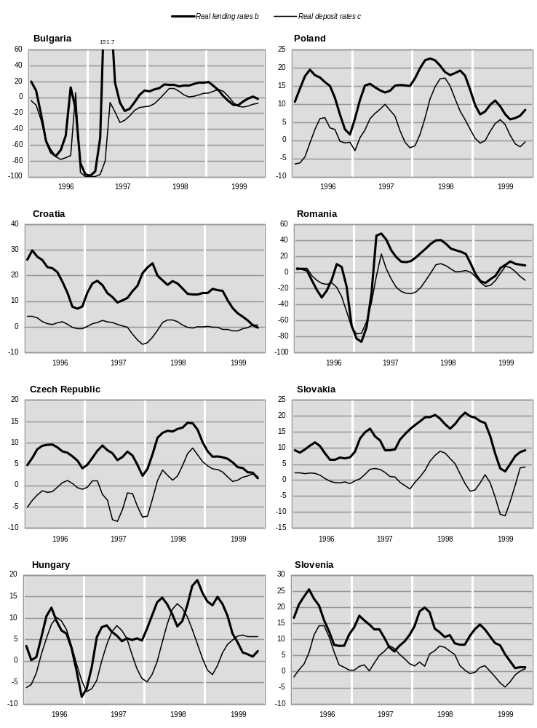
(For source and notes see end of chart.)

The charts provide evidence of high real interest rate spreads in most transition economies for quite long periods between 1994 and 1999 (for example in Croatia, Romania, Slovakia, the Baltic states and Kazakhstan, among others). Most likely they are the result of the combined effect of both factors described above: the quality of banks’ assets in the transition economies is far from satisfactory (due to the large share of substandard and non-performing loans); in addition, as discussed in more detail below, during the transition the prices of non-tradable goods (which have a substantial weight in the CPI) typically grow faster than the prices of tradables (such as producer prices).
It can be seen on the charts that for short periods, consumers and borrowers in some countries have also benefited from differential price changes, that is, periods when real deposit rates have been positive and higher than real lending rates (which implies a transfer of real resources from banks to depositors and borrowers). However, such episodes have been the exception rather than the rule.
CHART 3.2.1 (concluded)
Real short-term interest rates in selected transition economies, 1996-1999
(Three-month moving average of the ex-post forward-looking real rates, a per cent)

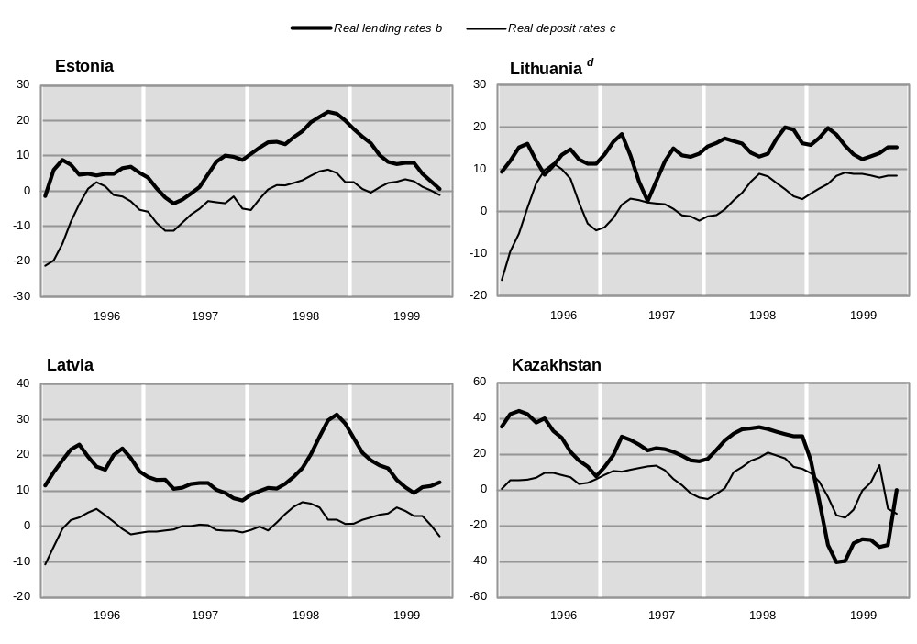
Source: UN/ECE secretariat calculations, based on national statistics and direct communications from central banks.
a The ex-post forward-looking rates are the nominal rates discounted by the rate of inflation in the following three-month period.
b Discounted by PPI.
c Discounted by CPI.
d The lending rate for Lithuania is discounted by the index of producer prices excluding the prices of petroleum products.

In sum, the painful process of economic restructuring during the transition (and sometimes policy mistakes in implementing the transformation agenda) have often resulted in an extra financial burden, mostly on the population but sometimes also on viable enterprises, in the form of hidden transfers of real monetary funds which have been channelled through the financial system and which cover part of the costs of the needed adjustment.

(c) Selected policy issues: EU accession and monetary integration
The start in 1997 of accession negotiations between the European Union and a new group of candidate members has incited lively policy debates in the transition economies that seek membership of the European Union on a plethora of issues related to the choice of efficient pre-accession strategies. One of the topics concerns the strategy of integration into the financial system of the European Union and the setting of targets related to the process of future monetary integration. In particular, much public attention has been focused on issues related to the European Union’s exchange rate mechanism (ERM) and to eventual future accession to the euro zone. This interest was increased by the debut of the monetary union in 1999 and by the forthcoming launch, in 2002, of the euro as the single currency of circulation in the countries of the euro zone.
The euro has acquired a somewhat emblematic appeal as a symbol of economic integration within the European Union, and this is especially so for the transition economies that are striving to be part of a pan-European success story. Perhaps this is one of the reasons why a number of policy makers in the transition economies have been attracted by the idea of rapid monetary integration with the European Union and by early adoption of the single currency. Voices advocating such policy goals have been loud both in countries that are among the front-runners for membership in the European Union (such as Hungary and Poland) and in those for which membership is a more distant goal (such as Bulgaria). Moreover, this idea seems to have found supporters in economies applying different exchange rate regimes: from currency boards (Bulgaria, Estonia, Lithuania) to more flexible regimes such as the crawling peg with a wide fluctuation band (Poland). Among the presumed advantages of rapid euro-ization, those repeatedly cited are: the elimination of exchange rate risk; the strengthening of monetary and financial discipline; the reduction in transaction costs related to cross-border payments; and the boost to policy credibility and transparency (especially for foreign investors).
Despite its appeal to policy makers and some of the positive effects that speedy monetary integration may bring about, it has to be stated that such a strategy involves considerable risks for those transition economies that may attempt to pursue it. Moreover, the less prepared is an economy, the greater will be the risks stemming from a premature abolition of the national currency as a key policy instrument. The conditions for successful monetary integration have been extensively discussed in both the academic literature and in the wide-ranging policy debate that preceded the launching of the economic and monetary union (EMU). In view of this, attention here is focussed only on some aspects that have not been so widely discussed and that stem from the specificity of the transition economies that are now entering accession negotiations.
What is specific in the forthcoming round of enlargement of the European Union, is that the candidates are all relatively low income economies. Although in the past there have been new members joining the European Union with incomes well below the average per capita GDP of the Union, this has been the exception rather than the rule. The adopted criteria for participating in the EMU imply that the members are mature, similar and converging economies, as indeed was the case when these criteria were put forward a decade ago. They focus mainly in fact on the “fine tuning” elements of economic and monetary convergence, leading to the final phase of an integration process that started decades ago. Consequently, when proponents of rapid monetary integration mechanically apply such criteria to “test” which of the transition economies are ready to join the EMU, they tend to overlook major differences in economic fundamentals that exist at present between the transition economies and member states of the European Union.
The fact is that the distance in terms of income levels between most of the accession candidates from the transition economies and the European Union can still be measured in decades. That is, even under favourable assumptions about future growth, they still face a long process of catching up before they reach the income levels and living standards prevailing in western Europe. Moreover, as repeatedly discussed in this Survey, all transition economies are still undergoing fundamental structural changes and these will also continue for some time to come.
The turbulence that still characterizes the transition economies, and which is likely to continue in the foreseeable future, has a number of implications for eventual monetary integration. One of the crucial factors that will have profound and lasting policy implications for the candidate members of the European Union concerns their real exchange rates. The long-term dynamics of the real exchange rate reflect fundamental structural changes in the economy which lead to permanent shifts in the relative positioning of some important macroeconomic variables.
In particular, a robust theoretical finding in the economic literature (which has been verified in numerous empirical studies) is the link between changes in relative productivity and the associated changes in the structure of relative prices which is usually referred to as the “Balassa-Samuelson effect”. This notion is used to characterize a variety of implications which result from the incidence of a difference in productivity levels (and/or in productivity growth) between two (or more) economies, or between sectors within an economy.
The Balassa-Samuelson effect implies that economies that are systematically characterized by higher levels of productivity would also tend to have currencies that are relatively more “expensive” in nominal exchange rate terms than the currencies of less productive economies. That is, a difference in productivity levels leads to the emergence of a discrepancy between the actual purchasing power of the currencies and the market determined nominal exchange rates established between them (this is the so-called “exchange rate deviation index”). In this sense the exchange rate deviation index can be regarded as a specific definition of the real exchange rate.
The actual deviation of nominal exchange rates from their domestic purchasing power parities has been identified and measured empirically in studies of cross-country comparisons of income levels (which in turn result from differences in productivity). In particular, such studies have shown that per capita income disparities among countries are positively correlated with such deviations; on the other hand, such discrepancies are not observed among countries with similar levels of per capita incomes.
The deviation indices, computed on the basis of the results of the latest (1996) round of the European Comparison Programme, provide similar evidence for the European economies (chart 3.2.2). While the deviation indices for the member states of the European Union are close to one (meaning that the observed exchange rates among the member states of the European Union are close to their purchasing parities), for the transition economies they are in general substantially larger than one. Moreover, the statistical association observable in the chart is consistent with the conjecture outlined above: the lower the per capita income (the greater the income disparity), the larger the discrepancy between the nominal exchange rate and the domestic purchasing power of a given currency.
One of the important dynamic consequences of the Balassa-Samuelson effect is that in a fast-growing economy – characterized with a sustained rate of productivity catch up – the fundamental (or “equilibrium”) real exchange rate will tend to appreciate relative to economies growing at a slower pace. This implies that if one of the main goals of transformation policy – that of reducing the income gap vis-à-vis the developed industrialized economies – is to be achieved, the transition economies will inevitably experience an appreciation of their real exchange rates. Indeed, the recent data on real effective exchange rates (chart 3.2.3) provide strong evidence of a systematic trend towards real exchange rate appreciation in all the transition economies for which the quality of the available statistics allow such indices to be computed. From the perspective of the existing purchasing power disparities (chart 3.2.2), if the transition economies start improving their relative per capita income position vis-à-vis the developed west European countries (this would correspond to a movement to the right on the chart), there will at the same time be a reduction in their exchange rate deviation indices (they will also move downwards on the chart).
In the context of the envisaged EU accession, this means that as long as the process of catching up with EU productivity and income levels continues, there will be a parallel process of real appreciation of the transition economies’ currencies vis-à-vis the euro (assuming that the latter takes on its planned function of a single currency). It should be emphasized that as the shifts in productivity and real exchange rate reflect parallel changes in economic fundamentals, they occur irrespective of policy, in particular of the exchange rate regime. However, such shifts entail an adjustment process that can involve a number of important economic variables.
Assuming that a transition economy opts for unilateral euro-ization and that it is in the course of catching up with EU productivity levels, what would be the likely outcome of such a policy? Obviously assuming a continuing productivity catch up, it cannot reverse or stop the process of real exchange rate appreciation. However, if the nominal exchange rate is eliminated as an adjustment mechanism, the real appreciation must be forced through different channels.
CHART 3.2.2
Exchange rate deviation indices for the ECE transition economies and the European Union member states in 1996

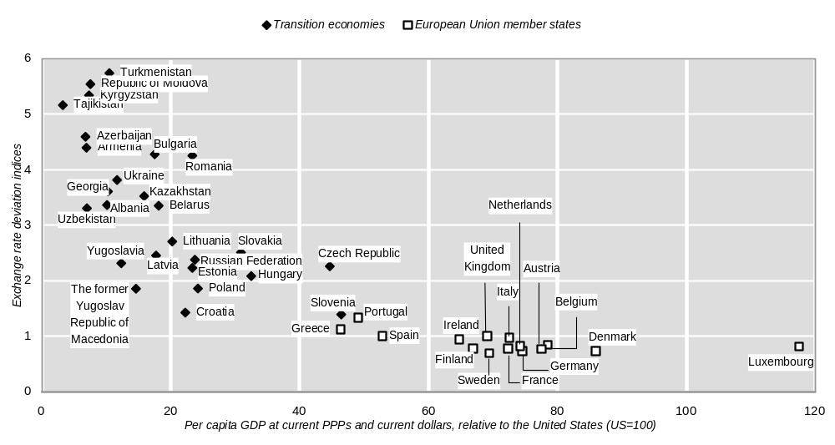
Source: UN/ECE secretariat.
Note: The exchange rate deviation indices are the ratios between purchasing power parities and average annual exchange rates for the corresponding countries.

Hypothesizing on the expected outcomes implies hypothesizing about the actual adjustment mechanisms. Thus, on the assumption of perfect markets and instantaneous adjustment (which, at least implicitly, probably reflects the current mainstream view), adjustment would occur through the domestic price level. The price level of tradable goods is set on the international market and is directly transmitted to the domestic market, given the absence of a nominal exchange rate mechanism. However, increasing (relative to a reference foreign country) productivity in the domestic sector producing tradable goods will lead to a systematic rise in wages in this sector; consequently, the spillover effect on wages in the non-tradables sector will lead to price increases in the latter leading to an overall rise in inflation, at a rate which exceeds that in the reference country. In the absence of a nominal exchange rate, the rise in the domestic price level relative to that in the reference country is equivalent to the appreciation of the real exchange rate.
Alternatively, assuming market imperfections (such as market segmentation, imperfect information, substantial adjustment costs, etc.) might lead to different static equilibrium outcomes. For example, if the international market is segmented and the prices of tradable goods in the catching up country are set independently of the prices in other market segments, partial equilibrium can be reached through both a nominal and a real adjustment in this segment. In the event of an increased supply of goods (a supply shift resulting from higher productivity and disturbing the previously established product market equilibrium), producers will have to accept either lower prices or to reduce supply (or some combination of the two) in order to re-establish equilibrium. A real adjustment of this type involves a cut in output which, in turn, entails either a reversal in productivity gains at the expense of maintaining redundant labour or maintaining productivity at a lower level of employment that is, by increasing unemployment.
Irrespective of the actual adjustment mechanisms, in both cases there will be negative consequences for the catching-up economy. In the first case, inflation rates would be systematically higher than those in the euro zone. In the second case, the outcome might be a combination of deflation with output reduction, eventually reversing the very catch up in productivity that had given rise to the adjustment in the first place.
CHART 3.2.3
Real effective exchange rates in selected transition economies, 1994-1999
(First quarter 1994=100)

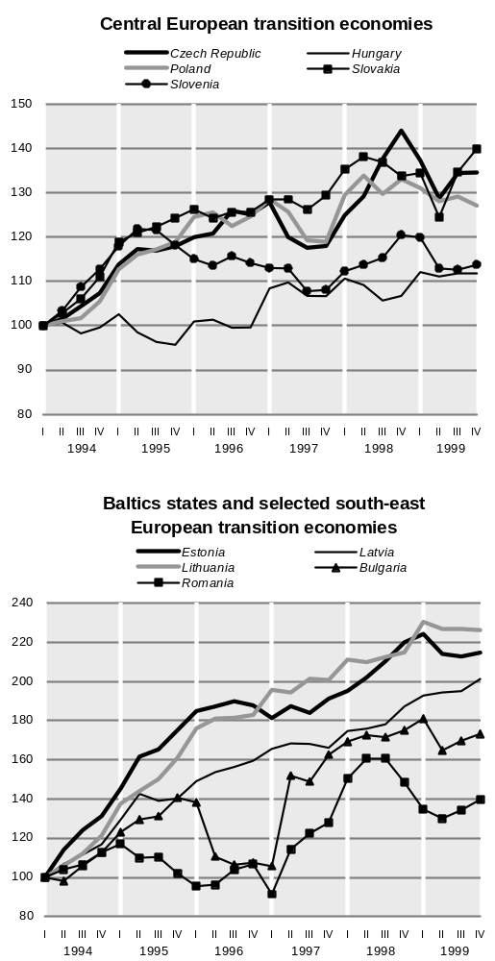

Source: UN/ECE secretariat calculations, based on national statistics.
Note: The real effective exchange rate indicator was computed from the nominal exchange rates against the deutsche mark and the dollar, deflated respectively by the domestic and German or United States consumer price indices, while the shares of the European Union and the rest of the world in total exports of individual transition economies were used to determine the deutsche mark and the dollar trade weights, respectively.

There may be similar negative consequences as a result of sticking to a fixed exchange rate regime during a period of sustained and high rates of economic growth and productivity. The main difference in this case, though, is that the continued existence of the exchange rate mechanism leaves the door open for an eventual correction in the nominal exchange rate.
The main conclusion from these reflections is that a process of fundamental structural change and productivity catch up requires a sufficient degree of nominal flexibility since the real adjustments give rise to changes in relative prices (including real exchange rates), which are actually brought about by differential changes in nominal variables. In this context the nominal exchange rate is a key variable that can and does absorb the required adjustments and hence during the process of catch up it is essential that there be sufficient nominal exchange rate flexibility. The exchange rate regime is the key policy instrument for this purpose, and as such it provides policy options that can allow the economy to adjust more smoothly than under the alternatives discussed above.
Preventing real appreciation through the nominal exchange rate mechanism may have negative and damaging economic implications. In this sense, the sticking to a fixed nominal exchange rate for a long time may not be the most efficient long-term policy course during the transition. A fixed exchange rate regime may be an efficient policy instrument for short-term macroeconomic stabilization during the initial phases of transition; however, maintaining it during a period of high and sustained economic growth (which, after all, is the objective of the next phase of the transition) is questionable in view of the need to accommodate the accompanying real appreciation.
As has been observed in the literature, real exchange rate appreciation can be regarded as the equilibrium outcome of a successful process of transformation; when the transition is complete the real appreciation will cease. There is nothing that policy can do to change or reverse this outcome; policy makers have to accept the implications and side effects of this fundamental economic change and tune their policies accordingly. In the first place this concerns exchange rate policy, which will need to provide for more flexibility in the nominal exchange rate during the later phases of the transition. Premature elimination of the exchange rate mechanism as a policy instrument (this would be the result of a premature euro-ization i.e. before the productivity catch up is achieved) would deprive policy makers of a vital degree of manoeuvre and might even put brakes on the catch-up process itself. Monetary integration has rather to follow real integration, not attempt to lead it in the process of accession to the European Union.

(iii) Fiscal policy
TABLE 3.2.4
General government deficits and their sources of financing in the ECE transition economies, 1995-2000
(Per cent of GDP)
 | General government deficit/surplus |  |  |  |  | Deficit projected (IMF method)
 | 1995 | 1996 | 1997 | 1998 | 1999 | 1999 | 2000
Albania | .. | -6.5 | -12.0 | -3.7 | -13.8* | -9.8 | -4.0
Bulgaria | -6.0 | -16.4 | -1.6 | 0.7 | -1.0* | -2.8 | -1.5
Croatia | -1.7 | -1.8 | -2.2 | -1.5 | -3.6* | -3.6 | -3.5
Czech Republic | -2.0 | -2.4 | -2.6 | -2.9 | -4.1 | -3.9 | -3.8
Hungary | -7.7 | -4.2 | -5.5 | -7.8 | -5.6 | -3.9 | -3.5
Poland | -3.1 | -3.7 | -3.5 | -3.2 | -3.5* | -2.9 | -2.8
Romania | -3.5 | -5.1 | -6.5 | -6.5 | .. | -3.6 | -3.0
Slovakia | -0.5 | -3.9 | -6.3 | -6.2 | -3.0* | -3.0 | -3.0
Slovenia | -0.3 | -0.3 | -1.9 | -1.6 | -0.7* | -0.7 | -1.0
The former Yugoslav  Republic of Macedonia | -1.0 | -1.0 | -0.4 | -1.9 | -1.6 | .. | ..
Estonia | -2.0 | -3.0 | 1.0 | -1.6 | -5.3 | .. | -1.5
Latvia | .. | -1.5 | -0.2 | -1.0 | -3.5* | -4.0 | -1.9
Lithuania | -4.8 | -3.8 | -2.1 | -5.5 | -7.6* | .. | -2.8
Armenia | -3.4 | -5.0 | -2.6 | -2.8 | -4.0 | -5.1 | -4.5
Azerbaijan | -3.7 | -2.3 | -1.0 | -2.0 | -4.5 | -4.0 | -2.6
Belarus | -3.4 | -2.2 | -1.7 | -1.0 | -1.6 | .. | ..
Georgia | -6.7 | -8.2 | -5.1 | -5.0 | -6.2 | .. | ..
Kazakhstan | .. | .. | -7.4 | -8.2 | -5.7 | -7.0 | -6.0
Kyrgyzstan | -13.8 | -8.8 | -6.0 | -3.6 | -2.5 | -7.0 | -7.4
Republic of Moldova | .. | -10.6 | -10.2 | -4.2 | -4.2 | -4.0 | ..
Russian Federation | -3.9 | -5.1 | -5.8 | -6.2 | -1.7* | -2.5 | -1.2
Tajikistan | -3.0 | -3.6 | -1.6 | -1.0 | -3.1 | -3.0 | -2.2
Ukraine | .. | .. | .. | .. | -1.5* | -1.5 | ..
Memorandum item:
European Union | -5.0 | -4.1 | -2.3 | -1.5 | -1.5 | .. | ..
Source: UN/ECE secretariat estimates and calculations, based on direct communications from national Ministries of Finance. European Union from Eurostat.
Note: The general government deficit, or financing requirement, is defined here as (current revenue) - (current and capital expenditure plus net lending for policy purposes). A deficit is negative, a surplus is positive. With this definition of the deficit, it follows that privatization and other capital receipts are components of financing, not of revenue. The three components of financing (borrowing, privatization and other capital receipts) sum to the general government deficit (or surplus) with opposite sign. Where the borrowing item is negative, this indicates net repayment of government debt. The "IMF" method of the IMF Fiscal Affairs Division is generally to treat only privatization receipts, but not other capital receipts, as financing. Thus the "IMF methodology deficit" is normally equal to the general government deficit plus other capital receipts. The general government deficit here is closest to the present definition of the "Maastricht criterion", as presently interpreted by Eurostat. The "IMF-GFS" method, frequently cited by national sources, defines the general government deficit as in the first panel of this table. Deficits projected at the start of 1999 and 2000 are official budget deficits, forecast in the initial budget proposals, necessarily involving GDP and inflation projections as well as fiscal data. Sources are national ministries of finance, official press releases from Reuters, letters of intent and other country information offered to the IMF (www.imf.org/external), and official websites of ministries of finance.

In 1999 fiscal policy in all but a few countries of eastern Europe came under pressure from the consequences of the Russian and global financial crises and the slowdown in import demand in western Europe. The associated weakening of output in the transition economies led, in the first half of 1999, to revenue shortfalls and demands for additional expenditure, most acutely in the Baltic states where the impact was already visible by the end of 1998. An additional source of strain was the impact of the ongoing reforms in public finance in a number of countries (in particular, pension and health care reforms), often associated with significant short-term costs and disruptions.
Until mid-year, budget deficits were largely missing the ex-ante targets which raised fears that some countries might be facing a fiscal crisis. However, the clear improvement in the general economic environment during 1999, in combination with a number of supplementary fiscal measures, helped to ease the strain on government budgets. In fact, the outcomes for the year as a whole turned out to be much better than had been feared earlier on. The overall picture for 1999 is not, therefore, markedly worse than in 1998 (table 3.2.4), although for both years taken together, there would appear to be a pause in the longer-term process of fiscal consolidation. Further reduction of budget deficits remains an important target of economic policy across the board, not least in countries also concerned at their current account deficit. The government budgets for 2000 suggest that virtually all the east European transition economies have targeted a return to the path of incremental deficit reduction coupled with further structural reform of public finances.
For many of the countries of the CIS, 1999 was a year of progress in reducing general government budget deficits. There was a remarkable improvement in the Russian public finances, with the general government deficit falling from over 6 per cent in 1998 to 1.7 per cent. Nonetheless, the entire process of institutional transformation in the field of public finance, as in the broader transition itself, is markedly less advanced in the CIS than in eastern Europe. The institutional weakness of new states, and the delays in the implementation of major structural reforms, are often reflected in persistent fiscal imbalances which, in turn, have proved a major barrier to sustained growth and investment. For these countries continuing to strengthen the public finances, and especially the institutional framework of tax collection and expenditure control, is an important element in strengthening not only the wider programme of economic reform but also the basis for political stability.
For all transition economies, the continued pursuit of fiscal consolidation was one of the reasons initial budget targets for 1999 (table 3.2.4) had been somewhat optimistic about a further lowering of deficits. The period beginning in late 1998 saw a halt to improving trends, and it was this which attracted more attention than worries about the conjunctural impact of a single year. For this reason, a longer perspective on transition public finance development is needed.

(a) Economic transformation and fiscal reforms
At the start of the transition, in 1989-1990, the need for major fiscal reforms was generally underestimated. The emphasis was more on the need for rapid privatization and “getting the state out of the economy”; the need to reform state structures and public administration in order to perform their very different but crucial roles in a market economy received less attention until a number of fiscal crises emerged in late 1991 and 1992.
The first sign of serious problems was a sharp drop in budget revenues, due in the first place to the collapse of the main sources of revenue in the centrally planned economies, the turnover and profits taxes, neither of which resembled taxes with similar names in the market economies. This fall in revenue was partly due to the dramatic output decline during the first years of transition, but it was also the result of the collapse of the social and administrative order which provided the institutional framework for collecting taxes under the old regime. The growth of the de novo private sector was another positive development which initially had negative fiscal implications, as the generally understaffed tax administrations were not prepared to cope with the snowballing number of taxpayers.
More generally, a central task was the creation of a tax base, as understood in the western market economies, a process which is still underway, and which involves, inter alia, the social acceptance of fiscal rules in place of official discretion. Thus both entirely new approaches to tax and entirely new, and much larger, and newly trained, tax administrations had to be developed at the same time as urgent demands on them were already escalating.
The large and variegated budget subsidies under the old regime were an early target for elimination, but other categories of expenditure could not be cut so quickly. Moreover, quasi-fiscal activities, such as directed credits, the tolerance of accumulating tax arrears as a form of shadow subsidy, and the maintenance of a myriad of long-standing off-budget funds, further clouded the expenditure side of the balance. Thus, in the early years of transition, deficits, not all of them transparent, were expanding rapidly at a time when non-inflationary forms of finance generally remained very limited.
An important measure to deal with the revenue shortfall was the adoption of the value added tax (VAT), which is now in operation in virtually all the ECE transition economies. The rates adopted initially have generally been reduced, and in most countries VAT now provides about the same proportion of total fiscal revenue (including the social security contributions) as in most of western Europe, that is, some 15 to 25 per cent. As another step in reforming public finances, a number of transition economies have introduced, or are in the process of introducing, uniform personal income taxes.
However, there were inevitable lags between the start of such wide-ranging fiscal reforms, and their results in the form of increased fiscal revenue; in the meantime many transition economies continued to face serious revenue shortfalls. In a number of transition economies, governments were thus forced to revert to immediate expenditure cuts in order to maintain control over the fiscal balance. This, in turn, created a dilemma since a number of reforms actually entailed higher public spending: social expenditure was rising in line with unemployment; there was considerable demand for public funds to clear bad debts from the books of banks and to rehabilitate ailing state owned firms; and the preparation of state owned firms for privatization generally involved upfront costs. There was also an obvious need to create genuine local government and to enable it to take over the services traditionally supplied by enterprises, which also implied increased public spending. Thus, there were no easy solutions to be found in the short run, and this difficult initial period was actually lengthened by the failure to drive ahead with fiscal reform earlier.
With developing fiscal problems in eastern Europe, and the final break-up of the USSR, 1992 can be regarded as a benchmark year for the analysis of fiscal imbalances in the transition economies. Chart 3.2.4 broadly indicates the degree of progress made since then.
Box 3.2.1
Measuring the fiscal stance
The fiscal statistics for the ECE transition economies used in this section are based on replies by Ministries of Finance to a questionnaire prepared by the UN/ECE secretariat. In choosing among alternative methodological approaches, the aim was to produce an economically meaningful data set which would be as internationally and intertemporally comparable as is presently possible. For this purpose the fiscal operations of the state are taken at the broadest definition of the “consolidated general government”. The latter takes into account the consolidated fiscal flows at all levels and any “extrabudgetary funds” whose receipts are collected with state authority (state pension or social funds are the best-known examples of the latter). Public corporations are not considered part of general government.
The choice of fiscal balance measure depends on the purpose of the measurement. The “general government deficit” presented in table 3.2.4, is the difference between current revenues and expenditures. The latter includes net lending for policy purposes while capital receipts, from privatization and sales of other government owned assets, are not included in current revenue. Other definitions of the fiscal balance are also widely used for different purposes. For example, the so-called “primary balance”, is the surplus or deficit, net of interest payments, and may be calculated by reference to table 3.2.6. The definition of the deficit in the first panel of table 3.2.4 is in line with the official conventions now used by Eurostat to determine the fiscal deficit according to the “Maastricht criterion” for membership of the EMU.
Table 3.2.5 shows the main sources of financing the fiscal deficit: borrowing or selling of state assets (due to the importance of privatization revenues as a source of finance in the transition economies, these are shown separately). Borrowing may involve drawing direct credits from the central bank (thereby utilizing the state’s right to print money and monetize the deficit), borrowing from the private sector or from abroad. The sum of these three financial flows (with opposite sign) by definition should equal the deficit.
It should be mentioned that despite numerous attempts to introduce international standards in the reporting of national fiscal accounts (in the first place by the IMF), national practices still vary considerably. Moreover, it is an inherent feature of any type of accounting that there exists ample room for discretion in the treatment of individual accounting items. Discretionary treatment may cause considerable differences in the final accounts, especially when this involves large individual items (subsection (b) below offers some examples). For this reason, in various publications there have been widely varying, sometimes conflicting, measures of the fiscal stance in the transition economies. In this section an attempt has been (to the extent possible on the basis of the available statistics and with the usual caution about the quality of the source data) to use a uniform methodology for the measurement of the general government deficit in the different countries. It must be noted that in some cases this may result in deficits that are different from those officially reported by the national ministries of finance or by other international organizations.
Finally, all the data presented in tables 3.2.4-3.2.8 are on a cash, rather than an accruals, or commitments basis. However, a feature of many transition economies in recent years has been the accumulation of unusually large tax and spending arrears and for this reason considerable care must be taken in interpreting the basic data.

Government expenditure in most of the transition economies in 1992 was significantly higher than in market economies with comparable levels of per capita GDP (in purchasing power parity terms), sometimes up to 10 percentage points of GDP higher. The weighted mean deficit of 25 transition economies of the ECE region (that is all except Bosnia and Herzegovina and Yugoslavia for which data are lacking) in 1992 was 11.2 per cent of GDP while general government expenditure averaged 54.7 per cent. The corresponding averages for eastern Europe and the Baltic states were 5.4 per cent and 49.7 per cent, respectively; and for the CIS 20.1 per cent and 62.8 per cent, respectively.
Two main conclusions can be drawn from the data presented on the first panel of chart 3.2.4. Firstly, even without applying statistical methods, it is evident that in 1992 there was no statistical association between the share of expenditure in GDP and per capita income in PPP terms within the group of transition economies. Secondly, whatever the measurement problems, it seems clear that revenues in 1992 were insufficient to support expenditure; and given that the available means of financing the deficits were very limited, public expenditure was unequivocally too high in most of the transition economies.
Fiscal transformation has nevertheless proceeded since 1992, despite difficulties and setbacks. Thus, as is shown in the second panel of chart 3.2.4, in 1998 there was a more consistent relationship between per capita GDP and the share of general government expenditure in GDP. In addition, the comparison of 1992 with 1998 suggests that two important changes have taken place, although it is open to question whether both may be termed favourable. The weighted mean of the general government budget deficit in the ECE transition economies has fallen from 16.1 per cent of GDP in 1992 to 5.4 per cent in 1998, and the share of general government expenditure in GDP from 58.6 per cent to 38.0 per cent. These averages mask considerable intercountry differences. In eastern Europe and the Baltic states, the mean budget deficit has fallen from 5.1 per cent in 1992 to 2.7 per cent of GDP in 1998, while the general government share of expenditure in GDP has shrunk more modestly, from 47.4 per cent in 1992 to 42.2 per cent in 1998. In the CIS countries, the fall in the average share of government expenditure has been considerable, from 62.5 per cent to 35.2 per cent, and the budget deficit has declined from 20.1 per cent to 7.1 per cent.
TABLE 3.2.5
The sources of financing in general government deficits in the ECE transition economies, 1995-1999
(Per cent of GDP)
 | Financing of general government deficit by components
 | General government borrowing |  |  |  |  | Privatization receipts |  |  |  |  | Other capital receipts
 | 1995 | 1996 | 1997 | 1998 | 1999 | 1995 | 1996 | 1997 | 1998 | 1999 | 1995 | 1996 | 1997 | 1998 | 1999
Albania | .. | 6.4 | 12.0 | 3.7 | .. | .. | 0.1 | – | – | .. | .. | .. | – | .. | ..
Bulgaria | 5.2 | 15.4 | -2.1 | -2.7 | .. | 0.4 | 0.9 | 3.2 | 1.7 | .. | 0.3 | 0.1 | 0.6 | 0.4 | ..
Croatia | 0.7 | 0.4 | 1.2 | -0.5 | .. | 0.1 | – | – | – | .. | 0.9 | 1.4 | 1.0 | 2.0 | ..
Czech Republic | -0.4 | 0.3 | 1.2 | 1.5 | 0.8 | 2.0 | 1.6 | 0.8 | 0.9 | 1.4 | 0.4 | 0.5 | 0.5 | 0.5 | 1.9
Hungary | 3.7 | -0.3 | 2.3 | 6.6 | 4.6 | 2.9 | 3.4 | 2.2 | 0.2 | 0.1 | 1.1 | 1.1 | 1.1 | 1.0 | 0.9
Poland | 1.8 | 2.2 | 1.4 | 1.2 | .. | 0.9 | 1.0 | 1.4 | 1.3 | .. | 0.4 | 0.6 | 0.7 | 0.7 | ..
Romania | 2.9 | 4.0 | 3.8 | 4.7 | .. | 0.6 | 0.9 | 1.7 | 1.8 | .. | 0.1 | 0.1 | 0.9 | – | ..
Slovakia | -1.9 | 1.6 | 4.6 | 4.8 | .. | 1.7 | 1.4 | 0.5 | 0.6 | .. | 0.7 | 0.9 | 1.2 | 0.8 | ..
Slovenia | -0.1 | -0.2 | 1.2 | 0.7 | .. | 0.4 | 0.4 | 0.5 | 0.8 | .. | 0.1 | 0.1 | 0.1 | 0.1 | ..
The former Yugoslav  Republic of Macedonia | 1.0 | 0.6 | 0.3 | 1.8 | 1.5 | .. | .. | .. | .. | .. | 0.1 | 0.4 | 0.1 | 0.1 | 0.1
Estonia | 0.6 | 1.9 | -2.2 | 0.3 | 4.7 | .. | .. | .. | .. | .. | 1.4 | 1.0 | 1.1 | 1.3 | 0.6
Latvia | .. | 1.4 | -1.2 | -0.1 | 3.8 | .. | 0.1 | 1.4 | 1.2 | .. | .. | .. | .. | .. | ..
Lithuania | 4.7 | 3.7 | 1.9 | 0.3 | .. | 0.1 | 0.1 | 0.2 | 5.2 | .. | – | – | – | – | ..
Armenia | 3.4 | 4.9 | 2.6 | 0.6 | 2.9 | – | – | – | 2.2 | 1.2 | .. | .. | .. | .. | ..
Azerbaijan | 3.7 | 2.3 | 0.9 | 1.4 | 4.1 | .. | .. | 0.1 | 0.6 | 0.4 | .. | .. | .. | .. | ..
Belarus | 2.7 | 1.9 | 1.2 | 0.6 | 1.3 | 0.1 | 0.1 | 0.2 | 0.1 | 0.1 | 0.5 | 0.2 | 0.3 | 0.3 | 0.2
Georgia | 6.7 | 7.8 | 4.7 | 3.9 | 5.3 | .. | 0.4 | 0.4 | 1.1 | 0.9 | .. | .. | .. | .. | ..
Kazakhstan | .. | .. | 3.8 | 4.2 | 3.8 | .. | .. | 3.3 | 3.8 | 1.8 | .. | .. | 0.3 | 0.2 | 0.1
Kyrgyzstan | 13.5 | 7.3 | 5.5 | 3.3 | 1.7 | 0.3 | 0.4 | 0.1 | 0.2 | 0.5 | – | 1.2 | 0.4 | – | 0.3
Republic of Moldova | .. | 9.8 | 7.5 | 3.3 | 3.0 | .. | .. | 0.6 | .. | .. | .. | 0.7 | 2.1 | 0.9 | 1.1
Russian Federation | 2.9 | 4.2 | 4.7 | 5.4 | .. | 0.4 | 0.1 | 0.9 | 0.7 | .. | 0.5 | 0.8 | 0.2 | 0.1 | ..
Tajikistan | 3.0 | 3.4 | 1.0 | 0.3 | 1.8 | .. | .. | .. | .. | .. | .. | 0.2 | 0.5 | 0.7 | 1.3
Source and note: As for table 3.2.4.

In fact, despite the declining share of expenditure in GDP, real public expenditure has been rising in many east European and Baltic economies during this period thanks to relatively high GDP growth, whereas this has not been the case for the CIS countries. It is, therefore, evident that quite different tasks face the policy makers in the two groups of countries. In the transition economies aspiring to membership of the European Union, the fiscal reform process consists more in ensuring that the budget process continues to acquire the necessary instruments for increased efficiency, in the course of which further control over expenditure is likely to provide savings. The problem for the CIS countries remains that of obtaining enough revenue to meet basic expenditure needs, for which fiscal austerity is not a long-term solution. This reflects both the lagging reform process and the failure to embark on a path of sustained growth. Fiscal developments in 1999 have continued to underline the need for further institutional developments, but the need to shift to a longer-term fiscal outlook, against which cyclical fluctuations in government expenditure can be seen in a more realistic perspective, is also necessary.

(b) Recent fiscal developments, 1999-2000

Eastern Europe and the Baltic states
The economic slowdown of 1998 and early 1999 was perhaps the first mature cyclical downturn for the advanced reformers, and, as such, a key question-mark for policymakers was the extent to which business and market opinion might allow the automatic fiscal stabilizers to work. A number of developments in early 1999 were particularly striking: in Estonia, which had earned a reputation for fiscal prudence, the general government deficit increased in the first quarter to 8.5 per cent of GDP: the revenue forecast in the initial budget proposal proved to be overoptimistic, but expenditure also increased in a pre-election period (see table 3.2.4 for initial budget projections and outturns). In Poland the central government deficit in July had already reached 97.2 per cent of the target for the entire year; revenue shortfalls were important, but a large rise in expenditure, in particular for the troubled Social Security Office, were just as significant. In Hungary, increased expenditure, linked, as in Poland, to pension reform, was a key factor in the deterioration of the fiscal situation; the fiscal deficit at the end of May had already reached 87 per cent of its annual target.
CHART 3.2.4
Government expenditure and per capita GDP in the ECE transition economies, 1992 and 1998
(Dollars per capita)

1992
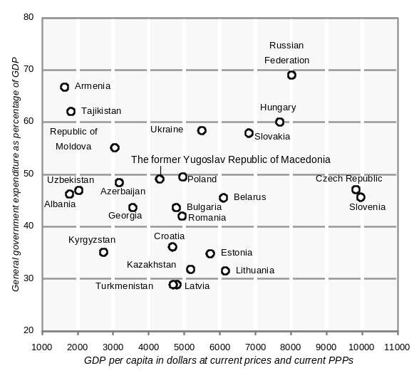
1998
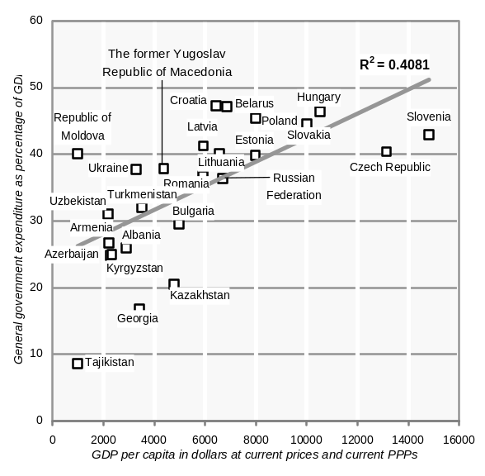

Source: UN/ECE secretariat calculations for per capita GDP in purchasing power parity current dollars.

In Estonia expenditure cuts were adopted in a supplementary budget, passed by parliament in June, after the elections. The revised budget aimed at keeping the deficit under 3 per cent of GDP, but the final result was actually 5.3 per cent (table 3.2.4). Although the current account deficit declined during this period, removing one source of concern about the fiscal deficit, the government has argued that the problems encountered in 1999 were due more to non-cyclical expenditure rising rather than to cyclical reductions in revenue coupled with increasing expenditure on unemployment benefits. In the panel for Estonia in chart 3.2.5, the recent budget “scissors” are visible: current revenue fell from 37.2 per cent of GDP in 1998 to 35.6 per cent in 1999 while total expenditures rose from 38.7 per cent to 40.8 per cent of GDP. The dynamics of revenue and expenditure in Latvia in 1999 (chart 3.2.5) were similar, with an even more pronounced dominance of spending inertia, as revenue was virtually stable while expenditures rose significantly. Arguably, neither of these developments reflected a conscious attempt to adopt a fiscal stance, but rather the outcome of political pressures and commitments in a recessionary situation.
CHART 3.2.5
General government revenue and expenditure in selected ECE transition countries, 1995-1996
(Per cent of GDP)

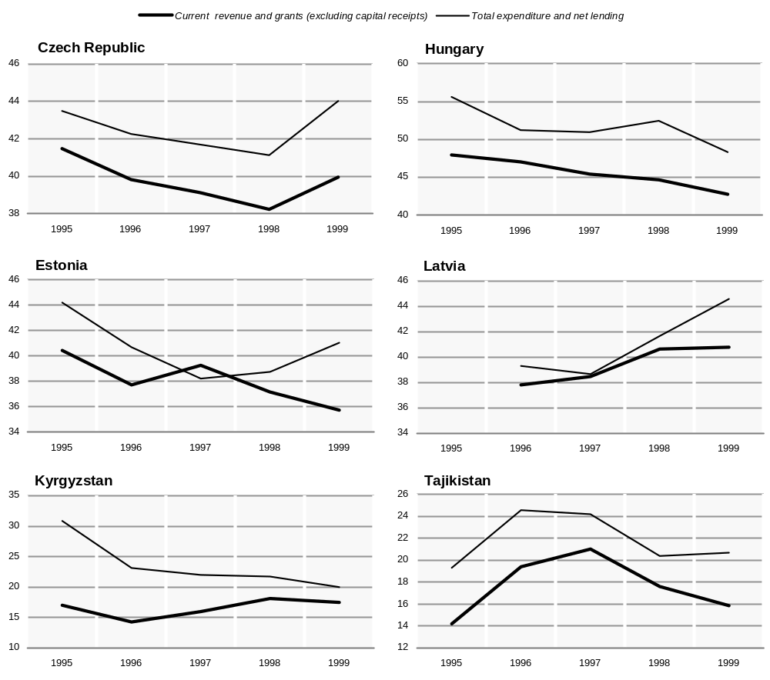
Source: UN/ECE secretariat calculations, based on direct communications from national Ministries of Finance.

Latvia and Lithuania (table 3.2.4) were subject to the same pressures as Estonia and, similarly, after a poor start, also saw some improvement during the year. Lithuania ended 1999 with a deficit of 7.6 per cent of GDP, which was actually better than some of the more pessimistic expectations. Like Estonia, both countries passed supplementary budgets, but in Lithuania this was not done until October. There was little in the way of crisis in these episodes, barring perhaps the late autumn difficulty Lithuania had in placing its debt, and the resultant high interest rates.
In Hungary, despite a much higher debt ratio than that in Estonia (table 3.2.6), and with a relatively large current account deficit, the government resisted the pressures for a fiscal correction, insisting that the second half of 1999 would be far more favourable for the budget. The Polish government also refused to change its fiscal stance on the basis of similar arguments. In the event, such a position turned out to be justified: with the improvement in output in the second half of the year fiscal revenues increased and the two governments largely succeeded in meeting their deficit targets. It is also notable that in both Hungary and Poland the monetary authorities did not find it necessary to counter the degree of fiscal relaxation in 1999 as the year progressed; in the Czech Republic monetary policy was also accommodating.
The other central and south-east European countries differed from this pattern of a more or less cyclical downturn. Slovakia’s budget deficit was halved, a result of austerity measures and reflecting a determination to correct the fiscal situation after the previous government’s expansionary but unsustainable policies. In Bulgaria and Slovenia the governments have been pursuing medium-term goals of fiscal consolidation in recent years; in Bulgaria the deficit was actually 1 per cent of GDP, considerably smaller than the government’s initial target of 2.8 per cent, whereas Slovenia maintained its record of very small deficits.
The events in Kosovo had severe fiscal consequences for Albania, already deeply in deficit. Its deficit is largely foreign-financed, and it was anticipated that the war would add another 4 per cent of GDP to the initial target of 9.8 per cent; of this, 5.5 per cent was to be financed from domestic sources. The former Yugoslav Republic of Macedonia, which had achieved very low budget deficits after an inauspicious start at independence, maintained a tight fiscal stance in 1999 (table 3.2.4). Romania’s principal fiscal difficulty was in financing its deficit (rather than just its overall size), the absence of confidence being a reflection of the overall transformation crisis in which it remains mired. Croatia veered suddenly into deficit in 1999, but only a small proportion was due to the consequences of the Kosovo conflict. In addition, it has been argued that the actual reported cash deficit may be even larger because of expenditure arrears. In fact, Croatia’s budgetary revenue and spending are among the highest in eastern Europe as a percentage of GDP, exceeding 50 per cent, and both have been rising in recent years (tables 3.2.7 and 3.2.8); one of the new government’s priorities is to reverse this tendency.
In general, the budgets adopted for the year 2000 (table 3.2.4) suggest cautiously optimistic projections for renewed fiscal consolidation. These fiscal goals are often underpinned by memoranda or Letters of Intent to the IMF, and for the Baltic countries are included in the conditions agreed for stand-by arrangements. Targeted deficits for the Baltic states have been more sharply reduced for 2000 than in central Europe reflecting, in part, the burden which necessarily falls on fiscal policy under a currency board or, as in Latvia, a tight currency peg.
In the first two months of 2000, just as in 1999, both Hungary and Poland have reported deficits which were relatively high as a proportion of the annual target but substantially lower than in the same period of 1999. Although this has prompted some renewal of concerns, both governments are optimistic that the budgets will remain under control, and they expected a normal upturn in revenues. The general outlook, then, even for more troubled economies such as Romania, is for lower budget deficits in 2000, and thus for a return to the general trend of fiscal consolidation. Set against the continuing tasks of transition, which still require increased expenditures, this is not an easy task, but it seems to be an objective that policy makers at present are determined to pursue.

Russia and other CIS countries
The remarkable improvement in the Russian fiscal situation in 1999 came as a surprise to most analysts and observers. The result was a reduction in the consolidated general government deficit to less than 1.7 per cent of GDP, in contrast to 6.2 per cent in 1998, and considerably below the target adopted in March 1999 (2.5 per cent).
Russian Federation Goskomstat estimates that the revenues of the consolidated federal, regional and local budget increased from 25.5 per cent to 26.8 per cent of GDP, whereas the corresponding share of expenditure declined from 31.2 per cent to 28.0 per cent of GDP. Two items account for almost all the expenditure decline: more than half is due to reductions in debt service, and somewhat more than a quarter to reductions in collective social expenditure, mainly at the regional and local level. The increase in revenues as a percentage of GDP was almost entirely due to the increased collection of profits tax. There was no fall in the share of income taxes, which – given the substantial fall in personal incomes in 1999 over 1998 – is a reflection of improved collection. The continued strength of the contribution to revenues from VAT (6.4 per cent of GDP) is another confirmation of improved tax collection.
TABLE 3.2.6
General government debt and interest payments in the ECE transition economies, 1995-1999
(Per cent of GDP)
 | Stock of government debt  outstanding at end of period |  |  |  |  | Interest payments on debt during period
 | 1995 | 1996 | 1997 | 1998 | 1999 | 1995 | 1996 | 1997 | 1998 | 1999
Albania | .. | 44.6 | 51.5 | 46.4 | .. | .. | 3.1 | 5.5 | 7.8 | ..
Bulgaria | 110.2 | 60.2 | 126.7 | .. | 87.1 | 14.6 | 20.2 | 8.4 | 4.4 | ..
Croatia | .. | .. | .. | .. | .. | .. | 1.2 | 1.5 | 1.5 | ..
Czech Republic | 15.3 | 13.1 | 13.0 | 13.4 | .. | 1.2 | 1.0 | 1.2 | 1.2 | 1.0
Hungary | 86.4 | 72.8 | 63.9 | 62.3 | .. | 9.3 | 8.3 | 9.8 | 7.8 | ..
Poland | 54.6 | 48.2 | 47.2 | 43.2 | .. | 4.5 | 3.7 | 3.5 | 3.3 | ..
Romania | .. | .. | .. | .. | .. | 1.3 | 1.6 | 3.6 | 4.7 | ..
Slovakia | 24.1 | 28.9 | 31.2 | 31.8 | .. | 2.3 | 2.2 | 2.1 | 3.0 | ..
Slovenia | 18.8 | 22.7 | 23.2 | 23.8 | .. | 1.2 | 1.2 | 1.2 | 1.3 | ..
The former Yugoslav Republic of Macedonia | .. | .. | .. | .. | .. | 1.6 | 2.0 | 2.2 | 1.9 | 1.6
Estonia | .. | 6.2 | 6.7 | 5.9 | 6.6 | 0.2 | 0.5 | 0.5 | 0.5 | 0.4
Latvia | .. | 14.4 | 12.0 | 9.9 | 13.0 | .. | 1.6 | 1.0 | 0.8 | ..
Armenia | .. | 35.1 | 44.5 | 43.9 | 50.2 | .. | .. | 2.5 | 1.9 | 2.0
Azerbaijan | .. | 14.0 | 13.5 | 16.1 | 25.6 | .. | .. | .. | .. | 0.5
Belarus | 17.1 | 11.7 | 12.4 | 21.0 | 15.7 | 0.2 | 0.7 | 0.7 | 0.7 | 0.7
Georgia | .. | .. | 30.7 | 41.9 | 72.8 | .. | .. | 1.1 | 1.9 | ..
Kazakhstan | .. | .. | 12.2 | 16.6 | 28.3 | .. | .. | 0.6 | 0.8 | 1.1
Kyrgyzstan | .. | .. | .. | .. | .. | 1.4 | 0.7 | 1.3 | 1.7 | 3.4
Republic of Moldova | .. | 40.2 | 47.8 | 61.4 | 78.5 | .. | .. | 4.8 | 5.5 | 7.5
Russian Federation | 48.5 | 49.4 | 49.7 | 139.9 | .. | .. | .. | .. | 5.9 | ..
Source: As for table 3.2.4.

The main reason why the increase in world oil prices does not appear to have had a visible direct impact on the figures for government revenue in 1999 is that until mid-year the export tax paid by exporters of oil was based on the world market price prevailing at the start of the year. At mid-year the base price for calculating the export tariff was raised to $15 a barrel, but by the fourth quarter it had already reached $25. Consequently, the impact of higher oil prices shows up more clearly in the oil companies’ payments of profits tax.
In general, the economic upturn in 1999 resulted in generally higher profitability in the enterprise sector which, in turn, expanded the base for the profits tax. The official figures for the proportion of all enterprises which are loss-making also reflects this: this share fell from 48.3 per cent in 1998 to 40.6 per cent in 1999. But in oil extraction, the proportion of loss-makers fell from 44.4 per cent to 27.7 per cent and in gas from 54.5 per cent to 32.4 per cent. The improvement in enterprise profitability was not only due to higher oil prices. For example, in the food industry, which has greatly benefited from extensive import substitution following the very large devaluation of the rouble, the share of loss-making enterprises has also fallen, from 44.6 per cent in 1998 to 36.5 per cent in 1999.
There have also been other positive developments on the revenue side which are not obvious in the figures quoted above. Chief of these is the marked improvement in obtaining revenues in monetary form, in place of the mutual offsets and barter arrangements which in previous years accounted for a large share of the fiscal flows in Russia. The federal budget has been particularly successful in monetizing its revenues, but while the regional and local budgets achieve a high rate of collection of taxes due, virtually 95 per cent, 35 per cent of their receipts are still in the form of non-monetary offsets, although this has been reduced from 50 per cent in 1998.
TABLE 3.2.7
General government current revenue in the ECE transition economies, 1997-1999
(Per cent of GDP)
 | Total current  revenue and grants |  |  | Taxes on income,  profits and capital gains |  |  | Social  security contributions
 | 1997 | 1998 | 1999 | 1997 | 1998 | 1999 | 1997 | 1998 | 1999
Albania | 16.2 | 20.6 | .. | 1.1 | 1.4 | .. | 2.8 | 2.0 | ..
Bulgaria | 36.4 | 39.2 | .. | 10.4 | 8.7 | .. | 7.6 | 7.7 | ..
Croatia | 47.7 | 50.6 | .. | 7.4 | 8.3 | .. | 14.3 | 13.9 | ..
Czech Republic | 39.1 | 38.7 | 40.3 | 8.6 | 9.0 | 8.9 | 14.8 | 14.7 | 14.7
Hungary | 45.4 | 44.7 | 42.7 | 8.6 | 8.8 | 8.8 | 14.0 | 13.8 | 12.9
Poland | 41.4 | 40.3 | .. | 11.3 | 11.1 | .. | 9.2 | 9.3 | ..
Romania | 30.5 | 32.1 | .. | 8.0 | 7.6 | .. | 7.0 | 9.1 | ..
Slovakia | 41.1 | 38.3 | .. | 9.3 | 9.6 | .. | 12.8 | 11.6 | ..
Slovenia | 41.9 | 43.0 | .. | 9.1 | 9.2 | .. | 13.8 | 13.8 | ..
The former Yugoslav Republic of Macedonia | 34.9 | 33.9 | 36.2 | 5.4 | 5.7 | 6.6 | 12.3 | 11.4 | 11.6
Estonia | 39.3 | 37.2 | 35.7 | 10.1 | 11.1 | 10.9 | 10.0 | 10.2 | 9.7
Latvia | 38.5 | 40.6 | 40.8 | 8.0 | 8.3 | 8.6 | 9.5 | 11.3 | 11.7
Lithuania | 30.8 | 32.3 | .. | .. | .. | .. | .. | .. | ..
Armenia | 15.7 | 17.5 | 17.5 | 4.0 | 2.7 | 2.5 | .. | .. | ..
Azerbaijan | 16.2 | 14.6 | 19.6 | 4.9 | 4.5 | 5.3 | .. | .. | ..
Belarus | 44.5 | 44.5 | 41.4 | 7.9 | 8.2 | 7.9 | 8.9 | 9.9 | 8.5
Georgia | 11.3 | 11.2 | 15.8 | 1.8 | 2.0 | 2.9 | 1.2 | 1.6 | 2.1
Kazakhstan | 20.7 | 17.9 | 19.0 | 4.9 | 3.9 | 4.8 | 7.5 | 4.3 | ..
Kyrgyzstan | 16.0 | 18.1 | 17.5 | 2.2 | 2.5 | 1.8 | .. | .. | ..
Republic of Moldova | 30.3 | 29.0 | 24.0 | 5.9 | 4.4 | 3.7 | .. | .. | ..
Russian Federation | 40.6 | 35.8 | .. | .. | 6.4 | .. | 10.4 | 9.2 | ..
Tajikistan | 21.0 | 17.6 | 15.9 | .. | .. | .. | .. | .. | ..
 | Domestic taxes on  goods and services |  |  | Taxes on international  trade and transactions |  |  | Non-tax revenue
 | 1997 | 1998 | 1999 | 1997 | 1998 | 1999 | 1997 | 1998 | 1999
Albania | 5.5 | 7.7 | .. | 2.9 | 3.0 | .. | 3.2 | 4.5 | ..
Bulgaria | 8.4 | 11.7 | .. | 2.1 | 2.1 | .. | 7.2 | 7.4 | ..
Croatia | 16.6 | 20.2 | .. | 3.8 | 3.1 | .. | 4.6 | 3.9 | ..
Czech Republic | 11.6 | 11.0 | 12.6 | 0.9 | 0.8 | 0.7 | 2.7 | 2.6 | 2.8
Hungary | 13.4 | 13.8 | 14.0 | 1.9 | 1.3 | 1.2 | 6.6 | 6.1 | 4.8
Poland | 12.2 | 11.9 | .. | 1.5 | 1.1 | .. | 5.8 | 5.4 | ..
Romania | 7.1 | 9.1 | .. | 1.5 | 1.6 | .. | 2.5 | 2.6 | ..
Slovakia | 12.1 | 11.3 | .. | 2.3 | 1.9 | .. | 3.8 | 3.3 | ..
Slovenia | 14.2 | 14.8 | .. | 2.0 | 1.5 | .. | 2.1 | 2.7 | ..
The former Yugoslav Republic of Macedonia | 11.1 | 10.3 | 10.9 | 3.0 | 3.6 | 4.3 | 2.5 | 2.4 | 2.4
Estonia | 14.3 | 12.7 | 12.4 | – | – | .. | 4.4 | 2.6 | 2.3
Latvia | 12.5 | 12.9 | 12.1 | 0.7 | 0.5 | 0.4 | 5.5 | 5.7 | 5.9
Lithuania | .. | .. | .. | .. | .. | .. | 1.3 | 1.6 | ..
Armenia | 7.0 | 8.3 | 8.9 | .. | .. | .. | 1.1 | 2.3 | 1.4
Azerbaijan | 6.6 | 6.6 | 8.3 | 0.5 | 0.6 | 1.8 | 1.4 | 1.0 | 1.7
Belarus | 13.7 | 13.4 | 12.4 | 2.5 | 2.3 | 1.9 | 2.3 | 2.2 | 1.9
Georgia | 4.0 | 3.5 | 6.5 | 1.0 | 0.9 | 0.6 | 1.8 | 1.4 | 0.7
Kazakhstan | 5.5 | 6.6 | 6.6 | 0.5 | 0.6 | 0.6 | 1.0 | 1.1 | 1.4
Kyrgyzstan | 7.4 | 8.3 | 8.3 | .. | .. | .. | 2.8 | 3.3 | 2.7
Republic of Moldova | 16.7 | 17.4 | 12.9 | 1.4 | 1.2 | 1.8 | 4.5 | 4.8 | 3.4
Russian Federation | .. | 10.1 | .. | .. | 1.3 | .. | 3.2 | 3.4 | ..
Tajikistan | .. | .. | .. | .. | .. | .. | 5.4 | 4.3 | 4.2
Source: As for table 3.2.4.

The improvement in federal budget revenues represents a deliberate shift of revenue assignment towards the centre. For example, the amount of VAT revenues retained in the regions was cut in April; for 1999 as a whole, and in constant prices, this reduction is estimated at 38 per cent on the 1998 level. Thus the overall improvement in revenue did not quite compensate the regions for their loss of VAT revenues: in real terms, preliminary data suggest that they had 11 per cent less to spend. Given the absence of deficit financing mechanisms, the regional authorities had little choice but to try to balance their budgets.
TABLE 3.2.8
General government expenditure in the ECE transition economies, 1995-1999
(Per cent of GDP)
 | Total expenditure including capital outlays |  |  | Current expenditure on goods and services |  |  | Subsidies and other current transfers |  |  | Capital outlays
 | 1997 | 1998 | 1999 | 1997 | 1998 | 1999 | 1997 | 1998 | 1999 | 1997 | 1998 | 1999
Albania | 28.3 | 24.4 | .. | 6.6 | 4.9 | .. | 12.7 | 7.0 | .. | 3.7 | 4.7 | ..
Bulgaria | 38.0 | 38.5 | .. | 15.0 | 16.5 | .. | 10.7 | 13.3 | .. | 3.1 | 4.0 | ..
Croatia | 49.8 | 52.1 | .. | 23.2 | 24.6 | .. | 18.7 | 18.2 | .. | 6.0 | 6.9 | ..
Czech Republic | 41.7 | 41.6 | 44.4 | 8.2 | 8.2 | 9.4 | 26.8 | 27.1 | 27.8 | 5.5 | 5.2 | 5.7
Hungary | 51.0 | 52.5 | 48.3 | 18.3 | 17.9 | 16.5 | 18.2 | 19.5 | 20.3 | 6.0 | 5.9 | 5.6
Poland | 44.9 | 43.5 | .. | 15.3 | 15.0 | .. | 22.2 | 21.1 | .. | 3.6 | 3.7 | ..
Romania | 36.9 | 38.6 | .. | 11.5 | 12.7 | .. | 16.8 | 17.7 | .. | 3.9 | 4.1 | ..
Slovakia | 47.4 | 44.5 | .. | 12.4 | 11.1 | .. | 24.6 | 23.6 | .. | 7.0 | 6.2 | ..
Slovenia | 43.8 | 44.5 | .. | 39.0 | 39.2 | .. | 19.6 | 19.8 | .. | 4.8 | 5.3 | ..
The former Yugoslav  Republic of Macedonia | 35.3 | 35.8 | 37.8 | 33.9 | 33.9 | 35.2 | 20.3 | 20.1 | 20.0 | 1.3 | 1.9 | 2.6
Estonia | 38.2 | 38.7 | 41.0 | 18.2 | 18.8 | 20.0 | 14.8 | 15.0 | 16.2 | 4.4 | 4.4 | 4.5
Latvia | 38.7 | 41.7 | 44.6 | 16.4 | 18.0 | .. | 18.2 | 18.9 | .. | 2.5 | 3.9 | 4.7
Lithuania | 32.9 | 37.8 | .. | .. | .. | .. | .. | .. | .. | 3.1 | 4.0 | ..
Armenia | 18.3 | 20.3 | 21.6 | 10.5 | 10.1 | 10.7 | 3.2 | 3.2 | 5.9 | 1.2 | 3.7 | 1.7
Azerbaijan | 17.2 | 16.6 | 24.1 | .. | .. | 15.0 | .. | .. | 4.4 | 1.3 | 1.2 | 6.3
Belarus | 46.1 | 45.6 | 43.0 | 18.3 | 19.7 | 16.4 | 17.6 | 16.2 | 16.5 | 9.1 | 8.8 | 9.0
Georgia | 16.3 | 16.2 | 22.0 | 9.2 | 7.1 | .. | 2.1 | 4.0 | 3.6 | 1.9 | 1.4 | 1.5
Kazakhstan | 28.1 | 26.1 | 24.7 | 11.2 | 10.0 | 11.8 | 12.7 | 11.6 | 9.0 | 1.8 | 2.2 | 1.6
Kyrgyzstan | 22.0 | 21.7 | 20.0 | .. | .. | .. | 3.2 | 3.2 | 2.9 | 0.7 | 0.8 | –
Republic of Moldova | 40.5 | 33.2 | 28.1 | 21.8 | 16.3 | 12.7 | 8.7 | 6.0 | 5.0 | 4.9 | 5.0 | 2.4
Russian Federation | 46.4 | 42.0 | .. | .. | 13.3 | .. | .. | 19.6 | .. | 4.2 | 3.2 | ..
Tajikistan | 22.6 | 18.6 | 18.9 | .. | .. | .. | .. | .. | .. | 1.6 | 1.8 | 1.8
Source: As for table 3.2.4.

Strains in the fiscal system were eased to a large degree by the still compressed level of pensions and wages (in real terms). The relative wages of those employed in the local “budgetary sectors”, principally in health and education, have also been lagging behind even their traditionally low levels. The discontent with this state of affairs has been partly tempered by the payment of long-standing arrears, but the eventual reform of the wage structures in these professions (largely inherited from the Soviet era) will inevitably have fiscal repercussions. The long delay in carrying out this reform, for fiscal reasons, has undoubtedly had an effect on the quality of service in these sectors which are critical for investment in human capital. Thus the development of a satisfactory fiscal federalism will depend on a number of additional major reforms if progress is to be made.
In sum, the fiscal out-turn of 1999 may well mark a turning point in the chronic Russian fiscal crisis. The budget for 2000 is based on the assumption of a $19 a barrel price for oil (yearly average), and although it may be described as ambitious, it seems more realistic than many previous budgets. One of the principal outstanding questions is whether the IMF funding written into the budget will be forthcoming during the year.
A sustained turnaround in the prospects for economic stability and growth in Russia would, of course, have a positive impact on the other CIS countries, many of which, although carrying heavy debt burdens, are now in a position where their fiscal situation is capable of being improved incrementally (tables 3.2.4 and 3.2.6). Ukraine has continued to close its fiscal gap, although its external debt position remains precarious. The new government succeeded in getting a balanced budget for 2000 passed by the heterogeneous Rada; however, a continuing problem remains the substantial number of tax exemptions, non-monetary payments, and arrears in both taxes and state expenditures, which exceed Russian levels.
Armenia, Georgia and the Republic of Moldova, all of which have undergone a massive economic contraction, and face problems as fundamental as assuring daily supplies of electricity, have found it difficult to agree budgets for 2000, and the budgetary procedures were not finalized at the moment of writing this Survey. The central Asian countries, where government have been facing persistent fiscal revenue shortages, are likely to continue to face serious difficulties during the next few years despite recent agreements on IMF funding.
Indeed, in relative terms, both budget revenue and expenditure have collapsed to very low levels in a number of CIS countries (tables 3.2.7 and 3.2.8). Chart 3.2.5 illustrates the pattern of revenue and expenditure over the last five years in two of the central Asian states, Kyrgyzstan and Tajikistan, where much lower levels of expenditure and revenue have been the dominant feature. The inability of these states to find sources of revenue has been the main determinant for their reductions in expenditures It is thus very important, even from the narrow vantage point of the fiscal deficit, to emphasize the need for changes in the underlying economic fundamentals that will support economic growth and thus in turn improve government revenues. Most of these states are caught in a low-level development trap where state weakness, low revenues and fiscal austerity combine in a vicious circle from which it is difficult to escape. This suggests that it is not expenditure cuts, but a transformation and modernization of the fiscal system, carefully sequenced with economic restructuring, which needs to be given priority.
For those countries, such as Belarus and Uzbekistan, where little fiscal reform has taken place so far, the reported fiscal position has tended to look superficially attractive. There are many signs, however, that this conservatism is no longer viable. The lessons of the past decade may at least enable the authorities in these countries to avoid repeating some of the major mistakes committed elsewhere, in particular the failure to develop new fiscal structures before completely abandoning the old ones.

3.3. Output and demand

(i) Output
Aggregate GDP in the ECE transition economies grew by more than 2 per cent in 1999 and, somewhat unexpectedly, was the highest rate of economic growth for the transition economies taken as a whole since the start of economic transformation in 1989. In contrast to previous years when eastern Europe was the main source of growth, the expansion of aggregate output in 1999 was largely due to the CIS countries whose aggregate GDP increased by almost 3 per cent. The main factor behind this development was the unexpectedly strong economic recovery in Russia: nothing close to its 3.2 per cent rate of GDP growth in 1999 had been reached during the past decade. In contrast, the performance of eastern Europe (aggregate GDP growth of 1.4 per cent) and, especially of the Baltic states (a fall of 1.7 per cent) was rather disappointing.
The development of output in 1999 was nevertheless rather uneven and volatile throughout the region. The start of the year was disastrous for many of the transition economies. The deterioration in output which had started in the second half of 1998 continued in the first quarter of 1999, when half of the transition economies fell into recession and in the remainder there were sharp declines in their rates of economic growth (table 3.3.1). However, from then onwards, and especially in the second half of the year, this trend was reversed and in many countries the final months of 1999 were marked by steady recovery.

(a) Eastern Europe and Baltic states
In 1999 output growth decelerated considerably in most of the east European transition economies (table 3.3.1). Central Europe remained the main engine of growth in this part of the continent but its aggregate GDP grew more slowly than in previous years and performance was more differentiated across countries. Hungary, Poland and Slovenia were least affected by the external shock and were the fastest growing economies in eastern Europe. In 1999, Slovakia joined Poland and Slovenia in the still small group of transition economies that have surpassed the level of GDP from before the start of economic and political transformation; Hungary also come very close to this level (appendix table B.1).
Although in Hungary GDP increased less than expected in 1999, growth was nevertheless impressive against a background of generally bleak economic performance throughout the region. The pattern of growth in Hungary has remained broadly the same during the last several years: it has been boosted by the export led expansion of output in selected manufacturing branches (such as automobiles and office automation) dominated by multinationals. The pace of industrial output decelerated somewhat in the first half of 1999, but double-digit growth resumed in the second half of the year (chart 3.3.1). Booming construction activity, underpinned by strong investment demand, also contributed to the strong growth performance: gross construction output in 1999 increased by 6.1 per cent (table 3.3.4).
The process of industrial restructuring and selective reindustrialization which has been underway in Hungary in the past decade has been unique among the transition economies. Thus the output of machinery and equipment has been growing at unprecedently high rates (table 3.3.2), more than quadrupling between 1994 and 1999. Thanks to the leading role of FDI in the development of advanced technologies in new and high value added industries (most of the investments were in greenfield projects), economic growth has not only been solid but has also been marked by a massive transfer of technological and managerial know-how. The new industries already have a dominant position in the Hungarian manufacturing sector and this has contributed to the overall upgrading of the quality of
TABLE 3.3.1
GDP and industrial output in the ECE transition economies, 1998-1999
(Percentage change over the same period of the preceding year)
 | GDP |  |  |  |  | Industrial output
 |  | 1999 |  |  |  |  | 1999
 | 1998 | Jan.-Mar. | Jan.-Jun. | Jan.-Sept. | Jan.-Dec. | 1998 | Jan.-Mar. | Jan.-Jun. | Jan.-Sept. | Jan.-Dec.
Eastern Europe | 1.8 | -0.2 | 0.3 | 1.1 | 1.4 | 0.8 | -4.6 | -3.8 | -2.3 | -0.2
Albania | 8.0 | .. | .. | .. | 8.0 | 21.8 | 26.6 | 18.0 | 21.1 | 16.0
Bosnia and Herzegovina | .. | .. | .. | .. | .. | 23.8 | 11.7 | 9.6 | 9.3 | 10.6
Bulgaria | 3.5 | -0.7 | 0.5 | 2.1 | 2.6 | -12.7 | -16.2 | -13.4 | -14.1 | -12.5
Croatia | 2.5 | -1.5 | -1.1 | -1.0 | -0.3 | 3.7 | -3.6 | -1.9 | -2.8 | -1.4
Czech Republic | -2.2 | -3.3 | -1.6 | -0.7 | -0.2 | 1.6 | -9.1 | -6.6 | -5.2 | -3.1
Hungary | 4.9 | 3.3 | 3.5 | 3.8 | 4.5 | 12.5 | 7.0 | 7.1 | 8.4 | 10.5
Poland | 4.8 | 1.6 | 2.3 | 3.3 | 4.1 | 3.5 | -2.6 | -0.7 | 1.5 | 4.4
Romania | -5.4 | -4.6 | -3.9 | -3.8 | -3.2 | -16.8 | -9.6 | -9.3 | -9.0 | -8.0
Slovakia | 4.4 | 1.8 | 2.4 | 1.8 | 1.9 | 3.8 | -8.1 | -6.6 | -4.8 | -3.4
Slovenia | 3.9 | 3.0 | 5.3 | 4.9 | 4.9 | 3.7 | -2.9 | -2.3 | -1.7 | -0.5
The former Yugoslav  Republic of Macedonia | 2.9 | .. | .. | .. | 2.7 | 4.5 | -13.3 | -9.7 | -2.7 | -2.6
Yugoslavia | 2.5 | .. | .. | .. | -19.3 | 3.6 | -10.4 | -28.2 | -26.0 | -23.1
Baltic states | 4.5 | -4.4 | -3.5 | -3.1 | -1.7 | 5.6 | -10.3 | -9.6 | -8.7 | -8.2
Estonia | 4.0 | -5.6 | -3.9 | -2.6 | -1.4 | 2.3 | -12.8 | -10.4 | -7.2 | -3.9
Latvia | 3.9 | -1.0 | -0.9 | -0.4 | 0.1 | 3.1 | -13.2 | -14.3 | -11.6 | -8.8
Lithuania | 5.1 | -5.8 | -4.8 | -4.9 | -3.0 | 8.2 | -8.0 | -7.3 | -8.1 | -9.9
CIS | -3.0 | -2.3 | -0.5 | 1.4 | 2.9 | -3.0 | -1.2 | 2.7 | 5.9 | 7.2
Armenia | 7.2 | 4.6 | 4.9 | 6.1 | 3.0 | -2.7 | -4.4 | 2.8 | 7.6 | 5.2
Azerbaijan | 10.0 | 6.2 | 5.6 | 6.9 | 7.4 | 2.2 | 4.1 | 2.0 | 2.8 | 3.6
Belarus | 8.4 | 1.4 | 2.4 | 2.4 | 3.4 | 12.4 | 3.7 | 7.0 | 7.6 | 9.9
Georgia | 2.9 | 1.2 | 1.7 | 2.4 | 3.0 | -2.7 | -5.7 | 0.6 | 1.7 | 4.8
Kazakhstan | -1.9 | -3.6 | -3.5 | 0.3 | 1.7 | -2.4 | -3.2 | -3.5 | – | 2.2
Kyrgyzstan | 2.1 | 1.2 | 0.1 | 3.5 | 3.6 | 5.3 | -4.6 | -10.0 | -4.6 | -1.7
Republic of Moldova | -8.6 | -7.8 | -5.3 | -1.7 | -4.4 | -15.0 | -27.1 | -25.2 | -12.8 | -9.0
Russian Federation | -4.9 | -2.9 | -0.7 | 1.5 | 3.2 | -5.2 | -1.6 | 3.1 | 7.0 | 8.1
Tajikistan | 5.3 | 2.4 | 2.4 | 0.9 | 3.7 | 8.2 | 4.4 | 7.9 | 6.8 | 5.0
Turkmenistan | 5.0 | 13.3 | 14.6 | 14.0 | 16.0 | 0.2 | 15.0 | 18.0 | 18.0 | 15.0
Ukraine | -1.7 | -4.7 | -3.0 | -1.7 | -0.4 | -1.0 | -2.4 | 0.2 | 2.3 | 4.3
Uzbekistan | 4.4 | 2.9 | 3.8 | 4.4 | 4.4 | 5.8 | 4.7 | 5.6 | 5.9 | 6.1
Total above | -1.1 | -1.6 | -0.2 | 1.2 | 2.2 | -1.2 | -2.9 | -0.5 | 1.9 | 3.6
Memorandum items:
CETE-5 | 3.2 | 0.9 | 1.8 | 2.5 | 3.1 | 4.5 | -3.0 | -1.3 | 0.4 | 2.8
SETE-7 | -1.6 | -3.1 | -3.4 | -2.5 | -2.9 | -9.7 | -9.7 | -11.9 | -11.4 | -10.0
Former GDR | 2.0 | .. | .. | .. | .. | 7.6 | 4.6 | 4.8 | 5.2 | 4.8
Source: National statistics; CIS Statistical Committee; direct communications from national statistical offices to UN/ECE secretariat.
Note: Industrial output figures for 1999 in table 3.3.1 are based on monthly data. Because of differences in coverage, the cumulative monthly figures for 1999 as a whole differ slightly from the reported annual figures for some countries; where this is the case, the annual figures have been used. On regional aggregates see the note to table 3.1.1.

CHART 3.3.1
GDP and gross industrial output in selected transition economies, 1997-1999
(Year-on-year percentage change)

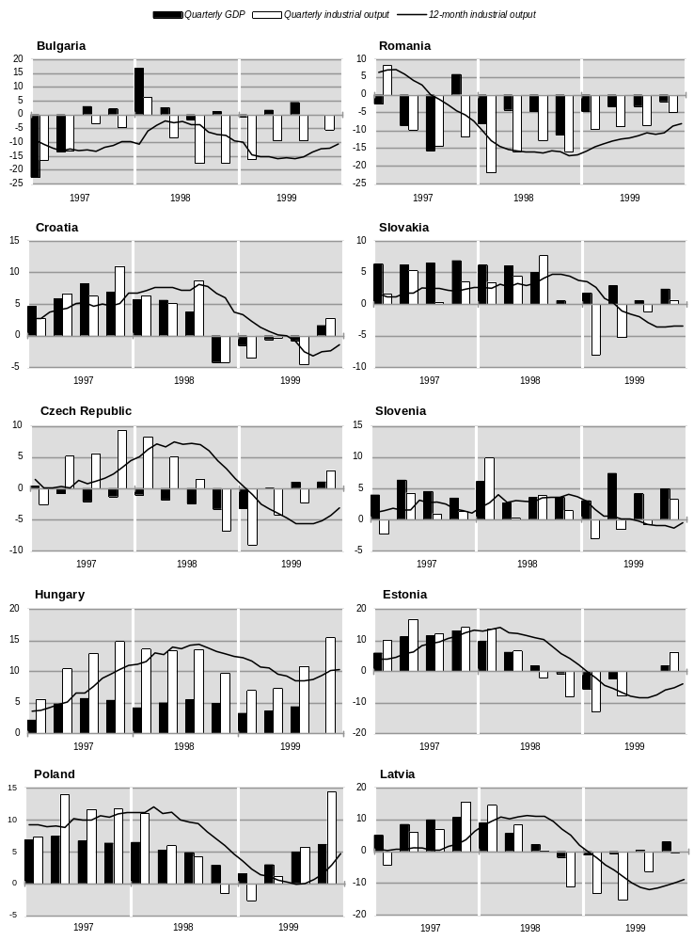
(For source and notes see end of chart.)

CHART 3.3.1 (concluded)
GDP and gross industrial output in selected transition economies, 1997-1999
(Year-on-year percentage change)

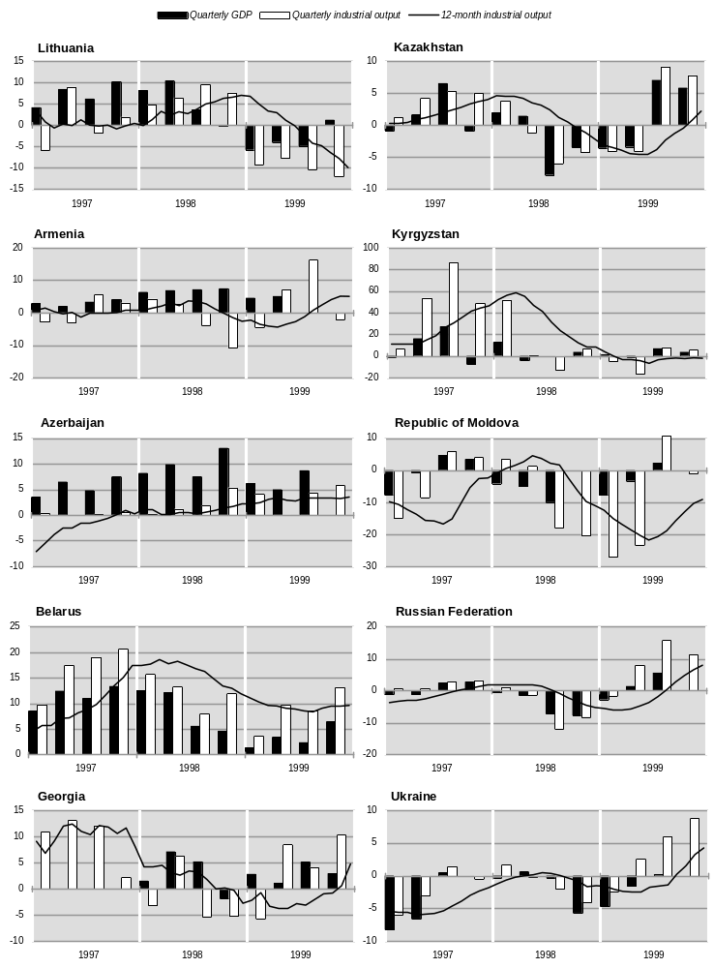
Source: UN/ECE secretariat calculations, based on national statistics.

CHART 3.3.2
Private consumption and volume of retail sales in selected transition economies, 1997-1999
(Year-on-year percentage change)

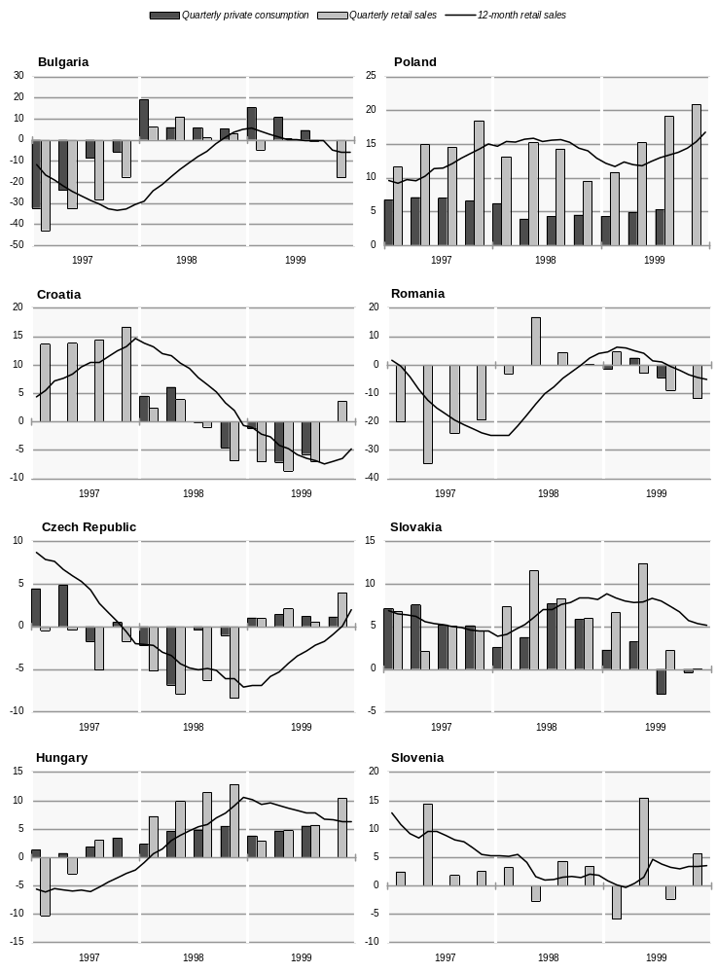
(For source and notes see end of chart.)
CHART 3.3.2 (concluded)
Private consumption and volume of retail sales in selected transition economies, 1997-1999
(Year-on-year percentage change)

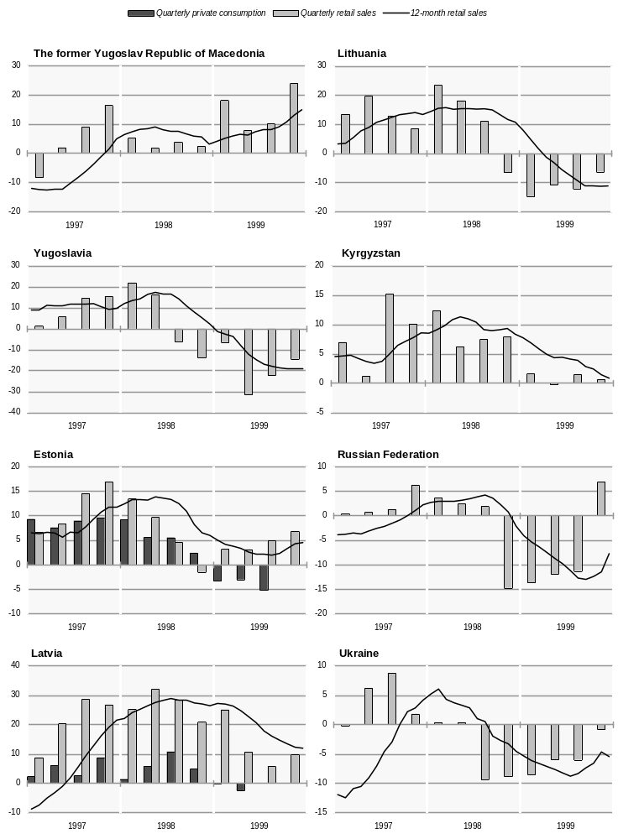
Source: UN/ECE secretariat calculations, based on national statistics.

TABLE 3.3.2
Growth of industrial output by branch in eastern Europe and the Baltic states, 1998-1999
(Annual percentage change)
NACE codes | C-E | C | D | 15, 16 | 17-19 | 20-22 | 23-25 | 26 | 27, 28 | 29-35 | 36, 37 | E
 | Total industry | Mining and quarrying | Manu-facturing | Food, beverages and tobacco | Textiles, apparel and leather | Wood, paper and printing | Chemical industry | Non-metallic mineral products | Basic metals and metal products | Machinery and equipment | Other manu-facturing industries | Electricity, gas, steam and water
Bosnia and Herzegovina
1998 | 23.8 | 22.8 | 29.7 | 13.8 | 17.7 | 16.9 | 32.6 | 27.3 | 121.4 | 14.3 | -1.0 | 13.6
1999 | 10.6 | -0.6 | 17.9 | 22.7 | -5.7 | 9.5 | 21.0 | 12.4 | 41.1 | -7.6 | 1.7 | 1.4
Bulgaria
1998 | -12.7 | 0.3 | -16.7 | -7.6 | -14.8 | -18.1 | -29.8 | -17.0 | -18.3 | -7.4 | -2.1 | 10.1
1999 | -12.5 | -11.8 | -13.2 | -11.1 | -21.3 | -20.2 | -0.2 | 16.3 | -15.9 | -10.4 | -1.3 | -10.0
Croatia
1998 | 3.7 | -2.4 | 3.2 | 3.5 | -0.8 | 8.0 | -3.6 | 14.0 | 13.0 | 3.0 | -7.0 | 8.7
1999 | -1.4 | 1.9 | -2.9 | -5.5 | -10.0 | -2.7 | 1.2 | -2.0 | -3.5 | -0.9 | 2.9 | 7.0
Czech Republic
1998 | 1.6 | -5.7 | 2.5 | -0.4 | -6.4 | 5.3 | 0.6 | 1.1 | -4.4 | 13.7 | 10.7 | -1.5
1999 | -3.1 | -12.0 | -2.7 | -0.6 | -12.0 | 0.7 | -1.6 | 2.2 | -13.4 | 0.8 | 8.2 | -3.5
Hungary
1998 | 12.5 | -20.4 | 16.1 | 1.0 | 10.7 | 5.6 | 2.4 | 12.5 | 2.8 | 41.3 | 22.6 | –
1999 | 10.5 | 1.1 | 12.5 | 2.8 | 8.6 | 2.2 | -6.9 | -3.3 | -0.3 | 35.6 | 1.8 | -1.9
Poland
1998 | 4.7 | -12.9 | 6.5 | 6.8 | -0.1 | 13.0 | -0.7 | 12.4 | 5.3 | 10.5 | 5.3 | 0.9
1999 | 4.7 | -3.9 | 5.6 | 1.3 | -3.3 | 18.0 | 4.6 | 13.2 | -0.3 | 7.3 | 11.0 | 2.3
Romania
1998 | -17.0 | -13.9 | -18.1 | -1.0 | -29.2 | -34.5a | -14.7 | -16.8 | -9.5 | -17.3b | -35.8c | -12.4
1999 | -8.0 | -9.1 | -8.0 | -2.1 | -5.5 | -2.8 | -20.0 | -10.1 | -29.8 | -11.4b | 11.4c | -6.3
Slovakia
1998 | 4.6 | -11.1 | 6.1 | 3.0 | -5.5 | -2.0 | -9.3 | 20.8 | -2.5 | 37.5 | -2.2 | -5.8
1999 | 4.2 | -6.4 | 3.8 | -1.1 | 8.9d | 7.1d | -1.4d | -0.4d | 4.8 | 5.4 | 2.3d | 11.5
Slovenia
1998 | 3.7 | -0.4 | 3.9 | 3.2 | -1.3 | -7.3 | 2.3 | 6.7 | 3.4 | 11.0 | 9.5 | 3.3e
1999 | -0.5 | -4.0 | – | 2.1 | -9.3 | -3.7 | 1.1 | 3.9 | 4.0 | 2.2 | -3.7 | -4.1e
The former Yugoslav
Republic of Macedonia
1998 | 2.9 | 1.8 | 3.0 | -6.0 | 26.0 | 14.3 | 8.4 | -14.2 | 14.0 | -6.4 | 40.2 | 3.3
1999 f | -9.7 | -9.5 | -12.1 | 1.3 | -22.2 | -17.2 | -14.6 | -24.4 | -20.6 | -16.7 | -8.6 | -4.9
Yugoslavia
1998 | 3.6 | -0.3 | 4.8 | 6.2 | 5.5 | -1.4 | 6.5 | 9.0 | 2.4 | 5.0 | 0.8 | 0.8e
1999 | -23.1 | -17.5 | -28.5 | -4.0 | -31.6 | -26.4 | -39.6 | -27.9 | -43.3 | -32.3 | -29.3 | -5.6e
Estonia
1998 | 1.5 | -1.4 | 2.9 | -6.1 | 2.0 | 23.0 | -11.6g | 17.9 | .. | -15.3h | 3.7c | -5.1
1999 | -3.9 | -9.9 | -3.4 | -20.4 | -4.3 | 18.2 | -16.7g | -19.9 | -8.0 | 4.5 | 0.4c | -6.2
Latvia
1998 | 2.2 | 4.7 | 4.5 | -2.1 | -0.6 | 19.0 | -11.7g | 44.4 | 36.5 | -14.4h | 17.1 | 1.8
1999 | -8.8 | 8.9 | -9.8 | -16.7 | -12.9 | 1.9 | -37.8g | -10.0 | -0.2i | -21.4i | -3.0 | -4.7
Lithuania
1998 | 7.0 | 59.9 | 5.5 | -3.6 | 0.2 | 3.5 | 17.3 | 2.5 | 4.7 | 15.3 | 8.9 | 6.0
1999 | -9.9 | -20.1 | -6.4 | -5.3 | -0.2 | 0.5 | -19.3 | -8.9 | 0.3 | 4.8 | -0.3 | -19.9
Source: National statistics and direct communications from national statistical offices to UN/ECE secretariat.
Note: Data are presented in terms of the NACE classification except for The former Yugoslav Republic of Macedonia and Yugoslavia. For these two countries national classification data have been aggregated into NACE groups. Figures for total industry may differ slightly for some countries from those shown in other tables because of differences in coverage. (Statistics on industrial output by branches normally cover enterprises above a certain threshold defined in terms of the number of employed persons.) Industrial sales for Slovakia, Estonia and Lithuania.
a Excluding printing and publishing. f January-June.
b Excluding computers. g Excluding manufacture of coke, refined petroleum products and nuclear fuel (NACE 23).
c Excluding recycling (NACE 37). h Excluding manufacture of office machinery and computers (NACE 30).
d January-November. i Excluding manufacturing of basic metals (NACE 27).
e Production and distribution of electricity only (NACE 40.1).

Hungarian exports. At the same time, some of the more traditional manufacturing industries have been performing less well; and in 1999 this difference between new or traditional activities became even more pronounced.
The Slovenian economy has been growing steadily since 1993, and is second only to Poland in terms of the extent to which output has recovered since the start of economic transformation (appendix table B.1). Despite the negative external factors, growth continued strongly in 1999, largely underpinned by domestic demand. Growth was especially strong in the first half of the year largely as a result of an upsurge in spending prior to the introduction of VAT in July. Although this was a one-time effect, the average rate of growth of GDP remained high in the second half of the year as well, supported by an acceleration in construction output which increased by 10.7 per cent in 1999 (table 3.3.4). Manufacturing industry also did better in the second half of the year, especially in the fourth quarter (chart 3.3.1), thanks to the recovery in exports; however, gross industrial output for the year as a whole remained stagnant (table 3.3.1).
Compared with Hungary and Slovenia, the short-term negative impact of the Russian crisis was more pronounced in Poland: between September 1998 and March 1999 industry plunged into recession (chart 3.3.1), the first since 1992. However, in the second half of the year, and especially in the fourth quarter, growth resumed strongly, largely offsetting the negative consequences of the external shock encountered during the previous 12 months. As a result, Poland’s annual rate of growth of GDP (4.1 per cent, according to preliminary estimates) was among the highest in the region. On average, gross industrial output also increased relatively strongly in 1999 (by 4.7 per cent), although output in a number of branches continued to fall (table 3.3.2). Furthermore, in contrast to the export-led growth in Hungary, the recovery in Poland was much more driven by domestic demand, especially by an upsurge in consumer spending, while export performance was worse than in 1998 (tables 3.1.2 and 4.2.3). Concerns about the sustainability of such a pattern of growth were among the factors that prompted the National Bank of Poland to tighten monetary policy at the end of 1999 and the beginning of 2000 (section 3.2(ii)).
The Czech economy has been through a period of painful adjustment and a prolonged recession (which lasted from the second quarter of 1997 to the first of 1999 – chart 3.3.1). The restrictive stance of policy since 1997 and the implementation of a series of measures aimed at deeper microeconomic restructuring – an issue that had been neglected during the first phases of transition – had a dampening effect on both supply and demand. Apart from the negative impact of the external environment, the deterioration in industrial output in 1998-1999 was instigated by a domestic credit squeeze: after the substantial tightening of banking regulations in 1998 – a measure provoked by the widespread practice of soft-lending which had resulted in a persistent deterioration in the quality of banks’ assets – banks became much more cautious in their lending. GDP started to recover in the second quarter of 1999 (chart 3.3.1) but at a rather modest rate and the average change in 1999 was still negative (-0.2 per cent). In turn, industrial output only began to recover in the fourth quarter of the year (chart 3.3.1), mostly thanks to the strengthening of exports to western Europe. However, a stronger rate of recovery seems unlikely in the short run due to the deep-seated problems of the Czech economy which will require lasting policy efforts and considerable resources.
The Slovak economy also endured a forced adjustment in 1999, following several years of imbalanced growth boosted by excessive public spending. Having to address the mounting external and internal imbalances, the government elected in 1998 imposed an austerity programme which, inter alia, envisaged the cancellation or scaling down of a number of overambitious public investment projects. The direct impact of these measures is most visible in the construction sector where output fell by 25.8 per cent in 1999 (table 3.3.4). GDP growth in 1999 was less than in 1998, but nevertheless remained positive (1.9 per cent in annual terms). The curbing of domestic demand through fiscal policy, coupled with weak external demand in the first half of the year, had a negative impact on gross industrial output which fell by close to 7 per cent, year-on-year, during the first six months (table 3.3.1). With the strengthening of export demand in the second half of the year, industrial performance started to improve with a small increase in gross industrial output in the fourth quarter (chart 3.3.1).
Economic activity in the south-east European transition economies in 1999 remained subdued. The Kosovo conflict dominated developments in the region for most of the year, not only in political but also in economic terms. As repeatedly argued in this Survey, the south-east European transition economies have been facing enormous difficulties in the process of economic and political transformation throughout the last decade, and the Kosovo conflict only made these problems more visible to the outside world.
Judging from the average annual figures for 1999, the immediate negative effect of the war in Kosovo on south-east Europe as a whole probably turned out to be smaller than had been feared when the conflict was still underway. Apart from the Yugoslav economy, which was devastated by NATO air strikes, the other south-east European transition economies managed to overcome part of the economic losses incurred during the conflict. Both the start of reconstruction works in Kosovo and the strengthening of the recovery in western Europe played a positive role in improving output performance in the region during the second half of the year. The sector that seems to have been most seriously hurt is transport due to the immense damage caused by the air strikes. This is also evident from the statistics on goods transport in the transition economies in 1999 (table 3.3.4). Although the figures are not exhaustive, the data indicate that transportation in the south-east European transition economies fell sharply in all countries for which such statistics are available.
The information embargo imposed by Yugoslavia during the Kosovo conflict created gaps in the reporting on the current economic situation in this country. Nevertheless, the partial and tentative estimates produced by independent sources present a rather gloomy picture of the devastation caused by the air strikes. Although the information ban was subsequently lifted, current Yugoslav economic statistics remain rather scarce and difficult to interpret. Most of the reported statistics for 1999 do not apparently include the territory of Kosovo; at the same time, it is not always clear whether the changes over time refer to the same territorial units. The preliminary official estimates for the year as a whole point to a collapse of GDP by some 20 per cent and of industrial output by some 23 per cent (table 3.1.1). Although the depth of the recession according to these figures appears to be smaller than suggested by earlier assessments, it still amounts to a severe worsening of an economic situation which was already in a precarious state. It is clear that the war has left deep scars on the Yugoslav economy: the enormous damage to the economic infrastructure and production facilities as a result of the bombing will result in a downward shift in aggregate output which will be difficult to overcome even in the medium term.
All the neighbouring countries also suffered, to varying degrees, indirect economic damage from the Kosovo conflict. Probably the most affected was The former Yugoslav Republic of Macedonia where industrial output declined sharply in the first half of the year (table 3.3.1). However, there was an upturn in economic activity after the end of the conflict and there was positive GDP growth for the year as a whole. According to preliminary and partial estimates, Albania’s GDP increased by some 8 per cent in 1999, the same as that reported for 1998. Current statistical reporting in Albania is still rather incomplete in coverage and does not allow any analysis in detail of the determinants of this relatively strong growth; however, preliminary data and independent assessments suggest that agriculture was probably the main source of growth, partly boosted by the refugees from Kosovo. In both Albania and The former Yugoslav Republic of Macedonia services also appear to have been an important source of GDP growth; in addition, the increase in consumer spending, induced by the influx of refugees during the conflict, also gave an additional boost to output in both countries. Data on the economic situation in Bosnia and Herzegovina are still fragmentary and it is difficult to assess current economic performance. Partial and tentative estimates suggest that the post-Dayton recovery continued in 1999 despite the negative impact of the Kosovo conflict. However, all the indications are that this economy is only kept running thanks to the continuing injection of official aid; if this were to be discontinued, the economic implications may be disastrous.
After a poor start, the Bulgarian economy strengthened during the second half of 1999 and according to preliminary estimates GDP grew by some 2.5 per cent for the year as a whole (table 3.1.1). The quarterly national accounts data for the first three quarters of the year indicate that agriculture and services contributed most to the growth of aggregate output. At the same time, the recession in Bulgaria’s industry continued for the third consecutive year (table 3.1.1 and chart 3.3.1), the cumulative output decline since 1997 amounting to more than 30 per cent.
During the last two years Croatia’s economic performance has been dominated by the efforts to reduce the current account deficit (which had reached double-digit levels in 1997 – table 3.1.2) to sustainable proportions. While fiscal and monetary restraint has been quite successful in reducing the external gap, the adjustment has been achieved at the price of a recession which started in the last quarter of 1998 and continued through most of 1999 (chart 3.3.1). Construction activity fell sharply in 1999 (table 3.3.4), mostly as a result of reduced spending on public infrastructural projects. Negative external factors also contributed to the weakening of economic activity: thus the tourist industry incurred considerable losses of income during the Kosovo conflict and even when it was over. In the face of persistent recession, the authorities relaxed somewhat the stance of fiscal and monetary policy in the course of the year, easing the strain on domestic demand (the upcoming parliamentary elections also probably had an influence on this). Consequently, after 12 months of decline, industrial output started to recover in the fourth quarter of 1999 (chart 3.3.1), partly boosted by a moderate recovery in exports to western Europe.
The Romanian economy has been in the grip of a profound crisis for several years: deep-rooted economic problems coupled with incoherent policies have resulted in poor economic performance and political instability. Although the feared default on the foreign debt was avoided in 1999, the deep recession continued for a third consecutive year, leading to a cumulative decline of GDP by some 14 per cent since 1996 and of industrial output by some 30 per cent (table 3.1.1). The Romanian economy is still plagued by a large number of inefficient industrial enterprises which require restructuring, but the authorities do not have the necessary resources to accomplish this in a relatively short time. The policy of forced restructuring – which has been pursued since 1997 through the tightening of credit and the curbing of flows of soft finance to the enterprise sector, measures which have been essential for the rehabilitation of the financial sector – has at the same time resulted in an unprecedented contraction of some of Romania’s main industrial branches such as chemicals and metal processing (table 3.3.2).
The Baltic economies were hit unexpectedly badly in 1999 by the aftershocks of the Russian crisis (see box 3.3.1). During the first half of the year, GDP was falling in all three countries (table 3.3.1 and chart 3.3.1); although a moderate recovery started in the second half (at first in Estonia, and later in Latvia and Lithuania) the annual rates of growth in the three countries remained negative or close to zero. The negative demand shock on industrial output was the main factor on the supply side behind the contraction of aggregate output in all three economies. The crisis reportedly brought about some further reorientation of the exports of the Baltic states to west European markets; with the recovery in west European import demand in the second half of the year, the decline of Baltic exports started to level out, and this contributed to the resumption of growth in a number of sectors.

(b) Commonwealth of Independent States
The relatively strong growth figures reported by a number of CIS countries, in the first place Russia, should be judged against the background of the previous year’s slump triggered by the Russian crisis of 1998. Thus despite its 3.2 per cent growth, Russia’s GDP in 1999 was still 1.9 per cent below its 1997 level. Hence some caution is needed in interpreting Russia’s economic performance and prospects: the current upturn still resembles more a cyclical recovery than the start of a process of sustained growth. Nevertheless, performance in most sectors of the economy in 1999 was quite impressive.
The strong recovery of industrial output was clearly the main driving force behind the economic upturn in Russia: positive growth resumed in the second quarter of 1999 and in the second half of the year gross industrial production was growing at double-digit rates (chart 3.3.1). Rapid growth of industrial output also continued during the first months of 2000. Recovery was underway in most industrial branches and some of them posted sizeable gains: output of the chemical and light industries increased by more than 20 per cent, wood processing by over 17 per cent, and engineering by close to 16 per cent

Box 3.3.1.
The effect of the Russian crisis on the Baltic economies
The initial assumption that the Baltic economies would recover rapidly from the shock caused by the steep fall in their exports to Russia failed to materialize in 1999 despite the improvement of the situation in their western markets. In all three countries, GDP growth was negative or close to zero, and economic recovery is likely to take longer than previously expected. One possible explanation for this miscalculation is myopic behaviour by governments and enterprises who were misled by the relatively small direct initial impact and underestimated the indirect effects transmitted via international markets and through the behaviour of foreign investors. In addition, the economic situation in the Baltic countries was aggravated by lagging reforms, in particular in the fiscal area.
In the aftermath of the Russian crisis, the share of Russia in total Baltic exports fell from some 19 per cent in the first quarter of 1998 to less than 10 per cent in the fourth quarter; the share slipped further in the first half of 1999 (to 7.5 per cent), recovering only slightly in the second half. The average monthly dollar value of exports to Russia from these three countries shrank from $130 million in the pre-crisis months (January-August 1998) to $60 million in the fourth quarter of 1998, and to less than $50 million in the first half of 1999. In the months that followed they recovered a little but still remained some 10 per cent below their average level in the last quarter of 1998.
Initially, transit earnings were less affected, and in some cases even increased. While the transit of Russian imports shrank noticeably, the transit of Russian exports through the Baltic terminals rose as Russia sought to increase its hard-currency earnings and benefit from the upturn in international crude and oil product prices.1 This helped to mitigate the immediate shock to the Baltic economies, in particular in Latvia where revenues from transit carriage amount to 10 per cent of GDP. However, this development was reversed in 1999 when Russia increased state controls over oil and raw material exports: in the third quarter of 1999 the volume of transit carriage through Latvia’s ports fell by nearly 10 per cent and revenues shrank even more, by around 20 per cent according to some estimates, as service providers cut tariffs in order to remain competitive.
Given the high export-dependence of the Baltic economies, when export volumes continued to fall significantly, industrial sales followed suit (particularly in the food-processing, oil-refining, chemical and textile sectors); the shipping sector was also strongly affected. The prolonged export squeeze and the rapid deterioration in output during the second half of 1998 and throughout most of 1999 (chart 3.3.1) led to a significant worsening of the labour market: unemployment in the region peaked in March-April 1999, with official rates approaching 7-10 per cent and those based on labour-force surveys hovering around 12-14 per cent). Consequently, the drop in average real incomes led to a weakening of domestic consumption, with further negative feedback on output.
In addition, the repercussions of the crisis spilled over into the farming sector as well. Agricultural products that could no longer be sold in Russia (and were squeezed out of the other CIS and eastern European markets) were diverted to the domestic market, leading to oversupply and falling prices, and leaving farmers in an even more difficult situation.2
In all three Baltic countries, the parliaments had voted the 1999 budgets on the basis of optimistic growth forecasts justifying higher expenditures, even after the downside risks stemming from the Russian default of August 1998 had become evident.3 By mid-1999, all three countries were faced with the necessity of cutting expenditure: at the end of June, the Estonian parliament voted a supplementary budget that reduced spending by 1 billion krooni ($67 million), the public investment programme being most strongly affected by these cuts; about the same time, the Latvian parliament passed a budgetary amendment slashing expenditure by 28 million lats ($50 million). The reluctance of Lithuania’s authorities to undertake unpopular measures led to delays in their response; however, in view of the deteriorating economic situation, the parliament finally decided in October 1999 to cut budget expenditure by 6 per cent (600 million litas, equal to some $150 million) and to suspend the deposit compensation programme. These measures, however, were not sufficient to yield significant improvements in the fiscal situation and 1999 ended with much higher deficits than anticipated.
According to the Baltic governments, the positive signals produced by healthier balances of payments in 1999 and, recently, by tighter fiscal policies, as well as by the start of EU accession negotiations by Latvia and Lithuania, should give a new impetus to their economies. It should be noted, however, that some of the government interventions, including support for agriculture and exports, are increasingly taking the form of protectionist measures. In turn, the curtailing of public expenditure envisaged in the government budgets in Latvia and Lithuania for 2000 may have a negative impact on some sectors of the economy and further dampen domestic demand.

1 The cargoes loaded and unloaded in Latvian ports increased by nearly 5 per cent in volume in the last quarter of 1998 and by another 11 per cent in the second quarter of 1999. Revenues, however, were slightly down, reflecting lower tariffs. Central Statistical Bureau of Latvia, Monthly Bulletin of Latvian Statistics, No. 11, November 1999.
2 For example, meat and dairy product prices fell considerably in all three countries, dragging down food prices as a whole: in the first half of 1999 food prices were some 2-3 per cent lower than in the same period of the previous year, while prices in general continued to rise slowly – by 0.8 per cent in Lithuania, 2.4 per cent in Latvia and 3.1 per cent in Estonia.
3 Domestic politics also played a role at the time: in Estonia, the government had undertaken a commitment to increase wages in the public sector, and parliamentary elections were due in the spring of 1999; in Lithuania, the conservative party that held a parliamentary majority felt bound by its promise to compensate depositors for the 1992 loss in the real value of their rouble savings. Both these measures required considerable increases in public expenditure.

(table 3.3.3). In all of these branches, output in 1999 was not only higher than its 1997 level but its 1996 level as well. The recovery in Russia was even more broadly based: output also grew in agriculture, construction and goods transport (table 3.3.4). In the two latter sectors, gross output was also higher than in 1997, positive growth occurring for the first time during the last decade.
The strength of the output recovery in Russia came as a surprise to most analysts and observers, especially given that assessments of Russia’s economic performance were generally highly negative after the economic collapse of August 1998. As argued in previous issues of this Survey, the Russian crisis was predominantly home-grown, combining macroeconomic mismanagement with microeconomic distortions and a weak institutional environment. Furthermore, the volatility of output during the past two years – quite unusual given the size of the Russian economy – is indicative of additional factors that appear to have increased the instability of economic performance.
In the first place, due to the excessive dependence of the Russian economy on oil exports, negative external factors – in the first place the fall in world oil prices in 1997-1998 – contributed significantly to the economic collapse. Conversely, the sharp rise in oil prices in 1999 was highly beneficial, not only for the oil firms but for the economy as a whole (see also section 3.2(iii)). These developments suggest that the Russian economy may be prone to threshold effects, when a change confined to a limited economic area may have disproportionately strong repercussions on the rest of the economy; besides, such a transmission mechanism apparently works in both directions, positive as well as negative, once the tide turns. Seen from a different perspective, this suggests considerable fragility and a high degree of vulnerability to external shocks, making the Russian economy to a large extent a hostage to the situation on world commodity markets (in the first place oil).
Apart from external disturbances, two important changes have taken place on the domestic side of the Russian economy since the August 1998 collapse: i) a realignment of the real exchange rate (a real depreciation by almost one half compared with the pre-crisis level); and ii) a fall in real wages (average real wages in the 12 months following the collapse were some 35 per cent lower than during the 12 months preceding it). Both these changes were equivalent to a strong supply push as they boosted substantially the competitiveness of local producers on the domestic market, resulting in extensive import substitution.
At the same time, many of the fundamental problems of the Russian economy – which were at the core of the 1998 crisis – are still there and little progress has been made in dealing with them. As repeatedly argued in this Survey, deep microeconomic restructuring and the creation of an effective institutional framework are prerequisites for achieving strong and sustained growth in Russia. Until sufficient progress has been made in these directions, instability will continue to threaten economic performance. To summarize: the economic upsurge in Russia in 1999 resulted from the combination of a favourable external environment and appropriate domestic adjustment after the crisis. If unchanged these factors may continue to have a positive influence on output. At the same time, the current equilibrium appears to be very fragile, with the risk that even a slight disturbance could destabilize it again. The windfall gains from the current economic upturn create a window of opportunity for a decisive break with the past and for the rapid implementation of radical reforms, but it is up to the Russian authorities whether they press ahead in this direction.
A recovery was also underway in most of the CIS countries in 1999. In fact, in all of them with the exception of the Republic of Moldova and Ukraine, there was positive GDP growth. After a decade of decline, Ukraine’s economy also seems to be close to bottoming out with GDP declining by a marginal 0.4 per cent in 1999. Indeed, industrial production in Ukraine did increase by 4.3 per cent in 1999 (for the first time during the 1990s) and output growth was accelerating in the course of the year (chart 3.3.1); GDP also appears to have been growing during the second half of the year. However, decline continued in the once important agricultural sector (table 3.3.4), following years of neglect and mismanagement. The sources of the recovery in industrial output were similar to those in Russia: the real depreciation of the hryvnia in the second half of 1999 has generated import substitution resulting in a significant net trade effect in spite of the weak export performance. Nonetheless, despite this improvement, the economic situation in Ukraine is even more precarious than that in Russia because of its looming foreign debt problem. If the eurobond default in February 2000 were to escalate into a full-scale debt-cum-financial crisis, this would have severe consequences for the economy. Another potential threat is related to the accumulated debt to Gazprom: recently there have been disruptions in gas supplies from Russia due to Ukraine’s chronic non-payment for past deliveries.
In the Republic of Moldova, GDP fell by 4.4 per cent in 1999 following an 8.6 per cent decline in 1998. The current economic crisis in this country is rooted in the chronic twin deficit problem that has marred economic performance for several years. The failure of the authorities to address these problems led to the suspension of IMF lending in 1997, and the pressing balance of payments constraint – which intensified in the aftermath of the Russian crisis due to the contraction in exports to Russia – triggered the subsequent recession. The forced adjustment of domestic demand to these constraints in 1999 led to the halving of imports (table 4.2.5), with negative effects on output. A poor harvest (table 3.3.4) added to the negative developments in 1999.
Despite the figures reported by the Belarussian official statistics for 1999 (growth of GDP by 3.4 per cent and of industrial output by almost 10 per cent), the economy has recently been facing serious problems. The unsustainable growth-promoting policy of previous years – based on the supply of cheap, soft credit to local manufacturers (including industries exporting to Russia) – has been a source of persistently high inflation and macroeconomic instability (table 3.1.1). The sharp contraction of the Russian market after August 1998, however, was a major blow to the Belarus economy, and the partial reorientation of some of its exports to non-CIS markets was insufficient to offset this demand shock (table 4.2.5). The attempts by the authorities to counter these negative developments with administrative measures (such as price controls and rationing) have resulted in widespread shortages of basic necessities. Squeezed by the external shock, the Belarus economy is facing a balance of payments constraint on growth and badly needs additional external resources; however, unsustainable policies and the lack of progress in systemic reforms have prevented new borrowing from the IMF.
Economic recovery has been underway in the CIS countries of the Caucasian rim since 1996. In 1999 GDP continued to grow in all three countries albeit at lower rates than expected (table 3.1.1). In Armenia, relatively weak performance in agriculture (output increased by only 1 per cent – see table 3.3.4), which accounts for a third of the country’s GDP, was the main reason for the lower than expected rate of economic growth. In contrast, industrial output increased in 1999 (after a recession in 1998) thanks to strong recovery in the second and third quarters (chart 3.3.1). However, the consequences of the tragic incident in the Armenian parliament on 27 October reportedly have had a negative impact on the economy, resulting in a recession during the closing months of the year. During the last two years Azerbaijan has been the fastest growing economy in this region mostly thanks to the reconstruction of the oil and gas sector which has attracted considerable amounts of FDI. The rapid expansion of investment in 1996-1998 (table 3.3.9) and an upturn in a number of related business activities (such as construction, transportation and other services) have been the main engine of economic recovery. In 1999 the inflow of FDI slowed down markedly; however the output of oil and oil products increased considerably, stimulated by the rise in world market prices. A good harvest (table 3.3.4) also contributed to the strength of GDP growth in 1999. In Georgia, GDP increased by 3 per cent in 1999, about the same rate as in 1998 (table 3.1.1). The completion of the Georgian segment of the Baku-Supsa oil pipeline (which started operation in April) and the recovery of industrial output after the second quarter (chart 3.3.1) contributed to the positive outcome for the year; however, economic activity in other sectors remained subdued.
In 1999, economic activity was relatively strong in most of the central Asian CIS countries: their aggregate GDP grew by 2.9 per cent which was equal to the CIS average. This performance was the result of several factors: more favourable demand conditions for primary commodities in the aftermath of the Asian crisis; an adjustment of exchange rates in response to the devaluation of the Russian rouble; and bumper cotton and wheat harvests in some countries of the region. Although this upturn, following a series of external shocks, is encouraging, the central Asian economies remain vulnerable: the current recovery is narrowly based and the volatility of output in 1998 and 1999 underlines both the negative and positive impacts of fluctuating commodity prices.
The Kazakh economy, dependent on the production and export of oil and metals, is extremely vulnerable to external shocks and was greatly affected by the fall in demand for primary commodities and the pressures on exchange rates after the Asian and Russian financial crises in 1997 and 1998. Output continued to decline in the first half of 1999, with both GDP and industrial output falling by 3.5 per cent. The government’s efforts to protect the value of the domestic currency during most of this period only exacerbated the economic situation. Over the course of 1999, however, the authorities increasingly focused their efforts to address the economic imbalances and introduced policy changes aimed at reversing the output decline, in the first place, letting the currency float freely from April. These measures, coupled with the recovery of world prices for key exportables and a bumper harvest, contributed to a dramatic turnround in economic performance: after four quarters of consecutive decline, GDP was growing in the second half of the year at an annualized rate of 6-7 per cent (chart 3.3.1). The recovery was led by a sharp upturn in the output of export-oriented sectors: for example, crude oil production for the year as a whole rose by 12 per cent. Thanks to strong growth during the second half of the year, GDP increased by 1.7 per cent in 1999 as a whole and industrial output by 2.2 per cent.
TABLE 3.3.3
Growth of industrial output by branch in the CIS economies, 1997-1999
(Annual percentage change)
 | Total industry | Fuels | Energy | Ferrous metals | Non- ferrous metals | Engineering | Chemicals | Building materials | Logging, wood and paper | Light industry | Food processing
Armenia
1997 | 8.2 | .. | -2.3 | 18.1 | -25.4 | -33.1 | -1.6 | 6.2 | .. | 50.4 | 24.3
1998 | -2.6 | .. | 0.1 | -34.1 | 74.4 | -27.8 | -12.3 | 2.5 | 3.4 | 7.8 | 8.3
1999 a | 7.6 | .. | 2.2 | 93.1 | 49.0 | -40.1 | 5.8 | -5.5 | -16.0 | 5.9 | 6.4
Azerbaijan
1997 | 0.3 | 0.2 | -6.6 | 430.3 | 262.4 | -0.7 | -28.2 | -4.4 | 7.3 | -16.5 | -6.6
1998 | 2.2 | 7.5 | 5.9 | -70.6 | -35.1 | -30.4 | -11.4 | -22.2 | -64.5 | -41.9 | -2.3
1999 b | 4.1 | 14.1 | 2.8 | -99.3 | -88.9 | -66.1 | 2.6 | -23.8 | -73.5 | -81.4 | 1.0
Belarus
1997 | 18.8 | -1.0 | 5.6 | 35.1 | 51.3 | 25.7 | 19.4 | 26.1 | 34.7 | 27.1 | 21.0
1998 | 12.4 | 0.6 | -7.4 | 14.9 | 12.0 | 15.5 | 7.7 | 15.2 | 21.7 | 22.8 | 19.2
1999 | 9.7 | 1.9 | 5.5 | -0.6 | .. | 15.4 | 5.6 | -1.3 | 14.2 | 9.7 | 15.3
Georgia
1997 | 8.1 | 64.7 | 3.2 | 14.0 | -33.7 | 11.2 | 20.4 | 26.1 | 6.1 | -12.6 | 10.7
1998 | -2.7 | .. | .. | .. | .. | .. | .. | .. | .. | .. | ..
1999 | 4.8 | .. | .. | .. | .. | .. | .. | .. | .. | .. | ..
Kazakhstan
1997 | 4.0 | 0.5 | -14.2 | 25.2 | 13.8 | -29.9 | -29.9 | -19.3 | -27.4 | -18.8 | 0.3
1998 | -2.1 | .. | .. | .. | .. | .. | .. | .. | .. | .. | ..
1999 | 2.2 | .. | .. | .. | .. | .. | .. | .. | .. | .. | ..
Kyrgyzstan
1997 | 50.4 | 7.9 | -6.9 | .. | 280.3 | 5.9 | -20.5 | 11.7 | 1.2 | -7.0 | -9.7
1998 | 8.3 | -50.0 | -7.8 | .. | 25.8 | 2.8 | -41.7 | 5.8 | -17.4 | -18.5 | 21.1
1999 a | -4.6 | 54.2 | 11.5 | .. | -6.5 | 21.0 | 256.9 | -25.8 | -12.6 | -23.7 | -5.7
Republic of Moldova
1997 | – | .. | 1.1 | .. | .. | -22.4 | -52.6 | 9.5 | -5.6 | -3.3 | 2.8
1998 | -11.0 | .. | -6.9 | .. | .. | -16.9 | -4.9 | -16.9 | -23.5 | -16.5 | -17.7
1999 | -9.0 | .. | .. | .. | .. | .. | .. | .. | .. | .. | ..
Russian Federation
1997 | 1.9 | 0.3 | -2.1 | 1.2 | 6.0 | 3.5 | 2.4 | -4.0 | 0.9 | -2.4 | -0.8
1998 | -5.2 | -2.5 | -2.5 | -8.1 | -5.0 | -7.5 | -7.5 | -5.8 | -0.4 | -11.5 | -1.9
1999 | 8.1 | 2.4 | 0.2 | 14.4 | 8.5 | 15.9 | 21.7 | 7.7 | 17.2 | 20.1 | 7.6
Tajikistan
1997 | -2.0 | -0.9 | -5.9 | .. | 3.3 | -21.3 | -2.8 | -19.5 | -24.4 | -4.0 | -18.8
1998 | 8.1 | -24.8 | 4.0 | .. | 7.7 | 6.4 | -39.9 | -14.3 | 1.7 | 4.1 | 19.1
1999 a | 6.8 | 2.9 | 10.9 | .. | 19.4 | -13.5 | 7.0 | 83.5 | 13.3 | 6.5 | -16.2
Turkmenistan
1997 | .. | .. | .. | .. | .. | .. | .. | .. | .. | .. | ..
1998 | .. | .. | .. | .. | .. | .. | .. | .. | .. | .. | ..
1999 | 15.0 | 10.0 | -4.0 | .. | .. | 8.0 | 20.0 | 7.0 | .. | 39.0 | 35.0
Ukraine
1997 | -0.3 | 6.2 | -2.6 | 8.1 | 9.4 | -0.2 | 2.1 | -10.4 | -0.9 | 1.1 | -10.3
1998 | -1.5 | -0.7 | -0.3 | -6.8 | 12.4 | -4.5 | 0.9 | 4.1 | 10.4 | 1.5 | -0.5
1999 | 4.3 | -1.3 | 6.6 | 6.2 | 8.9 | -0.8 | -1.1 | -0.6 | 23.6 | 5.7 | 7.8
Uzbekistan
1997 | 4.1 | 4.2 | -1.0 | -17.1 | 7.6 | 44.2 | 1.3 | -3.4 | 11.1 | 11.3 | 34.2
1998 | 5.8 | 6.6 | -1.4 | -2.8 | 2.0 | 5.4 | 24.6 | -0.7 | 9.4 | 3.0 | 10.5
1999 a | 5.9 | 0.5 | -1.6 | -14.5 | 0.8 | 8.3 | 10.5 | 0.3 | 21.5 | 8.7 | 11.8
Source: National statistics; CIS Statistical Committee; direct communications from national statistical offices to UN/ECE secretariat.
Note: Data are presented in terms of national branch classifications comparable among the countries shown in the table. These classifications are not fully compatible with NACE or ISIC. Figures for total industry differ for some countries from those shown in other tables because of differences in coverage.
a January-September.
b January-March.

The unusually high rates of growth of GDP and industrial output in Kyrgyzstan in 1997 and until the first quarter of 1998 were due to the one-time effect of the start of operations at the Kumtor gold mine. The deterioration in output, which started in the second quarter of 1998 and continued in the first half of 1999, was mainly due to the negative impact of the Russian financial crisis. During this period exports declined sharply, largely due to trade restrictions erected in other central Asian countries to minimize their own trade imbalances. Thanks to an upturn in industrial output during the second half of 1999 (chart 3.3.1) and a better harvest (gross agricultural output rose by 8.7 per cent in 1999, table 3.3.4), real GDP for the full year still increased by 3.6 per cent. However the largely agricultural economy of Kyrgyzstan continues to be fragile. The industrial sector is overly reliant on gold sales and susceptible to external shocks; thus, despite the general improvement in the second half of 1999, industrial production for the full year was down by 1.7 per cent.
TABLE 3.3.4
Agriculture, construction and goods transport in the ECE transition economies, 1996-1999
(Annual percentage change)
 | Gross agricultural output |  |  |  | Gross construction output a |  |  |  | Goods transport b
 | 1996 | 1997 | 1998 | 1999 | 1996 | 1997 | 1998 | 1999 | 1996 | 1997 | 1998 | 1999
Albania | .. | .. | .. | .. | .. | .. | .. | .. | .. | .. | 35.9 | ..
Bosnia and Herzegovina | .. | 15.4 | .. | .. |  |  | 17.5 | -8.4 | .. | .. | 22.5 | -8.0
Bulgaria | -11.5 | 17.4 | -1.1 | .. | 17.5 | -4.4 | -15.5 | .. | -8.4 | 8.4 | -12.2 | 2.8c
Croatia | 1.6 | 3.4 | 9.9 | .. | 9.0 | 16.7 | 0.7 | -7.7 | 6.7 | -4.6 | -16.4 | -14.3
Czech Republic | -1.4 | -5.1 | 0.7 | 1.1 | 5.3 | -3.9 | -7.0 | -6.5 | 20.7 | 21.9 | 17.8 | 0.8d
Hungary | 6.3 | -3.8 | -2.1 | .. | -0.1 | 9.7 | 13.1 | 6.1 | 5.0 | -0.3 | 9.5 | -2.9c
Poland | 0.7 | -0.2 | 5.9 | .. | 4.6 | 17.1 | 11.0 | 3.2 | 2.8 | 6.6 | -3.8 | ..
Romania | 1.3 | 3.4 | -7.5 | .. | 3.7 | -24.4 | -0.6 | -19.5e | -15.6 | -18.0 | .. | ..
Slovakia | 2.0 | -1.0 | -5.9 | .. | 4.4 | 9.2 | -3.5 | -25.8 | -8.2 | -5.6 | 0.8 | ..
Sloveniaf | 0.7 | -1.2 | 2.5 | .. | -2.5 | -5.2 | 1.7 | 10.7 | -11.6 | 8.7 | 2.9 | -3.1
The former Yugoslav  Republic of Macedonia | -2.0 | .. | .. | .. | 2.0 | -16.0 | -9.0 | -7.0g | -28.4 | 15.2 | 8.6 | -23.6g
Yugoslavia | 1.3 | 7.2 | -3.0 | .. | -9.0 | -3.0 | -6.0 | -21.0 | 82.4 | 7.5 | 15.0 | ..
Estonia | -6.3 | -1.5 | -5.0 | .. | 21.0 | 15.0 | .. | .. | .. | -1.7 | 0.7 | ..
Latvia | -5.7 | 0.2 | -9.1 | .. | 5.3 | 8.2 | 16.5 | 7.8 | 0.3 | 1.4 | .. | ..
Lithuania | 8.5 | 5.8 | -2.5 | -12.0 | -7.2 | 12.3 | 22.6 | -14.2d | -0.8 | 12.0 | 0.8 | ..
Armenia | 2.0 | -6.0 | 13.1 | 1.0 | .. | .. | .. | .. | .. | .. | .. | -5.0c
Azerbaijan | 3.0 | -6.0 | 6.0 | 7.0 | .. | .. | .. | .. | -4.8 | 26.2 | .. | 35.0c
Belarus | 2.4 | -4.9 | -0.7 | -8.6 | -2.0 | 15.0 | 16.0 | -1.0 | -1.3 | 14.8 | 0.9 | 2.0c
Georgia | 6.0 | 6.5 | -8.0 | .. | .. | .. | .. | .. | .. | .. | .. | -14.0c
Kazakhstan | -5.0 | -0.8 | -18.9 | 28.9 | -36.0 | -4.0 | -17.6 | 26.4c | -9.4 | -0.8 | -6.4 | -4.0c
Kyrgyzstan | 15.3 | 12.2 | 2.9 | 8.7 | -31.0 | 14.0 | -47.7 | .. | 19.9 | .. | .. | -6.0c
Republic of Moldova h | -13.0 | 12.0 | -10.6 | -8.0 | -13.0 | -12.0 | .. | .. | -9.4 | 2.0 | -9.3 | -45.0c
Russian Federation | -5.1 | 1.5 | -13.2 | 2.4 | -14.0 | -6.0 | -5.0 | 5.4 | -4.6 | -3.4 | -3.4 | 5.2
Tajikistan | 2.0 | 3.6 | 6.5 | .. | .. | .. | .. | .. | -20.5 | -19.7 | .. | -14.0c
Turkmenistan | -33.3 | 20.6 | 24.4 | 26.0 | .. | .. | .. | .. | .. | .. | .. | 31.0c
Ukraine | -9.5 | -1.9 | -9.8 | -5.7 | -31.0 | -9.9 | 2.7 | .. | -17.2 | -10.6 | -2.7 | -6.0c
Uzbekistan | -6.0 | 4.0 | 4.0 | 6.0c | .. | .. | .. | .. | .. | .. | .. | 7.0c
Source: National statistics; CIS Statistical Committee; direct communications from national statistical offices to UN/ECE secretariat.
a In Croatia, Slovenia, The former Yugoslav Republic of Macedonia and Yugoslavia construction refers to effective working time. In Poland work abroad and by enterprises not classified in construction is excluded. In Estonia construction refers to sales of construction work. In Latvia, Lithuania, Belarus, Kazakhstan, Kyrgyzstan, Republic of Moldova, Russian Federation and Ukraine construction refers to the volume of work done by construction enterprises and companies.
b Based on ton-km and covering all means of transport (rail, road, sea river, air, pipeline), except when specified otherwise. Bulgaria: public sector only; Czech Republic: transport receipts; Slovenia and The former Yugoslav Republic of Macedonia: road and rail transport only; Estonia: from 1995 only freight turnover (earlier, the exploited freight turnover); Latvia: from 1998 excludes Latvian merchant vessels registered under foreign flags; Lithuania: excluding sea transport.
c January-September.
d January-November.
e January-June.
f Agriculture is final agricultural output, excluding intra-branch consumption.
g January-July.
h For 1998 and 1999, territorial coverage of agriculture is incomplete.

Tajikistan – arguably, the poorest country among the successor states of the former Soviet Union – is still recovering from the civil war that ended in 1997. Similar to other natural resource dependent economies (aluminium, electricity and cotton form the foundation of its economy), Tajikistan has been affected by the Russian financial crisis and the unfavourable external environment for commodity exporters. During 1999, aluminium and cotton prices fell while key import prices rose, leading to deterioration in the terms-of-trade and a worsening of the country’s external balance. As a result of falling commodity prices and bad weather affecting the cotton harvest, economic growth slowed to 3.7 per cent. Apart from cotton, however, the harvest was better than in previous years and agricultural production, for the year as a whole, is estimated to be slightly up. Industrial production, in contrast, increased strongly by 5 per cent, partly because of the strength of aluminium production for export.
Turkmenistan’s GDP increased by 16 per cent in 1999, the highest rate of growth among all the transition economies. This rapid growth reflects in the first place recovery from a low base, but also record grain and cotton harvests and a short-lived, but statistically important, resumption of natural gas exports. All the important sectors of the economy expanded in 1999: gross industrial output grew by 16 per cent and gross agricultural production by 26 per cent. Despite a recent contract to sell large quantities of gas to Russia, the future economic prospects of Turkmenistan largely depend on finding alternative transit routes for the export of gas that would allow the diversification of its export markets.
GDP in Uzbekistan increased by 4.4 per cent in 1999, continuing the trend of relatively strong growth in 1997 and 1998 (table 3.1.1). The policy responses to the external shocks in 1998 and 1999 were broadly in line with the country’s inward oriented strategy – a cautious approach to structural reforms, reliance on administrative measures, the maintenance of trade restrictions, and a low convertibility of the national currency. As a result, the overall impact of the Russian crisis on Uzbekistan’s economy has been less pronounced than elsewhere in central Asia. There were large increases in both industrial and agricultural output in 1999 (about 6 per cent each), and most industrial branches (with the exception of ferrous metals and energy) performed well (table 3.3.3), reflecting mostly buoyant domestic demand. The increase in agricultural output (table 3.3.4) reflected a better cotton harvest after the disastrous 1998 crop. However, the mounting economic pressures arising from persistent macroeconomic imbalances suggest that the authorities, sooner rather than later, will have to initiate policy adjustments and implement long-delayed economic reforms.

(ii) Demand
The disturbance to external demand caused by the Asian and Russian crises gradually diminished in 1999. In the second half of the year, external demand started to improve for most transition economies thanks to growing west European import demand (the main export market for eastern Europe and the Baltic countries) and the upturn in the world market prices of oil and of some other commodities (which benefited Russia and the commodity exporting CIS countries). The dynamics of domestic demand in 1999 varied from country to country but the main trend was a gradual strengthening during the course of the year.
In the fastest growing central European transition economies, which weathered relatively successfully the period of external turbulence (Hungary, Poland and Slovenia), domestic demand remained strong during this period, offsetting to some extent the negative external factors. As indicated by the data on the contribution of the components of final demand to GDP growth (table 3.3.6), domestic demand was the primary source of GDP growth in these three economies both in 1998 and 1999. In contrast, the economies that were most strongly affected by the external shock (such as the Baltic countries), also experienced the largest negative aftershocks on domestic demand. It is noteworthy, however, that in these cases there were lags in the transmission of the external disturbance to domestic demand. For example, in Estonia and Latvia, while the negative net trade effect on GDP growth was already visible in 1998 (and was quite considerable in the case of Latvia), domestic demand in that year remained strong and contributed positively to GDP growth. But as the negative impact of the external shock began to work through the economy, domestic demand began to fall in 1999 in both countries; at the same time, with the strengthening of exports, the net trade balance contributed positively to the growth of aggregate output.
A number of transition economies have been undergoing a process of reducing domestic demand in response to balance of payment constraints or domestic imbalances or as a result of external demand shocks. One of the observable outcomes of this process is a substantial shift in the composition of final demand, with net trade providing the main contribution to growth. Such a shift has been underway in the Czech Republic since 1997 and Croatia since 1998; in 1999, a similar process could be observed in Romania, Slovakia, The former Yugoslav Republic of Macedonia, Estonia, Latvia and the Republic of Moldova (tables 3.3.5 and 3.3.6). The national accounts data for Russia suggest a similar adjustment after the August 1998 default: the plunge in private consumption was accompanied by a large positive net trade effect which (together with the replenishment of stocks after the crisis) was the main demand-side source of the 1999 economic recovery.

(a) Consumption
Real per capita incomes and private consumption have been rising steadily in recent years in those countries that have made the most progress in systemic reform. The growth in consumer demand has been particularly strong in Poland where the household consumption has been growing without interruption since 1991, resulting in a cumulative increase by 56 per cent during these nine years. The slowdown in output at the end of 1998 and in early 1999 had only a relatively minor impact on consumer confidence; moreover, during the course of the year consumer spending and retail trade were growing at an accelerating pace (chart 3.3.2), largely boosted by an upsurge in consumer credit (see section 3.2(ii)). However, despite its positive impact on growth, such buoyant consumer spending has also been an increasing source of concern for policy makers because of the risk of overheating and the widening current account deficit (table 3.1.2). Consumption continued to rise steadily in Hungary in 1999 for a second consecutive year (table 3.3.7) reflecting both the strength of the economic recovery and the stability in consumer confidence. Although the deceleration in output in the first quarter caused some slowdown in the pace of household consumption, consumer spending was accelerating in the rest of the year, and especially in the last quarter (chart 3.3.2). Consumer demand in Slovenia was quite uneven in 1999, mostly owing to the effect of the introduction of VAT in July, which led to an abnormally large amount of purchases being concentrated in the second quarter of the year (chart 3.3.2). It is noteworthy that Slovenia is one of the few transition economies where real government consumption expenditure in recent years has been growing faster than private consumption (table 3.3.7), which may also be partly attributed to the recent and relatively long-lasting period of stable economic growth.
The pattern of consumer demand has also been changing in the advanced reformers with a rising share of spending being allocated to the purchase of luxuries and consumer durables. One particular expression of these changes has been the surge in the sales of new cars in some countries: in 1999 these increased by 23 per cent in Poland, by 24.8 per cent in Hungary, and close to 25 per cent in Slovenia.
Consumer demand in 1999 was not so buoyant in the other east European and Baltic countries. Personal consumption in the Czech Republic started to recover moderately in the first quarter of 1999 and continued to grow throughout the year, leading the recovery in output. The upturn in consumer confidence reflected rising real household incomes and better expectations for the future (after the shake-up experienced in 1998); nonetheless, personal consumption increased by just over 1 per cent in 1999. In Slovakia, the austerity policy package had a negative effect on personal consumption – although with a lag – leading to a weakening of consumer demand, especially in the second half of the year. The downturn in consumer demand in Croatia was much more pronounced: private consumption during the first three quarters of 1999 declined by almost 5 per cent (table 3.3.7) and the volume of retail sales in this period was also considerably lower than a year earlier; however, some signs of recovery in consumer demand appeared in the last quarter of the year (chart 3.3.2).
In Bulgaria, consumer demand was rising during most of the year, largely reflecting a recovery from the large decline of 1996-1997. However, the preliminary data for retail sales during the fourth quarter indicate a sharp downturn. It remains to be seen whether the national accounts figures will confirm this apparent change in the trend of personal consumption. In Romania, consumer spending and retail sales weakened during 1999, with personal consumption falling by almost 5 per cent for the full year (table 3.3.7).
According to the available tentative data, consumer demand weakened considerably in the Baltic states; however, in some cases there are confusing inconsistencies in the preliminary statistics which make it difficult to draw firm conclusions. The quarterly national accounts data (table 3.3.7) indicate a drop in personal consumption in Estonia and Latvia during the first three quarters of the year (quite significant in the case of Estonia), following several years of robust growth; in Lithuania, where quarterly statistics for the expenditure side of the national accounts are still unavailable, retail sales also point to a marked drop in consumer spending.
TABLE 3.3.5
Contribution of final demand components to real GDP growth in eastern Europe and the Baltic states, 1995-1999
(Percentage points)
 | 1995 | 1996 | 1997 | 1998 | 1999 a |  | 1995 | 1996 | 1997 | 1998 | 1999 a
Bulgaria |  |  |  |  |  | Slovakia
Consumption | -1.8 | -5.8 | -13.3 | 6.2 | 6.4 | Consumption | 2.4 | 7.6 | 3.1 | 2.5 | 0.3
Fixed investment | 2.2 | -3.2 | -3.3 | 1.8 | 3.4 | Fixed investment | 1.5 | 10.9 | 5.2 | 4.2 | -7.5
Changes in stocks | 4.9 | -5.1 | 6.0 | 3.3 | 3.0 | Changes in stocks | 6.8 | 0.7 | -3.8 | -2.3 | 2.5
Net trade | -2.5 | 3.9 | 3.5 | -8.0 | -6.8 | Net trade | -3.7 | -12.6 | 2.1 | – | 6.5
Exports | .. | .. | 1.9 | -9.6 | -4.9 | Exports | 2.0 | -0.2 | 8.4 | 6.8 | 4.7
Imports | .. | .. | 1.6 | 1.6 | -2.0 | Imports | -5.7 | -12.4 | -6.3 | -6.8 | 1.8
GDP | 2.9 | -10.1 | -7.0 | 3.5 | 2.1 | GDP | 6.9 | 6.6 | 6.5 | 4.4 | 1.9
Croatia |  |  |  |  |  | Slovenia
Consumption | .. | -0.1 | 8.7 | 1.0 | -1.9 | Consumption | 6.0 | 2.1 | 2.8 | 2.5 | 3.1
Fixed investment | .. | 5.9 | 4.8 | 0.7 | -1.4 | Fixed investment | 3.6 | 2.0 | 2.6 | 3.1 | 3.7
Changes in stocks | .. | -0.3 | 2.7 | -4.6 | 1.0 | Changes in stocks | 1.6 | -1.0 | -0.2 | 0.4 | -0.6
Net trade | .. | 0.4 | -9.4 | 5.4 | 2.0 | Net trade | -7.1 | 0.4 | -0.6 | -2.0 | -2.4
Exports | .. | 3.8 | 3.1 | 2.8 | -0.1 | Exports | 0.7 | 1.8 | 6.2 | 4.1 | 2.2
Imports | .. | -3.4 | -12.5 | 2.6 | 2.0 | Imports | -7.8 | -1.4 | -6.8 | -6.1 | -4.6
GDP | 6.8 | 5.9 | 6.8 | 2.5 | -0.3 | GDP | 4.1 | 3.5 | 4.6 | 3.9 | 4.9
Czech Republic |  |  |  |  |  | The former Yugoslav Republic of Macedonia
Consumption | 2.1 | 4.2 | 1.1 | -1.6 | 0.6 | Consumption | -1.6 | 2.1 | 1.8 | 3.2 | 0.5
Fixed investment | 5.6 | 2.6 | -1.0 | -1.3 | -1.8 | Fixed investment | 1.5 | 1.1 | -0.7 | 0.2 | 0.2
Changes in stocks | 1.0 | 1.4 | -1.2 | -0.4 | 0.8 | Changes in stocks | 4.1 | -1.5 | 2.3 | 0.2 | -1.9
Net trade | -2.7 | -3.4 | – | 1.1 | 0.1 | Net trade | -4.6 | -0.6 | -1.9 | -0.5 | 3.7
Exports | 8.1 | 5.0 | 4.5 | 6.6 | 4.6 | Exports | -1.1 | -4.3 | 8.3 | 6.9 | 0.6
Imports | -10.8 | -8.4 | -4.6 | -5.5 | -4.4 | Imports | -3.5 | 3.7 | -10.2 | -7.4 | 3.1
GDP | 5.9 | 4.8 | -1.0 | -2.2 | -0.2 | GDP | -1.1 | 1.2 | 1.4 | 2.9 | 2.7
Hungary |  |  |  |  |  | Estonia
Consumption | -5.6 | -2.3 | 1.6 | 3.0 | 2.8 | Consumption | 7.3 | 4.7 | 5.7 | 5.0 | -1.5
Fixed investment | -1.0 | 1.3 | 1.9 | 2.9 | 1.2 | Fixed investment | 1.1 | 2.9 | 4.9 | 2.4 | -4.4
Changes in stocks | 3.2 | 1.7 | 0.2 | 1.8 | -0.6 | Changes in stocks | 0.2 | 0.4 | 3.5 | -3.9 | -3.9
Net trade | 4.9 | 0.6 | 0.7 | -2.9 | 0.5 | Net trade | -0.4 | -4.4 | -3.2 | -1.7 | 8.6
Exports | 4.6 | 3.1 | 10.4 | 8.0 | 5.8 | Exports | 3.9 | 1.6 | 21.6 | 10.5 | -2.2
Imports | 0.3 | -2.5 | -9.7 | -10.9 | -5.3 | Imports | -4.3 | -6.0 | -24.8 | -12.2 | 10.8
GDP | 1.5 | 1.3 | 4.6 | 4.9 | 3.8 | GDP | 4.3 | 3.9 | 10.6 | 4.0 | -2.6
Poland |  |  |  |  |  | Latvia
Consumption | 2.6 | 5.6 | 4.8 | 3.3 | 3.3 | Consumption | -0.8 | 6.9 | 3.4 | 4.8 | -1.8
Fixed investment | 3.0 | 3.7 | 4.5 | 3.4 | 1.8 | Fixed investment | 1.2 | 3.4 | 3.7 | 2.2 | -1.8
Changes in stocks | 1.3 | 0.2 | 0.1 | 0.1 | – | Changes in stocks | -2.4 | -2.3 | -1.5 | 3.0 | 0.4
Net trade | 0.1 | -3.4 | -2.6 | -1.9 | 0.9 | Net trade | 1.2 | -4.6 | 3.0 | -6.4 | 1.9
Exports | 5.4 | 3.1 | 3.0 | 3.7 | .. | Exports | 1.9 | 9.5 | 7.2 | 3.7 | -4.3
Imports | -5.3 | -6.5 | -5.6 | -5.6 | .. | Imports | -0.7 | -14.1 | -4.2 | -10.2 | 6.2
GDP | 7.0 | 6.0 | 6.9 | 4.8 | 4.1 | GDP | -0.8 | 3.3 | 8.6 | 3.9 | -0.4
Romania |  |  |  |  |  | Lithuania
Consumption | 8.3 | 5.7 | -3.5 | -3.5 | -3.9 | Consumption | .. | 2.2 | 6.7 | 6.6 | ..
Fixed investment | 1.4 | 1.2 | 0.4 | -1.1 | -2.1 | Fixed investment | .. | 2.5 | 4.6 | 2.8 | ..
Changes in stocks | -2.4 | -0.6 | -3.4 | 2.6 | -0.9 | Changes in stocks | .. | -0.1 | 1.8 | -1.1 | ..
Net trade | -0.2 | -2.3 | 0.5 | -3.5 | 3.7 | Net trade | .. | 0.4 | -5.8 | -3.2 | ..
Exports | 4.2 | 0.6 | 3.2 | 1.7 | 2.1 | Exports | .. | 6.0 | 10.3 | 2.4 | ..
Imports | -4.4 | -2.9 | -2.7 | -5.2 | 1.6 | Imports | .. | -5.6 | -16.2 | -5.7 | ..
GDP | 7.1 | 3.9 | -6.1 | -5.4 | -3.2 | GDP | 3.3 | 4.7 | 7.3 | 5.1 | -3.0
Source: National statistics and direct communications from national statistical offices to UN/ECE secretariat.
Note: The sum of component changes may not equal the GDP change for some countries due to statistical discrepancies in the national source.
a January-September for Bulgaria, Hungary, Estonia and Latvia.

The economic upturn in the Russian Federation, so far, has not added to the well being of the Russian population. On the contrary, due to the upsurge of inflation after the collapse of the rouble, real disposable incomes of the population continued to fall in 1999 resulting in a cumulative decline of some 30 per cent during 1998-1999. The 12 months following the August 1998 default were marked by a major fall in consumer demand: the volume of retail sales was declining at a double-digit rate (chart 3.3.2) while, as noted earlier, the share of total final consumption in nominal GDP fell by 8.5 percentage points in 1999. Retail sales only started to recover in the final months of 1999; however, during the fourth quarter, the volume of retail sales was still some 9 per cent below their level in the fourth quarter of 1997.
TABLE 3.3.6
Contribution of final demand components to real GDP growth in selected CIS economies, 1995-1999
(Percentage points)
 | 1995 | 1996 | 1997 | 1998 | 1999 |  | 1995 | 1996 | 1997 | 1998 | 1999
Armenia |  |  |  |  |  | Kyrgyzstan
Consumption | 8.5 | 3.8 | 7.1 | 5.1 | .. | Consumption | -15.6 | 5.9 | -8.2 | 13.0 | 4.3
Fixed investment | -3.5 | 1.7 | 0.4 | 1.9 | .. | Fixed investment | 7.3 | -2.6 | -6.6 | -0.2 | -1.5
Changes in stocks | .. | .. | .. | -1.0 | .. | Changes in stocks | 1.4 | 4.7 | 6.8 | -6.6 | -0.5
Net trade | 3.5 | 2.1 | -8.0 | 2.6 | .. | Net trade | 1.5 | -0.9 | 17.9 | -4.1 | 0.4
Exports | -19.3 | 1.7 | -1.5 | – | .. | Exports | -5.9 | 2.0 | 6.5 | -3.3 | 4.9
Imports | 22.8 | 0.4 | -6.5 | 2.6 | .. | Imports | 7.4 | -2.9 | 11.4 | -0.7 | -4.5
GDP | 6.9 | 5.9 | 3.3 | 7.2 | 3.0 | GDP | -5.4 | 7.1 | 9.9 | 2.1 | 3.6
Azerbaijan |  |  |  |  |  | Republic of Moldova
Consumption | -2.8 | 7.9 | 10.5 | 9.9 | .. | Consumption | 7.1 | 8.6 | 11.6 | -1.9 | -15.1
Fixed investment | -4.7 | 17.4 | 19.5 | 16.6 | .. | Fixed investment | -1.9 | 4.1 | -0.8 | 1.8 | -4.3
Changes in stocks | .. | .. | .. | .. | .. | Changes in stocks | -0.7 | -3.9 | -0.3 | -0.1 | -0.8
Net trade | -16.8 | -19.9 | 1.1 | -4.1 | .. | Net trade | -5.9 | -14.6 | -7.0 | -6.3 | 15.8
Exports | -2.7 | 0.3 | 11.2 | 4.0 | .. | Exports | 17.9 | -5.1 | 3.4 | -14.1 | -5.1
Imports | -14.1 | -20.2 | -10.1 | -8.2 | .. | Imports | -23.7 | -9.6 | -10.4 | 7.7 | 20.9
GDP | -11.8 | 1.3 | 5.8 | 10.0 | 7.4 | GDP | -1.9 | -7.8 | 1.6 | -8.6 | -4.4
Belarus |  |  |  |  |  | Russian Federation
Consumption | -7.6 | 2.6 | 7.6 | 7.7 | .. | Consumption | -2.2 | -2.3 | 1.8 | -5.5 | -3.6
Fixed investment | -9.8 | -0.8 | 4.8 | 2.6 | .. | Fixed investment | -2.2 | -3.7 | -1.3 | -1.1 | -0.3
Changes in stocks | 0.4 | 2.6 | -0.9 | -0.7 | .. | Changes in stocks | -1.4 | -1.7 | 0.4 | -5.5 | 2.0
Net trade | 6.7 | -1.6 | -1.5 | -3.7 | .. | Net trade | – | 0.8 | -0.4 | 4.3 | 5.1
Exports | -19.9 | 4.3 | 11.6 | -5.0 | .. | Exports | 1.9 | 0.2 | 0.3 | 0.7 | 1.2
Imports | 26.5 | -5.9 | -13.1 | 1.3 | .. | Imports | -1.8 | 0.6 | -0.7 | 3.6 | 3.9
GDP | -10.4 | 2.8 | 11.4 | 8.4 | 3.4 | GDP | -4.1 | -3.4 | 0.9 | -4.9 | 3.2
Georgia |  |  |  |  |  | Ukraine
Consumption | 9.1 | .. | .. | .. | .. | Consumption | -2.5 | -6.4 | -1.4 | 1.1 | ..
Fixed investment | 7.0 | .. | .. | .. | .. | Fixed investment | -7.2 | -5.3 | 0.4 | 0.6 | ..
Changes in stocks | -0.1 | .. | .. | .. | .. | Changes in stocks | -9.1 | -1.6 | -0.4 | -0.1 | ..
Net trade | -1.4 | .. | .. | .. | .. | Net trade | 2.2 | – | -0.3 | 0.5 | ..
Exports | -0.9 | .. | .. | .. | .. | Exports | 0.4 | 7.9 | -2.5 | -6.9 | ..
Imports | -0.5 | .. | .. | .. | .. | Imports | 1.8 | -7.9 | 2.2 | 7.4 | ..
GDP | 2.6 | 11.2 | 11.3 | 2.9 | 3.0 | GDP | -12.2 | -10.0 | -3.0 | -1.7 | -0.4
Kazakhstan
Consumption | -16.6 | -5.7 | 0.8 | -4.5 | ..
Fixed investment | -9.9 | -5.5 | 0.6 | 0.1 | ..
Changes in stocks | .. | .. | .. | 0.7 | ..
Net trade | 11.2 | 8.3 | -2.2 | -1.5 | ..
Exports | 1.9 | 0.8 | 0.4 | -4.2 | ..
Imports | 9.4 | 7.5 | -2.7 | 2.7 | ..
GDP | -8.2 | 0.5 | 1.7 | -1.9 | 1.7
Source: National statistics; CIS Statistical Committee; direct communications from national statistical offices to UN/ECE secretariat.
Note: The sum of component changes may not equal the GDP change for some countries due to statistical discrepancies in the national source.

Indeed, the Russian authorities now seem to be facing an acute policy dilemma with respect to the course of exchange rate and incomes policies: the fall in real wages and the rouble’s depreciation have been important supply-side factors in the recovery of output; but at the same time these changes have brought about a considerable deterioration in living standards, especially for the low- and medium-income layers of society. Clearly, such an outcome is socially unacceptable and may be politically hazardous. The start of a recovery in consumer demand in the closing months of 1999 – which was backed by a moderate recovery in real incomes – may be an indication that the authorities want to prevent the further impoverishment of the population. Some real appreciation of the rouble may be another precondition for the recovery of private consumption, and may also be important for checking inflation. However, if the recovery in real incomes and the real appreciation of the rouble intensify, they may erode the present competitive edge of local manufacturers which has been driving the revival in output. Balancing these conflicting policy objectives, and finding a policy mix which is both economically viable and socially acceptable, is a major challenge facing policy makers in Russia.
Consumer demand in Ukraine remained weak through most of 1999, largely due to the lagged effects of the forced devaluation of the hryvnia in September 1998: during the first three quarters of the year, the volume of retail sales was declining at double-digit rates (chart 3.3.2). Although the fall in the volume of retail trade slowed down during the fourth quarter, the continuing depreciation of the currency (which eventually led to the abandonment of the exchange rate regime, based on a rigid trading band, in February 2000) is likely to result in a further erosion of real incomes and of consumer spending.
TABLE 3.3.7
Real final consumption in selected transition economies, 1996-1999
(Annual percentage change)
 | Private consumption expenditure a |  |  |  | Government consumption expenditure b |  |  |  | Total
 | 1996 | 1997 | 1998 | 1999 c | 1996 | 1997 | 1998 | 1999 c |  | 1996 | 1997 | 1998 | 1999 c
Bulgaria | -1.9 | -17.2 | 8.2 | 9.5 | -28.9 | -1.4 | 4.0 | -1.4 |  | -6.7 | -15.1 | 7.5 | 7.5
Croatia | 1.1 | 12.8 | 0.3 | -3.0 | -2.9 | 3.0 | 3.2 | -0.1 |  | -0.1 | 10.0 | 1.1 | -2.2
Czech Republic | 6.9 | 1.9 | -2.6 | 1.2 | 3.6 | 0.8 | -0.9 | -0.1 |  | 6.0 | 1.6 | -2.2 | 0.8
Hungary | -3.2 | 1.9 | 5.3 | 4.7 | -2.3 | 3.1 | 1.8 | 2.2 |  | -2.9 | 2.2 | 4.2 | 3.9
Poland | 8.3 | 6.8 | 4.7 | 3.5 | 3.4 | 3.2 | 1.6 | 7.2 |  | 7.2 | 6.1 | 4.1 | 4.2
Romania | 8.1 | -3.5 | -4.6 | -4.9 | 1.5 | -8.5 | -0.4 | -2.2 |  | 7.0 | -4.3 | -4.0 | -4.5
Slovakia | 6.3 | 5.9 | 5.0 | 0.5 | 22.3 | 0.8 | 0.2 | 0.3 |  | 10.9 | 4.2 | 3.5 | 0.4
Slovenia | 2.4 | 3.3 | 2.3 | 3.7 | 3.7 | 4.3 | 5.6 | 5.1 |  | 2.7 | 3.6 | 3.2 | 4.1
The former Yugoslav  Republic of Macedonia | 3.0 | 3.1 | 3.4 | 1.0 | 0.2 | -2.4 | 4.1 | -1.4 |  | 2.4 | 2.0 | 3.6 | 0.5
Estonia | 8.3 | 8.9 | 5.6 | -3.8 | -0.8 | 1.3 | 7.4 | 3.8 |  | 5.6 | 6.7 | 6.1 | -1.8
Latvia | 10.3 | 5.0 | 5.8 | -0.8 | 1.8 | 0.3 | 5.3 | -6.6 |  | 8.1 | 3.8 | 5.7 | -2.2
Lithuania | 8.4 | 9.6 | 3.5 | .. | -4.0 | 1.5 | 23.6 | .. |  | 2.6 | 7.8 | 7.7 | ..
Armenia | 3.8 | 7.3 | 5.2 | .. | -2.4 | -2.3 | -2.4 | .. |  | 3.2 | 6.3 | 4.4 | ..
Azerbaijan | 9.4 | 11.7 | 13.3 | .. | -0.5 | 1.8 | -0.3 | .. |  | 8.1 | 10.5 | 11.4 | ..
Belarus | 4.3 | 9.7 | 11.4 | .. | -0.2 | 8.9 | 6.1 | .. |  | 3.2 | 9.5 | 10.0 | ..
Georgia | .. | .. | .. | .. | .. | .. | .. | .. |  | .. | .. | .. | ..
Kazakhstan | -5.2 | 3.2 | -3.9 | .. | -14.7 | -10.2 | -14.4 | .. |  | -6.7 | 1.0 | -5.4 | ..
Kyrgyzstan | 6.0 | -8.9 | 17.8 | 4.5 | 7.3 | -4.5 | 4.2 | 1.9 |  | 6.3 | -8.1 | 15.1 | 4.1
Republic of Moldova | 19.0 | 9.1 | 5.0 | -13.8 | -8.6 | 20.0 | -18.6 | -18.9 |  | 10.4 | 12.1 | -2.0 | -15.0
Russian Federation | -4.5 | 4.5 | -4.3 | -7.3 | 0.8 | -2.4 | -15.4 | 0.8 |  | -3.1 | 2.5 | -7.3 | -5.3
Ukraine | -9.5 | -1.6 | 3.3 | .. | -5.4 | -2.3 | -3.4 | .. |  | -8.4 | -1.8 | 1.3 | ..
Source: National statistics; CIS Statistical Committee; direct communications from national statistical offices to UN/ECE secretariat.
a Expenditures incurred by households and non-profit institutions serving households.
b Expenditures incurred by the general government on both individual consumption of goods and services and collective consumption of services.
c January-September for Bulgaria, Hungary, Estonia and Latvia.

Preliminary retail trade statistics for 1999 suggest that consumer demand was growing for the year as a whole in the rest of the CIS countries, with the notable exception of the Republic of Moldova (table 3.3.8). However, the mediocre quality of the current (monthly and quarterly) statistics in many CIS countries remains a major obstacle to a more detailed analysis of current developments in domestic demand in these countries.

(b) Investment
The turbulence created by the Asian and Russian crises had a generally negative impact on investor confidence in the transition economies. The economic slowdown between mid-1998 and mid-1999 also caused a cyclical fall in investment demand. As a result, investment weakened in many – although not all – ECE transition economies in 1999, and was in general slow to recover when output started to strengthen during the course of the year.
Investment demand fell in 1999 in Croatia, the Czech Republic, Romania and Slovakia as well as in the Baltic states (table 3.3.9). In the Czech Republic, gross fixed capital formation has been declining since 1997; the continuing restructuring of the country’s financial sector added to the weakness of investment in 1999. Some first signs of a change in investor sentiment appeared in the second half of the year when fixed investment started to recover in some manufacturing branches, although this was not sufficient to offset the continuing decline in other sectors of the economy. The sharp fall in gross fixed capital formation in Slovakia (by more than 18 per cent year-on-year in the first three quarters of 1999) was almost entirely due to the scaling down of the public investment programme (involving large-scale infrastructural projects) as part and parcel of the government’s fiscal retrenchment. Similarly, the reduction in infrastructure investment financed by public funds (in line with the policy of fiscal restraint), was the main reason for the overall weakening of investment in Croatia. In contrast, the sharp fall of investment in Estonia was mostly of a cyclical nature, due to the cutting of investment expenditure by firms facing financial difficulties during the unexpectedly deep recession. Investment demand also fell considerably in the other two Baltic countries as well.
TABLE 3.3.8
Retail trade in the transition economies, 1997-1999
(Percentage change over same period of previous year)
 |  |  | 1999
 | 1997 | 1998 | Jan.-Mar. | Jan.-Jun. | Jan.-Sept. | Jan.-Dec.
Bulgaria | -34.9 | 2.3 | -4.6 | -1.8 | -1.4 | -6.0
Croatia | 14.9 | -0.4 | -7.1 | -7.9 | -7.6 | -4.6
Czech Republic | -2.0 | -7.1 | 1.0 | 1.6 | 1.2 | 2.0
Hungary | -1.6 | 12.3 | 2.9 | 3.9 | 4.6 | 6.3
Poland a | 6.8 | 2.6 | 10.8 | 13.2 | 15.3 | 16.9
Romania | -12.1 | 4.1 | 0.3 | -0.3 | -2.3 | -5.0
Slovakia | 4.6 | 8.2 | 6.6 | 9.7 | 7.0 | 5.2
Slovenia | 5.4 | 2.1 | -5.9 | 5.5 | 2.9 | 2.9
The former Yugoslav  Republic of Macedonia | 8.6 | 3.2 | 18.1 | 12.5 | 11.6 | 15.0
Yugoslavia | 11.3 | 2.3 | -6.5 | -19.5 | -20.4 | -18.9
Estonia | 12.0 | -5.0 | 3.2 | 3.3 | 3.9 | 5.0
Latvia | 21.5 | 26.5 | 25.2 | 17.1 | 12.9 | 12.0
Lithuania | 12.9 | 9.2 | -14.8 | -12.7 | -12.5 | -11.1
Armenia | 5.2 | 6.1 | 12.7 | 14.9 | 7.4 | 7.7
Azerbaijan | 14.9 | 10.3 | 14.8 | 13.9 | 13.7 | 13.3
Belarus | 17.9 | 26.1 | -3.9 | -1.7 | 1.6 | 9.7
Georgia | 27.5 | 11.7 | -8.4 | 4.5 | 4.5 | 4.6
Kazakhstan | 29.3 | 19.1 | 7.2 | 3.7 | -1.1 | 3.7
Kyrgyzstan | 8.6 | 9.6 | 1.6 | 0.7 | 1.0 | 0.9
Republic of Moldova b | -3.4 | -12.3 | -33.1 | -33.0 | -32.7 | -27.8
Russian Federation | 4.0 | -3.3 | -13.7 | -12.8 | -12.3 | -7.7
Tajikistan | 9.0 | 8.5 | 49.4 | 37.8 | 21.1 | 4.0
Turkmenistan | 13.7 | 17.0 | 23.0 | 28.0 | 38.0 | 37.0
Ukraine | 1.9 | -5.5 | -8.5 | -7.2 | -6.8 | -5.4
Uzbekistan | 12.6 | 14.2 | 12.9 | 11.8 | 11.0 | 10.5
Source: National statistics; CIS Statistical Committee; direct communications from national statistical offices to UN/ECE secretariat.
Note: Retail trade covers goods and catering in the CIS countries, except Russia; mainly goods for all other countries. The coverage in 1999, based on current reporting, may differ from the coverage in the annual statistics.
a In some years there is a considerable discrepancy between the monthly and the annual data for retail sales in Poland due to differences in coverage. For example, according to the cumulative monthly figures (which exclude firms with less than five employees) annual retail sales in 1997 increased by 15 per cent whereas the annual data indicate only 6.8 per cent growth. There is a similar discrepancy in 1998: the annual figure is 2.6 per cent growth, which is much below the figure from the monthly data (12.9 per cent).
b Registered enterprises.

Hungary, Poland and Slovenia were again the outstanding exceptions to this pattern of adjustment in final domestic demand, as investment in these countries remained relatively strong throughout the period of increased volatility: in Slovenia fixed investment continued to grow at double-digit rates in 1999; in Hungary and Poland the pace decelerated somewhat compared with the previous two years (the weakening was more notable in Poland during the first half of the year) but it still remained quite high (table 3.3.9). A continuing surge in manufacturing investment (in the case of Hungary) and strong investment activity in construction and services (in the case of Poland) were among the main factors behind the vigour of investment in the latter two countries.
Gross fixed capital formation increased significantly in Bulgaria in 1999 (for the second consecutive year), despite the weak performance of the manufacturing sector (table 3.3.9). While this may be seen as a recovery from the abrupt contraction that occurred during the financial crisis of 1996-1997, there have also been shifts in the composition of investment in this period. The present expansion in investment is predominantly driven by some large public investment projects, which have been important for the recovery in output, but there are few signs of a recovery of fixed investment in the corporate sector.
Investment in the CIS countries generally remained relatively weak in 1999, lagging behind the improvement in output. The recovery in Russia so far has not generated an investment boom but at least it appears that the decade-long process of declining investment may be coming to an end. Indeed, in 1999 there was a modest recovery in total investment demand (gross capital formation increased by 12.8 per cent and total investment outlays by 4.5 per cent – table 3.3.9), thanks to an upturn in the second half of the year. At the same time, the national accounts data suggest that a substantial share of the new investment was due to the rebuilding of stocks while gross fixed capital formation actually continued to fall: both in volume – by 1.7 per cent (table 3.3.9) and in proportion to nominal GDP – from 17.7 per cent in 1998 to 15.3 per cent in 1999.
According to national accounts data for 1999, gross fixed capital formation fell sharply in Kyrgyzstan and the Republic of Moldova (table 3.3.9); however, the reasons were different in the two countries. In Kyrgyzstan, the downward trend in investment in recent years is largely a statistical phenomenon, reflecting the one-time effect of the large Kumtor gold mine project (most of the investment expenditure related to this project is accounted for in the 1995 data), while the shrinking of investment in the Republic of Moldova is due to the continuing recession in the country. For those CIS countries for which at least some data for 1999 are available, there was some moderate growth of total investment outlays in Georgia, Ukraine and Uzbekistan (mostly concentrated in the second half of the year). After several years of strong growth, the volume of investment in both Azerbaijan and in Georgia declined in 1999; in the former it was mostly due to a smaller inflow of FDI into the oil sector during the year, while in the latter it reflected the completion of the Georgian sector of the Baku-Supsa pipeline project.
TABLE 3.3.9
Investment in selected transition economies, 1996-1999
(Annual percentage change)
 | Gross capital formation |  |  |  | Gross fixed capital formation |  |  |  | Investment outlays
 | 1996 | 1997 | 1998 | 1999 a | 1996 | 1997 | 1998 | 1999 a | 1996 | 1997 | 1998 | 1999 b
Bulgaria | -53.2 | 33.1 | 44.3 | 33.9 | -21.2 | -23.9 | 16.3 | 28.8 | .. | .. | .. | ..
Croatia | 31.7 | 34.2 | -13.8 | -1.7 | 37.6 | 23.3 | 3.0 | -5.9 | .. | .. | .. | ..
Czech Republic | 11.8 | -5.9 | -4.9 | -3.0 | 8.1 | -2.9 | -3.9 | -5.5 | 18.1 | 1.8 | -17.0 | -5.7
Hungary | 12.8 | 8.2 | 17.1 | 1.8 | 6.7 | 9.2 | 13.3 | 5.8 | 5.2 | 8.5 | 12.7 | 6.6
Poland | 19.5 | 20.8 | 13.8 | 6.8 | 19.7 | 21.7 | 14.2 | 6.9 | 19.2 | 22.2 | 15.3 | 6.0
Romania | 2.5 | -11.5 | 7.5 | -14.1 | 5.7 | 1.7 | -5.1 | -10.8 | 3.1 | -5.4 | -18.6 | -12.8
Slovakia | 40.8 | 3.7 | 5.2 | -13.4 | 39.8 | 14.5 | 11.0 | -18.2 | 39.6 | 11.7 | 8.3 | -19.0
Slovenia | 4.2 | 10.1 | 14.0 | 11.4 | 9.2 | 11.3 | 12.9 | 14.0 | .. | .. | .. | ..
The former Yugoslav  Republic of Macedonia | -1.8 | 7.5 | 1.9 | -7.5 | 6.5 | -4.3 | 1.5 | 1.2 | -26.5 | -24.3 | 23.6 | 48.4
Yugoslavia | .. | .. | .. | .. | .. | .. |  |  | -5.7 | 0.8 | .. | ..
Estonia | 12.5 | 29.0 | -4.4 | -25.3 | 11.4 | 17.5 | 8.1 | -14.1 | .. | .. | .. | ..
Latvia | 6.0 | 12.2 | 27.8 | -6.1 | 22.3 | 20.7 | 11.1 | -9.1 | 55.5 | 20.6 | 23.0 | -5.0
Lithuania | 8.3 | 26.3 | 6.1 | .. | 10.9 | 20.1 | 10.9 | .. | 17.9 | 14.6 | 20.5 | -18.4
Armenia | 7.8 | 4.9 | 5.0 | .. | 10.3 | 2.1 | 11.9 | .. | .. | .. | 18.0 | 0.4
Azerbaijan | 111.4 | 67.0 | 45.0 | .. | 111.4 | 67.0 | 45.0 | .. | 110.0 | 39.0 | 23.0 | -3.0
Belarus | 7.2 | 15.9 | 6.9 | .. | -3.1 | 21.7 | 10.1 | .. | -4.8 | 19.5 | 25.0 | -5.4
Georgia | .. | .. | .. | .. | .. | .. | .. | .. | 11.0 | 36.0 | 80.0 | -57.1
Kazakhstan | -29.6 | 5.6 | 5.6 | .. | -23.9 | 3.3 | 0.8 | .. | -39.0 | 12.0 | 12.8 | 3.8
Kyrgyzstan | 11.4 | 0.7 | -31.5 | -13.0 | -13.0 | -29.6 | -1.6 | -11.9 | 19.0 | -4.0 | -36.0 | -1.8
Republic of Moldova | 0.6 | -4.2 | 7.3 | -19.7 | 25.6 | -3.9 | 9.2 | -19.5 | -8.0 | -8.0 | -0.2 | -25.0
Russian Federation | -20.6 | -3.9 | -31.5 | 12.8 | -17.2 | -7.1 | -6.6 | -1.7 | -18.1 | -5.0 | -6.7 | 4.5
Turkmenistan | .. | .. | .. |  | .. | .. |  |  | 63.0 | -53.0 | 17.0 | ..
Ukraine | -25.7 | 0.3 | 2.1 | .. | -22.7 | 2.1 | 3.0 | .. | -22.0 | -8.8 | 6.1 | 2.9
Uzbekistan | .. | .. | .. |  | .. | .. |  |  | 7.0 | 17.0 | 15.0 | 2.0
Source: National statistics; CIS Statistical Committee; direct communications from national statistical offices to UN/ECE secretariat.
Note: “Gross capital formation” and “gross fixed capital formation” are standard categories of the United Nations 1993 SNA (System of National Accounts) and the European Union’s 1995 ESA (European System of Accounts). Gross capital formation includes gross fixed capital formation plus changes in inventories and acquisitions less disposal of valuables. “Investment outlays” (also called “capital investment” in some transition economies) mainly refers to expenditure on construction and installation works, machinery and equipment. Gross fixed capital formation is usually estimated by adding the following components to “capital investment”: net changes in productive livestock, computer software, art originals, the cost of mineral exploration and the value of major renovations and enlargements of buildings and machinery and equipment (which increase the productive capacity or extend the service life of existing fixed assets).
a January-September for Bulgaria, Hungary, Estonia and Latvia.
b January-September for Romania and The former Yugoslav Republic of Macedonia.

3.4 Costs and prices

(i) Overview
Disinflation, which had started in the mid-1990s and became remarkably rapid and widespread in 1998, came to a halt in many transition economies in 1999. Over the 12 months to December 1999, price inflation, measured by both the CPI and the PPI, was higher than in 1998 in the majority of countries. As in previous years, the rates of inflation varied considerably between countries, from very low, one-digit rates in some of the east European and Baltic countries to triple digits in Belarus. There were also a few small economies where prices actually fell. The underlying causes of inflation also differed between countries, but there were a number of common factors behind the rebound in 1999. World crude oil prices, which had fallen markedly in 1998 (by some 40 per cent) and contributed significantly to the rapid fall in inflation rates, soared by nearly 130 per cent between March 1999 and December. A number of other industrial raw material prices, such as those for non-ferrous metals increased considerably in 1999, although by less then the price of crude oil. This external shock was exacerbated by the sharp appreciation of the dollar during most of 1999, by more than 15 per cent against the euro for the year as a whole. This imported inflation, given the usual lags, fed through to domestic prices during the second half and, particularly, the fourth quarter of 1999.
In the first half of 1999, both external and internal demand were subdued, or even falling in some countries. Weak demand intensified competition and to a large extent, by squeezing profit margins, offset the cost-push effect of the increase in unit labour costs. In spite of a significant worsening of the labour markets in many of these economies, particularly in the Baltics, nominal wage growth moderated in almost all the countries of the region, but it still outpaced both productivity growth and the rate of inflation (with the main exception of some CIS countries). Another inflationary factor in some CIS countries arose from the currency depreciations triggered by the Russian devaluation.
In the second half of the year, a largely trade-induced improvement in output in most east European economies, and an earlier and stronger than predicted recovery in Russia, and therefore in many of the CIS economies, boosted productivity growth. Despite continued wage pressure in some of the east European and Baltic economies, this favourable supply-side effect on unit labour costs, combined with prudent macroeconomic policies and sharply falling food prices in some (mainly due to the diversion of exports to the home market), partly offset the impact of higher import prices on the overall rate of inflation.
Another major factor behind price increases in 1999 was further increases in regulated prices and indirect taxes. This process is expected to intensify during 2000, particularly in those countries where deregulation started only recently or was partly postponed in 1999 in order not to boost the level of overall prices any further.
Most of the official forecasts incorporated in the government budgets for 2000 were made when oil prices were already increasing rapidly but had reached nowhere near their present levels. Thus, in contrast to 1998, when actual performance frequently overshot ex-ante targets and official forecasts, in 2000 the inflation targets may prove to be too optimistic in some of the transition economies, as was the case in 1999. (This will depend to a large extent on what happens to oil prices.) An important factor which could maintain the recent uptrend of inflation in 2000 are wage pressures which may intensify if inflationary expectations rise as a result of the large rise in oil prices. However, given the present and prospective weakness in most labour markets and the increasingly prudent stance of macroeconomic policies in many countries, the risk of the recent upturn in prices turning into a more sustained inflation would appear to be fairly small.

(ii) Consumer prices in 1999
Inflation rates in 1999 were higher than in 1998 in most of the transition economies (table 3.4.1). Over the 12 months to December 1999, the rate of change in the consumer price index was lower than a year earlier in only 10 of the 25 transition economies for which there are data.
Among the east European countries consumer prices actually fell in Albania, Bosnia and Herzegovina and The former Yugoslav Republic of Macedonia, mainly because of the effect of war-induced uncertainties and weak household demand. The Kosovo conflict also took its toll on the Croatian economy which had already started to weaken in late 1998; both the volume of retail trade and private consumption expenditure fell sharply (nearly by 5 per cent) in 1999, partly due to the large fall in tourism revenues. In fact, the industrial producer price index accelerated sharply in 1999 after falling in 1998. The new government, which inherited very high levels of indebtedness is preparing a new economic programme and a reduced budget for 2000, which should underline the objectives of consolidation and austerity in terms of public sector spending, restructuring, and balance of payments. If agreed by the cabinet and the parliament, the programme may well lead, inter alia, to a devaluation of the kuna (even if least desired) and a further increase in unemployment which was already nearly 13 per cent in the first half of 1999. Therefore, while import price pressures may increase, a further weakening of household demand should check the rise in prices in 2000, which is targeted at some 3 per cent (year on year).
In the Czech Republic, real wage growth has been strong and consumer demand, after a depression in 1998, started to recover in the second of 1999, but consumer price inflation remained moderate and was actually lower than in 1998. This was partly due to more intense competition during the recession, particularly for foodstuffs, the prices of which actually fell again in 1999. However, the most important factor behind the slowdown in the Czech inflation rate in 1999 was the significant slowdown in the increase of regulated prices, particularly those related to energy. This was done in order not to fuel the “head-line” inflation rate and to reduce the pressure for further wage increases. By avoiding the wage-price spiral the authorities tried to prevent, at least partly, upward pressure on interest rates and thus to sustain the fragile recovery. In early 2000, the government had virtually frozen spending on wages in the public sector and thus has already had an impact on the private sector wage negotiations. A large majority of companies are offering their unions increases which will only match the forecast inflation of some 4 per cent. If wage pressures diminish and the recent improvement in labour productivity continues, domestic cost and demand pressures will be reduced sharply and the inflation target could be reached in 2000, on the assumption that import prices, at worst, remain stable.
TABLE 3.4.1
Consumer prices in the transition economies, 1998-1999
(December over previous December, percentage change)
 | 1998 |  |  |  | 1999
 | All items | Food | Non-food goods | Services | All items | Food | Non-food goods | Services
Albania | 7.8 | 7.1 | .. | .. | -1.0 | -1.5 | .. | ..
Bosnia and Herzegovina | 2.2 | -6.7 | 1.5 | 7.5 | -0.4 | -1.1 | -2.6 | 3.9
Bulgaria | 0.9 | -4.7 | – | 22.0 | 6.2 | -5.9 | 5.5 | 21.9
Croatia a | 5.6 | 4.0 | 4.7 | 10.2 | 4.6 | 4.1 | 4.9 | 4.0
Czech Republic | 6.7 | -0.5 | 8.5 | 12.7 | 2.5 | -0.4 | 2.9 | 5.2
Hungary | 10.4 | 8.0 | 9.4 | 15.0 | 11.3 | 7.2 | 13.5 | 14.0
Poland | 8.5 | 2.9 | 9.6 | 14.7 | 9.9 | 6.0 | 10.6 | 12.5
Romania | 40.7 | 26.6 | 46.9 | 68.1 | 54.9 | 36.6 | 60.1 | 94.7
Slovakia | 5.5 | 4.6 | 5.7 | 6.4 | 14.4 | 4.5 | 10.5 | 28.8
Slovenia | 6.6 | 4.5 | 6.0 | 9.5 | 8.1 | 6.3 | .. | 9.0
The former Yugoslav Republic of Macedonia a | -1.0 | -4.6 | -0.7 | 1.9 | 2.4 | -0.3 | -4.3 | 0.2b
Yugoslavia | 45.7 | 43.2 | 48.4 | 47.3 | 54.0 | 62.2 | 51.1 | 28.4
Estonia | 6.8 | 0.5 | 2.6 | 10.8 | 3.9 | 0.7 | 3.2 | 8.1
Latvia | 2.8 | 0.8 | 2.8 | 7.0 | 3.3 | 1.6 | 3.7 | 5.1
Lithuania | 2.4 | -1.5 | 5.2 | 10.9 | 0.3 | -3.0 | .. | ..
Armenia | -1.2 | -4.3 | 1.0 | 6.5 | 2.1 | -1.6 | 2.9 | 15.3
Azerbaijan | -7.6 | -9.1 | -3.0 | -0.5 | -0.5 | -2.0 | -0.1 | 6.2
Belarus | 181.6 | 186.8 | 197.7 | 126.7 | 251.3 | 271.2 | 204.7 | 211.8
Georgia | 10.8 | .. | 14.1 | 9.5 | 11.1 | .. | .. | ..
Kazakhstan | 1.9 | -0.5 | 0.1 | 9.2 | 18.1 | 21.0 | 19.9 | 9.9
Kyrgyzstan | 18.3 | 17.2 | 15.2 | 29.8 | 39.8 | 45.5 | 30.2 | 36.5
Republic of Moldova | 18.2 | 11.4 | 20.7 | 34.2 | 43.8 | 44.1 | 35.5 | 55.6
Russian Federation | 84.5 | 96.1 | 99.5 | 18.5 | 36.7 | 36.2 | 39.1 | 33.6
Tajikistan | 2.7 | -3.0 | 19.2 | 32.0 | 30.1 | 29.7 | 17.4 | 53.4
Turkmenistan | 19.8 | 22.7 | 12.6 | 23.6 | .. | .. | .. | ..
Ukraine | 20.0 | 22.1 | 24.1 | 13.0 | 19.2 | 26.2 | 10.6 | 11.9
Uzbekistan | 25.9 | 24.1 | .. | .. | .. | .. | .. | ..
Source: UN/ECE secretariat estimates, based on national statistics.
a Retail price index. For Croatia the food price index is from the cost of living index.
b September.

In all the other countries of eastern Europe consumer price inflation accelerated in 1999. In Hungary disinflation stopped in mid-year: although the devaluation of the forint slowed down in 1999, pressure from higher import prices started to intensify after the second quarter. Wage increases, particularly in the private sector slowed down but were still higher than price inflation. In addition, a strong growth in employment helped to maintain household demand. Furthermore, in contrast to the Czech Republic, regulated price increases accelerated strongly in Hungary during the course of 1999. The tendency for a gradual convergence of the regulated and market-determined price increases in the last four years was reversed in 1999, with the former (for both products and services) exceeding the average rate by a large margin. Excluding these regulated and supply-shock related price increases, the core inflation rate, as measured both by the National Bank and the Central Statistical Office of Hungary, started to decline from August. The central bank, focusing on the core rate, refrained from monetary tightening in early 2000; although the CPI rose unexpectedly in December by 0.8 per cent, the core rate fell by 0.3 per cent. However, the inflation target of 6-7 per cent assumed in the 2000 budget (some 4 percentage points lower than in 1999) may prove to be too ambitious given the basic assumption for the average crude oil price of $18 per barrel. Nevertheless, a deceleration in the rate of inflation is not unlikely if the government implements the approved fiscal tightening, achieves the target for nominal wage growth of 8.25 per cent (in spite of shortages of skilled labour appearing in certain sectors, and a growing number of strikes and trade union pressures), and cuts the forint’s crawling peg devaluation to 0.3 per cent per month from 1 April. One major risk is that in order to reach the inflation target, the government may be forced to limit or postpone the planned deregulation of controlled prices.
For the first time since 1990, there was an acceleration in the within-year inflation rate in Poland in 1999. The increase in prices in the 12 months to December was just below 10 per cent, well above the central bank’s initial target of 6.6-7.8 per cent. Higher prices for food and transport fuel were the major factors behind this acceleration. The prices of food, a major component of the Polish CPI basket, increased more than 7 per cent during the last four months of the year (more than twice the rate in the same period of 1998), largely as a result of the government’s decision to raise import tariffs to protect the domestic market from subsidized EU exports. The prices of transport fuel rose by 53 per cent (a combination of soaring dollar oil prices and the weaker zloty) and thus, despite its small (2 per cent) weight in the basket, contributed more than 1 percentage point to the overall increase. Other potentially important sources of cost pressure remained subdued. Given the increased slack in the labour market in 1999 (the unemployment rate reached 13 per cent in December, (2.6 percentage points higher than a year earlier), both nominal and real wage growth slowed down considerably, while industrial productivity surged in the second half of 1999. Monetary and exchange rate policies remained cautious, particularly in the fourth quarter when concerns increased at the continued strength of consumer demand (due to a surge in household borrowing) and a large increase in the current account deficit. However, in Poland as well, given the strength of consumer demand and of economic activity in general, the target rate of inflation of 5.4-6.8 per cent in 2000 may be difficult to achieve unless imported inflation is reversed during the year.
The acceleration of consumer price inflation in Slovenia partly reflected the long-delayed introduction of VAT on 1 July 1999. The consumer price index in July rose by 1.6 per cent but the subsequent rate of increase slowed faster than expected. Nevertheless, the increases in real incomes and consumption continued to be relatively robust despite a bad fall in income from tourism. Furthermore, except in the second quarter, productivity performance was poor and exacerbated labour cost pressure on prices. Nevertheless, consumer price inflation remained at just above 8 per cent in 1999, one of the lowest rates among the advanced transition economies, thanks to the continued prudence of fiscal policy and a tightening of monetary policy after the introduction of VAT.
For several years the Slovak economy managed to achieve low inflation and high output growth by combining an expansive fiscal policy with a relatively tight monetary policy, an artificially strong Slovak koruna and, above all, by maintaining various price controls and a very slow place of price deregulation – an unsustainable strategy in the long run. After the September 1998 elections, the central bank allowed the Slovak koruna to float and removed the import surcharge. In January 1999 the new government announced an austerity package which included, inter alia, significant increases in the ceilings of regulated prices, and forecast a consumer price inflation rate of 10 per cent in the 12 months to December. Given the backlog of price controls and the unexpectedly large increase in import prices in 1999, this target was exceeded by more than 4 percentage points. While food prices increased by 4.5 per cent (as in 1998) and non-food goods prices by 10.5 per cent (less than twice the rate in 1998) the prices of services, where most of the deregulation was focused, increased by some 29 per cent (nearly 5 times their rate in 1998). Furthermore, if all the price adjustments that have been announced in the initial programme had been made, the increase in prices would have been even larger. (The deregulation of government controlled rents, which would have added several percentage points to the inflation rate not only through their direct effect but also through their indirect effects on other rents, were postponed from October 1999 to early 2000.) Given the large and growing slack in the labour market (unemployment reached almost 20 per cent of the labour force at the end of 1999, nearly 4 percentage points higher than at the end of 1998) and falling real wages, there was increasing concern at the risk of deepening social tensions to a point where the sustainability of the overall reform programme might be put in question. In the medium term, however, the fiscal deficit, already very large due to low revenues and extensive social spending, could become unsustainable if the structural reforms are delayed or proceed too slowly in order to avoid the pain of restructuring. The government’s target of a 14 per cent inflation rate in 2000 is only slightly below the 1999 rate and seems realistic if mounting nominal wage pressures are matched by the expected improvement in productivity.
In Romania, stop-go policies in the past brought the economy to the brink of collapse in 1996. The economic reform programme of the last three years has lowered the inflation from triple to double digits but, given political disagreements consequently, a more hesitant implementation of supply-side reforms, the rate of deceleration in 1997 and 1998 was slow and mainly achieved through falling real incomes and depressed demand. In 1999 the Kosovo conflict added to the dampening effect of tight monetary and fiscal policies. But given the poor productivity performance, the large depreciation of the leu, and sharply increased energy costs, consumer prices increased by some 55 per cent in 1999, the second highest rate, after Belarus, of all the transition economies. Faced with growing labour unrest and the forthcoming general elections later in the year, in addition to the extension of VAT (19 per cent) to all consumer goods in January and the planned energy price increases in April it will be difficult for the government to reduce inflation in 2000 to its target of 25-30 per cent.
In Bulgaria, consumer prices were more or less stable in 1998 and fell in the first half of 1999 (except in January when the monthly rate rose by 1.6 per cent when VAT was extended to staple food items), but then started to increase slowly in the second half of the year, mainly because of the feed-through of higher import prices and increases in the administered prices of energy (electricity, heat and motor fuel) which particularly affected service prices. There was also a weak recovery in household consumption (in the first half of 1999) reflecting a sizeable improvement in real wages for the second consecutive year. However, real wages in Bulgaria had collapsed more than 50 per cent between 1993 and 1997, and in 1999 they were still only about one fifth above their level in 1997 and more than one third below their level in 1993. Adding to this a 16 per cent unemployment rate and the ongoing restructuring and contraction in various public services, the recovery in consumer demand was hardly a key element in pushing up the inflation rate in Bulgaria in 1999. The general discontent with living standards and job insecurity were reflected in the setback suffered by the ruling party in the October local elections and the government reshuffle in late December. Even if, as expected, the recovery in consumer demand gains momentum in 2000, given the recent improvements on the supply side (particularly in labour productivity) and the stable lev, the inflation target of some 3 per cent (annual average) does not seem overambitious.
In Yugoslavia, where the economy is in severe recession – due to long-term disinvestment, the destruction of much of the country’s infrastructure and production capacity by NATO bombing in 1999, and external sanctions – inflation soared in 1999 despite government price controls particularly on agricultural products. The “official” inflation rate of some 50 per cent seems to be much lower than the true rate given the huge difference between the official and black market exchange rates of the dinar against the deutsche mark.
In the Baltic economies, consumer price disinflation continued in 1999 for the sixth consecutive year, at low single-digit rates, mainly reflecting the recession – induced fall in household incomes and consumption. In Estonia the rate almost halved between 1998 and 1999 while in Lithuania prices were virtually stable. The inflation rate slightly accelerated in Latvia where productivity fell sharply while real wages increased by some 8 per cent. Nevertheless, the rate (3.3 per cent) was still one of the lowest among the transition economies. This continued low and falling rates of consumer price inflation in the Baltic countries, in contrast to most of the east European economies, was due not only to sharply weaker economic activity, but also due to policies which were tightened in response to mounting fiscal deficits, in turn a reflection of falling revenues and additional expenditures necessitated, at least partly, by the Russian crisis. Furthermore, imported inflation, which was important in most of the east European countries, was relatively weaker in Latvia and particularly in Lithuania thanks to their exchange rate regimes, with currency of the former being pegged to the SDR and that of the latter to the dollar. Import substitution and a significant increase in the domestic supply of cheaper food and other consumer products, the latter reflecting a diversion of supply to the home market after the loss of foreign markets, also weakened consumer price inflation (see box 3.3.1).
In most of the CIS economies inflation picked up strongly in the months following the Russian financial crisis in 1998. Following the rouble’s collapse, Russia being their major trading partner, some of these economies were forced to devalue (nominally or effectively) their currencies. Consequently, there was a sharp reversal of the recent downward trend in inflation during the last quarter of 1998, most notably in Kyrgyzstan, the Republic of Moldova and Ukraine. In 1999, the rate of change in the 12 months to December in consumer prices among the CIS economies ranged from a slight fall in Azerbaijan to an increase of some 250 per cent in Belarus. The rate of inflation in 1999 was lower than in 1998 only in Azerbaijan, Russia and, slightly, in Ukraine. In Russia, this was mainly due to: subdued wage increases, improved labour productivity, and the substitution of cheaper domestic production for imports, particularly for food, which has a very large weight in the CPI basket, as in all the CIS countries. Nevertheless, much of the slowdown in consumer price inflation in 1999 in the CIS economies was due to the collapse in real household incomes (due to a combination of weak wage growth, much less than price inflation in most of them, and increasing open unemployment) and intensified job insecurity. Both these elements had direct negative effects on consumer demand which had already weakened significantly in 1998.

(iii) Producer prices and labour costs in industry in 1999
Producer prices in eastern Europe and the Baltic countries picked up sharply in 1999 (table 3.4.2). The 12-month rate in December was higher than a year earlier except in Slovenia where the relatively low rate remained unchanged, and in Bosnia and Herzegovina and Latvia where prices actually fell. This general rebound in inflation was mainly due to large increases in the price of imported oil and related products and also albeit much smaller, in those of some metals. Furthermore, in most east European countries and the Baltics, poor labour productivity performance in the first half (with the main exception of Hungary) combined with moderated but still robust wage rises led to significant growth in unit labour costs in industry (table 3.4.3). More intense competition, both on external and domestic markets, probably squeezed profit margins in most of them, a factor which kept output prices from rising faster. Profit margins appear to have increased in 1999 only in Hungary and Poland, particularly in the second half of the year, as suggested by the rates of change in real unit labour costs (table 3.4.3).
In many CIS countries, the acceleration in industrial producer price inflation had already started in mid-1998 following the rouble crisis and the subsequent currency depreciations. This upward trend continued in most of them in 1999. In the absence of wage pressure in most of them, owing to the near absence of indexation and still large margins of excess labour (section 3.5), this general acceleration in the inflation of industrial output prices can be explained by higher import prices combined, in some cases, such as Kazakhstan, and particularly in the Republic of Moldova, with poor productivity performance. There were, however, a few cases where industrial labour productivity improved while real product wages declined sharply (Russia and Ukraine), and some branches, such as the energy sector and export industries which were not hit by import substitution and other protectionist measures by their major trading partners, where profit margins probably rose. Thus, in Russia, for example, both the increase in revenues from profits tax and the decrease in the proportion of loss-making enterprises suggested that the food industry (thanks to import substitution) and the energy sector probably enjoyed a big improvement in profitability in 1999 (section 3.2(iii)).
Producer price inflation is a rough indicator of cost pressures in the economy and usually an early indicator of future changes in the consumer price index unless food and service prices are moving strongly in the opposite direction. The reversal of the downward trend in inflation in 1999 was more general and stronger when measured by the PPI than by the CPI. Furthermore, in contrast to 1998, the inflation rate measured by the PPI compared to CPI was also higher than the CPI in many of the transition countries in 1999. The main reason for this is that the import price shock had a much stronger direct effect on industry than on agriculture and the service sector. Among the east European countries, the main exceptions to this pattern were Hungary, Poland, Slovakia and Slovenia. Sharply increased food prices (Hungary, Slovenia, but particularly in Poland), a factor rate of deregulation of service prices (particularly in Slovakia), and the introduction of VAT in Slovenia, were the main reasons why consumer prices rose more than industrial producer prices in 1999.
Among the CIS countries consumer prices only rose more than producer prices in Ukraine where food prices rose nearly three times more than the other products in the basket. This was due to the combined effect of a relatively poor agricultural performance in the autumn, and the collapse of household incomes which cut other items of expenditure. In contrast to eastern Europe and the CIS, it was only in Lithuania among the three Baltic states where the industrial producer prices rose more than consumer prices. In fact, given the slump in demand, and falling food prices, consumer prices were nearly stable in 1999 whereas industrial producer prices rose by 23.6 per cent over the 12 months to December. However, this was entirely due to the oil price shock, without which industrial producer prices in Lithuania in 1999 would have been even lower than in 1998.

(iv) Inflation during the first decade of transition
TABLE 3.4.2
Producer prices in industry a in the transition economies, 1998-1999
(Percentage change)
 | Annual |  |  | December over
 | average |  |  | December
 | 1998 | 1999 | 1998 |  | 1999
Albania | .. | .. | .. |  | ..
Bosnia and Herzegovina | 3.6 | 4.3 | 9.0 |  | -0.7
Bulgaria | 20.0 | 3.2 | 0.4 |  | 12.5
Croatia | -1.5 | 2.5 | -2.1 |  | 5.9
Czech Republic | 4.9 | 1.1 | 2.2 |  | 3.6
Hungary | 11.4 | 5.0 | 7.0 |  | 7.7
Poland | 7.2 | 5.7 | 4.9 |  | 8.0
Romania | 33.5 | 42.2 | 19.8 |  | 63.0
Slovakia | 3.3 | 3.7 | 1.5 |  | 7.6
Slovenia | 6.0 | 2.2 | 3.6 |  | 3.5
The former Yugoslav  Republic of Macedonia | 4.2 | -0.2 | -0.2 |  | 4.3
Yugoslavia | 25.9 | 43.3 | 41.3 |  | 61.1
Estonia | 4.1 | -1.3 | – |  | 2.1
Latvia | 2.0 | -4.0 | -1.9 |  | -0.9
Lithuania | -3.8 | 3.1 | -8.2 |  | 23.6
Armenia | 6.0 | 4.1 | 4.6 |  | 2.9
Azerbaijan | -5.5 | -1.3 | -8.4 |  | 0.6
Belarus | 72.8 | 355.2 | 200.5 |  | 242.8
Georgia | .. | .. | .. |  | ..
Kazakhstan | 1.0 | 19.1 | -5.2 |  | 57.6
Kyrgyzstan | 9.4 | 51.4 | 26.4 |  | 46.7
Republic of Moldova | 9.7 | 47.1 | 13.6 |  | 58.6
Russian Federation | 7.0 | 59.1 | 23.3 |  | 67.3
Tajikistan | 28.4 | 45.6 | 5.9 |  | 64.0
Turkmenistan | -30.5 | .. | 6.6 |  | ..
Ukraine | 13.2 | 31.1 | 35.4 |  | 15.7
Uzbekistan | 40.0 | 38.0 | 48.4 |  | 34.5
Source: UN/ECE secretariat estimates, based on national statistics.
a Industry = mining + manufacturing + utilities.

(a) Consumer price inflation, 1989-1999
One of the major achievements of the transition economies during the first 10 years of reform process has been the remarkable lowering of inflation rates. Following the liberalization of most prices and the initial devaluation of domestic currencies at the start of the reforms, prices soared to double and, in some cases, even triple-digit monthly rates. These hyper or near hyper inflation rates were rapidly lowered to annualized rates of about 20-40 per cent in less than three years in most of them, mainly through standard measures of financial restraint. However, to a large extent reflecting the accumulation of imbalances during the years of central planning, reducing these moderate rates of inflation further, to one-digit annual rates, has proved to be difficult and costly in terms of lost output growth. In some of these economies, particularly in most of the CIS, the much deeper and longer than initially expected recession was partly due to the impact of too restrictive stabilization programmes which had the overriding aim of reducing inflation as quickly and to as low a level as possible. Furthermore, in order to suppress inflation, the adjustment of relative prices – an important dimension of the transition to a market economy – was delayed in several countries and this, in turn, slowed down the recovery of fixed investment (both domestic and foreign), output and the creation of new jobs. This “postponed inflation” has also proved to be unsustainable in the long term, as was demonstrated in Slovakia in 1999, the most recent example amongst the early reformers.
Chart 3.4.1 shows that the pattern of price varied greatly among the transition economies, in terms of both the size of the initial shock and the rate of disinflation which followed. Nevertheless, there are a number of common characteristics which enables the countries to be divided into broad groups.

Early reformers
In the Czech Republic and Slovakia the initial price shock was relatively mild, with the annual average rate reaching some 60 per cent in 1991. In both countries it then fell quickly, to around 10 per cent by 1994 and then to single digits in 1995-1996. However in both economies, particularly in Slovakia, the achievement of inflation is somewhat misleading because it reflects the heavy support for the koruna and the very slow pace of liberalization of controlled or administered prices, such as rents, energy prices, etc. In fact in both countries the cost of maintaining these low rates of inflation rose to unsustainable levels and recently both countries have started a painful macroeconomic adjustment.
In Hungary, reflecting to a large extent the gradual market reforms which had started long before 1989, the initial acceleration in inflation was even more subdued and gradual than in the Czech Republic and Slovakia, reaching some 35 per cent in 1991. Subsequently, the rate fluctuated between 20 and 30 per cent, and a steady process of disinflation did not start before early 1996, when the economy started to recover from the major macroeconomic adjustment imposed by the stabilization programme of March 1995 mainly to correct the growing twin deficits. However the deceleration was slow, accommodating the crawling peg of the forint and gradual price adjustments. At the end of 1999 the rate of inflation was still just above 10 per cent. Strong productivity growth was one of the major factors behind this slow but steady rate of disinflation.
In Poland and Slovenia, the initial price shock was much more significant, particularly in the latter, where average monthly rates reached double digits. Nevertheless the disinflation which followed was significant and the rise in prices had fallen to moderate rates already in 1993, as in the Czech Republic, Slovakia and Hungary. In both countries disinflation continued without interruption until late 1999, although at a much slower pace in Poland. In Slovenia the 12-month rate was already in single digits by mid 1996, but in Poland it was still above 10 per cent in the first quarter of 1999. Thus in Poland the rate of disinflation was much more gradual than in Slovenia and in fact was more like in Hungary, in accommodating strong growth, the crawling peg of the zloty and gradual but frequent price adjustments.
TABLE 3.4.3
Wages and unit labour costs in industry a in the transition economies, 1998-1999
(Annual average percentage change)
 | Nominal wages b |  |  | Real  product wages c |  |  | Labour productivity d |  |  | Unit  labour costs e |  |  | Real unit  labour costs f
 | 1998 | 1999 g | 1998 |  | 1999 g | 1998 |  | 1999 g | 1998 |  | 1999 g | 1998 |  | 1999 g
Albania | .. | .. | .. |  | .. | 27.9 |  | .. | .. |  | .. | .. |  | ..
Bosnia and Herzegovina | 34.3 | 17.6 | 29.7 |  | 14.5 | 26.7 |  | 13.3 | 6.0 |  | 3.8 | 2.3 |  | 1.0
Bulgaria | 17.7 | 8.2 | -2.0 |  | 7.1 | -9.0 |  | -4.8 | 29.3 |  | 13.6 | 7.8 |  | 12.5
Croatia | 11.8 | 5.7 | 13.5 |  | 4.2 | -2.1 |  | 1.7 | 14.2 |  | 4.0 | 15.9 |  | 2.4
Czech Republic | 10.1 | 6.4 | 5.0 |  | 5.8 | 2.2 |  | -2.0 | 7.7 |  | 8.5 | 2.7 |  | 7.9
Hungary | 16.6 | 14.0 | 4.7 |  | 9.1 | 7.5 |  | 7.3 | 8.4 |  | 6.3 | -2.7 |  | 1.7
Poland | 14.9 | 8.9 | 7.2 |  | 3.5 | 4.6 |  | 5.9 | 9.9 |  | 2.8 | 2.5 |  | -2.2
Romania | 55.1 | 41.6 | 16.2 |  | 4.2 | -12.0 |  | -2.8 | 76.3 |  | 45.7 | 32.1 |  | 7.2
Slovakia | 9.8 | 7.8 | 6.3 |  | 5.1 | 8.2 |  | -1.8 | 1.5 |  | 9.7 | -1.8 |  | 7.0
Slovenia h | 10.7 | 8.1 | 4.5 |  | 6.2 | 4.8 |  | -0.4 | 5.6 |  | 8.5 | -0.3 |  | 6.6
The former Yugoslav  Republic of Macedonia | 3.2 | 1.6 | -1.0 |  | 3.0 | 8.4 |  | -2.1 | -4.8 |  | 3.8 | -8.6 |  | 5.2
Yugoslavia | 32.4 | 18.2 | 5.2 |  | -13.9 | 6.5 |  | .. | 24.3 |  | .. | -1.3 |  | ..
Estonia h | 11.8 | 9.8 | 7.4 |  | 12.0 | 4.4 |  | -1.9 | 7.1 |  | 11.9 | 2.9 |  | 14.2
Latvia | 17.0 | 14.4 | 14.7 |  | 19.8 | 12.2 |  | -10.1 | 4.3 |  | 27.3 | 2.2 |  | 33.3
Lithuania | 13.1 | 5.6 | 17.5 |  | 7.0 | 9.3 |  | -7.0 | 3.4 |  | 13.7 | 7.5 |  | 15.1
Armenia | 31.9 | 20.7 | 24.5 |  | 16.0 | 6.4 |  | 9.3 | 24.0 |  | 10.4 | 17.0 |  | 6.0
Azerbaijan | 38.3 | 6.3 | 46.4 |  | 8.3 | -1.5 |  | 1.2 | 40.4 |  | 5.0 | 48.6 |  | 7.1
Belarus | 104.5 | 311.1 | 18.3 |  | -15.6 | 10.9 |  | 6.2 | 84.5 |  | 287.1 | 6.7 |  | -20.5
Georgia | .. | .. | .. |  | .. | -3.7 |  | .. | .. |  | .. | .. |  | ..
Kazakhstan | 13.1 | 8.8 | 11.9 |  | -0.1 | -0.4 |  | 0.4 | 13.6 |  | 8.3 | 12.4 |  | -0.5
Kyrgyzstan | 25.0 | 21.6 | 14.3 |  | -18.8 | 7.6 |  | 2.5 | 16.1 |  | 18.6 | 6.2 |  | -20.7
Republic of Moldova | 25.3 | 17.0 | 14.2 |  | -17.5 | -10.8 |  | -7.4 | 40.4 |  | 26.4 | 28.0 |  | -10.9
Russian Federation | 14.9 | 38.3 | 7.4 |  | -10.5 | -0.1 |  | 7.5 | 15.0 |  | 28.7 | 7.5 |  | -16.8
Tajikistan | 77.9 | 41.8 | 38.5 |  | 3.7 | 12.4 |  | 17.4 | 58.2 |  | 20.8 | 23.2 |  | -11.7
Turkmenistan | 47.7 | .. | 112.5 |  | .. | -0.8 |  | .. | 48.9 |  | .. | 114.2 |  | ..
Ukraine | 6.7 | 13.9 | -5.7 |  | -16.8 | 2.1 |  | 5.8 | 4.5 |  | 7.7 | -7.7 |  | -21.4
Uzbekistan | 46.9 | 63.3 | 4.9 |  | 17.0 | 5.3 |  | 5.1 | 39.5 |  | 55.3 | -0.4 |  | 11.2
Source: UN/ECE secretariat estimates, based on national statistics and direct communications from national statistical offices.
a Industry = mining + manufacturing + utilities.
b Average gross wages in industry except in Bosnia and Herzegovina and The former Yugoslav Republic of Macedonia: net wages in industry; in Bulgaria; Estonia and all the CIS economies: gross wages in total economy; in Yugoslavia: net wages in total economy.
c Nominal wages deflated by producer price index.
d Gross industrial output deflated by industrial employment.
e Nominal wages deflated by productivity.
f Real product wages deflated by productivity.
g January-September 1999 over January-September 1998.
h Estimated on the basis of January-September output data and January-June employment data.

Baltic countries
Both the size of their initial price shock and the following pattern of disinflation were similar to Poland and particularly Slovenia. However, the speed at which the inflation rate fell from annual average rates of some 1000 per cent in 1992 to moderate levels in only two years was much faster, particularly in Latvia and Lithuania.
CHART 3.4.1
Consumer prices in the transition economies, 1989-1999
(12-month year-on-year percentage change, December values for the period 1989-1992, semi-logarithmic scale)

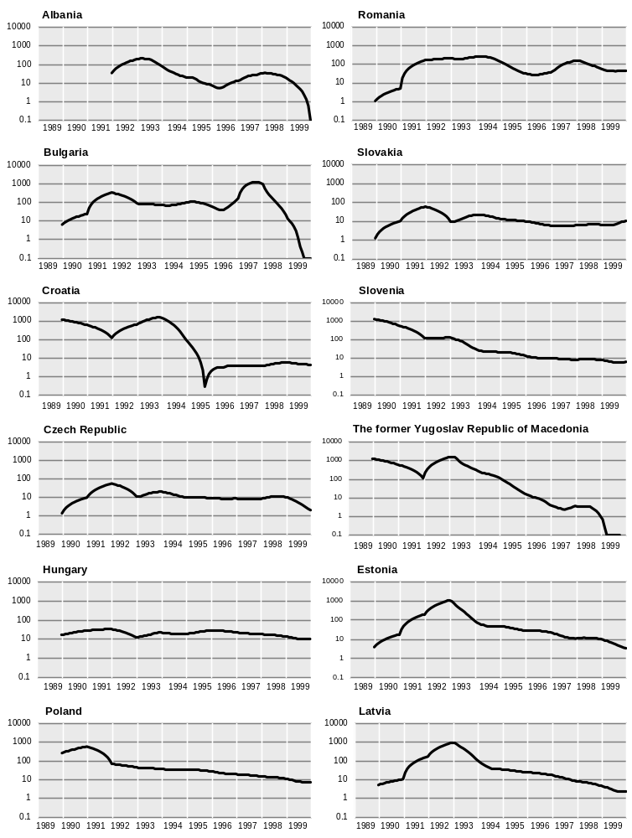
(For source and notes see end of chart)
CHART 3.4.1 (concluded)
Consumer prices in the transition economies, 1989-1999
(12-month year-on-year percentage change, December values for the period 1989-1992, semi-logarithmic scale)

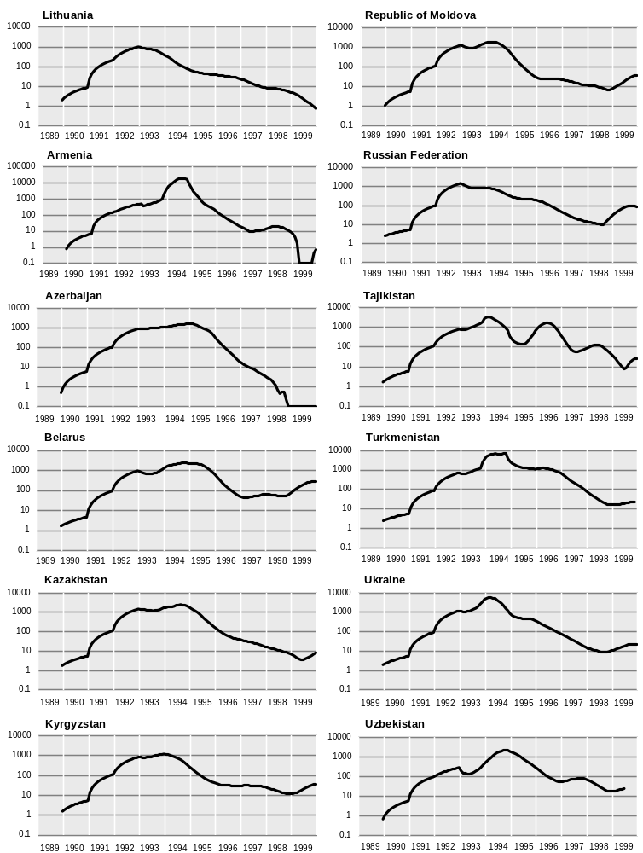
Source: National statistics and UN/ECE secretariat estimates.

This significant progress in macroeconomic stabilization in the Baltic states however was achieved at some cost in output growth: their average real GDP in 1999 was more than one third below its 1989 level, compared with 22 per cent and 4 per cent increases, respectively, in Poland and Slovenia. Although their different initial conditions, geographical situations, currency regimes and their later starts with reform should be taken into consideration, their relatively strict macroeconomic policies played a significant role not only in the remarkable rate of disinflation but also in the relatively weaker output performance.

CIS
As the result of their much longer and deeper communist legacy, the initial price shock in most of the CIS economies, which took inflation to hyper or near-hyper monthly rates, lasted much longer than in the Baltics. In 1994, when inflation in the latter was already quite moderate, most of the CIS economies still had double-digit monthly rates. Nevertheless, the subsequent disinflation was spectacular, with moderate or even low annual rates being reached by 1996 in the majority of them. The most rapid rates of disinflation were in Armenia, Azerbaijan and Georgia. This sharp downward trend in inflation continued until the effects of Russian financial crisis hit the region in late 1998. The only exceptions to this sharp inverted v-shape pattern in the evolution of inflation were Belarus, Tajikistan and Uzbekistan, where reforms were applied only fitfully or hardly at all. The trade-off between the gains in lower inflation and lost output growth as a result of acute macrostabilization was huge in most of the CIS, involving costs which are becoming more and more evident both in terms of the overall state of the reform process and the population’s well being.

South-east Europe
Reflecting the unfavourable initial conditions which were relatively less severe in Croatia, with large macroeconomic imbalances and thus greater vulnerability to external shocks in addition to the effects of war, these countries have had rather exceptional patterns of inflation. All of them, albeit at varying intensity and for different reasons, experienced double price shocks during 1989-1999. Furthermore, except in Romania where implementing reforms has continued to be problematic, the second price shock was followed by rapid disinflation, even to the point of deflation in Albania, Bosnia and Herzegovina, Bulgaria and The former Yugoslav Republic of Macedonia. Also in these economies the trade off between the fall in inflation and the lost growth in output was considerable, even before the additional losses due to the Kosovo crisis.

(b) Relative price changes, 1991-1999
One of the major characteristics of the transition economies which distinguishes them from the developed market economies over the past decade is the large discrepancies in their relative price changes. The reform process implies not only a large-scale restructuring of the supply side, in terms, for example, of the composition of output and the allocation of employment, but also significant changes in the composition of household expenditure and in relative prices, both of which rendered the overall consumer price index extremely volatile. There are a number of reasons why relative price changes can be expected to be more divergent among these economies. One is their greater vulnerability to external shocks, such as large changes in world market prices for commodities (e.g. the oil price fall in 1998 and its rise in 1999), large devaluations/depreciations (e.g. the Bulgarian lev in 1996 and Russian rouble in 1998), etc. Another very important and widespread cause is the gradual increase in the ceilings of various regulated prices. Under the centrally planned economy not only were most private services, such as financial intermediation, real estate, tourism and various personal services, underdeveloped or virtually non-existent, but other traditional services (rents, utilities, public transport, health, education etc.) were provided at artificially low prices. While most of the other prices were liberalized during the early phases of the reform process, the prices of most of these formerly state provided services remained under control as an element of the social safety net and only gradually increased. These adjustments of administered or controlled prices are still going on, albeit at different rates in individual countries. In fact this touches one of the major dilemmas in these economies: achieving macroeconomic stability at the same time as gradually moving towards a market economy where the prices are set by market forces ideally at market clearing levels to secure an efficient allocation of resources. In fact in some of these countries the authorities tried to prevent the consumer price index from rising faster by holding back the necessary adjustments, and thus increasing the amount of “postponed inflation” in the pipeline. This policy proved to be counter-productive in the long-run, and demonstrated the fact that not only slowing down the overall rate of inflation but also the achievement of a largely market determined and broadly stable relative price structure is important for sustaining macroeconomic stability, without which future growth and eventual catching up would be put under further stain.
Chart 3.4.2 shows the cumulative changes in the prices of three broad components of the consumer basket relative to the cumulative change in the total index since the start of the reforms. It shows clearly that in all the transition economies, service prices rose more rapidly than food and non-food goods prices.
Taking the period 1991-1999 as a whole, the largest changes in relative prices were in the CIS countries, where service prices, reflecting mainly the more unfavourable initial conditions in these economies, increased several times faster than total consumer prices. The only exception is Belarus, where major reforms have yet to start, and where most service prices are still under the control of the state.
CHART 3.4.2
Relative price changes within the consumer price index in selected transition economies, 1991-1999
(Percentages)

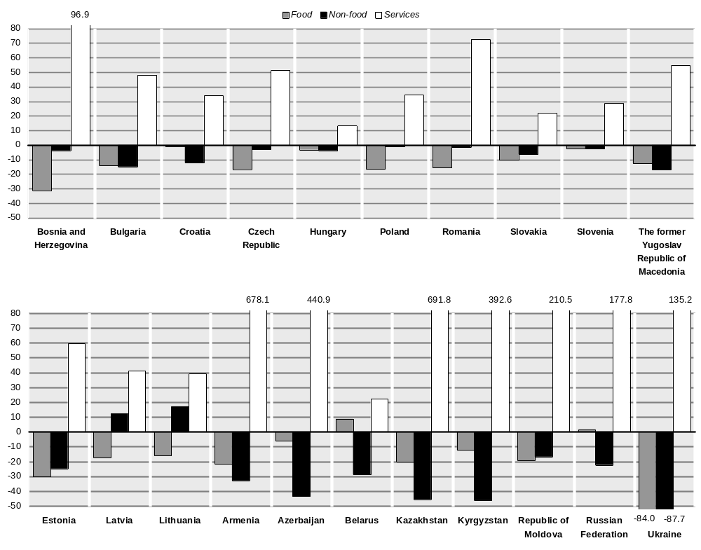
Source: UN/ECE secretariat estimates, based on national sources.
Note: The zero-line represents the cumulative per cent change in the total CPI between 1991 and 1999. Each component’s relative price change is calculated as the following: [(Ij ÷ It)-1]*100, where I is the price index in 1999 with 1991=100 (except in Croatia, The former Yugoslavia Republic of Macedonia, the Baltics and the CIS where 1993=100 and in Bosnia and Herzegovina 1995=100), j is the component and t the total.

Food prices, which have a large weight in the consumer price indexes of the transition economies, generally fluctuated more than average but they also tended to rise more slowly than the overall index, with the sole exception of Belarus. During the same period the prices of non-food goods also pulled down the overall rate of consumer price inflation, particularly in the CIS countries (except Republic of Moldova) where they increased even more slowly than food prices. Only in Latvia and, especially, Lithuania did non-food goods’ prices actually rise faster than the overall index, mainly a reflection of the relatively more rapid growth of unit labour cost in industry.
Among all the transition countries the smallest relative price changes were in Hungary and Slovakia. In Hungary this is mainly due to the fact that the economy started the transition process with a more developed service sector and a less distorted price structure, as a result of the gradual market reforms that had already started in the 1980s. But in Slovakia it reflects the very slow pace at which regulated prices were liberalized until late 1998.

3.5 Labour markets

(i) Introduction
The former communist regimes in eastern Europe and the former Soviet Union, ideologically committed to full employment, achieved near full employment levels, although at the price of low labour productivity and low wages. Labour hoarding was pervasive and overemployment, albeit to varying degrees, was a general characteristic of labour markets under central planning.
The transitional or transformation recession, which followed the revolutions of 1989, depressed both output and employment well below their pre-reform levels. However the fall in output was much greater than that for employment and so there was also a collapse of labour productivity. There were various reasons for this weak response of employment to the change in output, but a major factor was the reluctance of governments to risk a massive increase in open unemployment in the absence of comprehensive social safety nets. It was judged safer to keep workers on the payroll, sometimes at miserable wages, in order to provide them with the non-wage benefits offered at the enterprise level as a substitute for social provision. While this policy, albeit to varying degrees, postponed micro-restructuring, it did help to maintain the often fragile popular support for other major reforms, such as price liberalization which destroyed a large part of the population’s savings and significantly reduced their real wages. Nevertheless, in some countries the lag in the employment response to output change was extended for far too long. Thus overemployment (or excess employment, indicated by the difference between cumulative change in GDP and the cumulative change in employment) in some countries remained unchanged or even increased (mainly in the former Soviet republics) with negative impacts on overall efficiency, profitability and hence fixed investment (both domestic and foreign). This in turn reduced or even retarded the overall rate of recovery. Growth in new sectors, both in industry and services, was thus restrained and the creation of “new jobs” was much slower than expected. Nevertheless, in many countries, especially in central Europe, structural change has been significant and there were many signs in 1999 that the pace of industrial restructuring was beginning to accelerate.

(ii) Changes in employment in the transition economies over 1990-1998

(a) Evolution of total employment
One of the major consequences of the structural adjustments required by the transition process was a large decline in employment during the 1990s, even in those economies where had output started to recover relatively quickly. Between 1989 and 1998 employment fell by more than 27 million in all the UN/ECE transition economies taken together, that is by 14 per cent.
As GDP was still 35 per cent below its 1989 level in 1998, the cause might seem to lie solely in the transformation recession, particularly as 22 million of the 27 million jobs lost were in industry. As soon as the figures are disaggregated into country groups, however, a different picture emerges.
The substantial lag of net job creation behind the growth of output is striking for the five leading reformers of central Europe – the Czech Republic, Hungary, Poland, Slovakia and Slovenia. This raises the question whether this is a normal lag, or whether there are more deep-seated barriers to job creation. Their aggregate GDP in 1998 was already 5.8 per cent above its 1989 level and yet employment declined over the same period by 12.6 per cent (appendix tables B.1 and B.5). Industrial output in the same countries in 1998 was only 2.3 per cent below its 1989 level, but industrial employment had fallen 27.3 per cent (appendix tables B.4 and B.6). This substantial fall in industrial employment was not totally offset by job creation in other sectors. The figures for annual changes in output and employment indicate that the typical inertia in the dynamics of employment was less marked in this group of economies. Although the rate of decline in output in central Europe was steeper than that of jobs in the early years of the transition, this was less true than in the other groups of transition economies. Thus there may have been relatively less overemployment than in the slower reformers. Nonetheless, employment in these countries grew by just under 5 per cent during the entire five year span of 1994-1998, when output grew by nearly 25 per cent. The greater part, by far, of the total increase in employment, moreover, was due to one country, Poland.
The return to economic growth in the other transition economies has been no more favourable to net employment creation, partly because of the absorption of the “overhang” of excess labour, and partly as a result of restructuring and technological innovation embodied in the growth process.
In the south-east European economies employment in 1998 was 23 per cent below its 1989 level, while GDP was 27 per cent lower. In the Baltic states employment fell by nearly 20 per cent, and GDP by more than 33 per cent. The falls in employment between 1989 and 1998 were virtually identical in the countries of the CIS and the central European countries (about 13 per cent), although GDP fell 46 per cent in the former. This pattern of CIS responses reflects the relative absence of restructuring and was therefore part of a pattern in which there was a continued fall in output, large declines in productivity, and a serious deterioration in real wages.
Excess employment was a general feature of the transition economies at the start of economic transformation, and its scale and development over time has varied widely among countries. As chart 3.5.1 suggests, three distinct groups of countries emerge. The first, composed of countries far above the reference line, consists of four advanced reforming central European economies (excluding the Czech Republic), in which the cumulative decline in employment considerably exceeded that in output, which suggests that excess employment has diminished significantly. In the second group, countries far below the reference line, are the CIS states, Latvia, Lithuania and Yugoslavia, where excess employment appears to have reached very large proportions, a reflection of major delays in the reform process. Thus the chronic “labour hoarding” of the Soviet era has actually increased in this group during the transition. The third group includes those countries which remain very close to the reference line. In 1998, excess employment in this group remained high and was close to that in 1989.
CHART 3.5.1
The output-employment relationship in selected
transition economies, 1990-1998
(Percentages)

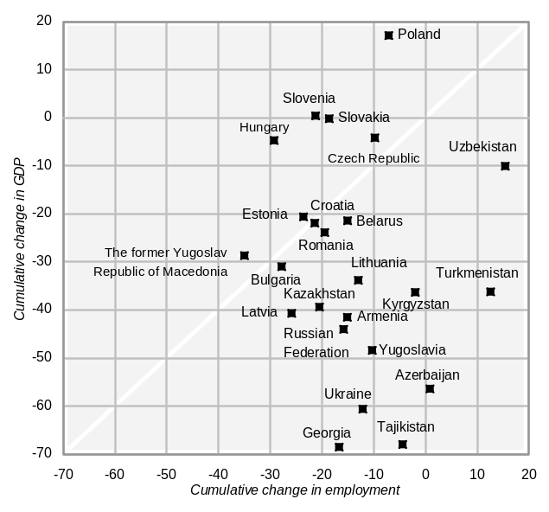
Source: UN/ECE secretariat estimates, based on national statistics.
Note: The reference line describes the situation when the cumulative rate of change in employment is equal to the cumulative rate of change in output. The horizontal distance from this line indicates the change in the size of excess employment during 1990-1998. Countries above (below) the line are those where the size of excess employment declined (increased) since 1990.

Does the experience of most of the more rapid reformers suggest policy lessons for increasing the job content of economic growth? There are a few key lessons which have been widely drawn, although they remain controversial. The least debated observation concerns the evident importance of reducing the mismatch between workers seeking work and the location of new jobs, which has already resulted in marked regional imbalances. This evidently requires improvement in housing markets, but improved commuter transport services may also increase the geographical spread of the local labour markets so that no change of residence is needed to change jobs, and better infrastructure for the economy could boost the regional dispersion of greenfield investments, something the Hungarian government, for example, is now promoting.
Skill mismatch has also become increasingly important, and education and retraining measures must be carefully implemented to be effective. The efficacy of active labour market policies remains in some dispute. The relative importance of wage flexibility is also sometimes questioned, in particular because other components of labour costs may be more important. One of these is the tax wedge between gross and net wages, especially in the form of payroll taxes, which are generally larger in transition economies than in all but two EU countries, Italy and Belgium. In this regard, a number of reforms have been proposed to shift the tax burden from labour. Given the substantial pool of unemployment and the increase in non-participation in the labour market, the measures proposed are undoubtedly important, but it still remains to be shown to what extent the barriers to job creation, for a given rate of growth, are unusually high.

(b) Structural changes
CHART 3.5.2
Cumulative changes in employment by broad sectors in selected transition economies, 1990-1998
(Per cent)

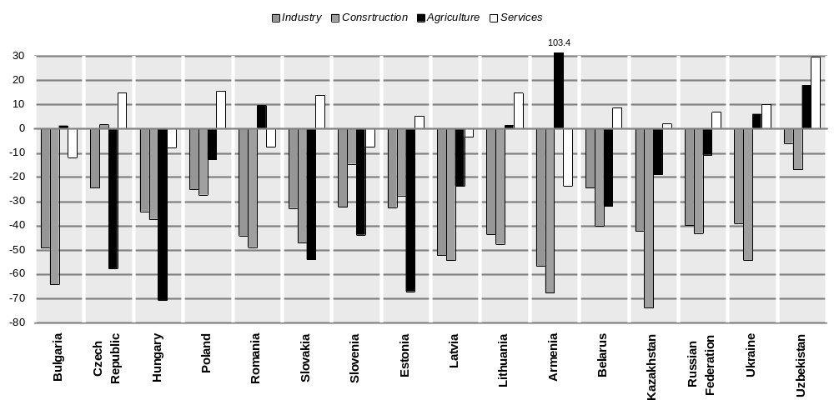
Source: UN/ECE secretariat estimates, based on national statistics.

During 1990-1998 there were considerable changes in the sectoral composition of employment, as well as in its overall size. Despite substantial intercountry variations, several major tendencies can be identified. The fall in employment has been greatest in agriculture, industry and construction, whereas employment in services has increased in most of the transition economies. Charts 3.5.2 and 3.5.3 summarize the main changes in employment between 1989 and 1998, both in absolute terms and in terms of the composition of total employment by five broad sectors: agriculture, industry, of which manufacturing, construction and services.
A common feature is the dramatic fall of overemployment in industry, a reflection of the high rate of overemployment prevailing under the previous system. The rate of decline varied in most of eastern Europe and the Baltic states between some 25 and 50 per (chart 3.5.2). In the CIS countries, with the exception of Uzbekistan, the fall was even more pronounced. Industrial employment continued to decline through 1998 in most countries, although at a somewhat lower rate. However, in 1999, the rate of decline accelerated again in some countries due to intensified restructuring, as in the Czech Republic and particularly in Poland. In eastern Europe, Hungary is the only country where employment in industry has been increasing, since 1997. It was also rising over the same period in Belarus and Uzbekistan where reform, in contrast, has been very slow.
The situation in construction was very similar to that of industry. With the exception of the Czech Republic, employment in construction declined sharply in all the transition economies (chart 3.5.2). The decline may be partly explained by increasing productivity due to improved management and technology, but the main cause has been the considerable fall in housing and infrastructure construction by the public sector, with the exception of Slovakia, due to budget constraints.
The evolution of employment in manufacturing was more differentiated across the transition economies. In those where manufacturing has become the main engine of economic recovery, employment in this sector stopped falling in 1994-1995 and thereafter was flat (the Czech Republic and Slovakia) or even started to increase (Hungary and Poland). Elsewhere it has continued to decline, although at a much slower rate. In all the east European countries and Estonia, the decline of employment in manufacturing was less pronounced than in industry (chart 3.5.3). Poland was the only country where employment in manufacturing in 1998 exceeded, albeit slightly, its 1992 level, although industrial employment had fallen by more than 2 per cent over the same period. In contrast, in Latvia and Lithuania, employment in manufacturing has fallen much more than in industry (more than 40 per cent), possibly reflecting the breakdown of the former close production ties and the loss of key markets in the former Soviet Union. The reduction of manufacturing employment between 1992-1998 was relatively modest in the Czech Republic, Hungary and Slovakia (between some 10 and 15 per cent), but it reached about 25 per cent in Estonia and Romania.
The share of manufacturing in total employment declined by 1-3 percentage points in most of the countries in chart 3.5.3, but by close to 8 percentage points in Latvia and nearly 10 percentage points in Lithuania. In 1998, the share of manufacturing varied in most cases between some 20 and 25 per cent, but it still remained relatively high, nearly 30 per cent in the Czech Republic.
In contrast to the sharp decline in industry and construction, the service sector has grown rapidly, and in many countries created a considerable number of new jobs, helping to absorb a substantial share of the labour force displaced from other sector of economic activity. Employment in services fell in only a few countries (Bulgaria, Hungary, Romania, Slovenia, Latvia and Armenia). In the rest of the countries shown in chart 3.5.2 it was broadly unchanged or increased. The increase was particularly large (about 15 per cent) in the Czech Republic, Poland, Slovakia and Lithuania, and exceptionally so in Uzbekistan (some 30 per cent). This pattern of relative change of employment in services (as distinct from that in other branches of the economy) can be explained in part by the fact that employment in the health, education and other social services, where there was little privatization, has generally fallen considerably less than total employment. At the same time, under the centrally planned economy most private services were underdeveloped or virtually non-existent. Therefore employment in these branches, and particularly in financial intermediation, has increased markedly. Consequently, the share of services in total employment has increased considerably. In 1998, services held the largest share of total employment in all countries except Romania and Armenia, in most cases reaching 50 per cent or more. Between 1989 and 1998, the largest increases were in the Czech Republic, Hungary, Slovakia, all the Baltic states, Kazakhstan and Russia, on average by more than 12 percentage points.
If the direction of changes in employment in industry, manufacturing, construction and services, especially as regards their shares of total employment, have been fairly similar across countries, the evolution of employment in agriculture has varied considerably. Broadly, there are three different groups of countries. In the first, comprising the Czech Republic, Hungary, Estonia, Slovakia and Slovenia, agricultural employment fell steeply between 1989 and 1998, by some 45 to 70 per cent (chart 3.5.2). In the second (Poland, Latvia, Kazakhstan and Russia), the decline was relatively modest, not exceeding 25 per cent. In the third group, agricultural employment actually increased: by some 2 per cent in Bulgaria and Lithuania, 6 to 18 per cent in Ukraine, Romania and Uzbekistan, and more than doubling in Armenia.
As a result, the share of agriculture in total employment in 1998 remained generally at or above its 1989 level. The only exceptions were the countries belonging to the first group, where the decline in some cases was more than 10 percentage points (Hungary and Estonia), and where the share of agriculture in 1998 varied between some 6 and 9 per cent and was gradually converging to EU levels. In most of the other countries in chart 3.5.3, the share of agriculture in total employment ranged between 14 per cent in Russia and some 25 per cent in Bulgaria and Poland. In Romania, Armenia and Uzbekistan it was close to or even above 40 per cent. In Uzbekistan the share of agriculture in total employment (38.5 per cent in 1989) has been traditionally high, but in Romania and Armenia the increase was the result of a massive inflow of the labour force to the agricultural sector. This was partly due to the emergence of numerous small farms after the privatization of large agricultural enterprises, but agriculture was also continuing to act as a shock absorber since workers displaced in other branches of the economy returned to their rural origin, sometimes supported by incentive schemes. In 1998 Romania and Armenia were the only countries where there were more people employed in agriculture than in industry or services.

CHART 3.5.3
The structure of employment by broad sectors in selected transition economies, 1989 and 1998
(Share of total employment, per cent)

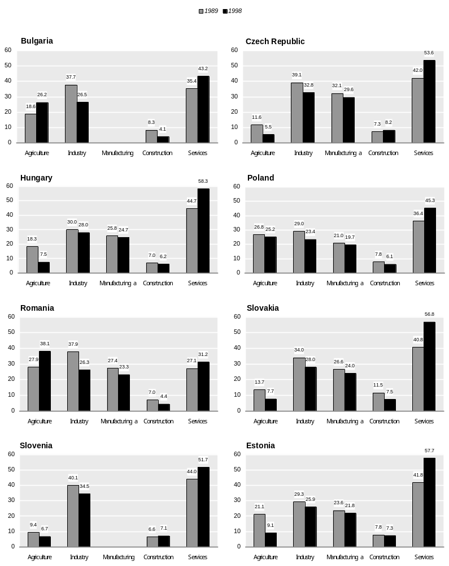
(For source and notes see end of chart.)

CHART 3.5.3 (concluded)
The structure of employment by broad sectors in selected transition economies, 1989 and 1998
(Share of total employment, per cent)

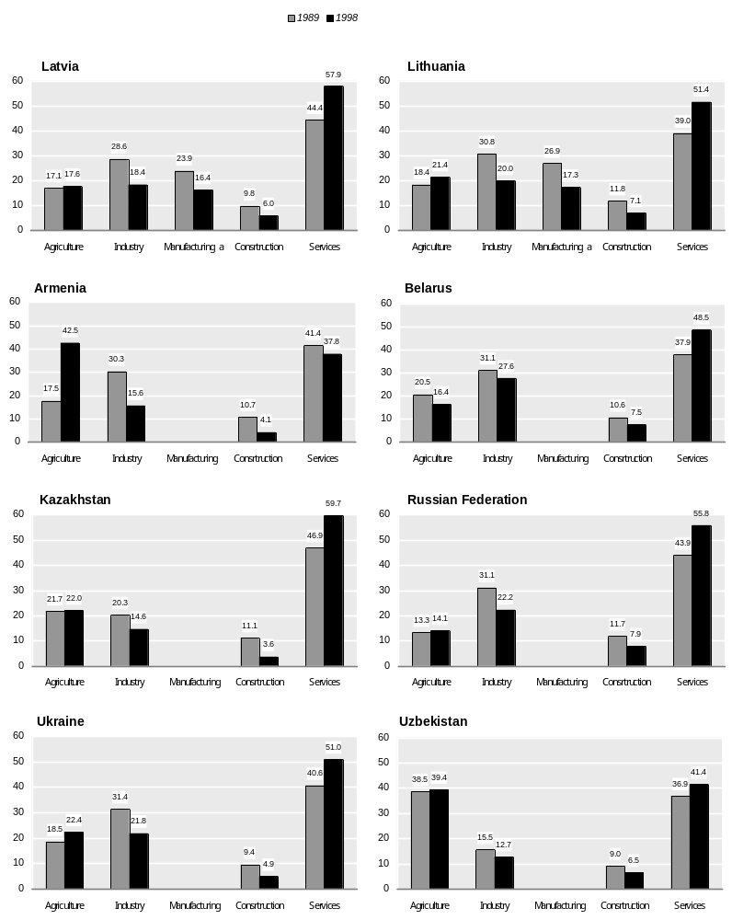
Source: UN/ECE secretariat estimates, based on national statistics.
a For manufacturing, 1992 and 1998.

(c) The evolution of service sector employment, 1992-1998
Many of the service sector branches were traditionally underdeveloped or even non-existent in the former centrally planned economies. Thus, at the start of the transition the expectations were that this sector would grow rapidly and that, in particular, it would create a considerable number of new jobs, absorbing a large share of the labour force released in other parts of the economy. The available data suggest that in general this has in fact occurred, but the situation differs considerably among countries.
The share of services in total employment has increased markedly during the transition and in 1998, with the exception of Poland, was above 50 per cent of total employment (chart 3.5.4). However, this considerable increase in share was not always the result of growth in the absolute number of persons employed in services. In some cases it was simply the result of a much larger decline of employment in the other sectors of the economy. Hungary and Latvia exemplify this: in 1998, both countries had the highest share of services in total employment, close to 60 per cent. However, the absolute number of persons employed in the sector between 1992 and 1998 was generally flat in Hungary and declined slightly in Latvia (charts 3.5.4 and 3.5.5). Thus, the major reason for the increased share of services was the relatively large decline of employment in other sectors. Only in the Czech Republic between 1994 and 1996, and in Poland from 1994 to 1998, was the service sector growing sufficiently to fully absorb workers displaced from other sectors and ensure an excess of job creation over job destruction. In Estonia, Lithuania and Slovakia, the service sector has also absorbed displaced labour, but not enough to fully compensate for the cutbacks in the other sectors.
An indirect indicator of the development of the service sector, which can also be used for cross-country comparisons, is the number of people employed in services per 1,000 of the population. As chart 3.5.6 indicates, developments in the service sector in terms of employment per 1,000 inhabitants generally corresponds to the trend in the absolute figures after adjusting for changes in the total population. Between 1992 and 1998, the number employed in the service sector per 1,000 inhabitants increased in all countries except Hungary (the largest increases, by some 30 persons, were in the Czech Republic, Estonia and Poland) and in 1998 exceeded 210 persons in all countries. The highest level was some 255 persons in the Czech Republic and Estonia. The main exception is Poland, where despite a marked increase, the ratio still remains comparatively low at just 185 persons. The existing size and rates of expansion of the service sector in the transition economies suggests that in most of them it is still significantly smaller than in the majority of the western market economies. This can largely be explained by their much lower incomes per head compared to the latter.
Although services were generally the most dynamic sector, in terms of increased employment, the development of the various branches was far from homogeneous. During 1992-1998, only in three groups of services was there a clear upward trend in all countries: wholesale and retail trade, and repairs (I); financial intermediation (IV); and public administration, defence and social security (VI). The leading branch was financial intermediation (IV) where between 1992 and 1998 the number employed increased considerably, with the increase in most countries ranging between some 50 per cent and nearly 90 per cent, although it still remained the smallest branch in 1998 (table 3.5.1, panel A). In contrast, employment in transport, storage and communication (III) fell in all countries except Poland, where it virtually stagnated. In general, there were also increases in hotels and restaurants (II) and real estate, renting and business (V), but in education (VII) and health and social work (VIII) the changes were very diverse.
These divergent trends were of course reflected in changes in the distribution of employment within the service sector (panel B of table 3.5.1). In line with the developments described above, the three most dynamic sectors (I, IV and VI) increased their shares of total services employment; while the most notable fall was the share of transport, storage and communication. Apart from these, there were no other major changes in the employment structure of services.
CHART 3.5.4
The share of services in total employment in selected transition economies, 1992-1998
(Per cent)

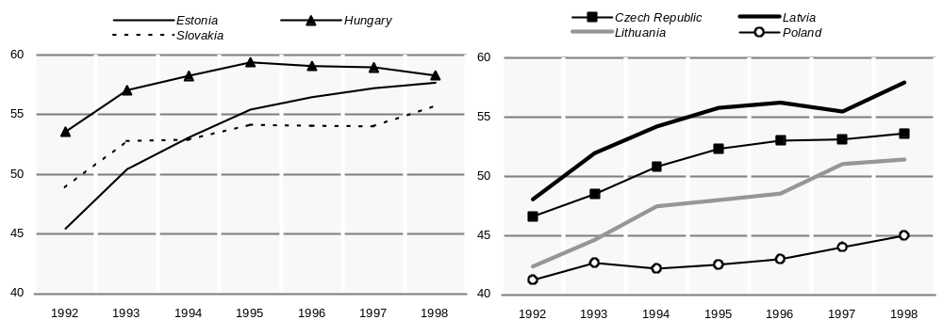
Source: UN/ECE secretariat estimates, based on national statistics.

CHART 3.5.5
The evolution of employment in the service sector in selected transition economies, 1992-1998
(Indices, 1992=100)

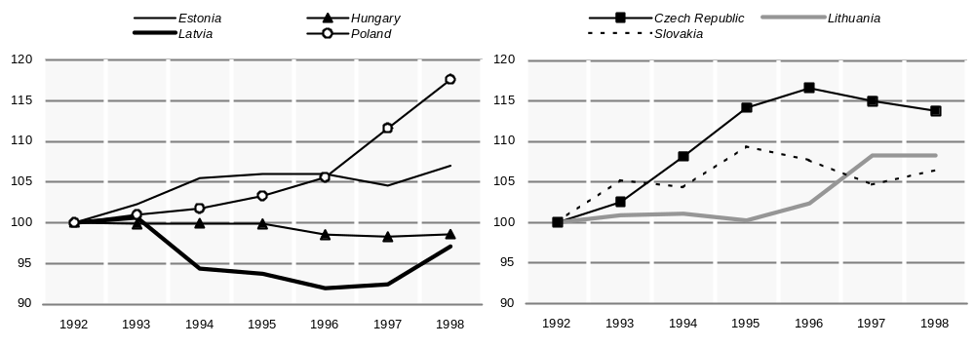
Source: UN/ECE secretariat estimates, based on national statistics.

(iii) Recent developments

(a) Changes in employment in 1999
As a result of the deterioration in output growth in late 1998 and early 1999, combined with a faster rate of enterprise restructuring in a large number of countries over the year, the weak upward trend of employment in eastern Europe in the last two years came to a halt, and in the first three quarters of 1999, it declined by 0.7 per cent, compared with a small increase in the same period of 1998 (table 3.5.2). The changes in individual countries reflect the diversity of their macroeconomic situations. In the first three quarters of 1999, there were relatively large increases of employment only in Hungary and Slovenia; it was flat in The former Yugoslav Republic of Macedonia and there was some recovery from very low levels in Bosnia and Herzegovina, but elsewhere the decline was general.
In Hungary, where economic activity remained strong in 1999, employment increased by 3.5 per cent, much more than in 1998, and there were signs of a new pattern of employment emerging. For a second consecutive year employment increased in Slovenia where, as in Hungary, the growth of output remained relatively strong. Although, the rate of employment growth was relatively modest (just above 1 per cent) it was still higher than in 1998. The growth of employment was largely concentrated in services; there was a small increase in construction but in agriculture and industry it continued to fall.
CHART 3.5.6
The number of persons employed in the service sector in selected transition economies, 1992-1998
(Per 1,000 inhabitants)

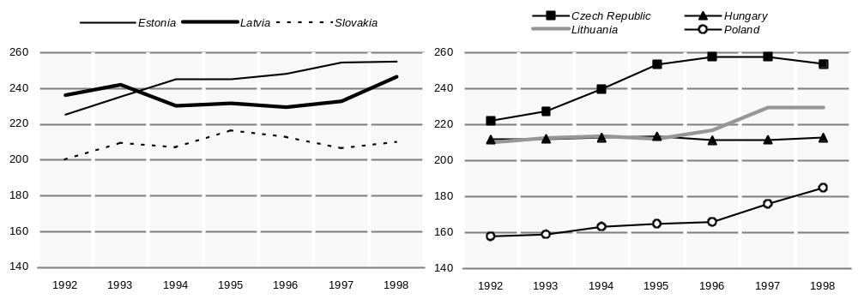
Source: UN/ECE secretariat estimates, based on national statistics.

In Poland, after five years of sustained and relatively high growth, employment started to fall. This was mainly due to the slowdown of output, which started in late 1998 and continued during the first months of 1999, but another major factor was a faster rate of restructuring in various branches of the economy which led to large job losses in the coal mining, steel and textile industries. As in previous years, state owned industry continues to shed labour. But for the first time since the country began its transition, large layoffs were made by private firms in order to increase efficiency. The data on paid employment indicate that it declined by 1.2 per cent in 1999 (compared with an increase of 1.3 per cent in 1998). The largest falls were in agriculture, and mining and quarrying (in both cases above 13 per cent). Employment in construction was flat, but in manufacturing it fell by more than 3 per cent. By contrast, employment in services continued to increase, but unlike previous years the number of new jobs in services was not enough to fully absorb the losses in the other sectors.
The employment situation has deteriorated considerably in the Czech Republic, where the weak economic performance, and a long-delayed increase in the rate of enterprise restructuring has led to an increased number of job losses. In the first three quarters of 1999, employment declined by nearly 4 per cent, the largest fall since 1992 and affecting all the major sectors of the economy including services. In Slovakia, also as a result of a marked slowdown in the growth of output and the start of a long-delayed process of industrial restructuring, total employment fell by nearly 2 per cent in the first three quarters of 1999, but by more than 3 per cent in industry and nearly 9 per cent in construction; only in services was there a small increase.
Employment continued to fall in Romania, but by surprisingly little in the first three quarters of 1999 given the depth of the recession in output. This suggests that agriculture, which now accounts for more than 40 per cent of total employment, continues to absorb – or reabsorb – workers displaced in other parts of the economy.
TABLE 3.5.1
Employment in the service sector in selected transition economies, 1992-1998
(Percentage change, percentage)
 |  |  | of which:
 | Total  service |  | Wholesale and  retail  trade,  repairs |  |  | Hotel  and restaurants |  |  |  | Transport, storage  and communi-cations |  |  | Financial intermediation |  | Real estate, renting  and  business |  | Public administration, defence  and social security |  |  |  | Education | Health  and social work |  |  | Other community, social and personal service activities
 |  |  | I |  |  | II |  |  |  | III |  |  | IV |  | V |  | VI |  |  |  | VII | VIII |  |  | IX
Panel A: change over 1992-1998
Czech Republic | 13.9 |  | 39.0 |  |  | 44.1 |  |  |  | -7.9 |  |  | 70.8 |  | 17.1 |  | 43.4 |  | -6.8 |  |  |  | -2.0 |  |  | -17.0
Estonia | 6.1 |  | 25.7 |  |  | -18.2 |  |  |  | -5.0 |  |  | 45.8 |  | 38.9 |  | 13.3 |  | 14.8 |  |  |  | -27.3 |  |  | -9.0
Hungary | -1.5 |  | -1.7 |  |  | 5.2 |  |  |  | -12.8 |  |  | 19.1 |  | 16.2 |  | 0.2 |  | -2.0 |  |  |  | 0.6 |  |  | -9.1
Latvia | -2.9 |  | 27.1 |  |  | -51.1 |  |  |  | -10.9 |  |  | 66.7 |  | -24.2 |  | 77.8 |  | -7.2 |  |  |  | -10.4 |  |  | -34.3
Lithuania | 8.2 |  | 35.7 |  |  | 34.9 |  |  |  | -21.9 |  |  | 4.9 |  | 10.6 |  | 42.5 |  | 10.8 |  |  |  | 5.2 |  |  | -21.6
Poland | 17.6 |  | 22.1 |  |  | 45.4 |  |  |  | -0.3 |  |  | 60.6 |  | 49.8 |  | 31.3 |  | 11.5 |  |  |  | 6.1 |  |  | -6.8
Slovakia | 6.4 |  | 27.1 |  |  | 24.5 |  |  |  | -5.2 |  |  | 85.8 |  | -4.9 |  | 0.8 |  | -10.1 |  |  |  | 5.2 |  |  | 20.6
Average | 6.8 |  | 25.0 |  |  | 12.1 |  |  |  | -9.2 |  |  | 50.5 |  | 14.8 |  | 29.9 |  | 1.6 |  |  |  | -3.2 |  |  | -11.0
Panel B: share of branches in total services
Czech Republic
1992 |  |  | 23.7 |  |  | 4.4 |  |  |  | 15.9 |  |  | 2.2 |  | 14.8 |  | 5.4 |  | 14.2 |  |  |  | 11.7 |  |  | 7.7
1998 |  |  | 28.9 |  |  | 5.6 |  |  |  | 12.9 |  |  | 3.3 |  | 15.2 |  | 6.8 |  | 11.6 |  |  |  | 10.1 |  |  | 5.6
Estonia
1992 |  |  | 20.7 |  |  | 5.1 |  |  |  | 17.6 |  |  | 1.7 |  | 8.0 |  | 9.3 |  | 14.1 |  |  |  | 13.9 |  |  | 9.5
1998 |  |  | 24.5 |  |  | 3.9 |  |  |  | 15.8 |  |  | 2.3 |  | 10.5 |  | 9.9 |  | 15.3 |  |  |  | 9.5 |  |  | 8.2
Hungary
1992 |  |  | 22.0 |  |  | 5.3 |  |  |  | 15.8 |  |  | 3.1 |  | 6.4 |  | 13.4 |  | 14.3 |  |  |  | 10.8 |  |  | 8.9
1998 |  |  | 21.9 |  |  | 5.6 |  |  |  | 14.0 |  |  | 3.8 |  | 7.6 |  | 13.7 |  | 14.2 |  |  |  | 11.0 |  |  | 8.2
Latvia
1992 |  |  | 21.4 |  |  | 7.6 |  |  |  | 16.2 |  |  | 1.4 |  | 10.0 |  | 5.8 |  | 15.6 |  |  |  | 10.8 |  |  | 11.3
1998 |  |  | 28.0 |  |  | 3.8 |  |  |  | 14.9 |  |  | 2.5 |  | 7.8 |  | 10.6 |  | 14.9 |  |  |  | 9.9 |  |  | 7.6
Lithuania
1992 |  |  | 22.7 |  |  | 2.4 |  |  |  | 15.8 |  |  | 1.8 |  | 5.4 |  | 6.3 |  | 17.5 |  |  |  | 13.1 |  |  | 14.9
1998 |  |  | 28.5 |  |  | 2.9 |  |  |  | 11.4 |  |  | 1.8 |  | 5.5 |  | 8.4 |  | 17.9 |  |  |  | 12.8 |  |  | 10.8
Poland
1992 |  |  | 29.7 |  |  | 2.5 |  |  |  | 14.9 |  |  | 3.0 |  | 8.6 |  | 5.4 |  | 13.1 |  |  |  | 16.2 |  |  | 6.4
1998 |  |  | 30.8 |  |  | 3.1 |  |  |  | 12.6 |  |  | 4.3 |  | 10.9 |  | 6.0 |  | 12.5 |  |  |  | 14.7 |  |  | 5.1
Slovakia
1992 |  |  | 21.4 |  |  | 2.7 |  |  |  | 15.2 |  |  | 1.8 |  | 14.2 |  | 7.9 |  | 19.1 |  |  |  | 12.0 |  |  | 5.8
1998 |  |  | 25.5 |  |  | 3.1 |  |  |  | 13.5 |  |  | 3.1 |  | 12.7 |  | 7.5 |  | 16.1 |  |  |  | 11.9 |  |  | 6.5
Average
1992 |  |  | 23.1 |  |  | 4.3 |  |  |  | 15.9 |  |  | 2.2 |  | 9.6 |  | 7.6 |  | 15.4 |  |  |  | 12.6 |  |  | 9.2
1998 |  |  | 26.7 |  |  | 3.9 |  |  |  | 13.9 |  |  | 2.8 |  | 9.7 |  | 8.9 |  | 14.7 |  |  |  | 11.6 |  |  | 7.6
Rank
1992 |  |  | 1 |  |  | 8 |  |  |  | 2 |  |  | 9 |  | 5 |  | 7 |  | 3 |  |  |  | 4 |  |  | 6
1998 |  |  | 1 |  |  | 8 |  |  |  | 3 |  |  | 9 |  | 5 |  | 6 |  | 2 |  |  |  | 4 |  |  | 7
Source: UN/ECE secretariat estimates, based on national statistics.
Note: Branches are defined according to the NACE classification.

In Bulgaria, a faster rate of closure of loss-making enterprises contributed to a fall in employment of more than 5 per cent in the first three quarters of 1999. All sectors of the economy were affected but there were particularly steep falls in agriculture and industry (some 8 and 10 per cent, respectively). In the other countries of the region for which data are available, employment continued to decline at much the same rates as in 1998, although more so in Albania and, especially, Croatia, where the economy went into recession.
In the Baltic states, also reflecting weaker economic performance, there was a notable deterioration in the labour markets in 1999. In the first three quarters, employment fell by more than 4 per cent in Estonia and nearly 2 per cent in Latvia. In Lithuania, the situation deteriorated over the year and in the third quarter employment fell by nearly 1 per cent. In all the three countries, employment declined most in agriculture and industry, while in services it fell only slightly or even continued to increase (Lithuania).
TABLE 3.5.2
Total and industrial employment in the transition economies, 1997-1999
(Percentage change over the same period of preceding year)
 | Total employment |  |  |  | Employment in industry
 | 1997 | 1998 | QI-QIII 1998 | QI-QIII 1999 |  | 1997 | 1998 | QI-QIII 1998 | QI-QIII 1999
Eastern Europe a | 1.2 | 0.4 | 0.1 | -0.7 |  | -1.2 | -1.9 | -1.2 | -3.8
Albania | -0.7 | -2.0 | -0.4 | -2.1 |  | 3.5 | -4.8 | .. | ..
Bosnia and Herzegovina | 52.7 | 5.9 | 5.4 | 4.0 |  | 21.9 | -2.3 | .. | -3.5b
Bulgaria | -3.9 | -0.2 | .. | -5.2 |  | -4.4 | -4.0 | .. | -9.8
Croatia | -0.8 | 6.6 | 7.0 | -2.7 |  | -4.0 | 5.9 | 6.3 | -4.4
Czech Republic | -1.9 | -1.5 | -1.2 | -3.5 |  | -0.6 | -0.6 | -0.4 | -3.3
Hungary | 0.1 | 1.4 | 2.4 | 3.5 |  | 1.7 | 4.6 | 5.1 | 1.1
Poland | 2.8 | 2.3 | 1.2 | -0.3 |  | 0.3 | -1.1 | -0.7 | -4.1
Romania c | 1.0 | -1.9 | -1.4 | -1.0 |  | -2.5 | -5.4 | -5.3 | -6.4
Slovakia | 0.2 | -0.4 | -0.3 | -1.9 |  | -2.0 | -4.1 | -3.6 | -3.1
Slovenia | -0.2 | 0.2 | 0.4 | 1.2 |  | -4.2 | -1.0 | -1.4b | -1.3b
The former Yugoslav  Republic of Macedonia | -5.4 | -2.7 | -4.3 | 0.2 |  | -7.6 | -3.6 | -4.1 | -0.6
Yugoslavia | 5.9 | -0.2 | -1.5 | .. |  | -3.1 | -2.8 | -2.7 | ..
Baltic states | 1.0 | -0.5 | -0.1 | -1.4 |  | -0.5 | -3.3 | -3.1 | -2.5
Estonia b | 0.4 | -1.3 | -0.6 | -4.4 |  | -5.7 | -2.0 | -2.4 | -5.4
Latvia | 1.9 | 0.6 | 1.1 | -1.7 |  | 3.5 | -8.1 | -7.8 | -1.7
Lithuania | 0.6 | -0.8 | -0.6 | -0.1 |  | – | -1.0 | -0.8 | -1.1
CIS a | -1.4 | -1.2 | -1.0 | 0.3 |  | -8.2 | -3.8 | -2.5 | -1.0
Armenia | -4.4 | -2.5 | -2.4 | -2.0 |  | -10.2 | -8.5 | -8.7 | -1.6
Azerbaijan | 0.2 | 0.2 | 0.1 | 0.1 |  | -14.5 | 3.8 | 2.2 | 1.6
Belarus | 0.1 | 1.1 | 0.8 | 1.5 |  | 0.2 | 1.4 | 1.1 | 1.3
Georgia | 4.5 | 0.8 | .. | .. |  | -23.2 | 1.0 | .. | ..
Kazakhstan | -0.7 | -5.3 | -5.5 | -0.3 |  | -11.8 | -2.0 | -0.7 | -0.4
Kyrgyzstan | 2.3 | 0.9 | 0.8 | 0.4 |  | -6.1 | -2.2 | -2.2 | -6.9
Republic of Moldova | -0.8 | -0.2 | -0.7 | -2.5 |  | -2.4 | -4.7 | -4.9 | -5.8
Russian Federation | -2.0 | -1.5 | -1.5 | 0.9 |  | -9.0 | -5.1 | -2.1 | -0.5
Tajikistan | 3.4 | 0.3 | 2.0 | 0.7 |  | -12.2 | -3.8 | 1.3 | -9.1
Turkmenistan | 0.5 | 0.2 | .. | .. |  | 9.4 | 1.0 | .. | ..
Ukraine | -2.7 | -1.1 | -1.6 | -1.4 |  | -8.5 | -3.1 | -2.4 | -3.3
Uzbekistan | 1.4 | 1.4 | 1.1 | 1.0 |  | 0.2 | 0.5 | -0.5 | 0.7
Total above a | -0.7 | -0.9 | -0.9 | -0.2 |  | -5.6 | -2.5 | -2.1 | -2.3
Memorandum items:
CETE-5 | 1.2 | 1.2 | 0.6 | -0.5 |  | -0.1 | -0.4 | – | -2.8
SETE-7 | 1.1 | -0.7 | -0.8 | -1.0 |  | -2.7 | -3.9 | .. | ..
Source: UN/ECE secretariat estimates, based on national statistics.
Note: Changes in employment based on quarterly statistics are not always fully comparable with those based on annual data due to differences in coverage.
a Three quarters regional aggregates of total employment exclude Bulgaria, Georgia, Turkmenistan and Yugoslavia; those for employment in industry also exclude Albania and Bosnia and Herzegovina.
b First half of the year for quarterly data.
c Based on labour force survey data.

In the CIS countries, where economic recovery resumed in most of them, employment generally stopped falling in 1999. In the first three quarters, it continued to grow, in Belarus, Tajikistan and Uzbekistan and, slightly, in Azerbaijan and Kyrgyzstan. Here too, the growth of employment was mainly concentrated in services, although in Azerbaijan and Kyrgyzstan, as in 1998, the main increase was in agriculture. In Russia, as a result of a relatively strong rebound in economic activity early in the year, employment rose by nearly 1 per cent, the first increase since the transition started. In the other CIS countries, it continued to decline at much the same rates as in 1998, except in the Republic of Moldova, where the fall was much larger because of the more difficult situation in the economy.

(b) Unemployment
TABLE 3.5.3
Registered unemployment in the transition economies, 1998-1999
(Per cent of labour force at end of period)
 | 1998 | 1999
 | Dec. | Mar. | Jun. | Sept. | Dec.
Eastern Europe | 12.6 | 14.0 | 13.6 | 13.9 | 14.6*
Albania | 17.6 | 17.8 | 18.0 | 18.1 | ..
Bosnia and Herzegovina a | 38.5 | 39.2 | 39.0 | 39.5 | 39.1
Bulgaria | 12.2 | 13.2 | 12.8 | 14.2 | 16.0
Croatia | 18.6 | 19.1 | 18.9 | 19.6 | 20.8
Czech Republic | 7.5 | 8.4 | 8.4 | 9.0 | 9.4
Hungary | 9.1 | 10.4 | 9.4 | 9.4 | 9.6
Poland | 10.4 | 12.1 | 11.6 | 12.1 | 13.0
Romania | 10.3 | 12.0 | 11.4 | 10.9 | 11.5
Slovakia | 15.6 | 16.7 | 17.7 | 17.8 | 19.2
Slovenia | 14.6 | 14.1 | 13.4 | 13.1 | 13.0
The former Yugoslav  Republic of Macedonia | 41.4 | 39.2 | 46.3 | 46.8 | ..
Yugoslavia b | 27.2 | 27.7 | 26.7 | 27.4 | 27.4
Baltic states | 7.3 | 8.7 | 8.1 | 8.4 | 9.1
Estonia c | 5.1 | 6.7 | 6.4 | 6.6 | 6.7
Latvia | 9.2 | 10.1 | 10.0 | 9.5 | 9.1
Lithuania | 6.9 | 8.5 | 7.5 | 8.4 | 10.0
CIS | 9.0 | 9.2 | 8.1 | 8.1 | 8.4
Armenia | 8.9 | 10.4 | 10.4 | 11.3 | 11.5
Azerbaijan | 1.4 | 1.1 | 1.2 | 1.2 | 1.2
Belarus | 2.3 | 2.3 | 2.1 | 2.1 | 2.0
Georgia | 4.2 | 5.5 | 5.5 | 5.4 | 5.6
Kazakhstan | 3.7 | 3.6 | 3.5 | 3.7 | 3.9
Kyrgyzstan | 3.1 | 3.1 | 3.1 | 3.0 | 3.0
Republic of Moldova | 1.9 | 2.4 | 2.3 | 2.4 | 2.1
Russian Federation d | 13.3 | 13.6 | 11.9 | 11.9 | 12.3
Tajikistan | 2.9 | 3.1 | 3.2 | 3.1 | 3.1
Turkmenistan | .. | .. | .. | .. | ..
Ukraine | 4.3 | 4.0 | 4.0 | 4.1 | 4.3
Uzbekistan | 0.4 | 0.6 | 0.6 | 0.6 | 0.5
Memorandum items:
CETE-5 | 10.2 | 11.7 | 11.3 | 11.8 | 12.5
SETE-7 | 15.4 | 16.1 | 15.7 | 15.9 | 16.6*
Russian Federation e | 2.7 | 2.7 | 2.2 | 1.8 | 1.7
Former-GDR | 17.4 | 18.4 | 16.8 | 17.2 | 17.7
Source: National statistics; direct communications from national statistical offices to UN/ECE secretariat.
a Figures cover only the Moslem-Croat Federation; data for Republika Srpska are not available.
b For 1999 excluding Kosovo and Metohia.
c Job seekers.
d Based on monthly Russian Goskomstat estimates according to the ILO definition, i.e. including all persons without employment but actively seeking work. Since September, the figures have been revised in accordance with the results of the November labour force survey.
e Registered unemployment.

As a result of the Russian crisis, the general economic slowdown, and intensified industrial restructuring in some countries, unemployment started to increase in most of the transition economies in the second half of 1998. In early 1999 (February-March) nine countries (Croatia, the Czech Republic, Estonia, Latvia, Lithuania, Romania, Russia, Slovakia and Yugoslavia) reported their highest unemployment rates since the transition started in 1989. During the spring and summer, despite the rebound in economic activity and the usual seasonal fall in unemployment, there was no significant improvement.
At the end of December 1999, the total number of registered unemployed in the transition economies exceeded 19 million people (some 7.6 million in eastern Europe, 333,000 in the Baltic states and 11.1 million in the CIS), the largest number since records began in the early 1990s. In eastern Europe the number of persons unemployed grew by some 16 per cent in the 12 months to December 1999. In the Baltic states, which were much more exposed to the consequences of the Russian crisis of mid-1998, unemployment soared by nearly one quarter. In contrast, the number of unemployed in the CIS countries fell by 4 per cent, reflecting a notable improvement in output growth in most of them from early 1999, particularly in Russia.
In eastern Europe, the rates of registered unemployment were already high before they increased in 1999. The average rate in December 1999 reached 14.6 per cent (two percentage points more than a year earlier) – with most countries falling within a range of just over 9 per cent in the Czech Republic and Hungary to nearly 21 per cent in Croatia (table 3.5.3). In the 12 months to December 1999, the rate declined only in Slovenia, which, with its main trading partners in the west, was not much affected by the Russian crisis and where there has been a slight downward trend since October 1998. In Hungary, despite continued enterprise restructuring, strong output growth has continued to generate a relatively strong demand for labour, and the rate of unemployment declined fairly steadily from February 1999, even though the rate at the end of 1999 was still higher than in 1998. In the other countries of the region, the rate of unemployment increased considerably, in most cases by 2 to 4 percentage points, reflecting already weak economic situations which were aggravated by the Kosovo conflict and, in some of them, by intensified restructuring.
In the Czech Republic, with only a moderate revival of the economy after the first quarter, unemployment increased further in 1999. Intensified restructuring of traditional Czech industrial companies particularly in the chemicals, manufacturing and metallurgy sectors, also added to the unemployment figures. Although in the 12 months to December 1999, the unemployment rate increased by nearly 2 percentage points, it was still less than expected at under 10 per cent. The ongoing process of industrial restructuring, together with bank privatization as well as the poor financial situation of many domestic companies, is likely to take the unemployment rate above 10 per cent in early 2000. The official forecast of the Finance Ministry is for a 10.6 per cent unemployment rate by the end of the year.
Unemployment also worsened considerably in Poland in 1999. After falling since 1995, it started to rise at the end of 1998 and continued to do so throughout most of 1999 despite a relatively strong growth of output in the second and third quarters. In the 12 months to December 1999, the rate increased by nearly three percentage points to 13 per cent, the highest since 1996. The rise in registered unemployment was partly due to the government’s overhaul of state healthcare services, but even more to a wave of mass layoffs caused by intensified enterprise restructuring in the coal mining, steel and textile industries and the ending of job guarantees as a result of the privatization process. At the beginning of 2000, unemployment was continuing to rise (in February the rate increased to 13.9 per cent) and appears set to continue to do so as the restructuring of domestic companies will continue during the year. To make matters worse, new entrants to the labour market in 2000 are estimated to be around 150,000 as a result of demographic changes.
In Slovakia, austerity measures launched in mid-year and a weaker economic performance, particularly in industry and public sector construction, led to a dramatic rise in unemployment. By the end of December 1999, the unemployment rate was at a record 19.2 per cent, up from 15.6 per cent a year earlier and one of the highest among the transition economies. The situation is unlikely to improve in the near future; on the contrary, corporate restructuring and the recent amendment to the privatization law, intended to accelerate the privatization of large-scale companies, will almost certainly lead to further increases.
In Bulgaria, after a seasonal lull in the spring and summer, the unemployment rate started rising again and reached 16 per cent in December 1999, nearly 4 percentage points higher than a year ago and the largest increase among all the transition economies. The sharp rise partly reflects the new health insurance system introduced in mid-year, but the main reason was the large number of job cuts in industry as the government’s restructuring programme got underway. Given the currently weak economic performance in the industrial sector combined with the continued closure of unviable loss-making enterprises, the trend of rising unemployment is unlikely to be reversed during 2000.
In Romania, despite earlier expectations and continued economic recession, the increase in the unemployment rate was surprisingly small (just above 1 percentage point in the 12 months to December 1999). This partly reflects the specific response of employment to falling aggregate output when agriculture acts as a shock-absorber (see above), but another major factor is the postponement of enterprise restructuring and the avoidance of mass layoffs in loss-making companies in order to avoid social tension.
In Albania, the unemployment rate remained at some 18 per cent over the first nine months of 1999 and is unlikely to have declined since, given the usual seasonal rise in unemployment in the winter and the economic consequences of the Kosovo conflict. In Croatia unemployment rose rapidly and exceeded 20 per cent in December 1999, a reflection of the weak economic performance and the belated start of some industrial restructuring. The Kosovo crisis greatly affected the labour markets in The former Yugoslav Republic of Macedonia and Yugoslavia. In the former, the economic slowdown pushed the already high 1999 unemployment rate to almost 46 per cent in April and it continued to rise slightly for the rest of the year. Reliable data for Yugoslav unemployment are not available. According to the official figures, the registered unemployment rate increased only slightly and in December 1999 stood at 27.4 per cent. Although very high, the rate seems to be far from reality and does not correspond to other economic indicators..
In the Baltic states, the recession, caused mainly by the loss of key export markets after the Russian crisis, resulted in a considerable increase in unemployment. It started to rise rapidly in the last quarter of 1998 and continued to do so in the first months of 1999 when all three countries reported the highest unemployment rates since they regained independence. In December 1999, the unemployment rate varied between 6.7 per cent in Estonia and 10 per cent in Lithuania. Changes in unemployment in the second half of 1999, however, differed considerably between them. In Estonia, and particularly in Latvia, where the recession was less pronounced and where it started to bottom out in July-August, there was no further increase in unemployment in the second half of 1999. But, in Lithuania, where the economy remained in recession, unemployment started rising again in July and by December 1999 had reached a record 10 per cent (3 percentage points higher than a year earlier). Given the economic difficulties facing the country, the average unemployment rate in 2000 is expected by the government to be 9.5 per cent (against 8.4 per cent in 1999).
Data for registered unemployment, which are the only statistics available for the majority of CIS countries, do not indicate any notable changes in unemployment rates in the 12 months to December 1999, with the exception of Armenia. The rates were still very low, varying between 0.5 per cent (Uzbekistan) and 5.6 per cent (Georgia), the main exception again being Armenia (more than 11 per cent). These figures, however, are very misleading as to both the magnitude and the dynamics of unemployment since a large proportion of the jobless, although willing to work, do not register for various reasons (low unemployment benefits which are often paid in arrears, undeveloped employment services, strict and complicated rules of registration etc.).
Estimates recently published by the CIS Statistical Committee suggest that in 1999 more accurate figures for the average unemployment rate (those out of work and searching independently for a job, in addition to those formally registered) would be some 8 per cent in Belarus, 11 per cent in the Republic of Moldova and 13 per cent in Georgia and Kazakhstan. Moreover, in the Republic of Moldova, the registered unemployment rate in December 1999 was practically the same as in December 1998, despite a steep decline in employment.
In Russia, the results of the labour force survey suggest a notable improvement during 1999, the unemployment rate falling from 14.1 per cent in February to 11.7 per cent in August. There was a small seasonal increase, to 12.3 per cent of the labour force in November, but in the 12 months to December 1999, the rate declined by one percentage point, the first fall since registration started. There was also some reduction of unemployment in Ukraine, according to the newly-instituted quarterly labour force survey. The rate declined from 14 per cent in March to 10.3 per cent in September. According to the Ukrainian State Statistical Committee analysis, this reflected, inter alia, the continued growth of the informal sector.

? In 1999, Poland’s current account deficit increased by some $5 billion while the aggregate deficit of the rest of eastern Europe fell by some $2.5 billion (table 4.1.1).
? Thus, in Hungary, both the Ministry of Finance and the Ministry of Economics have stated that the rate of GDP growth in 2000 may reach 5 per cent or more. Reuters News Service, 21 March 2000. In particular, it is expected that the new government programme to encourage house building and motorway construction may give a further boost to economic growth. Statement by Minister of Economic Affairs, G. Matolcsy, reported by Reuters News Service, 24 January and 2 March 2000.
? Deputy Prime Minister M. Kasyanov stated in February that Russia’s GDP could increase in 2000 by 2.5-3 per cent. Reuters Business Briefing, 23 February 2000. A forecast prepared by the Ministry of Economics at the beginning of the year put the rate of growth of GDP in 2000 in the range of 1.5-3.0 per cent. ITAR-TASS news agency, 10 March 2000.
? Reuters Business Briefing, 21 March 2000.
? Thus, as of 4 January 2000, Hungary switched from pegging the forint to a eurodollar currency basket to a crawling peg based exclusively on the euro. The Polish monetary authorities have announced their intention to increase the flexibility of the exchange rate regime in 2000 and, eventually, to replace the current crawling band with a managed float.
? On 14 December the central bank lifted controls over the trading rates of commercial banks and abolished the rule requiring them to sell 70-95 per cent of their hard currency to the state. RFE/RL Newsline, Vol. 3, No. 242, Part II, 15 December 1999.
? For example, one of the administrative regulations introduced after August 1998 required exporters to sell 75 per cent of their currency earnings to the central bank and/or to importers only; other market participants could only bid for the remainder of such sales, which were also subject to certain restrictions. In June 1999 the separation of the two market segments was abolished but the surrender requirement for exporters was preserved. In January 2000 the central bank proposed forcing exporters to sell all their export earning on the forex market. Reported by Reuters News Service, 14 June 1999; Agence France Presse, 7 January 2000.
? For details see UN/ECE, Economic Survey of Europe, 1999 No. 1, pp. 70-81.
? While the official exchange rate remained fixed at 6 dinars per deutsche mark, towards the end of 1999 the black market rate was close to 20 dinars.
? These issues are discussed in more detail in UN/ECE, Economic Survey of Europe, 1999 No. 1, pp. 67-70.
? The number of credit cards in Poland was estimated at 6.5 million in 1999 and it is expected to reach some 10 million in 2000. Reported by Reuters News Service, 6 February 2000.
? In the period January-September 1999 the value of household credits in Poland increased by 36.2 per cent over the same period of 1998 while, over the same period, the value of corporate credits grew by 21.1 per cent. UN/ECE calculations, based on National Bank of Poland data.
? The two ratios are indicators of vulnerability to rapid shifts in money demand as the extent of which the national currency (in this case, various components of the total stock of domestic money), backed by foreign exchange reserves, is a measure of the capacity of the monetary authorities to respond to a run on domestic currency assets.
? The real returns are obtained when the nominal returns are discounted by a relevant price deflator. Conventional logic suggests that in order to reflect properly the real effect, the discount rate should mirror the specific price changes faced by different economic agents.
? Moreover, periods of macroeconomic instability have been accompanied by very large fluctuations in real interest rates: on chart 3.2.1 such developments can be traced in the cases of Bulgaria (before 1997), in Romania (throughout the whole period but especially in 1996-1997) and in Kazakhstan (in 1999).
? The ex-post forward looking real interest rates are the nominal rates discounted by the prevailing rate of inflation over the life of the loan or deposit. For practical purposes this means that the interest rates at time t (the moment of placing the deposit or withdrawing the loan) should be discounted by the average rate of inflation prevailing in period (t+T), where T is the date of maturity of the asset. So defined, the real interest rate measures the actual real return on the financial asset (real costs borne by firms or real income accruing to depositors). Such quantitative assessments can only be performed ex-post, as they imply knowledge of the future inflation rate (hence, forward-looking), which may be different from the ex-ante judgment of the economic agents.
? As noted, applying the proper discount rates is also essential both for the proper identification and measurement of the extent of hidden transfers of real resources. When computing the real rates shown on chart 3.2.1, the short-term nominal lending rates were discounted by the average PPI in the subsequent three-month period whereas the short-term deposit rates were discounted using the average CPI in this period.
? See, for example, the changes in real deposit rates in Bulgaria (1996-1997), Romania (throughout most of the period depicted on the chart), in the Czech Republic (during the period of forced adjustment after the 1997 exchange rate crisis) and Slovakia (a similar development in 1999).
? The extra resources are then often channeled to other end-users (for example, as a result of the writing off of bad loans).
? This process initially involved five economies in transition (the Czech Republic, Estonia, Hungary, Poland and Slovenia) as well as Cyprus. In accordance with the decision of the Helsinki summit of the EU in December 1999, the number of countries invited to engage in negotiations was extended to 12 including five more transition economies (Bulgaria, Latvia, Lithuania, Romania and Slovakia) as well as Malta.
? In fact, during the 1999 debates concerning the future of south-east Europe (prompted by the Kosovo conflict), one of the ideas that received wide circulation was that of the euro-ization of the whole south-east European region. M. Emerson and D. Gros, The CEPS Plan for The Balkans (Brussels, Centre for European Policy Studies, 1999).
? Under the present regulations in the European Union, a country must have been an EU-member and must have participated in the ERM for at least two years before being allowed to join the monetary union. However, in principle, these regulations do not preclude a unilateral adoption of the euro as the currency of circulation in a given country.
? Oxford Analytica, “Estonia: euro desperation”, Oxford Analytica Brief, 28 January 2000.
? In principle the necessary fundamental economic conditions for efficient participation in a monetary union have been derived from the theoretical notion of an “optimal currency area”, the idea pioneered in the 1960s by the 1999 Nobel prize laureate Robert Mundell. Basically, what is implied by economic theory as a pre-requisite for monetary integration is a high degree of structural similarity between the participating economies and a high degree of convergence in economic performance.
? For a comparative quantitative assessment of per capita income levels in Europe and a review of the process of economic convergence in Europe in the postwar period see chap. 5 of this Survey.
? The most widely quoted of these pre-requisites (although probably there is an element of oversimplification in their everyday use) are the quantitative criteria of macroeconomic performance that have come to be known as the “Maastricht convergence criteria”.
? This issue is discussed in more detail in chap. 5.
? The “real exchange rate”, in general, reflects the relative price of domestic goods and services vis-à-vis the price of foreign goods and services and there are various ways of defining it. The most commonly used definitions are based on the “double deflation” of the nominal exchange rate in which the latter is deflated by the differential between domestic and foreign prices (or between domestic and foreign unit labour costs). Another approach is to take the relative (domestic) price of non-tradable goods vis-à-vis the (domestic) price of tradable goods (the so-called “domestic terms-of trade”). Yet another definition is the “exchange rate deviation index”, discussed later in this section.
? Named after the two economists that derived it independently of one another and at approximately the same time. B. Balassa, “The purchasing power parity doctrine: a reappraisal”, Journal of Political Economy, Vol. 72, December 1964, pp. 584-596; P. Samuelson, “Theoretical notes on trade problems”, Review of Economics and Statistics, Vol. 36, June 1964, pp. 647-668.
? Initially this notion was put forward to explain the difference in price levels between rich and poor countries (more specifically, the fact that the price levels in wealthier countries are systematically higher than in poorer countries). For a textbook illustration see M. Burda and C. Wyplosz, Macroeconomics (Oxford, Oxford University Press, 1997), p. 180. Among the first to analyse the domestic implications of differential sectoral productivity growth (manufacturing vs. services) was W. Baumol, “Macroeconomics of unbalanced growth: the anatomy of urban crisis”, American Economic Review, Vol. 57, 1967, pp. 415-426. Later this analysis was extended to explain a wide array of similar situations.
? I. Kravis, A. Heston and R. Summers, “New insights into the structure of the world economy”, The Review of Income and Wealth, Series 27, No. 4, December 1981, pp. 339-356.
? UN/ECE, International Comparisons of Gross Domestic Product in Europe, 1996 (United Nations publication, Sales No. E.99.II.E.13).
? The exchange rate deviation indices in chart 3.2.2 are defined as the ratios between the purchasing power parities (PPPs) and the average exchange rates in 1996.
? Note that apart from the assumption of perfect markets and perfect nominal adjustment, such a conjecture also implies that product market equilibrium is not affected by the differential growth in productivity. This may not necessarily be the case for trade on international markets if the productivity catch up involves a relatively large economy.
? In fact, a different reading of chart 3.2.2 is that if the transition economies are to attain per capita income levels comparable to those in the present member states of the European Union, the average level of their domestic (nominal) prices will also have to increase to the average price levels in the Union.
? Allowing more room for nominal exchange rate flexibility will also act as a deterrent to the eventual inflow of destabilizing speculative capital.
? L. Halpern and C. Wyplosz, “Equilibrium exchange rates in transition economies”, IMF Staff Papers, Vol. 44, No. 4, December 1997, pp. 430-461.
? It should be noted that the fiscal statistics of the transition economies have also being undergoing major reforms in recent years. As discussed in more detail in box 3.2.1, despite the notable progress many problems (some of which are conceptual in nature) still remain.
? The 1999 results for Russia are still preliminary, except for the federal budget, which accounts for less than half of general government.
? For a discussion see V. Tanzi, “Financial markets and public finance in the transformation process”, in V. Tanzi (ed.), Transition to Market: Studies in Fiscal Reform (International Monetary Fund, Washington, D.C., 1993), pp. 1-28. In particular, Tanzi (p. 1) refers to the “sequencing literature”, which stressed, inter alia, the importance of timely fiscal reforms. In a similar vein, M. Dabrowski noted that the first macroeconomic stabilization programme brought a spectacular but illusory and short-lived fiscal success in Poland; it thus diverted public attention from the need for major tax reform. M. Dabrowski, “Comments on de Crombrugghe”, in K. Mizsei (ed.), Developing Public Finance in Emerging Market Economies (Boulder, CO, Westview Press, 1994), for the Institute for EastWest Studies, pp. 130-133. The UN/ECE secretariat also argued early on that the issue of sequencing reforms may be more important than pace. UN/ECE, Economic Survey of Europe in 1989-1990, chap. 1. In the event, however, the issue of the speed of transformation came to dominate the policy debate about reforms at that time.
? For a region-wide account of fiscal developments during this period see UN/ECE, Economic Survey of Europe in 1992-1993, pp. 143-146.
? For example turnover tax rates were not “parametric”: there were generally thousands of separate rates of the turnover tax. There was also a considerable degree of policy discretion in taxing enterprise profits as it was normal practice for such taxes to be negotiated. In a nutshell, the rule of law was absent in the fiscal sphere of the centrally planned economies. The notion of “taxation” itself is probably irrelevant in the context of the old state finances, for which the main preoccupation was to extract resources for the state to allocate.
? In eastern Europe, Hungary was the first to switch to VAT in 1988, while in most transition economies it was introduced during the first half of the 1990s. VAT was one of the last fiscal measures to be discussed in the former USSR, and was adopted by the newly-independent states separately on 1 January 1992. Slovenia was one of the last transition economies to introduce VAT, on 1 July 1999, as part of the process of tax harmonization with the European Union.
? UN/ECE secretariat calculations based on OECD, Revenue Statistics 1965-1998 (Paris), 1999, pp. 126-184, and national fiscal statistics provided directly to UN/ECE by Ministries of Finance.
? Weighted by the corresponding current dollar values of GDP at PPPs. The fiscal data for 1992 are from IMF Staff Country Report No. 99/74, Republic of Estonia – Selected Issues and Statistical Appendix, (Washington, D.C.), August 1999, pp. 44-46 (www.imf.org/external). To avoid lack of comparability, the 1998 data used in the lower panel of chart 3.2.4 are also from this source, and do not match precisely the fiscal data shown in tables 3.2.4 to 3.2.7 (communicated directly to the UN/ECE secretariat by national Ministries of Finance). All transition economies’ 1992 fiscal data are known to suffer from a number of measurement difficulties, including problems in the consolidation of different levels of government.
? With all due caution, this is now a statistically significant relationship, with per capita GDP in current dollars and at PPPs accounting statistically for some 45 per cent of the variation in the share of government expenditure among the countries in the region.
? UN/ECE secretariat calculations based on the IMF data used in chart 3.2.4. As noted, these figures may differ from the fiscal data supplied by national Ministries of Finance (see table 3.2.4).
? W. Buiter thinks it is doubtful whether “even a nightwatchman’s function” for the state could be carried out with 17 per cent of GDP as general government expenditure. W. Buiter, Aspects of Fiscal Performance in Some Transition Economies under Fund-supported Programs, IMF Working Paper WP/97/31 (Washington, D.C.), April 1997.
? Van den Noord points to the problems that lack of market confidence may cause when a fiscal position threatens to become unsustainable, even if it is due to cyclical factors. P. van den Noord, The Size and Role of Automatic Fiscal Stabilizers in the 1990s and Beyond, OECD Economics Department Working Paper, No. 230 (Paris), January 2000, p. 10. Unfavourable market responses may then diminish or even reverse the positive effects of the stabilizers. This concern, which is just as relevant in established market economies, would appear to apply a fortiori to transition economies engaged in long-term fiscal consolidation and/or frequently reliant on capital inflows to support a current account deficit, with thin financial markets. The effective constraint on fiscal policy may be even more significant for economies which have adopted a currency board and thus forfeited discretionary monetary policy.
? European Commission, “1999 regular report from the Commission on Estonia’s progress towards accession” (Brussels), 1999, p. 20. Estonia’s Minister of Finance, in presenting the overall budget results for 1999, characterized the year as economically “the most difficult since the restoration of independence”. Postimees, reported in RFE/RL Newsline, Vol. 4, No. 12, Part II, 18 January 2000.
? Government of Estonia, “Memorandum of economic policies”, 11 February 2000 (www.imf.org/external). While some desirable changes in tax and social security procedures also had an initial negative impact, the Minister of Finance in February 2000 stated that satisfying all interest groups who wished to be favoured in the Estonian budget would result in a deficit of 18 per cent of GDP, a current account deficit of 15-18 per cent, inflation of nearly 10 per cent, and a fall in the state’s credibility. ETA, Estonian News Agency (Tallinn), 10 February 2000, as reported in the BBC Summary of World Broadcasts, SUW/0627 WC/4, 18 February 2000.
? National Bank of Poland, Monetary Policy Council, Inflation Report, III Quarter (Warsaw), December 1999, p. 41; OECD, Economic Surveys 1999-2000. Poland (Paris), 2000, pp. 56-57.
? PlanEcon, Hungary: The Fiscal Follies Continue. Monthly Report, 19 March 1999, p. 27. See also M. Augusztinovics, “Pension system reforms in the transition economies” and “Introduction and summary of discussion” in UN/ECE, Economic Survey of Europe, 1999 No. 3, for an analysis of this question.
? Government of Estonia, “Memorandum of economic policies”, 11 February 2000 (www.imf.org/external).
? The increase in expenditure was almost entirely due to two factors: higher spending on wages in the public sector and an increase in transfer payments.
? For a more general overview of the Baltic economies reaction to the external shocks, see box 3.3.1.
? It should be noted that in Hungary in 1999 there was also some use of non-standard accounting practices to meet the initial deficit target: the social funds counted the sale of shares in Richter Pharmaceuticals as revenue, and a 15-year licence for a cellular network was similarly entered in the official fiscal accounts. Additionally, some expenditures were backdated or brought forward. The total effect is estimated to be less than 1 per cent of GDP, but still not negligible. For more discussion on the fiscal burden of the transition to a multi-pillar pension system in Hungary and Poland, see M. Augusztinovics, op. cit.
? The rise in the central bank’s interest rates in Poland in the last quarter was mostly due to concerns about excessive growth in consumer credit and spending (sect. 3.2(ii)).
? Albania’s “Letter of Intent” to the IMF, 21 December 1999 (www.omf.org/external) confirms that it was on target.
? Data for The former Yugoslav Republic of Macedonia before 1998 show a decline in the general government deficit from 13.4 per cent of GDP in 1993 to 2.9 per cent in 1994, followed by a series of very small deficits. IMF Staff Country Report No. 99/74, op. cit., pp. 44-46.
? The estimated consolidated central government deficit of 4.9 per cent of GDP on a cash basis does not completely capture the deterioration of the fiscal situation since the accumulated stock of expenditure arrears at the end of 1999 is reported to have been around 6 per cent of GDP. IMF, Public Information Notice (PIN), No. 00/4, 21 January 2000, p. 4 (www.imf.org/external); IMF Staff Country Report No. 00/7, Republic of Croatia: Staff Report for 1999 Article IV Consultation” (Washington, D.C.), January 2000 (www.imf.org/external), p. 10.
? Interfax-Europe, 16 and 17 March 2000.
? This figure is preliminary as the Russian Ministry of Finance had not, at the time of writing this Survey, released consolidated figures for the 1999 budget but only a preliminary report on the federal budget (www.minfin.ru/ budjet). Additional data analysed here are from Russian Federation Goskomstat, Sotsial’no-ekonomicheskoe polozhenie Rossii (Moscow), January 2000, pp. 126-130, supplemented by Ekonomicheskaya ekspertnaya gruppa, Ministry of Finance of the Russian Federation, Obzor ekonomicheskikh pokazatelei, 10 February 2000 (www.eeg.ru/obzor.html)
? UN/ECE secretariat calculation, based on figures supplied directly by the Russian Ministry of Finance (table 3.2.4). Alternative official estimates for 1998 vary somewhat, principally because the 0.4 per cent of GDP deficit from the regional and local budgets is not always accounted for, and also because privatization receipts of 0.7 per cent of GDP were then counted by the Russian authorities as part of revenue, rather than financing. The third component of general government, the extra-budgetary social funds, is likely to add a substantial amount to both revenue and expenditure, but is widely expected to remain in surplus.
? Russian Federation Goskomstat, op. cit., pp. 126-127.
? Ibid.
? Ekonomicheskaya ekspertnaya gruppa, op. cit., pp. 2-3.
? Ibid.
? Russian Federation Goskomstat, Sotsial’no ekonomicheskoe polozhenie Rossii (Moscow), December 1999, p. 132.
? Ibid.
? Ekonomicheskaya ekspertnaya gruppa, op. cit., p. 19.
? At the same time, the federal budget’s tax collection rate remains at a lower level. Overall it is estimated that offsets account for some 20 per cent of the 1999 consolidated budget revenues. Ibid.
? Ibid., p. 19.
? For an interpretation of the Russian fiscal crisis as a reflection of the broader transformation crisis of the economy as a whole see UN/ECE, “Policy lessons of the Russian crisis”, Economic Survey of Europe, 1998 No. 3, pp. 7-14.
? M. Gorban and P. Westin, “Next year’s budget: the first reading”, Russian Economic Trends, RECEP, October 1999, p. 3.
? Some alternative scenarios suggest that the fiscal situation could, in principle, remain manageable even without IMF finance, although this underscores Russia’s continued vulnerability to sharp changes in world oil prices. Ekonomicheskaya ekspertnaya gruppa, 10 February 2000, op. cit., p. 8.
? With the exception of Turkmenistan which has no steady relationship with the international financial organizations.
? The recent fiscal data reported by the Kyrgyz Ministry of Finance differ from those reported by the IMF (“IMF approves second annual PRGF loan for Kyrgyz Republic”, Press Release No. 00/8, 9 February 2000), probably by omitting the externally financed Public Investment Programme or other lending.
? In recent years, there has been considerable progress in the current statistical reporting of the transition economies and, in particular, in the compilation of quarterly national accounts (23 out of 27 transition economies now publish these). This considerable improvement compared with the early 1990s has made it possible to widen the range of current economic indicators in this Survey. In particular, this issue of the Survey presents for the first time quarterly changes in GDP and final private consumption in a number of transition economies (charts 3.3.1 and 3.3.2).
? Between 1994 and 1999 the share of machinery and equipment in total industrial output has more than doubled, reaching (according to preliminary estimates) close to 40 per cent in 1999. UN/ECE secretariat calculation, based on Hungarian national statistics.
? In 1999 output fell in several manufacturing branches such as chemical industry, metal processing and mineral products (table 3.3.2).
? During the second quarter GDP grew by 7.4 per cent, year-on-year.
? It should be noted that gross output and value added do not always move in the same direction. For example, while gross industrial output in Slovenia during the first three quarters of 1999 declined by 1.7 per cent (table 3.3.1), industrial value added increased by 2 per cent (Institute of Macroeconomic Analysis and Development, Slovenian Economic Mirror (Ljubljana), January 2000). Thus industry as a whole (that is, mining, manufacturing and the sector of electricity, gas and water) contributed positively to GDP growth in 1999 despite the fall in gross output.
? Poland’s gross industrial output in the fourth quarter of 1999 was 14.4 per cent higher than a year earlier while according to preliminary estimates GDP was some 6.2 per cent higher (chart 3.3.1).
? Both major components of final domestic demand (total consumption and gross capital formation) in 1999 were growing faster than GDP (tables 3.3.7 and 3.3.9).
? In early 2000 the Czech Statistical Office published the results of a major revision of national accounts from 1996 onwards. More importantly, the 1996 GDP growth rate was revised upwards (from 3.8 per cent to 4.8 per cent) while a downward revision was made for the 1997 GDP growth rate, from 0.3 per cent to -1.0 per cent.
? There was a substantial shrinking in the share of credit extended to the non-government sector in 1999 (table 3.2.2). Consequently, the tightening of prudential regulations has probably offset to a large degree the counter-cyclical loosening of monetary policy by the Czech National Bank (sect. 3.2(ii)).
? Thus in 1999 the government launched a costly “revitalization programme” aiming at the restructuring (and eventual privatization) of some 15-20 large state owned firms. Within this programme it is envisaged to restructure or write-off up to $200 million of firms’ debt. Oxford Analytica, “Czech Republic: revitalization progress” Oxford Analytica Brief, 29 November 1999.
? It should be noted, however, that the supply-side determinants of aggregate growth in Slovakia in 1999 are not entirely clear. As in Slovenia, there is a conflict in the 1999 Slovak statistics between the reported changes in gross industrial output and industrial value added in the quarterly national accounts: for the first three quarters of the year the former points to a 5 per cent output decline, while the latter suggests a sizeable 10 per cent output growth which contributed to the increase in GDP reported in this period.
? For more details see UN/ECE, Economic Survey of Europe, 1999 No. 2, chap. 1.
? At the moment of writing this Survey, most of the Danube bridges destroyed during the war had still not been repaired; the Danube itself was still blocked by the wreckage and navigation along the river had not resumed.
? The most comprehensive assessment of the war damage has been made by “Group 17”, an independent group of economists and experts. Group 17, Final Account. Economic Consequences of the NATO Bombing: Estimate of the Damage and Finances Required for the Economic Reconstruction of Yugoslavia (Belgrade, Reporter, 1999).
? In Yugoslavia there is considerable regional heterogeneity in per capital income levels. Thus, according to estimates reported by Group 17, per capita GDP in Kosovo in 1998 was only about a quarter of the average for the whole of Yugoslavia. Hence, compiling indices for sub-territorial units may present a number of methodological difficulties and may result in distortions if this heterogeneity is not properly accounted for. Group 17, Economic Monthly Review, No. 1 (Belgrade), January 2000.
? Economist Intelligence Unit, Country Report. Albania (London), 1st Quarter 2000.
? According to very rough preliminary assessments, the rate of growth of GDP in 1999 was in the range of 5-8 per cent. H. Kolstrup, “Bosnia and Herzegovina 1999. Report of the UN Resident Coordinator” (Sarajevo), January 2000.
? The number of tourists in 1999 was 12.8 per cent lower than in 1998 and the number of overnight stays was 15.1 per cent less. Croatian National Bank, Monthly Bulletin, No. 46 (Zagreb), February 2000, p. 11.
? The crisis in Romania is discussed in more detail in UN/ECE, Economic Survey of Europe, 1999 No. 1, pp. 70-81.
? For example credit to the non-government sector has been steadily declining in proportion to GDP after 1996 – see table 3.2.2. Direct and indirect subsidies to enterprises reportedly also have been trimmed down.
? Thus, the 30 per cent drop in the output of the Mazeikiai refinery, which accounts for nearly 10 per cent of Lithuania’s GDP, was the main reason for the depth of the recession in this country.
? For this reason 1997 is used here and below as an alternative to 1998 as a reference point in assessing 1999 economic performance.
? For more details see UN/ECE, Economic Survey of Europe, 1998 No. 3, pp. 31-40.
? Average monthly wages due, deflated by CPI. UN/ECE secretariat calculations, based on Russian national statistics.
? Once a major net exporter of grain, in 2000 Ukraine will have to import large quantities of wheat due to the unprecedently poor 1999 harvest. Economist Intelligence Unit, Country Report. Ukraine (London), 1st Quarter 2000.
? According to preliminary data, the strong growth of industrial output was continuing in the early months of 2000.
? The reliability of the official growth figures for Belarus throughout the 1990s, but especially in the second half of this decade, has been questioned by independent outside observers. Most independent analysts tend to believe that the official statistics overstate the growth of real output in this period.
? L. McAdams, “Belarus: economic woes reduce people to poverty”, RFE/RL Weekday Magazine, 1 June 1999.
? In May 1999 an IMF delegation failed to reach an agreement with the authorities on a set of economic policies which would allow the Fund to extend Belarus a new loan under the Contingency and Compensatory Fund Facility (CCFF). Reported by Reuters News Service, 27 May 1999.
? Agricultural production increased in 1999 by almost 30 per cent (table 3.3.4) and the share of agriculture in Kazakhstan’s GDP increased from 8.4 per cent in 1998 to 10.2 per cent in 1999. This was due in the first place to a two-fold increase in the grain harvest, but there were also large increases in the production of raw cotton (by some 50 per cent), potatoes (by one third) and sunflower seeds (by 20 per cent). Interfax News Agency, 3 February 2000.
? The two key crops – cotton and wheat – recorded bumper harvests with cotton output increasing by 40 per cent.
? According to preliminary estimates, production of natural gas, which is the cornerstone of Turkmenistan’s economy, increased by over 120 per cent in January-November 1999. Turkmenistanprognoz, Sotsial'no-ekonomicheskoe polozhenie Turkmenistana (Ashgabad) January-November 1999. Sales to Ukraine in the first half of the year reportedly accounted for some 90 per cent of the increase. M. Lelyveld, “Turkmenistan: economy facing brighter prospects”, RFE/RL Weekday Magazine, 10 January 2000.
? However, escaping dependence on sales to or transit through Russia is conditional on the costly construction of an alternative pipeline, an issue that so far has not been resolved. See B. Pannier, “Turkmenistan: gas industry seeks export routes”, RFE/RL Weekday Magazine, 15 September 1999.
? Despite the resultant stable economic environment in Uzbekistan, mounting pressures in the foreign exchange market indicate growing macroeconomic imbalances: thus the spread between the official and black market exchange rates at the beginning of 2000 was reportedly close to 500 per cent. Economist Intelligence Unit, Country Report. Uzbekistan (London), 1st Quarter 2000.
? As noted above, the reported quarterly national accounts have increased in number; however in some cases they are still incomplete, especially for the CIS countries. Due to the partial character of the data for some transition economies, it is not always possible to evaluate the contribution of the components of final demand to the growth of GDP in the current year (table 3.3.6).
? Probably other CIS countries that were affected by the Russian crisis, as well as Russia itself, were also undergoing a similar adjustment in 1999; however, due to the lack of adequate data it is not possible to identify this in all cases.
? The share of total final consumption in Russia’s GDP fell (in nominal terms) from 78.4 per cent in 1998 to 70.9 per cent in 1999; at the same time the share of net trade increased from 7.5 per cent to 16.9 per cent. Direct communication from the Russian Federation Goskomstat to UN/ECE secretariat.
? The volume of retail trade is often used as a proxy for private consumption in current analysis because of lags in the publication of national accounts data or the lack of such. However, the quality of the retail trade statistics in many transition economies is questionable, and often there are perplexing differences between current retail trade data and private consumption data from the national accounts. For example, there have been systematic discrepancies of this type in the monthly statistics of Poland and Latvia and, occasionally, in other eastern European and Baltic countries (chart 3.3.2). The quality of the official retail trade statistics in a large number of the CIS countries (table 3.3.8) remains particularly unreliable.
? As noted earlier, these concerns prompted the gradual tightening of monetary policy which started in the fourth quarter of 1999.
? The sales number for Hungary and Poland are as reported by Reuters News Service, 18 January 2000. In Slovenia, the data refer to the volume of retail sales in the sector “motor vehicles and repairs” during January-October. Institute of Macroeconomic Analysis and Development, Slovenian Economic Mirror (Ljubljana), January 2000.
? It should be noted that the preliminary Slovak statistics for 1999 are somewhat confusing due to the discrepancies between the national accounts data on private consumption and the retail sales figures (chart 3.3.2).
? For example, in both Estonia and Latvia, the national accounts data for personal consumption in 1999 are in conflict with the retail trade statistics which suggest positive growth in the volume of retail sales throughout the year (table 3.3.8 and chart 3.3.2), a discrepancy which is difficult to interpret.
? According to preliminary Russian Federation Goskomstat data, average real disposable incomes of the population in 1999 dropped by some 15 per cent, following the 17 per cent average annual decline recorded in 1998. Russian Federation Goskomstat, Sotsial'no-ekonomicheskoe polozhenie Rossii (Moscow), December 1999, p. 179.
? According to Russian Federation Goskomstat estimates, the share of the population below the official poverty line in December 1999 was 29.9 per cent, an increase of some 9 percentage points from December 1997. Ibid.
? As of February 2000, following a wave of bankruptcies that started in 1997, 16 banks in the Czech Republic were in liquidation or in bankruptcy proceedings; four others had been closed down without liquidation. Czech National Bank website (www.cnb.cz).
? Zagrebačka Banka, Croatian Economic Forecast (Zagreb), January 2000.
? Eesti Pank, Monetary Developments & Policy Survey, Third Quarter of 1999 (Tallinn), December 1999, pp. 12-14.
? Direct communication from the Russian Federation Goskomstat to UN/ECE secretariat.
? The increase in regulated prices, year-on-year, fell from 29.7 per cent in June 1998 to 11 per cent in June 1999 and 4.3 per cent in September 1999. “The only key item to be increased in July 1999 was the maximum rent, whereas in July 1998, in addition to rents, the maximum rates for power, gas and railway fares were also raised. Consequently, the month-on-month rise in regulated prices in July 1999 (1.9 per cent) was considerably lower than in July 1998 (8.4 per cent)”. Czech National Bank, Inflation Report, October 1999, pp. 3-4. Over the 12 months to December, the total CPI increased by 6.8 per cent in 1998 and 2.5 per cent in 1999. During the same period, “net” inflation (CPI excluding regulated prices or that part of the price index which can be influenced by monetary policy) remained low and rather stable (falling from 1.7 per cent to 1.5 per cent). Thus, regulated price increases added only 1 percentage point to the overall CPI in 1999 compared with 5 points in 1998. Czech National Bank, Monthly Bulletin, No. 2, 1999.
? In August the CPI increased by 10.9 per cent, year-on-year. For non-regulated products the increase was only 8.5 per cent. The increase in the price of services subject to regulation exceeded the average rate of inflation by 10 percentage points. National Bank of Hungary, Quarterly Report on Inflation, September 1999, p. 7.
? Ibid. December 1999, p. 13.
? In January 2000, the government already took measures to limit increases in regulated prices, excise taxes, etc. in order to lower inflationary expectation and eventual wage demands.
? SG Warsaw, Weekly Financial Market Review, 21 January 2000. Apart from higher world market prices, the increase in fuel prices in 1999 was caused by major increases in excise taxes.
? Prices of imported products increased also by reintroduction of import surcharge in June 1999. The initial 7 per cent was reduced to 5 per cent in January 2000.
? In October, the Slovak Statistical Bureau revised its 12 months to December 1999 forecast to 15 per cent from an earlier estimate of 19.5 per cent, in the light of slower than expected September inflation data (0.6 per cent) and the Finance Ministry’s decision on the postponement of state controlled rents. Reuters News Service, 11 October 1999.
? In January 2000 the CPI increased by 4.3 per cent.
? After the severe financial crisis in 1996 and a period of hyperinflation, in mid-1997, a currency board was introduced and the lev was pegged to the deutsche mark. Inflation fell rapidly together with a severe depression in aggregate demand and a collapse of output.
? According to some independent estimates, the real rate of inflation is some three times higher then the official one. Institute of Economic Sciences, Monthly Analyses and Prognosis (Belgrade), October 1999.
? The annual increase in the volume of retail trade in Latvia in 1999 was 12 per cent. However, this was due to a huge increase in January after which it weakened steadily over the remaining 11 months. However, this Latvian data may not be very reliable (sect. 3.3(ii), above). Furthermore, real private consumption in the first three quarters of 1999 was 0.8 per cent lower than in the same period of 1998. But this contraction was still much less than in Estonia (-3.8 per cent) and Lithuania where the retail trade volume declined by some 12 per cent.
? For example, in Ukraine the hyrvnia was effectively devalued in September and its value fell by over 50 per cent against the dollar during the following three months. After achieving virtual price stability between January-August, the monthly inflation rate accelerated to an average of 4 per cent.
? Russian food imports in the first of 1999 were some 30 per cent below their level in the same period of 1998. See sect. 4.2, table 4.2.3.
? Output per worker.
? For example, Kazakhstan and Uzbekistan imposed temporary trade barriers on Kyrgyzstan’s exports in order to dampen their own growing trade deficits.
? According to the Russian Statistical Office, nominal profits of enterprises operating in the energy sector (excluding electricity) increased on average more than sixfold, and those in the non-ferrous metals sector more than 17-fold. Russian Federation Goskomstat, Sotsial'no-ekonomicheskoe polozhenie Rossii (Moscow), January 2000.
? Retail trade volume in January-November 1999 was 11.6 per cent below the corresponding period of 1998.
? In December 1999, the prices of refined petroleum products rose by 23.9 per cent. Given their weight of more than 30 per cent in total industrial output, the producer price index rose 6.9 per cent. Refined petroleum products excluded, the index rose by just 0.02 per cent in December. For the year as a whole, prices for petroleum products increased 148 per cent. Oil refinery activities excluded, industrial output prices fell by 1.6 per cent over 1999. Statistical Office of Lithuania (Vilnius), 7 January 2000 (www.std.lt).
? For an extended discussion on the inflation-output growth relationship in the transition economies, see UN/ECE, Economic Survey of Europe, 1999 No. 1, pp. 118-120 and pp. 124-125.
? Georgia is not included in chart 3.4.1 as its inflation rate reached nearly 50,000 per cent in mid-1994.
? Bosnia and Herzegovina and Yugoslavia are not included in chart 3.4.1 due to the scale of hyperinflation during 1992-1994. However, they also experienced sharp disinflation after this war-induced price shock, while only to pick up again in the latter recently.
? For a detailed discussion of rents, see UN/ECE, Economic Survey of Europe, 1999 No. 1, pp. 115-118, and on energy prices, 1998 No. 1, pp. 109-114.
? In chart 3.4.2 the base years vary in order to take account of the different starting points of the reforms. See the note to the chart.
? Excludes Georgia, Turkmenistan, Tajikistan and Uzbekistan for which there are no data.
? UN/ECE secretariat calculations, based on national statistics. It is sometimes suggested that the official figures may overstate the fall in employment to some extent. This may be valid for the first years of transition, when coverage of the new and rapidly expanding private sector and particularly of small enterprise was far from comprehensive. On the measurement problems presented by the hidden economy, see M. Lackó, “The hidden economies of Visegrad countries in international comparison”, in L. Halpern and C. Wyplosz (eds.), Hungary. Towards a Market Economy (Cambridge, Cambridge University Press, 1998).
? For manufacturing taking the change separately is much less drastic, and is discussed in subsection (b) below.
? T. Boeri, M. Burda and J. Köllö, Mediating the Transition: Labour Markets in Central and Eastern Europe, CEPR and Institute for EastWest Studies (London), 1998, p. 42.
? The situation in industry was even more strking. During 1994-1998, industrial output recovered by nearly 40 per cent, whereas employment fell by 3 per cent implying a remarkable increase in measured productivity growth.
? The difference between the rates of change in employment and output may be used as an indicator of the degree of such excess labour capacity. The lagged response of labour demand to changes in output was a prime cause of the “U” shaped path of development of measured productivity in the east European and Baltic economies, particularly in industry. UN/ECE, Economic Survey of Europe in 1996-1997, chap. 3.3, pp. 111-114.
? Some estimates of the degree of excess employment in east European countries in the 1980s are as high as 20-30 per cent. Eurostat, OECD, Employment and Unemployment in Economies in Transition. Conceptual and Measurement Issues (Paris), 1993, pp. 68-74.
? A significant degree of overemployment in most of the CIS countries is visible in the widespread use of involuntary temporary leave and part-time work, particularly in large- and medium-size enterprises. In the Russian Federation, for example, the involuntary underemployment rate in September 1999 was estimated at 7 per cent of employees in large- and medium-sized enterprises. TACIS, Russian Economic Trends, December 1999, p. 13.
? Z. Brixiova, W. Li and T. Yousef, Skill Acquisition and Firm Creation in Transition Economies, IMF Working Paper 99/130 (Washington D.C.), September 1999.
? Boeri et al., op. cit., examine this issue, pp. 78-86.
? T. Boeri et al., op. cit., p. 48.
? For most countries shown in chart 3.5.3 where data on manufacturing are available separately from the larger category of industry, the consistent series begins in 1992, when the NACE classification was introduced. For this reason the coverage of this sector is for 1992-1998.
? In 1998, employment in manufacturing accounted for some 85-90 per cent of total employment in industry in all countries under review. During 1992-1998, its share of industrial employment increased slightly in the Czech Republic, Hungary and Poland (by 2-3 percentage points) but it declined in Slovakia and all the Baltic states (in Latvia and Lithuania by more than 5 percentage points).
? In Poland, employment in manufacturing between 1994 and 1998 increased by 5 per cent, or by nearly 150,000 net new jobs. In Hungary, it increased more than 7 per cent between 1995 and 1998, equivalent to some 62,000 new manufacturing jobs.
? The main reason for this divergence is the rapid restructuring in the coal-mining industry. During 1992-1998, coal-mining lost more than 100,000 jobs and in 1998 employed some 240,000 people. According to the government’s restructuring plan, backed by a World Bank-supported Redundancy and Retraining Payments Programme, some 110,000 mining jobs are to be eliminated by the end of 2002. Oxford Analytica, East Europe Daily Brief, 9 September 1999.
? Armenia was the only country where the share of services in total employment declined between 1989 and 1998. This was in line with the large decline of employment in all non-agricultural sectors of the economy (in industry and construction, for example, by nearly 60 and 70 per cent, respectively) and a massive inflow of the labour force to agriculture.
? In the CIS countries, between 1989 and 1998, the number employed in agriculture only fell significantly in Belarus (by about one third), and there was a relatively modest decline in Kazakhstan and Russia. In the other countries of the region it increased by some 20 to 50 per cent and doubled in Armenia and Georgia.
? In 1997, the share of agriculture in total employment varied in the OECD countries between some 2 per cent in Belgium and the United Kingdom and 10 per cent in Ireland, but it was nearly 14 per cent in Portugal and over 20 per cent in Greece. OECD, Statistics Directorate, Labour Force Statistics 1977-1997 (Paris), 1998, p. 43.
? In Romania, generous redundancy payments to workers dismissed from loss-making state owned enterprises (amounting to 12-20 times their monthly salaries according to their length of service) have been one of the reasons for the growing government budget deficit, which in September 1998 amounted to 3.6 per cent of GDP. National Bank of Romania, Quarterly Bulletin, No. 3, 1998, p. 28.
? This subsection considers the developments within the service sector in four central European countries and the three Baltic states for which consistent data on employment in services by nine branches in terms of the NACE classification are available starting from 1992.
? Employment in agriculture declined over the same period by 40 per cent in Hungary and 30 per cent in Latvia, and in industry by some 15 and 42 per cent, respectively.
? In the Czech Republic, the service sector was actually the only contributor to the increase in total employment over 1994-1996, whereas in Poland, where employment has been increasing since 1994, agriculture, manufacturing and recently construction have also contributed to the growth in employment. Nevertheless, it is worth mentioning that the contribution of services grew steadily and reached some 80 and 90 per cent of the overall increase in 1997 and 1998, respectively.
? Other aspects of services, such as their quality, infrastructure, etc., are not considered here.
? Between 1992 and 1998 there was a slight increase (less than 2 per cent) in population only in Slovakia; it declined by 2 per cent in Hungary and nearly 7 per cent in Estonia and Latvia; in the other countries under review, population was broadly unchanged.
? In 1997, service employment per 1,000 inhabitants varied in the OECD countries between some 260 persons in Germany and Belgium to 330 persons in the United Kingdom, with the highest level of nearly 370 persons in Switzerland. Relatively low levels – in the range of 200 to 216 persons - were in Greece, Italy and Spain. Computed on the basis of OECD, Statistics Directorate, Labour Force Statistics 1977-1997 (Paris), 1998.
? In accordance with the NACE classification the following nine branches (groups) of services are considered: (I) Wholesale and retail trade, repairs; (II) Hotels and restaurants; (III) Transport, storage and communications; (IV) Financial intermediation; (V) Real estate, renting and business; (VI) Public administration, defense and social security; (VII) Education; (VIII) Health and social work; and (IX) Other community, social and personal services.
? The only exception was Hungary where employment in (I) Wholesale and retail trade, repairs, was actually flat over the period under review and even declined in 1998.
? Assessing recent changes in employment in the transition economies is difficult as quarterly employment data are not comparable with the annual data which have a broader coverage. (The quarterly data are not only different from the annual data but the size of the difference between them also varies among countries.)
? Taking into account the consequences of the Kosovo conflict on the Macedonian economy and the sharp increase in unemployment, the official figures indicating a 0.2 per cent increase should be treated with some caution.
? In 1998 the increase in total employment was almost entirely due to the expansion of new jobs in manufacturing; in 1999, construction and manufacturing were significant, but for the first time the main contributor was the service sector. Employment in services grew by more than 90,000 persons (compared with some 17,000 in manufacturing and 23,000 in construction). This tendency is particularly notable as Hungary was the only central European country where employment in services stagnated or even declined between 1992 and 1998.
? It is still difficult to judge the scale of this decline. After the first quarter of 1999, because of the lack of resources, GUS (the Polish National Statistical Office) stopped conducting the quarterly labour force survey, the most valuable source for employment statistics. Another two employment series produced by GUS – average paid employment and employment in the enterprise sector – account for some 60 and 40 per cent, respectively, of the labour force survey data. According to the latter, employment declined by more than 1 per cent in the first quarter of 1999, whereas the paid employment series indicated a small increase.
? Reuters Business Briefing, 8 March 2000.
? There were large increases in real estate, rental and business services (6.8 per cent) and in wholesale and retail trade and repairs (7.6 per cent). GUS, Biulletyn Statystyczny, No. 2 (Warsaw), February 2000, p. 46.
? In the first three quarters of 1999, GDP fell by nearly 4 per cent and industrial output by more than 9 per cent.
? In the first three quarters of 1999, employment fell by more than 6 per cent in industry, some 7 per cent in construction, and 1 per cent in services; but there was a substantial rise (more than 3 per cent) in the number of workers engaged in agriculture.
? In the first half of the year; more recent data were not available at the time of writing.
? Croatian unemployment is exaggerated by the measure of “registered unemployment”, which is considerably higher than that given in the labour force survey: the latter gives a rate of 12.6 per cent in the first half of 1999, as opposed to 19 per cent according to the registered figures. For similar reasons, caution is needed in interpreting the unemployment data in all the countries of the former Yugoslavia.
? In January 2000 the unemployment rate had reached 9.8 per cent.
? Interfax Czech Republic Business News Service, 25 January 2000.
? Industrial output was growing more rapidly than GDP but this did not lead to an increase in the number of jobs created. On the contrary, the fall in industrial employment accelerated from 3.5 per cent in the first quarter to more than 5 per cent in the fourth.
? The launch of healthcare reforms encouraged many who were unofficially employed in the grey economy to register as unemployed to ensure that they continue to be covered by the state health insurance scheme. SG Warsaw, Weekly Financial Market Review, 26 November 1999.
? Many companies that were privatized in the mid-1990s have reached the end of the initial contractual agreement concerning layoffs, and are now free to downsize.
? Gazeta Wyborcza (Warsaw), 23 February 2000.
? In January the unemployment rate increased to 19.5 per cent.
? As in Poland, under the new system, those not officially employed have their insurance paid only if they are registered as jobless. The authorities attributed most of the September rise in unemployment to the effect of this reform.
? This is a key reform target for the government under the three-year programme agreed with the IMF in 1998.
? In February the unemployment rate reached a nine-year high of 18.1 per cent.
? The eight-month stand-by arrangement signed with the IMF on 5 August 1999 contains several benchmarks for structural change in the economy, addressing primarily privatization and the restructuring of state owned enterprises and banks. A World Bank loan of $44.5 million is to be used to compensate miners for the closure of 29 unprofitable mines, closures which had been postponed after protesting miners in February 1999 forced the government to backtrack. Romania Economic Newsletter, Vol. 9, No. 2 (Bethesda, MD), July-September 1999.
? In January 2000, the rate increased further to 21.3 per cent of the labour force.
? Since 1999, the official statistics data on unemployment exclude Kosovo and Metohia, and thus are not comparable with 1998; figures for the period of the NATO bombing have not been published.
? In 1999, GDP declined by more than 19 per cent and industrial output by 23 per cent. Government officials stated that during the NATO bombing nearly 1 million workers lost their jobs as their factories were destroyed. Reuters New Service, 29 September 1999. Before the bombing started there were around 2.5 million employed in the country. The unreality of the unemployment figures has also been pointed out by Group 17. Group 17, Economic Monthly Review, No. 1 (Belgrade), January 2000.
? When discussing unemployment in these countries it should be kept in mind that the official figures for persons registered as unemployed underestimate the actual number. Unemployment rates in November 1999, derived from labour force surveys based on the ILO definition of unemployment, stood at 11.7 per cent in Estonia (June), 14.5 per cent in Latvia and 15.3 per cent in Lithuania, whereas the registered rates were 6.4, 9.1 and 9.5 per cent, respectively.
? The government’s original forecast of 5.5 per cent GDP growth for 1999 was lowered to 1.3 per cent in August. The actual outturn was a decline of 3 per cent.
? In January 2000 it reached 10.8 per cent.
? Reuters News Service, 4 January 2000.
? This proportion varies in different countries between 40 to 80 per cent.
? CIS Statistical Committee, Ekonomika stran Sodruzhestva Nezavisimykh Gosudarstv v 1999 godu (Economy of CIS in 1999) (Moscow), January 2000, p. 6.
? In 1999, the Russian Federation Goskomstat started to conduct regular quarterly labour force surveys. Although it continues to publish monthly estimates of unemployment according to the ILO definition, these are now regularly, and often substantially, revised when the results of the subsequent labour force survey are known. For a discussion of this see UN/ECE, Economic Survey of Europe, 1999 No. 1, p. 132 and 1999 No. 2, p. 43.
? Direct communication from the Ukrainian State Statistical Committee.

