**Overview of Single window in Kenya**

(extract from the proceedings of the UNECE Global Trade Facilitation Conference “Connecting International Trade: Single Windows and Supply Chains in the Next Decade”, 12- 13 December 2011, Geneva, Switzerland)

**Implementation of a National Single Window System - the Kenyan Experience**

***Alex Kabuga****[1]*

The development of the Kenyan National Single Window started with a port-centric project in the port of Mombasa in 2005. It was spearheaded by the Port Authority and Revenue Authority and was subsequently developed into a national Single Window in 2007. The Kenya Electronic Single Window System covers air, rail, road and maritime systems. The conceptual approach underlying it was to develop a cross-cutting national project, including all government regulatory agencies. The ministerial-level Steering Committee for this national project included the Treasury, the Ministry of Transport and the Ministry of Trade.

In 2011, the Kenya Trade Network Agency (KENTRADE) was set up by the Kenyan Government to manage the Kenya Electronic Single Window System. Its key objective is “to facilitate international trade in Kenya by reducing delays and lowering cost associated with clearance of goods at the Kenyan borders, while maintaining the requisite controls and collection of duties and taxes, where applicable, on goods imported or exported”.

**Objective – Reduction in Cargo Dwell Time**

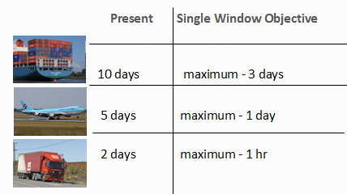

The objective of the Single Window system was to reduce cargo dwell time to three days at the port, one day at the airport and a maximum of one hour at the border. This can be achieved by eliminating existing inefficiencies, for instance the inefficient space utilization at ports, where waiting times lead to congestion. Furthermore there are inefficiencies in the cargo clearance process which involves manually handling paper documents between many stakeholders. These inefficiencies lead to delays in cargo clearance, high trade transaction costs and corruption which together reduce Kenya’s competitiveness.

**Manual handling and processing of trade documentation**

*“We don’t seem to trust our systems. We still want to see the physical documents. This is an issue which has to do with change management and we are dealing with it.”*

**Importance of Trade in EAC Economies**

An important factor in the development of the National Single Window system was to be able to show the importance of trade facilitation for Kenya. The share of trade in GDP in the economies of the East African Community is important, ranging from 36 percent in Rwanda to 57 percent in Kenya.

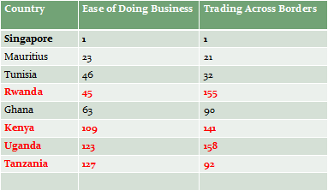

Yet, according to World Bank rankings, East Africa is not well placed. Kenya is placed 109th on Ease of Doing Business Index and 141st on the Trading across Borders index.

A survey was carried out to quantify the economic losses incurred through inefficient procedures and to highlight the potential savings through trade facilitation. Based on the present volume of goods imported and exported, the survey predicts saving to the economy from US$ 150 to US$250 m in the first 3 years and US$ 300m to US$ 450m per annum thereafter. These savings are derived from reduced trade transaction costs, reduced delays, inefficiencies, corruption, paperwork and manual handling of documents, reduced cost of capital (JIT Concept) and demurrage as well as improved space utilization at ports and the resultant increased capacity utilization.

**Key Milestones in the Development of the National Single Window in Kenya**

The development of a project charter, master plan and business process re-engineering were key milestones in the Single Window development. The status quo situation was assessed and stakeholders consulted on their needs. Stakeholders were involved in all stages of the project and at all levels in over 216 meetings organized over a seven months period to ensure information exchange and joint project ownership. Software requirement specifications were produced and a project stakeholders’ needs assessment conducted. This assessment covered all stakeholders who were to be integrated in the system, assessing their capacity and the stage of development of their systems in place. Agencies were assisted in establishing computer systems and in streamlining their business processes and developing requirements for their community-based systems.

Finally, the Government set up the operator agency Kenya Trade Network Agency (KENTRADE). In keeping with UNECE Resolution No. 33 it was set up as an independent entity to run the Single Window process.

**Lessons Learnt**

Enabling factors for the successful implementation of a National Single Window are:

* Political will and strong government support
* a strong supporter at the senior level to drive the implementation process
* a dedicated project implementation team
* co-operation of the multiple government agencies involved
* continuous sensitization and change management to ensure stakeholders ‘buy in’
* Business Process Rationalization
* regional cooperation,
* and an adequate budget.

Quick Wins are crucial in driving the implementation process. There is no need for a computer system to be in place to achieve successes; these can be achieved through administrative decisions having an effect on the ground.

**Challenges**

Challenges in the Single Window implementation process include capacity building & training, multiple stakeholders, the need for an enabling legal environment, and change management.

**Going Forward**

With the East African Community (EAC) East Africa has a community and customs union in place and is on the way to having common borders. National Single Windows are planned to be implemented in each of the five East African States. Going forward it is planned to sensitize all East African Community Partner States to the Single Window concept and to set up technical working groups. These are intended to (a) spearhead initiatives in EAC Partner States, (b) advocate the establishment of National Electronic Single Window Systems in EAC partner States, and (c) advocate the creation of a Regional Platform for EAC partners States to integrate the Single Window Systems.

1. Alex KABUGA is Chief Executive Officer of the Kenya Trade Network Agency, KENTRADE, which is the Single Window Implementing Agency in Kenya