UN/SCEGHS/31/INF.13
Committee of Experts on the Transport of Dangerous Goods
and on the Globally Harmonized System of Classification
and Labelling of Chemicals
Sub-Committee of Experts on the Globally Harmonized
System of Classification and Labelling of Chemicals 22 June 2016

Thirty-first session
Geneva, 5– 8 July 2016
Item 4 (a) of the provisional agenda
Hazard communication issues:
Labelling of small packagings

Labelling of small packagings: comments on document ST/SG/AC.10/C.4/2016/8
Transmitted by the expert from the United States of America
Background
1. The United States thanks the representative from the European Chemical Industry Council (CEFIC) for ST/SG/AC.10/C.4/2016/8 containing a proposed example illustrating general principles applicable to the labelling of small packages using fold out labels. In particular, the United States appreciates the changes CEFIC made in response to comments made at the last session.
Comments
2. However, after additional review, the United States believes that additional language is needed to make clear that the example is for situations where there is insufficient space to place the GHS pictogram(s), signal word, and hazard statement(s) together, as provided in 1.4.10.5.4.1.
3. In addition, the United States believes it is not appropriate to include measurements for the containers and the label in the example. The size of the container in the example (150 mm high x 30 mm diameter) appears to have sufficient surface area to fit the GHS pictogram(s), signal word, and hazard statement(s) together, particularly if the information need appear in one language only or if there are few hazard statements assigned to the chemical. Notably, the size of the full size label in example 8 of Annex 7 is significantly smaller (65 mm x 65 mm) than the size of the label in the proposed example 9 (approx. 150 mm x 94 mm).
4. Rather than including specific size criteria, the United States suggests a performance-based approach, and recommends that the example include language stating that it applies only where the manufacturer/supplier or competent authority has determined there is insufficient space for the required information to be placed together on the exterior portion of the label. This is the approach the United States has taken in implementing the GHS.

5. In addition, the at the end of the proposed example, we suggest that additional text be included to clarify that the illustrations following the accordion style illustration show how the principles of the example apply to the book style, order book style, and window style foldout labels.
Proposal
6. In the attached annex, the United States presents proposed revisions as suggested above.

Annex
“Example 9: Example for fold-out label
This example is for use on containers where the manufacturer/supplier or competent authority has determined there is insufficient space to place the GHS pictogram(s), signal word, and hazard statement(s) together, as provided in 1.4.10.5.4.1, on the surface of the container (front of the pull-out label). This might occur, for example, when the container is small, there are a large number of hazard statements assigned to the chemical, and the competent authority requires information to be displayed in multiple languages, so that the information may not be printed on the label in a size that is easily legible without the aid of any device other than corrective lenses.
Metal container with 100 ml capacity
A fold-out label is securely affixed to the immediate container (i.e. the fold-out label is attached so that it remains affixed during the foreseeable conditions and period of use). The fold-out label is produced in such a way that the front part cannot be detached from the remainder of the label and the label can be closed again so it is not hanging loose.
The information is structured as follows and is provided, if applicable, in all the languages used for the label:
Front page
Information to be provided on the front page of the multilayer/fold-out label should contain at least:
GHS information:
- Product identifier*
- Hazard pictogram(s)
- Signal word
- Supplier identification (name, address and telephone number of the company)
Additional information:
- A symbol to inform the user that the label can be opened to illustrate that additional information is available on inside pages.
- If more than one language is used on the fold-out label: the country codes or language codes
Text pages/Pages inside
GHS information:
- Product identifier including, as applicable, hazardous components contributing to the classification
- Signal word
- Hazard statements
- Precautionary statements
- Additional information (e.g. directions for use, information required by other regulations, etc.)
Additional information:
- If more than one language is used on the fold-out label: the country codes or language codes
Back page (affixed to the immediate container):
- Product identifier*
- Hazard pictogram(s)
- Signal word
- Supplier identification (name, address and telephone number of the company)
The product identifier (if applicable) and the signal words on the front page and the back page are in all languages used on the label.
If there is enough space on the front or on the back page, these pages can also be used to display text.
The text on the inside pages (text pages) can also be distributed on more than one page, if the available space is not sufficient. In general it is better to spread the text across more than one page than to have smaller letters that make the text difficult to read. In all cases, the visibility and easy legibility of the label elements should be ensured without the aid of any device other than corrective lenses and contrasted with any other information on the hazardous product or the container.
It is recognized that some regulatory systems (e.g. pesticides) may have specific requirements for the application of labels using a multilayer or booklet style format. Where this is the case, labelling would be undertaken in accordance with the competent authority’s requirements.
The size of the fold-out label and the number of folds should be in a rational relationship to the size of the container. This may limit the number of languages, which can be displayed on the fold-out label.
Examples:
Application of the labelling principles discussed in this example are illustrated for a multilingual label in the accordion style below:
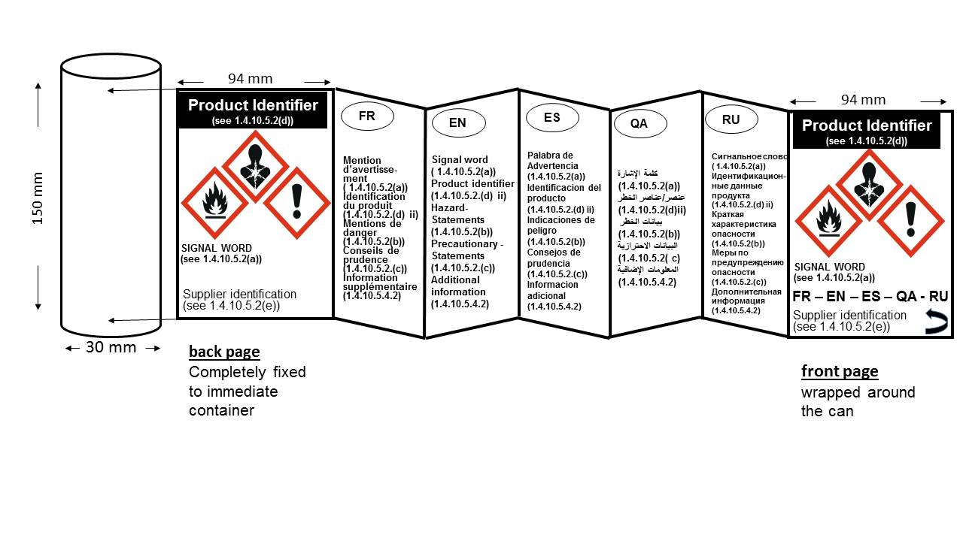

Additionally, the labeling principles discussed in this example could also be applied to the following foldout label styles: book style, order book style and window style.

Book style
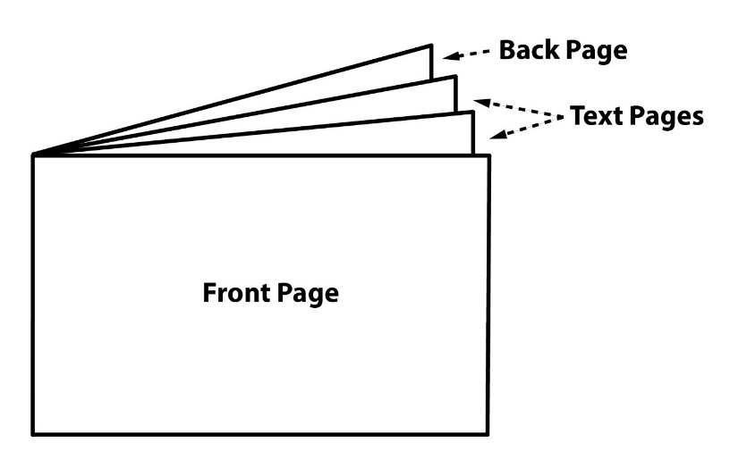
Order book style

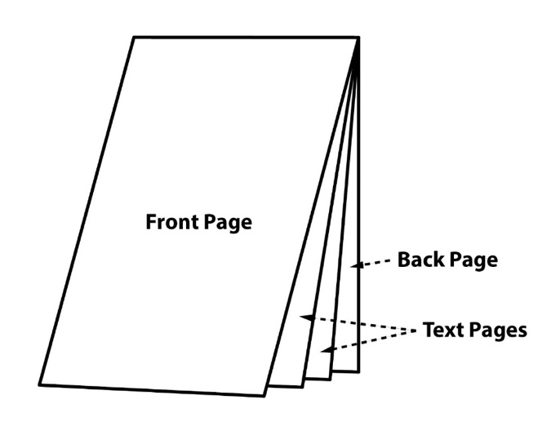
Window style
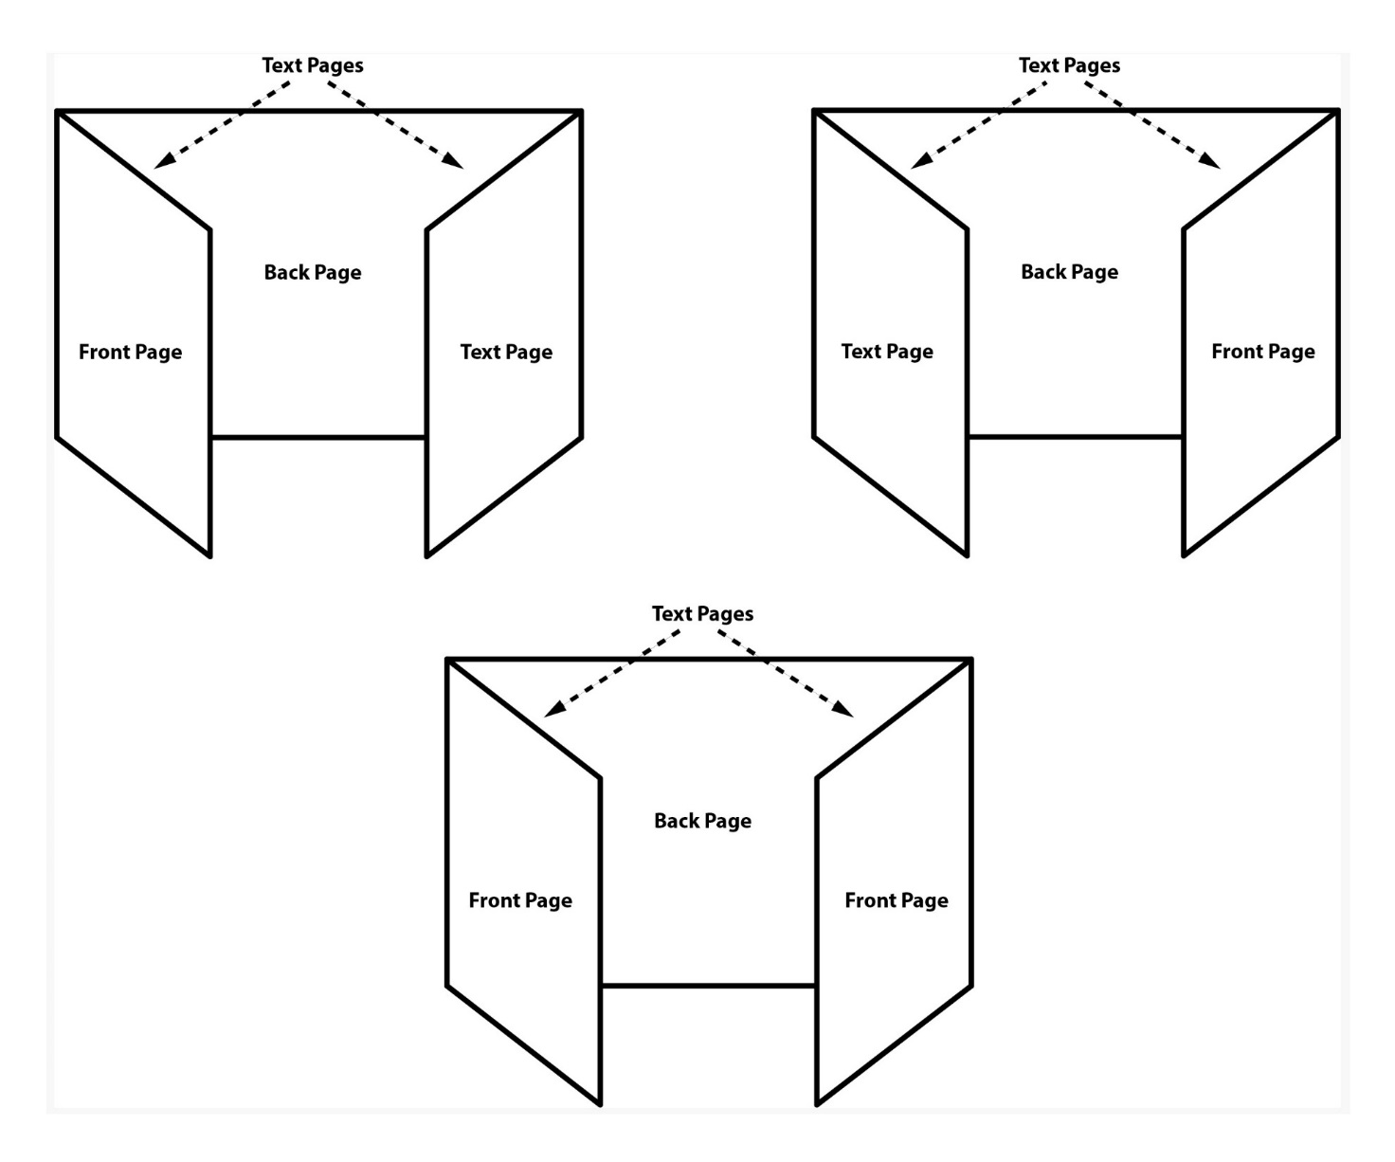”

* The product identifier on the front and back page does not include hazardous components. If hazardous components are required on the label they are displayed in the appropriate languages on the text pages.
* The product identifier on the front and back page does not include hazardous components. If hazardous components are required on the label they are displayed in the appropriate languages on the text pages.

