UN/SCETDG/49/INF.34
Committee of Experts on the Transport of Dangerous Goods
and on the Globally Harmonized System of Classification
and Labelling of Chemicals
Sub-Committee of Experts on the Transport of Dangerous Goods 16 June 2016
Forty-ninth session
Geneva, 27 June – 06 July 2016
Item 2 (c) of the provisional agenda
Explosives and related matters: review of tests in parts I and II
of the Manual of Tests and Criteria
Temperature Influence on Minimum Burning Pressure for Ammonium Nitrate Emulsions (ANEs)
Transmitted by the expert from Spain
Background
1. At the forty-eighth session the expert from Canada presented the document ST/SG/AC.10/C.3/2015/41, proposing:
“to amend Test Series 8 in order to replace the current Tests 8 (c) (Section 18.6.1 Koenen Test) and 8 (d) (Section 18.7.1 Vented Pipe Test and Section 18.7.2 Modified Vented Pipe Test) with the CERL MBP Test described below in the annex. It is further proposed that inclusion in the UN 3375 and Division 5.1 be restricted to those products having a MBP above 5.6 MPa (800 psig).”
2. In relation with this document Spain’s expert presented, in turn, informal document UN/SCETDG/48/INF.22 indicating that he could not support Canada’s proposal because
(a) The MBP test does not provide proper information about the considered hazard
(b) No relationship exists between the MBP test and Koenen and VPT tests
3. The document included an annex compiling the experience and knowledge of a Spanish explosives manufacturer, which had been using the MBP test for quite a long time in the framework of process risk assessments for explosives or precursors, especially in transfer or dosing operations where a pump is used.
4. During the discussions some members of the WGE expressed their view that they could not agree on the acceptance of the Canadian proposal. Nevertheless, other members felt that the MBP test could be useful as a possible additional or alternative test.
5. After a lengthy, complex discussion, the EWG could not agree on the acceptance of the proposal in 2015/41. Then, Canada, taking into account the aforesaid view of some members, offered to establish an informal correspondence group to amend the current proposal.
Considerations
6. Taking into account that the MBP test is being put forward fairly regularly and that a number of members of the EWG do not have a clear opinion about the suitability of this test, basically due to the lack of clear test data, the Spanish explosive manufacturer has continued evaluating this test.
7. The aim of this informal document is to share with the members of the EWG an interesting information that has been obtained recently. A full report presenting these results is attached.
8. It seems that the MBP values reported until now have been determined at room temperature. There is no data of MBP at high temperatures. If the MBP test is proposed as a test to evaluate the risk of an external fire, it would seem reasonable to have MBP values at temperatures closer to those ANEs can reach when they are involved in an external fire.
9. Thus, to know the MBP behaviour as a function of the ANE temperature, the MBPs of four matrix emulsions have been determined at several temperatures ranging between 20 and 180 °C.
10. MBPs showed a decreasing linear dependence on temperature, the MBP of the studied emulsions tend to converge to similar values as the temperature at which the measurement has been carried out increases. The MBPs reach a null value at temperatures close to 200 °C.
Recommendations
11 It is proposed to take into account the dependence of the MBP on the ANE temperature when the suitability of the MBP test to analyse the risk of an external fire is under consideration.

Minimum Burning Pressure Dependence on Temperature

for Ammonium Nitrate Emulsions (ANEs)

MAXAM

June 2016

José R. Quintana
R&D Department
MaxamCorp Holding

CONTENTS

Page no.

1. INTRODUCTION 3

2. EXPERIMENTAL 4

3. RESULTS 7

4. DISCUSSION 9

5. REFERENCES 11

1. INTRODUCTION
The measurement of minimum burning pressures (MBP) is a usual test employed in process risk assessments for explosives or precursors, especially in transfer or dosing operations where a pump is used.
In recent years the possibility of using MBP measurement as a replacement or alternative for Koenen and Vented Pipe Tests in Series 8 has been raised. Both tests are used to assess the effect of exposure of an ANE candidate to an external fire under confined and vented conditions.
MBP measurements have been carried out so far at room or process temperatures, i.e. at relative low values (20-100 °C). However when an ANE product is involved in an external fire, its temperature is raised to values higher than 200 °C as it was reported in modified vented pipe tests (1,2) and in a full-scale burning test of a tank (3). For this reason we have considered of interest to know the influence of temperature on the minimum burning pressure.
The present study analyzes the behavior of two ANE emulsions of one salt (ammonium nitrate) and two ANE emulsions of two salts (ammonium nitrate and sodium nitrate) with two water contents (9 and 17 %).

2. EXPERIMENTAL
2.1. Apparatus and procedure
MBPs were determined using the methodology developed by CANMET (4, 5). Measurements were performed in a 4 L pressure vessel (Autoclave Engineers, 4 Liter EZE-Seal General Arrangement, model 401A-9344) with no venting during testing. Purging and pressurizing were performed by using high pressure nitrogen cylinders.

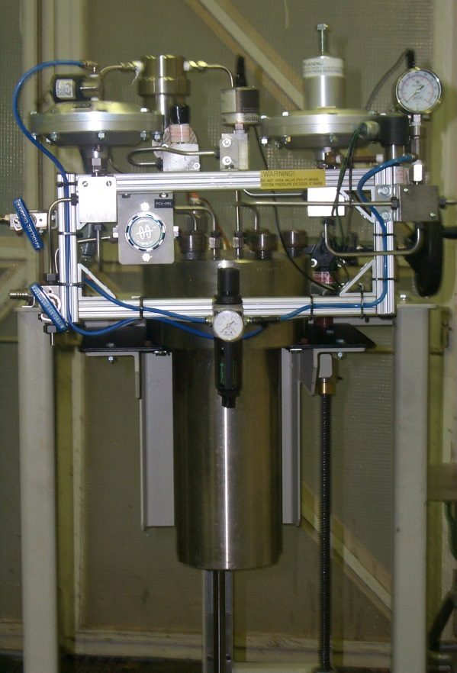 | 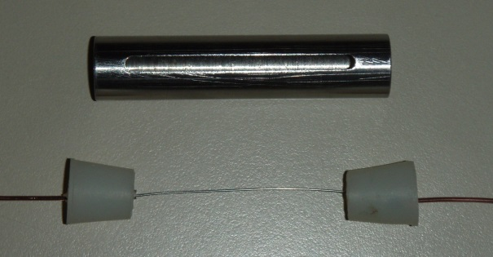
 | 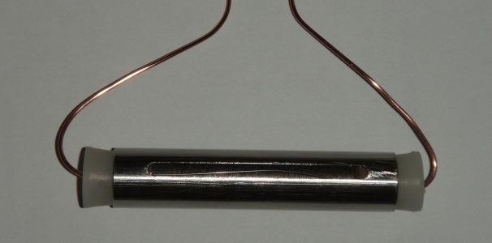
Picture 1. Pressure vessel | Picture 2. Test cell

The sample was introduced into a cylindrical stainless steel cell which was placed horizontally. The steel tube had an inner diameter of 13.2 mm and a length of 70 mm. The tube had a slit machined along the top portion of the tube with a width of 3 mm and a length of 53 mm.
The sample was ignited at room temperature, using a straight length of nichrome wire (Thyssenkrupp Ni/Cr 60/15) having a diameter of 0.5 mm, a length of 50 mm and a nominal resistance of 5.731 Ω.m⁻¹. When the pressure vessel was set to the desired initial pressure, a constant current of 10 A was supplied to the hot wire. This current was provided by a TTI DC power supply unit, model TSX 1820. Usually, the wire melted before 10 s. In cases in which the wire did not come to melt, the power supply unit was switched off after 20 seconds.
The pressure in the vessel was monitored using a Setra pressure transmitter model C206 (0-20.68 MPa) and the data acquisition system consisted of a Testo datalogger model 175-S1, which was connected to a PC by a RS232 interface.
The procedure to perform the MBP measurements was based on classifying the outcomes as “go“ or “no-go”, considering a “go” outcome when at least a 70 % in weight of the sample was consumed. If the result was a “go”, the initial pressure was lowered for the following test. If the result was a “no-go”, the initial pressure was increased. This process was repeated several times until the MBP was obtained with the required accuracy.
In order to carry out the MBP measurements at high temperatures, the pressure vessel was fitted with an electric heating jacket with heating capacity to raise temperature up to 300 °C, and the temperatures inside the vessel and at the wall were controlled by two PID controllers.

2.2. Tested substances
In order to carry out his study, we have chosen several matrix emulsions because they remain almost unaltered at temperatures as high as 180 °C, due to the special structure of the emulsions where the oxidizing aqueous solution is contained inside microscopy droops surrounded by a layer of emulsifier and mineral oil with very high boiling temperature. It was found that the weight loss just before starting the test at 180 °C was 2.4 % for the emulsion EM6.

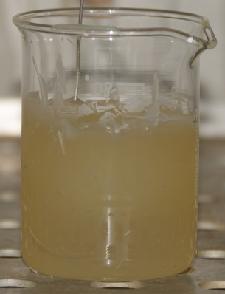 | 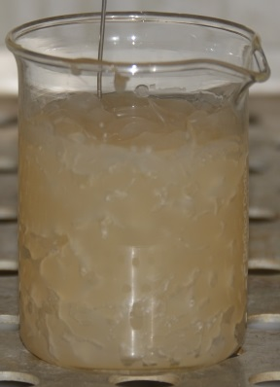 | 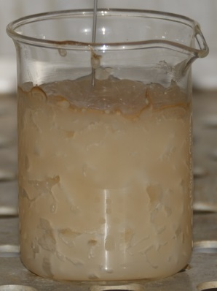
Picture 3. EM6 appearance at 125, 166 and 181 °C
Four different matrix emulsions that included different water content and the presence of sodium nitrate were tested. The specified compositions of the substances used in this study are shown in Table 1. Viscosity was found to be between 30 and 40 Pa⋅s for all samples.

Table 1. Matrix emulsions analyzed
 | EM1 | EM6 | EM10 | EM16
Ammonium nitrate | 76.0 | 84.0 | 72.0 | 64.0
Sodium nitrate | - | - | 12.0 | 12.0
Water | 17.0 | 9.0 | 9.0 | 17.0
Paraffin oil | 5.6 | 5.6 | 5.6 | 5.6
PIBSA emulsifier | 1.4 | 1.4 | 1.4 | 1.4

3. RESULTS
The results of minimum burning pressure measurements obtained for different matrix emulsions and temperatures are shown in Tables 2-5. The initial pressure of the lowest “go” event is shown in the column “go”, and the initial pressure of the highest “no-go” event, but lower than the lowest “go” event is shown in the column “no-go”. The MBP was determined as the mean of both pressures.

Table 2. MBP results at 20 °C.
Compositions | Pressure (MPa) |  | MBP  (MPa)
 | go | no go
EM1 AN 76.0%, W 17.0%, PO 5.6%, PIBSA 1.4% | 12.20 | 11.83 | 12.02
EM6 AN 84.0%, Water 9.0%, PO 5.6%, PIBSA 1.4% | 3.44 | 3.04 | 3.24
EM16 AN 64.0%, SN 12.0%,W 17.0%, PO 5.6%, PIBSA 1.4% | 7.14 | 6.83 | 6.99
EM10 AN 72.0%, SN 12.0%,W 9.0%, PO 5.6%, PIBSA 1.4% | 2.92 | 2.58 | 2.75
NOTE: AN: ammonium nitrate, SN: sodium nitrate, W: water, PO: paraffin oil, PIBSA: PIBSA emulsifier

Table 3. MBP results at 80 °C.
Compositions | Pressure (MPa) |  | MBP  (MPa)
 | go | no go
EM1 AN 76.0%, W 17.0%, PO 5.6%, PIBSA 1.4% | 7.10 | 6.60 | 6.85
EM6 AN 84.0%, Water 9.0%, PO 5.6%, PIBSA 1.4% | 2.78 | 2.54 | 2.66
EM16 AN 64.0%, SN 12.0%,W 17.0%, PO 5.6%, PIBSA 1.4% | 5.39 | 5.06 | 5.23
EM10 AN 72.0%, SN 12.0%,W 9.0%, PO 5.6%, PIBSA 1.4% | 2.00 | 1.85 | 1.93
NOTE: AN: ammonium nitrate, SN: sodium nitrate, W: water, PO: paraffin oil, PIBSA: PIBSA emulsifier

Table 4. MBP results at 140 °C.
Compositions | Pressure (MPa) |  | MBP  (MPa)
 | go | no go
EM1 AN 76.0%, W 17.0%, PO 5.6%, PIBSA 1.4% | 4.49 | 4.02 | 4.26
EM6 AN 84.0%, Water 9.0%, PO 5.6%, PIBSA 1.4% | 0.50 | 0.30 | 0.40
EM16 AN 64.0%, SN 12.0%,W 17.0%, PO 5.6%, PIBSA 1.4% | 3.31 | 3.09 | 3.20
EM10 AN 72.0%, SN 12.0%,W 9.0%, PO 5.6%, PIBSA 1.4% | 0.80 | 0.50 | 0.65
NOTE: AN: ammonium nitrate, SN: sodium nitrate, W: water, PO: paraffin oil, PIBSA: PIBSA emulsifier

Table 5. MBP results at 180 °C.
Compositions | Pressure (MPa) |  | MBP  (MPa)
 | go | no go
EM1 AN 76.0%, W 17.0%, PO 5.6%, PIBSA 1.4% | 1.29 | 1.02 | 1.16
EM6 AN 84.0%, Water 9.0%, PO 5.6%, PIBSA 1.4% | 0.30 | 0.17 | 0.24
EM16 AN 64.0%, SN 12.0%,W 17.0%, PO 5.6%, PIBSA 1.4% | 1.53 | 1.30 | 1.41
EM10 AN 72.0%, SN 12.0%,W 9.0%, PO 5.6%, PIBSA 1.4% | 0.55 | 0.26 | 0.40
NOTE: AN: ammonium nitrate, SN: sodium nitrate, W: water, PO: paraffin oil, PIBSA: PIBSA emulsifier

4. DISCUSSION
Minimum burning pressure values for the different ANE emulsions at various temperatures between 20 and 180°C are shown in Table 6.

Table 6. Minimum Burning Pressure (MBP) for the different emulsions and temperatures.
Temperatures (°C) | 20 | 80 | 140 | 180
EM1 AN 76.0%, W 17.0%, PO 5.6%, PIBSA 1.4% | 12.02 | 6.85 | 4.26 | 1.16
EM6 AN 84.0%, W 9.0%, PO 5.6%, PIBSA 1.4% | 3.24 | 2.66 | 0.40 | 0.24
EM16 AN 64.0%, SN 12.0%, W 17.0%, PO 5.6%, PIBSA 1.4% | 6.99 | 5.23 | 3.20 | 1.41
EM10 AN 72.0%, SN 12.0%, W 9.0%, PO 5.6%, PIBSA 1.4% | 2.75 | 1.93 | 0.65 | 0.40

The minimum burning pressures as a function of temperature for the analyzed emulsions are shown in Figure 1.

Figure 1. Minimum Burning Pressure, MBP, as a function of temperature for AN emulsions (EM1 & EM6) and AN/SN emulsions (EM16 & EM6).

In Figure 1 a decreasing linear dependence with temperature is observed for every studied matrix emulsion. Considering the same water content, ammonium nitrate/sodium nitrate emulsions show a lower dependence than those containing only ammonium nitrate. Thus, although AN/SN emulsions have lower MBPs than AN emulsions at 20 °C, they have higher values at 180 °C.
The linear relationship between MBP and temperature allows us to extrapolate at a null MBP and to determine the temperature at which an emulsion is able to auto-sustain combustion at atmospheric pressure T_{MBP=0}. The obtained values range between 180 and 230 °C, and they are shown in Table 7.

Table 7. Temperatures (°C) at which emulsions can auto-sustain combustion at atmospheric pressure, T_{MBP=0}.
EM1 AN 76.0%, W 17.0%, PO 5.6%, PIBSA 1.4% | 198
EM6 AN 84.0%, W 9.0%, PO 5.6%, PIBSA 1.4% | 183
EM16 AN 64.0%, SN 12.0%, W 17.0%, PO 5.6%, PIBSA 1.4% | 227
EM10 AN 72.0%, SN 12.0%, W 9.0%, PO 5.6%, PIBSA 1.4% | 197

It can be concluded that although matrix emulsions can have quite different MBPs, all studied emulsions show a null MBP at temperatures close to 200 °C. This fact suggests that when an ANE is involved in an external fire, if the fire last long enough so the inventory temperature reaches a value close to 200 °C, the ANE itself is able to keep the combustion even when the external fuels are already consumed.

5. REFERENCES
1. D.L. Kennedy, Orica Explosives and Dyno Nobel, ‘The Modified Vented Pipe’, June 2002.
2. J.R. Quintana, and F. Beitia, UEE, ‘Performance of Modified Vented Pipe Test (Australian Procedure) on Ammonium Nitrate Emulsions and Suspensions (ANE)’, UN/SCETDG/25/INF.74, Geneva, July 2004.
3. H. Karlström, Dyno Nobel, Forcit and Kimit, ‘Full-scale Burning Test of a Tank Loaded with Emulsion Matrix’, UN/SCETDG/21/INF.20, Geneva, July 2002.
4. Turcotte, R.; Feng, H.; Badeen, C.M.; Goldthorp, S.; Johnson, C. and Chan, S.K., ‘A Test to Measure the Minimum Burning Pressure of Water-based Commercial Explosives and their Precursors’, CERL Report 2009-15 (OP-J), May 2009.
5. Turcotte, R.; Goldthorp, S.; Badeen, C.M.; Johnson, C.; Feng, H. and Chan, S.K., ‘Influence of Physical Characteristics and Ingredients on the Minimum Burning Pressure of Ammonium Nitrate Emulsions’, Propellants Explosives Pyrotechnics 2010, 35, 233.

______________________

