|  |  |
| --- | --- |
| Submitted by the expert from Germany | Informal document **GRSG-109-19**  (109th GRSG, 29 September – 2 October 2015  agenda item 15) |

**Information on requirements for driver assistance systems for heavy goods vehicles addressing blind spot accidents**

´

The text reproduced below has been prepared by the expert from Germany to inform experts from GRSG about activities in Germany to address blind spot accidents of heavy goods vehicles. The research was undertaken by the Federal Highway Research Institute (BASt).

I. Information

# Introduction

Turning maneuvers with collisions between trucks turning right and cyclists usually have serious consequences for the vulnerable road user. In the past the safety of vulnerable road users was raised by an improvement of the truck driver's vision by increasing the number of mirrors and by equipping trucks with side underrun protection. Since turning accidents still happen and driver assistance systems have been introduced in a lot of vehicle segments it seems to be obvious to use such assistance to address turning accidents between trucks and cyclists.

In order to stimulate system development, e. g. by means of incentives or legislation, performance requirements and corresponding test procedures are necessary. Aim of the work carried out by BASt therefore was to develop such requirements and a possible test method.

# Accident analysis

In 2010, 1,994 cyclists were killed in road accidents in the EU-24 countries, this represented 6.8 % of all road fatalities. For comparison: 381 cyclists were killed in road accidents in Germany in 2010 and 406 in 2012, which corresponds to 10.4 % (2010) and 11.3 % (2012) of all road fatalities, respectively [CANDAPPA N. et al. (2012)].

Road traffic accidents between heavy goods vehicles (HGVs over 3.5 tons maximum permissible gross vehicle weight) and cyclists resulted in 296 fatalities for 2010, as shown in Figure 1.



*Figure 1:* Fatalities in accidents involving HGVs and in accidents involving buses or coaches, by road user type (Data: EU-24; 2010 (for EE, NI, NL and SE from 2009); Source: CARE Database/EC)

It is not possible to identify the exact number and severity of this accident situation in the German national road accident statistics because the conflict situation "blind spot" is not explicitly quantified. Therefore, an extrapolation [SCHRECK & PÖPPEL-DECKER (2014)] for the year 2012 was carried out to assess the relevance of the conflict situation. The extrapolation shows that around 640 injury accidents resulting in 23 fatalities and another 118 seriously injured cyclists are due to the accident situation between right-turning trucks and driving straight cyclists. In the same configuration, the number of injured, severely injured and killed pedestrians is a magnitude lower (55 injured, 16 sesiously injured, 4 fatalities), so pedestrians will be neglected for the following considerations.

Thus, accidents involving right turning trucks represent 1 % of all bicycle accidents, and about 6 % of cyclists killed. It became clear that the "light" trucks, as defined as vehicles weighing less than 7.5 tones permissible gross weight, only slightly contribute to the serious accidents. In 549 collisions with "light" trucks, one cyclist was killed. 90 % of the accidents with killed cyclists in "blind spot" situations are accidents with "heavy” trucks (more than 7.5 tones permissible gross weight). So, in every 10 injury accidents between a “heavy” truck and a cyclist in a "blind spot" situation on average about one cyclist is killed. That shows the accident severity in terms of seriously or fatally injured cyclists that are involved are much higher than in accidents of other traffic participants in other accident situations.

Within the research project this paper is based on ([SCHRECK & SEINIGER (2014)]), accidents are analyzed in detail. The study uses police-reported accident data from the German Federal Statistical Office. Furthermore the German In-Depth Accident Study (GIDAS) and the German Insurers accident database (database UDV) was used. For the detailed analysis of accidents in GIDAS and in the database UDV, 120 accidents were available.

Accident databases GIDAS and UDV allowed for the detailed analysis of the speeds of the truck and bicycle, the driving behavior of the truck before and during the collision, the driving characteristics of the truck before the collision with respect to the infrastructure and the type of junction. The point of collision of the cyclist hitting the truck and potential visual obstructions in the infrastructure were available as well.

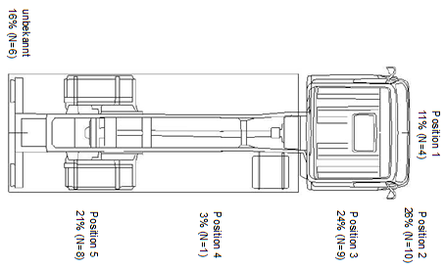

*Figure 2.* Impact location of bicycle on truck [Data source: UDB UDV; image: DEKRA (2014)]

While the total number of accidents for light (<7.5 t gross weigth) and heavy (>7.5 t gross weight) commercial vehicles is higher, the severity of accidents between heavy commercial vehicles and bicycles is much higher: for instance, in all relevant accidents in 2012 (n= 2319), accidents with heavy vehicles (n= 475) led to 12 fatalities and 62 severely injured (0,4%; 13% of all heavy vehicle & bicycle accidents). The same numbers for light commercial vehicles (n=1844) are 2 fatalities and 186 severely injured (0,1%; 10%).

Main findings from the accident analysis are:

* Truck speeds are below 30 km/h in more than 90% of all cases.
* Bicycle speeds are below 20 km/h in more than 80% of all cases.
* Bicycle and truck did not change their speeds during the accident in about two thirds of all cases.
* Visual obstruction and / or bad visibility due to weather (night, rain etc.) was not found to be an important factor.
* Impact location of the bicycle on the truck is predominately in the front region, to a lesser extent near the rear axle.
* Accident severity is higher for heavy commecial vehicles (>7.5 t gross weight).

# Deduction of requirements and test cases

The benefits of a turning assistance system for trucks increases with increasing overlap between the standards set by the requirements of the test method for the system and the conditions in the accident situations.

Once a parameter space for typical accidents between trucks and cyclists is outlined, the greatest possible coverage of this parameter space by as few as possible test cases needs to be achieved.

Due to the missing experience with a turning assistance, the use of emergency braking for safety reasons (possible false activations) is initially not advisable.

High-intensity information (warnings) are in the course of a driving situation only justified if the probability for an accident is high - otherwise vehicle drivers tend to ignore or disable the system alerts. In general, driver reactions to any information (high or low threshold / warning or information) can be expected only after a reaction time. This response time is much longer than the time required to avoid the accident in many situations - the accident cannot be avoided despite the warning.

A (low threshold) informational assistance system, however, can be activated sufficiently early, as it helps the driver rather than annoys him. Such an approach provides a useful solution if the information is made available to the driver in an appropriate manner. The identification of an appropriate transfer of information in terms of human machine interaction is not part of this work.

Since the information given by turning assistance systems needs to be reliable, effective recognition of the objects is required. Specifications for sensors, viewing angles, and detection times can be derived from this detection requirement.

The definition of relevant detection areas is done via a parametric, simplified kinematics model (using parallel and straight line segments for the initial trajectories and constant radius turning in the final segment) of the truck and bicycle trajectories during an accident, and taking into account the needed reaction times (of the driver) and stopping distances (of the truck). Test cases then are defined in such a manner that the whole detection area around the truck is covered by as little as possible test cases.

Accident analyses show that obstructions of sight, night and bad weather are not an essential factor for these accidents, so these factors are not addressed in the proposed test cases.

The following parameters have been derived from accidentology:

* Driving speed truck: vTruck = 10, 20 km / h
* Driving speed bike: vCycle ranges from 10 to 20 km / h
* Lateral distance of the initial trajectories (with respect to the right edge of the truck):   
  A = 1.5 to 4.5 m
* Truck turning radius R = 5, 10, 25 m
* Maximum lateral acceleration of the truck: ay < 1,5 m/s²
* Impact location of the bike onto the truck: L = 0 to 6 m
* Required reaction time after driver information: 1,4 s
* Braking performance of driver after reaction time: 6 m/s²

The necessary viewing area of a sensor around the truck would then be the hull around all bicycle trajectories from all possible parameter combination. This hull and proposed test cases are shown in *Figure 3*.

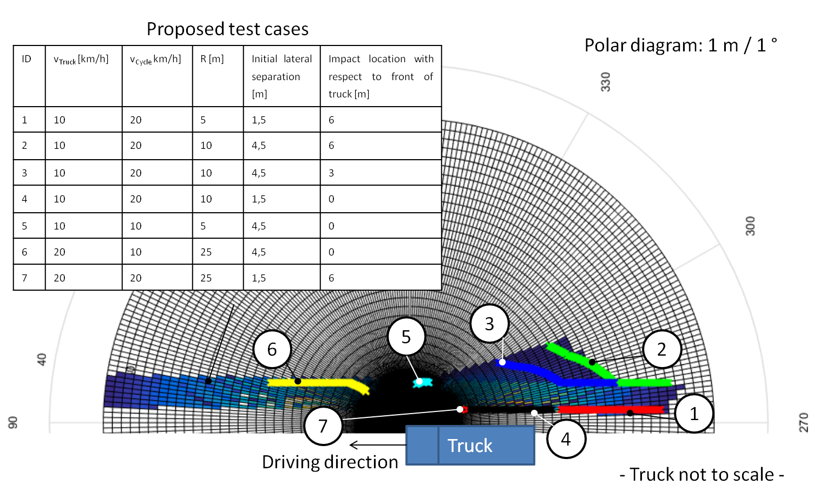

*Figure 3.* Bicycle trajectories relative to the front inner corner of the truck (=center of polar diagram), and proposed test cases (ID = 1 to 7).

Note that in theory a bicycle detection at the end of the nearer end of the trajectory satisfies the necessary detection criterion; it is not required to inform the driver already at the point where the bicycle is at the far end of the trajectory (which corresponds to 4 seconds before the last possible information).

# Testing Concept

Purpose of testing is to verify whether the system informs the driver, at least at the latest time at which avoidance is still possible, defined by the braking performance, driver reaction time and kinematics as shown in *Figure 3*. This means that an object which sufficiently appears to any sensor technology as a cycle needs to be moved and synchronized to the truck according to the proposed test cases.

Since an information must be given at a time when the accident is still comfortably avoidable, all tests can be conducted without impacts, thus allowing for the use of a real bicycle (and possibly human dummy) rather than a specific bicycle dummy. The bicycle would be guided by a motion system, therefore a review of the trajectory is not required. For checking the trajectory of the truck itself, an alley from pylons or "Botts' Dots" can be used to visually determine whether the vehicle had maintained the required trajectory.

Video recording and time synchronizing equipment might be required to check whether the information was given at an appropriate time.

An exemplary test setup is depicted in Figure 4 and Figure 5.

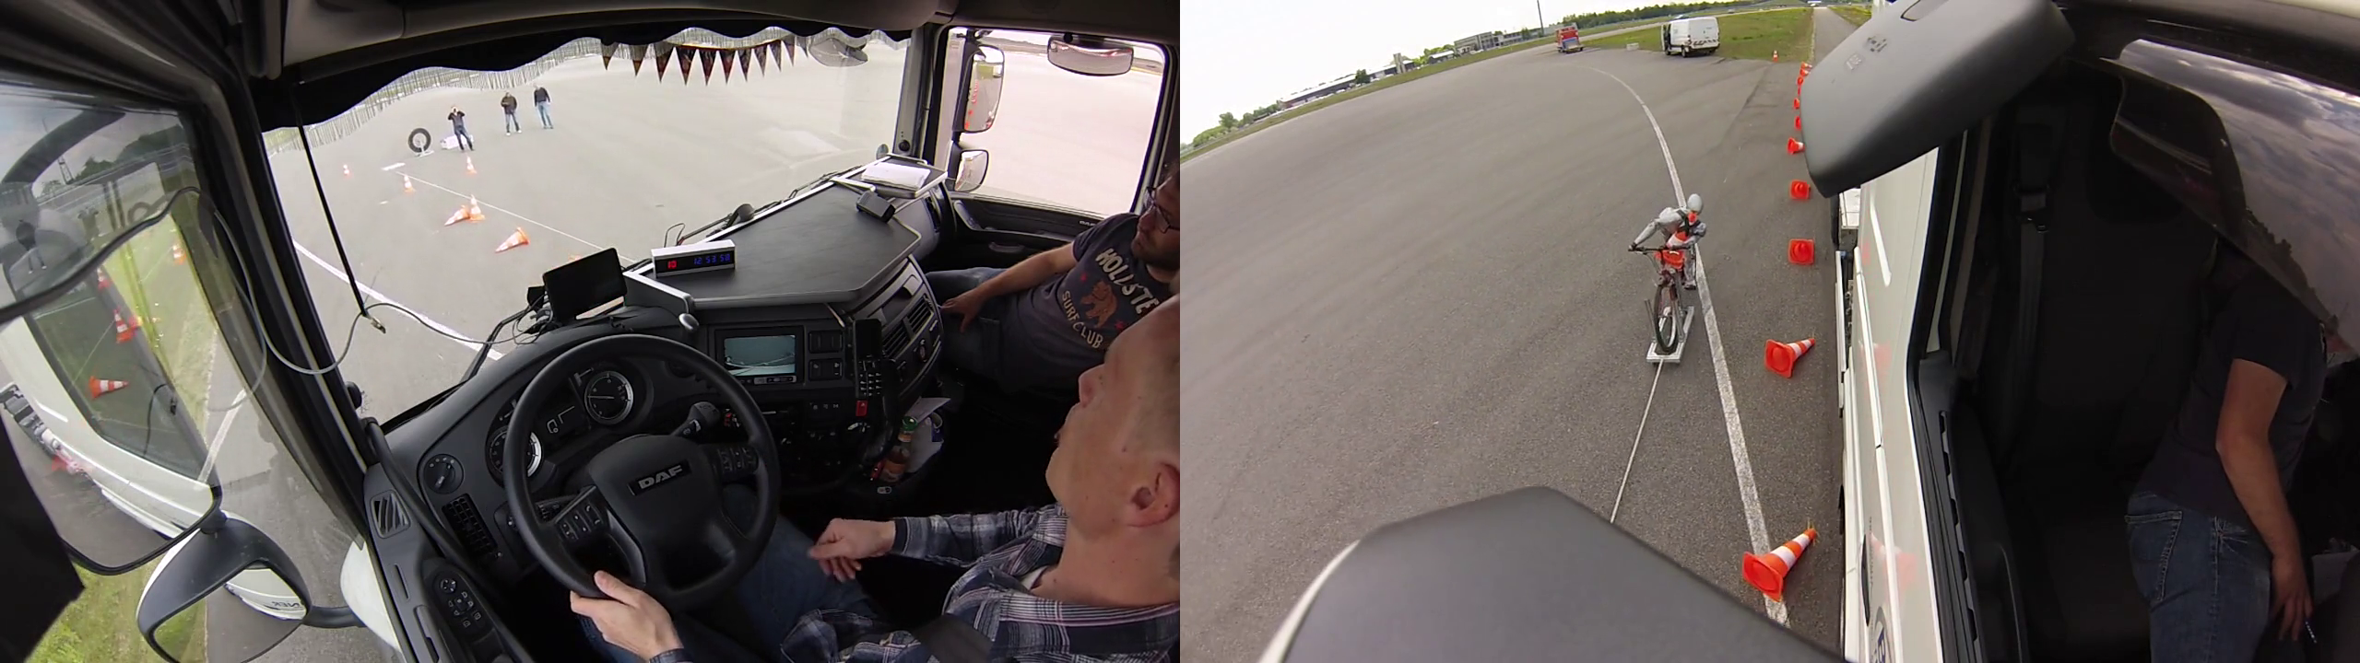

*Figure 4:* Exemplary test setup, view from inside (left) and from the mirror (right)

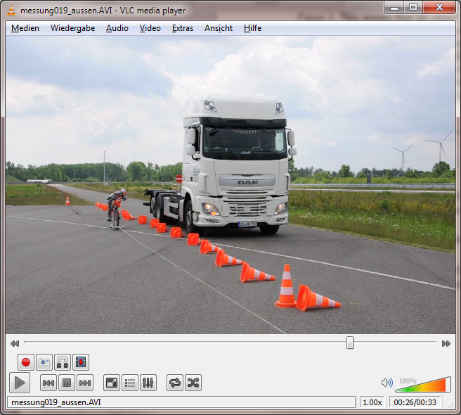

*Figure 5:* Exemplary test setup, view from outside

# Literature

[CANDAPPA N. et al. (2012)] Candappa N. et al. :Basic Fact Sheet "Cyclists", Deliverable D3.9 of the EC FP7 project DaCoTA.]

[DEKRA (2014)] Ritter, Stefanie: Kollisionen zwischen rechts abbiegenden Lkw und Fahrrädern – ein Update nach zehn Jahren, Seite 296-305, Verkehrsunfall und Fahrzeugtechnik, September 2014.

[SCHRECK & PÖPPEL-DECKER (2014)] Schreck, Benjamin & Pöppel-Decker, Martin: Unfallgeschehen zwischen rechtsabbiegenden Güterkraftfahrzeugen und geradeausfahrenden Radfahrern, p. 239-242, Zeitschrift für Verkehrssicherheit, 4.2014.

[SCHRECK & SEINIGER (2014)] Schreck, Benjamin & Seiniger, Patrick: Abbiege-Assistenzsystem für Lkw, Grundlagen für ein Testverfahren; Bericht, Bergisch Gladbach, 2014.

Further information on the work can be found in <http://www-esv.nhtsa.dot.gov/Proceedings/24/files/24ESV-000286.PDF>

The full report is available from the Federal Highway Research Institute (BASt, [www.bast.de](http://www.bast.de)).

II. Next steps

Further testing is currently done to check the robustness of the test procedure. The next step will be the preparation of a proposal for a new regulation for heavy goods vehicles on the mandatory equipment of driver assistance systems addressing blind spot accidents. Accordingly Germany intends to submit an official proposal for a new regulation for the 110th session of GRSG (April 2016).

__________