|  |
| --- |
| **UN/SCETDG/48/INF.14** |
| **Committee of Experts on the Transport of Dangerous Goods and on the Globally Harmonized System of Classification and Labelling of Chemicals**  **Sub-Committee of Experts on the Transport of Dangerous Goods 10 November 2015**  **Forty-eight session**  Geneva, 30 November-9 December 2015  Item 6 (c) of the provisional agenda  **Miscellaneous proposals for amendments to the Model Regulations  on the Transport of Dangerous Goods: packagings** |

Amendment of Special Provisions, Packing Instructions and Related Sections of the Model Regulations

Distributed by the expert from the Russian Federation

Introduction

The autumn session of the Joint Meeting of the RID Committee of Experts and the Working Party on the Transport of Dangerous Goods, the Inland Transport Committee of the UN Economic Commission for Europe (ITC UNECE) was held in Geneva (Swiss Confederation) on September 15–25, 2015. During the consideration of the amendments to the RID/ADR/ADN concerning the need to harmonize these texts with the provisions of the Model Regulations of the UN Recommendations on the Transport of Dangerous Goods (the 19th edition), when discussing the new packing instruction P910, the delegation of the Russian Federation drew attention of the delegates to the need to clarify the requirements applied to battery packing. In addition to thermal insulation, such packing must also ensure electrical insulation (electrical non-conductivity). The point of view of the Russian Federation was supported by several participants. Considering that when determining the concept of the electrical non-conductivity of the packing it is required to amend not only the texts of the RID/ADR/ADN, but also the UN Model Regulations themselves, the Secretariat of the ITC UNECE addressed the Russian side with the request to prepare a proposal for the next session of the Subcommittee of Experts on the Transport of Dangerous Goods (November 30 – December 9, 2015, Geneva). Given the above, and taking into account the need for future harmonization of the provisions of the UN Model Regulations with RID/ADR/ADN/Annex 2 to the SMGS, the Russian Federation has prepared the relevant amendments (color-marked).

Proposal 1

To amend Chapter 3.3 of the Model Regulations

**188** Cells and batteries offered for transport are not subject to the requirements of Annex 2 to the SMGS if they meet the following provisions:

(a) For a cell made of lithium or lithium alloy, the lithium content is less than 1 g, and for a lithium-ion cell the Watt-hour rating does not exceed 20 W∙h;

(b) For a battery made of lithium or lithium alloy the total lithium content is not more than 2 g, and for the lithium-ion battery the Watt-hour rating does not exceed 100 W∙h. Except for the batteries manufactured before January 1, 2009, lithium-ion batteries that are subject to this provision should have labels indicating the capacity in W∙h on the outer part of the body;

(c) Each cell or battery meets the provisions of subparagraphs a) and e) p. 2.2.9.1.7;

(г) Batteries and cells, except when installed in equipment, shall be placed in inner packaging that completely encloses batteries or cells. Batteries and cells must be protected so as to prevent short circuits, including the protection against electrical contact with conductive materials inside the inner packaging that can cause short circuits. The inner packaging shall be packed in the solid outer packaging which conforms to the provisions of 4.1.1.1, 4.1.1.2 and 4.1.1.5;

**310\*** Testing requirements set out in section 38.3 of the *Manual of Tests and Criteria* do not apply to production runs consisting of not more than 100 cells and batteries, or to pre-production prototypes of cells and batteries when these prototypes are transported for testing, if:

(a) these cells and batteries are transported in outer packaging, such as metal, plastic or plywood drums, or metal, plastic or wooden boxes meeting the criteria for packing group I; and

(b) each cell and battery is individually placed in inner packaging inside the outer packaging, and is surrounded by electrically non-conductive and non-combustible cushioning material.

* The text of special provision 310 of the IMDG/ADR/ADN Regulations is of another edition.

Proposal 2

To amend Chapter 4.1 of the Model Regulations

|  |  |  |
| --- | --- | --- |
| P801 | PACKING INSTRUCTION | P801 |
| This instruction applies to new and used batteries assigned to UN Nos. 2794, 2795 and 3028. | | |
| The following types of packaging are authorized provided that the general provisions of **4.1.1 (except 4.1.1.3)** and **4.1.3** are met:  (1) Rigid outer packaging;  (2) Wooden slatted crates;  (3) Pallets. | | |
| **Additional requirements:**  1. Batteries shall be protected against short circuits.  2. Stacked batteries shall be adequately secured in tiers separated by a layer of electrically non-conductive material.  3. Battery terminals shall not support the weight of other superimposed elements.  4. Batteries shall be packaged or secured to prevent inadvertent movement. Any cushioning material used shall be inert. | | |

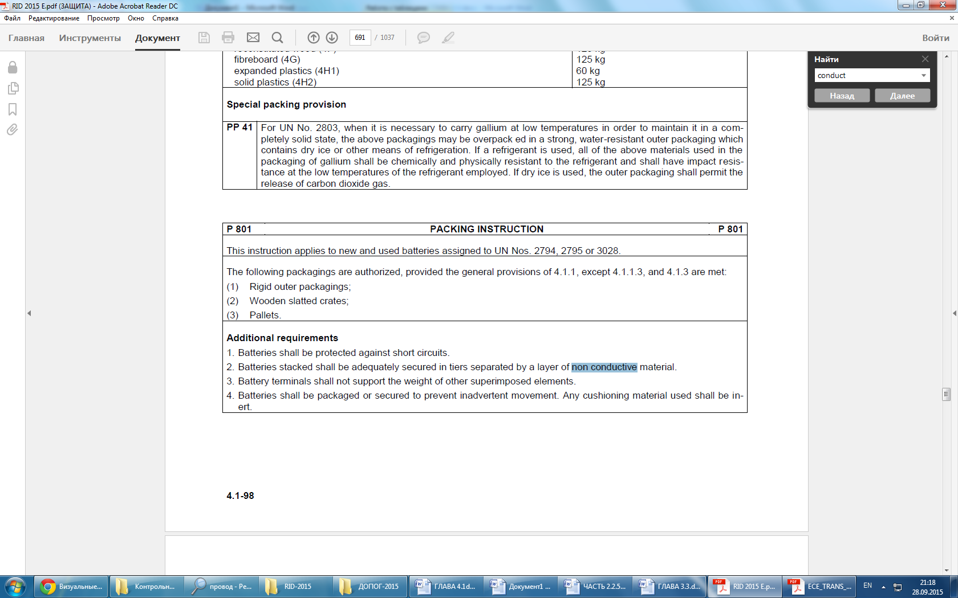

| **P908** | **PACKING INSTRUCTION** | **P908** |
| --- | --- | --- |
| This instruction applies to damaged or defective lithium-ion cells and batteries and lithium metal cells and batteries including those installed in equipment, under UN Nos. 3090, 3091, 3480 and 3481. | | |
| The following packaging are authorized, provided that the general provisions of 4.1.1 and 4.1.3 are met: | | |
| For cells, batteries and equipment containing cells and batteries: | | |
| Drums (1A2, 1B2, 1N2, 1H2, 1D, 1G); | | |
| Boxes (4A, 4B, 4N, 4C1, 4C2, 4D, 4F, 4G, 4H1, 4H2); | | |
| Jerricans (3A2, 3B2, 3H2). | | |
| Packaging shall conform to the requirements of packing group Il. | | |
| 1. Each damaged or defective cell or battery or equipment containing such cells and batteries shall be individually placed in inner packaging and then inside outer packaging. The inner or outer packaging shall be leak-proof to prevent the potential leakage of electrolyte. | | |
| 2. Each inner packaging item shall be surrounded by sufficient non-combustible and electrically non-conductive thermal insulation material to ensure protection against dangerous heat increases.  3. Sealed packaging shall be equipped with a venting device when appropriate.  4. Appropriate measures shall be taken to minimize the effects of vibrations and shocks, prevent movement of the cells or batteries within the package that may lead to further damage and dangerous conditions during transport. Cushioning material that is non-combustible and electrically non-conductive may also be used to meet this requirement.  5. Non-combustibility shall be assessed according to a standard recognized in the country where the packaging is designed or manufactured. | | |
| For leaking cells or batteries, sufficient inert absorbent material shall be placed into the inner or outer packaging to absorb any released electrolyte. | | |
| The quantity of cells or batteries with a net weight over 30 kg shall be limited to one cell or battery per outer packaging item. | | |
| **Additional requirement:** | | |
| Cells or batteries shall be protected against short circuits. | | |

|  |  |  |  |  |  |
| --- | --- | --- | --- | --- | --- |
| **P909** | **PACKING INSTRUCTION** | | | **P909** | |
| This instruction applies to UN Nos. 3090, 3091, 3480 and 3481 transported for disposal or recycling, either packed together with or packed without non-lithium batteries: | | | | | |
| (1) Cells and batteries shall be packed in accordance with the following:  a) The following packaging are authorized, provided that the general provisions of 4.1.1 and 4.1.3 are met:  Drums (1A2, 1B2, 1N2, 1H2, 1D, 1G);  Boxes (4A, 4B, 4N, 4C1, 4C2, 4D, 4F, 4G, 4H2); и Jerricans (3A2, 3B2, 3H2).  b) Packaging shall conform to the requirements of packing group Il.  c) Metal packaging shall be fitted with an electrically non-conductive lining material (e.g., plastics) of adequate strength for the intended use. | | | | | |
| (2) Lithium-ion cells with a Watt-hour rating of not more than 20 W∙h, lithium-ion batteries with a Watt-hour rating of not more than 100 W∙h, lithium metal cells with a lithium content of not more than 1 g and lithium metal batteries with an aggregate lithium content of not more than 2 g may be packed in accordance with the following:  a) In durable outer packaging with a gross weight of up to 30 kg meeting the general provisions of 4.1.1, except 4.1.1.3, and 4.1.3.  b) Metal packaging shall be fitted with an electrically non-conductive lining material (e.g., plastics) of adequate durability for the intended use. | | | | | |
| (3) For cells or batteries installed in equipment, durable outer packaging made of suitable material and of adequate durability and design depending on the packaging capacity and intended utilization may be used. Packaging may not meet the requirements of 4.1.1.3. Large equipment may be handed over for transport without packaging or on pallets in case equivalent protection of the cells or batteries is ensured by the equipment they are installed in. | | | | | |
| (4) In addition, for cells or batteries with a gross weight of 12 kg or more having a durable impact-resistant outer casing, durable outer packaging made of suitable material and of adequate durability and design depending on the packaging capacity and its intended utilization may be used. Packaging may not meet the requirements of 4.1.1.3. | | | | | |
| **Additional requirements:**  1. Cells and batteries shall be designed or packaged so as to prevent short circuits and dangerous heat increases.  2. Protection against short-circuits and dangerous heat increases may include, for example:  − Individual protection of battery terminals;  − Inner packaging to prevent contact between cells and batteries;  − Batteries with recessed terminals designed to protect against short circuits; or  − The use of an electrically non-conductive and non-combustible cushioning material to fill empty space between cells or batteries in the packaging.  3. Cells and batteries shall be secured within the outer packaging to prevent excessive movement during transport (e.g. by using a non-combustible and electrically non-conductive cushioning material or through the use of a tightly closed plastics bag). | | | | | |
| **P910** | | | | | **PACKING INSTRUCTION** | **P910** | |
| This instruction applies to UN Nos. 3090, 3091, 3480 and 3481 production runs consisting of not more than 100 cells and batteries, or to pre-production prototypes of cells and batteries when these prototypes are transported for testing. | | | | | | | | | |
| The following packaging are authorized provided that the general provisions of 4.1.1 and 4.1.3 are met:  (1) For cells and batteries, including when packed with equipment:  Drums (1A2, 1B2, 1N2, 1H2, 1D, 1G);  Boxes (4A, 4B, 4N, 4C1, 4C2, 4D, 4F, 4G, 4H1, 4H2);  Jerricans (3A2, 3B2, 3H2).  Packaging shall conform to the requirements of packing group II and shall meet the following requirements:  a) Batteries and cells, including equipment, of different sizes, shapes or masses shall be placed in outer packaging of a tested design type listed above, provided the total gross weight of the package does not exceed the gross weight for which the design type has been tested;  b) Each cell or battery shall be individually placed in inner and then inside outer packaging;  c) Each inner packaging item shall be completely surrounded by sufficient non-combustible and electrically non-conductive thermal insulation material to protect against dangerous heat increases;  d) Appropriate measures shall be taken to minimize the effects of vibration and shocks and prevent movement of the cells or batteries within the package that may lead to damage and dangerous conditions during transport. Cushioning material that is non-combustible and electrically non-conductive may be used to meet this requirement;  e) Non-combustibility shall be assessed according to a standard recognized in the country where the packaging is designed or manufactured;  f) A cell or battery with a net weight of more than 30 kg shall be limited to one cell or battery per outer packaging.  (2) For cells and batteries installed in equipment:  Drums (1A2, 1B2, 1N2, 1H2, 1D, 1G);   Boxes (4A, 4B, 4N, 4C1, 4C2, 4D, 4F, 4G, 4H1, 4H2);   Jerricans (3A2, 3B2, 3H2).  Packaging shall conform to the performance level requirements of packing group II and shall meet the following requirements:  а) Equipment of different sizes, shapes and masses shall be placed in outer packaging of a tested design type listed above provided that the total gross weight of the package does not exceed the weight for which the design type has been tested;  b) The equipment shall be constructed or packaged in such a manner as to prevent accidental operation during transport;  c) Appropriate measures shall be taken to minimize the effects of vibration and shocks and prevent movement of the equipment within the package that may lead to damage and dangerous conditions during transport. When cushioning material is used to meet this requirement, it shall be non-combustible and electrically non-conductive; and  d) Non-combustibility shall be assessed according to a standard recognized in the country where the packaging is designed or manufactured.  (3) Equipment or batteries may be transported unpackaged under conditions specified by the competent authority. Additional conditions that may be considered during the approval process include, but are not limited to the following:    а) Equipment or batteries shall be durable enough to withstand shocks and loadings normally encountered during transport, transshipment between cargo transport units and cargo transport units and warehouses as well as any removal from a pallet for subsequent manual or mechanical handling; and  b) Equipment or batteries shall be fixed in cradles or crates or other handling devices in such a way that they will not become loose under normal transport conditions. | | | | | | | | | |
| **Additional requirements**  Cells and batteries shall be protected against short circuits;  Protection against short circuits includes, but is not limited to:  – Individual protection of battery terminals;  – Inner packaging to prevent electrical contact between cells and batteries;  – Batteries with recessed terminals designed to protect against short circuits; or  – The use of a non-conductive and electrically non-combustible cushioning material to fill empty spaces between cells or batteries inside the packaging. | | | | | | | | | |
| **LP904** | | | **PACKING INSTRUCTION** | **LP904** | | | |
| This instruction applies to single damaged or defective batteries of UN Nos. 3090, 3091, 3480 and 3481, including those installed in equipment. | | | | | | | |
| The following types of large packaging are authorized to be used for single damaged or defective batteries and for single damaged or defective batteries installed in equipment, provided that the general provisions of 4.1.1 and 4.1.3 are met: | | | | | | | |
| For batteries and equipment with installed batteries, these are large packaging items made of: | | | | | | | |
| steel (50A); | | | | | | | |
| aluminum (50B); | | | | | | | |
| metal other than steel or aluminum (50N); | | | | | | | |
| rigid plastics (50H); | | | | | | | |
| plywood (50D). | | | | | | | |
| Packaging shall conform to the performance level requirements of packing group II. | | | | | | | |
| 1. Each damaged or defective battery or equipment with such a battery installed shall be individually placed in inner packaging and then inside outer packaging. The inner packaging or outer packaging shall be leak-proof to prevent potential release of electrolyte.  2. Each inner packaging item shall be surrounded by sufficient non-combustible and electrically non-conductive thermal insulation material to protect against a dangerous evolution of heat.  3. Sealed packaging shall be equipped with a venting device when appropriate.  4. Appropriate measures shall be taken to minimize the effects of vibrations and shocks, prevent movement of the battery within the package that may lead to further damage and dangerous conditions during carriage. Cushioning material that is non-combustible and electrically non-conductive may also be used to meet this requirement.  5. Non-combustibility shall be assessed according to a standard recognized in the country where the packaging is designed or manufactured. | | | | | | | |
| For leaking batteries, sufficient inert absorbent material shall be added to the inner or outer packaging to absorb any released electrolyte. | | | | | | | |
| **Additional requirement:** | | | | | | | |
| Batteries shall be protected against short circuits. | | | | | | | |

Proposal 3

To amend Chapter 6.4 of the Model Regulations

|  |  |
| --- | --- |
| 6.4.10.2 | A package shall be capable of meeting the assessment criteria prescribed for tests in 6.4.8.8 (b) and 6.4.8.12 after burial in an environment defined by a thermal conductivity of 0.33 W/(m·K) and a temperature of 38 °C in the steady state. Initial conditions for the assessment shall assume that any thermal insulation of the package remains intact, the package is at the maximum normal operating pressure and the ambient temperature is 38 °C. |

The word combination "thermal conductivity" shall be replaced with "thermal conductivity coefficient".

*[*[*W*](https://ru.wikipedia.org/wiki/%D0%92%D0%B0%D1%82%D1%82)*/([m](https://ru.wikipedia.org/wiki/%D0%9C%D0%B5%D1%82%D1%80" \o "Метр)·*[*K*](https://ru.wikipedia.org/wiki/%D0%9A%D0%B5%D0%BB%D1%8C%D0%B2%D0%B8%D0%BD)*)] is the measurement unit of the thermal conductivity coefficient In the SI system.*

Justification

These amendments ensure the conditions for the participants of transport aimed at correct interpretation of the packing requirements.

Enforceability

No enforcement difficulties are expected.