|  |  |  |  |
| --- | --- | --- | --- |
|  | United Nations | ST/SG/AC.10/C.3/2015/34 | |
| _unlogo | **Secretariat** | | Distr.: General  1 September 2015  Original: English |

**Committee of Experts on the Transport of Dangerous Goods  
and on the Globally Harmonized System of Classification  
and Labelling of Chemicals**

**Sub-Committee of Experts on the Transport of Dangerous Goods**

**Forty-eighth session**

Geneva, 30 November – 9 December 2015  
Item 2 (a) of the provisional agenda

**Explosives and related matters:** **tests and criteria for flash compositions**

Proposals on the US- and HSL Flash Composition Tests

Transmitted by the expert from Japan[[1]](#footnote-2)

Introduction

1. At the forty-fifth session of the Sub-Committee, Japan provided technical information on the apparatus, materials and appropriate criteria of US- and HSL tests in informal document INF.19 (45th session). The Working Group on Explosives (EWG) generally supported the proposals in informal document INF.19 and concluded by asking the expert from Japan to prepare a formal proposal.

2. The expert from Japan presented a formal proposal in ST/SG/AC.10/C.3/2014/72 at the forty-sixth session and that paper was referred to the EWG for consideration during the forty-seventh session.

3. Based on comments at the forty-sixth session and at a “IGUS/EPP” meeting in March 2015, Japan revised the proposals in ST/SG/AC.10/C.3/2014/72 to a certain extent and the revised proposals were provided in informal document INF.28 (47th session).

4. At the forty-seventh session, the EWG reviewed the revised proposals from Japan contained in informal document INF.28. The expert from the United Kingdom and the Unites States of America supported the proposals related to the two versions of test. The EWG concurred that the proposals were acceptable and Japan agreed to submit the proposals in informal document INF.28 in a formal paper for the 48th session.

5. This formal paper presents all proposals in informal document INF.28 (47th session) together with additional table for the examples of results of US flash composition test and consequential amendments.

Proposals

6. Rename the title of Appendix 7 of Manual of Tests and Criteria (MTC) to read "FLASH COMPOSITION TESTS” and insert a new subsection heading “A. HSL Flash Composition Test” at the beginning as shown in Proposal 1 of the annex to this document.

7. Amend section 1 of Appendix 7 of MTC as shown in Proposal 2 of the annex to this document.

8. Amend section 2.2 of Appendix 7 of MTC as shown in Proposal 3 of the annex to this document.

9. Amend section 4 and the “Examples of results” of Appendix 7 of MTC as shown in Proposal 4 of the annex to this document.

10. After the figure A7.9 of Appendix 7 of MTC, insert new texts and figure shown in Proposal 5 of the annex to this document.

11. Amend wording in 2.1.3.5.1 (a) as shown in Proposal 6 of the annex to this document.

12. Amend Note 2 in 2.1.3.5.5 of the Model Regulations as shown in Proposal 7 of the annex to this document.

13. Amend the waterfall type of 2.1.3.5.5 default fireworks classification table as shown in Proposal 8 of the annex to this document.

Annex

~~Annex~~Proposal 1

“Appendix 7

~~HSL~~ Flash composition tests

A. HSL Flash Composition Test

Introduction

~~Annex~~Proposal 2

“1. Introduction

This test is used to determine whether pyrotechnic substances in powder form or as pyrotechnic units as presented in the fireworks, that are used in waterfalls, or to produce an aural effect, or used as a bursting charge or lifting charge, are considered to be flash compositions for the purposes of determining the classification of fireworks using the UN default fireworks classification table in 2.1.3.5.5 of the Model Regulations.”

~~Annex~~Proposal 3

“2.2 The end of the pressure vessel furthest from the side-arm is closed with a cone in firing plug which is fitted with two electrodes, one insulated from, and the other earthed to, the plug body. The other end of the pressure vessel is closed by a~~n~~ brass or aluminium bursting disc 0.2 mm thick (bursting pressure approximately 2 200 kPa) held in place with a retaining plug which has a 20 mm bore. A soft lead washer or a washer of a suitable deformable material (for example, polyoxymethylene) is used with both plugs to ensure a good seal. ”

~~Annex~~Proposal 4

“4. Test criteria and method of assessing results

The test results are interpreted in terms of whether a gauge pressure of 2 070 kPa is reached and, if so, the time taken for the pressure to rise from 690 kPa to 2 070 kPa gauge. The result is considered positive “+” and ~~T~~the pyrotechnic substances in powder form or as pyrotechnic units as presented in the fireworks, that are used in waterfalls, or to produce an aural effect, or used as a bursting charge or lifting charge, is to be considered as flash composition if the minimum time taken for the pressure rise is shown to be less than, or equal to, ~~8~~6 ms for 0.5 g of pyrotechnic substance.

“Examples of results:

| *~~Substance~~* | *~~Maximum pressure rise (kPa)~~* | *~~Mean time for a pressure rise from 690 to 2 070 kPa (ms)~~* | *~~Result~~* |
| --- | --- | --- | --- |
| ~~1~~ | ~~> 2 070~~ | ~~0.70~~ | ~~Flash composition~~ |
| ~~2~~ | ~~> 2 070~~ | ~~4.98~~ | ~~Flash composition~~ |
| ~~4~~ | ~~> 2 070~~ | ~~1.51~~ | ~~Flash composition~~ |
| ~~5~~ | ~~> 2 070~~ | ~~0.84~~ | ~~Flash composition~~ |
| ~~6~~ | ~~> 2 070~~ | ~~11.98~~ | ~~Not flash composition~~ |

| *Composition (wt. %)* | *Use or*  *effect* | *Minimum time for a pressure rise from 690 to 2 070 kPa (ms)* | *Result* |
| --- | --- | --- | --- |
| Potassium perchlorate/Aluminum = 77/23 | Aural (report) | 0.48 | Flash composition |
| Potassium perchlorate/ Barium nitrate/ Aluminum /Magnalium = 20/20/45/15 | Aural  (report) | 2.15 | Flash composition |
| Potassium perchlorate /Potassium benzoate  = 71/29 | Aural  (whistle) | 0.89 | Flash composition |
| Potassium perchlorate /Potassium terebiphthalate /Titanium = 62/25/13 | Aural  (whistle) | 1.67 | Flash composition |
| Potassium nitrate/Charcoal /Sulfur  =75.5 / 15.2 / 9.3 (Granular black powder 5FA) | Lifting | 4.05 | Flash composition |
| Potassium nitrate/Charcoal /Sulfur  =75.5 / 15.2 / 9.3 (Granular black powder 2FA) | Lifting | 4.74 | Flash composition |
| Potassium perchlorate /Aluminum (P2000)/Aluminum (P50) = 53/16/31 | Waterfall | 2.73 | Flash composition |
| Potassium perchlorate /Aluminum (P2000)/Aluminum (P50)/ Antimony Sulfide  = 50/15/30/5 | Waterfall | 1.19 | Flash composition |
| Potassium perchlorate/Charcoal = 80/20 | Bursting | 0.85 | Flash composition |
| Potassium perchlorate/Charcoal = 60/40 | Bursting | 2.80 | Flash composition |
| Potassium perchlorate/Charcoal = 50/50 | Bursting | 9.26 | Not flash composition |
| Potassium perchlorate/ Potassium nitrate /Charcoal = 53/26/21 | Bursting | 1.09 | Flash composition |
| Potassium perchlorate/ Potassium nitrate /Charcoal = 53/26/21 (Cottonseed core) | Bursting | 7.39 | Not flash composition |
| Potassium perchlorate/Charcoal /Aluminum  = 59/23/18 | Bursting | 1.14 | Flash composition |

”

~~Annex~~Proposal 5

“

B. US Flash Composition Test

1. Introduction

This test may be used to determine if pyrotechnic substances in powder form or as pyrotechnic units as presented in fireworks that are used in waterfalls, or to produce an aural effect or used as a bursting charge or propellant charge, may be considered a “flash composition” for the purposes of the default fireworks classification table in 2.1.3.5.5 of the Model Regulations.

2. Apparatus and materials

The experimental set up consists of:

A cardboard or fibreboard sample tube with a minimum inside diameter of 25 mm and a maximum height of 154 mm with a maximum wall thickness of 3.8 mm, closed at the base with a thin cardboard or paperboard disk, plug or cap just sufficient to retain the sample;

A 1.0 mm thick 160 × 160 mm witness plate consisting of steel conforming to specification S235JR (EN10025) or ST37-2 (DIN17100) or SPCC (JIS G 3141) or equivalent having a stretch limit (or rupture strength) of 185-355 N/mm2, an ultimate tensile strength of 336-379 N/mm2 and a percentage elongation after fracture of 26-46% ;

An electric igniter, e.g. a fuse head, with lead wires of at least 30 cm in length;

A mild steel confinement sleeve (weighing approximately 3 kg) having an outside diameter of 63 mm and a minimum length of 165 mm with a flat-bottomed round bore whose interior dimensions for diameter and depth are 38 mm and 155 mm, respectively, and a notch or groove cut into one radius of the open end sufficient to allow the igniter lead wires to pass through (the steel sleeve might be provided with a rugged steel handle for easier handling);

A steel ring of approximately 50 mm height with an inner diameter of 95 mm; and

A solid metal base, e.g. a plate of approximately 25 mm in thickness and 150 mm square.

3. Procedure

3.1 Prior to testing, the pyrotechnic substance is stored for at least 24 hours in a desiccator at a temperature of 20-30 °C. Twenty-five (25) g net mass of the pyrotechnic substance to be tested as a loose powder or granulated or coated onto any substrate, is pre-weighed and then poured carefully into a fibreboard sample tube with the bottom end closed with a cardboard or paperboard disk, cap or plug. After filling, the top cardboard or paperboard disk, cap or plug might be inserted lightly to protect the sample from spillage during transport to the test stand. The height of the sample substance in the tube will vary depending on its density. The sample should be first consolidated by lightly tapping the tube on a non-sparking surface. The final density of the pyrotechnic substance in the tube should be as close as possible to the density achieved when contained in a fireworks device.

3.2 The witness plate is placed on the supporting ring. If present, the paperboard or cardboard top disk, cap or plug of the fibreboard sample tube is removed and the electric igniter is inserted into the top of the pyrotechnic substance to be tested and visually positioned to an approximate depth of 10 mm. The paperboard or cardboard top disk, cap or plug is then inserted or re-inserted, fixing the igniter's position in the fibreboard sample tube and the depth of its match head. The lead wires are bent over and down along the sidewall and bent away at the bottom. The sample tube is placed vertically and centred on the witness plate. The steel sleeve is placed over the fibreboard sample tube. The igniter lead wires are positioned to pass through the slotted groove in the bottom edge of the steel confining sleeve and will be ready to attach to the firing circuit apparatus. Finally, the alignment of the steel sleeve and the witness plate is corrected so that their centres are aligned with the centre of the steel ring. See Figure A7.10 as an example of the test set-up. The cardboard or paperboard disk, cap or plug at the bottom end of the sample tube should be placed properly to avoid air gap between the witness plate and the bottom end of the substance to be tested.

3.3 The electric igniter is then initiated from a safe position. After initiation and a suitable interval the witness plate is recovered and examined. The test should be performed 3 times unless a positive result is obtained earlier.

4. Test criteria and method of assessing results

The result is considered positive “+” and the pyrotechnic substances in powder form or as pyrotechnic units as presented in the fireworks, that are used in waterfalls, or to produce an aural effect, or used as a bursting charge or lifting charge, is to be considered as flash composition if:

(a) In any trial the witness plate is torn, perforated, pierced or penetrated; or;

(b) The average of the maximum depths of indented witness plates from all three trials exceeds 15 mm.

Examples of results

| *Composition (wt. %)* | *Use or*  *effect* | *Observation of witness plate or averaged depth of indentation (mm)* | *Result* |
| --- | --- | --- | --- |
| Potassium perchlorate/Aluminum = 77/23 | Aural (report) | Pierced | Flash composition |
| Potassium perchlorate/ Barium nitrate/ Aluminum /Magnalium = 20/20/45/15 | Aural  (report) | 11.3 | Not flash composition |
| Potassium perchlorate /Potassium benzoate  = 71/29 | Aural  (whistle) | Pierced | Flash composition |
| Potassium perchlorate /Potassium terebiphthalate /Titanium = 62/25/13 | Aural  (whistle) | Pierced | Flash composition |
| Potassium nitrate/Charcoal /Sulfur  =75.5 / 15.2 / 9.3 (Granular black powder 5FA) | Lifting | 15.3 | Flash composition |
| Potassium nitrate/Charcoal /Sulfur  =75.5 / 15.2 / 9.3 (Granular black powder 2FA) | Lifting | 7.3 | Not flash composition |
| Potassium perchlorate /Aluminum (P2000)/Aluminum (P50) = 53/16/31 | Waterfall | Pierced | Flash composition |
| Potassium perchlorate /Aluminum (P2000)/Aluminum (P50)/ Antimony Sulfide  = 50/15/30/5 | Waterfall | Pierced | Flash composition |
| Potassium perchlorate/Charcoal = 80/20 | Bursting | Pierced | Flash composition |
| Potassium perchlorate/Charcoal = 60/40 | Bursting | 17.7 | Flash composition |
| Potassium perchlorate/Charcoal = 50/50 | Bursting | 6.7 | Not flash composition |
| Potassium perchlorate/ Potassium nitrate /Charcoal = 53/26/21 | Bursting | Torn | Flash composition |
| Potassium perchlorate/ Potassium nitrate /Charcoal = 53/26/21 (Cottonseed core) | Bursting | 12.7 | Not flash composition |
| Potassium perchlorate/Charcoal /Aluminum  = 59/23/18 | Bursting | Pierced | Flash composition |

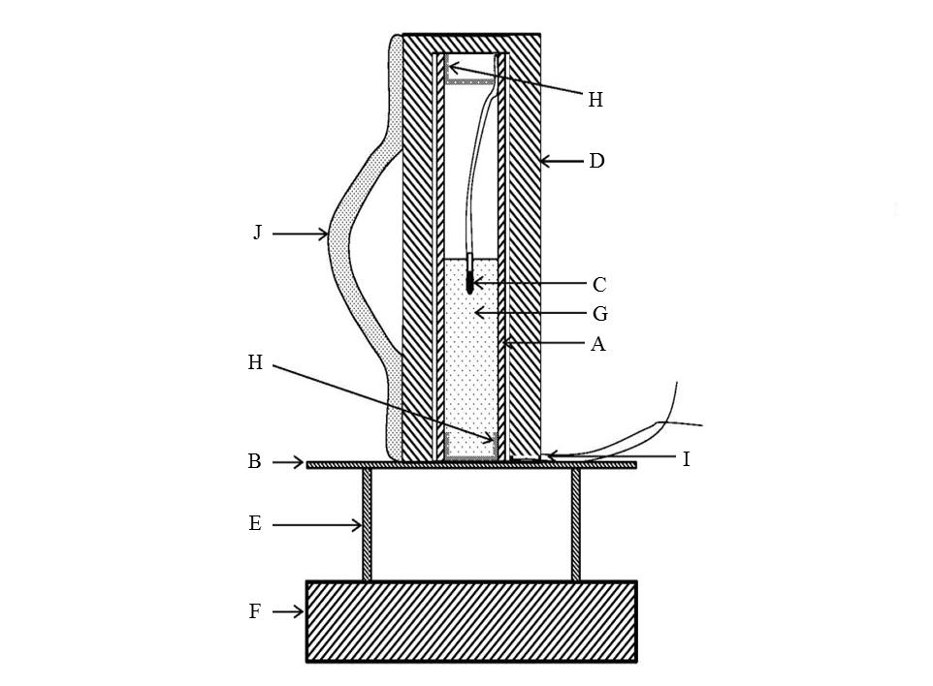

|  |  |
| --- | --- |
| 1. Cardboard or fibreboard sample tube | 1. Steel witness plate |
| 1. Electric igniter | 1. Mild steel confinement sleeve |
| 1. Steel ring | 1. Solid metal base |
| 1. Substance to be tested | 1. Cardboard or paperboard disk, cap or plug |
| 1. Groove in sleeve for igniter wires | 1. Handle welded on (optional) |

**Figure A 7.10”**

~~Annex~~Proposal 6

“2.1.3.5.1 Fireworks shall normally be assigned to hazard divisions 1.1, 1.2, 1.3, and 1.4 on the basis of test data derived from Test Series 6. However:

(a) Waterfalls giving a positive result when tested in one of the ~~HSL~~ Flash composition tests in Appendix 7 of the Manual of Tests and Criteria shall be classified as 1.1G regardless of the results of Test Series 6; ”

~~Annex~~Proposal 7

“2.1.3.5.5 Default fireworks classification table

NOTE 1: References to percentages in the table, unless otherwise stated, are to the mass of all pyrotechnic substances (e.g. rocket motors, lifting charge, bursting charge and effect charge).

NOTE 2: “Flash composition” in this table refers to pyrotechnic substances in powder form or as pyrotechnic units as presented in the firework that are used in waterfalls, or to produce an aural effect or used as a bursting charge, or propellant charge unless:

(a) The time taken for the pressure rise is demonstrated to be more than 6 ms for 0.5 g of pyrotechnic substance; or

(b) The pyrotechnic substance gives a negative "-" result in the US Flash Composition Test in Appendix 7 of the Manual of Tests and Criteria.”

~~Annex~~Proposal 8

“

| *Type* | *Includes: / Synonym:* | *Definition* | *Specification* | *Classification* |
| --- | --- | --- | --- | --- |
| Waterfall | cascades, showers | pyrotechnic fountain intended to produce a vertical cascade or curtain of sparks | containing a pyrotechnic substance which gives a positive result when tested in one of the ~~HSL~~ Flash composition tests in Appendix 7 of the Manual of Tests and Criteria regardless of the results of Test Series 6 (see 2.1.3.5.1 (a)) | 1.1G |
| containing a pyrotechnic substance which gives a negative result when tested in one of the ~~HSL~~ Flash composition tests in Appendix 7 of the Manual of Tests and Criteria | 1.3G |

”

\_\_\_\_\_\_\_\_\_\_\_\_\_

1. In accordance with the programme of work of the Sub-Committee for 2015-2016 approved by the Committee at its seventh session (refer to ST/SG/AC.10/C.3/92, paragraph 95 and ST/SG/AC.10/42, para. 15). [↑](#footnote-ref-2)