E/ECE/324/Add.4/Rev.5-E/ECE/TRANS/505/Add.4/Rev.5
26 June 2014
Agreement
Concerning the Adoption of Uniform Technical Prescriptions for Wheeled Vehicles, Equipment and Parts which can be Fitted and/or be Used on Wheeled Vehicles and the Conditions for Reciprocal Recognition of Approvals Granted on the Basis of these Prescriptions*
(Revision 2, including the amendments which entered into force on 16 October 1995)
_________
Addendum 4: Regulation No. 5
Revision 5
Incorporating all valid text up to:
03 series of amendments - Date of entry into force: 10 June 2014
Uniform provisions concerning the approval of power-driven vehicle's "sealed beam" headlamps (SB) emitting a European asymmetrical passing beam or a driving beam or both

_________
UNITED NATIONS

Regulation No. 5
Uniform provisions concerning the approval of power-driven vehicle's "sealed beam" headlamps (SB) emitting a European asymmetrical passing beam or a driving beam or both
Contents
Page
Regulation

1. Scope 5
2. Definitions 5
3. Application for approval 6
4. Markings 7
5. Approval 7
6. General specifications 10
7. Rated values 11
8. Illumination 11
9. Colour 13
10. Gauging of discomfort 13
11. Conformity of production 14
12. Penalties for non-conformity of production 15
13. Modifications of the type of sealed beam headlamp unit (SB unit) and extension of approval 15
14. Production definitively discontinued 15
15. Transitional provisions 16
16. Names and addresses of Technical Services responsible for conducting approval tests and
of Type Approval Authorities 16
Annexes
1 SB units for agricultural or forest tractors and other slow-moving vehicles 17
2 Communication 18
3 Minimum requirements for conformity of production control procedures 20
4 Examples of arrangements of approval marks 23
5 Tests for stability of photometric performance of headlamps in operation 39
6 Requirements for lamps incorporating lenses of plastic material - testing of lens or material
samples and of complete lamps 43
Appendix 1 - Chronological order of approval tests 48
Appendix 2 - Method of measurement of the diffusion and transmission of light 49
Appendix 3 - Spray testing method 51
Appendix 4 - Adhesive tape adherence test 52
7 Minimum requirements for sampling by an inspector 53

1. Scope
This Regulation applies to sealed beam headlamps (SB) for vehicles of category T.
2. Definitions
For the purpose of this Regulation:
2.1. "Sealed beam" headlamp unit (hereinafter termed "SB unit"), means a headlamp unit whose components, comprising a reflector system, a lens system and one or more electrical light sources are all parts of an integral whole which has been sealed in the course of manufacture and which cannot be dismantled without rendering the unit completely unusable;
2.2. "Lens" means the outermost component of the headlamp (unit) which transmits light through the illuminating surface;
2.3. "Coating" means any product or products applied in one or more layers to the outer face of a lens;
2.4. SB units are considered to be of different types if they differ in one or more of the following essentials of form or characteristics:
2.4.1. Trade name or mark;
2.4.2. Characteristics of the optical system;
2.4.3. Inclusion of additional components capable of altering the optical effects by reflection, refraction, absorption and/or deformation during operation;
2.4.4. The rated voltage (the same approval number may be granted if the only change is of rated voltage);
2.4.5. The rated wattage;
2.4.6. The shape of the filament(s);
2.4.7. The kind of beam produced (passing beam, driving beam or both);
2.4.8. Suitability for right-hand or left-hand traffic or for both traffic systems;
2.4.9. The colour of the light emitted;
2.4.10. The materials constituting the lens and coating, if any.
2.5. "Colour of the light emitted from the device." The definitions of the colour of the light emitted given in Regulation No. 48 and its series of amendments in force at the time of application for type approval shall apply to this Regulation.
3. Application for approval
3.1. The application for approval shall be submitted by the owner of the trade name or mark or by his duly accredited representative. It shall specify:
3.1.1. Whether the SB unit is intended to provide both a passing beam and a driving beam, or only one of these beams;
3.1.2. Whether, if the headlamp is intended to provide a passing beam, it is designed for both left-hand and right-hand traffic or for either left-hand or right-hand traffic only;
3.1.3. Where applicable, that it is designed for agricultural or forest tractors and other slow-moving vehicles (see Annex 1).
3.2. Every application for approval shall be accompanied by:
3.2.1. Drawings in triplicate, sufficiently detailed to permit identification of the type and giving a front view of the unit (with, if applicable, details of the lens moulding) and a cross-section; also the filament(s) and shield(s) shall be shown on the drawings at a scale of 2 : 1 both in front view and in side view; the drawing shall show the position intended for the approval number and the additional symbols in relation to the circle of the approval mark;
3.2.2. Brief technical description;
3.2.3. Samples as follows:
3.2.3.1. For approval of an SB unit to emit white light: five samples;
3.2.3.2. For approval of a unit to emit coloured light: one coloured-light sample, and five white-light samples differing from the type submitted only in that the lens or filter is not coloured.
3.2.3.3. In the case of SB units differing only in that they are designed to emit coloured light from a type designed to emit white light and which has previously satisfied the tests in paragraphs 6., 7. and 8. below, it will be sufficient to submit one sample of the coloured-light type to undergo only the tests given in paragraph 9. of this Regulation.
3.2.4. For the test of plastic material of which the lenses are made:
3.2.4.1. Thirteen lenses;
3.2.4.1.1. Six of these lenses may be replaced by six samples of material at least 60 x 80 mm in size, having a flat or convex outer surface and a substantially flat area (radius of curvature not less than 300 mm) in the middle measuring at least 15 x 15 mm;
3.2.4.1.2. Every such lens or sample of material shall be produced by the method to be used in mass production;
3.2.4.2. A reflector to which the lenses can be fitted in accordance with the manufacturer's instructions.
3.3. The materials making up the lenses and coatings, if any, shall be accompanied by the test report of the characteristics of these materials and coatings if they have already been tested.
3.4. The Type Approval Authority shall verify the existence of satisfactory arrangements for ensuring effective control of the conformity of production before type approval is granted.
4. Markings
4.1. SB units submitted for approval shall bear the trade name or mark of the applicant.
4.2. They shall comprise on the front lens, a space of sufficient size for the approval mark and the additional symbols provided for in paragraph 5. below; the space shall be shown on the drawings referred to in paragraph 3.2.1. above.
4.3. They shall carry, either on the front lens or on the body, the values of the rated voltage and of the rated wattage of the driving beam filament, followed by that of the rated wattage of the passing beam filament, as applicable.
4.4. In the case of SB units designed to meet the requirements both of countries where the traffic keeps to the right and of those where the traffic keeps to the left, the two settings of the unit on the vehicle shall be marked by the letters "R/D" for the position for right-hand traffic and the letters "L/G" for the position for left-hand traffic.
4.5. The trade names or marks and markings provided for under this paragraph 4. shall be clearly legible and indelible.
5. Approval
5.1. General
5.1.1. If all the headlamp type samples submitted in accordance with paragraph 3. above satisfy the provisions of this Regulation, approval shall be granted.
5.1.2. Where grouped, combined or reciprocally incorporated lamps satisfy the requirements of more than one Regulation, a single international approval mark may be affixed provided that each of the grouped, combined or reciprocally incorporated lamps satisfies the provisions applicable to it.
5.1.3. An approval number shall be assigned to each type approved. The same Contracting Party may not assign the same number to another type of headlamp covered by this Regulation except in the case of an extension of the approval to a device differing only in the colour of the light emitted.
5.1.4. Notice of approval or of extension or refusal or withdrawal of approval or production definitively discontinued, of a type of headlamp pursuant to this Regulation shall be communicated to the Parties to the 1958 Agreement applying this Regulation, by means of a form conforming to the model in Annex 2 to this Regulation.
5.1.5. In addition to the mark prescribed in paragraph 4.1. above, an approval mark as described in paragraphs 5.2. and 5.3. below shall be affixed in the spaces referred to in paragraph 4.2. above to every headlamp conforming to a type approved under this Regulation.
5.2. Composition of the approval mark
The approval mark shall consist of:
5.2.1. An international approval mark, comprising:
5.2.1.1. A circle surrounding the letter "E" followed by the distinguishing number of the country which has granted approval;
5.2.1.2. The approval number prescribed in paragraph 5.1.3. above.
5.2.2. The following additional symbol (or symbols):
5.2.2.1. On SB headlamps meeting left-hand traffic requirements only, a horizontal arrow pointing to the right of an observer facing the SB headlamp, i.e. to, the side of the road on which the traffic moves;
5.2.2.2. On SB headlamps designed to meet the requirements of both traffic systems by means of an appropriate adjustment of the setting of the headlamp, a horizontal arrow with a head on each end, the heads pointing respectively to the left and to the right;
5.2.2.3. On headlamps meeting the requirements of this Regulation in respect of the passing beam only, the letters "SC";
5.2.2.4. On headlamps meeting the requirements of this Regulation in respect of the driving beam only, the letters "SR";
5.2.2.5. On headlamps meeting the requirements of this Regulation in respect of both the passing beam and the driving beam, the letters "SCR";
5.2.2.6. On headlamps incorporating a lens of plastic material, the group of letters "PL" shall be affixed near the symbols prescribed in paragraphs 5.2.2.3. to 5.2.2.5. above;
5.2.2.7. In every case the relevant operating mode during the next procedure according to paragraph 1.1.1.1. of Annex 5 and the allowed voltage(s) according to paragraph 1.1.1.2. of Annex 5 shall be stipulated on the approval certificates and on the communication form transmitted to the countries which are Contracting Parties to the Agreement and which apply this Regulation.
In the corresponding cases the device shall be marked as follows:
On units meeting the requirements of this Regulation which are so designed that the filament of the passing beam shall not be lit simultaneously with that of any other lighting function with which it may be reciprocally incorporated:
An oblique stroke (/) shall be placed behind the passing lamp symbol in the approval mark;
5.2.2.8. The two digits of the approval number (at present 03) which indicate the series of amendments incorporating the most recent major technical amendments made to the Regulation and at the time of issue of the approval and, if necessary, the required arrow may be marked close to the above additional symbols;
5.2.2.9. The marks and symbols referred to in paragraphs 5.2.1. and 5.2.2. above shall be clearly legible and indelible even when the headlamp is fitted in the vehicle.
5.3. Arrangement of the approval mark
5.3.1. Independent lamps
Annex 4, Figures 1 to 9, to this Regulation gives examples of arrangements of the approval mark with the above-mentioned additional symbols.
5.3.2. Grouped, combined or reciprocally incorporated lamps
5.3.2.1. Where grouped, combined or reciprocally incorporated lamps have been found to comply with the requirements of several Regulations, a single international approval mark may be affixed, consisting of a circle surrounding the letter "E" followed by the distinguishing number of the country which has granted the approval, and an approval number. This approval mark may be located anywhere on the grouped, combined or reciprocally incorporated lamps, provided that:
5.3.2.1.1. It is visible after their installation;
5.3.2.1.2. No part of the grouped, combined or reciprocally incorporated lamps that transmits light can be removed without at the same time removing the approval mark.
5.3.2.2. The identification symbol for each lamp appropriate to each Regulation under which approval has been granted, together with the corresponding series of amendments incorporating the most recent major technical amendments to the Regulation at the time of issue of the approval and, if necessary, the required arrow shall be marked:
5.3.2.2.1. Either on the appropriate light-emitting surface,
5.3.2.2.2. Or in a group, in such a way that each of the grouped, combined or reciprocally incorporated lamps may be clearly identified (see four possible examples in Annex 4).
5.3.2.3. The size of the components of a single approval mark shall not be less than the minimum size required for the smallest of the individual marks by the Regulation under which approval has been granted.
5.3.2.4. An approval number shall be assigned to each type approved. The same Contracting Party may not assign the same number to another type of grouped, combined or reciprocally incorporated lamps covered by this Regulation.
5.3.2.5. Annex 4, Figure 10, to this Regulation gives examples of arrangements of approval marks for grouped, combined or reciprocally incorporated lamps with all the above-mentioned additional symbols.
5.3.3. Lamps, the lens of which is used for different types of headlamps and which may be reciprocally incorporated or grouped with other lamps
The provisions laid down in paragraph 5.3.2. above are applicable.
5.3.3.1. In addition, where the same lens is used, the latter may bear the different approval marks relating to the different types of headlamps or units of lamps, provided that the main body of the headlamp, even if it cannot be separated from the lens, also comprises the space described in paragraph 4.2. above and bears the approval mark of the actual functions.
If different types of headlamps comprise the same main body, the latter may bear the different approval marks.
5.3.3.2. Annex 4, Figure 11, to this Regulation gives examples of arrangements of approval marks relating to the above case.
6. General specifications
6.1. Each sample shall conform to the specifications set forth in this paragraph 6. and in paragraphs 7. and 8. below, and, if necessary, paragraph 9.
6.2. SB units shall be so made as to retain their prescribed photometric characteristics and to remain in good working order when in normal use, despite the vibrations to which they may be subjected.
6.2.1. Headlamps shall be fitted with a device enabling them to be so adjusted on the vehicle as to comply with the rules applicable to them. Such a device need not be fitted on the SB headlamp inserts if the use of such inserts is confined to vehicles on which the headlamp setting can be adjusted by other means. Where an SB headlamp providing a driving beam and an SB headlamp providing a passing beam are assembled as exchangeable subunits to form a composite unit the adjusting device shall enable each SB unit individually to be duly adjusted.
6.2.2. However, this will not apply to headlamp assemblies whose reflectors are indivisible. For this type of assembly the requirements of paragraph 8. of this Regulation shall apply. In the case where more than one light source is used to provide the main beam the combined main-beam functions will be used to determine the maximum value of the illumination (E_{max}).
6.3. The terminals shall only be in electrical connection with the appropriate filament or filaments and shall be robust and firmly fixed to the unit.
6.4. If the units are circular they shall provide all the physical features and electrical connections shown in one of the plates SB₂ - SB₇ in Annex 4 and shall be made to the dimensions in that plate.
6.5. SB units designed to meet the requirements both of countries where the traffic keeps to the right and of those where the traffic keeps to the left, may be adapted for traffic on a given side of the road either by an appropriate initial setting when fitted on the vehicle, or by selective setting by the user. Such initial or selective setting may consist, for example, of fixing the angular setting of the unit on the vehicle. In all cases, only two precise setting positions, one for right-hand and one for left-hand traffic, shall be possible, and the design shall preclude inadvertent shifting of the unit from the one position to the other or its setting in an intermediate position. Conformity with the requirements of this paragraph shall be verified visually and, where necessary, by a test fitting.
6.6. Complementary tests shall be done according to the requirements of Annex 5 to ensure that in use there is no excessive change in photometric performance.
6.7. If the lens of the headlamp is of plastic material, tests shall be done according to the requirements of Annex 6.
7. Rated values
7.1. The values of rated voltage are: 6, 12 and 24 volts.
7.2. The power consumed at the test voltage by any submitted SB unit shall not exceed the rated wattage marked on the unit, by more than the percentage specified in Table 1. No lower limit is specified for the tolerance on wattage but the minimum illumination values specified in Table 2 of paragraph 8.8. shall be obtained.

Table 1
 |  |  |  | Circular units of  180 mm diameter |  | Circular units of  145 mm diameter
Rated voltage |  |  |  | 6 | 12 | 6 | 12
Test voltage |  |  |  | 6 | 12 | 6 | 12
 |  |  |  | Rated wattage and permitted tolerance
Double filaments¹ |  | Driving beam |  | 60 + 0% |  | 37.5 + 0%
 |  | Passing beam |  | 50 + 0% |  | 50 + 0%
Driving beam filament only |  |  |  | 75+ 0% |  | 50 + 0%
Passing beam filament only |  |  |  | 50 + 0% |  | 50 + 0%
¹ In the case of SB units with double filaments, the samples may be submitted for approval for the two functions or for the passing beam only.
8. Illumination
8.1. SB units shall be so made as to give adequate illumination without dazzle for the passing beam, and good illumination for the driving beam.
8.2. The illumination produced by the unit shall be checked on a vertical screen set at a distance of 25 m in front of the unit and at right angles to its axis (see Annex 4, plates SB_{8a} and SB_{8b}).
8.3. The passing beam shall produce a sufficiently sharp "cut-off" to permit satisfactory alignment with its aid. The "cut-off" shall be a horizontal line on the side opposite to the direction of the traffic for which the unit is intended; on the other side it should be horizontal or within an angle of 15° above the horizontal.
8.4. The SB unit shall be aimed so that on passing beam:
8.4.1. In the case of units designed to meet the requirements of right-hand traffic, the "cut-off" on the left half of the screen is horizontal and, in the case of units designed to meet the requirements of left-hand traffic, the "cut-off" on the right half of the screen is horizontal;
8.4.2. This horizontal part of the "cut-off" is situated, on the screen, 25 cm below the level of the horizontal plane passing through the focus of the unit (see Annex 4, plates SB_{8a} and SB_{8b});
8.4.3. The screen is in the position indicated in Annex 4, plates SB_{8a} and SB_{8b}.
8.5. When so aimed, the unit need, if its approval is sought solely for a passing beam, meet only the requirements referred to in paragraph 8.8. below; if it is intended to provide both a passing beam and a driving beam it shall meet the requirements referred to in paragraphs 8.8. and 8 9. below.
8.6. Where an SB unit so aimed does not meet the requirements referred to in paragraphs 8.8. and 8.9. below, its alignment may be changed, provided that the axis of the beam is not laterally displaced by more than 1° (= 44 cm) to the right or left. To facilitate alignment by means of the "cut-off", the unit may be partially occulted in order to sharpen the "cut-off".
8.7. In the case of an SB unit providing a driving beam only, it shall be so aimed that the area of maximum illumination is centred on the point of intersection HV of the lines hh and vv; such a unit need meet only the requirements referred to in paragraph 8.9. below.
8.8. The illumination produced on the screen by the passing beam shall meet the following requirements:

Table 2
Point on measuring screen |  | Required illumination  in lux
SB units for  right-hand traffic | SB units for  left-hand traffic | Minimum | Maximum
B 50 L  75 R | B 50 R  75 L | -  6 | 0.3  -
50 R  25 L | 50 L  25 R | 6  1.5 | -  -
25 R | 25 L | 1.5 | -
Energy point in zone III |  | - | 0.7
Energy point in zone IV |  | 2 | -
Energy point in zone I |  | - | 20
8.8.1. There shall be no lateral variations detrimental to good visibility in any of the zones, I, II, III and IV;
8.8.2. SB units designed to meet the requirements of both right-hand and left-hand traffic shall, in each of the two setting positions, meet the requirements set forth above for the corresponding direction of traffic.
8.9. In the case of an SB unit designed to provide a driving beam and a passing beam, measurements of the illumination produced on the screen by the driving beam shall be taken with the same unit alignment and voltage as for measurements under paragraph 8.8. above.
8.10. The illumination produced on the screen by the driving beam shall meet the following requirements:
8.10.1. The point of intersection HV of the line hh and vv shall be situated within the isolux 90 per cent of maximum illumination. The maximum value shall not be less than 32 lux;
8.10.2. Starting from point HV, horizontally to the right and left, illumination shall be not less than 16 lux up to a distance of 1.125 metres, and not less than 4 lux up to a distance of 2.25 metres.
8.11. The screen illumination values mentioned in paragraphs 8.8. and 8.9. above shall be measured by means of a photoelectric cell, the effective area of which shall be contained within a square of 65 mm side.
9. Colour
The light emitted shall be white.
10. Gauging of discomfort
The discomfort caused by the passing beam of SB units shall be gauged.
11. Conformity of production
11.1. Headlamps approved under this Regulation shall be so manufactured as to conform to the type approved by meeting the requirements set forth in paragraphs 8. and 9. above.
11.2. In order to verify that the requirements of paragraph 12.1. below are met, suitable controls of the production shall be carried out.
11.3. The holder of the approval shall in particular:
11.3.1. Ensure the existence of procedures for the effective control of the quality of products;
11.3.2. Have access to the control equipment necessary for checking the conformity to each approved type;
11.3.3. Ensure that data of test results are recorded and that related documents shall remain available for a period to be determined in accordance with the Type Approval Authority;
11.3.4. Analyze the results of each type of test in order to verify and ensure the stability of the product characteristics, making allowance for variation of an industrial production;
11.3.5. Ensure that for each type of product at least the tests prescribed in Annex 3 to this Regulation are carried out;
11.3.6. Ensure that any collecting of samples giving evidence of non-conformity with the type of test considered shall give rise to another sampling and another test. All the necessary steps shall be taken to re-establish the conformity of the corresponding production.
11.4. The Type Approval Authority which has granted type approval may at any time verify the conformity control methods applicable to each production unit.
11.4.1. In every inspection, the test books and production survey records shall be presented to the visiting inspector.
11.4.2. The inspector may take samples at random to be tested in the manufacturer's laboratory. The minimum number of samples may be determined in the light of the results of the manufacturer's own checks.
11.4.3. When the quality level appears unsatisfactory or when it seems necessary to verify the validity of the tests carried out in the application of paragraph 11.4.2. above, the inspector shall select samples, to be sent to the Technical Service which has conducted the type approval tests, using the criteria of Annex 7.
11.4.4. The Type Approval Authority may carry out any test prescribed in this Regulation. These tests will be on samples selected at random without causing distortion of the manufacturer's delivery commitments and in accordance with the criteria of Annex 7 to this Regulation.
11.4.5. The Type Approval Authority shall strive to obtain a frequency of inspection of once every two years. However, this is at the discretion of the Type Approval Authority and their confidence in the arrangements for ensuring effective control of the conformity of production. In the case where negative results are recorded, the Type Approval Authority shall ensure that all necessary steps are taken to re-establish the conformity of production as rapidly as possible.
11.5. Headlamps with apparent defects are disregarded.
11.6. The reference mark is disregarded.
12. Penalties for non-conformity of production
12.1. The approval granted in respect of an SB unit pursuant to this Regulation may be withdrawn if the requirements set forth above are not met, or if a unit bearing the approval mark does not conform to the type approved.
12.2. If a Contracting Party to the Agreement applying this Regulation withdraws an approval it has previously granted, it shall forthwith so notify the other Contracting Parties applying this Regulation, by means of a communication form conforming to the model in Annex 2 to this Regulation.
13. Modifications of the type of sealed beam headlamp unit (SB unit) and extension of approval
13.1. Every modification of the type of sealed beam headlamp unit (SB unit) shall be notified to the Type Approval Authority which approved the type of sealed beam headlamp unit (SB unit). The Authority may then either:
13.1.1. Consider that the modifications made are unlikely to have an appreciable adverse effect and that in any case the sealed beam headlamp unit (SB unit) still complies with the requirements; or
13.1.2. Require a further test report from the Technical Service responsible for conducting the tests.
13.2. Confirmation or refusal of approval, specifying the alterations, shall be communicated by the procedure specified in paragraph 5.1.4. above to the Parties to the Agreement applying this Regulation.
13.3. The Type Approval Authority issuing the extension of approval shall assign a series number to each communication form drawn up for such an extension and inform thereof the other Parties to the 1958 Agreement applying this Regulation by means of a communication form conforming to the model in Annex 2 to this Regulation.
14. Production definitively discontinued
If the holder of the approval completely ceases to manufacture a device approved in accordance with this Regulation he shall inform the Type Approval Authority which granted the approval. Upon receiving the relevant communication that Authority shall inform thereof the other Parties to the 1958 Agreement applying this Regulation by means of a communication form conforming to the model in Annex 2 to this Regulation.
15. Transitional provisions
15.1. As from twelve months after the official date of entry into force of the 03 series of this Regulation, Contracting Parties applying this Regulation shall cease to grant approvals according to this Regulation.
15.2. Contracting Parties applying this Regulation shall not refuse to grant extensions of approval to this and any previous series of amendments of this Regulation.
15.3. Existing approvals granted before the official date of entry into force of the 03 series of this Regulation and all extensions of approvals, including those to a preceding series of amendments to this Regulation granted subsequently, shall remain valid indefinitely.
15.4. Contracting Parties applying this Regulation shall continue to issue approvals for headlamps on the basis of this and any previous series of amendments to this Regulation, provided that the headlamps are intended as replacements for fitting to vehicles in use.
15.5. Contracting Parties applying this Regulation shall continue to allow fitting of a headlamp approved to this Regulation on a vehicle or vehicle type.
15.6. Contracting Parties applying this Regulation shall continue to allow fitting or use on a vehicle in use of a headlamp approved to this Regulation as amended by any previous series of amendments, provided that the headlamp is intended for replacement.
16. Names and addresses of Technical Services responsible for conducting approval tests and of Type Approval Authorities
The Contracting Parties to the 1958 Agreement applying this Regulation shall communicate to the United Nations Secretary-General the names and addresses of the Technical Services responsible for conducting approval tests and of the Type Approval Authorities which grant approval and to which forms certifying approval or refusal, or extension or withdrawal of approval, or production definitively discontinued, issued in other countries, are to be sent.

Annex 1
SB units for agricultural or forest tractors and other slow-moving vehicles
1. The provisions of this Regulation shall also apply to the approval of special SB units for agricultural or forest tractors and other slow-moving vehicles, such units being intended to provide both a driving beam and a passing beam and having a diameter* of less than 160 mm with the following modifications:
1.1. The minimum requirements for illumination laid down in paragraph 8.8. of this Regulation shall be reduced in the ratio
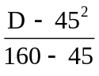
subject to the following absolute lower limits:
3 lux at either point 75R or point 75L;
5 lux at either point 50R or point 50L;
1.5 lux in zone IV;
1.2. Instead of the symbols provided for in paragraph 5.2.2. of this Regulation, the unit shall be marked with the letters "SM" in an inverted triangle.

Annex 2
Communication
(Maximum format: A4 (210 x 297 mm))

Issued by: Name of administration:
………….......................
………….......................
………….......................
………….......................


Concerning:² Approval granted,
Approval extended,
Approval refused,
Approval withdrawn,
Production definitively discontinued,
of a type of sealed beam headlamp unit (SB unit) pursuant to Regulation No. 5.
Approval No. ............................................ Extension No. ............................................
1. SB unit submitted for approval as type³
Rated voltage
Rated wattage
2. The passing lamp filament may/may not² be lit simultaneously with the driving lamp filament and/or another reciprocally incorporated lamp
3. Trade name or mark
______________
¹ Distinguishing number of the country which has granted/extended/refused/withdrawn approval (see approval provisions in the Regulation).
² Strike out what does not apply.
³ Indicate the appropriate marking selected from the list below:
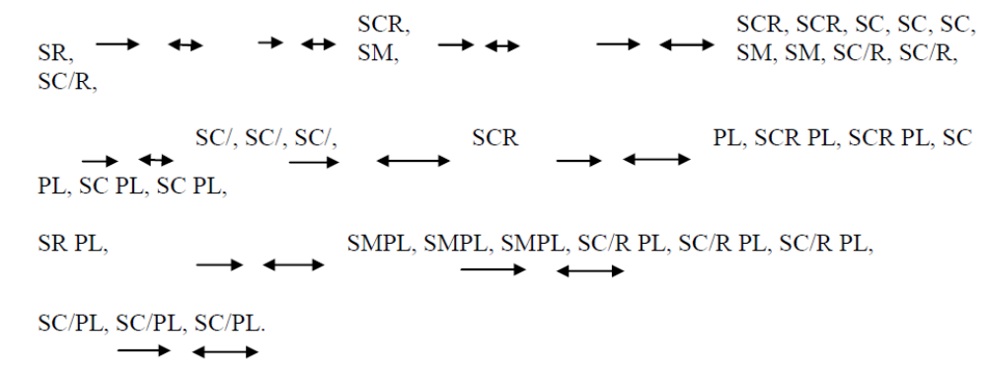
4. Manufacturer's name and address
5. If applicable, name and address of manufacturer's representative
6. Submitted for approval on
7. Technical Service responsible for conducting approval tests
8. Date of report issued by that Service
9. Number of report issued by that Service
10. Approval granted/refused/extended/withdrawn²
11. Reason(s) of extension (if applicable)
12. Maximum intensity (in lux) of the driving beam at 25 m from the unit
13. Test laboratory
14. Date and number of laboratory report
15. Date of extension of the approval
16. Place
17. Date
18. Signature
19. The attached drawing, No. shows the unit in front view (with, if applicable, details of the lens moulding) and a cross-section.

Annex 3
Minimum requirements for conformity of production control procedures
1. General
1.1. The conformity requirements shall be considered satisfied from a mechanical and geometric standpoint, if the differences do not exceed inevitable manufacturing deviations within the requirements of this Regulation.
1.2. With respect to photometric performances, the conformity of mass-produced headlamps shall not be contested if, when testing photometric performances of any headlamp chosen at random:
1.2.1. No measured value deviates unfavourably by more than 20 per cent from the values prescribed in this Regulation. For values B 50 L (or R) and zone III, the maximum unfavourable deviation may be respectively:
B 50 L (or R) : 0.2 lx equivalent 20 per cent
0.3 lx equivalent 30 per cent
Zone III: 0.3 lx equivalent 20 per cent
0.45 lx equivalent 30 per cent
1.2.2. Or if
1.2.2.1. For the passing beam, the values prescribed in this Regulation are met at HV (with a tolerance of +0.2 lx) and related to that aiming at least one point of each area delimited on the measuring screen (at 25 m) by a circle 15 cm in radius around points B 50 L (or R) (with a tolerance of + 0.1 lx), 75 R (or L), 25 R, 25 L, and in the entire area of zone IV which is not more than 22.5 cm above line 25 R and 25 L;
1.2.2.2. And if, for the driving beam, HV being situated within the isolux 0.75 E_{max}, a tolerance of +20 per cent for maximum values and - 20 per cent for minimum values is observed for the photometric values at any measuring point specified in paragraph 8.10. of this Regulation.
1.2.3. If the results of the tests described above do not meet the requirements, the alignment of the headlamp may be changed, provided that the axis of the beam is not displaced laterally by more than 1° to the right or left.
1.3. With respect to the verification of the change in vertical position of the cut-off line under the influence of heat, the following procedure shall be applied:
One of the sampled headlamps shall be tested according to the procedure described in paragraph 2.1. of Annex 5 after being subjected three consecutive times to the cycle described in paragraph 2.2.2. of Annex 5.
The headlamp shall be considered as acceptable if Δr does not exceed 1.5 mrad.
If this value exceeds 1.5 mrad but is not more than 2.0 mrad, a second headlamp shall be subjected to the test after which the mean of the absolute values recorded on both samples shall not exceed 1.5 mrad.
1.4. The chromaticity coordinates shall be complied with.
2. Minimum requirements for verification of conformity by the manufacturer
For each type of headlamp the holder of the approval mark shall carry out at least the following tests, at appropriate intervals. The tests shall be carried out in accordance with the provisions of this Regulation.
If any sampling shows non-conformity with regard to the type of test concerned, further samples shall be taken and tested. The manufacturer shall take steps to ensure the conformity of the production concerned.
2.1. Nature of tests
Tests of conformity in this Regulation shall cover the photometric characteristics and the verification of the change in vertical position of the cut-off line under the influence of heat.
2.2. Methods used in tests
2.2.1. Tests shall generally be carried out in accordance with the methods set out in this Regulation.
2.2.2. In any test of conformity carried out by the manufacturer, equivalent methods may be used with the consent of the Type Approval Authority responsible for approval tests. The manufacturer is responsible for proving that the applied methods are equivalent to those laid down in this Regulation.
2.2.3. The application of paragraphs 2.2.1. and 2.2.2. above requires regular calibration of test apparatus and its correlation with measurements made by a Type Approval Authority.
2.2.4. In all cases the reference methods shall be those of this Regulation, particularly for the purpose of administrative verification and sampling.
2.3. Nature of sampling
Samples of headlamps shall be selected at random from the production of a uniform batch. A uniform batch means a set of headlamps of the same type, defined according to the production methods of the manufacturer.
The assessment shall in general cover series production from individual factories. However, a manufacturer may group together records concerning the same type from several factories, provided these operate under the same quality system and quality management.
2.4. Measured and recorded photometric characteristics
The sampled headlamp shall be subjected to photometric measurements at the points provided for in the Regulation, the reading being limited to points E_{max}, HV, HL, HR in the case of the driving beam, and to points B 50 L (or R), HV, 75 R (or L) and 25 L (or R) in the case of the passing beam (see figure in Annex 4).
2.5. Criteria governing acceptability
The manufacturer is responsible for carrying out a statistical study of the test results and for defining, in agreement with the Type Approval Authority, criteria governing the acceptability of his products in order to meet the specifications laid down for verification of conformity of products in paragraph 12.1. of this Regulation.
The criteria governing the acceptability shall be such that, with a confidence level of 95 per cent, the minimum probability of passing a spot check in accordance with Annex 7 (first sampling) would be 0.95.

Annex 4
Examples of arrangements of approval marks

Figure 1
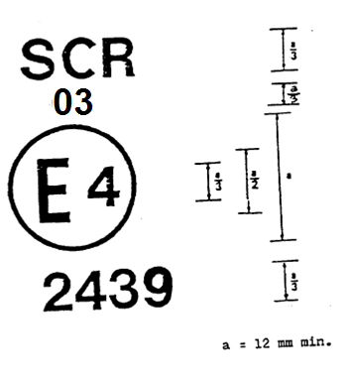
The SB headlamp bearing the approval marking shown above is a headlamp approved in the Netherlands (E 4), meeting the requirements of this Regulation as amended by the 03 series of amendments in respect of both the driving beam and the passing beam (SCR), and which is designed for right-hand traffic only.
Note: The approval number and the additional symbol(s) shall be placed close to the circle and either above or below the letter "E", or to the right or left of that letter. The digits of the approval number shall be on the same aide of the letter "E" and face the same direction.
The additional symbol(s) shall be diametrically opposed to the approval number.
The use of Roman numerals as approval numbers should be avoided so as to prevent any confusion with other symbols.

Figure 2 Figure 3a
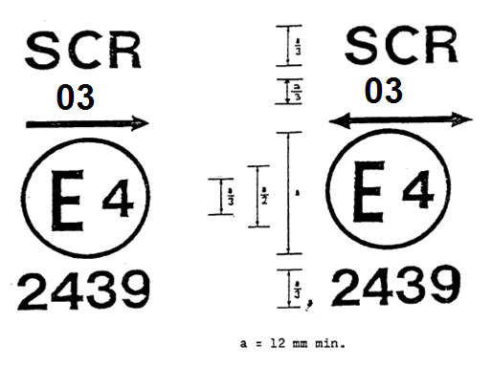

Figure 3b
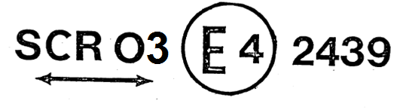
The SB headlamp bearing the approval mark shown above is a headlamp meeting the requirements of this Regulation with respect to both the passing beam and the driving beam and designed:
For both traffic systems, by means of an adjustment as desired of the headlamp.
For left-hand traffic only.

Figure 4 Figure 5

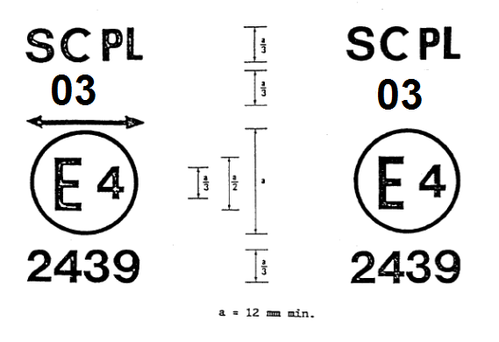
The SB headlamp bearing the approval mark shown above is a headlamp incorporating the lens of plastic material meeting the requirements of this Regulation with respect to the passing beam only, and designed:
For both traffic systems.
For right-hand traffic only.

Figure 6 Figure 7
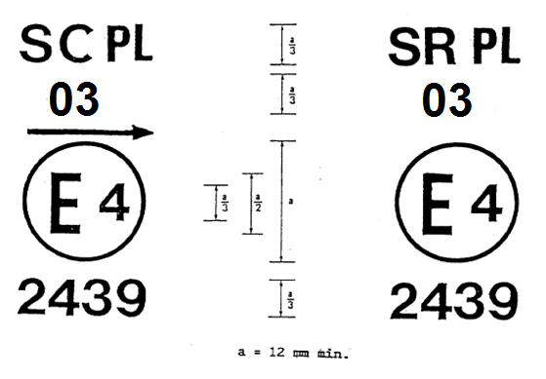
The SB headlamp bearing the approval mark shown above is a headlamp incorporating the lens of plastic material meeting the requirements of this Regulation:
With respect to both the passing beam only, and designed for left-hand traffic only.
With respect to the driving beam only.

Figure 8 Figure 9

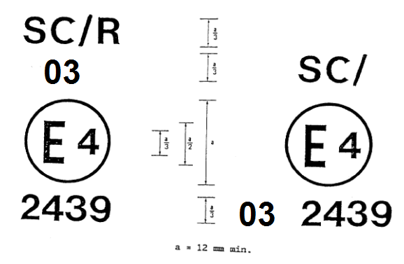
Identification of a headlamp meeting
the requirements of Regulation No. 5
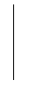
With respect to both the passing beam and driving beam and designed for right-hand traffic only.
With respect to the passing beam only and designed for right-hand traffic only.

The passing lamp filament shall not
be lit simultaneously with the
driving lamp filament and/or another
reciprocally incorporated lamp.

Examples of simplified markings for grouped, combined or reciprocally incorporated lamps

Figure 10
(The vertical and horizontal lines schematize the shape of the light-signalling device. They are not part of the approval mark).
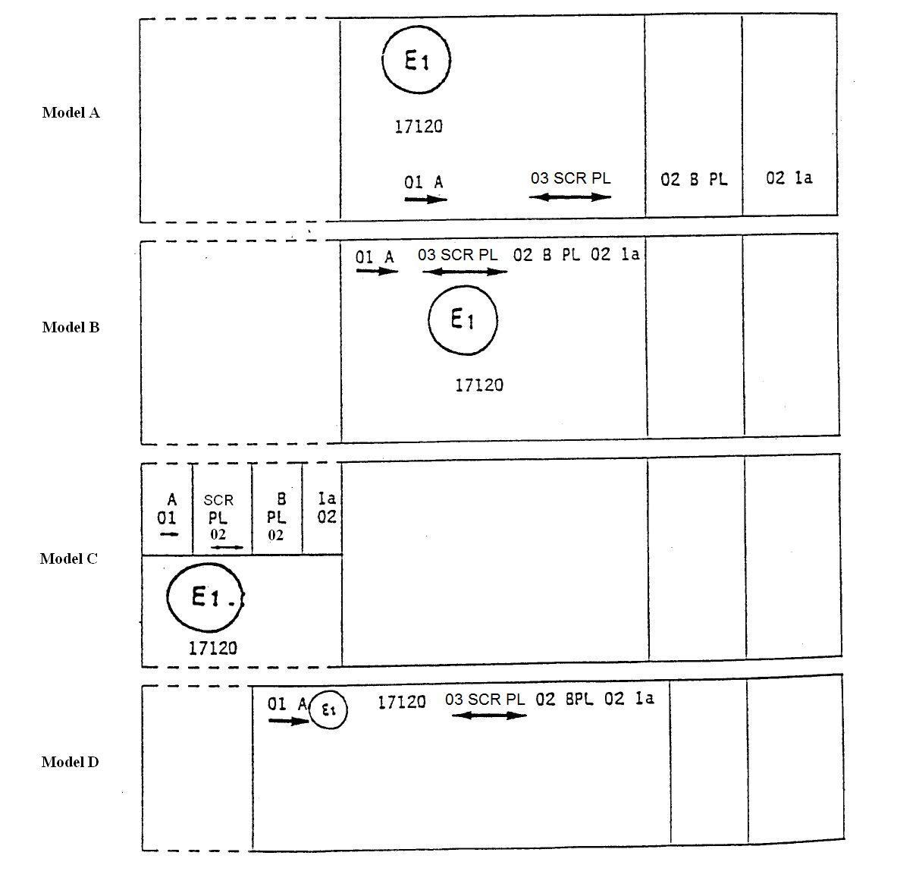
Note: The four examples shown above correspond to a lighting device bearing an approval mark relating to:
A front position lamp approved in accordance with the 02 series of amendments to Regulation No. 7;
A headlamp meeting the requirements of this Regulation with respect to the passing beam and to the driving beam, and designed for both traffic systems and incorporating a lens of plastic material;
A front fog lamp approved in accordance with the 04 series of amendments to Regulation No. 19 and incorporating a lens of plastic material;
A front direction indicator lamp of category 1 a approved in accordance with the 01 series of amendments to Regulation No. 6.

Figure 11

Lamp reciprocally incorporated with a headlamp
Example 1

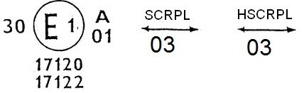
The above example corresponds to the marking of a lens of plastic material intended to be used in different types of headlamps, namely:
either: a headlamp with a passing beam designed for right-hand and left-hand traffic and a driving beam approved in Germany (E l) in accordance with the requirements of Regulation No. 5 as amended by the 03 series of amendments, which is reciprocally incorporated with a front position lamp approved in accordance with the 02 series of amendments to Regulation No. 7;
or: a headlamp with a passing beam designed for right-hand and left-hand traffic and a driving beam with a maximum intensity comprised between 86,250 and 101,250 candelas, approved in Germany (E l) in accordance with the requirements of Regulation No. 31 as amended by the 02 series of amendments which is reciprocally incorporated with the same front position lamp as above;
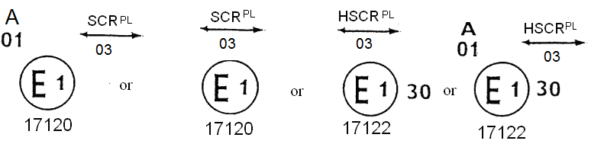
or even: either of the above-mentioned headlamps approved as a single lamp.
The main body of the headlamp shall bear the only valid approval number, for instance:

Figure 11

Example 2
03 SR 01 CR
81151
The above example corresponds to the marking of a lens used in an assembly of two headlamps approved in Germany (E 1), consisting of a headlamp emitting a passing beam designed for both traffic systems and of a driving beam meeting the requirements of Regulation No. 1, and of a headlamp emitting a driving beam meeting the requirements of Regulation No. 5.
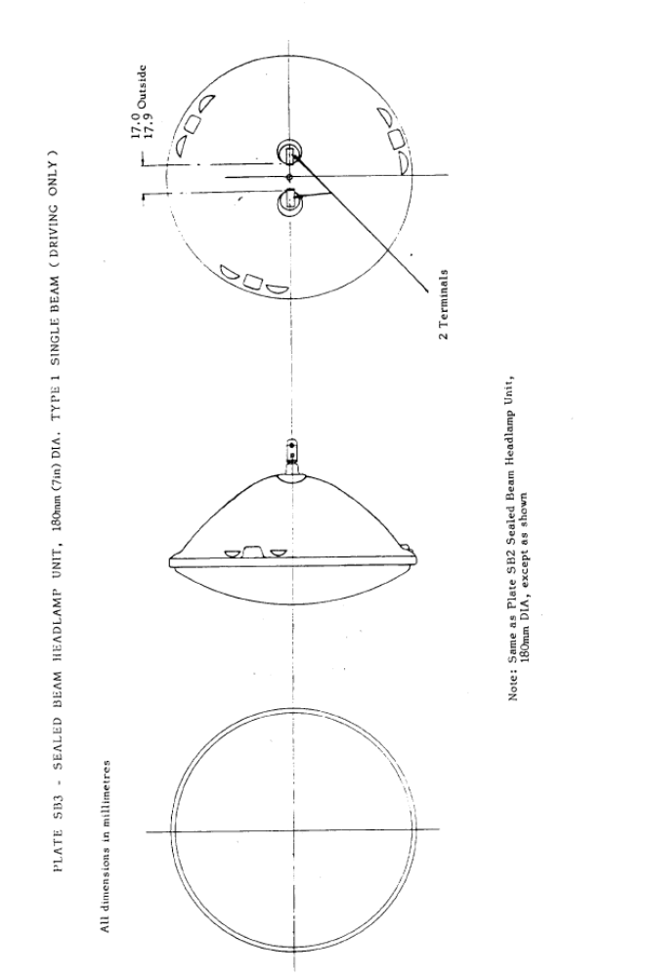
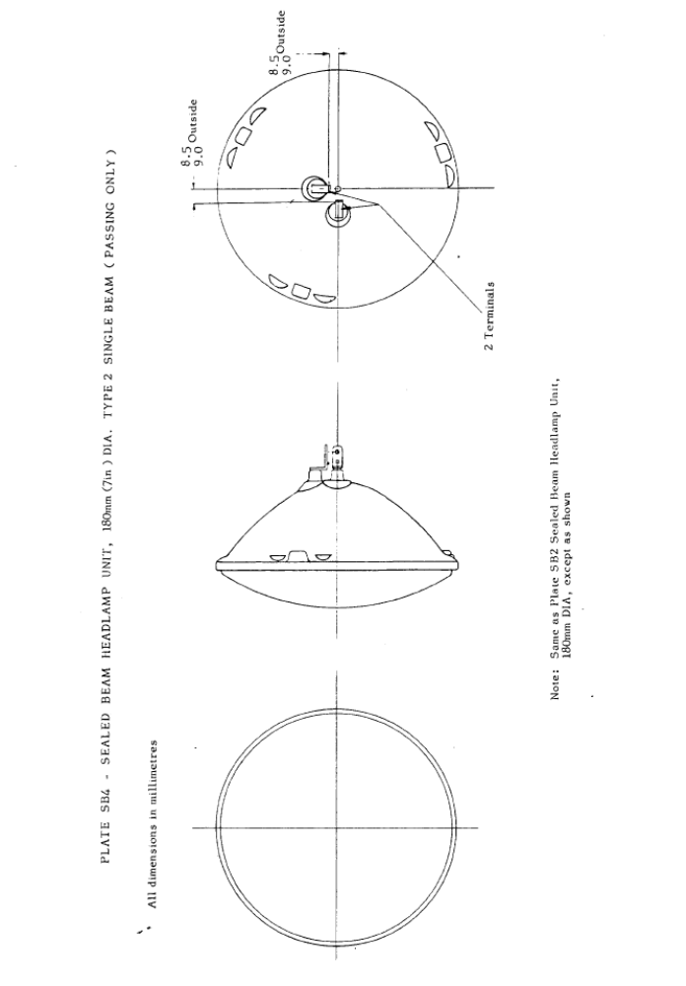
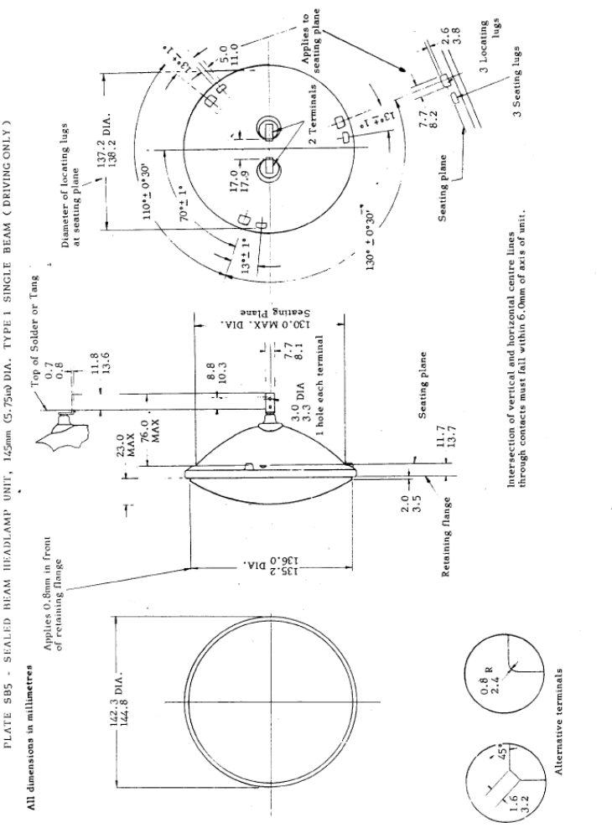
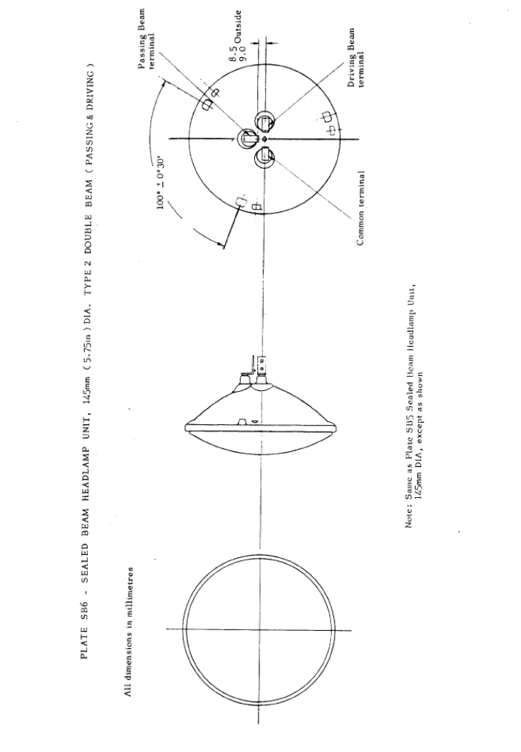
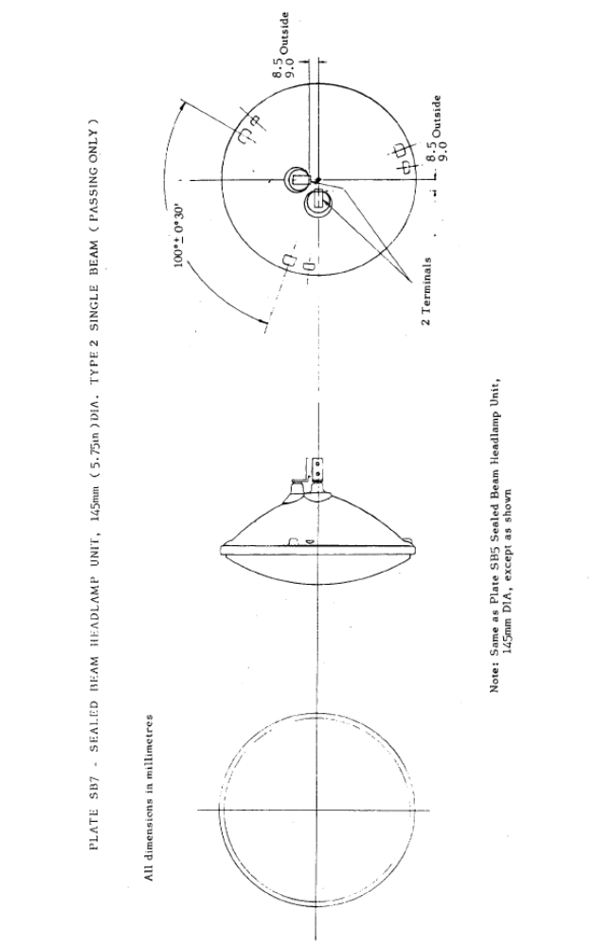
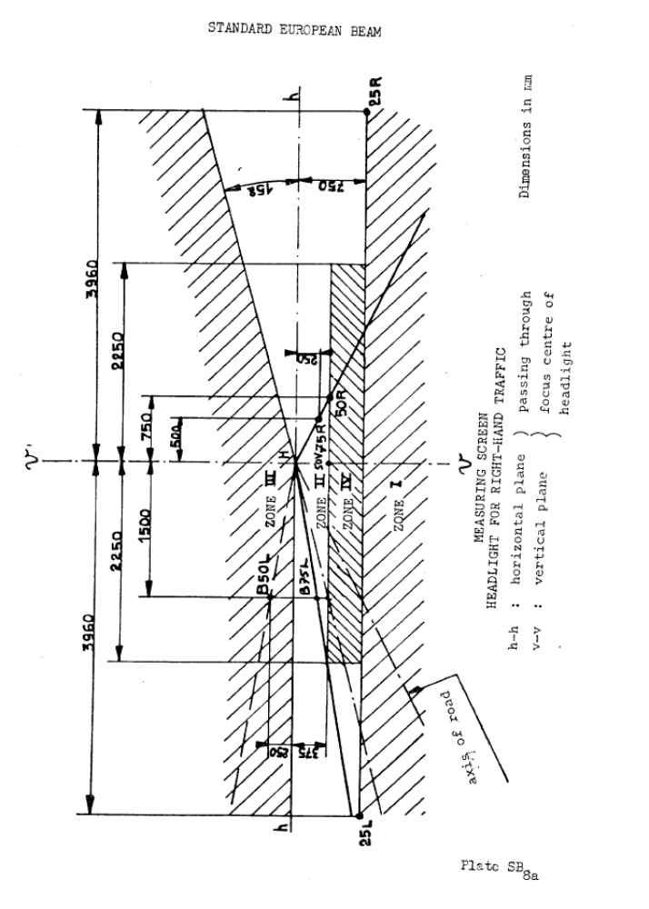
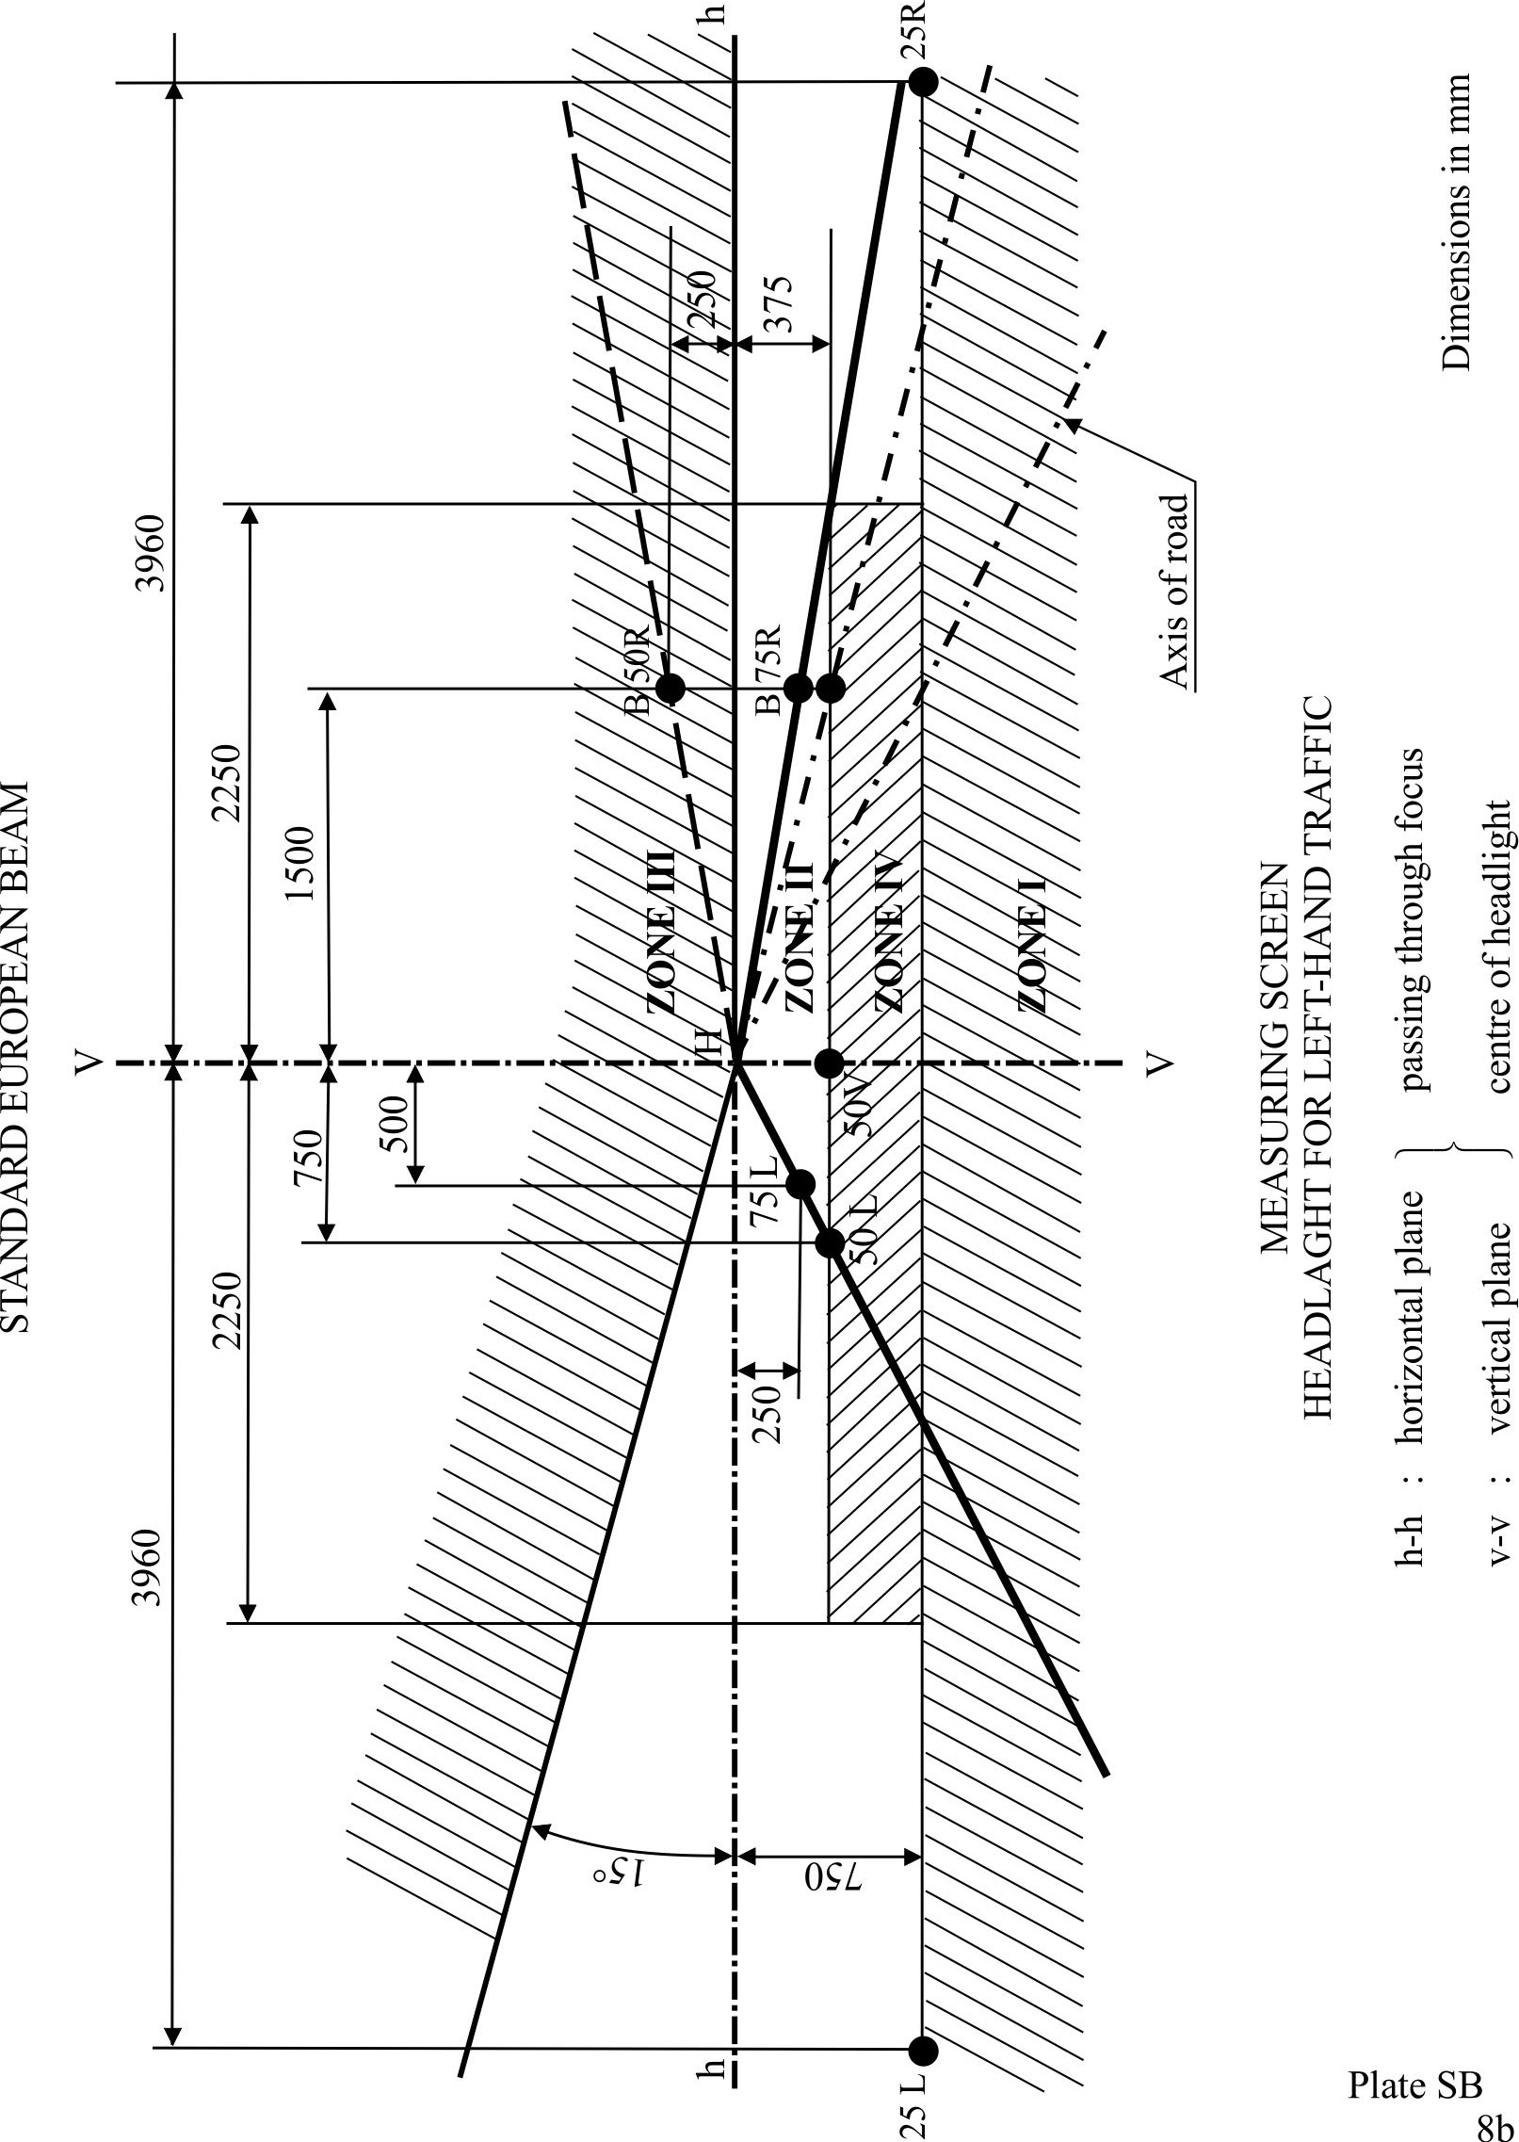
Annex 5
Tests for stability of photometric performance of headlamps in operation
Tests on complete headlamps
Once the photometric values have been measured according to the prescriptions of this Regulation, in points for E_{max} for driving beam and HV, 50 R, B 50 L for passing beam (or HV, 50L, B50R for headlamps designed for left-hand traffic) a complete headlamp sample shall be tested for stability of photometric performance in operation. "Complete headlamps" shall be understood to mean the complete lamp itself including those surrounding body parts and lamps which could influence its thermal dissipation.
1. Test of stability of photometric performance
The tests shall be carried out in a dry and still atmosphere at an ambient temperature of 23 °C ± 5 °C, the complete headlamp being mounted on a base representing the correct installation on the vehicle.
1.1. Clean headlamp
The headlamp shall be operated for 12 hours as described in paragraph 1.1.1. and checked as prescribed in paragraph 1.1.2.
1.1.1. Test procedure
The headlamp shall be operated for a period according to the specified time, so that:
1.1.1.1. (a) In the case where only one lighting function (driving or passing beam) is to be approved, the corresponding filament is lit for the prescribed time,
(b) In the case of a reciprocally incorporated passing lamp and driving lamp (dual filament SB headlamp):
If the applicant declares that the headlamp is to be used with a single filament lit at a time, the test shall be carried out in accordance with this condition, activating¹ each specified function successively for half the time specified in paragraph 1.1. above;
In all other cases^{l,} ² the headlamp shall be subjected to the following cycle until the time specified is reached:
15 minutes, passing-beam filament lit
5 minutes, all filaments lit.
(c) In the case of grouped lighting functions all the individual functions shall be lit simultaneously for the time specified for individual lighting functions (a) also taking into account the use of reciprocally incorporated lighting functions (b), according to the manufacturer's specifications.
1.1.1.2. Test voltage
The voltage shall be adjusted so as to supply a wattage 15 per cent (26 per cent for 24 V types) higher than the rated wattage specified in this Regulation for the type(s) of SB headlamp(s) concerned is (are) obtained.
1.1.2. Test results
1.1.2.1. Visual inspection
Once the headlamp has been stabilized to the ambient temperature, the headlamp lens and the external lens, if any, shall be cleaned with a clean, damp cotton cloth. It shall then be inspected visually; no distortion, deformation, cracking or change in colour of either the headlamp lens or the external lens, if any, shall be noticeable.
1.1.2.2. Photometric test
To comply with the requirements of this Regulation, the photometric values shall be verified in the following points:
Passing beam:
50R - B50L - HV for headlamps designed for right-hand traffic
50L - B50R - HV for headlamps designed for left-hand traffic
Driving beam:
Point of E_{max}
Another aiming may be carried out to allow for any deformation of the headlamp base due to heat (the change of the position of the cut-off line is covered in paragraph 2. of this annex);
A 10 per cent discrepancy between the photometric characteristics and the values measured prior to the test is permissible including the tolerances of the photometric procedure.
1.2. Dirty headlamp
After being tested as specified in paragraph 1.1. above, the headlamp shall be operated for one hour as described in paragraph 1.1.1., after being prepared as prescribed in paragraph 1.2.1. below, and checked as prescribed in paragraph 1.1.2.
1.2.1. Preparation of the headlamp
1.2.1.1. Test mixture
1.2.1.1.1. For headlamp with the outside lens in glass:
The mixture of water and a polluting agent to be applied to the headlamp shall be composed of:
9 parts by weight of silica sand with a particle size of 0-100 μm,
1 part by weight of vegetal carbon dust (beechwood) with a particle size of 0-100 μm,
0.2 part by weight of NaCMC, and
an appropriate quantity of distilled water, with a conductivity of ≤ 1 mS/m.
The mixture shall not be more than 14 days old.
1.2.1.1.2. For headlamp with outside lens in plastic material:
The mixture of water and polluting agent to be applied to the headlamp shall be composed of:
9 parts by weight of silica sand with a particle size of 0-100 μm,
1 part by weight of vegetal carbon dust (beechwood) with a particle size of 0-100 μm,
0.2 part by weight of NaCMC,³
13 parts by weight of distilled water with a conductivity of ≤ 1 mS/m, and
2 ± 1 parts by weight of surface-actant.
The mixture shall not be more than 14 days old.
1.2.1.2. Application of the test mixture to the headlamp
The test mixture shall be uniformly applied to the entire light emitting surface of the headlamp and then left to dry. This procedure shall be repeated until the illumination value has dropped to 15-20 per cent of the values measured for each following point under the conditions described in paragraph 1 above:
Point of E_{max} in driving beam, photometric distribution for a driving/passing lamp,
Point of E_{max} in driving beam, photometric distribution for a driving lamp only,
50R and 50V for a passing lamp only, designed for right-hand traffic,
50L and 50V⁵ for a passing lamp only, designed for left-hand traffic.
1.2.1.3. Measuring equipment
The measuring equipment shall be equivalent to that used during headlamp approval tests.
2. Test for change in vertical position of the cut-off line under the influence of heat
This test consists of verifying that the vertical drift of the cut-off line under the influence of heat does not exceed a specified value for an operating passing lamp.
The headlamp tested in accordance with paragraph 1.1. above shall be subjected to the test described in paragraph 2.1. below, without being removed from or readjusted in relation to its test fixture.
2.1. Test
The test shall be carried out in a dry and still atmosphere at an ambient temperature of 23 °C ± 5 °C.
Using a mass production SB headlamp which has been aged for at least one hour the headlamp shall be operated on passing beam without being dismounted from or readjusted in relation to its test fixture. (For the purpose of this test, the voltage shall be adjusted as specified in paragraph 1.1.1.2. above). The position of the cut-off line in its horizontal part (between vv and the vertical line passing through point B50L for right-hand traffic or B50R for left-hand traffic) shall be verified 3 minutes (r₃) and 60 minutes (r₆₀) respectively after operation.
The measurement of the variation in the cut-off line position as described above shall be carried out by any method giving acceptable accuracy and reproducible results.
2.2. Test results
2.2.1. The result expressed in milliradians (mrad) shall be considered as acceptable when the absolute value Δ r_{I} = | r₃ – r₆₀ | recorded on the headlamp is not more than 1.0 mrad (Δ r_{I} ≤ 1.0 mrad).
2.2.2. However, if this value is more than 1.0 mrad but not more than 1.5 mrad (1.0 mrad Δ r_{I} ≤ 1.5 mrad) a second headlamp shall be tested as described in paragraph 2.1. above after being subjected three consecutive times to the cycle as described below, in order to stabilize the position of mechanical parts of the headlamp on a base representative of the correct installation on the vehicle:
Operation of the passing lamp for one hour, (the voltage shall be adjusted as specified in paragraph 1.1.1.2. above),
Period of rest for one hour.
The headlamp type shall be considered as acceptable if the mean value of the absolute values Δ r_{I} measured on the first sample and Δ r_{II} measured on the second sample is not more than 1.0 mrad
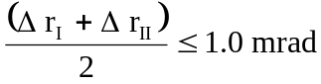

Annex 6
Requirements for lamps incorporating lenses of plastic material - testing of lens or material samples and of complete lamps
1. General specifications
1.1. The samples supplied pursuant to paragraph 3.2.4. of this Regulation shall satisfy the specifications indicated in paragraphs 2.1. to 2.5. below.
1.2. Two out of the five samples of complete lamps supplied pursuant to paragraph 3.2.3. of this Regulation and incorporating lenses of plastic material shall, with regard to the lens material, satisfy the specifications indicated in paragraph 2.6. below.
1.3. The samples of lenses of plastic material or samples of material shall be subjected, with the reflector to which they are intended to be fitted (where applicable), to approval tests in the chronological order indicated in Table A reproduced in Appendix 1 to this annex.
1.4. However, if the lamp manufacturer can prove that the product has already passed the tests prescribed in paragraphs 2.1.-2.5. below, or the equivalent tests pursuant to another Regulation, those tests need not be repeated; only the tests prescribed in Appendix 1, Table B, shall be mandatory.
2. Tests
2.1. Resistance to temperature changes
2.1.1. Tests
Three new samples (lenses) shall be subjected to five cycles of temperature and humidity (RH = relative humidity) change in accordance with the following programme:
3 hours at 40 °C ± 2 °C and 85-95 per cent RH;
1 hour at 23 °C ± 5 °C and 60-75 per cent RH;
15 hours at -30 °C ± 2 °C;
1 hour at 23 °C ± 5 °C and 60-75 per cent RH;
3 hours at 80 °C ± 2 °C;
1 hour at 23 °C ± 5 °C and 60-75 per cent RH;
Before this test, the samples shall be kept at 23 °C ± 5 °C and 60-75 per cent RH for at least four hours.
Note: The periods of one hour at 23 °C ± 5 °C shall include the periods of transition from one temperature to another which are needed in order to avoid thermal shock effects.
2.1.2. Photometric measurements
2.1.2.1. Method
Photometric measurements shall be carried out on the samples before and after the test.
These measurements shall be made using a standard lamp, at the following points:
B 50 L and 50 R for the passing beam of a passing lamp or a passing/driving lamp (B 50 R and 50 L in the case of headlamps intended for left-hand traffic);
E_{max} route for the driving beam of a driving lamp or a passing/driving lamp.
2.1.2.2. Results
The variation between the photometric values measured on each sample before and after the test shall not exceed 10 per cent including the tolerances of the photometric procedure.
2.2. Resistance to atmospheric and chemical agents
2.2.1. Resistance to atmospheric agents
Three new samples (lenses or samples of material) shall be exposed to radiation from a source having a spectral energy distribution similar to that of a black body at a temperature between 5,500K and 6,000K. Appropriate filters shall be placed between the source and the samples so as to reduce as far as possible radiations with wave lengths smaller than 295 nm and greater than 2,500 nm. The samples shall be exposed to an energetic illumination of 1,200 W/m² ± 200 W/m² for a period such that the luminous energy that they receive is equal to 4,500 MJ/m² ± 200 MJ/m². Within the enclosure, the temperature measured on the black panel placed on a level with the samples shall be 50 °C ± 5 °C. In order to ensure a regular exposure, the samples shall revolve around the source of radiation at a speed between 1 and 5 1/min.
The samples shall be sprayed with distilled water of conductivity lower than 1 mS/m at a temperature of 23 °C ± 5 °C, in accordance with the following cycle:
spraying: 5 minutes;
drying: 25 minutes.
2.2.2. Resistance to chemical agents
After the test described in paragraph 2.2.1. above and the measurement described in paragraph 2.2.3.1. below have been carried out, the outer face of the said three samples shall be treated as described in paragraph 2.2.2.2. with the mixture defined in paragraph 2.2.2.1. below.
2.2.2.1. Test mixture
The test mixture shall be composed of 61.5 per cent n-heptane, 12.5 per cent toluene, 7.5 per cent ethyl tetrachloride, 12.5 per cent trichloroethylene and 6 per cent xylene (volume per cent).
2.2.2.2. Application of the test mixture
Soak a piece of cotton cloth (as per ISO 105) until saturation with the mixture defined in paragraph 2.2.2.1. above and, within 10 seconds, apply it for 10 minutes to the outer face of the sample at a pressure of 50 N/cm², corresponding to an effort of 100 N applied on a test surface of 14 x 14 mm.
During this 10-minute period, the cloth pad shall be soaked again with the mixture so that the composition of the liquid applied is continuously identical with that of the test mixture prescribed.
During the period of application, it is permissible to compensate the pressure applied to the sample in order to prevent it from causing cracks.
2.2.2.3. Cleaning
At the end of the application of the test mixture, the samples shall be dried in the open air and then washed with the solution described in paragraph 2.3. below (Resistance to detergents) 23 °C ± 5 °C.
Afterwards the samples shall be carefully rinsed with distilled water containing not more than 0.2 per cent impurities at 23 °C ± 5 °C and then wiped off with a soft cloth.
2.2.3. Results
2.2.3.1. After the test of resistance to atmospheric agents, the outer face of the samples shall be free from cracks, scratches, chipping and deformation, and the mean variation in transmission 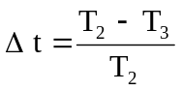, measured on the three samples according to the procedure described in Appendix 2 to this annex shall not exceed 0.020
(Δ t_{m} ≤ 0.020).
2.2.3.2. After the test of resistance to chemical agents, the samples shall not bear any traces of chemical staining likely to cause a variation of flux diffusion, whose mean variation 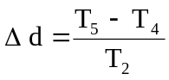, measured on the three samples according to the procedure described in Appendix 2 to this annex shall not exceed 0.020
(Δ d_{m} ≤ 0.020).
2.3. Resistance to detergents and hydrocarbons
2.3.1. Resistance to detergents
The outer face of three samples (lenses or samples of material) shall be heated to 50 °C ± 5 °C and then immersed for five minutes in a mixture maintained at 23 °C ± 5 °C and composed of 99 parts distilled water containing not more than 0.02 per cent impurities and one part alkylaryl sulphonate.
At the end of the test, the samples shall be dried at 50 °C ± 5 °C. The surface of the samples shall be cleaned with a moist cloth.
2.3.2. Resistance to hydrocarbons
The outer face of these three samples shall then be lightly rubbed for one minute with a cotton cloth soaked in a mixture composed of 70 per cent n-heptane and 30 per cent toluene (volume per cent), and shall then be dried in the open air.
2.3.3. Results
After the above two tests have been performed successively, the mean value of the variation in transmission 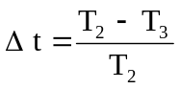, measured on the three samples according to the procedure described in Appendix 2 to this annex shall not exceed 0.010
(Δ t_{m} ≤ 0.010).
2.4. Resistance to mechanical deterioration
2.4.1. Mechanical deterioration method
The outer face of the three new samples (lenses) shall be subjected to the uniform mechanical deterioration test by the method described in Appendix 3 to this annex.
2.4.2. Results
After this test, the variations:
in transmission: ,
and in diffusion: ,
shall be measured according to the procedure described in Appendix 2 in the area specified in paragraph 2.2.4. above. The mean value of the three samples shall be such that: Δ t_{m} ≤ 0.100;
Δ d_{m} ≤ 0.050.
2.5. Test of adherence of coatings, if any
2.5.1. Preparation of the sample
A surface of 20 mm x 20 mm in area of the coating of a lens shall be cut with a razor blade or a needle into a grid of squares approximately 2 mm x 2 mm. The pressure on the blade or needle shall be sufficient to cut at least the coating.
2.5.2. Description of the test
Use an adhesive tape with a force adhesion of 2 N/(cm of width) ± 20 per cent measured under the standardized conditions specified in Appendix 4 to this annex. This adhesive tape, which shall be at least 25 mm wide, shall be pressed for at least five minutes to the surface prepared as prescribed in paragraph 2.5.1. above.
Then the end of the adhesive tape shall be loaded in such a way that the force of adhesion to the surface considered is balanced by a force perpendicular to that surface. At this stage, the tape shall be torn off at a constant speed of 1.5 m/s ± 0.2 m/s.
2.5.3. Results
There shall be no appreciable impairment of the gridded area. Impairments at the intersections between squares or at the edges of the cuts shall be permitted, provided that the impaired area does not exceed 15 per cent of the gridded surface.
2.6. Tests of the complete lamp incorporating a lens of plastic material
2.6.1. Resistance to mechanical deterioration of the lens surface
2.6.1.1. Tests
The lens of lamp sample No. 1 shall be subjected to the test described in paragraph 2.4.1. above.
2.6.1.2. Results
After the test, the results of photometric measurements carried out on the lamp in accordance with this Regulation shall not exceed by more than 30 per cent the maximum values prescribed at points B 50 L and HV and not be more than 10 per cent below the minimum values prescribed at point 75 R (in the case of headlamps intended for left-hand traffic, the points to be considered are B 50 R, HV and 75 L).
2.6.2. Test of adherence of coatings, if any
The lens of lamp sample No. 2 shall be subjected to the test described in paragraph 2.5. above.
3. Verification of the conformity of production
3.1. With regard to the materials used for the manufacture of lenses, the lamps of a series shall be recognized as complying with this Regulation if:
3.1.1. After the test for resistance to chemical agents and the test for resistance to detergents and hydrocarbons, the outer face of the samples exhibits no cracks, chipping or deformation visible to the naked eye (see paragraphs 2.2.2., 2.3.1. and 2.3.2.);
3.1.2. After the test described in paragraph 2.6.1.1. above, the photometric values at the points of measurement considered in paragraph 2.6.1.2. are within the limits prescribed for conformity of production by this Regulation.
3.2. If the test results fail to satisfy the requirements, the tests shall be repeated on another sample of headlamps selected at random.

Annex 6 - Appendix 1
Chronological order of approval tests
A. Tests on plastic materials (lenses or samples of material supplied pursuant to paragraph 3.2.4. of this Regulation).
Samples | Lenses or samples of material |  |  |  |  |  |  |  |  |  | Lenses
Tests | 1 | 2 | 3 | 4 | 5 | 6 | 7 | 8 | 9 | 10 | 11 | 12 | 13
1.1. Limited photometry (para. 2.1.2.) |  |  |  |  |  |  |  |  |  | X | X | X
1.1.1. Temperature change (para. 2.1.1.) |  |  |  |  |  |  |  |  |  | X | X | X
1.2. Limited photometry (para. 2.1.2.) |  |  |  |  |  |  |  |  |  | X | X | X
1.2.1. Transmission measurement | X | X | X | X | X | X | X | X | X
1.2.2. Diffusion measurement | X | X | X |  |  |  | X | X | X
1.3. Atmospheric agents (para. 2.2.1.) | X | X | X
1.3.1. Transmission measurement | X | X | X
1.4. Chemical agents (para. 2.2.2.) | X | X | X
1.4.1. Diffusion measurement | X | X | X
1.5. Detergents (para. 2.3.1.) |  |  |  | X | X | X
1.6. Hydrocarbons (para. 2.3.2.) |  |  |  | X | X | X
1.6.1. Transmission measurement |  |  |  | X | X | X
1.7. Deterioration (para. 2.4.1.) |  |  |  |  |  |  | X | X | X
1.7.1. Transmission measurement |  |  |  |  |  |  | X | X | X
1.7.2. Diffusion measurement |  |  |  |  |  |  | X | X | X
1.8. Adherence (para. 2.5.) |  |  |  |  |  |  |  |  |  |  |  |  | X

B. Tests on complete lamps (supplied pursuant to paragraph 3.2.3. of this Regulation).
Tests | Complete headlamp
 | Sample No.
 | 1 | 2
2.1. Deterioration (para. 2.6.1.1) | X
2.2. Photometry (para. 2.6.1.2) | X
2.3. Adherence (para. 2.6.2) |  | X

Annex 6 - Appendix 2
Method of measurement of the diffusion and transmission of light
1. Equipment (see figure below)
The beam of a collimator K with a half divergence 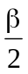= 17,4 x 10⁻⁴ rd is limited by a diaphragm D_{T} with an opening of 6 mm against which the sample stand is placed.
A convergent achromatic lens L₂, corrected for spherical aberrations, links the diaphragm D_{T} with the receiver R; the diameter of the lens L₂ shall be such that it does not diaphragm the light diffused by the sample in a cone with a half top angle of β/2 = 14°.
An annular diaphragm D_{D} with angles 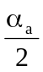 = 1° and 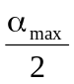 = 12° is placed in an image focal plane of the lens L₂.
The non-transparent central part of the diaphragm is necessary in order to eliminate the light arriving directly from the light source. It shall be possible to remove the central part of the diaphragm from the light beam in such a manner that it returns exactly to its original position.
The distance L₂ D_{T} and the focal length F₂ of the lens L₂ shall be so chosen that the image of D_{T} completely covers the receiver R.
When the initial incident flux is referred to 1,000 units, the absolute precision of each reading shall be better than 1 unit.
2. Measurements
The following readings shall be taken:
Reading | With sample | With central  part of D_{D} | Quantity represented
T₁ | no | no | Incident flux in initial reading
T₂ | yes  (before test) | no | Flux transmitted by the new material  in a field of 24 °C
T₃ | yes  (after test) | no | Flux transmitted by the tested  material in a field of 24 °C
T₄ | yes  (before test) | yes | Flux diffused by the new material
T₅ | yes  (after test) | yes | Flux diffused by the tested material

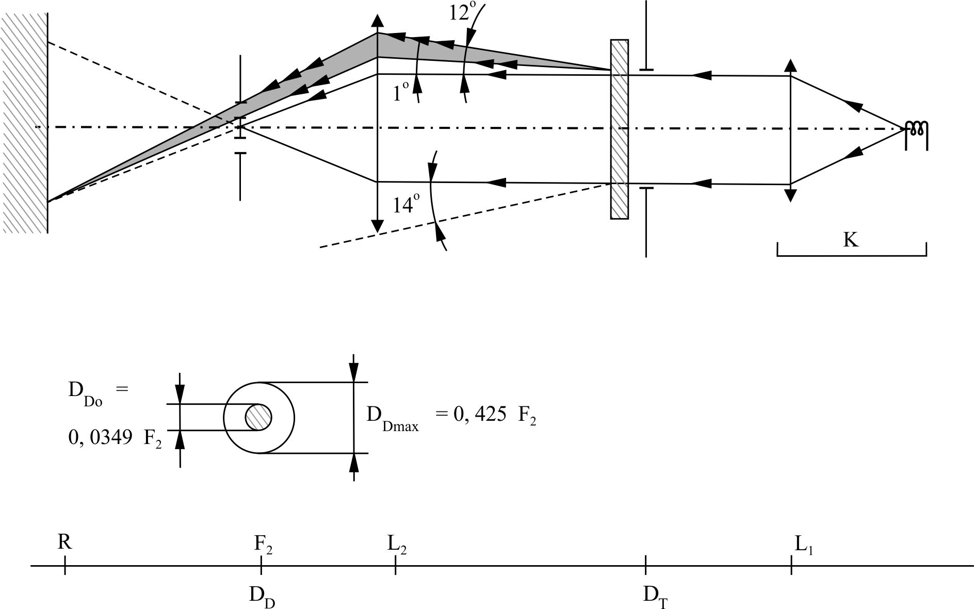

Annex 6 - Appendix 3
Spray testing method
1. Test equipment
1.1. Spray gun
The spray gun used shall be equipped with a nozzle 1.3 mm in diameter allowing a liquid flow rate of 0.24 ± 0.02 1/minute at an operating pressure of 6.0 bars - 0, + 0.5 bar.
Under these operation conditions the fan pattern obtained shall be 170 mm ± 50 mm in diameter on the surface exposed to deterioration, at a distance of 380 mm ± 10 mm from the nozzle.
1.2. Test mixture
The test mixture shall be composed of:
Silica sand of hardness 7 on the Mohr scale, with a grain size between 0 and 0.2 mm and an almost normal distribution, with an angular factor of 1.8 to 2;
Water of hardness not exceeding 205 g/m³ for a mixture comprising 25 g of sand per litre of water.
2. Test
The outer surface of the lamp lenses shall be subjected once or more than once to the action of the sand jet produced as described above. The jet shall be sprayed almost perpendicular to the surface to be tested.
The deterioration shall be checked by means of one or more samples of glass placed as a reference near the lenses to be tested. The mixture shall be sprayed until the variation in the diffusion of light on the sample or samples measured by the method described in Appendix 2, is such that:
= 0.0250 ± 0.0025
Several reference samples may be used to check that the whole surface to be tested has deteriorated homogeneously.

Annex 6 - Appendix 4
Adhesive tape adherence test
1. Purpose
This method allows to determine under standard conditions the linear force of adhesion of an adhesive tape to a glass plate.
2. Principle
Measurement of the force necessary to unstick an adhesive tape from a glass plate at an angle of 90°.
3. Specified atmospheric conditions
The ambient conditions shall be at 23 °C ± 5 °C and 65 ± 15 per cent relative humidity (RH).
4. Test pieces
Before the test, the sample roll of adhesive tape shall be conditioned for 24 hours in the specified atmosphere (see paragraph 3. above).
Five test pieces each 400 mm long shall be tested from each roll. These test pieces shall be taken from the roll after the first three turns were discarded.
5. Procedure
The test shall be under the ambient conditions specified in paragraph 3. above.
Take the five test pieces while unrolling the tape radially at a speed of approximately 300 mm/s, then apply them within 15 seconds in the following manner:
Apply the tape to the glass plate progressively with a slight lengthwise rubbing movement of the finger, without excessive pressure, in such a manner as to leave no air bubble between the tape and the glass plate.
Leave the assembly in the specified atmospheric conditions for 10 minutes.
Unstick about 25 mm of the test piece from the plate in a plane perpendicular to the axis of the test piece.
Fix the plate and fold back the free end of the tape at 90°. Apply force in such a manner that the separation line between the tape and the plate is perpendicular to this force and perpendicular to the plate.
Pull to unstick at a speed of 300 mm/s ± 30 mm/s and record the force required.
6. Results
The five values obtained shall be arranged in order and the median value taken as the result of the measurement. This value shall be expressed in Newtons per centimetre of width of the tape.

Annex 7
Minimum requirements for sampling by an inspector
1. General
1.1. The conformity requirements shall be considered satisfied from a mechanical and a geometric standpoint, in accordance with the requirements of this Regulation, if any, if the differences do not exceed inevitable manufacturing deviations.
1.2. With respect to photometric performance, the conformity of mass-produced headlamps shall not be contested if, when testing photometric performances of any headlamp chosen at random:
1.2.1. No measured value deviates unfavourably by more than 20 per cent from the values prescribed in this Regulation.
For values B 50 L (or R) and Zone III the maximum deviation may be respectively:
B 50 L (or R) : 0.2 lx equivalent 20 per cent
0.3 lx equivalent 30 per cent
Zone III: 0.3 lx equivalent 20 per cent
0.45 lx equivalent 30 per cent
1.2.2. Or if
1.2.2.1. For the passing beam, the values prescribed in this Regulation are met at HV (with a tolerance of 0.2 lx) and related to that aiming at least one point of each area delimited on the measuring screen (at 25 m) by a circle 15 cm in radius around points B 50 L (or R) (with a tolerance of 0.1 lx), 75 R (or L), 25 R, 25 L, and in the entire area of zone IV which is not more than 22.5 cm above line 25 R and 25 L;
1.2.2.2. And if, for the driving beam, HV being situated within the isolux 0.75 E_{max}, a tolerance of +20 per cent for maximum values and -20 per cent for minimum values is observed for the photometric values at any measuring point specified in paragraph 8.10. of this Regulation. The reference mark is disregarded.
1.2.3. If the results of the tests described above do not meet the requirements, the alignment of the headlamp may be changed, provided that the axis of the beam is not displaced laterally by more than 1° to the right or left.
1.2.4. Headlamps with apparent defects are disregarded.
1.2.5. The reference mark is disregarded.
1.3. The chromaticity coordinates shall be complied with.
2. First sampling
In the first sampling four headlamps are selected at random. The first sample of two is marked A, the second sample of two is marked B.
2.1. The conformity is not contested
2.1.1. Following the sampling procedure shown in Figure 1 of this annex the conformity of mass-produced headlamps shall not be contested if the deviation of the measured values of the headlamps in the unfavourable directions are:
2.1.1.1. Sample A
A1: one headlamp 0 per cent
one headlamp not more than 20 per cent
A2: both headlamps more than 0 per cent
but not more than 20 per cent
go to sample B
2.1.1.2. Sample B
B1: both headlamps 0 per cent
2.1.2. Or, if the conditions of paragraph 1.2.2. above for sample A are fulfilled.
2.2. The conformity is contested
2.2.1. Following the sampling procedure shown in Figure 1 of this annex the conformity of mass-produced headlamps shall be contested and the manufacturer requested to make his production meet the requirements (alignment) if the deviations of the measured values of the headlamps are:
2.2.1.1. Sample A
A3: one headlamp not more than 20 per cent
one headlamp more than 20 per cent
but not more than 30 per cent
2.2.1.2. Sample B
B2: in the case of A2
one headlamp more than 0 per cent
but not more than 20 per cent
one headlamp not more than 20 per cent
B3: in the case of A2
one headlamp 0 per cent
one headlamp more than 20 per cent
but not more than 30 per cent
2.2.2. Or, if the conditions of paragraph 1.2.2. above for sample A are not fulfilled.
2.3. Approval withdrawn
Conformity shall be contested and paragraph 10. applied if, following the sampling procedure in Figure 1 of this annex, the deviations of the measured values of the headlamps are:
2.3.1. Sample A
A4: one headlamp not more than 20 per cent
one headlamp more than 30 per cent
A5: both headlamps more than 20 per cent
2.3.2. Sample B
B4: in the case of A2
one headlamp more than 0 per cent
but not more than 20 per cent
one headlamp more than 20 per cent
B5: in the case of A2
both headlamps more than 20 per cent
B6: in the case of A2
one headlamp 0 per cent
one headlamp more than 30 per cent
2.3.3. Or, if the conditions of paragraph 1.2.2. above for samples A and B are not fulfilled.
3. Repeated sampling
In the cases of A3, B2, B3 a repeated sampling, third sample C of two headlamps and fourth sample D of two headlamps, selected from stock manufactured after alignment, is necessary within two months' time after the notification.
3.1. The conformity is not contested
3.1.1. Following the sampling procedure shown in Figure 1 of this annex the conformity of mass-produced headlamps shall not be contested if the deviations of the measured values of the headlamps are:
3.1.1.1. Sample C
C1: one headlamp 0 per cent
one headlamp not more than 20 per cent
C2: both headlamps more than 0 per cent
but not more than 20 per cent
go to sample D
3.1.1.2. Sample D
D1: in the case of C2
both headlamps 0 per cent
3.1.2. Or, if the conditions of paragraph 1.2.2. above for sample C are fulfilled.
3.2. The conformity is contested
3.2.1. Following the sampling procedure shown in Figure 1 of this annex the conformity of mass-produced headlamps shall be contested and the manufacturer requested to make his production meet the requirements (alignment) if the deviations of the measured values of the headlamps are:
3.2.1.1. Sample D
D2: in the case of C2
one headlamp more than 0 per cent
but not more than 20 per cent
one headlamp not more than 20 per cent
3.2.1.2. Or, if the conditions of paragraph 1.2.2. above for sample C are not fulfilled.
3.3. Approval withdrawn
Conformity shall be contested and paragraph 13. applied if, following the sampling procedure in Figure 1 of this annex, the deviations of the measured values of the headlamps are:
3.3.1. Sample C
C3: one headlamp not more than 20 per cent
one headlamp more than 20 per cent
C4: both headlamps more than 20 per cent
3.3.2. Sample D
D3: in the case of C2
one headlamp 0 or more than 0 per cent
one headlamp more than 20 per cent
3.3.3. Or, if the conditions of paragraph 1.2.2. above for samples C and D are not fulfilled.
4. Change of the vertical position of the cut-off line
With respect to the verification of the change in vertical positions of the cut-off line under the influence of heat, the following procedure shall be applied:
One of the headlamps of sample A after sampling procedure in Figure 1 of this annex shall be tested according to the procedure described in paragraph 2.1. of Annex 5 after being subjected three consecutive times to the cycle described in paragraph 2.2.2. of Annex 5.
The headlamp shall be considered as acceptable if Δr does not exceed 1.5 mrad.
If this value exceeds 1.5 mrad but is not more than 2.0 mrad, the second headlamp of sample A shall be subjected to the test after which the mean of the absolute values recorded in both samples shall not exceed 1.5 mrad.
However, if this value of 1.5 mrad on sample A is not complied with, the two headlamps of sample B shall be subjected to the same procedure and the value of Δr for each of them shall not exceed 1.5 mrad.

Figure 1

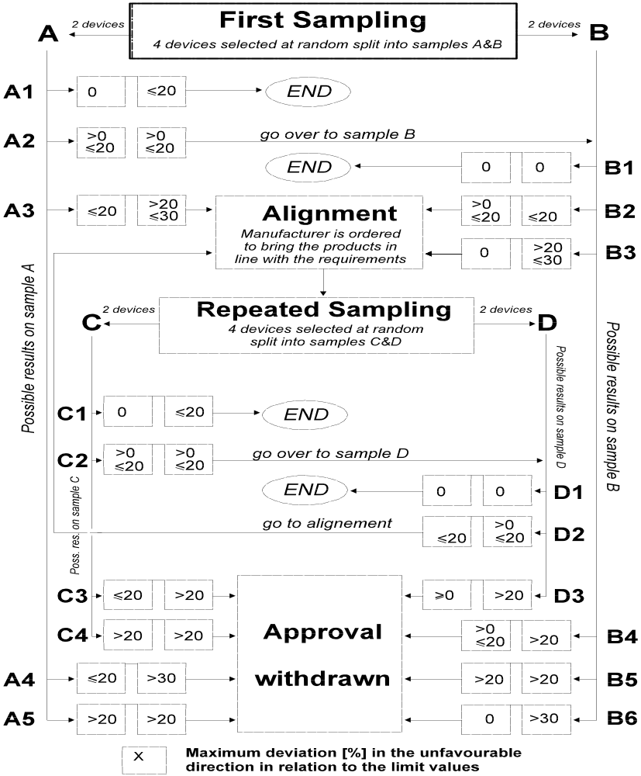

* * Former title of the Agreement: Agreement Concerning the Adoption of Uniform Conditions of Approval and Reciprocal Recognition of Approval for Motor Vehicle Equipment and Parts, done at Geneva on 20 March 1958.
? Nothing in this Regulation shall prevent a Party to the Agreement applying this Regulation from prohibiting the combination of a headlamp incorporating a lens of plastic material approved under this Regulation with a mechanical headlamp-cleaning device (with wipers).
? As defined in the Consolidated Resolution on the Construction of Vehicles (R.E.3.), document ECE/TRANS/WP.29/78/Rev.3, para 2. - www.unece.org/trans/main/wp29/wp29wgs/wp29gen/wp29resolutions.html
? In the case of SB units designed to meet the requirements of traffic moving on one side of the road only (either right or left), it is further recommended that the area which can be occulted to prevent discomfort to users in a country where traffic moves on the side of the road opposite to that of the country for which the SB unit was designed should be outlined indelibly on the front lens. This marking is not necessary, however, where the area is clearly apparent from the design.
? The distinguishing numbers of the Contracting Parties to the 1958 Agreement are reproduced in Annex 3 to the Consolidated Resolution on the Construction of Vehicles (R.E.3), document ECE/TRANS/WP.29/78/Rev. 3, Annex 3 - www.unece.org/trans/main/wp29/wp29wgs/wp29gen/wp29resolutions.html
? 24-volts units are under consideration.
? All the photometric measurements shall be carried out at the test voltage given in paragraph 7. of this Regulation.
? The test screen shall be sufficiently wide to allow examination of the "cut-off" over a range of at least 5° from the line vv.
? If, in the case of a unit designed to meet the requirements of this Regulation with respect to the passing beam only, the focal axis diverges appreciably in from the general direction of the beam, lateral adjustment shall be effected in the manner which best satisfies the requirements for illumination at points 75 R and 50 R for right-hand traffic and at points 75 L and 50 L for left-hand traffic.
? A unit designed to emit a passing beam may incorporate a driving beam not complying with the specification.
? The limit of realignment of 1° towards the right or left is not incompatible with vertical realignment, which is only limited by the conditions laid down in paragraph 8.9. of this Regulation.
? This requirement will be the subject of a recommendation for the benefit of Type Approval Authorities.
* * If the projected area of the reflector is not circular, the diameter shall be that of a circle having the same area as the projected area of the apparent useful surface of the reflector.
? Letters in brackets refer to headlamps intended for left-hand traffic.
? The limit of realignment of 1° towards the right or left is not incompatible with vertical realignment, which is only limited by the conditions laid down in paragraph 8.9. of this Regulation.
? When the driving beam is reciprocally incorporated with the passing beam, HV in the case of the driving beam shall be the same measuring point as in the case of the passing beam.
? HL and HR: points on "hh" located at 1.125 m to the left and to the right of point HV respectively.
? When the tested headlamp is grouped and/or reciprocally incorporated with signalling lamps, the latter shall be lit for the duration of the test. In the case of a direction indicator lamp, it shall be lit in flashing operation mode with an on/off time ratio of approximately one to one.
? Should two filaments be simultaneously lit when headlamp flashing is used, this shall not be considered as being normal use of both filaments simultaneously.
? NaCMC represents the sodium salt of carboxymethylcellulose, customarily referred to as CMC. The NaCMC used in the dirt mixture shall have a degree of substitution (DS) of 0.6-0.7 and a viscosity of 200-300 cP for a 2 per cent solution at 20 °C.
? The tolerance on quantity is due to the necessity of obtaining a dirt that correctly spreads out on all the plastic lens.
? 50 V is situated 375 mm below HV on the vertical line v-v on the screen at 25 m distance.
? For L₂ it is recommended to use a focal distance of about 80 mm.
? The limit of realignment of 1° towards the right or left is not incompatible with vertical realignment, which is only limited by the conditions laid down in paragraph 8.9. of this Regulation.

