E/ECE/324/Add.10/Rev.2/Amend.1−E/ECE/TRANS/505/Add.10/Rev.2/Amend.1
22 June 2015
Agreement
Concerning the Adoption of Uniform Technical Prescriptions for Wheeled Vehicles, Equipment and Parts which can be Fitted and/or be Used on Wheeled Vehicles and the Conditions for Reciprocal Recognition of Approvals Granted on the Basis of these Prescriptions*
(Revision 2, including the amendments which entered into force on 16 October 1995)
_________
Addendum 10 – Regulation No. 11
Revision 2 - Amendment 1
04 series of amendments – Date of entry into force: 15 June 2015
Uniform provisions concerning the approval of vehicles with regard to door latches and door retention components
This document is meant purely as documentation tool. The authentic and legal binding text is: ECE/TRANS/WP.29/2014/71.
_________
UNITED NATIONS

Insert a new paragraph 2.7., to read:
"2.7. Additional protections"
Paragraph 2.7., renumber as paragraph 2.7.1.
Insert a new paragraph 2.7.2., to read:
"2.7.2. "Full locking system" is a system that renders the interior door release handle or any other door interior latch release control of any of the vehicles doors inoperable other than by operation of the systems locks."
Insert a new paragraph 6.3.1.1., to read:
"6.3.1.1. If fitted, a full locking system may only be activated when the ignition key is not in the engine running mode and shall be installed in combination with at least one of the following measures:
(a) An alarm system with interior detection in accordance with Regulation No. 116 or Regulation No. 97, or other equipment which is able to detect an occupant's movement. The setting of the full locking system shall be prohibited where an occupant's movement is detected within the passenger compartment; or
(b) An acoustic warning device (e.g. horn) which can be activated from the interior of the vehicle in case that the ignition is switched off and the full locking system is activated."
Insert new paragraphs 13.7. to 13.9., to read:
"13.7. As from the official date of entry into force of the 04 series of amendments, no Contracting Party applying this Regulation shall refuse to grant or refuse to accept type approvals under this Regulation as amended by the 04 series of amendments.
13.8. As from 1 September 2016, Contracting Parties applying this Regulation shall grant type approvals only if the vehicle type to be approved meets the requirements of this Regulation as amended by the 04 series of amendments.
13.9. Contracting Parties applying this Regulation shall not refuse to grant extensions of type approvals for existing types which have been granted according to the preceding series of amendments to this Regulation."
Annex 2, amend to read:
"Annex 2
Arrangements of approval marks

Model A

(See paragraph 4.4. of this Regulation)

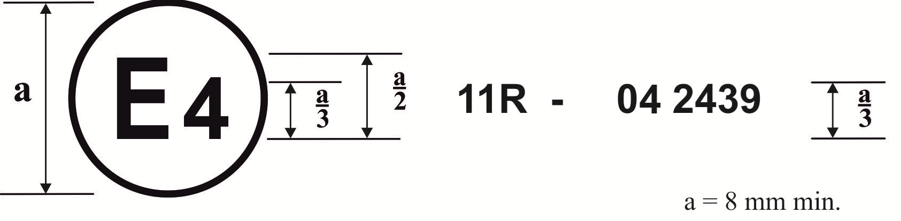
The above approval … Regulation No. 11, under approval number 042439...

Model B

(See paragraph 4.5. of this Regulation)

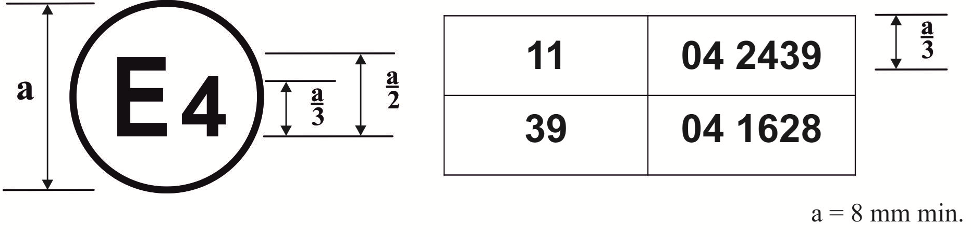
The above approval mark … Regulation No. 11 as amended by the 04 series of amendments …"

* Former title of the Agreement: Agreement Concerning the Adoption of Uniform Conditions of Approval and Reciprocal Recognition of Approval for Motor Vehicle Equipment and Parts, done at Geneva on 20 March 1958.

