E/ECE/324/Add.6/Rev.6−E/ECE/TRANS/505/Add.6/Rev.6
22 November 2012
Agreement
Concerning the Adoption of Uniform Technical Prescriptions for Wheeled Vehicles, Equipment and Parts which can be fitted and/or be used on Wheeled Vehicles and the Conditions for Reciprocal Recognition of Approvals Granted on the Basis of these Prescriptions*
(Revision 2, including the amendments which entered into force on 16 October 1995)
_________
Addendum 6: Regulation No. 7
Revision 6
Incorporating all valid text up to:
Supplement 16 to 02 series of amendments: Date of entry into force: 19 August 2010
Supplement 17 to 02 series of amendments: Date of entry into force: 30 January 2011
Corrigendum 1 to Supplement 15 to 02 series of amendments: Date of entry into force: 09 March 2011
Supplement 18 to 02 series of amendments: Date of entry into force: 23 June 2011
Supplement 19 to 02 series of amendments: Date of entry into force: 28 October 2011
Supplement 20 to 02 series of amendments: Date of entry into force: 26 July 2012
Uniform provisions concerning the approval of front and rear position lamps, stop-lamps and end-outline marker lamps for motor vehicles (except motor cycles) and their trailers
_________

UNITED NATIONS

Regulation No. 7
Uniform provisions concerning the approval of front and rear position lamps, stop-lamps and end-outline marker lamps for motor vehicles (except motor cycles) and their trailers
Contents
Page
Scope 4
1. Definitions 4
2. Application for approval 5
3. Markings 6
4. Approval 7
5. General specifications 10
6. Intensity of light emitted 12
7. Test procedure 14
8. Colour of light emitted 15
9. Conformity of production 15
10. Penalties for non-conformity of production 16
11. Production definitively discontinued 16
12. Remarks concerning colours and particular devices 16
13. Names and addresses of Technical Services responsible for conducting approval tests,
and of Type approval Authorities 16
14. Transitional provisions 16
Annexes
1 Front and rear position lamps, end-outline marker lamps and stop-lamps: minimum angles
required for light distribution in space of these lamps 18
2 Communication 21
3 Examples of arrangements of the approval marks 23
4 Photometric measurements 31
5 Minimum requirements for conformity of production control procedures 33
6 Minimum requirements for sampling by an inspector 35

Scope
This Regulation applies to:
Front and rear position lamps and stop lamps for vehicles of categories L, M, N, O and T; and,
End-outline marker lamps for vehicles of categories M, N, O and T.
1. Definitions
For the purpose of this Regulation,
1.1. "Front position lamp" means the lamp used to indicate the presence and the width of the vehicle when viewed from the front;
1.2. "Rear position lamp" means the lamp used to indicate the presence and the width of the vehicle when viewed from the rear;
1.3. "Stop-lamp" means the lamp used to indicate to other road-users to the rear of the vehicle that its driver is applying the service brake. The stop-lamps may be activated by the application of a retarder or a similar device;
1.4. "End-outline marker lamp" means a lamp fitted near to the extreme outer edges and as close as possible to the top of the vehicle and intended to indicate clearly the vehicle's overall width. In the case of certain power-driven vehicles and trailers, this lamp is intended to complement the vehicle's position lamps and draw special attention to its outline;
1.5. Definitions of terms:
The definitions given in Regulation No. 48 and its series of amendments in force at the time of application for type-approval shall apply to this Regulation.
1.6. "Front and rear position lamps, stop-lamps and end-outline marker lamps of different type" means lamps which differ in each said category in such essential respects as:
(a) The trade name or mark;
(b) The characteristics of the optical system, (levels of intensity, light distribution angles, category of filament lamp, light source module, etc.);
(c) The variable intensity control, if any.
A change of the colour of the filament lamp or the colour of any filter does not constitute a change of type.
1.7. References made in this Regulation to standard (étalon) filament lamp(s) and to Regulation No. 37 shall refer to Regulation No. 37 and its series of amendments in force at the time of application for type approval.
2. Application for approval
2.1. The application for approval shall be submitted by the holder of the trade name or mark or by his duly accredited representative. It shall specify:
2.1.1. The purpose or purposes for which the device submitted for approval is intended and whether it may also be used in an assembly of two lamps of the same kind/type;
2.1.2. In the case of an end-outline marker lamp, whether it is intended to emit white or red light;
2.1.3. In the case of a category S3 or S4 stop lamp, whether it is intended to be mounted outside or inside (behind the rear window) the vehicle;
2.1.4. Whether the device produces steady luminous intensity (category R, R1, RM1, S1 or S3) or variable luminous intensity (category R2, RM2, S2 or S4);
2.1.5. At the choice of the applicant, that the device may be installed on the vehicle with different inclinations of the reference axis in respect to the vehicle reference planes and to the ground or rotate around its reference axis; these different conditions of installation shall be indicated in the communication form.
2.2. For each type of device, the application shall be accompanied by:
2.2.1. Drawings, in triplicate, in sufficient detail to permit identification of the type of the device and showing the following:
(a) in what geometrical position(s) the device (and if applicable for category S3 or S4 lamps the rear window) may be mounted on the vehicle; the axis of observation to be taken is the axis of reference in the tests (horizontal angle H = 0°, vertical angle V = 0°); and the point to be taken as the centre of reference in the said tests;
(b) The geometrical conditions of installation of the device(s) that meet(s) the requirements of paragraph 6;
(c) In the case of an interdependent lamp system, the interdependent lamp or the combination of interdependent lamps that fulfil the requirements of paragraphs 5.10. and 6.1. and of Annex 4 to this Regulation;
(d) The position intended for the approval number and the additional symbols in relation to the circle of the approval mark.
2.2.2. A brief technical description stating, in particular, with the exception of lamps with non-replaceable light sources:
(a) The category or categories of filament lamp(s) prescribed; this filament lamp category shall be one of those contained in Regulation No. 37 and its series of amendments in force at the time of application for type approval; in the case of a category S3 or S4 stop lamp, which is intended to be mounted inside the vehicle, the technical description shall contain the specification of the optical properties (transmission, colour, inclination, etc.) of the rear window(s);
(b) The light source module specific identification code.
2.2.3. In the case of a lamp with variable luminous intensity, a concise description of the variable intensity control, an arrangement diagram and a specification of the characteristics of the system ensuring the two levels of intensity;
2.2.4. Two samples; if the approval is applied for devices which are not identical but are symmetrical and suitable for mounting one on the left and one on the right side of the vehicle, the two samples submitted may be identical and be suitable for mounting only on the right or only on the left side of the vehicle.
In the case of a lamp with variable luminous intensity the application shall also be accompanied by the variable intensity control or a generator providing the same signal(s).
2.2.5. In the case of a category S3 or S4 stop lamp which is intended to be mounted inside the vehicle, a sample plate or sample plates (in case of different possibilities) having the equivalent optical properties corresponding to those of the actual rear window(s).
3. Markings
Devices submitted for approval:
3.1. Must bear the trade name or mark of the applicant; this marking must be clearly legible and be indelible;
3.2. With the exception of lamps with non-replaceable light sources, must bear a clearly legible and indelible marking indicating:
(a) The category or categories of filament lamp(s) prescribed; and/or
(b) The light source module specific identification code.
3.3. Must comprise a space of sufficient size for the approval marking and the additional symbols prescribed in paragraph 4.2. below; this space shall be shown in the drawings mentioned in paragraph 2.2.1. above;
3.4. In the case of lamps with an electronic light source control gear or a variable intensity control and/or non-replaceable light sources and/or light source module(s), must bear the marking of the rated voltage or range of voltage and rated maximum wattage;
3.5. Lamps operating at voltages other than the nominal rated voltages of 6 V, 12 V or 24 V respectively, by the application of an electronic light source control gear or a variable intensity control being not part of the lamp, or having a secondary operating mode, must also bear a marking denoting the rated secondary design voltage;
3.6. In the case of lamps with light source module(s), the light source module(s) shall bear:
3.6.1. The trade name or mark of the applicant; this marking must be clearly legible and indelible;
3.6.2. The specific identification code of the module; this marking must be clearly legible and indelible. This specific identification code shall comprise the starting letters "MD" for "MODULE" followed by the approval marking without the circle as prescribed in paragraph 4.2.1.1. below and, in the case several non-identical light source modules are used, followed by additional symbols or characters; this specific identification code shall be shown in the drawings mentioned in paragraph 2.2.1. above.
The approval marking does not have to be the same as the one on the lamp in which the module is used, but both markings shall be from the same applicant.
3.6.3. The marking of the rated voltage or range of voltage and rated maximum wattage.
3.7. An electronic light source control gear or a variable intensity control being part of the lamp but not included into the lamp body shall bear the name of the manufacturer and its identification number.
4. Approval
4.1. General
4.1.1. If the two devices which are submitted in pursuance of paragraph 2.2.4. above satisfy the provisions of this Regulation, approval shall be granted. All the devices of an interdependent lamp system must be submitted for type approval by the same applicant.
4.1.2. When two or more lamps are part of the same unit of grouped, combined or reciprocally incorporated lamps, approval may be granted only if each of these lamps satisfies the provisions set out in this Regulation or in another Regulation. Lamps not satisfying the provisions of any of those Regulations shall not be part of such unit of grouped, combined or reciprocally incorporated lamps. This provision shall not apply to headlamps fitted with a double-filament bulb, where only one beam is approved.
4.1.3. An approval number shall be assigned to each type approved. Its first two digits (at present 02) shall indicate the series of amendments incorporating the most recent major technical amendments made to the Regulation at the time of issue of the approval. The same Contracting Party shall not assign the same number to another type of device covered by this Regulation, except in case approval is extended to a device which only differs from the already approved device by the colour of the light emitted.
4.1.4. Notice of approval or of extension or refusal or of withdrawal of approval or production definitively discontinued of a type of device pursuant to this Regulation shall be communicated to the Parties to the 1958 Agreement applying this Regulation, by means of a form conforming to the model in Annex 2 to this Regulation.
4.1.5. Every device conforming to a type approved under this Regulation shall bear, in the space referred to in paragraph 3.3. above, and in addition to the markings prescribed in paragraphs 3.1. and 3.2. or 3.4. respectively, an approval mark as described in paragraphs 4.2. and 4.3. below.
4.2. Composition of the approval mark
The approval mark shall consist of:
4.2.1. An international approval mark, comprising:
4.2.1.1. A circle surrounding the letter "E" followed by the distinguishing number of the country which has granted approval;
4.2.1.2. The approval number prescribed in paragraph 4.1.3. above.
4.2.2. The following additional symbol or symbols:
4.2.2.1. On devices meeting the requirements of this Regulation in respect of the front position lamps, the letter "A";
4.2.2.2. On devices meeting the requirements of this Regulation in respect of the rear position lamps, the letter "R" followed or not by the Figure "1" when the device produces steady luminous intensity and by the Figure "2" when the device produces variable luminous intensity.
4.2.2.3. On devices meeting the requirements of this Regulation in respect of the front end-outline marker lamps, the letters "AM";
4.2.2.4. On devices meeting the requirements of this Regulation in respect of the rear end-outline marker lamps, the letters "RM" followed by the Figure "1" when the device produces steady luminous intensity and by the Figure "2" when the device produces variable luminous intensity;
4.2.2.5. On devices meeting the requirements of this Regulation in respect of the stop-lamps, the letter "S" followed by the figure:
"1" When the device produces steady luminous intensity;
"2" When the device produces variable luminous intensity;
"3" When the device meets the specific requirements for category S3 stop- lamps and produces steady luminous intensity;
"4" When the device meets the specific requirements for category S4 stop- lamps and produces variable luminous intensity;
4.2.2.6. On devices comprising both a rear position lamp and a stop- lamp meeting the requirements of this Regulation in respect of such lamps, the letters "R" or "R1" or "R2" and "S1" or "S2" as the case may be, separated by a horizontal dash;
4.2.2.7 On front or rear position lamps of which the visibility angles are asymmetrical with regard to the reference axis in a horizontal direction, and on front or rear end-outline marker lamps, a horizontal arrow pointing towards the side on which the photometric specifications are met up to an angle of 80° H;
4.2.2.8. On devices which may be used as part of an assembly of two lamps, the additional letter "D" to the right of the symbol mentioned in paragraphs 4.2.2.1. and 4.2.2.6;
4.2.2.9. On devices with reduced light distribution in conformity to paragraph 2.3. in Annex 4 to this Regulation a vertical arrow starting from a horizontal segment and directed downwards.
4.2.2.10. On interdependent lamps, which may be used as part of an interdependent lamp system, the additional letter "Y" to the right of the symbol mentioned in paragraph 4.2.2.1. to 4.2.2.6. shall be marked on each device.
4.2.3. The two digits of the approval number (at present 02 corresponding to the 02 series of amendments which entered into force on 5 May 1991), which indicate the series of amendments incorporating the most recent major technical amendments made to the Regulation at the time of issue of the approval and, if necessary, the required arrow may be marked close to the above additional symbols.
4.2.4. The marks and symbols referred to in paragraphs 4.2.1. and 4.2.2. above shall be clearly legible and indelible even when the device is fitted in the vehicle.
4.3. Arrangement of the approval mark
4.3.1. Independent lamps
Annex 3, paragraphs 1 to 6, gives examples of the approval mark with the above mentioned additional symbols.
If different types of lamps complying with the requirements of several Regulations uses the same outer lens having the same or different colour, a single international approval mark may be affixed, consisting of a circle surrounding the letter "E" followed by the distinguishing number of the country which has granted the approval, and an approval number. This approval mark may be located anywhere on the lamp, provided that:
4.3.1.1. It is visible after their installation.
4.3.1.2. The identification symbol for each lamp appropriate to each Regulation under which approval has been granted, together with the corresponding series of amendments incorporating the most recent major technical amendments to the Regulation at the time of issue of the approval and if necessary, the required arrow shall be marked.
4.3.1.3. The size of the components of a single approval mark shall not be less than the minimum size required for the smallest of the individual marks under which approval has been granted.
4.3.1.4. The main body of the lamp shall include the space described in paragraph 3.3. above and shall bear the approval mark of the actual function(s).
4.3.1.5. Paragraph 7. of Annex 3 to this Regulation gives examples of an approval mark with the above-mentioned additional symbols.
4.3.2. Grouped, combined or reciprocally incorporated lamps
4.3.2.1. Where grouped, combined or reciprocally incorporated lamps have been found to comply with the requirements of several Regulations, a single international approval mark may be affixed, consisting of a circle surrounding the letter "E" followed by the distinguishing number of the country which has granted the approval, and an approval number. This approval mark may be located anywhere on the grouped, combined or reciprocally incorporated lamps, provided that:
4.3.2.1.1. It is visible after their installation;
4.3.2.1.2. No part of the grouped, combined or reciprocally incorporated lamps that transmits light can be removed without at the same time removing the approval mark.
4.3.2.2. The identification symbol for each lamp appropriate to each Regulation under which approval has been granted, together with the corresponding series of amendments incorporating the most recent major technical amendments to the Regulation at the time of issue of the approval and, if necessary, the required arrow shall be marked:
4.3.2.2.1. Either on the appropriate light-emitting surface,
4.3.2.2.2. Or in a group, in such a way that each of the grouped, combined or reciprocally incorporated lamps may be clearly identified.
4.3.2.3. The size of the components of a single approval mark shall not be less than the minimum size required for the smallest of the individual marks under which approval has been granted.
4.3.2.4. An approval number shall be assigned to each type approved. The same Contracting Party may not assign the same number to another type of grouped, combined or reciprocally incorporated lamps covered by this Regulation.
4.3.2.5. Paragraph 8. of Annex 3 to this Regulation gives examples of approval marks for grouped, combined or reciprocally incorporated lamps with all the above mentioned additional symbols.
4.3.3. Lamps reciprocally incorporated with a type of headlamp of which the lens is also used for other types of headlamps
The provisions laid down in paragraph 4.3.2. above are applicable.
4.3.3.1. However, if different types of headlamps or of units of lamps including a headlamp comprise the same lens, the latter may bear the different approval marks relating to these types of headlamps or units or lamps, provided that the main body of the headlamp, even if it cannot be separated from the lens, also comprises the space described in paragraph 3.3. above and bears the approval marks of the actual functions. If different types of headlamps comprise the same main body, the latter may bear the different approval marks.
4.3.3.2. Paragraph 9. of Annex 3 to this Regulation gives examples of approval marks relating to lamps which are reciprocally incorporated with a headlamp.
4.3.4. The approval marking shall be clearly legible and indelible. It may be placed on an inner or outer part (transparent or not) of the device which cannot be separated from the transparent part of the device emitting the light. In any case the marking shall be visible when the device is fitted on the vehicle or when a movable part such as the hood or boot lid or a door is opened.
5. General specifications
5.1. Each device supplied shall conform to the specifications set forth in paragraphs 6. and 8. below.
5.2. The devices must be so designed and constructed that in normal conditions of use, and notwithstanding the vibrations to which they may be subjected in such use, their satisfactory operation remains assured and they retain the characteristics prescribed by this Regulation.
5.3. Lamps having been approved as front or rear position lamps, are deemed being also approved end-outline marker lamps.
5.4. Front and rear position lamps which are grouped or combined or reciprocally incorporated may also be used as end-outline marker lamps.
5.5. Position lamps, which are reciprocally incorporated with another function, using a common light source, and designed to operate permanently with an additional system to regulate the intensity of the light emitted, are permitted.
5.5.1. However, in the case of rear position lamp reciprocally incorporated with a stop lamp, the device shall either:
(a) Be a part of a multiple light source arrangement, or
(b) Be intended for use in a vehicle equipped with a failure monitoring system for that function.
In either case, a note shall be made within the communication document.
5.6. In the case of light source modules, it shall be checked that:
5.6.1. The design of the light source module(s) shall be such as:
(a) That each light source module can only be fitted in no other position than the designated and correct one and can only be removed with the use of tool(s);
(b) If there are more than one light source module used in the housing for a device, light source modules having different characteristics can not be interchanged within the same lamp housing.
5.6.2. The light source module(s) shall be tamperproof.
5.6.3. A light source module shall be so designed that regardless of the use of tool(s), it shall not be mechanically interchangeable with any replaceable approved light source.
5.7. If the front position lamp incorporates one or more infrared radiation generators, the photometric and colour requirements for this front position lamp shall be met with and without the operation of the infrared radiation generator(s).
5.8. In case of failure of the variable intensity control of:
(a) A rear position lamp category R2 emitting more than the maximum value of category R or R1;
(b) A rear end-outline marker lamp category RM2 emitting more than the maximum value of category RM1;
(c) A stop lamp category S2 emitting more than the maximum value of category S1;
(d) A stop lamp category S4 emitting more than the maximum value of category S3;
Requirements of steady luminous intensity of the respective category shall be fulfilled automatically.
5.9. In the case of replaceable filament lamp(s):
5.9.1. Any category or categories of filament lamp(s) approved according to Regulation No. 37 may be used, provided that no restriction on the use is made in Regulation No. 37 and its series of amendments in force at the time of application for type approval.
5.9.2. The design of the device shall be such that the filament lamp can be fixed in no other position but the correct one.
5.9.3. The filament lamp holder shall conform to the characteristics given in IEC Publication 60061. The holder data sheet relevant to the category of filament lamp used, applies.
5.10. An interdependent lamp system shall meet the requirements when all its interdependent lamps are operated together. However, if the interdependent lamp system providing the rear position lamp function is partly mounted on the fixed component and partly mounted on a movable component, the interdependent lamp(s) specified by the Applicant shall meet the outboard geometric visibility, colorimetric and photometric requirement, at all fixed positions of the movable component(s). In this case, the inboard geometric visibility requirement is deemed to be satisfied if this (these) interdependent lamp(s) still conform to the photometric values prescribed in the field of light distribution for the approval of the device, at all fixed positions of the moveable component(s).
6. Intensity of light emitted
6.1. The light emitted by each of the two devices supplied shall be in the reference axis, of not less than the minimum intensity and of not more than the maximum intensity specified below:
 | Minimum luminous intensity in cd | Maximum luminous intensity in cd when used as
 | Minimum luminous intensity in cd | Single lamp | Lamp (single) marked "D" (paragraph 4.2.2.6.)
6.1.1. Front position lamps, front end-outline marker lamp  A or AM | 4 | 140 | 70
6.1.2. Front position lamps incorporated in a headlamp | 4 | 140 | -
6.1.3. Rear position lamps, rear end-outline marker lamp
6.1.3.1. R or R1 or RM1 (steady) | 4 | 17 | 8.5
6.1.3.2. R2 or RM2 (variable) | 4 | 42 | 21
6.1.4. Stop-lamps | 60 | 260 | 130
6.1.4.1. S1 (steady)
6.1.4.2. S2 (variable) | 60 | 730 | 365
6.1.4.3. S3 (steady) | 25 | 110 | 55
6.1.4.4. S4 (variable) | 25 | 160 | 80
6.1.5. For an assembly of two or more lamps the total intensity shall not exceed the maximum value prescribed for a single lamp.
6.1.6. When an assembly of two independent lamps to be type approved as "D" lamps having the same function is deemed to be a single lamp, it shall comply with the requirements for:
(a) Maximum intensity if all lamps together are lit;
(b) Minimum intensity if either lamp has failed.
6.1.7. In case of failure of a single lamp containing more than one light source the following provisions shall apply:
6.1.7.1. A group of light sources, wired so that the failure of any one of them causes all of them to stop emitting light, shall be considered to be one light source.
6.1.7.2. The lamp shall comply with the minimum intensity required in the table of standard light distribution in space as shown in Annex 4 when any one light source has failed. However, for lamps designed for only two light sources, 50 per cent of the minimum intensity in the axis of reference of the lamp shall be considered sufficient, provided that a note in the communication form states that the lamp is only for use on a vehicle fitted with an operating tell-tale which indicates when any one of these two light sources has failed.
6.2. Outside the reference axis and within the angular fields defined in the diagrams in Annex 1 to this Regulation, the intensity of the light emitted by each of the two devices supplied must:
6.2.1. In each direction corresponding to the points in the light distribution table reproduced in Annex 4 to this Regulation, be not less than the product of the minimum specified in the table of paragraph 6.1. above, by the percentage specified in the said table of the direction in question;
6.2.2. In no direction within the space from which the light-signalling device is visible, exceed the maximum specified in the table of paragraph 6.1. above;
6.2.3. However, a luminous intensity of 60 cd shall be permitted for rear position lamps reciprocally incorporated with stop-lamps (see paragraph 6.1.3. above) below a plane forming an angle of 5° with and downward from the horizontal plane;
6.2.4. Moreover,
6.2.4.1. Throughout the fields defined in the diagrams in Annex 1, the luminous intensity of the light emitted must be not less than 0.05 cd for front and rear position lamps and end-outline marker lamps, not less than 0.3 cd for stop-lamps;
6.2.4.2. If a rear position lamp is reciprocally incorporated with a stop-lamp producing either steady or variable luminous intensity, the ratio between the luminous intensities actually measured of the two lamps when turned on simultaneously at the intensity of the rear position lamp when turned on alone should be at least 5: 1 in the field delimited by the straight horizontal lines passing through ±5° V and the straight vertical lines passing through ±10° H of the light distribution table.
If the rear position lamp or the stop lamp or both contain more than one light source and are considered as a single lamp, the values to be considered are those obtained with all sources in operation;
6.2.4.3. The provisions of paragraph 2.2. of Annex 4 to this Regulation on local variations of intensity must be observed.
6.3. The intensities shall be measured with the filament lamp(s) continuously alight and, in the case of devices emitting red light, in coloured light.
6.4. In the case of devices of categories R2, RM2, S2 and S4 the time that elapses between energising the light source(s) and the light output measured on the reference axis to reach 90 per cent of the value measured in accordance with paragraph 6.3. above shall be measured for the extreme levels of luminous intensity produced by the device. The time measured to obtain the lowest luminous intensity shall not exceed the time measured to obtain the highest luminous intensity.
6.5. The variable intensity control shall not generate signals which cause luminous intensities:
6.5.1. Outside the range specified in paragraph 6.1. above and
6.5.2. Exceeding the respective steady luminous intensity maximum specified in paragraph 6.1. for the specific device:
(a) For systems depending only on daytime and night time conditions: under night time conditions;
(b) For other systems: under standard conditions.
6.6. Annex 4, to which reference is made in paragraph 6.2.1. above, gives particulars of the methods of measurement to be used.
7. Test procedure
7.1. All measurements, photometric and colorimetric, shall be made:
7.1.1. In case of a lamp with replaceable light source, if not supplied by an electronic light source control gear or a variable intensity control, with an uncolored or colored standard filament lamp of the category prescribed for the device, supplied with the voltage necessary to produce the reference luminous flux required for that category of filament lamp,
7.1.2. In the case of a lamp equipped with non-replaceable light sources (filament lamps and other), at 6.75 V, 13.5 V or 28.0 V respectively.
7.1.3. In the case of a system that uses an electronic light source control gear or a variable intensity control, being part of the lamp applying at the input terminals of the lamp the voltage declared by the manufacturer or, if not indicated, 6.75 V, 13.5 V or 28.0 V respectively.
7.1.4. In the case of a system that uses an electronic light source control gear or a variable intensity control, not being part of the lamp the voltage declared by the manufacturer shall be applied to the input terminals of the lamp.
7.2. However, in the case of light sources operated by a variable intensity control to obtain variable luminous intensity, photometric measurements shall be performed according to the applicant’s description.
7.3. The test laboratory shall require from the manufacturer the light source control gear or a variable intensity control needed to supply the light source and the applicable functions.
7.4. The voltage to be applied to the lamp shall be noted in the communication form in Annex 2 of this Regulation.
7.5. The limits of the apparent surface in the direction of the reference axis of a light-signalling device shall be determined.
7. 6. In the case of a category S3 or S4 stop lamp, which is intended to be mounted inside the vehicle a sample plate or sample plates (in case of different possibilities) as supplied (see paragraph 2.2.5.) shall be positioned in front of the lamp to be tested, in the geometrical position(s) as described in the application drawing(s) (see paragraph 2.2.1.).
8. Colour of light emitted
The colour of the light emitted inside the field of the light distribution grid defined in paragraph 2. of Annex 4 shall be red or white. Outside this field, no sharp variation of colour shall be observed. To check these colorimetric characteristics, the test procedure described in paragraph 7. of this Regulation shall be applied.
However, for lamps equipped with non-replaceable light sources (filament lamps and other), the colorimetric characteristics should be verified with the light sources present in the lamp, in accordance with the relevant sub-paragraph of paragraph 7.1. of this Regulation.
In the case of a category S3 or S4 stop lamp, which is intended to be mounted inside the vehicle, the colorimetric characteristics shall be verified with the worst case combination(s) of lamp and rear window(s) or sample plate(s).
These requirements shall also apply within the range of variable luminous intensity produced by:
(a) Rear position lamps of category R2;
(b) Rear end-outline marker lamps of category RM2;
(c) Stop lamps of categories S2 and S4.
9. Conformity of production
The conformity of production procedures shall comply with those set out in the Agreement, Appendix 2 (E/ECE/324-E/ECE/TRANS/505/Rev.2), with the following requirements:
9.1. Lamps approved under this Regulation shall be so manufactured as to conform to the type approved by meeting the requirements set forth in paragraphs 6. and 8. above.
9.2. The minimum requirements for conformity of production control procedures set forth in Annex 5 to this Regulation shall be complied with.
9.3. The minimum requirements for sampling by an inspector set forth in Annex 6 to this Regulation shall be complied with.
9.4. The authority which has granted type approval may at any time verify the conformity control methods applied in each production facility. The normal frequency of these verifications shall be once every two years.
10. Penalties for non-conformity of production
10.1. The approval granted in respect of a device may be withdrawn if the foregoing conditions are not satisfied.
10.2. If a Contracting Party to the Agreement applying this Regulation withdraws an approval it has previously granted, it shall forthwith so notify the other Contracting Parties applying this Regulation by means of a communication form conforming to the model in Annex 2 to this Regulation.
11. Production definitively discontinued
If the holder of the approval completely ceases to manufacture a device, approved in accordance with this Regulation, he shall so inform the authority which granted the approval. Upon receiving the relevant communication, that authority shall inform thereof the other Parties to the 1958 Agreement applying this Regulation, by means of a copy of a communication form conforming to the model in Annex 2 to this Regulation.
12. Remarks concerning colours and particular devices
The Contracting Parties to the Agreement to which this Regulation is annexed are not precluded by Article 3 of that Agreement from prohibiting, for devices installed on vehicles registered by them, certain colours for which provision is made in this Regulation, or from prohibiting for all categories or for certain categories of vehicles registered by them stop-lamps having only steady luminous intensity.
13. Names and addresses of Technical Services
responsible for conducting approval tests, and of
Type approval Authorities
The Contracting Parties to the 1958 Agreement applying this Regulation shall communicate to the United Nations Secretariat the names and addresses of the Technical Services responsible for conducting approval tests and of the Type Approval Authorities which grant approval and to which forms certifying approval or extension or refusal or withdrawal of approval or production definitively discontinued, issued in other countries, are to be sent.
14. Transitional provisions
14.1. Signalling lamps not equipped with filament lamps and category S3 stop lamps intended to be mounted inside a vehicle.
14.1.1. As from the date of entry into force of Supplement 6 to the 02 series of amendments, no Contracting Party applying this Regulation shall refuse to grant approvals under this Regulation as amended by Supplement 6 to the 02 series of amendments.
14.1.2. As from 36 months after the date of entry into force of Supplement 6 to the 02 series of amendments, Contracting Parties applying this Regulation shall grant approvals only if the type of lamps as described in paragraph 14.1. above meets the requirements of this Regulation as amended by Supplement 6 to the 02 series of amendments.
14.1.3. Contracting Parties applying this Regulation shall not refuse to grant extensions of approvals to the preceding series of amendments to this Regulation.
14.1.4. Contracting Parties applying this Regulation shall continue to grant approvals to those types of lamps as described in paragraph 14.1. above which comply with the requirements of this Regulation as amended by the preceding series of amendments during the 36 months' period which follows the date of entry into force of Supplement 6 to the 02 series of amendments.
14.2. Fitting of lamps described in paragraph 14.1. above on a vehicle.
14.2.1. As from the date of entry into force of Supplement 6 to the 02 series of amendments, no Contracting Party applying this Regulation shall prohibit the fitting on a vehicle of lamps described in paragraph 14.1. above approved under this Regulation as amended by Supplement 6 to the 02 series of amendments.
14.2.2. Contracting Parties applying this Regulation shall continue to allow the fitting on a vehicle of lamps described in paragraph 14.1. above approved to this Regulation as amended by the preceding series of amendments during the 48 months' period which follows the date of entry into force of Supplement 6 to the 02 series of amendments.
14.2.3. Upon the expiration of a period of 48 months after the date of entry into force of Supplement 6 to the 02 series of amendments, Contracting Parties applying this Regulation may prohibit the fitting of lamps described in paragraph 14.1. above which do not meet the requirements of this Regulation as amended by Supplement 6 to the 02 series of amendments on a new vehicle for which type approval or individual approval was granted more than 24 months after the entry into force of Supplement 6 to the 02 series of amendments to this Regulation.
14.2.4. Upon expiration of a period of 60 months after the date of entry into force of Supplement 6 to the 02 series of amendments, Contracting Parties applying this Regulation may prohibit the fitting of lamps as described in paragraph 14.1. above which do not meet the requirements of this Regulation as amended by Supplement 6 to the 02 series of amendments on a new vehicle first registered more than 60 months after the date of entry into force of Supplement 6 to the 02 series of amendments to this Regulation.

Annex 1
Front and rear position lamps, end-outline marker lamps and stop-lamps: minimum angles required for light distribution in space of these lamps
In all cases, the minimum vertical angles of light distribution in space are 15° above and 15° below the horizontal for all categories of devices included in this Regulation, except:
(a) For lamps with a permissible mounting height  750 mm above the ground, for which they are 15° above and 5° below the horizontal;
(b) For category S3 or S4 stop lamp for which they are 10° above and 5° below the horizontal.
Minimum horizontal angles of light distribution in space
Front position lamps.  On and above the H plane  for all lamps.  Under the H plane for  lamps intended for M₂,M₃, N₂ or N₃ category vehicles | 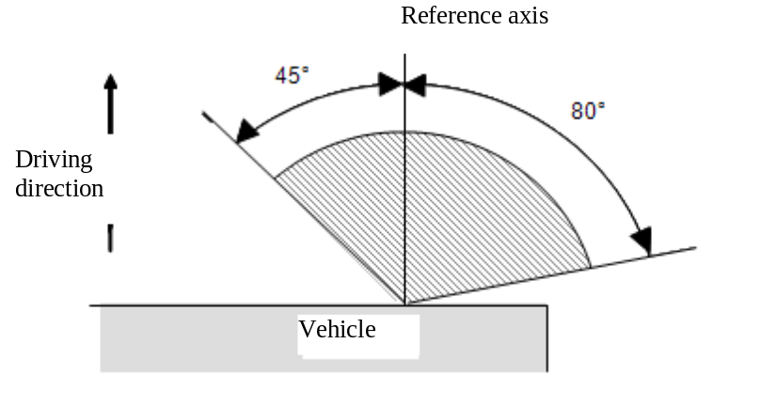
Front position lamps,  Under the H plane for M₁  or N₁ category vehicles  H plane: "horizontal plane going through the reference centre of the lamp" | 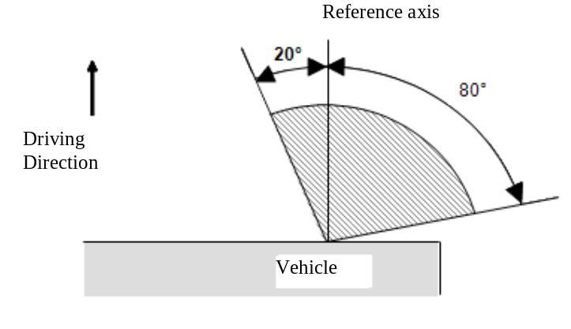

Front end-outline marker lamp (AM)
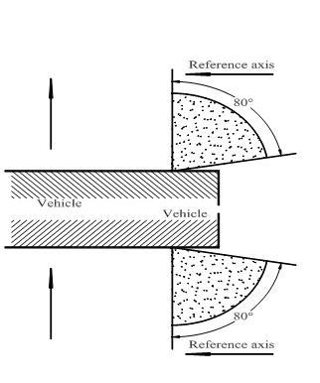
Driving direction

Rear end-outline marker lamp
(RM1, RM2)

Driving direction

Rear position lamps
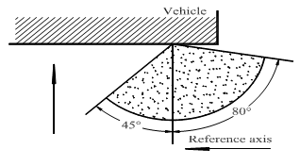
Driving direction

Reference axis
20°
80°
Driving direction

Stop lamps (S1 and S2)
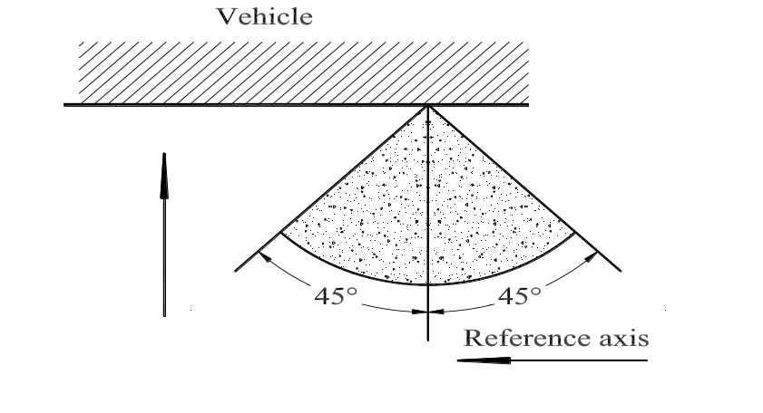
Driving direction
Reference axis
20°
45°
Driving direction

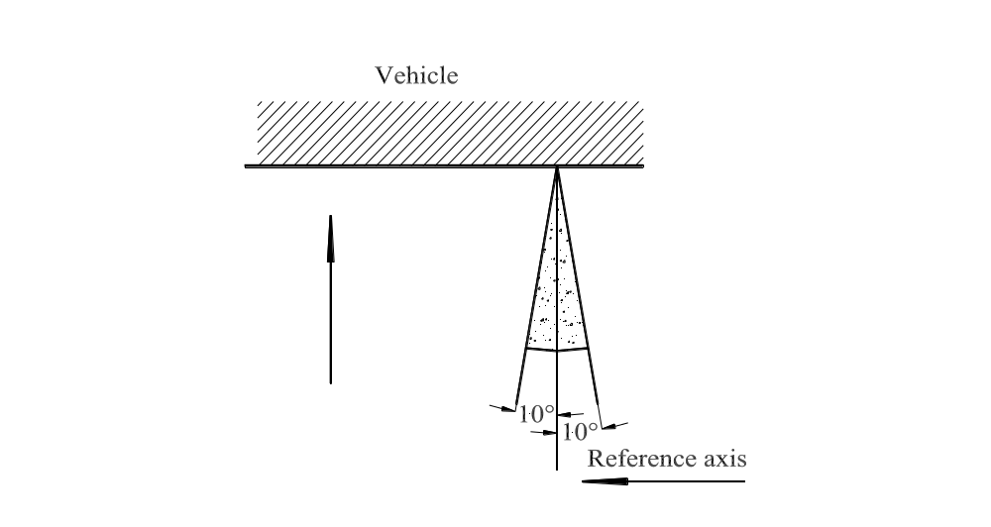
Stop-lamps (S3)

Driving direction
Annex 2
Communication
(Maximum format: A4 (210 x 297 mm))

issued by: Name of Administration:
......................................
......................................
......................................

concerning: Approval granted
Approval extended
Approval refused
Approval withdrawn
Production definitively discontinued
of a type of device pursuant to Regulation No. 7
Approval No........... Extension No...........
1. Trade name or mark of the device:
2. Manufacturer's name for the type of device:
3. Manufacturer's name and address:
4. If applicable, name and address of the manufacturer's representative:
5. Submitted for approval on:
6. Technical Service responsible for conducting approval tests:
7. Date of report issued by that Service:
8. Number of report issued by that Service:
9. Concise description:
9.1. By category of lamp:
For mounting either outside or inside or both²
Colour of light emitted: red/white²
Number, category and kind of light source(s):
Voltage and wattage:
Light source module specific identification code:
Only for installation on M₁ and/or N₁ category vehicles: yes/ no²
Only for limited mounting height of equal to or less than 750 mm above
the ground: yes/no²
Geometrical conditions of installation and relating variations, if any:
Application of an electronic light source control gear/variable intensity control:
(a) Being part of the lamp: yes/no²
(b) Being not part of the lamp: yes/no²
Input voltage(s) supplied by an electronic light source control gear/variable
intensity control:
Electronic light source control gear/variable intensity control manufacturer
and identification number (when the light source control gear is part of
the lamp but is not included into the lamp body):
Variable luminous intensity: yes/no²
9.2. Function(s) produced by an interdependent lamp forming part of an
interdependent lamp system:
Front position lamp yes/ no²
R1 Rear position lamp yes/ no²
R2 Rear position lamp yes/ no²
S1 Stop lamp yes/ no²
S2 Stop lamp yes/ no²
S3 Stop lamp yes/ no²
S4 Stop lamp yes/ no²
End-outline marker lamp yes/ no²
10. Position of the approval mark: ................................................................................
11. Reason(s) for extension (if applicable):
..................................................................................................................................
12. Approval granted/extended/refused/withdrawn²: ...................................................
13. Place: .......................................................................................................................
14. Date: ........................................................................................................................
15. Signature: ................................................................................................................
16. The list of documents deposited with the Type Approval Authority which has granted approval is annexed to this communication and may be obtained on request.

Annex 3
Examples of arrangements of the approval marks
1. Front position lamp
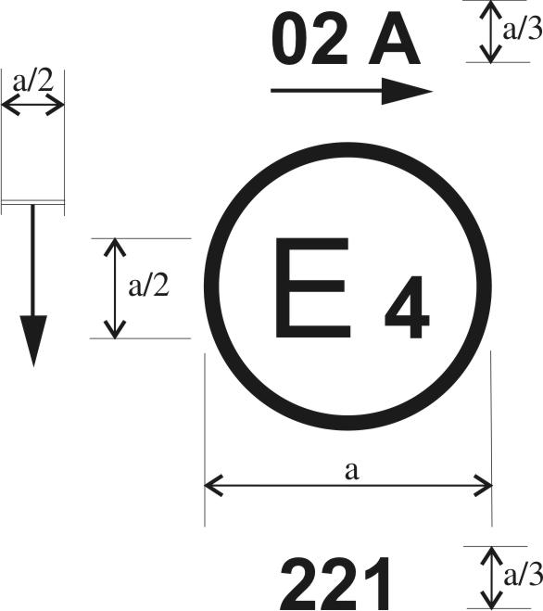
The device bearing the approval mark shown above is a front position lamp approved in the Netherlands (E4), under approval number 221 pursuant to Regulation No. 7.
The number mentioned close to the symbol "A" indicates that approval was granted in accordance with the requirements of Regulation No. 7 as amended by the 02 series of amendments. The horizontal arrow indicates the side on which the required photometric specifications are met up to an angle of 80° H. The vertical arrow starting from a horizontal segment and directed downwards indicates a permissible mounting height of equal to or less than 750 mm from the ground for this device.
2. Rear position lamp
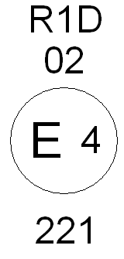

The device bearing the approval mark shown above is a rear position lamp approved in the Netherlands (E4) under approval number 221 pursuant to Regulation No. 7, which may also be used in an assembly of two rear position lamps.
The number mentioned below the symbol "R1D" indicates that approval was granted in conformity with the requirements of Regulation No. 7 as amended by the 02 series of amendments.
The absence of an arrow means that, both right and left, the required photometric specifications are met up to an angle of 80° H.
3. Front end-outline marker lamp
E2
125
AM
02

The device bearing the approval mark shown above is a front end-outline marker lamp approved in France (E2) under approval number 125 pursuant to Regulation No. 7.
The number mentioned below the symbol "AM" indicates that approval was granted in conformity with the requirements of Regulation No. 7 as amended by the 02 series of amendments. The horizontal arrow indicates the side on which the required photometric specifications are met up to an angle of 80° H.
4. Rear end-outline marker lamp
E3
122
RM2
02

The device bearing the approval mark shown above is a rear end-outline marker lamp with variable luminous intensity approved in Italy (E3) under approval number 122 pursuant to Regulation No. 7.
The number mentioned below the symbol "RM" indicates that approval was granted in conformity with the requirements of Regulation No. 7 as amended by the 02 series of amendments. The horizontal arrow indicates the side on which the required photometric specifications are met up to an angle of 80° H.
5. Stop-lamp
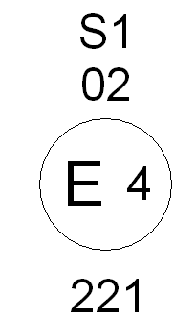

The device bearing the approval mark shown above is a stop-lamp with one level of illumination approved in the Netherlands (E4) under approval number 221 pursuant to Regulation No. 7.
The number mentioned below the symbol "S1" indicates that the approval was granted in conformity with the requirements of Regulation No. 7 as amended by the 02 series of amendments.
6. Device comprising both a rear position lamp and a stop-lamp
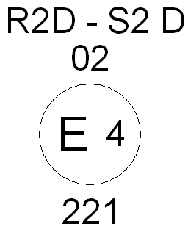

The device bearing the approval mark shown above is a device comprising both a rear position lamp and a stop-lamp with variable luminous intensity, approved in the Netherlands (E4) under approval number 221 pursuant to Regulation No. 7.
The number mentioned below the symbol "R2D-S2D" indicates that approval was granted in conformity with the requirements of Regulation No. 7 as amended by the 02 series of amendments. The rear position lamp is incorporated into a stop-lamp, both with variable luminous intensity, which may also be used in an assembly of two lamps.
The absence of an arrow means that, both right and left, the required photometric specifications are met up to an angle of 80° H.
Note: The approval number and the additional symbols shall be placed close to the circle and either above or below the letter "E" or to the right or to the left of that letter. The digits of the approval number shall be on the same side of the letter "E" and face the same direction. The approval number and the additional symbol including the number of the series of amendments to the Regulation in question, where applicable, shall be placed diametrically opposite to each other.
The use of Roman numerals as approval numbers should be avoided so as to prevent any confusion with other symbols.
7. Marking of independent lamps
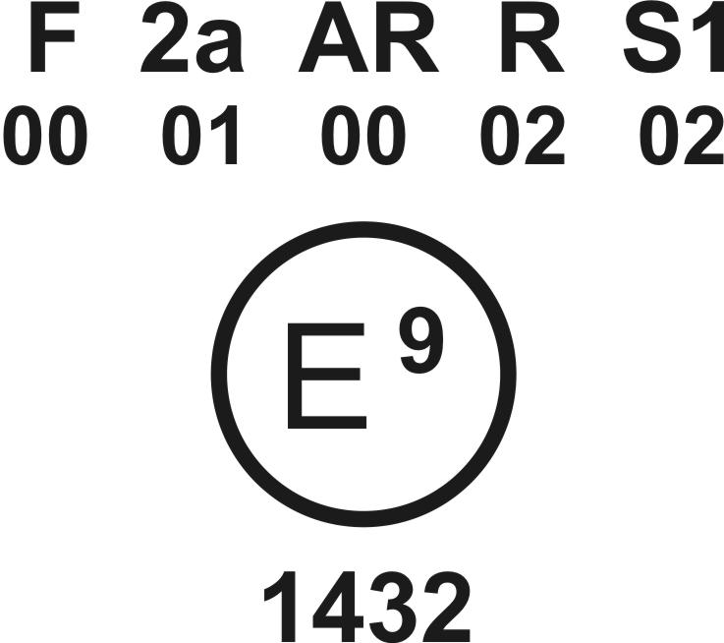

The above example corresponds to the marking of a lens intended to be used in different types of lamps. The approval marks indicate that the device was approved in Spain (E9) under approval number 1432 and comprises:
A rear fog lamp (F) approved in accordance with Regulation No. 38 in its original version,
A rear direction indicator lamp of category 2a approved in accordance with the 01 series of amendments to Regulation No. 6,
A reversing lamp (AR) approved in accordance with Regulation No. 23 in its original version,
A red rear position lamp (R) approved in accordance with the 02 series of amendments to Regulation No. 7,
A stop-lamp with one level of illumination (S1) approved in accordance with the 02 series of amendments to Regulation No. 7.
8. Simplified marking of grouped, combined or reciprocally incorporated lamps when two or more lamps are part of the same assembly
(The vertical and horizontal lines schematize the shape of the light-signalling device. These are not part of the approval mark)

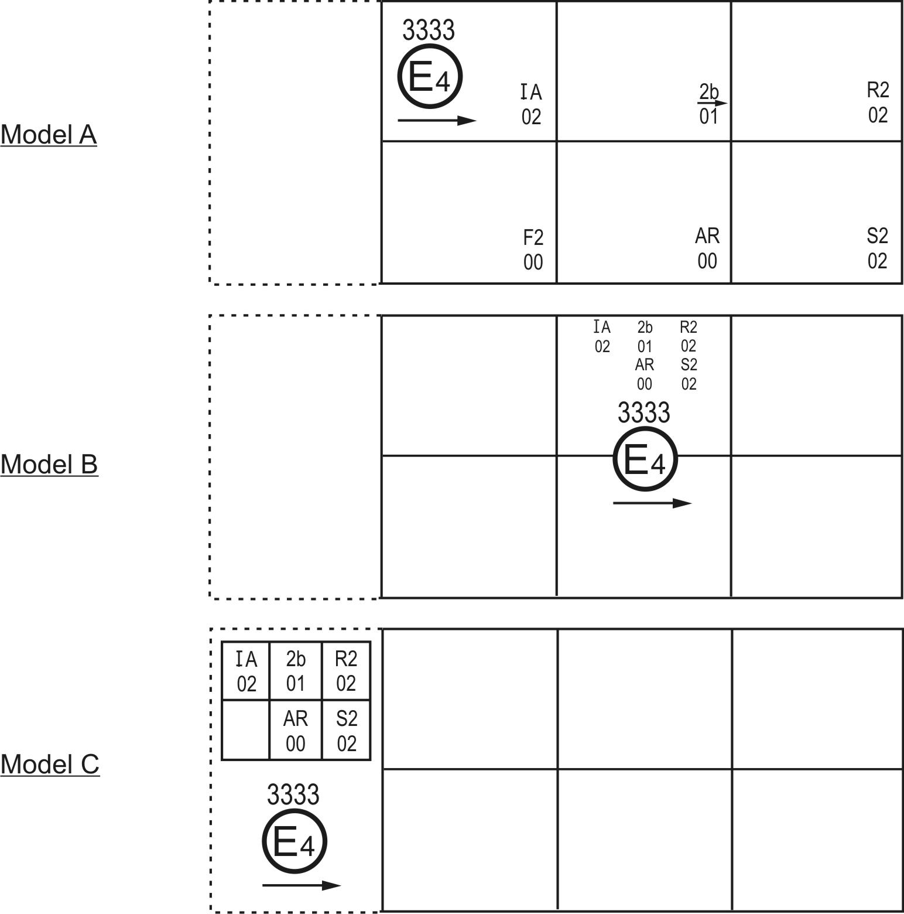
Note: These three examples of approval marks (models A, B and C) represent three possible variables for the marking of a lighting device when two or more lamps are part of the same assembly of grouped, combined or reciprocally incorporated lamps.
They indicate that the device was approved in the Netherlands (E4) under approval number 3333 and comprises:
A reflex-reflector of class IA approved in accordance with the 02 series of amendments to Regulation No. 3,
A rear direction indicator lamp with variable luminous intensity (category 2b) approved in accordance with the 01 series of amendments to Regulation No. 6,
A red rear position lamp with variable luminous intensity (R2) approved in accordance with the 02 series of amendments to Regulation No. 7,
A rear fog lamp with variable luminous intensity (F2) approved in accordance with Regulation No. 38 in its original version,
A reversing lamp (AR) approved in accordance with Regulation No. 23 in its original version,
A stop-lamp with variable luminous intensity (S2) approved in accordance with the 02 series of amendments to Regulation No. 7.
Note: The three examples of approval marks (models D, E and F) below correspond to a lighting device bearing an approval mark comprising:
A front position lamp approved in accordance with the 02 series of amendments to Regulation No. 7,
A headlamp with a passing beam designed for right- and left-hand traffic and a driving beam with a maximum intensity comprised between 86,250 and 111,250 candelas (indicated by the number "30"), approved in accordance with the 02 series of amendments to Regulation No. 20,
A front fog lamp approved in accordance with the 02 series of amendments to Regulation No. 19,
A front direction indicator lamp of category 1a approved in accordance with the 01 series of amendments to Regulation No. 6.
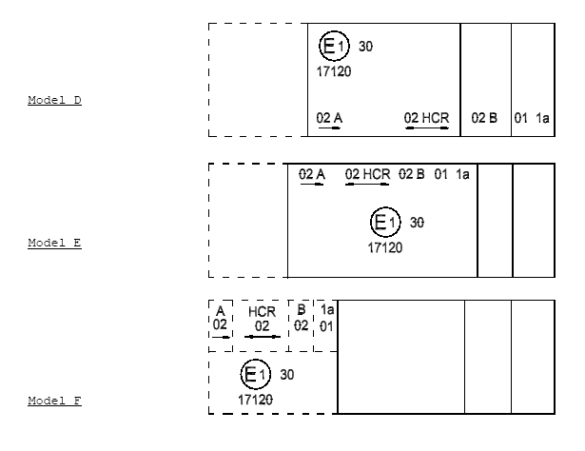

Model D
Model E
Model F

9. Lamp reciprocally incorporated with a headlamp
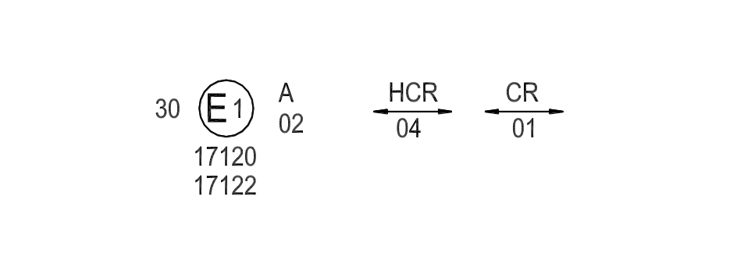
The above example corresponds to the marking of a lens intended to be used in different types of headlamps, namely:
Either A headlamp with a passing beam designed for right- and left-hand traffic and a driving beam with a maximum intensity comprised between 86,250 and 111,250 candelas (indicated by the number "30") approved in Germany (E1) in accordance with the requirements of Regulation No. 8 as amended by the 04 series of amendments, which is reciprocally incorporated with
A front position lamp approved in accordance with the 02 series of amendments to Regulation No. 7;
Or A headlamp with a passing beam designed for right- and left-hand traffic and a driving beam, approved in Germany (E1) in accordance with the requirements of Regulation No. 1 as amended by the 01 series of amendments, which is reciprocally incorporated with the same front position lamp as above;
Or Even either of the above-mentioned headlamps approved as a single lamp.
The main body of the headlamp shall bear the only valid approval number, for instance:
or or or
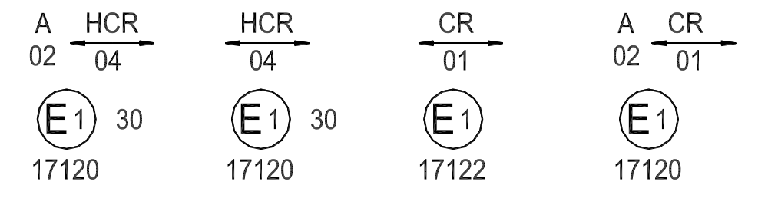
10. Light source modules
MD E3 17325
The light source module bearing the identification code shown above has been approved together with a lamp approved in Italy (E3) under approval number 17325.
11. Interdependent lamps
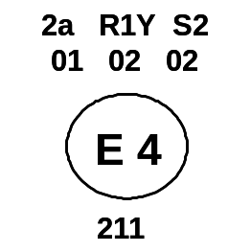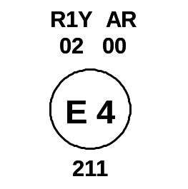
Marking of an interdependent lamp comprising part of an interdependent lamp system providing:  A rear direction indicator lamp (category 2a) approved in accordance with the 01 series of amendments to Regulation No. 6,  A red rear position (side) lamp (R1) approved in accordance with the 02 series of amendments to Regulation No. 7. This is also marked Y as it is an interdependent lamp forming part of an interdependent lamp system,  A stop-lamp with variable luminous intensity (S2) approved in accordance with the 02 series of amendments to  Regulation No. 7. |  | Marking of an interdependent lamp comprising part of an interdependent lamp system providing:  A red rear position (side) lamp (R1) approved in accordance with the 02 series of amendments to Regulation No. 7. This is also marked Y as it is an interdependent lamp forming part of an interdependent lamp system,  A reversing lamp (AR) approved in accordance with Regulation No. 23 in its original version.

Annex 4
Photometric measurements
1. Measurement methods
1.1. During photometric measurements, stray reflections shall be avoided by appropriate masking.
1.2. In case the results of measurements should be challenged, measurements shall be carried out in such a way as to meet the following requirements:
1.2.1. The distance of measurement shall be such that the law of the inverse of the square of the distance is applicable;
1.2.2. The measuring equipment shall be such that the angular aperture of the receiver viewed from the reference centre of the lamp is comprised between 10 angular minutes and one degree;
1.2.3. The intensity requirement for a particular direction of observation shall be deemed to be satisfied if that requirement is met in a direction deviating by not more than one-quarter of a degree from the direction of observation.
1.3. In the case where the device may be installed on the vehicle in more than one or in a field of different positions the photometric measurements shall be repeated for each position or for the extreme positions of the field of the reference axis specified by the manufacturer.
2. Table of standard light distribution
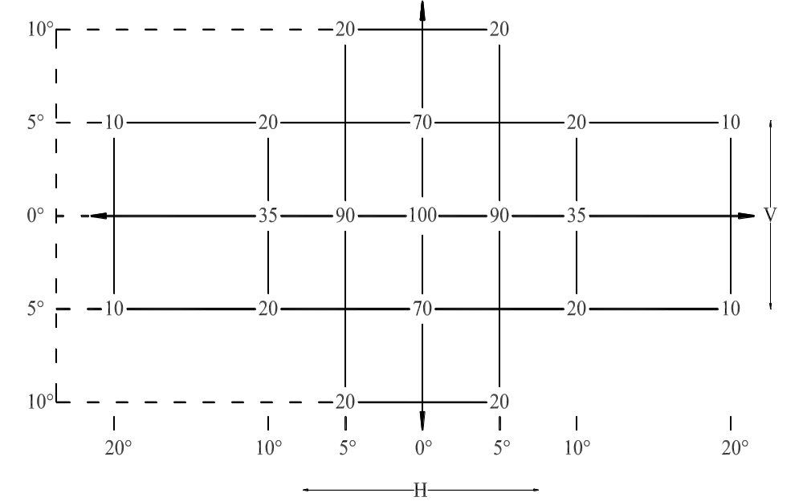

Table of light distribution for category S3 stop-lamp
10° | 32 | - | 64 | - | 32
5° | 64 | 100 | 100 | 100 | 64
0° | 64 | 100 | 100 | 100 | 64
5° | 64 | 100 | 100 | 100 | 64
 | 10° | 5° | 0° | 5° | 10°
2.1. The direction H = 0° and V = 0° corresponds to the reference axis. (On the vehicle it is horizontal, parallel to the median longitudinal plane of the vehicle and oriented in the required direction of visibility.) It passes through the centre of reference. The values shown in the table give, for the various directions of measurement, the minimum intensities as a percentage of the minimum required in the axis for each lamp (in the direction H = 0° and V = 0°).
2.2. Within the field of light distribution of paragraph 2., schematically shown as a grid, the light pattern should be substantially uniform, i.e. the light intensity in each direction of a part of the field formed by the grid lines shall meet at least the lowest minimum value being shown on the grid lines surrounding the questioned direction as a percentage.
2.3. However, in the case where a device is intended to be installed at a mounting height of equal to or less than 750 mm above the ground, the photometric intensity is verified only up to an angle of 5° downwards.
3. Photometric measurement of lamps
The photometric performance shall be checked:
3.1. For non-replaceable light sources (filament lamps and other): with the light sources present in the lamp, in accordance with the relevant sub-paragraph of paragraph 7.1. of this Regulation.
3.2. For replaceable filament lamps: when equipped with filament lamps at 6.75 V, 13.5 V or 28.0 V, the luminous intensity values produced shall be corrected. The correction factor is the ratio between the reference luminous flux and the mean value of the luminous flux found at the voltage applied (6.75 V, 13.5 V or 28.0 V). The actual luminous fluxes of each filament lamp used shall not deviate more than +5 per cent from the mean value. Alternatively a standard filament lamp may be used in turn, in each of the individual positions, operated at its reference flux, the individual measurements in each position being added together.
3.3. For any signalling lamp except those equipped with filament lamp(s), the luminous intensities, measured after one minute and after 30 minutes of operation, shall comply with the minimum and maximum requirements. The luminous intensity distribution after one minute of operation can be calculated from the luminous intensity distribution after 30 minutes of operation by applying at each test point the ratio of luminous intensities measured at HV after one minute and after 30 minutes of operation.

Annex 5
Minimum requirements for conformity of production control procedures
1. General
1.1. The conformity requirements shall be considered satisfied from a mechanical and geometric standpoint, if the differences do not exceed inevitable manufacturing deviations within the requirements of this Regulation.
1.2. With respect to photometric performances, the conformity of mass-produced lamps shall not be contested if, when testing photometric performances of any lamp chosen at random according to paragraph 7. of this Regulation, respectively:
1.2.1. No measured value deviates unfavourably by more than 20 per cent from the values prescribed in this Regulation;
1.2.2. If, in the case of a lamp equipped with a replaceable light source and if results of the test described above do not meet the requirements, tests on lamps shall be repeated using another standard filament lamp.
1.3. The chromaticity coordinates shall be complied with when tested under conditions of paragraph 7. of this Regulation.
2. Minimum requirements for verification of conformity by the manufacturer
For each type of lamp the holder of the approval mark shall carry out at least the following tests, at appropriate intervals. The tests shall be carried out in accordance with the provisions of this Regulation.
If any sampling shows non-conformity with regard to the type of test concerned, further samples shall be taken and tested. The manufacturer shall take steps to ensure the conformity of the production concerned.
2.1. Nature of tests
Tests of conformity in this Regulation shall cover the photometric and colorimetric characteristics.
2.2. Methods used in tests
2.2.1. Tests shall generally be carried out in accordance with the methods set out in this Regulation.
2.2.2. In any test of conformity carried out by the manufacturer, equivalent methods may be used with the consent of the competent authority responsible for approval tests. The manufacturer is responsible for proving that the applied methods are equivalent to those laid down in this Regulation.
2.2.3. The application of paragraphs 2.2.1. and 2.2.2. requires regular calibration of test apparatus and its correlation with measurements made by a competent authority.
2.2.4. In all cases the reference methods shall be those of this Regulation, particularly for the purpose of administrative verification and sampling.
2.3. Nature of sampling
Samples of lamps shall be selected at random from the production of a uniform batch. A uniform batch means a set of lamps of the same type, defined according to the production methods of the manufacturer.
The assessment shall in general cover series production from individual factories. However, a manufacturer may group together records concerning the same type from several factories, provided these operate under the same quality system and quality management.
2.4. Measured and recorded photometric characteristics
The sampled lamp shall be subjected to photometric measurements for the minimum values at the points listed in Annex 4 and the required chromaticity coordinates.
2.5. Criteria governing acceptability
The manufacturer is responsible for carrying out a statistical study of the test results and for defining, in agreement with the competent authority, criteria governing the acceptability of his products in order to meet the specifications laid down for verification of conformity of products in paragraph 9.1. of this Regulation.
The criteria governing the acceptability shall be such that, with a confidence level of 95 per cent, the minimum probability of passing a spot check in accordance with Annex 6 (first sampling) would be 0.95.

Annex 6
Minimum requirements for sampling by an inspector
1. General
1.1. The conformity requirements shall be considered satisfied from a mechanical and a geometric standpoint, in accordance with the requirements of this Regulation, if any, if the differences do not exceed inevitable manufacturing deviations.
1.2. With respect to photometric performance, the conformity of mass-produced lamps shall not be contested if, when testing photometric performances of any lamp chosen at random according to paragraph 7. of this Regulation, respectively:
1.2.1. No measured value deviates unfavourably by more than 20 per cent from the values prescribed in this Regulation;
1.2.2. If, in the case of a lamp equipped with a replaceable light source and if results of the test described above do not meet the requirements, tests on lamps shall be repeated using another standard filament lamp.
1.2.3. Lamps with apparent defects are disregarded.
1.3. The chromaticity coordinates shall be complied when tested under conditions of paragraph 7. of this Regulation.
2. First sampling
In the first sampling four lamps are selected at random. The first sample of two is marked A, the second sample of two is marked B.
2.1. The conformity is not contested
2.1.1. Following the sampling procedure shown in Figure 1 of this annex the conformity of mass-produced lamps shall not be contested if the deviation of the measured values of the lamps in the unfavourable directions are:
2.1.1.1. Sample A
A1: one lamp 0 per cent
one lamp not more than 20 per cent
A2: both lamps more than 0 per cent
but not more than 20 per cent
Go to sample B
2.1.1.2. Sample B
B1: both lamps 0 per cent
2.1.2. Or, if the conditions of paragraph 1.2.2. for sample A are fulfilled.
2.2. The conformity is contested
2.2.1. Following the sampling procedure shown in Figure 1 of this annex the conformity of mass-produced lamps shall be contested and the manufacturer requested to make his production meet the requirements (alignment) if the deviations of the measured values of the lamps are:
2.2.1.1. Sample A
A3: one lamp not more than 20 per cent
one lamp more than 20 per cent
but not more than 30 per cent
2.2.1.2. Sample B
B2: in the case of A2
one lamp more than 0 per cent
but not more than 20 per cent
one lamp not more than 20 per cent
B3: in the case of A2
one lamp 0 per cent
one lamp more than 20 per cent
but not more than 30 per cent
2.2.2. Or, if the conditions of paragraph 1.2.2. for sample A are not fulfilled.
2.3. Approval withdrawn
Conformity shall be contested and paragraph 10. applied if, following the sampling procedure in Figure 1 of this annex, the deviations of the measured values of the lamps are:
2.3.1. Sample A
A4: one lamp not more than 20 per cent
one lamp more than 30 per cent
A5: both lamps more than 20 per cent
2.3.2. Sample B
B4: in the case of A2
one lamp more than 0 per cent
but not more than 20 per cent
one lamp more than 20 per cent
B5: in the case of A2
both lamps more than 20 per cent
B6: in the case of A2
one lamp 0 per cent
one lamp more than 30 per cent
2.3.3. Or, if the conditions of paragraph 1.2.2. for samples A and B are not fulfilled.
3. Repeated sampling
In the cases of A3, B2, B3 a repeated sampling, third sample C of two lamps and fourth sample D of two lamps, selected from stock manufactured after alignment, is necessary within two months' time after the notification.
3.1. The conformity is not contested
3.1.1. Following the sampling procedure shown in Figure 1 of this annex the conformity of mass-produced lamps shall not be contested if the deviations of the measured values of the lamps are:
3.1.1.1. Sample C
C1: one lamp 0 per cent
one lamp not more than 20 per cent
C2: both lamps more than 0 per cent
but not more than 20 per cent
Go to sample D
3.1.1.2. Sample D
D1: in the case of C2
both lamps 0 per cent
3.1.2. Or, if the conditions of paragraph 1.2.2. for sample C are fulfilled.
3.2. The conformity is contested
3.2.1. Following the sampling procedure shown in Figure 1 of this annex the conformity of mass-produced lamps shall be contested and the manufacturer requested to make his production meet the requirements (alignment) if the deviations of the measured values of the lamps are:
3.2.1.1. Sample D
D2: in the case of C2
one lamp more than 0 per cent
but not more than 20 per cent
one lamp not more than 20 per cent
3.2.1.2. Or, if the conditions of paragraph 1.2.2. for sample C are not fulfilled.
3.3. Approval withdrawn
Conformity shall be contested and paragraph 10. applied if, following the sampling procedure in Figure 1 of this annex, the deviations of the measured values of the lamps are:
3.3.1. Sample C
C3: one lamp not more than 20 per cent
one lamp more than 20 per cent
C4: both lamps more than 20 per cent
3.3.2. Sample D
D3: in the case of C2
one lamp 0 or more than 0 per cent
one lamp more than 20 per cent
3.3.3. Or, if the conditions of paragraph 1.2.2. for samples C and D are not fulfilled.

Figure 1
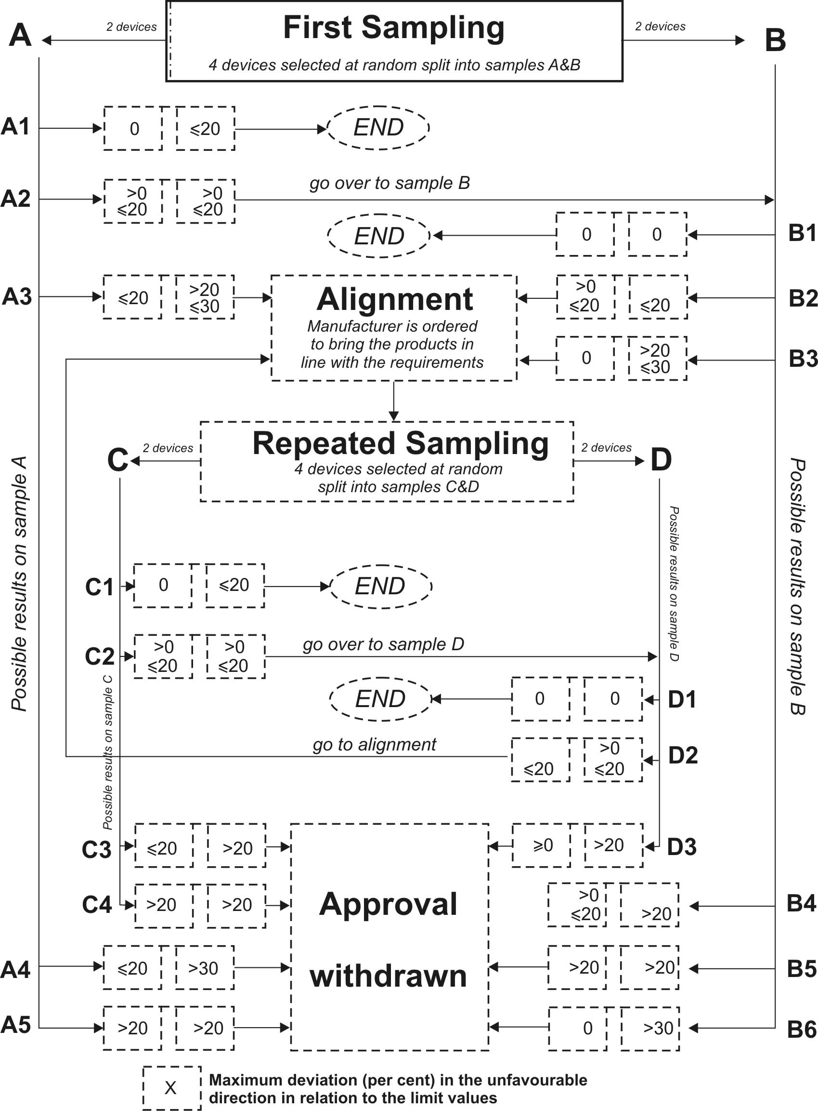

* * Former title of the Agreement: Agreement Concerning the Adoption of Uniform Conditions of Approval and Reciprocal Recognition of Approval for Motor Vehicle Equipment and Parts, done at Geneva on 20 March 1958.
? As defined in the Consolidated resolution on the Construction of vehicles (R.E.3), document ECE/TRANS/WP.29/78/Rev.2, para.2.
? The distinguishing numbers of the Contracting Parties to the 1958 Agreement are reproduced in Annex 3 to the Consolidated Resolution on the Construction of Vehicles (R.E.3), document ECE/TRANS/WP.29/78/Rev.2/Amend.1.
? Good visibility (meteorological optical range MOR > 2,000 m defined according to WMO, Guide to Meteorological Instruments and Methods of Observation, Sixth Edition, ISBN: 92-63-16008-2, pp 1.9.1/1.9.11, Geneva 1996 ) and clean lens.
? For the purpose of this Regulation "being part of the lamp" means to be physically included in the lamp body or to be external, separated or not, but supplied by the lamp manufacturer as part of the lamp system.
? The angles shown in these diagrams are correct for devices to be mounted on the right side of the vehicle. The arrows point to the front of the vehicle.
? Distinguishing number of the country which has granted/extended/refused/withdrawn approval (see approval provisions in the Regulation).
? Strike out what does not apply.

