Proposal for amendments to UN Regulation No. 67 (LPG vehicles)

Uniform provisions concerning the approval of:
- Approval of specific equipment of vehicles of category M and N using liquefied petroleum gases in their propulsion system II.
- Approval of vehicles of category M and N fitted with specific equipment for the use of liquefied petroleum gases in their propulsion system with regard to the installation of such equipment
The text reproduced below was prepared by the expert from Italy to amend UN Regulation No. 67 to introduce the new filling unit profile “J15” as specified in ISO 19825 and to align with the same standard the naming of Euro filling unit.
The modifications to the current text of the UN Regulation are marked in bold for new or strikethrough for deleted characters.

I. Proposal

Par. 6.17.10.6., amend to read:
6.17.10.6. Specific provisions regarding the K15 light vehicle Euro filling unit (Annex 9 – Figure 3):

Par. 6.17.10.7.3., renumber as paragraph 6.17.10.8 and amend to read:
6.17.10.7.3. The Euro filling unit shall comply with the impact test as described in Annex 9, paragraph 7.4.
6.17.10.8. The J15, K15 and heavy-duty vehicle Euro filling units shall comply with the impact test as described in Annex 9, paragraph 7.

Annex 9
Par. 7, amend to read:
7. Impact test requirements for the J15, K15 and heavy-duty vehicle Euro filling unit units

Figure 3, amend the figure title to read:
Figure 3
Connecting area of the K15 light vehicle Euro filling unit

Insert a new Figure 6:
Figure 6
Connecting area of the J15 filling unit
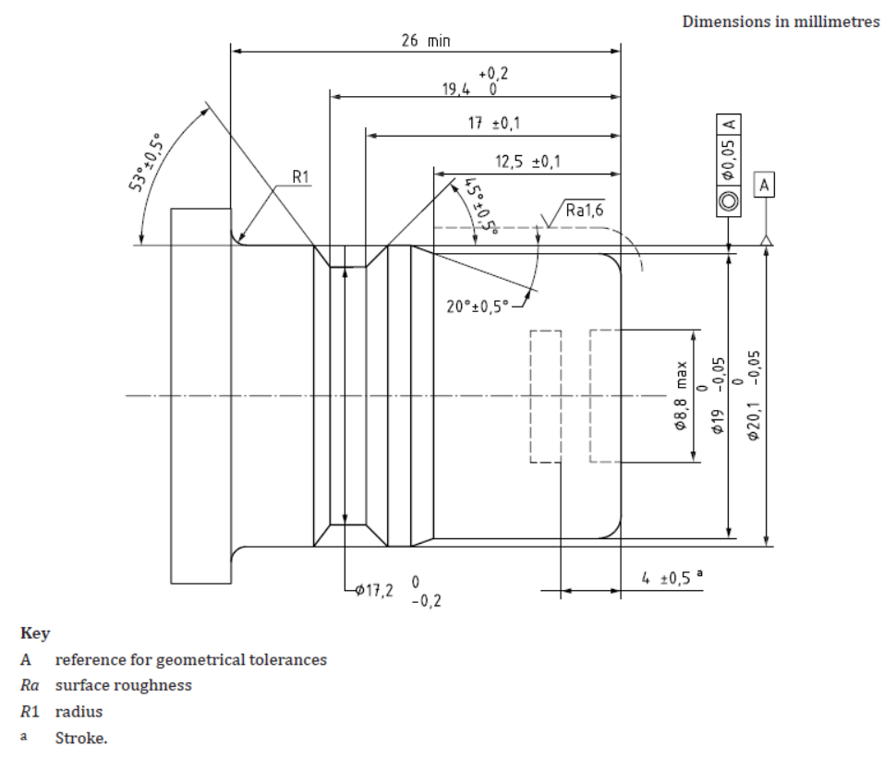

II. Justification

This proposal aims to align UN Regulation No. 67 with ISO19825. For that reason the name of light vehicle Euro filling unit is changed to K15 according to the above mentioned ISO standard, and a new profile J15 is inserted in Annex 9.

____________

