|  |  |  |  |
| --- | --- | --- | --- |
|  | United Nations | ECE/TRANS/WP.29/GRSG/2020/9 | |
| _unlogo | **Economic and Social Council** | | Distr.: General  20 January 2020  Original: English |

**Economic Commission for Europe**

Inland Transport Committee

**World Forum for Harmonization of Vehicle Regulations**

**Working Party on General Safety Provisions**

**118th session**

Geneva, 30 March-3 April 2020

Item 8(a) of the provisional agenda

**Amendments to gas-fuelled vehicle regulations**

**UN Regulation No. 67 (LPG vehicles)**

Proposal for amendments to UN Regulation No. 67 (LPG vehicles)

Submitted by the expert from Italy[[1]](#footnote-2)\*

The text reproduced below was prepared by the expert from Italy to amend UN Regulation No. 67 to introduce the new filling unit profile “J15” as specified in ISO 19825 and to align with the same standard the naming of Euro filling unit. The modifications to the current text of the UN Regulation are marked in **bold** for new or strikethrough for deleted characters.

Proposal for amendments to UN Regulation No. 67 (LPG vehicles)

I. Proposal

*Paragraph. 6.17.10.6.,* amend to read:

"6.17.10.6. Specific provisions regarding the **K15** ~~light vehicle Euro~~ filling unit (Annex 9 – Figure 3):"

*Paragraph 6.17.10.7.3*., renumber as paragraph 6.17.10.8 and amend to read:

~~"6.17.10.7.3. The Euro filling unit shall comply with the impact test as described in Annex 9, paragraph 7.4.~~

**6.17.10.8. The J15, K15 and heavy-duty vehicle Euro filling units shall comply with the impact test as described in Annex 9, paragraph 7."**

*Annex 9*

*Paragraph 7,* amend to read:

"7. Impact test requirements for the **J15, K15** **and heavy-duty vehicle** Euro filling ~~unit~~ **units"**

*Figure 3,* amend the figure title to read:

"Figure 3

Connecting area of the **K15** ~~light vehicle Euro~~ filling unit"

*After Figure 5,* insert a new Figure 6:

"Figure 6

**Connecting area of the J15 filling unit**

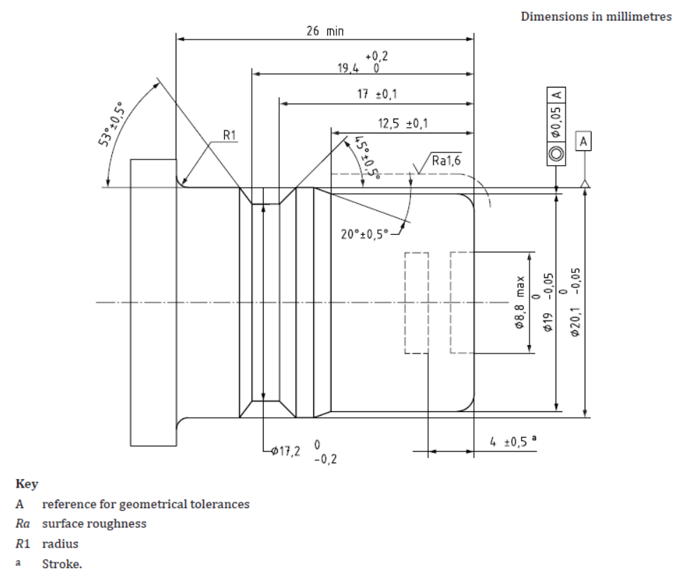

II. Justification

This proposal aims to align UN Regulation No. 67 with ISO19825. For that reason the name of light vehicle Euro filling unit is changed to K15 according to the above mentioned ISO standard, and a new profile J15 is inserted in Annex 9.

1. \* In accordance with the programme of work of the Inland Transport Committee for 2020 as outlined in proposed programme budget for 2020 (A/74/6 (part V sect. 20) para 20.37), the World Forum will develop, harmonize and update UN Regulations in order to enhance the performance of vehicles. The present document is submitted in conformity with that mandate. [↑](#footnote-ref-2)