Proposal for amendments to ECE/TRANS/WP.29/GRSG/2019/30
I. Proposal
Annex 3
Paragraph 7.6.2.8., amend to read:
“7.6.2.8. For vehicles of classes I, II and III, required escape hatches shall be positioned as follows:
(a) If there is only one hatch, it shall be situated in the middle third of the passenger compartment; or
(b) If there are two hatches, they shall be separated by a distance of at least 2 m measured between the nearest edges of the apertures in a line parallel to the longitudinal axis of the vehicle.”
Insert a new Paragraph 7.6.2.9. to read:
“7.6.2.9. For vehicles of classes A and B, required escape hatches shall be positioned as follows:
(a) If there is only one hatch, it shall be situated in the middle third of the passenger compartment. As an alternative, on vehicles with a very short passenger compartment length, the hatch may be located in the mid-section of this compartment, and this mid-section shall be equally spaced longitudinally each side of the transverse centre line of the passenger compartment, with a length of no greater than [1.6m] as shown in figure [].
(b) If there are two hatches, they shall be separated by a distance of at least 2 m measured between the nearest edges of the apertures in a line parallel to the longitudinal axis of the vehicle.
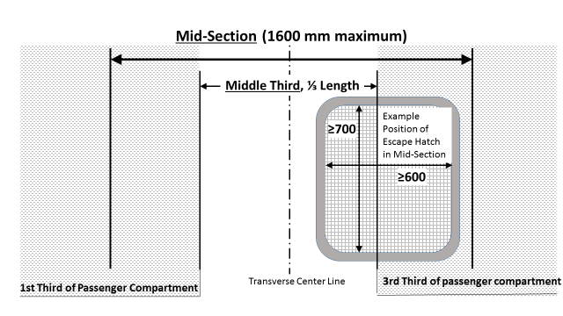Figure [#]
Alternative placement of escape hatch for very short passenger compartment length having a middle third smaller than 1600 mm”

