Proposal for amendment to ECE/TRANS/WP.29/GRSG/2019/32
The text reproduced below was prepared by the expert from the European Association of Automotive Suppliers (CLEPA) to add a missing footnote and to clarify the application of Annex 4 for heat pumps. The modifications to the existing text of the Regulation are marked in bold for new and strikethrough for deleted characters.
I. Proposal
Annex 8, paragraph 6.2. replace figure 4 by the following :

“ Figure 4
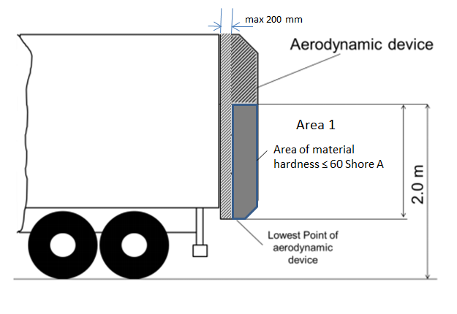 “

II. Justification
- From technical point of view it is necessary to support the soft area of the device with a frame.
- Paragraph 6.2. already exempts components (fastenings, hinges, actuators, springs, cables, lamps etc.) from being made of soft material, but current figure 4 may be misleading, that the entire part shall be made from soft material.
- Following the intention of paragraph 6.1. which exempts from the force test an area of maximum remaining length of 200 mm in longitudinal direction of the vehicle, this “exempted” area should be shown in figure 4 .

