Proposal for amendments to the proposal for the 04 series of amendments to UN Regulation No. 26 (External projection for passenger cars – document GRSG/2019/34)

Submitted by the experts from France and OICA *

The text reproduced below was prepared by the experts from France and OICA to clarify requirements in UN Regulation No. 26 on windscreen wipers. It is based on document ECE/TRANS/WP.29/GRSG/2019/34 submitted by France. The modifications to the document GRSG/2019/34 are marked in red characters.
I. Proposal
Paragraphs 6.4. to 6.4.2., amend to read:
"6.4. Windscreen wipers
6.4.1. The windscreen wiper fittings shall be such that the wiper shaft (number 1 in Figure 0) is furnished with a protective casing (number 1.1 in Figure 0) which has a radius of curvature meeting the requirements of paragraph 5.4. above and an end surface area of not less than 150 mm². The holder (head and main part, i.e. numbers 2, 2.1 in Figure 0) are designed with a radius of curvature meeting the requirements of paragraph 5.4. above. In the case of rounded covers, these shall have a minimum projected area of 150 mm² when measured not more than 6.5 mm from the point projecting furthest. These requirements shall also be met by rear window wipers and headlamp wipers.
6.4.2. Paragraph 5.4. shall not apply to the wiper blades (number 4 in Figure 0), or to any supporting members (number 3 in Figure 0) if present, to second holder (number 2.2 in Figure 0) if present, to the functional hinge between the holder head and the holder (number 5 in Figure 0) if present, or to the junction between the main and the second holder (number 6 in Figure 0) if present. However, these units shall be so made as to have no sharp angles or pointed or cutting parts.
Add a new paragraph 6.4.3., to read:
6.4.3 Compliance with the provisions in paragraphs 6.4.1 and 6.4.2 shall be verified with the wipers in parked position.

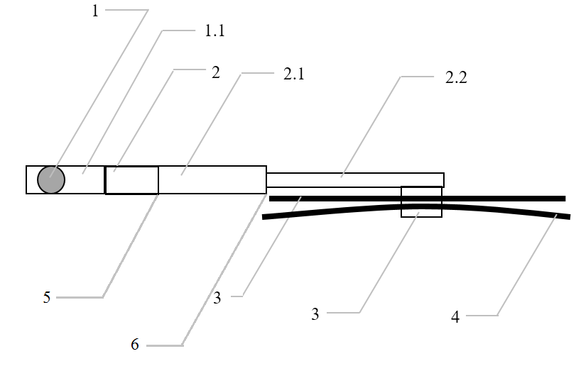
Figure 0 - Example of parts distribution

1 – Wiper shaft
1.1 – Protective casing
2 – Holder head
2.1 – Main holder
2.2 – Second holder
3 – Supporting members
4 – Wiper blades
5 – Functional hinge
6 – Junction between the main and second holder"

Insert new paragraphs 12.8. to 12.10. 12.11, to read:
"12.8. As from the official date of entry into force of the 04 series of amendments, no Contracting Party applying this Regulation shall refuse to grant approval under this Regulation as amended by the 04 series of amendments.
12.9. As from 24 months after the date of entry into force of the 04 series of amendments, Contracting Parties applying this Regulation shall grant approvals only if the vehicle type to be approved meets the requirements of this Regulation as amended by the 04 series of amendments.
12.10. Starting 36 months after the entry into force to the 04 series of amendments to this Regulation, Contracting Parties applying this Regulation may refuse first national registration (first entry into service) of a vehicle which does not meet the requirements of the 04 series of amendments to this Regulation."
12.9. As from 1 September 2022, Contracting Parties applying this Regulation shall not be obliged to accept type approvals to the preceding series of amendments, first issued after 1 September 2022.
12.10. Contracting Parties applying this Regulation shall continue to accept type approvals issued according to the preceding series of amendments to this Regulation first issued before 1 September 2022.
12.11. Contracting Parties applying this Regulation shall not refuse to grant type approvals according to any preceding series of amendments to this Regulation or extensions thereof.

