|  |  |  |  |
| --- | --- | --- | --- |
|  | United Nations | ECE/TRANS/WP.29/GRSG/2019/34 | |
| _unlogo | **Economic and Social Council** | | Distr.: General  19 July 2019  Original: English |

**Economic Commission for Europe**

Inland Transport Committee

**World Forum for Harmonization of Vehicle Regulations**

**Working Party on General Safety Provisions**

**117th session**

Geneva, 8-11 October 2019

Item 3 of the provisional agenda

**UN Regulation No. 26 (External projections of passenger cars)**

Proposal for the 04 series of amendments to UN Regulation No. 26 (External projection for passenger cars)

Submitted by the expert from France[[1]](#footnote-1)\*

The text reproduced below was prepared by the expert from France to clarify requirements in UN Regulation No. 26 on windscreen wipers. It is based on document ECE/TRANS/WP.29/GRSG/2019/11 that was presented at the 116th session of the Working Party on General Safety Provisions (GRSG) (see report ECE/TRANS/WP.29/GRSG/95, para. 14). The modifications to the current text of UN Regulation No. 26 are marked in bold characters for new and strikethrough for deleted characters.

I. Proposal

*Paragraphs 6.4. to 6.4.2.,* amend to read:

"6.4. Windscreen wipers

6.4.1. The windscreen wiper fittings shall be such that the wiper shaft **(number 1 in Figure 0)** is furnished with a protective casing **(number 1.1 in Figure 0)** which has a radius of curvature meeting the requirements of paragraph [5.4.](https://raceonline.utac.com/fr/document/show/document_id/4022#A0_S5_4_) above and an end surface area of not less than 150 mm². **The holder (head and main part, i.e. numbers 2, 2.1 in Figure 0) are designed with a radius of curvature meeting the requirements of paragraph 5.4. above.** In the case of rounded covers, these shall have a minimum projected area of 150 mm² when measured not more than 6.5 mm from the point projecting furthest. These requirements shall also be met by rear window wipers and headlamp wipers.

6.4.2. Paragraph [5.4.](https://raceonline.utac.com/fr/document/show/document_id/4022#A0_S5_4_) shall not apply to the wiper blades **(number 4 in Figure 0),** ~~or~~ to ~~any~~ supporting members **(number 3 in Figure 0) if present, to second holder (number 2.2 in Figure 0) if present, to the functional hinge between the holder head and the holder (number 5 in Figure 0) if present, or to the junction between the main and the second holder (number 6 in Figure 0) if present**. However, these units shall be so made as to have no sharp angles or pointed or cutting parts.

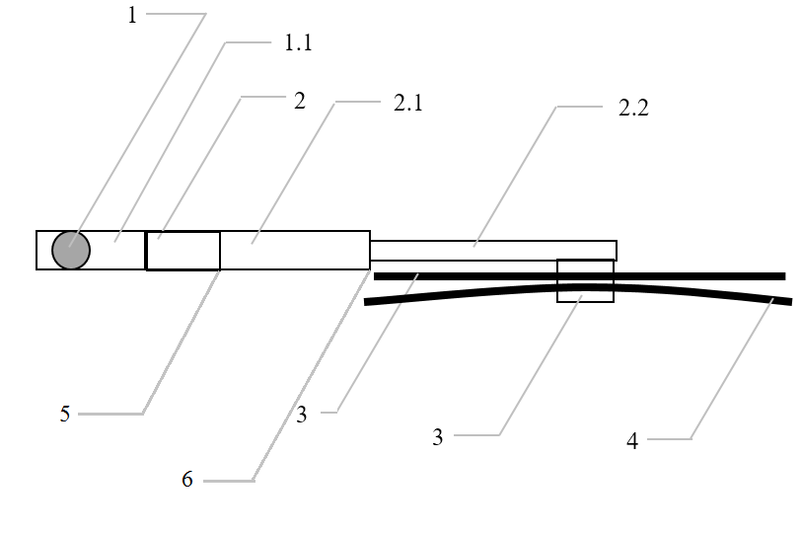**Figure 0 - Example of parts distribution**

**1 – Wiper shaft**

**1.1 – Protective casing**

**2 – Holder head**

**2.1 – Main holder**

**2.2 – Second holder**

**3 – Supporting members**

**4 – Wiper blades**

**5 – Functional hinge**

**6 – Junction between the main and second holder"**

*Insert new paragraphs 12.8. to 12.10.,* to read:

"12.8. As from the official date of entry into force of the 04 series of amendments, no Contracting Party applying this Regulation shall refuse to grant approval under this Regulation as amended by the 04 series of amendments.

**12.9. As from 24 months after the date of entry into force of the 04 series of amendments, Contracting Parties applying this Regulation shall grant approvals only if the vehicle type to be approved meets the requirements of this Regulation as amended by the 04 series of amendments.**

**12.10. Starting 36 months after the entry into force to the 04 series of amendments to this Regulation, Contracting Parties applying this Regulation may refuse first national registration (first entry into service) of a vehicle which does not meet the requirements of the 04 series of amendments to this Regulation."**

II. Justification

1. Even if data on road accident does not allow to evaluate this too specific loadcase regarding wipers parts, it seems needed to remind the initial objectives of the Regulation within this wiper requirement paragraphs:

*"The purpose of this Regulation is to reduce the risk or seriousness of bodily injury to a person hit by the bodywork or brushing against it in the event of a collision […]. (Para. 1.2.)*

*The external surface of vehicles shall not exhibit, directed outwards, any pointed or sharp parts or any projections of such shape, dimensions, direction or hardness as to be likely to increase the risk or seriousness of bodily injury to a person hit by the external surface or brushing against it in the event of a collision […]. (Para. 5.2.)*

*No protruding part of the external surface shall have a radius of curvature less than 2.5 mm […] (Para. 5.4.)"*

2. In this way, this draft proposal clarifies how to deal with potential “exempted” parts and which requirements apply to which part of the windscreen wiper. A generic drawing presenting the concerned areas seems to be the best way for a coherent application in association with requirement wording.

3. Geometrical requirements are only applicable on contactable parts (sphere protocol).

1. \* In accordance with the programme of work of the Inland Transport Committee for 2018–2019 (ECE/TRANS/274, para. 123 and ECE/TRANS/2018/21/Add.1, Cluster 3.1), the World Forum will develop, harmonize and update UN regulations in order to enhance the performance of vehicles. The present document is submitted in conformity with that mandate. [↑](#footnote-ref-1)