|  |  |  |  |
| --- | --- | --- | --- |
|  | United Nations | ECE/TRANS/WP.29/GRSG/2019/2 | |
| _unlogo | **Economic and Social Council** | | Distr.: General  7 January 2019  Original: English |

**Economic Commission for Europe**

Inland Transport Committee

**World Forum for Harmonization of Vehicle Regulations**

**Working Party on General Safety Provisions**

**116th session**

Geneva, 1–5 April 2019

Item 3 of the provisional agenda

**UN Regulation No. 26 (External projections of passenger cars)**

Proposal for Supplement 4 to the 03 series of amendments to UN Regulation No. 26 (External projections of passenger cars)

Submitted by the expert from the International Organization of Motor Vehicle Manufacturers[[1]](#footnote-2)\*

The text reproduced below was prepared by the expert from the International Organization of Motor Vehicle Manufacturers (OICA) to amend the provisions for rear edges of the bonnet. It is based on informal document GRSG-115-16, presented at the 115th session of the Working Party on General Safety Provisions (GRSG) (see report ECE/TRANS/WP.29/GRSG/94, para. 13). The modifications to the current text of UN Regulation No. 26 are marked in bold characters.

**I. Proposal**

*Paragraph 6.8.1.,* amend to read:

"6.8.1. Sheet-metal edges, such as gutter edges and the rails of sliding doors, shall not be permitted unless they are folded back or are fitted with a shield meeting the requirements of this Regulation which are applicable to it.

An unprotected edge shall be considered to be folded back either if it is folded back by approximately 180º, or if it is folded towards the bodywork in such a manner that it cannot be contacted by a sphere having a diameter of 100 mm.

The requirements of paragraph 5.4. above shall not apply to the following sheet metal edges: rear edge of bonnet and front edge of rear luggage boot.

**The rear edge of the bonnet includes the extrapolation of this edge to the left and right (e.g. as upper edge of the fender or as edge of the a-pillar) and other inward facing edges of body panels not easily contacted by vulnerable road users may be blunted.**"

II. Justification

1. During its ninetieth session in April 2006, GRSG agreed to amend paragraph 6.8.1. with the last subparagraph: "The requirements of paragraph 5.4. above shall not apply to the following sheet metal edges: rear edge of bonnet and front edge of rear luggage boot".

2. GRSG justified this amendment with an experience-based justification: "some sheet metal edges can be considered as not dangerous due to their location (edges not likely to increase the risk of bodily injury)" (see document ECE/TRANS/WP.29/GRSG/2006/11).

3. This justification is valid in the same way for rear edges of fenders or rear edges of A-pillars if they extend from the rear edge of the bonnet to the left and to the right.

|  |  |
| --- | --- |
| https://www.top-autowelt.de/var/galerie/20098.jpg | 197d396955624304b6f7764573e678b1.jpg  Fender  panel  Bonnet |

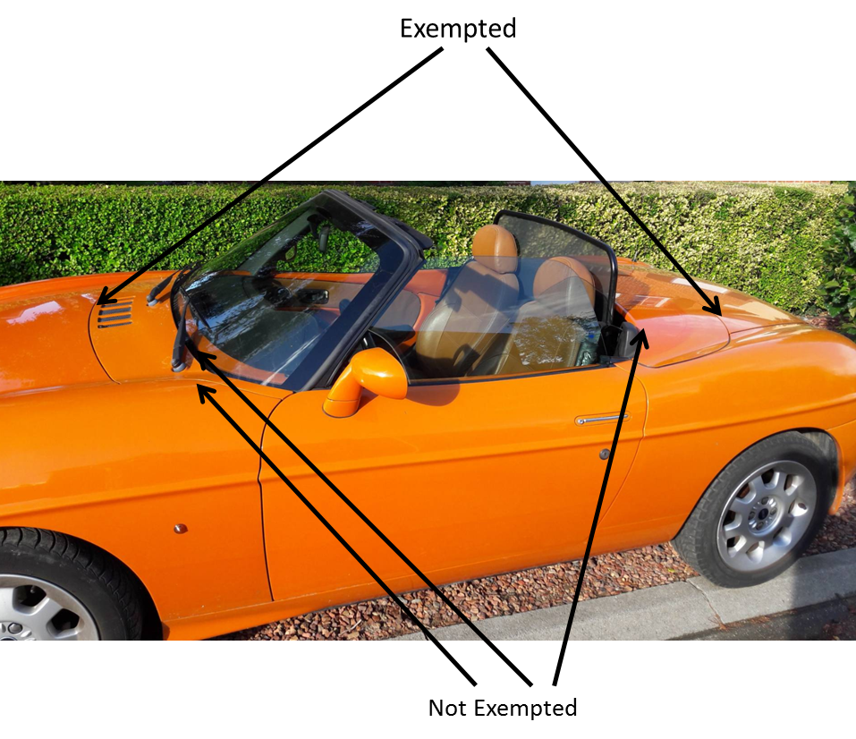

Not exempted

Exempted

1. \* In accordance with the programme of work of the Inland Transport Committee for 2018–2019 (ECE/TRANS/274, para. 123 and ECE/TRANS/2018/21/Add.1, Cluster 3.1), the World Forum will develop, harmonize and update UN regulations to enhance the performance of vehicles. The present document is submitted in conformity with that mandate. [↑](#footnote-ref-2)