|  |  |  |  |
| --- | --- | --- | --- |
|  | United Nations | ECE/TRANS/WP.29/GRB/2019/7 | |
| Description: _unlogo | **Economic and Social Council** | | Distr.: General  9 November 2018  Original: English |

**Economic Commission for Europe**

Inland Transport Committee

**World Forum for Harmonization of Vehicle Regulations**

**Working Party on Noise**

**Sixty-ninth session**

Geneva, 22-25 January 2019

Item 7 (b) of the provisional agenda

**Tyres: UN Regulation No. 75 (Tyres for motorcycles/mopeds)**

Proposal for a Supplement to UN Regulation No. 75

Submitted by the experts from France[[1]](#footnote-2)\*

The text reproduced below was prepared by the experts from France to amend UN Regulation No. 75. The modifications to the existing text of the Regulation are marked in bold for new or strikethrough for deleted characters.

I. Proposal

*Paragraph 2.31.3.,* amend to read:

"2.31.3.Tyres suitable for maximum speeds in excess of 240 km/h **but below 270 km/h** ~~are~~ **shall be** identified by means of letter code~~s~~ "V" ~~or~~ **and tyres suitable for maximum speeds of 270 km/h or above shall be identified by means of letter code** "Z" ~~(see~~ *~~paragraph 2.36.3.~~* ~~)~~ . **The letter code shall be** placed within the tyre size designation in front of the indication**~~s~~** of the structure (see *paragraph 3.1.4.*)."

*Paragraph 2.36.3.,* amend to read:

"2.36.3. For **tyres classified with speed category symbol "V"operated at** speeds above 210 km/h but not exceeding ~~270~~ **240** km/h, the maximum load rating ~~must~~ **shall** not exceed the percentage of the mass, associated with the load capacity index of the tyre, indicated in the table below with reference to the speed **capability of the vehicle** **to which the tyre is fitted** ~~category symbol of the tyre~~ ~~and the maximum design speed of the vehicle to which the tyre is to be fitted:~~

|  |  |
| --- | --- |
| ***Maximum operating speed***  ***(km/h)*** | ***Maximum load rating***  ***(per cent)*** |
| 210 | 100 |
| 220 | 95 |
| 230 | 90 |
| 240 | 85 |

**For intermediate operating maximum speeds linear interpolations of the maximum load rating are allowed."**

*Insert new paragraphs 2.36.4. and 2.36.5. and 2.36.6.,* to read:

**"2.36.4. For tyres classified with speed category symbol “V” and the letter code “V” operated at speeds above 240 km/h but below 270 km/h the maximum load rating shall not exceed the percentage of the mass associated with the load capacity index of the tyre, indicated in the table below with reference to the speed capability of the vehicle to which the tyre is fitted:**

|  |  |
| --- | --- |
| ***Maximum operating speed***  ***(km/h)*** | ***Maximum load rating***  ***(per cent)*** |
| 240 | 85 |
| 250 | 80\* |
| 260 | 75\* |
| 270 | 70\* |
| \*Applicable up to the maximum speed specified by the tyre manufacturer. This maximum speed shall be below 270 km/h. | |

**For intermediate maximum operating speeds linear interpolations of the maximum load rating are allowed.**

**2.36.5. For tyres classified with speed category symbol “W” and the letter code “Z”designed for speeds up to 270 km/h and above , the maximum load rating shall not exceed the percentage of the mass associated with the load capacity index of the tyre, indicated in the table below with reference to the speed capability of the vehicle to which the tyre is fitted:**

|  |  |
| --- | --- |
| ***Maximum operating speed***  ***(km/h)*** | ***Maximum load rating***  ***(per cent)*** |
| 240 | 100 |
| 250 | 95 |
| 260 | 85 |
| 270 | 75 |

**For intermediate maximum operating speeds linear interpolations of the maximum load rating are allowed.**

*Paragraph (former) 2.36.4.,* renumber into 2.36.6. and amend to read:

"2.36.~~4~~**6**.For **tyres classified with speed category symbol “W” and the letter code “Z” designed for speeds above 270 km/h operated** at speeds in excess of 270 km/h, the maximum load rating ~~must~~ **shall** not exceed ~~the mass~~ **a linear interpolation between the load rating prescribed at 270 km/h and the maximum load at maximum speed both as** specified by the tyre manufacturer ~~with reference to the speed capacity of the tyre~~. ~~For intermediate speeds between 270 km/h and the maximum speed permitted by the tyre manufacturer, a linear interpolation of the maximum load rating applies."~~

*Paragraph 3.1.14.,* amend to read:

"3.1.14. Tyres suitable for speeds above 240 km/h ~~must~~ **shall** be marked with the appropriate letter code "V" or "Z'', as ~~applicable (see~~ *~~paragraph 2.36.3.~~*~~) in front of the indication of the structure (see~~ *~~paragraph 3.1.4.~~*~~)~~ **defined in paragraph 2.31.3."**

*Paragraph 3.1.15.,* amend to read:

"3.1.15. Tyres suitable for speeds above 240 km/h **but below 270 km/h** ~~(270 km/h respectively)~~ ~~must~~ **shall** bear, within parenthesis, the marking of the load capacity index (see *paragraph 3.~~1.6~~.*) applicable at a speed of 210 km/h ~~(or 240 km/h respectively)~~ and a reference speed category symbol (see *paragraph 3.~~1.5~~.*) as follows:

"V'' in case of tyres identified with the letter code "V'' within the size designation.

~~"W" in case of tyres identified with the letter code "Z" within the size designation~~."

*Insert a new paragraph 3.1.16.,* to read:

**"3.1.16. Tyres suitable for speeds above 270 km/h shall bear, within parenthesis, the marking of the load capacity index (see paragraph 3.) applicable at a speed of 240 km/h and a reference speed category symbol (see paragraph 3.) as follows:**

**"W" in case of tyres identified with the letter code "Z" within the size designation."**

*Renumber former paragraph 3.1.16.* into 3.1.17.

*Paragraph 4.1.15.,* amend to read:

"4.1.15. For tyres identified by means of letter code "V" within the size designation and suitable for speeds over 240 km/h **but below 270 km/h** or for tyres identified by means of letter code "Z" within the size designation and suitable for speeds over 270 km/h, the maximum speed permitted by the tyre manufacturer and the load carrying capacity allowed for that maximum speed."

*Paragraph 6.2.1.1.,* amend to read:

"6.2.1.1. Where application is made for tyres identified by means of letter code "V'' within the size designation and suitable for speeds over 240 km/h or for tyres identified by means of letter code "Z" within the size designation and suitable for speeds over 270 km/h (see paragraph 4.1.15.), the above load/speed test is carried out on one tyre at the load and speed conditions marked within parenthesis on the tyre (see *paragraph* *3.1.15.*). Another load/speed test must be carried out on a second tyre of the same type at the load and speed conditions, if any, specified as maximum by the tyre manufacturer (see paragraph 4.1.15.). **For tyres identified by means of letter code "V'' within the size designation and suitable for speeds over 240 km/h, the maximum load specified by the manufacturer shall not exceed the maximum load rating indicated in paragraph 2.36.4. with reference to the maximum speed specified by the manufacturer."**

*Paragraph 7.1.4.,* amend to read:

"7.1.4. Extensions of approval for tyres suitable for speeds over 240 km/h **but below 270 km/h** for tyres identified by means of letter code "V" within the size designation (or 270 km/h for tyres identified by means of letter code "Z" within the size designation), aiming at certification for different maximum speeds and/or loads, are permitted provided that a new test report, related to the new maximum speed and load rating, is supplied by the technical service responsible for carrying out tests.

Such new load/speed capabilities must be specified in item 9. of Annex 1."

*Annex 7,*

*Paragraph 2.2.3.,* amend to read:

"2.2.3. The maximum load rating associated with a maximum speed of 270 km/h for tyres with speed symbol "W" (see *paragraph 2.36.~~3~~.****5. of this Regulation***),"

*Paragraphs 2.2.4., 2.5.2.1. and 2.5.6.1.,* delete.

*Insert a new paragraph 2.6.1.,* to read:

**"2.6.1. Apply to the test axle a load equal to 65 per cent of the maximum load at the maximum speed specified by the tyre manufacturer;"**

*Former paragraphs 2.6.1. to 2.6.4.,* renumber to 2.6.2. to 2.6.5. and amend to read:

**"2.6.2.** ~~Twenty minutes to build up~~ **Increase within twenty minutes the speed** from zero to the initial test speed~~as specified in paragraph 2.5.2.1. above~~**, which is 30 km/h less than the maximum speed specified by the tyre manufacturer (see paragraph 4.1.15. of this Regulation) if a 2.0 m diameter test drum is used, or 40 km/h less if a 1.7 m diameter test drum is used.;**

**2.6.3. Run** twenty minutes at the initial test speed**;**

**2.6.4.** ~~Ten minutes to build up~~ **Increase within ten minutes the speed** to the maximum test speed ~~as specified in paragraph 2.5.6.1. above~~ **, which is the maximum speed specified by the tyre manufacturer (see paragraph 4.1.15. of this Regulation) if a 2.0 m diameter test drum is used, or 10 km/h less if a 1.7 m diameter test drum is used;**

**2.6.5. Run** five minutes at the maximum test speed."

II. Justification

1. The aim of this proposal is to clarify the identification, marking and test provisions applicable to tyres designed for speeds above 240 km/h by:

(a) Clearly separating the three following cases: maximum design speed above 240 km/h and below 270 km/h, maximum design speed of 270 km/h, maximum design speed above 270 km/h, by splitting current paragraph 2.36.3. into three new paragraphs 2.36.3. to 2.36.5.

(b) For tyres designed for speeds above 240 km/h and below 270 km/h, and for tyres designed for speeds above 270 km/h, clarifying the provisions regarding the identification with the letter-code “V” or “Z” and the marking of the load capacity index and the reference speed within parenthesis, by splitting current paragraph 3.1.15. into two new paragraphs 3.1.15. and 3.1.16.

(c) Clarifying that tyres designed for a maximum speed of 270 km/h shall be identified by means of letter code "Z" and bear the speed category symbol W, without any parenthesis.

(d) Clarifying better in Annex 7, which conditions are only applicable to the second load/speed test, in order to minimize the risk of misinterpretations.

2. The chart below summarizes the maximum load ratings with reference to the maximum speed, for the different letter-codes and speed category symbol combinations.

**Chart**

**Maximum load ratings vs maximum speed**

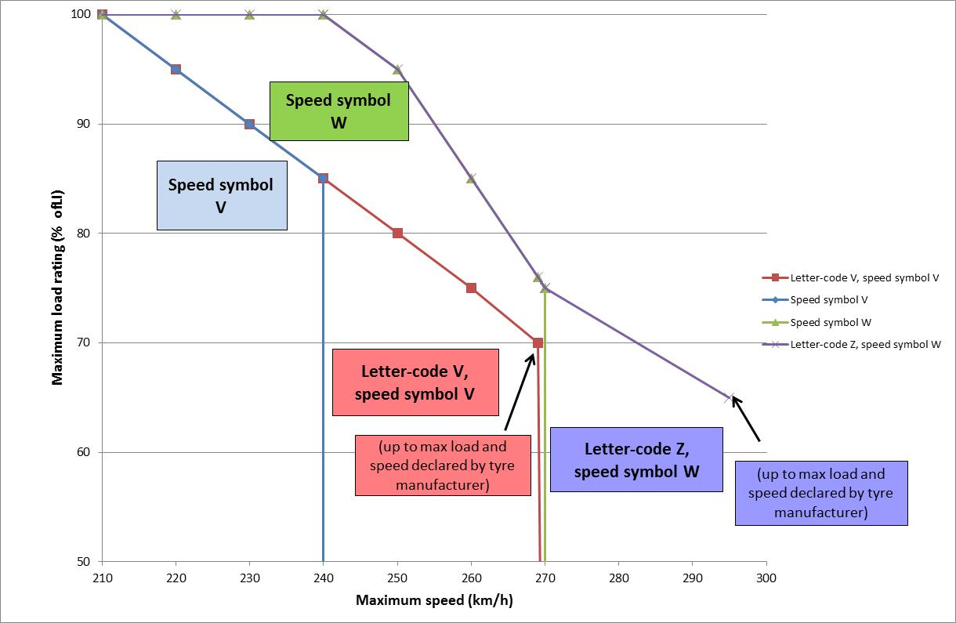

1. \* In accordance with the programme of work of the Inland Transport Committee for 2018–2019 (ECE/TRANS/274, para. 123 and ECE/TRANS/2018/21/Add.1, Cluster 3), the World Forum will develop, harmonize and update UN Regulations in order to enhance the performance of vehicles. The present document is submitted in conformity with that mandate. [↑](#footnote-ref-2)