|  |  |  |  |
| --- | --- | --- | --- |
|  | United Nations | ECE/TRANS/2019/3 | |
| _unlogo | **Economic and Social Council** | | Distr.: General  7 December 2018  Original: English |

**Economic Commission for Europe**

Inland Transport Committee

**Eightieth session**

Geneva, 19-22 February 2019  
Item 4 (a) of the provisional agenda  
**Strategic questions of a horizontal policy nature:  
Status of accession to international United Nations   
transport agreements and conventions**

Status of accessions to United Nations transport agreements and conventions under the purview of the Inland Transport Committee

Note by the secretariat

|  |
| --- |
| *Summary* |
| This document presents the status of accessions by ECE and non-ECE member States to the United Nations transport agreements and conventions administered by ECE. |
| On 1 December 2018, the total number of contracting parties to the 58 United Nations legal instruments in the field of transport administered by ECE was 1,753, with thirteen new contracting parties to eight legal instruments. |
| The Committee may wish to **invite countries**, which have not yet done so, to accede to the United Nations conventions and other legal instruments in inland transport administered by the Committee and its subsidiary bodies. |
|  |

I. Overview

1. Figure I below shows the growth of the total number of contracting parties to legal instruments on inland transport concluded under the purview of the Inland Transport Committee (ITC). On 1 December 2018, the total number of contracting parties to the 58 United Nations legal instruments in the field of transport administered by the United Nations Economic Commission for Europe (ECE) was 1,753, with eighteen new contracting parties to eight legal instruments (see annex for details). Out of these 58 legal instruments, nine have not yet entered into force. The summary tables on the status of signatures, ratifications and accessions for all legal instruments are available at www.unece.org/trans/conventn/intro.html.

Figure I

**Annual Growth of Contracting Parties to Legal Instruments on inland transport under the purview of the ITC**

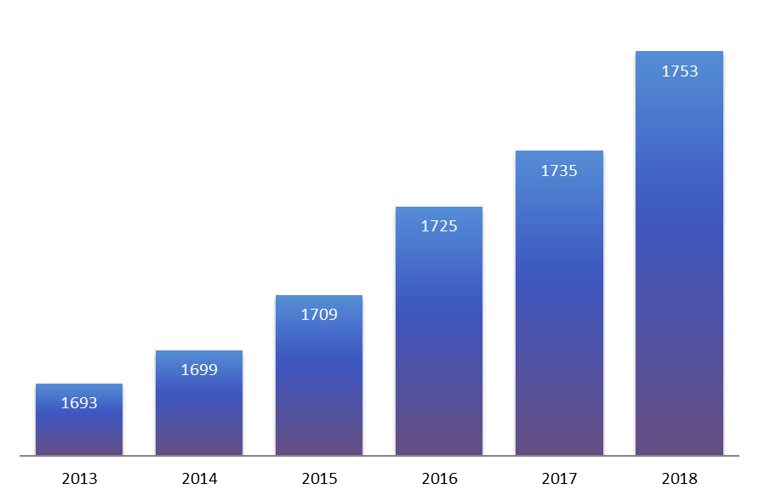

*Source*: ECE

2. Figure II below illustrates the evolution of accessions by ECE and non-ECE member States since 2010.

Figure II

**Accession of ECE and non-ECE Contracting Parties (1950** – **2018)**

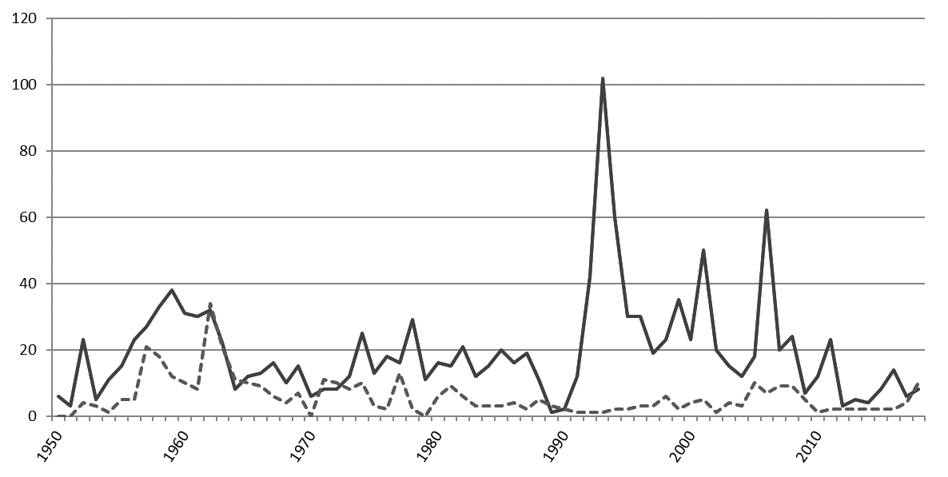

*Legend:* Solid line: ECE member States - Dotted line: non-ECE member States

*Source*: ECE

3. Of the 193 United Nations Member States, 147 States (76 per cent) are contracting parties to at least one legal instrument on inland transport, in addition to two Permanent Observers to the United Nations and one non-State contracting party. Almost eleven per cent of the United Nations Member States are contracting parties to at least 30 legal instruments.

**II. Geographical Distribution of Contracting Parties**

4. The total number of contracting parties to the 58 transport conventions is 1,753 (as of 1 December 2018). Of these, 1,354 are ECE contracting parties and 399 are non-ECE contracting parties.

5. Of the 147 United Nations Member States that are contracting parties, 91 (62 per cent) are non-ECE member States.

6. Out of the 58 legal instruments under the purview of ITC, 49 are in force. Non-ECE member States are contracting parties to 30 transport conventions, representing 30 per cent of the total number of accessions to these conventions. This also means that about 60 per cent of United Nations transport conventions serviced by ECE and in force, have a geographical coverage beyond the territory of ECE. On average, each ECE member State is party to 24 legal instruments, while each of the 91 non-ECE member States is party to 4.4 legal instruments.

Figure III

**ECE and non-ECE Contracting Parties   
to at least one United Nations Transport Convention**

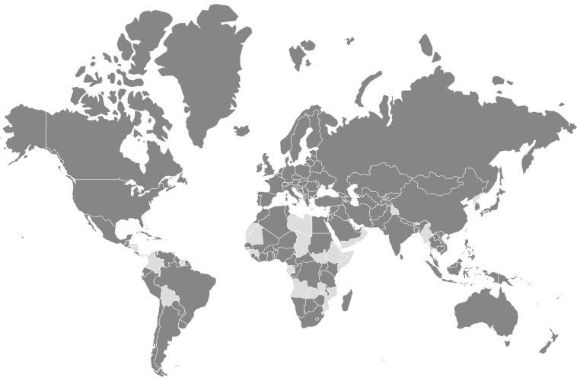

*Legend:* Dark grey: contracting parties - Light grey: non-contracting parties

*Source:* ECE

7. The European Union is currently the only non-State contracting party to United Nations legal instruments under the purview of the Committee. It is party to seven legal instruments.

8. Forty-six United Nations Member States are not contracting parties to any legal instruments on inland transport concluded under the purview of ITC: Angola, Belize, Bhutan, Bolivia (Plurinational State of), Brunei Darussalam, Chad, Colombia, Comoros, Democratic People's Republic of Korea, Djibouti, Dominica, Equatorial Guinea, Eritrea, Ethiopia, Gabon, Gambia, Grenada, Guinea, Guinea-Bissau, Honduras, Kiribati, Libya, Maldives, Marshall Islands, Mauritania, Micronesia (Federated States of), Mozambique, Myanmar, Nauru, Nicaragua, Palau, Panama, Saint Kitts and Nevis, Saint Lucia, Saint Vincent and the Grenadines, Samoa, Sao Tome and Principe, Somalia, South Sudan, Suriname, Swaziland, Timor-Leste, Tuvalu, Vanuatu, Yemen and Zambia.

9. The Committee may wish to consider this information and provide guidance on ways to increase the number of new accessions to the legal instruments under its purview.

**Annex**

**Accessions registered from 1 January - 1 December 2018**

| *Date* | *Contracting party* | *Convention* |
| --- | --- | --- |
| 29.11.2018 | Oman | Customs Convention on the International Transport of Goods under Cover of TIR Carnets (TIR Convention), of 14 November 1975 |
| 31.10.2018 | Argentina | Customs Convention on the International Transport of Goods under Cover of TIR Carnets (TIR Convention), of 14 November 1975 |
| 18.10.2018 | Nigeria | European Agreement concerning the International Carriage of Dangerous Goods by Road (ADR), of 30 September 1957 |
| 18.10.2018 | Nigeria | Agreement concerning the Establishing of Global Technical Regulations for Wheeled Vehicles, Equipment and Parts which can be fitted and / or be used on Wheeled Vehicles, of 25 June 1998 |
| 18.10.2018 | Nigeria | Convention on Road Traffic, of 8 November 1968 |
| 18.10.2018 | Nigeria | Agreement concerning the Adoption of Uniform Conditions for Periodical Technical Inspections of Wheeled Vehicles and the Reciprocal Recognition of Such Inspections, of 13 November 1997 |
| 18.10.2018 | Nigeria | Agreement concerning the Adoption of Uniform Technical Prescriptions for Wheeled Vehicles, Equipment and Parts which can be fitted and /or be used on Wheeled Vehicles and the Conditions for Reciprocal Recognition of Approvals Granted on the Basis of these Prescriptions, of 20 March 1958 |
| 28.06.2018 | Armenia | Convention on Road Signs and Signals, of 8 November 1968 |
| 12.06.2018 | Cabo Verde | Convention on Road Traffic, of 8 November 1968 |
| 17.05.2018 | Saudi Arabia | Customs Convention on the International Transport of Goods under Cover of TIR Carnets (TIR Convention), of 14 November 1975 |
| 4.05.2018 | Uzbekistan | Agreement concerning the Establishing of Global Technical Regulations for Wheeled Vehicles, Equipment and Parts which can be fitted and / or be used on Wheeled Vehicles, of 25 June 1998 |
| 28.03.2018 | United Kingdom of Great Britain and Northern Ireland | Convention on Road Traffic, of 8 November 1968 |
| 14.03.2018 | Republic of Moldova | Additional Protocol to the CMR concerning the electronic consignment note (e-CMR) |
| 6.03.2018 | Russian Federation | Additional Protocol to the CMR concerning the electronic consignment note (e-CMR) |
| 01.03.2018 | Armenia | Agreement concerning the Adoption of Uniform Technical Prescriptions for Wheeled Vehicles, Equipment and Parts which can be fitted and /or be used on Wheeled Vehicles and the Conditions for Reciprocal Recognition of Approvals Granted on the Basis of these Prescriptions, of 20 March 1958 |
| 31.01.2018 | Turkey | Additional Protocol to the CMR concerning the electronic consignment note (e-CMR) |
| 25.01.2018 | Qatar | Customs Convention on the International Transport of Goods under Cover of TIR Carnets (TIR Convention), of 14 November 1975 |
| 15.01.2018 | San Marino | European Agreement concerning the International Carriage of Dangerous Goods by Road (ADR), of 30 September 1957 |