Submitted by the expert from France | Informal document GRVA-01-38  1st GRVA, 25-28 September 2018  Agenda item 10
Part I. Proposal for amendments to Regulation No. 79 (Steering equipment) based on informal document GRRF-86-13
The text reproduced below was prepared by the expert from France introducing an amendment to UN Regulation No. 79 based on informal document GRRF-86-13.
The modifications on informal document GRRF-86-13 are marked in blue bold for new and in yellow highlight strikethrough for deleted characters.
I. Proposal
Annex 8, paragraph 2.4., amend to read:
"2.4. Lateral acceleration
The position representing the centre of gravity, at which the lateral acceleration shall be measured, shall be determined in agreement between the vehicle manufacturer and the Technical Service. The position at which the lateral acceleration is measured and the centre of gravity of the vehicle shall be identified in the test report.
The lateral acceleration shall be measured without taking into account the additional effects due to the movements of the vehicle body (e.g. roll of sprung mass).
The lateral acceleration and the lateral jerk at vehicle's center of gravity shall be determined. The raw lateral acceleration data shall be measured closest as possible to the position of the vehicle's center of gravity. The position at which the lateral acceleration is measured and the centre of gravity of the vehicle shall be identified in the test report. The sampling rate shall be at least 40 Hz 100 Hz.
To determine the lateral acceleration, the raw data shall be filtered by applying a 4th order Butterworth filter with a cut-off frequency of 0.2 Hz.1Hz.
To determine the lateral jerk, the 500ms moving average of the the time derivation of the filtered lateral acceleration shall be considered.
The lateral acceleration data at the vehicle center of gravity shall be determined by removing additional effects due to the movements of the vehicle body (e.g. roll of sprung mass) and by correcting for sensor placement via the use of coordinate transformation. As reference, the vehicle coordinate system as described in ISO 8855:2011 shall be used."
Annex 8, insert a new paragraph 2.5., to read:
"2.5. Overriding force
The measurement of the overriding force during the test can be performed by two methods: either trough the internal driver torque signal or by an external device fitted on the steering wheel [which doesn’t induce any deactivation of the system].
Prior to performing the overriding force test, by the internal driver torque signal, it shall be verified by an external measurement steering wheel that there is no relevant differences between the both measured values with a tolerance below less than or equal to 3N
During the overriding force test, only the internal driver torque signal shall be recorded and used for the evaluation because an external device on the steering wheel would manipulate the measurement."

Annex 8, paragraph 3.2.1.1. and 3.2.1.2., amend to read:
"3.2.1.1. The vehicle speed shall remain in the range from V_{smin} up to V_{smax}.
The test shall be carried out for each speed range specified in paragraph 5.6.2.1.3. of this Regulation separately or within contiguous speed ranges where the ay_{smax} is identical.
The vehicle shall be driven without any force applied by the driver on the steering control (e.g. by removing the hands from the steering control) with a constant speed or with a predefined initial speed (e.g. for vehicles automatically decelerating in curves) on a curved track with lane markings at each side.
The necessary lateral acceleration to follow the curve shall be between 80 and 90 % of the maximum lateral acceleration specified by the vehicle manufacturer ay_{smax}. The measured lateral acceleration during the test execution can be outside of the above-mentioned limits.
The lateral acceleration and the lateral jerk shall be recorded during the test.
3.2.1.2. The test requirements are fulfilled if:
No outside edge of the tyre tread of the vehicle’s front wheel does cross the outside edge of The vehicle does not cross any lane marking.
The recorded acceleration is within the limits specified in paragraph 5.6.2.1.3. of this Regulation.
The system does not exceed the specified value ay_{smax} specified according to 5.6.2.1.1 of this Regulation by more than 0.3 m/s².
The moving average over half a second of the lateral jerk does not exceed 5 m/s³.”

Annex 8, paragraph 3.2.2.2., amend to read:

3.2.2.2. The test requirements are fulfilled if:
The recorded acceleration is within the limits specified in paragraph 5.6.2.1.3. of this Regulation.
The system does not exceed the specified value aysmax specified according to 5.6.2.1.1 of this Regulation by more than 0.3 m/s².
The moving average over half a second of the lateral jerk does not exceed 5 m/s³.”

Annex 8, insert new paragraphs 3.2.5. to 3.2.5.2., to read:
“3.2.5. Lane Crossing Warning Test for M1 N1 and for M2 M3 N2 and N3 if not equipped with a LDWS fulfilling the technical requirements of Regulation No. 130.
3.2.5.1. The vehicle shall be driven with activated ACSF with a vehicle test speed between V_{smin} and V_{smax}.
The vehicle shall be driven without any force applied by the driver on the steering control (e.g. by removing the hands from the steering control) on a curved track with lane markings at each side.
The technical service defines a test speed and a radius which would provoke a lane crossing. The test speed and radius shall be defined such that the necessary lateral acceleration to follow the curve is in between ay_{smax} + 0.1 m/s² and ay_{smax} + 0.4 m/s².
3.2.5.2.The test requirements are fulfilled if:
The optical warning signal and additionally the acoustic or haptic warning signal was given at the latest when the outside edge of the tyre tread of the vehicle’s front wheel has crossed the outside edge of the lane marking.”
The system continues to provide assistance as required in § 5.6.2.2.3.

II. Justification:
Annex 8: 2.4. Lateral acceleration

- For keeping a traceability, it could be interesting to indicate in the report both the position at which the lateral acceleration was measured and the position of the centre of gravity of the vehicle
- For dynamical tests the usual value of sampling rate is at least 100 Hz
- The figures below show the shapes of the lateral acceleration signals versus the value of the cut-off frequency: No filter, filter at 2Hz, filter at 1 Hz and filter at 0.2 Hz.
The results show that the best representation of the dynamical behavior is obtained when the used filter is 1Hz.

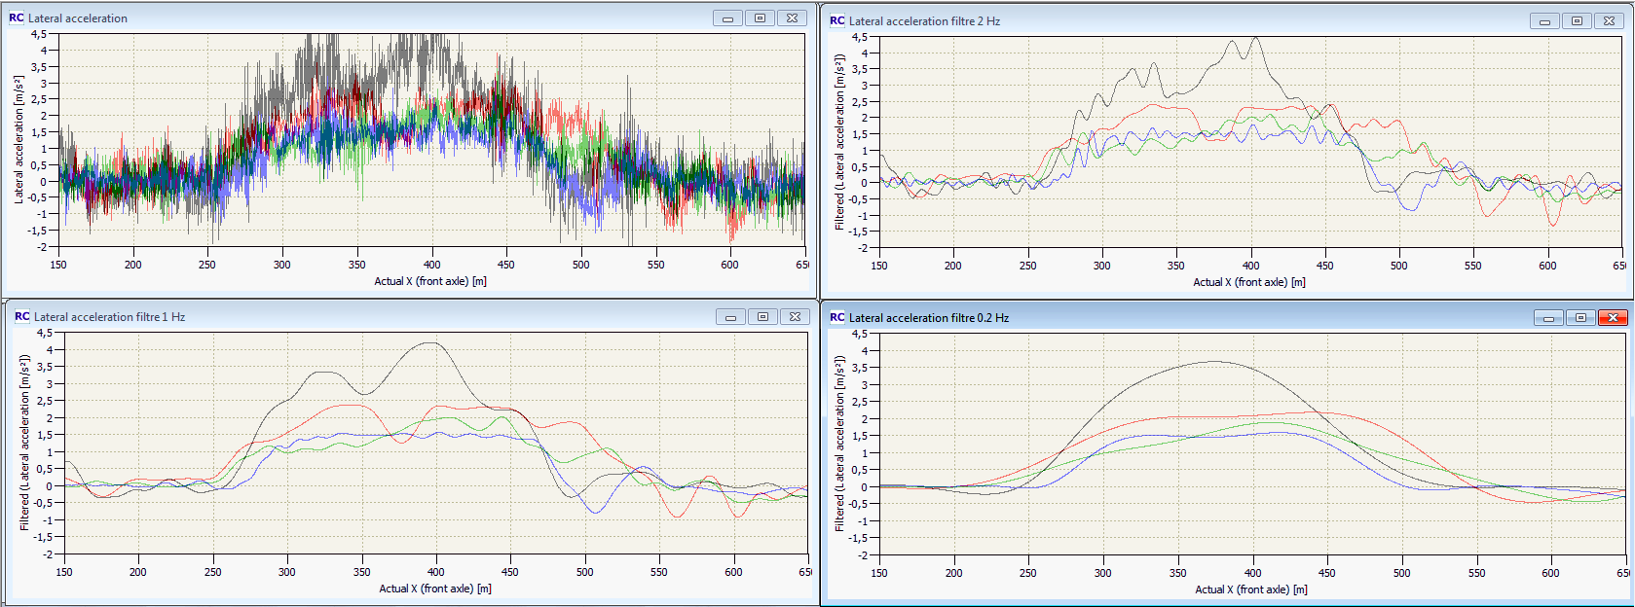
“Lateral Acceleration Filtering”: Comparison of tests led on 4 vehicles in the same curve.
- Figure 1: raw data (no filtered)
- Figure 2: Signal filtered at 2Hz
- Figure 3 : Signal filtered at 1Hz
- Figure 4 : Signal filtered at 0,2hz.

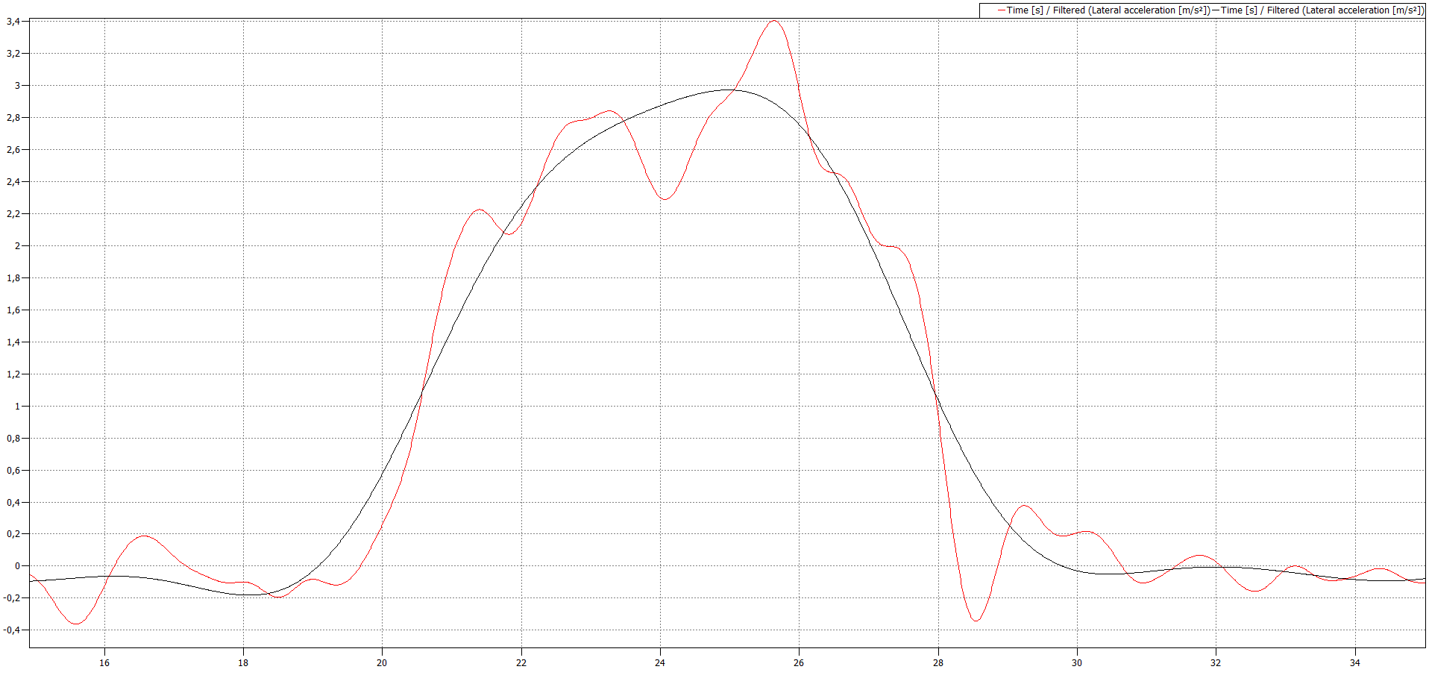

Figure “Lateral Acceleration Filtering”: Comparison between the 2 proposals for a vehicle near the limits: blue line (0.2hz) as proposed in document GRRF 86-13 and red line (1 Hz) as proposed in this document. In the first case the vehicle passes the test (Maximum value: 3m/s²) while in the second case the vehicle fails the test (maximum value: 3,4m/s²).

Annex 8: 2.5 Overriding Force Test
The intention is to offer the possibility for measuring the torque either with the internal sensor or with an external mean. A driving robot, an additional steering wheel torque system or a force sensor fitted smoothly on the steering wheel, which does not influence the steering of the vehicle, should be usable. The no influence can be checked, for instance, by driving the vehicle on a straight road, and/or in a curve, hand-off, with and without additional system. If in the both cases, the first optical warning signal appears at the same time after driver left the steering wheel, it can be considered there is no effect of the external equipment.

Annex 8, paragraph 3.2.1.1. and 3.2.1.2., amend to read:
The fact to accept that the lateral acceleration can reach ay_{smax} whilst the test is performed
between 80 % and 90 % of ay_{smax} provides already a tolerance. It is not necessary to give an
additionnal tolerance of 0.3 m/s².

Annex 8, insert new paragraphs 3.2.5. to 3.2.5.2., to read:
It is added in the § 3.2.5.2. a condition to be checked before declaring the test requirement
fulfilled such as defined in § 5.6.2.2.3.

Part II. Proposal for amendments to Regulation No. 79 (Steering equipment).

The text reproduced below was prepared by the expert from France introducing an amendment to UN Regulation No. 79. It is aimed at clarifying the text of the Regulation. The modifications to the existing text of the Regulation are marked in bold for new characters.

- Proposal

Paragraph 5.1.6.1.1., amend to read:
5.1.6.1.1. Every CSF intervention shall immediately be indicated to the driver by an optical
warning signal which is displayed for at least 1 s or as long as the intervention exists,
whichever is longer.
When a flashing mode is used, the lighting phase shall start with the beginning of the
intervention and finish with the end of intervention or immediately after intervention.
In the case of a CSF intervention which is controlled by an Electronic Stability Control
(ESC) or a Vehicle Stability Function as specified in the relevant UN Regulation (i.e. UN
Regulations Nos. 13, 13-H or 140), the ESC flashing tell-tale indicating the interventions of
ESC may be used, as long as the intervention exists, as an alternative to the optical warning
signal specified above.

Paragraph 5.1.6.2.6., amend to read:
5.1.6.2.6. Any intervention of an ESF shall be indicated to the driver with an optical and with an acoustic or haptic warning signal to be provided at the latest with the start of the ESF intervention and maintained as long as the intervention exists.
For this purpose appropriate signals used by other warning systems (e.g. blind spot detection, lane departure warning, forward collision warning) are deemed to be sufficient to fulfil the requirements for the respective optical, acoustic or haptic signals above.
The optical warning signal [shall] be a flashing signal.

Paragraph 5.6.4.2.3., amend to read:
5.6.4.2.3. The system shall only be activated (standby mode) after a deliberate action by the driver.
Activation by the driver shall only be possible on roads where pedestrians and cyclists are prohibited and which, by design, are equipped with a physical separation that divides the traffic moving in opposite directions and which have at least two lanes in the direction the vehicles are driving. These conditions shall be ensured by the use of at least two independent means.
In the case of a transition from a road type with a classification permitting an ACSF of Category C, to a type of road where an ACSF of Category C is not permitted, the system shall be deactivated automatically (off mode).

Paragraph 5.6.4.5.6., amend to read:

5.6.4.5.6. The system shall provide a means of detecting that the driver is holding the steering control and shall warn the driver in accordance with the warning strategy below:
If, after a period of no longer than 3 seconds after the initiation of the lane change procedure and before the start of the lane change manoeuvre, the driver is not holding the steering control, an optical warning signal shall be provided. This signal shall be the same as the signal specified in paragraph 5.6.2.2.5. above.
The warning signal shall be active until the driver is holding the steering control, or until the system is deactivated, either manually or automatically according to 5.6.4.6.8.

II. Justification:
Paragraph 5.1.6.1.1.:
It is proposed to clarify the visualization requirement of the optical signal when a flashing mode is used to indicate to the driver the CSF intervention in order to be sure that sufficient light is provided to the driver.
Paragraph 5.1.6.2.6.:
It is proposed to mention the duration of the signals as for the other categories of ACSF (e.g. CSF). Furthermore, the flashing mode of the optical signal should be privilegiate by analogy to other system intervening in situation where a risk exists (e.g. ESC intervention).
Paragraph 5.6.4.2.3.:
Adding “off mode” at the end for clarification.
Paragraph 5.6.4.5.6.:
It is made reference to the paragraph 5.6.4.6.8. where the different cases of manually and automatically deactivation are defined.

