UN/SCETDG/53/INF.37

Committee of Experts on the Transport of Dangerous Goods
and on the Globally Harmonized System of Classification
and Labelling of Chemicals 14 June 2018
Sub-Committee of Experts on the
Transport of Dangerous Goods
Fifty-third session

Geneva, 25 June-4 July 2018
Item 4 (b) of the provisional agenda
Electric storage systems:
hazard-based system for classification of lithium batteries
Hazard based classification of lithium cells and batteries
First elements of a classification scheme in complement to document ST/SG/AC.10/C.3/2018/59
Transmitted by the expert from France and the European Association for Advanced Rechargeable Batteries (RECHARGE)
Introduction
- The informal working group on lithium batteries met from 6 to 8 December 2017 in Geneva. Its report can be found in document ST/SG/AC.10/C.3/2018/59.
- The working group has agreed on some principles for a hazard based classification of lithium batteries, however these principles are not yet concretely presented in a consistent classification scheme such as a flow chart for instance.
- In paragraph 45 of the report it is mentioned that France, RECHARGE and PRBA would prepare some draft to present some of the principles in the format of a flowchart. This is the purpose of this document. As one of the first criteria and step for classification was concerning propagation, it focuses on it, and contains some flowchart elements as well as a draft test procedure for assessment of a thermal propagation criteria and other consecutive hazards.
- This document allows to provide an example of concrete structure. The committee is invited to elaborate further, especially on specific points above mentioned.
- At this stage, it is a first draft, and although not complete, it clearly shows the feasibility and the benefits of such a way of presentation.
- It is proposed to discuss these developments in a lunchtime working group that could meet Tuesday 26th and Wednesday 27th and come back with its conclusions Thursday.
Proposed classification
- The proposed classification and the underlying principles were defined according to the discussions of the IWG and hypothesis issued from the results gathered by RECHARGE and the expert of France.
- The proposed classification for lithium cells is based on three hazards highlighted during the discussions of the IWG (ST/SG/AC.10/C.3/2018/59):
(a) Propagation from cell to cell
(b) Heat production (divided into three criteria):
(i) Presence of fire during thermal runaway;
(ii) Global heat release rate (HRR);
(iii) Maximal temperature reached during a thermal runaway (including gas temperature when applicable).
(c) Emission of gas
9. Classification: The terms used in the diagram are defined in annex 1
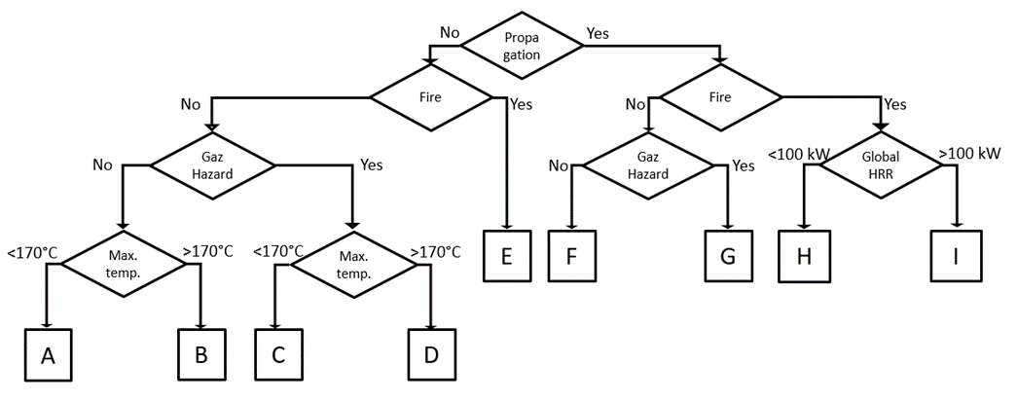
10. As for now, the proposed classification differentiates nine categories:
11. For practical reasons, the 9 categories have been assigned a letter from “A” to “I”. However, categories are currently purely descriptive and should not be seen as a hierarchy of hazard.
- A: benign hazard
- B: high temperature hazard
- C: gas hazard
- D: high temperature and gas hazard
- E: high temperature and gas hazard with the presence of flames
- F: propagation and high temperature hazard
- G: propagation, high temperature and gas hazard
- H: propagation, high temperature and gas hazard with the presence of flames
- I: propagation, violent reaction, high temperature and gas hazard with the presence of flames
Explanation of options chosen for the diagram
12. Some hypotheses and principles considered in the present document are expected to be modified after further discussions and possible experimental testing. However, they are based on current knowledge and experience gained from testing.
13. For the sake of simplicity, and to limit the complexity of the classification diagram, some hypotheses were considered:
(a) When there is propagation between cells, the temperature is generally higher than 170°C and the hazard coming from high temperature is systematically considered. Therefore, at this point, the maximal temperature has not been introduced in the diagram for boxes F, G, H and I.
(b) When there is propagation between cells without fire, the reaction is propagating through thermal conduction and is usually less violent. Therefore, at this point the HRR has not been introduced in the diagram for boxes F and G.
(c) In the presence of fire, the high temperature hazard is systematically considered. Therefore, at this point, the maximal temperature has not been introduced in the diagram for box E.
(d) In the presence of fire, the gas hazard is difficult to assess due to possible incomplete combustion and possible presence of toxic or suffocating gas. The hazard is systematically considered high in this case. Therefore, at this point, the gas hazard has not been introduced in the diagram for boxes E, H and I.
(e) In the absence of propagation, the reaction is nonviolent and the hazard associated to the global heat release rate is not addressed. Therefore, at this point, the HRR has not been introduced in the diagram for boxes A, B, C, D and E.
14. The criterion for gas hazard determination relates to the total volume of gas emitted and all the gas emitted are considered potentially harmful to human. This volume threshold, in absence of fire, should be further discussed.
15. The temperature threshold considered as hazardous is 170°C. It has been chosen to be under the melting point of metallic Li (170°C) and under auto-ignition temperature of paper (218°C). This temperature is also harmonized with criterion in the recommendation on the transport of dangerous goods UN Manual of Test and Criteria, paragraph 38.3.4 (6th revised edition).
16. The threshold for global heat release rate value has been fixed at 100 kW and should be discussed. Comparison with HRR of different type of material (as reference fires) would be useful.
Tests required for classification of a cell
17. Each point where the diagram requires a decision to be made shall be based from data coming from tests. Some existing standards may provide some of those tests. However, the thermal propagation test is specific and should be developed. Once solid data will be gained by experience it could be possible to establish conservative default classification values to minimize the cost of testing.
18. The thermal propagation test proposed is inspired by the test method of SAE AS6413 standard, currently under discussion, and is described in annex 2. This apparatus allows the characterization of three hazards: the propagation behavior, the presence of flame and the gas hazard.
19. In the test proposed in annex 2, thermal propagation is demonstrated if at least one of the following events happens:
(a) The witness cell vents, leaks or goes in thermal runaway
(b) The temperature of the witness cell increases abruptly
(c) The temperature of the witness cell is higher than 170°C
Other apparatus than the one described in annex 2 can be used, in open atmosphere for example, for the determination of thermal propagation.
20. The fire hazard can be determined by observation during the thermal propagation test described in annex 2. Fire means that flames are emitted from the cell (as defined in the UN Manual of Test and Criteria, paragraph 38.3.2.3)
21. If the observation of flame is obstructed by the apparatus used in the thermal propagation test, an alternative thermal runaway test, run on a single cell in open atmosphere, can also be used to assess fire hazard.
22. The gas hazard could be assessed also during the thermal propagation test described in annex 2. An alternative thermal runaway test, run on a single cell, can also be used to assess the volume of gas emitted. The test must be performed in a set-up allowing the measurement of the total volume of emitted gas. For example, an airtight box equipped with temperature and pressure sensors can be used.
23. Gases emitted may include, but are not limited to:
(a) Carbon dioxide (CO2)
(b) Carbon monoxide (CO)
(c) Carbonates
(d) Hydrogen (H2)
(e) Hydrogen fluoride (HF)
(f) Oxygen (O2)
They are considered a priori harmful to human, flammable and corrosive. If the volume of emitted gases is higher than the non-hazardous criterion, the responsible organization can prove that emitted gases are not hazardous in the expected concentration by using advanced characterization method (FTIR, gas analyzer, GC-MS …). Those cells can then be considered as non-hazardous regarding to the gas hazard.
24. The global heat release rate can be calculated based on the maximal heat release rate value found in literature. The current value for Li-ion cells is 250 kW/kg. A review of 200 tests result of published and unpublished data is presented in annex 3. The experimental heat release can also be considered. In that case, the responsible organization should measure the global heat release rate of a single cell when heated by a non-limited heat source. Testing apparatus such as Tewarson calorimeter can be used.
25. At this point, batteries are considered to be tested at a state of charge (SOC) of 100%. In further work, it must be assessed how the SOC could lead to other classifications. Introducing this consideration in the test scheme would lead to the introduction of other regulation modifications to ensure that the battery is transported at the specified SOC.
26. The packaging requirements associated to the risk in transport of the different categories identified in this document should be considered in a later stage.
Next steps
27. The following actions are already identified to elaborate a concrete categorization of Li-ion batteries:
(a) Validation of considered hazard and threshold.
(b) Validation of thermal propagation test protocol and more detailed description. The influence of the sealed chamber on the reaction (volume of the chamber, oxygen input…) is a parameter to study.
(c) Experimental validation of some options.
(d) Verification of the categorization on existing results.
28. This version of the classification does not consider the influence of packaging, mitigating propagation phenomenon and thermal runaway effects. That being, it can be used to identify hazard relevant for the choice of packaging.
29. The proposition presented in this document is related to the classification of cells. The question of the classification for batteries (assembly of cells) has to be addressed at a later stage once the principles for cells are agreed on.

Annex 1
Classification criteria definitions
- Propagation: the criteria for propagation is defined in annex 2 as: The witness cell vents, leaks or goes into thermal runaway; the temperature of the witness cell increases abruptly; the temperature of the witness cell is higher than 170°C.
- Fire: Fire means that flames are emitted from the cell (as defined in UN Manual of Test and Criteria, paragraph 38.3.2.3)
- Temperature: measured on the cell surface of the witness cell in the propagation test in annex 2
- Gaz hazard: a volume of gas above at the threshold value, and with a composition presenting either flammability risks or toxicity risks (see § 23)
- Global HRR: The Heat Release Rate is the rate at which heat is released by a fire. This parameter allows to evaluate if the violence of the thermal runaway reaction.
Annex 2
First draft of a thermal propagation test protocol
- To evaluate thermal propagation, more than two cells must be on test. To avoid heat dispersion through multiple cell, the number of “neighbor” cell should be minimized. The optimal number of cell for thermal propagation test is then 3 cells.
- To ensure reproducibility of results, the test should be performed several times (for example three times) in the same conditions.
- Setup proposed for cylindrical and prismatic cells:

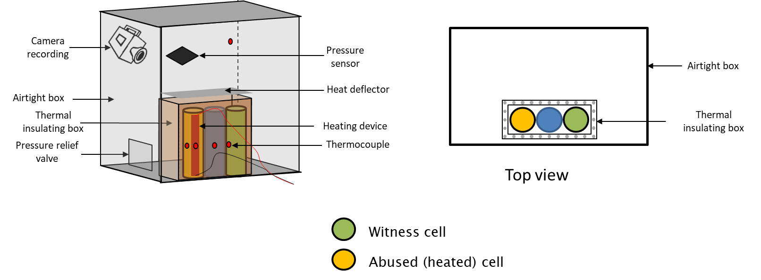

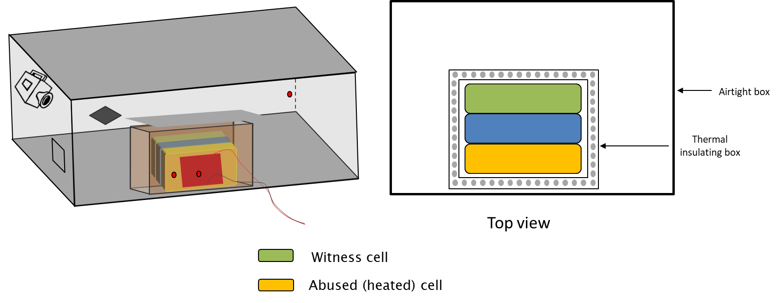
- The cells are placed into the test chamber in a way to maximize contact surface.
- The cells are contained in a thermal insulated box (opened on top) allowing heat dissipation only in the direction of the witness cell side. To minimize heat dissipation during fire or venting events, a heat deflector is placed above the insulated box
- At the beginning of the test, the temperature in the test chamber should be between 15 and 30°C.
- The volume of the chamber has to be defined.
- The heating device should be capable of increasing the cell temperature at a rate of 5 to 20°C per minute, up to 200°C.
- The heating device is placed on a side of the heated cell to avoid heating other cells. Other initiation source and configurations are possible depending on the characteristics of the cells. The heating device in covered by an insulating layer to avoid heat loss.
- The set up allows to record the test and visualize smoke and flame emissions.
- Thermocouples are placed on each cell and in the chamber. A control thermocouple is placed on the heating device.
- A pression sensor is placed in the chamber to calculate the total volume of gas emitted during the test. If the gas hazard is assed during another test, the chamber does not have to be equipped with a pressure sensor.
- The testing protocol consist to heat the abused cell up to 200°C and maintain this temperature for 1h.
- Propagation criteria are:
(a) The witness cell vents, leaks or goes into thermal runaway
(b) The temperature of the witness cell increases abruptly
(c) The temperature of the witness cell is higher than 170°C
15. Propagation criteria (temperature, venting, leaking or runaway) are evaluated on the witness cell because:
(a) The abused cell parameters are not representative of thermal propagation
(b) The first neighbor cell parameters are variable, and non-reliable due to its proximity with the heater. It is then difficult to use these results for classification purpose.
Annex 3
Maximal heat release rate value
